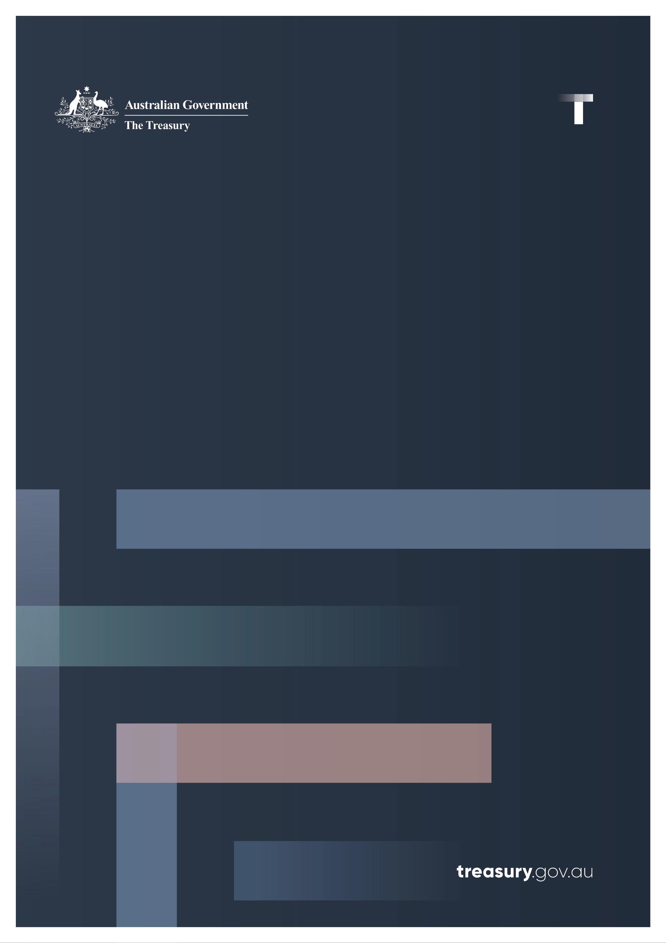

Sustainable Finance Roadmap

June 2024

© Commonwealth of Australia 2024

This publication is available for your use under a [Creative Commons Attribution 4.0 International](https://creativecommons.org/licenses/by/4.0/) licence, with the exception of the Commonwealth Coat of Arms, the Treasury logo, photographs, images, signatures and where otherwise stated. The full licence terms are available from <http://creativecommons.org/licenses/by/4.0/legalcode>.

Creative Commons attribution licence 3.0 icon. 

Use of Treasury material under a [Creative Commons Attribution 4.0 International](https://creativecommons.org/licenses/by/4.0/) licence requires you to attribute the work (but not in any way that suggests that the Treasury endorses you or your use of the work).

**Treasury material used ‘as supplied’**

Provided you have not modified or transformed Treasury material in any way including, for example, by changing the Treasury text; calculating percentage changes; graphing or charting data; or deriving new statistics from published Treasury statistics – then Treasury prefers the following attribution:

*Source: The Australian Government the Treasury.*

**Derivative** **material**

If you have modified or transformed Treasury material, or derived new material from those of the Treasury in any way, then Treasury prefers the following attribution:

*Based on The Australian Government the Treasury data*.

**Use of the Coat of Arms**

The terms under which the Coat of Arms can be used are set out on the Department of the Prime Minister and Cabinet website (see <https://www.pmc.gov.au/honours-and-symbols/commonwealth-coat-arms>).

**Other uses**

Enquiries regarding this licence and any other use of this document are welcome at:

Manager  
Media Unit  
The Treasury  
Langton Crescent   
Parkes ACT 2600  
Email: [media@treasury.gov.au](mailto:media@treasury.gov.au)

*In the spirit of reconciliation, the Treasury acknowledges the Traditional Custodians of country throughout Australia and their connections to land, sea and community. We pay our respect to their Elders past and present and extend that respect to all Aboriginal and Torres Strait Islander peoples*.

# Contents

Foreword 1

Pillar 1: Improve transparency on climate and sustainability 2

Priority 1: Implementing climate‑related financial disclosures 2

Priority 2: Developing the Australian Sustainable Finance Taxonomy 3

Priority 3: Supporting credible net zero transition planning 6

Priority 4: Developing sustainable investment product labels 7

Pillar 2: Financial system capabilities 9

Priority 5: Enhancing market supervision and enforcement 9

Priority 6: Identifying and responding to systemic financial risks 10

Priority 7: Addressing data and analytical challenges 11

Priority 8: Ensuring fit for purpose regulatory frameworks 12

Pillar 3: Australian Government leadership and engagement 13

Priority 9: Issuing Australian sovereign green bonds 13

Priority 10: Stepping up Australia’s international engagement 14

Key reform timeline 15

# Foreword

Building a net zero economy in a way that delivers prosperity and security for our people is a defining opportunity for our country and economy, and a major focus of the Albanese Government.

We want to help companies, investors and the broader community make the most of the energy and net zero transformation and help realise our ambition to become a renewable energy superpower.

That’s why I’m pleased to release our Sustainable Finance Roadmap.

The Roadmap is all about mobilising the significant private capital required to achieve net zero, modernising our financial markets and maximising the economic opportunities associated with energy, climate and sustainability goals.

It’s about ensuring markets have access to high quality, credible and comparable information when it comes to climate and sustainability, and helping investors and companies have the confidence and certainty they need to invest and manage climate and sustainability related risks.

So far, our primary focus has been on the introduction of mandatory disclosure of climate ‑related financial risks and opportunities, with legislation now before the Parliament. Now, with this Roadmap, we’ll move to delivering the next set of sustainable finance reforms.

This includes funding the completion of Australia’s preliminary sustainable finance taxonomy, developing a labelling regime for investment products marketed as sustainable, and supporting credible business transition planning through best practice guidance.

While facilitating the net zero transformation is a key objective, the Government is taking a ‘climate first, not only’ approach to sustainable finance. Financial markets are increasingly focused on responding to nature ‑related financial risks and opportunities, and integrating these considerations is also a key feature of our approach.

The Government has worked closely with a broad range of stakeholders to develop this Roadmap, and we will continue to engage broadly through implementation.

By working together, the Albanese Government is confident that we’ll successfully build the market structures and frameworks that can help to deliver a sustainable, prosperous, and inclusive economy, that works in the interests of investors, communities, and our people.

The Hon Jim Chalmers MP

Treasurer

# Pillar 1: Improve transparency on climate and sustainability

## Priority 1: Implementing climate‑related financial disclosures

The Government is implementing mandatory climate‑related financial disclosure requirements for large businesses and financial institutions with legislation currently before the Parliament. These disclosures will provide investors with greater transparency and more comparable information about entities’ exposures to climate‑related financial risks and opportunities and their climate‑related plans and strategies.

Subject to the passage of legislation, reporting requirements for Australia’s largest companies and financial institutions as well as entities above the publication threshold of National Greenhouse and Energy Reporting (NGER) scheme disclosure requirements will commence from 1 January 2025.

The Government has also committed to introduce climate disclosure requirements for Commonwealth entities commensurate with the Government’s commitment for the private sector. These will enhance climate opportunity and risk disclosures across the Commonwealth public sector and ensure market neutrality between the private and Commonwealth public sectors is maintained.

Disclosure requirements will be underpinned by standards to be published by the Australian Accounting Standards Board (AASB). The AASB is targeting August 2024 to finalise climate disclosure standards, prior to the commencement of reporting requirements. In addition, the Australian Auditing and Assurance Board (AUASB) is developing assurance standards for phased introduction.

The Australian Securities and Investments Commission (ASIC) will provide guidance to the market to help preparers comply with new reporting obligations. ASIC will consult on this guidance including on the approach to relief from the new reporting obligations and how the obligations may interact with existing legal and regulatory requirements. ASIC will also commence work to consider how the new regime will impact existing class and individual financial reporting relief.

The Government has announced that it will reform the financial reporting bodies by consolidating them within a single body, intended to be operational on or after 1 July 2026, subject to the passage of legislation. This reform will, in the long term, support the oversight, maintenance and development of climate and sustainability‑related financial reporting and assurance standards.

This work is supported by funding of $83.7 million over six years for the financial regulators, financial reporting bodies and Treasury, as part of the 2023–24 MYEFO.

|  |
| --- |
| Next steps  The **AASB** will finalise climate‑related disclosure standards, targeting August 2024.  The **AUASB** will develop assurance standards for climate in late 2024, following the release of final international assurance standards in September 2024.  **ASIC** will engage with and assist reporting entities to meet these new climate disclosure requirements. This includes issuing guidance and considering how the new regime will impact existing class and individual financial reporting relief.  The **Government** will conduct further consultation on proposed consolidation of the financial reporting bodies, ahead of related legislation being introduced.  The **Government** will conduct a review of climate‑related financial disclosure requirements in 2028–29. The review will be led by **Treasury**, working with the Council of Financial Regulators (CFR) and the new financial reporting body. |

## Priority 2: Developing the Australian Sustainable Finance Taxonomy

The Government has partnered with industry, through the Australian Sustainable Finance Institute (ASFI) to develop an Australian sustainable finance taxonomy. The taxonomy will support mobilisation of private capital towards sustainable activities and provide a base for further measures to address greenwashing and help facilitate Australia’s transition to net zero.

ASFI will deliver technical screening criteria for six priority sectors, against the objective of climate mitigation. These sectors align with the sector coverage in the Government’s sector decarbonisation plans and includes electricity and energy, industry, built environment, transport, resources, agriculture, and land. The initial taxonomy will also incorporate ‘do no significant harm’ and ‘minimum social safeguard’ criteria. These criteria are endorsed by a technical expert group and informed by public consultation.

Once finalised, the initial taxonomy will be available for use on a voluntary basis by both the private and public sectors. The taxonomy will provide an important source of guidance and consistency for firms, investors, and regulators, improving transparency and supporting the development of credible sustainable finance products.

The Government will explore options for governance arrangements and potential regulatory use cases in consultation with key stakeholders. The Government will also consider next steps for the taxonomy’s development including potential expansion priorities, reflecting strong interest expressed in the public consultation feedback received on the Sustainable Finance Strategy.

The Government will continue to play a key role in the taxonomy’s ongoing development, governance and surrounding policy design and implementation. The Government is working to ensure that the taxonomy complements other reforms such as the development of sector decarbonisation plans, and the development and implementation of Australia’s 2035 emissions reduction target.

|  |
| --- |
| Next steps  **ASFI** will finalise development of the initial Australian Sustainable Finance Taxonomy by the end of 2024. This will cover ‘green’ and ‘transition’ activities that contribute to climate change mitigation, in six priority sectors, as well as ‘do no significant harm’ and ‘minimum social safeguard’ criteria.  The **Government** will review the industry‑led voluntary taxonomy developed by ASFI, explore initial use cases for sustainable finance taxonomies in the financial and regulatory architecture by mid-2025 and consider relevant governance arrangements.  The **Government** will continue to support ongoing maintenance of the initial taxonomy to ensure it evolves as technology, policy, and markets change, and remains credible, usable, internationally interoperable, and reflective of Australia’s economy and context. |

|  |
| --- |
| Box 1: Integration of nature‑related objectives  Firms, investors, and financial regulators increasingly recognise the importance of responding to nature‑related risks and opportunities. The Government is progressing nature‑related initiatives including:  Encouraging nature‑related financial disclosures   * The 2024–25 Budget provided $4.1 million over two years for the Department of Climate Change, Energy, the Environment and Water (DCCEEW) to develop tools and guidance to support the voluntary uptake of nature‑related financial reporting by businesses and financial institutions. * ASIC is monitoring regulatory developments in relation to nature‑related risks and opportunities and disclosure of these under emerging frameworks. * The Government is also closely monitoring the work of the International Sustainability Standards Board (ISSB) on biodiversity, ecosystems, and ecosystems services, and will consider its sustainability disclosure requirements in light of the global baseline developed by the ISSB.   Developing the Australian Sustainable Finance Taxonomy   * The inclusion of the Do No Significant Harm (DNSH) principle which ensures an investment or activity cannot be considered sustainable under the taxonomy if it causes significant harm to other environmental or social objectives. * The Government will consider building out the taxonomy to cover additional sustainability objectives over time, such as biodiversity and ecosystem protection, sustainable water use and pollution prevention and control.   Addressing data and analytical challenges   * The Government recognises that data access, comparability and reliability can be a barrier to understanding nature‑related financial risks. * Environment Information Australia (EIA) has been established to give businesses easier access to the environment data they require and give the community more transparent information about the state of Australia’s environment. * As part of a broader sustainability data project, the Treasurer has specifically asked the CFR to consider policy responses to nature‑related data challenges.   Issuing Australian sovereign green bonds   * As set out in the [*Australian Government Green Bond Framework*](https://www.aofm.gov.au/sites/default/files/2023-12-05/Green%20Bond%20Framework_WEB.pdf), initiatives with nature‑positive objectives can be eligible to be financed under the program.   Establishment of the Nature Finance Council   * The Government established the Nature Finance Council in December 2023 to provide advice, through the Minister for the Environment and Water, on how to mobilise the capital required to underpin a nature positive economy and increase private sector financial flows to benefit nature. * The Council’s advice will inform how the Government’s sustainable finance reforms can be leveraged or expanded effectively to support the Government’s nature positive agenda. |

## Priority 3: Supporting credible net zero transition planning

Climate‑related transition plans are an aspect of an entity’s strategy that lays out the entity’s targets, actions, or resources for its transition towards a lower emission economy, including actions to reduce its greenhouse gas emissions or adaptation activities to manage physical climate risks[1]. Credible and robust transition plans support effective near‑ and long‑term capital allocation.

Australia’s corporate transition plan disclosure requirements will be contained in the new climate disclosure regime for large companies and financial institutions. These requirements will be progressively rolled out from 1 January 2025, subject to the passage of legislation (see Priority 1).

The Government recognises the need for further guidance to support best practicetransition planning. In addition to updated guidance from ASIC to support compliance with new climate disclosure obligations, Treasury will develop and publish guidance on best practice transition plan disclosures before the end of 2025. Treasury’s guidance will consider:

* Priorities of transition plan preparers (e.g. companies) and users (e.g. investors).
* Emerging domestic and international frameworks and standards including the UK’s Transition Plan Taskforce Disclosure Framework, outcomes of the G20 Sustainable Finance Working Group’s transition plan workstream; and the International Platform on Sustainable Finance’s Transition Working Group.
* The Government’s upcoming Net Zero Plan and sector decarbonisation pathways, and how they may support or interact with corporate transition planning guidance.
* Observed transition plan disclosure practices by Australian companies, both before and after implementation of the Government’s climate disclosure reforms.

As with the taxonomy, the Government will consider appropriate linkages between transition plan guidance, the Government’s sector decarbonisation plans, and the development of Australia’s 2035 emissions reduction target.

|  |
| --- |
| Next steps  **Treasury** will develop and publish best practice guidance for the disclosure of corporate transition plans by the end of 2025.  **Treasury** will commence longer‑term work to assess the impact of the guidance and provide advice to Government on future measures after initial guidance is issued. |

## Priority 4: Developing sustainable investment product labels

While investment product issuers are subject to extensive disclosure obligations, the diversity of the sustainable finance landscape can be confusing for investors. Without a more prescriptive regulatory framework, it is difficult for investors to understand how sustainability considerations are factored into investment products or strategies.

The Government has committed to establish consistent labels and disclosure requirements for investment products marketed as ‘sustainable’ or similar, including for managed funds and within the superannuation system. Such a regime will support product issuers as well as investors, given the increasing demand for investment products with specific sustainability objectives.

Treasury is commencing work to develop a new regime and will closely consider:

* Existing industry approaches to sustainable investment product marketing in Australia.
* Interactions with new sustainable finance frameworks, such as the taxonomy, and broader climate and sustainability activities like emissions reduction targets.
* Key labelling developments in other markets, particularly in the United States, United Kingdom, and the European Union.

|  |
| --- |
| Next steps  **Treasury** will commence detailed policy work to develop a sustainable investment product labelling regime, including public consultation in early 2025.  **The Government** is targeting 2027 for regime commencement subject to final policy decisions. |

|  |
| --- |
| Box 2: Climate adaptation  The Sustainable Finance Strategy’s initial focus on responses to climate change encompasses both climate mitigation and climate adaptation. While sustainable finance discussions often focus on investment to meet emissions reduction goals, climate adaptation is a necessary consideration. Adaptation forms part of effective risk management by firms and financial institutions, and private finance will be needed to enhance resilience across the economy.  A key component of the Government’s response to climate change is the development of Australia’s first National Climate Risk Assessment and National Adaptation Plan. These initiatives are being progressed by DCCEEW and delivered over two years throughout 2023 and 2024. The Risk Assessment will help us understand the national level risks and impacts from climate change.  The National Adaptation Plan, to be released late 2024, has three proposed objectives: mainstreaming adaptation action, driving an uplift in private sector investment, and supporting people and communities in disproportionately vulnerable situations. The plan will provide a blueprint for responding to nationally significant climate risks. From a financial system perspective, this work will provide important insights on systemic risks that must be managed and opportunities to unlock investment in these areas.  As part of the Strategy, several initiatives are underway to mainstream consideration of climate adaptation in the financial sector:   * The Government’s new climate disclosure requirements (see Priority 1) will significantly enhance the quality and comparability of firm‑level climate risk information available across markets. This information, particularly companies’ transition plans and the outcomes of scenario analysis to test resilience to various climate outcomes, will feed into investment decisions which consider climate adaptation needs and highlight opportunities to improve resilience. * Commonwealth agencies, including the Australian Prudential Regulation Authority (APRA), ASIC and Treasury are participating in the Hazards Insurance Partnership (HIP) managed by the National Emergency Management Agency. The HIP brings together insurers and public sector agencies with the aim of ensuring that climate resilience initiatives put downward pressure on insurance premiums. * The CFR’s examination of responses to data challenges (see Priority 7) will include consideration of data related to companies’ assessments of physical and transition‑related climate risks. * Government projects with a climate change adaptation objective will be eligible to be funded via the green bond program, as set out in the [*Australian Government Green Bond Framework*](https://www.aofm.gov.au/sites/default/files/2023-12-05/Green%20Bond%20Framework_WEB.pdf)*.*   The Government will continue to consider opportunities to further embed consideration of climate adaptation across the financial sector. This could include the expansion of the Australian Sustainable Finance Taxonomy to broader sustainability objectives (see Priority 2). |

# Pillar 2: Financial system capabilities

## Priority 5: Enhancing market supervision and enforcement

Ensuring the continuation of a strong and proactive regulatory approach to greenwashing and other sustainable finance‑related misconduct will strengthen Australia’s position as an attractive destination for green capital.

Sustainable finance is one of ASIC’s four external strategic priorities for the period 2023–2027. Under the priority, ASIC will support market integrity and efficiency through supervision and enforcement of current governance and disclosure standards to reduce harms from greenwashing, while engaging closely on climate‑related financial disclosure requirements. In line with this strategic priority, ASIC is undertaking targeted surveillance and overseeing sustainability‑related disclosure and governance practices across its regulated entities.

Enhanced supervision and enforcement practices, in conjunction with reforms such as the mandatory climate disclosure requirements, will provide transparent and comparable information across financial markets and support ASIC’s ability to scrutinise claims made by regulated entities. Other reforms, including the sustainable finance taxonomy and investment product labels, will strengthen ASIC’s ability to promote transparency and respond to misconduct.

ASIC will continue its focus on targeting greenwashing misconduct in 2024–25 through ongoing surveillance activity and, where appropriate, enforcement action. Entities across ASIC’s regulated population will be covered, including listed companies, responsible entities and superannuation trustees.

ASIC will also continue to share the findings that emerge from its supervisory and enforcement work to improve and uplift market practice. The forthcoming climate disclosure standards and associated guidance will also support firms to understand regulatory expectations for climate‑related financial disclosures and manage risk of misconduct.

|  |
| --- |
| Next steps  **ASIC** will continue to address market misconduct, including through greenwashing surveillance and enforcement. |

## Priority 6: Identifying and responding to systemic financial risks

The CFR Climate Working Group was established in 2017 to coordinate regulators’ response to climate‑related financial risks, including at the systemic level. APRA has led the CFR’s efforts to better understand how climate‑related financial risks affect banks, insurers and superannuation funds.

The CFR will continue to expand its work on climate and sustainability‑related financial risks, deepening risk management capabilities and practices across financial regulators and market participants.

APRA is continuing work on Climate Vulnerability Assessments (CVA). The Insurance Climate Vulnerability Assessment CVA will assess the impact of climate risk on the affordability of general insurance over the medium term (to 2050). The design phase of the Insurance CVA is now complete, and participating insurers are using this to model natural peril risk against two potential future climate scenarios. APRA aims to publish insights from the Insurance CVA in the first half of 2025. This work builds on an initial Banking CVA which assessed selected physical and transition climate risks that may be faced by the banking sector and highlighted the value of collaboration between financial institutions and regulators to identify and better understand these risks.

The Reserve Bank will also continue its consideration of how climate change affects the economy and the financial system as part of its monetary policy and financial stability responsibilities. The Bank is building its capacity to conduct analysis and research into how climate change will affect the structure and operation of the economy and the implications for monetary policy and how climate risks might translate into financial stability risks.

|  |
| --- |
| Next steps  **APRA** will engage with stakeholders as part of reviewing the effectiveness of Prudential Practice Guide CPG 229 Climate Change Financial Risks, with a focus on key issues such as embedding climate risk considerations clearly in risk management frameworks.  By mid‑2025, **APRA** will publish findings of its Insurance CVA.  The **CFR** will continue to expand its work on climate and sustainability related financial risks deepening risk management capabilities and practices across financial regulators and market participants. |

## Priority 7: Addressing data and analytical challenges

Sustainability data is an increasingly important input to financial decision‑making. Available and accurate data enables investors and financial institutions to assess risks and opportunities, make effective disclosures, and demonstrate credible progress towards sustainability targets.

In November 2023, the Treasurer wrote to the Chair of the CFR requesting options to address key sustainability‑related data challenges faced by financial system participants. The CFR is focussing on four key topics:

1. Accessibility of corporate climate data by market participants.
2. Estimation and use of scope 3 emissions by business and financial institutions.
3. Data to inform companies’ assessments of physical and transition‑related climate risks.
4. Nature‑related data relevant to understanding financial risks.

The process will involve close consultation including with financial market participants and other government agencies. The CFR will present key findings and recommendations to the Treasurer in early 2025.

In addition to the work of the CFR, other agencies across Government are also working to address climate‑related data challenges. Examples include:

* DCCEEW is improving transparency of greenhouse gas emission data through reforms to the NGER scheme, and the Australian Carbon Credit Units (ACCU) scheme.
* The Government amended the NGER scheme as part of the Safeguard Mechanism reforms in 2023 to publish additional facility level emissions information and is continuing to progress further reforms to improve transparency of and access to greenhouse gas emissions data.
* In the 2024–25 Budget, the Government committed $28.7 million over ten years (inclusive of $0.9 million per year ongoing from 2028–29) to improve greenhouse gas emissions accounting in the agriculture and land sector.

|  |
| --- |
| Next steps  The **CFR** will make recommendations for addressing key sustainability data challenges to Government in early 2025.  The **CFR** will continue to assess the availability and quality of sustainability related data to support informed financial sector decision‑making. |

## Priority 8: Ensuring fit for purpose regulatory frameworks

Australia’s principles‑based approach to corporate governance obligations and financial regulation has effectively adapted to incorporate evolving understandings of material sustainability risks. Both ASIC and APRA have set strong expectations around disclosing and managing the financial risks associated with climate change within their existing mandates.

Stakeholder feedback on the Sustainable Finance Strategy generally agreed that financial regulatory frameworks are fit for purpose, however some stakeholders identified concerns with the annual superannuation performance test. Some stakeholder submissions, including those from superannuation funds and investment managers, suggested the current design of the test is a barrier to integrating climate and other sustainability considerations in superannuation investment decision making.

In March 2024, the Government published a [consultation paper](https://treasury.gov.au/consultation/c2024-471223) which sought input on how to refine the test to make sure super funds are able to invest in ways that deliver the best possible returns for Australians. The consultation paper noted stakeholder concerns that investment strategies which materially differ from the prescribed benchmarks face additional risk of failing the test. This could discourage superannuation funds from responding to sustainability‑related risks and opportunities, which may otherwise be in the best financial interest of their members, where it does not align closely with the benchmark indices.

|  |
| --- |
| Next steps  Following public consultation, the **Government** will consider stakeholder feedback on options to refine the annual superannuation performance test.  The **Government** will continue to work with financial regulators, governance experts and industry stakeholders to identify policy priorities for mainstreaming sustainability considerations in corporate governance and financial institution decision‑making. |

# Pillar 3: Australian Government leadership and engagement

## Priority 9: Issuing Australian sovereign green bonds

The Government is issuing green bonds. A well‑designed and credible green bond program will help mobilise additional climate‑aligned capital, support the development of Australia’s broader sustainable finance markets and signal the Government’s commitment to climate, environmental and other sustainability‑related goals.

In December 2023, the Australian Office of Financial Management (AOFM) published the [*Australian Government Green Bond Framework*](https://www.aofm.gov.au/sites/default/files/2023-12-05/Green%20Bond%20Framework_WEB.pdf), which provides a comprehensive overview of the Government’s climate and environmental priorities and outlines how green bonds will be used to finance Eligible Green Expenditures. An Interdepartmental Green Bond Committee, co‑chaired by Treasury and DCCEEW, has been established to support a robust governance process for project evaluation, selection and ongoing reporting.

The first green bond was issued on 4 June 2024. The bond line is $7 billion in size and will mature in June 2034. The Government will provide green bond investors with regular and transparent allocation and impact reporting. Annual reporting will commence in 2025 will be published on the AOFM website.

|  |
| --- |
| Next steps  The **Government** will publish annual allocation and impact reporting, commencing in 2025.  **Treasury** will continue to support implementation of the [*Australian Government Green Bond Framework*](https://www.aofm.gov.au/sites/default/files/2023-12-05/Green%20Bond%20Framework_WEB.pdf)including to ensure that Australia’s green bond program continues to align with international best practice. |

## Priority 10: Stepping up Australia’s international engagement

The Government has committed to stepping up Australia’s international engagement on sustainable finance to promote the development of consistent global standards and high‑quality interoperable frameworks. These efforts will facilitate the alignment of frameworks across different jurisdictions, and ensure global frameworks and standards cater to issues that are relevant to Australia’s economy and our surrounding region, and do not create new barriers to cross‑border investment.

Australia will scale up engagement on sustainable finance policy in multilateral and regional fora, and deepen our bilateral relationships, to promote high ambition, knowledge sharing, capability development and interoperability.

International engagement will focus on the following priority areas:

* **ASEAN engagement**, to implement the recommendations in Australia’s Southeast Asia Economic Strategy to 2040.
* **Bilateral engagement,** building on cooperation agendas or commitments including in the Australia‍–‍New Zealand 2+2 Climate and Finance Dialogue, Singapore–Australia Green Economy Agreement, the Australia–Indonesia Climate and Infrastructure Partnership, and the Australia‍–‍UK Free Trade Agreement.
* **Multilateral and regional engagement** to support the agendas in key forums such as G20 Sustainable Finance Working Group (SFWG), Coalition of Finance Ministers for Climate Action (CFMCA), the International Platform for Sustainable Finance (IPSF), the United Nations Framework Convention on Climate Change (UNFCCC) and the Paris Agreement.

Australia will host the Global Nature Positive Summit in 2024, to help build consensus on principles and policy settings to deliver investment in nature, both in Australia and globally.

Australia will also continue to support innovative financing models and approaches to support sustainable investment in our region. This will complement the expansion of direct Government‑led financing efforts in the region.

Australia will continue to make efforts in international fora including the G20, to argue for the development of market structures which reward global resources producers that improve their environmental and social footprint.

|  |
| --- |
| Next steps  The **Government** will continue to elevate sustainable finance as a key pillar of Australia’s broader climate‑ and nature‑related international engagement, to help position Australia as a regional and global leader in sustainability.  The **Government** will prioritise making sustainable finance and disclosure frameworks internationally interoperable in Australia’s broader climate and nature related international engagement, including as part of the implementation of our Southeast Asia Economic Strategy.  The **Government** will advocate for differentiated international trading markets for resources produced to higher environmental, social and governance standards through G20 engagements. |

# Key reform timeline

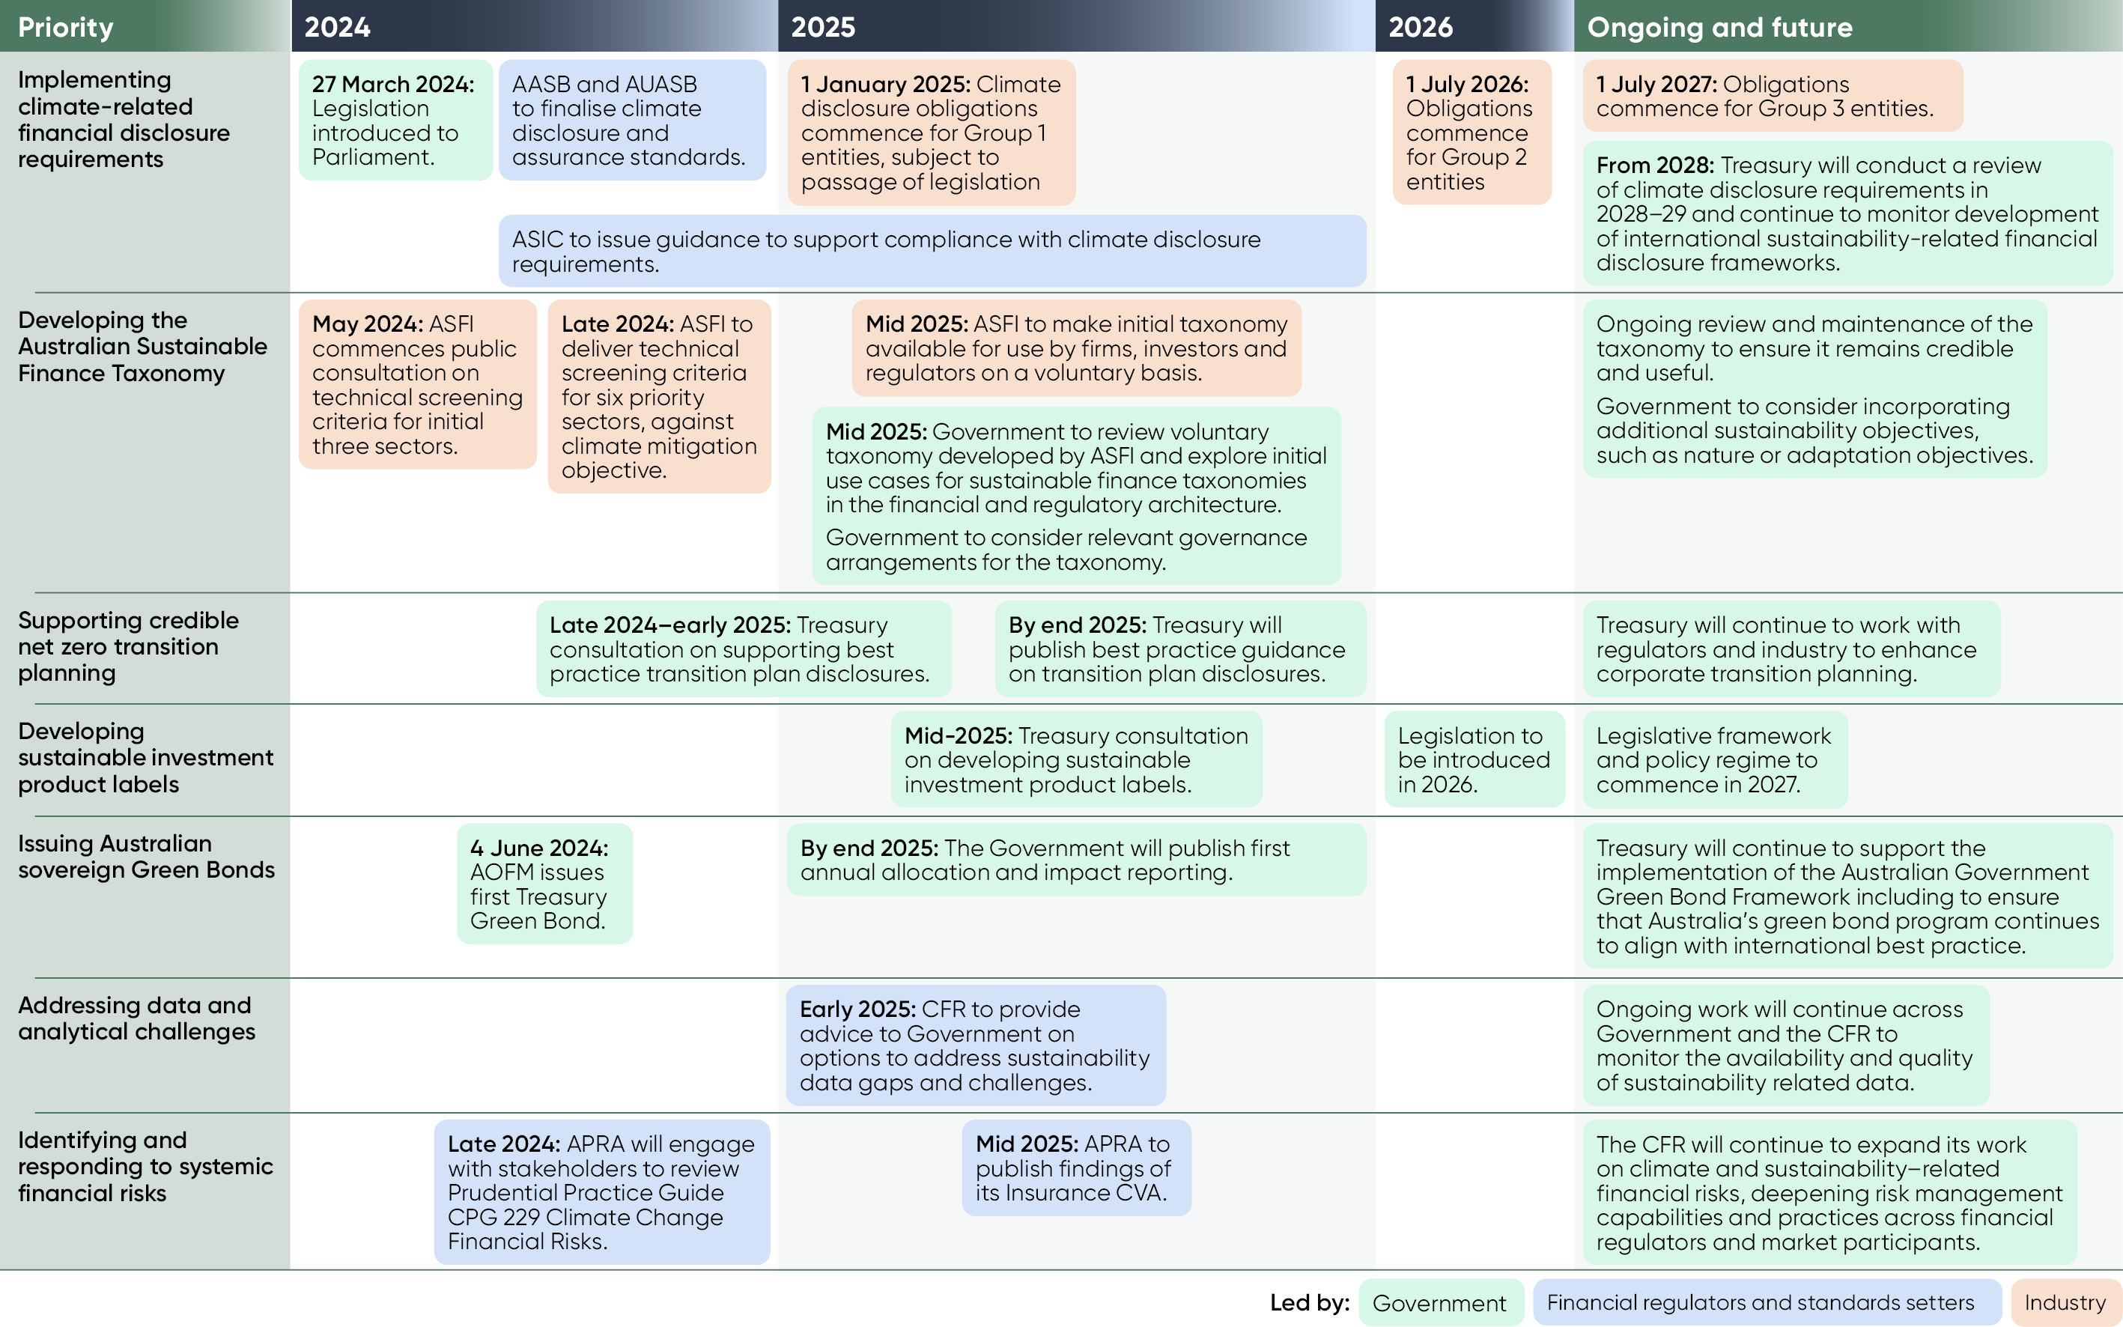

1. *IFRS S2 Climate‑related Disclosures*