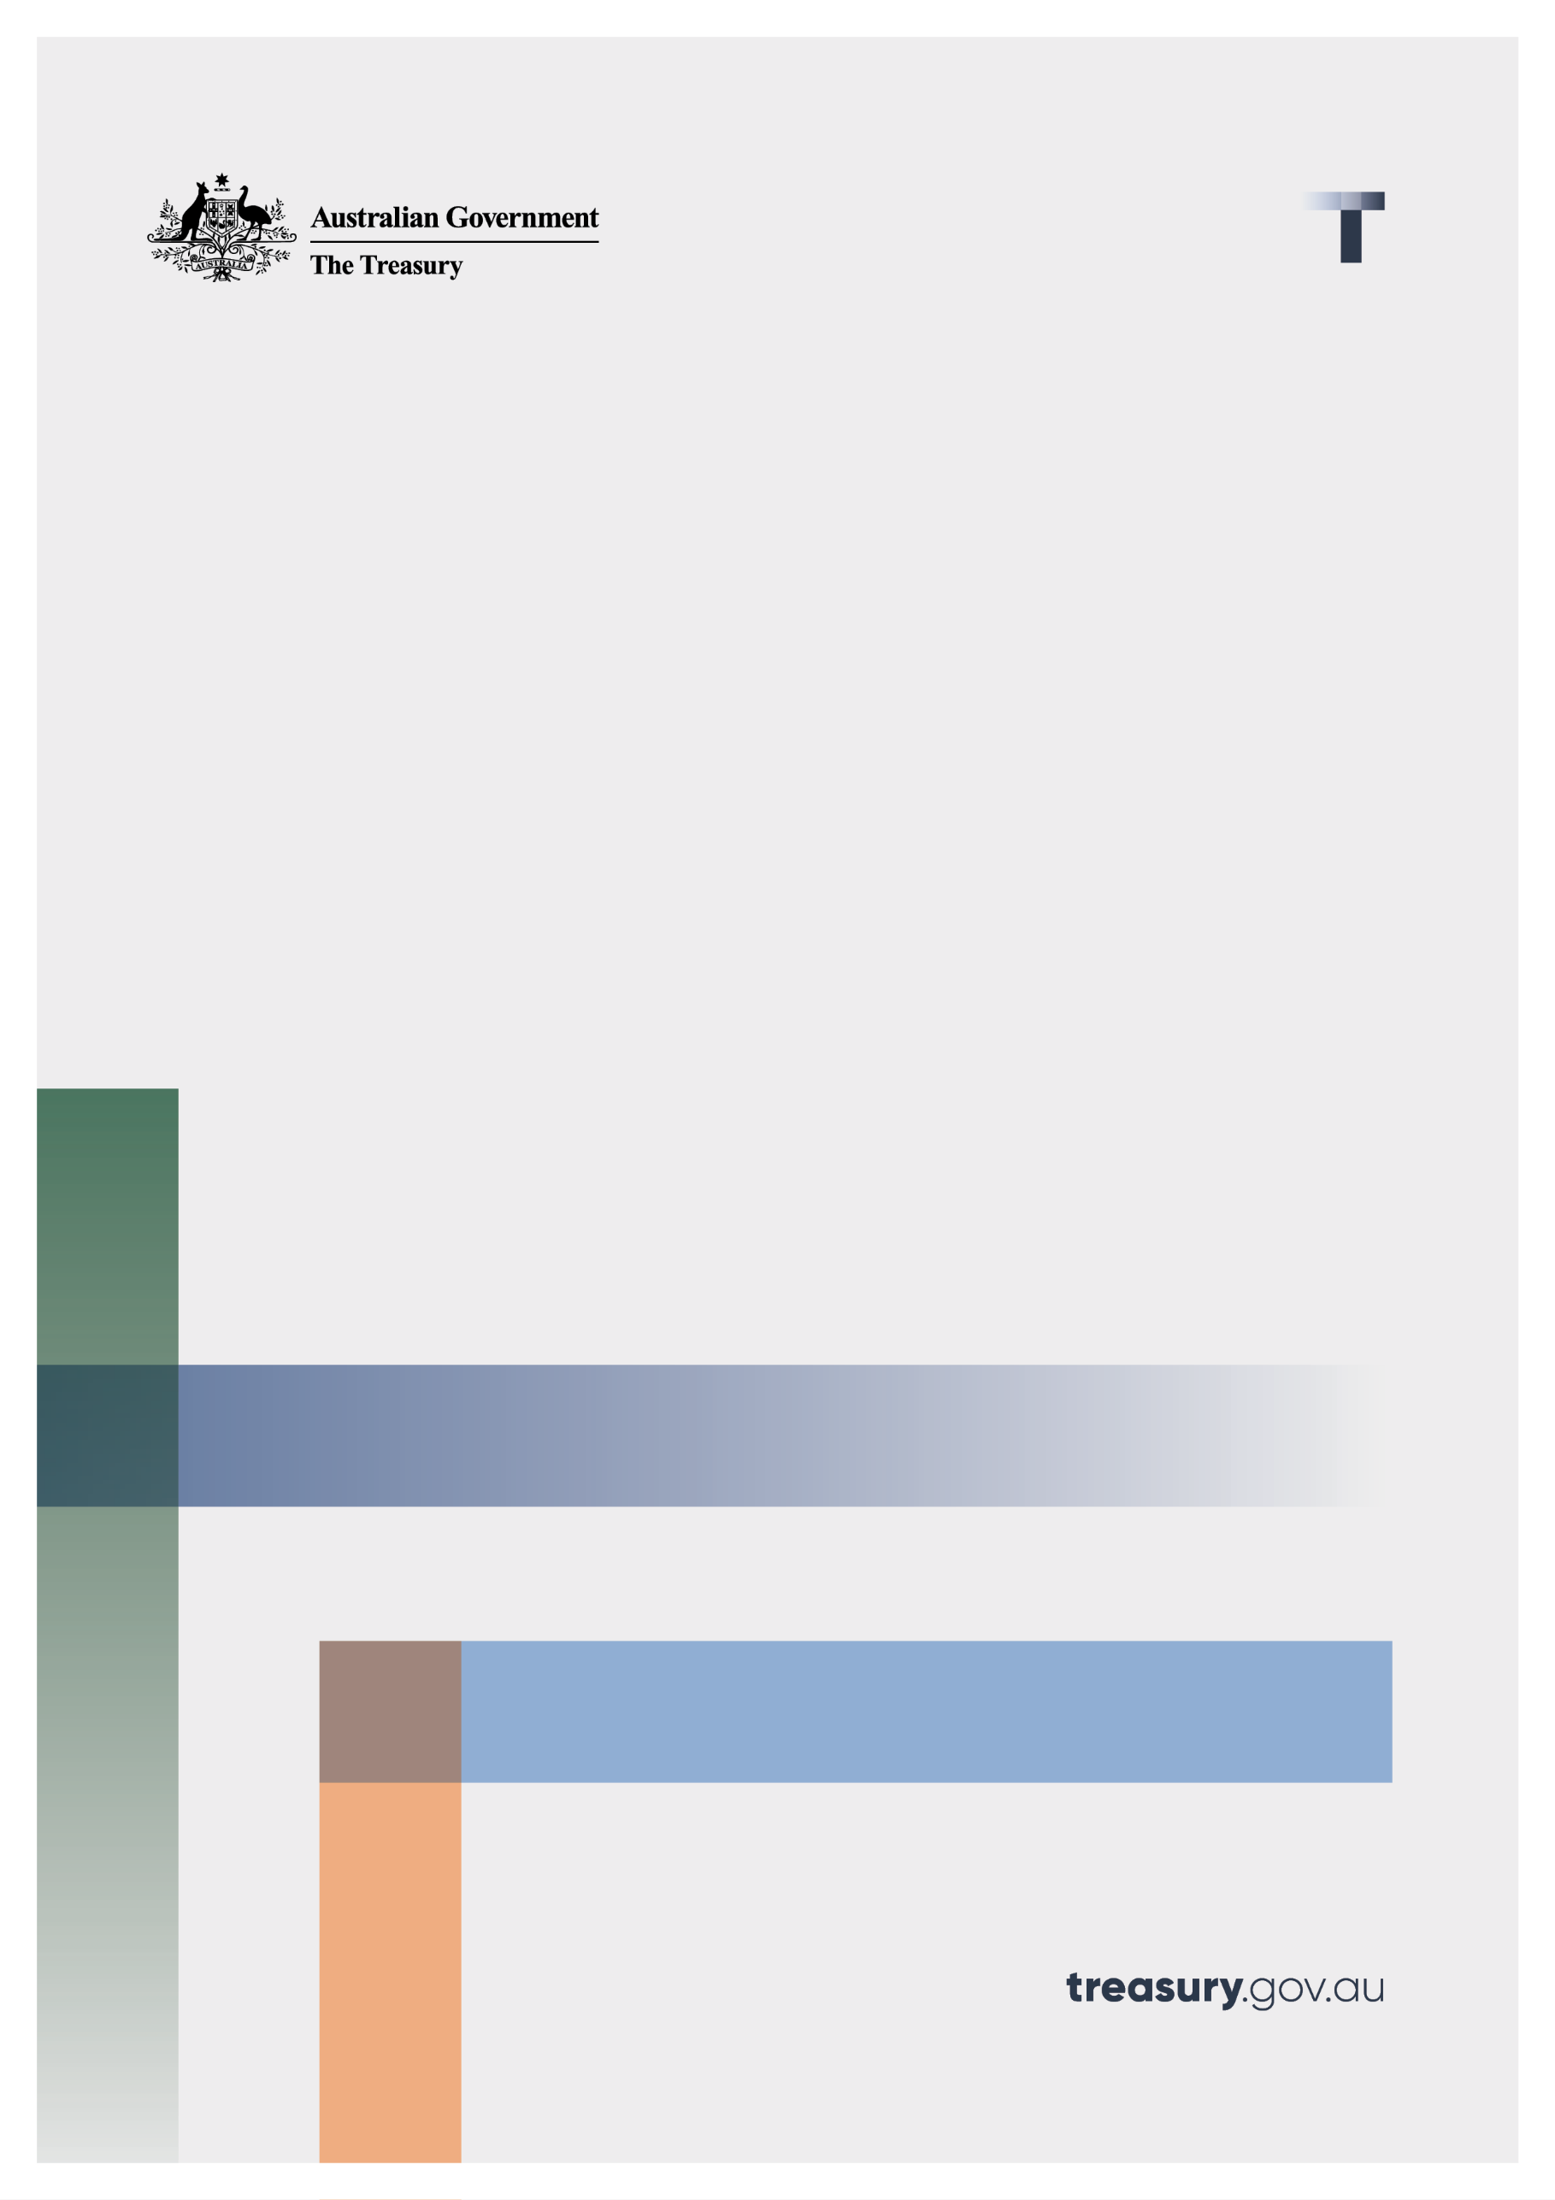

Critical Minerals Production Tax Incentive

Consultation paper

June 2024

© Commonwealth of Australia 2024

This publication is available for your use under a [Creative Commons Attribution 3.0 Australia](http://creativecommons.org/licenses/by/3.0/au/deed.en) licence, with the exception of the Commonwealth Coat of Arms, the Treasury logo, photographs, images, signatures and where otherwise stated The full licence terms are available from <http://creativecommons.org/licenses/by/3.0/au/legalcode>.

Creative Commons attribution licence 3.0 icon. 

Use of Treasury material under a [Creative Commons Attribution 3.0 Australia](http://creativecommons.org/licenses/by/3.0/au/deed.en) licence requires you to attribute the work (but not in any way that suggests that the Treasury endorses you or your use of the work).

**Treasury material used ‘as supplied’.**

Provided you have not modified or transformed Treasury material in any way including, for example, by changing the Treasury text; calculating percentage changes; graphing or charting data; or deriving new statistics from published Treasury statistics — then Treasury prefers the following attribution:

*Source: The Australian Government the Treasury*

**Derivative** **material**

If you have modified or transformed Treasury material, or derived new material from those of the Treasury in any way, then Treasury prefers the following attribution:

*Based on The Australian Government the Treasury data*

**Use of the Coat of Arms**

The terms under which the Coat of Arms can be used are set out on the Department of the Prime Minister and Cabinet website (see <https://www.pmc.gov.au/honours-and-symbols/commonwealth-coat-arms>).

**Other uses**

Enquiries regarding this licence and any other use of this document are welcome at:

Manager  
Media and Speeches Unit  
The Treasury  
Langton Crescent   
Parkes ACT 2600  
Email: [media@treasury.gov.au](mailto:media@treasury.gov.au)

*In the spirit of reconciliation, the Treasury acknowledges the Traditional Custodians of country throughout Australia and their connections to land, sea and community. We pay our respect to their Elders past and present and extend that respect to all Aboriginal and Torres Strait Islander peoples.*

# Contents

Contents ii

Consultation Process 1

How to respond 1

Critical Minerals Production Tax Incentive 2

Introduction 2

The Critical Minerals Production Tax Incentive 3

Proposed details 3

Issues for discussion 4

Who is eligible? 4

Eligible processing expenditure 5

Eligible outputs 6

Administrative arrangements 7

Community benefit principles 7

# Consultation Process

Treasury is seeking stakeholder feedback on the Government’s Critical Minerals Production Tax Incentive (CMPTI), which was announced in the 2024-25 Budget as part of the Future Made in Australia package.

We encourage you to respond with feedback on the proposed design and administration details and questions outlined in this paper. More information can be found on the Treasury website at <https://treasury.gov.au/consultation/c2024-541266>.

Your feedback will inform advice to government on the final design and administration arrangements, and the drafting of legislation to implement the CMPTI ahead of its 1 July 2027 commencement. Your feedback will also inform the sequencing of drafting, which could proceed in tranches, with some parts of the CMPTI implemented through subordinate legislation.

Treasury and The Department of Industry, Science and Research will conduct further consultations on regulations to support the primary legislation with respect to the purity and specifications of the critical minerals.

## How to respond

Treasury welcomes feedback from stakeholders on the questions highlighted throughout this paper. Stakeholders may also wish to comment on other design and administration considerations not raised in this paper. Responses can be provided in writing submitted to the below details.

We understand that some submissions may contain commercially sensitive or proprietary information. Respondents who wish for their comments to be treated as confidential should note this in their submissions. Treasury may publish all or part of any non-confidential submissions it receives. Information from responses may be shared with other parts of Government, including the Department of Industry, Science and Resources, Geoscience Australia and the Australian Taxation Office even if marked as confidential, in order to inform final design and administration of the Critical Minerals Production Tax Incentive.

|  |  |
| --- | --- |
| Email | [CriticalMineralsProductionTaxIncentive@treasury.gov.au](mailto:CriticalMineralsProductionTaxIncentive@treasury.gov.au) |
| Mail | Director  Production Tax Incentives Unit  Corporate and International Tax Division  The Treasury  Langton Crescent  PARKES ACT 2600 |
| Enquiries | Enquiries can be initially directed to Adrian Gebers |
| Phone | 02 6263 4844 |

# Critical Minerals Production Tax Incentive

## Introduction

The Australian Government has announced that it will invest in a Future Made in Australia plan. The *Future Made in Australia* agenda is about attracting and enabling investment, making Australia a renewable energy superpower, value‑adding to our resources and strengthening economic security, backing Australian ideas and investing in the people, communities and services that will drive our national success.

The Future Made in Australia package includes support for investment in critical minerals processing through the Critical Minerals Production Tax Incentive (CMPTI) announced in the 2024-25 Budget, valued at $7 billion over the decade.

This incentive is consistent with the Government’s Critical Minerals Strategy 2023 – 2030. It will assist to extract more value onshore from our resources by building sovereign capability in critical minerals processing.

The critical minerals industry is aligned with the economic resilience and security stream of the National Interest Framework.[1] The economic resilience and security stream includes sectors where some level of domestic capability is necessary or efficient to deliver adequate economic resilience and security, and the private sector would not invest in this capability without public investment.

Critical minerals are the building-blocks for important sectors such as clean energy manufacturing, transport, agri-tech, medicine, defence, space, computing, and telecommunications.

Critical minerals are metallic or non-metallic elements that are essential for the functioning of our modern technologies, economies or national security and face a risk that their supply chains could be disrupted.[2]

Australia is home to some of the world’s largest reserves of critical minerals needed to diversify supply chains and support low emissions technologies, such as lithium, cobalt and rare earth elements. The global demand for critical minerals will need to increase by around 350 per cent by 2040 as the world progresses towards its net zero commitments.[3] Australia is already the world’s largest producer of lithium and well placed to meet future global demand.[4]

The net zero transformation will increase demand for critical minerals required for renewable energy technologies such as hydrogen electrolysers, batteries and solar panels.

Australia can leverage its track record as a trusted and reliable trade partner, with established relations in key markets in North Asia, the United States and Europe, to be a reliable supplier into markets of the future.

Processing critical minerals in Australia allows us to move up and along global supply chains to capture more value, create more diverse and sustainable supply chains, and make a bigger contribution to the net zero economy.

### The Critical Minerals Production Tax Incentive

The CMPTI announced in the 2024-25 Budget will allow eligible entities to claim 10 per cent of eligible expenditure for processing and refining any of the 31 minerals currently published on the Government’s Critical Minerals list through each eligible facility. Eligible expenditure will exclude the costs of the raw materials, as well as the capital costs of depreciation, and financing.

The CMPTI will be delivered through Australia’s tax system as a refundable offset to eligible producers of processed and refined critical minerals between 2027-28 and 2039-40. Depending on the circumstances of the claiming company this means the offset may result in a cash refund or a reduced income tax liability. Entities may be able to adjust their Pay As You Go (PAYG) instalment rate based on the expected credit under the existing framework where they are in a tax payable position.

The CMPTI will be uncapped, and demand driven. The total value of support will depend on the industry’s success in responding to this initiative and broader economic factors that help bring projects online.

The CMPTI will be available in respect of each facility for up to 10 years for eligible expenditure incurred from first production between the period starting 1 July 2027 and ending 30 June 2040. Eligible taxpayers will need to have taken a final investment decision – or have already started production – by 1 July 2030 in respect of each eligible facility.

The CMPTI will only be payable where minerals are processed to specified purity levels, or outputs.

Broader eligibility requirements which align with the Future Made in Australia Community Benefit Principles will also be established as part of accessing the taxpayer support through the CMPTI.

### Proposed details

|  |  |
| --- | --- |
| The incentive | * 10 per cent of eligible expenditure on eligible processing and refining, provided as a refundable tax offset. * Available in respect of each eligible facility for up to 10 years from 1 July 2027 and 30 June 2040. * All eligibility criteria (summarised below) must be met in order to qualify. |
| Eligible entities | * Corporations that are subject to Australian income tax throughout the relevant income year (except entities that are fully exempt from paying corporate income taxes). * Foreign investment will continue to be subject to Australia’s foreign investment settings. |
| Eligible facilities | * Facilities must be located in Australia. * Final investment decision (FID) required with respect to each eligible facility on or before 30 June 2030, or production commenced by 30 June 2030. * Critical mineral processing and refinement can be from an existing facility or a new deployment. |
| Eligible processing activities/outputs | * Processing of the 31 critical minerals currently identified on Australia’s Critical Minerals List.[5] Additions to the critical minerals list will not automatically be eligible for the incentive. * Specifications to determine what processing activities are eligible will be developed, which may be based on the nature and composition of the outputs from that processing. * Activities in the mining and extraction part of the supply chain will not be eligible. * Eligibility does not depend on the end use of the output, including whether it is used domestically or exported. |
| Eligible expenditure | * Eligible expenditure will include the direct costs of processing and refining the specific eligible mineral to the specified output. It will not include indirect costs or costs that are incurred regardless of the level of processing, such as product marketing, financing costs, capital works and depreciation. * Eligible expenditure must be at arm’s length and on commercial terms. |
| Maximum project size/output | * There is no proposed restriction placed on the maximum size of the critical minerals processing facility or output. |
| Maximum incentive claimed | * There is no proposed restriction on the maximum amount of incentive a taxpayer can claim each year or over the life of the CMPTI, up to a limit of 10 years per facility. * Eligible entities processing critical minerals through multiple facilities across different sites can claim the credit for all qualifying expenditure from each facility that meets all relevant eligibility criteria. |
| Community benefit criteria | * Additional community benefit criteria are being considered to ensure that the CMPTI benefits investment in local communities (including First Nations communities), domestic industry and supply chains, and skills, promotion of diverse workforces and secure jobs, transparency and compliance with tax obligations, including benefits received under this incentive. |

## Issues for discussion

The CMPTI will provide a production incentive valued at 10 per cent of eligible processing and refining costs for any of Australia’s 31 critical minerals. The incentive will be available for up to 10 years per project, for production between 2027-28 and 2039‑40. Eligible taxpayers will need to have taken a final investment decision in respect of each project by 2030. This is designed to support the accelerated development of a critical minerals processing industry onshore.

### Who is eligible?

The CMPTI will be available to corporations that are subject to Australian income tax throughout the relevant income year (except entities that are fully exempt from paying corporate income taxes). This is necessary as the credit is being delivered through the tax system.

These corporations will be eligible in relation to qualifying expenditure incurred at the processing and refining facilities located in Australia as it is the value-adding activity that is the intended focus of the support, not the extraction of minerals from the earth. While in some cases it may be the same company that extracts the ore and performs the downstream processing and refining, some miners will rely on third parties to perform this function.

|  |
| --- |
| Questions   1. Please provide any feedback on the proposed eligibility criteria. 2. What key factors would need to be accounted for in a definition of Final Investment Decision (FID) for the purposes of the CMPTI? 3. How long do you expect it will take for processing and refining facilities to reach first production following FID? |

### Eligible processing expenditure

The CMPTI will be available at a rate of 10 per cent of eligible processing expenditure incurred by the eligible entity.

Eligible processing expenditure will be defined in legislation and targeted at the direct costs of processing and refining the specific eligible mineral output (see discussion below). Limiting the tax base of the CMPTI to processing expenditure is consistent with the objective of supporting activity that moves Australia further downstream of the mining stage to capture more of the value-added economic opportunity. The CMPTI is not intended to support mining or extraction activity.

Categories of costs that may be relevant include:

* Reagents and other consumables
* Labour
* Utilities
* Maintenance
* Logistics/transport

Eligible processing costs will exclude raw materials (feedstock), depreciation, and finance costs. This is to ensure public investment is targeted at the value-adding downstream processing activity and avoids support for costs incurred regardless of the level of processing. Costs will need to be apportioned to reflect only the expenditure on the processing of eligible critical minerals to the required specifications.

The approach taken to eligible processing costs is similar (but not identical) to the approach the US is proposing in respect of the *Advanced Manufacturing Production Credit (AMPC).* The AMPC targets support to costs associated with activities undertaken by the taxpayer that add value to the critical mineral.[6]

Integrity rules will be developed through the legislative design phase including to ensure activity between related entities is priced on an arm’s length and commercial basis.

|  |
| --- |
| Questions   1. Please provide feedback on the proposed eligible expenditure. 2. Please provide feedback on where you draw the line between mining and primary processing and mid-stage processing. 3. Are there any competitive neutrality considerations to ensure the CMPTI treats different projects fairly and does not distort commercial decision-making? For example, how should capital costs for power generation be treated for facilities that produce their own power? 4. What, if any, transport costs should qualify? How could a sensible boundary between eligible and ineligible transport costs be drawn? 5. What reagent costs should be eligible? 6. What costs associated with the treatment, enrichment or disposal of waste should be included? Why? 7. What structures are likely to be adopted in critical minerals processing that could give rise to related party transactions? How should related party dealings be treated under the CMPTI? 8. What intellectual property (IP) arrangements are adopted by critical minerals processers? What treatment should apply to the payment of royalties? What measures could be put in place to manage integrity risks? |

### Eligible outputs

The Department of Industry, Science, and Resources (DISR) will develop a list of specific outputs resulting from the refinement and processing of the 31 relevant minerals within the scope of the CMPTI. These will be subject to separate consultation with the sector to ensure their appropriateness for users and producers of Australian processed critical minerals.

For example, the list may specify that lithium spodumene be transformed into lithium hydroxide, lithium carbonate or refined to a minimum purity of 99 per cent lithium by mass, to be eligible.

Eligible outputs will be finalised in line with the Government’s National Interest Framework and the *Critical Minerals Strategy*. Selected outputs must be consistent with a prudent basis for public investment. Relevant factors will include the role of outputs in economic resilience and national security, and potential for lasting global competitiveness.

The establishment of specified outputs will be done through regulations that may be updated from time to time. Treasury and DISR will consult further on these specifications separately to the current consultation process. The Treasurer will be able to update the regulations through a legislative instrument. These instruments will be subject to the requirements of the *Legislation Act 2003* including on consultation and parliamentary scrutiny.

Special rules, such as rules providing for apportionment, may be required where costs are incurred for a combination of eligible and ineligible production. For example, where only some of the resulting output relates to an eligible critical mineral or is of the specified purity. This will ensure that the activities supported by the CMPTI achieve the desired level of ‘value add’ in the targeted supply chain. Guidance will be made available prior to the commencement of this incentive.

|  |
| --- |
| Questions   1. Which critical minerals are currently processed in Australia? To what grade? 2. Of Australia’s 31 critical minerals, what are the current common market requirements for processed outputs? 3. What is the form of the raw critical mineral when it arrives at your facility and what is its state when it leaves your facility? 4. Can you provide details on the full workflow process to convert the raw critical mineral to the end-product(s) in your facility? Does the workflow process involve beneficiation? 5. What are the associated costs (e.g., reagents and consumables, labour, utilities, maintenance, logistics/transport, waste, etc.) for each processing stage undertaken in your facility? 6. Does the end product undergo any further processing after it leaves your facility? Can you provide more details regarding the next steps and/or process? 7. To what extent are different minerals processed together e.g., from the same raw material? What considerations does this give rise to for the application of the CMPTI? 8. What is a sensible approach to apportionment of mixed-use costs? |

### Administrative arrangements

The CMPTI is likely to be co-administered by DISR and the Australian Taxation Office with mineral sample testing to be conducted by Geoscience Australia. The administrative arrangements applying to the CMPTI will be designed to provide the community with confidence that funds are being provided to support projects that are consistent with the Future Made in AustraliaNational Interest Framework.

An important aspect of administration will be balancing the level of regulatory assurance to ensure consistency of actual production with eligible outputs under the CMPTI.

Standard compliance activity would be applied by the regulators. Appropriate assurance arrangements will also be established to support adherence with broader eligibility requirements, including those that support the delivery of the Future Made in Australia Community Benefit Principles.

|  |
| --- |
| Questions   1. Please provide feedback on the proposed administration arrangements. 2. What testing certifications of processed minerals are common in industry? 3. Do businesses regularly rely on commodity contracts to evidence the purity of the commodities being exchanged? 4. Do current facilities fail processed mineral purity tests? If so, how often? |

### Community benefit principles

The Future Made in Australia package will harness Australia’s potential and ensure the benefits of growth in priority industries are widely shared. To guide this, the Future Made in Australia legislation will include Community Benefit Principles which will focus on investment in local communities (including First Nations communities), domestic industry and supply chains, and skills, and the promotion of diverse workforces, secure jobs and tax transparency. The CMPTI will include eligibility criteria that align with the Community Benefit Principles.

For example, transparency and disclosure reporting requirements will be established as part of accessing the taxpayer support. These could take the form of annual ATO reporting on the recipients of the CMPTI and amount of credit each has received. and requirements for recipients to demonstrate compliance with their tax obligations, including being up to date with relevant registration requirements, satisfactory lodgement of tax returns and payment of tax liabilities not under dispute. These could be modelled on the existing statement of tax record requirements for large entities tendering for Government contracts, or alternative models could be identified.

|  |
| --- |
| Questions   1. What obligations should be imposed on potential recipients of the CMPTI to ensure the community benefit principles are met? 2. What obligations are potential recipients of the CMPTI currently subject to that might support the community benefit objectives (noting these will be finalised under the *Future Made in Australia Act*)? 3. Are there any additional objectives that you consider important? What obligations might support these? 4. Recipients of the CMPTI may be subject to additional transparency and disclosure requirements in order to be eligible. What kind of requirements are appropriate? What are the key practical considerations to take into account when setting the requirements? 5. How should entities proposing to claim the CMPTI be required to demonstrate compliance with tax obligations? 6. What information do you think should be reported publicly on the recipients of the CMPTI and the amount of credit received? 7. Who should the reporting requirements be imposed on? For example, on the recipient entity, or central reporting through a regulator? |

1. The National Interest Framework is outlined in [*Future Made in Australia: National Interest Framework Supporting paper.*](https://treasury.gov.au/sites/default/files/2024-05/p2024-526942-fmia-nif.pdf)The framework will guide how the Government will identify priority industries and how policy support will be designed to support the Government’s Future Made in Australia objectives.
2. Geoscience Australia, ‘Critical minerals at Geoscience Australia’, Geoscience Australia (2024), <https://www.ga.gov.au/scientific-topics/minerals/critical-minerals>.
3. International Energy Agency, ‘Critical Minerals Demand Dataset’, International Energy Agency (2022), https://www.iea.org/data-and-statistics/data-product/critical-minerals-demand-dataset.
4. Department of Industry, Science and Resources (DISR) (Commonwealth of Australia), ‘Resources and Energy Quarterly March 2023’, DISR (2023), 158, https://www.industry.gov.au/publications/resources-and-energy-quarterly-march-2023.
5. DISR, ‘Australia’s Critical Minerals List and Strategic Materials List’, DISR (2024), <https://www.industry.gov.au/publications/australias-critical-minerals-list-and-strategic-materials-list>, accessed 13 June 2024.
6. US Federal Register, <https://www.federalregister.gov/d/2023-27498>, US Government Federal Register website, 15 December 2023, accessed 28 May 2024.