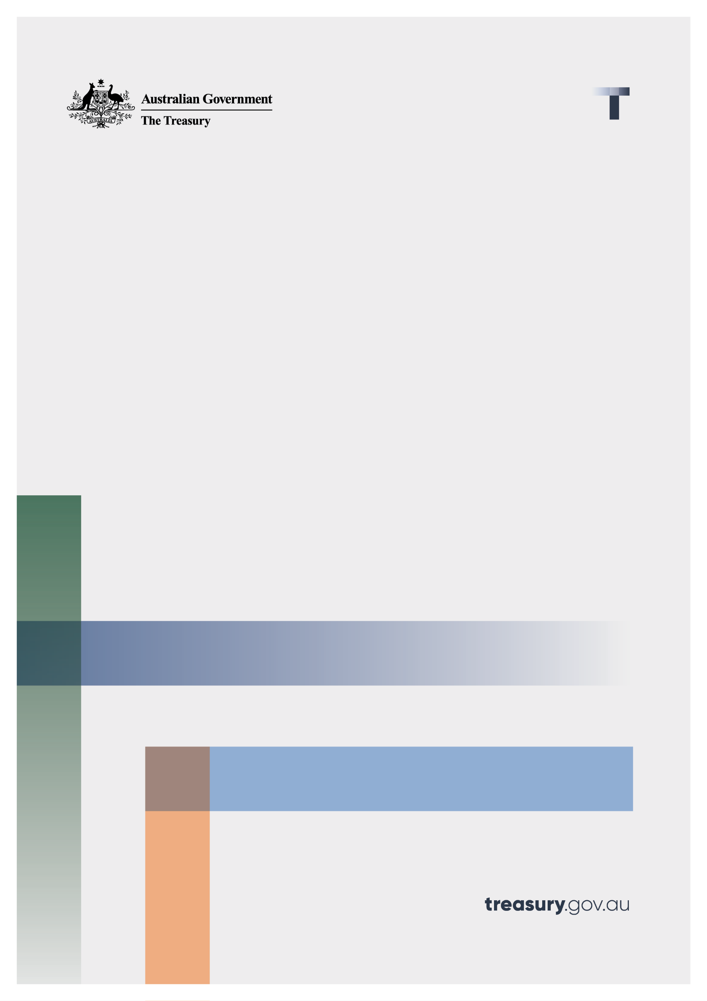

Hydrogen Production Tax Incentive

Consultation paper

June 2024

© Commonwealth of Australia 2024

This publication is available for your use under a [Creative Commons Attribution 3.0 Australia](http://creativecommons.org/licenses/by/3.0/au/deed.en) licence, with the exception of the Commonwealth Coat of Arms, the Treasury logo, photographs, images, signatures and where otherwise stated. The full licence terms are available from <http://creativecommons.org/licenses/by/3.0/au/legalcode>.

Creative Commons attribution licence 3.0 icon. 

Use of Treasury material under a [Creative Commons Attribution 3.0 Australia](http://creativecommons.org/licenses/by/3.0/au/deed.en) licence requires you to attribute the work (but not in any way that suggests that the Treasury endorses you or your use of the work).

**Treasury material used ‘as supplied’.**

Provided you have not modified or transformed Treasury material in any way including, for example, by changing the Treasury text; calculating percentage changes; graphing or charting data; or deriving new statistics from published Treasury statistics — then Treasury prefers the following attribution:

*Source: The Australian Government the Treasury*

**Derivative** **material**

If you have modified or transformed Treasury material, or derived new material from those of the Treasury in any way, then Treasury prefers the following attribution:

*Based on The Australian Government the Treasury data*

**Use of the Coat of Arms**

The terms under which the Coat of Arms can be used are set out on the Department of the Prime Minister and Cabinet website (see <https://www.pmc.gov.au/honours-and-symbols/commonwealth-coat-arms>).

**Other uses**

Enquiries regarding this licence and any other use of this document are welcome at:

Manager  
Media and Speeches Unit  
The Treasury  
Langton Crescent   
Parkes ACT 2600  
Email: [media@treasury.gov.au](mailto:media@treasury.gov.au)

*In the spirit of reconciliation, the Treasury acknowledges the Traditional Custodians of country throughout Australia and their connections to land, sea and community. We pay our respect to their Elders past and present and extend that respect to all Aboriginal and Torres Strait Islander peoples.*

# Contents

Contents ii

Consultation Process 1

How to respond 1

Hydrogen Production Tax Incentive 2

Introduction 2

The Hydrogen Production Tax Incentive 2

Proposed details 3

Issues for discussion 4

Who is eligible? 4

Incentive amount 5

What is eligible production? 5

Administrative arrangements 6

Community Benefit Principles 7

Interaction with other government incentives 8

# Consultation Process

Treasury is seeking stakeholder feedback on the Government’s Hydrogen Production Tax Incentive (HPTI), which was announced in the 2024-25 Budget as part of the Future Made in Australia package.

We encourage you to respond with feedback on the proposed design and administration details and questions outlined in this paper. More information can be found on the Treasury website at <https://treasury.gov.au/consultation/c2024-541265>.

Your feedback will inform advice to government on the final design and administration arrangements, and the drafting of legislation to implement the HPTI ahead of its 1 July 2027 commencement. Your feedback will also inform the sequencing of drafting, which could proceed in tranches, with some parts of the HPTI implemented through subordinate legislation.

Aspects of the HPTI will rely on the [[Guarantee of Origin](https://cer.gov.au/schemes/guarantee-origin)](https://www.dcceew.gov.au/energy/renewable/guarantee-of-origin-scheme)[1] scheme being developed by the Department of Climate Change, Energy, the Environment and Water (DCCEEW) and the Clean Energy Regulator (CER).

## How to respond

Treasury welcomes feedback from stakeholders on the discussion questions highlighted throughout this consultation paper. Stakeholders may also wish to comment on other design and administration considerations not raised in this paper. Responses can be provided in writing to the details below.

We understand that some submissions may contain commercially sensitive or proprietary information. Respondents who wish for their comments to be treated as confidential should note this in their submissions. Treasury may publish all or part of any non-confidential submissions it receives. Information from responses may be shared with other parts of Government, including the Department of Climate Change, Energy, Environment and Water, the Clean Energy Regulator, the Australian Renewable Energy Agency, the Clean Energy Finance Corporation and the Australian Taxation Office even if marked as confidential, in order to inform final design and administration of the Hydrogen Production Tax Incentive.

|  |  |
| --- | --- |
| Email | [HydrogenProductionTaxIncentive@treasury.gov.au](mailto:HydrogenProductionTaxIncentive@treasury.gov.au) |
| Mail | Director  Production Tax Incentives Unit  Corporate and International Tax Division  The Treasury  Langton Crescent  PARKES ACT 2600 |
| Enquiries | Enquiries can be initially directed to Adrian Gebers |
| Phone | 02 6263 4844 |

# Hydrogen Production Tax Incentive

## Introduction

The Australian Government has announced that it will invest in a Future Made in Australia plan*.* The Future Made in Australia agenda is about attracting and enabling investment, making Australia a renewable energy superpower, value‑adding to our resources and strengthening economic security, backing Australian ideas and investing in the people, communities and services that will drive our national success.

The Future Made in Australia package includes support for investment in renewable hydrogen through the Hydrogen Production Tax Incentive announced in the 2024-25 Budget, estimated at a cost to the budget of $6.7 billion over ten years from 2024–25.

Renewable hydrogen is aligned with the principles outlined under the ‘Net Zero Transformation Stream’ of the National Interest Framework.[2] This is because an Australian renewable hydrogen industry is expected to have a sustained comparative advantage in a net zero global economy. Most notably, renewable hydrogen:

* is highly energy intensive and can take advantage of our abundant renewable resources;
* can make a major contribution to decarbonisation in other areas of the economy; and
* aligns with our international trading partners current and future needs.

Renewable hydrogen can be used for high-temperature industrial processes and is a key feedstock for producing chemicals such as ammonia and methanol. When used as a fuel, the only by-product is water and there are no carbon emissions at that point.

Renewable hydrogen opens the door to green metals, such as iron, steel, alumina and aluminium, and other applications critical to industrial decarbonisation. Our world class renewable energy resources make Australia well placed to produce green hydrogen at internationally competitive prices. Additionally, Australia is close to key markets, and our major trading partners have expressed a significant appetite for importing renewable hydrogen.

### The Hydrogen Production Tax Incentive

The Hydrogen Production Tax Incentive (HPTI) announced in the 2024-25 Budget is a time-limited measure to accelerate the growth of Australia’s hydrogen industry. The HPTI is intended to bring forward project development, make renewable hydrogen available sooner, and build scale to reduce production costs over time.

The HPTI will be delivered through Australia’s tax system as a refundable tax offset to eligible producers of renewable hydrogen for a maximum of 10 years between 2027-28 and 2039-40. Depending on the circumstances of the claiming company this means the offset may result in a cash refund or a reduced income tax liability. Entities may be able to adjust their Pay As You Go (PAYG) instalment rate based on the expected credit under the existing framework where they are in a tax payable position.

The HPTI will be uncapped and demand driven. The total value of support will depend on the industry’s success in responding to this initiative and broader economic factors that help bring projects online.

The HPTI will only be available to producers who meet eligibility criteria. This will include verification of hydrogen production volumes and the emissions intensity of the hydrogen produced through the Guarantee of Origin Scheme, administered by the Clean Energy Regulator. Broader eligibility requirements which align with the Future Made in Australia Community Benefit Principles will also be established as part of accessing the taxpayer support through the HPTI.

### Proposed details

|  |  |
| --- | --- |
| The incentive | * $2 per kilogram of eligible hydrogen produced, provided as a refundable tax offset. * Available in respect of hydrogen produced from eligible facilities for up to 10 years between 1 July 2027 and 30 June 2040. * The amount of the offset will not be adjusted for inflation. * All eligibility criteria (summarised below) must be met in order to qualify * No additional incentive will be provided for meeting community benefit criteria or emissions intensity thresholds, the support is provided as a flat $2 per kilogram of hydrogen produced where eligibility criteria are met. |
| Eligible entities | * Corporations that are subject to Australian income tax throughout the relevant income year (except entities that are fully exempt from paying corporate income taxes). * Foreign investment will continue be subject to Australia’s foreign investment settings |
| Eligible facilities | * Facilities must be located in Australia and meet the minimum capacity and emissions intensity thresholds below. * Final investment decision (FID) required with respect to each eligible facility on or before 30 June 2030 (or production commenced by 30 June 2030). * Renewable hydrogen production can be from an existing or new facility where the facility meets the eligibility requirements on or before 30 June 2030. * Each facility must be located on a single site. * Projects will need to have their facility registered with the Clean Energy Regulator using a GO production profile. |
| Emissions intensity threshold | * Each kilogram of renewable hydrogen must be produced with an emissions intensity less than or equal to 0.6 kg of carbon dioxide equivalent from well to the production gate. * Verification of production volumes and emissions intensity will occur through the Guarantee of Origin Scheme (see section below on administration and verification). |
| Minimum capacity | * The production facility must include a minimum capacity equivalent to a 10 megawatt (MW) electrolyser (measured as the nameplate capacity of the electrolysis deployment, or equivalent for alternative production methods). |
| Maximum project size/output | * There is no proposed restriction on the maximum size of an eligible renewable hydrogen production facility. |
| Maximum incentive claimed | * There is no proposed restriction on the maximum amount of incentive a taxpayer can claim each year or over the life of the HPTI, up to a limit of 10 years per facility. * Taxpayers producing hydrogen at multiple eligible facilities can claim the credit for each individual facility that meets all relevant eligibility criteria. |
| Eligible end uses/offtake | * All renewable hydrogen produced is proposed to be eligible, regardless of the end use. * Hydrogen produced for either domestic use or export is proposed to be eligible. * The incentive will be paid for hydrogen produced, including where hydrogen is used as an intermediate input into other products such as ammonia or methanol. Downstream producers of derivative products (that do not produce hydrogen) will be indirectly supported with greater access to lower cost hydrogen. |
| Community benefit criteria | * Additional community benefit criteria will be applied that ensure the HPTI befits investment in local communities (including First Nations communities), supply chains and skills, promotion of diverse workforces and secure jobs and transparency and compliance with tax obligations including benefits received under this incentive. |

## Issues for discussion

The Hydrogen Production Tax Incentive (HPTI) will provide an incentive amount of $2 per kilogram of hydrogen that is produced at an emission intensity of less than 0.6 kilograms of carbon dioxide equivalent up to the production gate. This is in respect of each renewable hydrogen facility for up to 10 years from first production between 2027–28 and 2039–40. Eligible entities will need to have taken a final investment decision (FID) by 2030 in respect of each eligible facility.

### Who is eligible?

The HPTI will be available to corporations that are subject to Australian income tax throughout the relevant income year (except entities that are fully exempt from paying corporate income tax). This is necessary as the credit is being delivered through the tax system.

|  |
| --- |
| Questions   1. Please provide any feedback on the impact this incentive may have on your community, facility or industry. 2. Please provide any feedback on the proposed eligibility criteria. 3. What key factors would need to be accounted for in a definition of an eligible facility for the purposes of the HPTI? 4. What key factors would need to be accounted for in a definition of Final Investment Decision (FID) for the purposes of the HPTI? 5. How long do you expect it will take for projects to reach first production following FID? 6. For foreign investors, do you currently encounter any impediments to investment in projects that would be eligible? |

### Incentive amount

The $2 per kilogram of renewable hydrogen will be provided to eligible corporations as a credit against their corporate income tax liability. Depending on the circumstances of the claiming company this means the offset may result in a cash refund, a reduced income tax liability or applied to pre-existing tax liabilities.

Providing the support through the tax system will mean that all corporations can be eligible if they meet the base criteria, allowing them to have confidence to factor in the incentive into their financial models which will support investment decisions.

Refundability would provide cash flow to businesses that are not yet profitable from manufacturing hydrogen, allowing them to continue their operations while the market for hydrogen grows and their operations are further established.

### What is eligible production?

The HPTI is designed to bring forward production of renewable hydrogen and is limited to projects reaching final investment decision before 2030. The HPTI will be claimable for each kilogram of renewable hydrogen produced between the 2027-28 and 2039-40 financial years through a process that results in an emissions intensity of less than 0.6kg of carbon dioxide equivalent up to the production gate. Producers will be able to access the incentive for a maximum of 10 years from first eligible production for each facility.

The Government is contemplating including requirements for grid connected electrolyser projects to match their hydrogen production with electricity generated in the same electricity grid in order to access the HPTI. For example, a project connected to the National Electricity Market (NEM) would be required to match their production with electricity generators connected to the NEM. This would mean that renewable hydrogen production does not inadvertently have a negative impact on our transition to net zero, by ensuring that the hydrogen is produced where the renewable energy is available.

It is not proposed to include further requirements on renewable energy generation for access to the incentive, such as additionality or hourly time-matching. Observed international experience has highlighted that compliance with these requirements increases operating costs for projects and can be difficult to achieve for early-stage projects. Such requirements will provide limited system benefits at the scale of foreseeable investment, and it is appropriate at the current stage of industry development to prioritise overcoming other barriers. We note, however, that Guarantee of Origin (GO) certificates will require renewable energy generation in the same year as the hydrogen production occurs. The HPTI will not prescribe which renewable hydrogen production pathways will be eligible. The threshold of 0.6kg of carbon dioxide equivalent up to the production gate is intended to provide support for only the cleanest hydrogen in line with the Government’s decarbonisation goals. As such, it is expected that the majority of production will come through electrolysis.

A further eligibility requirement is that each production facility must also have a minimum capacity equivalent to a 10-megawatt electrolyser.

Compliance with the production facility minimum capacity requirements and emissions intensity of products will be verified through the Guarantee of Origin scheme, administered by the CER. Participants will need to provide information about the capacity of facilities by registering production profiles under the GO scheme. They will also need to report the emissions intensity and quantity of hydrogen products as part of creating GO Certificates.

|  |
| --- |
| Questions   1. Please provide any feedback on the proposed emissions intensity threshold of 0.6kg of carbon dioxide equivalent up to the production gate. 2. Other than electrolysis, what production processes would meet this emissions intensity threshold now or before 2030? 3. Please provide feedback on the proposed minimum capacity requirement (equivalent to 10 MW electrolyser)? 4. For renewable production processes other than electrolysis, is using the minimum capacity requirement of “equivalent to a 10MW electrolyser” appropriate? Is another definition of capacity required to deal with other production pathways? 5. Should grid connected electrolyser projects be required to match their hydrogen production with electricity generated by the same electricity grid? Please provide feedback on this proposal. 6. Please provide feedback on the proposal to not include additional requirements on renewable energy generation for access to the incentive, such as additionality and hourly time-matching with hydrogen production. |

### Administrative arrangements

It is proposed that the HPTI be co-administered by the ATO and DCCEEW, leveraging relevant accreditation regimes such as the Guarantee of Origin Scheme operated by the Clean Energy Regulator.

The administrative arrangements applying to the HPTI will be designed so as to achieve streamlined administration and provide the community with confidence that funds are supporting projects that meet the HPTI eligibility requirements.

Verification of hydrogen production volumes, associated emissions intensity, production pathway and energy source will occur through the proposed Guarantee of Origin (GO) scheme. Producers will be required to register their facility with the Clean Energy Regulator using a production profile. This profile will capture information relating to the facility including general information (including the site capacity) and information to calculate the emissions intensity of hydrogen from the facility.

Once a facility is registered under the GO scheme, producers will need to create GO Certificates for each kilogram of hydrogen produced in order to receive the credit. Producers will be able to claim credits based on the information in the certificate and the ATO will be able to validate claims against the registry of certificates.

Producers will need to retain records under the existing taxation record keeping requirements. The GO scheme will also include a public registry that stores information about registered facilities and every GO certificate. Further information can be found in the Guarantee of Origin scheme design consultation document.[3]

Appropriate assurance arrangements will also be established to support adherence with broader eligibility requirements, including those that support the delivery of the Future Made in Australia Community Benefit Principles.

|  |
| --- |
| Questions   1. Please provide any feedback on the proposed administrative approach. 2. The proposed GO scheme will be used to support the registration and verification of hydrogen production. Are there any additional factors that would need to be accounted for in the proposed design of that scheme? 3. The Government may legislate the administrative arrangements in subordinate legislation. Please provide any feedback on this proposed approach. |

### Community Benefit Principles

The Future Made in Australia package will harness Australia’s potential and ensure the benefits of growth in priority industries are widely shared. To guide this, the Future Made in Australia legislation will include Community Benefit Principles which will focus on investment in local communities (including First Nations communities), domestic industry and supply chains, and skills, and the promotion of diverse workforces, secure jobs and tax transparency. The HPTI will include eligibility criteria that align with the Community Benefit Principles.

For example, transparency and disclosure reporting requirements will be established as part of accessing the taxpayer support. These could take the form of annual ATO reporting on the recipients of the HPTI and amount of credit each has received. and requirements for recipients to demonstrate compliance with their tax obligations, including being up to date with relevant registration requirements, satisfactory lodgement of tax returns and payment of tax liabilities not under dispute. These could be modelled on the existing statement of tax record requirements for large entities tendering for Government contracts, or alternative models could be identified.

|  |
| --- |
| Questions   1. What obligations should be imposed on potential recipients of the HPTI to ensure the community benefit principles are met? 2. What obligations are potential recipients of the HPTI currently subject to that might support the community benefit objectives (noting these will be finalised under the *Future Made in Australia Act*)? 3. Are there any additional objectives that you consider important? What obligations might support these? 4. Recipients of the HPTI may be subject to additional transparency and disclosure requirements in order to be eligible. What kind of requirements are appropriate? What are the key practical considerations to take into account when setting the requirements? 5. How should entities proposing to claim the HPTI be required to demonstrate compliance with tax obligations? 6. What information do you consider important for the community that should be reported publicly on the recipients of the HPTI such as the amount of credit received? 7. Who should the reporting requirements be imposed on? For example, on the recipient entity, or central reporting through a regulator? |

### Interaction with other government incentives

Recipients can claim other forms of support and participate in other programs alongside the HPTI. The Government is not seeking to limit the support of the HPTI where other Commonwealth, State or foreign government support is provided.

The HPTI was announced alongside an extension to the Hydrogen Headstart program. Renewable hydrogen projects may be eligible for both the HPTI and support through Hydrogen Headstart if successful through the latter program’s competitive application process. Hydrogen Headstart is designed to target a project’s specific commercial gap. Payments under the Hydrogen Headstart program will proportionally reduce if a project is receiving the HPTI. This means the total amount received from Hydrogen Headstart and the HPTI will remain consistent with the initial agreement under Hydrogen Headstart.

|  |
| --- |
| Questions   1. Please provide feedback on the proposed treatment of the interactions between the HPTI and other forms of Commonwealth, State or foreign government support. 2. How can the HPTI best leverage other types of support? Please provide examples relevant to your project if possible. 3. What are the key practical considerations with receiving support through the HPTI and the Hydrogen Headstart program simultaneously? 4. Are there specific interactions with other support programs that should be considered? |

1. DCCEEW, 2 May 2024, Guarantee of Origin Scheme [[https://www.dcceew.gov.au/energy/renewable/guarantee-of-origin-scheme](https://www.dcceew.gov.au/energy/renewable/guarantee-of-origin-scheme%5d)]
2. The National Interest Framework is outlined in [*Future Made in Australia: National Interest Framework Supporting paper.*](https://treasury.gov.au/sites/default/files/2024-05/p2024-526942-fmia-nif.pdf)The framework will guide how the Government will identify priority industries and how policy support will be designed to support the Government’s Future Made in Australia objectives.
3. *Australia’s Guarantee of Origin scheme design paper* 2023 [<https://storage.googleapis.com/files-au-climate/climate-au/p/prj291cc9979281a4ffc59d8/public_assets/Guarantee%20of%20Origin%20Scheme%20design%20paper.pdf>](https://storage.googleapis.com/files-au-climate/climate-au/p/prj291cc9979281a4ffc59d8/public_assets/Guarantee%20of%20Origin%20Scheme%20design%20paper.pdf)