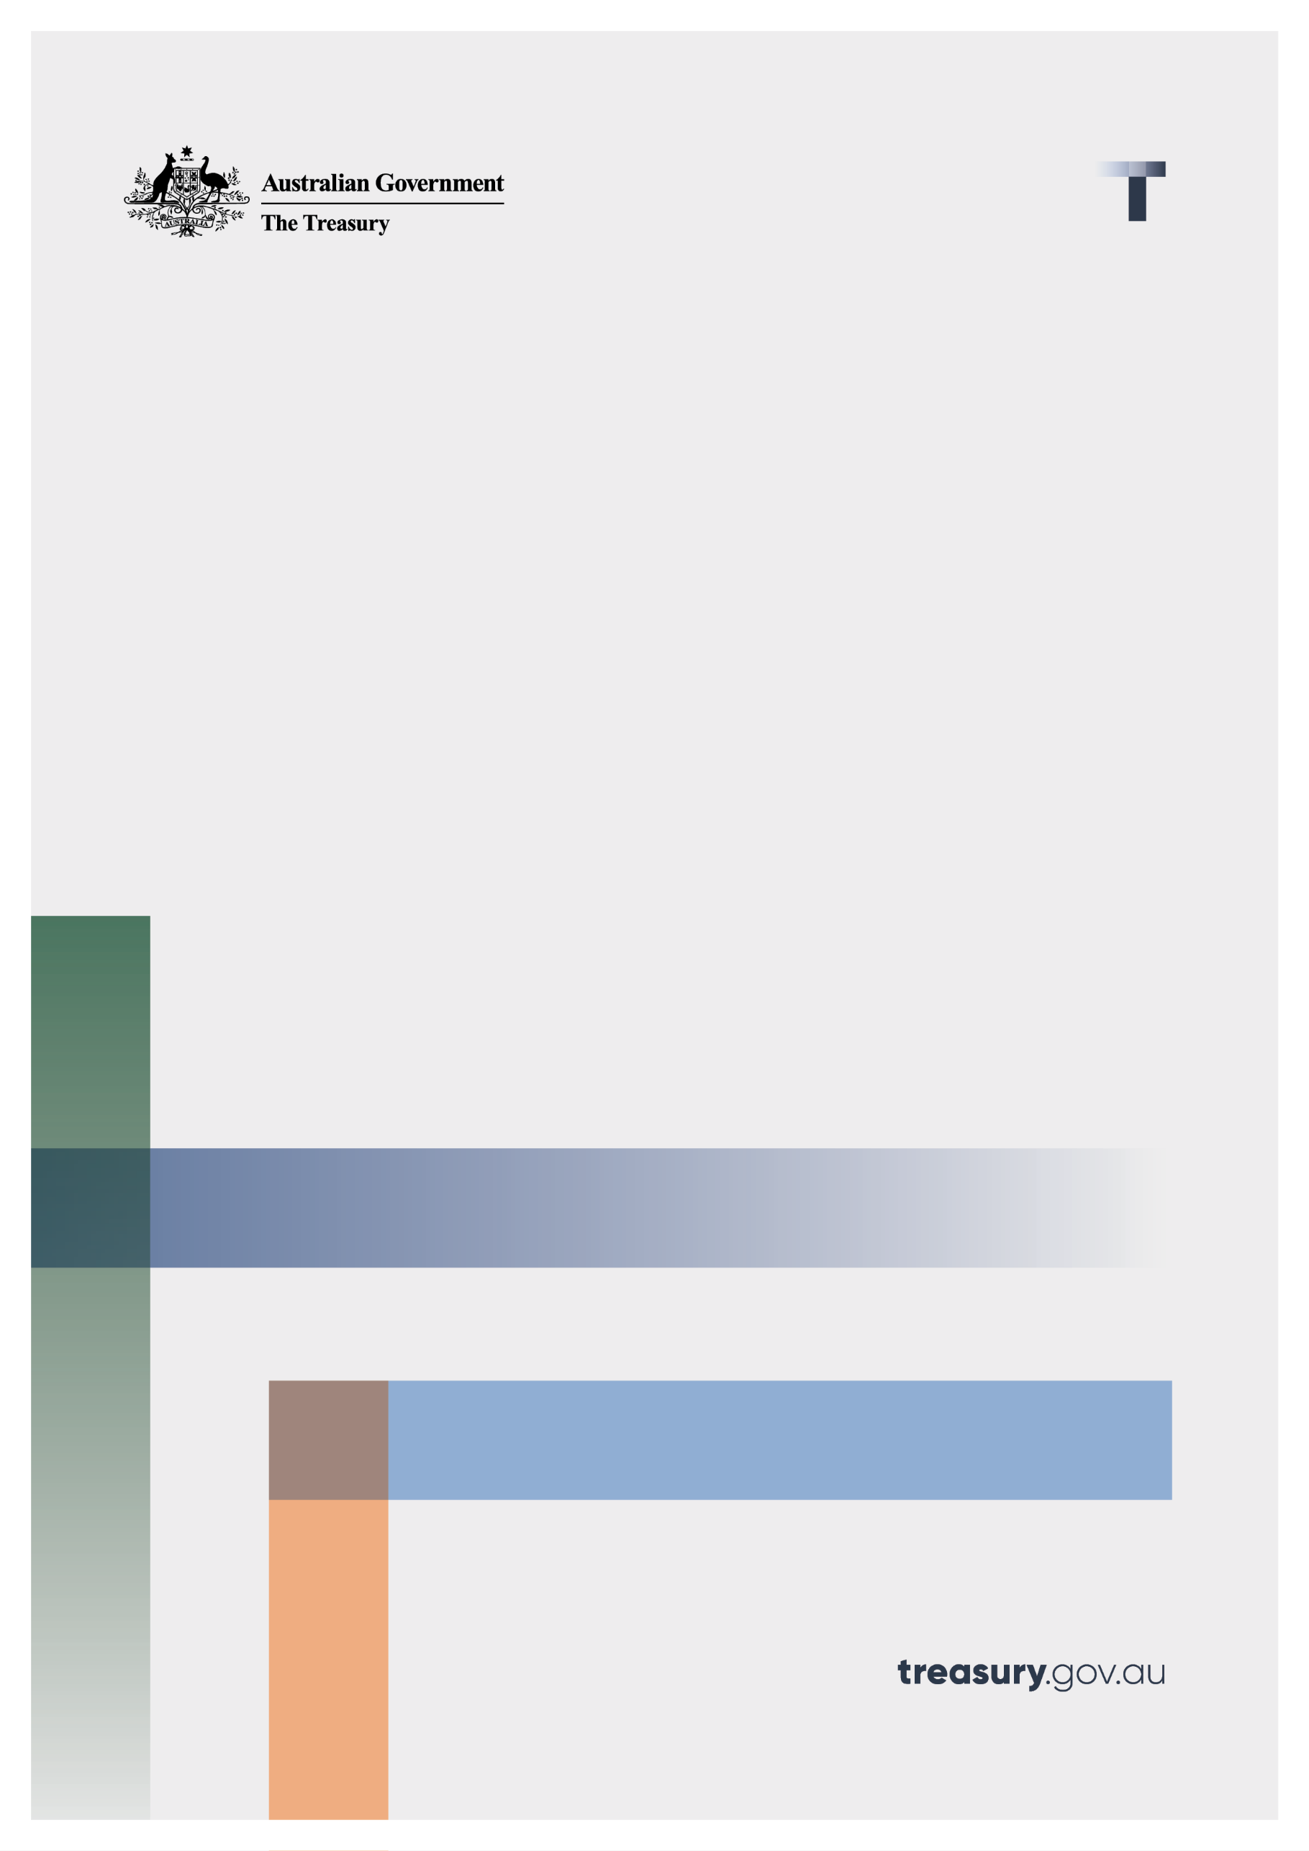

Global and domestic minimum taxes:

Interactions with other Australian tax laws

Consultation paper

March 2024

© Commonwealth of Australia 2024

This publication is available for your use under a [Creative Commons Attribution 3.0 Australia](http://creativecommons.org/licenses/by/3.0/au/deed.en) licence, with the exception of the Commonwealth Coat of Arms, the Treasury logo, photographs, images, signatures and where otherwise stated . The full licence terms are available from <http://creativecommons.org/licenses/by/3.0/au/legalcode>.

Creative Commons attribution licence 3.0 icon. 

Use of Treasury material under a [Creative Commons Attribution 3.0 Australia](http://creativecommons.org/licenses/by/3.0/au/deed.en) licence requires you to attribute the work (but not in any way that suggests that the Treasury endorses you or your use of the work).

**Treasury material used ‘as supplied’.**

Provided you have not modified or transformed Treasury material in any way including, for example, by changing the Treasury text; calculating percentage changes; graphing or charting data; or deriving new statistics from published Treasury statistics — then Treasury prefers the following attribution:

*Source: The Australian Government the Treasury*.

**Derivative** **material**

If you have modified or transformed Treasury material, or derived new material from those of the Treasury in any way, then Treasury prefers the following attribution:

*Based on The Australian Government the Treasury data*.

**Use of the Coat of Arms**

The terms under which the Coat of Arms can be used are set out on the Department of the Prime Minister and Cabinet website (see <https://www.pmc.gov.au/honours-and-symbols/commonwealth-coat-arms>).

**Other uses**

Enquiries regarding this licence and any other use of this document are welcome at:

Manager  
Media and Speeches Unit  
The Treasury  
Langton Crescent   
Parkes ACT 2600  
Email: [media@treasury.gov.au](mailto:media@treasury.gov.au)

*In the spirit of reconciliation, the Treasury acknowledges the Traditional Custodians of country throughout Australia and their connections to land, sea and community. We pay our respect to their Elders past and present and extend that respect to all Aboriginal and Torres Strait Islander peoples.*

Contents

Consultation Process 3

Request for feedback and comments 3

Closing date for submissions: 16 April 2024 3

Introduction/Background 4

Purpose 4

Issues for discussion 4

General policy approach 4

Hybrid mismatch rules 4

Foreign hybrid entity rules 5

Foreign income tax offsets 5

Controlled foreign company rules 6

Amendments being considered 6

Division 832 Income Tax Assessment Act 1997 - Hybrid mismatch rules 6

Division 830 Income Tax Assessment Act 1997 – Foreign hybrids 7

Division 770 Income Tax Assessment Act 1997 - Foreign income tax offsets 8

Foreign income tax paid by CFCs 9

Other issues 9

Questions 9

# Consultation Process

## Request for feedback and comments

Treasury invites you to comment on proposals on how the global and domestic minimum taxes will interact with Australia’s hybrid mismatch rules, foreign hybrid rules, controlled foreign company regime and foreign income tax offsets. Your submissions will assist Treasury in finalising consequential amendments to relevant Australian income tax provisions.

Closing date for submissions: 16 April 2024

|  |  |
| --- | --- |
| Email | [contact.internationaltax@treasury.gov.au](mailto:contact.internationaltax@treasury.gov.au) |
| Mail | Assistant Secretary  International Tax Branch  Corporate and International Taxation Division  The Treasury  Langton Crescent  PARKES ACT 2600 |
| Enquiries | Enquiries can be initially directed to [contact.internationaltax@treasury.gov.au](mailto:contact.internationaltax@treasury.gov.au) |
|  |  |

The principles outlined in this paper have not received Government approval and are not yet law. Consequently, this paper is merely a guide as to how the principles might operate.

## Introduction/Background

In the Exposure Draft Explanatory Materials which accompany the released draft legislation, the Government notified stakeholders that consequential amendments will be required to ensure that legislation implementing the global and domestic minimum taxes will have appropriate interactions with certain tax integrity and other rules in the existing income tax laws.[1]

## Purpose

The purpose of this consultation paper is to seek stakeholder feedback on interactions with Australia’s hybrid mismatch rules, foreign hybrid entity rules, foreign income tax offsets, and controlled foreign company rules. The interactions may require consequential amendments to the current income tax laws. We also seek feedback on any other significant interactions that should be considered.

## Issues for discussion

### General policy approach

Our general policy approach to the interactions is outlined below.

1. **Australian income tax laws will continue to apply to relevant taxpayers prior to any application of the global and domestic minimum taxes. We would expect that a taxpayer will calculate their regular income tax liability and subsequently calculate any global or domestic minimum tax liability**.
2. **However, a foreign jurisdiction’s domestic minimum tax, in some circumstances, will take precedence over Australia’s income tax laws.**
3. **The treatment of any interactions should be consistent with the OECD Model Rules to ensure Australia’s global and domestic minimum tax rules achieve qualified status under the OECD Peer Review processes.**

### Hybrid mismatch rules

Hybrid mismatch arrangements are cross border transactions involving instruments and entities that are treated differently under different jurisdictions’ tax systems. Such arrangements may result in double non-taxation, which Australia’s hybrid mismatch rules are intended to address.

For example, where for tax purposes a financial instrument is treated as debt in Australia and equity in a foreign jurisdiction, the payment of interest on the debt may be deductible in Australia and not be included in the foreign recipient’s income. Under our hybrid mismatch rules, the Australian payment will not be deductible to the extent that the paid amount is not included in the non-resident recipient’s income.

By way of further example, where an entity is treated as fiscally opaque in Australia and fiscally transparent in a foreign jurisdiction for tax purposes, Australia’s hybrid mismatch rules will address any deduction/non-inclusion or deduction/deduction outcome arising from the mismatching characterisations.

Treasury considers it is appropriate for Australia’s hybrid mismatch rules to continue operating even if a foreign jurisdiction imposes global or domestic minimum taxes.

This is because hybrid mismatch rules target different jurisdictions’ tax treatment of arrangements and entities, whereas global and domestic minimum taxes are imposed on financial accounting profits to address the shortfall of corporate taxes paid on profits in a jurisdiction.

### Foreign hybrid entity rules

Under the foreign hybrid entity rules in Division 830 of the *Income Tax Assessment Act 1997* (ITAA 1997), an entity that qualifies as a ‘foreign hybrid’ is treated as a partnership, rather than a company, for Australian tax purposes. As a result, an attributable taxpayer in relation to a foreign hybrid limited partnership is taxed on their share of the foreign hybrid’s net income under Division 5 of the *Income Tax Assessment Act 1936* (ITAA 1936), dealing with partnerships, instead of on their share of the foreign hybrid’s attributable income calculated under the Controlled Foreign Company (CFC) rules.

Australia’s foreign hybrid entity rules should continue operating without regard to the imposition of foreign global and domestic minimum taxes.

Our reason is that the foreign hybrid entity rules ensure that tax is appropriately imposed on the relevant partners of entities that are treated as ‘flow through’ in a foreign jurisdiction. We consider this outcome should not change merely because foreign tax is imposed on that entity solely because of the global minimum tax or an OECD approved foreign Qualified Domestic Minimum Tax (QDMT).

### Foreign income tax offsets

Foreign income tax offsets (FITOs) are available for certain foreign taxes that taxpayers have paid on income, profits or gains that are included in their Australian assessable income. A FITO is designed to avoid double taxation. A taxpayer may be entitled to a FITO for foreign income tax that a CFC has paid on attributed foreign income. In certain other circumstances, a taxpayer may also be entitled to a FITO for foreign income tax paid by another entity.

The amount of any offset will be subject to the satisfaction of the conditions in Division 770 of the ITAA 1997, which require among other things that taxes paid on income, profits or gains are included in the taxpayer’s Australian assessable income and that there is a cap on the amount of tax offset for a given year.

An issue is whether FITOs should be available to Australian taxpayers in respect of global and domestic minimum taxes imposed by foreign jurisdictions.

Treasury considers it is appropriate that taxes imposed under a foreign QDMT could give rise to a FITO, while taxes imposed under a foreign Income Inclusion Rule or Undertaxed Profits Rule will not. This is to avoid circularity and is consistent with the OECD’s *Commentary to the Global Anti-Base Erosion Model Rules* which states that:

* ‘It is intended that the GloBE Rules apply after the application of the Subject to Tax Rule and domestic tax regimes, including regimes for the taxation of PEs or CFCs. Therefore, to preserve the intended rule order, domestic tax regimes should not provide a foreign tax credit for any tax imposed under a Qualified UTPR or IIR which is implemented in a foreign jurisdiction, otherwise the application of that domestic tax regime would create circularity issues since those Taxes have already been determined prior to applying the Qualified UTPR or IIR.’[2]

Further, Treasury acknowledges there could be future jurisdictional responses to global and domestic minimum tax rules designed to compensate multinational enterprise groups (MNE Groups) for the imposition of top-up tax. We are therefore of the view that, to safeguard the Australian tax base, it would be inappropriate to provide additional FITOs to the extent there is no overall increase in economic tax burden borne in the foreign jurisdiction.

### Controlled foreign company rules

Under Australia's CFC rules, domestic taxpayers that have an attributable interest in a CFC may be liable to pay tax in respect of certain types of income of that company.

Under the global minimum tax (subject to some limitations) CFC taxes are pushed down to calculate the jurisdictional effective tax rate for the jurisdiction in which the subsidiary is located. That is, any tax paid in Australia regarding a CFC’s income would be taken into account in calculating the effective tax rate of the jurisdiction of the subsidiary for the purposes of the global minimum tax but not for the purposes of a QDMT.

Treasury’s view is that Australia’s CFC rules should not provide a notional allowable deduction for any taxes paid under an Income Inclusion Rule or Undertaxed Profits Rule. CFC taxes are factored into the calculation of the jurisdictional effective tax rate under the Income Inclusion Rule and Undertaxed Profits Rule, and providing a notional allowable deduction for such taxes under Australia’s CFC provisions would lead to circularity.

In contrast, Treasury considers that a notional allowable deduction could be provided for top-up tax paid under a foreign jurisdiction’s QDMT. This would ensure consistent treatment with that of FITOs discussed above.

## Amendments being considered

### Division 832 Income Tax Assessment Act 1997 - Hybrid mismatch rules

*Disregarding Australia’s global and domestic minimum taxes in identifying whether a payment is subject to Australian income tax*

The existence of Australia’s global and domestic minimum tax rules will not have an impact on Australia’s hybrid mismatch rules for the purposes of identifying whether a payment is subject to Australian income tax and relatedly, whether it gives rise to a hybrid mismatch.

Treasury is not anticipating that any amendments are required to the existing definition of ‘*subject to Australian income tax’* in section 832-125 ITAA 1997. The operation of Australia’s global and domestic minimum taxes will not affect whether an amount is included in an entity’s assessable income (as defined in the ITAA 1997), as they will be taxes imposed and assessed under separate Acts altogether. As such, an amount of income or profits is not considered subject to Australian income tax solely due to the operation of Australia’s global and domestic minimum taxes.

The definition of a deduction (see section 995-1 ITAA 1997) should not be impacted by Australia’s global and domestic minimum taxes. Accordingly, an amount of loss or outgoing, which is taken into account in calculating an Australian Constituent Entity’s GloBE Income (or Loss) but does not actually result in an income tax deduction, is not considered a deduction for the purposes of identifying a hybrid mismatch.

*Disregarding foreign global and domestic minimum taxes in identifying whether a payment is subject to foreign income tax*

A foreign jurisdiction’s global and domestic minimum taxes will not have an impact on Australia’s hybrid mismatch rules for the purposes of identifying whether a payment is subject to foreign income tax and relatedly, whether it gives rise to a hybrid mismatch.

Treasury anticipates amendments will be required (possibly to section 832-130 ITAA 1997) to ensure that the following taxes are disregarded for the purposes of Division 832:

1. tax imposed by a domestic minimum tax (whether or not deemed qualified by the G20/OECD Inclusive Framework on BEPS. This would ensure consistent treatment of domestic minimum taxes under the hybrid mismatch rules);
2. tax imposed by an Income Inclusion Rule; and
3. tax imposed by an Undertaxed Profits Rule.

Item (2) will also cover taxes imposed by a foreign jurisdiction that implements an Income Inclusion Rule that applies to domestic Constituent Entities instead of implementing a domestic minimum tax.

We are considering whether this could be achieved by adding these taxes to the list of foreign taxes in subsection 832-130(7) ITAA 1997 and clarifying that these taxes are not considered provisions that correspond to section 456 or 457 ITAA 1936 for the purposes of subsection 832-130(5) ITAA 1997.

We expect that adding these taxes to the list in subsection 832-130(7) would also ensure that:

1. an amount of a loss or outgoing is not considered to be a foreign income tax deduction under section 832-120 for the purposes of Division 832 merely because an item of expense is included in the calculation of a Constituent Entity’s GloBE Income (or Loss).
2. a foreign jurisdiction’s domestic minimum tax will not affect whether an entity is taken to be a liable entity under section 832-325 identified for a foreign jurisdiction in respect of an entity’s income or profits for the purposes of Division 832.

*Disregarding foreign global and domestic minimum taxes in identifying whether a payment is subject to foreign income tax at a rate of 10% or less*

The anticipated amendments to subsection 832-130 above will also ensure that a foreign jurisdiction’s global and domestic minimum taxes will not be taken into account in determining the application of Australia’s targeted integrity rule in Subdivision 832-J concerning payments of interest or amounts under derivative financial arrangements.

### Division 830 Income Tax Assessment Act 1997 – Foreign hybrids

Division 830 can apply to a limited partnership that is treated, for the purposes of the tax law of the foreign jurisdiction where it is formed, as a partnership. A limited partnership is a foreign hybrid limited partnership where the conditions in section 830-10 are met, including that foreign income tax on the income or profits of the partnership is imposed under the law of the foreign jurisdiction on the partners, not the limited partnership. However, a foreign jurisdiction that currently imposes tax on the partners of the limited partnership may choose to implement its domestic minimum tax so as to impose the tax on the limited partnership (i.e., the Flow-Through Entity) itself. This could be, for example, so as to avoid the potential operation of the Switch-Off Rule applying to that jurisdiction’s QDMT legislation for the purposes of the QDMT Safe Harbour.

Treasury considers a foreign jurisdiction’s domestic minimum tax should not impact the application of Division 830.

As such, Treasury anticipates the need to amend section 830-10 to ensure the following taxes are disregarded for the purposes of section 830-10:

1. tax imposed by a domestic minimum tax;
2. tax imposed by an Income Inclusion Rule, including taxes imposed by a foreign jurisdiction that implements an Income Inclusion Rule that applies to domestic Constituent Entities instead of implementing a domestic minimum tax;
3. tax imposed by an Undertaxed Profits Rule.

For completeness, Treasury also anticipates the need to amend section 830-15, concerning foreign hybrid companies, to ensure that a domestic minimum tax, Income Inclusion Rule, and Undertaxed Profits Rule are disregarded for the purposes of section 830-15. This will ensure that Division 830 continues to operate as intended.

### Division 770 Income Tax Assessment Act 1997 - Foreign income tax offsets

Treasury considers that while a foreign income tax offset should be available for top-up taxes imposed under a foreign jurisdiction’s QDMT (including where the income is subject to tax in Australia through our Controlled Foreign Company (CFC) rules), a foreign income tax offset should not be available for top-up taxes imposed under a foreign jurisdiction’s global minimum tax. This approach is consistent with the OECD Commentary (see paragraph 45 in Chapter 4 of the Commentary) which was released on 14 February 2022 to complement the OECD Model Rules. The availability of a foreign income tax offset in respect of tax imposed under a foreign jurisdiction’s QDMT will be subject to the satisfaction of the conditions in Division 770 and potential further safeguards (discussed further below).

Treasury anticipates the need to add the following taxes to the exceptions in subsection 770-10(5):

1. tax imposed by an Income Inclusion Rule, including one that applies to domestic Constituent Entities
2. tax imposed by an Undertaxed Profits Rule.

Further, Treasury does not anticipate a need for an amendment to expressly include a foreign jurisdiction’s QDMT within the scope of Division 770, as it is expected that a natural reading of the foreign income tax offset rules could allow such a tax to count towards the tax offset for the year, subject to the existing limits in Division 770.

However, Treasury recognises there could be future jurisdictional responses to global and domestic minimum tax rules designed to compensate MNE Groups for the imposition of top-up tax. To illustrate, a jurisdiction may implement a domestic minimum tax regime, but to maintain its competitiveness, effectively redirect the additional tax revenue back to the relevant MNE Groups through government grants, credits, or other incentives.

Treasury is of the view that, to safeguard the Australian tax base, it would be inappropriate to provide additional FITOs to the extent there is no overall increase in economic tax burden borne in the foreign jurisdiction. One proposed amendment could be that the current operation of section 770-140 is expanded to cover such future responses.

Another option or a complementary option is to have a regulatory making power to make a legislative instrument stipulating, with greater precision, when a domestic minimum tax will not attract a FITO.

### Foreign income tax paid by CFCs

Treasury does not anticipate the need for an amendment to expressly allow a foreign jurisdiction’s QDMT to be treated as a notional allowable deduction for the purposes of Australia’s CFC rules in Part X of ITAA 1936. Treasury’s view is that a natural reading of section 393 should allow such a tax to be claimed as a notional allowable deduction, subject to the satisfaction of the conditions in that provision. Among them is a requirement that the foreign tax paid by the CFC is in respect of amounts included in the notional assessable income of the eligible CFC for the eligible period.

Further, we consider that a natural reading of subsections 770-130(2) and 770-135(3) allow for an amount of QDMT paid by an entity (including a CFC) in the QDMT jurisdiction to be taken into account for the purposes of sections 770-130 and 770-135 ITAA 1997, subject to the conditions in those sections. Where section 770-135 applies in respect of QDMT, the requirement in subsection 770-135(8) to gross up the shareholder’s attributed income continues to apply.

However, Treasury does anticipate the need for an amendment to ensure that global minimum taxes do not give rise to a notional allowable deduction under section 393 of the ITAA 1936.

As mentioned above, we consider that payment of foreign global minimum taxes should not give rise to a foreign income tax offset under section 770-10.

### Other issues

Treasury has identified potential interactions between a foreign domestic minimum tax, foreign Income Inclusion Rule or foreign Undertaxed Profits Rule and the definition of ‘subject to tax’ in sections 317 and 324 of the ITAA 1936. This interaction extends to the definition of ‘subject to foreign tax’ in subsection 995-1(1) of the ITAA 1997.

These provisions underpin other integrity provisions, such as the application of the CFC rules to eligible designated concession income. While still considering the potential interactions, Treasury is of the view that it would be inappropriate to limit the application of an integrity provision due to the application of a foreign domestic minimum tax, foreign Income Inclusion Rule or foreign Undertaxed Profits Rule. Or in other words, the operation of a foreign domestic minimum tax, foreign Income Inclusion Rule or foreign Undertaxed Profits Rule will not affect whether an amount is ’subject to tax’ for the purposes of such provisions.

## Questions

In responding to this consultation paper, we encourage stakeholders to address the following questions.

1. **Do you agree with the proposed policy positions? If not, please propose an alternative and the reasons why.**
2. **Do you agree with the approaches outlined? If not, please indicate your suggested approach.**
3. **Do you consider there are any other significant interactions that should be considered? If so, how should they be addressed?**

1. See paragraph 3.75 of Exposure Draft Explanatory Materials for the Taxation (Multinational – Global and Domestic Minimum Tax) Imposition Bill 2024, Taxation (Multinational – Global and Domestic Minimum Tax) Bill 2024 and Taxation (Multinational – Global and Domestic Minimum Tax) Consequential Bill 2024.
2. OECD (2022), *Tax Challenges Arising from the Digitalisation of the Economy – Commentary to the Global Anti-Base Erosion Model Rules (Pillar Two), OECD, Paris*, [https://www.oecd.org/tax/beps/tax-challenges-arising-from-the digitalisation-of-the-economy-global-anti-base-erosion-model-rules-pillar-two-commentary.pdf](https://www.oecd.org/tax/beps/tax-challenges-arising-from-the%20digitalisation-of-the-economy-global-anti-base-erosion-model-rules-pillar-two-commentary.pdf) – see paragraph 45, chapter 4.