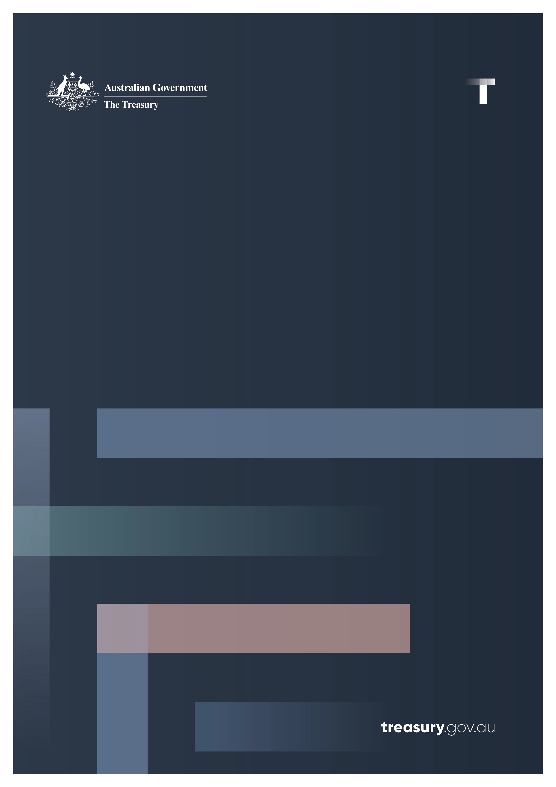

National Interest Statement
  - 2023 Loan Agreement between the Commonwealth of Australia and the Independent State of Papua New Guinea
February 2024

Contents
Summary 1
Legislative Requirements 2
National Interest Assessment 3
Nature and Terms of the Loan Agreement 4

Summary
This National Interest Statement (Statement) relates to the loan agreement between Australia and the Independent State of Papua New Guinea (PNG) for A$600 million. This Statement is being tabled pursuant to the requirements of sections 8D-8E of the International Monetary Agreements Act 1947 (IMA Act).
The loan is in response to a request by letter from PNG Prime Minister, Mr James Marape on 17 May 2023 requesting financial assistance. In his letter, Prime Minister Marape thanked Australia for vital budget support and noted the important progress the PNG government has taken to repair PNG’s budget. The letter formally requested further support of A$600 million required to enable the PNG Government to meet its 2023 budget financing needs.
The provision of further bilateral support reinforces the positive relationship between Australia and PNG and the importance both governments attach to regional prosperity and stability. The loan builds on the previous budget support loans Australia provided in 2020, 2021 and 2022 and represents Australia’s continued support under the Comprehensive Strategic and Economic Partnership with PNG.
On 8 December 2023, Australia formally entered into a loan agreement with PNG to support its estimated 2023 budget financing shortfall and support the delivery of reform actions under PNG’s International Monetary Fund Extended Credit Facility and Extended Fund Facility Program (IMF Program). The IMF Program, approved on 22 March 2023, supports PNG’s reform agenda, helps protect the vulnerable and foster inclusive growth, with a focus maintained on strengthening debt sustainability, alleviating foreign exchange shortages, and enhancing governance and operationalising the anti-corruption framework. The IMF Program provides PNG with US$918 million and demonstrates PNG’s commitment to secure other concessional financing with which to address its fiscal shortfall.
PNG has experienced significant economic challenges exacerbated by COVID-19. However, the PNG Government remains committed to budget repair and improving the country’s fiscal position. In comparison to PNG’s 2022 Budget deficit of K$5.98 billion (A$2.45 billion) or 5.9 per cent of GDP, PNG’s 2023 MYEFO identified the current budget deficit of K$4.98 billion (A$2.04 billion) or 4.4 per cent of GDP.
The loan is provided at the Australian Government’s cost of borrowing and involves no cost to the Australian taxpayer.

Legislative Requirements
The IMA Act (section 8c (1)) provides that Australia may enter into an agreement for a loan to another country where the loan provides financial assistance in support of an IMF program to another country and if the Treasurer is satisfied that at least one other government or organisation has, or will be, providing similar assistance.
Australia’s loan of A$600 million will be provided in support of the IMF-funded Extended Credit Facility and Extended Fund Facility Program. The Program supports PNG’s reform agenda, which seeks to help protect the vulnerable and foster inclusive growth. The reforms under the Program focus on strengthening debt sustainability, alleviating foreign exchange shortages, and enhancing governance and operationalizing the anti-corruption framework.
New Zealand provided funding of US$850,000 to PNG’s Treasury in support of PNG’s ongoing economic reform agenda, including under the IMF Extended Credit Facility and Extended Fund Facility Program.
This Statement is tabled pursuant to the requirements of sections 8D-8E of the IMA Act. The IMA Act requires the Treasurer to table a statement as soon as practicable after entering into such an agreement. The Statement should include a description, in as much detail as practicable, of the nature and terms of the agreement; and the reasons why the agreement is in Australia’s national interest, having regard to foreign policy, trade and economic interests.

National Interest Assessment
It is in Australia’s national interests to promote economic and political stability in PNG given its geographic proximity and the unique and enduring connections that span decades. PNG’s security and stability is a fundamental Australian strategic interest.
Helping the PNG Government meet its estimated 2023 budget financing shortfall will support the continued funding of essential government services such as healthcare and education, support PNG’s economic reform, and ongoing budget repair efforts. It will also support PNG to deliver reform under the International Monetary Fund Extended Credit Facility and Extended Fund Facility Program (IMF Program).
PNG’s economic outlook for 2023 shows stabilisation from the pandemic. In 2023, the PNG economy is projected to grow at 3.0 per cent. Uncertainty remains around commencement of several key resource projects in the first half of 2024, with much of PNG’s medium-term growth reliant on their progress. Many challenges remain from inflationary pressures, a slowing global economy, and a weak fiscal position. This loan builds upon the support Australia provided to PNG in 2020, 2021 and 2022 to help with budget repair efforts and support the delivery of reform actions.
PNG’s self-identified long-term budget repair goals are worthy of Australian support and this loan will continue to strengthen our bilateral relationship underpinned by the Comprehensive Strategic and Economic Partnership (CSEP) of 2020. The CSEP provides an enduring and overarching framework for deepening bilateral cooperation across security, trade and investment, governance, development cooperation, health, education, gender equality, climate change, people-to-people and institutional links, underpinned by a commitment to achieving concrete outcomes by 2030.
As PNG focuses on economic repair, the clear goals of the PNG Government remain providing a better standard of living and more opportunities for its citizens. These considerations are core to Australia’s decision to approve the loan.

Nature and Terms of the Loan Agreement
On 8 December 2023, Australia and PNG entered into a 20-year loan following a request from the PNG Prime Minister, Mr James Marape, to support PNG to meet its estimated 2023 budget financing shortfall. The loan will also assist PNG in delivering economic reforms under the International Monetary Fund Extended Credit Facility and Extended Fund Facility Program. This loan represents Australia’s continued commitment to helping PNG towards more sustainable macroeconomic policy settings and reducing longer-term vulnerability.
The total principal of the loan is A$600 million with the base interest rate set at the 10-year Australian Government bond rate as at the date 10 business days before a date nominated by PNG to drawn down the loan (21 December), being 4.280 per cent (as published on 6 December). This rate, along with the rates of other Australian Government Securities, are published on the Reserve Bank of Australia website (and are subject to revisions). Repayments of the loan principal and interest are 6 monthly.
The loan is provided on a full cost recovery basis to ensure that it can be provided to PNG at no cost to Australian taxpayers. Australia has an option to review the loan’s interest rate 10 years after drawdown, or at any earlier date, at which time the rate can be amended if it no longer aligns with the Australian Government’s cost of borrowing.

