Advice on amending tax cuts to deliver broader cost-of-living relief

Overview
The upcoming Stage 3 tax cuts were designed and legislated when dramatically different circumstances were expected to unfold. Since they were legislated, the global economy has been impacted by several significant, unanticipated shocks. The COVID-19 pandemic disrupted supply chains and saw the rollout of unprecedented government support. More recently, ongoing global conflicts have led to rapid increases in energy and food prices, which are rippling through domestic prices and have contributed to inflation reaching 30-year highs.
Low- and middle-income households have been under significant pressure from unanticipated cost-of-living increases associated with the lift in prices. It is challenging to provide support to these households without unduly adding to inflationary pressures and perpetuating cost-of-living challenges.
Treasury expects inflation to return to the target band over the coming 18 months and built into this profile are the Stage 3 tax cuts. One way to provide further relief to those households most affected by cost-of-living increases and not impact inflation is to redesign the Stage 3 tax cuts.
It remains important to deliver an overall tax cut around the size of the Stage 3 tax cuts to unwind bracket creep and lower average income tax rates. This case is supported by the ongoing improvement in the budget position and adverse impacts of rising average income tax rates.
A redesign of the Stage 3 tax cuts presents other opportunities, including enhancing the participation benefits of the tax cuts, especially for women, and distributing the future impact of bracket creep more evenly. This can be achieved with the same budgetary cost as the Stage 3 tax cuts.
The redesign of the Stage 3 tax cuts outlined in this document is estimated to provide cost-of-living relief to 13.6 million taxpayers. This option is broadly revenue neutral, will not add to inflationary pressures and will support labour supply.

Rising cost-of-living pressures have changed the focus of tax relief
The Stage 3 tax cuts were first legislated in 2018 under dramatically different economic circumstances. First announced in the 2018–19 Budget, the Stage 3 tax cuts are now estimated to cost $105.7 billion over the current forward estimates period from 2023–24 to 2027–28. The Australian economy was expected to be supported by a positive global outlook, with strong, broad-based global growth. Inflation, and therefore interest rates, were expected to remain low.
However, unanticipated global events meant that these projections have not come to pass. The COVID-19 pandemic suppressed economic growth globally, disrupted supply chains and saw the rollout of unprecedented government support. Ongoing global conflict has led to rapid increases in energy and food prices.

Rising cost-of-living pressures have been broad based
These shocks have contributed to a rapid rise in inflation and associated cost-of-living increases. Inflation has been high and broad-based, with annual CPI growth rising to a peak of 7.8 per cent in the December 2022 quarter and remaining high through 2023. Interest rates have also risen, with the cash rate increasing by 4.25 percentage points starting in May 2022.
Price rises reflected in the CPI have been broad-based and, as such, effective rates of inflation are estimated to have been similar across income quintiles (Chart 1). At the same time, income has risen through a combination of increased wages and additional hours being worked, particularly for lower-income groups.
Broader measures of cost of living, which include mortgage interest costs, have been rising faster than CPI and have affected mortgagors more acutely.

Chart 1: Inflation by income quintile, through the year to June 2023
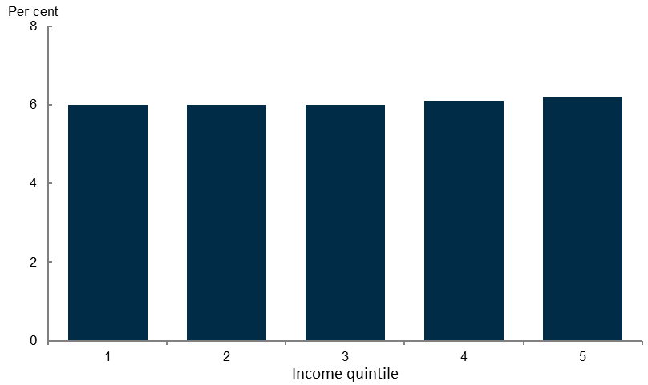
Source: RBA November Statement on Monetary Policy.

The ability to deal with rising cost-of-living pressures is unevenly distributed
Cost-of-living pressures have disproportionately impacted low- and middle- income households because these households have less capacity to absorb rising prices for essential spending (such as food, healthcare, rent or mortgage repayments) by reducing discretionary spending or drawing down savings.
Chart 2 shows savings as a share of disposable income to illustrate the extent to which households at different points in the income distribution can change their saving behaviour to respond to the cost-of-living increases.

Chart 2: Saving as a share of disposable income, 2021–22 | Chart 3: Household savings ratio
 | 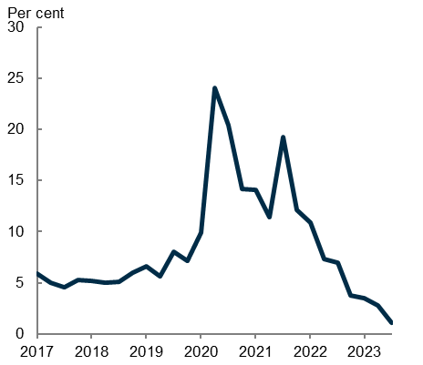
Source: ABS National Accounts: Distribution of Household Income, Consumption and Wealth. | Note: Seasonally adjusted.  Source: ABS National Accounts: National Income, Expenditure and Product.

In 2021–22, households in the lowest income quintile spent more than their disposable income on average. This group is largely made up of benefit-receiving households, who have received targeted cost-of-living support including increased income support payments and energy bill relief. Their benefits have also been indexed to inflation, mostly maintaining their spending power.
Households in the second and third quintiles saved less than 20 per cent of their income, compared to 40 per cent for the highest income households, which has limited their ability to absorb rising prices (Chart 2). As this distributional data is from 2021–22 when aggregate savings rates were over 10 per cent during the COVID-19 lockdown periods (Chart 3), it is expected that savings rates have fallen across the income distribution, with the average now 1.1 per cent in the September 2023 quarter.
Further, households in the 3 lowest quintiles consume a higher proportion of their total spending on essential goods and services. These lower-income households also tend to consume lower-cost versions of goods. As a result, they have less scope to reduce spending when faced with higher prices through reducing saving or changing their expenditure patterns.
The household savings ratio has declined over the past 18 months to the lowest level since 2007 (Chart 3) and inflationary pressures have been broadly based, both illustrating the pressure some households are under and a run down in the accumulated savings experienced by higher income households over the COVID-19 period.

Working households have experienced the fastest rise in their cost of living
Working households have experienced the fastest rise in their cost of living, with prices rising 9 per cent through the year to the September 2023 quarter (Chart 4). The relatively large rise in cost of living for these households reflects rising mortgage interest costs, which almost doubled through the year to June 2023. The RBA has found that rising mortgage interest costs have led to total mortgage repayments (principal and interest) increasing by between 30 and 50 per cent since May 2022 for most variable-rate borrowers. The RBA has also found that lower-income mortgage holders were significantly more likely to be experiencing financial stress than those on higher incomes.

Chart 4: Selected cost of living indexes by household type, change through the year to September 2023
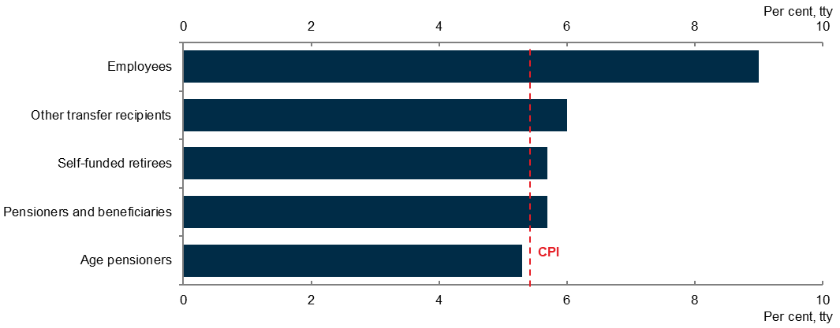
Source: ABS Select Cost of Living Indexes.

Renters typically have lower incomes and substantially lower savings than homeowners, regardless of age. Across the income distribution, renters are far more likely than homeowners to experience financial stress, including being unable to pay bills, missing meals, or reaching out to community or family for financial help (Chart 5).

Chart 5: Individuals experiencing financial stress, by housing tenure and income quintile, 2022–23
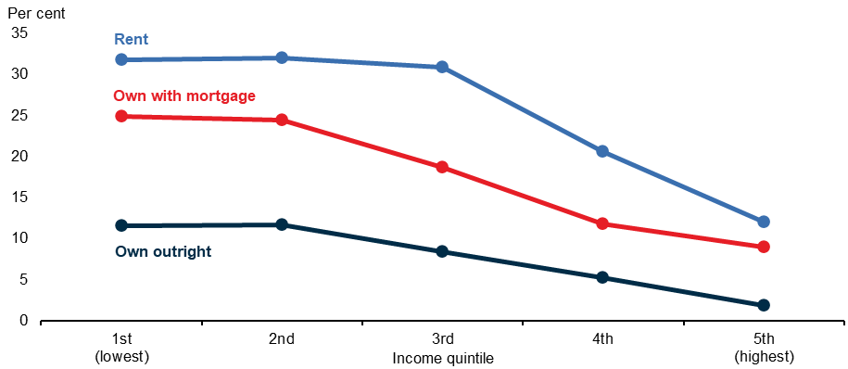
Notes: Individuals aged 18 years and over. Income is financial year disposable income.
Source: Treasury analysis of HILDA (Wave 22).

Lower-income workers have experienced relatively strong earnings growth. This partly reflects the increase in the minimum wage arising from the Fair Work Commission’s award wage decision, and that some low-income earners are working more, including in response to cost-of-living pressures. However, lower-income households are more likely to experience financial distress.

Broad-based tax cuts could ease cost-of-living pressure for more people in need
The legislated Stage 3 tax cuts are targeted at higher-income earners, following two earlier stages of tax cuts targeted to low- and middle-income earners. However, the Stage 3 tax cuts were designed and legislated before the increase in cost-of-living pressures faced by Australian households emerged. The Stage 3 tax cuts could be redesigned to provide broader cost-of-living relief to Australian taxpayers, including low- and middle-income earners who are more vulnerable to these pressures.
It remains important to deliver an overall tax cut around the size of the Stage 3 tax cuts to unwind bracket creep and lower average income tax rates. This case is supported by the ongoing improvement in the budget position and adverse impacts of rising average income tax rates.
Maintaining the overall magnitude of the cut (and thus the broad budget impact of Stage 3) also ensures that any redesign does not add to inflationary pressures. The legislated cuts are factored into Treasury’s economic forecasts, which project inflation to decline to 2¾ per cent by 2024–25.
Redesigning the Stage 3 tax cuts presents an opportunity to reduce the future incidence of bracket creep at lower income levels, while also supporting progressivity. The average tax increases from bracket creep are largest and the disincentives to participate in the work force are greatest at lower income levels. As a result, a redesign provides an opportunity to further boost incentives to participate in the labour market, especially for women, beyond the boost provided by Stage 3.
Ensuring average tax rates for high-income earners do not rise too high and that the top marginal tax rate is only paid by a small share of taxpayers also remain relevant objectives.
To balance these considerations Treasury recommends a redesign that:
- reduces the 19 per cent tax rate to 16 per cent
- proceeds with the legislated reduction in the 32.5 per cent rate to 30 per cent
- retains the 37 per cent tax rate (which would otherwise be removed under Stage 3)
- increases the threshold for the 37 per cent tax rate from $120,000 to $135,000
- increases the threshold for the 45 per cent tax rate from $180,000 to $190,000.

Impacts of the recommended redesign of Stage 3 tax cuts
The recommended package is estimated to provide cost-of-living relief to 13.6 million taxpayers, compared to 10.8 million taxpayers under the current legislated tax cuts compared to 2023–24 settings. This option is broadly revenue neutral and not expected to impact the outlook for inflation.
Under the recommended package all taxpayers would receive a reduction in their tax liability. Across all income deciles, the tax cut is between 1.5 and 2.5 per cent of taxable income on average (Chart 6). Some taxpayers in the bottom quintile will have also benefited from increased government transfers and other support.

Chart 6: Average tax cuts as a share of taxable income, by taxable income quintile, 2024–25
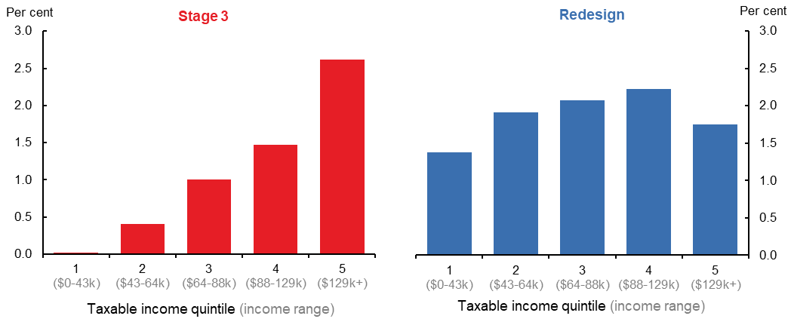
Note: Tax cut as a share of taxable income, averaged for each taxable income quintile for taxpayers.
Source: Treasury analysis.

Under the recommended redesign, all resident taxpayers with taxable income under $146,486 will get a larger tax cut relative to the Stage 3 tax cuts (Chart 7 and Table A1). An individual with taxable income of $40,000 would receive a tax cut of $654, in contrast to receiving no tax cut under Stage 3. An individual with taxable income of $100,000 would receive a tax cut of $2,179, $804 more than under Stage 3. An individual with taxable income of $190,000 would receive a tax cut of more than $4,500, lower than under the Stage 3 legislated tax cuts, but still a larger absolute tax cut than other taxpayers.

Chart 7: Tax cut from Stage 3 and recommended option in 2024–25, compared to 2023–24 policy settings
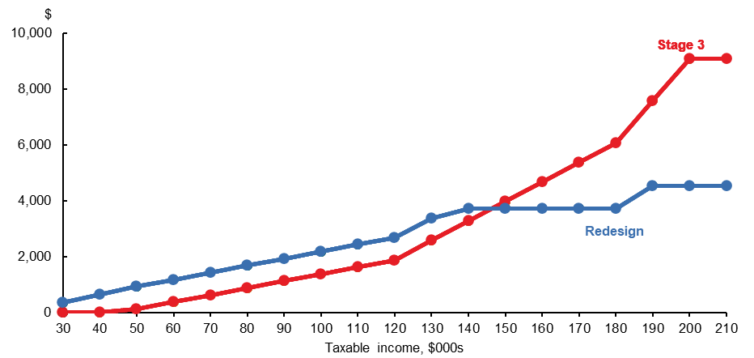
Note: Calculation for Australian resident taxpayers. Data available in Table A1 in the appendix.
Source: Treasury analysis.
The recommended redesign provides greater benefits to individuals in the low- to middle-income range, which has disproportionately more women than higher income ranges (Chart 8). Women make up the majority of individuals in the bottom 5 deciles, while only 30 per cent of individuals in the top decile are women. Under the recommended redesign, female taxpayers would receive an average tax cut of $1,649 compared with $1,278 under Stage 3 settings.

Chart 8: Female share of taxpayers by income decile, 2024–25
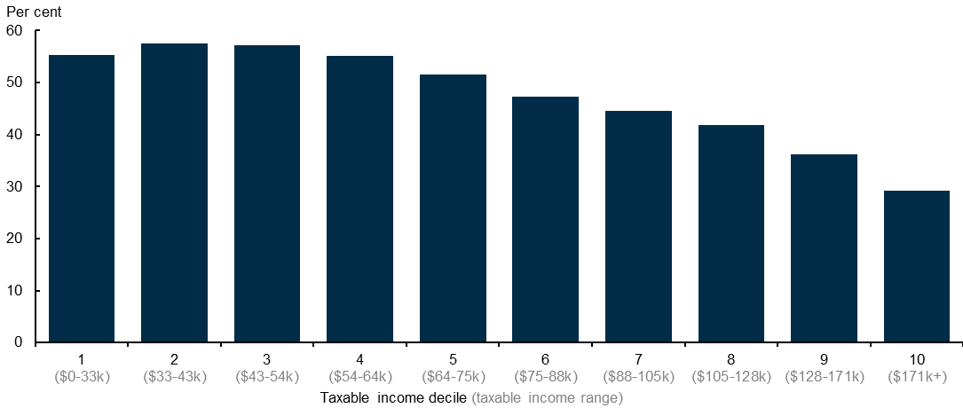
Source: Treasury analysis.

Effect of the recommended redesign on the inflation outlook
The legislated cuts are factored into the Budget economic forecasts, which project inflation to decline to 2¾ per cent by 2024–25. The redesign will not impact the inflation outlook.
The redesign of the Stage 3 cuts is broadly revenue neutral – reducing tax receipts by $1.3 billion over the forward estimates period from 2023–24 to 2027–28 but will increase tax receipts by around $28 billion over the medium term from 2023–24 to 2034–35. The redesign results in a small save to the budget in 2024–25 of around $1.3 billion (Table 1).

Table 1: Change to receipts of redesign option ($ billion)
Proposal | 2023–24 | 2024–25 | 2025–26 | 2026–27 | 2027–28 | Total over forward estimates
Redesign option | - | 1.3 | -1.6 | -0.9 | 0.0 | -1.3
The recommended redesign shifts some of the tax cuts to those on lower incomes, who tend to spend more of their additional income than high-income households; that is, they have higher marginal propensities to consume. However, even after factoring in this effect, the redesign will not add to inflationary pressures.

Effect of the recommended redesign on bracket creep
By reducing the first tax rate from 19 to 16 per cent, the redesign produces a smaller increase in average tax rates (Chart 9) for the first seven income deciles over the next 10 years. In other words, it reduces bracket creep more for these groups compared with both Stage 3 and a no change scenario.
Under the recommended redesign, average tax rates for higher income earners are still significantly reduced compared to a no change in taxes scenario but by less than under Stage 3.

Chart 9: Increase in average tax rates (ATRs) from 2023–24 to 2034–35 under tax scenarios by decile
Note: Taxable income deciles calculated for taxpayers.
Source: Treasury analysis.

Effect of the recommended redesign on labour supply
The redesign will raise labour supply – particularly of women. Household composition and lifecycle factors influence labour force participation decisions in response to financial incentives. Women have lower labour force participation rates and, when employed, are more likely to work part-time (Charts A2 and A3 in the appendix). When faced with the same percentage change to after-tax wages, women – particularly women with children – are more responsive in the amount they work compared to men. In addition, people with less formal education and those with lower wage potential are more responsive to changes in after-tax income than other individuals.
These different labour supply responses mean that the distribution of tax cuts matters both for who it encourages to work, and for its overall effect on labour force participation. Delivering a tax cut to high-income individuals is expected to increase overall participation by less than a tax cut that delivers an increase in after-tax wages for those on lower incomes.
The redesign is expected to produce a larger increase in labour supply, driven by increases in hours worked and participation of women with taxable income between $20,000 and $75,000 (Chart 10). Overall, the recommended redesign sees an increase in labour supply of about 930,000 hours per week (0.25 per cent), more than double Stage 3. Female labour supply is expected to increase by 0.37 per cent.

Chart 10: Expected change in weekly hours worked under Stage 3 and the redesign
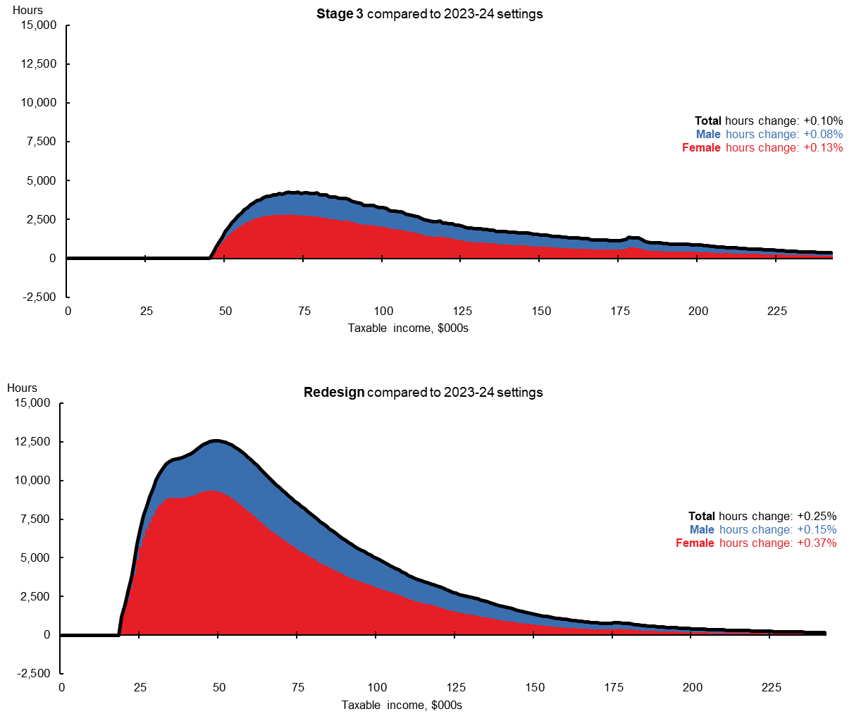
Source: Treasury analysis.
The design of the tax cut also affects labour supply decisions for particular occupations. Compared with Stage 3, the redesign delivers a larger tax cut to more than 90 per cent of taxpayers in in-demand occupations, including teachers, nurses, aged carers and disability support workers, and childcare workers (Chart 11).

Chart 11: Share of taxpayers getting a larger tax cut by occupation, recommended redesign compared to Stage 3
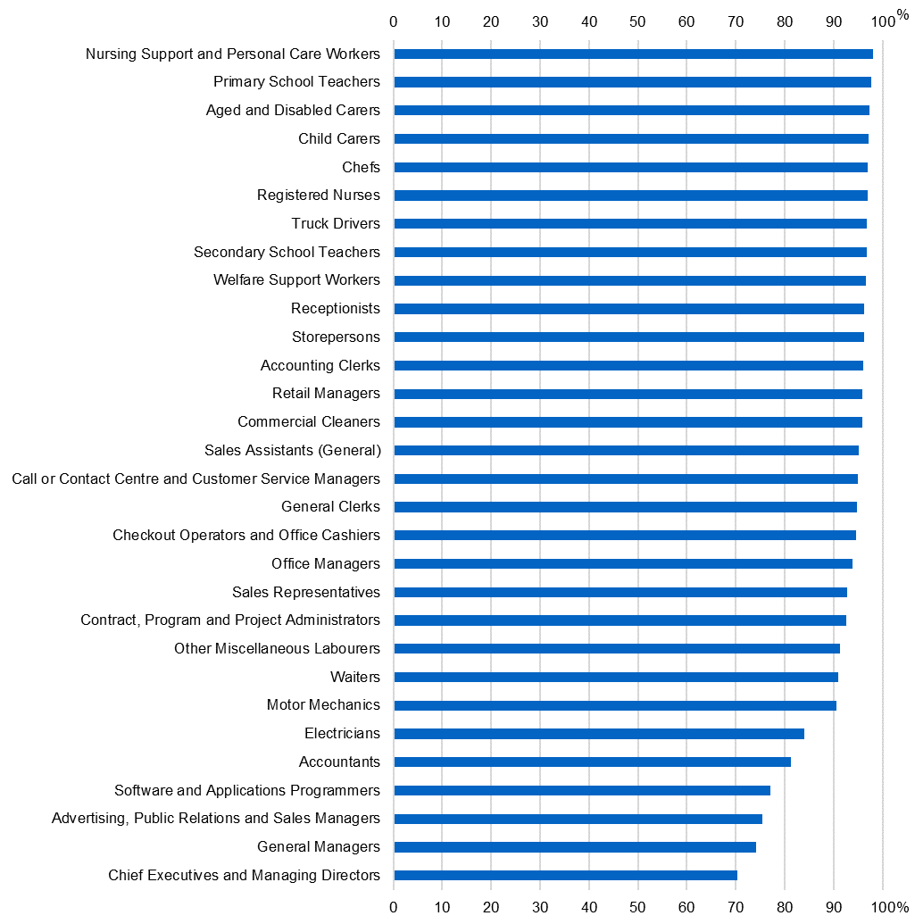
Notes: ANZSCO unit group occupations with more than 100,000 tax filers. Occupation data based on taxfilers reporting salary and wage income on 2020–21 tax returns.
Source: Treasury analysis.

Appendix

Table A1: Change in tax for Stage 3 and recommended redesign in 2024–25 compared to 2023–24 policy settings
($) | Recommended  redesign vs 2023–24 | Stage 3 vs  2023–24 | Recommended  redesign vs Stage 3
30,000 | -354 | – | -354
40,000 | -654 | – | -654
50,000 | -929 | -125 | -804
60,000 | -1,179 | -375 | -804
70,000 | -1,429 | -625 | -804
80,000 | -1,679 | -875 | -804
90,000 | -1,929 | -1,125 | -804
100,000 | -2,179 | -1,375 | -804
110,000 | -2,429 | -1,625 | -804
120,000 | -2,679 | -1,875 | -804
130,000 | -3,379 | -2,575 | -804
140,000 | -3,729 | -3,275 | -454
150,000 | -3,729 | -3,975 | 246
160,000 | -3,729 | -4,675 | 946
170,000 | -3,729 | -5,375 | 1,646
180,000 | -3,729 | -6,075 | 2,346
190,000 | -4,529 | -7,575 | 3,046
200,000 | -4,529 | -9,075 | 4,546

Chart A2: Labour force participation | Chart A3: Average weekly hours worked
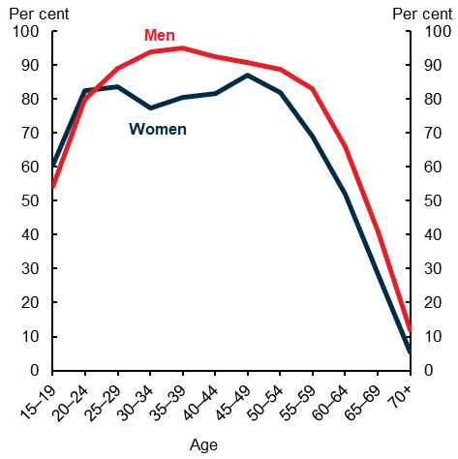 | 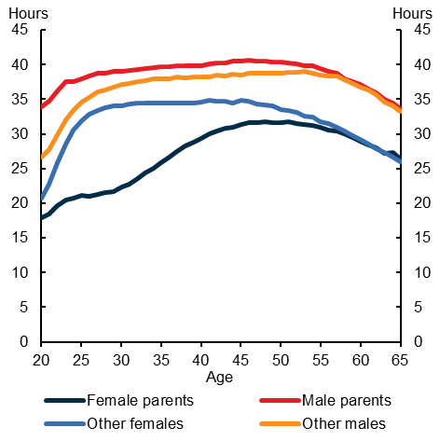
Source: Treasury; ABS Labour Force Survey. 2022–23. | Source: Treasury; ABS Census of Population and Housing. 2021.

This includes: support for people on working age and student payments has been increased by $40 a fortnight; eligibility for the Parenting Payment (single) has been expanded to include single principal carers whose children are under 14; and the maximum rates of Commonwealth Rent Assistance have been increased by 15 per cent. Further, some support measures are temporary and are due to expire shortly. The Federation Funding Agreements underpinning the Energy Bill Relief Fund, which provides temporary energy rebates to individuals who hold an eligible concession card or receive eligible government payments.

