Independent Evaluation of the JobKeeper Payment
  - Final Report
28 September 2023

© Commonwealth of Australia 2023
ISBN: 978-1-925832-85-3
This publication is available for your use under a Creative Commons Attribution 3.0 Australia licence, with the exception of the Commonwealth Coat of Arms, photographs, images, signatures and where otherwise stated. The full licence terms are available from http://creativecommons.org/licenses/by/3.0/au/legalcode.
Use of material from the Independent Evaluation of the JobKeeper Payment Final Report is to be treated as Australian Government material under a Creative Commons Attribution 3.0 Australia. The licence requires you to attribute the work (but not in any way that suggests that the Independent Evaluation of the JobKeeper Payment endorses you or your use of the work).
Independent Evaluation of the JobKeeper Payment material used ‘as supplied’
Provided you have not modified or transformed material from the Independent Evaluation of the JobKeeper Payment in any way including, for example, by changing the Final Report text; calculating percentage changes; graphing or charting data; or deriving new statistics from published statistics – then the Independent Evaluation of the JobKeeper Payment prefers the following attribution:
Source: The Australian Government Independent Evaluation of the JobKeeper Payment Final Report.
Derivative material
If you have modified or transformed the Final Report material, or derived new material from those of the Evaluation in any way, then the Independent Evaluation of the JobKeeper Payment prefers the following attribution:
Based on The Australian Government Independent Evaluation of the JobKeeper Payment Final Report data.
Use of the Coat of Arms
The terms under which the Coat of Arms can be used are set out on the Department of the Prime Minister and Cabinet website (see https://www.pmc.gov.au/honours-and-symbols/commonwealth-coat-arms).
Other uses
Enquiries regarding this licence and any other use of this document are welcome at:
Manager
Media Unit
The Treasury
Langton Crescent
Parkes ACT 2600
Email: media@treasury.gov.au

The Independent Evaluation of the JobKeeper Payment acknowledges the Traditional Custodians of country throughout Australia and their connections to land, sea and community. We pay our respect to their Elders past and present and extend that respect to all Aboriginal and Torres Strait Islander peoples today.

28 September 2023

Dr Steven Kennedy PSM
Secretary to the Treasury
Department of the Treasury
Langton Crescent
PARKES ACT 2600

Dear Dr Kennedy
In accordance with the terms of reference, I am pleased to present the final report of the Independent Evaluation of the JobKeeper Payment.
I thank all the individuals that gave time to discuss JobKeeper with the evaluation secretariat team and me, and those who made research available to us. A list of the individuals and organisations that made formal submissions is at Attachment A to the report.
I particularly want to record my thanks to the secretariat team, ably led by Thomas Williamson.
Yours sincerely

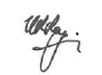
Nigel Ray

Table of contents
Abbreviations and acronyms vi
Glossary vii
Executive summary and key findings 1
Main Report 9
1 Introduction 9
1.1 Terms of reference 9
1.2 Evaluation approach 10
1.3 Policy context in early 2020 14
1.4 Introduction of JobKeeper: objectives and design 15
2 Coverage of JobKeeper 18
2.1 Individual characteristics 18
2.2 Business characteristics 19
2.3 Coverage by industry 20
2.4 Coverage by geography 21
3 Economic effects of JobKeeper 23
3.1 Early economic impacts of the COVID-19 pandemic 23
3.2 Short-term effects of JobKeeper 26
3.3 Medium and longer-term effects of JobKeeper 33
3.4 JobKeeper and labour scarring 35
4 JobKeeper design features 38
4.1 Timing and flexibility 38
4.2 Payment rate structure 45
4.3 Eligibility criteria 50
5 Integrity and implementation 56
5.1 Program delivery and integrity 56
5.2 Transparency 60
5.3 Communication strategy 66
6 Value for money 68
6.1 Approach to assessing value for money of JobKeeper 69
6.2 Benefits of the JobKeeper Payment 69
6.3 Cost of JobKeeper 70
7 Suitability of JobKeeper in future circumstances 73
7.1 Why was JobKeeper an appropriate policy in the pandemic? 73
7.2 A JobKeeper-type wage subsidy should be reserved for a macroeconomic crisis 74
7.3 A JobKeeper-type wage subsidy is not suitable for managing the business cycle 74
7.4 Short-time work schemes 75
Attachment A: List of submissions 76
Attachment B: Bibliography 77

List of boxes, figures and tables
Box 1: The effects of job retention scheme generosity 30
Box 2: Literature on labour scarring 36
Box 3: International comparisons of payment rate structures 46
Box 4: dnata case study 55
Box 5: ATO gap analysis methodology 58
Box 6: Voluntary disclosures and repayments 62
Box 7: Transparency mechanisms in pandemic job retention schemes abroad 64
Box 8: Costing policy in a crisis: managing uncertainty 72

Figure 1: JobKeeper individuals by sex and age 19
Figure 2: JobKeeper coverage by industry 21
Figure 3: JobKeeper coverage by state 22
Figure 4: Discretionary travel and mobility 24
Figure 5: Weekly transaction volumes growth 24
Figure 6: ASX200 and S&P500 25
Figure 7: Job separations (indexed) by JobKeeper status 26
Figure 8: Consumer and business confidence 27
Figure 9: Changes in payroll jobs (indexed) 28
Figure 10: Paid jobs in JobKeeper-eligible firms in 2020 29
Figure 11: Income source as share of March income, by quintile 32
Figure 12: Labour mobility 34
Figure 13: Unemployment rate in Australia during economic slowdowns 37
Figure 14: Income support flow for individuals on the first phase of JobKeeper 39
Figure 15: Separations and jobs by JobKeeper status and turnover 40
Figure 16: JobKeeper income compared to usual pay 48
Figure 17: Change in employment and turnover, by firm temporary migrant reliance 54

Table 1: JobKeeper Payment program logic 11
Table 2: Key releases by government departments on JobKeeper 12
Table 3: JobKeeper payment rates 17
Table 4: JobKeeper payments by business size 20
Table 5: Treatment of Temporary visa holders and non-residents 53
Table 6: Some reports on JobKeeper implementation and program management 57
Table 7: JobKeeper payment gap 58

Abbreviations and acronyms
Term | Definition
ABS | Australian Bureau of Statistics
ACCI | Australian Chamber of Commerce and Industry
ACE | Australian Centre for Evaluation
ACNC | Australian Charities and Not-for-profits Commission
ACTU | Australian Council of Trade Unions
ANAO | Australian National Audit Office
AOFM | Australian Office of Financial Management
APRA | Australian Prudential Regulatory Authority
ASBFEO | Australian Small Business and Family Enterprise Ombudsman
ASIC | Australian Securities and Investments Commission
ASX | Australian Securities Exchange
ATO | Australian Taxation Office
BAC | Boosting Apprenticeship Commencements
BCA | Business Council of Australia
CEWS | Canada Emergency Wage Subsidy
CJRS | Coronavirus Job Retention Scheme (United Kingdom)
ERS | Employment Retention Subsidy (Republic of Korea).
GFC | Global Financial Crisis
HILDA | Household, Income and Labour Dynamics in Australia
IGTO | Inspector General of Taxation and Taxation Ombudsman
ILO | International Labour Organization
IMF | International Monetary Fund
JSS | Job Support Scheme (Singapore)
NAVA | National Association for the Visual Arts
NEET | Not in employment, education or training
NOW | Temporary Emergency Measure for the Preservation of Jobs (Netherlands)
OECD | Organisation for Economic Co-operation and Development
PMI | Purchasing Managers’ Index
RBA | Reserve Bank of Australia
STP | Single Touch Payroll
STW | Short-Time Work scheme
TWSS | Temporary COVID-19 Wage Subsidy Scheme (Ireland)
WHO | World Health Organization

Glossary
Aggregated annual turnover
Annual turnover, plus the annual turnovers of any business entities that are affiliates or connected.
Business
Businesses include all companies, partnerships, trusts, plus individuals with business income (sole traders).
Business Activity Statement (BAS)
Businesses registered for Goods and Services Tax (GST) are required to lodge a BAS with the ATO to report their tax obligations. A BAS is a form filled out by businesses between one and 12 times a year, depending on the business size. It includes details such as turnover and calculates the amount of GST a business must pay to the ATO.
Business failure
A business ceasing operations owing to its inability to make a profit.
Cashflow boost
Officially known as Boosting Cashflow for Employers program. Tax-free payments made by the Australian Government to eligible businesses and not-for-profit organisations to ease financial pressure arising from the COVID-19 downturn. The cashflow flow boost was announced on 12 March 2020 as part of the first stimulus package in response to COVID-19.
Casual employees
Employees without certain paid leave entitlements, guaranteed hours of work, and whose employment can end without notice unless notice is required by a registered agreement, award or employment contract.
Coronavirus Supplement
Additional financial support for people who received certain income support payments, such as the JobSeeker Payment. Those eligible received a fortnightly supplement of $550.
COVID-19
COVID-19 is an infectious disease caused by a newly discovered coronavirus. Cases were confirmed in Australia from late January 2020.
COVID-19 Disaster Payment
A lump sum payment paid to those who had lost work or income as a result of a COVID-19 lockdown.
Instant asset write-off
A business can claim an immediate deduction for the business portion of the cost of an asset in the year the asset is first used or installed ready for use.
JobKeeper-nominated workers
Workers who have been nominated by their employer for JobKeeper payments.
Major Bank Levy
A levy applied to Australian banks with more than $100 million in total liabilities. This covers Australia’s 5 largest banks – Commonwealth Bank, ANZ, Westpac, National Australia Bank and Macquarie.
Not-for-profit
Not-for-profit (NFP) organisations are organisations that provide services to the community and do not operate to make a profit for members (or shareholders, if applicable).
Pandemic
A widespread occurrence of an infectious disease over a whole country or the world at a particular time.
Pandemic Leave Disaster Payment
A support payment for those who had to self-isolate or quarantine due to COVID-19, and for those caring for someone who had to self-isolate or quarantine.
Public registry
An official list of names or businesses which under law is required to be made available to the public.
Registered charity
An organisation registered with the Australian Government, which is run for the public benefit, is not-for-profit, does not have a disqualifying purpose, and is not an individual or a political party. To receive charity status charities must be registered with the Australian Charities and Not-for-profits Commission.
Short-time work scheme (STW)
A payment scheme that allows firms experiencing economic difficulties to temporarily reduce the hours worked of employees while providing them with income support from the Government for hours not worked. STW schemes are popular in Europe. Australia does not have a STW scheme.
Short-term casual and long-term casual
In the context of JobKeeper, short term casuals are casual workers who have been employed in their job for less than 12 months. Long term casuals are casual workers who have been employed in their job for more than 12 months.
Single Touch Payroll (STP)
STP data are provided to the ATO by businesses with STP-enabled payroll or accounting software each time the business runs its payroll. STP data include both business and job-level tax and superannuation information.
Tax gap
An estimate of the difference between the amount of tax the ATO collects and what the ATO would have collected if every taxpayer was fully compliant with tax law.
Temporary migrant
A person who comes to Australia for a temporary stay for a range of purposes. In relation to JobKeeper, temporary migrants refer principally to temporary migrants with work rights – including those on Student visas, Working Holiday Maker visas, and Temporary Resident (Skill Employment) visas.
Turnover test
A test to determine business eligibility for JobKeeper support. In most cases, a business which was eligible for JobKeeper support had, or expected to have, a reduction in GST turnover of 30 per cent (50 per cent for a business with aggregated turnover of $1 billion or more).

Executive summary and key findings
The COVID-19 pandemic had extraordinary health and economic implications globally and in Australia. It evolved rapidly and was characterised by enormous uncertainty, particularly in the early months of 2020. Modelling of health outcomes at this time suggested Australia could experience as many as 150,000 deaths. As in many other countries, authorities in Australia introduced social distancing and other measures in mid to late March to curb the spread of COVID-19. Alongside the virus itself, the measures significantly affected the ability of many workers and businesses to participate in the labour market and economy.
Early in March 2020, the Managing Director of the International Monetary Fund (IMF), Kristalina Georgieva, stated that the biggest challenge presented by the early stage of the pandemic was handling uncertainty.She noted that it was difficult to predict the extent and duration of the expected fall in global growth. As opposed to regular downturns in the business cycle, the early period of the pandemic presented a crisis characterised by unquantifiable risks. These stemmed from unknowns around the path of the virus, the structure and functioning of the economy under quarantine, and the nature of shocks to goods, labour and financial markets. This environment necessitated a robust policy response.
JobKeeper was a central pillar of the policy response in Australia. It was a wage subsidy and income support program announced on 30 March 2020. It was the third instalment in a series of economic support packages introduced in the space of 3 weeks during March 2020 as the crisis was unfolding rapidly. JobKeeper provided support to around 4 million individuals – around one-third of pre-pandemic employment – and one million businesses.
JobKeeper had 3 objectives: to support business and job survival; to keep employees connected to their employers; and to provide income support to individuals. It enabled eligible workers at eligible firms to receive a payment from the government through their employer. For stood down workers, the payment was an income support payment; for others, it was a wage subsidy. JobKeeper remained in place until 28 March 2021. Modifications to policy design, including changes to eligibility criteria and the payment rate and structure, were made following a three-month review.
The Independent Evaluation of the JobKeeper Payment (the evaluation) considers both the impact and processes of JobKeeper. The scope for the evaluation includes the entire JobKeeper Payment. In line with its terms of reference, the evaluation assesses the effectiveness of JobKeeper in achieving its objectives. It also records lessons learned from the design and implementation of JobKeeper, with a view to informing future policy responses.
The evaluation draws on evidence from a range of sources and data. These include submissions provided to the evaluation, previous assessments and analyses of JobKeeper undertaken by the Treasury and the Australian National Audit Office (ANAO), academic research, and internal Treasury research. The evaluation also draws on international evidence and interviews with stakeholders, academics and senior public servants in Australia and other countries.
Key findings of the evaluation are set out below, with contextual information and supporting evidence presented in the main report.

Key findings
- JobKeeper helped to stabilise the Australian economy during a crisis. It played a critical role in addressing the extraordinary and unquantifiable uncertainty at the time of its introduction and averting the worst economic tail risks of the pandemic.
- JobKeeper provided certainty during a crisis. At the time, the IMF warned the pandemic presented a crisis like no other with the worst economic fallout since the Great Depression. Around two-thirds of total economic losses associated with the pandemic were expected to stem from uncertainty.
- The behaviour of consumers and businesses changed drastically from early March 2020. Physical movement declined sharply. Retail transaction volumes fell, initially for discretionary purchases but also for essential purchases by late March. Business and consumer confidence fell at an unprecedented speed to record lows. Job separations increased and applications for income support spiked sharply in late March.
- The announcement of JobKeeper on 30 March 2020 had an immediate effect. Business and consumer sentiment partially reversed their declines. Job separations fell sharply and within weeks were below pre-pandemic levels. Applications for income support peaked in the week JobKeeper was announced.
- JobKeeper laid the foundation for a speedy recovery. It preserved employee-employer relationships and prevented the failure of otherwise productive firms. It also boosted income and provided stimulus to underpin a broad economic recovery.
- JobKeeper was effective in achieving its stated objectives. It preserved employment, supported incomes and prevented large scale business failures during the pandemic.
- Take-up of JobKeeper was high. It provided support to around 4 million employees – almost one third of pre-pandemic employment – and around one million businesses. Credible estimates suggest that JobKeeper preserved between roughly 300,000 and 800,000 jobs or around 2½ to 6 per cent of pre-pandemic employment.
- JobKeeper reduced the risk of labour scarring. This was achieved by maintaining employee-employer relationships and providing broader stimulus that contributed to a faster and stronger labour market recovery. In addition to direct economic benefits, the preservation of employment had benefits to individuals’ well-being associated with avoiding the uncertainty and stigma associated with becoming unemployed.
- Businesses that received JobKeeper suffered a median turnover decline of 28 per cent in the June quarter 2020 and 23 per cent in the September quarter 2020. Total company insolvencies during the initial months of the pandemic were lower compared with a year earlier and compared with previous economic downturns, though this likely reflected the effect of other policy support as well as JobKeeper.
- This finding is consistent with international evidence. The Organisation for Economic Co-operation and Development (OECD) found that job retention schemes supported around 50 million jobs across OECD countries by May 2020, preventing a surge in unemployment and supporting aggregate demand. Recently published evaluations in the United Kingdom and New Zealand similarly concluded that their wage subsidy programs prevented job losses and business closures.
- While there were important benefits associated with JobKeeper, there were also significant costs. The fiscal cost of JobKeeper was significantly frontloaded in the first 6 months. The economic cost, while relatively small, became more significant in the later stages of the program.
- JobKeeper had a relatively small and short-lived economic cost associated with inhibiting productivity enhancing labour reallocation. In the initial phase, JobKeeper had a positive impact on productivity as it was more likely to support highly productive, but liquidity constrained firms. In contrast, the extension phases of JobKeeper generally supported less productive firms and weighed on productivity growth.
- JobKeeper also had a large fiscal cost which reflected expectations about the scale of the economic crisis at the onset of the pandemic and the size of program needed to cushion its impact. With a total cost of $88.8 billion, JobKeeper was the one of the largest fiscal and labour market interventions in Australia’s history. The initial 6 months of the program cost approximately $70 billion. The first and second three-month extensions cost around $13 billion and $6 billion respectively.
- Overall, JobKeeper provided value for money through its broad social benefits and the role it played in addressing extraordinary and unquantifiable uncertainty and averting the worst economic tail risks of the pandemic.
- The evaluation uses a qualitative approach to analysing the social value of JobKeeper. This approach recognises that the unquantifiable risks present in the early stage of the pandemic, along with the difficulty of disentangling the effects of one policy measure from those of the broader stimulus package, make attempting to quantify the macroeconomic benefits of JobKeeper inherently unreliable.
- The social benefits of JobKeeper were significant. JobKeeper helped to preserve the capacity of the economy by avoiding the destruction of firms and employee employer relationships that were otherwise viable and productive. The program flattened the distribution of wages and enhanced the well-being of recipients.
- For policy evaluation purposes, the fiscal cost of JobKeeper is treated as a transfer payment from one group in society to another. The upper bound to the social cost of JobKeeper is estimated to be $22.4 billion (25 per cent of the gross fiscal cost of the program plus its administration cost). Other relatively small costs relate to temporarily impeding productivity-enhancing labour reallocation.
- The lessons identified in Finding 7 would potentially help maximise social benefits and minimise costs should a future JobKeeper-type policy be required.

- JobKeeper was implemented with incredible speed and was well managed. In the circumstances, implementation struck an appropriate balance between rapidly deploying support and managing risks of error and fraud.
- Use of established tax system concepts and the Australian Taxation Office (ATO) were appropriate and enabled efficient implementation of JobKeeper. It also relieved pressure on Services Australia which was experiencing rapid increases in applications for assistance at the time.
- Once announced, JobKeeper was implemented with speed and appropriate recognition of the urgency of rolling out support to manage the crisis. Simplicity in policy design and utilising Single Touch Payroll (STP) technology was critical to the speed of implementation while also managing risks.
- The Australian National Audit Office (ANAO) concluded that the ATO’s administration of JobKeeper was effective and that its arrangements were fit for purpose to protect the integrity of JobKeeper payments. Monitoring and reporting on the operational performance of JobKeeper was effective.
- The incidence of fraud was low. The estimated payment gap for JobKeeper was 2.4 per cent – smaller than other ATO-administered programs and taxes such as the Cashflow Boost, GST tax receipts and large corporate groups income tax.
- Cross-agency collaboration and leveraging of pre-existing relationships was a strength of the design and delivery of JobKeeper. There would be benefit in establishing an emergency committee of key government agencies that could be activated to coordinate economic policy during an economic crisis.
- The development of JobKeeper represented a significant effort by the officials involved, many of whom worked in extraordinary circumstances. Stakeholders noted that government agencies worked together constructively and flexibly to establish JobKeeper quickly in the early stages of the pandemic.
- The collaboration that occurred across government agencies depended on strong pre-existing relationships between senior public servants. While this was effective for the introduction of JobKeeper, there would be benefit in adopting a more structured approach for the purpose of co ordinating economic policy during a crisis.
- Establishing an emergency committee of key government economic agencies that could be activated quickly at the onset of an economic crisis would serve this purpose. Arrangements around the composition and modalities of the committee could be pre-determined such that it was ready to be stood up quickly when required. At a minimum, membership should include officials from the Treasury, the Reserve Bank of Australia, the Australian Office of Financial Management, the ATO and Services Australia.
- While JobKeeper was effective, there are lessons that could improve outcomes and value for money should a similar scheme be required in future.
  - In a rapidly evolving crisis, a policy design that more readily adapted to changing conditions – similar in concept to an automatic stabiliser – could reduce costs without compromising effectiveness.
- When JobKeeper was announced, a commitment was made to keep it in place for 6 months with extension beyond September 2020 subject to a three-month review.
- The commitment reflected an assumption that health restrictions would be in place for at least 6 months and a desire to provide certainty to employers and employees about the nature and duration of policy assistance. As it turned out, nation-wide restrictions and shutdowns were shorter-lived than expected.
- A more flexible policy design during the first phase of JobKeeper would have enabled an earlier move from prospective to retrospective eligibility thresholds, for example after 3 months. This would have allowed better targeting of payments beyond the initial 3 months and lowered the cost of the program.
- Many OECD countries introduced or had existing policies in place that could adapt more readily to emerging health and economic developments compared with JobKeeper. Short term work schemes, popular in European countries including Switzerland and Germany, responded to the number of furloughed workers. New Zealand’s wage subsidy was tied more directly to the timing of lockdowns.
- International evidence suggests that policy objectives such as reducing uncertainty and underpinning confidence can be achieved through a more flexible upfront policy commitment that is contingent upon unfolding developments.
  - An earlier commitment to JobKeeper more closely aligned with the introduction of social distancing and other pandemic related restrictions could have increased its efficacy.
- JobKeeper was announced on 30 March 2020, later than job retention schemes in comparable countries and after the introduction of widespread restrictions in Australia to manage the pandemic from mid-March.
- Speed and timeliness are critical to policy effectiveness during a crisis. Evidence suggests that an earlier commitment to JobKeeper that was better aligned with changes in consumer and business behaviour and the announcement of restrictions would have increased its effectiveness.
- There was a dramatic increase in net flows onto income support in the second half of March 2020. Job separations also spiked sharply during this period particularly among workers that later received JobKeeper. Both job separations and flows of individuals onto income support fell sharply immediately following the announcement of JobKeeper.
- An earlier commitment to JobKeeper could have avoided the well-being cost to many individuals stemming from the uncertainty and stigma associated with becoming unemployed.
  - A tiered payment structure, or one that is proportionate to previous earnings, is better targeted than a flat payment. Authorities should consider the investment required to enable a payment that is proportionate to earnings.
- The flat payment of $1,500 per fortnight during the first phase of JobKeeper provided certainty, simplicity, and clarity for both employees and employers. It also reduced risks associated with the speedy implementation of JobKeeper.
- Some stakeholders argued that the flat payment was unfair in the sense that those who previously worked very few hours received the same payment as full-time workers.
- The flat payment was also inefficient. It resulted in around 11 per cent of recipients receiving higher payments through JobKeeper than their pre-pandemic earnings. This may have disincentivised returning to work or increasing work hours during the economic recovery.
- A two-tiered payment was introduced in the extension phase of JobKeeper such that those working less than 20 hours per week received a lower payment than others. The change recognised and partially addressed the issues with the flat payment. It also reflected improved confidence in the system and data used to administer JobKeeper.
- The structure of payments under JobKeeper was unusual. Other OECD countries with a wage subsidy program typically provided support proportionate to an employee’s normal wage up to a certain ceiling.
- The introduction of STP was critical to facilitate JobKeeper but there were limitations around the data collected that precluded Australia from adopting a proportionate payment in the design of JobKeeper. Authorities should consider the investment required to provide the option of a proportionate payment in future.
  - Narrow recipient eligibility and exclusions reduced the effectiveness of JobKeeper and had negative economic consequences.
- JobKeeper excluded some employees and employers. Exclusions included casuals who had been in their job for less than a year, temporary migrants, foreign governments and their agencies and local government entities.
- Exclusions based on employee characteristics such as being a short-term casual or temporary migrant compromised the efficacy of JobKeeper and led to worse outcomes. In particular, the exclusion of short-term migrants from JobKeeper likely reduced the productive capacity of the Australian economy and constrained recovery in some sectors. The exclusion of entities owned by foreign governments resulted in some otherwise eligible Australian workers missing out on JobKeeper support which was not in keeping with the objectives of the policy.
- Exclusions of significantly funded government sectors, such as public schools and universities and many childcare providers, was appropriate. In principle, sector-focussed policies tailored to the specific challenges and needs of these organisations would have been more appropriate forms of support than JobKeeper. In many cases, sector-specific support was available. The appropriateness and effectiveness or otherwise of these packages is beyond the scope of the evaluation.
  - Transparency requirements should be built into policy design to build public trust and enable appropriate scrutiny of public expenditures.
- JobKeeper did not include in its design a public registry or disclosure requirement for entities that received the payment. Some information became available over time, but disclosures were restricted to listed companies which comprised a small proportion of total JobKeeper entities (around 593 out of about one million) and payments ($4.3 billion out of a total of $88.8 billion).
- The decision not to include a public register in JobKeeper reflected concerns about privacy and publicly identifying firms that may have been in a precarious financial position owing to the pandemic. This could in turn have affected firms’ willingness to utilise the policy, hence reducing its effectiveness.
- In terms of transparency arrangements, JobKeeper was an outlier compared with job retention schemes in other countries. The United Kingdom, Canada, Ireland and New Zealand had public registers or other disclosure requirements that enabled the public to know which businesses were claiming wage subsidies. In some cases, for example in the United Kingdom, public awareness of wage subsidy recipients was considered a mechanism to reduce the likelihood of fraud. The experience of other countries does not suggest transparency requirements had a negative effect on take-up.
- Transparency and openness in public policy builds public confidence and trust. It also enables appropriate scrutiny of public expenditures. Should a similar program be required in future, disclosure requirements for businesses receiving the payments should be part of the initial policy design.
- Clear communication from policy makers is critical, particularly when speedy implementation necessarily requires that some details are decided after the initial policy announcement.
- Stakeholders reported that key institutions involved in designing and implementing JobKeeper were appropriately responsive and efficient in engaging with industry under difficult circumstances. Treasury and the ATO were generally collaborative and communicated well, resolving issues quickly as they arose.
- Some stakeholders submitted that the communication of key policy details and changes by decision-makers could have been clearer and more structured. A more considered and consistent approach to communicating policy decisions would have improved clarity and reduced uncertainty among businesses receiving JobKeeper.
- Availability of timely and granular data – and the ability to analyse it effectively – is essential for effective policy design and monitoring during a crisis.
- Stakeholders highlighted the importance of timely and granular data to formulate policy at speed during a crisis and monitor its effectiveness. Other countries have also recognised the importance of data availability – particularly tax microdata – in responding to the pandemic.
- STP and Business Activity Statement (BAS) data were essential to the development and monitoring of JobKeeper. Other novel data initiatives during the pandemic also provided valuable insight. The release by the Australian Bureau of Statistics (ABS) of Weekly Payroll Jobs and Wages in Australia, Business impacts of COVID 19 and Household Impacts of COVID-19 early in the pandemic greatly assisted policy makers.
- There is scope for further investment to improve access to timely and granular data and associated analytical capacity to better equip policymakers to respond in future crises.
- Communication of policy costings during a crisis should emphasise the uncertainty around producing cost estimates in such an environment and be clear about assumptions. This could be achieved by using a range rather than a point estimate or including a sensitivity analysis.
- The cost for the first 6 months of JobKeeper was initially estimated to be $130 billion. This figure was later revised to $70 billion. The 12-month program ultimately cost $88.8 billion.
- The JobKeeper costing relied on assumptions about the length of shutdowns and other restrictions that were highly uncertain. As noted above, nation-wide restrictions were shorter lived than expected.
- Public perceptions of institutional credibility can be critical to policy effectiveness during a crisis. Publishing a range or sensitivity analysis that sets out clearly the assumptions underpinning a costing in similar circumstances rather than a point estimate would appropriately acknowledge the inherent uncertainty associated with formulating policy in such an environment while also protecting perceptions of Treasury’s credibility.
- The 2020–21 Budget was postponed because of pandemic-related uncertainty. The same rationale could be extended to postpone point estimates of policy costings.
- JobKeeper was a policy designed for an extraordinary situation. While it was justified during the pandemic, such a policy should be considered only where there is an exogenous and temporary shock with substantial economy wide implications.
- JobKeeper effectively froze a large portion of the labour market during the most economically destructive period of the pandemic. As noted above, there were significant fiscal and economic costs associated with the policy. These costs can be justified by the role JobKeeper played in addressing the extraordinary and unquantifiable macroeconomic uncertainty at the time of its introduction and averting the worst economic tail risks of the pandemic. At its peak, the pandemic threatened to reduce the capacity of the economy by destroying firms and employee employer relationships that were otherwise viable and productive.
- A national wage subsidy policy such as JobKeeper is not appropriate for managing aggregate demand or fluctuations in the business cycle typically associated with recessions. These circumstances are characterised by quantifiable risk and require firm level and labour market adjustment. A wage subsidy would inhibit necessary adjustment at significant cost.
- A JobKeeper-type wage subsidy should be reserved for a macroeconomic crisis and is not appropriate for industry- or region-specific shocks or downturns in Australia. Some of the key benefits of JobKeeper identified in this evaluation, including economy-wide stabilisation and reducing macroeconomic uncertainty, are not relevant in these circumstances. Other policies beyond the scope of this evaluation may be more appropriate.
- A short-time work (STW) scheme like that used in Germany, Switzerland and other European countries is not appropriate for Australia. Operationally, STW schemes typically operate alongside unemployment insurance systems which are not a feature of Australia’s current institutional arrangements. Beyond operational limitations, OECD analysis suggests the efficacy of a STW scheme may be limited in an Australian context. Australian firms face relatively low layoff costs which, alongside the administrative costs typically associated with STW schemes, may weaken firms’ incentive to participate. More generally, the OECD notes that firms face weaker incentives to maintain active employment and reengage employees in the recovery period under STW schemes.

Main Report

Introduction

Terms of reference
The evaluation should consider the effectiveness of JobKeeper in achieving its objectives by measuring its policy outcomes using relevant quantitative and qualitative data and drawing conclusions from this analysis. Beyond the stated JobKeeper objectives, other conclusions should also be drawn on the value for money and the broader outcomes of JobKeeper.
The evaluation will record lessons learned from the design and implementation of JobKeeper, with a view to informing future policy responses. The evaluation could also signal areas for potential further research into the medium- or longer-term effects of JobKeeper.
The scope for this evaluation includes the entire JobKeeper Payment which commenced 30 March 2020 and ran to 28 March 2021 (including the initial six-month program and the 2 subsequent three-month extensions).
The evaluation will include examination of:
- The economic and policy context, and how this influenced the design features and implementation of JobKeeper.
- The effect of the JobKeeper Payment on:
  - individuals and businesses who received JobKeeper (compared, where possible, to what would have happened had they not received JobKeeper); and
  - the labour market and the broader economy.
- The effectiveness and appropriateness of the JobKeeper Payment’s key design features (payment to business, rate, eligibility criteria, delivery mechanism and duration) in achieving the policy objectives.
- The costs, benefits, and value for money of the JobKeeper Payment.
- International comparisons of similar labour market policies adopted in other advanced economies.
- How Treasury and other agencies responded to payment delivery, program implementation and integrity challenges across the program.
- Lessons learned from the design and implementation of JobKeeper.
- Suitability of the JobKeeper Payment for responding to different economic circumstances and challenges.
The evaluation will draw on a range of data, including JobKeeper Payment program data and publicly available economic and labour market data, and be informed by external engagement and consultation.

Evaluation approach
The evaluation has taken a broad approach in line with its terms of reference. It was designed in a manner consistent with the Commonwealth Evaluation Policy. In particular, it conforms to the relevant aspects of the 5 principles in the Policy that require that evaluations are: fit for purpose; useful; robust, ethical and culturally appropriate; credible; and transparent where appropriate. The evaluation was designed and undertaken while the Australian Centre for Evaluation (ACE) was still being established. Members of the ACE were consulted during the process.
The evaluation of JobKeeper is different in some regards to many other policy evaluations. JobKeeper was a response to a health and economic crisis. Its size was unprecedented and its economic and social effects were broad and far-reaching. Some of the key benefits and costs of JobKeeper stemmed from its macroeconomic impacts and are challenging to quantify with any degree of accuracy. For these reasons, the evaluation does not attempt to undertake a quantitative value-for-money assessment of JobKeeper. Rather, a largely qualitative approach is taken when assessing some of the costs and benefits of the program and its overall value for money.
The evaluation is both a process and an impact evaluation. The process component of the evaluation relies heavily on the ANAO report Administration of the JobKeeper Scheme but also draws on other information. To assess impacts, the evaluation team has attempted to measure the outcomes of JobKeeper where possible and compare these with the policy’s objectives and intended outcomes. Evidence is then combined and synthesised into findings. Principles to consider for any similar future payments or programs are also reported.
Sources of information and evidence used in the evaluation include:
- Previous reports and reviews completed on the JobKeeper Payment.
- Formal submissions made through a public consultation process.
- Interviews and conversations with stakeholders such as business groups, unions, academics, international peers and senior public servants who designed and worked on JobKeeper.
- Academic papers and literature on JobKeeper and similar programs introduced overseas.
- Analysis of program data and other data sources.

Program logic of the JobKeeper Payment
The evaluation has been guided by a program logic. A program logic (or similarly, a theory of change) can be a useful tool to plan programs and policies and communicate how they will lead to the desired outcomes for stakeholders. In the case of JobKeeper, a program logic was not developed contemporaneously owing to the short time allocated to design and implement the program. A program logic was developed during the evaluation process and has been used to frame the approach taken to the JobKeeper evaluation and the issues that have been prioritised for investigation. The program logic for JobKeeper diagrammatically sets out the inputs that are used by the program activities to deliver outputs (see Table 1 below). These outputs have outcomes over the short, medium and long-term.

Table 1: JobKeeper Payment program logic
Proposal: A wage subsidy program to support workers and businesses through the COVID-19 pandemic. |  |  | Program objective: Provide income support, maintain employment connections and support businesses to survive.
Inputs  Substantial government investment for payments.  ATO and Treasury staff.  Existing ATO payment systems, particularly STP.  Private software providers – STP system links.  Time to develop and implement the policy. | Activities  Design a system to deliver payments to eligible businesses and employees.  Deliver payments to businesses to pay to workers with accuracy and integrity.  Training staff to deliver the system and communicate with the public.  Educating the public on JobKeeper, including factsheets and websites. | Outputs  Employers become aware of scheme and decide to apply.  Forms and software integrations to apply for and receive payments.  Payments made to eligible entities monthly in arrears.  Monitoring of compliance and systems to ensure integrity. | Short-term outcomes  Reduce uncertainty during an economic crisis.  Provide an immediate floor under consumer and business confidence.  Support incomes of employees and eligible entities affected by COVID-19 and associated restrictions.  Keep employees and employers connected, ready for economic reopening, but also restricts labour mobility while in place. | Medium-term outcomes  Intended outcomes  Businesses can resume economic activity once restrictions ease. Reduce search and recruitment costs, preserve match specific human capital.  Worker’s incomes are protected and businesses remain viable.  Unintended outcomes  Reduce movement of employees to new employers.  Some entities that were otherwise unviable supported. | Long-term outcomes  Economy returns to long-run path of growth.
Assumptions: Without substantial support the economy faces a risk of a severe downturn (rapidly rising unemployment), the economy will be able to open in the short term (about 6 months) |  |  | External Factors: Rates of infections rising and falling, other economic support implemented by the government, international restrictions and responses to COVID-19.

Official government reports and reviews
The evaluation draws on previous reviews and analysis of JobKeeper conducted by the Treasury, the ANAO and the Inspector-General of Taxation and Taxation Ombudsman (IGTO). Government reports and reviews are useful when considering the economic and policy context and the reason policy decisions were made. There is also useful information about how Treasury and other agencies responded to delivery and implementation challenges. Reports that were delivered after the program finished also contribute evidence about the effect of the payment across the economy and society helping to inform judgments about whether policy objectives were achieved. Some publications of government agencies used in the evaluation are listed in Table 2. These publications were used to inform analysis in Chapters 1, 2, 3, 4 and 5.

Table 2: Key releases by government departments on JobKeeper
Title | Date | Department | Type | Website
The JobKeeper Payment: Three-month review | 21 July 2020 | Treasury | Review | https://treasury.gov.au/publication/jobkeeper-review
A Report on aspects of the Australian Taxation Office’s administration of JobKeeper and Boosting Cash Flow Payments for new businesses | December 2020 | Inspector-General of Taxation and Taxation Ombudsman | Analysis | https://www.igt.gov.au/investigation-reports/jobkeeper-and-boosting-cash-flow-payments/
An Investigation into the ATO’s administration of JobKeeper enrolment deferral decisions | September 2021 | Inspector-General of Taxation and Taxation Ombudsman | Investigation | https://www.igt.gov.au/investigation-reports/an-investigation-into-the-atos-administration-of-jobkeeper-enrolment-deferral-decisions/
Insights from the first six months of JobKeeper | 11 October 2021 | Treasury | Analysis | https://treasury.gov.au/publication/p2021-211978
Administration of the JobKeeper Scheme | 4 April 2022 | Australian National Audit Office | Audit | https://www.anao.gov.au/work/performance-audit/administration-the-jobkeeper-scheme

Submissions received through a public consultation process
A consultation paper released on 16 June 2023 called for public submissions, to be submitted by 14 July 2023. Submissions were received from a range of stakeholders including industry bodies, unions and academics. Submissions were particularly helpful to inform the evaluation of JobKeeper’s effect on individuals and businesses and the appropriateness of policy design features (Chapters 3, 4 and 5). They also provided useful references for comparison with similar programs introduced overseas. Submissions can be accessed on Treasury’s website.

Interviews with experts and key stakeholders
Interviews were conducted with academics, think tanks, senior public servants, key stakeholders, and international peers over the course of June to September 2023. Combined with submissions and previous reviews and reports, these conversations assisted in understanding the context for JobKeeper, why certain decisions were made and to inform judgments about the appropriateness of certain design features (Chapters 1, 4 and 5). Additionally, these conversations provided insight into the effect of JobKeeper on individuals and businesses (Chapter 3).

Academic research and literature
There is a substantial body of literature that analyses the effect of job retention schemes during the pandemic (see bibliography at Attachment B). The OECD has published studies that provide detailed comparison and analysis of wage subsidy schemes in several countries. There have been recent publications in New Zealand and the United Kingdom on their wage subsidy schemes. Those evaluations have been points of comparison for the JobKeeper evaluation and show the effects of similar programs.
Academic research and literature has provided a critical source of evidence and information during the evaluation, informing the analysis in Chapters 3, 4, 6 and 7 in particular. Where possible, the evaluation attempts to synthesise the findings of these reports to draw conclusions about JobKeeper and its effects. Literature on international experiences with job retention schemes also informed considerations around the appropriateness of such policies in different contexts.

Treasury research using a combination of labour market data and program microdata
There were 2 broad categories of data used in JobKeeper analysis: aggregated data and microdata. Aggregate data include releases on the labour force, national accounts, and business and consumer confidence indices. Microdata sources include data from the JobKeeper Payment itself, which can be combined with other microdata such as BAS and income tax assessments.
Program data were collected from firms that received JobKeeper by the ATO; they have been de-identified for privacy. These data capture information such as the number of employees, amounts paid, industry and location. Data analysis conducted by the Treasury and the evaluation team was used to analyse the economic and policy context of JobKeeper (Chapter 1), the recipients and coverage of JobKeeper (Chapter 2) and its economic effects (Chapter 4). It was also used to understand the costs and benefits of JobKeeper and ultimately assess value for money (Chapter 6).
Analysis of program data also helped the evaluation to draw conclusions about the timing of JobKeeper – when it commenced, when it was amended and when it finished – and about some aspects of JobKeeper’s design eligibility and payment rates (Chapter 4).

Policy context in early 2020
25 January | First reported cases of COVID-19 in Australia.
1 March | Australia records its first death from COVID-19.  Foot traffic and public transport use is already declining across Australian cities.
4 March | IMF Managing Director Kristalina Georgieva states that the pandemic presents a crisis and that two-thirds of total economic losses associated with the pandemic are expected to stem from uncertainty.
9 March | Italy becomes first country to introduce nation wide lockdown.
11 March | Confirmed COVID-19 cases in Australia rise to over 100. From this point on, cases in Australia double every few days over March 2020.
12 March | Australian Government announces first stimulus package providing $17.6 billion in support.  The ASX200 declines 7.4 per cent and global benchmarks suffer the largest single-day percentage falls since October 1987, with the United States of America’s S&P500 and the United Kingdom’s FTSE100 declining by 9.5 per cent and 10.9 per cent respectively. Stress emerges in US Treasury markets, typically a safe haven market during crises and periods of elevated uncertainty.  All Australian states and territories have confirmed COVID-19 cases.
14 March | Global fatalities from COVID-19 rise to over 5,000. From this point, global fatalities more than double each week over the course of March and early April.
15 March | Weekly discretionary retail sales contract. Passenger motor vehicle traffic volume on toll roads is falling sharply.
16 March | Deputy Chief Health Officer, Dr Paul Kelly, cites estimates that between 20 and 60 per cent of the population could be infected by COVID-19, with a death rate of 1 per cent, implying that as many as 150,000 Australians could die under the worst-case scenario.  The ASX200 declines a further 9.7 per cent, the largest daily fall in over 30 years, with the index down 30.1 per cent since 21 February. The US S&P500 fell 12.0 per cent, down 29.2 per cent over the same period.  Victoria declares State of Emergency and bans non-essential gatherings of over 500 people.
18 March | Prime Minister Morrison announces nation-wide ban on essential indoor gathering of 100 people or more; strict visitor rules for aged care facilities; social distancing of 1.5 metres; lifting work restrictions on 20,000 student nurses to assist with the pandemic response.
19 March | Prime Minister Morrison announces the closure of Australia’s borders to all non-citizens and non-residents. Qantas announces suspension of all international flights and 60 per cent of domestic flights and stands down two-thirds of its staff.  Tasmanian Premier Rockliff announces state border restrictions.  The Reserve Bank of Australia eases monetary policy, commits to purchase government bonds as necessary to support market function and provides additional liquidity to banks.
22 March | Australian Government announces second stimulus package providing $66.1 billion in support.  Victorian Premier Andrews announces Victoria will implement a shutdown of all non-essential activities and that school holidays will be brought forward.  Western Australia Premier McGowan and South Australia Premier Marshall announce restrictions and arrival requirements for travellers from other states and territories. Unless exempt, arrivals would be required to self-isolate for 14 days.
23 March | New South Wales Premier Berejiklian announces that non-essential activities and businesses will be temporarily shut down. Parents are encouraged to keep children at home.
24 March | Queensland Premier Palaszczuk announces state border restrictions.
29 March | Cumulative cases in the US increase to more than 120,000. Italy, Spain, and France have recorded 92,000, 108,000 and 40,000 cases respectively. Iran has recorded 35,000 cases and South Korea has recorded 9,000 cases. Australia recorded over 3,800 cases.
30 March | JobKeeper is announced.

Introduction of JobKeeper: objectives and design
The JobKeeper Payment was a wage subsidy and income support program delivered in the first year of the COVID-19 pandemic. It was announced on 30 March 2020. It was to remain in place for a period of 6 months until 27 September 2020, based on health advice about the likely duration of pandemic-related restrictions. Following a three-month review, on 21 July 2020, a decision was taken to extend JobKeeper into a second phase until 28 March 2021. Modifications to policy design, including changes to eligibility criteria and the payment rate and structure, were incorporated into the second (‘extension’) phase.
JobKeeper was the third stimulus package to be announced over the course of March 2020 to cushion the economic effects of the COVID-19 pandemic. A $17.6 billion package announced on 12 March 2020 included one-off direct payments to households through a one-off $750 payment to pensioners, veterans and other income support recipients, cash flow assistance for small and medium businesses, assistance to support industries in severely affected regions and an increased instant asset write-off. A further $66.1 billion package announced on 22 March 2020 expanded and increased income support payments, introduced early release of superannuation and a $39.1 billion (including measures from the first package) Boosting Cash Flow Payments for Australian businesses.
With an initial estimated cost of $130 billion over 6 months, JobKeeper was significantly larger than the 2 previous programs combined and one of the largest labour market policy interventions in Australia’s history. Once announced, it became a key pillar and the single largest component of the fiscal stimulus package during the pandemic.
JobKeeper had 3 broad objectives:
- supporting business and job survival
- preserving the employment relationship
- providing needed income support.
JobKeeper’s design reflected the unprecedented health and economic situation presented by the pandemic. As a key element of the fiscal response, policymakers at the time considered that it needed to be sufficiently large to be credible and to counterbalance the economic uncertainty during the early months of the economic shock.
To achieve its goals and maximise take-up, policy designers considered that the scheme needed to be simple for businesses to understand and to engage with. It also needed to be delivered as quickly as possible and so deliberately used existing systems, data sources and concepts as much as possible.
The policy features of the initial and extension phases are summarised below. Key features are examined in detail in Chapter 4 of the evaluation.

First phase of JobKeeper: 30 March 2020 – 27 September 2020
In the first phase, the government provided eligible businesses $1,500 per fortnight for each eligible employee. The $1,500 payment was required to be passed on to the eligible employee.
Employers were eligible for JobKeeper if, at the time of applying, they estimated that their turnover had fallen or would likely fall in a month or quarter relative to the corresponding period in the previous year by the respective following amounts:
- 50 per cent or more if their business had an aggregated annual turnover of more than $1 billion.
- 30 per cent or more if their business had an aggregated annual turnover of $1 billion or less.
- 15 per cent or more if they were a registered charity with the Australian Charities and Not-for-profits Commission (ACNC).
An employer was not entitled to JobKeeper if the entity was an Australian Government agency or local governing body; a sovereign entity; a company in liquidation (or provisional liquidation); or a company imposed with the Major Bank Levy.
In early May 2020, public universities were subject to an alternative turnover test, which meant none were eligible for JobKeeper. Approved providers of child care were excluded from early July 2020 onwards.
An eligible employee needed to meet all the following criteria:
- a permanent full-time, part-time, or long-term casual (a casual employed on a regular and systematic basis for longer than 12 months).
- employed by the eligible employer on 1 March 2020 (including those stood down or re hired).
- an Australian resident or a New Zealander on a Special Category 444 visa.
- aged at least 18 years old (or 16 or 17 years old if independent and not undertaking full-time study).
Some individuals were also entitled to JobKeeper as an eligible business participant, including sole traders.
The first phase of JobKeeper supported around 4 million individuals, and around one million unique businesses, with payments totalling $70 billion.
The flat assessable payment of $1,500 per fortnight paid in full to eligible employees was broadly equal to the National Minimum Wage for an adult full-time employee.
The eligibility criteria to access JobKeeper drew upon existing tax and revenue concepts and definitions. The full pass-through of payments to employees meant that JobKeeper operated as both a wage subsidy and an income transfer, depending on the circumstances of individual recipients.

Second (extension) phase of JobKeeper: 28 September 2020 – 28 March 2021
On 21 July 2020, following an interim three-month review of the program by the Treasury, it was announced that the JobKeeper Payment would be modified and extended for an additional 6 months from 28 September 2020. During the extension, the payment was tapered and tiered by employment status.
To be eligible for JobKeeper in Phase 2, businesses and not-for-profits needed to demonstrate that they had experienced an actual decline (as opposed to a prospective decline) in turnover for a certain reference period of the respective following amounts:
- 50 per cent or more if their business had an aggregated annual turnover of more than $1 billion.
- 30 per cent or more if their business had an aggregated annual turnover of $1 billion or less.
- 15 per cent or more if they were a registered charity with the ACNC (excluding schools and universities).
A two-tiered payment was also introduced to better align the payment with the hours worked by employees and eligible business participants (see Table 3).

Table 3: JobKeeper payment rates
JobKeeper Phase 1 | Flat payment
28 March 2020 to 27 September 2020 | The payment was a flat rate of $1,500 per fortnight for all eligible employees, regardless of hours usually worked.
JobKeeper Extension (Phase 2) | Tier 1 | Tier 2
Part 1:  28 September 2020 to 3 January 2021 | The payment rate was $1,200 per fortnight for all eligible employees who, in the 4 weekly pay periods before the reference period, were working in the business or not-for-profit for 20 hours or more a week on average and for business participants who were actively engaged in the business for 20 hours or more per week. | A lower payment $750 per fortnight for employees who were working in the business or not-for-profit for less than 20 hours a week on average and business participants who were actively engaged in the business less than 20 hours per week in the reference period.
Part 2:  4 January 2021 to 28 March 2021 | The payment rate was $1,000 per fortnight for all eligible employees who, in the 4 weekly pay periods before the reference period, were working in the business or not-for-profit for 20 hours or more a week on average and for business participants who were actively engaged in the business for 20 hours or more per week. | A lower payment of $650 per fortnight for employees who were working in the business or not-for-profit for less than 20 hours a week on average and business participants who were actively engaged in the business for less than 20 hours per week in the reference period.

Coverage of JobKeeper
Key points
- JobKeeper had an extensive reach throughout the Australian economy. During the first phase of JobKeeper (28 March – 27 September 2020), the program supported approximately one-third of all Australian businesses and jobs – according to ATO data, 4 million individuals and one million businesses were supported in one or more JobKeeper fortnights.
- Small businesses (turnover less than $10 million) comprised over 96 per cent of recipient entities and received more than 60 per cent of all payments.
- The industries most affected by pandemic-related restrictions had the largest share of businesses and employees covered; they included accommodation and food services, construction, and arts and recreation services.
- Coverage of individuals supported by JobKeeper was relatively more evenly distributed across regions than it was across industries, with Victoria exhibiting higher coverage than other states in the extension phase due to lockdowns. Relative to pre-pandemic employment levels, more men received JobKeeper payments than women.

This section presents key summary statistics on the program focusing on the businesses and individuals that received JobKeeper payments.

Individual characteristics
Figure 1 shows the shares of employment and JobKeeper receipt by age and gender. Younger workers aged between 15 and 34 accounted for around 35 per cent of the JobKeeper population during the initial phase, despite representing just under 40 per cent of the pre-pandemic workforce and over 50 per cent of lost work hours during the June and September 2020 quarters. On average, 55 per cent of JobKeeper recipients were male and 45 per cent were female, compared with male and female pre-pandemic shares of employment of 52.9 per cent and 47.1 per cent respectively.
JobKeeper recipients as a share of pre-pandemic employment declined in the JobKeeper extension. Coverage more than halved from 28 per cent of pre-pandemic employment in the first phase of JobKeeper to 12 per cent in the first 3 months of the extension phase, before declining again to 8 per cent in the second 3 months of the extension phase.

Figure 1: JobKeeper individuals by sex and age
- JobKeeper receipt by sex (share of pre-pandemic employment)  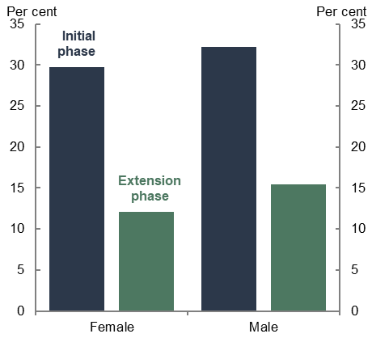 | - JobKeeper receipt by age (share of overall payments)  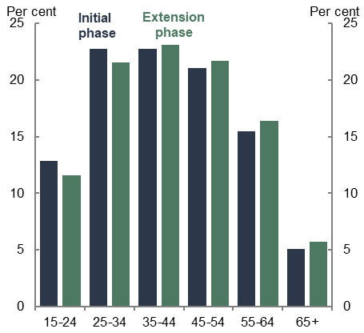
Source: ATO Taxation Statistics 2019–20; ABS Labour Force, Australia, Detailed.
In the extension phase, a higher proportion of recipients were male than in the initial phase, as male-dominated industries such as construction continued to be significantly impacted by the pandemic. The extension phase also introduced a tiered payment system based on previous hours worked. Overall, 87 per cent of individuals claimed Tier 1 payments and 13 per cent claimed Tier 2 payments. Those that claimed Tier 1 payments were more likely to be male (62 per cent) than female (38 per cent), which is roughly consistent with rates of full-time and part-time employment by gender. Tier 2 recipients were also more likely to be younger (15-24 years old) and older (over 65 years).

Business characteristics
The support largely flowed to small businesses. Table 4 presents an overview of the distribution of payments by entity size across the entire lifespan of the program. In the first phase, over 80 per cent of payments went to businesses with a turnover less than $50 million and not-for-profits. The largest businesses, with a turnover above $250 million, only received around 11 per cent of payments and accounted for 0.2 per cent of recipient entities. Sole traders were the most common entity type. These patterns continued in the extension phase.

Table 4: JobKeeper payments by business size
Entity size | Entities | % | Net Payment $b | %
A. Micro | 961,238 | 90.0% | 39.15 | 44.1%
B. Small | 66,750 | 6.2% | 15.29 | 17.2%
C. Medium | 16,802 | 1.6% | 12.12 | 13.6%
D. Large | 1,813 | 0.2% | 3.52 | 4.0%
E. Very large | 2,404 | 0.2% | 9.10 | 10.2%
F. Not-For-Profit | 19,031 | 1.8% | 9.62 | 10.8%
G. Super fund | 95 | <0.1% | <0.01 | <0.1%
H. Other | 15 | <0.1% | 0.02 | <0.1%
TOTAL | 1,068,148 | 100.0% | 88.82 | 100.0%
Source: ATO Taxation Statistics 2019–20.
Note: The entity size is based on total business turnover, and is defined as follows:
A. Micro – More than $0 but less than $2 million
B. Small – $2 million to $10 million
C. Medium – $10 million to $100 million
D. Large – $100 million to $250 million
E. Very Large – Over $250 million

Coverage by industry
Figure 2 shows the share of individuals and entities covered by JobKeeper across industries – Arts and Recreation Services had the largest coverage of employment, while Accommodation and Food Services had the largest coverage of entities. The largest portion of JobKeeper payments in the initial phase was distributed to large employing industries such as Construction; Professional, Scientific and Technical services; Health Care and Social Assistance; and Retail Trade. Payments relative to compensation of employees were highest in industries most affected by the restrictions, such as Arts and Recreation Services and Accommodation and Food Services.
All industries saw declines in the number and proportion of individuals covered in the extension phase. Almost a third (31 per cent) of all entities that operate in the Accommodation and Food Services industry were supported in the first 3 months of the extension phase of JobKeeper. Other industries that exhibited high shares of JobKeeper support in the first 3 months of the extension phase included Transport, Postal and Warehousing, Other Services and Arts and Recreation Services.

Figure 2: JobKeeper coverage by industry
- Share of pre-pandemic entities  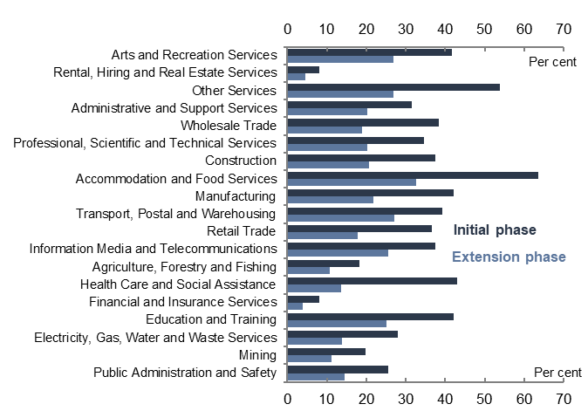 | - Share of pre-pandemic employment  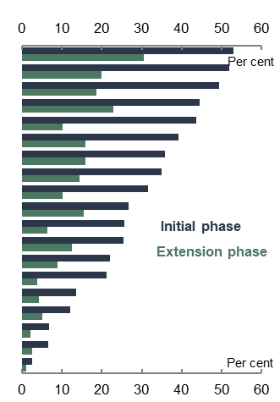
Source: ATO Taxation Statistics 2019–20.

Coverage by geography
Figure 3 shows the coverage of JobKeeper across individuals by state and territory. As a share of employment, Victoria and New South Wales (NSW) had the highest JobKeeper coverage and the Northern Territory the lowest. Victoria and NSW accounted for two-thirds of all entities and payments in the first phase, a slightly greater share than the states’ share of state final demand, reflecting the impact of the second wave of COVID-19 in Victoria in the September quarter 2020. Coverage of individuals supported by JobKeeper was relatively more evenly distributed across regions than it was across industries, reflecting the diversified nature of most regions and the widespread impact of health restrictions. The regions most reliant on JobKeeper were in Sydney and Melbourne metropolitan areas, the Gold Coast and the Mornington Peninsula.

Figure 3: JobKeeper coverage by state
- Total individual recipients  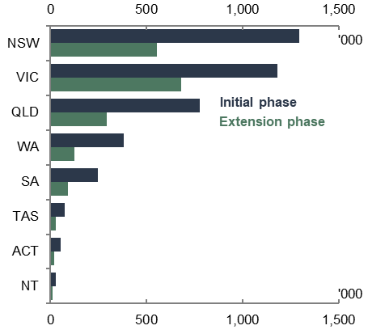 | - Proportion of April 2020 individuals  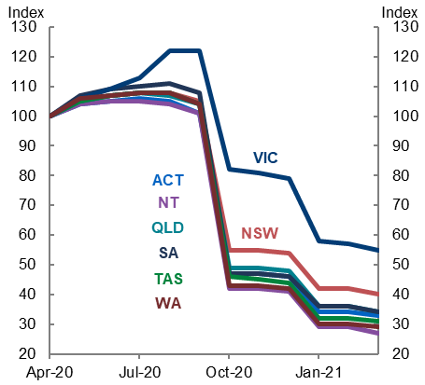
Source: ATO Taxation Statistics 2019–20.
Note: Panel A is the total number of individuals claiming JobKeeper by state and territory. Panel B shows the number of JobKeeper-nominated workers, indexed to equal 100 in April 2020.
The decline in JobKeeper coverage across each of the phases was experienced across all states and territories. This is largely due to the easing of restrictions and consequent improvements in economic activity.
Victoria exhibited the highest coverage of individuals as a share of pre-pandemic employment across the entire extension phase. This can largely be attributed to the second wave of COVID-19 and the associated lockdowns in Victoria. Victoria’s JobKeeper coverage was almost 18 per cent of total pre-pandemic employment in the first 3 months of the JobKeeper extension and around 11 per cent in the second 3 months, more than 4 percentage points above the national average in both periods.

Economic effects of JobKeeper
Key points
- JobKeeper was effective at preserving employment, supporting incomes and preventing large scale business failures during the pandemic (Finding 2). JobKeeper reduced uncertainty at a time when business and consumer sentiment was plummeting in response to the COVID-19 crisis. It showed that the government was committed to supporting businesses and workers through the pandemic. Its announcement was accompanied by a rebound in confidence.
- JobKeeper functioned as both a wage subsidy to employers and an income transfer to lower-earning workers. In the initial phase of the pandemic, it helped to preserve employee-employer relationships, provided income support to employees and businesses and alleviated labour market dysfunction. Estimates suggest that JobKeeper preserved between 300,000 and 800,000 jobs.
- JobKeeper initially had a strong positive effect on productivity by preventing otherwise competitive and productive firms from collapse. Over time, JobKeeper’s distortionary effects – most notably reducing labour mobility and the productive reallocation of labour and supporting unviable businesses – became more apparent.
- Minimising labour scarring was a key goal of JobKeeper. JobKeeper directly protected jobs and contributed to the economic recovery. The unemployment rate peaked in July 2020 and declined to be below its pre-pandemic level by mid-2021, indicating that risks of labour scarring had largely been averted. Sustained strength in the labour market supported young workers who are often more susceptible to scarring.

Early economic impacts of the COVID-19 pandemic
The pandemic had a significant impact on macroeconomic activity. Real GDP in Australia fell by 6.7 per cent in the June quarter 2020, the largest quarterly fall on record. Declines in output were even larger elsewhere. In the corresponding quarter, GDP declined by 7.8 per cent in Japan, by 9.5 per cent in the United States, by 12.1 per cent in the Euro area and by 20.4 per cent in the United Kingdom. Aggregate OECD GDP declined by 9.8 per cent.
In Australia, the scale of the impact on the labour market was unprecedented in the post-war era. The unemployment rate increased from its pre-pandemic level of around 5 per cent to 7½ per cent by June 2020, but this only captured part of the overall impact. Total hours worked declined by 10.1 per cent in April 2020 and around 1.8 million workers had their hours reduced, of which 760,000 worked zero hours for economic reasons. In addition to those who became unemployed or had their work hours reduced, almost 700,000 people left the labour force completely between March and May 2020.
High frequency and real time indicators showed that behavioural changes preceded the introduction of official restrictions. Voluntary behavioural changes saw discretionary travel and mobility – foot traffic, driving and public transport use – decline sharply from early March 2020 (Figure 4).

Figure 4: Discretionary travel and mobility
- NSW toll road volumes  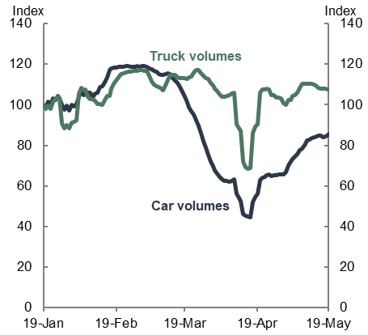 | - Apple Mobility Trends  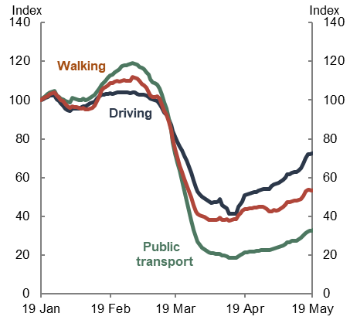
Source: Treasury analysis of Transurban and Apple data.
Note: 7-day rolling averages, indexed to equal 100 on 19 January 2020.
Real time indicators of consumer spending showed marked changes in consumption patterns from early March 2020. Initial spikes in essentials as consumers stockpiled essential goods for precautionary reasons were mirrored by sharp declines in discretionary consumer sales. Retail transactions for discretionary categories plummeted from mid-March 2020 (Figure 5).

Figure 5: Weekly transaction volumes growth
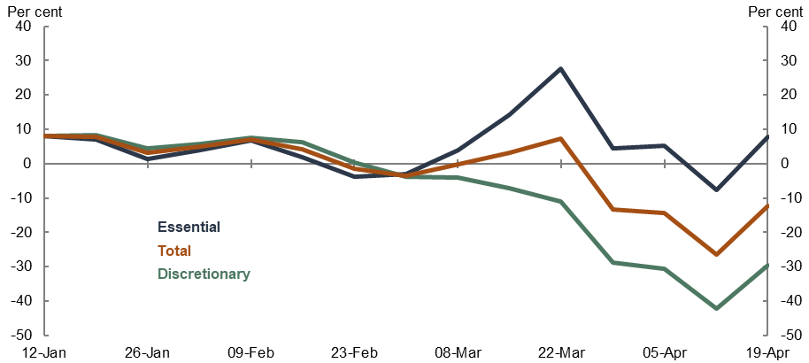
Source: Treasury analysis of bank spending data.
Globally, Purchasing Managers’ Index (PMI) activity indicators for major economies plummeted into deeply contractionary territory, highlighting widespread recession risks. Uncertainty rattled investors and spurred a global flight away from risky assets such as equities and corporate debt and towards cash. On 12 March 2020, the ASX200 fell 7.4 per cent while the United States’ S&P500 (Figure 6) and the United Kingdom’s FTSE 100 suffered the greatest single-day percentage falls since 1987. Stock exchanges in Indonesia, Japan and Hong Kong also saw prices plunge on the same day. The market turmoil on 12 March was attributed to the United States’ announcement of a travel ban from most of Europe and the World Health Organization’s (WHO) declaration of COVID-19 as a global pandemic. Typical safe-haven assets showed signs of strain in March 2020. US and Australian 10-year government bond yields increased by 65 and 88 basis points respectively between 9 and 19 March. Central banks, including the US Federal Reserve and the Reserve Bank of Australia, committed to purchase government bonds as necessary to support market function, provided additional liquidity to banks, and eased monetary policy; these measures restored market function and supported a reversal in bond yields.

Figure 6: ASX200 and S&P500
- S&P/ASX200 (Australia)  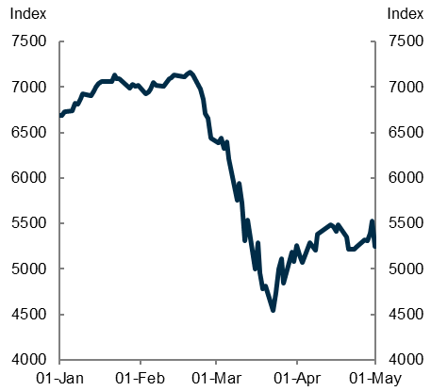 | - S&P500 (USA)  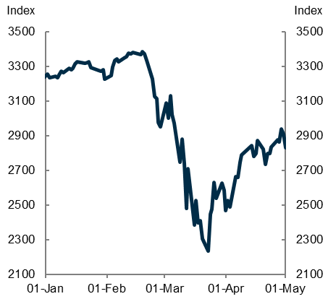
Source: Bloomberg.
The ABS surveyed businesses on the impacts of COVID-19 in mid-March 2020 and 86 per cent of all businesses reported that they expected to be adversely affected by COVID-19. By late March 2020, NAB and ANZ measures of business and consumer confidence had fallen at an unprecedented rate to record lows reflecting the high degree of uncertainty and restrictions on activity (see Chapter 3.2). The Westpac Melbourne Institute Consumer Sentiment Index fell by more than 21 points in March and April 2020, the sharpest two-month decline recorded since the Index began in 1974.
In the fortnight to 3 April 2020, nearly half (47 per cent) of Australian businesses reported having made staffing changes owing to COVID-19. The ABS Business Indicators, Business Impacts of COVID-19 survey for May 2020 found that a quarter (24 per cent) of businesses surveyed reported laying off staff in response to COVID-19. Job separations in what would become JobKeeper-nominated businesses almost doubled from mid-March to the end of the month (Figure 7). These results highlight many JobKeeper-nominated businesses were amongst the most adversely affected by the initial COVID-19 shock prior to JobKeeper’s announcement.

Figure 7: Job separations (indexed) by JobKeeper status
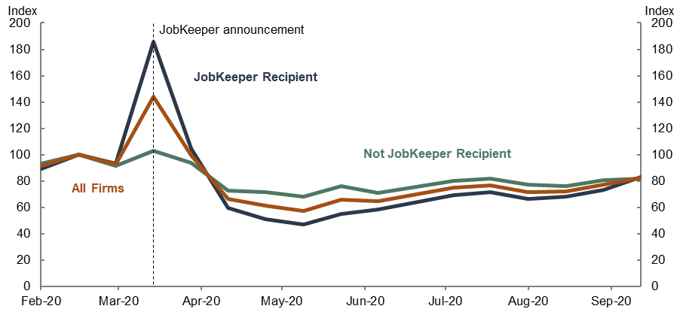
Source: Treasury analysis of de-identified administrative data (STP data linked to JobKeeper status).
Note: Figure 7 presents fortnightly time series of job separations, indexed to equal 100 in the fortnight ending 1 March 2020. Separations are based on cease dates for a worker’s employment relationship with a business (it can include workers who were on zero pay). Series exhibits volatility around end of financial year, which has been corrected. Based on employees in STP data on weekly or fortnightly pay cycles.

Short-term effects of JobKeeper
The announcement of JobKeeper on 30 March 2020 affected economic outcomes through several different channels:
- Reducing uncertainty and improving confidence
- Preserving employee-employer relationships
- Supporting business viability
- Supporting employee and business incomes.

Uncertainty and confidence
The most immediate effect of JobKeeper was through the confidence channel. Although it is difficult to isolate JobKeeper’s direct effect on confidence, sharp falls in consumer confidence and business sentiment began to reverse almost immediately after the announcement of JobKeeper (Figure 8). The ANZ measure of consumer confidence increased by 10 per cent to be above 70 in the week following the announcement. Business confidence also improved immediately following the announcement. JobKeeper was influential in 44 per cent of business’ decisions to retain staff during the pandemic. These results are consistent with experience in the United Kingdom and New Zealand when their wage subsidies were announced.

Figure 8: Consumer and business confidence
- ANZ consumer confidence  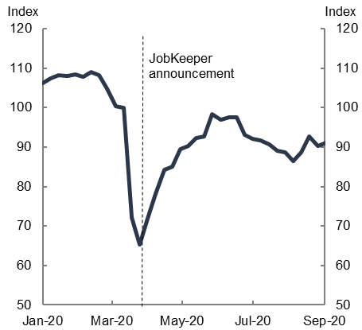 | - NAB business confidence  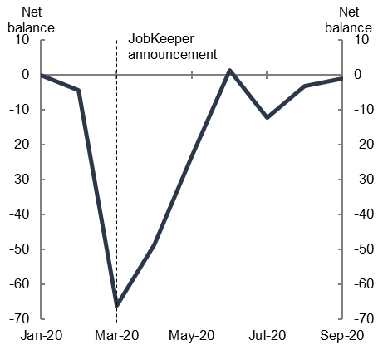
Source: ANZ-Roy Morgan and NAB
Note: Panel A presents weekly time series of consumer confidence, indexed to equal 100 in the week ending 15 March 2020. The announcement of JobKeeper was captured in the last week of March 2020. Panel B presents monthly time series of business confidence, so the impact of the announcement was captured in observations following March.

Supporting employment
There is clear evidence that JobKeeper had a significant and immediate positive impact on supporting employment during the crisis. There is also evidence that the employment benefits of JobKeeper were concentrated in the early months of the pandemic and had significantly dissipated by the end of the program.
Published studies suggest that in the initial stages of the fiscal response to the pandemic and when uncertainty remained elevated, between roughly 300,000 and 800,000 jobs were estimated to be saved directly by JobKeeper. Bishop and Day (2020) produced the first estimate of JobKeeper’s direct effect on employment, estimating at least 700,000 jobs were saved in the first 4 months. Over JobKeeper’s entire lifespan, Watson, Tervala and Sainsbury (2022) found it preserved around 812,000 jobs. Borland and Hunt (2023) contend that jobs-saved estimates were likely upper bounds given the technical assumptions used in the calculations and the limited external validity of the results.
Bradshaw, Deutscher and Vass (2023) estimate jobs saved directly by JobKeeper to be within the range of 300,000 to 700,000 in mid-to-late April 2020. By the end of the initial phase, the analysis finds up to 400,000 jobs were directly preserved by JobKeeper. The authors estimate JobKeeper’s employment effects using a quasi-experimental method (fuzzy regression discontinuity) using employee eligibility conditions for identification. As explored in detail later in this chapter and in Chapter 6, a notable challenge in estimating the jobs saved by JobKeeper is the difficulty in identifying the appropriate counterfactual. The estimation technique employed by Bradshaw et al. circumvents this issue.
Bradshaw et al. also found that the spill-over of JobKeeper’s employment effects to ineligible workers within firms ‘were likely modest at best’ in the initial phase. The employment effects on the ineligible population would have depended largely on whether their labour was complementary or substitutable with the labour of eligible workers. Treasury analysis of business microdata shows jobs losses were largely borne by employees in ineligible businesses and ineligible employees in JobKeeper-nominated businesses (Figure 9, Panel A).
Aggregate employment was 8.1 per cent lower at the end of April 2020 compared with the start of March 2020 (Figure 9, Panel B). Within businesses that were eligible for JobKeeper, payroll jobs held by non-JobKeeper-nominated employees declined by around 50 per cent while payroll jobs for JobKeeper-nominated workers declined by around 5 per cent over this period. Early estimates suggested JobKeeper-eligible workers were at least 7 percentage points more likely than ineligible workers to maintain employment to May 2020.

Figure 9: Changes in payroll jobs (indexed)
- By JobKeeper status (JobKeeper businesses)  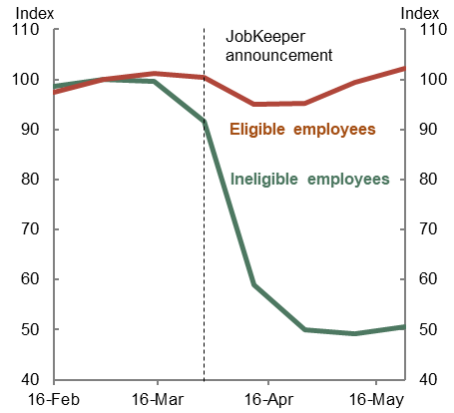 | - Aggregate  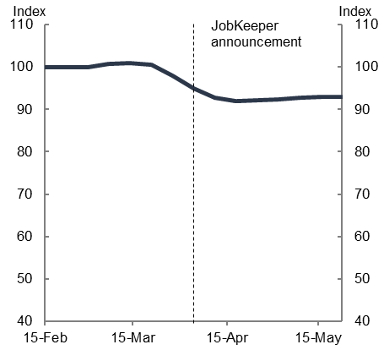
Source: (a) Treasury analysis of de-identified administrative data (STP data linked to JobKeeper status); (b) ABS Weekly Payroll Jobs and Wages in Australia, Week ending 30 May 2020.
Note: Panel A presents fortnightly time series, indexed such the cohorts’ share of all payroll jobs is equal to 100 in the fortnight ending 1 March 2020. Payroll jobs include all employee-employer relationships with pay, including any JobKeeper amounts, in the given fortnight. Series are shown for: payroll jobs in recipient businesses split by those that became JobKeeper-nominated versus those that did not. Panel B presents weekly time series, indexed to equal 100 in the week ending 29 February 2020.
Among Xero subscribers (which are predominantly small businesses) employment fell by 13 per cent from the beginning of March 2020 to the end of April. A feature of the Xero data is its ability to distinguish people by employment status, which shows that payroll jobs within Xero businesses fell least for ongoing full-time employees (down 2 per cent) and ongoing part-time employees (down 5 per cent) and by most for casual employees (down by 25 per cent).
JobKeeper’s direct effect fell away and lost significance as restrictions were eased, aggregate employment rebounded, and the economy recovered. While subsidised wages incentivised businesses to retain eligible employees early in the crisis or reengage them as the economy reopened, additional labour demand was filled by the ineligible worker population (Figure 10, Panel A). There is also evidence that, within JobKeeper-eligible businesses, non-JobKeeper workers were more likely to move into different jobs after being stood down or let go in the initial shock compared with JobKeeper workers (Figure 10, Panel B). This trend became more apparent over time.

Figure 10: Paid jobs in JobKeeper-eligible firms in 2020
- JobKeeper-nominated workers  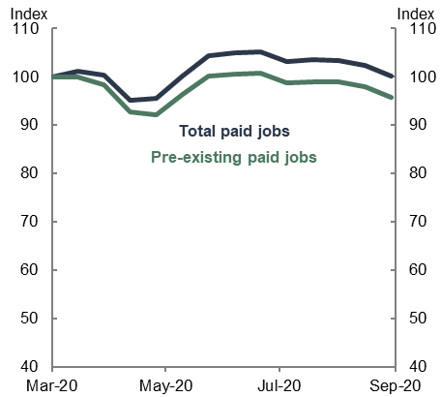 | - Non-JobKeeper-nominated workers  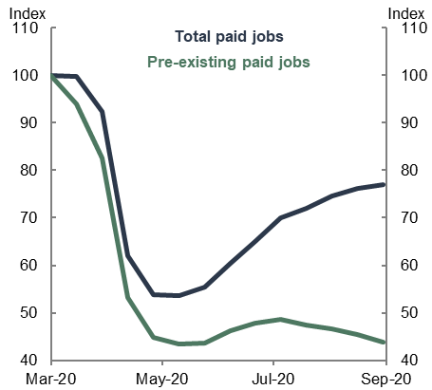
Source: Treasury analysis of STP
Note: Both panels present fortnightly time series, indexed to equal 100 in the fortnight ending 1 March 2020. Pre-existing jobs are defined as those that existed before 1 March 2020. Since all JobKeeper-nominated jobs had to be ‘pre-existing’ the difference between the 2 lines in the left panel is due to differences in whether the pre-existing job happened to have pay in the fortnight ending 1 March. Data is fortnightly.
Most JobKeeper-nominated workers maintained their relationship with their JobKeeper employer once they were transitioned off the policy. At the end of the initial phase in September 2020, just under 1.8 million employees (excluding eligible business participants) transitioned off JobKeeper and, over the following months, around 186,000 of these employees lost their JobKeeper jobs while 68,000 lost employment altogether. Within months of JobKeeper’s conclusion in March 2021 when 835,000 employees transitioned off the program, around 96,000 lost their JobKeeper jobs and 41,000 lost employment altogether.
Job loss among JobKeeper recipients was highest in the cohort of ‘vulnerable’ employees who worked zero or low hours whilst on the payment. Program data showed the number and share of vulnerable JobKeeper workers declined over time, reflecting improved hours worked. Despite this, jobs lost by vulnerable employees accounted for 50 per cent of JobKeeper jobs lost in the months after both the end of the initial phase in September 2020 and after JobKeeper’s conclusion in March 2021.
While JobKeeper support had a clear significant positive effect on employment headcount in the early months (April to June 2020), it had a negative effect on average hours worked because it subsidised the reduction of hours and standing down of employees. This is a typical feature of job retention schemes like JobKeeper, which aim to avoid unnecessary layoffs by subsidising the wages of stood down workers or those on reduced hours.
As restrictions eased, JobKeeper-nominated firms were incentivised to expand the hours worked by their JobKeeper-eligible employees. By engaging these employees and generating revenue, JobKeeper shifted from an income transfer for the stood-down workers to a wage subsidy for the businesses. Walkowiak (2021) suggested that given these incentives, firms may have also reduced underemployment amongst their part-time JobKeeper-eligible employees with subsidised wages.
Box 1: The effects of job retention scheme generosity
In response to the COVID-19 health and economic crises, many OECD economies implemented job retention schemes to mitigate and prevent the worst effects of the pandemic. These schemes supported about 60 million jobs across almost all OECD countries by preserving employee-employer relationships.
Job retention schemes differed by design features and duration, according to the national circumstances and requirements. The generosity of job retention schemes also varied across countries, providing an insight on the effects of payment rate designs (see Chapter 4.2).
Wage subsidies like JobKeeper are typically more generous and broader in scope than STW schemes. Both support incomes for stood down workers and those on reduced hours. Wage subsidies can also provide support for active eligible businesses, incentivising their take-up of support. During the pandemic, greater participation supported more jobs saved.
Evidence from European job retention schemes supports the link between generosity, take-up and employment dynamics. That is, higher generosity (higher replacement rate) and broader support (looser eligibility criteria) corresponded with greater participation in schemes. A separate case study of the German Kurzarbeit scheme, a relatively modest job retention scheme, provides evidence that greater take-up can significantly dampen labour demand shocks by preserving employment. These studies found more pronounced effects in contact-intensive sectors most affected by the pandemic such as retail trade and hospitality.
The link between generosity, take-up and employment dynamics was weaker in JobKeeper’s context, largely based on relatively narrow eligibility criteria (see Chapter 4.3). OECD analysis found that JobKeeper was relatively generous to eligible workers, particularly lower wage workers, and to businesses. On the other hand, JobKeeper’s coverage was less comprehensive compared to other pandemic job retention schemes. For example, JobKeeper covered around one-third of Australian employment while New Zealand’s wage subsidy scheme covered 65 per cent of New Zealand employment, the highest coverage in the OECD. Nonetheless, estimates suggest JobKeeper directly saved between roughly 300,000 to 800,000 jobs that would have otherwise been lost.

Business viability
Supporting businesses through the crisis was a key objective of several policies announced in late March 2020. JobKeeper operated alongside substantial temporary relief measures including the Cashflow Boost and policy changes to reduce the threat of actions that could unnecessarily push businesses into insolvency. In combination, these policies played an important role in mitigating the threat of unnecessary business insolvencies and closures due to COVID-19. Notably, company insolvencies in May 2020 were lower compared with May 2019 (by 38 per cent) and lower compared with previous downturns.
JobKeeper mostly supported businesses that were heavily affected by the initial pandemic shock. JobKeeper businesses suffered a median turnover decline of 28 per cent in the June quarter 2020 and 23 per cent in the September quarter 2020. Survey evidence provided by Sensis suggests 44 per cent of businesses would not have survived without JobKeeper.
These results are consistent with findings presented in the United Kingdom’s evaluation of the Coronavirus Job Retention Scheme (CJRS). During the CJRS, the median turnover decline in recipient United Kingdom businesses was 27 per cent. Around 72 per cent of businesses supported by the CJRS experienced a turnover decline compared to 40 per cent among other businesses. Similarly, New Zealand’s wage subsidy scheme ‘supported firms experienced disproportionately larger revenue losses than unsupported firms.’ The outcome evaluation of this program estimated the subsidy mostly had a positive effect on firm survival rates over a 12-month horizon following support.
At the end of the initial phase of JobKeeper in September 2020 and at the conclusion of the overall program in March 2021, there were short-lived spikes in business exits among firms that received JobKeeper up until these points. The spikes in business exits were slightly more pronounced in March 2021, in small businesses, and in industries deemed vulnerable – those expected to have a higher reliance on JobKeeper – such as Accommodation and Food Services, Retail Trade, and Arts and Recreation Services. This evidence suggests that in the latter phases of JobKeeper, the payment may have only delayed exits for some recipient businesses since those that remained on the payment were likely to be less viable.

Income support and equity benefits
JobKeeper provided income support for both employees and firms for income lost owing to the pandemic. In aggregate, income support provided by JobKeeper has been found to offset the negative impact of the pandemic on Australian gross income for most of the policy’s lifespan.
While this finding may be true in aggregate, it is not necessarily true at the individual level. Among employees, those who were ineligible received no income support at all through JobKeeper and they were more likely to lose employment. In many cases, ineligible employees may have received income support from other sources such as JobSeeker. There is also evidence that some employees were overcompensated for lost income. Around 11 per cent of JobKeeper recipients received more from JobKeeper compared with their pre-pandemic earnings including those who previously worked relatively few hours but received the flat JobKeeper Payment in the first phase. Contemporaneous international schemes partially compensated employees for lost income caused by the pandemic but not fully. These issues are explored further below in Chapter 4.2.
JobKeeper’s initial flat rate of $1,500 per fortnight reduced wage inequality in Australia. Lower income individuals were both more likely to be on JobKeeper and the flat rate payment was a larger share of their pre-pandemic wages. Treasury analysis (2021) found initial JobKeeper support was concentrated in the lower 3 quintiles of the employment income distribution (Figure 11). Breunig and Sainsbury (2023) reached similar conclusions with respect to the broader COVID-19 fiscal support. The authors found the upwards shift in the income distribution was concentrated in 3 places: higher population mass at the lower‐middle and upper‐middle segments of the income distribution, and lower population mass at the bottom of the income distribution.

Figure 11: Income source as share of March income, by quintile
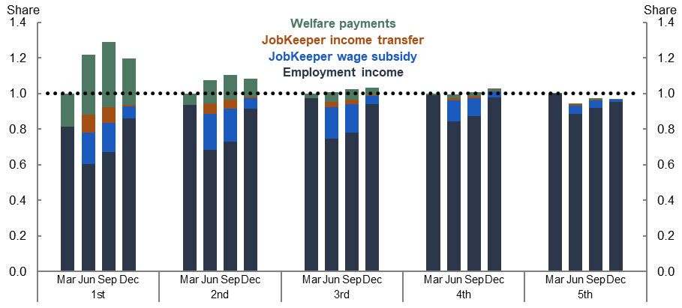
Source: Treasury analysis of Labour Market Tracker Data and ABS Australia National Accounts: National Income, Expenditure and Product (Cat. No. 5206.0).
Note: Only covers employment and welfare income. Business, investment or other income excluded. Workers assigned income quintile based on 2019 wage and salary income. As such those without wage income in 2019 are excluded.
The contribution of JobKeeper payments to income dropped in December 2020 across the distribution as the payment was scaled back and fewer workers received JobKeeper. Analysis of Household, Income and Labour Dynamics in Australia (HILDA) data suggests that among those that received JobKeeper, the top 40 per cent of earners in Australia experienced income declines while incomes rose for the remaining 60 per cent of workers.
A counterpoint noted by Borland and Hunt (2023) is that the equity benefits of JobKeeper were dampened by the fact that JobKeeper was also a transfer for businesses that remained active. Business owners and shareholders who are generally towards the top of the income distribution therefore also received a boost to business, investment, and other non-employment income. These forms of income are not included in Figure 11.
Murphy (2023) examines the extent to which businesses were able to make windfall gains through JobKeeper by manipulating their production and active employment. In doing so, Mr Murphy demonstrates that some businesses could have received approximately $2 of JobKeeper for every $1 lost by doing so.

Broader macroeconomic effects
JobKeeper was the largest component of the government’s fiscal response to the pandemic. By preventing loss of employment, business failures and supporting incomes it contributed to supporting aggregate demand when the crisis was at its worst and uncertainty at its highest. It also helped to limit a reduction in the productive capacity of the economy and pave the way for a rapid recovery.
Estimates of JobKeeper’s output multiplier range from around 1.3 to 1.5. The multipliers suggest between roughly $0.23 to $0.36 of every JobKeeper dollar dispersed was consumed by recipients. These estimates are indicative only and should be treated with caution as quantitative estimates of the macroeconomic effects of JobKeeper are inherently unreliable. It is not possible to identify a robust counterfactual given the extraordinary and unquantifiable uncertainty that existed in the peak of the crisis in March–April 2020 and in the absence of any modern Australian experience of a global pandemic. We do not know with any degree of certainty what would have happened to employment and output in the absence of JobKeeper. Moreover, it is difficult to disentangle the impacts of the different elements of the fiscal and monetary policy response to the crisis.

Medium and longer-term effects of JobKeeper

Labour mobility and productivity
Labour mobility fell sharply during the initial months of the pandemic (Figure 12). This reflected a combination of pandemic-related circumstances, extreme uncertainty and the introduction of JobKeeper which was designed to maintain pre-pandemic employment relationships.
There is a well-established body of literature covering the importance of labour mobility or ‘dynamism’ for productivity growth. Labour mobility and job switching ensures workers are employed in roles that suit their preferences and skills. As labour is reallocated to more productive firms, aggregate labour productivity increases and the economy benefits. Productivity-enhancing labour reallocations in Australia have declined in recent years and can account for roughly one-quarter of the slowdown in labour productivity growth.

Figure 12: Labour mobility
- Share of workers with a new job  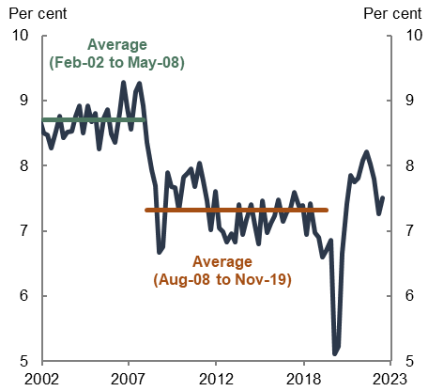 | - Job switching rate  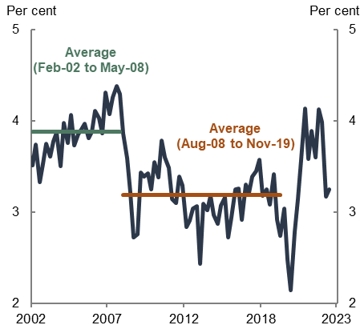
Source: Treasury analysis of ABS Labour Force microdata.
Note: New jobs defined as having a tenure of less than 3 months. Data are not seasonally adjusted.
With JobKeeper’s support, the resilience of high productivity firms to the pandemic in the initial phase boosted aggregate labour productivity. Andrews, Hambur, and Bahar (2021) estimated that aggregate labour productivity increased between 4¼ and 5½ per cent over the pandemic, compared to the counterfactual where reallocation and productivity were not linked. Roughly half of this gain over the initial phase (2¾ per cent) is attributed to JobKeeper which disproportionately shielded high productivity – and liquidity constrained – firms.
The benefits of supporting high productivity firms were noticeable at the conclusion of the initial phase. JobKeeper’s first 6 months limited the scarring effects of the associated recession by preventing indiscriminate premature exits and layoffs amongst high productivity firms. Once ineligible businesses exited JobKeeper, more labour flowed towards these firms contributing to labour productivity gains.
The extension phase likely preserved more jobs in lower productivity businesses. This phase curtailed some productivity-enhancing reallocations by preserving jobs in less productive businesses. Although this phase was more distortive than the initial phase, there is no evidence to suggest JobKeeper facilitated widespread ‘zombification.’ Andrews, Charlton and Moore (2021) provide evidence that the reallocation-productivity link remained intact amongst both the JobKeeper eligible and ineligible workforces across the pandemic. The stronger link amongst ineligible employees suggests opportunities for growth in high productivity businesses were not crowded out by JobKeeper’s continued support for businesses that would have otherwise restructured or exited.
These results support analysis from Borland and Hunt (2021) who found JobKeeper had a small and short-lived impact on output by preventing labour reallocation. The small cost of missing productivity growth from the limited dynamism is attributed by the authors to JobKeeper covering one quarter of Australia’s workforce at its peak. Further, the lack of job destruction at the transition and graduation points suggests that these negative productivity effects from preserving jobs in lower productivity businesses were perhaps even smaller.

JobKeeper and labour scarring
One purpose of keeping people connected to their employers during the COVID-19 recession was to avoid labour scarring. Labour scarring relates to the adverse, longer-term effects a worker experiences from downturns. Effects of labour scarring can include lower chances of employment overall, slower career progression and lower incomes. These effects are most salient in the aftermath of economic downturns, especially those characterised by high unemployment.
Labour scarring can have economy-wide implications. When labour is underutilised, economic output is reduced. Human capital starts to wane as skills and knowledge are lost or not used. Business specific human capital (linked to a particular business and worker pair) can also be lost, reducing economic potential.
Box 2: Literature on labour scarring
Studies on labour scarring published prior to 2020 point to many of the lingering negative effects of a period of high unemployment. Most literature finds negative effects on workers such as lower earnings and fewer employment opportunities.
Professor Borland finds that individuals entering the labour market during downturns have worse outcomes. When the youth unemployment rate is 5 percentage points above average, earnings for graduates is about 8 per cent lower at the time of entry and 3.5 per cent lower 5 years after entry. Farber finds that workers who lost their jobs during the Global Financial Crisis (GFC) period experienced very low rates of reemployment and difficulty finding full-time employment. Kroft et al. finds a reduced chance of receiving a call back for an interview which decreases with the length of unemployment. For good reason, the OECD and ILO raised labour scarring for young people as a key issue during COVID-19.
During COVID, concerns around labour scarring continued as labour programs were introduced. The US Bureau of Labour Statistics (BLS) published surveys from 2020 and 2021 and found that job recovery had so far been more rapid than previous recessions, but labour force participation has not recovered from declines seen through the pandemic. A Treasury research paper in 2020 found that graduating into a labour market with 5 percentage point higher youth unemployment had earnings that were 3½ per cent lower after 5 years. Day and Jenner found that regions with larger downturns have higher unemployment rates decades after the initial shock.
Labour scarring can have larger impacts on more vulnerable groups. e61 notes that those not in employment, education or training (NEET), those that have not completed Year 12 and Aboriginal and Torres Strait Islander people may be more susceptible to economic shocks. Ongoing monitoring of labour market outcomes for these groups is warranted.
Recovery from periods of high unemployment can take many years. It took almost a decade for the unemployment rate to recover to its pre-recession level following the 1990s recession and the rate of unemployment never returned to its pre-GFC level after the GFC (Figure 13).

Figure 13: Unemployment rate in Australia during economic slowdowns
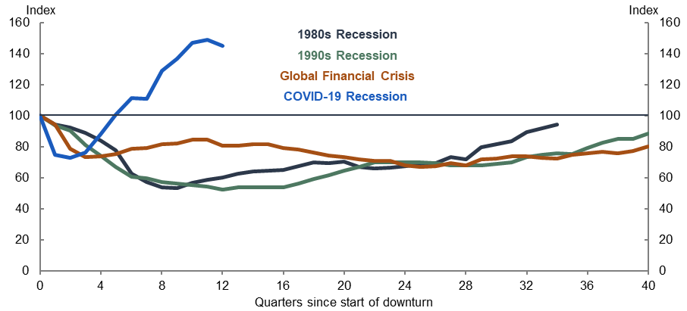
Source: ABS Labour Force Survey 2023.
Note: Vertical axis is average quarterly unemployment rate, indexed to equal 100 in the quarter before the downturn. The vertical axis has been inverted.
The trajectory of the unemployment rate during COVID-19 was atypical because the shock was extraordinary. Concerns around scarring at the outset of COVID-19 in part reflected the experience from previous slowdowns. Initially, the labour market impact of COVID-19 was more severe than recent periods of sharp increases in unemployment. Equally, the recovery was also much faster and stronger. The removal of health restrictions and consequent re-opening of large parts of the economy, supported by JobKeeper and other stimulus, paved the way for a rapid fall in the unemployment rate.

JobKeeper and new labour market entrants
Recent graduates, new entrants and those who were not employed prior to the onset of COVID-19 were not directly supported by JobKeeper. Complementary policies were introduced to assist these groups to enter or remain in training or education, including Boosting Apprenticeship Commencements (BAC) and the JobTrainer fund. The scale and stimulus effect of JobKeeper contributed to the broader economic and labour market recovery which assisted recent labour market entrants.

JobKeeper design features
The experience designing and implementing JobKeeper offers valuable lessons against the possibility that a similar policy be adopted in future (see Chapter 7). In the circumstances of March 2020, the need for simplicity and speedy implementation using available systems necessarily required trade-offs and compromises in JobKeeper’s design. Policymakers were conscious that there was scope to improve JobKeeper’s design as experience with implementation was gained and more information became available about the nature of the challenges presented by the pandemic. They took steps to do so following the three-month review.
As discussed in Chapter 3, JobKeeper was successful in achieving the government’s objectives. Nevertheless, submissions, academic studies and interviews with key stakeholders provide a source of information and analysis on the opportunities to improve on JobKeeper’s design should a similar policy be needed in future. These opportunities relate to eligibility criteria, the payment rate and issues around the timing, flexibility and targeting of payments. This chapter explores these issues and draws conclusions in support of Finding 7.

Timing and flexibility
Key points
- Speed and timeliness are critical to policy effectiveness during a crisis. While JobKeeper was implemented efficiently after its announcement, evidence suggests that an earlier commitment to the policy would have increased its efficacy (Finding 7.b).
- Building more flexibility into the design of JobKeeper such that it could adapt and respond to evolving economic and health conditions would have improved outcomes. An earlier switch from prospective to retrospective turnover thresholds would have improved the targeting of JobKeeper payments (Finding 7.a).
- An earlier move to retrospective payments would also address many of the concerns around overcompensating some businesses without the uncertainty, costs and potential adverse incentives introduced by a clawback mechanism.
- There is scope for further investment in real time data development and associated analytical capacity to better equip policymakers to respond quickly and ensure policy settings reflect developments in conditions during future crises.

Earlier introduction of JobKeeper
Speed and timeliness were critical to the effectiveness of pandemic policy responses. While JobKeeper was implemented efficiently after its announcement, evidence suggests that an earlier commitment to the policy would have increased its efficacy.
The JobKeeper Payment was announced on 30 March as the economic effects of the pandemic were unfolding. Before JobKeeper’s introduction, significant changes in behaviour driven by the pandemic had clear implications for the economy and labour market (for more details see Chapter 3). Between 18 and 24 March, states and territories announced or scaled up restrictions including limits on public gatherings, border closures and social distancing rules. These announcements reinforced the behavioural changes already evident. In the 2 weeks prior to JobKeeper there was a large increase in applications for income support (Figure 14). Job separations increased in the weeks prior to JobKeeper. This trend reversed sharply immediately after the announcement. By May, entities that received JobKeeper started to increase their staff levels (Figure 15).

Figure 14: Income support flow for individuals on the first phase of JobKeeper
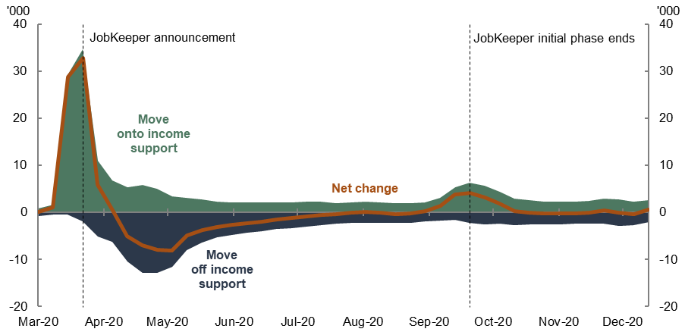
Source: Treasury analysis of de-identified administrative data (linked STP and welfare payment microdata).
Note: Income support includes Newstart Allowance (prior to 20 March 2020), JobSeeker Payment (from 20 March 2020) and Youth Allowance (Other). Flows onto and off income support payments include flows from nil rate recipient status to being in receipt of a payment. Two-week moving average.

Figure 15: Separations and jobs by JobKeeper status and turnover
- Separations  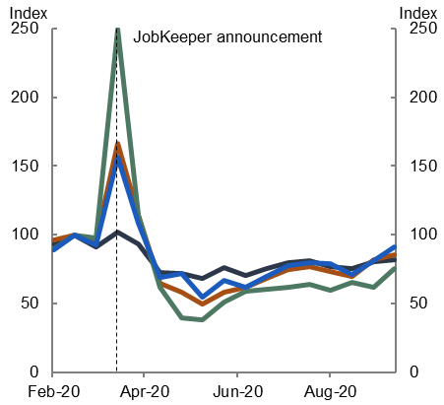 | - Jobs  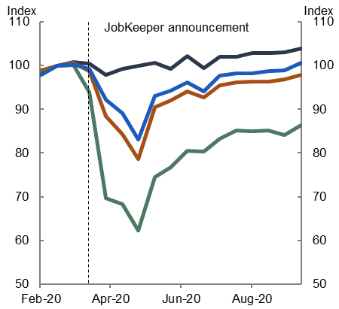
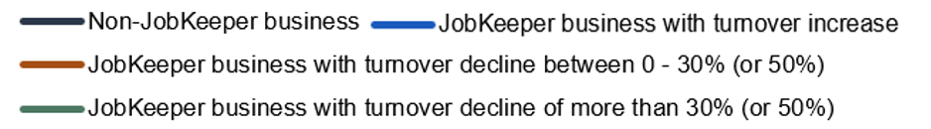
Source: De-identified administrative data (STP and BAS data linked to JobKeeper status).
Note: Figure 15 presents fortnightly time series of job separations and payroll jobs, indexed equal to 100 in the fortnight ending 1 March 2020. Separations are based on cease dates for a worker’s employment relationship with a business (it can include workers who were on zero pay). Series exhibits volatility around end of financial year, which has been corrected. Payroll jobs are based on employee-employer relationships with pay, including any JobKeeper amounts. Dashed line indicates start of JobKeeper. Turnover analysis is based on June quarter 2020 data compared to a year earlier.
An earlier introduction would have resulted in improved outcomes for a large number of Australians that initially lost employment but were subsequently reemployed once JobKeeper was introduced (Figures 14 and 15). There is a significant body of evidence around the importance of employment for individual well-being and the negative effects of unemployment on well-being. The well-being benefits of maintaining employment connections include social and psychological benefits of being employed, such as social interactions and a sense of connection and purpose. Exposure to unemployment is linked to increased psychological distress, depression and anxiety. Negative effects can occur even without serious financial strain. International evidence suggests that well-being loss associated with unemployment is long-lasting and is only partly mitigated by income support through unemployment benefits and future re-employment.
The benefits can be difficult to quantify but the literature suggests they are likely to be substantial. In an Australian context, Atkins (2020) finds there was a significant mental health benefit associated with maintaining employment during the pandemic. More generally, Carroll (2005) estimates that the loss of well-being associated with being unemployed is equivalent to $42,100 (2001 dollars) for Australian men and $86,000 for Australian women. On the other hand, the evaluation of New Zealand’s COVID wage subsidy scheme, uses a value of $8,405 (2023 NZD) as the well-being benefit of being employed compared with being unemployed.
Several submissions to the evaluation suggested that an earlier commitment to JobKeeper would have led to better outcomes. This view is supported by the academic literature. Borland and Hunt (2023) find that an earlier introduction could have resulted in more jobs being retained. The study compares the New Zealand and Australian supports. In both countries, the drops in GDP were similar and job losses stopped after wage subsidy policies were announced. In New Zealand, the wage subsidy was announced on 17 March, 13 days earlier than JobKeeper. In New Zealand, the labour market adjustment came almost entirely through a reduction in hours worked, while in Australia the adjustment came via employment.
In its submission, the Australian Council of Trade Unions (ACTU) noted that it had called for the introduction of a wage subsidy before the announcement of JobKeeper, arguing that similar schemes were operating in other countries. Similarly, the Business Council of Australia (BCA) noted that introducing JobKeeper sooner may have saved more jobs. In its submission, the BCA compares the experience of Australia and New Zealand and observed that Australia suffered a greater loss of employment in the early stage of the pandemic.

Improved flexibility and adaptability
There is considerable literature that emphasises the need for wage subsidies to be designed such that they can adapt to economic conditions and developments. In Job retention schemes during the COVID-19 lockdown and beyond, the OECD considers the design of job retention schemes introduced by member countries during 2020 and finds that ‘job retention support should be time-limited, but limits should not be set in stone.’ This emphasises the need for flexibility as part of policy design, and to consider when and under what circumstances to wind down programs.
Cassells and Duncan (2020) suggest that a wage subsidy that is flexible to respond to economic conditions as they arise will help minimise distortions. Watson, Tervala and Sainsbury (2022) state that policy trade-offs between speed and quality should be announced early, provide an overwhelming level of economic support to meet the relevant economic challenges, but also provide flexibility to calibrate and adjust the measure once it has been introduced to ensure that it is well targeted and cost effective.
Several European countries scaled up STW schemes in response to COVID-19. These schemes are directly tied to reductions in work hours and hence operate in a similar manner to automatic stabilisers in the sense that the level of support provided automatically adjusts to economic developments. It would likely be difficult for a wage subsidy to be this adaptable. New Zealand demonstrated that one way to come closer to such a system is by linking the reintroduction of the wage subsidy to health restrictions.
Many experts and stakeholders hold a view that JobKeeper could have been better designed to adapt to the rapidly changing health and economic developments. One criticism is that it did not adequately consider a rapid, V-shaped recovery following the onset of COVID-19 as suggested by literature on economic crises stemming from pandemics. In his submission, Mr Murphy contended that overcompensation in the JobKeeper program was partly linked to the pre-commitment to a 6-month payment duration ‘whereas the national lockdown that prompted JobKeeper only lasted 2 months.’ When a no-COVID-19 world is used as a counterfactual scenario (a ‘V-shaped’ recovery), analysis suggests JobKeeper went beyond a macroeconomic stabilisation policy tool and over-compensated many households and businesses. Mr Murphy went on to argue that subsequent Commonwealth and state programs were linked to the (uncertain) duration of lockdowns.
In his submission, Mr Goding similarly linked the projected decline in turnover test and the relatively lengthy support at the start of the program to profiteering and wastefulness. He suggested a more flexible approach to the timing of the payment may have led to fewer payments going to businesses that had reopened and were not at risk of firing employees.
The Australian Chamber of Commerce and Industry (ACCI) raised shorter than expected lockdowns in its submission, noting that the first phase of reopening commenced around 10 weeks after the lockdowns began. The submission states that while there were restrictions on some industries, many businesses quickly recovered and no longer required the assistance JobKeeper provided.

Adopting retrospective turnover tests sooner
Switching to a retrospective turnover test as soon as practicable would be an effective way to achieve adaptability and targeting in wage subsidy design. Retrospective eligibility testing reduces scope for payments to businesses that may no longer need them as economic conditions improve. In this way, retrospective turnover testing can achieve similar results to an automatic stabiliser, with the scope of support provided adjusting as conditions change. This feature guards against the risk that conditions change suddenly in the presence of a policy with a fixed time commitment.
The benefits of retrospective turnover tests were recognised by JobKeeper’s designers, who shifted to a retrospective turnover test in the extension phase of JobKeeper. A lesson for the future is that a clear upfront commitment to move to a retrospective test as soon as possible – for example, at the three-month mark – could improve targeting and efficiency while also providing certainty around the duration of the policy.

Targeting of payments: Retrospective eligibility versus a ‘clawback’ mechanism
A common criticism of JobKeeper is that payments were not tightly enough targeted to firms that needed support. Treasury’s Insights from the first six months of JobKeeper concluded that $27 billion of JobKeeper payments were paid to businesses whose turnover did not decline by at least 30 per cent (or 50 per cent) compared with a year earlier. Treasury also estimated that at least $4.9 billion was paid to growing or restructuring businesses that had higher through the year turnover. These businesses were eligible for alternative turnover tests to demonstrate that they were adversely affected by the pandemic.
Many commentators, academics and stakeholders argue that a ‘clawback mechanism’ should have been included in JobKeeper’s design to enforce repayment of funds from firms that didn’t meet the turnover thresholds ex-post. The ACTU was a prominent advocate for the inclusion of a claw-back mechanism. The ACTU labelled JobKeeper’s targeting and integrity mechanisms inadequate given many recipient companies ended up with significant increases in turnover in the period for which they claimed support. Mr Goding’s submission to the evaluation argued that the absence of a claw-back was ‘at odds with community expectations’ and contributed to ‘profiteering and wastefulness’.
An evaluation of the Commonwealth’s fiscal response to the pandemic chaired by Peter Shergold AC with the assistance of a secretariat from the e61 Institute also recommended a clawback mechanism in future policy responses. This evaluation suggested payments to businesses which did not end up meeting the turnover test thresholds ‘could have been better spent supporting excluded groups of workers’.
Some submissions to the evaluation highlighted the negative effects of including a clawback mechanism in JobKeeper’s design. Professor Borland’s submission concluded that a cost-recovery mechanism – whether a contingent loan or claw-back mechanism – ‘would have created uncertainty for businesses about the net payments they would receive, and therefore have been likely to reduce willingness to participate’ in JobKeeper.’ The BCA also noted the adverse effects a clawback would have through increasing uncertainty for business and potentially compromising take-up.
Scope for international comparison of clawback arrangements is limited as schemes had different eligibility conditions, timing, scope, and compliance mechanisms. New Zealand’s scheme is most instructive, as it also relied on retrospective revenue thresholds and was similar in many other ways to JobKeeper. A mandatory clawback mechanism was not included in New Zealand’s scheme, with authorities opting instead for a ‘high-trust model’ with voluntary repayments at the discretion of businesses. New Zealand authorities highlighted that a public register of businesses receiving wage subsidy payments provided transparency and enabled public scrutiny. Transparency arrangements in JobKeeper are considered in Chapter 5.2.
The decision by Australian authorities not to include a clawback mechanism in JobKeeper’s design reflected the goal of supporting confidence, a desire to maximise take-up by reducing uncertainty, and a desire to encourage businesses to adapt and innovate. Treasury’s Insights from the first six months of JobKeeper explained how including a clawback may have operated like an ‘anti-production subsid[y] and perversely [encouraged] businesses to reduce activity to qualify for support.’ That is, a clawback mechanism may have potentially disincentivised businesses from recovering when circumstances improved and encouraged them to reduce output, sales, and revenue. Motivated by potentially higher profits, some businesses may have prioritised continued receipt of JobKeeper over full operating activity.
On balance, a policy design that enabled a switch to retrospective eligibility sooner, combined with transparency of claimants, would have been a better option to improve targeting of JobKeeper payments. The inclusion of a clawback mechanism could have undermined the role of JobKeeper in underpinning confidence and reducing uncertainty in the early months of the pandemic and introduced adverse incentives and distortions.

The importance of timely data
Significant progress has been made to data granularity, timeliness and coverage in recent years, including through initiatives introduced by the ABS in response to the pandemic. The release of ABS Weekly Payroll Jobs and Wages in Australia, Business impacts of COVID-19 and Household Impacts of COVID-19 early in the pandemic greatly assisted policy makers. These datasets were not perfect and had limitations at the time of their introduction. They still provided invaluable insights to assist policy makers to understand the pandemic’s effect on the economy and labour market and respond accordingly.
There is scope for further investment in the quality and availability of real time data to assist with policy in future. Stakeholders identified data gaps regarding household and business balance sheets. Such data, along with the capability to analyse and interpret such data, would be beneficial for future emergency policies.
STP was essential to the administration and delivery of the JobKeeper Payment. Without it and business’ existing systems for interaction with the ATO, payments could not have started to flow 6 weeks after announcement. STP was primarily designed as a system for information flows, so there were limitations in what could be achieved with this system. Including additional information on employees, in particular hours worked and an employee’s usual location of work, would enhance the data set for future policy design and implementation.
High frequency data were key to understanding, responding and adapting to COVID-19 and the associated economic shock. Investments should continue to be made in data capability and infrastructure and to remove barriers to agility. This includes the ability to access and analyse data in a timely matter.

Payment rate structure
Key points
- The flat payment of $1,500 per fortnight during the first phase of JobKeeper provided certainty, simplicity, and clarity for both employees and employers. It contributed to the speedy implementation and high uptake of JobKeeper.
- At the time, it was thought that anything other than a flat payment could cause unacceptable delays and introduce implementation risks.
- The flat payment rate was a unique feature of JobKeeper. Other countries that adopted wage subsidies typically used a tiered or proportional payment based on pre-pandemic income.
- Many academics and stakeholders argue the flat payment was inefficient and disincentivised certain groups of recipients from working as the economy recovered from the initial COVID-19 shock. Some also highlight the fiscal cost associated with relatively high payments to low-income earners.
- ABS data indicate that 11 per cent of JobKeeper-eligible employees received more from the JobKeeper than their normal wage. These were typically part-time and lower paid employees. Higher earners received a much lower JobKeeper payment relative to their pre-pandemic earnings.
- While there is anecdotal evidence of a disincentive effect for those who received more than their usual earnings, the issue has not yet been interrogated by a data-driven empirical study. There is no evidence that lower proportionate coverage for higher wage earners affected the efficacy of JobKeeper in preserving employment connections for this group.
- The extension phase of JobKeeper included a two-tiered payment, which improved the efficiency of JobKeeper. The adjustment reflected improved confidence in the system and data used to administer JobKeeper. The experience of the extension phase assuaged earlier concerns about implementation risks associated with tiered payments.
- One of the lessons learned from JobKeeper is that a tiered wage subsidy payment, or one that is proportionate to previous earnings, is more targeted and efficient. It would be worth considering the investment required to enable a payment that is proportionate to earnings (Finding 7.c).

Context for JobKeeper’s payment rate structure
JobKeeper’s payment rate structure reflected the unprecedented health and economic situation presented by the pandemic. Support needed to be simple and implemented rapidly.
In the first phase of JobKeeper, the flat payment structure was designed to be simple and easy to administer, supporting a timely take-up of the payment. The flat taxable payment of $1,500 per fortnight paid in full to eligible employees was also broadly equivalent to the National Minimum Wage for an adult full-time employee. The payment rate reflected JobKeeper’s income support objective.
The ATO advised that both its own system and business’ payroll systems did not allow for a tiered or proportional payment rate to be implemented from introduction without introducing unacceptable risk.
Box 3: International comparisons of payment rate structures
During the pandemic, many countries supported employee-employer connections through STW schemes or wage subsidy programs. Job retention schemes typically had tiered payment rates dependent on employees’ usual hours worked or made payments proportionate to usual wages, subject to a maximum ceiling rate. JobKeeper’s flat rate approach is unique internationally.
Payment rate structures abroad:
Denmark: | The basis on which wages were usually paid determined how much of employees’ wages were subsidised by Denmark’s STW scheme. Employees usually paid on a monthly basis had 75 per cent of their wages subsidised by the scheme, up to Kr23,000 per month. Participating businesses covered the remaining 25 per cent of the employee’s wage bill. The Danish Government covered 90 per cent of the wage bill for eligible employees usually paid hourly, up to Kr26,000 per month.
France: | France’s pandemic job retention scheme was a more generous extension of the existing STW scheme, Activité Partielle.  Eligible minimum wage earners were covered by a 100 per cent replacement rate under the scheme. Other eligible workers received a subsidy of 84 per cent of their net wages (70 per cent of gross wages), up to a maximum of 4.5 times the minimum wage.
Germany: | During the COVID-19 pandemic, Germany also strengthened the support provided by their existing STW scheme, Kurzarbeit. This scheme generally provided employees working reduced hours 60 per cent of their wages for hours not worked.  After their fourth month on the STW scheme, eligible employees were generally paid 70 per cent of their wages for hours not worked. After their seventh month on the scheme, this was increased to 80 per cent.
Japan: | Japan strengthened its wage subsidy scheme during the pandemic. From April to June 2020, wage bills in eligible small and medium businesses were subsidised 90 per cent by the government. From June 2020 until August 2021, these businesses were entitled to a wage subsidy of 100 per cent. For larger businesses, wages were subsidised by 75 per cent across the policy.
Ireland: | Ireland introduced the Temporary COVID-19 Wage Subsidy Scheme (TWSS) in March 2020 lasting until August 2020. The TWSS subsidised up to 85 per cent of eligible employees’ wages and was available to businesses with a projected turnover decline of at least 25 per cent.  In September 2020, the TWSS was succeeded by the Employment Wage Subsidy Scheme (EWSS) which required demonstrated turnover declines of at least 30 per cent for businesses to be deemed eligible. The replacement scheme was initially planned to run until March 2021; however, it was extended until April 2022. The payment rates were phased down in the latter stages of the policy.
Netherlands: | The Netherlands’ Temporary Emergency Measure for the Preservation of Jobs (NOW) scheme lasted from March 2020 to October 2021 and was available for businesses with a projected turnover decline of at least 20 per cent. The NOW scheme paid up to 90 per cent of eligible businesses’ wage bills, depending on turnover for 3 months.
New Zealand: | New Zealand’s wage subsidy was the most like JobKeeper. The tiered payment rates for eligible part-time and full-time employees in JobKeeper’s extension phase was broadly aligned with the payment rates of the New Zealand wage subsidy scheme.  In New Zealand, eligible employees who usually worked 20 hours or more per week were entitled to $585.80 NZD per week in support. Eligible employees who usually worked less than 20 hours were entitled to $350.00 NZD per week. Eight weeks of wage subsidies were paid in lump sum from the date of application.
Republic of Korea: | In response to the COVID-19 pandemic, the Republic of Korea expanded its STW scheme, the Employment Retention Subsidy (ERS). The ERS provided support to businesses that continued to pay at least 70 per cent of their eligible employees’ wages.  The payment rate to businesses was dependent on the size of the business. The ERS covered 67 per cent of the payments made to eligible workers in larger firms, up from 50 per cent before the pandemic. For affected workers in smaller firms, the replacement rate was increased from 67 per cent before the pandemic to 75 per cent. The subsidy was capped at a maximum of 66,000 KRW per day per employee.
United Kingdom: | The United Kingdom’s CJRS subsidised 80 per cent of furloughed employees’ salaries up to a total of £2,500 per month.  The rate of CJRS support was reduced in the last extension phase of the policy (July to September 2021) to reflect the improving economic conditions. Furloughed employees still received 80 per cent of their salaries. However, CJRS provided 70 per cent from 1 July and 60 per cent from 1 August. The remaining payments were made by employers to stood down employees.

Efficiency of JobKeeper’s payment rate structure
The unique design of JobKeeper’s initial flat payment rate likely resulted in some inefficiencies in the distribution of payments amongst employees. The extension phase of JobKeeper reduced these adverse outcomes. The efficiency of the payment rate structure is distinct from the impacts of JobKeeper on income inequality discussed in Chapter 3.
The initial flat rate effectively acted as a wage floor with all eligible employees receiving the same level of support. For stood down workers, JobKeeper’s initial flat rate of $1,500 compensated 47 per cent of a median full-time earner’s ($1,592 per week) lost earnings. The $1,500 rate was greater than the pre-pandemic earnings for 60 per cent of part-time workers. As Cassells and Duncan (2020) note, ‘a part-time worker on 15 hours per week effectively [had] access to the same weekly wage as their colleague who may still [have worked] a 35-hour week’. While it may be inefficient, more generous proportionate payments to those on lower incomes is partly what drives JobKeeper’s effect of reducing wage inequality.
The ABS Household Impacts of COVID-19 Survey looked at those receiving JobKeeper. Across all phases of JobKeeper, about two-thirds of recipients reported receiving less income than their usual pay, 22 per cent reported receiving about the same and 11 per cent reported receiving more. The proportion of those who received more income than their usual pay was higher during the initial phase of JobKeeper than during the extension phases. The proportion those who received less income was lower during the initial phase and higher during the extension phases (Figure 16). The reduction likely reflected the introduction of the tiered payment rates based on average hours usually worked. The ABS also reported that of those who received less from JobKeeper than their usual pay around half were forced to take a pay cut.

Figure 16: JobKeeper income compared to usual pay
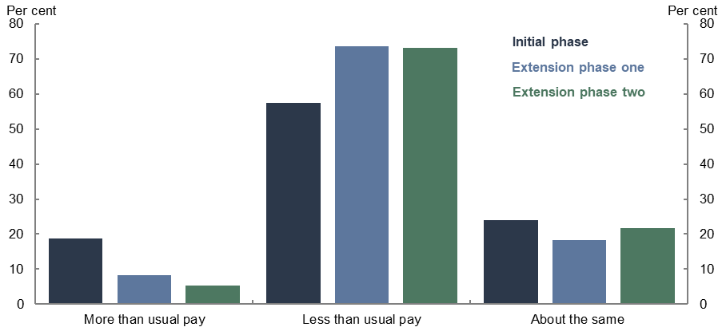
Source: ABS Household Impacts of COVID-19 Survey

Potential consequences of the inefficient payment rate structure
Given the simplicity of JobKeeper in the initial phase of the policy, some submissions to the evaluation found the payment to be appropriate and effective in achieving its objectives. Other submissions raised concerns about the potential disincentive effects of overcompensation.
Treasury’s three-month review also provided anecdotal evidence from industry stakeholders of JobKeeper’s initial payment rate distorting incentives to work. These adverse effects were centred primarily on 2 employee recipient groups.
- Part-time and casual workers who received more from JobKeeper than their usual wages, particularly in the initial phase. These workers may have been reluctant to do additional hours of work.
- Employees who were stood down who may have been reluctant to recommence working as businesses began to reopen.
Compared with analysis of other features of JobKeeper, there is an absence of quantitative evidence on employees’ possible disincentives to work. As exhibited above, the basis for these views lies almost entirely in industry stakeholders’ case studies.
Similarly, there is no evidence that lower proportionate coverage for higher wage earners affected the efficacy of JobKeeper in preserving employment connections for this group. Pre-existing employee-employer relationships for lower hours workers may have been changed by JobKeeper’s payment rate structure. For instance, employers were incentivised to renegotiate part-time employees’ hours to reflect the fact that subsidised wages provided by JobKeeper were above some of these employees’ usual wages. These incentives for businesses likely reduced underemployment among their eligible part-time population.

Alternative payment rate structures
The literature on wage subsidies and similar policy responses indicates that JobKeeper’s payment structure was not optimal in either phase of the policy.
Alternative and potentially more optimal pandemic support policies have been analysed with respect to the Australian experience and to international experience. Cassells and Duncan (2020) proposed an adjustment to JobKeeper’s design of a proportionate wage subsidy of up to 100 per cent of normal wages, up to a maximum payment rate ceiling. The authors noted that their preferred design also incorporated ‘a graduated scale of entitlement depending on the degree of business turnover loss’. The proportionate turnover test was included to prevent the risk of businesses manipulating their productive activity.
Breunig and Watson (2020) proposed an alternative JobKeeper payment rate ‘capped at the lesser of all or a fraction of average fortnightly income over the 6 months to February 2020, or $1,500 per fortnight’. These analyses were consistent with modelling by Abbott and Phan (2022) that found the optimal policy offered a proportional but capped wage subsidy alongside enhanced unemployment benefits. When only wage subsidies are implemented, the optimal replacement rate decreases slightly but the ceiling almost doubles. The welfare costs of the pandemic were significantly reduced under both policy options.
The Three-month review noted lower and tiered payment rates would remove or lessen the potential disincentives for some employees that arise from the flat payment and align with comparable international policies. The review noted that lowering the payment rate and, thereby, narrowing or removing any differential between the JobKeeper and JobSeeker payments may have potentially amplified disincentives to work among recipients. The changes to these payments coincided to minimise such risks.

Eligibility criteria
Key points
- There were exclusions to JobKeeper eligibility based on employee and employer characteristics. Around 2 million employees were excluded based on their status as a short-term casual or because they were employed on a temporary visa. Many employers who were significantly government funded were also excluded, along with employers owned by foreign governments and sovereign entities.
- Submissions were critical of employee-based exclusions, citing a failure to protect some of Australia’s most vulnerable workers – many of whom are young and women – and the significant effects on labour supply in some industries which constrained recovery.
- Narrow recipient eligibility and exclusions reduced the effectiveness of JobKeeper and had negative economic consequences (Finding 7.d). Most notably, exclusion from JobKeeper significantly increased the likelihood of job loss with significant economic and well-being costs for individuals (Chapters 3 and 4.1).
- Excluding temporary migrants was not consistent with international peers and likely contributed to a temporary labour supply shock. Businesses that were most reliant on temporary migrant labour responded by reducing output.
- The exclusion of largely government-funded organisations from JobKeeper was appropriate. In Principle, policies tailored to the specific challenges and needs of these organisations were better suited than JobKeeper to support these sectors. The effectiveness or otherwise of these policies is beyond the scope of the evaluation.
- Excluding foreign-government owned firms left some Australian workers unsupported because of who owned the firm. This result was inconsistent with the intent of JobKeeper.

Employee-based exclusions
Estimates suggest that around 2 million employees were excluded based on their characteristics. The 2 largest groups of employees excluded were short-term casuals and temporary migrants.
- Casual employees were only eligible for JobKeeper if they had been with their employer on a regular and systematic basis for at least the previous 12 months on 1 March 2020. This restriction led to around 950,000 short-term casuals being excluded from JobKeeper.
- JobKeeper was only made available for workers who were also eligible for JobSeeker payments. This restriction led to around 1.1 million temporary migrants being excluded from JobKeeper. Estimates suggest over 500,000 people on temporary visas left Australia during the pandemic.
Several submissions and academic studies have questioned the efficacy and equity of employee-based exclusions from JobKeeper. The ACTU’s submission suggested the exclusion of short-term casuals and temporary migrants overlooked ‘those who were experiencing job and financial insecurity long before the COVID-19 crisis began’. Their submission highlighted that these exclusions disproportionately affected women and young workers and that the distinction between short- and long-term casuals appeared arbitrary.
The National Association for the Visual Arts (NAVA) submission noted that the contemporary arts sector was particularly affected by the exclusion of short-term casuals. Their submission highlighted that many employees in the contemporary arts sector ‘have multiple employers and/or are employed casually.’ NAVA cites its own survey results which show that over 70 per cent of arts workers are employed casually in small to medium-sized arts organisations.
Dr Walkowiak’s submission argued that the exclusion of temporary migrants may have resulted in ‘institutionalised discriminatory layoffs’ and led to labour shortages and a cost to productivity.
Professor Borland suggested in his submission that excluding temporary migrants from income support had an adverse impact on equity. He suggested that ‘the design of JobKeeper (or JobSeeker) could have been improved with respect to providing some type of income support to categories of workers/jobseekers who were excluded from both JobKeeper and JobSeeker, such as temporary visa holders’. Cassells and Duncan (2020) argued that the exclusion of certain employer and employee groups challenges the overall efficacy of the JobKeeper design and its primary objective of retaining existing employee-employer matches.
A further issue that arose in stakeholder discussions is that exclusions at the employee level reduced the efficiency of the underlying payment system. The JobKeeper Payment was administered using ATO’s STP data. Ideally, the ATO would prefill the JobKeeper application forms, as they do with tax return forms, using STP data. The STP dataset is not able to identify short-term causal workers or temporary migrants. So, JobKeeper forms were left blank, leaving businesses to self-fill.

Short-term casuals
There were several reasons that decision-makers excluded short-term casuals from JobKeeper eligibility. The employee-employer relationships that JobKeeper was seeking to preserve were considered less firmly established among this group and temporary increases to JobSeeker entitlements would provide income support if employment connections were lost. There was also a desire to maintain some degree of mobility and flexibility in the labour market. Lastly, there was a desire to use existing legislative definitions to define eligible employees.
Exclusion from JobKeeper had economic and well-being costs for short-term casuals. The evidence discussed in Chapter 3 finds that non-JobKeeper eligible employees (and particularly casuals) were much more likely to lose employment in the early stages of the pandemic. There are significant well-being costs associate with loss of employment (Chapter 4.1).
From a financial and economic perspective, the increased accessibility and payment rate of JobSeeker did not fully compensate for being excluded from JobKeeper. The Jobseeker Payment was $192 per week lower than JobKeeper. This difference is likely to be significant for those on income support.
Evidence on the extent to which short-term casual exclusion affected labour mobility in the early months of the pandemic is mixed. Internal Treasury research suggests that few jobless workers were redeployed during the initial lockdowns. Around 40 per cent of the recovery in paid employment between mid-April and mid-June (the early lockdown phase) was driven by JobKeeper eligible workers returning to their past jobs (Figure 10, Panel A). Most JobKeeper ineligible workers were redeployed after 1 June (Figure 10, Panel B), after the worst of the initial lockdowns.
On the other hand, Andrews, Charlton and Moore (2021) found that short-term casuals had higher labour reallocation than those eligible for JobKeeper, but this benefit was short lived. They highlighted that Australia initially had higher reallocation-productivity than New Zealand (whose wage subsidy covered all casuals), but the cross-country differences faded by late 2020.
Lastly, short-term casuals share many similar characteristics to long-term casuals which lends support to the ACTU’s observation that the distinction between long-term and short-term casuals in JobKeeper seemed arbitrary. For example, short-term casuals had similar pre-pandemic incomes to long-term casuals. About 45 per cent of short-term casuals and 49 per cent of long-term casual workers earned above $550 a week. In addition to having similar incomes, there was a low risk that any worker could have claimed both JobKeeper and JobSeeker. The ATO matched JobKeeper and JobSeeker data, preventing people from claiming both.

Temporary migrants
The exclusion of temporary migrants from JobKeeper eligibility carried significant economic and well-being costs for those affected. These costs were larger for temporary migrants compared with Australian workers as they were not eligible for JobSeeker payments if they lost their jobs. The exclusion of temporary migrants was inconsistent with international counterparts (Table 5).

Table 5: Treatment of Temporary visa holders and non-residents
Country | Treatment of Temporary visa holders and non-residents
Australia | Not eligible (except New Zealand, reciprocal arrangement) – Eligibility was based on JobSeeker eligibility.
New Zealand | Eligible – All residents and work visas (including working holiday makers and students).
United States | Eligible – All residents who paid tax and had a valid Social Security number were eligible.
United Kingdom | Eligible – All employees were eligible, regardless of visa type.
Canada | Eligible – Eligibility was based on place of employment, not nationality and residence.
Germany | Eligible – All employees who pay social security contributions were eligible.
Japan | Eligible – All residents with a valid residence card were eligible.
Singapore | Not eligible – The Jobs Support Scheme (JSS) only covered local employees (Singapore Citizens and Permanent Residents).

Many temporary migrants left Australia and were not replaced, causing a temporary labour supply shock. In June 2021, the stock of temporary migrants was 22 per cent lower than in March 2020. The decline was driven by a 34 per cent decrease in the number of student visa holders and a 69 per cent decrease in working holiday visa holders. These workers were concentrated in hospitality, agriculture, and administrative services. The stock of temporary migrants has since recovered, exceeding pre-pandemic levels by the end of the June quarter 2023.
In firms where more than 40 per cent of employees were temporary migrants, employment declined by more than 20 per cent in early 2020 (Figure 17, Panel A). These firms also recovered more slowly than other firms. While most firms’ turnover largely recovered by June 2021, temporary migrant dependent firms’ output was still down by around 18 per cent (Figure 17, Panel B).

Figure 17: Change in employment and turnover, by firm temporary migrant reliance
- Change in employment  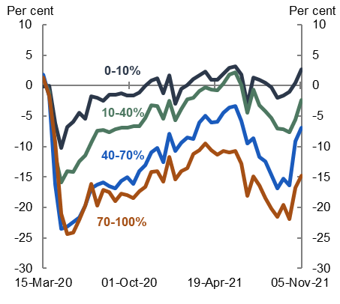 | - Change in turnover  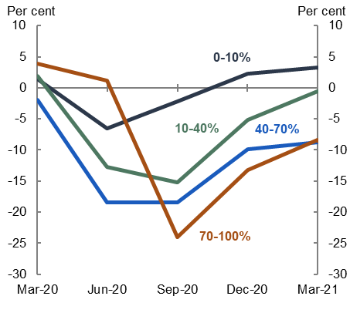
Source: Treasury analysis of tax and visa microdata, controlling for industry, location and firm size.

Exclusions based on employer characteristics
Many organisations that are significantly government funded – public schools, public universities and many childcare providers, among others – were excluded from receiving JobKeeper explicitly or by the design of eligibility criteria.
While there is no doubt that government-funded entities faced significant challenges and hardships because of the pandemic, their exclusion from JobKeeper was appropriate and consistent with the payment’s objectives. In principle, sector-focused policies tailored to the specific challenges and needs of these organisations would have been more appropriate forms of support than JobKeeper. In many cases, sector-specific support was available. The appropriateness and effectiveness or otherwise of these packages is beyond the scope of the evaluation.
JobKeeper also excluded firms owned by foreign governments and sovereign entities. The evaluation understands that the purpose of this exclusion was to ensure that funding did not support workers offshore. It resulted in the exclusion from JobKeeper of some Australians, working in some heavily impacted sectors. The ACTU’s submission is critical of the exclusion of foreign government owned companies, arguing that Australian workers of these companies were left with little government support leading to financial hardship. Box 4 considers the case study of dnata. The exclusion of firms such as dnata was not consistent with the objectives of JobKeeper.
Box 4: dnata case study
A partner of 46 airlines, dnata offers ground handling, cargo and catering services in Australia. The business is part of the Emirates Group, which is wholly owned by the government of Dubai. This ownership structure made dnata ineligible for JobKeeper.
dnata was initially eligible for JobKeeper, until an amendment made on 1 May 2020. The amendment changed the definition of sovereign entities, effectively excluding from JobKeeper all employees of companies wholly owned by foreign governments. The Australian workers at dnata were largely performing roles that, if duplicated in the private sector or with a different employer, would have qualified for the JobKeeper program. It was operating in a heavily pandemic-affected industry.
The amendment to the sovereign entities definition was backdated to 30 March 2020 – the start of JobKeeper payments. Business excluded by the sovereign entity definition change had anticipated receiving the first 2 JobKeeper instalments on 8 May, but this change meant they did not receive the payments.

Integrity and implementation

Program delivery and integrity
Key points
- The administration of JobKeeper has been substantially investigated by the Auditor-General and the IGTO. These investigations support Finding 5 that JobKeeper delivery was effective and payment integrity was maintained.
- The Auditor-General’s audit of JobKeeper found that the administration of JobKeeper was effective and that the ATO implemented fit-for-purpose arrangements to protect the integrity of JobKeeper payments.
- The Auditor-General found that the ATO successfully balanced the need for rapid implementation and the integrity of the program. The ATO made the payment process as simple and fast as possible for eligible entities.
- The Auditor-General noted that the ATO maintained fit for purpose governance arrangements to monitor scheme performance, regularly monitored performance and provided regular reporting to Treasury and other government entities.
- The IGTO investigated actions, decisions and systems of the ATO in relation to JobKeeper and commended its responsiveness in assisting the Australian community.
- The ATO’s gap analysis estimated that the net payment gap for JobKeeper was only 2.4 per cent.

The Auditor-General conducted a substantial audit of the administration of JobKeeper in 2021–22. This evaluation does not revisit the administration of the program. No submission received by the evaluation questioned the Auditor-General’s conclusions.
In addition, the IGTO provided a submission to the evaluation, attaching the IGTO’s 2 published reports on JobKeeper.
The ATO has published a payment gap analysis. The gap analysis estimates the difference between the amount of JobKeeper the ATO paid and what the ATO expects it should have paid out if every payment was fully compliant with tax law.
The evaluation summarises these public sources, which taken as a whole, indicate that while there are lessons to be learned, program delivery was effective and payment integrity was maintained.

Table 6: Some reports on JobKeeper implementation and program management
Title | Date | Author | Website
Administration of the JobKeeper Scheme | 4 April 2022 | Australian National Audit Office | https://www.anao.gov.au/work/performance-audit/administration-the-jobkeeper-scheme
A report on Aspects of the ATO’s Administration of the JobKeeper and Boosting Cash Flow Payments for New Businesses | December 2020 | Inspector General of Taxation and Taxation Ombudsman | https://www.igt.gov.au/investigation-reports/jobkeeper-and-boosting-cash-flow-payments/
An investigation into the ATO’s administration of JobKeeper enrolment deferral decisions | September 2021 | Inspector General of Taxation and Taxation Ombudsman | https://www.igt.gov.au/investigation-reports/an-investigation-into-the-atos-administration-of-jobkeeper-enrolment-deferral-decisions/
JobKeeper payment gap | 31 October 2022 | Australian Taxation Office | https://www.ato.gov.au/About-ATO/Research-and-statistics/In-detail/Tax-gap/JobKeeper-payment-gap/

Approach taken in the reports
The Auditor-General conducted the audit to assess the effectiveness of the ATO’s administration of JobKeeper. This audit was phase 2 of the ANAO’s multi-year strategy to assess the delivery of the Australian Government’s response to the pandemic. The Auditor-General examined ATO documentation, analysed JobKeeper data to assess timeliness of payments and correct payment rates, examined the Treasury documentation relating to the evaluation of the JobKeeper program and policy, and conducted meetings with ATO and Treasury staff.
The Inspector General of Taxation and Taxation Ombudsman (IGTO) received 327 complaints relating to JobKeeper from individuals and businesses. In response, the IGTO carried out 168 investigations into ATO actions and decisions made in administering JobKeeper. Following its investigations of JobKeeper complaints, the IGTO published 2 reports that outline its observations on the ATO’s administration of JobKeeper.
The ATO gap analysis estimated the difference between the amount of a particular tax the ATO collected and what would have been collected if all taxpayers were completely compliant. Tax gap analysis and trends are an indicator of the performance of the tax and superannuation systems. In the case of JobKeeper, the approach has been modified as the program was a payment rather than a tax. Box 5 provides more details on the methodology used.

Box 5: ATO gap analysis methodology
Estimation method
For payments made in the initial six-month program (April to September 2020), verification teams were assigned a randomly selected sample of 1,513 JobKeeper payments. The process was designed to make use of existing client information and to contact the client only when necessary.
For payments made in the extension periods (October 2020 to March 2021), operational audit data were obtained on all taxpayers who received JobKeeper payments in the extension phase. The JobKeeper extension population was run through a 2-step regression process to determine the extent of the gap.
The key measure is the ‘net payment gap’, which estimates and reflects incorrect payments not recovered or detected. The ‘gross payment gap’ estimates all the incorrect payments that were applied for even if they were ultimately stopped or recovered by the ATO as part of compliance activity.

Table 7: JobKeeper payment gap
Element | Number of Payments | Value in $m
Payments applied for | 64,454,373 | 89,163
Stopped | 144,741 | 206
Recovered | 145,941 | 202
Final Payments | 64,163,691 | 88,755
Correct payments | 62,619,666 | 86,575
Net payment gap | 1,544,025 | 2,180
Gross payment gap | 1,834,707 | 2,588
Net gap (per cent) |  | 2.4
Gross gap (per cent) |  | 2.8
Source: ATO (2022) Australian tax gaps overview.
Businesses that did not ultimately realise turnover decline thresholds in the first JobKeeper period are considered part of the policy gap and are not estimated in the gap analysis. This is because these businesses were not necessarily non-compliant.

The reports found JobKeeper’s program delivery was effective

The ANAO found the ATO’s operational performance was effective
The Auditor-General found that the ATO’s monitoring and reporting on the operational performance of the JobKeeper scheme was effective. The ATO maintained fit for purpose governance arrangements to monitor scheme performance, regularly monitored performance, and provided regular reporting to Treasury and other government entities.
The report found the ATO appropriately prioritised rapid implementation of JobKeeper. The payment arrangements were found to be largely fit-for-purpose to protect the integrity of JobKeeper payments.
The Auditor-General concluded that the ATO made JobKeeper payments in a timely manner. 99 per cent of JobKeeper payments were made to entities within the initial 14-day timeframe set out in the Rules. The average timeframe was 4 days.
ANAO found that the ATO reported externally on the JobKeeper scheme in a timely and informative manner. While the legislative framework for JobKeeper did not impose reporting obligations, the ATO and Treasury developed reporting standards in line with public sector mechanisms such as parliamentary committees, including the Senate Select Committee on COVID-19 (COVID-19 Committee), and annual reporting requirements.

The IGTO commended the ATO on its responsiveness
The IGTO noted that the ATO needed to act quickly to implement administrative systems and associated guidelines to facilitate JobKeeper payments. The IGTO notes some matters arose that had an impact on the efficient and fair administration of the tax system.

The ATO showed JobKeeper was one its most effective programs
The ATO estimated the net payment gap of 2.4 per cent, or 1.5 million payments to the value of $2.2 billion. That is, the correct payments were made to 97.6 per cent of applicants under the JobKeeper program. This compares favourably to other ATO estimates. The estimated gaps for taxes and programs administered by the ATO are 7.8 per cent for GST (2019–20), 2.9 per cent for Wine Equalisation Tax (2018–19) and 3.8 per cent for the Superannuation guarantee (2018–19).
Australia’s payment gap was less than the United Kingdom’s payment gap. The United Kingdom Evaluation estimated the level of error and fraud within the CJRS lifecycle of 1 March 2020 to 30 September 2021. The gap was estimated to be in a range between 3.0 per cent and 7.8 per cent, with the most likely gap was 5.1 per cent.
In Australia, the most common causes of payment ineligibility were entities being late or not lodging their tax return or activity statement, and employees of Eligible Business Participants being employed elsewhere. Table 7 outlines the full results from the ATO gap analysis on JobKeeper.

While the implementation of JobKeeper was effective, ANAO and the IGTO provide some valuable lessons
The Auditor-General made no formal recommendations to the ATO or Treasury. The Auditor-General did identify some lessons for the implementation of similar economic response measures in future. The key lesson was for the implementing agency to adhere to a more structured approach when documenting the reasons for exercising discretion on overpayments. This would provide more transparency and accountability for the use of public funds.
The IGTO reports provide a summary of the key issues raised by their community which accord with best-practice policy implementation and regulation. As noted by the Auditor-General, the ATO’s arrangements were generally appropriate. It balanced the need for rapid implementation and the integrity of the program in the extraordinary circumstances of the pandemic.

Transparency
Key points
- Transparency and openness in public policy builds public trust. International organisations and governments of advanced economies recognise this and have recommendations and policies in place to promote transparency and openness in public policy.
- JobKeeper did not include in its design a public registry or disclosure requirement for entities that received the JobKeeper Payment. Over time, information became available to the public about some entities that received JobKeeper. Entity-specific disclosures were restricted to listed companies which comprise a small proportion of total JobKeeper entities (593 out of around 1 million). There is no public information about the vast majority of entities that received JobKeeper.
- The decision not to include a public register reflected concerns about privacy and publicly identifying firms that may have been in a precarious financial position.
- In this regard, JobKeeper was an outlier compared with programs in other countries. Comparable schemes had public registers or other disclosure requirements. There is no evidence that these requirements affected take-up of the subsidy or had a negative signalling effect.
- Future design of a wage subsidy or similar policy should include a public register of recipient entities or other real-time disclosure requirements (Finding 7.e). Best practice in public policy is greater transparency and there was strong public appetite to understand where JobKeeper payments were going.
- Consideration should also be given to facilitating repayments in a way that minimises cost and ambiguity for the repaying entity.

The role of transparency in public policy
Transparent design and implementation of public policy is good practice and consistent with international standards. The IMF, World Bank and OECD recognise that transparency helps economies to function better, encourages governments to act more effectively and efficiently and enables citizens to fully participate in public life. Providing access to information held by government also builds legitimacy in government. It allows the public to understand decision-making process and hold governments to account. Transparency also improves internal accountability.
In Australia, the Department of Finance sets out clear guidelines around transparency in all facets of policy making. There are 3 core frameworks overseen by the Department of Finance.
- The Commonwealth Grants Rules and Guidelines that promotes the proper use and management of public resources, which is in part achieved through probity and transparency.
- The Managing Commonwealth Resources framework to support an accountable and transparent public sector.
- Transparency in Australian Government Procurement which states that ‘Transparency involves relevant entities taking steps to enable appropriate scrutiny of their procurement activity’.
These frameworks and guidelines aim to ensure that government decisions allow for appropriate scrutiny and are defensible.

Transparency arrangements in JobKeeper
The initial design of JobKeeper did not incorporate any transparency mechanisms. Unlike other countries’ job retention schemes, there was not a public register of entities that received the payment and there was no requirement for public disclosure for recipient entities.
The absence of transparency mechanisms was partly a function of utilising ATO systems to administer JobKeeper which meant that Australian taxation legislation applied to recipients of JobKeeper. Entities and individuals that received JobKeeper were not publicly disclosed in compliance with the Privacy Act 1988 (Privacy Act) and the Taxation Administration Act 1953 (Taxation Administration Act).
Over the lifespan of JobKeeper and in the period after its conclusion, some changes were made to transparency requirements. In some cases, additional disclosures were a direct response to public and political pressure for information about recipient entities.
In July 2020, the Australian Securities and Investment Commission (ASIC) issued guidance requiring listed entities to disclose in notices to market operators (such as the ASX) how much support they had received and any repayments they made. The support entities were required to disclose was not limited to JobKeeper.
On 13 September 2021, the Treasury Laws Amendment (2021 Measures No. 2) Act 2021 received Royal Assent with amendments introduced by crossbench senators. These amendments obliged ASIC to regularly publish a consolidated report of all notices provided to market regulators as soon as practicable.
On 7 December 2021, ASIC published its first report detailing listed companies that had received the JobKeeper Payment. The latest report was published on 18 August 2022.
To date, 593 publicly listed firms have reported receiving JobKeeper payments covering at least 186,000 employees. This is a small fraction of the more than 1 million businesses and 4 million individuals who received the payment. Listed entities received only about $4.3 billion in JobKeeper payments, less than 5 per cent of total payments.

Public engagement with JobKeeper
JobKeeper had a high level of public engagement and interest over the course of the policy. The public had a clear desire and expectation to know who received JobKeeper payments.
During JobKeeper’s lifetime, media reporting and public engagement with businesses that received support were limited to information disclosed by the individual businesses. Ownership Matters highlighted the need for more transparent practices in its submission to the Senate Economics Legislation Committee inquiry on JobKeeper. The submission relied on information compiled from listed entities’ annual reports.
Calls for increased transparency around JobKeeper recipient entities intensified over time as the economic recovery strengthened and business conditions and profitability improved. Support for transparency extended to some businesses that received JobKeeper. In its submission to a Senate Committee inquiry, Domino’s Pizza Enterprises supported greater disclosure of payment receipt. Domino’s Pizza Enterprises suggested ‘the publication of a list of all entities with annual turnover of more than $50 million … would align with community expectations’.
Box 6: Voluntary disclosures and repayments
Like voluntary disclosures of JobKeeper receipt, voluntary repayments of JobKeeper were not incorporated in the original design of the policy. There was ambiguity as to how repayment was treated in taxation law. This made repayments more difficult, although the ATO clarified some aspects of the treatment of JobKeeper repayments over time.
A few companies chose to repay their JobKeeper payments. Most repayments were made by publicly listed firms. According to ASIC’s report on JobKeeper payments, listed entities voluntarily repaid $248 million of JobKeeper payments, about 5.8 per cent of the $4.3 billion they received. According to the ATO’s de-identified data set, entities with incomes greater than $10 million made about $193 million of voluntary JobKeeper repayments.
In retrospect, the process to make voluntary repayments should have been simpler and considered in JobKeeper’s initial design. Public engagement with JobKeeper put pressure on companies who received potentially unneeded support to make repayments, strengthening the case for more transparent practices via a public register of recipients.

Stakeholder concerns about the implications of public disclosure
There were concerns among some stakeholders about the potentially distortive outcomes a public register may have introduced for the take-up, delivery, and efficacy of JobKeeper.
Some feared disclosure of the receipt of government support through JobKeeper could signal financial vulnerability. In such a highly uncertain environment, this could affect market perceptions and in the extreme, threaten the survival of otherwise viable firms.
There were further concerns around the privacy implications associated with disclosing entities that received JobKeeper payments and how such a provision interacted with the legislative infrastructure of the ATO’s delivery system. While it is undoubtedly the case that trust in the ATO to maintain taxpayer privacy is fundamental to the administration of the tax law, JobKeeper was a grants program rather than a tax. Consistent with other grants programs, any future wage subsidy should have transparency as a primary objective in the design of the policy. Applicants should expect that if they apply for a subsidy or grant then this will be made public.

International experience with transparency arrangements
JobKeeper was an outlier compared with programs in other countries. Comparable schemes used abroad had public registers or other disclosure requirements (see Box 7). International experience does not support the concerns raised around public transparency and reputational issues, nor that transparency requirements affected take-up of wage subsidy programs.
Recently published impact evaluations for both the United Kingdom and New Zealand wage subsidies did not identify linkages between disclosure requirements and take-up or reputational issues. The fact that a large cross-section of firms around the world were suffering a significant upheaval and turmoil in the early stages of the pandemic may explain why concerns about reputational risks were not borne out.

Box 7: Transparency mechanisms in pandemic job retention schemes abroad
Australia’s transparency practices in JobKeeper were less robust than most comparable policies used abroad during the pandemic. There was no transparency mechanism in JobKeeper’s initial design and information was eventually released in an ad-hoc and incomplete manner making engagement with this information more difficult.
Several comparable job retention schemes used abroad incorporated public registries of entities that received support during the pandemic to avoid such outcome. Information disclosed in transparency mechanisms abroad:
Canada: | The names and business numbers of companies that received the Canada Emergency Wage Subsidy (CEWS) were added to a public registry by the Canada Revenue Agency. The public registry is no longer available; however, users can view more detailed data at the semi-aggregate level.
Ireland: | A published list of most employers that received the Temporary Wage Subsidy Scheme (TWSS) included:  - the employer’s name  - the employer’s address.  Ireland’s published list of TWSS recipients does not include information on the value of wage subsidies received nor does it disclose the number of employees covered.
New Zealand: | A public register of all the companies that received their wage subsidies listed:  - the name of the entity  - the name of wage subsidies received  - the number of employees paid  - the total amount received by each entity.  New Zealand’s register, unlike many others, is still available to the public and easily accessible with a browsable function.

United Kingdom: | A monthly list of CJRS claimants published:  - the name of the employer  - the company number for each claimant  - the value of employers’ CJRS claim (in bands).  The publication of the list was intended to encourage public tip-offs and to deter fraudulent claims. Employees were able to check whether their employer had claimed the CJRS through the online personal taxation platform. Information published on the claimants list was removed by the United Kingdom Government after one year.
United States of America: | Detailed data on the loans provided under the Payment Protection Program was released by the US Small Business Administration (SBA). Key information released included:  - the business name and type  - the industry and sector of the business  - the number of jobs supported  - the loan amount and amount forgiven  - the date of the loan approval and forgiveness  - the lender.  The US PPP database is the most detailed of the comparable policies. The detailed nature of the database is not only beneficial to monitoring but also to analysis of the policy.
Singapore: | Singapore’s JSS had limited transparency provisions. The JSS was considered a grant under Singapore’s accounting rules, meaning firms had to report any JSS funding on their balance sheets.

Communication strategy
Key points
- Authorities recognised that the speed at which JobKeeper was implemented, and the fact that some policy details were understandably settled after the initial announcement, meant that an efficient communication strategy to disseminate information would be critical to achieving policy outcomes.
- There were multiple ministerial offices and government departments involved in communicating policy details and providing guidance on JobKeeper. While stakeholders acknowledged, and in some cases commended, authorities’ effort to communicate the policy, many suggested that a more structured and better co-ordinated approach could have minimised scope for confusion.
- Stakeholder feedback highlights the importance of clear communication from policy makers, particularly when speedy implementation necessarily requires that some details are decided after the initial policy announcement (Finding 8).

The JobKeeper communication strategy
As discussed in Chapters 1 and 3, JobKeeper was implemented in a period of extraordinary uncertainty. It was introduced at speed and its reach was intended to be nationwide. The prioritisation of rapid implementation necessarily meant that some policy details were amended or decided as issues arose in the days and weeks following the initial announcement. Authorities recognised that an efficient communication strategy to disseminate information in a clear and timely manner would be critical to achieving policy outcomes.
Authorities created a specific JobKeeper ATO website on the date of announcement (now decommissioned). This website initially sought expressions of interest in JobKeeper from businesses and was developed by the ATO into a source of truth platform over time.
Treasury published digital factsheets tailored to employers and to employees, streamlining the dissemination of information. These factsheets included information on eligibility, payment process, and timing. Treasury also updated the factsheets to reflect the changes made to the policy under the extension phases. These resources directed the public to the JobKeeper ATO website for further information.

Feedback on the JobKeeper communication strategy
Submissions noted and commended authorities’ efforts to communicate JobKeeper details quickly and clearly, acknowledging that implementing a communication strategy was difficult in the circumstances. Some, though not all, found that policymakers were appropriately responsive and efficient in engaging with industry to resolve complications or issues with policy design as they arose.
Several submissions argued that a more structured method of communicating policy details and decisions could have improved clarity and reduced uncertainty for JobKeeper recipients, particularly in the weeks following the initial policy announcement in March 2020.
NAVA found that ‘the eligibility criteria for JobKeeper was confusing when communicated, particularly as criteria kept changing as different business situations were taken into consideration’. Professional accounting bodies similarly found there was ‘confusion over the ever-changing rules and how to calculate turnover’. The Australian Small Business and Family Enterprise Ombudsman (ASBFEO) recommended future policy responses should have ‘clear and targeted communication supported by practical guidance for small business’.
The professional accounting bodies noted that JobKeeper changes were often contained on several different government websites which they argue led to some confusion as websites were updated at different times and occasionally there were differences between sites. The accounting bodies advocated for a ‘single source of truth’ website to which other government websites could refer rather than duplicate.
The IGTO also raised concerns about what it observed as inconsistencies in public guidance that created uncertainty. As noted in Chapter 5.1, the IGTO recommended that synchronising public advice and guidance with the implementation of significant new tax law minimises some of the uncertainty caused by the administration of that new law.
The concerns raised in submissions were echoed in interviews and discussions with some key stakeholders. A common theme was that the involvement of multiple government agencies and ministerial offices in disseminating information at different times increased scope for confusion and inconsistency in communicating policy details.

Value for money
Key points
- JobKeeper provided value for money through its broad social benefits and the role it played alongside other policy measures in addressing extraordinary and unquantifiable uncertainty and averting the worst economic tail risks of the pandemic (Finding 4). Although difficult to measure, the scale and nature of the benefits compared favourably with the upper bound estimate of JobKeeper’s social costs.
- The evaluation is concerned with the broad social value of JobKeeper. It takes a qualitative approach to analysing value for money. Quantitative measurement of the macroeconomic benefits and some of the costs of JobKeeper would be inherently unreliable, because of the impossibility of identifying a robust counterfactual for what would have happened to employment, the economy and indeed the path of the COVID-19 virus in the absence of JobKeeper. In addition, disentangling the macroeconomic impacts of JobKeeper from other policy support presents quantitative challenges.
- The direct economic benefits of JobKeeper included preserving employee-employer relationships, providing income support, and ensuring otherwise productive businesses remained viable. These direct benefits had broader macroeconomic consequences, through the confidence channel and by supporting aggregate demand and supply. JobKeeper also played a critical role in addressing the extraordinary and unquantifiable uncertainty at the time of its introduction and averting the worst economic tail risks of the pandemic. Other benefits of JobKeeper were improved equity across the wage distribution and increased well-being of recipients.
- On the cost side, the value for money assessment of JobKeeper is concerned with the social cost of the program rather than its gross fiscal cost of $88.8 billion. JobKeeper was a transfer payment from one group in society to another through which no resources were created or destroyed. Consistent with best practice evaluation, such payments are not treated as economic costs though there is a social cost of taxation associated with the additional taxation needed to finance the program.
- The upper bound to the social cost of JobKeeper is estimated to be $22.4 billion (25 per cent of the gross fiscal cost of the program plus its administration cost). This is an overestimate of the true social cost of JobKeeper as downward adjustments to the gross fiscal cost should be made to account for voluntary repayments, the tax revenue raised on JobKeeper payments, and the expenditure saved by preventing recipients from becoming unemployed and accessing JobSeeker payments. The large spike in job separations and flows onto income support payments just prior to the introduction of JobKeeper in late March 2020 suggests the latter adjustment would be non-trivial.
- While JobKeeper was value for money, there are lessons identified throughout this evaluation which could help to increase the benefits and reduce costs should a similar program be required in future, including by minimising inefficiencies relating to deadweight. These do not detract from the overall positive value for money assessment of JobKeeper.
- The discrepancy between the initial estimate of the cost of JobKeeper and its actual cost highlights the risk associated with estimating policy costings during an economic crisis. In a crisis, there would be benefits in emphasising the uncertainty around producing cost estimates in such an environment and being clear about the assumptions underpinning the costing (Finding 10).

Approach to assessing value for money of JobKeeper
A value for money assessment is an analysis of whether resources were well spent on a policy or program. In the case of JobKeeper, the value of undertaking such an exercise ex-post is largely to inform future policy deliberations.
The evaluation is primarily concerned with the social value of JobKeeper, defined as the broad benefits and costs to society associated with the program and its overall effect on welfare. The evaluation applies a largely qualitative approach to assessing the social benefits and costs of JobKeeper, although it draws on quantitative analysis in doing so.

Benefits of the JobKeeper Payment

Economic benefits
As identified in Findings 1 and 2, JobKeeper had far-reaching economic implications and was effective in achieving its stated objectives of preserving employment, supporting incomes, and preventing business failures. The direct effect of JobKeeper on employment was large. It supported approximately 4 million employees – almost one third of pre-pandemic employment. Credible estimates suggest it prevented the direct loss of between 300,000 to 800,000 jobs.
JobKeeper provided income support to employees and businesses. The large majority of JobKeeper payments were made to small businesses and not-for-profits with turnover of less than $10 million. Andrews, Bahar and Hambur (2023) suggest JobKeeper played a critical role in preventing otherwise productive but financially fragile businesses from failing in the early stages of JobKeeper. Business failures were low during the pandemic relative to levels experienced prior to the pandemic and in previous downturns, though this likely reflected the effect of other policy support as well as JobKeeper.
Beyond its direct economic benefits, JobKeeper had macroeconomic consequences reflecting its scale and the environment in which it was introduced. JobKeeper played a critical role in addressing the extraordinary and unquantifiable uncertainty at the time of its introduction and averting the worst economic tail risks of the pandemic. Quantitative estimates of the macroeconomic effects are inherently unreliable. It is not possible to identify a robust counterfactual given the extraordinary and unquantifiable uncertainty that existed in the peak of the crisis in March–April 2020 and in the absence of any modern Australian experience of a global pandemic. We do not know with any degree of certainty what would have happened to employment and output in the absence of JobKeeper. It is difficult to disentangle the impacts of the different elements of the fiscal and monetary policy response to the crisis.
The impossibility of establishing a robust counterfactual against which to assess macroeconomic benefits is recognised in evaluations of the United Kingdom and New Zealand wage subsidy schemes. In the evaluation of the United Kingdom wage subsidy scheme, authorities do not attempt to quantify the macroeconomic impacts of the scheme through the crisis against a robust counterfactual, for similar reasons to those outlined above. Instead, they look to the strength and speed of the recovery, compared with recent recoveries from recessions, as a basis for empirical estimates of the macroeconomic impact of the policy. There would be 2 difficulties in adopting a similar approach in the Australian context. First, the nature of the impact of lockdown and reopening associated with a pandemic is very different from a normal business cycle recession and recovery. Second, the most recent recessions in Australia prior to the pandemic preceded significant structural changes to the labour market.

Equity benefits
There were equity benefits associated with JobKeeper. While equity was not an explicit policy objective of JobKeeper, it is common practice to consider equity when appraising the social benefits of a policy. The United Kingdom Green Book on policy appraisal recognises that financial benefits for lower income households carry a higher social value based on the principle of diminishing marginal utility of income. In an Australian context, the Measuring What Matters framework recognises the importance of equity in ensuring well-being outcomes are shared fairly among the population.
As discussed in Chapter 3, JobKeeper payments played a larger role in supporting people in lower wage quintiles, primarily because lower wage earners were more likely to receive JobKeeper than higher wage earners and the payment itself was a larger proportion of lower wage earners’ pre-pandemic wages.

Well-being benefits
JobKeeper had well-being benefits that extended to non-monetary benefits of being employed (or not being unemployed), which are discussed in Chapter 4. These include social and psychological benefits of being employed, such as social interactions and a sense of connection and purpose. Estimating this benefit would rely on a robust estimate of the number of people who would have been unemployed in the absence of JobKeeper which, as discussed above, is not possible.

Cost of JobKeeper

Social cost of payments
The evaluation is concerned with the total economic cost of JobKeeper. This is conceptually different from its fiscal cost.
JobKeeper payments were transfers from one group of society to another, where no resources were created or destroyed in the process. Payments that are transfers between groups are not economic costs and society overall is not made better or worse off. All additional government expenditure must be financed at some point. Economic theory suggests there is a reduction in economic welfare, the so-called ‘marginal excess burden’ of taxation, associated with higher taxation. This cost is often called the social cost of taxation.
This loss of economic welfare is typically reported as the amount of loss for every unit of tax raised. In Australia, the social cost of taxation is often considered to be about 25 per cent (economic welfare is reduced by 25 cents for every dollar of taxation raised). The United Kingdom and New Zealand use a cost of 20 per cent of tax raised.
JobKeeper had a gross fiscal cost of $88.8 billion. Applying a social cost of taxation rate of 25 per cent to the gross fiscal cost and adding the administrative cost (see below) yields an upper bound for the social cost of the program of $22.4 billion. This is an indicative estimate only and likely an over-estimate of the true social cost of JobKeeper. Quantitative cost-benefit analyses typically adjust the gross fiscal cost of a program to arrive at a net fiscal cost. In JobKeeper’s case, this would include deducting voluntary repayments, the tax revenue raised from JobKeeper payments (JobKeeper was assessable income), and the expenditure JobKeeper saved by preventing recipients from becoming unemployed and accessing JobSeeker payments. The social cost of taxation rate is typically applied on this final (net) fiscal cost amount – the amount of taxation required for the payment. To calculate this figure a macroeconomic counterfactual would be needed, which as discussed above is not possible.

Inefficiency of JobKeeper
JobKeeper had costs relating to the inefficiency of payments being wasted. Deadweight is defined as the proportion of spending on activities that would have occurred in the absence of the policy or program. Fraud and error in payments also detract from the effectiveness of the payment. Most policies have some degree of deadweight, error and fraud. These inefficiencies do not add to the social cost described above, because they are included in the gross fiscal cost. But they do suggest that policy objectives could have been achieved at a lower gross fiscal and, therefore, social cost. The key consideration is how effective JobKeeper was at minimising payments towards these streams and whether there are lessons to be learned.
The administration of JobKeeper was highly efficient. There was a relatively low net payment gap of 2.4 per cent associated with the payment. This equates to an error and fraud cost of around $2.2 billion, as discussed in Chapter 5.
Estimating deadweight for JobKeeper is challenging because of the impossibility of estimating a robust counterfactual. Still, there is evidence to suggest it was substantial. The Insights report found that $8.9 billion in payments were made to businesses that experienced an increase in turnover and were not a fast growing or new businesses subject to different eligibility requirements. The shift to a retrospective turnover test in the extension phase should have reduced this source of deadweight.

Productivity and administrative costs
As discussed in Chapter 3, there was a cost to JobKeeper associated with impeding productivity-enhancing labour mobility. This cost, while relatively small and temporary, was larger in the extension phase.
Lastly, the cost of administering a program the size and complexity of JobKeeper was substantial. Estimates published by the ANAO indicate that ATO administration of JobKeeper cost at least $286 million and involved 1160 staff at the peak of the program. Treasury also employed an average of 22 staff in the division responsible for JobKeeper policy between April 2020 and June 2021, although this division had a broader scope than JobKeeper.
Box 8: Costing policy in a crisis: managing uncertainty
The JobKeeper Payment was originally announced on 30 March 2020 with an estimated fiscal cost of $130 billion for the first 6 months of the program. The costing reflected assumptions about the likely reach and take-up of JobKeeper and the length of time that shutdowns and other restrictions to manage the pandemic would remain in place.
The costing assumptions were made early in the pandemic at the height of uncertainty around both health and economic outcomes. As it turned out, shutdowns and other restrictions were lifted earlier than anticipated and the take-up of JobKeeper was lower than expected. A joint Treasury-ATO media release issued on 22 May 2020 announced that a reporting error in the program exposed an overestimate of the cost of JobKeeper. The cost estimate for the first phase of JobKeeper was subsequently revised down to $70 billion.
The adjustment to the cost risked causing reputational damage to the government, the Treasury and the ATO. This risk could be managed by emphasising the uncertainty around producing cost estimates during a crisis and being transparent about the assumptions that underpin costings. This could be achieved by using a range rather than a point estimate or including a sensitivity analysis.

Suitability of JobKeeper in future circumstances
Key points
- JobKeeper was an appropriate policy response in the circumstances Australia found itself in March 2020. Such a scheme should only be considered in Australia in response to a shock that is exogenous, with economy-wide macroeconomic effects and that is expected to be temporary (Finding 11).
- In the Australian context, a JobKeeper-type policy should be reserved for a macroeconomic crisis. Other policies can provide better-targeted support in response to industry or region-specific shocks at a lower economic cost.
- A JobKeeper-type wage subsidy is not appropriate for managing aggregate demand during typical fluctuations in the business cycle. If used for this purpose, a wage subsidy would impede productivity-enhancing resource reallocation to the detriment of long-term prospects, including for workers.
- Australia’s institutional settings do not lend themselves to a STW scheme.

Why was JobKeeper an appropriate policy in the pandemic?
JobKeeper was an appropriate policy response at the outset of the pandemic, alongside other monetary and fiscal stimulus measures. COVID-19 was an exogenous shock that was not itself economic in nature. The pandemic and the policy response to manage it had far-reaching, nationwide economic effects. The extraordinary and unquantifiable uncertainty, alongside the nature of social distancing restrictions and industry-wide shutdowns, did not discriminate between highly productive firms and workers and less productive firms and workers. The prospect of destroying firms and employee-employer relationships that were otherwise viable and productive threatened to destroy the productive capacity of the Australian economy.
While the economic consequences of the pandemic were expected to be temporary, there was enormous uncertainty about the duration and scope of those consequences. In March 2020, the unquantifiable uncertainties about the path of the COVID-19 virus, the potential global financial and goods market – including supply chain – shocks, and the functioning of the economy under lockdown supported a robust economic policy response.
It made sense to effectively freeze a large part of the Australian labour market at the outset of the pandemic and to provide broad support to the firms and workers most likely to be significantly affected, so that the businesses and the employer-employee relationships would be in place to help accelerate the recovery. The evidence presented in Chapter 3 suggests that JobKeeper helped prevent large-scale destruction of otherwise productive firms and employee-employer relationships in the early months of the pandemic when the macroeconomic risks were greatest. In doing so, it helped preserve the productive capacity of the economy and pave the way for a rapid recovery after reopening and lifting of restrictions.

A JobKeeper-type wage subsidy should be reserved for a macroeconomic crisis
By mid-2020, the functioning of the economy under lockdown and quarantine and the nature of shocks, including the COVID-19 virus, were better understood. The way the pandemic developed in Australia meant some regions and industries were affected by restrictions while others returned to more normal activity levels. A nascent economic recovery was underway, but it was highly fragmented across industries and regions.
The evidence presented in Chapter 3 indicates that once the initial period of uncertainty and the most acute macroeconomic risks had receded, the positive effects of JobKeeper were smaller. On the other hand, the economic costs of the policy – including impeding productivity enhancing labour reallocation – were larger, though still minor and short-lived. While changes were made to tighten eligibility in the extension phases, the nation-wide nature of JobKeeper made it difficult to target support to businesses and employees affected by the later waves of the pandemic. As a result, JobKeeper generally supported less productive firms in the extension phase.
Policies introduced later in the pandemic addressed the increasingly localised economic effects of the pandemic and associated health measures. The Pandemic Leave Disaster Payment, announced in August 2020, and the COVID-19 Disaster Payment, announced in June 2021, were available for individuals who lost income because of state- or territory-imposed lockdowns or because they were directed to self-isolate or quarantine. These payments were administered through the income support system. The states and territories also introduced business support programs for those affected by COVID-19 following JobKeeper. The effectiveness of these policies is beyond the scope of this evaluation, but conceptually, the approach of providing more targeted support to particular industries and regions was appropriate by that stage of the pandemic as the macroeconomic crisis had abated.

A JobKeeper-type wage subsidy is not suitable for managing the business cycle
Economic slowdowns – and in some cases, recessions – can occur during the business cycle for many reasons. Some are associated with sharp changes in the price of production inputs, imbalances or volatility in asset markets, a loss of confidence in the domestic economy or a slowdown in external demand. Economic slowdowns are typically characterised by weaker growth or a decline in output, a period of elevated unemployment and a larger than usual number of business closures as less productive firms exit.
Economic slowdowns and recessions are always costly, in economic terms and to the well-being of those affected by loss of employment or business closure. As discussed in Chapter 4, long term adverse labour market effects or labour scarring are a significant risk in protracted downturns, which are best avoided. In Australia, monetary policy has been the primary tool for managing cyclical economic fluctuations since the 1990s. Experience shows tailored fiscal measures can support monetary policy to help stabilise the economy in response to a contractionary shock. The appropriate form of fiscal support depends significantly on the circumstances. The ability to design appropriate policy responses in slowdowns is possible only when risks can be quantified by drawing upon the experience of past episodes.
While JobKeeper was appropriate in the initial crisis phase of the pandemic, a similar policy would unlikely be appropriate for managing aggregate demand during more typical fluctuations in the business cycle. The process of firm-level and labour market adjustment during downturns tends to reallocate resources from less productive firms to more productive firms which are more likely to adapt and survive. The result is a productivity enhancing reallocation of resources which increases aggregate productive capacity and wages over time. A wage subsidy risks impeding this adjustment process and weighing on long-term economic outcomes to the detriment of both workers and businesses. Other policies – conventional monetary policy and fiscal stimulus measures – are better suited to addressing the costs of economic slowdowns without impeding the adjustment process.

Short-time work schemes
Some stakeholders canvassed the option of introducing a permanent STW scheme in Australia. STW schemes are used in several European countries, including France, Germany and Switzerland, to manage the risk of job losses during economic and non-economic shocks.
A STW scheme would be difficult to implement in Australia. STW schemes typically run alongside unemployment insurance systems, which are not a feature of Australia’s current institutional arrangements. Australia’s working-age income support payment – the JobSeeker Payment – is set at a single rate rather than, as in many OECD countries, one proportionate to prior earnings. It is available for an unlimited duration, subject to satisfying eligibility requirements. It is funded by general taxation revenue, not through a per employee unemployment insurance tax. In his submission to the evaluation, Professor Borland acknowledged the practical difficulties of implementing a STW in Australia and suggested that it may not be workable under current institutional settings.
Beyond operational limitations, OECD analysis suggests the efficacy of a STW scheme may be limited in an Australian context. Australian businesses face relatively low layoff costs. STW schemes are more attractive in countries where the presence of relatively high layoff costs encourages businesses to respond to shocks with adjustments in work arrangements rather than by laying off staff.
More generally, wage subsidies likely facilitate swifter economic recoveries than STW work schemes. Both wage subsidies and STW schemes aim to preserve employee-employer relationships. But STW schemes only subsidise hours not worked by employees stood down or those on reduced hours. Wage subsidies also cover the cost of hours worked by eligible employees, so providing more generous support to businesses that continue to operate. Given these design differences, the OECD identified that businesses face stronger incentives to maintain active employment during crises and re-engage employees in the recovery period under wage subsidies than under STW schemes.

Attachment A: List of submissions
- Mr Piotr Gorecki
- The Inspector-General of Taxation and Taxation Ombudsman
- National Association for the Visual Arts
- Business Council of Australia
- Dr Emmanuelle Walkowiak
- Institute of Certified Bookkeepers
- Council of Small Business Organisations Australia
- Professor Jeff Borland
- Australian Council of Trade Unions
- Australian Small Business and Family Enterprise Ombudsman
- Professional Accounting Bodies
- Australian Chamber of Commerce and Industry
- Mr Vincent Goding
- Mr Chris Murphy

Attachment B: Bibliography

Legislation
Coronavirus Economic Response Package (Payments and Benefits) Act 2020.
Coronavirus Economic Response Package (Payments and Benefits) Amendment Rules (No. 3) 2020.
Coronavirus Economic Response Package (Payments and Benefits) Rules 2020.
Fair Work Act 2009.
Treasury Laws Amendment (2021 Measures No. 2) Act 2021.

Other
Abbott and Phan (2022) Should wages be subsidized in a pandemic?, Macroeconomic Dynamics, 27(6):1549-1580.
ABS (Australian Bureau of Statistics) (2020) Business Indicators, Business Impacts of COVID-19, March 2020, ABS.
ABS (2020) Business Indicators, Business Impacts of COVID-19, Week Commencing 30 March 2020, ABS.
ABS (2020) Business Indicators, Business Impacts of COVID-19, April 2020, ABS.
ABS (2020) Business Indicators, Business Impacts of COVID-19, May 2020, ABS.
ABS (2021) Household Impacts of COVID-19 Survey, March 2021, Australia, ABS.
ABS (2023) Job Vacancies, Australia, May 2023, ABS.
ACOSS (Australian Council of Social Services) (2020) The impact of financial distress on mental health during COVID-19, ACOSS.
Addink (2019) ‘The Principle of Transparency‘, in Good Governance: Concept and Context, Oxford Academic.
Aiyar and Dao (2021) The Effectiveness of Job-Retention Schemes: COVID-19 Evidence From the German States, IMF (International Monetary Fund).
Ali (10 February 2021) Furlough Scheme Extension To March 2021 And The Implications for UK Migrant Workers, Reiss Edwards.
ANAO (Australian National Audit Office) (2022) Administration of the JobKeeper Scheme, ANAO.
Ando, Balakrishnan, Gruss, Hallaert, Jirasavetakul, Kirabaeva, Klein, Lariau, Liu, Malacrino, Qu and Solovyeva (2022) European Labor Markets and the COVID-19 Pandemic, IMF.
Andrews and Hansell (2019) Productivity-enhancing labour reallocation in Australia, Treasury (The Australian Government the Treasury).
Andrews, Bahar and Hambur (2023) The COVID-19 shock and productivity-enhancing reallocation in Australia: Real-time evidence from Single Touch Payroll, CAMA (Centre for Applied Macroeconomic Analysis), ANU.
Andrews, Charlton and Moore (2021) COVID-19, productivity and reallocation: Timely evidence from three OECD countries, OECD (Organisation for Economic Co-operation and Development).
Andrews, Deutscher, Hambur and Hansell (2020) The career effects of labour market conditions at entry, Treasury.
Andrews, Hambur and Bahar (2021) The COVID-19 shock and productivity-enhancing reallocation in Australia: Real-time evidence from Single Touch Payroll, OECD.
Anne-Smith and Bailie (12 March 2021) ‘Third Stimulus Check: Do Non-U.S. Citizens Qualify?‘, Forbes Advisor.
ANZ Bank New Zealand (2020) ‘September 2020 – Final: Hanging in there‘, ANZ Business Outlook survey, ANZ Bank New Zealand.
ANZ Bank New Zealand (2020) ‘September 2020: Steady at a low level‘, ANZ-Roy Morgan Consumer Confidence, ANZ Bank New Zealand.
Apple (2020) Mobility Trend Reports, Apple.
ASIC (Australian Securities and Investment Commission) (7 July 2020) Focuses for financial reporting under COVID-19 conditions [media release], ASIC.
ASIC (2022) Section 323DC Consolidated Report, ASIC.
Atkinson (2 September 2020) The impact of COVID-19 on the mental wealth of Australia, The University of Sydney.
ATO (Australian Taxation Office) (2021) Single Touch Payroll, ATO.
ATO (2022) Australian tax gaps overview, ATO.
ATO (2 February 2022) Letter to the President of the Senate from the Acting Commissioner of Taxation responding to Orders of 4 and 23 August 2021 (1196 and 1219), Parliament of Australia.
Auditor-General’s Office Singapore (2023) Report of the Auditor-General for the financial year 2022/23, Auditor-General’s Office Singapore.
Barlevy (2002) The Sullying Effect of Recessions, Review of Economic Studies, 69(1):65-96.
BBC (British Broadcasting Corporation) (12 March 2020) ‘Coronavirus: FTSE 100, Dow, S&P 500 in worst day since 1987‘, BBC.
Bishop and Day (2020) How many jobs did JobKeeper Keep?, RBA (Reserve Bank of Australia).
Black and Chow (2022) Job Mobility in Australia during the COVID-19 Pandemic, RBA.
Borland (2020) Scarring effects: A review of Australian and International literature, Australian Journal of Labour Economics, 23(2):173-187.
Borland and Charlton (2020) The Australian Labour Market and the Early Impact of COVID-19: An Assessment, The Australian Economic Review, 53(3):297-324.
Borland and Hunt (2021) Did the Australian JobKeeper program save jobs by subsidizing temporary layoffs?, Melbourne Institute.
Borland and Hunt (2023) JobKeeper: An Initial Assessment, The Australian Economic Review, 56(1):109-123.
Bradshaw, Deutscher and Vass (2023) The employment effects of JobKeeper receipt, Treasury.
Breunig and Sainsbury (2023) Too Much of a Good Thing? Australian Cash Transfer Replacement Rates During the Pandemic, The Australian Economic Review, 56(1):70-90.
Breunig and Watson (16 June 2020) Strengthening JobKeeper, Asia and the Pacific Policy Society.
Brown and Koettl (2015) Active labor market programs-employment gain or fiscal drain?, IZA Journal of Labor Economics, 4(12): 1-36.
Caballero and Hammour (1994) The Cleansing Effect of Recessions, The American Economic Review, 84(5), 1350–1368.
Calavrezo, Duhautois and Walkowiak (2009) The Short-Time Compensation Program in France: An Efficient Measure against Redundancies?, HAL.
Calavrezo, Duhautois and Walkowiak (2009) The Substitution of Worksharing and Short-Time Compensation in France: A Difference-in-differences Approach, Economics Bulletin, 29(2).
Carlsson-Szezak, Reeves and Swartz (2020) What Coronavirus Could Mean for the Global Economy, Harvard Business Review.
Carroll (2005) Unemployment and Psychological Well-Being, Economic Record, 83(262):287-302.
Cassells and Duncan (2020) JobKeeper: The efficacy of Australia’s first short-time wage subsidy, Australian Journal of Labour Economics, 23(2):99-128.
Cassells and Duncan (2020) JobKeepers and JobSeekers: How many workers will lose and how many will gain?, Bankwest Curtin Economics Centre.
Cassells and Duncan (2020) Short-term and long-term casual workers: how different are they?, Bankwest Curtin Economics Centre.
Chapman and Piggott (2020) Transitioning from JobKeeper, ARC Centre of Excellent in Population Ageing Research.
Claessens and Kose (n.d.) Recession: When bad times prevail, IMF.
CMS Legal (n.d.) FAQ on short-time work (Kurzarbeit), CMS Legal.
Commonwealth of Australia (2006) Handbook of Cost-Benefit Analysis, Commonwealth of Australia.
Commonwealth of Australia (2023) Budget 2023-24, Budget Strategy and Outlook, Budget Paper No. 1, Commonwealth of Australia.
Commonwealth of Australia (2023) Measuring What Matters, Commonwealth of Australia.
Commonwealth of Australia (2023) Working Future: The Australian Government’s White Paper on Jobs and Opportunities, Commonwealth of Australia.
Commonwealth of Australia, Federal Financial Relations (2020) National Partnership on COVID-19 Response, Commonwealth of Australia, Federal Financial Relations.
Conifer (20 May 2022) ‘Hundreds of millions of dollars in JobKeeper went to a group of private schools that grew their surpluses to almost $1 billion’, ABC (Australian Broadcasting Corporation).
Coronavirus Economic Response Package Amendment (Ending JobKeeper Profiteering) Bill 2021.
Corti, Ounnas and Ruiz (2023) Job Retention Schemes Between The Great Recession And The COVID-19 Crises, CEPS (Centre for European Policy Studies).
Day and Jenner (2020) Labour Market Persistence from Recessions, RBA.
Dayman (20 April 2020) ‘Yes, Foreigners are Eligible for Japan’s ¥100,000 COVID-19 Stimulus Package’, GaijinPotBlog.
Department of Employment and Workplace Relations (2023) Boosting Apprenticeship Commencements and Completing Apprenticeship Commencements, Department of Employment and Workplace Relations.
Department of Employment and Workplace Relations (2023) JobTrainer Fund, Department of Employment and Workplace Relations.
Department of Finance (2022) Managing Commonwealth Resources, Department of Finance.
Department of Finance (2023) Commonwealth Grants Rules and Guidelines 2017, Department of Finance.
Department of Finance (2023) Transparency in Commonwealth Government Procurement, Department of Finance.
Department of Home Affairs (2022) Student visa and Temporary Graduate visa program report, Department of Home Affairs.
Department of Home Affairs (2023) Work restrictions for student visa holders, Department of Home Affairs.
Dias da Silva, Dossche, Dreher, Foroni and Koester (2020) Short-time work schemes and their effects on wages and disposable income, ECB (European Central Bank).
Domino’s Pizza Enterprises (n.d.), Submission No 4 to Senate Standing Committees on Economics, Parliament of Australia, Inquiry into Coronavirus Economic Response Package Amendment (Ending JobKeeper Profiteering) Bill 2021.
Doniger and Kay (2021) Ten Days Late and Billions of Dollars Short: The Employment Effects of Delays in Paycheck Protection Program Financing, Board of Governors of the Federal Reserve System.
Duretto, Majeed and Hambur (2022) Overview: Understanding productivity in Australia and the global slowdown, Treasury.
e61 Institute (2022) Precenting scarring in the post-pandemic youth labour market, e61 Institute.
Edelberg, Sheiner, and Wessel (2022) Recession Remedies: Lessons learned from the U.S. economic policy response to COVID-19, Brookings Institute.
Eichhorst, Marx, Rinne and Brunner (2022) Job Retention Schemes during COVID-19: A Review of Policy Responses, IZA Institute of Labor Economics.
Farber (2015) Job Loss in the Great Recession and its Aftermath: U.S. Evidence from the Displaced Workers Survey, NBER (National Bureau of Economic Research).
Fujiwara (2010) The Department for Work and Pensions Social Cost-Benefit Analysis framework, His Majesty’s Government, Department for Work and Pensions.
Fyfe, Maré and Taptiklis (2023) COVID-19 Wage Subsidy: Outcome Evaluation – Value for Money, Motu Economic and Public Policy Research.
Georgieva (4 March 2020) Joint Press Conference on COVID-19 by IMF Managing Director and World Bank Group President, IMF.
Giupponi and Landais (2022) Subsidizing Labor Hoarding in Recessions: The Employment & Welfare Effects of Short Time Work, The Review of Economic Studies, 90(4):1963–2005.
Giupponi, Landais and Labeyre (2022) Should We Insure Workers or Jobs During Recessions?, The Journal of Economic Perspectives, 36(2):29–54.
Goding (2022) COVID, crisis, and unordinary order: A critical analysis of Australia’s JobKeeper wage subsidy scheme as an exceptional measure, Jindal Global Law Review, 13:39–68.
Gottliebsen (1 September 2021) ‘Confusing two JobKeeper issues’, The Australian.
Government of Canada, CRA (Canada Revenue Agency) (2022) CEWS claims – detailed data, Government of Canada, CRA.
Government of Canada, CRA (2022) Frequently asked questions – Canada emergency wage subsidy (CEWS), Government of Canada, CRA.
Government of Ireland, Revenue, Irish Tax and Customs (2023) List of employers who received payments under TWSS, Government of Ireland, Revenue, Irish Tax and Customs.
Government of Japan, MIC (Ministry or Internal Affairs and Communications) (2020) Special fixed amount benefits, Government of Japan, MIC.
Government of Singapore, Auditor-General’s Office Singapore (2023) Report of the Auditor-General for the financial year 2022/23, Government of Singapore, Auditor-General’s Office Singapore.
Government of Singapore, Inland Revenue Authority of Singapore (2023) Jobs Support Scheme (JSS), Government of Singapore, Inland Revenue Authority of Singapore.
Hambur, Montaigne, Parsons and Whalan (2022) Looking under the lamppost or shining a new light: New data for unseen challenges, Treasury.
Hamilton (2020) A tale of two wage subsidies: The American and Australian fiscal responses to COVID-19, Institute for International Economic Policy, The George Washington University.
Hijzen and Menyhert (2016) Measuring Labour Market Security and Assessing its Implications for Individual Well-Being, OECD.
His Majesty’s Government, Government Finance Function and HMT (His Majesty’s Treasury) (2022) The Green Book, His Majesty’s Government, Government Finance Function and HMT.
His Majesty’s Government, HMRC (His Majesty’s Revenue and Customs) (2021) Check which employees you can put on furlough to use the Coronavirus Job Retention Scheme, His Majesty’s Government, HMRC.
His Majesty’s Government, HMT and HMRC (2023) The Coronavirus Job Retention Scheme final evaluation, His Majesty’s Government, HMT and HMRC.
Huang (11 March 2020) ‘Japan stocks follow Dow into a bear market as Trump suspends travel from Europe; WHO declares coronavirus outbreak a pandemic‘, CNBC.
Hyslop, Maré and Minehan (2023) COVID-19 Wage Subsidy: Outcome evaluation, Motu Economic and Public Policy Research.
ILO (International Labour Organization) (2020) Temporary Wage Subsidies, ILO.
ILO and OECD (2020) The impact of the COVID-19 pandemic on jobs and incomes in G20 economies, ILO and OECD.
IMF (2013) 2013 Review of the Fund’s transparency policy, IMF.
IMF (2020) Kurzarbeit: Germany’s Short-Time Work Benefit, IMF.
Institute of Singapore Charted Accountants (2020) COVID-19 Government Relief Measures: Accounting for the grant provided by the Singapore Government for wages paid to local employees under the Jobs Support Scheme, Institute of Singapore Charted Accountants.
Kassenboehmer and Haisken-DeNew (2009) You’re fired! The causal negative effect of entry unemployment on life satisfaction, The Economic Journal, 119(March):448-462.
Kennedy (2022) A tale of two crises: reflections on macroeconomic policy responses to the GFC and the pandemic [speech, ‘The 2022 Sir Leslie Melville Lecture’], Treasury.
Kroft, Lange and Notowidigdo (2013) Duration Dependence and Labor Market Conditions: Evidence from a Field Experiment, The Quarterly Journal of Economics, 128(3):1123-1167.
Leigh (2022) A more dynamic economy, The Australian Economic Review, 55(4):431-440.
Lian (16 March 2021) ATO clarifies JobKeeper repayment tax deductibility, accountantsdaily.
Mandel, Lee and Wook Cho (2020) ‘Labour and Employment Compliance in the Republic of Korea’ in International Labour and Employment Compliance Handbook, Kluwar Law.
Marinescu, Skandalis and Zhao (2021) The impact of the Federal Pandemic Unemployment Compensation on job search and vacancy creation, Journal of Public Economics, 200(2021).
Marinos (2020) A light at the end of the inequality tunnel?, The University of Melbourne.
MartinJenkins (2023) Process Evaluation of the COVID-19 Wage Subsidy, MartinJenkins.
May (25 October 2020) BossKeeper: how JobKeeper lined the pockets of top ASX directors, executives and shareholders, Michael West Media.
Merikull and Paulus (2023) The impact of the COVID-19 job retention support on employment, Economics Letters, 222(2023):1-3.
Müller, Schulten and Drahokoupil (2022) Job retention schemes in Europe during the COVID-19 pandemic – different shapes and sizes and the role of collective bargaining, Transfer: European Review of Labour and Research, 28(2):247-265.
Murphy (2023) Fiscal Policy in the COVID-19 Era, Economic Papers, 42(2):107-152.
New Zealand Government, MSD (Ministry of Social Development) (n.d.) 2020 COVID-19 Wage Subsidy, New Zealand Government, MSD.
New Zealand Government, MSD (n.d) COVID-19 wage subsidies – Employer Search, New Zealand Government, MSD.
New Zealand Government, MSD (n.d.) Declaration – 2020 COVID-19 Wage Subsidy Scheme, New Zealand Government, MSD.
New Zealand Government, MSD (n.d.) Previous COVID-19 payments, New Zealand Government, MSD.
New Zealand Government, MSD (n.d.) New Zealand Wage Subsidy Scheme evaluations, New Zealand Government, MSD.
New Zealand Government, The Treasury (2015) Guide to Social Cost Benefit Analysis, New Zealand Government, The Treasury.
New Zealand Government, The Treasury (2022) CBAx Tool Spreadsheet model, New Zealand Government, The Treasury.
Norton (2021) Would universities have received JobKeeper under more favourable rules?, Andrew Norton.
OECD (2016) Open Government: The Global Context and the Way Forward, OECD.
OECD (2020) GDP Growth – Second quarter of 2020, OECD, OECD.
OECD (2020) Job retention schemes during the COVID-19 lockdown and beyond, OECD.
OECD (2021) OECD Employment Outlook 2021, OECD.
OECD (2021) OECD Economic Surveys: Australia – September 2021, OECD.
OECD (2022) OECD Employment Outlook 2022: Building Back More Inclusive Labour Markets, OECD.
Ownership Matters (6 July 2021), Submission No 1 to Senate Standing Committees on Economics, Parliament of Australia, Inquiry into Coronavirus Economic Response Package Amendment (Ending JobKeeper Profiteering) Bill 2021.
Pappas (2020) The toll of job loss, Monitor on Psychology, 51(7):54.
Parliament of Australia (2021) Parliamentary Joint Standing Committee on Migration, Parliament of Australia.
Piacentini, Frazis, Meyer, Schultz and Sviekauskas (2022) The Impact of the COVD-19 on Labour Markets and Inequality, United States Government, Bureau of Labor Statistics.
Phillips, Gray and Biddle (2020) COVID-19 JobKeeper and JobSeeker impacts on poverty and housing stress under current and alternative economic and policy scenarios, Centre for Social and Research Methods, ANU.
Rahman and Samboh, (12 March 2020) ‘Time-out: IDX halts trading as shares plunge 5%‘, The Jakarta Post.
Sensis (2020) September 2020 Business Index, Sensis.
Shergold, Broadbent, Marshall and Varghese (2022) Fault lines: An independent review into Australia’s response to COVID-19, e61 Institute.
Sin and Shen (12 March 2020) ‘Hong Kong’s Hang Seng Index plunges into bear market‘, Reuters.
Smith and Davies (2020), Cost-wellbeing analysis of housing outcomes in the New Zealand General Social Survey, Kōtātā Insight.
Strandh, Winefield, Nilsson and Hammarström (2014), Unemployment and mental health scarring during the life course, European Journal of Public Health, 24(3):440-445.
Sunak (12 November 2020) The Coronavirus Act 2020 Functions of Her Majesty’s Revenue and Customs (Coronavirus Job Retention Scheme) Direction, His Majesty’s Government.
Tazreiter and Metcalfe (2021), New Vulnerabilities for Migrants and Refugees in State Responses to the Global Pandemic, COVID-19, Social Sciences, 10(9):1-14.
Tehan and Cash (12 April 2020) Higher Education Relief Package [media release], Department of Education, Skills and Employment.
Transurban (2023) NSW Toll Road Data, NSW Toll Road Data.
Treasury (2020) Factsheet: Temporary relief for financially distressed businesses, Treasury.
Treasury (25 April 2020) Factsheet: JobKeeper Payment: Supporting businesses to retain jobs, Treasury.
Treasury (22 May 2020) JobKeeper update [Joint media release with the ATO], Treasury.
Treasury (2020) The JobKeeper Payment: Three-month review, Treasury.
Treasury (2021) Insights from the first six months of JobKeeper, Treasury.
United States Government, IRS (Internal Revenue Service) (2022) Questions and Answers about the First Economic Payment – Topic A: Eligibility, United States Government, IRA.
United States Government, SBA (United States Small Business Administration) (2023) PPP data, United States Government, SBA.
Vincent (2021) Job retention schemes in Europe: France, in Drahokoupil and Müller Job Retention Schemes in Europe, ETUI (The European Trade Union Institute).
Vissing-Jorgensen (2021) The Treasury market in spring 2020 and the response of the Federal Reserve, Bank for International Settlements.
Walkowiak (2021) JobKeeper: The Australian Short-Time Work Program, Australian Journal of Public Administration.
Watson, Tervala and Sainsbury (2022) The JobKeeper Payment: How good are wage subsidies?, CAMA, ANU.
World Bank (2015) Open Government, World Bank.
World Bank (2022) Social Protection and Jobs Responses to COVID-19 – A Real-Time Review of Country Measures, World Bank.
Young (2012) Losing a Job: The Nonpecuniary Cost of Unemployment in the United States, Social Forces, 91(2):609-634.
Zimonjic (22 December 2020) ‘Federal government launches searchable database of firms, groups that got wage subsidy‘, CBC (Canadian Broadcasting Corporation).
Zubielqui and Harris (2023) Why the COVID-19 Crisis Is an Ethical Issue for Business: Evidence from the Australian JobKeeper Initiative, Journal of Business Ethics.

Georgieva (4 March 2020) Joint Press Conference on Covid-19 by IMF Managing Director and World Bank Group President.
OECD (Organisation for Economic Co-operation and Development) (2020) Job retention schemes during the COVID-19 lockdown and beyond.
New Zealand Government, MSD (Ministry of Social Development) (n.d.) New Zealand Wage Subsidy Scheme evaluations; His Majesty’s Government, HMT (His Majesty’s Treasury) and HMRC (His Majesty’s Revenue and Customs) (2023) The Coronavirus Job Retention Scheme final evaluation.
OECD (2021) OECD Economic Surveys: Australia – September 2021.
Treasury (The Australian Government the Treasury) (2020) The JobKeeper Payment: Three-month review.
Further information on the first phase of the program can be found in the Treasury publication Insights from the first six months of the JobKeeper Payment.
OECD (2020) GDP Growth – Second quarter of 2020, OECD.
Rahman and Samboh, (12 March 2020) ‘Time-out: IDX halts trading as shares plunge 5%‘; Huang (11 March 2020) ‘Japan stocks follow Dow into a bear market as Trump suspends travel from Europe; WHO declares coronavirus outbreak a pandemic‘; Sin and Shen (12 March 2020) ‘Hong Kong’s Hang Seng Index plunges into bear market‘.
Vissing-Jorgensen (2021) The Treasury market in spring 2020 and the response of the Federal Reserve.
ABS (Australian Bureau of Statistics) (2020) Business Indicators, Business Impacts of COVID-19, March 2020.
ABS (2020) Business Indicators, Business Impacts of COVID-19, Week Commencing 30 March 2020.
ABS (2020) Business Indicators, Business Impacts of COVID-19, May 2020.
Treasury (2021) Insights from the first six months of JobKeeper.
Ibid
ABS (2020) Business Indicators, Business Impacts of COVID-19, April 2020.
His Majesty’s Government, HMT and HMRC (2023) The Coronavirus Job Retention Scheme final evaluation; ANZ Bank New Zealand (2020) ‘September 2020 – Final: Hanging in there‘, ANZ Business Outlook survey; ANZ Bank New Zealand (2020) ‘September 2020: Steady at a low level‘, ANZ-Roy Morgan Consumer Confidence.
Bishop and Day (2020) How many jobs did JobKeeper Keep?
Watson, Tervala and Sainsbury (2022) The JobKeeper Payment: How good are wage subsidies?
Bradshaw, Deutscher and Vass (forthcoming 2023) The employment effects of JobKeeper receipt.
Ibid
Treasury (2020) The JobKeeper Payment: Three-month review.
Bishop and Day (2020) How many jobs did JobKeeper Keep?
Borland and Charlton (2020) The Australian Labour Market and the Early Impact of COVID-19: An Assessment.
Bishop and Day (2020) How many jobs did JobKeeper Keep? The effect of JobKeeper on average hours worked was found to be negative, given the increase in employment was greater than the increase in total hours worked. This result, however, was not statistically significant.
Walkowiak (2021) JobKeeper: The Australian Short-Time Work Program.
OECD (2021) OECD Employment Outlook 2021.
Ando et al. (2022) European Labor Markets and the COVID-19 Pandemic.
OECD (2020) Job retention schemes during the COVID-19 lockdown and beyond.
Corti et al. (2023) Job Retention Schemes Between The Great Recession And The Covid-19 Crises.
Aiyar and Dao (2021) The Effectiveness of Job-Retention Schemes: COVID-19 Evidence From the German States.
OECD (2020) Job retention schemes during the COVID-19 lockdown and beyond.
Borland and Hunt (2021) Did the Australian JobKeeper program save jobs by subsidizing temporary layoffs?; OECD (2022) OECD Employment Outlook 2022: Building Back More Inclusive Labour Markets.
Treasury (2020) Factsheet: Temporary relief for financially distressed businesses.
Treasury (2020) The JobKeeper Payment: Three-month review.
Treasury (2021) Insights from the first six months of JobKeeper.
Sensis (2020) September 2020 Business Index.
His Majesty’s Government, HMT and HMRC (2023) The Coronavirus Job Retention Scheme final evaluation.
Hyslop, Maré and Minehan (2023) COVID-19 Wage Subsidy: Outcome evaluation.
Borland and Hunt (2023) JobKeeper: An Initial Assessment citing Breunig and Sainsbury (2023) Too Much of a Good Thing? Australian Cash Transfer Replacement Rates During the Pandemic; Murphy (2023) Fiscal Policy in the COVID-19 Era.
Treasury (2021) Insights from the first six months of JobKeeper; Murphy (2023) Fiscal Policy in the COVID-19 Era; Submission 18 – Murphy.
ABS (2021) Household Impacts of COVID-19 Survey, March 2021, Australia.
Dias da Silva et al. (2020) Short-time work schemes and their effects on wages and disposable income.
Treasury (2021) Insights from the first six months of JobKeeper.
Breunig and Sainsbury (2023) Too Much of a Good Thing? Australian Cash Transfer Replacement Rates During the Pandemic.
Marinos (2020) A light at the end of the inequality tunnel?
Borland and Hunt (2023) JobKeeper: An Initial Assessment.
Murphy (2023) Fiscal Policy in the COVID-19 Era; Submission 18 – Murphy.
Watson, Tervala and Sainsbury (2022) The JobKeeper Payment: How good are wage subsidies?
Borland and Hunt (2023) JobKeeper: An Initial Assessment.
Black and Chow (2022) Job Mobility in Australia during the COVID-19 Pandemic.
Leigh (2022) A more dynamic economy.
Duretto, Majeed and Hambur (2022) Overview: Understanding productivity in Australia and the global slowdown ; Andrews and Hansell (2019) Productivity-enhancing labour reallocation in Australia.
Andrews, Hambur and Bahar (2021) The COVID-19 shock and productivity-enhancing reallocation in Australia: Real-time evidence from Single Touch Payroll.
Ibid
Andrews, Charlton and Moore (2021) COVID-19, productivity and reallocation: Timely evidence from three OECD countries.
Borland and Hunt (2021) Did the Australian JobKeeper program save jobs by subsidizing temporary layoffs?
Borland (2020) Scarring effects: A review of Australian and International literature.
Ibid
Farber (2015) Job Loss in the Great Recession and its Aftermath: U.S. Evidence from the Displaced Workers Survey.
Kroft et al. (2013) Duration Dependence and Labor Market Conditions: Evidence from a Field Experiment.
ILO (International Labour Organization) and OECD (2020) The impact of the COVID-19 pandemic on jobs and incomes in G20 economies.
Piacentini et al. (2022) The Impact of the COVD-19 on Labour Markets and Inequality.
Andrews et al. (2020) The career effects of labour market conditions at entry.
Day and Jenner (2020) Labour Market Persistence from Recessions.
e61 Institute (2022) Precenting scarring in the post-pandemic youth labour market.
Department of Employment and Workplace Relations (2023) Boosting Apprenticeship Commencements and Completing Apprenticeship Commencements ; Department of Employment and Workplace Relations (2023) JobTrainer Fund;
Kassenboehmer and Haisken-DeNew (2009) You’re fired! The causal negative effect of entry unemployment on life satisfaction; Hijzen and Menyhert (2016) Measuring Labour Market Security and Assessing its Implications for Individual Well-Being; Pappas (2020) The toll of job loss.
ACOSS (Australian Council of Social Services) (2020) The impact of financial distress on mental health during COVID-19; Strandh et al. (2014) Unemployment and mental health scarring during the life course.
Young (2012) Losing a Job: The Nonpecuniary Cost of Unemployment in the United States.
Atkinson (2 September2020) The impact of COVID-19 on the mental wealth of Australia.
Carroll (2005) Unemployment and Psychological Well-Being. For women the effect of unemployment on life satisfaction is greater and the effect of income on life satisfaction is smaller.
New Zealand Government, The Treasury (2022) CBAx Tool Spreadsheet model; Smith and Davies (2020) Cost-wellbeing analysis of housing outcomes in the New Zealand General Social Survey.
Borland and Hunt (2023) JobKeeper: An Initial Assessment.
OECD (2020) Job retention schemes during the COVID-19 lockdown and beyond.
Cassells and Duncan (2020) JobKeeper: The efficacy of Australia’s first short-time wage subsidy.
Watson, Tervala and Sainsbury (2022) The JobKeeper Payment: How Good Are Wage Subsidies?
Carlsson-Szezak, Reeves and Swartz (2020) What Coronavirus Could Mean for the Global Economy, Murphy (2023) Fiscal Policy in the COVID-19 Era.
Submission 18 – Murphy.
Murphy (2023) Fiscal Policy in the COVID-19 Era.
Submission 17 – Goding.
Submission 16 – Australian Chamber of Commerce and Industry.
Treasury (2021) Insights from the first six months of JobKeeper.
Submission 11 – Australian Council of Trade Unions.
Submission 17 – Goding.
Shergold et al. (2022) Fault lines: An independent review into Australia’s response to COVID-19.
Submission 10 – Borland.
Submission 5 – Business Council of Australia.
Treasury (2021) Insights from the first six months of JobKeeper.
Ibid
Hambur, Montaigne, Parsons and Whalan (2022) Looking under the lamppost or shining a new light: New data for unseen challenges.
World Bank (2022) Social Protection and Jobs Responses to COVID-19 – A Real-Time Review of Country Measures.
Vincent (2021) Job retention schemes in Europe: France.
Müller, Schulten and Drahokoupil (2022) Job retention schemes in Europe during the COVID-19 pandemic – different shapes and sizes and the role of collective bargaining.
IMF (International Monetary Fund) (2020) Kurzarbeit: Germany’s Short-Time Work Benefit.
Eichhorst et al. (2022) Job Retention Schemes during COVID-19: A Review of Policy Responses.
Mandel, Lee and Wook Cho (2020) ‘Labour and Employment Compliance in the Republic of Korea’ in International Labour and Employment Compliance Handbook.
Murphy (2023) Fiscal Policy in the COVID-19 Era.
Cassells and Duncan (2020) JobKeeper: The efficacy of Australia’s first short-time wage subsidy.
ABS (2021) Household Impacts of COVID-19 Survey, March 2021, Australia.
Submission 8 – Institute of Chartered Bookkeepers; Submission 9 – Council of Small Business Organisations Australia.
Submission 2 – Gorecki; Submission 5 – Business Council of Australia; Submission 6 – Walkowiak; Submission 8 – Institute of Chartered Bookkeepers; Submission 14 – Professional Accounting Bodies.
Treasury (2020) The JobKeeper Payment: Three-month review.
Cassells and Duncan (2020) JobKeeper: The efficacy of Australia’s first short-time wage subsidy.
Walkowiak (2021) JobKeeper: The Australian Short-Time Work Program.
Submission 6 – Walkowiak.
Cassells and Duncan (2020) JobKeeper: The efficacy of Australia’s first short-time wage subsidy.
Breunig and Watson (16 June 2020) Strengthening JobKeeper.
Abbott and Phan (2022) Should wages be subsidized in a pandemic?
Treasury (2020) The JobKeeper Payment: Three-month review.
Cassells and Duncan (2020) JobKeepers and JobSeekers: How many workers will lose and how many will gain?
Tazreiter and Metcalfe (2021) New Vulnerabilities for Migrants and Refugees in State Responses to the Global Pandemic, COVID-19.
Parliament of Australia (2021) Parliamentary Joint Standing Committee on Migration.
Submission 11 – Australian Council of Trade Unions.
Submission 4 – National Association for the Visual Arts.
Submission 6 – Walkowiak.
Submission 10 – Borland.
Cassells and Duncan (2020) JobKeeper: The efficacy of Australia’s first short-time wage subsidy.
ATO (Australian Taxation Office) (2021) Single Touch Payroll.
Fair Work Act 2009. The Fair Work Act was amended on 27 March 2021, removing the 12-month requirement for casuals to be considered a “regular casual employee”.
A single person receiving JobSeeker and the JobSeeker supplement would receive $1,116 a fortnight, $558 a week.
Andrews, Charlton and Moore (2021) COVID-19, productivity and reallocation: Timely evidence from three OECD countries.
Cassells and Duncan (2020) Short-term and long-term casual workers: how different are they?
Treasury (25 April 2020) Factsheet: JobKeeper Payment: Supporting businesses to retain jobs.
New Zealand Government, MSD (n.d.) Declaration – 2020 COVID-19 Wage Subsidy Scheme.
United States Government, IRS (Internal Revenue Service) (2022) Questions and Answers about the First Economic Payment – Topic A: Eligibility.
His Majesty’s Government, HMRC (2021) Check which employees you can put on furlough to use the Coronavirus Job Retention Scheme.
Government of Canada, CRA (Canadian Revenue Agency) (2022) Frequently asked questions – Canada emergency wage subsidy (CEWS).
CMS Legal (n.d.) FAQ on short-time work (Kurzarbeit).
Government of Japan, MIC (Ministry or Internal Affairs and Communications) (2020) Special fixed amount benefits.
ILO (2020) Temporary Wage Subsidies.
Department of Home Affairs (2022) Student visa and Temporary Graduate visa program report.
Commonwealth of Australia (2023) Budget 2023-24, Budget Strategy and Outlook, Budget Paper No. 1.
Coronavirus Economic Response Package (Payments and Benefits) Amendment Rules (No. 3) 2020.
Submission 11 – Australian Council of Trade Unions.
The Rules refers to the Coronavirus Economic Response Package (Payments and Benefits) Rules 2020, which is a legislative instrument made under the Coronavirus Economic Response Package (Payments and Benefits) Act 2020 by the Treasurer.
His Majesty’s Government, HMT and HMRC (2023) The Coronavirus Job Retention Scheme final evaluation.
IMF (2013) 2013 Review of the Fund’s transparency policy; World Bank (2015) Open Government; OECD (2016) Open Government: The Global Context and the Way Forward.
Addink (2019) Good Governance: Concept and Context, Chapter 8: The Principle of Transparency.
Department of Finance (2023) Commonwealth Grants Rules and Guidelines 2017.
Department of Finance (2022) Managing Commonwealth Resources.
Department of Finance (2023) Transparency in Commonwealth Government Procurement.
ASIC (Australian Securities and Investment Commission) (7 July 2020) Focuses for financial reporting under COVID-19 conditions.
Treasury Laws Amendment (2021 Measures No. 2) Bill 2021.
ASIC (2022) Section 323DC Consolidated Report.
May (25 October 2020) BossKeeper: how JobKeeper lined the pockets of top ASX directors, executives and shareholders.
Ownership Matters (6 July 2021), Submission No 1 to Senate Standing Committees on Economics, Parliament of Australia, Inquiry into Coronavirus Economic Response Package Amendment (Ending JobKeeper Profiteering) Bill 2021.
Domino’s Pizza Enterprises (n.d.), Submission No 4 to Senate Standing Committees on Economics, Parliament of Australia, Inquiry into Coronavirus Economic Response Package Amendment (Ending JobKeeper Profiteering) Bill 2021.
Lian (16 March 2021) ATO clarifies JobKeeper repayment tax deductibility.
ATO (2 February 2022) Letter to the President of the Senate from the Acting Commissioner of Taxation responding to Orders of 4 and 23 August 2021 (1196 and 1219), Parliament of Australia.
Gottliebsen (1 September 2021) Confusing two JobKeeper issues.
Zimonjic (22 December 2020) Federal government launches searchable database of firms, groups that got wage subsidy; Government of Canada, CRA (2022) CEWS claims – detailed data.
Government of Ireland, Revenue, Irish Tax and Customs (2023) List of employers who received payments under TWSS.
New Zealand Government, MSD (n.d) COVID-19 wage subsidies – Employer Search.
Sunak (12 November 2020) The Coronavirus Act 2020 Functions of Her Majesty’s Revenue and Customs (Coronavirus Job Retention Scheme) Direction.
United States Government, SBA (United States Small Business Administration) (2023) PPP data.
Government of Singapore, Auditor-General’s Office Singapore (2023) Report of the Auditor-General for the financial year 2022/23; Institute of Singapore Chartered Accountants (2020) COVID-19 Government Relief Measures: Accounting for the grant provided by the Singapore Government for wages paid to local employees under the Jobs Support Scheme.
For example, the exclusion of state and local government entities and schools was announced on 3 April 2020 and changes to the eligibility criteria (turnover test) for charities was announced on 5 April 2020.
Submission 4 – National Association for the Visual Arts.
Submission 12 – Australian Small Business and Family Enterprise Ombudsman.
Submission 14 – Professional Accounting Bodies.
Submission 3 – Inspector-General of Taxation and Taxation Ombudsman.
Andrews, Bahar and Hambur (2023), The Effects of COVID-19 and JobKeeper on Productivity-Enhancing Reallocation in Australia.
His Majesty’s Government, Government Finance Function and HMT (2022) The Green Book.
Commonwealth of Australia (2023) Measuring What Matters.
Commonwealth of Australia (2006) Handbook of Cost-Benefit Analysis.
Fujiwara (2010) The Department for Work and Pensions Social Cost-Benefit Analysis framework; New Zealand Government, The Treasury (2015) Guide to Social Cost Benefit Analysis.
Treasury (2021) Insights from the first six months of JobKeeper.
ANAO (Australian National Audit Office) (2022) Administration of the JobKeeper Scheme.
Treasury (22 May 2020) JobKeeper update.
Claessens and Kose (n.d.) Recession: When bad times prevail.
Barlevy (2002) The Sullying Effect of Recessions.
Commonwealth of Australia (2023) Working Future: The Australian Government’s White Paper on Jobs and Opportunities.
Kennedy (2022) A tale of two crises: reflections on macroeconomic policy responses to the GFC and the pandemic [speech, ‘The 2022 Sir Leslie Melville Lecture’].
Caballero and Hammour (1994) The Cleansing Effect of Recessions.
Submission 10 – Borland.
OECD (2020) Job retention schemes during the COVID-19 lockdown and beyond.
Ibid
Ibid

