Dr Steven Kennedy PSM

Secretary to the Treasury

Post-Budget economic briefing[1]*

Address to the Australian Business Economists

18 May 2023

## Introduction

I begin today by acknowledging the Traditional Custodians of the land on which we are meeting, the Wurundjeri People, and I acknowledge their ongoing connection to Country. I pay my respects to their Elders – past and present – and extend my respect to any First Nations people who are with us today.

I would like to thank the Australian Business Economists for the invitation to speak this afternoon. This is my fourth post-budget address to the ABE, and I am glad to have made my way to Melbourne for it this time.

There is value in reflecting on the size of the shocks our economy, and our communities, have endured in recent years.

The pandemic drove a fall in output of almost 7 per cent in a single quarter — equivalent to shutting down our entire finance, construction, or manufacturing sector overnight.

More than 3 times bigger than the next largest fall since quarterly measurement began in 1959 of -2 per cent in June 1974 (Chart 1).

**Chart 1: Quarterly change in output**

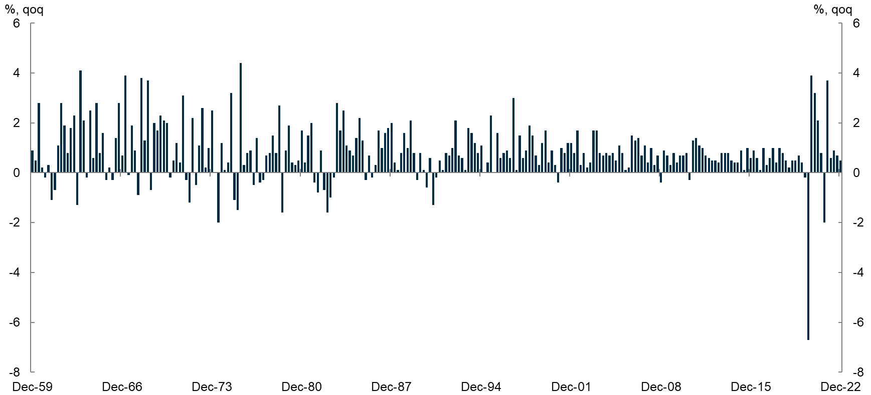

Source: ABS National Accounts, Income, Expenditure and Product.

And easily the largest fall since the Second World War.

Australia’s overseas migration fell into negative territory for the first time since the Second World War, with a net loss of 85,000 people in 2020-21.

As a result, our population growth fell to just 0.1 per cent, the lowest rate in more than 100 years.

Global trade and industrial production plummeted in 2020, by between 10 to 15 per cent.

These events prompted the largest fiscal response ever, with monetary policy also providing significant support.

In Australia, the direct fiscal response alone was $314 billion, more than six times the response during the global financial crisis. And the size of the Reserve Bank’s balance sheet grew around 2.5 times larger to around $640 billion or 27 per cent of GDP.

Far from rising and staying high — as feared — the COVID rebound saw unemployment fall to the lowest level in almost 50 years. This experience is altering our views on full employment.

One of the stories of this budget — one that risks being lost — is the virtue of full employment.

Near-record low unemployment and near-record high participation are increasing the size of our economy — helping to address, but not solve, our structural budget challenges.

Following the COVID shock, we experienced the largest energy shock since the oil crisis of the 1970s.

As a direct result of Russia’s invasion of Ukraine, we saw increases in global energy and food prices in the order of nearly 20 per cent for food and over 55 per cent for energy, and even higher in some countries, affecting billions of people (Chart 2).

**Chart 2: Global prices**

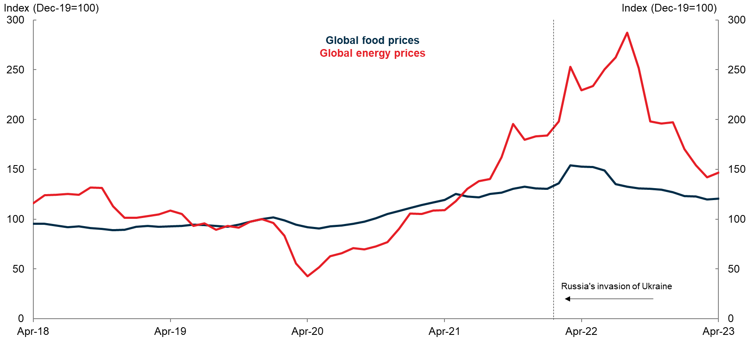

Sources: UN Food and Agriculture Organization, IMF and Refinitiv.

The echoes of the pandemic and the war-driven energy price shock are still reverberating through our economy.

And all against the backdrop of the longer run structural shift of reducing emissions, transitioning our energy systems and the most challenging geostrategic environment in many decades.

This reminds us that stability is the exception not the rule.

Moreover, that our economic settings must be adaptable and well suited to the challenges of the times.

It was in this context that the Budget, including the forecasts, was framed, noting the volatility that could easily re‑emerge.

Globally, growth is set to weaken significantly.

Domestically, growth is also expected to slow markedly as the effects of high domestic inflation and rising interest rates impact consumer behaviour.

Real time indicators support this assessment and are starting to show a pullback in spending.

If anything, consumption may already be falling a little faster than anticipated.

Partly offsetting the expected moderation in consumption (and downturn in dwelling investment) is a significant increase in exports, especially services exports reflecting the return of international students and visitors.

As a result of the slowdown in activity, the unemployment rate is expected to rise from its current historically low level to 4½ per cent by mid-2025 before settling back to 4¼ per cent.

While the near-term outlook is for subdued economic growth, the cycle is expected to turn in the second half of the forward estimates.

I will expand today on the outlook for inflation, full employment, migration, commodity prices and productivity, and I will discuss how all these developments are affecting the fiscal outlook and Australia’s debt dynamics.

## Inflation

The return of high inflation, to the fastest rate in thirty years, is one of the defining features of the current economic landscape.

And it played a critical role in the Budget delivered last week. Both in shaping the economic and fiscal projections, but also the policies included (and not included) in the Budget.

The peak in headline inflation has passed in most countries. This reflects both an improvement in supply and a reduction in demand.

Supply chains have largely recovered from disruptions related to the pandemic, with the reopening of economies, the last of these being China’s reopening in December. There has also been an easing in energy and food prices from the disruptions associated with Russia’s invasion of Ukraine.

On the other side of the equation, aggregate demand is slowing because of the decline in real incomes caused by higher prices and the fastest synchronised monetary policy tightening in the inflation-targeting era.

Despite this, there remain concerns among policy makers that inflation will stay higher for longer than currently anticipated in their central forecasts. A stark example of these concerns is Europe, where the energy price shock has been particularly acute.

The conventional view is that central banks can look through supply driven inflation shocks when they are expected to be temporary. Over time, these disruptions fade and inflation expectations remain anchored.

However, persistent higher inflation might cause businesses and households to reassess their expectations for future inflation. If expectations become de-anchored, it can be more difficult to return inflation to target, even once supply disruptions ease.

Supply disruptions have made judgements about the speed of withdrawal of extraordinary pandemic-related policy support more difficult. Central banks have had to balance the need to normalise policy quickly in response to inflation, with a desire to avoid an unnecessary weakening in economic conditions and excess unemployment.

Central banks have sought to do this by allowing inflation to return to their targets more gradually than otherwise, while keeping a close eye on incoming data and inflation expectations.

In Australia, as in other countries, the peak in inflation has passed (Chart 3). While the peak here was lower than in many countries, I know that few in our community would take comfort from that statistic.

**Chart 3: Inflation**

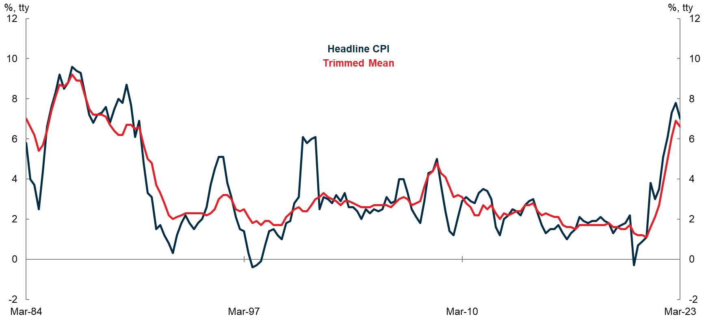

Source: ABS Consumer Price Index.

The Reserve Bank of Australia Board has embarked on the sharpest tightening phase since inflation targeting was introduced in the early 1990s. Since May 2022, the Board has increased the cash rate by 375 basis points.

Treasury expects inflation to continue moderating from here and be back in the inflation target band by 2024-25. There are no signs that medium-or long-term inflation expectations have been de-anchored and no evidence of a wage price spiral emerging.

Since the Budget was brought down, there has been an active debate about Treasury’s advice to Government that decisions in the Budget will put modest downward pressure on inflation in the near term and are not expected to contribute to broader inflationary pressures beyond that.

I will outline a couple of the ways we considered the impact of government policies on inflation.

First through examining the direct and indirect effects of policies.

Second through exploring movements in the budget position and its impact on the economy. For fiscal policy, it is primarily movements in the budget position that provide an indication of the stance of policy, unlike monetary policy where it is the level of interest rates that is most relevant.

Let’s start with the first case of the direct and indirect impact of the Government’s Cost of Living package, which includes policies that will directly reduce prices, and will not be fully offset by indirect effects.

The most significant policy is the cap on electricity and gas prices.

This policy lowers prices for consumers in the near term. Together with the rebates to consumers, the electricity and gas caps reduce inflation by around ¾ of a percentage point in 2023-24. The caps by ½ a point and the rebates by ¼ of a point. When the rebates stop in 2024-25, their effect is unwound.

This policy does mean consumers have more money than they otherwise would have to spend on other goods over time. But we think this partial offsetting effect is small and works with a lag.

Further working against this indirect offsetting effect are three things.

First, lowering energy prices and inflation reduces the indexation of payments which are linked to the CPI, taking pressure off price and income feedback loops and leaning against the psychology of higher prices.

Second, lower near-term inflation assists to keep inflation expectations anchored more broadly. This can also have helpful implications for wage setting arrangements.

And third, the reduction in profits that firms who have their prices capped now experience.

Policies such as rental assistance, pharmacy reform and bulkbilling incentives will also put small downward pressure on prices in the near term and have a largely immaterial and lagged offsetting effect on demand.

Other measures that make up the Cost of Living package, such as the modest increase in JobSeeker payments, do add to aggregate demand, with no direct effect on reducing prices. However, the costs of these policies are small such that any effects on aggregate demand and on price are not material.

The total Cost of Living package amounts to $14.6 billion over four years – $3.6 billion of which is in the next financial year equivalent to around 0.1 per cent of GDP. In the context of a $2.5 trillion economy, this is not enough to shift our model forecasts for activity or inflation in the near term.

The timing of most of these measures is also such that they do not begin until later this year and they are spread over time, further diminishing the near-term aggregate demand impact.

Hopefully, this helps in understanding how our advice was framed around the specific impact of cost of living policies. However, there were increases in spending beyond these policies in the Budget as well as increases in taxes.

An exploration of movements in the overall budget position is helpful in understanding the broader range of decisions and their overall impact on the economy. This considers, for example, the government funding of the Fair Work Commission decision to increase wages for aged care workers by 15 per cent and other measures.

From 2020-21 to 2021-22, as a proportion of GDP, the budget deficit contracted by 5 percentage points (a record contraction), from 2021-22 to 2022-23 the budget deficit is forecast to contract by nearly 1.5 percentage points (the third largest contraction in history).

Movements in fiscal settings are a little like monetary policy in that they can work with long and variable lags. These lags can depend on the composition of change in the fiscal settings. Nonetheless, the effects of the substantial consolidation in the budget position over the past two fiscal years will still be flowing through the economy in the year ahead, in much the same way, as we have not yet seen the full effects of the dramatic increases in interest rates.

Further, the small widening in the deficit in 2023-24, partly reflects lower company tax receipts, which in turn reflects our cautious approach to projecting commodity prices. Should prices remain higher, and all other things given, there would be less deterioration in the budget position in the year ahead.

This relative tightening in the fiscal position across 2022-23 and 2023-24 is the result of the Government’s decision to save most of the revenue upgrades. Swings in revenue are the most powerful way fiscal automatic stabilisers work to dampen cycles. Beyond the significant value of contributing to an improved medium term fiscal position, this also assists in managing a difficult economic cycle.

After 2023-24, the budget is forecast to return towards its structural position.

One final aspect that might have become apparent to you in this discussion of fiscal policy is the complexity of using fiscal policy to manage cycles.

Monetary policy is far better suited to fine tune business cycles, to the extent it can, than fiscal policy. Fiscal policy becomes more important in the case of crises such as the pandemic, where it is the primary macroeconomic tool.

Outside of these circumstances, I encourage the debate around fiscal policy to be primarily about the quality of spending and taxing decisions and the sustainability of these decisions. Especially given the ongoing challenges we face in these areas. I explore these issues in a little more detail later in my remarks.

## Full Employment

This Budget illustrates the benefits of full employment – to individuals and the fiscal position.

The low unemployment rate, higher participation, and a faster recovery in migration have all contributed to an increase in the productive capacity of our economy.

This has not solved our long term structural budget and productivity challenges, but it has contributed to a material improvement in our fiscal position, both in the short and longer term.

It has also benefitted those who find it hardest to get jobs. For example, while the national unemployment rate has declined by 1.6 percentage points since before the pandemic, it has declined by 3.1 percentage points for youth, and by 2.3 percentage points for those with a year 12 or lower level of education. When you push the boundaries of full employment, those on the margins benefit the most.

Sustaining the benefits of a larger and more engaged labour force is crucial to future prospects for growth and prosperity.

Let’s take a closer look at the positive labour market outcomes by breaking them down into a few parts.

First, the unemployment rate itself has fallen far faster and to a lower level than we, and others, thought possible (Chart 4).

The unemployment rate consistent with full employment and low and stable inflation is not a level that we can directly observe. This is why economists developed the statistical concept of a ‘Non-accelerating Inflation Rate of Unemployment’ – the NAIRU – and models to estimate it.

The NAIRU is not fixed over time. Policy and other factors can influence it.

**Chart 4: NAIRU and unemployment rate**



Note: The 68 per cent confidence intervals are ±1 standard error bands and the 95 per cent confidence intervals are ±2 standard error bands.  
Sources: ABS Cat. no. 6202.0, Treasury.

Prior to COVID we estimated the NAIRU to be around 4¾ per cent. With the unemployment rate now at 3.7 per cent and wages only picking up modestly, the NAIRU is almost certainly lower than earlier thought.

Treasury recently updated its estimate of the NAIRU to be around 4¼ per cent, although there is significant uncertainty surrounding the estimate.

We estimate that the NAIRU has fallen post-pandemic, and we have been surprised by the low rate of unemployment and high levels of participation that have been sustained without generating significant wage pressures.

This may show that we can, in normal times, drive the economy harder for longer without overheating (clearly complicated by current supply shocks). The Employment White Paper will explore this further, but the post-pandemic period has shown we need not settle for an unemployment rate with a 5 in front of it.

Secondly, as Jeff Borland has argued, in assessing full employment we need to look beyond the unemployment rate.

Even after the unemployment rate fell to as low as 3.4 per cent, we have continued to generate strong employment gains, by drawing in those from outside the labour force and by increasing the hours of those already employed, but under-utilised.

Again, the post-pandemic period has shown that we have more latent capacity sitting in our labour market than we thought, which can be drawn in when demand is strong enough – helping to grow our economy, without setting off unsustainable wages growth.

Labour supply has increased, reflecting growth in the working age population and a participation rate that is just 0.1 percentage points below its all-time high.

The combination of strong labour demand and labour supply has resulted in a 438,000 net increase in employment over the past year.

The Australian experience of a sharply increasing participation rate since the start of the pandemic is not unique, but it is uncommon.

The situation is shared with some countries including New Zealand and Canada, but the situations in the United States and the United Kingdom are quite different (Chart 5).

Among people aged 15–64, Australia’s participation rate is 1.8 percentage points higher than it was prior to the pandemic. In the United States, the participation rate for this age group has only recently recovered to just above pre-pandemic levels, and in the United Kingdom it is 0.7 percentage points below.

Chart 5: Change in participation rate

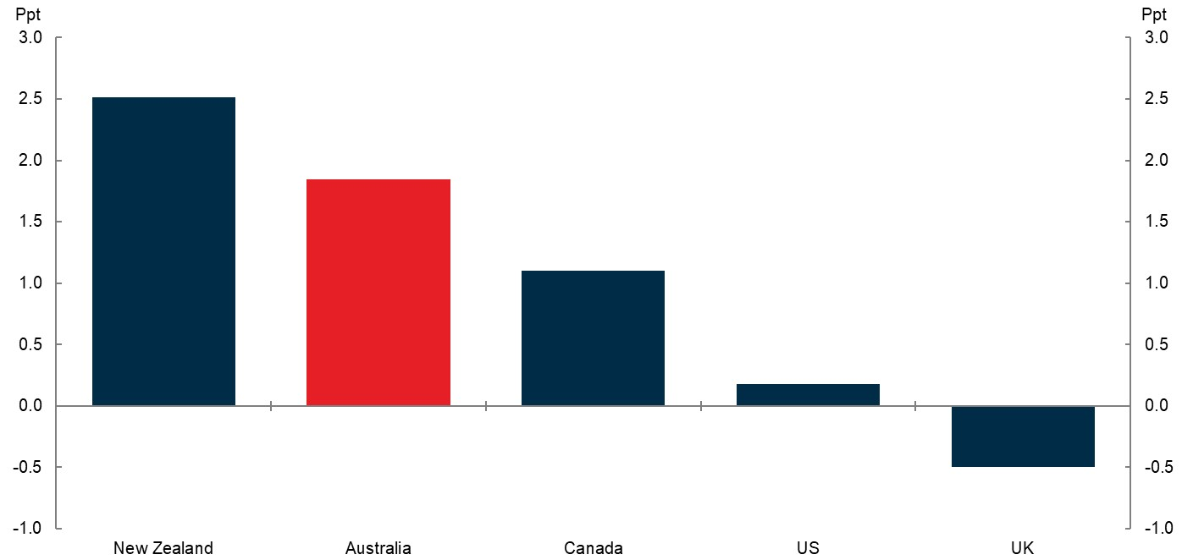

Note: Change in 15-64 participation rate from December 2019 to latest available.  
Sources: Refinitiv, national statistical agencies.

In the medium term, Treasury’s expectation for Australia’s trend participation rate has been revised up by ¾ percentage points to 66 per cent since the October Budget (Chart 6).

Chart 6: Trend participation rate

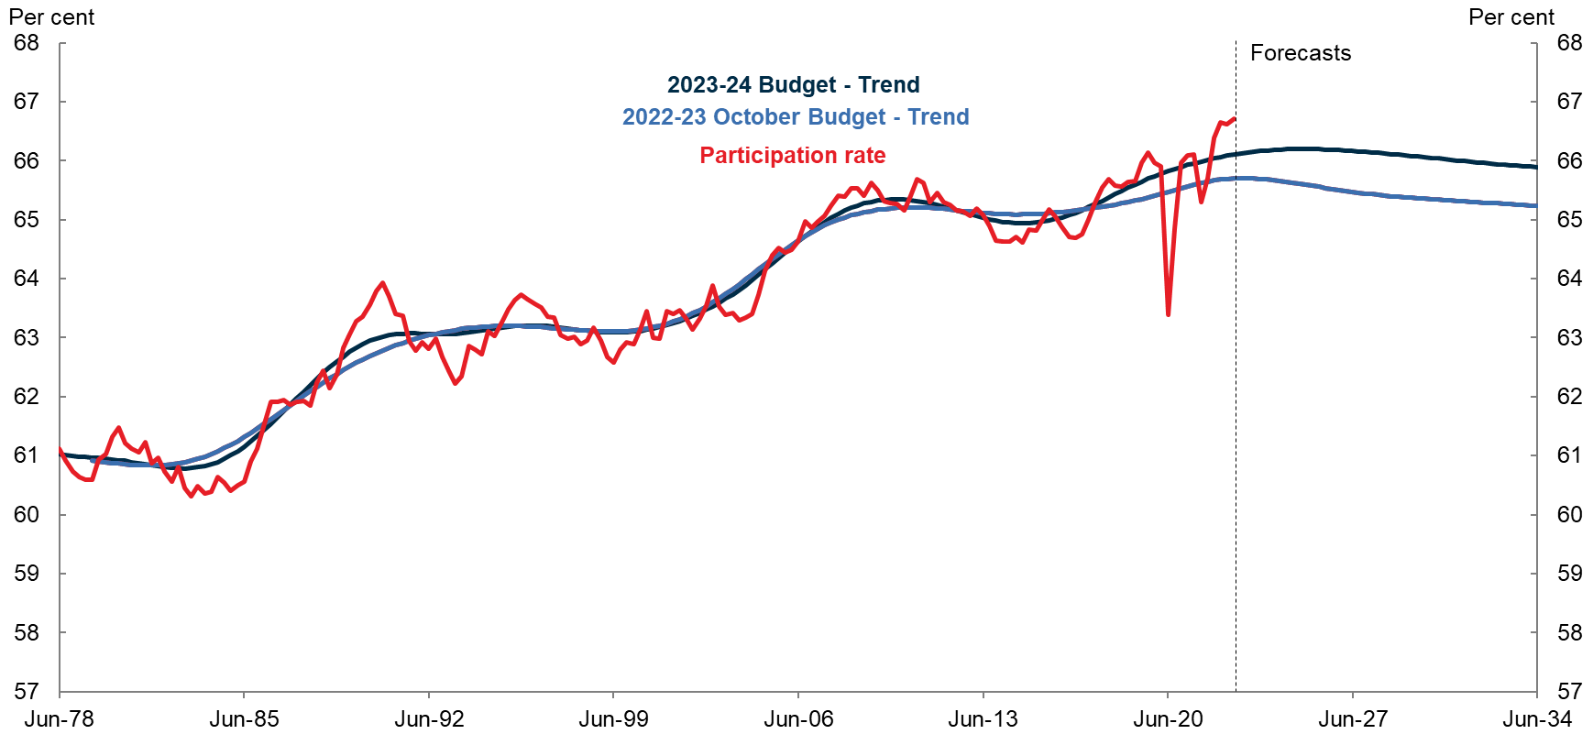

Sources: ABS Labour Force, Detailed and Treasury.

We have increased the predicted long-term participation rates to better capture trends in recent years. These trends reflect a variety of factors including migration – they are a younger cohort, and typically have higher participation rates - and educational attainment. Increased access to childcare and paid parental leave arrangements also strengthen workforce attachment and participation.

The higher projected trend participation rate increases the level of potential GDP by around 1¼ per cent compared to the October Budget, increasing the size of Australia’s workforce and our living standards.

Thirdly, let me turn to migration.

## A Faster Recovery in Migration

One of the more significant revisions in the Budget was to expectations surrounding migration and population growth.

As I noted earlier, international border restrictions during the COVID-19 pandemic saw large falls in arrivals of temporary migrants. These falls in arrivals, coupled with continued departures of migrants, saw net overseas migration (NOM), drop to -85,000 people in 2020‑21.

The reopening of Australia’s international borders has resulted in a sharp recovery. NOM is forecast to be 400,000 people in 2022-23 and 315,000 people in 2023-24, before returning closer to pre-pandemic levels from 2024-25. Significant upgrades to the forecasts for net overseas migration reflect both an increase in temporary migrant arrivals and lower temporary migrant departures.

Even with this stronger near-term outlook, cumulatively, net overseas migration is not expected to catch up to the pre-pandemic forecasts (in the 2019–20 MYEFO) until 2029–30.

Driven by the upgrade to net overseas migration, population growth is expected to peak at 2 per cent this financial year, before falling back to 1.5 per cent in 2024-25 and then gradually declining to 1.2 per cent by the end of the medium term (Chart 7).

Chart 7: Population growth by component



Source: Australian Bureau of Statistics, National, state and territory population, and Treasury projections.

There has been some conjecture as to how these changes might affect supply and demand and inflation. There is little doubt that participation focused migration expands the supply capacity of the economy through the contribution to additional labour supply.

The composition of the recent increase in migration also puts little pressure on many government services given the age of migrants and family characteristics.

However, there will be an increase in demand, including for housing and infrastructure services. And it is clear, that the wash through of policies such as HomeBuilder and the impact of monetary policy, in addition to persistent supply constraints, are creating a difficult housing cycle.

Moreover, the decision coming out of the pandemic for many to consume more housing services, seen in the fall in the ratio of people per household is further exacerbating the cycle, particularly in the rental market. As at September 2022, we estimate that the fall in average household size, relative to pre-pandemic, increased the number of households by around 130,000, all other things equal.

Recent responses by Governments to increase housing supply are a sensible no regrets response to the pressures, particularly commitments to accelerate reforms to planning and zoning.

The importance of migration is primarily through its long run settings, including skill and age composition, size, absorptive capacity of the community, contribution to GDP per capita, social cohesion, environmental consequences and so on.

These issues have been explored in detail in the recent migration review led by Martin Parkinson and before that in the 2016 Productivity Commission review of migration.

The Government has announced it will respond to the migration review later this year.

## Booming Commodity Prices

Commodity prices are another important development affecting the economy and fiscal position.

The terms of trade are expected to increase by 1½ per cent in 2022-23, after rising by almost 12 per cent in 2021-22, to reach their highest level on record.

Iron ore, metallurgical coal and thermal coal prices reached new record highs over the past two years (Chart 8).

Chart 8: RBA commodity price index



Source: RBA

To date, mining companies appear to be looking through the current price shocks, and they continue to expect prices to normalise. As such, they have not significantly altered their investment plans.

This indicates that the impact on real GDP from the recent rises in commodity prices is expected to be limited.

Typically, the positive correlation between the exchange rate and commodity prices tends to dampen the effects of commodity price movements on the domestic economy.

However, recent higher commodity prices have not been accompanied by an appreciation in the exchange rate. This has acted to deliver a larger boost to mining income on the back of record high prices measured in US dollars.

This has contributed significantly to nominal GDP, which is forecast to grow by 10¼ per cent in 2022–23 before slowing in 2023–24.

In this Budget, Treasury has revised its technical assumption for commodity prices to incorporate a longer glide path and higher long-run price levels, after analysis and consultations with industry and market forecasters. These assumption changes make a material near term but small long-term contribution to the upgrade to nominal GDP across the projection period.

Over the forward estimates, the new assumptions are expected to increase nominal GDP by around $87 billion and tax receipts by around $22.6 billion.

Around one fifth of the increase in tax receipts over the forward estimates reflects changes to the commodity price assumptions, primarily in 2023-24.

The changes are expected to reduce the likelihood and magnitude of upgrades to nominal GDP and revenue in future Budget updates.

The combination of lower unemployment, higher participation and the faster recovery in migration has materially increased our estimates of the productive capacity of our economy.

Together these effects have increased the level of potential GDP by 2¾ per cent by 2032-33.

Sustaining the gains generated by an economy operating closer to full employment should be high in the minds of policy makers. This Budget clearly demonstrates that point.

Before I move on to the medium-term fiscal position, let me say a few words about productivity. Because while employment and participation are moving in the right direction, productivity is not.

Recent productivity performance has been disappointing.  This has downgraded our estimate of the level of long-term potential GDP by 1½ per cent, offsetting just over half of the gains I mentioned above.

## The Productivity Challenge

The fiscal projections rely on an assumption of 1.2 per cent labour productivity growth. But achieving this rate of productivity growth is not assured.

Like in many advanced economies, Australia’s productivity growth has slowed in recent decades. Halting and reversing this decline in productivity growth is a long-term structural challenge that has implications for the fiscal position and living standards more broadly.

Tackling this challenge will require continued investment in the productive capacity of the economy. A well-functioning skills system will help build human capital. A clear policy environment, and enabling infrastructure, will allow individuals, businesses and communities to plan, invest and adapt to change. And responsive policy settings will foster dynamic and competitive markets, encourage the diffusion of best practice in the public and private sectors, and allow workers and capital to flow to their most productive uses.

The 6th Intergenerational Report will be released by the Government later this year and it will have more to say about the long-term economic and fiscal challenges and opportunities facing Australia.

## Structural Budget Challenges

The medium-term fiscal outlook has improved significantly since the October Budget. The underlying cash balance is expected to narrow from around 1.3 per cent of GDP in 2025-26 to just under 0.2 per cent of GDP in 2033-34.

The substantial improvement in the medium-term fiscal outlook reflects lower interest payments and a higher level of potential output and nominal GDP than previously forecast.

Overall, since the October Budget, the reductions in spending from lower interest payments and the NDIS sustainability framework more than offset new spending pressures (Chart 9).

Chart 9: Revisions to major payments since October Budget



Note: Interest refers to interest payments on Australian Government Securities. NDIS refers to the Commonwealth’s contribution to payments for NDIS participant supports.  
Source: Treasury.

By returning near-term revenue upgrades to the budget, new debt issuance and future interest payments are lower. By 2032-33 interest payments are 0.6 per cent of GDP lower than was expected in October.

Even still, the underlying cash balance is expected to remain in a structural deficit position over the medium term.

Payments as a share of GDP are expected to remain elevated and above pre-pandemic levels (Chart 10). These higher payments reflect increasing spending pressures from an ageing population, including healthcare and aged care, and services that the community values, such as the NDIS.

While NDIS costs continue to grow rapidly, they have been revised down substantially over the medium term. The commitment to a NDIS fiscal sustainability framework, incorporated into this Budget, is an important step forward in reform to the NDIS.

Higher payments also reflect the Government’s decision to increase defence funding over the medium-term in recognition of changing strategic circumstances and the recommendations of the Defence Strategic Review.

Chart 10: Payments and receipts



Source: Treasury.

Lower deficits in this year’s budget will result in a lower level of debt to GDP. It is expected to peak at 36.5 per cent of GDP, 10 percentage points lower and 5 years earlier.

This is a welcome development.

However, debt-to-GDP is expected to remain higher than prior to the pandemic, even 10 years from now (Chart 11). It would not be unusual for another economic downturn to come along in that time.

Australia has not achieved a period of sustained reductions in debt to GDP since before the global financial crisis.

Chart 11: Commonwealth gross debt to GDP

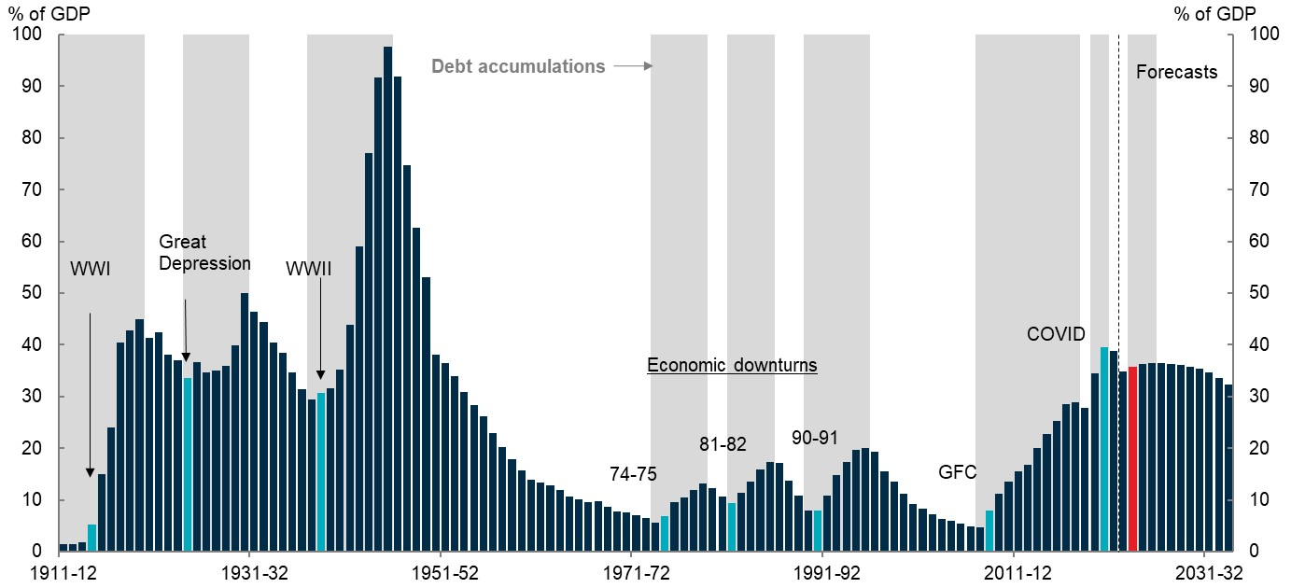

Note: Gross debt is presented in face value terms. Commencement of debt accumulations noted in light blue. Shaded areas indicate debt accumulation periods. Data is in financial years. Historical debt figures abstract from debt issued by the Commonwealth on behalf of the states and territories and as such, may differ historically from those reported in budget.

Sources: ABS, AOFM, Butlin (1985), Federal Budget Papers, PBO and Treasury.

The build-up of debt since the global financial crisis has made the fiscal position increasingly sensitive to borrowing costs, which have been more volatile recently. The ten-year bond yield, which approximates the average cost of new debt issuance, has risen as high as 4.2 per cent over the past year, but has fallen to around 3.3 per cent of late.

If yields are higher than budget projections assume, larger improvements to the primary balance will be necessary to reduce debt-to-GDP. Sensitivity analysis in the Budget shows if yields were 150 basis points higher by the end of 2026-27, gross debt-to-GDP would peak three years later and would be 3.0 percentage points of GDP higher by 2033‑34.

Australia’s debt levels compare favourably to other advanced economies, and Australia’s debt to GDP ratio is forecast to be more than 40 percentage points below levels in Canada, the United Kingdom, France and the United States.

Nevertheless, it is important that Australia continues to rebuild its fiscal buffers to ensure the Government can respond effectively to future crises.

Chart 12: International comparison of debt-to-GDP

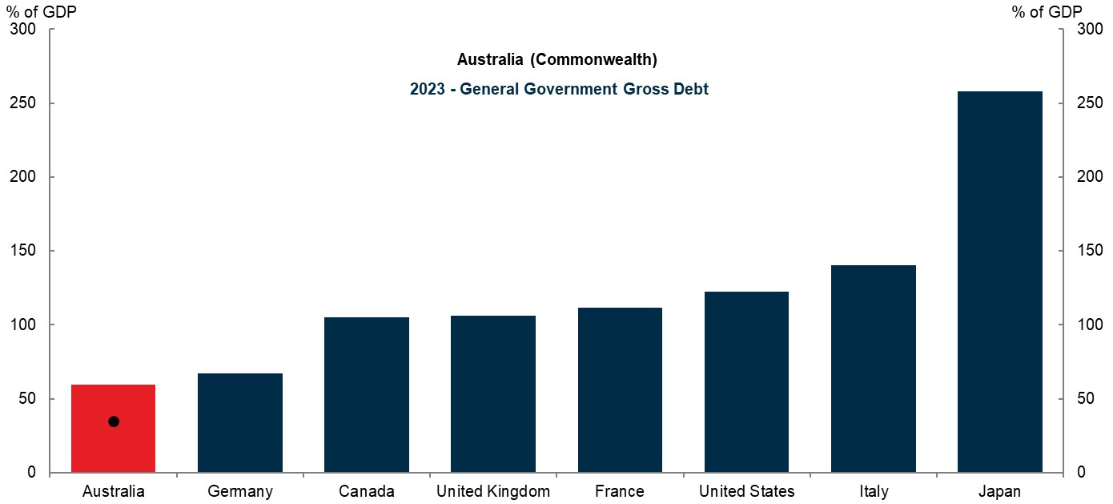  
Note: General Government Gross Debt data are prepared by the IMF and include total government debt (inclusive of state and local debt), slightly different assets and liabilities and are prepared on a calendar year basis. They are not directly comparable to debt metrics prepared by Treasury. Black dot shows the Treasury estimate for Commonwealth gross debt as at 30 June 2023.

Sources: IMF WEO April 2023, Treasury.

## Conclusion

The Australian economy is continuing to adjust following the turbulence of the past few years. Inflation and growth are continuing to moderate, in response to monetary and fiscal policy actions and continued easing of supply chains disruptions.

At the same time, full employment, a faster recovery in migration, and higher-than-expected commodity prices suggest that the nominal size of the economy is likely to be larger than previously anticipated.

The larger economy and full employment are supporting the fiscal position. The Budget reported the first surplus in the underlying cash balance since the global financial crisis. Deficits and debt are expected to be lower across the forward estimates and medium term.

While the structural budget deficit has narrowed, challenges remain.

Continuing to rebuild fiscal buffers will need to remain a priority to ensure the Government can respond to whatever crises the future holds.

And the challenge of halting and reversing the decline in productivity growth remains.

How the future will unfold is uncertain. What is certain is that our ability to meet these future budget challenges depends in part on the policy choices made today.

Thank you for the opportunity to speak with you today.

1. * I would like to express my appreciation to Luke Yeaman, Angelia Grant, David Lancaster and Evelyn Chen for their assistance in preparing this address.