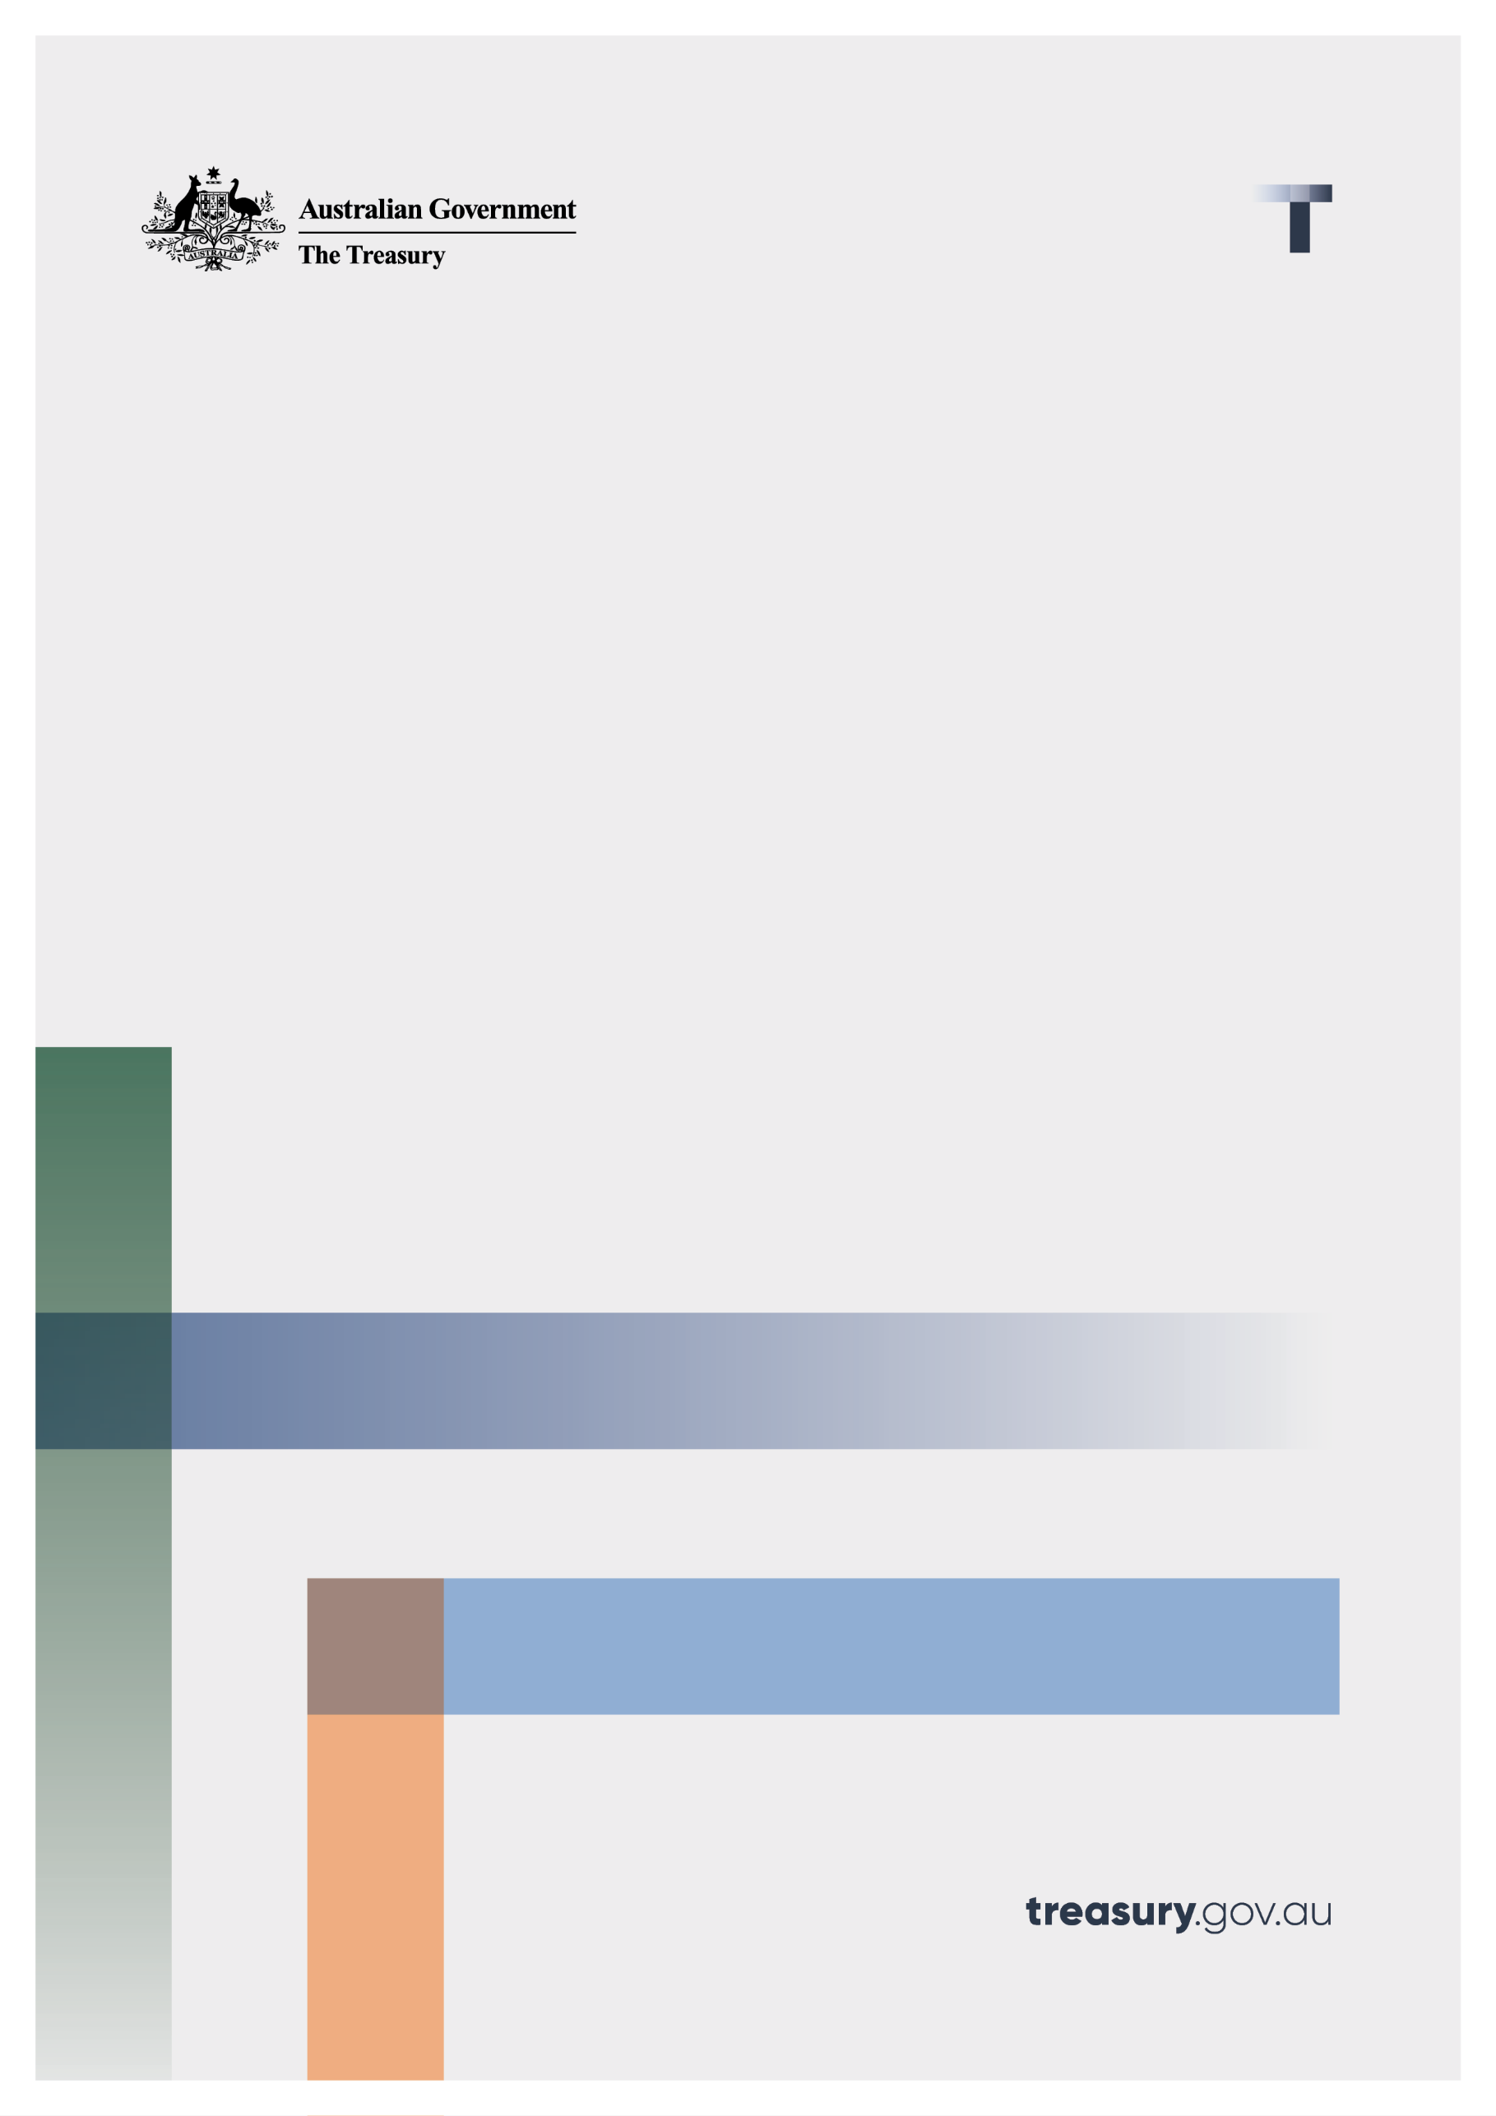

Review of sunsetting insurance regulations

Consultation paper

11 April 2023

© Commonwealth of Australia 2023

This publication is available for your use under a [Creative Commons Attribution 3.0 Australia](http://creativecommons.org/licenses/by/3.0/au/deed.en) licence, with the exception of the Commonwealth Coat of Arms, the Treasury logo, photographs, images, signatures and where otherwise stated. The full licence terms are available from <http://creativecommons.org/licenses/by/3.0/au/legalcode>.

Creative Commons attribution licence 3.0 icon. 

Use of Treasury material under a [Creative Commons Attribution 3.0 Australia](http://creativecommons.org/licenses/by/3.0/au/deed.en) licence requires you to attribute the work (but not in any way that suggests that the Treasury endorses you or your use of the work).

**Treasury material used ‘as supplied’**

Provided you have not modified or transformed Treasury material in any way including, for example, by changing the Treasury text; calculating percentage changes; graphing or charting data; or deriving new statistics from published Treasury statistics — then Treasury prefers the following attribution:

*Source: The Australian Government the Treasury*.

**Derivative** **material**

If you have modified or transformed Treasury material, or derived new material from those of the Treasury in any way, then Treasury prefers the following attribution:

*Based on The Australian Government the Treasury data*.

**Use of the Coat of Arms**

The terms under which the Coat of Arms can be used are set out on the Department of the Prime Minister and Cabinet website (see [www.pmc.gov.au/government/commonwealth-coat-arms](http://www.pmc.gov.au/government/commonwealth-coat-arms)).

**Other uses**

Enquiries regarding this licence and any other use of this document are welcome at:

Manager  
Media Unit  
The Treasury  
Langton Crescent   
Parkes ACT 2600  
Email: [media@treasury.gov.au](mailto:media@treasury.gov.au)

# Contents

Contents ii

Consultation Process 3

Request for feedback and comments 3

Review of sunsetting insurance regulations 4

Introduction 4

Purpose 4

Issues for discussion 5

Consultation Questions 11

# Consultation Process

## Request for feedback and comments

Interested stakeholders are invited to comment on the issues raised in this paper by 26 April 2023. Where your submission relates only to proposed amendments set out in the draft regulations and has no implications for the changes proposed by the Exposure Draft Primary Legislation, we will consider submissions provided by 10 May 2023. The Submissions may be lodged electronically or by post; however, electronic lodgement is preferred via email to: InsuranceSunsetting@treasury.gov.au.

For accessibility reasons, please submit responses via email in a Word, RTF, or PDF format. Submissions will be shared with other Commonwealth agencies where necessary for the purposes of this review. All information (including name and address details) contained in submissions may be made publicly available on the Australian Treasury website unless you indicate that you would like all or part of your submission to remain in confidence. Automatically generated confidentiality statements in emails are not sufficient for this purpose. If you would like only part of your submission to remain confidential, please provide this information clearly marked as such in a separate attachment. Legal requirements, such as those imposed by the *Freedom of Information Act 1982*, may affect the confidentiality of your submission

Closing date for submissions: 26 April 2023

|  |  |
| --- | --- |
| Email | InsuranceSunsetting@treasury.gov.au |
| Mail | Insurance Unit  Banking, Credit and Insurance Branch  Financial System Division  The Treasury  Langton Crescent  PARKES ACT 2600 |
| Enquiries | Enquiries can be initially directed to InsuranceSunsetting@treasury.gov.au |

The principles outlined in this paper have not received Government approval and are not yet law. As a consequence, this paper is merely a guide as to how the principles might operate.

# Review of sunsetting insurance regulations

## Introduction

Treasury has been undertaking a thematic review (review) of the following regulations (together, the Insurance Instruments) that are due to sunset on 1 October 2023 to determine whether they are still necessary and fit for purpose.

* *Insurance Acquisitions and Takeovers (Notices) Regulations 1992* made under the *Insurance Acquisitions and Takeovers Act 1991*.
* *Insurance Acquisitions and Takeovers Act 1991 – Decision-Making Principles IDM 1/1992* (Decision Making Principles) made under the *Insurance Acquisitions and Takeovers Act 1991*.
* *Life Insurance Regulations 1995* made under the *Life Insurance Act 1995.*
* *Insurance Regulations 2002* made under the *Insurance Act 1973*.

The purpose of the Acts under which the above regulations are made is to protect policyholders by regulating the types of persons that may carry on insurance businesses and prescribe standards to ensure the prudent management of the insurance industry.

The Insurance Instruments prescribe, at a more detailed level, matters relating to the regulation of the insurance industry, including the information required from insurers to ensure that prudential supervisory activities can be conducted.

## Purpose

Under the *Legislation Act 2003*, legislative instruments such as the Insurance Instruments, automatically cease to apply after a period of time, unless an active decision has been made to retain them. The aim of sunsetting is to ensure that legislative instruments are kept up to date and only remain in force so long as they are needed. Sunsetting is also an opportunity for agencies to review their legislative instruments and ensure that legislative instruments are clear and fit for purpose.

## Issues for discussion

Through the review, Treasury found that most provisions in the Insurance Instruments should be remade to allow continuity of the law, however, some should be redrafted to improve clarity and to align with modern drafting techniques.

The review also found that other minor changes should be made to the Insurance Instruments and the relevant primary legislation authorising the Insurance Instruments which are summarised in Table 1 below.

The Government has released exposure draft legislation and explanatory materials to:

* Repeal the Insurance Instruments.
* Remake most of the provisions of the Insurance Instruments.
* Make the proposed changes set out in Table 1.

The [draft exposure legislation and draft exposure explanatory materials](https://treasury.gov.au/consultation/c2023-383843) are available on the Treasury website.

The Government welcomes comments or feedback from stakeholders on the draft legislation and explanatory materials, including in response to the consultation questions set out in this consultation paper.

Table 1: Summary of proposed changes

|  |  |  |  |
| --- | --- | --- | --- |
|  | Proposed change | Relevant Act or Sunsetting Regulation | Relevant exposure legislation and explanatory materials |
|  | **Reflect modern communication methods** |  |  |
|  | Remove provisions that allowed Australian Prudential Regulation Authority (APRA) to charge for paper copies of documents, as they do not charge such fees. | *Life Insurance Regulations 1995* | Exposure Draft Explanatory Statement to Life Insurance Regulations 2023 |
|  | Introduce technology neutrality into mechanisms to make documents available to policy holders, so that modern electronic methods may be used. | *Life Insurance Regulations 1995*  *Insurance Regulations 2002*  *Life Insurance Act 1995*  *Insurance Act 1973* | Exposure Draft Life Insurance Regulations 2023  Exposure Draft Explanatory Statement to Life Insurance Regulations 2023  Exposure Draft Insurance Regulations 2023  Exposure Draft Explanatory Statement to the Insurance Regulations 2023  Exposure Draft Primary Legislation  Exposure Draft Explanatory Memorandum to the Primary Legislation |
|  | **Move some regulations into primary law** |  |  |
|  | Derivative provisions  Move provisions related to when a life insurance company can charge the assets of a statutory fund from the *Life Insurance Regulations 1995* to the *Life Insurance Act 1995*.  There is no intention to change the effect of these provisions, although drafting has been updated for clarity. The provisions allow life insurance companies to participate in global derivative markets.  The list of ‘approved bodies’ in the Exposure Draft Life Insurance Regulations 2023 has been updated to reflect that some bodies have ceased operation or been renamed. | *Life Insurance Regulations 1995*  *Life Insurance Act 1995* | Part 4, Exposure Draft Primary Legislation  Part 4, Exposure Draft Explanatory Memorandum to the Primary Legislation  Section 16, Exposure Draft Life Insurance Regulations 2023 |
|  | Various other provisions   * Move from the *Life Insurance Regulations 1995* to the *Life Insurance Act 1995*:   + Modifications to the application of the *Life Insurance Act 1995* to friendly societies.   + The requirement to provide actuarial reports to APRA in the event of a transfer of a life insurance business.   + Modifications to the application of provisions dealing with non-forfeiture of policies in certain cases of non-payment of premiums to policies where the sum insured and premium have been increased.   + Australian Securities and Investments Commission’s (ASIC) authority to publish information on unclaimed money.   + The list of life policies to be declared to be superannuation policies for the purposes of the *Life Insurance Act 1995*. * Move from the *Insurance Regulations 2002* to the *Insurance Act 1973*:   + The offence for failure to give APRA notice if a general insurer starts or stops carrying on insurance business (and increase the applicable penalty to 50 penalty units to bring the penalty in line with similar penalties in the *Insurance Act 1973*). * Where required as part of changes to forms and notices set out in rows 5-6 below. | *Life Insurance Regulations 1995*  *Insurance Regulations 2002*  *Life Insurance Act 1995*  *Insurance Act 1973* | Exposure Draft Life Insurance Regulations 2023  Exposure Draft Explanatory Statement to Life Insurance Regulations 2023  Exposure Draft Insurance Regulations 2023  Exposure Draft Explanatory Statement to the Insurance Regulations 2023  Exposure Draft Primary Legislation  Exposure Draft Explanatory Memorandum to the Primary Legislation |
|  | **Forms and notices** |  |  |
|  | * Amend the *Life Insurance Act 1995* to allow APRA to prescribe the form required to notify APRA when the life company establishes a statutory fund. * Amend the *Life Insurance Act 1995* to allow ASIC to approve the manner and form of:   + A transfer of a policy.   + Notice that a person is no longer the trustee who a policy is vested in.   + A statement of unclaimed money. | *Life Insurance Regulations 1995*  *Life Insurance Act 1995* | Part 2, Exposure Draft Primary Legislation  Part 2, Exposure Draft Explanatory Memorandum to the Primary Legislation |
|  | Amend the *Insurance Acquisitions and Takeovers Act 1991* to provide the Minister (or an APRA delegate) with the ability to approve the manner and form of notices required to be given under the *Insurance Acquisitions and Takeovers Act 1991*. | *Insurance Acquisitions and Takeovers (Notices) Regulations 1992* | Part 2, Exposure Draft Primary Legislation |
|  | **Minister’s decision-making principles under the *Insurance Acquisitions and Takeovers Act 1991*** |  |  |
|  | Overview of *Insurance Acquisitions and Takeovers Act 1991*  The *Insurance Acquisitions and Takeovers Act 1991* establishes a framework for the control and compulsory notification of certain acquisitions and agreements relating to Australian registered insurance companies. The Minister has various decision-making powers for these purposes.  Existing Decision Making Principles and findings of the review  Subsection 65(1) of the *Insurance Acquisitions and Takeovers Act 1991* currently allows the Minister to formulate principles to be complied with by him or her in making decisions under specified Parts of the *Insurance Acquisitions and Takeovers Act 1991*. The Decision Making Principles were made for the purpose of this provision. In making a decision under Part 3 or 4 of the *Insurance Acquisitions and Takeovers Act 1991*, the Minister is required to comply with any relevant decision‑making principle.  The *Insurance Acquisitions and Takeovers Act 1991* also requires the Minister to consider whether a matter is contrary to the public interest (referred to as the ‘public interest test’) when making certain decisions. Section 5(1) of the *Insurance Acquisitions and Takeovers Act 1991* prescribes when a matter is contrary to the public interest, namely:   1. likely to adversely affect the prudential conduct of the affairs of the company; or 2. likely to result in an unsuitable person being in a position of influence over the company; or 3. likely to unduly concentrate economic power in the Australian general insurance industry, in the Australian life insurance industry or in the Australian financial system; or 4. contrary to the national interest.   The review found that while the Decision Making Principles are still required in some form, their application could be made clearer.  The review also found that the *Insurance Acquisitions and Takeovers Act 1991* could be amended to make clearer the decisions to which the public interest test relates.  Proposed amendments   * Amend subsection 5(1) of the *Insurance Acquisitions and Takeovers Act 1991* to clarify that the primary public interest matters relating to the public interest test specified in subsection 5(1) of the *Insurance Acquisitions and Takeovers Act 1991* do not limit when a matter may be taken to be contrary to the public interest. * Update the current subsection 5(1)(b) of the *Insurance Acquisitions and Takeovers Act 1991* to replace ‘likely to result in an **unsuitable person** being in a position of influence over the company’ with ‘likely to result in a person who is **not a** **fit and proper person**’being in such a position. * Repeal the current enabling provision for the Decision Making Principles. This also results in the repeal of the Decision Making Principles. * Create a new subsection 5(2) of the *Insurance Acquisitions and Takeovers Act 1991*, which provides the Minister with the power to determine, by legislative instrument, matters to which regard must or may be had in determining whether a matter is contrary to the public interest (in addition to the matters set out in subsection 5(1)) or likely to have the effect or result that something is contrary to the public interest in subsection 5(1). * Make a new determination pursuant to new subsection 5(2) of the *Insurance Acquisitions and Takeovers Act 1991* to replace the Decision Making Principles.   + The new determination will more closely align the fit and proper person test with the fit and proper test applied by APRA in the similar context of the Financial Sector (Shareholdings) Rules 2019. * Clarify that the public interest test relates to the following decisions by the Minister:   + No objection to a trigger proposal.   + No objection to a trigger proposal as long as the person complies with conditions.   + Any determination made under the new instrument‑making power in subsection 5(2) of the *Insurance Acquisitions and Takeovers Act 1991* which informs the public interest test. | Decision Making Principles  *Insurance Acquisitions and Takeovers Act 1991* | Part 1, Exposure Draft Primary Legislation  Exposure Draft Treasury Laws Amendment (Insurance) Regulations 2023  Exposure Draft Explanatory Statement to Treasury Laws Amendment (Insurance) Regulations 2023  Exposure Draft Insurance Acquisitions and Takeovers (Public Interest) Determination 2023  Exposure Draft Explanatory Statement to Insurance Acquisitions and Takeovers (Public Interest) Determination 2023 |
|  | **Reviewable decisions** |  |  |
|  | Currently a number of decisions that APRA has the power to make under the *Life Insurance Act 1995* are reviewable decisions (i.e. subject to merits review). It is proposed to make further decisions by APRA reviewable decisions, for example, APRA’s decision whether or not to approve a fund of an eligible foreign life company for the purposes of determining the total value of assets the foreign life company can invest in a subsidiary. | *Life Insurance Act 1995*  *Life Insurance Regulations 1995* | Exposure Draft Primary Legislation |

## Consultation Questions

Overall view of the Insurance Instruments

1. The review found that the Insurance Instruments, when considered overall, are operating efficiently and effectively. Do you agree? If not, please provide details as to why.

Ability to charge assets in relation to derivatives

Regulation 4.00A of the *Life Insurance Regulations 2002* was brought in by the *Financial System Legislation Amendment (Resilience and Collateral Protection) Regulation 2016* as part of a reform package to amend a number of regulations and acts (*Payment Systems and Netting Act 1998*, *Banking Act 1959*, *Financial Sector (Business Transfer and Group Restructure) Act 1999*, *Insurance Act 1973*, *Life Insurance Act 1995*, and *Private Health Insurance (Prudential Supervision) Act 2015*). The package of amendments was implemented to allow Australian financial institutions to meet margin requirements in accordance with internationally agreed principles and provide legal certainty in relation to termination rights (often referred to as close-out rights), and the operation of real time gross settlement systems, approved netting arrangements and netting markets in all market conditions.

1. Do you consider that the circumstances in which the assets of a statutory fund can be charged under Regulation 4.00A of the *Life Insurance Regulations 2002* are in effect the same as the circumstances set out in the proposed new section 38A of the *Life Insurance Act 1995* (see Part 4, Exposure Draft Primary Legislation)?
2. Is the proposed section 38A easier to understand than Regulation 4.00A of the *Life Insurance Regulations 2002*?
3. Do you consider that the proposed section 38A being worded differently to similar regulations in other instruments (such as regulation 13.15A *Superannuation Industry (Supervision) Regulations 1994*)) will cause confusion?

Non-forfeiture of life insurance policies in certain cases of non-payment of premiums

1. Amendments to section 210 of the *Life Insurance Act 1995* are proposed to incorporate into the *Life Insurance Act 1995* the modifications to section 210 in Schedule 2 of the *Life Insurance Regulations 1995.*  Do you consider that this increases the clarity and transparency of the provision without changing its intended operation?

Unclaimed money

1. Do the unclaimed money provisions in the *Life Insurance Act 1975* strike the right balance between maintaining individuals’ privacy and ensuring that an individual can easily determine if they have unclaimed money?

Minister’s decision-making principles under the *Insurance Acquisitions and Takeovers Act 1991*

1. Do you consider it appropriate to align, as much as possible, the fit and proper person test in the *Insurance Acquisitions and Takeovers Act 1991* with the fit and proper test applied in the similar context of the Financial Sector (Shareholdings) Rules 2019 as set out in the Exposure Draft Insurance Acquisitions and Takeovers (Public Interest) Determination 2023?