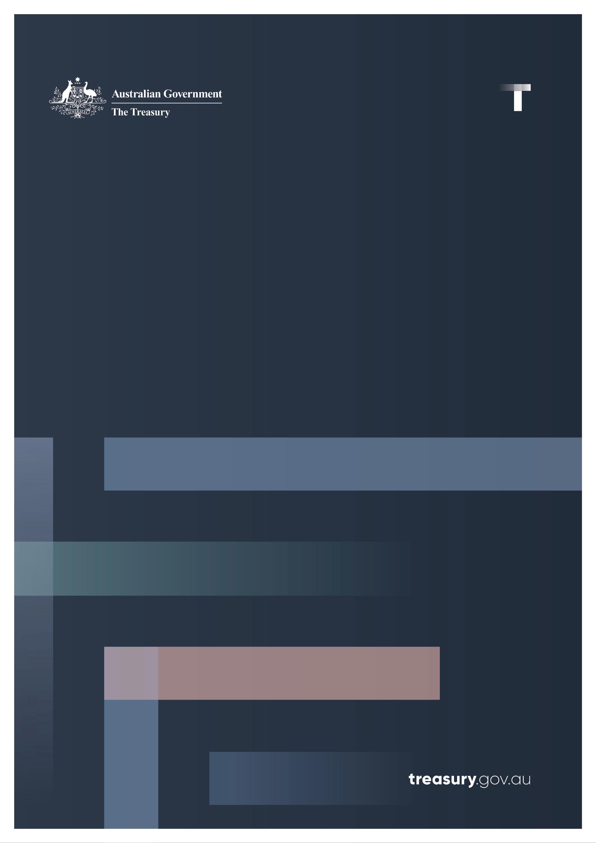

Australian Government Pay On‑Time Survey   
2021–22

Performance Report

April 2023

© Commonwealth of Australia 2023

ISBN: 978‑1‑925832‑67‑9

This publication is available for your use under a [Creative Commons Attribution 3.0 Australia](http://creativecommons.org/licenses/by/3.0/au/deed.en) licence, with the exception of the Commonwealth Coat of Arms, the Treasury logo, photographs, images, signatures and where otherwise stated. The full licence terms are available from <http://creativecommons.org/licenses/by/3.0/au/legalcode>.

Creative Commons attribution licence 3.0 icon. 

Use of Treasury material under a [Creative Commons Attribution 3.0 Australia](http://creativecommons.org/licenses/by/3.0/au/deed.en) licence requires you to attribute the work (but not in any way that suggests that the Treasury endorses you or your use of the work).

**Treasury material used ‘as supplied’**

Provided you have not modified or transformed Treasury material in any way including, for example, by changing the Treasury text; calculating percentage changes; graphing or charting data; or deriving new statistics from published Treasury statistics – then Treasury prefers the following attribution:

*Source: The Australian Government the Treasury*.

**Derivative** **material**

If you have modified or transformed Treasury material, or derived new material from those of the Treasury in any way, then Treasury prefers the following attribution:

*Based on The Australian Government the Treasury data*.

**Use of the Coat of Arms**

The terms under which the Coat of Arms can be used are set out on the Department of the Prime Minister and Cabinet website (see [http://www.pmc.gov.au/government/commonwealth‑coat‑arms](http://www.pmc.gov.au/government/commonwealth-coat-arms)).

**Other uses**

Enquiries regarding this licence and any other use of this document are welcome at:

Manager  
Media Unit  
The Treasury  
Langton Crescent   
Parkes ACT 2600  
Email: [media@treasury.gov.au](mailto:media@treasury.gov.au)

Contents

Overview 3

Survey of Australian Government agencies 4

Results 5

Government agencies are paying faster 5

Payment times by value and number 5

Interest payments 6

eInvoicing 7

Table of Agency Results 8

# Overview

This report contains the results of the Australian Government Pay On‑Time Survey for the 2021–22 financial year. The survey has been conducted annually since 2002, and collects information from Government agencies about their performance against the Department of Finance [RMG‑417 Supplier Pay On‑Time or Pay Interest Policy](https://www.finance.gov.au/publications/resource-management-guides/supplier-pay-time-or-pay-interest-policy-rmg-417)(the Pay On‑Time Policy).

The Pay On‑Time Policy requires non‑corporate Commonwealth entities (NCEs), referred to as Government agencies in this report, to pay invoices within 20 calendar days and electronic invoices (eInvoices) within 5 calendar days. Where payment is not made in full and on time, Government agencies are required to pay interest to the supplier on the outstanding amount if the interest accrued is more than $100. Interest is payable at the general interest charge rate available from the [ATO](https://www.ato.gov.au/Rates/General-interest-charge-(GIC)-rates/), calculated for each calendar day from the day after the payment is due up to and including the day the payment is made.

The 2021–22 Pay On‑Time Survey captures invoices for contracts valued up to $1 million paid by Government agencies during the 2021–22 financial year, referred to as eligible invoices in this report. This survey demonstrates an improvement in the proportion of eligible invoices paid within 20 calendar days in the 2021–22 financial year, as compared to the previous financial year.

Chart 1 shows the percentage of eligible invoices that were paid within 20 days for the 2020–21 and 2021–22 financial years. In aggregate, government agencies paid 96 per cent of eligible invoices within 20 calendar days in the 2021–22 financial year, as compared to 93 per cent in the 2020–21 financial year. This represents a 3‑percentage point improvement in the overall timeliness of payments.

Chart 1: Payments made in 20 calendar days

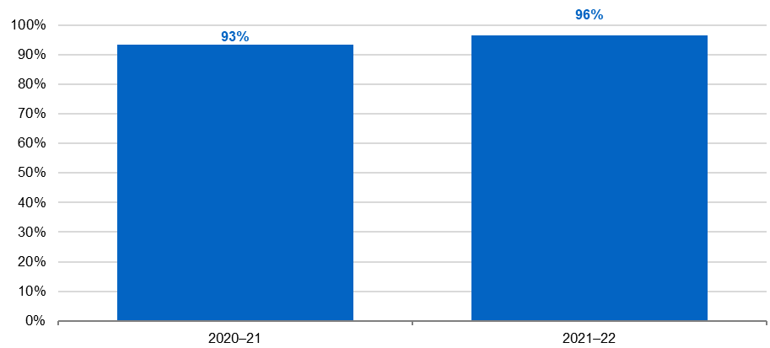

Improvements were also reported in the payment times for eligible eInvoices paid by Government agencies.

The number of eInvoicing‑enabled Government agencies increased from 29 in the 2020–21 financial year to 71 in the 2021–22 financial year. In aggregate, in the 2021–22 financial year, Government agencies processed 1,764 eligible eInvoices with a total value of $25.8 million, as compared to 92 eligible eInvoices with a total value of $1 million in the previous financial year. Overall, in the 2021–22 financial year, Government agencies paid 68 per cent of eInvoices within 5 days by number, and 68 per cent by value.

From 1 July 2022, all Australian Government agencies covered by mandate must be eInvoicing enabled.

# Survey of Australian Government agencies

The 2021–22 Pay On‑Time Survey captured data on Government agencies’ performance against the Pay On‑Time Policy for the 2021–22 financial year, including:

* The total number and value of invoices for contracts up to $1 million (GST inclusive).
* The total number and value of invoices for contracts up to $1 million (GST inclusive) that were paid within 20 days.
* The total number and value of eInvoices for contracts up to $1 million (GST inclusive).
* The total number and value of eInvoices for contracts up to $1 million (GST inclusive) that were paid within 5 days.
* The total value of interest paid on late invoices and eInvoices.

# Results

## Government agencies are paying faster

All 93 Government agencies in scope of the 2021–22 Pay On‑Time Survey provided data on payment times for eligible invoices.

In the past year, both the number (Table 1) and value (Table 2) of eligible invoices paid by Government agencies has increased. There has also been an improvement in the number and value of eligible invoices paid within 20 days.

Table 1: 2020–21 and 2021–22 comparison of payment times for invoices of contracts valued up to $1 million (GST inclusive), by number

|  |  |  |
| --- | --- | --- |
|  | **Number 2020–21** | **Number 2021–22** |
| Paid within 20 days | 869,774 (93%) | 1,420,408 (96%) |
| Paid after 20 days | 63,407 (7%) | 52,290 (4%) |
| Total invoices | 933,181 | 1,472,698 |

Table 2: 2020–21 and 2021–22 comparison of payment times for invoices of contracts valued up to $1 million (GST inclusive), by value

|  |  |  |
| --- | --- | --- |
|  | **Value 2020–21** | **Value 2021–22** |
| Paid within 20 days | $7.04bn (86%) | $7.51bn (90%) |
| Paid after 20 days | $1.14bn (14%) | $0.81bn (10%) |
| Total invoices | $8.18bn | $8.32bn |

## Payment times by value and number

Overall, by both value and number, a higher proportion of eligible invoices have been paid within 20 calendar days in the 2021–22 financial year as compared to the 2020–21 financial year.

Chart 2 provides the percentage of eligible invoices paid on time (that is, within 20 days) compared to those paid late (that is, in more than 20 days) by value and number for the 2020–21 and   
2021–22 financial years. As compared to the 2020–21 financial year, the percentage of eligible invoices paid on time in the 2021–22 financial year increased by 3‑percentage points by number (from 93 per cent to 96 per cent) and 4‑percentage point by value (from 86 per cent to 90 per cent).

Chart 2: Percentage paid on time by value and number

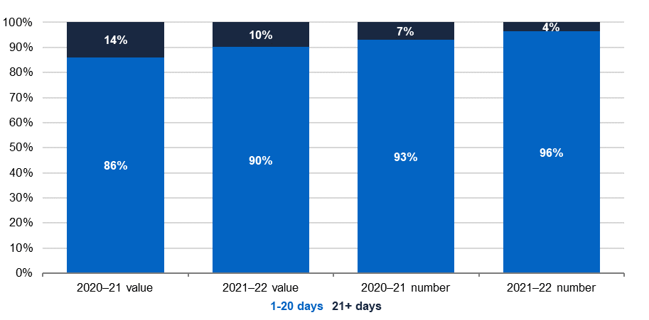

## Interest payments

Under the Pay On‑Time Policy, Government agencies are required to pay interest on late payments of eligible invoices if the amount of interest accrued is greater than $100.

Chart 3 compares the amount of interest paid by Government agencies due to late payment of eligible invoices across the 2020–21 and 2021–22 financial years. The amount of interest paid on late payment of eligible invoices in the 2021–22 financial year ($650,503) was 7‑percentage points higher than in the 2020–21 financial year ($609,404). This is likely to reflect the increase in number and total value of eligible invoices in the 2021–22 financial year, as compared to the 2020–21 financial year (see Table 1).

Chart 3: Interest paid

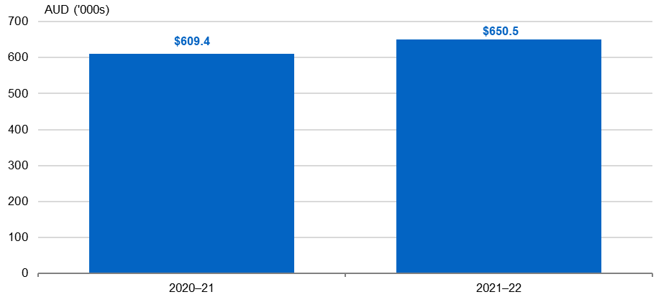

## eInvoicing

The number of eInvoicing‑enabled agencies increased from 29 in the 2020–21 financial year to approximately 71 in the 2021–22 financial year, which shows significant progress. From 1 July 2022 all Australian Government agencies covered by mandate were required to be eInvoicing‑enabled.

For the 2021–22 financial year, the number and value of eligible eInvoices paid by Government agencies has substantially increased, as compared to the previous financial year.   
In the 2021–22 financial year, Government agencies processed 1,764 eligible eInvoices with a total value of $25.8 million, as compared to 92 eligible eInvoices with a total value of $1 million in the previous financial year (Table 3).

Table 3: 2020–21 and 2021–22 comparison of payment times for eInvoices of contracts valued up to $1 million (GST inclusive), by value and number

|  |  |  |  |  |
| --- | --- | --- | --- | --- |
|  | **Value 2020–21** | **Value 2021–22** | **Number 2020–21** | **Number 2021–22** |
| Paid within 5 days | $575,467 (56%) | $17,516,284 (68%) | 57 (62%) | 1,195 (68%) |
| Paid late (after 5 days) | $446,381 (44%) | $8,315,577 (32%) | 35 (38%) | 569 (32%) |
| Total eInvoices | $1,021,848 | $25,831,861 | 92 | 1,764 |

Chart 4 provides the proportion of eligible eInvoices paid on time (that is, within 5 days) compared to those paid late (that is, more than 5 days) by number and value for the 2020–21 and 2021–22 financial years.

Chart 4: eInvoice payment times by number and value

Chart 4 provides the proportion of eligible eInvoices paid on time (that is, within 5 days) compared to those paid late (that is, more than 5 days) by number and value for the 2020–21 and 2021–22 financial years. 

By both value and number, the proportion of eligible eInvoices paid on time increased between the 2020–21 and 2021–22 financial years. Specifically, there has been a 6 percentage point increase by number, and a 12 percentage point increase by value between these financial years. Given that there has also been a significant increase in the number of eligible eInvoices received, this represents a substantial improvement in the timeliness of payments. 
Government agencies paid a total of $1,024 in interest due to late payment of eligible eInvoices. 


By both value and number, the proportion of eligible eInvoices paid on time increased between the 2020–21 and 2021–22 financial years. Specifically, there has been a 6‑percentage point increase by number, and a 12‑percentage point increase by value between these financial years. Given that there has also been a significant increase in the number of eligible eInvoices received, this represents a substantial improvement in the timeliness of payments.

Government agencies paid a total of $1,024 in interest due to late payment of eligible eInvoices.

## Table of Agency Results

Table 4 provides the percentage of eligible invoices paid within 20 days and eligible eInvoices within 5 days, by number and value, for all Government agencies that responded to the survey.

Overall, in the 2021–22 financial year, a higher proportion of Government agencies in scope of the Pay On‑Time Survey paid more than 90 per cent of eligible invoices by number within 20 days, as compared to the 2020–21 financial year. In the 2021–22 financial year, 71 of the 93 Government agencies in scope (or 76 per cent) paid more than 90 per cent of standard invoices by number within 20 days. This compares to 62 of the 91 Government agencies in scope (or 68 per cent) that paid more than 90 percent of standard invoices by number within 20 days in the 2020–21 financial year.

Table 4: Percentage of invoices paid on time by number and value for each Government agency surveyed

| **Agency** | **2021–22 Percentage (%) of invoices paid within 20 days  by number** | **2021–22 Percentage (%) of invoices paid within 20 days  by value** | **2021–22 Percentage (%) of eInvoices paid within 5 days by number** | **2021–22 Percentage (%) of eInvoices paid within 5 days  by value** |
| --- | --- | --- | --- | --- |
| Administrative Appeals Tribunal | 75 | 70 | N/A | N/A |
| Aged Care Quality and Safety Commission | 99 | 99 | N/A | N/A |
| Asbestos Safety and Eradication Agency | 100 | 100 | 100 | 100 |
| Attorney‑General’s Department | 93 | 93 | 18 | 32 |
| Australian Building and Construction Commission | 94 | 94 | N/A | N/A |
| Australian Bureau of Statistics | 97 | 80 | 86 | 91 |
| Australian Centre for International Agricultural Research (ACIAR) | 94 | 96 | N/A | N/A |
| Australian Commission for Law Enforcement Integrity (ACLEI) | 91 | 95 | N/A | N/A |
| Australian Communications and Media Authority (ACMA) | 98 | 97 | 100 | 100 |
| Australian Competition and Consumer Commission (ACCC) | 88 | 87 | N/A | N/A |
| Australian Crime Commission (Australian Criminal Intelligence Commission) | 82 | 62 | N/A | N/A |
| Australian Electoral Commission | 95 | 95 | N/A | N/A |
| Australian Federal Police | 96 | 94 | 100 | 100 |
| Australian Financial Security Authority | 96 | 96 | N/A | N/A |
| Australian Fisheries Management Authority | 100 | 100 | N/A | N/A |
| Australian Institute of Criminology | 59 | 63 | N/A | N/A |
| Australian Institute of Family Studies (AIFS) | 100 | 100 | N/A | N/A |
| Australian National Audit Office | 96 | 95 | 100 | 100 |
| Australian Office of Financial Management (AOFM) | 89 | 96 | 100 | 100 |
| Australian Prudential Regulation Authority (APRA) | 100 | 100 | 100 | 100 |
| Australian Public Service Commission | 90 | 85 | N/A | N/A |
| Australian Radiation Protection and Nuclear Safety Agency (ARPANSA) | 97 | 95 | N/A | N/A |
| Australian Research Council | 99 | 100 | N/A | N/A |
| Australian Securities and Investments Commission (ASIC) | 100 | 100 | 91 | 91 |
| Australian Security Intelligence Organisation | 75 | 70 | N/A | N/A |
| Australian Signals Directorate | 82 | 84 | 100 | 100 |
| Australian Skills Quality Authority (National Vocational Education and Training Regulator) | 93 | 88 | N/A | N/A |
| Australian Taxation Office | 95 | 90 | 89 | 96 |
| Australian Trade and Investment Commission (Austrade) | 87 | 88 | N/A | N/A |
| Australian Transaction Reports and Analysis Centre (AUSTRAC) | 97 | 96 | N/A | N/A |
| Australian Transport Safety Bureau (ATSB) | 81 | 82 | 100 | 100 |
| Bureau of Meteorology | 62 | 52 | 0 | 0 |
| Cancer Australia | 92 | 91 | 100 | 100 |
| Clean Energy Regulator | 94 | 93 | N/A | N/A |
| Climate Change Authority | 96 | 98 | N/A | N/A |
| Commonwealth Grants Commission | 99 | 99 | N/A | N/A |
| Department of Agriculture, Fisheries and Forestry | 96 | 93 | 75 | 67 |
| Department of Defence | 97 | 91 | 85 | 89 |
| Department of Education | 94 | 95 | 65 | 53 |
| Department of Finance | 96 | 99 | N/A | N/A |
| Department of Foreign Affairs and Trade | 97 | 96 | 24 | 23 |
| Department of Health and Aged Care | 80 | 82 | 30 | 25 |
| Department of Home Affairs | 97 | 91 | 100 | 100 |
| Department of Industry, Science and Resources | 93 | 92 | 64 | 74 |
| Department of Infrastructure, Transport, Regional Development, Communications and the Arts | 89 | 86 | 67 | 99 |
| Department of Parliamentary Services | 86 | 77 | N/A | N/A |
| Department of Social Services | 98 | 96 | 81 | 44 |
| Department of the House of Representatives | 97 | 99 | N/A | N/A |
| Department of the Prime Minister and Cabinet | 100 | 100 | 100 | 100 |
| Department of the Senate | 95 | 98 | 0 | 0 |
| Department of the Treasury | 95 | 94 | 100 | 100 |
| Department of Veterans’ Affairs | 89 | 89 | N/A | N/A |
| Digital Transformation Agency | 93 | 93 | 61 | 53 |
| Fair Work Commission | 99 | 95 | N/A | N/A |
| Fair Work Ombudsman and Registered Organisations Commission Entity | 91 | 84 | N/A | N/A |
| Federal Court of Australia | 93 | 91 | N/A | N/A |
| Future Fund Management Agency | 79 | 77 | N/A | N/A |
| Geoscience Australia | 90 | 89 | 100 | 100 |
| Great Barrier Reef Marine Park Authority | 98 | 98 | 100 | 100 |
| Independent Parliamentary Expenses Authority | 98 | 97 | 100 | 100 |
| Inspector‑General of Taxation | 86 | 87 | N/A | N/A |
| IP Australia | 100 | 100 | N/A | N/A |
| National Archives of Australia | 97 | 99 | 100 | 100 |
| National Blood Authority | 100 | 100 | N/A | N/A |
| National Capital Authority | 87 | 88 | 100 | 100 |
| National Competition Council | 100 | 100 | N/A | N/A |
| National Emergency Management Agency | 100 | 100 | 100 | 100 |
| National Faster Rail Agency | 99 | 100 | N/A | N/A |
| National Health and Medical Research Council (NHMRC) | 93 | 94 | N/A | N/A |
| National Health Funding Body (NHFB) | 82 | 91 | N/A | N/A |
| National Indigenous Australians Agency | 100 | 100 | N/A | N/A |
| National Mental Health Commission | 89 | 89 | N/A | N/A |
| NDIS Quality and Safeguards Commission | 96 | 93 | N/A | N/A |
| North Queensland Water Infrastructure Authority | 93 | 99 | N/A | N/A |
| Office of National Intelligence | 90 | 91 | N/A | N/A |
| Office of Parliamentary Counsel | 93 | 95 | N/A | N/A |
| Office of the Australian Accounting Standards Board (AASB) | 96 | 96 | N/A | N/A |
| Office of the Australian Information Commissioner | 92 | 87 | N/A | N/A |
| Office of the Commonwealth Director of Public Prosecutions (CDPP) | 94 | 93 | 100 | 100 |
| Office of the Commonwealth Ombudsman | 97 | 92 | N/A | N/A |
| Office of the Inspector‑General of Intelligence and Security | 100 | 100 | 100 | 100 |
| Office of the Official Secretary to the Governor‑General | 100 | 100 | N/A | N/A |
| Office of the Special Investigator | 83 | 87 | N/A | N/A |
| Organ and Tissue Authority | 97 | 99 | N/A | N/A |
| Parliamentary Budget Office | 91 | 91 | N/A | N/A |
| Productivity Commission | 94 | 99 | N/A | N/A |
| Professional Services Review | 100 | 100 | 100 | 100 |
| Royal Australian Mint | 100 | 100 | 75 | 80 |
| Safe Work Australia | 100 | 100 | N/A | N/A |
| Services Australia | 100 | 95 | 0 | 0 |
| Sport Integrity Australia | 76 | 58 | 100 | 100 |
| Tertiary Education Quality and Standards Agency | 99 | 100 | N/A | N/A |
| Workplace Gender Equality Agency | 93 | 95 | N/A | N/A |
| Total across all agencies (%) | 96 | 90 | 68 | 68 |

**N/A:** Agency was not eInvoice enabled or did not pay eInvoices up to $1 million in the 2021–22 financial year.

**Note 1:** Names of agencies are based on the Flipchart of PGPA Act Commonwealth entities and companies from the Department of Finance as of 15 November 2022.

**Note 2:** The 2021–22 Survey was completed by 93 agencies compared to 91 in 2020–21. It is common for the number of recorded agencies to vary each year due to Machinery of Government changes or through agencies under the same portfolio merging their submissions due to shared financial functions.