site

Children and the Gender Earnings Gap: Evidence for Australia

Elif Bahar, Natasha Bradshaw, Nathan Deutscher and Maxine Montaigne[[1]](#footnote-2)

Treasury Working Paper[[2]](#footnote-3)

2023–02

Date created: March 2023

© Commonwealth of Australia 2023

ISBN 978-1-925832-68-6

This publication is available for your use under a [Creative Commons BY Attribution 3.0 Australia](http://creativecommons.org/licenses/by/3.0/au/deed.en) licence, with the exception of the Commonwealth Coat of Arms, the Treasury logo, photographs, images, signatures and where otherwise stated. The full licence terms are available from <http://creativecommons.org/licenses/by/3.0/au/legalcode>.

CC by_grey

Use of Treasury material under a [Creative Commons BY Attribution 3.0 Australia](http://creativecommons.org/licenses/by/3.0/au/deed.en) licence requires you to attribute the work (but not in any way that suggests that the Treasury endorses you or your use of the work).

**Treasury material used 'as supplied'**

Provided you have not modified or transformed Treasury material in any way including, for example, by changing the Treasury text; calculating percentage changes; graphing or charting data; or deriving new statistics from published Treasury statistics – then Treasury prefers the following attribution:

*Source: The Australian Government the Treasury*

**Derivative material**

If you have modified or transformed Treasury material, or derived new material from those of the Treasury in any way, then Treasury prefers the following attribution:

*Based on The Australian Government the Treasury data*

**Use of the Coat of Arms**

The terms under which the Coat of Arms can be used are set out on the Department of the Prime Minister and Cabinet website (see [www.pmc.gov.au/government/commonwealth-coat-arms](http://www.pmc.gov.au/government/commonwealth-coat-arms)).

**Other uses**

Enquiries regarding this licence and any other use of this document are welcome at:

Manager  
Media Unit  
The Treasury  
Langton Crescent   
Parkes ACT 2600

Email: [media@treasury.gov.au](mailto:media@treasury.gov.au)

Children and the Gender Earnings Gap: Evidence for Australia

Elif Bahar, Natasha Bradshaw, Nathan Deutscher and Maxine Montaigne

2023-02

March 2023

# Abstract

This paper uses an event study approach to estimate the impact of children on the gender earnings gap in Australia. We use the Household, Income and Labour Dynamics in Australia (HILDA) survey to show the arrival of children has a large and persistent impact on the gender earnings gap, reducing female earnings by 55 per cent, on average, in the 5 years following parenthood. We further show, using personal income tax data collected by the Australian Tax Office (ATO), that this gap improves only slightly but remains high in the 10 years following the arrival of children. We attribute the gap in earnings to lower participation rates and reduced working hours amongst mothers. Although the decline in earnings for women is very similar regardless of their breadwinner status in the household pre‑children, women with greater access to workplace flexibility are more likely to remain employed after having children.

JEL Classification Numbers: J13, J16, J22, J31

Keywords: children, gender earnings gap, labour supply, wage differential, norms, discrimination, workplace policies

Nathan Deutscher

Macroeconomic Analysis and Policy Division

Macroeconomic Group

The Treasury

Langton Crescent

Parkes ACT 2600

## Introduction

Despite convergence in recent decades, there remain large disparities in earnings between men and women in Australia, as in many other countries. International literature has shown that the differential impacts of children on men’s and women’s earnings is the primary driver of gender earnings gaps (Kleven et al. 2019a) and has been documented in varying magnitudes in a number of countries (Kleven et al. 2019b). This divergence in earnings following entry into parenthood is often termed the ‘motherhood penalty’ (or ‘child penalty’).

In this paper, we examine the impact of children on the gender earnings gap in Australia, identify the motherhood penalty in Australia up to a decade following the arrival of the first child, and compare the results to international estimates. Our focus is on labour market outcomes, and not on the broader suite of measures of life satisfaction, health and wellbeing that potentially change in equally important ways for men and women on becoming parents.

We follow Kleven et al.’s (2019a) approach of using an event study to show that the arrival of children has a large and persistent impact on the earnings of women, but not for men. Using survey data, we show that women’s earnings fall by an average of 55 per cent in the first 5 years after entry into parenthood, while men’s are unchanged. We extend this analysis using administrative data which shows a similar gap persists for the first 10 years following parenthood. We attribute the gap in earnings to lower participation rates and reduced working hours amongst mothers, and to a lesser extent, a fall in hourly wages. We show that men’s earnings are not significantly affected by the arrival of children.

We then show, through an illustrative gender earnings gap decomposition, that the share of gender inequality attributable to the motherhood penalty has increased substantially since the early 2000s. In 2001, the motherhood penalty explained around half of all gender earnings inequality; by 2019, this had increased to four‑fifths. The increase is likely due to a decline in non‑child related drivers of inequality, such as the rise in female educational attainment or decline in employment discrimination.

We also contribute to the literature by investigating several potential drivers of the motherhood penalty in Australia that have emerged from the international literature. Health issues related to birth and biological differences have largely been ruled out as a cause through studies which compare gender differences in outcomes of same‑sex and adoptive parents (Anderson & Nix 2022; Kleven et al. 2021). Some earlier studies have also pointed to the role of employer discrimination (Blau & Kahn 2000; Neumark et al. 1996).

One explanation with mixed evidence is that the reduction in a mother’s earnings may result from choices within households based on each parent’s comparative advantage in the labour market. Anderson and Nix (2022) rule out fathers’ labour market advantage as a cause of the motherhood penalty in Norway by showing that child penalties experienced by women are significantly larger in heterosexual couples compared to same-sex couples, and that the contrast to same-sex couples remains even controlling for several measures of pre‑determined relative labour productivity differences between spouses. In contrast, using Swedish administrative data, Angelov et al. (2016) show that gender gaps following children are lower, or even negative, when the mother has higher earnings and education relative to the father. In our paper, we show that the motherhood penalty is the same regardless of a woman’s breadwinner status prior to children. We find that the penalty is significant even in households where the woman out‑earns her partner by a significant margin, implying that relative earnings prior to children have little influence on the intrahousehold allocation of paid work following children.

Another potential explanation for the reduction in women’s earnings relative to men’s after children could be differences in preferences for providing care. While such preferences likely play a substantial role in determining the allocation of work and care responsibilities between parents, we provide suggestive evidence that other factors are also at play. We observe a fall in women’s satisfaction with their work opportunities after the arrival of children. We also observe a rise in work‑life conflict, particularly for fathers, who are more likely to report that work affects their family life after the arrival of children. This suggests potential gains from more equal division of caring responsibilities, and more flexible workplaces.

We then investigate workplace norms around flexible working specifically and provide suggestive evidence that women working in more flexible occupations before parenthood are more likely to remain employed after the arrival of children. However, for women who remain employed, the hourly wage penalty is larger for women in more flexible occupations, which may reflect foregone promotion opportunities. This is consistent with other research that finds flexible work can restrict mothers’ earnings in industries or occupations that disproportionately penalise short or flexible working hours (Cortes & Pan 2019; Goldin 2019). Importantly, we also show that women with less access to flexibility are more likely to exit the labour force entirely. These results suggest flexibility can be a double-edged sword, allowing some mothers to remain engaged in work, but potentially at the cost of a lower hourly wage than they might otherwise earn.

Finally, we discuss the role of broader gender norms, which have been previously shown to have strong implications for labour market outcomes and family dynamics (Avdic & Karimi 2018; Bertrand et al. 2015; Bittman et al. 2003; Kuziemko et al. 2020). Kleven et al. (2019a) show that in Denmark child penalties are transmitted through generations, from parents to daughters (but not sons), as girls growing up in more traditional families experience larger motherhood penalties. Kleven et al. (2019b) also show a strong correlation between stated gender norms and the motherhood penalty, with more conservative countries experiencing larger penalties. We further this strand of the literature by placing Australia within the international landscape, showing Australia has both a high motherhood penalty and is relatively conservative in its gender norms.

Overall, our results highlight the strong labour supply implications of entry into parenthood for women. These results are consistent with international studies suggesting these differences in labour market outcomes do not purely reflect different preferences between the genders, but also constraints that may be driven by differences in workplace and social norms or institutions. This suggests a role for policy in reducing these constraints, to allow new parents to share work and care responsibilities more evenly. To our knowledge, we are the first paper to provide causal evidence of the motherhood penalty in both survey and tax data for Australia.

## Background

Gendered pay inequity in Australia is rooted in historical industrial practices and views of men’s and women’s roles. As early as 1912, women’s wages were set at 54 per cent of men’s, based on the ‘breadwinner assumption’ that men needed to be paid extra to provide for their family, since married women generally did not work outside of the home. This difference only applied in female‑dominated occupations to ensure women’s lower wages did not put men out of work, creating a strong wage‑based incentive for gendered occupational segregation (Pocock 1999). Important legislative changes including the equal work for equal pay decision in 1969 and the equal pay for work of equal value decision in 1972 were significant in narrowing the gender pay gap in Australia throughout the 1970s, putting Australia’s pay equity ahead of our international counterparts.

As in many other countries, women’s labour force participation rates have increased significantly over the past several decades, and the gender pay gap has gradually narrowed over time. These gains coincided with a significant long‑term increase in the level of women’s educational attainment, allowing women to enter skilled professions and access better paid jobs. The current gender pay gap in weekly ordinary time earnings for full‑time employees is 13.3 per cent and reflects the persistent effects of industrial and occupational segregation, women’s time out of the workforce and higher rates of part‑time work, and discrimination and bias (WGEA 2023). This gap is substantially higher when overtime and other earnings, and part‑time employees are included. Australia has relatively high rates of female workforce participation compared to other OECD countries, but Australian women are much more likely to work part‑time, and the female participation rate remains around 9 percentage points below men’s (ABS 2022a). Survey evidence suggests that care responsibilities are the primary reason for women not participating in the workforce or working part‑time, as women continue to take on the bulk of unpaid work in Australian households (ABS 2020a).

Expectations about the roles of men and women in Australia have also shifted over time. Our analysis using the Household, Income and Labour Dynamics in Australia (HILDA) survey indicates that the share of Australian’s who agree with the statements “mothers who don’t need the money really shouldn’t work” and “a pre‑school child is likely to suffer if his/her mother works full‑time” declined by 15 percentage points between 2005 and 2019.[[3]](#footnote-4) However, a sizeable minority of Australians (26 and 17 per cent, respectively) continued to agree with the statements.

Some of the policy levers available to address pay inequity for mothers are child care and paid parental leave settings. In 2011, Australia became the second‑last OECD country to implement a national paid parental leave scheme. The current scheme offers 20 weeks of leave to be shared flexibly to eligible parents, paid at the national minimum wage and is funded entirely from public funds. Child care in Australia operates primarily in a market-based system, and the Australian Government pays a means‑tested subsidy to providers that substantially reduces out‑of‑pocket child care costs, particularly for lower‑ and middle‑income families. Over the past several decades, there has been a substantial increase in the use of formal child care in Australia, and in average weekly hours used (ABS 2018). However, out of pocket costs remain relatively high on average in Australia, compared to other OECD countries (OECD 2020).

## Data

We draw on two datasets to examine the role of children in the gender earnings gap in Australia – the Household, Income and Labour Dynamics in Australia (HILDA) survey and the Australian Taxation Office (ATO) Longitudinal Information Files (ALife). Here we briefly describe both datasets, their strengths and limitations in this context, and provide some descriptive information about the analysis samples.

### The Household, Income and Labour Dynamics in Australia (HILDA) survey

HILDA is an annual longitudinal survey of Australian households, from 2001 onwards; we use the 2019 release.[[4]](#footnote-5) Each year HILDA collects detailed information on just under 10,000 households. Respondents (and their families) are asked questions about their income, employment and educational characteristics. In addition, HILDA includes information about satisfaction with life and work, which are helpful in exploring the mechanisms that might underlie the motherhood penalty.

We identify our key event, the arrival of a child, from changes in response to the question concerning the number of children ever had. We identify the year of birth (or the first year of a child’s arrival) as the year in which the total number of children a respondent ever had increases from zero to one. Furthermore, as HILDA interviews respondents’ families, we can link information on spouses or partners to respondents. Information on respondents’ partners will only be available for partners living in the same household.

The detail available in HILDA allows us to paint a relatively rich picture of the motherhood penalty in Australia. Nonetheless, the sample sizes in HILDA limit our ability to precisely estimate the motherhood penalty over longer periods of time or to conduct other more data‑intensive exercises. With this in mind, we turn to recently released administrative tax data.

### The ATO Longitudinal Information Files (ALife)

ALife is a longitudinal administrative dataset linking individual tax returns from the 1991 income year onwards (Carter et al. 2021).[[5]](#footnote-6) We use the 2018 release, which is a random 10 per cent sample of taxpayers lodging returns over the 28‑year period from the 1991 to 2018 income years. The data includes information from the tax returns and client records of these taxpayers. As such, ALife has high quality data on individual incomes and captures core demographic information such as age and gender.

The key drawback of ALife is that children are only observed when recorded on the tax return, and the requirement to do this has varied over time. Individuals are only required to report the number of dependent children for income test purposes for Medicare levy reductions, private health insurance rebates or other tax offsets. However, the reporting of dependent children has only increased over time, so we are confident we are capturing more births in our sample. For instance, only about 43 per cent of individuals reported whether they had dependent children in the 2000 income year, compared to 86 per cent in the 2018 year.

The ATO began deriving the number of children from the above information from 2000. We therefore only include individuals into our sample if they report having their first child after 2000, and if they are working age (between 15 and 65 years old). We identify the arrival of the first child when an individual reports zero dependent children in one year, and one (or more) dependent child(ren) in the following year.

Our sample in ALife is necessarily restricted to individuals who lodge a tax return, and we only include individuals into our sample if they lodge a tax return in all years of our balanced panel. Therefore, we are unable to capture individuals who do not complete a tax return in any given year. This is particularly likely to be individuals who are not in paid employment or earn below the tax‑free threshold. We also exclude individuals who worked overseas for all or part of the year. While this will likely understate the true motherhood penalty, it is a more conservative choice than assuming non‑lodgers have no earnings, which would likely overstate the penalty.

### Sample selection and summary statistics

For the estimation of the motherhood penalty, we focus on a balanced panel of individuals observed for 3 years prior to the arrival of their first child in both datasets, and for 5 years following the birth in HILDA and 10 years following the birth in ALife.[[6]](#footnote-7) This leaves us with 1,345 people in HILDA observed over 9 years (12,105 person‑years), and 52,994 people observed over 14 years in ALife (741,916 person‑years).

In Table 1 we provide some summary statistics for the 2 populations. While the ages of our sample are similar in both datasets, average incomes are lower for both men and women in the ALife dataset, and there is a higher proportion of men in the ALife dataset. This likely reflects that we are only able to observe entry into parenthood for a sub‑sample of the ALife population, as described above.

Table 1: Summary statistics

|  |  |  |  |
| --- | --- | --- | --- |
|  | **Women** | **Men** | **All** |
| *HILDA sample* |  |  |  |
| N | 708 | 637 | 1,345 |
| Age | 29.3  (29) | 32.3  (31) | 30.8  (30) |
| Income | 49,735.8  (47,215.5) | 62,359.0  (57,012.5) | 51,235.6  (46,000.0) |
| Hours worked | 31.2  (38) | 40.0  (40) | 35.6  (40) |
| *ALife sample* |  |  |  |
| N | 22,026 | 30,968 | 52,994 |
| Age | 31.9  (31) | 32.9  (32) | 32.5  (31) |
| Income | 42,667.6  (41,001.3) | 55,412.7  (52,325.5) | 50,115.4  (47,517.9) |

Notes: Statistics reported for year before birth (t=-1). Population weights have been used for the HILDA sample. Mean reported and median in brackets. Income is gross wages and salary, CPI adjusted to 2011–12 dollars.

Source: Treasury analysis of HILDA Release 19.0, ALife 2019 and ABS (2022b).

## Children and the Gender Earnings Gap

### Event study methodology

We adopt a similar event study methodology as Kleven et al. (2019a), exploiting sharp changes in earnings around the arrival of the first child for mothers and fathers and controlling flexibly for lifecycle and time trends.

While the decision to have children is not exogenous from many other determinants of income, the event study framework exploits the timing of child arrival among couples who will have children, rather than comparing people who have children to people without children. Amongst couples who do have children, unobserved determinants of labour market outcomes would be expected to be relatively smooth over time, while entry into parenthood creates sharp changes in labour market outcomes.

The identifying assumptions for causal estimation are strong,[[7]](#footnote-8) however we rely on analysis by Kleven et al. (2019a) showing that the event study methodology produces almost identical results to even more rigorous approaches.[[8]](#footnote-9) This provides strong evidence that an event study methodology drawing on within‑person variation can causally identify the impacts of children on labour market outcomes.

Our baseline event study model adopts the following form:

$Y_{ist}^{g}=\underset{j ≠1}{Σ}{α_{j}^{g}.I\left[j=t\right] }+ \underset{k}{Σ} β_{k}^{g}.I\left[k={age}_{is}\right]+ \underset{y}{Σ} δ_{y}^{g}.I\left[y=s\right]+ ϵ_{ist}^{g}$ (1)

where the dependent variable is the annual earnings for individual *i* of gender *g*, in year *s* and at event time *t*. For each parent, event time *t* is indexed to the year of the arrival of their first child. We run the regression separately for both men and women. The first term on the right‑hand side is a full set of event time dummies, excluding the year before the arrival of the first child (i.e. *j*=-1). We also include a full set of flexible age (second term) and year (third term) dummies. The age dummies control for underlying lifecycle trends in earnings, while the year dummies control for time trends such as business cycle swings and wage inflation.

Our baseline specification using HILDA includes a balanced panel of parents who we observe for all years between 3 years before and 5 years after the arrival of their first child. We extend our sample to study 10 years post‑parenthood in the ALife sample, discussed further below. We estimate Equation (1) in levels to enable inclusion of individuals with zero wage income (i.e. those who are not in paid employment), and then convert the level effects into a percentage of the no‑child counterfactual at event time *t*.

Further, following Kleven et al. (2019a) we then define the motherhood penalty, the amount that women’s earnings are falling behind men due to children at event time *t* as:

$P_{t}≡ \frac{α_{t}^{m}- α_{t}^{f}}{E\left[\tilde{Y_{ist}^{f}} | t\right]}$ (2)

### Event study results

Chart 1 plots the gender‑specific impacts of children on wage and salary earnings over time, relative to earnings in the year before children. In the 3 years prior to childbirth, the earnings of men and women move in a similar way. However, following the arrival of the first child, earnings of men and women immediately begin to diverge, with a significant gap remaining 5 years after entry into parenthood.

We find a significant and persistent penalty attached to having a child for women, but not for men. The motherhood penalty in earnings, defined as the percentage by which women fall behind men due to children, averages 55 per cent over the first 5 years (excluding the birth year). Extending our sample using the ALife dataset shows a slightly smaller, but still persistent, motherhood penalty in the longer run (see Appendix for further detail).[[9]](#footnote-10) Our estimated long run penalty (defined as the average penalty from 5 to 10 years after entry into parenthood) is 43 per cent, similar to the United Kingdom (44 per cent), larger in magnitude than estimates for Denmark (21 per cent), Sweden (26 per cent) and the United States (31 per cent), but smaller than estimates for Austria (51 per cent) and Germany (61 per cent) (Kleven et al. 2019b).

Chart 1: Impact of children on earnings, by sex

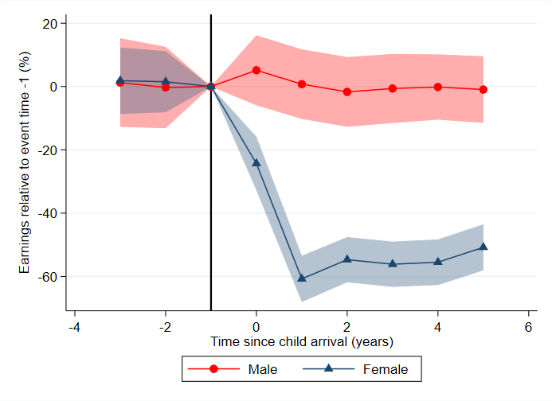

Notes: Plots estimated motherhood penalty as defined by Equation (2). Shaded area shows 95% confidence intervals, based on robust standard errors. Vertical line signifies year before first child arrives.

Source: Treasury analysis of HILDA Release 19.0.

Our main results include effects not only from the first child, but any additional children born during the observation window. To test the effect without multiple children, we estimate our original result separately for women who go on to have a second or multiple children over the observation period. Chart A3 shows that the motherhood penalty for women with one child is smaller than the penalty estimated for multiple children but remains significant up to 10 years after birth. Importantly, for women who only have one child, there is no significant recovery in earnings at year 5 – the age at which children generally become school‑age.

This documented motherhood penalty arises from three margins – employment, hours of work, and the hourly wage rate. Chart 2 shows that all three margins contribute, with particularly large effects for employment and hours of work. There is a sharp drop in the probability of employment for women in the first year of child arrival (of about 45 per cent), with minimal recovery 5 years after birth (Panel A). For women who remain employed, hours worked falls significantly following birth and does not recover over the period (Panel B). The motherhood penalty in employment averages 27 per cent in the first 5 years following children, while the motherhood penalty in hours worked averages 34 per cent. There is also evidence of an hourly wage penalty for women who remain employed, averaging around 5 per cent in the 5 years following child arrival (Panel C).[[10]](#footnote-11) However, our measure for the hourly wage is quite imprecise.

Across all three margins, the differences that emerge are driven entirely by women, with men largely unaffected. These effects highlight the strong labour supply implications of entry into parenthood for women.[[11]](#footnote-12)

Chart 2: Drivers of the motherhood penalty

|  |  |  |
| --- | --- | --- |
| This is an event study chart which plots the estimated impact of children on the probability of employment for men and women separately, for 3 years before and up to 5 years after the arrival of the first child. It shows a steep decline in female employment after the arrival of a child, only recovering slightly but remaining low for 5 years. Men's employment remains relatively stable. | This is an event study chart which plots the estimated impact of children on hours worked for men and women separately, for 3 years before and up to 5 years after the arrival of the first child. It shows a steep decline in female hours after the arrival of a child, remaining low for 5 years. Men's hours remains relatively stable. | This is an event study chart which plots the estimated impact of children on hourly wage for men and women separately, for 3 years before and up to 5 years after the arrival of the first child. It shows a small decline in female wage after the arrival of a child, however, the confidence intervals on this chart are wide. |

Notes: As above. Effects on participation are estimated unconditional on employment status, while the effect on hours and wages are conditional on participation. Shaded area shows 95% confidence intervals, based on robust standard errors. Vertical line signifies year before first child arrives.

Source: Treasury analysis of HILDA Release 19.0.

Wage effects will capture any impact of women sorting into lower‑paid occupations and industries following birth, however, our estimates do not capture anticipatory sorting effects more than 3 years prior to entry into parenthood. Consistent with recent studies, women may make work or study decisions early in their careers in anticipation of the requirement for more flexibility following entry into parenthood, or may invest less in their education because anticipated shorter careers or more career breaks would result in lower returns (Adda et al. 2017; Wasserman 2022).

Finally, as a sensitivity check, we show in the Appendix that our main result is not driven by a particular income class. In fact, women who earn an income in the top 25th percentile of their peer group’s income distribution experience a similar penalty as other women, suggesting that high income women are not immune to the motherhood penalty (Chart A11).

## Decomposition of the Gender Earnings Gap

Before turning to explanations for the motherhood penalty we explore just how much of the gender earnings gap it can explain. We do this following the methodology outlined in Kleven et al. (2019a). The analysis shows the percentage difference in earnings between men and women and isolates the portion of earnings inequality explained by children.

We begin by expanding our focus from the balanced panel of parents used in estimating the motherhood penalty to all HILDA survey respondents aged 25–64 years old. Based on this sample, we estimate the gender earnings gap as the difference between average male and female earnings, as a percentage of male earnings.[[12]](#footnote-13) This is shown in the top line in Chart 3 below. The gap begins at 49 per cent in the early 2000s before falling to 39 per cent by the late 2010s.[[13]](#footnote-14)

The next step of the decomposition estimates counterfactual earnings by sex (what men and women in our sample would have earned if they did not have children). To begin, we take all individuals in our sample and identify if they ever had children and, the years since the arrival of their first child. In line with the above results, we assume men suffered no earnings penalty from parenthood – what they would have earned equals what they did earn. For women, we scale up their earnings in the years following parenthood according to our estimated earnings penalty from the last section. For example, if the estimated motherhood penalty in a given year is 50 per cent, we assume they would have earned twice what we actually observe in the absence of children. We can then recalculate the gender earnings gap without the motherhood penalty and look at the difference between it and what we observe in practice to infer the role of motherhood in the gender earnings gap.

A key sensitivity in this exercise is what we assume about the motherhood penalty beyond the first 5 years. One approach would be to assume it remains fixed at around 50 per cent, given the strong persistence in the motherhood penalty. However, the HILDA data does suggest a gradual attenuation of the penalty over time, as apparent in Chart 1. To take a more conservative approach we fit a linear trend to the penalty from years one to 5 and extrapolate it out. This trend implies a motherhood penalty that eventually closes, but only 60 years after entry into parenthood, when most women will have retired anyway.

Chart 3 illustrates the results of this exercise. In 2001, women earned around 49 per cent less than men. Around half of this, 23 percentage points, could be explained by the motherhood penalty as observed and extrapolated above, represented by the blue shaded areas. By 2019, women were earning around 39 per cent less than men, of which around four-fifths, 30 percentage points, could be explained by the motherhood penalty. This echoes Danish findings that an increasing share of the gender earnings gap is due to the motherhood penalty (Kleven et al. 2019a). While increasing female educational attainment and success in tackling explicit discrimination have helped ameliorate the overarching gender earnings gap, the motherhood penalty remains.

Most of the contribution of the motherhood penalty to the gender earnings gap comes well after the early years of parenthood. Chart 3 also decomposes the child‑related gender earnings gap based on how far into parenthood the individual is. The penalty from the first 5 years of parenthood is only one-fifth of the current gender earnings gap (light blue), growing to three-fifths 20 years in (mid blue). In a way this is quite intuitive: most women are not ‘new’ mothers, but many have been mothers at some point, and it is the long shadow that parenthood casts on their labour market outcomes that drives these results.

Chart 3: Decomposition of gender earnings gap

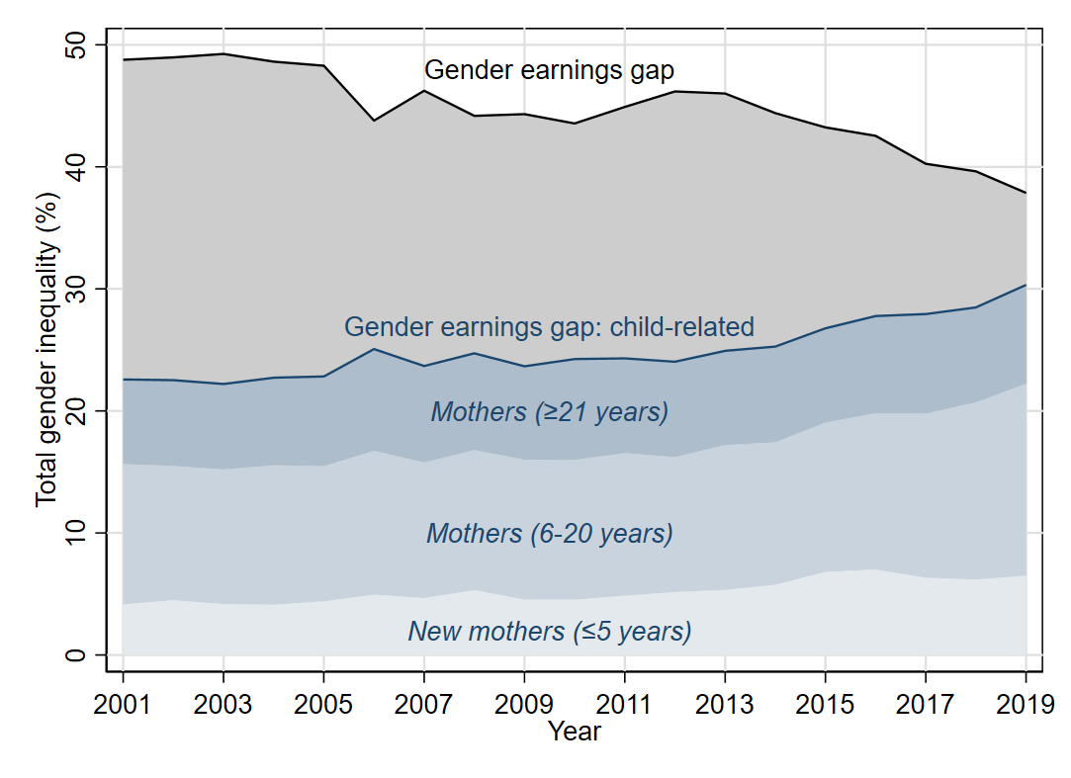

Notes: Shows the unconditional gender earnings gap for 25–64 year olds in the HILDA survey data, and the proportion of this accounted for by the motherhood penalty. Interpretation is as described in the text.

Source: Treasury analysis of HILDA Release 19.0.

Finally, this exercise assumes by necessity that the motherhood penalty has not changed over time.[[14]](#footnote-15) The relatively short and small panel of births in HILDA precludes a precise test of this assumption, as do the changes in the coverage of parenthood by the ALife dataset over time. Using Danish registry data, Kleven et al. (2019a) find only a modest decline in the motherhood penalty over time. Examining trends in the motherhood penalty, even over the first few years of parenthood, would be a worthwhile topic for further research.

## Why the Gap? Potential Explanations of the Motherhood Penalty

The estimates of the motherhood penalty imply that children have large effects on the careers of women, relative to men. However, it is unclear whether this reflects optimal allocations of time based on the relative earnings of parents, preferences, or constraints driven by workplace norms or institutions. In this section we discuss potential explanations of the motherhood penalty.

### Intrahousehold allocations of time

One explanation for the presence of a motherhood penalty may be that couples make choices about intrahousehold allocations of work and care based on relative earnings. Namely, it may be more financially optimal for the partner with the lower income to take time off work to care for children given their lower opportunity cost of staying at home. This household allocation would be consistent with the theoretical “unitary model” of the household proposed by Cortes and Pan (2020), where both parents have the same preferences and productivities at home, but different market wages.

To test whether our results are driven by financial decisions, we run separate regressions for women who are the primary earner in a couple before parenthood, and for women who are not (i.e. secondary earners). We define primary or secondary earner status using income from the year before having children and include all men and women in a heterosexual couple,[[15]](#footnote-16) regardless of whether the relationship continued post‑children. Around one‑third of the partnered mothers in our sample are the primary earner prior to children.

We find no difference in the motherhood penalty depending on earner status (Chart 4); mothers who were primary earners before parenthood experience a similar decline in earnings as mothers who were secondary earners within their household. This result is consistent with earlier literature that shows intrahousehold allocations of time are not always based on financial considerations, with female breadwinners spending more time on unpaid work than their partner (Bertrand et al. 2015; Bittman et al. 2003; Cortes & Pan 2020). In Appendix Chart A4 we also show that the motherhood penalty holds even for women who earn substantially more than their partner.

To complement this analysis, we also study the motherhood penalty across educational cohorts, and find that highly educated women experience a larger drop in earnings after the arrival of children, compared to other women (Chart A5 in Appendix).[[16]](#footnote-17) This drop in earnings is contrary to the significant investments highly educated women make in their human capital. This may reflect the fact that educated women are more likely to work in less flexible occupations (as discussed below), or that they are more likely to be partnered with highly educated and high earning partners due to assortative matching. Having a higher income spouse may create a disincentive to work full‑time due to high effective marginal tax rates, and could also make dropping out of the labour force more financially viable.

Literature has also shown that more educated women are likely to spend more time with their children, despite their higher opportunity cost of doing so (Guryan et al. 2008). These two results suggest that household choices around work and care are not based on financial considerations alone (consistent with the theoretical “non‑cooperative” model of the household proposed by Cortes and Pan (2020)).

Chart 4: Motherhood penalty, by breadwinner status

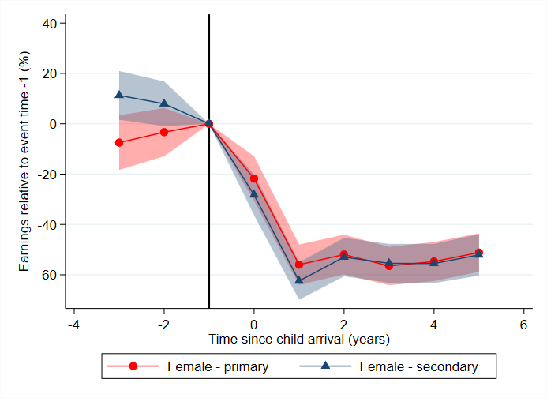

Notes: Breadwinner status defined in year before children. Shaded area shows 95% confidence intervals, based on robust standard errors. Vertical line signifies year before first child arrives.

Source: Treasury analysis of HILDA Release 19.0.

### Satisfaction with current arrangements

Even if household choices regarding labour supply are financially suboptimal, households may still be making choices consistent with their preferences. To analyse parents’ preferences, we study questions in HILDA around parents’ satisfaction with their employment opportunities and work‑family life. While preferences are likely to play a substantial role in allocations, dissatisfaction with current arrangements would suggest that other factors are also at play.

We first consider parents’ satisfaction with their employment opportunities. This is based on a survey question which asks parents to rate their satisfaction with their employment opportunities on a scale of one to 10, with one indicating the least satisfaction with employment opportunities and 10 the most satisfied. We then use the same event study design described in the previous section to measure the impacts of children.

The right panel of Chart 5 shows that women’s satisfaction with their employment opportunities begins to fall the year prior to parenthood and becomes significant one year after, indicating they may pre‑empt reduced work opportunities prior to the arrival of children. However, women’s satisfaction troughs later than their employment outcomes (Charts 1 and 2), implying that the longer‑term impacts of children may be unanticipated and that there are significant challenges in re‑engaging in the labour market. This is consistent with previous literature which finds women underestimate the difficulty of parenthood before children and often adopt more negative views about working after children (Kuziemko et al. 2020). It is also consistent with mothers facing discrimination in the labour market, due to employers’ disapproval of working mothers, or their expectation that working mothers will have a more intermittent labour market attachment than other workers (see Cortes and Pan 2020 for a discussion of relevant literature). In contrast, the left panel of Chart 5 shows that fathers’ satisfaction with their employment opportunities does not change significantly over time.

Next, we construct indexes to measure parents’ experiences of work‑family conflict, based on survey questions in the HILDA dataset (see Appendix for further detail). The mean scores of the indexes are shown in Chart 6. The left‑hand panel shows that overall, fathers, particularly fathers with young children, are more likely to report work impacting family life than family life impacting their work. Further, mothers are more likely than fathers to indicate that their family life impacts their work. These questions are only asked to parents balancing work and care responsibilities, and so excludes parents (predominantly women) who exit the labour force after entering parenthood.

Combined, these measures suggest that parents may be facing constraints when choosing how to allocate their time between paid employment and caring. Of course, there are likely costs and benefits to parenthood in other domains of life satisfaction. For example, Baetschmann et al. (2016) points to increases in overall life satisfaction for both men and women on entering parenthood.

Chart 5: Impact of children on parents’ satisfaction with their employment opportunities

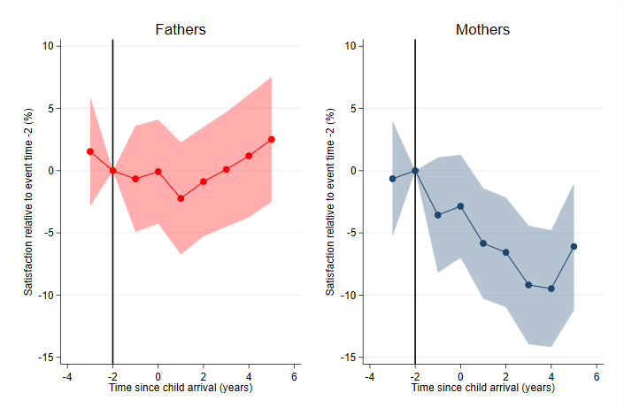

Notes: Question asks respondents their satisfaction with their employment opportunities on a 0–10 scale. Shaded area shows 95% confidence intervals, based on robust standard errors. The base year is t=-2, to allow for anticipatory effects. Vertical line signifies two years before first child arrives.

Source: Treasury analysis of HILDA Release 19.0.

Chart 6: Work‑family balance indexes, by sex and child age

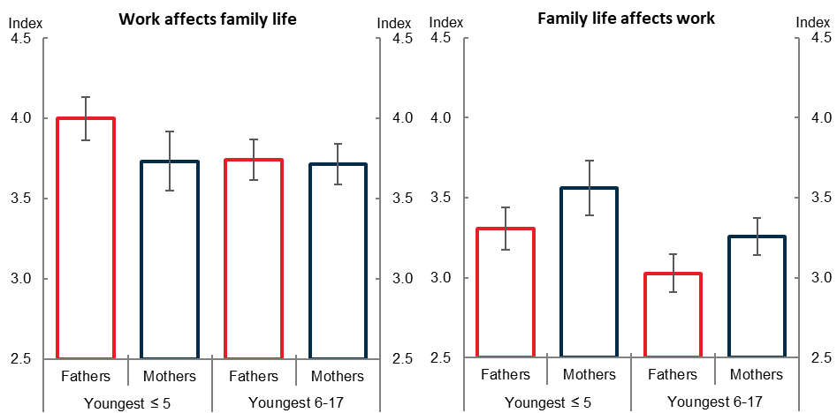

Notes: Indexes constructed using a combination of questions in HILDA that ask respondents about their work‑family balance. Further details in Appendix. Sample only includes parents who are currently employed.

Source: Treasury analysis of HILDA Release 19.0.

### Workplace flexibility

A potentially important mechanism for the motherhood penalty is how workplace settings around flexible work differ across occupations. Flexible work may make it easier for some parents to adjust their labour market inputs than other parents, though there may be costs of doing so. Flexibility within occupations is particularly relevant in Australia, with its highly gender‑segregated labour market.

To assess the availability of flexible work, we use a question in HILDA that asks respondents whether flexible start or finish times are available as an entitlement in their workplace. We take the average by 2‑digit occupation across all years to construct mean flexibility scores (by occupation across all years). We then assign occupations as high (low) flexibility if they score above (below) the overall median across all occupations. In the Appendix, we further test the robustness of this measure by constructing flexibility quartiles, where we compare the most flexible cohort (top 25th percentile) to everyone else, and we attain very similar results. We focus on one measure of workplace flexibility, but results are similar with other flexibility variables, such as availability of permanent part‑time work.

Table 2 shows occupations with the least availability of flexible work entitlements include managers, company directors and professionals – occupations that often reward long work hours and have rigid schedules. Our calculations suggest that less flexible occupations pay on average about 30 per cent more than flexible occupations (across both genders).

Despite this, more flexible occupations only have a slightly smaller gender earnings gap (about 30 per cent compared to 33 per cent for less flexible jobs). There is still variation in the magnitude of the gender earnings gap across occupations which suggests that it is not only less flexible jobs that exhibit large pay gaps (Table 2).

Table 2: Occupations and mean gender earnings gap by workplace flexibility

|  |  |
| --- | --- |
| **Lowest Flexibility Entitlements** | **Highest Flexibility Entitlements** |
| Managers (54 per cent) | Education Professionals (18 per cent) |
| Professionals (20 per cent) | Machinery Operators and Drivers (13 per cent) |
| ICT Professionals (18 per cent) | Machine and Stationary Plant Operators (58 per cent) |
| Business, Human Resource and Marketing Professionals (32 per cent) | Carers and Aides (26 per cent) |
| Chief Executives, General Managers and Legislators (31 per cent) | Factory Process Workers (18 per cent) |

Notes: Table lists occupations ranking in the top 5 lowest and highest in terms of availability of workplace flexibility entitlements. Average by 2‑digit occupation taken across HILDA waves 1–19. Flexibility measure taken from Yes/No responses to: ‘Workplace entitlements: Flexible start/finish times’. Mean gender earnings gap in parentheses, calculated as average difference in men and women’s CPI adjusted earnings.

Source: Treasury analysis of HILDA Release 19.0 and ABS (2022b).

After running our baseline event study by occupational flexibility, using occupations in the year before parenthood, we find that flexibility does not impact the observed motherhood penalty (Charts A6 and A7 in Appendix). We find a similar penalty regardless of the level of flexibility offered in jobs. Moreover, in Appendix Chart A8 we show that the occupational flexibility of partners does not change the motherhood penalty. This contrasts with previous literature which found within couples where the father works flexibly, mothers have less labour supply adjustment (Bang 2021). We posit that this may in part be due to the high cost of child care in Australia,[[17]](#footnote-18) differences in norms or institutions, which we reflect on in the next section, or different measures of workplace flexibility capturing different effects.[[18]](#footnote-19)

Whilst workplace flexibility doesn’t appear to impact the gender earnings gap before parenthood, one explanation could be that women choose to enter more flexible occupations after having children. These flexible occupations may have fewer promotion prospects or lower wages, which may explain the persistent motherhood penalty. Alternatively, certain flexible characteristics could be associated with even higher wages for some workers (He et al. 2019; Maestas et al. 2018; Mas & Pallais 2017), which may be due to higher skilled workers sorting into more flexible jobs, or employers combining wage and non‑wage benefits to attract employees (Mas & Pallais 2020). In the Appendix we show that whilst women are just as likely as men to change their occupation after entering parenthood (Table A3), they are not more likely to enter jobs with flexible working conditions (Table A4). These findings are consistent with mixed evidence regarding the existence of compensating wage differentials for non‑wage attributes, such as flexibility.[[19]](#footnote-20)

Chart 7: Outcomes for women, by workplace flexibility

|  |  |  |
| --- | --- | --- |
| This is an event study chart which plots the estimated impact of children on the probability of employment for women based on their level of workplace flexibility, for 3 years before and up to 5 years after the arrival of the first child. It shows a bigger decline in employment for women who have access to less flexibility. Both groups experience a slight recovery in employment around 4 or 5 years after child arrival, but still remains below pre-child levels. | This is an event study chart which plots the estimated impact of children on hours worked for women based on their level of workplace flexibility, for 3 years before and up to 5 years after the arrival of the first child. It shows both women in more and less flexible jobs experience a similar drop in their hours worked after child arrival, which doesn't recover in the subsequent 5 year period. | This is an event study chart which plots the estimated impact of children on hourly wage for women based on their level of workplace flexibility, for 3 years before and up to 5 years after the arrival of the first child. It shows a bigger decline in wage for women who have access to more flexibility. However, confidence intervals are wide on this chart. |

Notes: Chart shows effects for women only. Effects on participation are estimated unconditional on employment status, while the effect on hours and wages are conditional on participation. More flexibility defined as average pre‑parenthood occupational flexibility above median. Flexibility measure as above. Shaded area shows 95% confidence intervals, based on robust standard errors. Vertical line signifies year before first child arrives.

Source: Treasury analysis of HILDA Release 19.0.

Although the penalty in aggregate is the same regardless of the level of flexibility on offer, we explore whether the extensive or intensive margins of the penalty are affected by workplace conditions. That is, we explore whether workplace norms around flexibility impact mothers’ employment, hours worked or hourly wage. We find that women with less job flexibility before parenthood are more likely to exit the labour force after having children, whereas women with greater flexibility are more likely to experience lower wages (Chart 7). Whilst our evidence for this latter result is noisy, it does suggest that mothers working in flexible occupations may attract lower wages potentially reflecting forgone promotion opportunities. This result is also important as it suggests the availability (or lack thereof) of flexible work conditions may be one potential driver of a mother’s decision to exit the labour force. Our results here do not change when we control for education (Chart A9).

These results also suggest a role for workplace settings, particularly around the availability of flexibility, in potentially mitigating the motherhood penalty in employment and hours worked, but potentially at the cost of hourly wages. Similar findings in Kleven et al. (2019a) point to parenthood disproportionately leading women to be more likely to be in a flexible workplace but less likely to be in management. Further, Goldin (2014) argues that disproportionate rewards to long hours in some occupations results in larger gender pay gaps that could be ameliorated with more considered job design. This would benefit women, but also men, seeking greater flexibility at work.

### Gender norms

Another potential explanation for the motherhood penalty could be gender norms, and the institutional or policy settings that sustain these norms. To put Australia in context with the international landscape, we use the International Social Survey Programme (ISSP) to compare estimated child penalties with stated gender norms across countries, following Kleven et al.’s (2019b) approach. As mentioned above, our estimated long run motherhood penalty (43 per cent) is similar to the United Kingdom (44 per cent), larger in magnitude than estimates for Denmark (21 per cent), Sweden (26 per cent) and the United States (31 per cent), but smaller than estimates for Austria (51 per cent) and Germany (61 per cent) (Kleven et al. 2019b). These cross‑country differences may be driven by differences in gender norms, as well as institutional and policy settings across countries.

Our Australian results are consistent with the positive correlation found in Kleven et al. (2019b) between countries’ long run child penalties and the fraction of respondents in ISSP who think women should stay at home (i.e. not work) when they have young children (Chart 8). Furthermore, we test the robustness of this measure and also look at the share of respondents agreeing with the statement “men’s job is at work, women’s job is at home”, and find a similar association (Chart A10 in Appendix). For both measures, countries with larger child penalties display more conservative views about mothers working. Australia displays relatively conservative norms about men’s and women’s roles, and a relatively high motherhood penalty, compared with the other countries surveyed.

Chart 8: Gender norms and income gaps across countries

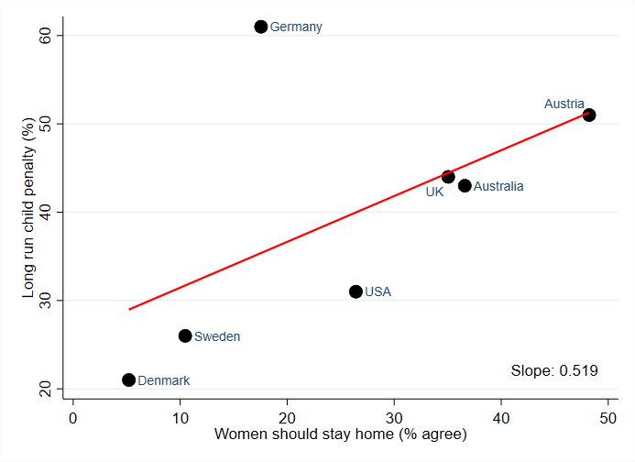

Notes: Chart plots share of respondents who state that women should stay at home when either their child is under school age or their youngest child is in school against each country’s long run (i.e. average of years 5 to 10) child penalty, fitting a linear line through these observations.

Source: Kleven et al. (2019b), Treasury analysis of International Social Survey Programme 2012 and long run child penalty for Australia from Chart A1.

Gender norms surrounding family choices are likely influenced by multiple factors, including historical attitudes towards women working. Previous literature has showed that historical settings can influence modern gender norms and attitudes (Grosjean & Khattar 2019). Parental leave policies and the norms around fathers taking leave likely also drive cross‑country differences in child penalties. For instance, past work has found that countries with more generous parental leave policies, particularly schemes with dedicated leave for fathers, have a more gender equal balance of work and care.[[20]](#footnote-21) Furthermore, other work for the United Kingdom found gender norms held by peers can influence mothers’ employment decisions (Cavapozzi et al. 2021). Future work could assess more rigorously the role of gender norms in shaping the gender pay gap in Australia.

## Conclusion

Considerable gender inequality remains in Australia, and in this paper, we show the vast majority of this inequality can be explained by children. The arrival of a child reduces women’s earnings by around 55 per cent in the first 5 years, while men’s earnings are not significantly affected. This earnings gap remains high for up to 10 years after the arrival of the first child, even for women who only have one child. Our results can be explained by women exiting the labour force and reducing their hours worked, and to a lesser extent, earning lower hourly wages. We take our research as strong evidence of a large and persistent long run motherhood penalty in Australia. We provide, for the first time, causal evidence that children have a significant impact on the long run labour market outcomes of Australian women.

Further, we discuss several potential explanations of the motherhood penalty. We provide evidence to suggest that the motherhood penalty is not purely a financial decision; female breadwinners experience the same penalty as their secondary female earning counterparts. We also show that the motherhood penalty is unlikely to be driven purely by preferences, with mothers’ satisfaction with their work opportunities falling, and fathers reporting that work impacts their family life post‑children.

We also provide evidence for the role of norms in two areas. First, we provide suggestive evidence that norms around working flexibly may be correlated with the penalty. We show mothers who work in more flexible occupations before children are less likely to exit the labour force once parents. However, these same women may be penalised for this flexibility by earning lower hourly wages. Second, we show how norms around gender roles are associated with the motherhood penalty at a national level. We argue here that countries (including Australia) with more conservative attitudes towards mothers working have higher penalties. Taking these results together, we conclude that both workplace settings around flexible working and broader gender norms likely explain the persistent penalty, though further research, especially for Australia, would be beneficial.

Australia’s motherhood penalty has important implications for both gender equality and aggregate productivity. On average, Australian women are now more educated than Australian men (ABS 2020b). Improving the utilisation of women’s skills would increase the returns on investments made in women’s human capital. Past literature has also found that there are potentially large productivity gains from diversifying the workforce within firms and sectors (Criscuolo et al. 2021; Ostry et al. 2018).

Our results have strong implications for targeting policy to address the motherhood penalty and reducing barriers to a more equal allocation of responsibilities within Australian households. Australia can learn from the experiences of other countries, which have reduced the cost of child care and increased paternal take‑up of parental leave. Both measures may help to increase fathers’ involvement in family life and improve mothers’ labour force participation, helping to reduce the motherhood penalty in the long run.

References

Adda J, Dustmann C and Stevens K (2017) ‘The Career Costs of Children’, *Journal of Political Economy*, 125(2):293–337.

Anderson ME and Nix E (2022) ‘What Causes the Child Penalty? Evidence from Adopting and Same-Sex Couples’, *Journal of Labor Economics*, 40(4):971–1004.

Angelov N, Johansson P and Lindahl E (2016) ‘Parenthood and the Gender Gap in Pay’, *Journal of Labor Economics*, 34(3):545–579.

Australian Bureau of Statistics (ABS) (2018) [*Childhood Education and Care, Australia*](https://www.abs.gov.au/statistics/people/education/childhood-education-and-care-australia/jun-2017) – June 2017, ABS Website, accessed 26 September 2022.

Australian Bureau of Statistics (ABS) (2020a) [*Barriers and Incentives to Labour Force Participation, Australia*](https://www.abs.gov.au/statistics/labour/employment-and-unemployment/barriers-and-incentives-labour-force-participation-australia/2018-19) – 2018-19 financial year, ABS Website, accessed 26 September 2022.

Australian Bureau of Statistics (ABS) (2020b) [*Gender Indicators, Australia*](https://www.abs.gov.au/statistics/people/people-and-communities/gender-indicators-australia/2020) – 2020, ABS Website, accessed 26 September 2022.

Australian Bureau of Statistics (ABS) (2022a) [*Labour Force, Australia*](https://www.abs.gov.au/statistics/labour/employment-and-unemployment/labour-force-australia/aug-2022) – August 2022, ABS Website, accessed 26 September 2022.

Australian Bureau of Statistics (ABS) (2022b) ‘Tables 1 and 2. CPI: All Groups, Index Numbers and Percentage Changes’ [time series spreadsheet], [*Consumer Price Index, Australia*](https://www.abs.gov.au/statistics/economy/price-indexes-and-inflation/consumer-price-index-australia/jun-2022) – June 2022, accessed 26 September 2022.

Avdic D and Karimi A (2018) ‘Modern Family? Paternity Leave and Marital Stability’, *American Economic Journal: Applied Economics*, 10(4):283–307.

Bang M (2021) ‘Job Flexibility and Household Labor Supply: Understanding Gender Gaps and the Child Wage Penalty’, *Working Paper*.

Baetschmann G, Staub KE and Studer R (2016) ‘Does the stork deliver happiness? Parenthood and life satisfaction’*,* *Journal of Economic Behavior and Organization*, 130:242–260.

Bertrand M, Kamenica E and Pan J (2015) ‘Gender Identity and Relative Income within Households’, *Quarterly Journal of Economics*, 130(2):571–614.

Bittman M, England P, Sayer L, Folbre N and Matheson G (2003) ‘When Does Gender Trump Money? Bargaining and Time in Household Work’, *American Journal of Sociology*, 109(1):186–214.

Blau FD and Kahn LM (2000) ‘Gender Differences in Pay’, *Journal of Economic Perspectives*, 14(4):75–99.

Carter A, Abhayaratna T and Johnson S (2021) ‘The ATO Longitudinal Information Files (ALife): Individuals – A New Dataset for Public Policy Research’, *Tax and Transfer Policy Institute Working Paper* *13*, Crawford School of Public Policy, Canberra.

Cavapozzi D, Francesconi M and Nicoletti C (2021) ‘The Impact of Gender Role Norms on Mothers’ Labor Supply’, *IZA Discussion Paper No. 14219*, Institute of Labor Economics, Bonn.

Cortes P and Pan J (2019) ‘When Time Binds: Substitutes for Household Production, Returns to Working Long Hours, and the Skilled Gender Wage Gap’, *Journal of Labor Economics*, 37(2):351–398.

Cortes P and Pan J (2020) ‘Children and the Remaining Gender Gaps in the Labor Market’, *NBER Working Paper No. 27980*, National Bureau of Economic Research, Cambridge.

Criscuolo C, Gal P, Leidecker T and Nicoletti G (2021) ‘The Human Side of Productivity: Uncovering the role of skills and diversity for firm productivity’, *OECD Productivity Working Papers No. 2021-29*, OECD Publishing, Paris.

Druedahl J, Ejrnæs M and Jørgensen TH (2019) ‘Earmarked paternity leave and the relative income within couples’, *Economics Letters*, 180:85–88.

Goldin C (2014) ‘A grand gender convergence: Its last chapter’, *American Economic Review*, 104(4):1091–1119.

Grosjean P and Khattar R (2019) ‘It’s raining men! Hallelujah? The long-run consequences of male-biased sex ratios’, *The Review of Economic Studies*, 86(2):723–754.

Guryan J, Hurst H and Kearney M (2008) ‘Parental Education and Parental Time with Children’, *Journal of Economic Perspectives*, 22(3):23–46.

He H, Neumark D and Weng Q (2019) ‘Do workers value flexible jobs? A field experiment’, *NBER Working Paper No. 25423*, National Bureau of Economic Research, Cambridge.

Kleven H, Landais C and Søgaard JE (2019a) ‘Children and gender inequality: Evidence from Denmark’, *American Economic Journal: Applied Economics*, 11(4):181–209.

Kleven H, Landais C and Søgaard JE (2021), ‘Does biology drive child penalties? Evidence from biological and adoptive families’, *American Economic Review: Insights*, 3(2):183–198.

Kleven H, Landais C, Posch J, Steinhauer A and Zweimüller J (2019b) ‘Child Penalties across Countries: Evidence and Explanations’, *AEA Papers and Proceedings*, 109:122–126.

Korsgren P and van Lent M (2022) ‘Earmarked Paternity Leave and Well-Being’, *IZA Discussion Paper No. 15022*, Institute of Labor Economics, Bonn.

Kotsadam A and Finseraas H (2011) ‘The state intervenes in the battle of the sexes: Causal effects of paternity leave’, *Social Science Research*, 40(6):1611–1622.

Kuziemko I, Pan J, Shen J and Washington E (2020) ‘The Mommy Effect: Do Women Anticipate the Employment Effects of Motherhood?’, *NBER Working Paper No. 24740*, National Bureau of Economic Research, Cambridge.

Maestas N, Mullen KJ, Powell D, von Wachter T, and Wenger JB (2018) ‘The value of working conditions in the United States and implications for the structure of wages’, *NBER Working Paper No. 25204*, National Bureau of Economic Research, Cambridge.

Mas A and Pallais A (2017) ‘Valuing Alternative Work Arrangements’, *American Economic Review*, 107 (12):3722–3759.

Mas A and Pallais A (2020) ‘Alternative Work Arrangements’, *NBER Working Paper No. 26605*, National Bureau of Economic Research, Cambridge.

Neumark D, Bank RJ and van Nort KD (1996) ‘Sex Discrimination in Restaurant Hiring: An Audit Study’, *The Quarterly Journal of Economics*, 111(3):915–941.

Organisation for Economic Cooperation and Development (2020) [*Is Child care Affordable?* *Policy Brief on Employment, Labour and Social Affairs*](http://oe.cd/childcare-brief-2020), OECD Publishing, Paris.

Ostry JD, Alvarez J, Espinoza R and Papageorgiou C (2018) ‘Economic Gains from Gender Inclusion: New Mechanisms, New Evidence’, *IMF Staff Discussion Note No. 2018/006*, International Monetary Fund, Washington.

Patnaik A (2019) ‘Reserving time for daddy: The consequences of fathers’ quotas’, *Journal of Labor Economics*, 37(4):1009–1059.

Pocock B (1999) ‘Equal Pay Thirty Years On: The Policy and Practice’, *Australian Economic Review*, 32(3):279–285.

Rosenbaum P (2021) ‘Pregnancy or motherhood cost? A comparison of the child penalty for adopting and biological parents’, *Applied Economics*, 53(29):3408–3422.

Sieppi A and Pehkonen J (2019) ‘Parenthood and gender inequality: Population-based evidence on the child penalty in Finland’, *Economics letters*, 182:5–9.

Wasserman M (2022) ‘Hours Constraints, Occupational Choice, and Gender: Evidence from Medical Residents’, *The Review of Economic Studies*, Advance online publication.

Wood D, Griffiths K and Emslie O (2020) ‘Cheaper child care: A practical plan to boost female workforce participation’, Grattan Institute, Melbourne.

Workplace Gender Equality Agency (WGEA) (2023) [*Australia’s Gender Pay Gap Statistics*](https://www.wgea.gov.au/publications/australias-gender-pay-gap-statistics) *–* February 2023, accessed 8 March 2023.

Yu W and Hara Y (2021) ‘Motherhood Penalties and Fatherhood Premiums: Effects of Parenthood on Earnings Growth Within and Across Firms’, *Demography*, 58(1):247–272.

Appendix

### Penalties using ALife data

As described in the data section, the ALife data provides longitudinal tax return data from the 1991 financial year onwards. This allows us to extend our analysis to follow individuals for 10 years after entry into parenthood. However, we are only able to observe births for parents who are required to record the number of dependent children in their care whilst lodging their individual tax return.

Chart A1 plots the gender‑specific impacts of children on wage and salary earnings over time, relative to earnings in the year before children. Unlike HILDA, the earnings profiles for men and women prior to birth are not parallel. The positive trend in men’s earnings prior to parenthood is in line with other papers in the literature and indicates some earnings growth preceding parenthood above age profiles. In contrast, the small decline in women’s earnings the year before parenthood is unsurprising and likely reflects the impacts of pregnancy, including potential anticipatory effects, and pregnancy‑related leave which is not fully covered by paid parental leave. While small, we should be cautious of these pre‑trends when interpreting the results in the ALife dataset.

Following children, women’s earnings begin to significantly decline. While the penalty on female earnings improves slightly over time, it remains persistent for a decade after birth. In contrast, male earnings appear to grow slightly due to children. This may be reflective of fathers’ increased specialisation in paid work following entry into parenthood, or employers’ greater trust in fathers, sometimes referred to as the ‘fatherhood premium’ (Yu & Hara 2021).

Chart A1: Long run impact of children on earnings, by sex

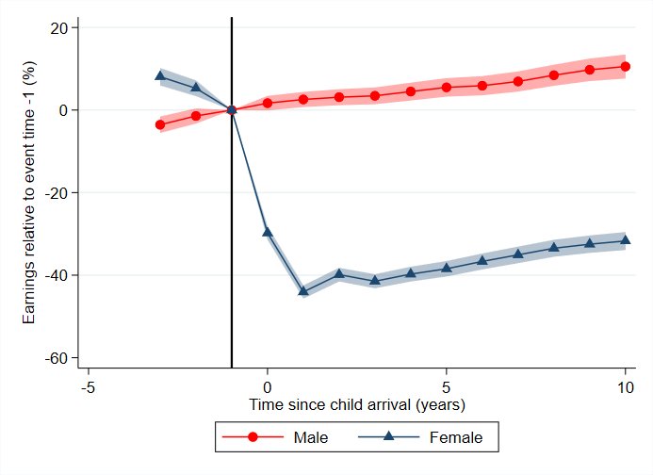

Notes: Plots estimated motherhood penalty as defined by Equation (2) but extends sample to 10 years after first birth. Shaded area shows 95% confidence intervals, based on robust standard errors. Vertical line signifies year before first child arrives.

Source: Treasury analysis of ALife 2019.

### Main regression results

Table A1: Event study regression results

|  |  |  |
| --- | --- | --- |
|  | (1)  Income | (2)  Income |
| t=-3 | 550.7  (3131.5) | 660.9  (1923.2) |
| t=-2 | -154.1  (3248.6) | 608.5  (1975.1) |
| t=0 | 3116.0  (3421.2) | -11752.5\*\*\*  (2084.4) |
| t=1 | 500.3  (3713.1) | -31629.0\*\*\*  (1941.4) |
| t=2 | -1207.4  (4007.4) | -30428.6\*\*\*  (2023.1) |
| t=3 | -484.9  (4294.3) | -32907.4\*\*\*  (2136.3) |
| t=4 | -126.7  (4304.5) | -34177.3\*\*\*  (2264.2) |
| t=5 | -815.4  (4593.9) | -33017.1\*\*\*  (2411.1) |
| Sex  Age and year coefficients  N  Rsquared  Adjusted Rsquared | Male  [omitted]  5716  0.168  0.154 | Female  [omitted]  6366  0.232  0.221 |

Notes: Table uses an event study model of the same form as Equation (1). Variables as described in text. Constant, and coefficients on age and year dummies are omitted. Robust standard errors in parentheses. \*p<0.05, \*\*p<0.01, \*\*\*p<0.001.

Source: Treasury analysis of HILDA Release 19.0.

### Predicted wages in levels

Chart A2: Mean financial year salary and wages since parenthood, by sex

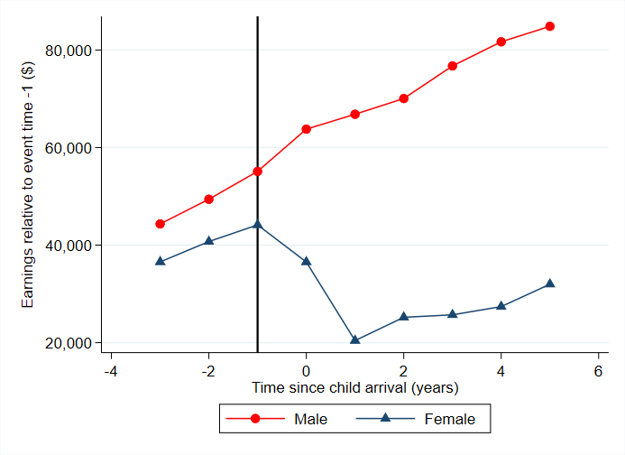

Notes: Predicted wages obtained after running event study model of the same form as Equation (1) for each sex. Wages are not adjusted for inflation. Vertical line signifies year before first child arrives.

Source: Treasury analysis of HILDA Release 19.0.

### Additional summary statistics

Table A2: Labour force status, by sex

|  |  |  |  |  |  |
| --- | --- | --- | --- | --- | --- |
| **Sex** | **Time since child arrival** | **Full-time** | **Part-time** | **Unemployed** | **Not in labour force** |
| Male | -3 | 82 | 8 | 4 | 5 |
|  | -2 | 82 | 6 | 5 | 7 |
|  | -1 | 84 | 6 | 4 | 6 |
|  | 0 | 85 | 5 | 2 | 8 |
|  | 1 | 84 | 7 | 3 | 6 |
|  | 2 | 82 | 8 | 2 | 9 |
|  | 3 | 81 | 8 | 3 | 8 |
|  | 4 | 83 | 7 | 3 | 8 |
|  | 5 | 83 | 8 | 2 | 8 |
| Female | -3 | 69 | 19 | 4 | 9 |
|  | -2 | 72 | 17 | 5 | 7 |
|  | -1 | 67 | 16 | 2 | 16 |
|  | 0 | 21 | 26 | 1 | 52 |
|  | 1 | 16 | 46 | 2 | 36 |
|  | 2 | 20 | 42 | 2 | 36 |
|  | 3 | 18 | 43 | 2 | 38 |
|  | 4 | 20 | 45 | 2 | 33 |
|  | 5 | 21 | 49 | 2 | 28 |

Notes: Table reports percent share of sample population in each labour force status group by sex. Time since child arrival is zero the year of first child’s arrival. Population weights have been used.

Source: Treasury analysis of HILDA Release 19.0.

### Multiple children

Chart A3: Impact of children on women’s earnings, by number of children

Panel A: Short run motherhood penalty (HILDA)

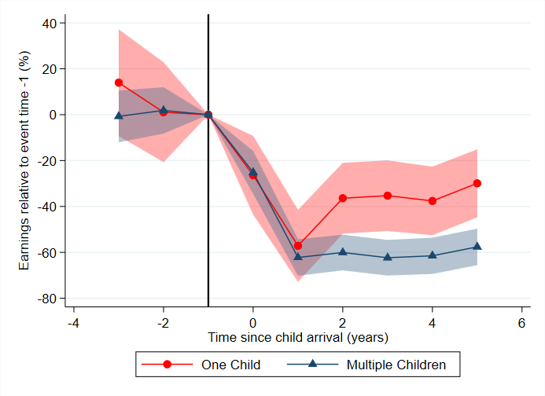

Panel B: Long run motherhood penalty (ALife)

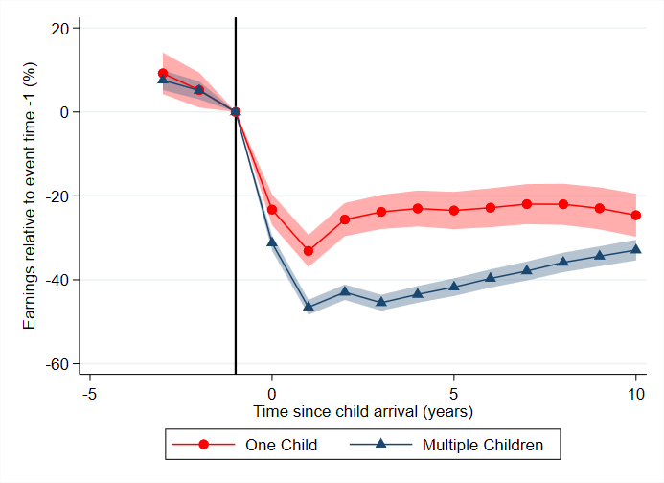

Notes: Separate regressions are run for women who go on to have one child, and two or more children within the observation period. Shaded area shows 95% confidence intervals, based on robust standard errors. Vertical line signifies year before first child arrives.

Source: Treasury analysis of HILDA Release 19.0 (Panel A) and ALife 2019 (Panel B).

### Breadwinner mothers

Chart A4: Motherhood penalty for primary earners

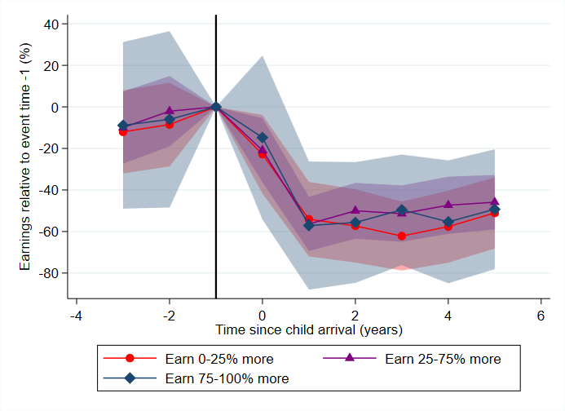

Notes: Primary earner status defined in t=-1. Includes women with partners who earn zero income. Shaded area shows 95% confidence intervals, based on robust standard errors. Vertical line signifies year before first child arrives.

Source: Treasury analysis of HILDA Release 19.0.

### Education

Chart A5: Motherhood penalty, by education cohort

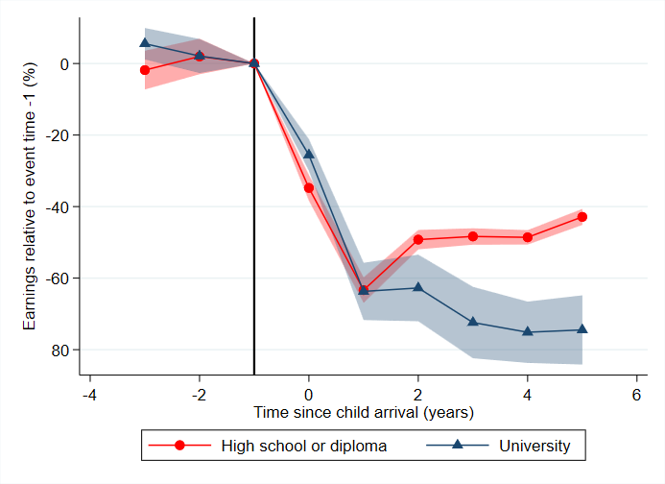

Notes: ‘High school or diploma’ refers to high school or some basic, non‑university tertiary education (i.e. diploma or certificate). ‘University’ refers to any university level qualification. Education cohorts defined in year before children. Shaded area shows 95% confidence intervals, based on robust standard errors. Vertical line signifies year before first child arrives.

Source: Treasury analysis of HILDA Release 19.0.

### Work‑family balance indexes

In HILDA, survey participants are given statements relating to work‑family balance and asked to state how much they agree on a measured 7‑point Likert scale (where 1 is ‘strongly disagree’ and 7 is ‘strongly agree’). Using these questions, we construct two indexes to measure work‑family conflicts.

#### Index 1: Work’s impact on family life

* Because of the requirements of my job, I miss out on home or family activities that I would prefer to participate in
* Because of the requirements of my job, my family time is less enjoyable and more pressured
* Working leaves me with too little time or energy to be the kind of parent I want to be
* Working causes me to miss out on some of the rewarding aspects of being a parent

#### Index 2: Family’s impact on work life

* Because of my family responsibilities, the time I spend working is less enjoyable and more pressured
* Because of my family responsibilities, I have to turn down work activities or opportunities that I would prefer to take on
* I worry about what goes on with my children while I’m at work
* Thinking about the children interferes with my performance at work

To construct the indexes, we sum the individual’s answers to each question, and divide by 4. We make an adjustment for people who only answer 3 of the questions and exclude anyone who answers less than 3.

### Additional results on flexibility

Chart A6: Motherhood penalty, by occupational flexibility

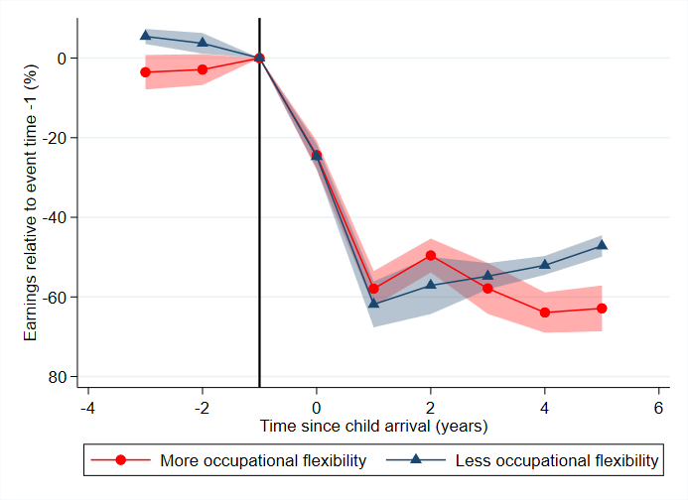

Notes: Occupational flexibility as defined in text. Shaded area shows 95% confidence intervals, based on robust standard errors. Vertical line signifies year before first child arrives.

Source: Treasury analysis of HILDA Release 19.0.

Chart A7: Motherhood penalty, by quartiles of occupational flexibility

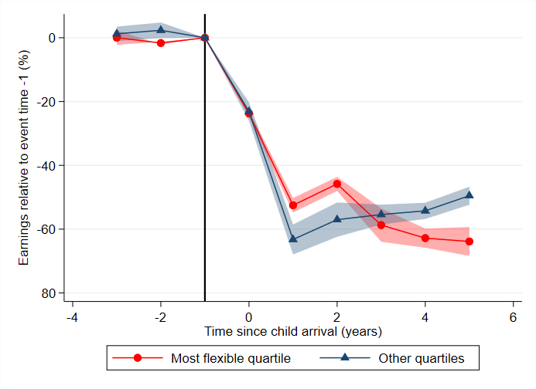

Notes: Occupational flexibility as defined in text. Shaded area shows 95% confidence intervals, based on robust standard errors. Vertical line signifies year before first child arrives.

Source: Treasury analysis of HILDA Release 19.0.

Chart A8: Motherhood penalty, by partner’s occupational flexibility

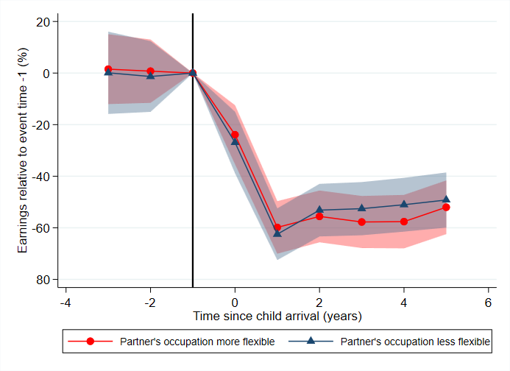

Notes: Occupational flexibility as defined in text. Shaded area shows 95% confidence intervals, based on robust standard errors. Vertical line signifies year before first child arrives.

Source: Treasury analysis of HILDA Release 19.0.

Chart A9: Outcomes for women controlling for education, by workplace flexibility

|  |  |  |
| --- | --- | --- |
| This is an event study chart which plots the estimated impact of children on the probability of employment for women based on their level of workplace flexibility controlling for education, for 3 years before and up to 5 years after the arrival of the first child. It shows a bigger decline in employment for women who have access to less flexibility. Both groups experience a slight recovery in employment around 4 or 5 years after child arrival, but still remains below pre-child levels. | This is an event study chart which plots the estimated impact of children on hours worked for women based on their level of workplace flexibility controlling for education, for 3 years before and up to 5 years after the arrival of the first child. It shows both women in more and less flexible jobs experience a similar drop in their hours worked after child arrival, which doesn't recover in the subsequent 5 year period. | This is an event study chart which plots the estimated impact of children on hourly wage for women based on their level of workplace flexibility controlling for education, for 3 years before and up to 5 years after the arrival of the first child. It shows a bigger decline in wage for women who have access to more flexibility. However, confidence intervals are wide on this chart. |

Notes: Uses an event study model of the same form as Equation (1) but controls for parents’ education in the year before parenthood. Chart shows effects for women only. Effects on participation are estimated unconditional on employment status, while the effect on hours and wages are conditional on participation. More flexibility defined as average pre‑birth occupational flexibility above median. Flexibility measure as above. Shaded area shows 95% confidence intervals, based on robust standard errors. Vertical line signifies year before first child arrives.

Source: Treasury analysis of HILDA Release 19.0.

Table A3: Children and probability of switching occupation

|  |  |  |
| --- | --- | --- |
|  | (1)  Switch occupation | (2)  Switch occupation |
| t=-3 | 0.410\*\*\*  (0.0291) | 0.420\*\*\*  (0.0283) |
| t=-2 | 0.325\*\*\*  (0.0271) | 0.356\*\*\*  (0.0259) |
| t=0 | 0.337\*\*\*  (0.0240) | 0.368\*\*\*  (0.0302) |
| t=1 | 0.389\*\*\*  (0.0244) | 0.438\*\*\*  (0.0280) |
| t=2 | 0.443\*\*\*  (0.0258) | 0.500\*\*\*  (0.0298) |
| t=3 | 0.514\*\*\*  (0.0277) | 0.545\*\*\*  (0.0312) |
| t=4 | 0.512\*\*\*  (0.0292) | 0.582\*\*\*  (0.0320) |
| t=5 | 0.514\*\*\*  (0.0310) | 0.628\*\*\*  (0.0341) |
| Sex  Age and year coefficients  N  Rsquared  Adjusted Rsquared | Male  [omitted]  5166  0.109  0.0945 | Female  [omitted]  4422  0.134  0.121 |

Notes: Table uses an event study model of the same form as Equation (1) but with the probability of switching occupation as the dependant variable. Dependant variable is a dummy which takes a value of one when a respondent is in a different occupation to the one held in the year before birth (i.e. t=-1). Constant, and coefficients on age and year dummies are omitted. Robust standard errors in parentheses. \*p<0.05, \*\*p<0.01, \*\*\*p<0.001.

Source: Treasury analysis of HILDA Release 19.0.

Table A4: Children and occupational flexibility

|  |  |  |
| --- | --- | --- |
|  | (1)  Occupational flexibility | (2)  Occupational flexibility |
| t=-3 | 0.00310  (0.0123) | 0.00479  (0.0159) |
| t=-2 | 0.000110  (0.0128) | 0.00568  (0.0143) |
| t=0 | -0.00409  (0.0114) | -0.0195  (0.0160) |
| t=1 | -0.00528  (0.0115) | -0.0133  (0.0149) |
| t=2 | -0.0109  (0.0121) | -0.0262  (0.0152) |
| t=3 | -0.0147  (0.0123) | -0.0222  (0.0160) |
| t=4 | -0.0252  (0.0128) | -0.0226  (0.0166) |
| t=5 | -0.0266\*  (0.0133) | -0.0189  (0.0172) |
| Sex  Age and year coefficients  N  Rsquared  Adjusted Rsquared | Male  [omitted]  5166  0.0731  0.0580 | Female  [omitted]  4422  0.0254  0.0104 |

Notes: Table uses an event study model of the same form as Equation (1) but with average occupational flexibility score as the dependant variable. Dependant variable takes a value between zero and one, where higher values indicate greater availability of workplace flexible entitlements in the respondent’s occupation. Constant, and coefficients on age and year dummies are omitted. Robust standard errors in parentheses. \*p<0.05, \*\*p<0.01, \*\*\*p<0.001.

Source: Treasury analysis of HILDA Release 19.0.

### Additional cross‑country evidence

Chart A10: Gender norms and income gaps across countries

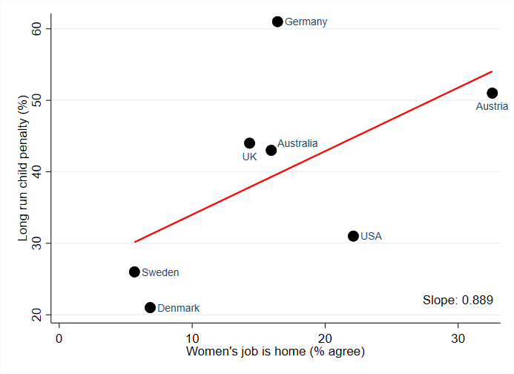

Notes: Chart plots share of respondents who agree or strongly agree that “men's job is to earn money, women's job is to look after the home” against each country’s long run (i.e. average of years 5 to 10) child penalty, fitting a linear line through these observations.

Source: Kleven et al. (2019b), Treasury analysis of International Social Survey Programme 2012 and long run child penalty for Australia from Chart A1.

### High income women

Chart A11: Motherhood penalty for high income earners

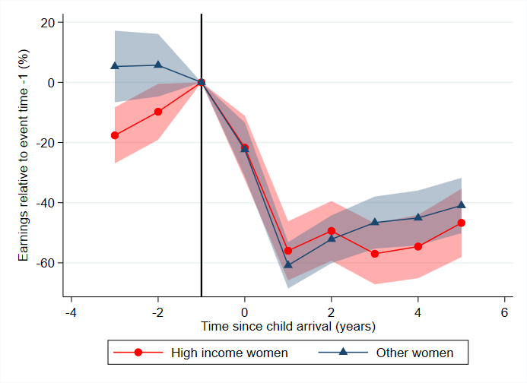

Notes: Income status defined in t=-1. High income defined as top 25th percentile. ‘Other women’ includes women who earn zero income. Shaded area shows 95% confidence intervals, based on robust standard errors. Vertical line signifies year before first child arrives.

Source: Treasury analysis of HILDA Release 19.0.

1. Macroeconomic Analysis and Policy Division, Macroeconomic Group, The Treasury, Langton Crescent, Parkes ACT 2600, Australia. Correspondence: nathan.deutscher@treasury.gov.au. We thank Rebecca Cassells, Mark Cully, Pauline Grosjean, Kristen Sobeck, colleagues in the Social Policy Division, and seminar participants at the Treasury, the Australian Conference of Economists 2022, and the e61 Institute for helpful feedback and suggestions. [↑](#footnote-ref-2)
2. The views expressed in this paper are those of the authors and do not necessarily reflect those of The Australian Treasury or the Australian Government.

   This paper uses unit record data from the Household, Income and Labour Dynamics in Australia (HILDA) Survey. The HILDA Project was initiated and is funded by the Australian Government Department of Social Services (DSS) and is managed by the Melbourne Institute of Applied Economic and Social Research (Melbourne Institute). The findings and views reported in this paper, however, are those of the authors and should not be attributed to either DSS or the Melbourne Institute.

   The paper uses data from the Australian Taxation Office (ATO) Longitudinal Information Files (ALife), specifically the 2019 release of the individuals’ file. The findings and views reported are those of the authors and should not be attributed to the ATO or the Australian Government. [↑](#footnote-ref-3)
3. Survey respondents are asked in a self-completion questionnaire to state how much they agree with each statement, on a scale of one to seven. We define ‘agree’ as selecting a number greater than 4. [↑](#footnote-ref-4)
4. The 2020 release of HILDA is now available but will reflect the substantial economic impacts of the COVID‑19 pandemic and associated policy responses. [↑](#footnote-ref-5)
5. The individual is the primary unit of taxation in Australia (though there are few return items subject to couple income tests). Income years run from 1 July through to 30 June; we refer to income years with reference to the year in which they end. [↑](#footnote-ref-6)
6. Our sample in both datasets will include natural births and adoptions. [↑](#footnote-ref-7)
7. Particularly that the timing of birth needs to be as good as randomly assigned, conditional on age and yearly shocks. [↑](#footnote-ref-8)
8. Kleven et al. (2019a) show several robustness tests estimating their results using difference-in-differences and IV estimators, which produce results that are almost perfectly aligned with the event study approach. [↑](#footnote-ref-9)
9. In Appendix Chart A1 we show our estimated long run penalty using administrative data, and in Chart A2 we show our main result using HILDA in levels. [↑](#footnote-ref-10)
10. The estimated motherhood penalties estimated here do not control for the other two margins. This explains why the penalties do not sum to the overall penalty. [↑](#footnote-ref-11)
11. In Appendix Table A2 we provide summary statistics on men and women’s labour force status in HILDA to support Chart 2. The share of women working full-time decreases after parenthood, and the share working part-time or leaving the labour force increases, while men’s labour force status remains largely unchanged. [↑](#footnote-ref-12)
12. To arrive at these averages we weight the sample using the cross-sectional responding person weights. [↑](#footnote-ref-13)
13. Note this is larger than the commonly reported gender pay gap, which does not account for differences in participation rates or hours of work between men and women. Nonetheless, this too has been narrowing, falling from 17.2 per cent in February 2014 to 13.3 per cent in February 2023 according to the Workplace Gender Equality Agency (WGEA 2023). [↑](#footnote-ref-14)
14. While the size of the motherhood penalty does not change over time in this exercise, the magnitude of its effect depends not just on the size of the penalty, but also on the counterfactual earnings of women relative to men. Because non-child related gender differences in earnings have narrowed over the period, child‑related gender inequality appears to increase in Chart 3, because the penalty is operating on a larger base. [↑](#footnote-ref-15)
15. As reported in HILDA or as stated on their tax return in ALife. [↑](#footnote-ref-16)
16. We also investigated the interaction between education cohort and the number of children women have, and found highly educated mothers who only have one child exhibit the worst penalty. However, these results are based on small sample sizes and therefore we refrain from providing this evidence here. [↑](#footnote-ref-17)
17. Wood et al. (2020) find that for most women, there is no financial benefit to working more than 3 days a week. The high cost of child care in Australia is likely a major factor driving the need for couples to specialise in either paid work or care. [↑](#footnote-ref-18)
18. As per Golden (2014), “workplace flexibility is a complicated, multidimensional statement. Differences in the empirical findings and appropriate frameworks seem to depend on the definition of flexibility applied and the particular type of non-wage amenity considered.” [↑](#footnote-ref-19)
19. We are unable to rule out the potential for sorting into occupations before children. It is possible women tend to sort themselves into a more flexible occupation in anticipation of requiring this flexibility after they have children. We count roughly equal numbers of men and women in both high and low flexible jobs in aggregate, but do observe differences within occupations. Nonetheless, we are unable to differentiate this potential sorting from broader labour market gender segregation. [↑](#footnote-ref-20)
20. These countries typically have parental leave policies with designated, ‘use-it-or-lose-it’ leave for fathers. This type of leave policy has been previously shown to encourage greater take-up amongst fathers and a more even balance of care responsibilities at home (Kotsadam & Finseraas 2011; Patnaik 2019). Literature for Denmark has shown an increase in the earmarked portion of leave for fathers results in an increase in women’s labour supply (Druedahl et al. 2019), while other work has even shown that life satisfaction, particularly for mothers, increases with enrolment into earmarked paternal leave (Korsgren & van Lent 2022). [↑](#footnote-ref-21)