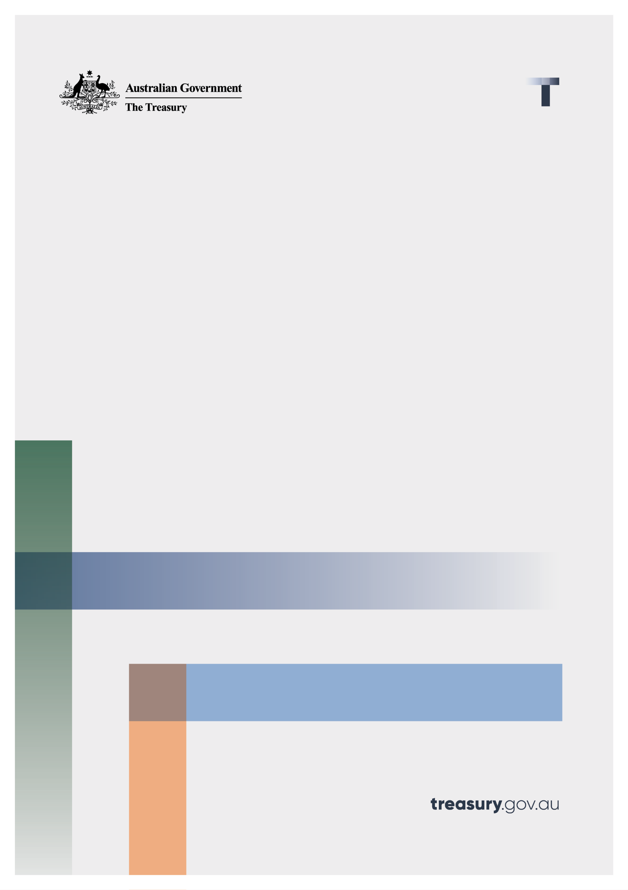

Legislating the objective of superannuation

Consultation paper

20 February 2023

© Commonwealth of Australia 2023

This publication is available for your use under a [Creative Commons Attribution 3.0 Australia](http://creativecommons.org/licenses/by/3.0/au/deed.en) licence, with the exception of the Commonwealth Coat of Arms, the Treasury logo, photographs, images, signatures and where otherwise stated. The full licence terms are available from <http://creativecommons.org/licenses/by/3.0/au/legalcode>.

Creative Commons attribution licence 3.0 icon. 

Use of Treasury material under a [Creative Commons Attribution 3.0 Australia](http://creativecommons.org/licenses/by/3.0/au/deed.en) licence requires you to attribute the work (but not in any way that suggests that the Treasury endorses you or your use of the work).

**Treasury material used ‘as supplied’.**

Provided you have not modified or transformed Treasury material in any way including, for example, by changing the Treasury text; calculating percentage changes; graphing or charting data; or deriving new statistics from published Treasury statistics — then Treasury prefers the following attribution:

*Source: The Australian Government the Treasury*.

**Derivative** **material**

If you have modified or transformed Treasury material, or derived new material from those of the Treasury in any way, then Treasury prefers the following attribution:

*Based on The Australian Government the Treasury data*.

**Use of the Coat of Arms**

The terms under which the Coat of Arms can be used are set out on the Department of the Prime Minister and Cabinet website (see [www.pmc.gov.au/government/commonwealth-coat-arms](https://www.pmc.gov.au/government/commonwealth-coat-arms)).

**Other uses**

Enquiries regarding this licence and any other use of this document are welcome at:

Manager  
Media and Speeches Unit  
The Treasury  
Langton Crescent   
Parkes ACT 2600  
Email: [media@treasury.gov.au](mailto:media@treasury.gov.au)

# Contents

Contents ii

Consultation process 3

Request for feedback and comments 3

Executive summary 4

Legislating the objective of superannuation 6

Introduction 6

Superannuation in Australia 6

The history of superannuation 6

Recommendations on the objective of superannuation 7

The objective of superannuation 9

Proposed objective 9

Drafting principles 10

Wording rationale 10

Practical application 12

Accountability 12

Consultation questions 13

# Consultation process

## Request for feedback and comments

Interested stakeholders are invited to comment on the issues raised in this paper by 31 March 2023. Submissions may be lodged electronically or by post; however, electronic lodgement is preferred via email to: [superannuationobjective@treasury.gov.au](mailto:superannuationobjective@treasury.gov.au). For accessibility reasons, please submit responses via email in a Word, RTF, or PDF format.

Submissions will be shared with other Commonwealth agencies where necessary for the purposes of this review. All information (including name and address details) contained in submissions may be made publicly available on the Australian Treasury website unless you indicate that you would like all or part of your submission to remain in confidence. Automatically generated confidentiality statements in emails are not sufficient for this purpose.

If you would like only part of your submission to remain confidential, please provide this information clearly marked as such in a separate attachment. Legal requirements, such as those imposed by the Freedom of Information Act 1982, may affect the confidentiality of your submission.

Closing date for submissions: 31 March 2023

|  |  |
| --- | --- |
| Email | [superannuationobjective@treasury.gov.au](mailto:superannuationobjective@treasury.gov.au) |
| Mail | Director  Superannuation Insurance and Governance Unit  Member Outcomes and Governance Branch  Retirement, Advice and Investment Division  The Treasury  Langton Crescent  PARKES ACT 2600 |
| Enquiries | Enquiries can be initially directed to [superannuationobjective@treasury.gov.au](mailto:superannuationobjective@treasury.gov.au) |

The principles outlined in this paper have not received Government approval and are not yet law. As a consequence, this paper is merely a guide as to how the principles might operate.

# Executive summary

A strong superannuation system is important for Australians, and Australia. For most Australians, superannuation is now one of their largest assets.[1]

Today, 78 per cent of Australians have money in their superannuation accounts that will be used to support them in retirement. [2] Australia’s superannuation pool has grown from around $148 billion[3] in 1992 to over $3.3 trillion.[4] It now represents 139.6 per cent of gross domestic product (GDP)[5] and is projected to grow to around 244 per cent of GDP by 30 June 2061.[6] Australia’s pool of pension assets is now one of the largest in the world, and the fourth largest in the OECD.[7]

Australia’s superannuation system provides broader benefits to the economy and financial system. Superannuation is an increasingly important source of capital in our economy and the significant scale of Australia’s superannuation system contributes to the strength of our financial markets through capital deepening. There is a significant opportunity for Australia to leverage greater superannuation investment in areas where there is alignment between the best financial interests of members and national economic priorities, particularly given the long-term investment horizon of superannuation funds. For these broad benefits of superannuation to be maximised and for superannuation to best support higher living standards for Australians over time, it is critical for there to be a clear, shared understanding of the objective of superannuation.

Clarification of the objective of superannuation in law will provide a shared understanding of the role of the superannuation system and anchor any future superannuation policy settings to a meaningful base. It will enshrine the core goal of supporting delivery of retirement incomes in law. Haphazard or inconsistent changes in superannuation system policy undermine the community’s trust in the system and increase costs to trustees, regulators, and ultimately members.

The objective of superannuation is a foundational issue, and the Government recognises that there are a broad range of views on how this should be framed. This consultation paper provides context about the history of Australia’s superannuation system, the rationale for enshrining the objective of superannuation in law and provides some options on potential framing. It also sets out how a legislated objective could improve accountability and transparency in policy development.

Legislating an objective of superannuation will provide stability and confidence to policy makers, regulators, industry, and the community that changes to superannuation policy will be aligned with the purpose of the superannuation system. It will also ensure members and funds have a shared understanding of the purpose of superannuation throughout both the accumulation and retirement phases. For the retirement phase, an objective can support a greater focus for funds on how income is provided in retirement and encourage individuals to think about their superannuation as an asset to be drawn down on.

Legislating an objective of superannuation is intended to complement the long-standing legal and regulatory obligations of trustees of superannuation funds to have in place investment strategies that deliver the best outcomes for their members.

The Government is seeking stakeholder feedback on the framing of the draft objective of superannuation, including the benefits of the objective and its practical application. Specific consultation questions are outlined at the end of the paper.

# Legislating the objective of superannuation

## Introduction

### Superannuation in Australia

Superannuation is an integral part of Australia’s retirement income system. The three pillars of the system – compulsory superannuation, the Age Pension, and private savings – work together to ensure Australians have income in retirement. Many Australians’ retirement incomes are a combination of all three pillars.

Compulsory superannuation, the Superannuation Guarantee (SG), requires employers to contribute a portion of an employee’s earnings to a superannuation fund. The SG rate will increase to 12 per cent by 1 July 2025. In combination with private savings (such as voluntary superannuation contributions), the SG enables Australians to achieve a higher standard of living in retirement compared with that provided by the Age Pension alone. Superannuation savings are supported by tax concessions that encourage people to save, and investments must be preserved until retirement (except for in exceptional circumstances).

Individuals can choose a fund, or funds, into which their superannuation contributions are made. Broadly, funds fall into two categories: APRA-regulated funds and self-managed superannuation funds (SMSFs). While the obligations of trustees and rules governing each type of fund differ, all superannuation funds serve the same purpose in preserving contributions made on behalf of the member until retirement.

Generally, an individual can access the monies held in superannuation once they reach preservation age. An individual can then choose to drawdown their superannuation monies as a lump sum or invest in a retirement product providing an income stream throughout retirement. Some funds provide defined benefits, meaning the benefits in retirement do not depend solely on contributions made, but on other factors such as years of service or average salary. These funds are typically linked to a specific employer.

### The history of superannuation

Employer-based superannuation has existed in Australia since pre-Federation, and universal mandatory contribution schemes were considered as far back as the Bruce Government in 1923. However, compulsory superannuation in the form of the SG was not introduced until 1992. Then‑Treasurer Dawkins introduced the scheme through the *Superannuation Guarantee (Administration) Act 1992,* with the rationale that “the increased self-provision for retirement will permit a higher standard of living in retirement than if we continued to rely on the Age Pension alone.”[8] At the time, the rate of SG was set to 3 per cent of employee earnings, legislated to increase to 9 per cent by July 2002.

### Recommendations on the objective of superannuation

#### The 2014 Financial System Inquiry

The 2014 Financial System Inquiry (FSI), chaired by David Murray, found that "an efficient superannuation system is critical to help Australia meet the economic and fiscal challenges of an ageing population.”[9]

FSI Recommendation 9 was that the Government “Seek broad political agreement for, and enshrine in legislation, the objectives of the superannuation system and report publicly on how policy proposals are consistent with achieving these objectives over the long term.”[10]

The FSI recommended that the objective of the superannuation system should be ***“to provide income in retirement to substitute or supplement the Age Pension.”***[11]

The FSI aimed to prioritise the concept of “retirement income” to reorient public perception of superannuation away from being a vehicle for asset accumulation, and towards providing income to support retirement.

The FSI recommended the Government seek broad agreement on the following six subsidiary objectives of the superannuation system:

* + facilitate consumption smoothing over the course of an individual’s life;
  + help people manage financial risks in retirement;
  + be fully funded from savings;
  + be invested in the best interests of superannuation fund members;
  + alleviate fiscal pressures on Government from the retirement income system; and
  + be simple and efficient, and provide safeguards.

In 2016, in response to the FSI, the former government introduced the Superannuation (Objective) Bill 2016(the 2016 Bill). The 2016 Bill was a standalone piece of legislation containing a draft primary objective of the superannuation system reflecting the recommendation of the FSI, as well as allowing subsidiary objectives to be prescribed by regulation that were intended to help guide interpretation of the law.

The 2016 Bill lapsed on 1 July 2019.

#### The 2020 Retirement Income Review

The 2020 Retirement Income Review (the Review) broadly agreed with the findings of the FSI that an objective was required to “anchor the direction of policy settings, help ensure the purpose of the system is understood, and provide a framework for assessing the performance of the system”.[12]

The Review found that the objective “has to be agreed and endorsed by the Australian community through the Government”, giving consistency and stability in the development of retirement income policy.[13]

The Review recommended the objective of the superannuation system should be ***“to deliver adequate standards of living in retirement in an equitable, sustainable and cohesive way”.***[14]

The Review’s recommended objective was guided by the following principles:

* + *adequacy*, to support a minimum standard of living in retirement;
  + *sustainability*, being the Australian economy’s capacity to pay and that the superannuation system should be robust to demographic, social and economic change;
  + *equity*, to target government support to those in need and provide similar outcomes for people in similar circumstances; and
  + *cohesion*, that the system should have effective incentives to smooth consumption and support individuals to take personal responsibility for their retirement incomes. The system should interact effectively with other systems and not be unnecessarily complex.

## The objective of superannuation

### Proposed objective

This consultation paper is seeking feedback on the following proposed objective:

Recognising there will be a range of views on the inclusion of each of these concepts, there are alternatives to the sentence structure of the objective as well as the precise wording of these concepts, such as:

* + *The objective of superannuation is to* ***deliver income*** *for a* ***dignified*** *retirement, alongside* ***government support****, in an* ***equitable and sustainable*** *way.*
  + *The objective of superannuation is to* ***support savings*** *to* ***deliver income*** *for a* ***dignified*** *retirement, in an* ***equitable and sustainable*** *way.*

### Drafting principles

The proposed objective is succinct and expressed in plain English to assist understanding and clarity. In addition, it seeks to answer the following three key questions:

**The purpose of superannuation**. This is essential to provide clarity on the role of superannuation and ensure that future policy changes can be anchored to the purpose of preserving savings and delivering income in retirement. It ensures all participants, including superannuation funds, regulators, governments and members, have a shared understanding of the purpose of the system.

**How superannuation delivers on its purpose.** These factors relate to how superannuation should operate in an equitable and sustainable way to provide stability in the underlying values of the system and deliver a dignified retirement for Australians.

**The place of superannuation in the broader retirement income system**. This recognises the interaction of superannuation with the other pillars of Australia’s retirement income system and its need to be fiscally sustainable.

A secondary, or subsidiary, set of objectives or principles in legislation is not proposed. This seeks to ensure the focus remains on a single, comprehensive objective – both in drafting and once legislated. It also reduces the risk that secondary objectives, many of which may in fact be benefits of the system, become contradictory with each other, or counter the clarity of the primary objective. Explanatory materials to a proposed bill would provide further guidance on the intent behind the objective.

### Wording rationale

The drafting of the proposed objective attempts to remain neutral, enduring, and clear. However, it is anticipated there will be a wide range of views on the particular terms used in the objective, driven by different understandings of the most appropriate terms to capture Australians’ experience and expectations of the superannuation system. This section describes the reasoning behind terms used in the proposed objective.

'**Preserve savings**’refers to the principle of preservation; that is, the concept that contributions to superannuation should not be accessed unless for the purpose of income in retirement, apart from exceptional circumstances. This recognises that superannuation exists first and foremost as a savings vehicle to fund retirement and not a pool of individuals’ savings to meet other lifetime costs.

‘**Deliver income**’ captures the purpose of the superannuation system – to provide universal savings that are then drawn down in retirement to deliver income that support retirees’ standards of living. The focus on delivering income makes clear that the purpose of superannuation is not for minimising tax on wealth accumulation or enabling retirees to leave tax-effective bequests.

‘**Dignified**’ denotes the importance of financial security and wellbeing in retirement but recognises that this does not necessarily equate to the same level of income in retirement for all Australians. This is a qualitative measure, that will require interpretation and may change over time to reflect society’s standards. According to the Cambridge Dictionary, ‘dignity’ means “the importance and value that a person has, that makes other people respect them or makes them respect themselves”. When used in the context of the objective, ‘dignified’ recognises that individuals deserve a high-quality standard of living in retirement, as served by both the superannuation system and government support. Superannuation has played an important role in combatting poverty in old age and lifting retirement standards. It has helped Australians navigate the complexity of very long-term decision-making through regular savings through their working life.

As detailed by the Retirement Income Review, ‘**equitable**’ captures the importance of a system that delivers similar outcomes to people in similar situations and targets support to those most in need. ‘**Sustainable**’ signifies that the system should be robust to demographic, economic and social change, and should be cost-effective for taxpayers in achieving retirement outcomes. While all Australians can save for their desired lifestyle in retirement, this outcome is influenced by personal circumstances and expectations, and is ultimately constrained by the need for equity and sustainability in the system. Beyond a certain level of income, additional Government support through tax concessions is not necessary or appropriate.

While many Australians rely on government support as a supplement to their superannuation savings to achieve a dignified retirement, not every Australian will draw upon government support. The phrase ‘alongside **government support’** aims to capture the importance of government payments or policies that act as a substitute or complement to superannuation, recognising the cohesive interaction with superannuation savings. The term ‘government support’ intends to encapsulate the broad range of supports available to retirees, including the Age Pension, Commonwealth Rent Assistance, and the Home Equity Access Scheme.

## Practical application

It is proposed that the objective of superannuation would be established in legislation. This is to ensure the stability of the objective and provide certainty to regulators, policy makers, and Government of the longevity of the objective.

The location of the objective in legislation could be in a new stand-alone Act or in existing superannuation legislation, such as the *Superannuation Industry (Supervision) Act 1993*.

The objective would be forward-looking and could be used as a common yardstick to consider prospective policy changes to the superannuation system. For example, how a proposed policy does or does not meet the legislated objective could be raised as part of consultation on policy or draft legislation.

It is not intended to impact regulatory supervision activities and while aligned with, it would be separate from, trustees’ fiduciary duties such as the best financial interests duty[15] and the sole purpose test.[16] As the objective is not intended to guide the regulation of trustees’ conduct, it would not change trustee obligations.

### Accountability

It is envisaged that existing policy development and parliamentary scrutiny processes would provide checks and balances ensuring that changes to the superannuation system are compatible with the objective.

As with all policy development, policy makers would consider how changes to policy fit within and impact existing legislation. As such, interactions between policy proposals and the objective would form part of policy advice to Government. Public consultation processes on policy proposals and draft legislation would enable stakeholders to share views around whether the changes are consistent with the objective. Stakeholders can similarly assess how any policy changes they recommend are aligned with the objective.

The objective would provide a guide for parliamentary scrutiny and debate in the context of superannuation legislation considered by Parliament. Further, bills can also be referred to the relevant standing or select committees for inquiry and report, which provides an opportunity for organisations and individuals to have their views considered as part of the decision-making process of Parliament.

## Consultation questions

1. What do you see as the practical benefits or risks associated with legislating an objective of Australia’s superannuation system?
2. Does the proposed objective meet your understanding of the objective of the superannuation system in Australia?
3. Is the proposed approach to enshrining the objective in legislation appropriate? Are there any alternative ways the objective could be enshrined?
4. What are the practical costs and benefits of any alternative accountability mechanisms to the one proposed?

1. Australian Bureau of Statistics (ABS) (2022) Household Wealth and Wealth Distribution, Australia 2019-20.
2. Australian Prudential Regulation Authority (APRA) (2019) *Superannuation in Australia: a timeline*.
3. ibid.
4. APRA (2022) Quarterly superannuation performance statistics, September Quarter 2022.
5. Calculated based on APRA (2022) Quarterly superannuation performance statistics and ABS (2022) Australia National Accounts: National Income, Expenditure and Product.
6. 2021 Intergenerational Report.
7. OECD (2023) Pension Markets in Focus 2022.
8. Hansard *SUPERANNUATION GUARANTEE (ADMINISTRATION) BILL 1992 Second Reading* 2022.
9. Financial Systems Inquiry Final Report (2014).
10. ibid.
11. ibid.
12. Retirement Income Review (2020).
13. ibid.
14. ibid.
15. Superannuation trustees have a legal obligation to perform their role in compliance with the best financial interests duty (BFID) under paragraphs 52(2)(c) and 52B(2)(c) of *the Superannuation Industry (Supervision) Act 1993*. The BFID requires that trustees are guided by the best financial interests of their members when making decisions about the fund and its investments.
16. The sole purpose test requires trustees to ensure the fund is maintained for the sole purpose of providing benefits to members upon their retirement or attainment of a certain age, or to beneficiaries of the member if the member dies. This test is enshrined in section 62 of the *Superannuation Industry (Supervision) Act 1993*.