2022

THE PARLIAMENT OF THE COMMONWEALTH OF AUSTRALIA

HOUSE OF REPRESENTATIVES

Treasury Laws Amendment (Measures for Consultation) Bill 2022: Government Response to the Review of the Tax Practitioners Board

EXPOSURE DRAFT EXPLANATORY MATERIALS

Table of Contents
Glossary iii
Chapter 1: Government response to the Review of the Tax Practitioners Board 5

Glossary
This Explanatory Memorandum uses the following abbreviations and acronyms.
Abbreviation | Definition
ATO | Australian Taxation Office
BAS services | Business activity statement services
Financial Services Royal Commission | Royal Commission into Misconduct in the Banking, Superannuation and Financial Services Industry
Tax Practitioners Board Review | Independent Review of the Tax Practitioners Board
TPB | Tax Practitioners Board
Special Account | Tax Practitioners Board Special Account
Commissioner | Commissioner of Taxation
TAS Act | Tax Agent Services Act 2009

- Government response to the Review of the Tax Practitioners Board
Table of Contents:
Outline of chapter 5
Context of amendments 6
Detailed explanation of new law 6
Recommendation 2.1 - Update and modernise the objects clause of the TAS Act 7
Recommendation 3.1 – Establishing a special account for the TPB 7
Recommendation 4.6 – Requiring tax practitioners to ensure their employees and associates are not disqualified entities 9
Recommendation 4.7 – Conversion to an annual renewal period 18
Recommendation 5.1 - Enable the Minister to supplement the existing Code of Professional Conduct 19
Further amendments 19
Commencement, application, and transitional provisions 20

Outline of chapter
  - This Bill amends the TAS Act to ensure that tax agent services and BAS services provided to the public are of an appropriate ethical and professional standard and to enhance the financial independence of the TPB from the ATO. To achieve this, the Bill implements some of the recommendations of the Tax Practitioners Board Review to:
- Recommendation 2.1 – update and modernise the objects clause;
- Recommendation 3.1 – create financial independence for the TPB from the ATO;
- Recommendation 4.6 – require tax practitioners to not employ or use disqualified entities in the provision of tax agent services without approval from the TPB;
- Recommendation 4.7 – convert to an annual registration period; and
- Recommendation 5.1 – enable the Minister to supplement the existing Code of Professional Conduct to ensure that emerging or existing behaviours and practices by tax practitioners are properly addressed.
  - Legislative references are to the TAS Act unless otherwise stated.

Context of amendments
  - In 2019, the Government announced an independent review into the effectiveness of the TPB and the TAS Act, to ensure that tax agent services are provided to the public in accordance with appropriate professional and ethical standards.
  - On 27 November 2020, the Government released the final report of the Tax Practitioners Board Review and its response to it. The Government’s response forms part of the Government’s wider commitment to improve the effectiveness of the TPB, who are responsible for the registration and regulation of tax practitioners. Implementation of the recommendations will uphold confidence and support high standards in the tax profession.
  - The Government supports 20 of the Review’s 28 recommendations in full, in part or in-principle and seeks to achieve three key objectives:
- to increase the independence and effectiveness of the TPB;
- ensuring high standards in the tax profession; and
- streamline the regulation of tax practitioners.
  - This Bill implements some of the recommendations through legislative changes. Further work is to be undertaken on the remaining recommendations of the Tax Practitioner Board Review.

Detailed explanation of new law
  - These amendments implement the Government’s commitment to ensuring high standards of ethics and competency in the tax profession. This has been achieved by creating a stronger, more independent and effective TPB through the implementation of some of the recommendations from the Tax Practitioners Board Review.

Recommendation 2.1 - Update and modernise the objects clause of the TAS Act
  - This provision updates and modernises the object of the TAS Act, to support public trust and confidence in the integrity of the tax profession and the tax system. This is in addition to the current object which is to ensure that tax agent services are provided to the community in accordance with appropriate standards of professional and ethical conduct.
[Schedule 1, item 1, section 2-5 of TAS Act]
  - As tax professionals play a key role in providing tax agent services to the community at large, there is a need and an expectation to hold them to a high standard, so that the public’s trust and confidence in the integrity of the tax profession and the tax system is maintained.
  - This amendment also rephrases the wording of the objects clause to reflect that the TPB is a more mature organisation that is no longer in its start-up phase, making them more contemporary, to align more closely with the TPB’s role and responsibilities and to ensure consumer protection to clients of tax practitioners.
[Schedule 1, item 1, subsection 2-5(2) of TAS Act]

Recommendation 3.1 – Establishing a special account for the TPB
  - A Special Account has been established for the TPB, meaning funding for the TPB will largely be independent from the ATO. A Special Account enables a special appropriation to be made specifically for the TPB, for the purposes identified in the TAS Act. This dispenses with the need for yearly discussions with the Commissioner and provides the TPB with greater financial independence and power to manage its funding needs. This option still allows the TPB and ATO to continue utilising their existing synergies and shared services which reduces overall costs and allows both bodies to benefit from information sharing.
[Schedule 1, item 13, subsection 60-145(1) of TAS Act]
  - The creation of a TPB Special Account also supports the TPB’s ongoing financial independence from the ATO. These provisions represent increased independence for the TPB as they will be legally entitled to an established amount, in comparison to the current process where the ATO has the final decision regarding the portion of their annual departmental budget allocated to the TPB.
  - Financial independence aligns with the overall purpose of the TPB Review, to recognise the TPB as having distinct functions and powers from the ATO, and as having responsibility for regulating tax practitioners with consistency and limits undue influence from the ATO. Similar to the objects clause, this provision will assist in ensuring the community and tax practitioners remain confident in the TPB’s regulation of the profession
  - The Special Account is established within the standalone TAS Act, which is compliant with section 80 of the Public Governance, Performance and Accountability Act 2013. Specific reporting requirements will apply to ensure the proper administration of the Special Account.
[Schedule 1, item 13, subsection 60-145(2) of TAS Act]
  - This amendment outlines the amounts that will be set aside specifically for the TPB and will be credited to the Special Account to increase its balance. This will primarily consist of any fees collected by the TPB on behalf of the Commonwealth (excluding penalties or penalty related payments) and be supplemented by additional amounts which must be appropriated by the Parliament for the purposes of the Special Account.
[Schedule 1, item 13, section 60-150 of TAS Act]
  - In practice, the TPB will be primarily funded by the fees received from tax practitioners. The Commissioner of Taxation must also credit amounts appropriated by the Parliament for the purposes of the TPB to the Special Account.
  - This furthers the financial independence of the TPB from the ATO for two reasons. First, the TPB will operate on a partial cost-recovery basis (reflecting the services it provides). Secondly, the Commissioner will not have discretion about the amount which should be credited to the Special Account. That is, the Commissioner will not be able to withhold amounts appropriated by the Parliament for the TPB’s purposes, which are specifically identified in the Portfolio Budget Statements.
  - The provision setting out the purposes of the Special Account governs the purposes for which money standing to the credit of the Special Account can be spent, decreasing its balance. The accountable authority for management and administration of the Special Account (in this instance, the Commissioner) is responsible for ensuring that funds from the Special Account are not used for purposes outside the scope established in this provision.
  - Primarily, the Special Account is to pay for all costs associated with the functions undertaken by the Board under the TAS Act and cover the salaries and wages for all TPB employees. This includes indirect costs that the ATO incurs (such as accommodation costs, and the expenses of administering the Special Account) in relation to the TPB’s operations. The balance of the Special Account can also be reduced without requiring a real or notional payment. This allows for the repayment of any savings to the Budget.
[Schedule 1, item 13, section 60-155 of TAS Act]
  - The amendments provide that any application fees for registration which have been received prior to the commencement date but must be refunded after commencement, should be debited from another appropriation, and not from the Special Account. This avoids the potential for the Special Account to commence with a negative balance as it ensures that only fees which have been initially credited into the account, may then be refunded and debited out from the account.
[Schedule 1, item 14 of TAS Act]

Recommendation 4.6 – Requiring tax practitioners to ensure their employees and associates are not disqualified entities
  - Tax practitioners play an important role in ensuring a high standard of tax agent and BAS services are provided to the public. The statutory requirements imposed on tax practitioners (i.e., registration, meeting education standards and an ongoing Code of Professional Conduct) assure the general public that only accredited professionals are eligible to handle complex tax affairs. Tax practitioners need to provide quality service and assistance to the general public.
  - Like many other professions, tax practitioners need to utilise the wider workforce to provide their services to assist the general public with meeting their compulsory tax law obligations.
  - Recommendation 4.6 is anchored in concerns in relation to insufficient internal governance practices leading to tax practitioners employing or using people who are unsuitable to provide tax services on their behalf. This increases the risk of sub-standard tax advice and tax fraud by or on behalf of taxpayers which diminishes the integrity of the tax system.
  - In particular, there is an identified gap in the regulation of tax services whereby entities who would not qualify to be registered as a tax practitioner (e.g., an applicant whose registration application was rejected) are nevertheless able to provide tax services under the auspices of a registered tax practitioners.
  - Recommendation 4.6 is being implemented by introducing the following three obligations:
- a disqualified entity must disclose their disqualified status to the tax practitioner if they are being employed or used to provide tax agent services on behalf of the tax practitioner; and
- tax practitioners have an obligation to ensure they do not employ or use individuals who meet the definition of a ‘disqualified entity’ to provide tax agent services on their behalf, unless approved by the TPB; and
- tax practitioners must disclose to the TPB, details of a disqualified entity that they have employed or used to provide tax agent services on their behalf that have not been approved by the TPB.
  - These amendments ensure that the entities employed or used by tax practitioners in the provision of tax services, have the appropriate ethical and professional attributes to be employed in the tax profession. The amendments mirror the requirements that currently apply in respect of legal practitioners and their employees and associates in Victoria and New South Wales.
  - The amendments are intended to facilitate compliance with, and preserve the integrity of, the taxation system. They are designed to reduce the possibility of tax fraud and evasion by or on behalf of taxpayers (e.g., claiming unsubstantiated deductions) in response to the identified gap in the law, as well as protecting consumers from services being provided by entities inappropriately.

Disqualified entity
  - The definition of a disqualified entity is partially based on the objective criteria which is currently utilised to determine whether individuals are ‘fit and proper’ in sections 20-15 and 20-45 of the TAS Act. In addition to this, it includes anyone who has:
- committed a serious offence;
- been subject to sanctions by the TPB;
- had their registration refused, terminated or suspended; or
- found to have breached the Act by the Board or Court.
By assessing entities against similar criteria to registered practitioners, the overall standard of tax services and the profession will increase.
[Schedule 1, items 4 and 6, subsection 45-5(2) and subsection 90-10(1) of TAS Act]

Disqualified entities must notify tax practitioners of their status if seeking or currently employed or used to provide tax agent services
  - A disqualified entity also has the following obligations:
- to not seek or continue employment or engagement with a tax practitioner without first disclosing their status; and
- to notify the tax practitioner of their status if they become a disqualified person in the course of their employment or engagement.
  - Disqualified entities must notify their potential or current employer that they satisfy the definition outlined in subsection 45-5(2) either prior to entering, renewing or extending their employment or engagement with a tax practitioner or within 30 days of the entity knowing or when they ought to have known that they are disqualified. This disclosure must be made in writing.
[Schedule 1, item 4, subsections 45-15(1) and (2) of TAS Act]
  - Following the provision of notice by a disqualified entity, it is the tax practitioner’s responsibility to contact the TPB and seek approval to employ or use the individual or entity to provide tax agent services on their behalf.
  - If a disqualified entity fails to provide written notice to the tax practitioner, prior to commencing or during the provision of tax agent services, the TPB can apply to the Federal Court to seek civil penalties of up to 100 penalty units for individuals and 500 penalty units for body corporates. Please refer to diagram 1.2 below for an illustration of these provisions.
[Schedule 1, item 4, subsection 45-15(3) of TAS Act]
  - These penalties aim to encourage disqualified entities to disclose their status to employers and remain transparent about issues which may impact the quality of services provided on a tax practitioner’s behalf. In particular, by requiring disqualified entities to disclose their status prior to engagement or if their status later changes during their engagement, the TPB is able to remain informed and effectively limit the provision of tax agent services by disqualified entities they deem inappropriate to work in the tax system.

Tax practitioner cannot employ or use a disqualified entity without TPB approval
  - Registered tax and BAS agents are required to comply with a new ongoing obligation under the Code of Professional Conduct. Tax practitioners must ensure that anyone who provides tax agent services on their behalf are not disqualified entities, unless they have received approval from the TPB.
[Schedule 1, item 2, subsections 30-10(15) and 45-5(1) of TAS Act]
  - As part of their Code of Professional Conduct obligations, tax practitioners are required to consider the following:
- who are the individuals or entities who have been employed or used or seek to be employed or used by the registered tax practitioner to provide tax agent services on their behalf; and
- whether any of those entities meet the definition of a disqualified entity.
Tax practitioners would likely need to assess the following entities who are or will be used in providing tax agent services: employees, associates or contractors. However, this list is illustrative only and depends on the specific facts and circumstances of each tax practitioner and the people they employ or use in their business.
  - Individuals who only provide peripheral services to assist a tax practitioner are not included in the scope of these amendments. For example, administrative support staff who are only responsible for the administrative management of client files and data would not be considered as providing tax agent services on behalf of a tax practitioner.
  - Further, individuals or entities who are included in the scope of those who are ‘used’ to provide tax agent services are those that would share in the revenue and income received from the services provided under the tax practitioner. This is intended to avoid imposing sanctions on those providing voluntary tax agent services at no cost, in line with section 50-5(1)(c).
  - Tax practitioners who fail to comply with this obligation under the Code of Professional Conduct can face further action from the TPB from the existing sanctions (i.e., orders, suspension or termination of registration (see Subdivision 30-B)). This obligation is the first of two methods to minimise the ability for disqualified persons or entities from providing tax services on behalf of a tax practitioner without TPB approval. Please see diagram 1.1 for an illustration of this provision.
  - The combination of an ongoing Code of Professional Conduct obligation and administrative sanctions acts as a strong deterrence to tax practitioners from employing or using those with a disqualified status.
  - A tax practitioner meets the Code of Professional Conduct requirement where the tax practitioner has sought and received approval from the TPB for the disqualified entity’s employment or use of their services. The exemption for this obligation provides an opportunity for a disqualified entity to continue employment in the tax profession and allows the TPB to review the matter before making a final decision on the employment of the disqualified person or entity.
  - Tax practitioners are expected to implement new onboarding requirements, information gathering and employee reporting processes to determine whether their staff and people they use are disqualified entities and require notification and approval by the TPB. This ensures that employees and contractors used by tax practitioners must meet the standards set by the new laws.

Tax practitioner to notify the TPB information about a disqualified entity
  - The second method to minimise the ability for disqualified persons or entities to provide tax services under a registered tax practitioner, is the notification requirement imposed on the tax practitioner and the associated civil penalty.
[Schedule 1, item 4, subsection 45-10(1) of TAS Act]
  - These provisions ensure that the TPB has all the information required to maintain appropriate standards of professional conduct in the provision of tax agent services and apply regulatory risk frameworks appropriately to the profession.
  - Within 30 days of a tax practitioner becoming aware, or when they ought to have become aware, that they seek to employ or use or have employed or used a disqualified entity without the TPB’s approval, registered tax practitioners must make a disclosure to the TPB.
[Schedule 1, item 4, subsection 45-10(3) of TAS Act]
  - This disclosure must be in writing and include the disqualified entity’s name and relationship with the tax practitioner. This information is essential to the TPB, as it will allow the TPB to commence a review into the disqualified entity, confirm they are disqualified, and if so, take any necessary action.
[Schedule 1, item 4, subsection 45-10(2) of TAS Act]
  - The TPB can apply to the Federal Court to seek civil penalties in relation to the tax practitioner’s breach of the notification obligation of up to 250 penalty units for individuals and 1,250 penalty units for body corporates. These penalties reinforce the serious nature of a potential breach as the employment or use of disqualified entities in the provision of tax agent services reduces the strength of the tax system and can significantly reduce the high standards maintained by tax professionals. Please see diagram 1.3 for an illustration of these provisions.
[Schedule 1, item 4, subsection 45-10(4) of TAS Act]

Approval processes for the TPB
  - The amendments outline the circumstances which must be considered by the TPB when determining whether to allow a disqualified person or entity to be employed or used by a registered tax or BAS agent. This process must be applied when a tax practitioner applies to the TPB in writing to seek approval to employ or use a disqualified entity, in accordance with their obligations under sections 30-10(15) and 45-5.
[Schedule 1, item 4, subsection 45-5(5) of TAS Act]
  - The three key factors outlined in the law are intended to ensure the TPB considers the specific nature of the disqualification in connection with the role which would be undertaken by the disqualified entity. This is particularly important due to the wide range of offences which are included within the definition for a disqualified entity. It also provides all disqualified individuals and entities greater certainty and consistency in the decision-making process undertaken by the TPB.
  - These factors are not exhaustive and the TPB is still required to consider any other matters relevant to their decision. The TPB have the flexibility to exercise their expertise in the area and include other factors which they deem as relevant to determining whether to approve a disqualified person or entity for employment with a tax practitioner.
  - Following the TPB’s decision-making process, which must be concluded within 30 days, they are required to notify the tax practitioner in writing of the outcome within a reasonable period. This timeframe ensures that both applicants for new roles and tax practitioners are able to receive confirmation in a timely manner on whether they can be engaged to provide tax agent services.
[Schedule 1, item 4, subsection 45-5(4) and 45-5(6) of TAS Act]
  - If the application is rejected, the TPB is required to provide reasons to the tax practitioner in relation to why the disqualified entity cannot be used to provide tax services. This process provides clarity for tax practitioners and to disqualified entities to understand why they are unable to pursue a livelihood in the taxation industry and will assist applicants who request an administrative review under section 70-10.
[Schedule 1, item 4, subsection 45-5(6) of TAS Act]

Merits review of the application
  - The decision to reject an application seeking approval for a disqualified entity to be employed or used to provide tax agent services can be appealed by applicants to the Administrative Appeals Tribunal. This avenue provides for merits review of the TPB’s decision by the tax practitioner applicants to the Administrative Appeals Tribunal, who can provide a determination on whether the correct decision was initially made.
[Schedule 1, item 5, subsection 70-10(ha) of TAS Act]

Application and transitional provisions for Recommendation 4.6
  - The amendments for Part 1, which includes Recommendations 4.6, commence from the first 1 January, 1 April, 1 July or 1 October to occur after the day the Bill receives the Royal Assent.
  - Application and transitional provisions have been included to appropriately capture both existing and new employees or entities who may be disqualified entities, and provide tax practitioners and regulators with sufficient time to implement Recommendation 4.6.
  - A transitional period for the notification requirements and the delayed application of the Code of Professional Conduct requirement has been allowed to ensure sufficient time for the following to occur:
- for tax practitioners to implement internal processes to confirm whether their existing workforce consists of disqualified entities;
- for existing employees and entities to disclose that they are disqualified to the relevant tax practitioner; and
- for the TPB to have time to establish the systems and operations necessary for the notification and approval process and administrative guidance.

Application and transitional rules in relation to the notification requirements
Application rules for tax practitioners and disqualified entities applying from commencement
  - The disclosure requirement in section 45-10 applies from the commencement date for tax practitioners who employ or use an entity to provide tax agent services on their behalf, and that entity is or becomes a disqualified entity after the commencement date without approval from the TPB. This is subject to the transitional rule outlined below.
  - The disclosure requirement in section 45-15 applies from the commencement date for:
- any disqualified entities seeking to be employed or used to provide tax agent services; or
- if an employee or entity later becomes a disqualified entity after commencement.
Transitional rules for tax practitioners and disqualified entities existing on commencement
  - An existing disqualified entity refers to all employees, associates, contractors or entities who have been employed or used to provide tax agent services prior to the commencement date, and fulfill the definition of a disqualified entity on the date of commencement.
  - The transitional rules provide that, in respect of the following two cohorts, notice only has to be provided within 30 days, from the date that is 12 months after commencement (‘the transitional period’):
- tax practitioners who employ or use the services of an existing disqualified entity; and
[Schedule 1, item 4, subsection 45-10(5) and section 45-20 of TAS Act]
- existing disqualified entities who provide tax agent services on behalf of a tax practitioner.
[Schedule 1, item 4, subsection 45-25 of TAS Act]
  - This means that where the existing disqualified entity is still employed or engaged immediately before the conclusion of the transitional period, the disqualified entity and their tax practitioner have 30 days after 12 months from the commencement date to give notice.
  - If they fail to provide notice within 30 days after the transitional period, civil penalties may be applicable to the disqualified entity and the tax practitioner. If a tax practitioner fails to notify the TPB after the transitional period, up to 250 penalty units can apply to individuals and body corporates may face up to 1,250 penalty units. Likewise, if an existing disqualified entity breaches their obligation to disclose their status to their tax practitioner after the transitional period, individuals could face up to 100 penalty units and body corporates could be penalised up to 500 penalty units.
[Schedule 1, item 4, subsection 45-20(4) and subsection 45-25(3) of TAS Act]
  - This transitional period ensures no civil penalties are applicable for both existing disqualified entities and the tax practitioners who engage them, for at least one year after commencement.
  - Comparatively, a 12 month transitional period does not apply for any entities who become a disqualified entity after the commencement date, or in other words, all entities who are not existing disqualified entities on the commencement date. These disqualified entities and their tax practitioners must provide notice within 30 days of becoming aware of their disqualified status.

Application rules for tax practitioners in relation to the Code of Professional Conduct
Application from commencement
  - For tax practitioners who will enter, renew or extend an engagement with a new employee or entities after the commencement date to provide tax agent services on their behalf, the ongoing obligations in the Code of Professional Conduct under subsection 30-10(15) apply to the tax practitioner from the commencement date.
[Schedule 1, subitem 8(1), subparagraph (1) of TAS Act]
Application from 12 months from commencement
  - From 12 months after the commencement date, registered agents must also ensure they do not continue to employ an existing disqualified entity. If an existing disqualified entity is still employed without approval from the TPB, the obligations and sanctions under the Code of Professional Conduct are applicable.
[Schedule 1, subitem 8(2), subparagraph (2) of TAS Act]
  - This means that the new Code of Professional Conduct obligation is deferred for tax practitioners for their existing disqualified entities by 12 months from commencement. This provides sufficient time for the tax practitioner and the TPB to implement the relevant information gathering and approval processes.
Acquisition of property
  - To the extent that the operation of section 30-10(15), or any other provisions which relate to section 30-10(15) would result in an acquisition of property from a person otherwise than on just terms within the meaning of section 51(xxxi) of the Constitution, the relevant provision will not have any effect. All other provisions in the TAS Act will continue to operate as normal. [Schedule 1, subitem 8(3), subparagraph (3) of TAS Act]
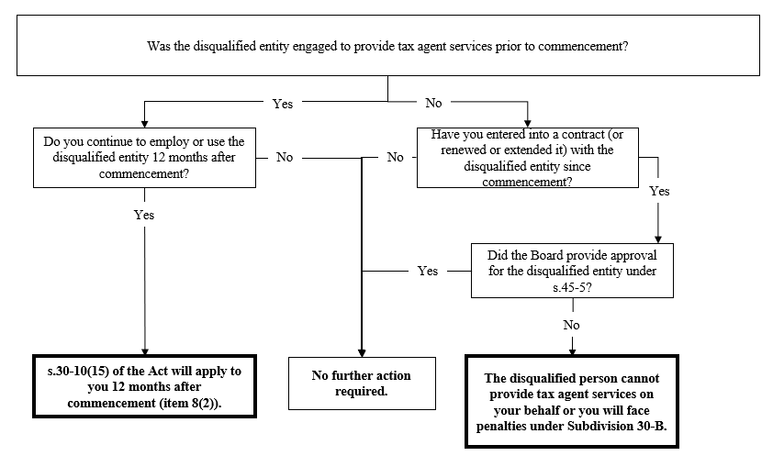
    - Application of Code of Professional Conduct obligations on tax practitioners
    - Obligations on disqualified entities under Part 4A
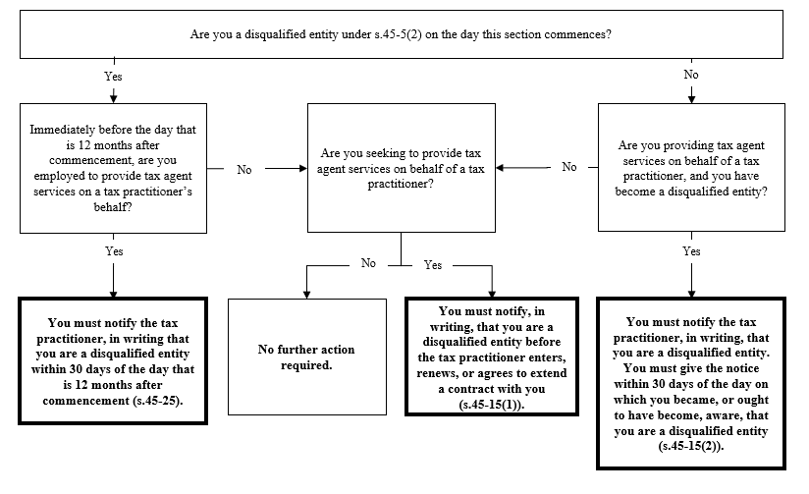

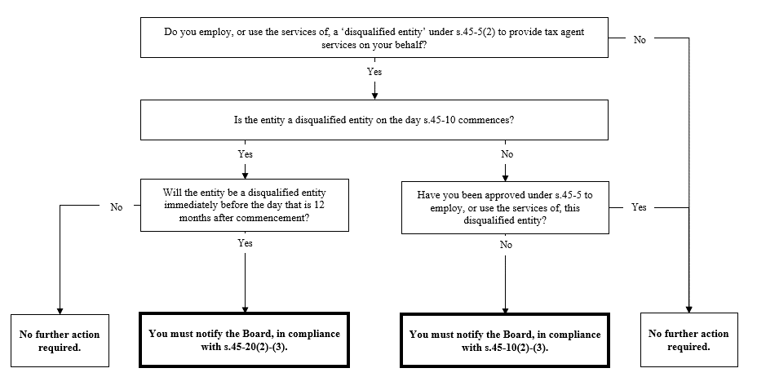
    - Obligations on tax practitioners under Part 4A

Recommendation 4.7 – Conversion to an annual renewal period
  - These provisions convert the renewal period from at least every three years to at least every year. The update to an annual renewal period will remove the requirement for registered agents to provide an annual declaration to the TPB which confirms they have maintained their ongoing obligations, and will align renewal with tax practitioners’ other requirements. This includes maintaining professional indemnity insurance and undertaking continued professional education.
[Schedule 1, items 9 and 11, subsection 20-1 and 20-25(4) of the TAS Act]
  - To accommodate for the shorter renewal period, the maximum time period permitted for the TPB to process and determine the outcome of an application has been reduced to four months. Within this four month timeframe, the TPB must decide whether to accept the new registration application, and if the applicant does not receive a final decision in this timeframe, the registration application is considered to be rejected by the TPB. Renewal of tax practitioners’ registration will continue to be active until a final decision is made by the TPB within the four month period.
[Schedule 1, item 10, subsection 20-25(2) and (3) of the TAS Act]
  - These changes only apply to any registration or renewal applications submitted on or after 1 July 2023, ensuring there is no retrospective effect of these amendments.
[Schedule 1, item 12 of the TAS Act]

Recommendation 5.1 - Enable the Minister to supplement the existing Code of Professional Conduct
  - Section 30-10 sets out the legislated Code of Professional Conduct for all registered tax practitioners. The Code sets out the professional and ethical standards that registered tax practitioners are required to comply with. It outlines the duties that registered tax practitioners owe to their clients, the TPB and other registered tax practitioners in their professional capacity.
  - The amendments enable the Minister to specify, in a legislative instrument, additional obligations that registered tax agents and BAS agents must comply with. The Minister can specify additional obligations on subjects that are already referred to in the Code of Professional Conduct in the TAS Act as well as obligations on new subjects relating to the personal and professional conduct of registered tax agents and BAS agents.
[Schedule 1, items 2 and 3, subsections 30-10(16) and 30-12(1) of the TAS Act]
  - This provision cannot be used to reduce any existing obligations under the Code of Professional Conduct in the Act. To the extent that a determination made by the Minister conflicts with the Code, the conflicting provisions have no effect.
[Schedule 1, item 3, subsection 30-12(2) of the TAS Act]
  - The purpose of the power is to create a proactive Code of Professional Conduct regime where changes to the tax professional environment can be promptly adapted to by the Minister through regulations. The Code of Professional Conduct is to be a more dynamic instrument that can adjust to changes in a more contemporary manner than is permitted in the TAS Act.
  - The legislative instrument process also ensures appropriate consultation with key stakeholders and parliamentary oversight, while also creating a proactive regime where emerging changes to behaviours and practise can be promptly adapted to by the regulator.

Further amendments
  - This instrument extends the definition of a BAS service under section 90-10 of the TAS Act, to also include services related to the superannuation guarantee charge which is listed at section 5 of the Tax Agent Services (Specified BAS Services No. 2) Instrument 2020. This ensures consistency as the definition has been moved into the primary law and clarifies the definition of a BAS service.
[Schedule 1, item 7, subsection 90-10(1) of the TAS Act]

Commencement, application, and transitional provisions
  - The amendments for Part 1, which includes Recommendations 2.1, 4.6, 4.7 and 5.1, commence from the first 1 January, 1 April, 1 July or 1 October to occur after the day the Bill receives the Royal Assent.
  - Recommendations 2.1, 4.7 and 5.1 apply in accordance with the commencement date set for Part 1.
  - Recommendation 4.6 applies in accordance with the rules set out above.
  - The amendments for Part 2, including Recommendation 3.1, commence on 1 July 2023.
  - Recommendation 3.1 applies in accordance with the commencement date set for Part 2, namely 1 July 2023.

