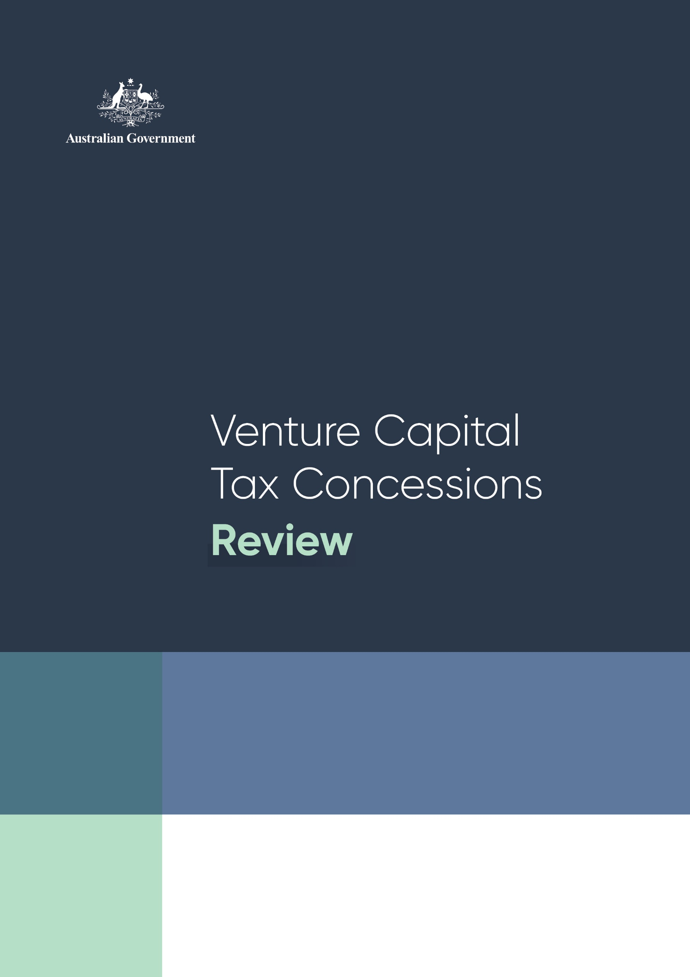



Venture Capital Tax Concessions Review

© Commonwealth of Australia 2022

ISBN: 978‑1‑925832‑57‑0

**This report was authored by Treasury and Industry Innovation and Science Australia (IISA).**

This publication is available for your use under a [Creative Commons Attribution 3.0 Australia](http://creativecommons.org/licenses/by/3.0/au/deed.en) licence, with the exception of the Commonwealth Coat of Arms, the IISA logo, photographs, images, signatures and where otherwise stated. The full licence terms are available from <http://creativecommons.org/licenses/by/3.0/au/legalcode>.

Creative Commons attribution licence 3.0 icon. 

Use of Treasury or IISA material under a [Creative Commons Attribution 3.0 Australia](http://creativecommons.org/licenses/by/3.0/au/deed.en) licence requires you to attribute the work (but not in any way that suggests that the Treasury or IISA endorse you or your use of the work).

**Treasury or IISA material used ‘as supplied’.**

Provided you have not modified or transformed Treasury or IISA material in any way including, for example, by changing the Treasury or IISA text; calculating percentage changes; graphing or charting data; or deriving new statistics from published Treasury or IISA statistics – then the following attribution is preferred:

Source: The Australian Government Department of the Treasury and independent statutory board, Industry Innovation and Science Australia.

**Derivative** **material**

If you have modified or transformed Treasury or IISA material, or derived new material from those of the Treasury or IISA in any way, then the following attribution is preferred:

Based on The Australian Government the Treasury and independent statutory board, Industry Innovation and Science Australia data.

**Use of the Coat of Arms**

The terms under which the Coat of Arms can be used are set out on the Department of the Prime Minister and Cabinet website (see [http://www.pmc.gov.au/government/commonwealth‑coat‑arms](http://www.pmc.gov.au/government/commonwealth-coat-arms)).

**Other uses**

Enquiries regarding this licence and any other use of this document are welcome at:

Manager  
Media Unit  
The Treasury  
Langton Crescent   
Parkes ACT 2600  
Email: [media@treasury.gov.au](mailto:media@treasury.gov.au)

# Contents

Addendum 2

Executive Summary 3

1. Background to the review 5

1.1 Scope of this review 5

1.2 Summary of program objectives 5

1.3 Consultation process 6

1.4 Quantitative data analysis process 6

2. Supporting startups and early stage businesses 8

2.1 Challenges facing startups 8

2.2 Government support 8

3. Venture capital tax concessions in Australia 10

3.1 What is venture capital? 10

3.2 History of targeted tax concessions to support venture capital 12

3.3 Key features of the programs in Australia 14

3.4 Eligible investee activities 15

4. Overview of the venture capital sector 16

4.1 Trends in Australian venture capital and later stage private equity 16

4.2 Australian venture capital industry compared to international trends 18

5. Assessment of Australia’s venture capital tax concessions 20

5.1 Impact of the programs 20

5.2 Objective: Increase levels of venture capital investment in Australia 21

5.3 Objective: Enhance the development of skills and experience of venture capital fund managers 23

5.4 Objective: Increase investment in early stage businesses 25

5.5 Objective: Increase foreign investment into Australia’s venture capital sector 28

5.6 Objective: Provide diversification and flexibility for investors through an AFOF structure 30

5.7 Objective: Foster a shift towards a culture of innovation and entrepreneurial risk‑taking 31

5.8 Objective: Provide Australia with a world’s best practice investment vehicle for venture capital 31

5.9 Objective: Make finance more readily available and cheaper for high‑risk expanding businesses 34

5.10 Objective: Improve funding for promising projects across the economy and in industries beyond the technology sector 36

6. Appendices 39

6.1 Operation of the programs 39

6.2 Administration of current programs 43

6.3 Recent reforms to tax settings 43

6.4 Terms of Reference 45

# Addendum

The report of the Venture Capital Tax Concessions Review was completed in November 2021. In the opinion of Treasury and Industry Innovation and Science Australia (IISA), no changes have occurred since the report was conducted that would materially affect the findings of the review. Language has been updated in places to reflect the change of Government.

# Executive Summary

In the 2021–22 Budget, the previous Commonwealth Government announced a joint Treasury and Industry Innovation and Science Australia (IISA) review of Australia’s venture capital tax concession programs (the programs) to ensure current settings are fit‑for‑purpose and support genuine, early stage Australian startups.

The Commonwealth Government, like many governments globally, supports investment in startups to drive innovation and support productivity growth. Support is provided through a variety of tax incentives and direct support measures for innovation. The programs, namely the Venture Capital Limited Partnership (VCLP), Early Stage Venture Capital Limited Partnership (ESVCLP), and Australian Venture Capital Fund of Funds (AFOF), offer vehicles and concessional tax treatment for investors willing to provide venture capital to early stage businesses when securing finance is a key viability concern. They also provide opportunities for non‑financial assistance, such as mentoring and access to networks. The programs have been operational for 15 to 20 years and have undergone several amendments to provide targeted support more effectively for Australia’s innovative, high growth potential businesses.

The venture capital sector in Australia has shown strong growth in recent years, though from a comparatively low base by international standards. Since the middle of the last decade, there has been a global surge in venture capital investment which has been mirrored in the Australian landscape. Venture capital growth has continued largely unabated through the COVID‑19 pandemic and the outlook for the Australian venture capital sector is broadly optimistic.

Drawing on stakeholder consultations, written submissions and quantitative data analyses, the review finds that overall:

* The tax concessions and investment vehicles offered by the programs in scope of this review have been well received.
* These programs have supported the growth of the Australian venture capital sector, which has experienced increased levels of venture capital investment, and the development of venture capital fund managers–the two primary objectives of the programs.
* Stakeholders recognised that the programs are just one contributing factor to the growth of the venture capital sector, but noted that their removal would be detrimental to the venture capital sector, and there were some calls for changes to the programs.

These findings should be viewed in light of the impact on revenue, which has an opportunity cost as these funds could have been used for other purposes. It is also difficult to quantify the effect of the programs–noting that the recent growth in the venture capital sector reflects global venture capital trends, macroeconomic factors–and separate them from the impacts of the Government’s broader suite of support for startups and innovation.

Notwithstanding, the growing reputation of Australian venture capital fund managers, increasing investment opportunities, and greater appetite of an increased range of investors for exposure to the asset class should continue to underpin the growth of venture capital investment in Australia.

|  |
| --- |
| Key findings of the review   1. The Australian venture capital sector has grown in recent years with increased venture capital investment, making finance more readily available for high risk expanding businesses across the economy. This growth reflects global trends and macroeconomic factors and the programs have likely played a supporting role. However, it is not possible to quantify the direct impact of the programs. 2. The programs have likely contributed to enhancing the development of skills and experience of venture capital fund managers, including by attracting overseas venture capital talent to Australia, though the relatively early developmental stage of the venture capital sector makes it difficult to assess fund manager performance to date. 3. The ESVCLP program has likely encouraged early stage investment in startups and expanding businesses. 4. The programs, particularly the VCLP program, have facilitated foreign investment in the Australian venture capital sector by offering the prospect of attractive returns and an internationally recognisable investment vehicle. 5. The AFOF program provides a capital aggregation platform and diversification opportunities for investors by allowing investors to indirectly invest in a portfolio of businesses through VCLP and ESVCLP funds. 6. The programs have supported a culture of innovation and entrepreneurial risk‑taking by supporting early stage businesses with venture capital and mentorship. 7. The programs provide an internationally recognisable vehicle, giving investors the confidence to invest in Australian venture capital. 8. The programs have made finance more readily available for high‑risk expanding businesses, however fintech remains an area for further growth. 9. The programs have improved funding opportunities for a diverse range of projects and businesses across the economy. |

1. Background to the review
   1. Scope of this review

The programs in‑scope for this review include:

* Venture Capital Limited Partnerships;
* Early Stage Venture Capital Limited Partnerships;
* Australian Venture Capital Fund of Funds; and
* Investments made directly by foreign residents registered under Part 3 of the Venture Capital Act 2002.

The Treasury and Industry Innovation and Science Australia (IISA) have undertaken this review for the following purposes, as set out in the Terms of Reference (Appendix 6.4):

* To consider how the concessions operate in practice and whether they are achieving their intended objectives;
* To satisfy the legislative requirement outlined in Section 118–455 of the *Income Tax Assessment Act 1997*; and
* To consider the recommendations of other relevant reviews, to which the Government has not yet responded, that examine the venture capital tax concessions.

This review is an assessment of whether the programs have met their objectives based on the views of stakeholders, including investors, fund managers, lawyers and industry groups, and the available quantitative data.

As per the Terms of Reference, the findings of the Senate Select Committee on Australia as a Technology and Financial Centre (formerly the Senate Select Committee on Financial Technology and Regulatory Technology) were considered and are discussed in Section 5.9.

* 1. Summary of program objectives

The review assesses the impact of the programs against their objectives, using both quantitative and qualitative sources.

There are two primary objectives across the three programs:

* Increase levels of venture capital investment in Australia
* Enhance the development of skills and experience of venture capital fund managers

In addition, each program has a specific objective:

* ESVCLP program to increase investment in early stage businesses
* VCLP program to attract foreign venture capital investment
* AFOF program to provide diversification and flexibility for funds and their investors

A further four broader program objectives, as set out in the explanatory memoranda, are also discussed. These broader program objectives are to:

* Foster a shift towards a culture of innovation and entrepreneurial risk‑taking
* Provide Australia with a world’s best practice investment vehicle for venture capital
* Make finance more readily available and cheaper for high‑risk expanding businesses
* Improve funding for promising projects across the economy and in industries beyond the technology sector
  1. Consultation process

To inform this review, direct stakeholder consultations were conducted, and written submissions were invited, in August and September 2021. The consultation process was designed to seek responses from stakeholders regarding the aforementioned program objectives. Twenty‑seven discussions were held with 36 stakeholders from across the venture capital sector, and 19 written submissions were received.

Written submissions and the Consultation Paper which guided the consultation process can be accessed through the IISA consultation website.[1]

* 1. Quantitative data analysis process

The programs’ quantitative data included in this review is reported by general partners through annual and quarterly reporting to the Department of Industry, Science and Resources (DISR). All program data used in this review was extracted from the DISR‑hosted program database between 27 and 30 September 2021. Program data presented reflects data up to the reporting period ending 30 June 2021. Note that data for the financial year 2020–21 is incomplete, as not all general partners had reported when the data was extracted. Investment data through time is analysed using the date of the investment transaction, grouped by financial year as required. As the data reporting requirements have evolved over time, not every dataset is available for the life of the programs.

While program data is reported quarterly, and annually by financial year, data compliance and data quality control work are continuous, thus the program data available can change between reporting dates. It is for this reason, as well as the date of analysis and due to the review completing some minor additional quality control work and non‑standard analyses, that the data presented in this review may not match other government‑reported venture capital program data.

The program data referred to in this review uses the following specific terms:

* ‘partnership’–defined in legislation as an association of people who carry on business together or jointly receive income;[2]
  + In this review, ‘partnership’ refers to venture capital program partnerships, which are flow‑through tax entities established under partnership legislation in each Australian state and territory.
* ‘general partner’–defined in legislation as a partner of a limited partnership whose liability in relation to the partnership is not limited;[3]
  + In this review, ‘general partner’ refers to the entity that manages the partnership.
* ‘limited partner’–defined in legislation as a partner of a limited partnership whose liability in relation to the partnership is limited;[4] and
  + In this review, ‘limited partner’ refers to the investors in the venture capital program partnerships.
* ‘fund’–a collection of vehicles that include the partnership and associated unit trusts.

Other quantitative data presented in this report is sourced as per references stated in the text.

1. Supporting startups and early stage businesses
   1. Challenges facing startups

Startups are important drivers of innovation and productivity gains in an economy. They can create new markets and products and revolutionise existing processes, increasing competition and generating job opportunities. Successful Australian businesses, such as Canva, started off as a Sydney‑based software business with a simple idea before transforming graphic design globally.[5] Today, Canva’s platform is used by tens of millions of people around the world every month.

However, such success stories are not the norm as the survival rate for startups is generally low. Failure is a feature of an innovative and dynamic economy however, with some businesses able to pivot to a new market or idea, while others fold, freeing up capital. The success or failure of startups can be due to many factors such as consumer demand, market conditions, access to supply inputs and to markets for scaling opportunities, interest rates, the regulatory environment, and some chance.

A significant challenge for startups, particularly in the early stages, is securing finance to develop their idea into a marketable product or service. Generally, this is because startups do not have a sales history or tangible assets for collateral, and if the idea is unique or novel, their business may be viewed as too high‑risk to obtain bank loans or other debt financing instruments.

As such, the early stage activities of many startups will initially be funded by personal savings, friends and family, and potentially some crowdfunding. Eventually, these sources of funding will be insufficient to expand the business, leading many startups to look for debt and equity financing from the private sector (eg, angel investors and venture capitalists), government support through grants, or co‑funding arrangements with research institutions.

* 1. Government support

Many governments globally choose to play a role in supporting startups and innovation to increase productivity and employment growth. At the basic level, governments can provide settings within which entrepreneurs can attempt to develop new ideas and investors have the confidence to invest. This relies on having sound fundamentals, such as a stable political‑legal system, competitive corporate tax rates, and a regulatory strategy which supports innovation.

Beyond these fundamentals, governments can use a range of measures to support startups. Noting each approach has different trade‑offs and benefits, these measures can include direct financing through grants or co‑investment schemes, or incentivising private investment through targeted tax policies. However, many, if not most, successful businesses start up without government support.

Directly financing startups–which is out of scope for this review–can deliver targeted government support. However, this approach can be costly to administer and relies on a high level of expertise to successfully identify applicants with the highest prospects of commercial success. The private sector is generally more efficient and in a better position than government to assess startups and their growth potential.[6]

Therefore, encouraging private investment, such as by offering tax incentives, can be a more efficient way for government to broaden businesses’ access to support and manage risk. However, there are also trade‑offs to this approach as it is costly–particularly if the tax incentive is uncapped–and it will likely subsidise some investment that would have occurred regardless.

The Commonwealth Government provides a range of direct support measures and tax incentives which support startups and innovation. State and territory governments also provide a range of startup and innovation supports which, although outside the scope of this review, operate alongside Commonwealth Government programs.

The Commonwealth Government also offers tax concessions to encourage innovation and incentivise investment in startups. These include tax incentives that are out of scope for this review, such as:

* targeted tax concessions for investments in early stage innovation companies (ESIC);
* tax concessions on employee share schemes (ESS) which employers use to attract and retain staff; and
* the Research and Development Tax Incentive (R&DTI), which offers tax offsets for companies conducting eligible research and development activities.

The Commonwealth Government also provides tax concessions to support additional and ongoing venture capital investment, namely through the three programs which are within the scope for this review: the VCLP, ESVCLP and AFOF programs.

1. Venture capital tax concessions in Australia
   1. What is venture capital?

Venture capital is generally considered to be high‑risk private equity capital provided to often new, innovative unlisted businesses with high growth potential in the following rounds or stages:[7]

* pre‑seed (the very early stage when a startup is getting their operations off the ground);
* seed (the first round of startup funding); and
* the series A, B, C rounds of funding and beyond (as startups are more established in their product development).

In exchange for venture capital and recognising the risk investors are taking, startups will offer an equity stake in their business. This provides investors security as well as decision‑making powers in the business. Securing venture capital investment can also give startups access to management expertise and contacts that investors have built up over time.[8] In this way, entrepreneurs can prioritise developing their business while gaining valuable industry acumen.

Compared with other forms of private equity, returns on venture capital investments are more dependent on the growth and success of the startup. Investments are generally made early in the business’ lifecycle when there is still a significant chance of failure and uncertainty around the potential for growth.

In contrast, later stage private equity involves investment in businesses in the late stage of expansion, turnaround and buy‑out or sale stage of investment.[9] It often involves the acquisition of mature, larger businesses that may be profitable but with significant levels of debt. These are still risky, but there is less chance of investors losing out entirely.

In the Board of Taxation’s 2011 review of the VCLP program,[10] the characteristics of venture capital and later stage private equity investments were summarised as shown in Table 1.

Table 1: Differences between venture capital and later stage private equity[11]

|  |  |  |
| --- | --- | --- |
| Variable | Venture Capital | Later Stage Private Equity |
| Risk | Very high | Lower |
| Type of capital (leverage) | Generally equity | Generally significant debt and equity |
| Investment timeframe | Long (for example up to 10 years) | Considerably shorter |
| Availability of capital | Difficult to raise, low reserves | Easier to raise, considerable reserves |
| Failure rate | High | Much lower |
| Average investment return[12] | Low | Much higher |
| Activity | Establishing and building companies, commercialising new innovations | Restructuring established companies |

Wealthy individuals with niche interests (also known as ‘angels’) and financial institutions, such as investment banks and venture capital firms, are common sources of venture capital.[13] Venture capital investors rarely seek immediate returns, but typically make short to medium‑term investments in startups with the intended return on investment mainly coming upon ‘exit’ or divestment, in contrast with regular income streams (eg, dividends) in other investments.[14] The exit may be in the form of a sale of shares to other investors, a buyback from the business itself, or an initial public offering.

Venture capital is often pooled into funds of committed capital which are then managed and invested by fund managers who have the expertise, and financial incentives, to assess and identify high‑growth investment prospects in a portfolio of early stage businesses. By investing in a portfolio, investors spread their risk across a range of businesses. While venture capitalists recognise that many businesses may fail in these early stages, investors hope to find at least a few highly successful businesses across a portfolio of investments, which may generate potentially significant returns to investors.

* 1. History of targeted tax concessions to support venture capital

A strong venture capital sector will support startups and promote innovation by unlocking access for startups to capital, networks and mentoring. Governments may be able to support the venture capital sector, and in turn startups, by providing targeted tax concession programs. However, a balance must be struck in the design of these programs to ensure that the government does not completely ‘de‑risk’ highly risky commercial ventures or subsidise projects with poor commercial prospects.[15]

The Commonwealth Government introduced the Venture Capital Limited Partnership (VCLP) and Australian Venture Capital Fund of Funds (AFOF) programs in 2002 following the ‘dotcom crash’. This was a challenging time for the venture capital sector, with investors’ appetites diminished, fundraising difficult and local funds delivering relatively poor returns.

In addition to the broad objectives of increasing levels of venture capital investment and developing the skills of fund managers, the VCLP program had the specific objective to increase foreign investment in the Australian venture capital industry. The VCLP program and AFOF program were introduced with the following objectives:

to provide an incentive for foreign investors from certain countries to invest in the Australian venture capital industry, to develop the Australian industry and to provide a source of equity capital for relatively high risk and expanding businesses which found it difficult to attract investment through normal commercial mechanisms.[16]

VCLPs were intended to be a best practice investment vehicle with an internationally‑recognisable limited partnership structure which is favoured by venture capital investors. They have flow‑through tax treatment and eligible foreign investors are exempt from taxation on the gains. In addition, the fund manager’s share of gains is taxed as capital, not revenue. The AFOF program also provides a flow‑through vehicle with a tax exemption for eligible foreign investors, and increased diversification and flexibility by facilitating investments in VCLPs and ESVCLPs.

The mid 2000s saw a turnaround in the level of venture capital activity with significant fundraisings. However, the Productivity Commission noted in 2007 that the Australian venture capital market was still shallow with the ‘relatively small pool of investment managers and the lack of a strong track record in delivering the kind of returns needed to attract major institutional investors’ being significant impediments at the time.[17] There was also a concern that the VCLP program was not adequately supporting early stage businesses.

As such, the ESVCLP program was introduced in 2007 to provide more targeted concessions for venture capital investments in early stage businesses and to build a pool of talented fund managers. At the same time, the Pooled Development Funds (PDF) program–which was similarly focused on early stage businesses–was closed to new applicants. The PDF program preceded the introduction of all three programs and offered a corporate structure. The ESVCLP program uses a limited partnership structure to align with international best practice and intended:

to encourage investments in start‑up enterprises with a view to commercialisation of the activity [and] stimulate activity in the venture capital sector and enhance the development of skills and the formation of capital.[18]

The investors, whether resident or non‑resident, also receive a tax exemption on their share of the partnership’s income.

The VCLP, ESVCLP and AFOF programs position Australia to attract and facilitate flows of venture capital into Australian startups and early stage businesses as they reduce the cost associated with connecting the buyers and sellers of capital (businesses and venture capital investors). The key features of the VCLP, ESVCLP and AFOF programs are set out in the following subsection. Examples of how they operate in practice and their administration are set out in Appendices 6.1 and 6.2.

* 1. Key features of the programs in Australia

Table 2: Summary of key features of the programs in Australia

|  |  |  |  |
| --- | --- | --- | --- |
|  | Venture Capital Limited Partnership (VCLP) | Early Stage Venture Capital Limited Partnership (ESVCLP) | Australian Venture Capital Fund of Funds (AFOF) |
| **Tax benefits[19]** | Flow‑through tax treatment | Flow‑through tax treatment | Flow‑through tax treatment |
| **Income tax exemption for eligible foreign investors** on their share of gains made by the partnership from disposal of eligible investments. | **Income tax exemption for eligible investors (both domestic and foreign)** on their share of gains made by the partnership from disposal of eligible investments.[20] | **Income tax exemption for eligible foreign investors** on their share of gains made by the partnership from disposal of eligible investments. |
|  | **Non‑refundable carry forward tax offset of 10%** of limited partners’ contribution to eligible investments.  The tax offset is reduced to the extent that an investor’s contribution is not invested. |  |
| General partners’ interests held on capital rather than on revenue account.[21] | General partners’ interests held on capital rather than on revenue account. | General partners’ interests held on capital rather than on revenue account. |
| **Eligibility criteria** | **Minimum $10 million** committed capital. | **Minimum $10 million** and **maximum $200 million** of committed capital. | **No minimum** capital requirement. (The general partner must advise that the partnership has sufficient capital to begin investment) |
| **No maximum** investment by one partner. | **Maximum investment by one partner is 30%** of committed capital. |  |
| **Maximum investment in one entity is 30%** of committed capital. | **Maximum investment in one entity is 30%** of committed capital. | **Maximum investment in one entity is 30%** of committed capital. |
| Eligible investments (investee company value) **must be less than $250 million** in total assets. | Eligible investments (investee company value) **must be less than $50 million** in total assets. |  |
| Must have a general partner that is a resident of either Australia or a country that has a double tax agreement with Australia. | Must have a general partner that is a resident of either Australia or a country that has a double tax agreement with Australia. | Each general partner of the AFOF is an Australian resident. |

* 1. Eligible investee activities

The VCLP and ESVCLP programs impose restrictions on the types of activities that can be undertaken by an investee business.[22] Generally, an investee business is not permitted to engage in ineligible activities, unless those ineligible activities comprise less than 25 per cent of the business’ assets, employees or income.[23]

Ineligible activities include:

* property development or land ownership;
* finance (banking, providing capital, leasing, factoring or securitisation);
* insurance;
* construction or acquisition of infrastructure facilities; or
* making investments that derive interest, rent, dividends, royalties or lease payments.

These activities are permitted if they are ‘ancillary or incidental’ to other primary activities which are not ineligible.[24] For example, ‘ancillary or incidental’ activity may occur where an investee that is a software developer undertakes a small number of infrequent investments, of low‑value and over a limited period of time, to test the functionality of an investment software product.[25] If an investee business breaches the eligibility requirements temporarily, IISA may exercise discretion to determine that the investee business does not become an ineligible venture capital investment.[26]

In 2018, the Government amended the Venture Capital Act 2002 and Income Tax Assessment Act 1997 to clarify that developing technology or providing services that facilitate finance, insurance and making investments (eg, software platforms, apps etc) are not ineligible investee activities. This is because they are distinct from the actual provision of, or engagement in ineligible activities, such as finance, insurance and making investments. IISA can also make a finding that an investee activity is not an ineligible activity because it is a substantially novel application of technology.[27] More detail on recent legislative amendments to the programs is provided in the Appendix at 6.3.

The restrictions on eligible investee activities are intended to direct VCLP and ESVCLP investment to economic activities with the most innovation potential, rather than passive income generation from asset ownership.[28] These restrictions can also help address anti‑competitive behaviour and market concentration, for example, by preventing banks from obtaining tax concessions to acquire competitors.

1. Overview of the venture capital sector
   1. Trends in Australian venture capital and later stage private equity

The venture capital sector in Australia has shown strong growth in recent years and mirrors global venture capital investment trends. This suggests that the Australian venture capital sector is influenced by global venture capital growth and macroeconomic factors observed internationally, such as expansionary fiscal policies and low interest rates.

The growing Australian venture capital sector supports startups in Australia by helping to connect them with sources of funding and expertise. The growth in Australia’s venture capital sector is observed in both the amount of venture capital raised and invested, though there are marked challenges in measuring and comparing venture capital sector performance domestically and internationally.[29]

Australian Investment Council (AIC) data suggests that the amount of venture capital raised annually in Australia has increased since 2014, with $1.33 billion raised in the 2020 calendar year (Figure 1). This trend aligns with global trends of increasing venture capital commitments. While the aggregate venture capital raised continues to rise, there remains volatility from year to year (Figure 2). This primarily reflects the nascent character of the venture capital sector in Australia, which is small by comparison with more mature markets overseas, and thus more susceptible to short term market volatility. For example, a small number of significant fundraising events in any one year will show a marked effect on the aggregate fundraising for that year. The funding rounds of government co‑investment programs have a similar effect.

Domestic factors underlying recent fundraising performance include the growing reputation of local fund managers, the increasing investment opportunities through the spread of technology and the appetite of an increased range of investors for exposure to the asset class.

Figure 1: Venture capital fundraising in Australia (aggregate capital raised, $ million).[30]

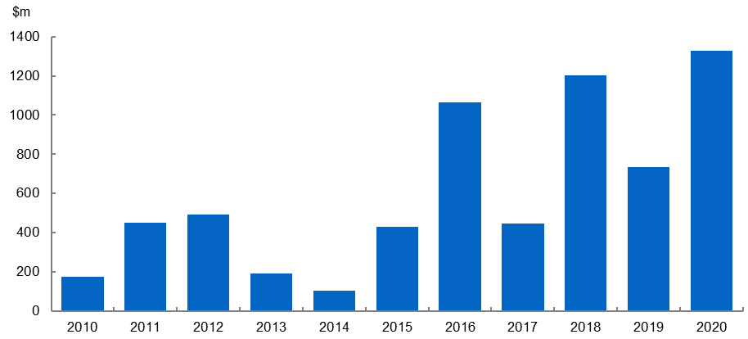

Venture capital investment in Australia has generally trended upwards over recent years. The AIC reported the aggregate value of Australian venture capital deals completed in 2020 was $2.4 billion, up from $2.3 billion in 2019. However, there was a decline in deal numbers in 2020, with 149 deals made, down from 189 deals in 2019 (Figure 2).

Figure 2: Venture capital investment in Australia ($ million).[31]

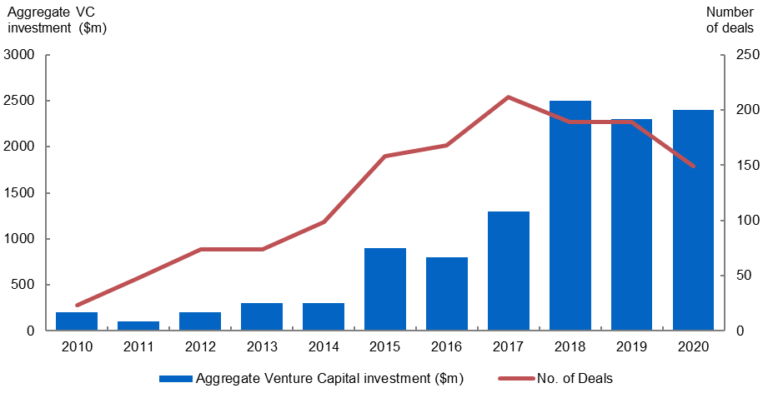

In slightly more recent data, KPMG has also observed similar trends to the AIC with the impact of COVID‑19 seemingly not felt strongly by the Australian venture capital sector. KPMG observed a continued rise in Australian venture capital funding throughout the 2020–21 financial year to a record US$2.5 billion (A$3.4 billion), up from US$1.95 billion (A$2.6 billion) in the previous year.[32] The number of venture capital investment deals was also higher over the past financial year, with a record 327 deals, up from 311 deals over the previous 12 months.

* 1. Australian venture capital industry compared to international trends

Despite positive developments, the Australian venture capital sector is still small by international standards (Figure 3). According to the Organization for Economic Co‑operation and Development (OECD), Australia’s venture capital investment as a percentage of gross domestic product was 0.034 per cent compared to an OECD average of 0.081 per cent in 2019.[33]

Figure 3: Trends in venture capital investment in selected OECD countries.[34]

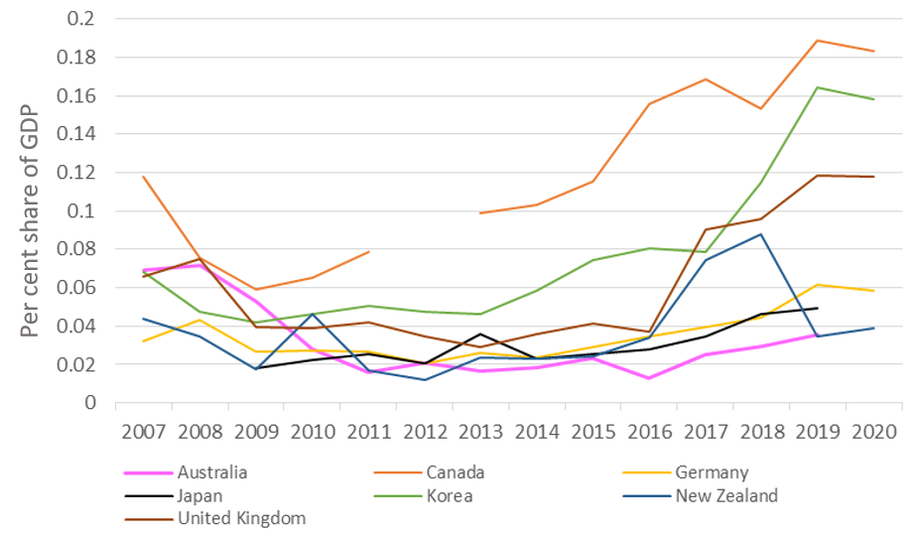

In the early stages of the COVID‑19 pandemic there were concerns within the venture capital industry around the potential for a significant tightening of capital availability for startups, and the impact on capital raising in future years. While there was some early slowdown in activity, in part as fund managers focused on ensuring that their existing portfolio businesses were positioned to adapt to the altered environment, the earlier concerns have not been evident through the available data over time.

This minimal disruption to capital availability may reflect the expansionary monetary and fiscal policies deployed globally in response to the economic impacts of COVID‑19. As global interest rates plunged to record lows, economies became awash with surplus capital chasing higher yields. This has resulted in increased asset prices and significant growth in venture capital activity globally, and is indicative of the role of many factors in influencing venture capital trends.

1. Assessment of Australia’s venture capital tax concessions
   1. Impact of the programs

The VCLP, ESVCLP and AFOF programs have been well received by investors and fund managers and have benefited innovative startups and early stage businesses across Australia. Since the inception of the venture capital tax concessions, a total of $20.04 billion of capital has been committed by program partnerships to 30 June 2021, with $17.19 billion of this committed capital[35] held by currently active partnerships.

The $20.04 billion of committed capital can be broken down by program:

* VCLPs: $16.16 billion (program commenced 2002)
* ESVCLPs: $3.43 billion (program commenced 2007)
* AFOFs: $451.91 million (program commenced 2002)

Of this committed capital, the cumulative direct investment in businesses via program partnerships to 30 June 2021 totalled $11.03 billion. This can be broken down by program:

* VCLPs: $9.27 billion
* ESVCLPs: $1.76 billion
* AFOFs: $2.23 million[36]

These cumulative investment totals can significantly lag the capital commitments as fund managers only draw down investors’ capital commitments as opportunities are identified and initial investments are made progressively over time. General partners also hold capital in reserve to enable ‘follow‑on’ investments to be made.

Over the life of the programs, investments have been made in an estimated 1775 unique businesses.[37] By value, the majority (94 per cent) of VCLP and ESVCLP program partnerships investments are in Australian businesses. The remaining 6 per cent is invested internationally, primarily in the United States (42 per cent), New Zealand (34 per cent) and Singapore (12 per cent).

Overall, stakeholders have welcomed the tax concessions and investment vehicles offered by the VCLP, ESVCLP and AFOF programs. In their view, these programs have supported the growth of the Australian venture capital sector. Whilst it was broadly accepted that it is difficult to quantify the direct impact of the tax incentives themselves, stakeholders do not want the programs to be withdrawn and believe that this would have a detrimental impact on the venture capital sector. Given the sector operates over a long investment timeframe, stakeholders generally value certainty and clarity.

While the programs have reportedly delivered a positive benefit to the venture capital sector, which in turn can benefit startups, this needs to be balanced against the cost to revenue and the opportunity cost of forgoing spending in other areas.

* 1. Objective: Increase levels of venture capital investment in Australia

Over the life of the programs, the Australian venture capital sector has grown with the flow of foreign and domestic capital from new and existing investors into Australian startups increasing.

Program partnerships’ investment levels grew gradually from program inception to 2014–15, then accelerated through to 30 June 2021, driven strongly by investments made through the VCLP program (Figure 4). The uptick in investment since 2014–15 has largely tracked global trends. Investments per annum through both the VCLP and ESVCLP program have also been trending upwards over time. Investments through the VCLP program are more volatile year‑on‑year while investments through the ESVCLP program have been increasing more steadily over time.

Figure 4: Cumulative direct investment and per annum direct investment in investee businesses by program partnerships over time.

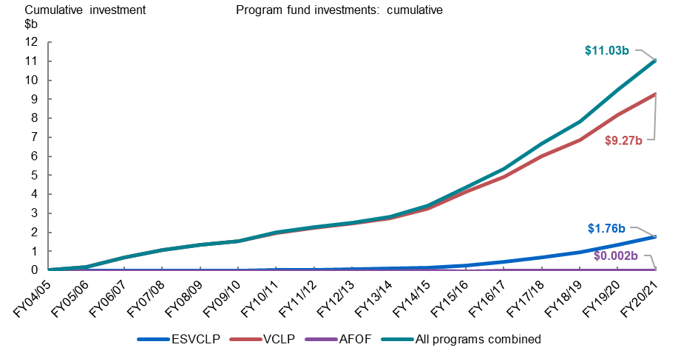

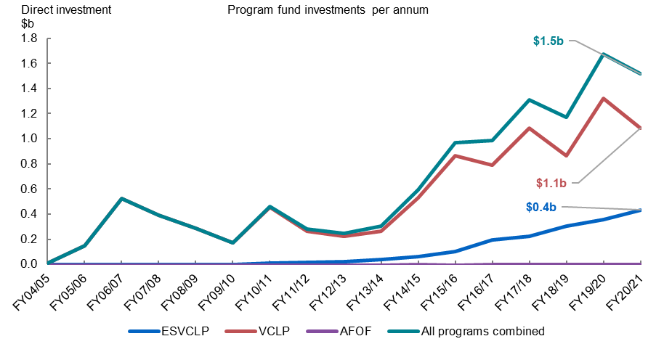

This growth in investments reflects broader Australian venture capital sector growth which has been strong in recent years, culminating in a record $1.3 billion raised by Australia‑focused venture capital fund managers across 10 funds in 2020, almost doubling the $735 million of investment in 2019.[38] Jelix Ventures noted that Australia’s venture capital sector has also grown in terms of the amount invested, the number of partnerships registered with IISA and the number of fund managers.[39]

Though it is not possible to attribute the growth of Australia’s venture capital sector solely to the programs, many stakeholders were of the view that the programs had supported Australian venture capital growth, while also noting other important contributing factors such as the prospect of significant returns on venture capital investments, and achieving strategic investment outcomes. Significantly, the strong growth in venture capital investment in Australia, evident from the middle of the 2010s, mirrors similar growth patterns in other countries which may indicate a broader global shift that is beyond the influence of domestic factors. This may reflect increasing investment opportunities, facilitated by developments in technology, and a new asset class that investors are increasingly gravitating towards for diversification. The structural decline in interest rates over time may also have led investors to seek higher yielding investments for their excess savings.

Many stakeholders held the view that the programs are just one factor amongst many in driving their investment decisions. Several stakeholders commented that the concessional tax treatment offered by the programs can help to attract investors to invest in venture capital for the first time. In contrast, more experienced venture capital investors and institutional investors are less reliant on tax concessions.

|  |
| --- |
| Finding 1: The Australian venture capital sector has grown in recent years with increased venture capital investment, making finance more readily available for high risk expanding businesses across the economy. This growth reflects global trends and macroeconomic factors and the programs have likely played a supporting role. However, it is not possible to quantify the direct impact of the programs. |

* 1. Objective: Enhance the development of skills and experience of venture capital fund managers

Stakeholders reported that the programs have enhanced the development of venture capital fund management expertise in Australia. The Australian Investment Council submitted that:

The VCLP, ESVCLP and AFOF programs are meeting their objective to develop venture capital management skills and experience in the Australian venture capital sector. This is both the management skills and experience of the fund managers including those who sit on the boards as directors of the portfolio companies as well as the management teams within the underlying businesses.[40]

Many stakeholders observed that the increasing number of venture capital funds and investment opportunities in Australia, as supported by the programs, enhances the development of venture capital fund management skills and experience. The Tech Council of Australia noted instances where venture capital fund managers have repatriated to Australia to pursue roles in the growing venture capital sector.[41] From a tax perspective, EY suggested that the concessional treatment of carried interests has attracted management skills to Australia.[42] Some stakeholders also noted that the programs are supporting a number of founders who will develop skills and knowledge suited to fund management in the future, and indeed an increasing proportion of Australian venture capital fund managers are now coming from a startup background–broadening the skill base of the Australian fund manager cohort overall.

The growth in the venture capital sector also indirectly implies that investors are pleased with the skills of the fund managers to produce satisfactory returns. However, many fund managers have not yet completed their first program fund term–which can take 15 years–so their performance over the fund lifecycle and their likelihood to be retained by the venture capital sector is yet to be fully understood.

The number of unique general partnerships has increased steadily over time, approximately in line with program registration trends (Figure 5), to reach 324 in 2021.[43] Most general partnerships manage one program fund (although they may occasionally manage two or, in rare instances, more).

The number of venture capital businesses which manage multiple general partnerships, has increased, which may reflect more fund managers establishing a successful track record which enables them to raise successive venture capital funds. Venture capital businesses operating multiple funds with larger collective portfolios may produce general partners with greater (or at least different) venture capital fund management skills. Having these additional skills in the ecosystem, particularly hosted in venture capital businesses with sufficient resources to disseminate them, may help to facilitate better knowledge transfer across the venture capital sector.

Figure 5: Full program registrations over time.

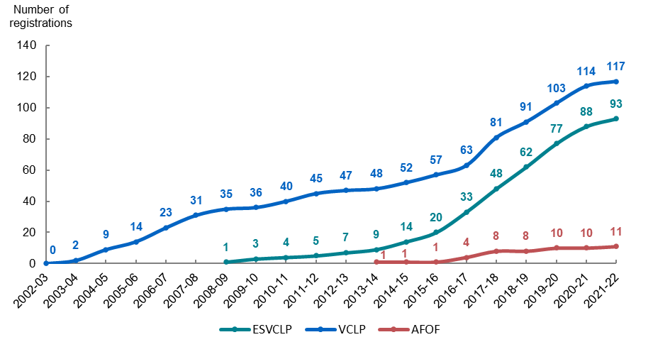

Noting the relative difficulty of assigning program partnerships to a venture capital business, estimates based on the latest reporting data suggest that approximately 48.4 per cent (140) of the program partnerships are managed by 50 venture capital businesses, and the remainder (149 program partnerships) by individual general partners. Venture capital businesses that manage multiple general partnerships typically manage two to three program partnerships each. However, some large, established venture capital businesses manage more.

There have been only five foreign domiciled general partners operating program partnerships over the life of the programs: three from the United States and two from New Zealand. Given the preponderance of domestic general partners operating within the programs, it can be inferred that the programs have successfully supported the development of Australian general partners and contributed to the development of the Australian venture capital ecosystem.

Some stakeholders positively viewed the $10 million minimum committed capital threshold for ESVCLP partnerships, commenting that the low threshold makes it easier for fund managers who are new to the venture capital sector to raise sufficient capital to begin investing. While some stakeholders questioned the economic viability of an ESVCLP with less than $10 million of committed capital using traditional fund management models, other stakeholders suggested lowering the minimum committed capital threshold to further enable the entry of first time venture capital fund managers.

|  |
| --- |
| Finding 2: The programs have contributed to enhancing the development of skills and experience of venture capital fund managers, including by attracting overseas venture capital talent to Australia, though the relatively early developmental stage of the venture capital sector makes it difficult to assess fund manager performance to date. |

* 1. Objective: Increase investment in early stage businesses

Most stakeholders agreed that the ESVCLP program has helped to increase investment in early stage businesses. Venture capital firm Blackbird said:

The ESVCLPs provide a robust program to invest in early stage businesses…and the program has encouraged the creation of more local VCs and for established VCs to raise follow‑on funds off the back of ESVCLPs, which enables the continued investment into high‑risk expanding businesses as they scale.[44]

As outlined earlier, the growth of the venture capital sector in Australia indicates that finance has increased for early stage businesses. Some stakeholders suggested that these programs have helped connect eligible early stage businesses with funding. Program data indicates that over $3.6 billion has been invested in early stage businesses through these programs collectively over their lifetime, with the majority of these investments occurring in the early expansion stage (Figure 6).

Figure 6: Lifetime direct investments by program and stage of investment.[45]

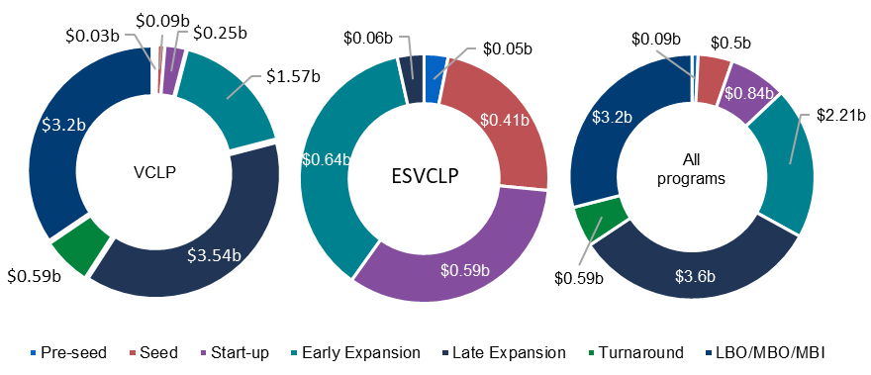

The targeted design of the ESVCLP program is clear from the program data (Figure 7). ESVCLPs have invested 96.5 per cent ($1.7 billion) in early stage and just 3.5 per cent in later stage ($61.0 million) businesses over the life of the programs. The later stage investments through the ESVCLP program have likely increased as businesses transition to later stages before eventual divestment.

Over time, the type of early stage investments made by ESVCLPs has shifted (Figure 7). The proportion (by value) of seed stage ESVCLP investments has increased yearly, up from 3.5 per cent in 2012–13 to 31.0 per cent in 2020–21, while the proportion of early expansion stage investments has generally fallen over time, decreasing from a high of 81.7 per cent in 2010–11 to 30.2 per cent in 2020–21.

Figure 7: ESVCLP program partnerships investments by stage over time.

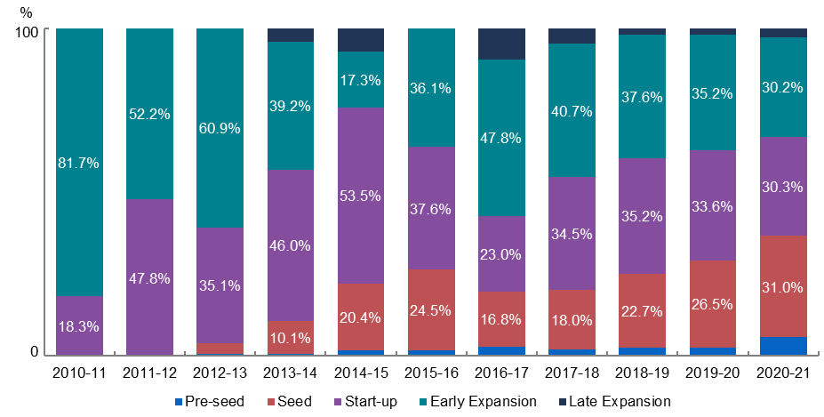

Program data also indicates that initial investments through the ESVCLP program are generally made when investees businesses are small, with a significant majority of investee businesses valued below $1 million at the time of first investment. This suggests that the existing program thresholds reflect the size of early stage businesses and support the program’s objectives, at the time of first investment.

For context, VCLPs have invested 21.0 per cent ($1.9 billion) in early stage businesses in contrast to 79.0 per cent ($7.3 billion) in later stage businesses. The stage of VCLP investments has been much more volatile over time with few clear trends. The proportion of early stage investments (including pre‑seed, seed, startup and early expansion) peaked at approximately 35 per cent of VCLP investments by value in 2009–10, 2013–14 and 2019–20.

It should be noted that some stakeholders perceived the venture capital sector as nascent and fragile to some degree.[46] As noted in Section 5.1, the ESVCLP program has attracted committed capital well below the VCLP program, which may be expected for a relatively newer program. Investors may also prefer to invest in lower risk businesses through the VCLP program. This may also help to explain why the ESVCLP program has less committed capital compared to the VCLP program as it is more reliant on a smaller pool of domestic investors. However, the increasing levels of venture capital investment in Australia are encouraging, as well as the positive stakeholder sentiment. The continued growth of the venture capital sector would be supported by new investors and fund managers who invest in businesses during their early stages.

|  |
| --- |
| Finding 3: The ESVCLP program has likely encouraged early stage investments in startups and expanding enterprises. |

* 1. Objective: Increase foreign investment into Australia’s venture capital sector

The programs have successfully facilitated foreign venture capital investment into Australia and positioned Australia as an attractive destination for international venture capitalists. Many stakeholders agreed that the limited partnership vehicle in the VCLP and ESVCLP programs is attractive to foreign investors as it is comparable to partnership structures used in various other jurisdictions. EY was of the view that:

the legal form of the ESVCLP and VCLP allows Australian VC firms to compete for capital internationally. The flow‑through nature of these vehicles is understood by both domestic and foreign investors and allows for a smoother fundraising process compared to other Australian vehicles such as the MIT.[47]

Over the life of the programs, all three programs have secured internationally‑sourced committed capital, with 56.6 per cent of VCLP, 12.8 per cent of ESVCLP and 33.7 per cent of AFOF committed capital coming from international sources.[48] In line with its intended objective, the VCLP has been the primary vehicle for foreign venture capital investment compared with the other programs. The proportion of internationally‑sourced committed capital for the VCLP program has, after an initial period of nearly exclusively domestic‑sourced capital at program commencement, been rising steadily over the past decade, from 20 per cent in 2009–10 to over 60 per cent by 2020–21 (Figure 8).

In contrast, it took until 2019–20 for the proportion of internationally‑sourced committed capital for the ESVCLP program to rise above 10 per cent, with the overwhelming majority of ESVCLP committed capital (91.5 per cent) sourced domestically over the life of the program (Figure 8). The dominant role of domestic investors may reflect the increased risk exposure of ESVCLP investments as foreign investors receive similar tax outcomes for investments through the VCLP program, which may carry less risk. AFOFs are similarly dominated by domestically‑sourced committed capital (approximately 69.2 per cent), with domestically‑sourced committed capital peaking in 2018–19 and declining slightly in the years following.

Figure 8: Annually reported limited partner committed capital by domestic or international status in the VCLP and ESVCLP programs.[49]

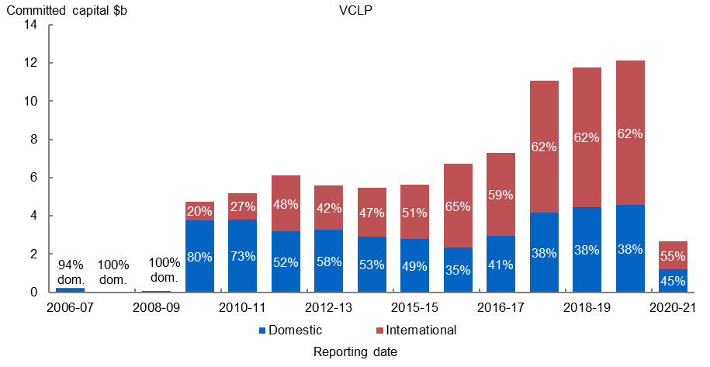

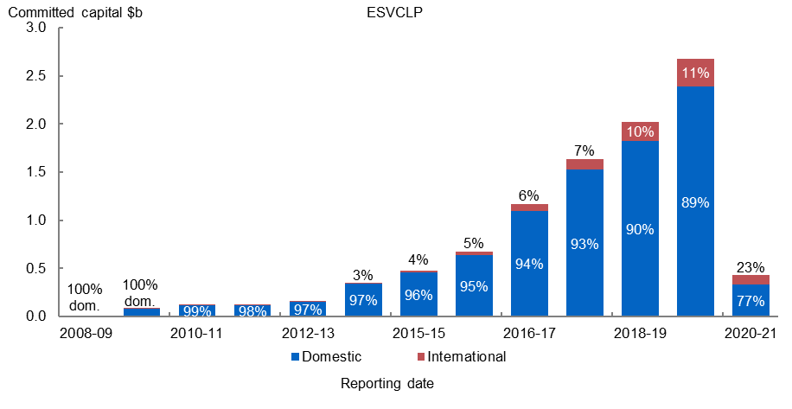

Some stakeholders questioned whether the concessionality of the tax incentives provided in Australia is right to attract investment, particularly compared with other jurisdictions.[50] For instance, FinTech Australia referenced the United Kingdom’s Seed Enterprise Investment Scheme and Enterprise Investment Scheme where investors can receive tax relief amounting to up to 50 per cent of their investment value, compared to the non‑refundable carry forward tax offset of 10 per cent under the ESVCLP program.[51]

Tax incentives vary internationally to reflect different domestic contexts and identified objectives. As noted earlier, it is difficult to assess how much tax settings are affecting investor behaviour. Similarly, some stakeholders mentioned that an increase to the ESVCLP tax offset may not make a significant impact on stimulating additional investment. However, it is noted that tax incentives are available globally and international investors have a range of choices for where they deploy capital.

|  |
| --- |
| Finding 4: The programs, particularly the VCLP program, have facilitated foreign investment in the Australian venture capital sector by offering the prospect of attractive returns and an internationally recognisable investment vehicle. |

* 1. Objective: Provide diversification and flexibility for investors through an AFOF structure

As seen in the data, the AFOF program has not been used as extensively as the VCLP or ESVCLP programs by value, with just $451.91 million of capital committed since the program commenced in 2002. Some stakeholders suggested that venture capital fund managers now have sufficient resourcing to decide investment allocation themselves and did not want to incur an extra layer of fees and complexity, which may contribute to the relatively low uptake of AFOFs.[52] That said, the structure exists for those who wish to use it and it was noted that the AFOF program provides a useful capital aggregation platform.

One stakeholder described AFOFs as a more passive investment option compared to VCLPs and ESVCLPs, as ‘investors are simply choosing fund managers rather than considering which businesses they should be investing in and actively assisting them in growing’.[53] In this way, the AFOF program provides investors with simple a simple diversification strategy and flexibility.

AFOFs have currently invested $48.6 million in ESVCLPs and $178 million in VCLPs across 29 unique partnerships. These 29 partnerships have cumulatively invested $1.39 billion in 627 unique investee businesses.[54] Three of the eleven registered AFOFs have invested entirely within their own venture capital business (ie, in their own VCLP and ESVCLPs), indicating that while AFOFs are diversifying investment risk by distributing capital across multiple VCLP/ESVCLP partnerships, they are doing so across a limited pool of venture capital businesses. AFOFs can also invest directly in some businesses, but this facility is rarely used with just $2.23 million invested directly by AFOFs in three businesses.[55]

|  |
| --- |
| Finding 5: The AFOF program provides a capital aggregation platform and investors with the opportunity to diversify by allowing investors to invest in a portfolio of early stage businesses through various VCLP and ESVCLP funds. |

* 1. Objective: Foster a shift towards a culture of innovation and entrepreneurial risk‑taking

These programs have achieved this objective to the extent that the programs have supported investment in startups that may be undertaking innovative activities. One theme identified through the stakeholder consultations was that the programs’ tax concessions offer an additional selling point beyond the returns on offer, which may attract some investors to commit capital to the higher risk venture capital sector when they would otherwise have invested elsewhere. However, this effect is less significant for institutional investors and more experienced venture capital investors.

Venture capital firm Square Peg observed that the programs have helped to start conversations with investors who are interested in investing in the venture capital sector but are cautious about the risks involved.[56] Similarly, superannuation funds have described the VCLP and ESVCLP programs as a useful ‘tailwind’ supporting the business case for increasing investment in Australia’s venture capital market, rather than offshore venture capital.[57]

The ESVCLP program specifically supports investment in smaller early stage businesses (Figures 6 and 7) that may be inherently more innovative and necessitate a higher level of entrepreneurial risk. In this way, the ESVCLP program–as one of the Government’s suite of measures to support innovation–encourages risk‑taking by entrepreneurs, by creating incentives for investors to increase the availability of venture capital finance and enabling mentorship of investee companies by an increasing number of experienced venture capital general partners.

As the venture capital sector continues to mature, deepen, and prove its track record, investors may be willing to commit more capital to higher risk early stage businesses, contributing further to a ‘flywheel effect’ for the Australian innovation ecosystem.

|  |
| --- |
| Finding 6: The programs have supported a culture of innovation and entrepreneurial risk‑taking by supporting early stage businesses with venture capital and mentorship. |

* 1. Objective: Provide Australia with a world’s best practice investment vehicle for venture capital

The programs align with internationally accepted approaches to tax incentives for venture capital. In 2015, the European Commission completed a comprehensive report on the design of venture capital tax incentives in a range of countries. According to the report, the design of Australia’s VCLP program is an exemplar of best practice for its promotion of cross‑border venture capital by targeting foreign investors.[58]

The report noted that it is ‘difficult to assess the impact of taxation and tax incentives on [venture capital] investment’.[59] International evidence suggests the impact of tax concessions on stimulating venture capital investment is mixed and it can be difficult to identify new investment attributable to the tax concessions. Some papers find positive effects, but it is generally not the most important determinant.[60]

However, the European Commission’s report provides a framework to consider the venture capital tax concession design features that contribute to the quality and quantity of investments made, while also identifying potential pitfalls for policymakers. These features can change over time, or differ from this framework, as investor strategies evolve and to reflect a given jurisdiction’s baseline tax system and unique domestic context. The features noted in the report include:

* **Concessional tax treatment:** including upfront tax relief on amounts invested, relief on capital gains and losses;
* **Early stage qualifying criteria:** tax concessions for angel and venture capital investors who specifically make new equity investment (eg, newly issued share capital) in businesses of a particular age and size;
* **Sectoral qualifying criteria:** tax concessions only available for sectors that promote economic activity and innovation, rather than sectors involving capital preservation, tax planning and passive activities (eg, finance and real estate), with exceptions for businesses that operate across various sectors (eg, fintech);
* **Open participation:** cross‑border investors permitted to invest, while related parties (ie, investors who are employed or controlled by the investee) are restricted from participating;
* **Limits on investments:** upper and lower limits on the size of investments attracting tax relief to ensure that incentives do not over‑subsidise investors;
* **Minimum holding period:** venture capital investments must be held for a minimum period of time;
* **Integrity:** tax incentive programs with fixed settings which are administered on a   
  non‑discretionary basis; and
* **Transparency:** transparent annual monitoring of fiscal costs and economic impacts, and prior announcement of any setting changes.

Although different vehicles can be used to facilitate venture capital investment, the limited partnership structure of Australia’s venture capital programs has been well received by investors due to its international familiarity in many jurisdictions including the United States. The flow‑through tax treatment continues to be a best practice feature for venture capital structures and treating carried interests on capital account helps to create the incentives to align the interests of fund managers, investors and entrepreneurs.

As the programs are concessional, they are also targeted to ensure that taxpayers receive the greatest value for the revenue foregone. With a targeted program comes restrictions and thresholds which may limit some investors. These restrictions, however, need to be balanced against costs–including revenue, compliance and inefficiencies–and broader government objectives. Concessional tax treatment, particularly on the gains realised upon an exit, can increase expected after‑tax returns which may incentivise some investments that would not have otherwise occurred. However, there is also a risk that the concessional treatment subsidises investments that would have occurred anyway. As such, it is common practice around the world to limit the generosity of tax incentives.

Some stakeholders discussed the targeted nature of the programs and noted that a common strategy is for investors to use stapled vehicles, such as MITs, to provide more flexibility to invest and attract different tax treatment. This demonstrates that investments are still being made where the potential returns meet investor needs. However, stakeholders highlighted that this dual vehicle investment strategy can significantly increase the costs and complexity for fund managers and investors.

Some stakeholders suggested that better aligning the programs with other government programs which support startups and innovation could improve their ability to meet their respective objectives.

It was suggested by some stakeholders that the programs should be broadened in their application by either expanding the definition of eligible investments or clarifying the interpretation of them. An example raised by some stakeholders was the status of fintechs as eligible investments.[61] This will be discussed in more detail in the following Section 5.9.

Some stakeholders discussed the thresholds of the programs. For example, the AIC noted the $250 million and $50 million limits on the size of eligible investees in the VCLP and ESVCLP programs respectively:

Given the effects of inflation over time, as well as increasing funding needs of investee companies, these value caps urgently need to be revised upwards to allow funds to continue to invest in companies originally intended to be the targets of these support measures.[62]

Similarly, a few internationally‑focussed stakeholders identified the threshold that limits a partnership to investing 20 per cent or less of its committed capital in non‑Australian businesses as restrictive on partnerships in an increasingly globalised venture capital market.[63]

There were also calls by some stakeholders to increase the value of the tax incentives. For example, some stakeholders discussed the idea of treating taxable gains from the programs on capital account.[64] Generally, these gains are on revenue account which is consistent with the broader tax laws.

Many stakeholders discussed the idea of a new investment vehicle, such as a Corporate Collective Investment Vehicle (CCIV), which may provide greater investment flexibility and reduce complexity and costs. In the 2021–22 Budget, the previous Government affirmed its commitment to complete the implementation of a CCIV regime.[65] It should be noted that the CCIV is likely to be used for investment strategies similar to those run through a MIT vehicle and the CCIV’s interaction with the programs is yet to be finalised.

|  |
| --- |
| Finding 7: The programs align with international best practice and provide an internationally recognisable vehicle, giving investors the confidence to invest in Australian venture capital. |

* 1. Objective: Make finance more readily available and cheaper for high‑risk expanding businesses

The growth of the venture capital sector demonstrates that finance has increased for expanding businesses. Stakeholders generally reported that these programs have helped connect startups with sources of funding. However, in the views of some, this access is limited by the restricted definition of eligible investments within the programs. As outlined in Section 5.4, a significant portion of program partnership investments have been in early stage businesses.

Over the life of the programs, more than $580 million has been invested in very early stage businesses ($89 million in pre‑seed, and $499 million in seed). This does not necessarily prove a lower cost of venture capital to expanding businesses, but does suggest that the programs may have contributed to making capital more available to businesses that meet the programs targeted eligible activity criteria.

Some stakeholders view the restrictions of the targeted programs as limiting on certain investments. In particular, the eligible activity criteria can be difficult to navigate for some investee companies that operate on the margins of these definitions, particularly for investee businesses whose business models evolve over time. Some stakeholders suggested that these restrictions have not kept pace with technological developments that cross sectoral boundaries. It was generally recognised that boundaries are a feature of targeted programs and that a solution will hence be difficult to derive. However, some suggested that clearer guidance on investment eligibility could be beneficial.

Specifically, some stakeholders noted that companies undertaking fintech development may struggle to meet the eligibility criteria for the programs. It was noted that some fintechs may transition from developing financial technology (which is an eligible activity) to using that technology in a business which has activities that are ineligible. Law firm Gilbert + Tobin observed that:

As a company’s activities change from development to commercialisation / building market share, it becomes more likely that its activities may be regarded as ineligible and therefore more likely that the entity will fail the predominant activities test (which is an ongoing test that must be met at all times that a VCLP or ESVCLP is invested in an entity).[66]

In October 2021, the Senate Select Committee on Australia as a Technology and Financial Centre released a final report which documented similar concerns over investee eligibility for the programs. In that report, FinTech Australia suggested that the VCLP and ESVCLP programs’ restrictions on investing in authorised deposit‑taking institutions (ADIs) impeded access to capital for neobanks.[67]

While the legislation does not expressly prohibit investing in fintechs, some stakeholders noted challenges in the interpretation of legislative provisions. Others indicated that their decision to not invest in fintech has been influenced by what they perceive as insufficient guidance on investment eligibility and differing interpretations by their legal professionals of the legislative provisions on eligible activities. The request for more guidance was echoed by Gilbert + Tobin:

Activities can also be excluded from being ineligible activities if the activities are covered by a finding from Innovation and Science Australia that the activities were a ‘substantially novel’ application of technology at the time the investment was made. However, again, the guidance in the explanatory materials accompanying the relevant law is unhelpful. The concept is subjective and the materials refer to concepts of ‘new or uncommon’ and ‘some degree of innovation’ without any practical examples.[68]

Despite these reported challenges, VCLP and ESVCLP program partnerships have been increasingly investing in fintechs and regtech through time (Figure 9). Significant year‑on‑year volatility is observed in the value of fintech and regtech investments by VCLPs through time. Fintech and regtech investments through ESVCLPs have increased more steadily over time, but at lower levels.

Figure 9: Value of fintech investments by ESVCLP and VCLP program partnerships per annum.[69]

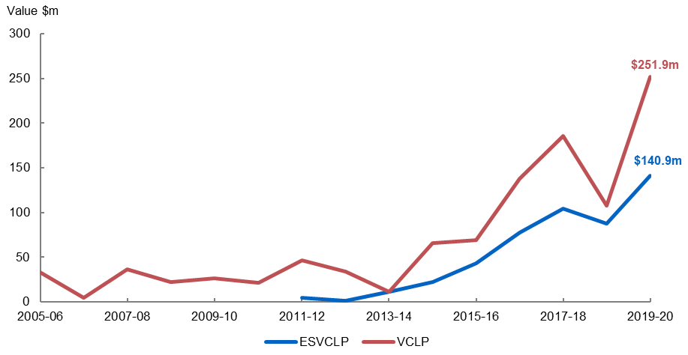

It was also noted by stakeholders that various Australian fintech startups, such as Afterpay, have been very successful without receiving capital through these programs. This is important to note as it demonstrates that the programs are not the only source of capital for Australian fintech startups.

|  |
| --- |
| Finding 8: The programs have made finance more readily available for high risk expanding businesses; however, fintech remains an area for further growth. |

* 1. Objective: Improve funding for promising projects across the economy and in industries beyond the technology sector

Some stakeholders noted that the programs have enabled investment in a diverse range of projects and businesses across the economy, including in space, alternative meats and transport.[70] For example, the Tax Institute observed that:

new and follow‑on investments have been made [by early stage venture capital and later stage private equity] in a number of sectors outside the technology sector, including trade and accommodation, health care and social assistance and other industries.[71]

While the programs have a 15 year maximum time limit on partnerships which supports capital investments in new and early stage businesses, some stakeholders raised concerns that this can be limiting for venture capitalists investing in knowledge intensive companies and ‘deep tech’ as it can take longer to successfully commercialise these products or services. Brandon Capital Partners, a venture capital firm and participant in the VCLP program, reported that:

the 15‑year limit on the life of a VCLP [is] a particular impediment to early‑stage investing, particularly in biotechnologies, where it will often take well beyond a decade for a pharmaceutical product or medical technology to be translated from research laboratories, developed and commercialised.[72]

Program data demonstrates that the program partnerships have successfully invested across many sectors over the life of the programs, and in cross‑sectoral enablers such as technology, which is increasingly pervasive across all sectors of the economy (Figure 10). ESVCLPs have invested proportionately more in the ‘Information, media and telecommunications’ sector (40.8 per cent) than VCLPs (12.0 per cent). In contrast VCLPs have invested more in the ‘Services’ sector (36.7 per cent vs 22.7 per cent) and in the ‘Manufacturing’ sector (18.8 per cent vs 7.6 per cent).

Figure 10: Lifetime distribution of VCLP and ESVCLP program partnerships direct investments by value across sectors.

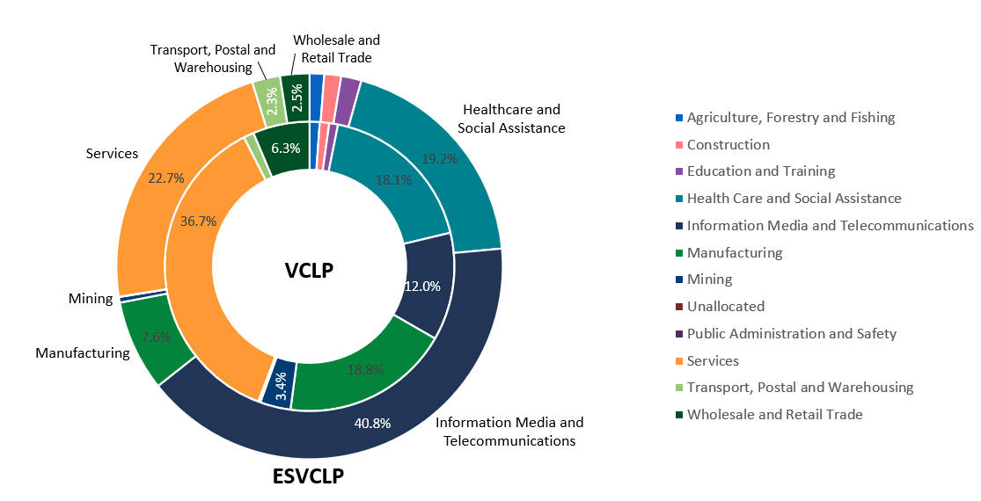

The sectoral focus of ESVCLPs has gradually shifted over time. The value of ESVCLP investments in the ‘Information media and telecommunications’ sector has declined as a proportion of overall investments over time while investments in other sectors including ‘Services’, ‘Transport and retail trade’ and ‘Manufacturing’ have increased (Figure 11).

VCLP investments have been highly diverse since commencement with no clear sector‑based trends over time. However, there has been diversification into additional sectors over time.

Figure 11: ESVCLP program partnership investments by value over time by sector.

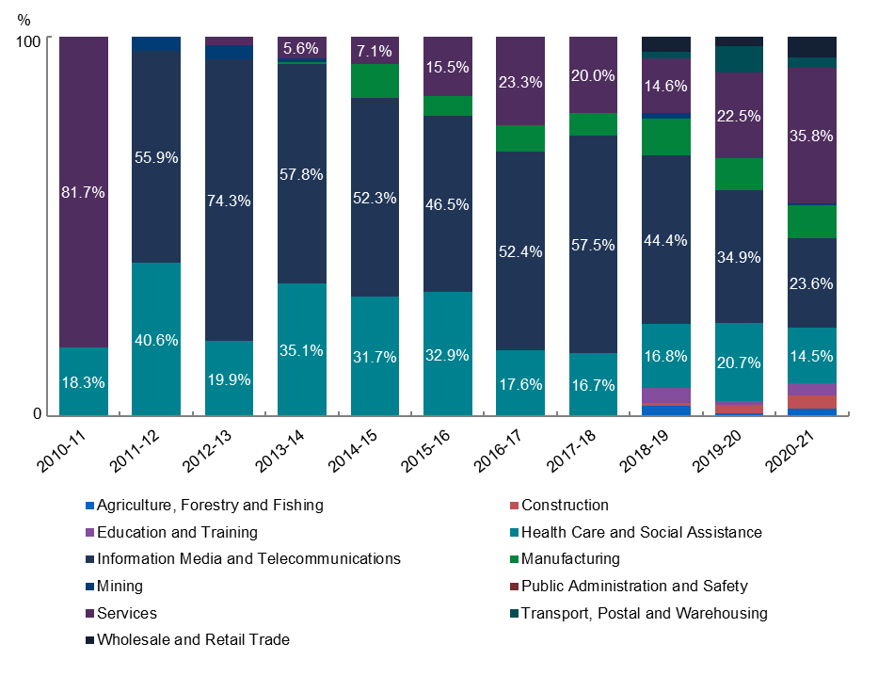

|  |
| --- |
| Finding 9: The programs have improved funding opportunities for a diverse range of projects and businesses across the economy. |

1. Appendices
   1. Operation of the programs
      1. VCLP and ESVCLP programs

VCLPs and ESVCLPs are flow‑through vehicles for Australian tax purposes. Any income will be taxed at the investor level, rather than at the partnership level.

The key differences between the VCLP and ESVCLP programs are that:

* The VCLP program is targeted at attracting foreign investment, so the income tax exemptions are only available to foreign investors.
* The ESVCLP program is targeted at supporting early stage businesses. Both domestic investors and foreign investors are eligible for the tax concessions, which include both a non‑refundable carry‑forward tax offset and income tax exemptions, but investee businesses must be ‘early stage’ with less than $50 million in total assets.

Example 1: VCLP program tax concessions in practice

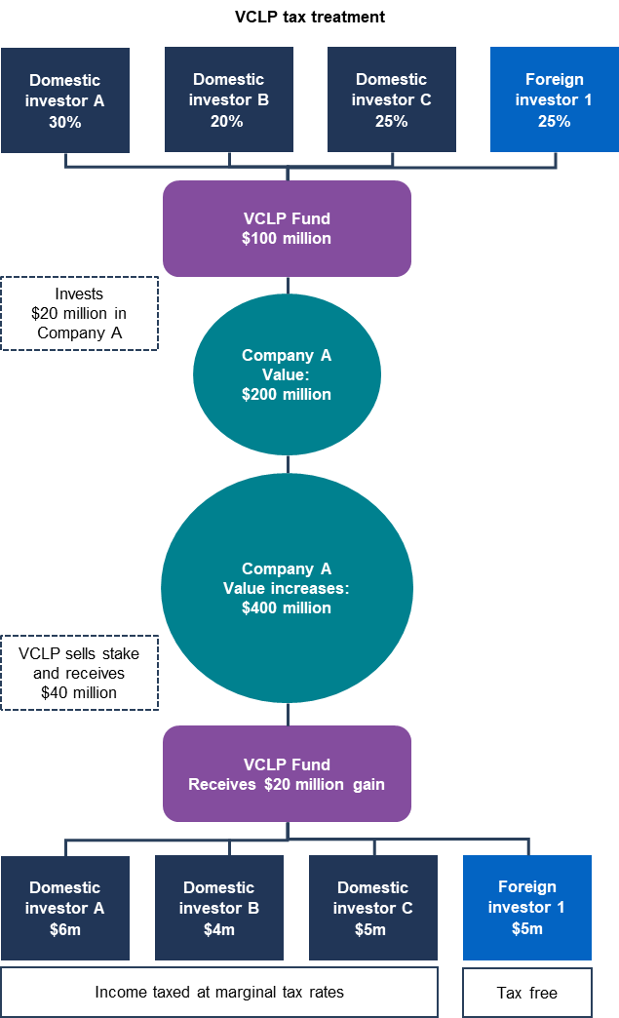

Example 2: ESVCLP program tax concessions in practice

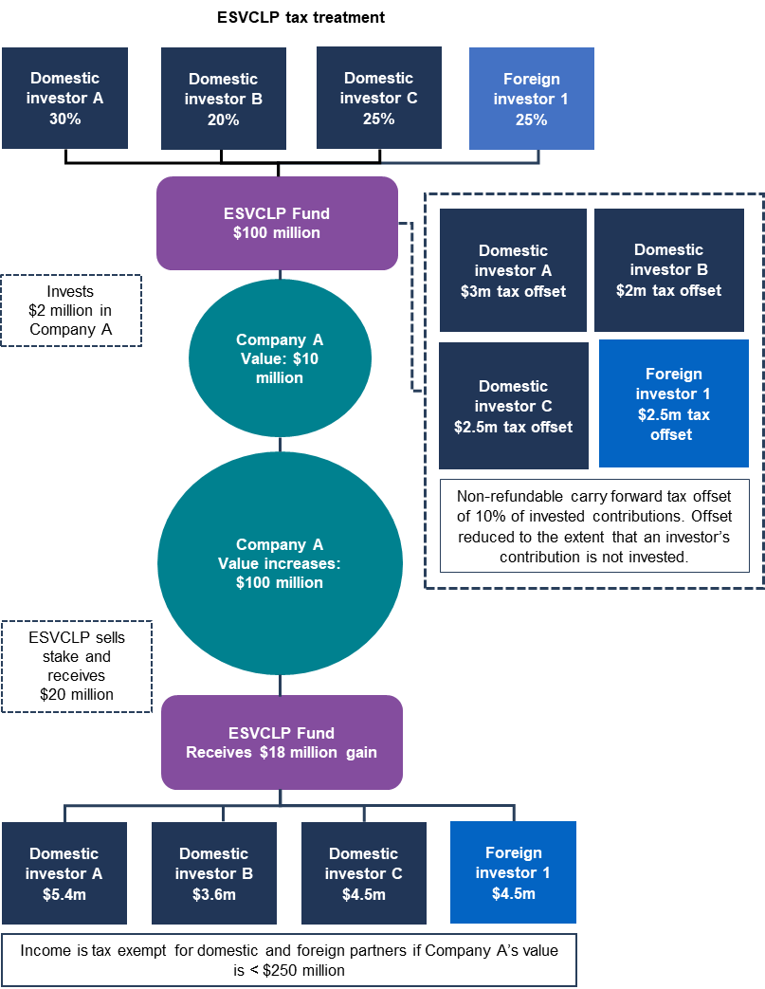

In the ESVCLP program, if an investee business grows to have more than $250 million in total assets, investors have six months to divest and retain tax‑free treatment on the entire gain. Gains above $250 million are taxed if investors do not divest within six months of exceeding the $250 million threshold.

* + 1. AFOF program

The AFOF program was established with a similar policy intent as the VCLP and ESVCLP programs, as well as to provide an alternative investment structure, intended to encourage diversified investment opportunities via a portfolio of registered ESVCLPs and VCLPs.

The primary purpose of an AFOF is to make eligible venture capital investments in VCLPs or ESVCLPs. AFOFs can also invest directly into a business if the VCLP or ESVCLP in which the AFOF has invested already holds a capital investment in that business.

As with ESVCLPs and VCLPs, AFOFs are flow‑through tax vehicles with tax concessions for fund managers and investors.

Example 3: AFOF program tax concessions in practice

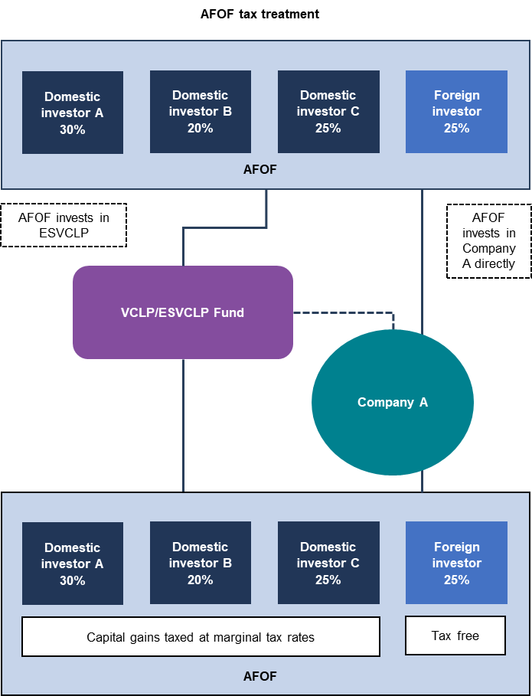

Note: the examples used in Chapter 6.1 are simplified examples meant to provide a stylistic overview of the operation of the programs and should not be considered to apply in every circumstance. For example, it does not include consideration of the carried interest that may be payable to a general partner or other more detailed arrangements that may exist.

* 1. Administration of current programs

Industry Innovation and Science Australia (IISA)[73] is an independent board which provides strategic advice to Government on innovation, science and research matters. IISA administers the programs primarily through one of its committee delegates, the Innovation Investment Committee (IIC).[74] The IIC administers the registration of VCLPs, ESVCLPs and AFOFs, considers ESVCLP investment plans for investment stage and resource availability, and can provide guidance to DISR throughout the programs’ lifecycles, including decisions relating to compliance and interpretation.[75] It also has a discretionary power to determine that an investee business meets the ‘eligible activity’ requirements despite a temporary breach of the requirements.[76]

The Department of Industry Science Energy and Resources (AusIndustry) supports IISA and the IIC in the administration of the registration regime for the VCLP, ESVCLP and AFOF programs including monitoring the compliance of registered partnerships with reporting requirements under the legislation, and preparing information for IISA and IIC to consider.

After a partnership is successfully registered, the Australian Taxation Office (ATO) administers the tax treatment for the VCLP, ESVCLP or AFOF programs.

* 1. Recent reforms to tax settings
     1. 2016 National Innovation and Science Agenda measures

In December 2015, the previous Government announced the National Innovation and Science Agenda to drive economic prosperity through science, research and innovation.[77] These measures included reforms to the ESVCLP program.[78]

Effective from 1 July 2016, reforms to the ESVCLP program enhanced the concessional tax treatment of income and gains received by investors within ESVCLPs to increase the attractiveness of ESVCLPs to domestic investors.

These reforms included:

* a new 10 per cent non‑refundable carry‑forward tax offset for limited partners in new ESVCLPs for capital invested during the year;
* increasing the maximum committed capital threshold for new and existing ESVCLPs from $100 million to $200 million; and
* no longer requiring ESVCLPs to divest their investment in an ‘early stage’ company when its value exceeds $250 million in assets (income tax applies to the excess gains made after an investee company has grown from less than $50 million to exceed $250 million).
  + 1. Recent amendments to program legislation

As part of the 2016–17 Budget, the previous Government announced reforms to confirm and clarify the eligibility of investments in fintech through the programs. These reforms aimed to respond to stakeholder concerns that fintechs were unable to access venture capital investment due to uncertainty over whether they were eligible venture capital investments in VCLP and ESVCLP programs.[79]

For the purposes of the venture capital tax concessions, finance–to the extent it consists of banking, providing capital, leasing, factoring or securitisation–insurance and making investments for the purposes of deriving passive income are ineligible activities.[80] These are relatively specific activities that are subject to separate comprehensive regulatory regimes.

Developing technology or providing services that facilitate finance, insurance and making investments (eg, software platforms, apps etc) are distinct from the actual provision of, or engagement in ineligible activities, such as finance, insurance and making investments.

In 2018, the Government amended the Venture Capital Act 2002 and Income Tax Assessment Act 1997 to clarify that an activity of an investee company is not an ineligible activity if it is:

* developing technology for use in relation to finance, insurance or making investments;
* an activity that is ancillary or incidental to the activity of developing technology referred to above; or
* covered by a finding from Innovation and Science Australia that it is a substantially novel application of technology.[81]

In 2020, a minor amendment to the *Income Tax Assessment Act 1997* clarified that Managed Investment Trusts (MITs) can invest in AFOFs (in addition to ESVCLPs and VCLPs).[82]

* 1. Terms of Reference

Australia’s venture capital tax concessions are to be reviewed by the Treasury and IISA for the following purposes:

* To consider how the concessions operate in practice and whether they are achieving their intended objectives.
* To satisfy the legislative requirement outlined in Section 118–455 of Income Tax Assessment Act 1997.
* To consider the recommendations of other relevant reviews, to which the Government has not yet responded, that examine the venture capital tax concessions.

### Scope

The Act provides Treasury and IISA with delegated responsibility to act in accordance with specific legislative aspects.

### In‑Scope

* Assessment of impacts arising from the venture capital concessions, i.e. how the concessions operate in practice and whether they’re achieving their intended objectives.
* Consideration of recommendations of other relevant reviews, to which the Government has not yet responded, that examine the venture capital tax concessions.
* Identifying what data is available (before deciding nature of impact assessment).
* Preparation of a succinct consultation paper providing means for stakeholders to offer views and provide evidence on operation of concessions.
* Treasury to prepare the impact assessment report for tabling in Parliament.

### Out‑of‑Scope

* Policy or reform recommendations or consideration and costing of policy options.
* Non‑tax related impacts on venture capital.
* New data generation that involves onerous tasks for stakeholders.
* Consultation not focussed on adducing data and/or views around operation of the venture capital tax concessions.

### Section 118–455 of *Income Tax Assessment Act 1997*

1. As soon as practicable after 24 months after the Treasury Laws Amendment (Tax Integrity and Other Measures) Bill 2018 received Royal Assent [3 October 2018], the Minister must cause an impact assessment of the operation of this Subdivision and other related tax concessions to be conducted.
2. The impact assessment must:
   1. examine the operation of the tax concession regime for:
      1. investments made through a Venture Capital Limited Partnership, Early Stage Venture Capital Limited Partnership or Australian Venture Capital Fund of Funds; and
      2. investments made directly by foreign residents registered under Part 3 of the Venture Capital Act 2002; and
   2. be conducted by the Department and Innovation and Science Australia; and
   3. make provision for public consultation.
3. For the purposes of conducting the impact assessment, the reference to Innovation and Science Australia in item 6 of the table in subsection 355–65(4) of Schedule 1 to the Taxation Administration Act 1953 is taken to include the Secretary of the Department.
4. The Minister must cause a written report about the impact assessment to be prepared.
5. The Minister must cause a copy of the report to be tabled in each House of the Parliament within 15 sitting days of that House after the day on which the report is given to the Minister.



1. Industry Innovation Science Australia, Venture Capital Tax Concessions Review (2021) <[https://iisa‑consult.industry.gov.au/vc‑review](https://iisa-consult.industry.gov.au/vc-review)>.
2. Income Tax Assessment Act 1997 (Cth) s 995‑1.
3. Ibid.
4. Ibid.
5. Australian Government, Blackbird Ventures – supercharging Australia’s most ambitious founders (26 June 2020) <[https://business.gov.au/grants‑and‑programs/early‑stage‑venture‑capital‑limited‑partnerships/customer‑stories/blackbird‑ventures](https://business.gov.au/grants-and-programs/early-stage-venture-capital-limited-partnerships/customer-stories/blackbird-ventures)>.
6. University of New South Wales Business School, Should governments run venture capital and private equity funds? (4 August 2021) <[https://www.businessthink.unsw.edu.au/articles/governments‑venture‑capital‑private‑equity‑funds](https://www.businessthink.unsw.edu.au/articles/governments-venture-capital-private-equity-funds%20)>.
7. Board of Taxation, Review of taxation arrangements under the Venture Capital Limited Partnership regime (June 2011) <<https://taxboard.gov.au/sites/taxboard.gov.au/files/migrated/2015/07/Report_VCLP.rtf>>.
8. Productivity Commission, Public Support for Science and Innovation, Research Report (2007) 309 <<https://www.pc.gov.au/inquiries/completed/science/report/science.pdf>>.
9. Australian Bureau of Statistics, Venture Capital and Later Stage Private Equity, Australia methodology (27 February 2020) <[https://www.abs.gov.au/methodologies/venture‑capital‑and‑later‑stage‑private‑equity‑australia‑methodology/2018‑19](https://www.abs.gov.au/methodologies/venture-capital-and-later-stage-private-equity-australia-methodology/2018-19)>.
10. Board of Taxation, Review of taxation arrangements under the Venture Capital Limited Partnership regime (June 2011) <<https://taxboard.gov.au/sites/taxboard.gov.au/files/migrated/2015/07/Report_VCLP.rtf>>.
11. Ibid 7.
12. The investment return on venture capital can be low on average as an investor can take on losses before they make any gains. There is also a high failure rate for startups and, even the successful ones take time to return a gain to investors. In contrast, later stage private equity is typically invested over a shorter timeframe with comparatively more certain returns and lower failure rates.
13. Dominic Regan and Gene Tunny, Venture capital in Australia (2008) 3 <[https://treasury.gov.au/sites/default/files/2019‑03/01_Venture_capital.pdf](https://treasury.gov.au/sites/default/files/2019-03/01_Venture_capital.pdf)>.
14. Australian Bureau of Statistics, Venture Capital and Later Stage Private Equity, Australia methodology (27 February 2020) <[https://www.abs.gov.au/methodologies/venture‑capital‑and‑later‑stage‑private‑equity‑australia‑methodology/2018‑19](https://www.abs.gov.au/methodologies/venture-capital-and-later-stage-private-equity-australia-methodology/2018-19)>.
15. Productivity Commission, Public Support for Science and Innovation, Research Report (2007) 313 <<https://www.pc.gov.au/inquiries/completed/science/report/science.pdf>>.
16. Explanatory Memorandum, Tax Laws Amendment (2007 Measures No. 2) Bill 2007 (Cth) 63 <[https://parlinfo.aph.gov.au/parlInfo/download/legislation/ems/r2740_ems_c904a1c4‑f018‑4aeb‑8a9e‑3598c868dbd9/upload_pdf/309114.pdf;fileType=application%2Fpdf](https://parlinfo.aph.gov.au/parlInfo/download/legislation/ems/r2740_ems_c904a1c4-f018-4aeb-8a9e-3598c868dbd9/upload_pdf/309114.pdf;fileType=application%2Fpdf)>.
17. Productivity Commission, Public Support for Science and Innovation, Research Report (2007) 312 <<https://www.pc.gov.au/inquiries/completed/science/report/science.pdf>>.
18. Explanatory Memorandum, Tax Laws Amendment (2007 Measures No. 2) Bill 2007 (Cth) 69 <[https://parlinfo.aph.gov.au/parlInfo/download/legislation/ems/r2740_ems_c904a1c4‑f018‑4aeb‑8a9e‑3598c868dbd9/upload_pdf/309114.pdf;fileType=application%2Fpdf](https://parlinfo.aph.gov.au/parlInfo/download/legislation/ems/r2740_ems_c904a1c4-f018-4aeb-8a9e-3598c868dbd9/upload_pdf/309114.pdf;fileType=application%2Fpdf)>.
19. A general partner has day‑to‑day management responsibilities for a partnership and has unlimited liability for debts. A limited partner is an investor who does not partake in management of the partnership and whose liability is limited to their investment.
20. There is a full tax exemption if the investee business does not exceed $250 million in assets. Gains made beyond this threshold are taxable.
21. The carried interest of a general partner is the partner’s entitlement to a distribution from the partnership, normally contingent on performance of the partner and profits attained for the limited partners of the partnership. Carried interest does not include a management or similar fee that the partner is entitled to or a distribution attributable to an equity investment by the partner.
22. These restrictions indirectly limit the scope of the AFOF program.
23. Income Tax Assessment Act 1997 (Cth) s 118‑425(3).
24. Ibid s 118‑425(13).
25. Australian Taxation Office, Venture capital limited partnerships (18 December 2018) <[https://www.ato.gov.au/business/venture‑capital‑and‑early‑stage‑venture‑capital‑limited‑partnerships/venture‑capital‑limited‑partnerships/](https://www.ato.gov.au/business/venture-capital-and-early-stage-venture-capital-limited-partnerships/venture-capital-limited-partnerships/)>.
26. Income Tax Assessment Act 1997 (Cth) s 118‑425(14).
27. Treasury Laws Amendment (Tax Integrity and Other Measures) Act 2018 (Cth), Sch 3.
28. Explanatory Memorandum, Treasury Laws Amendment (Tax Integrity and Other Measures) Bill 2018 (Cth) 26 <[https://parlinfo.aph.gov.au/parlInfo/download/legislation/ems/r6092_ems_a4fc66c2‑e247‑40f6‑b3e5‑e3a5838d1d41/upload_pdf/668040.pdf;fileType=application%2Fpdf](https://parlinfo.aph.gov.au/parlInfo/download/legislation/ems/r6092_ems_a4fc66c2-e247-40f6-b3e5-e3a5838d1d41/upload_pdf/668040.pdf;fileType=application%2Fpdf)>.
29. The lines between venture capital and other forms of private equity can be blurred, making accurate measurement of venture capital investment difficult. Analysing the venture capital landscape in Australia, as well as making global comparisons, can be challenging due to limitations of existing datasets. When comparing the Australian and global venture capital sectors using multiple data sources, accounting for the differences between data sets and focusing on broad data trends (rather than absolute figures) is more appropriate.
30. Australian Investment Council, Australian Private Capital Market Overview: A Preqin and Australian Investment Council Yearbook 2021 (June 2021) <[https://aic.co/common/Uploaded%20files/Yearbooks/Preqin‑Markets‑in‑Focus‑Alternative‑Assets‑in‑Australia%20‑%20FINAL%20Report.pdf](https://aic.co/common/Uploaded%20files/Yearbooks/Preqin-Markets-in-Focus-Alternative-Assets-in-Australia%20-%20FINAL%20Report.pdf)>. Note data is in respect of the calendar year unless otherwise specified.
31. Ibid.
32. KPMG, Q2’21 Venture Pulse Report – Global trends (21 July 2021) <[https://assets.kpmg/content/dam/kpmg/xx/pdf/2021/07/venture‑pulse‑q2‑2021.pdf](https://assets.kpmg/content/dam/kpmg/xx/pdf/2021/07/venture-pulse-q2-2021.pdf)> 86; Data from the Australian Investment Council and KPMG are not directly comparable as the methodologies and reporting arrangements are different..
33. Organisation for Economic Co‑operation and Development (OECD), Venture capital investment as a percentage of GDP (2019) <<https://stats.oecd.org/Index.aspx?DataSetCode=VC_INVEST>>.
34. Organisation for Economic Co‑operation and Development (OECD), Venture capital investment as a percentage of GDP (2019) <<https://stats.oecd.org/Index.aspx?DataSetCode=VC_INVEST>>; Note OECD VC investment data includes seed, startup and other early stage, and later stage VC. Gaps in data exists for Canada and no data provided to the OECD for the 2020 calendar year for both Australia and Japan. Note the ABS has ceased undertaking the Venture Capital survey for Australia from FY 2019.
35. Income Tax Assessment Act 1997 (Cth) s 118‑445(1): A partner’s committed capital in a partnership is the sum of the amounts that the partner may, under the partnership agreement establishing the partnership, become obliged to contribute to the partnership.
36. AFOFs invest primarily indirectly in VCLP and ESVCLP partnerships, as such this figure, representing the few direct investments made by AFOFs, does not represent the full AFOF investment portfolio value. AFOFs have also made investments valued at $48.6m in ESVCLPs and $178m in VCLPs over the life of the programs. Direct investments arising from these AFOF partnership investments are already included in the direct investments data for those ESVCLP and VCLP program partnerships.
37. Unique investments can only be estimated due to minor variations in investee names resulting in double counting of some businesses by the program database. This estimate has been derived using best endeavours to remove duplicate business entries from the count.
38. Australian Investment Council, Australian Private Capital Market Overview: A Preqin and Australian Investment Council Yearbook 2021 (June 2021) 8 <[https://aic.co/common/Uploaded%20files/Yearbooks/Preqin‑Markets‑in‑Focus‑Alternative‑Assets‑in‑Australia%20‑%20FINAL%20Report.pdf](https://aic.co/common/Uploaded%20files/Yearbooks/Preqin-Markets-in-Focus-Alternative-Assets-in-Australia%20-%20FINAL%20Report.pdf)>.
39. Jelix Ventures, Written submission (1 September 2021).
40. Australian Investment Council, Written submission (10 September 2021) 15.
41. Tech Council of Australia, Stakeholder consultation (13 August 2021).
42. EY, Written submission (3 September 2021) 8.
43. Note, this value represents the lifetime count of general partnerships operating within the programs in both fully registered and conditionally registered partnerships, and includes now inactive partnerships and instances where partnerships changed their names. Latest reporting data indicates there are 270 unique general partnerships.
44. Blackbird, Written submission (2 September 2021) 6.
45. Stages of investment are recorded by fund managers based on their own assessment. The Australian Bureau of Statistics defines these stages as follows:

    **Pre‑seed:** An investee company is in the process of setting up. Product is in research and development stage.

    **Seed:** An investee company is in the process of setting up. Product is at testing or pilot production stage.

    **Startup:** The investee company is not yet fully operational and may or may not be generating revenue.

    **Early expansion:** An investee company is operational and has products in the marketplace. The investee company will show significant revenue growth and may or may not be profitable.

    **Late expansion:** The investee company is improving its current product or developing new products, with continued revenue growth and is approaching, or at, profitable operating levels.

    **Turnaround:** Financing is provided to a company at a time of operational or financial difficulty with the intention of improving the company’s performance. The company may not be profitable, its product turnover is stagnant and/or it has flat or declining revenue.

    **LBO/LBI and MBO/MBI:** leveraged buy‑out/in and management buy‑out/in involve the acquisition of a product or business from either a public or private company, often with a significant amount of debt and little or no equity.

    <[https://www.abs.gov.au/Ausstats/abs@.nsf/Previousproducts/5678.0Glossary12014‑15?opendocument&tabname=Notes&prodno=5678.0&issue=2014‑15&num=&view=](https://www.abs.gov.au/Ausstats/abs@.nsf/Previousproducts/5678.0Glossary12014-15?opendocument&tabname=Notes&prodno=5678.0&issue=2014-15&num=&view=) and [https://www.abs.gov.au/ausstats/abs@.nsf/Previousproducts/5678.0Glossary12012‑13?opendocument&tabname=Notes&prodno=5678.0&issue=2012‑13&num=&view=](https://www.abs.gov.au/ausstats/abs@.nsf/Previousproducts/5678.0Glossary12012-13?opendocument&tabname=Notes&prodno=5678.0&issue=2012-13&num=&view=)>:
46. Innovation Investment Committee, Stakeholder consultation (4 August 2021).
47. EY, Written submission (3 September 2021).
48. These statistics reflect limited‑partner derived committed capital only. General partner (GP)‑sourced committed capital represents only a small portion of the total capital committed to program partnerships. Noting the likelihood of over estimation due to misreporting, the latest reported general partner capital commitment across all programs is estimated at $1.14b; with this comprised of committed capital from VCLP GPs ($726.5m), ESVCLP GPs ($337.7m) and AFOF GPs ($75.0m).
49. Note that the significant 2020–21 financial year decrease is committed capital apparent on these charts reflects the incomplete dataset available at the time of analysis.
50. FinTech Australia, Written submission (2 September 2021) 2; Seedspace, Written submission (September 2021) 4.
51. FinTech Australia, Written submission (2 September 2021) 2.
52. There are currently 11 AFOF partnerships registered. Eight of these AFOFs have invested in 29 limited partnerships, of which 12 were in VCLPs and 17 in ESVCLPs over the life of the programs.
53. King River Capital, Stakeholder consultation (18 August 2021).
54. AFOFs have invested in 29 VCLP and ESVCLP partnerships, 28 of these have invested in 627 unique investees over the life of the program (out of a total of 1775). One investee was common to both VCLP and ESVCLP partnerships, and has been counted once only. 550 of these unique investee businesses were invested in by ESVCLPs, and 78 by VCLPs. The twenty ninth AFOF investee partnership has not made any investments recorded in quarterly returns to date.
55. Note that AFOF investment data prior to 2020, and the introduction of smartform reporting, is not as reliable.
56. Square Peg, Stakeholder consultation (27 August 2021).
57. Superannuation funds, Stakeholder consultation (1 September 2021).
58. European Commission, Effectiveness of tax incentives for venture capital and business angels to foster the investment of SMEs and start‑ups, Final Report (2017), TAXUD/2015/DE/330 205 <[https://op.europa.eu/en/publication‑detail/‑/publication/d4cd684a‑6cf8‑11e7‑b2f2‑01aa75ed71a1/language‑en](https://op.europa.eu/en/publication-detail/-/publication/d4cd684a-6cf8-11e7-b2f2-01aa75ed71a1/language-en)>.
59. Ibid 67.
60. Marco Da Rin, Giovanna Nicodano and Alessandro Sembenelli, ‘Public Policy and the Creation of Active Venture Capital Markets’, Journal of Public Economics (2006), vol 90, 1699–1723.
61. FinTech Australia, Written submission (2 September 2021); Gilbert + Tobin, Written submission (3 September 2021); Jelix Ventures, Written submission (1 September 2021); Sydney Angels, Written submission (3 September 2021).
62. Australian Investment Council, Written submission (10 September 2021) 12.
63. VCLPs and ESVCLPs can invest up to 20 per cent of its committed capital in investments that would be eligible venture capital investments except for not meeting the Australian location test.
64. Gilbert + Tobin, Written submission (3 September 2021) 9; Seedspace, Written submission (September 2021) 4.
65. Commonwealth of Australia, Budget 2021‑22 – Budget Paper No. 2 (11 May 2021) <[https://budget.gov.au/2021‑22/content/bp2/download/bp2_2021‑22.pdf](https://budget.gov.au/2021-22/content/bp2/download/bp2_2021-22.pdf)>.
66. Gilbert + Tobin, Written submission (3 September 2021).
67. Parliament of Australia, Select Committee on Australia as a Technology and Financial Centre – Final Report (October 2021) 120, <<https://parlinfo.aph.gov.au/parlInfo/download/committees/reportsen/024747/toc_pdf/Finalreport.pdf;fileType=application%2Fpdf>>.
68. Gilbert + Tobin, Written submission (3 September 2021).
69. DISR estimate of fintech and regtech investment through the VCLP and ESVCLP programs as at February 2021. Note these are best estimates only, and were created through keyword querying of the ‘investment predominant activity’ descriptions in the program database using 20 keywords, for fintech: finance, , inves, paymen, block, chain, transact, superan, neobank, technology, fintech, bank, bitcoin, crypto, money transfer, savings, borrowing; and for regtech: regtech, regulat, compliance, profiling and diligence.
70. Tech Council of Australia, Written submission (13 August 2021) 5; Square Peg, Written submission (10 September 2021) 4.
71. Tax Institute, Written submission (14 September 2021).
72. Brandon Capital Partners, Written submission (3 September 2021).
73. In March 2021, the Industry Research and Development Amendment (Industry Innovation and Science Australia) Bill 2021 was passed to rename Innovation and Science Australia to Industry Innovation and Science Australia: Department of Parliamentary Services, Industry, Innovation and Science Australia (12 April 2021) <<https://parlinfo.aph.gov.au/parlInfo/download/library/prspub/7904190/upload_binary/7904190.pdf;fileType=application%2Fpdf#search=%22library/prspub/7904190%22>>.
74. Industry Innovation and Science Australia, Annual Report 2020‑21 (29 September 2021) 55 <[https://www.industry.gov.au/sites/default/files/2021‑10/iisa_annual_report_2021.pdf](https://www.industry.gov.au/sites/default/files/2021-10/iisa_annual_report_2021.pdf%20)>.
75. Ibid.
76. Income Tax Assessment Act 1997 (Cth) s 118‑425(14).
77. Department of Industry, Science, Energy and Resources, Boosting innovation and science (8 April 2021) <[https://www.industry.gov.au/policies‑and‑initiatives/boosting‑innovation‑and‑science](https://www.industry.gov.au/policies-and-initiatives/boosting-innovation-and-science)>.
78. Department of Industry, Science, Energy and Resources, National Innovation & Science Agenda (2015) <[https://www.industry.gov.au/sites/default/files/July%202018/document/pdf/national‑innovation‑and‑science‑agenda‑report.pdf?acsf_files_redirect](https://www.industry.gov.au/sites/default/files/July%202018/document/pdf/national-innovation-and-science-agenda-report.pdf?acsf_files_redirect)>.
79. Explanatory Memorandum, Treasury Laws Amendment (Tax Integrity and Other Measures) Bill 2018 (Cth) 26  
    <[https://parlinfo.aph.gov.au/parlInfo/download/legislation/ems/r6092_ems_a4fc66c2‑e247‑40f6‑b3e5‑e3a5838d1d41/upload_pdf/668040.pdf;fileType=application%2Fpdf](https://parlinfo.aph.gov.au/parlInfo/download/legislation/ems/r6092_ems_a4fc66c2-e247-40f6-b3e5-e3a5838d1d41/upload_pdf/668040.pdf;fileType=application%2Fpdf)>.
80. Ibid.
81. Treasury Laws Amendment (Tax Integrity and Other Measures) Act 2018 (Cth), Sch 3.
82. Income Tax Assessment Act 1997 (Cth) s 275‑10(4A); Explanatory Memorandum, Treasury Laws Amendment (2018 Measures No. 2) Bill 2019 (Cth) 14 <[https://parlinfo.aph.gov.au/parlInfo/download/legislation/ems/r6341_ems_54c01a4c‑d610‑49a1‑8822‑829d8ff9c444/upload_pdf/711025.pdf;fileType=application%2Fpdf](https://parlinfo.aph.gov.au/parlInfo/download/legislation/ems/r6341_ems_54c01a4c-d610-49a1-8822-829d8ff9c444/upload_pdf/711025.pdf;fileType=application%2Fpdf)>.