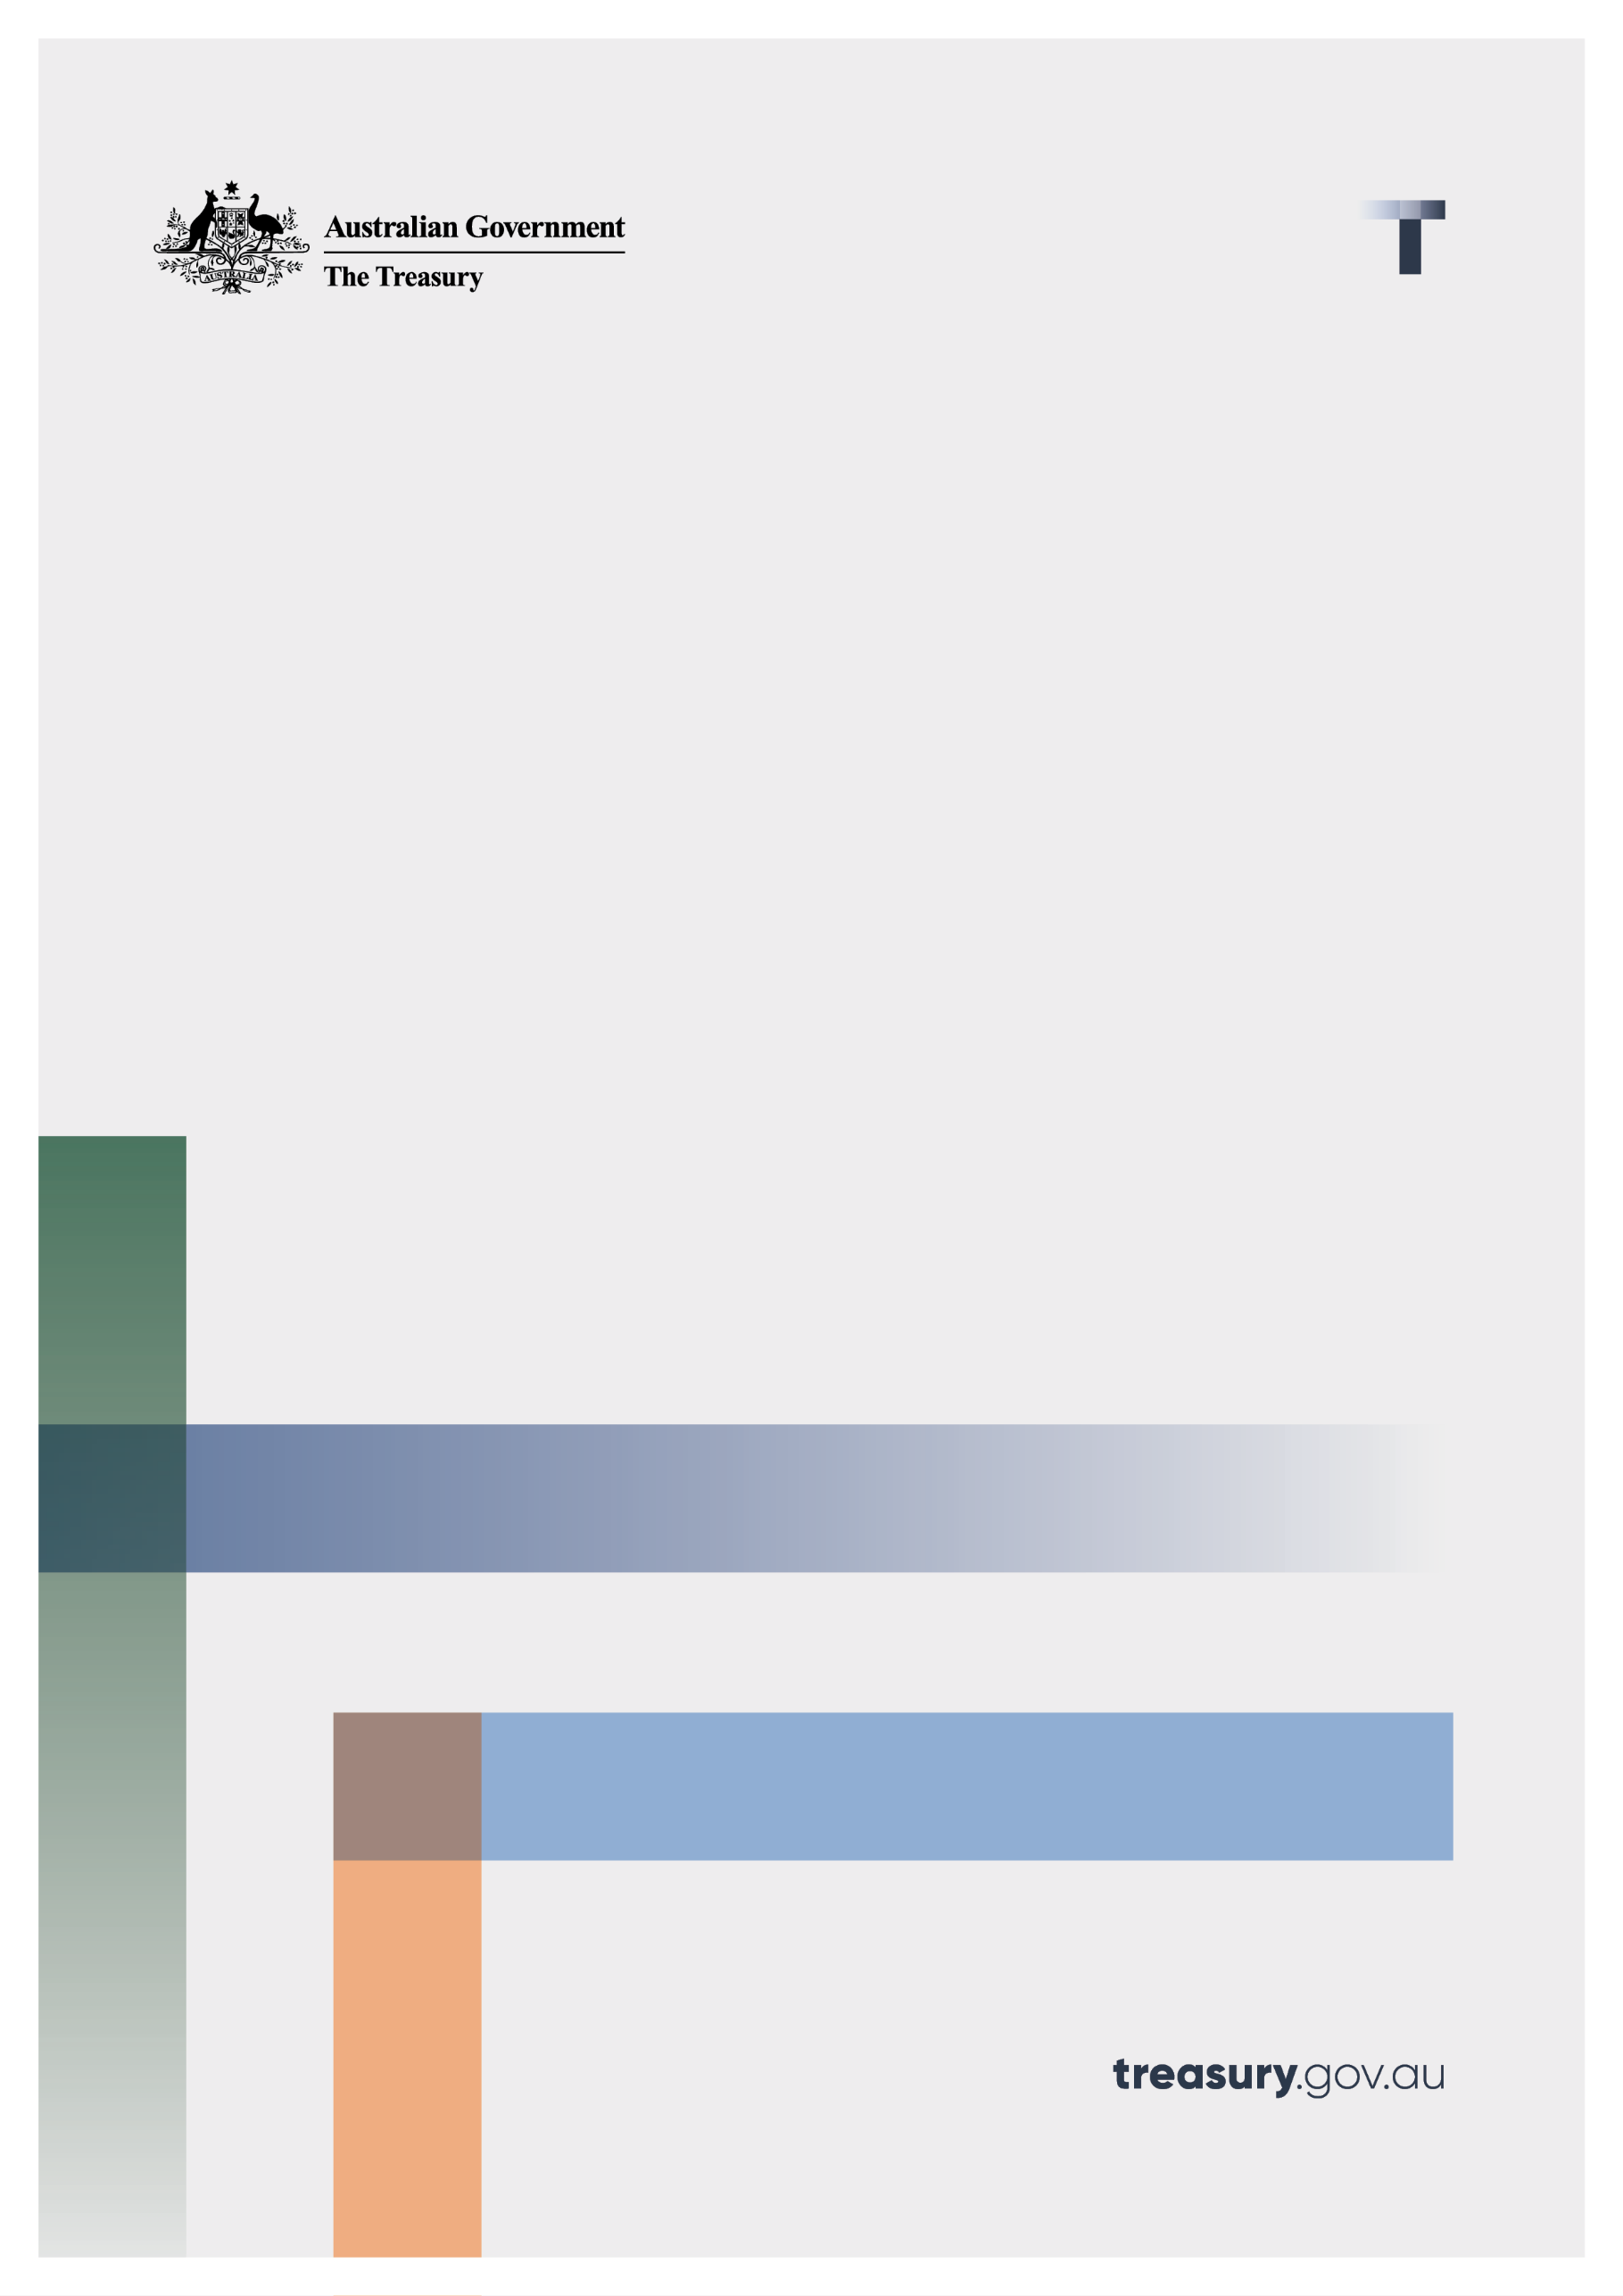

Global agreement on corporate taxation:

Addressing the tax challenges arising from the digitalisation of the economy

Consultation paper

October 2022

© Commonwealth of Australia 2022

This publication is available for your use under a [Creative Commons Attribution 3.0 Australia](http://creativecommons.org/licenses/by/3.0/au/deed.en) licence, with the exception of the Commonwealth Coat of Arms, the Treasury logo, photographs, images, signatures and where otherwise stated. The full licence terms are available from <http://creativecommons.org/licenses/by/3.0/au/legalcode>.

Creative Commons attribution licence 3.0 icon. 

Use of Treasury material under a [Creative Commons Attribution 3.0 Australia](http://creativecommons.org/licenses/by/3.0/au/deed.en) licence requires you to attribute the work (but not in any way that suggests that the Treasury endorses you or your use of the work).

**Treasury material used ‘as supplied’.**

Provided you have not modified or transformed Treasury material in any way including, for example, by changing the Treasury text; calculating percentage changes; graphing or charting data; or deriving new statistics from published Treasury statistics — then Treasury prefers the following attribution:

*Source: The Australian Government the Treasury*.

**Derivative** **material**

If you have modified or transformed Treasury material, or derived new material from those of the Treasury in any way, then Treasury prefers the following attribution:

*Based on The Australian Government the Treasury data*.

**Use of the Coat of Arms**

The terms under which the Coat of Arms can be used are set out on the Department of the Prime Minister and Cabinet website (see [www.pmc.gov.au/government/commonwealth-coat-arm](http://www.pmc.gov.au/government/commonwealth-coat-arm)s).

**Other uses**

Enquiries regarding this licence and any other use of this document are welcome at:

Manager  
Media and Speeches Unit  
The Treasury  
Langton Crescent   
Parkes ACT 2600  
Email: [media@treasury.gov.au](mailto:media@treasury.gov.au)

**Contents**

Consultation Process 3

Request for feedback and comments 3

Closing date for submissions: 01 November 2022 3

Purpose of the consultation 4

New two-pillar global agreement 7

Why a global deal on corporate taxation? 7

Pillar One 8

Pillar Two 10

Global anti-Base Erosion (GloBE) Rules 10

Subject to tax rule (STTR) 11

What are the outcomes for the economy? 13

What are the estimated revenue impacts? 14

Pillar One 14

Pillar Two 14

How will the global deal be implemented? 15

Pillar One 15

Pillar Two 16

Domestic Minimum Tax 17

What are the compliance costs and impacts on large multinationals? 17

Pillar One 17

Pillar Two 17

Australian implementation of the GloBE Model Rules 19

Mode of implementation 19

Timing of implementation 19

Readiness for implementation 20

Imposing the Top-up Tax liability 20

Administrative provisions 21

GloBE Information Return 21

Safe harbours 22

Interaction with integrity provisions 22

Corporate restructuring under GloBE 23

Tax paid under the GloBE Model Rules and imputation 23

Domestic Minimum Tax 24

Consultation to date 25

Next steps 26

References 27

# Consultation Process

## Request for feedback and comments

Treasury invites you to comment on aspects of the new two-pillar global agreement on corporate taxation or respond to the questions posed throughout this paper. Your submissions will assist Treasury continuing to assess the impacts and various implementation options available.

## Closing date for submissions: 01 November 2022

|  |  |
| --- | --- |
| Email | [contact.internationaltax@treasury.gov.au](mailto:contact.internationaltax@treasury.gov.au) |
| Mail | Assistant Secretary  International Tax Branch  Corporate and International Taxation Division  The Treasury  Langton Crescent  PARKES ACT 2600 |
| Enquiries | Enquiries can be initially directed to contact.internationaltax@treasury.gov.au |
|  |  |

# Purpose of the consultation

Treasury would like your views on how Australia can best engage with a new global agreement on corporate taxation that applies to large multinational companies.

Your submissions will help inform consideration of domestic implementation issues, such as interactions with Australia’s existing corporate tax system, ways to minimise compliance costs, and the implementation of a Domestic Minimum Tax. Your feedback will also help with various ongoing negotiations on design elements. To assist you, discussion questions are summarised below and included throughout the paper.

1. What are your views on the challenges facing the international tax system and what role do you see for the two-pillar multilateral solution to the tax challenges arising from digitalisation?
2. Do you agree the two-pillar multilateral solution will help make the international tax system fairer?
3. What costs and benefits do you see in Australia adopting the two-pillar multilateral solution?
4. What second round global tax system effects might arise, in regard to actions other countries may take that may impact Australian interests?
5. What are the major areas of Pillars One and Two that are likely to generate uncertainty for your business? How could that uncertainty be best addressed?
6. How do you think Pillars One and Two may impact investment decisions in Australia relative to the rest of the world?
7. Do you envision Pillars One and Two incentivising any behavioural changes and/or business restructures over the medium to long term?
8. Do you agree with the assumption that no Australian headquartered multinational will be in the scope of Amount A, given the current proposed thresholds and exclusions?
9. What challenges do you foresee with the OECD timelines, which have Pillar Two coming into effect in 2023 and Pillar One coming into effect in 2024?
10. What design features would you like to see within the existing Pillar One and Two frameworks? For example, are there any approaches to implementation which may mitigate implementation challenges?
11. What interaction issues could arise between Pillar One and Pillar Two, and other Australian or foreign tax laws? How should these interactions influence the way Australia implements the two-pillar multilateral agreement?
12. Are there any other comments or issues you wish to raise in relation to the Pillar One and Two rules that should be considered by Australia in the design and implementation stage?
13. What changes (e.g. to processes or systems) do you anticipate that businesses may be required to make in order to comply with Pillar Two?
14. Do you have any suggestions relating to the implementation of Pillar Two that could help minimise your compliance costs?
15. Would a Domestic Minimum Tax in Australia add to, or alternatively, mitigate the compliance costs of implementing Pillar Two?
16. If any of your related companies is a resident in a jurisdiction that does adopt the Global anti‑Base Erosion (GloBE) Model Rules, do you consider that your compliance burden will be largely the same whether or not Australia adopts these rules?

We also invite you to comment on the additional questions concerning Australia’s implementation of the GloBE Model Rules listed below:

1. Do you have any comments on how Australia should implement the GloBE Model Rules into domestic law?
2. Do you agree that the GloBE Model Rules should apply in Australia for fiscal years commencing on or after a specific date?
3. Do you have any comments on Australia’s timing of adoption of the GloBE Model Rules, including any advantages or disadvantages of being an early/late adopter? What challenges do you foresee if the GloBE Model Rules were to commence in 2023 as proposed under the OECD timeline?
4. We would like to understand your readiness for complying with the GloBE Model Rules. Do you have any comments on the skills and capabilities of your responsible staff and advisers in undertaking the calculations and applying the GloBE Model Rules?
5. Do you have any comments on the timeframes that may be required to implement the required system and reporting changes for your business in undertaking the calculations and applying the GloBE Model Rules?
6. Are there any remaining uncertainties or issues regarding Australia’s adoption of the GloBE Model Rules, including but not limited to the computation of GloBE income, adjusted covered taxes, and the transitional rules, which require further clarification?
7. If the UTPR is implemented by way of a denial of deductions or other alternative methods, including deemed income, do you have any views on how to allocate a UTPR Top-up Tax liability amongst Australian Constituent Entities?
8. Do you have any views or comments on how the adjustments should apply in years where Constituent Entities are in losses or have insufficient deductions?
9. Do you have any concerns if the Top-up Tax liability was to be joint and several amongst Australian Constituent Entities, whether under the IIR or the UTPR (if implemented by way of a separate tax charge)?
10. Are there any particular issues which should be considered in developing the necessary administrative or ‘machinery’ provisions in Australia’s domestic implementation of the GloBE Model Rules?
11. Do you see any issues with a GloBE Information Return that requires disclosure of detailed information supporting the calculation of these steps?
12. Do you have any additional feedback on how the GloBE Information Return could be designed (including on content, filing, and exchange of information requirements)?
13. Do you have any comments on possible scope, design, and conditions of access to a safe harbour?
14. Do you have any views on a Country-by-Country Reporting-based safe harbour, how it should be designed, and what adjustments would need to be made to the reported amounts?
15. Do you have any specific concerns on potential interactions with integrity provisions of the Australian tax law, such as the controlled foreign company (CFC) rules and the hybrid mismatch rules, and any uncertainties which may arise from their interaction with the GloBE Model Rules?
16. Are there any issues which you think may arise in allocating taxes imposed under Australia’s CFC Tax Regime?
17. Do you have any comments on how the GloBE Model Rules in relation to corporate restructurings and holding structures may interact with Australia’s tax laws on mergers and acquisitions, including tax consolidation? Do you also have any comments on how the GloBE Model Rules could be implemented so that interactions with our domestic rules, including tax consolidation, do not lead to outcomes inconsistent with the GloBE Model Rules?
18. Do you have any views on whether any Top-up Tax paid by an Australian Constituent Entity under the GloBE Model Rules should give rise to franking credits?
19. Do you have any comments on whether or not Australia should adopt a Domestic Minimum Tax in conjunction with the implementation of the GloBE Model Rules?
20. Do you agree that a Domestic Minimum Tax in Australia should only apply to multinationals in the scope of Pillar Two (for example, not applying to businesses that only operate in Australia)?
21. If Australia were to adopt a Domestic Minimum Tax, do you have any views on its design as a Qualified Domestic Minimum Tax (that is, on the Domestic Minimum Tax being consistent with the outcomes under the GloBE Model Rules)?
22. If a Domestic Minimum Tax were to be implemented, do you have any views as to whether there should be a separate return (that is, in addition to the GloBE Information Return and any potential local GloBE Tax Return), and do you have any additional feedback on this return? Would there be any particular issues if a Domestic Minimum Tax Return were to be due earlier than the GloBE Information Return?
23. If a Domestic Minimum Tax is implemented, how should the relevant liability be allocated amongst Australian Constituent Entities? Should the liability be joint and several amongst Australian Constituent Entities?
24. Do you have any views on whether tax paid in Australia under a Domestic Minimum Tax should give rise to franking credits?

# New two-pillar global agreement

In 2021 an historic multilateral agreement was reached through the OECD/G20 Inclusive Framework (the Inclusive Framework) on Base Erosion and Profit Shifting (BEPS) to reform the international corporate tax system to better address increasing globalisation and digitalisation.

**Note:** The OECD/G20 Inclusive Framework is a collaboration of over 140 jurisdictions working to improve the international tax system.

The new global agreement is embodied in a [statement](https://www.oecd.org/tax/beps/statement-on-a-two-pillar-solution-to-address-the-tax-challenges-arising-from-the-digitalisation-of-the-economy-july-2021.pdf) released by the OECD on 1 July 2021,[1] updated on 8 October 2021 and accompanied by a [detailed implementation plan](https://www.oecd.org/tax/beps/statement-on-a-two-pillar-solution-to-address-the-tax-challenges-arising-from-the-digitalisation-of-the-economy-october-2021.pdf) (See Attachment A).[2] The proposed multilateral solution consists of two ‘pillars’.

# Why a global deal on corporate taxation?

The original motivation for the global deal for reform of the international corporate tax system was the emergence of highly digitalised businesses – which exacerbated some of the longer-standing challenges associated with taxing corporate profits in a globalised economy, such as profit shifting. Concerns have also been growing about the use of low or no tax jurisdictions, sometimes referred to as ‘tax havens’, and the tax planning opportunities they present to some businesses.

**Note:** Profit Shifting is a strategy used by multinationals to lower taxation primarily by attributing revenues to low-tax jurisdictions and expenses to high-tax jurisdictions.

The international corporate tax system has been built on the concept of having a permanent (physical) establishment of a business in a jurisdiction as the basis for asserting taxing rights, the boundaries of which can become more blurred with the growth of the digital economy.

For example, globalisation and digitalisation of the economy have allowed businesses to engage in cross-border sales of goods and services more easily, with little or no physical presence in a jurisdiction. Digitalisation and globalisation have increased the ability of businesses to locate operations and intangible property in jurisdictions with low corporate income tax rates, allowing them to lower their global effective tax rate.

A leading example of these trends are the large ‘digital’ businesses that can generate significant revenues from markets in which their consumers and users are located, while paying comparatively little income tax where their products and services are consumed. Existing arrangements for allocating corporate income taxation rights face challenges in situations where a business has ‘scale without mass’. In these situations, services can be delivered remotely from low or no tax jurisdictions, with revenues attributed mostly to mobile intangible assets (e.g. copyright and patents). In addition, there has also been sustained competitive pressure for jurisdictions to lower corporate tax rates to attract mobile investment and economic activity (also known as the ‘race to the bottom’).

**Note:** Digital services taxes are taxes applied on the revenues of large multinational digital businesses.

Concerns about the taxation of digital businesses have led to at least 26 countries legislating digital services taxes,[3] which apply primarily to large businesses that sell digital advertising and streaming services. The United States Trade Representative has determined that such taxes are discriminatory against US companies and has announced retaliatory tariffs on imports for a number of countries including France, United Kingdom, Spain, Italy and Austria, which have announced or implemented digital services taxes. These tariffs were then suspended to allow the OECD multilateral negotiations to continue to work towards finalising the two-pillar solution.

Through the [OECD’s public consultation process in 2020](https://www.oecd.org/tax/beps/public-consultation-document-reports-on-pillar-one-and-pillar-two-blueprints-october-2020.pdf),[4] [economic analysis](https://read.oecd.org/10.1787/0e3cc2d4-en?format=pdf) was released predicting that the continued build-up of these pressures and the proliferation of unilateral actions, such as digital services taxes, could harm global economic growth.[5] The OECD argued that a better alternative is the multilateral solution being negotiated through the Inclusive Framework.

More broadly, there are concerns that smaller and more localised businesses are not on a level playing field when competing with large multinationals, since these multinationals are able to lower their tax burden through strategies that shift their taxable profits to low or no tax jurisdictions. Jurisdictions that offer low or zero tax rates to attract multinationals also risk being used as ‘tax havens’ for organised crime and other tax evaders. Coordinated global action can minimise the revenue risks and incentives associated with low or no tax jurisdictions and make the system fairer for local businesses.

The Government’s ongoing engagement on the multilateral two-pillar solution complements the Government’s election commitment to implement a multinational tax avoidance package. The Government is progressing a set of measures which target the deliberate activities of multinationals to minimise tax, and enhance public reporting (transparency) initiatives to maintain public trust in the integrity of the tax system. As announced before the election, the Government is committed to closing loopholes exploited by multinationals and to improving transparency of business arrangements.

## Pillar One

**‘Pillar One’** reallocates some of the taxing rights over the largest and most profitable multinationals to the countries where their goods and services are consumed (‘market jurisdictions’). The amount of taxing rights to be redistributed under Pillar One is known as ‘Amount A’. This redistribution would only apply where a multinational has global revenues exceeding EUR20 billion per annum and also has a profit‑before-tax to revenue ratio exceeding 10 per cent. The OECD has estimated that around 100 multinationals would be in the scope of Pillar One initially.

**Note:** Pillar One includes a new corporate tax on the largest and most profitable companies which increases the taxing rights of countries where goods and services are consumed.

The agreement provides exclusions for Extractives and Regulated Financial Services from the application of Amount A. These measures reflect the policy goals of excluding economic rents from location-specific non-renewable extractive resources and the returns on risk borne by firms that are subject to regulated capital adequacy requirements.

Amount A would be equal to 25 per cent of the multinational’s global residual profits. For the purpose of Amount A, global residual profit is defined as all profits above a 10 per cent (profit before tax/revenue) profitability threshold. The multinational would allocate these Amount A profits among market jurisdictions based on the share of revenue sourced from each of those jurisdictions. The market jurisdiction would then apply their domestic corporate tax system to tax the allocated residual profits, while another ‘relieving jurisdiction’ would relinquish their taxing rights over these profits. Pillar One would also include a ‘marketing and distribution profits safe harbour’ to cap the amount of profit reallocated to a market jurisdiction that is already able to tax the multinational’s residual profits.

**Note:** A multinational is a business that operates across multiple countries.

As a condition of joining Pillar One, countries would need to remove all digital services taxes and commit to not introducing similar measures in the future. This would reduce the risk of ongoing trade tensions.

OECD illustration of Pillar One[6]

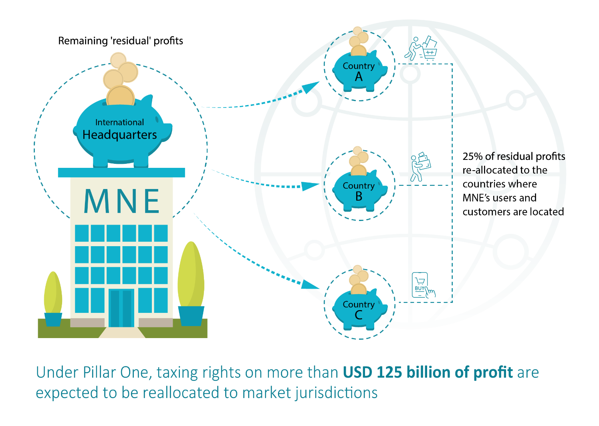

## Pillar Two

**Note:** The GloBE Rules set an effective global minimum corporate income tax rate of 15 per cent for large multinationals.

The STTR is included in bilateral tax treaties to apply to certain payments taxed at rates below 9 per cent.

**‘Pillar Two’** puts a floor on tax competition to reduce the incentive for multinationals to profit-shift to low tax jurisdictions. Pillar Two will help address the ‘race to the bottom’ where countries are competing with each other to attract mobile capital through offering ever lower corporate tax rates. Pillar Two does not explicitly mandate that any country increase their taxes, rather it creates incentives for countries to do so. This includes new taxing rights over undertaxed profits of entities within a multinational group which are taxed below the globally agreed minimum tax rate.

Pillar Two consists of the Global anti-Base Erosion (GloBE) Rules and the Subject to tax rule (STTR). The STTR applies before the GloBE Rules.

### Global anti-Base Erosion (GloBE) Rules

The GloBE Rules ensure an effective minimum tax rate of 15 per cent for multinationals with global revenue of at least EUR750 million per annum.

The GloBE Rules consist of two interlocking rules (the Income Inclusion Rule (IIR) and the Undertaxed Payments Rule (UTPR)), designed to collect a top-up tax on profits in undertaxed jurisdictions within a Multinational Enterprises (MNE) Group. These rules are discussed in more detail below.

The OECD Inclusive Framework has released the GloBE Model Rules, Commentary and Examples to inform the design of domestic legislation (Attachment B). The Implementation Framework is being developed and will be published by the end of 2022, to support tax authorities in the implementation and administration of the GloBE Rules.

The GloBE Rules allow, but do not require, a jurisdiction which implements the rules to claim primary rights over the collection of any top-up tax on undertaxed profits in that jurisdiction. This is achieved through implementing a Domestic Minimum Tax.

#### Income Inclusion Rule (IIR)

The IIR would allow jurisdictions to apply a top-up tax on a resident multinational ‘parent’ company, where the group’s income in another jurisdiction is being taxed below the global minimum rate of 15 per cent. For example, if a multinational had its headquarters in Australia, but its foreign subsidiaries in a particular jurisdiction were paying an effective tax rate of 10 per cent, Australia may be able to apply a top-up tax on the Australian parent company equivalent to 5 per cent of the foreign subsidiaries’ profits.[7]

#### Undertaxed Payments Rule (UTPR)

The UTPR would allow jurisdictions to apply a top-up tax on a resident subsidiary member of a multinational group if the group’s income in another jurisdiction is being taxed below the global minimum rate of 15 per cent and where no IIR applies. For example, if a multinational subsidiary in Australia had a foreign related entity paying less than the global minimum rate on its profits,[8] and there was no foreign jurisdiction applying the IIR in relation to those profits, then Australia may be able to apply the UTPR to the Australian subsidiary in respect of the under-taxation in the related entity’s jurisdiction. Top-up tax would be allocated using substance-based allocation factors among countries in which the multinational group operates and that have implemented the UTPR. Broadly, a country with proportionately more tangible assets and employees will receive a larger allocation of the UTPR top-up tax.

### Subject to tax rule (STTR)

The STTR is primarily intended to overcome problems for developing countries with bilateral tax treaties, where they have reduced taxing rights on certain income under those treaties. If an Inclusive Framework member country is taxing certain income below the STTR minimum rate of 9 per cent,[9] it is obligated to include the STTR into a bilateral tax treaty if requested to do so by the developing country treaty partner.

If a STTR is included in an existing bilateral tax treaty then, broadly,the payer jurisdiction may additionally tax certain related party payments on its gross amount where the payee jurisdiction has taxed the payment below the STTR minimum rate. This taxing right will be limited to the difference between the STTR minimum rate and the tax rate on the payment.

The STTR is seen by developing countries as integral to the two-pillar agreement. It allows the payer country to collect tax before the GloBE Rules are applied.

OECD illustration of Pillar Two[10]

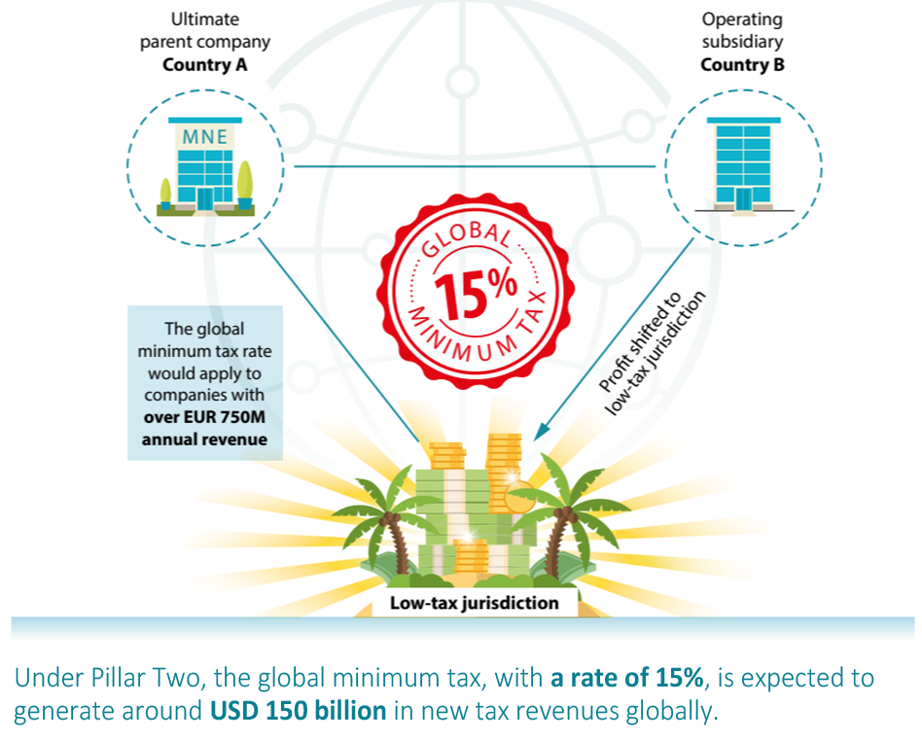

1. What are your views on the challenges facing the international tax system and what role do you see for the two-pillar multilateral solution to the tax challenges arising from digitalisation?

2. Do you agree the two-pillar multilateral solution will help make the international tax system fairer?

3. What costs and benefits do you see in Australia adopting the two-pillar multilateral solution?

4. What second round global tax system effects might arise, in regard to actions other countries may take that may impact Australian interests?

5. What are the major areas of Pillars One and Two that are likely to generate uncertainty for your business? How could that uncertainty be best addressed?

# What are the outcomes for the economy?

Over the long term, the OECD has estimated that the implementation of Pillars One and Two will have a positive impact on the global economy.[11] This is mainly based on the OECD’s assumption that implementation would avoid the negative economic implications of a protracted tax and trade related conflict, estimated to reduce global GDP from somewhere between 0.1 per cent to 1.2 per cent.[12]

The OECD has estimated that the negative investment impacts from higher taxation resulting from Pillars One and Two would lead to a reduction of global GDP of less than 0.1 per cent.[13] The OECD believes this would be more than offset by other factors, such as greater investment certainty and reduced compliance costs from avoiding the proliferation of unilateral taxes.

6. How do you think Pillars One and Two may impact investment decisions in Australia relative to the rest of the world?

7. Do you envision Pillars One and Two incentivising any behavioural changes and/or business restructures over the medium to long term?

# What are the estimated revenue impacts?

## Pillar One

With a number of detailed design elements yet to be settled, it is too early to formalise a revenue impact estimate for Australia regarding Pillar One at this stage. Based on an earlier version of the proposal, the OECD has estimated that Amount A of Pillar One would reallocate the taxing rights of about USD125 billion[14] worth of residual profits to be taxed in market jurisdictions.[15]

This is because there may be a net transfer of taxing rights from lower tax jurisdictions to higher tax jurisdictions. The OECD has estimated that the average percentage revenue gains from Pillar One may be greater for low-income countries than the gains for high and middle-income countries.

At this stage, the extent to which Australia would benefit from the estimated reallocation remains dependent on factors still under negotiation, such as mechanisms that reduce allocations to market countries where multinationals’ residual profits are already taxed and how large residual profits are used to relieve double taxation.

Treasury estimates that no Australian headquartered multinationals currently fall into the scope of Amount A. However, under future changing economic conditions, profitability and revenue levels, some Australian multinationals may eventually meet the EUR20 billion and 10 per cent profitability thresholds, or a revised EUR10 billion revenue threshold that is expected to take effect if the seven‑year review (around 2030) finds that Amount A has been successfully implemented. Additionally, Australian subsidiaries of in-scope multinationals may be impacted by certain elements of Amount A, in particular the Elimination of Double Taxation and the Marketing and Distribution Profits Safe Harbour mechanisms.

8. Do you agree with the assumption that no Australian headquartered multinational will be in the scope of Amount A, given the current proposed thresholds and exclusions?

## Pillar Two

The revenue impacts for Australia will be dependent on final implementation details and may also be influenced by how low-tax jurisdictions respond to the GloBE Rules by raising their tax rates, implementing Domestic Minimum Taxes, or other behavioural responses. Overall, the OECD has estimated that Pillar Two would generate around USD150 billion in additional global tax revenues annually.[16] While the OECD had estimated that the average percentage revenue gains from Pillar Two may be greater for high income jurisdictions than the gains for middle and low income jurisdictions, that estimate was based on earlier design assumptions.[17]

From an economic perspective, implementing Pillar Two will help strengthen Australia’s corporate tax base. A smaller differential between the headline tax rates of Australia and other countries may help make Australia more attractive for new business and investment. Also, multinationals that have already invested in Australia may have less incentive to relocate or to shift profits to other countries due to this decreased differential.

# How will the global deal be implemented?

The implementation plan agreed by over 130 members of the Inclusive Framework envisages that each of the two pillars will be implemented separately, through a combination of multilateral conventions or instruments and domestic legislation.

## Pillar One

According to the [implementation plan](https://www.oecd.org/tax/beps/statement-on-a-two-pillar-solution-to-address-the-tax-challenges-arising-from-the-digitalisation-of-the-economy-october-2021.pdf),[18] **Pillar One** would be made effective through a Multilateral Convention (treaty) originally due to be signed by mid-2022 and come into effect in 2023 once a critical mass of countries have ratified it. However, on 11 July, the OECD issued a revised timeline showing the Multilateral Convention would come into effect in 2024 when a critical mass has been achieved. The implementation plan also includes the development of model rules to assist countries with activating the Multilateral Convention into domestic law, where this might be needed**.**

As stated by the implementation plan, the Multilateral Convention would require countries to remove all digital services taxes and other relevant similar measures, and to commit not to introduce such measures in the future.

The Multilateral Convention would include rules to determine and allocate the residual profits under Amount A, eliminate double taxation, and apply a marketing and distribution profits safe harbour. The Multilateral Convention would also contain provisions to simplify administrative processes, mechanisms to facilitate information sharing between tax authorities, and binding dispute prevention and resolution mechanisms.

As part of Pillar One, negotiations will continue on simplified transfer pricing rules for certain marketing and distribution activities, known as ‘Amount B’. This work is planned to be completed by the end of 2022 but will progress separately to the work on Amount A and is not expected to be reflected in the Pillar One Multilateral Convention or model rules.

The implementation plan also specifies as part of the agreement on Pillar One that there will be a review of the scope threshold being reduced to EUR10 billion seven years after implementation.

## Pillar Two

The [implementation plan](https://www.oecd.org/tax/beps/statement-on-a-two-pillar-solution-to-address-the-tax-challenges-arising-from-the-digitalisation-of-the-economy-october-2021.pdf)[19] supported by over 130 members of the Inclusive Framework envisages that the global minimum tax rate would become operational through a critical mass of countries adopting domestic legislation that imposes ‘top-up taxes’ on multinationals, should they be taxed below the global minimum effective tax rate of 15 per cent.

Under the OECD/G20 October Statement, countries implementing the GloBE Rules are required to do so in a manner consistent with the GloBE Model Rules, Commentary and Examples (Attachment B) agreed by the Inclusive Framework. The Inclusive Framework will develop an Implementation Framework by the end of 2022, before the expected implementation in 2023. Through the Implementation Framework, the OECD will provide agreed administrative guidance, multilateral review processes and develop safe harbours to facilitate the co-ordinated implementation and administration of the GloBE Model Rules. The OECD is considering the merits of a potential multilateral convention to ensure the coordination and consistent implementation of the GloBE Model Rules. Implementation will also be facilitated by transitional rules and a delayed commencement of the UTPR from 2024.

While the OECD timeline indicates that the GloBE Model Rules will come into effect in 2023, there is an expectation that a critical mass of countries will implement in 2024. Several countries, including the UK, the EU and Switzerland, have indicated or are considering implementing Pillar Two to take effect from 2024. Canada has announced that it will implement the GloBE Rules to commence in 2023, in line with the OECD timetable.

The OECD Inclusive Framework is developing a model treaty provision to give effect to the STTR, and a multilateral instrument to facilitate implementation of the rule. The multilateral instrument will help jurisdictions amend their existing bilateral tax treaties where relevant, to include a STTR when requested to do so by a developing country treaty partner. According to the Implementation Plan, the multilateral instrument would be developed and open for signature in mid‑2022 for jurisdictions to consider signing. The STTR is scheduled to come into effect in 2023.

9. What challenges do you foresee with the OECD timelines, which have Pillar Two coming into effect in 2023 and Pillar One coming into effect in 2024?

10. What design features would you like to see within the existing Pillar One and Two frameworks? For example, are there any approaches to implementation which may mitigate implementation challenges?

11. What interaction issues could arise between Pillar One and Pillar Two, and other Australian or foreign tax laws? How should these interactions influence the way Australia implements the two-pillar multilateral agreement?

12. Are there any other comments or issues you wish to raise in relation to the Pillar One and Two rules that should be considered by Australia in the design and implementation stage?

### Domestic Minimum Tax

The GloBE Model Rules allow a jurisdiction which implements Pillar Two to claim primary rights to impose top-up tax over any low-taxed income in that jurisdiction by adopting a Domestic Minimum Tax. If designed consistently with the GloBE Model Rules, a Domestic Minimum Tax would not necessarily create an additional tax burden for an MNE, but would ensure that the top-up tax was paid in Australia rather than in a foreign jurisdiction. Some jurisdictions have indicated that they will implement a Domestic Minimum Tax. For example, Switzerland has announced the implementation of a Domestic Minimum Tax with the same scope provided in the GloBE Model Rules.[20]

# What are the compliance costs and impacts on large multinationals?

## Pillar One

Under Pillar One, the ultimate parent entity of a multinational group will be obligated to comply with the new rules. While it is estimated that no Australian headquartered company will be in scope initially, Australia will need legislative changes to implement certain parts of Pillar One. This might include legislation to enable the Australian Government to collect the Pillar One taxation payments from foreign companies, not necessarily captured by our existing tax system. The legislation might specify how such payments may be made, as well as provisions around the notice of assessment process and Commissioner of Taxation powers in relation to auditing and managing payments. Tax certainty processes may also require Australia to collect and exchange taxpayer information.

Australian businesses that may be subject to the new rules should seek to understand the new legislation as well as to undertake ongoing assessment to monitor how close they are to being in scope.

## Pillar Two

Pillar Two would require multinationals to determine if they are subject to the GloBE Rules. If so, these multinationals will have to comply with complex domestic legislation to determine their effective tax rates and any potential under-taxation in jurisdictions in which they operate. If top-up tax is payable, multinationals also need to determine where that tax should be paid. Where there is income that is undertaxed within the global group, multinationals will also have to bear the cost of top-up tax on the undertaxed profits.

Regardless of whether a top-up tax liability exists, all in-scope multinationals will need to complete a GloBE Information Return which discloses the required information for the purposes of complying with the GloBE Model Rules.

Most information necessary for multinationals to comply with the GloBE Model Rules may be available through existing internal accounting information systems. Nonetheless, some upfront and ongoing costs associated with amending existing reporting processes as well as establishing new internal assurance processes may be expected.

The compliance costs of Pillar Two for Australian businesses are expected to be significant. However, these costs should be reduced through the use of safe harbour provisions, the details and conditions of which are yet to be developed and agreed through the Inclusive Framework.

The Inclusive Framework will develop a multilateral instrument to facilitate implementation of the STTR in relevant bilateral tax treaties and a process to assist in implementing the STTR will be agreed. To the extent a STTR is included in relevant bilateral tax treaties (including bilateral tax treaties between jurisdictions other than Australia), multinational groups that seek treaty benefits in relation to their operations and activities will be affected, with the STTR applying to interest, royalties and a defined set of other payments yet to be settled. This may lead to additional compliance costs.

Treasury welcomes feedback and information about anticipated compliance costs and impacts of the two-pillar solution, including the GloBE Model Rules, Commentary, and Examples for the GloBE Model Rules at Attachment B.

13. What changes (e.g. to processes or systems) do you anticipate that businesses may be required to make in order to comply with Pillar Two?

14. Do you have any suggestions relating to implementation of Pillar Two that could help minimise your compliance costs?

15. Would a Domestic Minimum Tax in Australia add to, or alternatively, mitigate the compliance costs of implementing the GloBE Model Rules?

16. If any of your related companies is a resident in a jurisdiction that does adopt the Global anti-Base Erosion (GloBE) Model Rules, do you consider that your compliance burden will be largely the same whether or not Australia adopts these rules?

# Australian implementation of the GloBE Model Rules

The public release of the GloBE Model Rules in December 2021, and the Commentary and Examples in March 2022 (both at Attachment B), provides the opportunity for interested stakeholders to gain an understanding of how the GloBE Model Rules will operate.

Pillar One and the Pillar Two STTR have not yet been finalised by the OECD Inclusive Framework. However, the GloBE Model Rules (together with the Commentary and Examples) reflect the framework agreed for jurisdictions to proceed with implementation. As such, in addition to the previous questions on the two-pillar approach more generally, Treasury is also seeking specific feedback and comments from stakeholders in relation to questions on the implementation of the GloBE Model Rules in Australia.

## Mode of implementation

The October 2021 Statement (Attachment A) indicates that the GloBE Model Rules will have the status of a common approach. Consequently, Inclusive Framework members that choose to implement the GloBE Model Rules are required to do so in a manner consistent with the outcomes of Pillar Two. Implementation will require domestic legislation. The mode of implementation of GloBE Model Rules into Australian tax law is yet to be determined. Other jurisdictions are considering how they might implement domestically, for example by way of incorporating the rules into existing legislation or by inclusion in a separate taxing Act.

17. Do you have any comments on how Australia should implement the GloBE Model Rules into domestic law?

## Timing of implementation

A number of jurisdictions have made announcements in relation to Pillar Two. Announcements include amendments to domestic corporate tax rates to be consistent with the global minimum tax of 15 per cent; the intention to implement the GloBE Model Rules; or consultations seeking views from stakeholders on whether or not to implement the GloBE Model Rules.

As mentioned above, Canada has announced that they will implement the GloBE Model Rules to commence in line with the OECD timeline (2023 for the IIR and 2024 for the UTPR). Other countries have announced commencement from 2024.

18. Do you agree that the GloBE Model Rules should apply in Australia for fiscal years commencing on or after a specific date?

19. Do you have any comments on Australia’s timing of adoption of the GloBE Model Rules, including any advantages or disadvantages of being an early/late adopter? What challenges do you foresee if the GloBE Model Rules were to commence in 2023 as proposed under the OECD timeline?

## Readiness for implementation

Successful implementation of GloBE Model Rules in Australia will in part depend on stakeholders’ understanding of and ability to apply the GloBE Model Rules.

20. We would like to understand your readiness for complying with GloBE Model Rules. Do you have any comments on the skills and capabilities of your responsible staff and advisers in undertaking the calculations and applying the GloBE Model Rules?

21. Do you have any comments on the timeframes that may be required to implement the required system and reporting changes for your business in undertaking the calculations and applying the GloBE Model Rules?

22. Are there any remaining uncertainties or issues regarding Australia’s adoption of the GloBE Model Rules, including but not limited to the computation of GloBE income, adjusted covered taxes, and the transitional rules, which requires further clarification?

## Imposing the Top-up Tax liability

The GloBE Model Rules outline how the Top-up Tax is calculated, as well as allocated under the IIR and UTPR.

Generally, the IIR allocates the Top-up Tax to a specific entity (i.e. generally the Ultimate Parent Entity) based on its Ownership Interest in the Low-Taxed Constituent Entity. However, the UTPR allocates the Top-up Tax liability to a jurisdiction (and not to a specific entity in the jurisdiction).

Apart from an overarching requirement that the adjustment mechanism to collect the UTPR Top-up Tax shall be applied to the extent possible with respect to the taxable year in which the relevant fiscal year ends, the GloBE Model Rules are silent as to how a country may allocate that UTPR Top-up Tax among the Constituent Entities. One approach being considered by other countries is for all Constituent Entities in the jurisdiction of the MNE Group to be jointly and severally liable for the Top-up Tax imposed both under the IIR and UTPR.

23. If the UTPR is implemented by way of a denial of deductions or other alternative methods, including deemed income, do you have any views on how to allocate a UTPR Top-up Tax liability amongst Australian Constituent Entities?

Under the UTPR, the denial of deductions or equivalent adjustment shall apply to the extent possible with respect to the taxable year in which the fiscal year ends. If that adjustment is insufficient to produce an additional cash tax expense equal to the UTPR Top-up Tax amount for the jurisdiction, the difference shall be carried forward to the extent necessary to the succeeding fiscal years. There is a question as to how such an adjustment should be calculated and applied where the Australian Constituent Entities of an MNE Group are in tax losses and/or have insufficient deductions in the relevant year.

24. Do you have any views or comments on how the adjustments should apply in years where Constituent Entities are in losses or have insufficient deductions?

25. Do you have any concerns if the Top-up Tax liability was to be joint and several amongst Australian Constituent Entities, whether under the IIR or the UTPR (if implemented by way of a separate tax charge)?

## Administrative provisions

The GloBE Model Rules contain detailed provisions to determine aspects such as the attribution of taxing rights, the determination of GloBE income, Covered Taxes, and effective tax rates. However, the GloBE Model Rules do not contain all the necessary administrative or ‘machinery’ provisions (that is, provisions dealing with the lodgement of returns, assessments, payments, penalties, reviews, disputes etc.). One option is for Australian GloBE Model Rules to rely on or replicate the existing machinery provisions in the income tax law.

26. Are there any particular issues which should be considered in developing the necessary administrative or ‘machinery’ provisions in Australia’s domestic implementation of the GloBE Model Rules?

## GloBE Information Return

The GloBE calculations will be complex as there will be many steps to ascertaining the Top-up Tax amount. A GloBE Information Return, with sufficient disclosures demonstrating that the correct steps have been followed, may give assurance and certainty to both administrators and the MNE. In addition, this information is likely to be exchanged with other tax administrators.

27. Do you see any issues with a GloBE Information Return that requires disclosure of detailed information supporting the calculation of these steps?

28. Do you have any additional feedback on how the GloBE Information Return could be designed (including on content, filing, and exchange of information requirements)?

## Safe harbours

The GloBE Model Rules and Commentary foreshadowed further work to be undertaken on safe harbours as part of the Implementation Framework. There has been broad stakeholder support for such simplification measures to be developed to reduce compliance costs for MNE and tax administrations.

29. Do you have any comments on possible scope, design, and conditions of access to a safe harbour?

A number of submissions to the OECD public consultation suggest that a Country-by-Country Reporting‑based safe harbour be considered.

30. Do you have any views on a Country-by-Country Reporting-based safe harbour, how it should be designed, and what adjustments would need to be made to the reported amounts?

## Interaction with integrity provisions

The GloBE Model Rules are intended to apply after an Australian Constituent Entity has calculated its income tax liability under existing domestic tax law including, where applicable, controlled foreign company (CFC) rules and hybrid mismatch rules.

Generally, any income tax paid will be treated as a Covered Tax of the Constituent Entity. However, how and to what extent the tax will be attributed to a particular year is broadly based on financial accounting concepts of income tax expense.

The GloBE Model Rules provide that all or part of any tax liability which arises as a result of the application of the CFC rules will be attributed to the CFC instead of the Constituent Entity which paid the tax. The Rules also impose a limitation on the amount of CFC tax attributable to Passive Income that can be pushed down for the purposes of the CFC’s effective tax rate calculation. The Commentary and Examples provide further explanation on how to calculate this limitation.

31. Do you have any specific concerns on potential interactions with integrity provisions of the Australian tax law, such as the controlled foreign company (CFC) rules and the hybrid mismatch rules, and any uncertainties which may arise from their interaction with the GloBE Model Rules?

32. Are there any issues which you think may arise in allocating taxes imposed under Australia’s CFC Tax Regime?

## Corporate restructuring under GloBE

The GloBE Model Rules contain provisions concerning corporate restructurings (including mergers, acquisitions, and demergers). These provisions cover situations where an Entity joins or leaves an MNE Group, or acquires or disposes of assets and liabilities, which impact the calculation of GloBE Income, Covered Taxes, and the Substance-Based Income Exclusion.

For instance, a Constituent Entity may elect to include an amount in its GloBE Income representing the difference between the fair value and the carrying value of the assets and the liabilities. However, this election can only be made if a country’s rules permit the adjustment of the “tax basis” of assets and liabilities as a result of the relevant corporate restructuring transaction.

While these rules seek to produce outcomes that are generally aligned with the local tax treatment of such transactions, the impact in Australia will require an analysis of Australia’s tax laws including tax consolidation rules, which determine the tax cost base of assets and liabilities.

33. Do you have any comments on how the GloBE Model Rules in relation to corporate restructurings and holding structures may interact with Australia’s tax laws on mergers and acquisitions, including tax consolidation? Do you also have any comments on how the GloBE Model Rules could be implemented so that interactions with our domestic rules, including tax consolidation, do not lead to outcomes inconsistent with the GloBE Model Rules?

## Tax paid under the GloBE Model Rules and imputation

Australia’s imputation system seeks to prevent double taxation of profits earned by a corporate tax entity by ensuring that profits are not taxed when earned by a corporate tax entity and taxed again when a recipient, that is an Australian tax resident, receives a distribution of those profits. As such, companies can pass on, or ‘impute’ credits for the income tax already paid on profits distributed to their shareholders. Franking credits are attached to such distributions and can be used as tax offsets for the recipients that are Australian tax residents.

The concept of a Qualified IIR is introduced in the GloBE Model Rules to ensure that coordination and integrity is maintained across the various IIRs of implementing jurisdictions. The GloBE Model Rules should be implemented in a manner that maintains a level playing field. This level playing field may be jeopardised if tax credits are provided in respect of GloBE tax imposed by the rules of one country but not of another. In a domestic context, a related question may arise as to whether franking credits should be provided in relation to Top-up Tax payments under GloBE.

Australia allows for franking credits on Australian tax paid on foreign profits under Australia’s CFC rules, but not on foreign income tax paid. Whilst Australia’s CFC regime may be described as an integrity measure protecting Australia’s tax base, the GloBE Model Rules are more akin to an integrity measure ensuring global minimum effective tax rates. GloBE taxation may be viewed as an additional foreign income tax and contrasted from our CFC regime, as it does not represent tax on income which would otherwise be included in the Australian corporate income tax base, but instead is a tax addressing foreign under-taxation.

Additionally, it is also possible that if a franking credit was to be provided in relation to Top-up Tax payments, Australia’s IIR or UTPR would not be considered to be “Qualified” rules, due to the provision of a “tax credit equivalent to a portion of the tax paid under the IIR to be used against other taxes.”[21]

34. Do you have any views on whether any Top-up Tax paid by an Australian Constituent Entity under the GloBE Model Rules should give rise to franking credits?

## Domestic Minimum Tax

The GloBE Model Rules allow but do not require a jurisdiction which implements the GloBE Model Rules to adopt a Domestic Minimum Tax, giving the jurisdiction the first claim to additional taxing rights on any low-taxed domestic income.

The design of this tax will determine whether the tax paid is treated as a Covered Tax or an offset for the jurisdictional Top-up Tax liability.

Broadly, if a Domestic Minimum Tax is implemented in a way that is consistent with the outcomes under the GloBE Model Rules (including that no benefits related to the Domestic Minimum Tax are provided), it will be a Qualified Domestic Minimum Tax (QDMT). Designing a Domestic Minimum Tax on a different basis could mean that it is non-qualified and more likely to be treated as a Covered Tax. As such, it would be included in the effective tax rate calculation before the consideration of the substance-based carve out.

35. Do you have any comments on whether or not Australia should adopt a Domestic Minimum Tax in conjunction with the implementation of the GloBE Model Rules?

36. Do you agree that a Domestic Minimum Tax in Australia should only apply to multinationals in the scope of Pillar Two (for example, not applying to businesses that only operate in Australia)?

37. If Australia were to adopt a Domestic Minimum Tax, do you have any views on its design as a Qualified Domestic Minimum Tax (that is, on the Domestic Minimum Tax being consistent with the outcomes under the GloBE Model Rules)?

38. If a Domestic Minimum Tax were to be implemented, do you have any views as to whether there should be a separate return (that is, in addition to the GloBE Information Return and any potential local GloBE Tax Return), and do you have any additional feedback on this return? Would there be any particular issues if a Domestic Minimum Tax Return were to be due earlier than the GloBE Information Return?

39. If a Domestic Minimum Tax is implemented, how should the liability be allocated amongst Australian Constituent Entities? Should the liability be joint and several amongst Australian Constituent Entities?

40. Do you have any views on whether tax paid in Australia under a Domestic Minimum Tax should give rise to franking credits?

# Consultation to date

Treasury released a discussion paper in 2018 titled: [The digital economy and Australia’s corporate tax system](https://treasury.gov.au/sites/default/files/2019-03/c2018-t306182-discussion-paper-1.pdf),[22] which explored digital taxation issues in depth. In response to stakeholders’ feedback, including [44 public submissions](https://treasury.gov.au/consultation/c2018-t306182), the former Government announced that it would not be pursuing a digital services tax at the time and that it was committed to working with the OECD to develop a multilateral solution.[23] Treasury has also been undertaking continued targeted consultation with the Digital Tax Working Group, the Board of Taxation and the Australian Taxation Office’s National Tax Liaison Group to discuss digital taxation issues.

In 2020, the OECD undertook public consultation on design options of a new global deal, made up of blueprints relating to [‘Pillar One’](https://www.oecd-ilibrary.org/docserver/beba0634-en.pdf?expires=1637891160&id=id&accname=guest&checksum=683CEC36FCCBC81D21B09C0BF21DDB44)[24] and ‘[Pillar Two’](https://www.oecd-ilibrary.org/docserver/abb4c3d1-en.pdf?expires=1637891209&id=id&accname=guest&checksum=C06D26AD5C2695D28B0D04F0281EB874),[25] representing aspects of the OECD’s preferred two-pillar approach. The OECD received 201 submissions related to Pillar One and 197 submissions related to Pillar Two from a range of businesses and organisations. The OECD has also been undertaking targeted consultation with the Business Advisory Group,[26] which includes Australian representatives, throughout the negotiations. The Business Advisory Group has been examining aspects of the proposed solutions and providing feedback to the OECD.

The OECD has continued public consultations on various aspects of the two-pillar agreement. Consultation papers on the Pillar One (Amount A) building blocks have been released on a rolling basis, as the core design features of each building block have stabilised. The purpose of the consultation is to inform the final design of the agreement. In July 2022 the OECD also released a Progress Report on Pillar One for consultation.[27] Business, advisors and civil society provided 72 submissions, that are now being considered by the Inclusive Framework.

During April 2022, the OECD conducted a public consultation process on the issues that need to be addressed in the Pillar Two GloBE Implementation Framework. Written comments from interested stakeholders were received and discussed in a public meeting. The OECD is now developing the mechanisms to ensure consistent implementation and administration of the rules.

## Next steps

Australia will continue to work with the OECD to finalise the outstanding details of the two-pillar solution and work towards implementation. Further consultation with stakeholders will be necessary to assess the impacts and various implementation options available, and to minimise complexity and compliance costs for business, prior to a final decision to implement the two-pillar solution.

# References

[Australian Taxation Office (2021), Significant global entities – administrative penalties – penalties, retrieved from www.ato.gov.au](https://www.ato.gov.au/business/public-business-and-international/significant-global-entities/significant-global-entities---penalties/)

[Australian Government, Budget 2016-17, Budget Measures Budget Paper No. 2 2016-17, retrieved from archive.budget.gov.au](https://archive.budget.gov.au/2016-17/bp2/BP2_consolidated.pdf)

[Australian Taxation Office (2021), Tax Avoidance Taskforce highlights 2020-21, retrieved from www.ato.gov.au](https://www.ato.gov.au/General/Tax-avoidance-taskforce/Tax-Avoidance-Taskforce-highlights-2020-21/)

[KPMG (2021), Taxation of the digitalized economy, Developments summary, updated: November 22, 2021, retrieved from tax.kpmg.us](https://tax.kpmg.us/content/dam/tax/en/pdfs/2021/digitalized-economy-taxation-developments-summary.pdf)

[OECD (2021), Brochure: Two-Pillar Solution to address the tax challenges arising from the digitalisation of the economy, 8 October 2021, retrieved from www.oecd.org](https://www.oecd.org/tax/beps/brochure-two-pillar-solution-to-address-the-tax-challenges-arising-from-the-digitalisation-of-the-economy-october-2021.pdf)

[OECD (2020) PUBLIC CONSULTATION DOCUMENT Reports on the Pillar One and Pillar Two Blueprints 12 October 2020 – 14 December 2020, retrieved from www.oecd.org](https://www.oecd.org/tax/beps/public-consultation-document-reports-on-pillar-one-and-pillar-two-blueprints-october-2020.pdf)

[OECD (2021), Statement on a Two-Pillar Solution to Address the Tax Challenges Arising From the Digitalisation of the Economy, 1 July 2021, retrieved from www.oecd.org](https://www.oecd.org/tax/beps/statement-on-a-two-pillar-solution-to-address-the-tax-challenges-arising-from-the-digitalisation-of-the-economy-july-2021.pdf)

[OECD (2021), Statement on a Two-Pillar Solution to Address the Tax Challenges Arising from the Digitalisation of the Economy, 8 October 2021, retrieved from www.oecd.org](https://www.oecd.org/tax/beps/statement-on-a-two-pillar-solution-to-address-the-tax-challenges-arising-from-the-digitalisation-of-the-economy-october-2021.pdf)

[OECD (2020), PUBLIC CONSULTATION DOCUMENT Reports on the Pillar One and Pillar Two Blueprints, 12 October -14 December 2020, retrieved from www.oecd.org](https://www.oecd.org/tax/beps/public-consultation-document-reports-on-pillar-one-and-pillar-two-blueprints-october-2020.pdf)

[OECD (2021), Tax Challenges Arising from Digitalisation – Report on Pillar One Blueprint, 2020, retrieved from www.oecd.org](https://www.oecd-ilibrary.org/docserver/beba0634-en.pdf?expires=1637891160&id=id&accname=guest&checksum=683CEC36FCCBC81D21B09C0BF21DDB44)

[OECD (2021), Tax Challenges Arising from Digitalisation – Report on Pillar Two Blueprint, 2020, retrieved from www.oecd.org](https://www.oecd-ilibrary.org/docserver/abb4c3d1-en.pdf?expires=1637891209&id=id&accname=guest&checksum=C06D26AD5C2695D28B0D04F0281EB874)

[OECD (2020), Tax Challenges Arising from Digitalisation – Economic Impact Assessment, retrieved from www.oecd.org](https://www.oecd-ilibrary.org/docserver/0e3cc2d4-en.pdf?expires=1637884817&id=id&accname=guest&checksum=863F9AC56D973AF05B01B5BD32819BF1)

[OECD (2022), Progress Report on Amount A of Pillar One, retrieved from www.oecd.org](http://tweb/sites/intertax/itf/progress-report-on-amount-a-of-pillar-one-july-2022.pdf)

Swiss Federal Department of Finance (2022), Implementation of the OECD minimum tax rate in Switzerland, retrieved from www.efd.admin.ch

[The Treasury (2018), The digital economy and Australia’s corporate tax system, retrieved from treasury.gov.au](https://treasury.gov.au/sites/default/files/2019-03/c2018-t306182-discussion-paper-1.pdf)

[The Hon Josh Frydenberg MP, Treasurer of the Commonwealth of Australia (2019), Government response to digital economy consultation, retrieved from ministers.treasury.gov.au](https://ministers.treasury.gov.au/ministers/josh-frydenberg-2018/media-releases/government-response-digital-economy-consultation)

1. [OECD (2021), Statement on a Two-Pillar Solution to Address the Tax Challenges Arising From the Digitalisation of the Economy - 1 July 2021, retrieved from www.oecd.org](https://www.oecd.org/tax/beps/statement-on-a-two-pillar-solution-to-address-the-tax-challenges-arising-from-the-digitalisation-of-the-economy-july-2021.pdf)
2. [OECD (2021), Statement on a Two-Pillar Solution to Address the Tax Challenges Arising from the Digitalisation of the Economy, 8 October 2021, retrieved from www.oecd.org](https://www.oecd.org/tax/beps/statement-on-a-two-pillar-solution-to-address-the-tax-challenges-arising-from-the-digitalisation-of-the-economy-october-2021.pdf)
3. [KPMG (2021), Taxation of the digitalized economy, Developments summary, updated: 22 November 2021, retrieved from tax.kpmg.us](https://tax.kpmg.us/content/dam/tax/en/pdfs/2021/digitalized-economy-taxation-developments-summary.pdf)
4. [OECD (2020), PUBLIC CONSULTATION DOCUMENT Reports on the Pillar One and Pillar Two Blueprints, 12 October -14 December 2020, retrieved from www.oecd.org](https://www.oecd.org/tax/beps/public-consultation-document-reports-on-pillar-one-and-pillar-two-blueprints-october-2020.pdf)
5. [OECD (2020), Tax Challenges Arising from Digitalisation – Economic Impact Assessment, retrieved from www.oecd.org](https://read.oecd.org/10.1787/0e3cc2d4-en?format=pdf) 
6. OECD (2021), Brochure: Two-Pillar Solution to address the tax challenges arising from the digitalisation of the economy, 8 October 2021, retrieved from www.oecd.org
7. Subject to any exclusions and reductions.
8. Subject to any exclusions and reductions.
9. Calculated on an adjusted nominal basis.
10. OECD (2021), Brochure: Two-Pillar Solution to address the tax challenges arising from the digitalisation of the economy, 8 October 2021, retrieved from www.oecd.org
11. The OECD estimates are subject to a number of data and modelling caveats, and should be interpreted as illustrating the broad order of magnitude.
12. [OECD (2020), Tax Challenges Arising from Digitalisation – Economic Impact Assessment, retrieved from www.oecd.org](https://www.oecd-ilibrary.org/docserver/0e3cc2d4-en.pdf?expires=1637884817&id=id&accname=guest&checksum=863F9AC56D973AF05B01B5BD32819BF1) 
13. [OECD (2020), Tax Challenges Arising from Digitalisation – Economic Impact Assessment, retrieved from www.oecd.org](https://www.oecd-ilibrary.org/docserver/0e3cc2d4-en.pdf?expires=1637884817&id=id&accname=guest&checksum=863F9AC56D973AF05B01B5BD32819BF1) 
14. The OECD estimates do not take account of some elements of Pillar One which are still being finalised such as marketing and distribution safe harbour, pre-regime losses, impact of averaging mechanism to be in scope, domestic revenue threshold.
15. [OECD (2021), Brochure: Two-Pillar Solution to address the tax challenges arising from the digitalisation of the economy, 8 October 2021, retrieved from www.oecd.org](https://www.oecd.org/tax/beps/brochure-two-pillar-solution-to-address-the-tax-challenges-arising-from-the-digitalisation-of-the-economy-october-2021.pdf)
16. [OECD (2021), Brochure: Two-Pillar Solution to address the tax challenges arising from the digitalisation of the economy, 8 October 2021, retrieved from www.oecd.org](https://www.oecd.org/tax/beps/brochure-two-pillar-solution-to-address-the-tax-challenges-arising-from-the-digitalisation-of-the-economy-october-2021.pdf)
17. [OECD (2020), Tax Challenges Arising from Digitalisation – Economic Impact Assessment, retrieved from www.oecd.org](https://www.oecd-ilibrary.org/docserver/0e3cc2d4-en.pdf?expires=1637884817&id=id&accname=guest&checksum=863F9AC56D973AF05B01B5BD32819BF1) 
18. [OECD/G20 (2021), Statement on a Two-Pillar Solution to Address the Tax Challenges Arising from the Digitalisation of the Economy, 8 October 2021, retrieved from www.oecd.org](https://www.oecd.org/tax/beps/statement-on-a-two-pillar-solution-to-address-the-tax-challenges-arising-from-the-digitalisation-of-the-economy-october-2021.pdf)
19. [OECD/G20 (2021), Statement on a Two-Pillar Solution to Address the Tax Challenges Arising from the Digitalisation of the Economy, 8 October 2021, retrieved from www.oecd.org](https://www.oecd.org/tax/beps/statement-on-a-two-pillar-solution-to-address-the-tax-challenges-arising-from-the-digitalisation-of-the-economy-october-2021.pdf)
20. Swiss Federal Department of Finance (2022), Implementation of the OECD minimum tax rate in Switzerland, retrieved from www.efd.admin.ch/efd/en/home/taxes/international-taxation/implementation-oecd-minimum-tax-rate.html
21. OECD (2022), Commentary to the Global Anti-Base Erosion Model Rules (Pillar Two), Article 10.1, par 124 (Attachment B)
22. [The Treasury (2018), The digital economy and Australia’s corporate tax system, retrieved from treasury.gov.au](https://treasury.gov.au/sites/default/files/2019-03/c2018-t306182-discussion-paper-1.pdf)
23. [The Hon Josh Frydenberg MP, Treasurer of the Commonwealth of Australia (2019), Government response to digital economy consultation, retrieved from ministers.treasury.gov.au](https://ministers.treasury.gov.au/ministers/josh-frydenberg-2018/media-releases/government-response-digital-economy-consultation) 
24. [OECD (2021), Tax Challenges Arising from Digitalisation – Report on Pillar One Blueprint, 2020, retrieved from www.oecd.org](https://www.oecd-ilibrary.org/docserver/beba0634-en.pdf?expires=1637891160&id=id&accname=guest&checksum=683CEC36FCCBC81D21B09C0BF21DDB44)
25. [OECD (2021), Tax Challenges Arising from Digitalisation – Report on Pillar Two Blueprint, 2020, retrieved from www.oecd.org](https://www.oecd-ilibrary.org/docserver/abb4c3d1-en.pdf?expires=1637891209&id=id&accname=guest&checksum=C06D26AD5C2695D28B0D04F0281EB874)
26. The Business Advisory Group (BAG) is a subgroup of *Business at OECD (BIAC),* an international business association that advises government policy makers at the OECD
27. OECD (2022), Progress Report on Amount A of Pillar One, 11 July 2022, retrieved from [www.oecd.org](http://www.oecd.org)