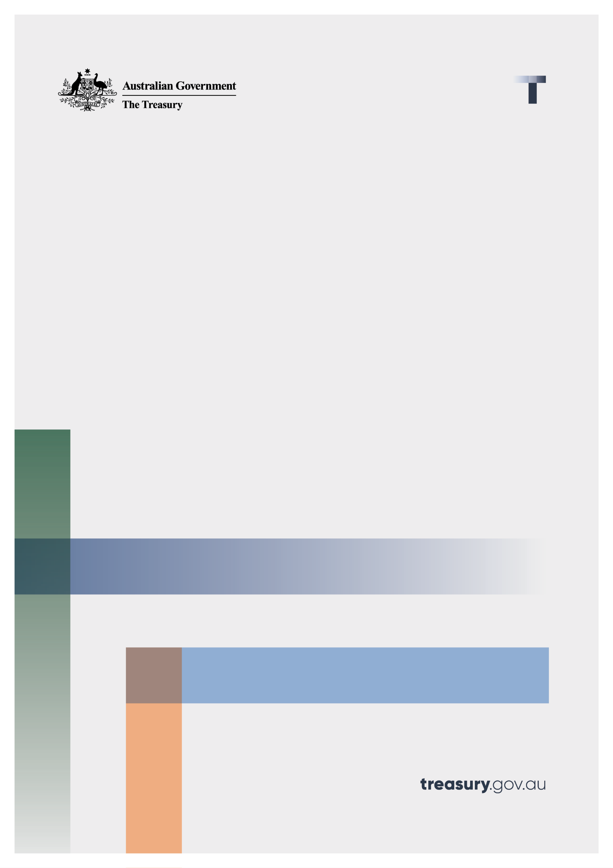

Shadow Economy Procurement Connected Policy

Consultation Paper on Performance Review

August 2022

© Commonwealth of Australia 2022

This publication is available for your use under a [Creative Commons Attribution 3.0 Australia](http://creativecommons.org/licenses/by/3.0/au/deed.en) licence, with the exception of the Commonwealth Coat of Arms, the Treasury logo, photographs, images, signatures and where otherwise stated. The full licence terms are available from <http://creativecommons.org/licenses/by/3.0/au/legalcode>.

Creative Commons attribution licence 3.0 icon. 

Use of Treasury material under a [Creative Commons Attribution 3.0 Australia](http://creativecommons.org/licenses/by/3.0/au/deed.en) licence requires you to attribute the work (but not in any way that suggests that the Treasury endorses you or your use of the work).

**Treasury material used ‘as supplied’.**

Provided you have not modified or transformed Treasury material in any way including, for example, by changing the Treasury text; calculating percentage changes; graphing or charting data; or deriving new statistics from published Treasury statistics — then Treasury prefers the following attribution:

*Source: The Australian Government the Treasury*.

**Derivative** **material**

If you have modified or transformed Treasury material, or derived new material from those of the Treasury in any way, then Treasury prefers the following attribution:

*Based on The Australian Government the Treasury data*.

**Use of the Coat of Arms**

The terms under which the Coat of Arms can be used are set out on the Department of the Prime Minister and Cabinet website (see [www.pmc.gov.au/government/commonwealth-coat-arm](http://www.pmc.gov.au/government/commonwealth-coat-arm)s).

**Other uses**

Enquiries regarding this licence and any other use of this document are welcome at:

Manager  
Media and Speeches Unit  
The Treasury  
Langton Crescent   
Parkes ACT 2600  
Email: [media@treasury.gov.au](mailto:media@treasury.gov.au)

# Contents

Contents ii

Consultation Process 3

Request for feedback and comments 3

Performance review of the Shadow Economy Procurement Connected Policy (PCP) 4

Introduction/Background 4

Purpose 4

Issues for discussion 5

1. Assessment of the PCP’s performance and effectiveness 5

2. Criteria for receiving a satisfactory Statement of Tax Record (STR) 6

3. Miscellaneous issues 7

# Consultation Process

## Request for feedback and comments

Interested parties are invited to comment on this consultation paper. While submissions may be lodged electronically or by post, electronic lodgement is preferred. For accessibility reasons, please submit responses sent via email in a Word or RTF format. An additional PDF version may also be submitted.

All information (including name and address details) contained in submissions will be made available to the public on the Treasury website unless you indicate that you would like all or part of your submission to remain in confidence. Automatically generated confidentiality statements in emails are not sufficient for this purpose. If you would like only part of your submission to remain confidential, please provide this information clearly marked as such in a separate attachment.

Closing date for submissions: 23 September 2022

|  |  |
| --- | --- |
| Email | taxadministrationconsultation@treasury.gov.au |
| Mail | Director, Tax Administration Unit  Individuals and Indirect Tax Division  The Treasury  Langton Crescent  PARKES ACT 2600 |

The principles outlined in this paper have not received Government approval and are not yet law. As a consequence, this paper is merely a guide as to how the principles might operate.

# Performance review of the Shadow Economy Procurement Connected Policy (PCP)

## Introduction/Background

As part of the 2018-19 Budget and in response to the Black Economy Taskforce’s Final Report, the Government announced a range of measures to tackle the shadow economy including a commitment that, from 1 July 2019, Government procurement processes will exclude businesses that do not have a satisfactory tax record.

Increasing the integrity of Commonwealth Government Procurement processes promotes good tax behaviour and creates an even playing field for businesses that comply with their tax obligations.

The Shadow Economy Procurement Connected Policy (PCP) commenced on 1 July 2019 and applies to new approaches to market on or after 1 July 2019, for procurements valued over $4 million (including GST) for all goods and/or services, including for construction services.

The PCP applies to Commonwealth Government procurements that are undertaken through open tenders and that are subject to the Commonwealth Procurement Rules. Procurements that meet these criteria must require that tenderers:

* Provide a satisfactory Statement of Tax Record (STR) that is a valid at the time of the tender closing.
* In circumstances where a satisfactory STR has not been issued in time to meet the tender deadline, provide a STR receipt demonstrating a STR has been requested from the ATO. In this case, the tenderer must provide the satisfactory STR no later than four business days from the close of tender and before the awarding of the contract.
* Hold copies of satisfactory and valid STRs for any first-tier subcontractors that the tenderer will engage to deliver goods or services with an estimated value of over $4 million including GST as part of the tender if known at the time of submission.
* Ensure, if first-tier subcontractors are subsequently engaged in respect of the contract, that the successful tenderer or prime contractor holds satisfactory and valid STRs of their first-tier subcontractors where the subcontractors estimated contract value will be over $4 million including GST.

The scope of the original PCP was limited, to ensure a smooth transition of the policy. The PCP notes that learning from this initial phase of operation would be assessed and updated guidance may be issued.

## Purpose

Under the Commonwealth Grants and Procurement Connected Policies (RMG 415) guide,   
policy-owning entities of approved PCPs are required to conduct annual reviews of their policy’s effectiveness in achieving its stated purpose and outcome. This consultation and review process is intended to fulfil this requirement.

In addition, this review provides an opportunity to examine and resolve some of the issues and suggestions for improvement that have been made by various stakeholders during the operation of the Shadow Economy PCP. Participants in this consultation are welcome to raise any other related issues or suggestions that are not covered by this consultation paper.

This review and consultation will examine the following issues:

1. Assess the performance of the PCP and whether it has been effective in achieving its stated purpose and outcomes.
2. Consider whether criteria for receiving a satisfactory STR should be added, removed or amended.
3. Resolve miscellaneous issues that have been raised during the operation of the PCP or during the course of this consultation.

This consultation paper is structured according to these three issues.

## Issues for discussion

### 1. Assessment of the PCP’s performance and effectiveness

#### Context

As noted in the foreword to the ‘Shadow economy – increasing the integrity of government procurement: Procurement connected policy guidelines’, the broad aims of the PCP are to:

* Reduce shadow economy behaviour by businesses involved in Government procurements contracts.
* Create a level playing field by eliminating competitors who can undercut their competition by not complying with key tax obligations.
* Improve supply chain integrity and set an example for private sector firms for their own supply chain management practices.

The PCP guidelines provide pre-set performance criteria against which the performance of the PCP should be measured, set out in the table below:

|  |  |
| --- | --- |
| Performance criteria | Responsible entity |
| 1. STRs are issued and provided to businesses within four business days | Australian Taxation Office (‘ATO’) |
| 1. Procurements with an estimated value of over $4 million inclusive of GST contain the requirement for a STR where required | Treasury with assistance from other agencies |
| 1. Unsatisfactory STRs issued result in corrective action by an applicant where possible | ATO |
| 1. Satisfactory feedback received from suppliers, procurement officers, ATO and Department of Finance | Treasury |

This consultation paper is seeking feedback and comments on performance criteria (b) and (d). Performance criteria (a) and (c) will be assessed through direct liaison with the ATO and analysis of their data holding regarding STRs they have issued during the operation of the PCP.

#### Consultation Questions

1. Has the PCP been effective in achieving the broad policy aims (detailed in the foreword to the guidelines)?
2. In your experience, is the PCP applied consistently?
3. Do you consider businesses could benefit from using the STR to improve integrity in their supply chain and for supply chain management practices?
4. If yes, are there any impediments to businesses using the STR to improve their supply chain integrity?

### 2. Criteria for receiving a satisfactory Statement of Tax Record (STR)

#### Context

As stated in the PCP guidelines, a satisfactory STR will be issued by the ATO if the following conditions are met:

* The applicant is up-to-date with registration requirements which may include being registered for an Australian Business Number (ABN) and GST, and having a Tax File Number;
* The applicant has lodged at least 90 per cent of all income tax returns, Fringe Benefit Tax returns and Business Activity Statements that were due in the last four years or the period of operation if less than four years. Reasonable delays in lodgements due to extensions agreed to by the ATO will not affect the receipt of a satisfactory STR; and
* On the date the STR is issued, the applicant does not have $10,000 or greater in overdue debt due to the ATO (excluding debt subject to a taxation objection, review or appeal under the provisions of Part IV C of the *Taxation Administration Act 1953*). If the applicant has entered into a payment plan with the ATO, they will meet this criterion.

#### Discussion

The PCP guidelines foreshadow that further criteria could be added to determine whether a STR is ‘satisfactory’.

The current STR criteria can mostly be automatically assessed. The ATO has significantly improved the turnaround time for issuing STRs and has recently achieved the benchmark of issuing 100 per cent of STR requests within 4 days of application in June 2022.

The current service standards can only be met if any expansion/s of STR requirements relate to source data that can be easily accessed digitally by the ATO and is fit for purpose.

Consultation Questions

1. Are the existing STR criteria appropriate and sufficient to meet the policy objectives of the Shadow Economy Procurement Connected Policy?
2. Should businesses that have a greater impact on the policy objectives of the PCP be subject to additional criteria to obtain an STR?

### 3. Miscellaneous issues

#### Context

During the operation of the Shadow Economy PCP, a number of issues have been raised by various stakeholders. This review provides an opportunity to address these issues and improve the overall operation of the PCP.

#### Discussion

The issues that have been brought to Treasury’s attention during the operation of the PCP are detailed below. We are also seeking your feedback on any other miscellaneous issues that you consider should be addressed through this performance review process.

*PCP threshold*

Questions have been raised about whether the current $4m (GST inclusive) threshold is still appropriate.

This threshold was chosen to reduce the impact on small businesses and align with existing Commonwealth Procurement Rules (CPRs) to reduce complexity. However, a commonly held view is that small businesses are more likely to be engaged in the shadow economy and the $4 million threshold will only impact larger businesses.

Relatedly, on 1 July 2022, the Government announced that CPRs would be revised to require that 20 per cent of procurements by value are sourced from small and medium businesses (SMEs), which represents an increase from the previous target of 10 per cent, with a view to increasing the benefit to SMEs from government contracts.

*STR submission timeframes*

The PCP currently requires tenderers to:

* Provide a satisfactory STR that is valid at the time of the tender closing.

In circumstances where a STR request has been made late in the tender period, the tenderer must provide a STR receipt demonstrating a STR has been requested from the ATO, and provide a satisfactory STR no later than four business days from the close of tender and before the awarding of the contract.

It has been suggested that these timeframes are short and unnecessarily restrictive. This has led to tender processes being set aside due to non-compliant submissions.

*Panel arrangements*

Businesses participating in a panel arrangement are required to provide a STR as part of their tender documentation. Panels may remain active for a number of years. It has been suggested that the PCP should be changed to only seek a STR from a business once it has been selected from the panel to deliver services (at contract stage) that meet the thresholds set out in the Shadow Economy PCP.

It has been further suggested that the requirement to provide STRs at the establishment stage of a new panel arrangement if the collective value of the arrangement is greater than $4 million is counterintuitive, given panel members may only be contracted to deliver works under the $4 million threshold or not at all.

Furthermore, anecdotal evidence suggests that a high administrative burden is placed on procurement officers to manage the large volume of STRs for the establishment of a Panel. Due to this resource burden, less time can be spent on evaluating tender applications as a result.

*Subcontractors*

The PCP does not apply all the way down the subcontractor chain: it only applies to first-tier subcontractors. Ideally, the PCP would apply all the way down the supply chain to meet the policy intent. However, in practice, this is onerous and difficult to comply with. As a compromise, it was decided that the arrangement only applies to first-tier subcontractors while the PCP foreshadowed that this setting would be reviewed in the future.

*Partnerships and trusts*

Structures such as partnerships and trusts are not separate legal identities (as opposed to natural persons and companies). While they can be registered for income tax, have an ABN and lodge tax returns, they do not have a tax liability. This does not sit well with the debt criterion for a satisfactory tax record.

To address this, the PCP requires STRs from partners. While legally all partners should be required to submit a satisfactory STR, in practice this would be very difficult for large partnerships, so a decision was made to restrict the requirement to partners that are directly involved with the procurement.

*New businesses and foreign tenderers*

Different rules apply to new businesses (i.e. businesses with tax records shorter than four years) and foreign tenderers as the ATO may not have sufficient tax records to determine if they satisfied the normal STR criteria. It was considered impractical to acquire this information from foreign jurisdictions in the case of foreign tenderers.

The PCP currently requires tenderers that fall into this category to state that they:

* do not have a tax record or a tax record of less than four years in Australia (applicable to foreign entities);
* will comply and pay all their Australian tax obligations (applicable to Australian and foreign entities);
* have no tax related convictions in the last four years (applicable to Australian and foreign entities); and
* are complying with their tax obligations outside of Australia (applicable to foreign tenderers and new Australian businesses).

Once the ATO receives these statements, a STR will be issued, stating they do not have a tax record with the ATO but will be accepted as having a satisfactory tax record, or, if they have a tax record with the ATO of less than four years, they meet the criteria at 6.b) i) – iii) in the guidelines but have a record of less than four years.

The issued STR is based on the tax records that are available to the ATO and is valid for six months only.

*Guidance and resources for tenderers*

It has been suggested that the STR guidance and resources available to tenderers is not comprehensive leading to lack of understanding and non-compliant tenders.

#### Consultation questions

1. Is the current $4m (GST inclusive) threshold appropriate? If not, what should it be?
2. Are the current policy settings in the PCP appropriate and sufficient in the context of the policy goals, in respect of:
   1. STR timeframes;
   2. panel arrangements;
   3. bids from trusts and partnerships;
   4. the application to first-tier subcontractors only; and
   5. new businesses and foreign tenderers
3. Are the guidelines satisfactory and sufficiently clear in operation (including in relation to whether the PCP applies in a given circumstance)?
4. Are there changes that should be made to the model contract clauses in the PCP guidelines?
5. Is there any additional guidance and resources that should be made available to assist tenderers to understand their obligations and submit compliant tenders?
6. Are there any other changes to the PCP or STR application process that should be made?
7. Do you have any other feedback on the application of the PCP?