,`

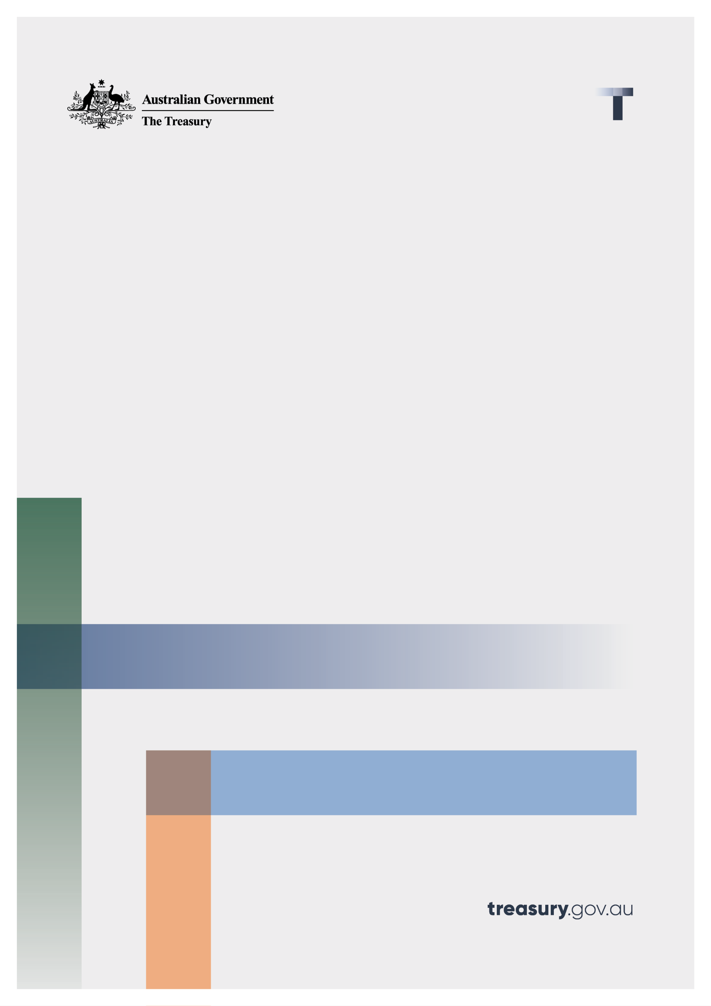

Quality of Advice Review

Consultation paper – Proposals for Reform

August 2022

© Commonwealth of Australia 2022

This publication is available for your use under a [Creative Commons Attribution 3.0 Australia](http://creativecommons.org/licenses/by/3.0/au/deed.en) licence, with the exception of the Commonwealth Coat of Arms, the Treasury logo, photographs, images, signatures and where otherwise stated. The full licence terms are available from <http://creativecommons.org/licenses/by/3.0/au/legalcode>.

Creative Commons icon

Use of Treasury material under a [Creative Commons Attribution 3.0 Australia](http://creativecommons.org/licenses/by/3.0/au/deed.en) licence requires you to attribute the work (but not in any way that suggests that the Treasury endorses you or your use of the work).

**Treasury material used ‘as supplied’.**

Provided you have not modified or transformed Treasury material in any way including, for example, by changing the Treasury text; calculating percentage changes; graphing or charting data; or deriving new statistics from published Treasury statistics — then Treasury prefers the following attribution:

*Source: The Australian Government the Treasury*

**Derivative** **material**

If you have modified or transformed Treasury material, or derived new material from those of the Treasury in any way, then Treasury prefers the following attribution:

*Based on The Australian Government the Treasury data*

**Use of the Coat of Arms**

The terms under which the Coat of Arms can be used are set out on the Department of the Prime Minister and Cabinet website (see [www.pmc.gov.au/government/commonwealth-coat-arm](http://www.pmc.gov.au/government/commonwealth-coat-arm)s).

**Other uses**

Enquiries regarding this licence and any other use of this document are welcome at:

Manager  
Media and Speeches Unit  
The Treasury  
Langton Crescent   
Parkes ACT 2600  
Email: [media@treasury.gov.au](mailto:media@treasury.gov.au)

# Contents

Contents ii

Consultation Process 3

Quality of Advice Review – Proposals for Reform 4

Glossary 5

Summary 6

Short form proposals for consultation 8

1. What Should Be Regulated? 10

2. How Should Personal Advice Be Regulated? 15

3. Intra-fund advice 24

4. Advice fees in superannuation 27

5. Advice Fees 29

6. Disclosure Obligations 32

7. Design and distribution obligations 34

8. Enforcement 36

Attachment A: Cameos 38

Attachment B – Consultation questions 44

# Consultation Process

## Request for feedback and comments

Interested parties are invited to provide comments on the proposals included in this Paper. It would be helpful if comments could be lodged using the template on the Treasury Quality of Advice Review website: <https://treasury.gov.au/review/quality-advice-review>.

Submissions may be lodged electronically or by post. Electronic lodgement is preferred.

All information (including name and address details) contained in submissions will be made available to the public on the Treasury website unless you indicate that you would like all or part of your submission to remain in confidence. Automatically generated confidentiality statements in emails do not suffice for this purpose. Respondents who would like part of their submission to remain in confidence should provide this information marked as such in a separate attachment.

Legal requirements, such as those imposed by the Freedom of Information Act 1982, may affect the confidentiality of your submission.

Please view Treasury’s [Submission Guidelines](https://treasury.gov.au/submission-guidelines) for further information.

Closing date for submissions: 23 September 2022

|  |  |
| --- | --- |
| Email | [AdviceReview@treasury.gov.au](mailto:AdviceReview@treasury.gov.au) |
| Mail | Quality of Advice Review Secretariat  Financial System Division  The Treasury  Langton Crescent  PARKES ACT 2600 |
| Enquiries | Enquiries can be initially directed to [AdviceReview@treasury.gov.au](mailto:AdviceReview@treasury.gov.au) |

The principles outlined in this paper have not received Government approval and are not yet law. As a consequence, this paper is merely a guide as to how the principles might operate.

# Quality of Advice Review – Proposals for Reform

## Purpose of the review

The purpose of the Review is to consider whether changes should be made to the regulatory framework applying to financial advice to improve the accessibility and affordability of financial advice. My answer to that question is 'yes'. Moreover, I think the changes need to be substantial if financial advice is going to be widely accessible and truly affordable. This is reflected in the proposals in this paper.

It is clear the current regulatory framework is a significant impediment to consumers accessing financial advice. It is also preventing advisers and institutions providing advice and assistance to their customers. The proposals in this paper are intended to make it easier for consumers to access financial advice that meets their needs from a range of different providers and for advisers and financial institutions to have more helpful conversations with their customers.

Some stakeholders might be concerned that the proposals would retract hard fought changes intended to protect consumers. I do not hold that view. The proposals are intended to make it easier for consumers to get personal advice. Therefore, they are also intended to make it easier for providers of financial advice - financial advisers, product issuers and digital advice providers - to provide personal advice. In my view this greater ease is achieved without introducing a corresponding risk of harm to consumers, who will be protected by a proposed new obligation to give good advice and by the many existing consumer protection provisions in the law.

## Feedback and consultation

Many people made thoughtful and detailed submissions in response to the Discussion Paper and I have had helpful discussions with a broad range of industry participants, consumer groups and regulators. Members of the Review Secretariat have undertaken site visits of advisers' offices and we have undertaken a survey of advisers. 3,326 advisers have responded to the survey. All of this has helped in the formulation of the proposals and I am grateful for the good will, work and effort of everyone who has participated in the Review so far.

## More to come

The Review is not over and this paper sets out proposals for the purposes of further discussion. They are not final recommendations, nor are they complete. This paper does not include any proposals for life insurance and general insurance commissions nor other forms of benefits because we are still collecting information on these topics. We are currently analysing qualitative and quantitative data from general insurers and expect to receive life insurance data from ASIC by the end of September 2022.

While we are not intending to release another proposals paper, we will continue to discuss proposals as they are developed and so there will be an opportunity for stakeholders to provide further feedback.

# Glossary

|  |  |
| --- | --- |
| Term | Definition |
| AFCA | Australian Financial Complaints Authority |
| AFSL | Australian financial services licensee |
| APRA | Australian Prudential Regulatory Authority |
| ASIC | Australian Securities and Investments Commission |
| ASIC Act | *Australian Securities and Investments Commission Act 2001* |
| Code of Ethics | Financial Planners and Advisers Code of Ethics 2019 |
| Competition and Consumer Act | *Competition and Consumer Act 2010* |
| Corporations Act | *Corporations Act 2001* |
| DDO | Design and Distribution Obligations |
| FDS | Fee Disclosure Statement |
| FOFA legislation | *Corporations Amendment (Future of Financial Advice) Act 2012* and *Corporations Amendment (Further Future of Financial Advice Measures) Act 2012* |
| FSG | Financial Services Guide |
| PDS | Product Disclosure Statement |
| Review | Quality of Advice Review |
| RG | ASIC Regulatory Guide |
| Ripoll Inquiry | Parliamentary Joint Committee on Corporations and Financial Services (PJC) into Financial Products and Services |
| ROA | Record of Advice |
| Royal Commission | Royal Commission into Misconduct in the Banking, Superannuation and Financial Services Industry |
| SIS Act | *Superannuation Industry (Supervision) Act 1993* |
| SOA | Statement of Advice |
| TMD | Target Market Determination |

# Summary

## Compliance burden

We have been told that the difficulty and burden of complying with regulation is impeding access to financial advice. It prevents many financial services providers providing simple advice and assistance to their customers; it inhibits the development of digital advice tools; and, it has made comprehensive advice unaffordable for many people. Advisers have left the industry and are not being replaced and when consumers do get financial product advice they are given documents they do not want and rarely read. I accept that all of these things are true. It is also true that removing regulatory requirements could make it much easier for the industry to provide financial product advice and to provide that advice at a lower cost. However, accessible and affordable advice is only worthwhile if the advice is good advice.

## The benefits of good financial advice

We have been provided with evidence that good and timely financial advice can improve outcomes for consumers. We have also been told about the harm that can follow when a person is not provided with relevant advice.

I accept that good financial advice can be valuable. Equally, bad advice can cause real harm. It is because of what the 2009 inquiry by the Parliamentary Joint Committee on Corporations and Financial Services (**PJC**) into Financial Products and Services (**Ripoll Inquiry**) described as the 'catastrophic' and 'devastating' effect of financial advice provided by Storm Financial and Opes Prime that we have much of the law the industry complains about now. It is imperative that changes to regulation made to promote greater access to advice do not expose consumers to harm.

## Current regulatory framework

The current regulatory framework focuses on disclosure, remuneration, education and conduct. Advisers who provide personal advice to retail clients must provide their clients with product disclosure statements (**PDSs**) for the products they recommend, a financial services guide (**FSG**), a statement of advice (**SOA**) and various warnings. These requirements commenced two decades ago with the *Financial Services Reform Act 2001* and proceed on the basis that, if consumers are armed with all the relevant information, they will make well informed choices in their own interests.

The Ripoll Inquiry concluded that disclosure did not protect consumers against harmful advice. (I note there is no reason to think it is more effective now.) And so the PJC recommended '*an explicit legislative fiduciary duty on financial advisers requiring them to place their clients' interests ahead of their own'*.[1] Following that, in 2013, the Future of Financial Advice legislation (**FOFA**) introduced bans on conflicted remuneration and required advisers to act in the best interests of their clients when providing them with personal advice. The duty directs attention to the adviser's purpose and process rather than to the substance of the advice[2]. These obligations apply in addition to the original disclosure obligations.

The premise and hope of FOFA is that, if the provider of the advice has no personal interest in the advice and if the adviser complies with the conduct requirements, the advice that follows will be sound.[3] However, even in the absence of commissions, bonuses and volume-benefits, it is very difficult to remove self-interest and hard to regulate conduct that happens in private and the evidence suggests the best interests duty has not been more effective than disclosure in protecting consumers from poor advice.

In my view a more direct and better way to regulate the provision of advice is to start precisely where the current regime does not - with the content of the advice. Consumers want good advice – not documents and processes. And advice can be more easily measured and assessed than conduct.

## A new way to regulate advice

The law can and in my view should require a provider of financial advice to provide good advice. What is good advice can and should be measured objectively in light of all of the relevant circumstances at the time the advice is given. The intention of a duty cast in this way is to focus attention directly on the consumer and the advice rather than on the provider and the process for formulating the advice. It is not intended to permit poorer quality of advice, to the contrary it is intended to encourage better more tailored personal advice.

A duty to give good advice does place a different kind of responsibility on providers than laws which prescribe process. It also creates the opportunity to remove many of the regulatory requirements relating to disclosure and some relating to conduct. This will allow providers to decide what they need to do to ensure their advice is in fact good advice. It will relieve providers of obligations to comply with requirements that are unnecessary or do not respond to the circumstances and needs of their customers. It creates more opportunity for providers to think about the form in which they provide advice to customers and opens up more room for innovation while requiring providers to keep a keen eye on what their customers want and need. In my view this would encourage better quality advice and provide consumers and advisers with a clear statement of what they can expect and what they are required to do.

In summary, by focusing on the quality of the advice given, the law does not need to regulate or prescribe the inputs. It is this premise which underpins the proposals set out for consideration in this paper.

The rest of the paper

The proposals on which I am seeking feedback are set out below. They are followed by a more detailed explanation of the proposals and examples. In considering the proposals, it is important to note two things: the proposals are intended to work together; and they are intended to apply in addition to many of the consumer protections that are part of the regulatory regime now.

# Short form proposals for consultation

What follows are short form proposals for consideration. The reasons I am thinking about these proposals follow in the detail of the paper. I am keen to get feedback on whether they will assist consumers to get advice (and providers to give advice) and whether they might introduce new risks to consumers.

### What should be regulated?

1. The financial services regime should regulate the provision of ‘personal advice’. The definition of ‘personal advice’ should be somewhat broader so that it is clear it applies whenever a recommendation or opinion is provided to a client about a financial product (or class of financial product) and, at the time the advice is provided, the provider has or holds information about the client’s objectives, needs or any aspect of their financial situation.

This would replace the current definition of ‘personal advice’ which applies where the provider actually considers the client’s objectives, financial situation or needs, or where a reasonable person might expect the provider to have considered any of these matters.

1. The regime should no longer regulate ‘general advice’ as a financial service and the definition should be removed together with the obligation to give a general advice warning.

What is currently general advice (but would not be covered under the proposed definition of personal advice) should continue to be subject to general consumer protections, in particular the prohibition against engaging in misleading or deceptive conduct in connection to the supply of financial services. The conflicted remuneration provisions would also need to be adjusted so that they continue to apply to conduct which is currently general advice.

### How should personal advice be regulated?

1. The financial services regime should require a person who provides personal advice to provide 'good advice’. 'Good advice' is advice that would be reasonably likely to benefit the client, having regard to the information that is available to the provider at the time the advice is provided.

The obligation to provide ‘good advice’ would replace the best interests duty, the appropriate advice duty, the duty to warn the client and the duty of priority in Chapter 7 of the Corporations Act.

1. A provider of personal advice should be a ‘relevant provider’ where the provider is an individual and the client pays a fee for the advice, the provider (or the provider’s authorising licensee) receives a commission in connection with the advice, there is an ongoing advice relationship between the adviser and the client, or the client has a reasonable expectation that such a relationship exists. The professional standards would not apply to a body corporate nor to an individual who is not a relevant provider.

A 'relevant provider' must (as they do now) comply with the professional standards (education and training standards and the Code of Ethics), noting the Government is separately considering the professional standards. This would replace the existing requirement that any individual who provides personal advice to a retail client be a relevant provider.

### Intra-fund advice and paying for advice through superannuation

1. Superannuation fund trustees should be able to provide personal advice to their members about their interests in the fund, including when they are transitioning to retirement. In doing so, trustees would be required to take into account the member's personal circumstances, including their family situation and social security entitlements if that is relevant to the provision of the advice.
2. Superannuation fund trustees should have discretion to decide how to charge members for personal advice they provide to members and the restrictions on collective charging of fees should be removed.
3. Superannuation trustees should be able to pay a fee from a member's superannuation account to an adviser for personal advice provided to the member about the member's interest in the fund on the direction of the member.

### Disclosure documents

1. Providers of personal advice should obtain annual written consent from their client to deduct ongoing advice fees from a financial product. The consent form should explain the services that will be provided and the fee the adviser proposes to charge over the course of the upcoming 12 months. Where advice fees are deducted from more than one product, a single consent form should cover each of the products issued by a product issuer.

This would replace the current requirements for advisers to annually give clients a fee disclosure statement, seek their agreement to renew fee arrangements and obtain their clients' signed consent to deduct fees from financial products.

1. Providers of personal advice should be able to determine what form of advice would best suit their clients. Providers should be required to maintain complete records of the advice they provide and to provide a written record of advice to a client on request. This would replace the current requirement for advisers to provide a statement of advice or record of advice.
2. Providers of personal advice should either continue to give their clients a copy of the financial services guide or make information available to their clients on their website about their remuneration and other benefits they receive, their internal dispute resolution procedures and AFCA. This information should be available at the time the advice is provided. This would offer advisers increased flexibility in how they provide information to their clients.

### Design and distribution obligations

1. The reporting requirements under the design and distribution obligations regime should be simplified by requiring relevant providers to only report to the product issuer where they have received a complaint in relation to a financial product.

Providers of personal advice who would no longer be required to be relevant providers, would continue to be subject to the current reporting requirements under the design and distribution obligations regime.

### Transition period and enforcement

1. There should be an adequate transition period for implementing these changes. Consideration should also be given to allowing providers to 'opt in' early.

# What Should Be Regulated?

## What does the law regulate now?

* 1. Financial product advice is a financial service

The regulation of financial advice in the Corporations Act starts with the definition of financial product advice in section 766B. The provision of financial product advice is a financial service. The obligations attaching to that financial service turn on whether the financial product advice is personal advice or general advice. These, too, are terms defined in the Corporations Act.

* 1. Is the current definition of personal advice too uncertain?

Many people have told us that the distinction between personal advice and general advice is too uncertain. Personal advice is financial product advice that considers one or more of a person's objectives, financial situation and needs, or which a reasonable person might think considers one or more of a person's objectives, financial situation and needs. They say the uncertainty creates excessive legal risk. They also say the definition of personal advice is too broad. This is because it prevents a provider that has information about their customers providing useful information and guidance to their customers without complying with onerous personal advice obligations.

While I acknowledge there is some uncertainty around the edges, I am not convinced the definition of personal advice is too uncertain. I say this because the same uncertainty exists in the definition of financial product advice itself and yet very few people have raised concerns about it.

I suspect the concerns that have been raised about the uncertainty of the definition of personal advice arise in large part because of the obligations attaching to the provision of personal advice. Few financial services providers are worried about providing general advice and so it is commonplace to see general advice warnings on statements which contain only information (and which are not financial product advice at all). On one view the warning is for the avoidance of doubt and does no harm.

The consequences of providing personal advice (rather than general advice) are of course much more significant. And so, because many providers cannot or do not want to provide personal advice they try to shoehorn what would more naturally be personal advice conversations with customers into general advice. The result is often scripted conversations during which providers deliberately avoid asking questions or using information they have about their customers and speak in generalisations. And so the customer gets less helpful advice than they otherwise could (we have been told that customers often complain about not being able to get advice from financial institutions) because providers are not prepared to use information they have to tailor advice when they could. They are worried (rightly) that by doing so they will provide personal advice and attract the coincident obligations. And it is this which makes the industry say the definition of personal advice is not only too uncertain but also too broad.

* 1. Should there be more categories of advice?

At the same time as I have been asked to provide greater certainty about the parameters of personal advice and general advice, many stakeholders have asked for more categories of advice – product advice, strategic advice, limited advice and product guidance are some of the suggested terms. The purpose of doing so would be to narrow the categories of advice that are regulated as personal advice and make it easier for providers to provide what is now regulated as personal advice to their customers.

While I agree with the intention, I think more categories and more definitions would create more regulatory boundaries, more complexity and with them more cost and more risk. In my view, the regulation would benefit from fewer defined terms and fewer boundaries and the definition of personal advice is not too broad.

* 1. Would a principles-based approach be more effective?

The Terms of Reference for the Review specifically ask us to consider whether a principles based regulatory regime would be more effective. My answer to that question is 'yes' if that expression means fewer defined terms, less prescription and more flexibility so that what is required by the law adjusts to the circumstances. I do not think it follows that principles based law is more uncertain. Few people say that the laws prohibiting misleading or deceptive conduct are unclear. Whether principles based law is certain turns on the clarity of the drafting. I also do not think principles based law poses greater risks for consumers than detailed and prescriptive law. However, I accept there is a greater responsibility for the industry in deciding how to comply with the law.

The feedback we have received confirms what one would expect - consumers want and benefit from specific, direct and straightforward advice which takes into account (considers) their relevant personal circumstances. We also know from the cases that when a customer speaks to their financial institution they expect them to have taken into account the information they hold about the customer. And so, financial institutions should be encouraged to speak to their customers about their objectives, financial situation and needs and when they have relevant information about their customers they should be encouraged to use it to provide helpful advice.

In my view, a principles based approach to regulation would encourage providers to give personal advice by making it easier to do so, where that is appropriate, rather than by narrowing defined terms, creating new categories of advice and adopting different rules for those different categories. If providers can be more confident about providing personal advice in a way which complies with the law, they should be more willing to assume they are providing personal advice when there is any doubt. In that way, they can have more natural and helpful conversations and other interactions with their customers and less effort and cost can be spent on avoiding crossing over the personal advice line.

* 1. What should personal advice cover?

Therefore, rather than narrowing the definition of personal advice or introducing more categories of personal advice, I am minded to recommend only minor changes to the definition of personal advice, with those changes being intended to broaden, somewhat, the existing definition. This broader definition would mean that a financial institution could not seek to avoid giving personal advice to a customer by seeking to quarantine information they hold about the customer for the purposes of giving advice. It is doubtful whether such efforts are effective, but the changes I am thinking about would make it clear they are not available. It would mean that, in very large part, all personal conversations and interactions between a customer and their bank, superannuation fund or insurer would be personal advice conversations and interactions *if* they include a recommendation or opinion which is intended to influence the customer to make a decision about a financial product or a class of financial product, or if they could reasonably be regarded as being intended to do so. The changes would not change conversations which merely provide information, even tailored information, into personal advice. In saying this, I do recognise that there will be cases in which it will be difficult to determine whether information that is tailored to the customer might contain a recommendation or opinion and therefore whether it would meet the definition of personal advice. The changes I am proposing to the duties which attach to giving personal advice will, I hope, encourage providers to assume they are providing personal advice when they are in doubt. This will be to the benefit of consumers.

**Proposal 1: Regulation of personal advice**

The financial services regime should regulate the provision of ‘personal advice’. ‘Personal advice’ is a recommendation or opinion provided to a client about a financial product (or class of financial product) and, at the time the advice is provided, the provider has or holds information about the client’s objectives, needs or any aspect of the client's financial situation.

**Outcome:** This proposal is aimed at reducing regulatory complexity and enabling advice providers to provide more helpful guidance and financial advice to their customers.

## General advice

* 1. What is general advice?

General advice is defined in section 766B of the Corporations Act as financial product advice that is not personal advice and as such it is the residue between financial product advice and personal advice. Almost no one is happy with the term 'general advice'. I include myself in this unhappy group.

* 1. Should general advice be called something else?

There is evidence that consumers do not understand what general advice is and indeed that the general advice warning can be misleading – an explanation that 'any advice' does not take into account the person's personal circumstances is in fact understood by some consumers to do just the opposite – to take into account the person's personal circumstances, especially where the advice was provided in a personal communication.

We have received many submissions about renaming general advice. Many suggested it be renamed general information or even product information. I do not favour this approach because it ignores the fact the current definition applies only where there is a recommendation or opinion, and is therefore something other than mere information.

ASIC commissioned independent research on alternative labels and published the findings on 4 May 2021. ASIC said the research found:

1. no evidence that a change in the label will change consumer understanding of general advice; and
2. no alternative labels to 'general advice' would be a significantly better fit with the description of general advice.
   1. Do we need general advice at all?

In my view we should start by asking 'what is the term 'general advice' for'?

There are two primary purposes: first it brings the provision of general advice into the regulation of financial services; and second, it requires consumers to be warned about the limitations of general advice.

It then serves other secondary purposes – a person who provides general advice to a retail client cannot accept conflicted remuneration and they will engage in retail product distribution conduct for the purposes of the design and distribution obligations.

It is difficult to see any benefit to consumers in providing a general advice warning, given that consumers:

1. struggle to understand the meaning of the term general advice; and
2. misunderstand or ignore general advice warnings.

It is also a concern that general advice warnings are often misused. As noted above, it is common for warnings to be included on all documents issued by financial services providers irrespective of whether they include general advice and, more problematically, the general advice warning is sometimes used in an effort to present personal advice as general advice.

Indeed I would go further - it is difficult to see how the regulation of general advice (as a financial service of itself) provides any benefit to consumers. This does not mean that general advice would not exist – I accept that general advice (which might be provided in customer seminars or newsletters for example) can be valuable - but rather that general advice does not need a label or its own regulation. In my view, general advice should no longer be a financial service.

This does not mean the recommendations and opinions that are now general advice would be unregulated. The consumer protection provisions in Division 2 of Part 2 of the ASIC Act are broadly drafted – they apply to conduct that is *connected with* a financial service, not merely conduct that is itself a financial service. For example, while a financial services provider that recommended a financial product to consumers in an advertisement or seminar would not be providing a financial service, it would nevertheless be undertaking conduct which is 'in connection with the supply or possible supply of financial services' (that is, dealing in a financial product). It would also be the 'promotion … of the supply or use of financial services'. Accordingly, if the advertisement or seminar included a misleading or deceptive representation, the financial services provider would breach the ASIC Act. The obligation for a financial services provider to 'do all things necessary to ensure that financial services covered by the licence are provided efficiently, honestly and fairly' in paragraph 912A(1)(a) of the Corporations Act also has a broad reach and may also be relevant.

* 1. Consequences of general advice ceasing to be a financial service

If general advice ceases to be a regulated financial service, a person that provides general advice would not need to provide a general advice warning when advertising a financial product, providing a newsletter or conducting a seminar. They would not need a specific AFS authorisation to do any of those things (assuming that in doing so they are not providing personal advice or dealing in a financial product).

A person that provides general advice and no other financial service would not need an AFS licence at all and they would fall outside Chapter 7 of the Corporations Act and the ASIC Act framework. There are 108 current AFS licensees with an authorisation to give general advice only. While this would mean that these existing licensees would no longer be subject to the general obligations of a licensee, including to ensure that financial services are provided efficiently, honestly and fairly and to have a complying dispute resolution system, they would nevertheless have obligations under the Competition and Consumer Act, in particular not to engage in misleading or deceptive conduct.

If this change is made, there will also need to be other changes to the Corporations Act. The general advice definition is relevant to the conflicted remuneration provisions and the design and distribution obligations and these will need to be amended to prevent any regulatory gaps because of the removal of general advice as a particular head of financial service. The proposal should not permit the provision of benefits which would influence a person to recommend a product (irrespective of whether the recommendation constitutes personal advice). So I would propose that the conflicted remuneration provisions in the corporations legislation be amended in the same way as the provisions that apply to life insurance so that conflicted remuneration is linked to the provision of personal advice or the provision of information about a financial product. Consequential changes will also need to be made to the design and distribution obligations in relation to the current exemption for personal advice providers from the design and distribution obligations. Diagram 1 provides an overview of the proposed regulatory framework.

**Diagram 1: Proposed Financial Advice Framework**

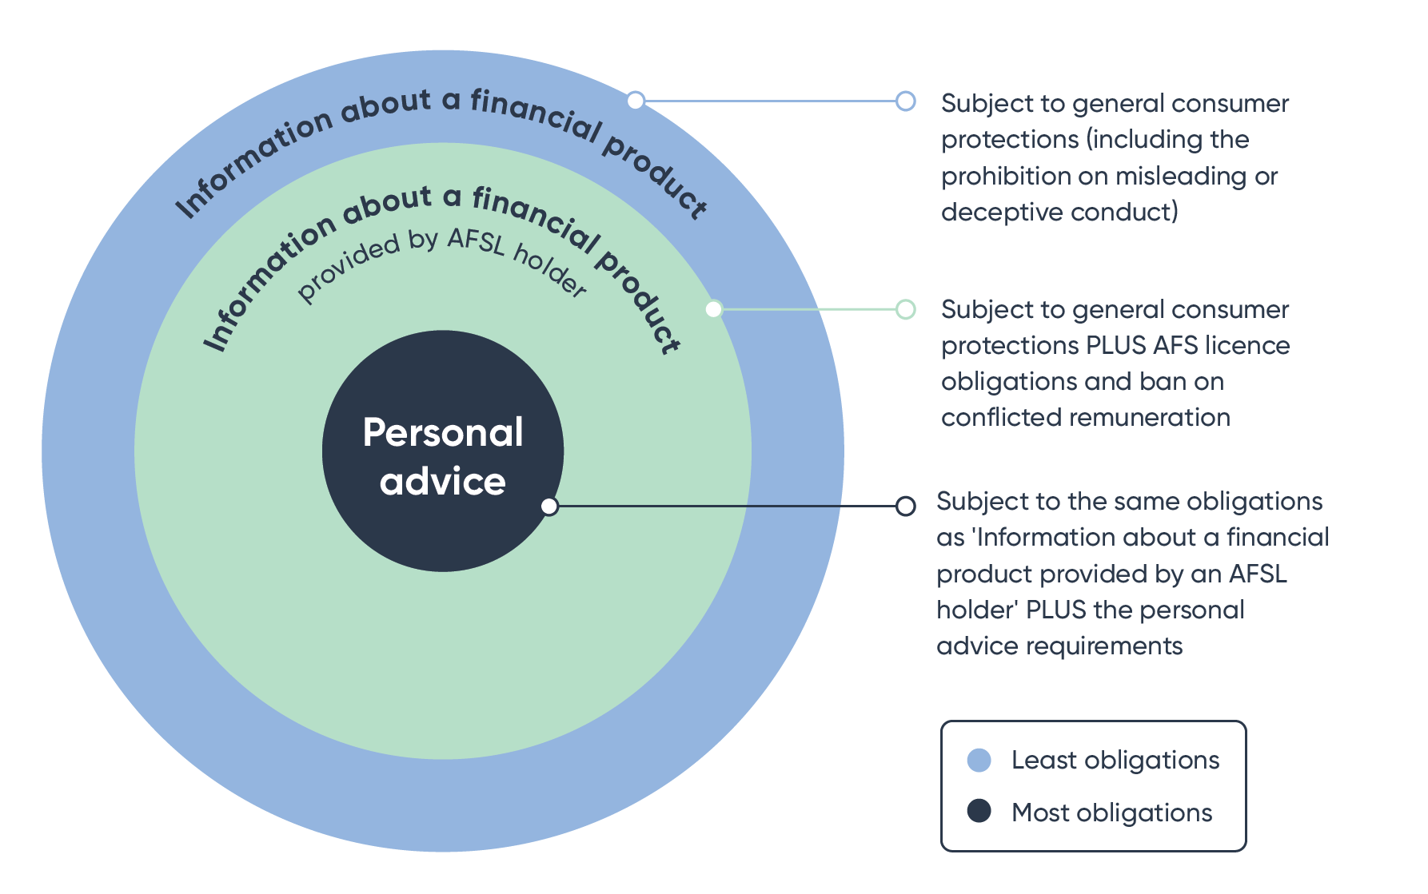

**Proposal 2: General advice**

‘General advice’ should no longer be regulated as a financial service and the definition of ‘general advice’ should be removed together with the obligation to give a general advice warning.

**Outcome:** This proposal is aimed at reducing regulatory complexity and aligning the regulatory regime with customer expectations.

# How Should Personal Advice Be Regulated?

Having decided what should be regulated (personal advice) it is then necessary to consider how it should be regulated so that good advice is more accessible and more affordable. If the existing law is an impediment, it should be changed.

## Existing personal advice regime

1. 1. Best interests duty

Chapter 7 of the Corporations Act requires a person who provides personal advice to a retail client to:

1. act in the best interests of the client in providing the advice, which the provider may do by complying with the safe harbour steps;
2. give a warning to the client if the advice is based on inadequate or insufficient information;
3. provide advice that is appropriate assuming the best interests duty is satisfied;
4. give priority to the client's interests if there is a conflict between the interests of the client and the provider or the interests of the client and the interests of an associate of the provider.

These obligations are referred to below as the 'Chapter 7 best interests obligations'.

* 1. Fiduciary-like, not fiduciary duties

The best interests duty and the duty of priority are intended to impose fiduciary-like duties, but they are not fiduciary duties. They do not prohibit, and were not intended to prohibit, an adviser acting in their own interests.

As many people have noted, if you thought the clues were in the language of acting in the client's interests, the safe harbour steps suggests otherwise. These steps are the steps a careful adviser might take in discharging their duty of care. They have nothing to say about acting without a conflict or not taking an unauthorised profit and so one may wonder in what way the formulation in Chapter 7 is fiduciary-like.

* 1. Safe harbour steps

Commissioner Hayne was critical of the safe harbour steps because they encouraged a narrow checklist based approach rather than a genuine consideration of what an adviser should do to comply with their duty to act in the best interests of the client.

In submissions and during discussions, many people told us they follow the safe harbour steps because that is required by ASIC and AFCA. Many people also told us the steps are highly prescriptive and documenting how the steps have been satisfied creates a significant regulatory burden. They say the safe harbour requires a review of the marketplace of relevant financial products and, consistent with that, some of the submissions we have received say that removing the safe harbour would improve access to advice because advisers would be free to scale their advice such that an assessment of available products is not required.

I doubt this last view is correct. It understates what is required by the primary obligation – to provide advice in the best interests of the client. Where that advice includes a product recommendation, there is no basis for saying that that duty requires anything less than the adviser recommending what the adviser honestly considers is likely to be the best financial product for the client at the time. It is not clear how an adviser could do so without having regard to the available products. And so, in my view it is the best interests duty rather than the safe harbour which makes it difficult for advisers to provide advice on a single financial product.

The question for me is whether, in light of the objectives of this Review, it is desirable.

* 1. Duty of priority

The duty of priority is particularly perplexing. It applies where there is a conflict between the interests of the adviser and client; it also applies where there is a conflict between an associate of the adviser and the client. In either of these circumstances, the Explanatory Memorandum to the *Corporations Amendment (Future of Financial Advice) Bill 2011* says the duty of priority tells providers what is expected of them. That I think assumes far too much about the clarity of the section.

The implication of the few cases which consider the duty is that the duty of priority prohibits an adviser having a conflict and that the only way to comply with the duty of priority is to avoid the conflict – to receive no benefit. However, this interpretation is inconsistent with the plain words of the section. The section proceeds on the basis that it is possible for an adviser to provide advice in the best interests of the client despite having a conflict of interest provided that in doing so they give 'priority' to the interests of the client. That is what the section tells the provider to do. Arguably then the provider can accept a benefit provided the client benefits a little more than the adviser or the licensee. How that can be measured is a more difficult problem.

Before leaving this particular topic, it is worth noting that in all of the submissions we received and in all of the discussions we have had about the best interests duty and the safe harbour no one referred to the duty of priority. I think it is fair to say this reflects the fact that as a practical matter it is largely ignored.

* 1. Advice disclosure obligations

In addition to complying with the Chapter 7 best interests obligations, a person who provides personal advice to a retail client must provide the client with:

1. a statement of advice or, in some circumstances, a record of advice; and
2. a financial services guide.

There are some exceptions. These obligations are referred to below as the 'Chapter 7 advice disclosure obligations'.

This topic is considered further in Chapter 6 of this paper. However, for the moment, I note that while these obligations are themselves straightforward, we have been told (and I accept) that preparing a statement of advice is time consuming and therefore adds to the cost of providing advice. AFCA has told us file notes are often more useful than statements of advice in conducting reviews and investigations. In my view, there is also no reason to think a statement of advice or financial services guide provides any real consumer benefit.

* 1. Relevant provider

In addition to these requirements, where the adviser is an individual providing personal advice to retail clients in relation to relevant financial products they must be a 'relevant provider'. A relevant provider must meet the prescribed education and training standards and comply with the Financial Planners and Advisers Code of Ethics 2019 and be registered with ASIC (from 1 January 2023).

The Government is separately reviewing the education and training standards that apply to relevant providers. I merely note here that while they are demanding obligations they are consistent with the obligations one expects to apply to a professional who charges fees for their professional advice.

The Code of Ethics is a legislative instrument which contains 12 standards, including obligations to:

1. act with integrity and in the best interests of each of the adviser's clients (Standard 2);
2. not give advice, refer or act in any other manner where the adviser has a conflict of interest or duty (Standard 3);
3. act for a client only with the client’s free, prior and informed consent (Standard 4);
4. provide advice and financial product recommendations in the best interests of the client and that are appropriate to the client’s individual circumstances (Standard 5).
5. take into account the broad effects arising from the client acting on the advice and actively consider the client’s broader, long-term interests and likely circumstances (Standard 6).

The Code of Ethics therefore covers the same topics as the Chapter 7 best interests obligations and uses some of the same terms, but it does so in different ways. Many submissions have pointed to the inconsistencies between the two sets of obligations. I agree – there are inconsistencies and it is possible that an adviser may comply with the Chapter 7 best interests obligations but not the Code of Ethics. This is undesirable.

* 1. Conclusions about the existing regime

The following conclusions can be drawn about the current regulation of the provision of personal advice to retail clients:

1. it is complex and in many respects difficult to understand;
2. it proceeds on the basis that all advice is provided by a financial adviser; and
3. it is largely inflexible – with some limited exceptions, all of the obligations apply to a person who provides personal advice to a retail client irrespective of the identity of the adviser, the content of the advice and even the wishes of the client.

In my view, the current regulation is also the wrong way around – it purports to protect consumers from poor and harmful advice by regulating the conduct of the adviser giving the advice rather than regulating the content of the advice. This too appears to be an outworking of the view from the Ripoll Inquiry that all personal advice should be given by financial advisers with fiduciary-like (if not fiduciary) duties to their clients. The result of this is that the regime is poorly suited to financial institutions (banks, insurers and superannuation funds) that may want to and may be asked to give personal advice to customers. As a consequence, financial institutions are reluctant to give their customers helpful personal advice and avoid using the information they have about their customers when they are asked for advice. It is also poorly suited to digital advice providers because, again, it assumes there is an individual providing the advice. It is difficult to know how an algorithm or software program can act in the best interests of the client.

The regime does not even work well for those for whom it has been directly designed – the financial advisers and advice licensees. They have been its loudest critics. They have told us the regime is complex, difficult to understand and imposes a very heavy compliance burden. I agree. The result of this is that it is difficult for advisers to operate sustainable businesses and to attract new entrants. Most relevantly for this Review, it means that it can be difficult for consumers to get helpful advice, especially simple one-off advice and to get it at an affordable price.

Of course, these outcomes might be justifiable if the regime was effective in protecting consumers from harmful advice and if there was not a more efficient way of protecting consumers from harm. It is not at all clear that either of these things is true.

* 1. How can the law be changed to encourage providers to give personal advice?

And so, the question for me is ‘what changes could be made to the law to encourage financial services providers to provide more good quality personal advice to their customers?’

I am currently thinking that a good place to start might be to:

1. repeal the Chapter 7 best interests obligations; and
2. narrow the requirement that any personal advice provided by an individual be provided by a relevant provider.

These obligations would be replaced by a statutory obligation to provide 'good advice'. The obligation would apply to anyone who provides personal advice to a retail client.

**Proposal 3** – **obligation to provide good advice**

A person who provides personal advice should be required to provide 'good advice’. 'Good advice' is advice that would be reasonably likely to benefit the client, having regard to the information that is available to the provider at the time the advice is provided.

**Outcome:** This proposal is aimed at reducing regulatory complexity and burden while improving the quality of advice.

This proposal does not mean:

1. there should not be certain advice that should be provided by a professional financial adviser with a duty to act in the best interests of their client; or
2. that a consumer cannot get advice from a professional financial adviser with a duty to act in their best interests if they want it.

A 'relevant provider' has a duty (twice) under the current law to act in the best interests of their client when providing personal advice.

I do not think it is necessary nor even desirable that a best interests duty apply in every instance where a person provides personal advice. In considering when it should apply, I think a good place to start is the general law. It imposes fiduciary obligations on a person who undertakes to act in the interests of another person in circumstances where that other person could be exposed to harm or detriment if the fiduciary acts for another purpose.[4]

This describes the circumstances of a person who enters into an agreement with an adviser for the provision of ongoing financial advice. In that case, I think it is appropriate that the adviser not only have the necessary skills to give that advice, but also that they have a duty to act in the interests of their client. Where that adviser is an individual, they should be a relevant provider. This would also mean that the only individual who could charge an ongoing advice fee would be a professional financial adviser. For me, a more difficult question is how much further the law should go. Potentially, a best interests duty should also apply to any individual adviser who is paid a fee by the client for personal advice. In that case, it is not unreasonable to expect (and their client may well expect) the adviser to act in the best interests of the client in providing that advice. Conversely, it might be less likely that a consumer would think their financial institution is acting in their best interests when providing advice for which there is no specific advice fee (as compared with a fee that is embedded in an administration fee or is included in a product fee). Finally, I think it might be appropriate to require an individual adviser who receives a commission in relation to their financial advice to have a duty to act in the best interests of their client. This is because a commission creates a greater risk that the adviser's advice might be detrimental to the consumer. Because the Code of Ethics would apply, the adviser would also require their client's consent to the receipt of the commission.

Personal advice about products that are not 'relevant financial products' (basic banking products, general insurance or consumer credit insurance) could continue to be provided by a person who is not a relevant provider, even if any of these factors are present, although in this case the provider would be required to provide good advice instead of advice that is in the best interests of the client.

I acknowledge that this formulation of when advice must be provided by a person with a best interests duty focuses on the undertaking of the adviser to act in the interests of their client rather than the exposure of the consumer to potential harm. However, I do not think this relaxation of the existing law (which currently requires anyone who gives personal advice to act in the best interests of the customer) would create a greater risk of consumer harm – anyone who gives personal advice to a retail client would have to give good advice. The greater the risk of harm, the more work a provider will need to do to be satisfied they are in fact providing good advice. It would, in my view, make personal advice more accessible and more affordable.

**Diagram 2: Application of professional standards**

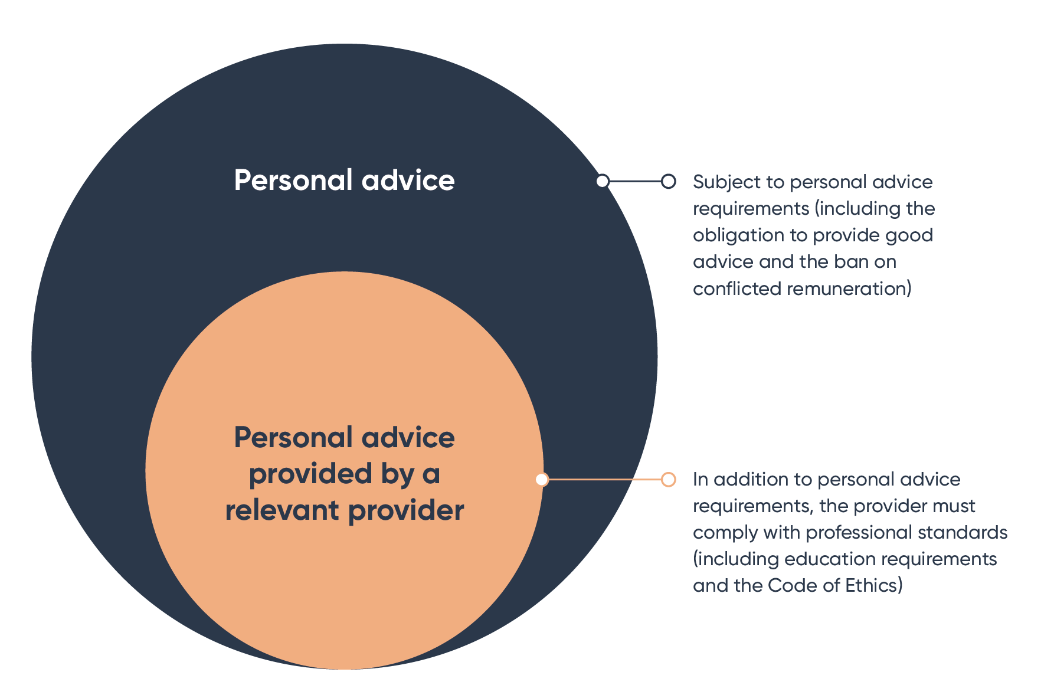

The proposal would also permit a digital advice provider to provide advice to a customer for a fee without the provider (or any of its employees) being a 'relevant provider'. This is consistent with the current regime. Again, I do not think this would expose consumers to the risk of poorer quality advice and again I think it would make personal advice more accessible and more affordable.

**Proposal 4 – requirement to be a relevant provider**

A provider of personal advice should be a ‘relevant provider’ where the provider is an individual and the client pays a fee for the advice, the provider (or the provider’s authorising licensee) receives a commission in connection with the advice, there is an ongoing advice relationship between the adviser and the client or the client has a reasonable expectation that such a relationship exists.

**Outcome:** This proposal is aimed at aligning obligations with the risk of consumer harm and increasing consumer access to financial advice.

* 1. A simple and direct approach to regulating advice

An obligation to provide good advice would be a simpler and more direct approach to regulating advice. It would provide a plain statement of what is required by all personal advice providers.

**Diagram 3: Proposed obligation to provide good advice**

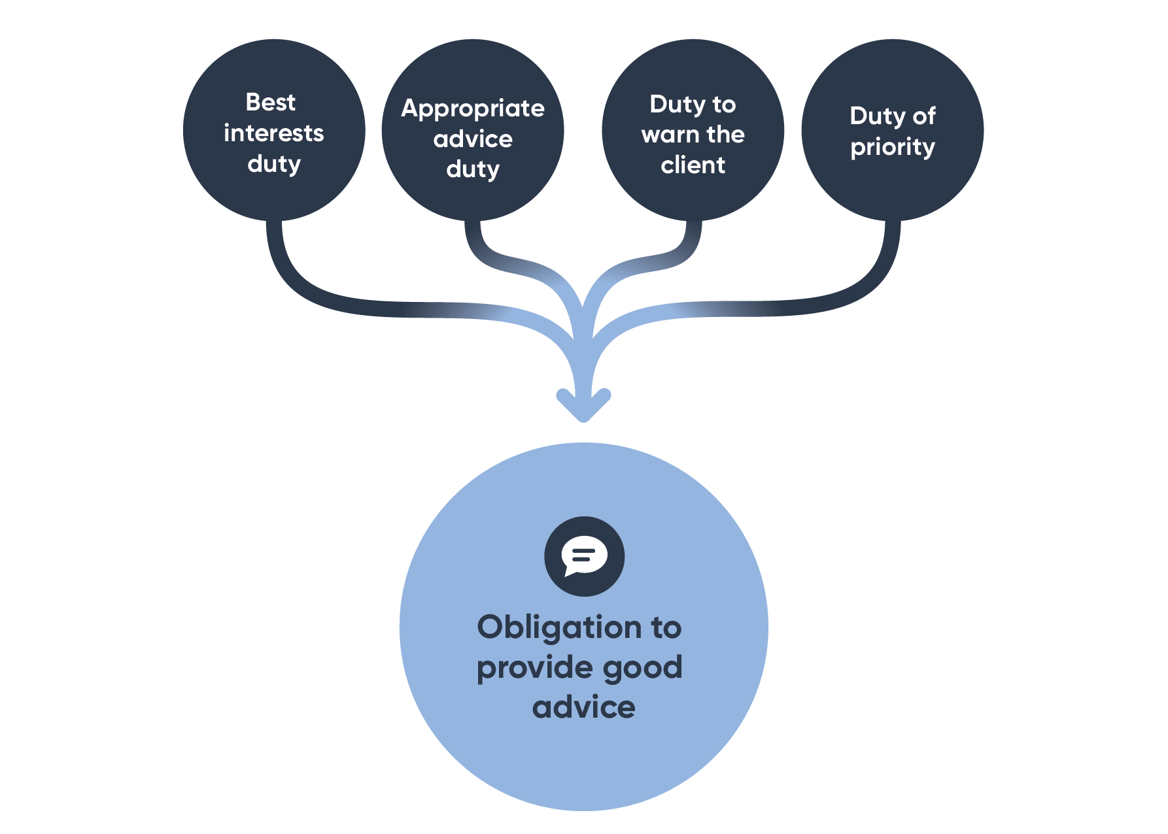

The obligation to provide good advice would apply whether the advice is provided by an individual, an algorithm or a digital advice service. It would also apply whether the advice is provided by an employee of a bank, insurer or superannuation fund or a professional financial adviser.

In my view, an obligation to give good advice should make it easier for banks, insurers and superannuation fund trustees to give simple advice to their customers. This is because there would be no prescribed process and because the advice could be provided by a staff member who is not a relevant provider. Where advice is simple and follows guidelines or rules provided by the employer, the professional standards that apply to a relevant provider are I think unnecessary and act as an impediment to the provision of personal advice. Having said that, the licensee will continue to have an obligation to ensure its staff are competent, appropriately trained and supervised. And so it is possible that in order to give good advice on more complex matters or to more vulnerable consumers, a licensee might decide that the advice can only be given by a relevant provider. In short, what is required to meet the competency requirements will turn on the advice, the client and the assistance provided to the staff member by supervisors, digital advice programs and rules.

An obligation to give good advice should also make it easier for digital advice providers (which might also be a bank, insurer or superannuation trustee) to give personal advice to their customers. Again, the nature of the advice will dictate the process. For all providers of personal advice, including financial advisers, the duty is intended to provide a much clearer articulation of what the intended outcome of their advice should be for their client.

* 1. Conflicts and consumer harm

The duty I am currently thinking about does not specifically address conflicts which Commissioner Hayne saw as the primary cause of poor advice.

However, the current best interests duty which focuses on the process of formulating advice rather than the content of advice provides more opportunity for the adviser to persuade themselves that their advice is in the interests of their client and so, while an obligation to give good advice does not remove conflicts of interest, it is I think harder to justify poor advice when the focus of the law is squarely on the content of the advice. The change from 'Be good. Do the right thing'[5] to 'provide good advice' is I think one of substance.

* 1. Protecting consumers from harm

Replacing the Chapter 7 best interests obligations with an obligation to provide 'good advice' would not mean the efforts of the last 20 years have been futile. To the contrary, many of the changes introduced by the *Financial Services Reform Act 2001*, FOFA legislation and the Royal Commission legislation provide a firm foundation of consumer protection which allows less prescription in the regulation of personal advice now.

Bans on conflicted remuneration, more diligent licensees and a more active regulator have helped, especially in stopping the more egregious advice practices. Following the implementation of the Royal Commission recommendations on anti-hawking and deferred sales of add-on insurance, the commencement of design and distribution obligations and performance testing in superannuation, it has become more difficult to distribute financial products to consumers for whom they are not suited (or even for whom they are suited). Annual advice fee renewals and more vigilant superannuation fund trustees have reduced the risk of consumers paying fees for services they do not receive. The Royal Commission has also contributed to closer self-examination by many participants and a greater readiness to compensate customers when poor advice is identified. Breach reporting obligations make it more likely that those shortcomings will in fact be identified. These are all significant and important changes which are relevant in considering the likely effect of removing the Chapter 7 best interests obligations and the Chapter 7 advice disclosure obligations.

And finally, an obligation to give personal advice that is 'good advice' is itself a strong obligation which can provide critical protection for consumers. It will be a breach of the law to give poor advice or harmful advice.

* 1. Risks and responsibility

I accept that if this new obligation to give good advice is adopted it would not remove all ambiguity from the law. I doubt that is possible. But in very large part, I also doubt that it will be hard for a provider of personal financial, acting in good faith, to determine whether any proposed advice is 'good'. What is required to form that view will turn on the difficulty and complexity of the advice.

I also accept that if this new obligation was adopted it would place a different kind of responsibility, and perhaps more responsibility, on providers of personal advice to satisfy themselves about the content of the advice. All providers of advice will need to turn their minds to what investigations and inquiries they need to make before they can form the view that the personal advice they are minded to give will be good advice – that it is reasonably likely to be to the benefit of the client.

The formulation I am considering proposing is intended to be easily understood. It is an objective test – is the advice 'likely' to benefit the client. What will benefit a client will turn on what the client has asked about and what the provider of advice has volunteered or undertaken to provide advice about. It is not a best advice test and it is not a test which requires a comparison with other financial products. The question in my view is clear – 'if my client follows my advice, are they likely to benefit?' What the provider will need to do in order to answer that question will adjust with the nature of the advice. And so, simple advice to, say, make additional contributions to a superannuation fund will need little information about the customer, whereas advice to buy a life insurance policy will need more. The provider of personal advice will need to take into account the information they have about the customer only to the extent it is relevant to the question of whether the advice will be good advice. Such information might be information the customer tells them or information the provider holds about the customer. Whether the provider will need to undertake further investigations of the customer or of particular financial products will, again, turn on the nature of the advice and what the client has asked for and what the provider has agreed to provide. In some cases, information based on customer cohorts might also be relevant and should be taken into account in determining whether any particular personal advice is good advice.

In my view, there is likely to be a great deal of personal advice that providers can have a high degree of confidence will be 'good advice' without needing to undertake all of the steps, or perhaps any of the steps, that are required now to comply with the Chapter 7 best interests obligations. If this is ultimately my recommendation to the Government, it is with:

1. the intention that providers will be willing and able to provide simple, sound and helpful – 'good' – personal advice to their customers; and
2. the expectation that there will still be types of advice which licensees will decide can only be given by a relevant provider in order for them to be confident the good advice obligation will be met, even though a specific fee is not paid for that advice.

## Acting in the best interests of the client and professional standards

* 1. When should professional standards also apply?

The proposal to replace the Chapter 7 best interests obligations with an obligation to give good advice is intended to apply to everyone who provides personal advice to a retail client, but it does not mean there is not an important place for advice provided by advisers who meet the professional standards.

As noted above, the standards have two components – education and training and the Code of Ethics. The education and training standards are currently being reviewed separately. Subject to any adjustments made, in my view, it remains appropriate that professional financial advisers, like other professionals, be held to high education and training standards. This is consistent with the professionalisation of the industry.

As also noted above, the Code of Ethics imposes a duty for a relevant provider to act in the best interests of their client and not have a conflict of interest. While the Code is contained in a legislative instrument, a relevant provider is required to comply with the Code under the Corporations Act. If an adviser breaches the Code, the client may commence proceedings for compensation, administrative actions be taken against the adviser or ASIC may commence proceedings (albeit slightly indirectly) for a civil penalty. There is therefore no need for the Code to be supplemented by being restated in the Corporations Act itself.

The proposal would prevent the overlapping and inconsistent obligations that exist now between the Chapter 7 best interests obligations and the Code of Ethics and would ensure there are substantially the same obligations and protections for consumers who seek an ongoing advice relationship with a professional financial adviser or who seek one off or occasional advice from a professional financial adviser. The regulation of a financial adviser through a Code of Ethics is also more consistent with their greater professionalisation.

* 1. Digital advice providers

The professional standards do not apply now to a body corporate and in my view the removal of the Chapter 7 best interests obligations (which do apply to a body corporate) does not mean the Code of Ethics should apply to a digital advice provider in the future even where the provider provides ongoing advice to retail consumers or charges a fee for advice. The provider's obligation will be solely to provide good advice. I do not think that is inappropriate. A best interests duty is intended to protect a consumer from the harm that can follow from a conflict of interest. I do not dismiss the real possibility that a digital advice provider may provide advice that serves the interests of the provider, but whether or not the advice is 'good advice' will be evident from the advice provided and the design of the program and therefore I think the duty is less important and less relevant than when advice is provided by an individual.

# Intra-fund advice

1. 1. What is intra-fund advice?

Before leaving the topic of what should be regulated, I want to say something about intra-fund advice. The term is used by the industry to refer to financial product advice (strictly, only personal advice) given by or on behalf of a superannuation fund trustee to a member of the fund about their interest in the fund.

Intra-fund advice is not a term defined in the Corporations Act. It is not a special category of financial product advice and no special rules or relief apply to intra-fund advice. Its genesis is in section 99F of the SIS Act. That section is entitled: 'Cost of financial product advice - collectively charged fees'. The title nicely describes the content of the section which is about charging for advice. It prohibits a trustee passing the cost of providing personal advice to a member on to any other member if any of the prescribed circumstances apply. The prescribed circumstances include providing advice:

1. to someone who is not yet a member about becoming a member;
2. about another financial product that is not an interest in the fund; and
3. about the consolidation of the member's superannuation accounts.

They also include providing advice where the member reasonably expects the trustee will provide further advice.

Section 99F of the SIS Act does not give trustees permission to provide personal advice (whether or not members are charged collectively for that advice) and it does not give trustees permission to meet the cost of providing personal advice to members from the assets of the fund (whether or not members are charged collectively for that advice). It says nothing more than what cannot be done.

Whether a trustee can give personal advice (intra-fund or otherwise) turns on its powers and duties. The sole purpose test in section 62 of the SIS Act is particularly relevant. It says that a trustee must ensure a fund is maintained solely for one or more of the prescribed purposes: providing retirement benefits to members, disability benefits to members and benefits to the dependants of deceased members. It is not obvious these purposes authorise the application of fund money (whether attributed to a particular member's account or otherwise) for providing personal advice to members. The question has never been considered by a court.

Nevertheless, I accept that section 99F proceeds on the basis that a trustee may provide personal advice to members on some topics at least and meet the cost of doing so from the fund. The new retirement income covenants in section 52(8A) of the SIS Act assume trustees can provide advice to their members (trustees are required to adopt a strategy which will 'assist' retired and retiring members to achieve and balance the prescribed objectives) and apply fund assets for that purpose.

* 1. Expanding intra-fund advice

Most (although not all) superannuation fund trustees have told us they would like to be able to provide more intra-fund advice to their members. They want to be able to provide advice to their members leading up to their retirement and in doing so they want to be able to take into account the member's assets, social security benefits and, where the member has a partner, the partner's financial position. Some trustees have said they would like to provide advice to their members about aged care. They say that in order to do so the intra-fund advice regime should be broadened (this could be done by narrowing the restrictions on collectively charging for personal advice in section 99F). I am not convinced this is the best approach.

* 1. Proposal to amend the sole purpose test in the SIS Act

In my view, superannuation trustees, like other product issuers, can be an important source of financial information and helpful personal advice for their customers (their members here). Given the purpose of the Review, I think the regulatory regime should encourage trustees to provide tailored information and personal advice to their members, or put in place arrangements for another provider to do so. The proposals I am considering and that I have set out in the previous section of this paper will do two things – they will expand somewhat the circumstances in which trustees, like other issuers of financial products, are giving personal advice to their members; and they will make it easier for trustees, again like other issuers of financial products, to give personal advice to their members which complies with the law.

However, superannuation trustees are not like other product issuers. What they can do is constrained by their duties to members and, particularly when they are applying fund assets, by the sole purpose test. As noted above, it is not clear the sole purpose test permits a trustee to apply fund assets to meet the costs of providing personal advice to members and if it does, it is not clear how broad that permission is.

Given these issues, if trustees are to be encouraged to provide more advice to their members, the sole purpose test in the SIS Act should be amended to expressly provide trustees with permission to:

1. provide personal advice to members about their interests in a fund; and
2. to apply fund assets to meet the cost of providing personal advice to members about their interests in the fund.

In expressing this view, I am not saying trustees cannot do so now, merely that section 99F does not provide that permission and trustees should not be encouraged to apply fund assets to meet the cost of providing members with personal advice if they are not clearly able to do so.

If the SIS Act is amended in this way, the question will be answered and it will be beyond doubt that trustees will be able to provide personal advice to their members about their retirement incomes. That advice would have to centre on the member's interest in the fund and the fund's retirement products, but so much is consistent with the basis of the relationship between the member and the trustee. In doing so, the advice could take into account the member's assets and liabilities, social security and aged care.

* 1. Proposal to remove section 99F of the SIS Act

If the SIS Act is amended to provide trustees with the power to give personal advice and apply fund assets in order to do so, in my view it would be desirable to remove section 99F of the Act. The section:

1. is poorly drafted and understood;
2. imposes an unnecessary compliance burden on trustees (albeit one which does not appear to concern many trustees); and
3. does not provide any protection to members from poor or harmful advice.

I also worry that section 99F is relied on by some trustees as containing the rules about what advice they may provide to their members and, more concerningly, as containing some relief from the best interests obligations. The answer to what topics a trustee may give advice on (if the cost is being paid from fund assets) is, again, found first in the sole purpose test and only then after considering the following questions:

1. what personal advice should the trustee give to members of the fund consistently with its powers and duties;
2. how should the trustee charge for personal advice consistently with its powers and duties; and
3. what risk is the trustee exposing the fund to in providing personal advice to members and does it have adequate resources set aside to meet any liabilities which might be incurred in connection with giving advice.

After considering those questions, the trustee will need to consider how the cost of providing advice should be allocated to members. In doing so the trustee must act in the best financial interests of members, treat members fairly, promote members' financial interests, allocate costs between members fairly and reasonably, comply with fees and costs rules and comply with its obligations about fund expenditure in Prudential Standard SPS 515: Strategic Planning and Member Outcomes. These are more than adequate and I am minded to recommend the repeal of section 99F of the SIS Act.

**Proposal 5 – personal advice to superannuation fund members**

Superannuation fund trustees should be able to provide personal advice to their members about their interests in the fund, including when they are transitioning to retirement. In doing so, trustees would be required to take into account the member's personal circumstances, including their family situation and social security entitlements if that is relevant to the provision of the advice.

**Proposal 6 - collective charging of advice fees**  
Superannuation fund trustees should have discretion to decide how to charge members for personal advice they provide to members and the restrictions on collective charging of fees should be removed.

**Outcome:** These proposals are aimed at improving access to personal advice for superannuation fund members and to provide increased regulatory certainty for superannuation trustees.

# Advice fees in superannuation

1. 1. Adviser service fees

Before leaving the topic of personal advice in superannuation, I want to turn to adviser fees paid from superannuation accounts. These fees might be one-off or ongoing. In either case, the legal basis upon which they are paid is problematic.

The SIS Act prohibits the payment of money from a fund other than to pay a superannuation benefit or to pay an expense that is incurred by the trustee in connection with the fund. A member cannot now direct a trustee to pay a fee to their adviser from their superannuation account. A fee for advice is not a superannuation benefit. Therefore, it can only be paid if it is an expense incurred by the trustee in connection with the fund. If the trustee engages an adviser to provide advice to a member about the member's interest in the fund, the cost of providing the advice is incurred by the trustee and can be deducted from the fund. This is the legal basis on which adviser fees are paid from superannuation accounts. However, I am not confident it accurately reflects the actual arrangements under which advice is provided to superannuation members by independent advisers. I think section 99FA of the SIS Act has exacerbated the issue.

Section 99FA was introduced into the SIS Act with effect from 1 July 2021 following the Royal Commission recommendations. It is intended to prevent advice fees being deducted from a member's superannuation account without their consent and so it requires an advice fee paid from a member's superannuation account to be paid in accordance with the terms of the arrangement entered into by the member and the adviser. The member must provide their consent to the trustee for the deduction of the fee the member has agreed with the adviser.

ASIC and APRA have written to trustees to remind them of their obligations to take steps to satisfy themselves that:

1. any advice paid for from the fund with the consent of the member under section 99FA is confined to advice about the member's interest in the fund; and
2. the cost of the advice is reasonable. In many cases trustees impose caps on advice fees that can be paid from the fund.

These steps do not convert the arrangement between the adviser and member into an arrangement between the adviser and trustee or the adviser, member and trustee, and it is very difficult to reconcile the arrangement required by the section with an expense that is incurred *by* the trustee. I therefore worry that section 99FA is flawed and should be replaced.

* 1. What adviser fees should be paid from superannuation funds?

Some people have told us that advice fees, particularly ongoing advice fees, should not be paid from superannuation at all. Other people have suggested that superannuation might be an appropriate place to fund financial advice generally.

The SIS Act prohibits ongoing advice fees being paid from a MySuper product. It does so on the basis that a person who is in a default product does not need regular personal advice. I agree that ongoing advice fees should not be paid from MySuper products, especially if members are able to access personal advice from their superannuation fund trustee without paying an additional fee (where the cost of the advice is met from collectively charged fees).

For members invested in choice products we have been told that superannuation balances should be preserved for retirement and ongoing advice fees deplete retirement incomes. On balance, I am persuaded that advice, including possibly regular advice, can add to a person's retirement income and that people should be able to apply some of their superannuation to the cost of receiving financial advice about their superannuation, including their retirement income. However, I am not persuaded that superannuation should be available to pay for broader financial advice. I am aware that the consequences of my views are that trustees will continue to be responsible for taking steps to ensure that advice fees are paid only for the provision of advice to a member about their interests. But a contrary view would make superannuation available for purposes that are not related to retirement incomes. The SIS Act requires trustees to determine whether insurance premiums would unreasonably erode members' retirement incomes, paying for financial advice from superannuation raises the same question. Where there is a direct connection with the member's interest in the fund, the potential to do so would seem to be much less than should the member's balance be available to pay for financial advice at large.

This does lead to the question about how much should be able to be paid from a member's superannuation account for financial advice about their superannuation interest (or another interest in the fund). In my view, the cost should fairly reflect the value of the advice and it should not unreasonably erode a member's retirement income and so I think there may be merit in limits being imposed on how much and how frequently advice fees can be deducted from a member's account. However, I think these are questions which trustees can answer having regard to the characteristics of their members. I do not think these are matters which should be prescribed by legislation.

* 1. Proposal to amend the SIS Act to permit the deduction of adviser fees

Given these concerns, I think there would be merit in replacing section 99FA of the SIS Act with a provision giving trustees express permission to pay an advice fee incurred by a member who has sought advice from an adviser about their interest in the fund. Rather than requiring the consent of the member to the deduction of an advice fee from their account, the SIS Act would authorise the trustee to pay an advice fee, including an ongoing advice fee, on the direction of the member. The purpose would be to regularise what happens as a practical matter now. The trustee would still need to be confident the advice related to the member's interest in the fund and so it would need some ability to confirm that, but it would not have to be a party to the arrangement between the member and adviser, even notionally. This might mean that trustees will only permit financial advice fees to be paid at the direction of members to advisers with whom they have an agreement that enables a trustee to review advice provided to members from time to time or to require an audit of that advice to be undertaken. As noted, this proposal is not intended to change fundamentally what trustees do now.

This proposal would also have repercussions for advisers and is considered further in Chapter 5 of this paper.

**Proposal 7 – Fees for advice provided to members about their superannuation**

Superannuation trustees should be able to pay a fee from a member's superannuation account to an adviser for personal advice provided to the member about the member's interest in the fund on the direction of the member.

**Outcome:** This proposal is aimed atimproving regulatory certainty for superannuation trustees.

# Advice Fees

1. 1. Fee disclosure and ongoing fee arrangements

Financial advisers and advice licensees have told us the fee disclosure and ongoing fee arrangement requirements add significantly to the time spent on administrative matters and to the cost of providing advice. They doubt that it provides value to their clients and have noted that signing forms can take up a not insignificant amount of time in meetings between advisers and their clients. We have also been told that some advisers avoid ongoing advice fee requirements by entering into rolling fixed term fee arrangements with their clients.

Under the current law, a 'fee recipient' (an adviser) must give their client a fee disclosure statement (FDS) annually within 60 days of the anniversary date of entering into the ongoing fee arrangement. The FDS must provide information about the services provided by the adviser and fees paid by the client in the previous year, as well as in relation to following year. If the arrangement is to continue for a further year, the adviser must obtain the client’s agreement to renew the arrangement within 120 days of the anniversary date. This process must be repeated every year. If the client's agreement is not obtained, the ongoing fee arrangement terminates after 30 days of when the renewal was due. If the advice fees are to be paid from a financial product, the client must also sign a consent form agreeing to the deduction of advice fees from the client’s financial product within 150 days of the anniversary date each year. An adviser must provide a copy of the client's consent form to the product issuer if the fee (or part of the fee) is to be deducted from a financial product the client holds with the product issuer. In addition, under the SIS Act, the member (or adviser on the member's behalf) must give their consent to the trustee paying a fee to their adviser whether or not the fee is ongoing.

This is undoubtedly a complicated regime which becomes more complicated when advice fees are paid from more than one financial product. This is frequently the case where a client seeks comprehensive advice. In that case, only part of the fee for the advice can be paid from the client's superannuation account and so the adviser and client might agree that the cost of providing advice will be allocated between different financial products. This will require separate consent forms for each product. We have also been told that those forms might be different as different product issuers have their own requirements.

In my view, the current regime is not working well and could be much simpler. I am therefore considering whether the current regime of fee disclosures, renewal agreements and consent forms could be replaced.

I understand it can be difficult to prepare an accurate record of fees that have been paid in the previous 12 months in a fee disclosure statement. This is because the adviser may not have accurate information at the time the FDS must be prepared, particularly where an advice fee is calculated on a fluctuating balance. I do not think this is a good reason to recommend removing the requirement for FDSs, but it is relevant where the information is otherwise available. It is. Assuming advice fees are not paid in cash, they are always deducted from a financial product held by the client (a superannuation fund, managed fund, custody arrangement or bank account). Therefore, the fees that are paid to the adviser will be disclosed to the client in the statements provided by the issuer of the relevant financial product to the client (their customer). Those fees will be identified as advice fees where they are paid from superannuation accounts, managed funds and custody arrangements. Given this, it is not at all clear why this information should be provided separately to the client by the adviser and I am considering whether removing the requirement for a FDS might be one way the cost of providing advice could be reduced without any consumer detriment. In saying this, I acknowledge that a FDS must also include information about the services that were promised and were provided. However, given the nature of the services advisers provide to their clients and given they will be required to have regular interactions with their clients (if there is an ongoing fee arrangement), the benefit of providing this information is not obvious when compared with the cost and time spent in preparing a FDS.

This would leave the renewal requirements and the consent form. It should be a requirement of the law (as it is now) that a consumer's agreement is sought and provided before advice fees are deducted from their financial products. They should also provide a direction to the product issuer before the deduction is made. An adviser could pass on that direction with the consent of their client. I also think a client should be given the opportunity to consent (or not) to ongoing advice fees in writing on annual basis, as the law currently requires. These are important consumer protection tools which I do not think should be relaxed. I also do not think they are unduly onerous. Where there is an ongoing advice fee, there should be regular contact between the client and the adviser. The law should continue to permit the client to terminate the arrangement at any time.

A renewal agreement and consent form could be combined into a single document, as currently envisaged by *ASIC Corporations (Consent to Deductions—Ongoing Fee Arrangements) Instrument 2021/124*. That document should explain the services that will be provided and the fee the adviser proposes to charge over the course of the following 12 months. As now, this could be done by explaining how the fee will be calculated together with an example, or where it is a fixed fee, the fixed fee. It should also say when fees will be deducted from the client's financial product or products and, where appropriate, contain a direction to the product issuer to deduct those fees. I do not think there is any reason why the form or content of a consent form should be prescribed. However, I understand that this may assist the industry and I have no objection to that being the case on the basis that it would not prejudice consumers.

**Diagram 4: Ongoing fee arrangements and consent requirements**

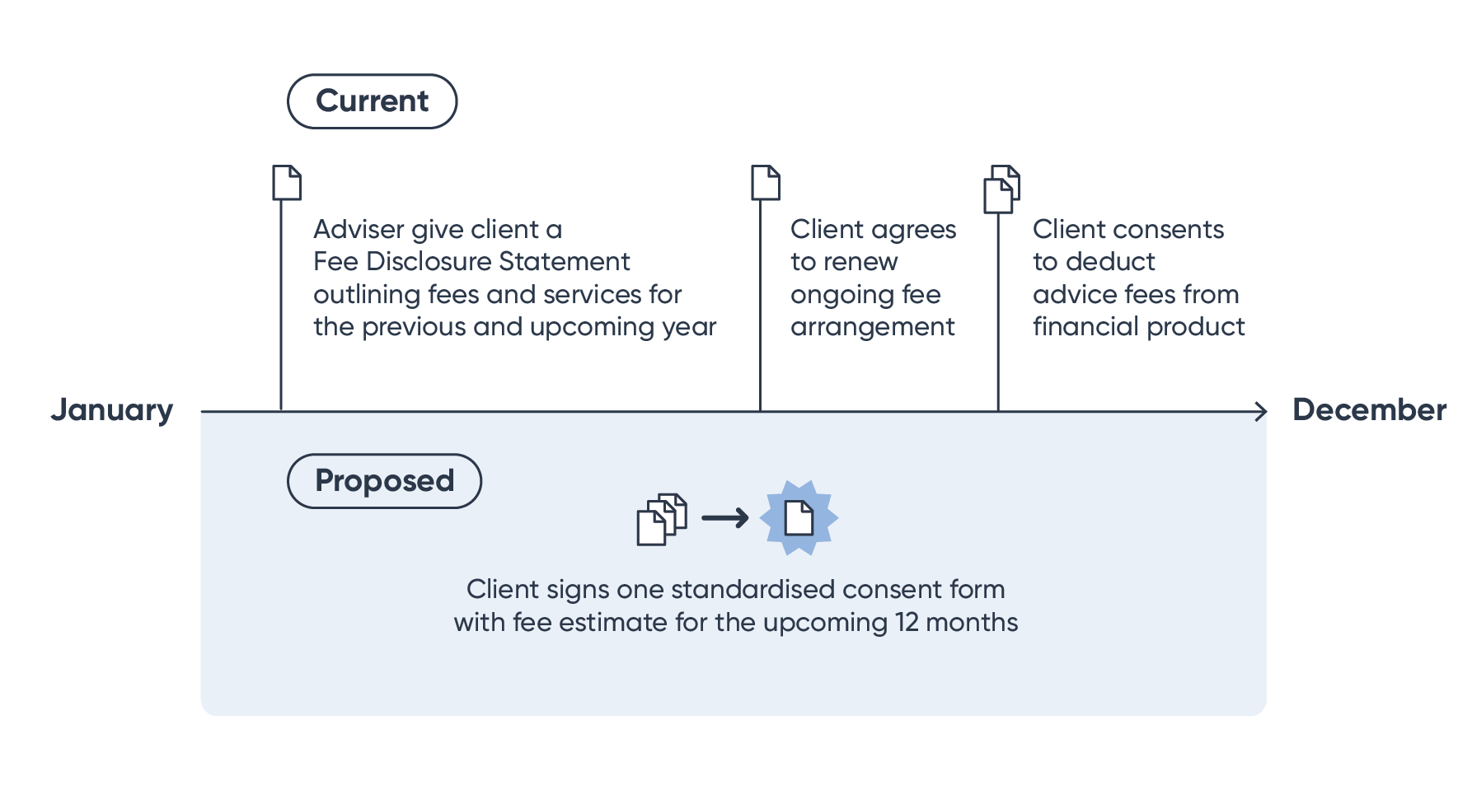

**Proposal 8 – Ongoing fee arrangements and consent requirements**

Fee disclosure statements should not be required. Providers of personal advice should obtain annual written consent from their client to deduct advice fees from a financial product if there is an ongoing fee arrangement. The consent form should explain the services that will be provided and the fee the adviser proposes to charge over the course of the following 12 months. Where advice fees are deducted from more than one product, a single consent form should cover each of the products issued by a product issuer.

**Outcome:** This proposal is aimed atreducing regulatory complexity and burden. This is intended to reduce the cost of providing advice and subsequently increase the accessibility and affordability of financial advice without consumer detriment.

# Disclosure Obligations

1. 1. Statements of Advice and Financial Services Guides

A person who provides personal advice to a retail client must provide them with a statement of advice (SOA), or sometimes, a record of advice (ROA). They must also provide a financial services guide (FSG). The content of each of them is prescribed. The intention is to arm consumers with the information they need to make decisions in their own interests. On one view this intention is slightly curious given the purpose for which a consumer might be thought to go to a financial adviser. In any event, the Ripoll inquiry concluded that disclosure was not an effective way to protect consumers from harmful advice. As a consequence, the Corporations Act was amended to ban conflicted remuneration, volume-based shelf-space fees and asset-based fees on borrowed amounts and to introduce the best interests obligations. At the same time it left in place the requirements for SOAs, ROAs and FSGs, despite having found they had not served the purpose they were intended to serve.

* 1. Are SOAs useful?

In the submissions and our discussions with advisers, SOAs have been universally criticised as adding to the cost of providing advice. Many stakeholders have provided us with estimates indicating that the added cost is not immaterial. More importantly we have been told SOAs are not providing consumers with what they want. Consumers do not want lengthy documents, they do not want templated text and they do not want documents filled with information designed to demonstrate the adviser has complied with the safe harbour.

Many people have also told us that SOAs should be shorter and that this could be achieved by reducing the content requirements. I am not confident that reducing the content requirements for SOAs would lead to better documents. I worry that even shorter documents would be full of templated text and be prepared by advisers (or more likely licensees) with an eye on defending a claim or regulatory proceedings rather than assisting their clients.

* 1. Proposal to remove the requirement for SOAs

I query whether consumers want written advice at all, especially when the advice is simple or limited or when they have a regular relationship with the provider. In my view, the law should encourage and allow providers to provide advice in the way that best suits their customers. I anticipate that this may be quite different depending on the nature of the advice, the client and their relationship with the provider. Stockbrokers might provide their advice over the telephone and provide nothing in writing. Call centre staff at a bank, insurer or superannuation fund might also provide simple limited advice by telephone. They may follow up with a confirming email. Digital advice will be provided online and may or may not be reduced to a printable document. Comprehensive advice might be recorded, as now, in a detailed document, but then further ad hoc advice might be provided informally in a meeting or over the telephone.

As to consumer harm, I am not persuaded SOAs provide any real protection to consumers. AFCA and ASIC both say they look at file notes as much as SOAs. In my own experience, SOAs are not necessarily even reliable records of the recommendations and opinions provided by advisers given the heavy emphasis on templated content.

And so I would like to be able to recommend that the Corporations Act be amended to remove the requirement for providers of advice to provide SOAs and ROAs. The Corporations Act would require only that a provider of personal advice maintain complete records of their advice. It might also require a written record of advice on request by the consumer. Removing the requirement for a SOA and ROA with their prescribed content would place more responsibility on providers to consider how they should provide advice, but it would also make it easier for providers to provide digital advice, simple advice and regular advice. More importantly, it would create an opportunity for providers to give their customers advice in a way their customers find most useful.

**Proposal 9: Statement of advice**

Providers of personal advice to retail clients would be required to maintain complete records of the advice they provide and to provide a written record of advice to a client on request. This would replace the existing requirement for advisers to provide a statement of advice or record of advice.

**Outcome:** This proposal is aimed atreducing regulatory complexity and burden. This is intended to reduce the cost of providing advice and subsequently increase the accessibility and affordability of financial advice without consumer detriment.

* 1. Proposal to remove the requirement for FSGs

Financial services guides are less difficult to provide than SOAs because their content does not change with the content of advice. Nevertheless, they do impose a compliance burden insofar as providers need to consider whether customers have an up to date version each time they provide them with a financial service and, if they do not, they must provide them with a new FSG before providing advice.

Some information in a FSG is important and that information should be available to consumers. However, that information could be more easily provided and just as effective if it was available on the licensee's or the adviser's website and I am considering recommending that a person who provides personal advice is not required to provide a FSG to a customer before doing so if the information that would otherwise be required to be included in the FSG is available on the provider's website. A provider of advice could choose not to provide a customer with a FSG.

**Proposal 10: Financial Services Guide**

Providers of personal advice should either continue to give their clients a copy of the financial services guide or make information available to their clients on their website about their remuneration and other benefits they receive, their internal dispute resolution procedures and AFCA. This information should be available at the time the advice is provided.

**Outcome:** This proposal is aimed at allowing advice providers more flexibility in the way they provide information to their clients.

# Design and distribution obligations

The design and distribution obligations in Part 7.8A of the Corporations Act require product issuers to identify the target market for their financial product and to take reasonable steps to ensure the product is issued only to consumers within the target market. Distributors of financial products are also required to take reasonable steps to ensure the product is issued to consumers within the target market for the product. However, a person who provides personal advice is not required to do so. This is because they have an obligation to provide advice that is in the best interests of their client.

Despite this exemption, personal advice providers have record keeping obligations relating to their distribution of products and they must provide reports to product issuers in respect of which they have engaged in retail product distribution conduct where they have received any complaints in relation to their products and where they are aware of significant dealings outside of the target market for a product. Absent ASIC's temporary relief, personal advice providers also have an obligation to report to product issuers the fact that they have received no complaints. An issuer may also require an adviser to report other information to the issuer by including the reporting obligation in a target market determination. This last obligation in effect allows a product issuer to impose an obligation on a financial adviser with whom the issuer has no agreement or relationship.

1. 1. DDO reporting requirements for financial advisers

The DDO reporting requirements are intended to provide product issuers with information about how their products are being distributed and to whom. Information about complaints and significant dealings outside the target market is intended to assist issuers to determine whether changes are necessary to the product design or the target market determination (TMD). They are also intended to assist an issuer to meet its obligations to take reasonable steps to ensure compliance by distributors with TMDs. This sits somewhat awkwardly with the exemption for a person who provides personal advice. They are free to recommend a product to a client who is outside the target market if they think it is in the best interests of the client. Nevertheless, these reporting requirements apply to providers of personal advice who engage in the distribution of retail products.

Advisers have told us that the DDO monitoring and reporting obligations impose another significant burden. The DDO regime should provide a real benefit to consumers. It is also very new and so I am reluctant to recommend changes before the industry has had time to get used to it. However, I wonder if some very modest changes might reduce the compliance burden for financial advisers without detracting from the overall regime.

It is currently unclear to me why an adviser who is free to recommend a product to a client whether or not they are within the target market, should separately be required to form a view as to whether it is a significant dealing outside the TMD. They may choose to do so because it is helpful for the purposes of providing advice in the best interests of their client, but I query whether they should be required to do so for reporting purposes. I also worry about the potential for product issuers to impose additional reporting obligations on advisers through their TMDs. However, in my view, the requirement to provide reports about complaints advisers receive about a product is of a different order. This information may well be important and valuable to a product issuer when considering the design of a product, its target market and any conditions applying to its distribution. Moreover, I doubt the obligation is onerous, at least for so long as there is not an obligation to report 'no complaints'.

* 1. Proposal for reducing reporting requirements

I am considering whether it would be appropriate to amend the DDO reporting requirements so that relevant providers do not have to report significant dealings outside the target market. I also think the law should be amended to prevent product issuers imposing additional reporting obligations through their target market determinations on relevant providers. In my view, it is appropriate for relevant providers to report the number and nature of complaints to the relevant product issuers, but I do not think it is necessary for them to report 'no complaints'. ASIC appears to have formed this view already – it has provided relief from this obligation in ASIC Corporations (Design and Distribution Obligations Interim Measures) Instrument 2021/784 .

If the definition of personal advice I am considering is adopted, it would also be appropriate for the DDO rules to be amended so that only those providers who are relevant providers are exempt from the obligation to take reasonable steps to ensure financial products are issued to consumers in the relevant target markets. This is because only relevant providers will continue to have a best interests duty under the Code of Ethics. I acknowledge that mortgage brokers who also have a best interests duty now under the *National Consumer Credit Protection Act 2009* may say the same relief should be extended to them. That is not a question for me.

All other providers of personal advice would continue to be subject to the full range of obligations applying to a distributor of financial products.

**Proposal 11: Design and distribution obligations reporting requirements**

The reporting requirements under the design and distribution obligations regime should be simplified by requiring relevant providers to only report to the product issuer where they have received a complaint in relation to a product.

**Outcome**: This proposal is aimed at reducing regulatory burden and the cost of running an advice business, which could increase the accessibility and affordability of financial advice.

# Enforcement

1. 1. The role of the Regulator

We have received a large amount of feedback about the role of ASIC. Many people interpret ASIC's guidance as the law. Many people are worried that ASIC will commence proceedings for what advisers and licensees perceive to be minor infractions of the law. As a result, advisers, advice licensees, digital advice providers (or potential providers) and financial institutions are risk averse and keen for ASIC to provide greater certainty about the application of the law. They want to be able to discuss the application of the law to their own circumstances with ASIC and for ASIC to provide opinions. Many people would like ASIC to have a rulings power like the ATO.

Whether or not this is a fair view of ASIC, the view influences behaviour in ways that are not necessarily consistent with the law and not necessarily desirable. It inhibits innovation in the provision of advice, it stops providers giving advice and, when they do, it contributes to lengthy processes and documents. I have been asked to make recommendations about the regulatory framework but that cannot do much to encourage greater trust and confidence in the industry that ASIC will not take disproportionately punitive action.

* 1. ASIC’s approach to enforcement

There is a clear role for ASIC in providing guidance to the industry in how to interpret the law. Where the law is principles based and less comprehensive or prescriptive then this might be more important. Examples appear to be particularly useful and I would like to encourage ASIC to continue to publish examples based on actual experiences. This is different to making law and I do not think it is appropriate for ASIC to have a rulings power. Its role is different to the ATO's. The Commissioner of Taxation may make public and private rulings.  They both contain the Commissioner's opinion about how a provision of the taxation law applies.  The rulings protect the taxpayers to which they apply if a court later finds the ruling is wrong.  In that case, the taxpayer is not required to pay any unpaid tax or penalties and they cannot be prosecuted.  The rulings are between the Commission and taxpayer or taxpayers and rarely affects other people.

This would not be the case if ASIC could make public and private rulings.  In that case, ASIC's interpretation of the law would not only protect the regulated entity but it would also likely have a direct effect on consumer rights.  A consumer should not be prevented from bringing a claim or proceedings against a licensee or adviser because of ASIC's interpretation of the law.

There are other reasons too why I am not minded to recommend that ASIC has a rulings power.  It is likely to create a significant amount of work for ASIC and it may well inhibit rather than promote innovation.  Regulated entities are most unlikely to do anything that is contrary to an ASIC ruling even if they believed it was wrong.

In the past, ASIC has adopted what it calls a facilitative approach to compliance with new law. The proposals I am considering would, if they are ultimately recommended and accepted, require some significant changes to the way advisers and financial institutions communicate and provide information and advice with their customers. The purpose is to encourage them to provide more personal advice to consumers and so I think it would be appropriate for ASIC to adopt a facilitative approach during a transition period. During this time, I expect that it would be helpful for ASIC to meet with industry so there is a free exchange of ideas. Of course, this would not prevent consumers bringing complaints or commencing proceedings and it does not mean that ASIC could not and should not take enforcement action, even during a transition period where behaviour is egregious or undertaken in bad faith. Proactive enforcement of the law is critical and will continue to be.

* 1. Proposal for transition period

If the proposals are adopted, there would be a need for a transition period, during which time providers can ‘opt-in’ but also feel confident that ASIC will not take enforcement action where they have acted in good faith to comply with the new law. This could be assisted by a facilitative approach to enforcement, by guidance in the form of examples from ASIC and by regular discussion between industry and ASIC. This would not prevent a consumer who has received advice they say is not good advice from taking further action.

**Proposed 12: Transition arrangements**

There should be an adequate transition period for implementing these changes. Consideration should also be given to allowing providers to 'opt in' early.

**Outcome**: This proposal is aimed at ensuring that the implementation of the reforms are workable and sustainable.

# Attachment A: Cameos

### Cameo 1 – Personal advice by a professional financial adviser

George is a financial adviser, authorised to provide personal advice to retail clients as a representative of ABC Financial Services Ltd. (AFSL 123 456).

George is authorised to provide a comprehensive range of personal advice to his clients. George meets with Mary, a new client. Mary is a small business owner and has a range of other investments, including superannuation. Mary is seeking advice on the optimal investment strategy to meet her needs and objectives.

George agrees to provide the advice for an upfront fee, and if Mary agrees to implement the advice, to provide ongoing advice on the performance and continued suitability of the investments for an ongoing fee that is deducted from her investment products.

Table 1: requirements for the provision of personal advice by a professional financial adviser

|  |  |  |
| --- | --- | --- |
| Current | Proposed | Implications |
| ***Corporations Act Obligations:*** George must act in the best interests of Mary in relation to the advice including making inquiries necessary to identify the objectives, financial situations and needs reasonably considered relevant to the advice sought.  The advice must be appropriate and George must prioritise Mary’s interests in the event of a conflict.  The licensee (ABC Financial Services Ltd) is required to take reasonable steps to ensure George complies with these obligations. | ***Corporations Act Obligations:*** George must provide good advice (i.e. advice that is reasonably likely to benefit Mary).  ABC Financial Services Ltd is required to take reasonable steps to ensure George complies with this obligation. | ***Licensee/Adviser:*** The Corporations Act no longer prescribes the process George should follow when providing advice. George should make sufficient inquiries to ensure that the advice provided is reasonably likely to benefit Mary.  ABC Financial Services Ltd may need to adjust its controls to ensure its advisers are meeting the new standard.  ***Consumer:*** No significant change. The advice must be good and Mary retains the right to access both internal and external dispute resolution, as required. |
| ***Professional Standards:*** George is providing personal advice to a retail client in relation to a relevant financial product – therefore George must be a relevant provider, which includes meeting the education and training standards and complying with the Code of Ethics. | ***Professional Standards:*** No change. As an ongoing relationship is envisaged and Mary is paying a fee for the advice, George must be a relevant provider and meet the professional standards (including the education and training standards and the Code of Ethics). | No change |
| ***Disclosure Documents:*** George must give Mary a statement of advice and a financial services guide. | ***Disclosure Documents:*** Unless Mary requests it, George is not required to provide Mary with a statement of advice, but must keep complete records.  George can either give Mary a financial services guide or make the relevant information available on his or his licensee’s website at the time the advice is provided. | ***Licensee/Adviser***: The form of advice documents provided to clients is no longer prescribed by law. This means that George and Mary can agree on a format that is most suitable for their circumstances.  ***Consumer:*** Mary can request a copy of the advice in writing. |
| ***Charging arrangements:*** Annually, George must provide Mary with a Fee Disclosure Statement (which includes services and fees provided over the past year and the upcoming year), get Mary’s agreement to renew the ongoing fee arrangement and obtain Mary’s signed consent for fees to be deducted from a product. | ***Charging arrangements:*** George must obtain Mary’s annual written consent to deduct ongoing advice fees from a financial product. This form is only required to include an explanation of the services and expected fees for the upcoming 12 months. | ***Licensee/Adviser:*** Simplified obligations apply in relation to obtaining client consent to deduct fees from a product.  ***Consumer:*** Mary continues to provide annual consent to the deduction of advice fees from a product. |

### Cameo 2 – Limited advice by a superannuation fund

Ms Hughes is 67 years old and is considering retirement. Ms Hughes is aware she has been contributing to a superannuation fund, Star Superannuation Fund, but she has never sought financial advice. She is unsure of what to do and calls her superannuation fund seeking assistance.

Mr Ram works in the call centre for Star Superannuation Fund and speaks to Ms Hughes. Mr Ram outlines the account-based pensions options available to her and how an account-based pension could be used to support her during retirement given her cost of living. Given Ms Hughes’ modest superannuation balance and her limited assets outside of superannuation, Mr Ram also recommends she applies for a Centrelink Aged Pension.

***Scenario A***

In accordance with the fund’s policy on charging members for personal advice, Ms Hughes is not directly charged for this advice.

***Scenario B***

In accordance with the fund’s policy on charging members for personal advice, Ms Hughes is directly charged $300 for this advice.

Table 2: Scenario A –provision of limited advice by a superannuation fund via collective charging

|  |  |  |
| --- | --- | --- |
| Current | Proposed | Implications of change |
| ***Corporations Act Obligations:*** Mr Ram must act in the best interests of Ms Hughes in relation to the advice including making inquiries necessary to identify the objectives, financial situations and needs reasonably considered relevant to the advice sought.  The advice must be appropriate and Mr Ram must prioritise Ms Hughes’ interests in the event of a conflict.  The licensee (Star Superannuation Fund) is required to take reasonable steps to ensure Mr Ram complies with his obligations. | ***Corporations Act Obligations:*** Mr Ram must provide good advice (i.e. advice that is reasonably likely to benefit Ms Hughes).  Star Superannuation Fund is required to take reasonable steps to ensure Mr Ram complies with his obligation. | ***Licensee/Adviser:***The Corporations Act no longer prescribes the process Mr Ram should follow when providing advice. Mr Ram should make sufficient inquiries to ensure that the advice is reasonably likely to benefit Ms Hughes.  Star Superannuation Fund may need to adjust its controls to ensure its advisers are meeting the new standard.  ***Consumer:*** No significant change. The advice must be good and Ms Hughes retains the right to access both internal and external dispute resolution, as required. |
| ***Professional Standards:*** As Mr Ram is providing personal advice to a retail client in relation to a relevant financial product, Mr Ram must be a relevant provider, which includes meeting the education standards and complying with the Code of Ethics. | ***Professional Standards:*** Mr Ram is not required to be a relevant provider as he neither charges a fee for the advice nor is in an ongoing advice relationship with Ms Hughes. This means that Mr Ram is not required to meet the education and training standards or the Code of Ethics.  However, as an AFS licensee, Star Superannuation Fund is still under an obligation to ensure that Mr Ram is adequately trained and competent to provide the advice. | ***Licensee/Adviser:*** This advice is no longer required to be provided by a relevant provider.  ***Consumer:*** Ms Hughes will be receiving advice from a person who is not subject to the professional standards. However, her adviser will still need to be competent and adequately trained to provide this advice and Ms Hughes has access to internal and external dispute resolution in relation to this advice, as required. |
| ***Disclosure Documents:*** Mr Ram must give Ms Hughes a statement of advice and a financial services guide. | ***Disclosure Documents:*** Unless Ms Hughes requests it, Mr Ram is not required to provide Ms Hughes with a statement of advice, but must keep complete records.  Mr Ram can either give Ms Hughes a financial services guide or ensure that the relevant information is available on the fund’s website at the time the advice is provided. | ***Licensee/Adviser***: The form of advice documents provided to clients is no longer prescribed by law. This means that Mr Ram and Ms Hughes can agree on a format that is most suitable for their circumstances.  ***Consumer:*** Ms Hughes can request a copy of the advice in writing. |
| ***Collective charging of advice fees:*** Legislated restrictions on the types of personal advice trustees can collectively charge apply. | ***Collective charging of advice fees:*** Trustees can collectively charge for personal advice to members about their interests in the fund (including in transition to retirement). | ***Trustees*:** Trustees must decide whether to collectively charge for the provision of personal advice having regard to their duties and the sole purpose test.  ***Consumer:*** No change. Superannuation fund members will need to engage with their fund to determine what, if any, advice services are offered and how they charge for these services. |

Table 3: Scenario B - provision of limited advice by a superannuation fund via direct charging

Same as scenario A except:

|  |  |  |
| --- | --- | --- |
| Current | Proposed | Implications of change |
| ***Professional Standards:*** As Mr Ram is providing personal advice on a relevant financial product, Mr Ram must be a relevant provider, which includes meeting the education standards and complying with the Code of Ethics. | ***Professional Standards:*** Mr Ram is required to be a relevant provider as Ms Hughes is being directly charged for the advice. This means that Mr Ram is required to meet the education and training standards and the Code of Ethics. | No change |

### Cameo 3 – Personal advice by a general insurer

XYZ Insurance sells general insurance products, including building and contents insurance.

Leigh currently owns a house with building insurance through XYZ Insurance. Leigh calls XYZ Insurance to see if they offer contents insurance which can be combined with his building insurance. Taylor works for XYZ insurance and answers Leigh’s call. Leigh asks what contents insurance XYZ Insurance offer, and whether it can be combined with his building insurance. Taylor looks up what information they have on Leigh’s existing insurance policy. She then asks Leigh some questions to determine what level of contents insurance coverage is suitable.

Following this conversation, Taylor recommends a combined building and contents insurance policy, which is tailored to his needs and level of coverage. XYZ Insurance does not charge a fee this advice.

Table 4: requirements for the provision of personal advice by a general insurer

|  |  |  |
| --- | --- | --- |
| Current | Proposed | Implications of change |
| ***Corporations Act Obligations:*** Taylor must act in the best interests of Leigh when providing the advice. Because this advice relates to a general insurance product the steps that Taylor must follow to comply with the best interests duty involve identifying the subject matter of the advice and obtaining information from the client relevant to that advice.  The advice must be appropriate, but Taylor is not required to prioritise Leigh’s interests in the event of a conflict.  The licensee (XYZ Insurance) is required to take reasonable steps to ensure Taylor complies with her obligations. | ***Corporations Act Obligations:*** Taylor must provide good advice (i.e. advice that is reasonably likely to benefit Leigh).  XYZ Insurance is required to take reasonable steps to ensure Taylor complies with this obligation. | ***Licensee/Adviser:***The Corporations Act no longer prescribes the process Taylor should follow when providing advice. Taylor should make sufficient inquiries to ensure that the advice is reasonably likely to benefit Leigh.  XYZ Insurance may need to adjust its controls to ensure its advisers meet this standard.  ***Consumer:*** No significant change. The advice must be good and Leigh retains the right to access internal and external dispute resolution. |
| ***Professional Standards:*** As Taylor is providing personal advice to a retail client in relation to a product that is not a relevant financial product (general insurance), Taylor is not required to be a relevant provider. | ***Professional Standards:*** No change – the exemption from the requirement to be a relevant provider continues to apply to persons who only provide personal advice to retail clients in relation to general insurance products. | No change |
| ***Disclosure Documents:*** Taylor may not be required to give Leigh a financial services guide if Leigh has already been provided a product disclosure statement and other specified information.  Taylor is not required to provide Leigh a statement of advice. | ***Disclosure Documents:*** No change. The existing exemptions for the provision of a financial services guide and statement of advice continue to apply.  If Taylor is required to give Leigh a financial services guide, she can either provide a financial services guide or ensure that the relevant information is available on the insurer’s website at the time the advice is provided. | No change |

### Cameo 4 – Personal advice by a digital advice provider

123 Investment Managers is a product provider which offers exchange traded funds (ETFs) and managed investment funds. It has recently established a digital advice service, which allows potential clients to manually enter personal information, and fill out a short risk assessment to find out which of 123 Investment Managers products is best suited to them. The digital advice service does not charge a fee for the advice.

Stefan has recently received a windfall gain of $5,000 and is deciding what to do with his money. He has heard from friends that managed investment funds are a good way to make diversified investments and recalls seeing advertising for 123 Investment Managers on his social media as a large company that offers these products. Stefan also has a high interest credit card, which currently has $2,000 in outstanding debt.

Stefan goes to 123 Investment Managers’ website to look at what products it provides and is directed to its digital advice service. Through the digital advice service, based on his age and risk preferences, 123 Investment Managers recommends that Stefan first pays off any outstanding debt, and invest his remaining savings in a high growth managed investment fund.

Table 5: Requirements for the provision of digital advice

|  |  |  |
| --- | --- | --- |
| Current | Proposed | Implications of Change |
| ***Corporations Act Obligations:*** 123 Investment Managers must act in the best interests of Stefan in relation to the advice including making inquiries necessary to identify the objectives, financial situations and needs reasonably considered relevant to the advice sought.  The advice must be appropriate, and 123 Investment Managers must prioritise the interests of Stefan in the event of a conflict. | ***Corporations Act Obligations:*** The advice 123 Investment Managers provides must be good advice (i.e. advice that is reasonably likely to benefit Stefan). | ***Licensee:*** Digital advice providers are required to ensure that the advice it provides is good.  ***Consumer:*** No significant change. The advice must be reasonably likely to benefit Stefan. Stefan retains the right to access both internal and external dispute resolution, as required. |
| ***Professional Standards:*** As 123 Investment Managers is not an individual, it is not required to be a relevant provider, and is not required to meet the professional standards (education and training standards and the Code of Ethics). | ***Professional Standards:*** No change – professional standards do not apply because the advice is not being provided by an individual. | No change |
| ***Disclosure Documents:*** 123 Investment Managers is not required give a financial services guide if Stefan has already been provided a product disclosure statement and other specified information.  123 Investment Managers must give Stefan a statement of advice. | ***Disclosure Documents***: Unless requested, 123 Investment Managers is not required to give Stefan a statement of advice, but must keep complete records.  If 123 Investment Managers is required to give Stefan a financial services guide, it can either give Stefan a financial services guide or ensure that the relevant information is available on its website at the time the advice is provided. | ***Licensee:*** Digital advice providers have flexibility to determine how the advice is provided.  ***Consumers:*** Stefan can request written advice. |

# Attachment B – Consultation questions

**Intended outcomes**

1. Do you agree that advisers and product issuers should be able to provide to personal advice to their customers without having to comply with all of the obligations that currently apply to the provision of personal advice?

**What should be regulated?**

1. In your view, are the proposed changes to the definition of ‘personal advice’ likely to:
2. reduce regulatory uncertainty?
3. facilitate the provision of more personal advice to consumers?

c) improve the ability of financial institutions to help their clients?

1. In relation to the proposed de-regulation of ‘general advice’ - are the general consumer protections (such as the prohibition against engaging in misleading or deceptive conduct) a sufficient safeguard for consumers?
   1. If not, what additional safeguards do you think would be required?

**How should personal advice be regulated?**

1. In your view, what impact does the replacement of the best interest obligations with the obligation to provide ‘good advice’ have on:
2. the quality of financial advice provided to consumers?
3. the time and cost required to produce advice?
4. Does the replacement of the best interest obligations with the obligation to provide ‘good advice’ make it easier for advisers and institutions to:
5. provide limited advice to consumers?
6. provide advice to consumers using technological solutions (e.g. digital advice)?
7. What else (if anything) is required to better facilitate the provision of:
   1. limited advice?
   2. digital advice?
8. In your view, what impact will the proposed changes to the application of the professional standards (the requirement to be a relevant provider) have on:
   1. the quality of financial advice?
   2. the affordability and accessibility of financial advice?
9. In the absence of the professional standards, are the licensing obligations which require licensees to ensure that their representatives are adequately trained and competent to provide financial services sufficient to ensure the quality of advice provided to consumers?
   1. If not, what additional requirements should apply to persons who are not required to be relevant providers?

**Superannuation funds and intra-fund advice**

1. Will the proposed changes to superannuation trustee obligations (including the removal of the restriction on collective charging):
   1. make it easier for superannuation trustees to provide personal advice to their members?
   2. make it easier for members to access the advice they need at the time they need it?

**Disclosure documents**

1. Do the streamlined requirements for ongoing fee arrangements:
2. reduce regulatory burden and the cost of providing advice, and if so, to what extent?
3. negatively impact consumers, and if so, how and to what extent?
4. Will removing the requirement to give clients a statement of advice:
5. reduce the cost of providing advice, and if so, to what extent?
6. negatively impact consumers, and if so, to what extent?
7. In your view, will the proposed change for giving a financial services guide:
   1. reduce regulatory burden for advisers and licensees, and if so, to what extent?
   2. negatively impact consumers, and if so, to what extent?

**Design and distribution obligations**

1. What impact are the proposed amendments to the reporting requirements under the design and distribution obligations likely to have on:
   1. the design and development of financial products?
   2. target market determinations?

**Transition and enforcement**

1. What transitional arrangements are necessary to implement these reforms?

**General**

1. Do you have any other comments or feedback?

1. Parliamentary Joint Committee on Corporations and Financial Services Inquiry into financial products and services in Australia: Committee view, p. 110, paragraph 6.28. (accessed from: <https://www.aph.gov.au/binaries/senate/committee/corporations_ctte/fps/report/report.pdf>).
2. *ASIC v Westpac Securities Administration Limited [2019] FCAFC 187* per Justice O'Bryan.
3. Paragraph 1.23 of the Revised Explanatory Memorandum to the Corporations Amendment (Further Future of Financial Advice Measures) Bill 2012 says: There are steps that providers may prove they have taken to demonstrate that they have acted in the best interests of the client. ***[Schedule 1, item 23, Division 2, subsection 961B(2)]*** These steps recognise that the requirement to act in a client’s best interests is intended to be about the process of providing advice, reflecting the notion that good processes will improve the quality of the advice that is provided. The provision is not about justifying the quality of the advice by retrospective testing against financial outcomes.
4. Mason J in Hospital Products Ltd v United States Surgical Corporation (1984) 156 CLR 41 at 96-97
5. Commonwealth, Royal Commission Royal Commission into Misconduct in the Banking, Superannuation and Financial Services Industry, Final Report (2019) vol 1, 178.