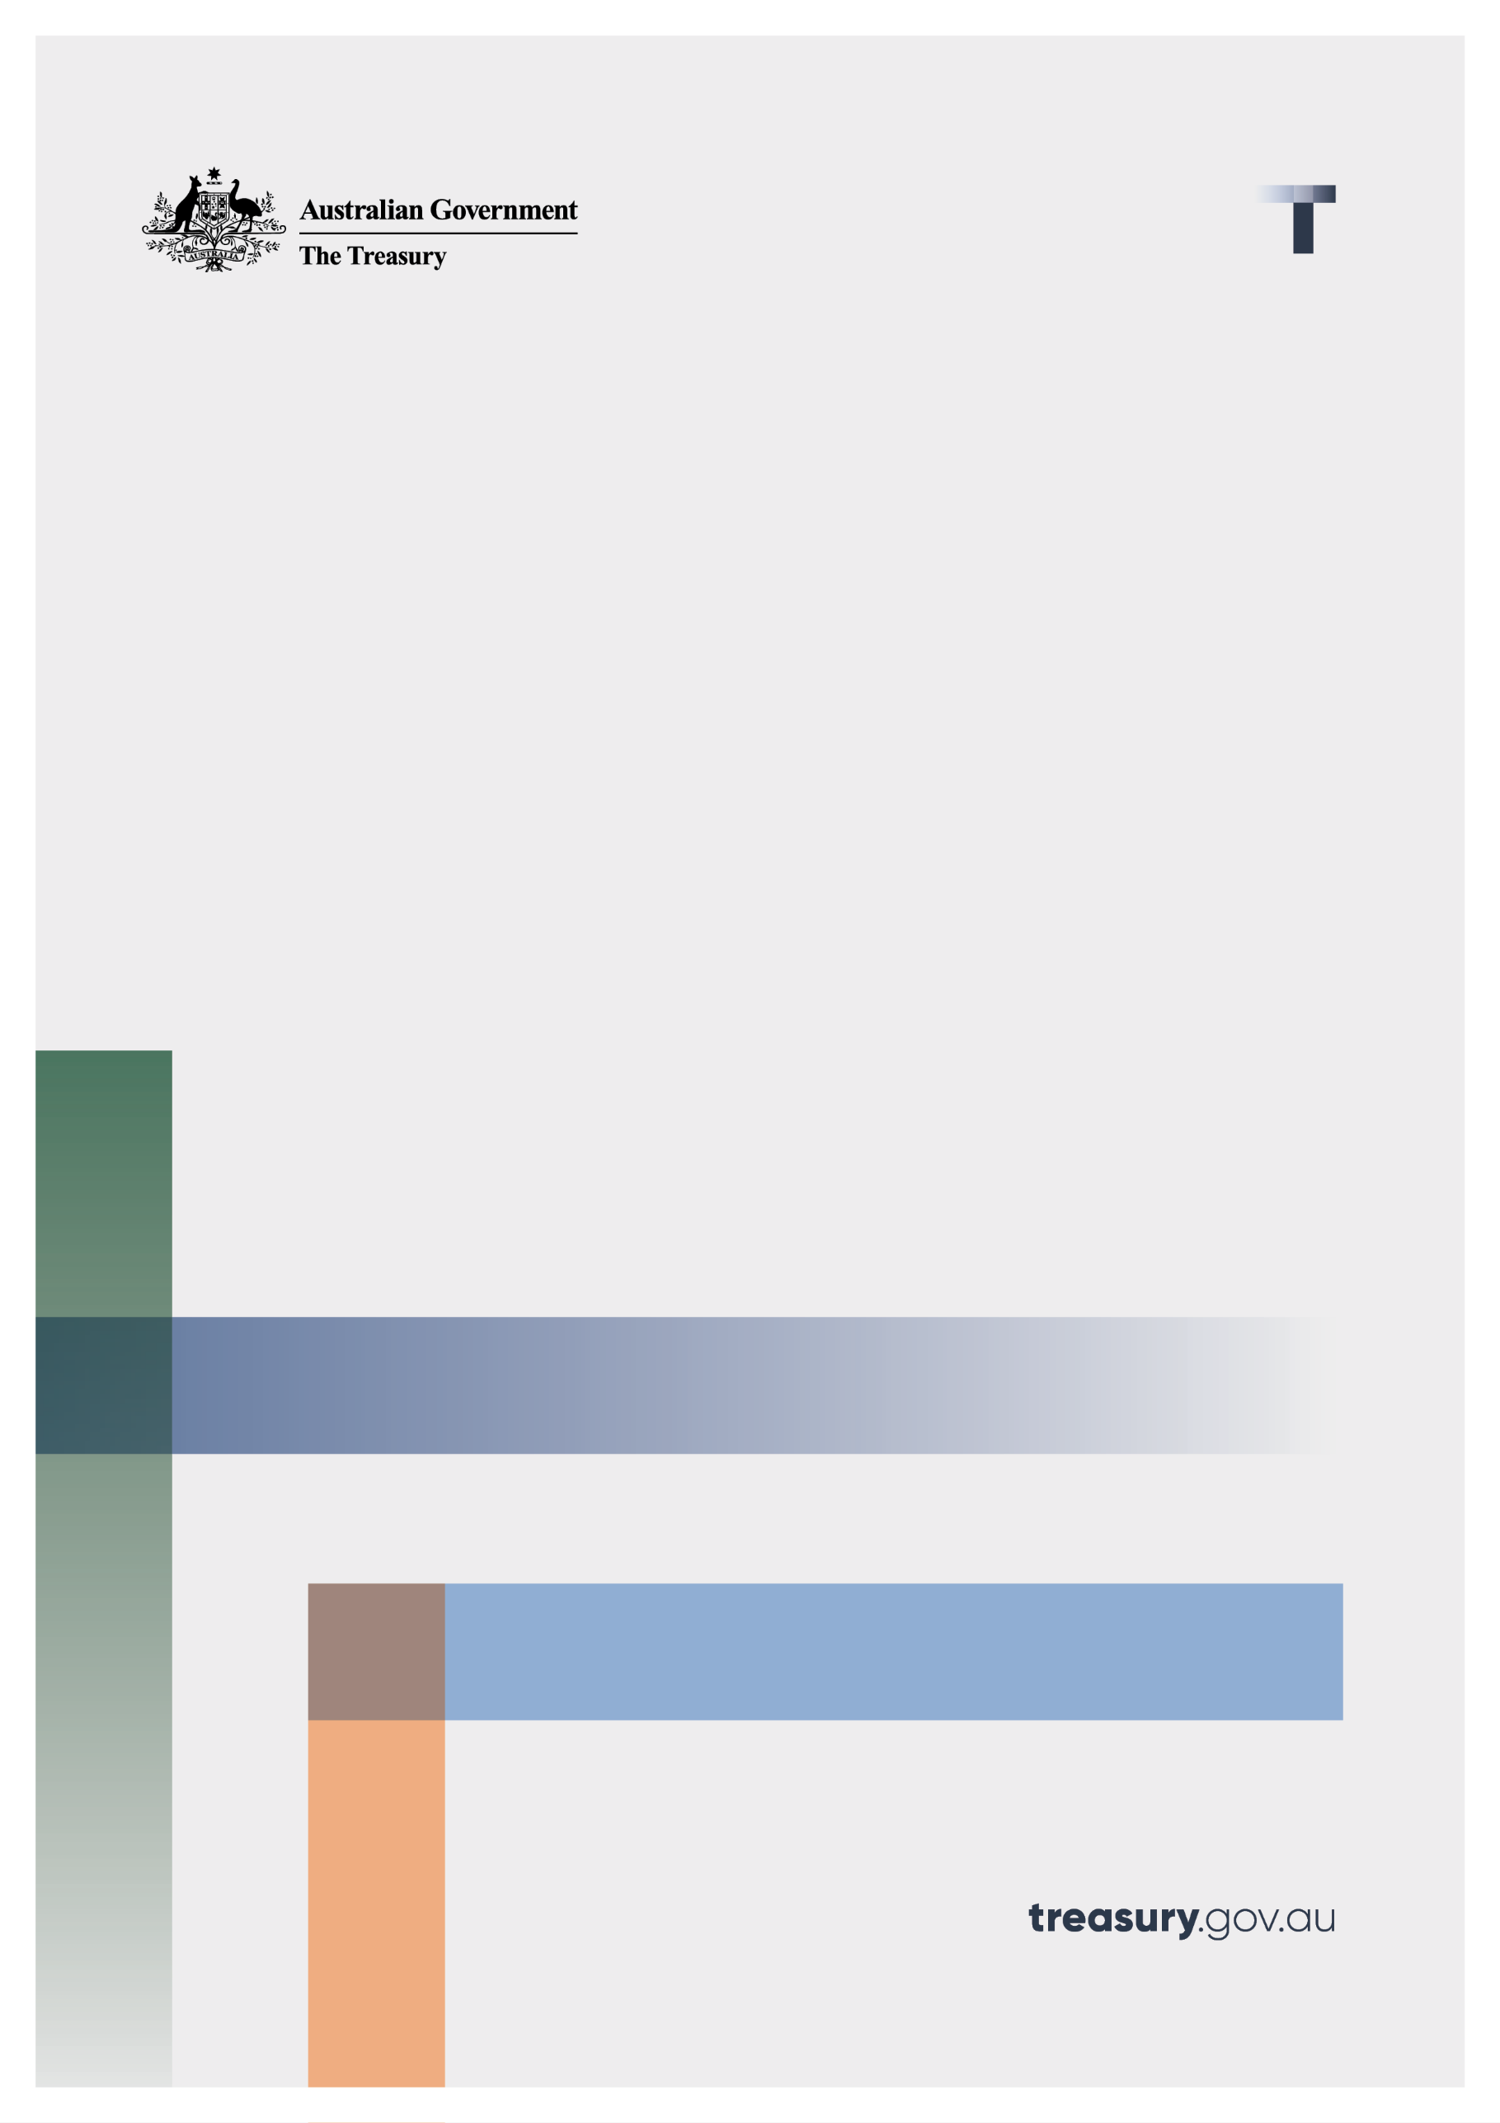

Removal of the stamping fee exemption

Consultation paper

28 June 2022

© Commonwealth of Australia 2022

This publication is available for your use under a [Creative Commons Attribution 3.0 Australia](http://creativecommons.org/licenses/by/3.0/au/deed.en) licence, with the exception of the Commonwealth Coat of Arms, the Treasury logo, photographs, images, signatures and where otherwise stated. The full licence terms are available from <http://creativecommons.org/licenses/by/3.0/au/legalcode>.

Creative Commons attribution licence 3.0 icon. 

Use of Treasury material under a [Creative Commons Attribution 3.0 Australia](http://creativecommons.org/licenses/by/3.0/au/deed.en) licence requires you to attribute the work (but not in any way that suggests that the Treasury endorses you or your use of the work).

**Treasury material used ‘as supplied’.**

Provided you have not modified or transformed Treasury material in any way including, for example, by changing the Treasury text; calculating percentage changes; graphing or charting data; or deriving new statistics from published Treasury statistics — then Treasury prefers the following attribution:

*Source: The Australian Government the Treasury*.

**Derivative** **material**

If you have modified or transformed Treasury material, or derived new material from those of the Treasury in any way, then Treasury prefers the following attribution:

*Based on The Australian Government the Treasury data*.

**Use of the Coat of Arms**

The terms under which the Coat of Arms can be used are set out on the Department of the Prime Minister and Cabinet website (see [www.pmc.gov.au/government/commonwealth-coat-arm](http://www.pmc.gov.au/government/commonwealth-coat-arm)s).

**Other uses**

Enquiries regarding this licence and any other use of this document are welcome at:

Manager  
Media and Speeches Unit  
The Treasury  
Langton Crescent   
Parkes ACT 2600  
Email: [media@treasury.gov.au](mailto:media@treasury.gov.au)

# Contents

Contents ii

Consultation Process 3

Request for feedback and comments 3

Removal of the stamping fee exemption 4

Introduction 4

Background 4

Policy objectives 5

Purpose 5

Consultation questions 5

# Consultation Process

## Request for feedback and comments

Interested stakeholders are invited to comment on the issues raised in this paper by 10 July 2022. Submissions may be lodged electronically or by post, however electronic lodgement is preferred via email to mailto:FinancialAdvice@treasury.gov.au. For accessibility reasons, please submit responses via email in a Word, RTF or PDF format.

Submissions will be shared with other Commonwealth agencies where necessary for the purposes of this review. All information (including name and address details) contained in submissions may be made publicly available on the Australian Treasury website unless you indicate that you would like all or part of your submission to remain in confidence. Automatically generated confidentiality statements in emails are not sufficient for this purpose.

If you would like only part of your submission to remain confidential, please provide this information clearly marked as such in a separate attachment. Legal requirements, such as those imposed by the Freedom of Information Act 1982, may affect the confidentiality of your submission.

Closing date for submissions: 10 July 2022

|  |  |
| --- | --- |
| Email | FinancialAdvice@treasury.gov.au |
| **Mail** | Assistant Director  Advice Unit  Retirement Advice and Investment Division  Treasury  Langton Cres  Parkes ACT 2600 |
| **Enquiries** | Enquiries can be initially directed to FinancialAdvice@treasury.gov.au |

# Removal of the stamping fee exemption

## Introduction

On 21 May 2020, the former Treasurer, the Hon Josh Frydenberg MP, [announced](https://ministers.treasury.gov.au/ministers/josh-frydenberg-2018/media-releases/government-response-treasury-consultation-stamping) that the ban on conflicted remuneration would be extended to listed investment companies (LICs) and trusts (LITs) from 1 July 2020. Removing conflicted remuneration was implemented to address potentially misaligned incentives between adviser and client, and to ensure capital markets remain efficient and globally competitive.

The Office of Best Practice Regulation (OBPR) determined that the measure was likely to have major impacts on affected businesses and individuals and a Regulation Impact Statement (RIS) was required to be prepared. However, a RIS was not completed prior to the final decision. As a result, Treasury is required to complete a post implementation review of the policy within two years of implementation.

## Background

Stamping fees are one-off volume-based payments made to Australian Financial Service (AFS) licensees or their representatives, like financial advisers, who secure investors for capital raising (such as the initial public offerings of shares).

Stamping fees represent a form of conflicted remuneration. Conflicted remuneration is a benefit given to an AFS licensee or its representative which may influence the financial product advice given to retail clients. The advice may be either general advice or personal advice.

The legislative treatment of stamping fees has changed over the last decade. The original 2012 Future of Financial Advice (FoFA) reforms included an exemption for stamping fees. However, the exemption only related to interests in non-investment entities or infrastructure funds. The exemption was to ensure real economy companies’ capital raisings were not negatively impacted by the reforms.

The FoFA reforms were developed in response to the 2009 Parliamentary Joint Committee on Corporations and Financial Services Inquiry into Financial Products and Services in Australia which identified conflicted remuneration as the leading cause of poor financial advice provided to clients. The purpose of banning conflicted remuneration was to remove the conflict between advisers and their clients’ interests that arises when advisers are provided with incentives (remuneration and other benefits) from the issuers of financial products. By removing this conflict, advisers would be free to act in the best interests of their clients and thereby provide better quality advice.

In 2014, the stamping fee exemption was expanded to include listed investment entities. Listed investment entities include LICs, LITs and real estate investment trusts (REITs). Since 1 July 2020, stamping fees paid in respect of LICs and LITs have been treated as conflicted remuneration and have been prohibited under the *Corporations Act 2001*. Stamping fees paid in respect of REITs remained exempt as part of the 2020 changes.

Listed investment entities were included in the ban on conflicted remuneration on the basis that the 2014 exemption created an inappropriate, market-distorting distinction between entities that are otherwise legitimately permitted to raise capital from retail investors. The exemption had allowed listed investment entities to pay AFS licensees or their representatives a stamping fee for access to their retail investor distribution network.

## Policy objectives

The changes to the treatment of stamping fees from 1 July 2020 was intended to remove the incentive for AFS licensees or their representatives to mis-sell products to retails clients in order to increase their remuneration, which would result in poorer consumer outcomes.

Stamping fees can also create a distortion in the funds management market that puts financial advice firms that use fees-for-service models at a competitive disadvantage. Firms not paying stamping fees were competing against firms that can offer discounted pricing by supplementing revenue through stamping fee earnings. Investment products such as exchange traded funds, exchange traded products and managed funds were likewise disadvantaged by being unable to pay stamping fees.

Removing distortions created by stamping fees was intended to improve competitive neutrality within the funds management industry and generate better outcomes for consumers.

## Purpose

This paper seeks feedback from industry on the regulatory impacts of the 2020 policy changes.

## Consultation questions

|  |
| --- |
| 1. What impact has the policy change had upon retail investors? 2. How has the policy affected stockbrokers and financial advisers? 3. How have consumers’ investment choices been affected? 4. Has the policy beneficially changed competition settings in the managed funds sector? 5. Have there been unintended consequences resulting from the policy changes? |