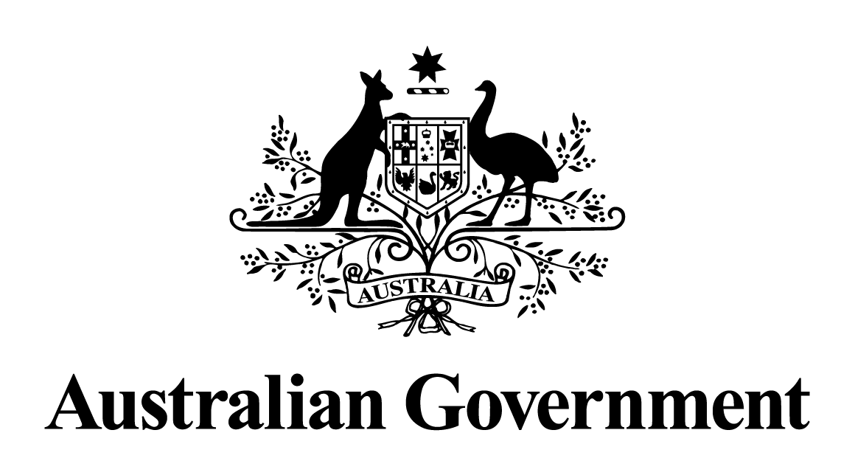
Australian Government response to the Senate Economics References Committee report:
Greenfields, cash cows and the regulation of foreign investment in Australia

April 2022

Introduction
This is the Australian Government’s response to the Senate Economics References Committee’s (the Committee) report, Greenfields, cash cows and the regulation of foreign investment in Australia, released in August 2021.

During the period in which the Committee was conducting its inquiry into foreign investment proposals, the Government introduced a comprehensive suite of reforms to the Foreign Acquisitions and Takeovers Act 1975 and its supporting regulations. The reforms included measures to address national security risks; strengthen the existing system, particularly as it relates to compliance by foreign investors; and streamline investment in non-sensitive businesses. The reforms did not change the underlying principles of Australia’s foreign investment framework – that Australia is open and welcoming to foreign investment that is not contrary to the national interest.

In accordance with the enacting legislation for the reforms, the Treasury provided an evaluation of the reforms to the Treasurer on 10 December 2021. The evaluation considered
the impact of the reforms on foreign investment and the broader Australian economy, and whether the right balance was struck between welcoming foreign investment into Australia and protecting Australia’s national interest.

The Government’s response to the Senate Committee’s recommendations are provided below.

Response to the recommendations made by the Committee
Recommendation 1
The Committee recommends that the Australian Government amends regulations to the effect that undertakings made as part of a foreign investment application can be enforced as conditions on an investment approval and that they consider publishing details relating to these decisions.
Australian Government response
the Government does not support this recommendation.

Enforceable conditions may be imposed on some investment approvals to ensure the investment is not contrary to the national interest. Commitments made in an application may be taken into account when deciding whether a proposed investment is contrary to the national interest, and may be included as a condition to an approval – but only if it is assessed to be necessary to ensuring the investment is not contrary to the national interest.

The foreign investment reforms that commenced on 1 January 2021 enhanced the Government’s ability to secure and manage an investor’s compliance with the conditions of their foreign investment approval and other compliance obligations under the foreign investment framework. This includes allowing the Treasurer to accept compliance-related undertakings (enforceable undertakings) under section 101C of the Foreign Acquisitions and Takeovers Act 1975, in accordance with the Regulatory Powers (Standard Provisions) Act 2014.

Generally, after the Treasurer accepts an enforceable undertaking, that undertaking will be published online by the Treasury. The Treasurer can decide that an accepted undertaking should not be published if the release of its contents would be contrary to the national interest.

Recommendation 2
The Committee received evidence of gaps in regulator capability. Accordingly, the Committee recommends the Australian Government conducts an audit of the expertise required by foreign investment regulators to thoroughly assess applications against the national interest and establishes a plan to staff these organisations accordingly.
Australian Government response
the Government supports in principle this recommendation.

For the foreign investment framework to be effective, the agencies responsible for administering it require sufficient expertise and resources to assess proposed investments against the national interest (or national security, as applicable), and to monitor and enforce compliance. The Treasury and the Australian Taxation Office also draw on expertise from across government by consulting with agencies in relation to particular aspects of the national interest, for instance national security and taxation.

To support the recent reforms to the framework, the 2020 July Economic and Fiscal Update and the 2020-21 Budget provided an additional $149.1 million to the Treasury, the Australian Taxation Office and some foreign investment consultation partners (the Department of Home Affairs and the Australian Security Intelligence Organisation). These packages provided funding for increased staffing and the implementation of an enhanced ICT case management system, advanced analytics and a register of foreign ownership of Australian assets. The Government is committed to providing additional funding to the Treasury as circumstances require.

In recent years, the Treasury has increased staffing levels and developed new capabilities. The number of staff in the Treasury’s Foreign Investment Division increased from 76 staff in early 2020 to 146 staff in late-2021. This includes significantly expanding the number of staff working on compliance and enforcement, and establishing a dedicated unit to provide advice on national security actions and to manage a market scanning capability to support the new national security call-in power.

Recommendation 3
The Committee recommends the Australian Government takes note of the Productivity Commission recommendation that consideration be given to the most suitable institutional design to support decision-making on foreign investment and monitoring and enforcement of compliance, and conducts a review to determine the structure necessary for an effective and efficient foreign investment regulator.
Australian Government response
the Government notes the Productivity Commission’s recommendation.

The Government considers it is appropriate for the Treasury to be the administrator and regulator of the foreign investment framework, noting the decision maker under the foreign investment framework is the Treasurer.

The Government has recently strengthened the Treasury’s capabilities as the foreign investment regulator through enhanced powers and increased funding. The recent reforms to the foreign investment framework significantly bolstered the Treasury’s toolkit to be an effective regulator, with enhanced powers to monitor compliance and increased penalties to manage and deter non-compliance. The reforms were supported by an additional $149.1 million that focused on increased staffing – including in relation to compliance and national security-related activities – and the implementation of an enhanced ICT case management system, advanced analytics and a register of foreign ownership of Australian assets.

Response to Senator Patrick’s Recommendations
Recommendation 1
The Australian Government should amend the Foreign Acquisitions and Takeovers Act 1975 to enable publication of foreign investment applications and approvals, including relevant associated information.
Australian Government response
the Government does not support this recommendation.

Under the foreign investment framework, the information that foreign investors provide in their applications is designated as protected information under the Foreign Acquisitions and Takeovers Act 1975. This limits how much information the Government can publicly disclose about the investments reviewed under the framework, including whether and how an investment has been approved, and the reasons for an investment being prohibited.

These rules support the integrity of the screening process by ensuring the information provided by investors is treated confidentially by the Government. In many cases, this information is commercially sensitive. If applicants were not confident their disclosures would be treated as commercial in confidence, they may be reluctant to provide the information the Government needs to be able to properly assess applications.

Recommendation 2
The corporate structure of the foreign investor and the role of related foreign entities in the Australian entities output should be defined and be part of the investment application.

The corporate structure of the foreign investor as it pertains to the Australian operations, including the role of related foreign entities in the Australian entities output should be deemed relevant associated information and publicly available.
Australian Government response
The Government notes this recommendation.

As part of its screening of foreign investment, the Government’s consultation process includes investigation of the investor’s corporate structure to understand the risks associated with the proposed investment, including tax risks. Where application information is insufficient, the Treasury and the Australian Taxation Office (ATO) seek additional information necessary to assess the risk. The government has recently established an early engagement service which can provide foreign investors with guidance on the application of Australia’s tax laws to a proposed investment. In addition, transactions which proceed may be subject to tax conditions and potential ATO compliance action. Commercial sensitivities and privacy considerations limit the ability to make this information publicly available.

Recommendation 3
Voluntary undertakings should be accepted as a self-imposed condition of the investment proposal, and thus be relevant associated information publicly disclosed. A little light over here, please.
Australian Government response
the Government does not support this recommendation.

Enforceable conditions may be imposed on some investment approvals to ensure the investment is not contrary to the national interest. Commitments made in an application may be taken into account when deciding whether a proposed investment is contrary to the national interest, and may be included as a condition to an approval – but only if it is assessed to be necessary to ensuring the investment is not contrary to the national interest.

The foreign investment reforms that commenced on 1 January 2021 enhanced the Government’s ability to secure and manage an investor’s compliance with the conditions of their foreign investment approval and other compliance obligations under the foreign investment framework. This includes allowing the Treasurer to accept compliance-related undertakings (enforceable undertakings) under section 101C of the Foreign Acquisitions and Takeovers Act 1975, in accordance with the Regulatory Powers (Standard Provisions) Act 2014.

Generally, after the Treasurer accepts an enforceable undertaking, that undertaking will be published online by the Treasury. The Treasurer can decide that an accepted undertaking should not be published if the release of its contents would be contrary to the national interest.

The information that foreign investors provide in their applications is designated as protected information under the Foreign Acquisitions and Takeovers Act 1975. This limits how much information the Government can publicly disclose about the investments reviewed under the framework, including whether an investment has been approved and the conditions that may have been imposed.

Response to the Australian Greens’ Recommendations
Recommendation 1
That the forceful dispossession of First Nations people from their lands be acknowledged, by: first establishing a Truth & Justice Commission; then enacting a national Treaty and/or Treaties with First Nations peoples in this country, sovereign to sovereign; and then, subject to Treaty negotiations, establishing a national First Nations Voice to be included in the governance of Australia, as determined by First Nations peoples.
Australian Government response
The Government partially supports this recommendation.

Fundamental to the Australian Government’s response to this recommendation is the National Agreement on Closing the Gap. In particular, priority one focusses on partnership and shared decision-making between Aboriginal and Torres Strait Islander people and governments, and priority three focuses on improving engagement with Aboriginal and Torres Strait Islander people, promoting culture, and increasing cultural safety to reduce the proportion of Indigenous Australians who have experiences of racism.

With respect to the recommendation to establish a Truth and Justice Commission, the Australian Government welcomes local truth-telling processes, and considers this is best dealt with by state and territory governments.

The Government is committed to truth-telling at the national level by working in partnership with Aboriginal and Torres Strait Islander peoples and communities; and local, state and territory governments.

The Government is also committed to tangible outcomes that recognise historical policies that have negatively impacted Aboriginal and Torres Strait Islander peoples. On 5 August 2021, as part of the Commonwealth’s Closing the Gap Implementation Plan, the Australian Government announced the $378.6 million financial and wellbeing redress scheme for Stolen Generations survivors who were forcibly removed as children from their families in the Northern Territory or the Australian Capital Territory prior to their respective self government, or the Jervis Bay Territory. The Scheme represents a major step forward towards healing, truth-telling and reconciliation and demonstrates the Commonwealths contributions towards the Priority Reforms and Outcomes under the National Agreement on Closing the Gap.

With respect to the recommendation to enact treaties and then establish a First Nations Voice, the Government is monitoring the work the states and territories are doing on treaties. It is important that states and territories take the lead on this work in their jurisdictions. The Government has supported the co-design of an Indigenous Voice. On 17 December 2021 the Government released the Indigenous Voice Co-design Final Report to the Australian Government, and announced their commitment to the implementation of Local and Regional Voices. Waiting until after treaty processes are complete across the country would delay progress on Aboriginal and Torres Strait Islander Australians having a greater say in decisions that impact them.

Recommendation 2
The decision to grant proposed foreign investments a ‘no objection notification’ (approval) or an ‘exemption certificate’ should be made public, along with a statement of reasons, with an exemption from this publication requirement being available on national security grounds, along with a statement of reasons for the exemption.
Australian Government response
the Government does not support this recommendation.

The information investors provide in their applications is designated under the foreign investment framework as protected information. This limits how much information the Government can publicly disclose about the investments reviewed under it, including whether, how and why an investment has been approved.

These rules support the integrity of the screening process by ensuring the information provided by investors is treated confidentially by the Government. If applicants were not confident their disclosures would be treated as commercial in confidence, they may be reluctant to provide the information the Government needs to be able to properly assess applications.

Recommendation 3
All undertakings made public in respect of a proposed foreign investment, by either the purchaser or government bodies, are to be held to be a condition of any subsequent approval; with powers to issue a divestment order being available for the breach of any such conditions.
Australian Government response
the Government does not support this recommendation.

Enforceable conditions may be imposed on some investment approvals to ensure the investment is not contrary to the national interest. Commitments made in an application may be taken into account when deciding whether a proposed investment is contrary to the national interest, and may be included as a condition to an approval – but only if it is assessed to be necessary to ensuring the investment is not contrary to the national interest.

The foreign investment reforms that commenced on 1 January 2021 enhanced the Government’s ability to secure and manage an investor’s compliance with the conditions of their foreign investment approval and other compliance obligations under the foreign investment framework. This includes allowing the Treasurer to accept compliance-related undertakings (enforceable undertakings) under section 101C of the Foreign Acquisitions and Takeovers Act 1975, in accordance with the Regulatory Powers (Standard Provisions) Act 2014.

Generally, after the Treasurer accepts an enforceable undertaking, that undertaking will be published online by the Treasury. The Treasurer can decide that an accepted undertaking should not be published if the release of its contents would be contrary to the national interest.

Recommendation 4
The annual statistical report contain information on the area, current value, tenure, beneficial owner, country of origin of beneficial owner, use and jurisdiction (state or territory) of all land in which there is a foreign interest.
Australian Government response
The Government notes this recommendation.

Once established, the Registrar of the Foreign Ownership of Australian Assets Register will be required to give the Treasurer an annual report, to be tabled in Parliament. The Registrar’s report will present de-identified statistical information on the legal interests recorded in the Register. The Government is committed to providing transparency of the level of foreign ownership of registrable Australian assets within the context of privacy and practical data limitations, and notes the community value of the information over the level of ownership in relation to different types of land.

Recommendation 5
The Australian Government introduce legislation that would include real estate agents, accountants and lawyers as designated services under the Anti-Money Laundering and Counter Terrorism Financing Act 2006.
Australian Government response
The Government notes this recommendation.

Australia has a robust Anti-Money Laundering/Counter-Terrorism Financing (AML/CTF) regime, which is continually reviewed to proactively manage emerging risks, improve consistency with international standards and best practice as set by the Financial Action Task Force, and enhance the operational effectiveness of the regime.

Expanding the existing regime to designated non-financial businesses and professions, including real estate agents, lawyers and accountants would capture as many as 100,000 additional businesses, the majority of which are small businesses or sole traders and practitioners. The Government is particularly cognisant of this regulatory imposition at a time when businesses face significant challenges stemming from the COVID-19 pandemic.

The Government will ensure that any future reforms to the AML/CTF regime will be co designed with affected sectors, and will be tailored and appropriate to the Australian context.

