Contents
The Consumer Data Right and Open Finance 2
CDR development 3
Strategic Assessment process 4
Consultation: who we spoke to and what we heard 5
Strategic Assessment insights 7
Strategic Assessment outcomes 9
A data purpose-driven approach will unlock consumer-centric use cases 9
Building on the success of Open Banking to expand to Open Finance 9
Access to consumer data held by Government will open up further benefits in an expanded CDR 10
Conclusions and next steps 12

The Consumer Data Right and Open Finance
The Consumer Data Right (CDR) is a key initiative of the Australian Government’s Digital Economy Strategy and provides the core infrastructure to support an increasingly data-driven economy. Like the rest of the economy, the data-driven economy is based on transactions in value (including data) between consumers, businesses and government. When data is exchanged within the CDR framework, it puts consumers in the driver’s seat by helping them derive value from data collected and generated about them as a result of their activities and transactions.
The core policy objectives of the Consumer Data Right (CDR) have been to encourage competition and greater access to previously unavailable information, as well as support new entrants into sectors to drive innovation and enhance product and service offerings.
Treasury’s recent Strategic Assessment consultation process highlighted the potential for the CDR to deliver so much more than these core objectives — it has the potential to truly underpin and support a world-leading, data-driven economy by providing an extensible data-sharing platform.
Following this consultation and a public submission process, ‘Open Finance’ has been identified as the next priority area to grow the CDR. Open Finance will bring targeted datasets from across general insurance, superannuation, merchant acquiring and non-bank lending service providers into the CDR. In addition, the process also identified that expanding the CDR to complementary government-held datasets may also significantly enhance the user experience and utility of CDR. Introducing data from across general insurance, superannuation, merchant acquiring and non-bank lending will build on the growing momentum of Open Banking by spurring rapid product development that gives consumers access to better deals and a more complete view of their finances. Consumers will also benefit from greater control over every part of their financial lives, including their savings, loans, assets and financial planning.
Open Finance will be implemented in phases involving the assessment and designation of key datasets within the superannuation, and general insurance sectors and merchant acquiring and non-bank lending service providers in 2022. To maximise efficiency of implementation and scale-up of the CDR and support a rich data-ecosystem, a targeted dataset approach will be adopted that prioritises and sequences assessment, designation and implementation of the CDR across these sectors.

CDR development
As a world-leading economic reform with a rolling program of expansion across the economy and a partnership with the private sector to encourage investment in data-driven innovation, the CDR supports more innovative and consumer-oriented services, as well as the digitalisation of business. It also has the potential to address increasing information asymmetries in some areas of the economy that create barriers for new entrants and, importantly, provides safer and more secure rails for sharing data.
The success of the CDR depends on creating a thriving innovation ecosystem. The CDR provides the legal framework to encourage data-driven innovation from private sector companies who create value-added products and services consumers want — a true public-private partnership that will continue to grow as more datasets become available and support cross-sectoral innovation.
Since the introduction of the CDR to the banking sector in July 2020, the number of accredited data recipients (ADRs) has been steadily growing; as of 18 January 2022, there are 26 ADRs, 11 of which are active. We expect those numbers to continue growing with the CDR’s expansion across the economy.
ADRs are already using the CDR to provide services to consumers, such as budgeting, bill payment and financial management apps, streamlined credit approval processes, the creation of in-depth financial overviews to assist consumers on their home-buying journey, and the use of financial transaction data combined with COVID location data to alert a consumer if they have been to a COVID hotspot.
In November 2021, rules were made that implement the CDR in the energy sector. Product data will be available from October 2022 to provide consumers with better information about energy product and service offerings and support more detailed comparison services, followed by phase one of consumer data from 15 November 2022.
Expansion to the third sector, telecommunications, is also underway with the publication of a detailed sectoral assessment in November 2021 and the finalisation of the telecommunications designation instrument. With the designation instrument now made, work will begin on developing telecommunications specific rules and standards.
In December 2021, the Government released its response to the Final Report of the Inquiry into Future Directions for the Consumer Data Right. The Government’s response commits to significantly strengthen and deepen the CDR’s functionality through implementing third-party action and payment initiation, along with other recommendations to grow the CDR ecosystem and foster greater international engagement.

Strategic Assessment process
As announced in the 2021–22 Budget, to inform the next phase of the economy-wide roll-out of the CDR, Treasury undertook a rapid, high-level assessment of sectors and datasets across the economy. The process involved wide-ranging consultation with domestic and international stakeholders in industry and government, and a six-week public consultation process supported by a consultation paper.
The Strategic Assessment provided an opportunity to step back and assess the most effective approach to successful CDR implementation across the economy, with a focus on spurring ecosystem growth and delivering tangible consumer benefits.
The consultation process sought feedback on whether implementation should continue to adopt a sector-by-sector approach to designation or replace it with a more agile dataset-focussed approach. The process explored expansion of the CDR with regard to concepts of life journeys and significant consumer decisions and use cases. It also explored the evolution of the CDR and its potential utility in all aspects of Australians’ lives, going beyond driving switching behaviour. These insights focus on the dataset(s) required to spur the types of innovative applications that are likely to drive rapid consumer uptake of the CDR and support broad innovation.
A public Strategic Assessment consultation paper was open for comment from 22 July to
2 September 2021. It identified:
Four policy objectives to inform future CDR roll-out
Non-exhaustive list of sectors for consideration
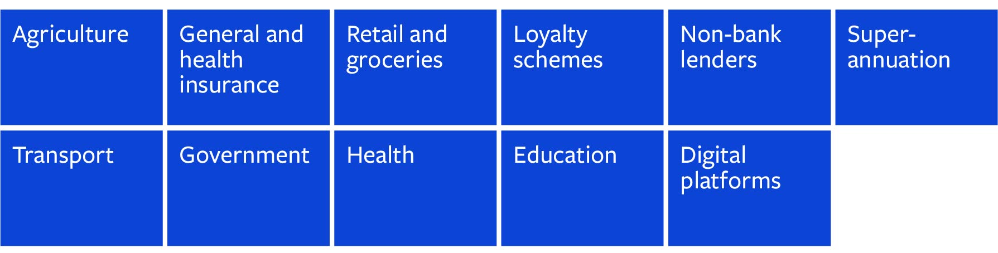

Consultation: who we spoke to and what we heard
Six domestic roundtables were held, with over 200 attendees in total:
- Roundtables brought together data holders, potential ADRs, consumer groups and regulators.
- They covered Insurance, Superannuation, Agriculture, Non-Bank Lenders, Retail and Loyalty Schemes, and Consumer Groups. A separate government and regulatory roundtable was convened to explore government datasets.
- Two workshop discussions with the CDR FinTech Community of Practice.
In addition, bilateral meetings were held with:
- Government agencies, regulators and private firms.
- Consumer and privacy advocates (for example, the Financial Rights Legal Centre and the Good Things Foundation).
- Business representative bodies (for example, the Business Council of Australia and the Insurance Council of Australia).
Over 40 written submissions were received, including from small and large tech firms, industry representative bodies, professional and general business associations, insurers and superannuation data holders.
What we heard
‘Both insurance and superannuation data is critical to improve competition, enable new and innovative entrants, and enhance consumer access and understanding of the available insurance and superannuation products.’ FinTech Australia
A multi-sector approach can create efficiencies and synergies: ‘Where the datasets are similar, multiple sectors could be released at the same time with respect to product data.’ Cuscal
‘We support consideration being given to moving from a sector-centric approach towards more of a focus on consumer experience.’ Australian Small Business and Family Enterprise Ombudsman

Treasury also engaged with international counterparts and numerous experts and prominent international representatives. This included:
- Government, regulators, researchers, consultants and international organisations in the United Kingdom, Singapore, New Zealand, India, Brazil, Estonia, Japan, Canada and the United States.
- Prominent organisations including the World Bank, the Bank for International Settlements, the Department for Business, Energy and Industrial Strategy (UK), Ministry of Business, Innovation and Employment (NZ), European Banking Federation, Oxford University, Fintech New Zealand, and multinational fintechs such as Truelayer.

Strategic Assessment insights
The advice we received from business, industry and other experts to inform our decision-making was both significant and valuable, generating key insights that we carefully analysed and incorporated into our recommendations.
At a glance, these insights included that the Consumer Data Right:
- could be the central nervous system of Australia’s data economy
- should be data holder-agnostic
- prioritise agile and responsive implementation
- retain consumer-centred development, and
- play a role in digital identify verification and sharing of credentials.
Recommendations
CDR can be the ‘central nervous system’ of Australia’s data economy
‘For social outcomes, the number of problems that CDR can solve is infinite. Use cases as wide as gambling and alcohol addiction help to welfare spending and government program eligibility would help people navigate a complex and stressful process to access the help and funding that they need.’ Adatree
- Stakeholders saw the CDR as a competitive, secure space to innovate on their own terms.
- A CDR framework that adapts to the changing needs of Australians will create a digital economy for Australia that works for individuals and businesses.
- Opportunities highlighted went beyond product comparison and switching, to deeper insights for consumers and even to matters with broader social impacts. Potential applications through CDR include informing consumers making values-based purchases, to even assisting organisations, including not-for-profits and governments, in the delivery of disaster relief.
CDR should adopt a data holder-agnostic approach
- Stakeholders noted that unlocking public sector data could drive private innovation and improve how consumers use government data services.
- Managed appropriately and thoughtfully, including government data into the CDR system can increase consumer trust in both government data use and the CDR.
Prioritise an agile and responsive implementation of CDR
- Changes in the digital and data frontier are not always predictable or stable.
- The CDR framework should be flexible to these changes, both in terms of expanding to new datasets and in responding to the development of technology.
- The changing boundaries and participants of any given industry mean that traditional definitions of sectors can be overtaken in practice. An agile and responsive CDR framework will ensure that participation and resulting benefits are maximised in line with that practice.
Consumer-centred development must be retained
- Digital consumers are segmented with divergent needs, capabilities and trust of the online world.
- In order for consumers to get the most out the system, the CDR needs to understand how different consumers will engage, or not engage, with an expanded set of sectors or datasets.
- The CDR and its consent-driven core of transparency with embedded privacy principles can reassure consumers of their digital safety and provide a foundation for confident consumer engagement.
CDR has a role in Digital Identity Verification and sharing of credentials
- Identity verification, through both government data and private sector solutions, was a recurring proposal made during the Strategic Assessment.
- Bringing digital identity verification into the CDR builds off the Inquiry into the Future Directions for the Consumer Data Right report, which recommended that the CDR should incorporate interoperable authentication.
Key factors to support prioritisation and sequencing of further CDR expansion
‘… it may be that a new approach is needed that focuses less on the features of a particular sector or dataset, and more on the impact of the scale and combination of different dataset(s), potentially viewed through the lens of the net interests of the citizen/consumer.’ Australian Society for Computers & Law
- Prioritise datasets that build on existing dataset(s) or are highly complementary to support faster ecosystem growth.
- Prioritise datasets that support multiple use-cases, broad innovation and user-journeys rather than simple switching use cases.
- Focus on friction points for consumers that can be addressed through data-driven innovation and standardisation.
- Consider how the CDR might interact with any existing data-sharing mechanisms already operating in a sector.
- Consider maturity of ICT infrastructure and digital capability of sector, as well as the proprietary nature of datasets.
- Applying the above factors also supports building on open banking and prioritising expansion to other financial services and products (‘Open Finance’).

Strategic Assessment outcomes

A data purpose-driven approach will unlock consumer-centric use cases
Leveraging the rich insights received through the Strategic Assessment, key factors were identified to guide the future prioritisation and sequencing of CDR to future datasets. These key factors complement a more agile approach to future CDR expansion that prioritises a smaller number of targeted datasets across sectors that will more rapidly unlock consumer-centric use cases.
The key factors are illustrated below and include the value of dataset(s) alone or when combined with other dataset(s), the relative costs to data holders of making a single or multiple dataset(s) available and the digital readiness of certain sectors to support sequencing of various dataset(s).
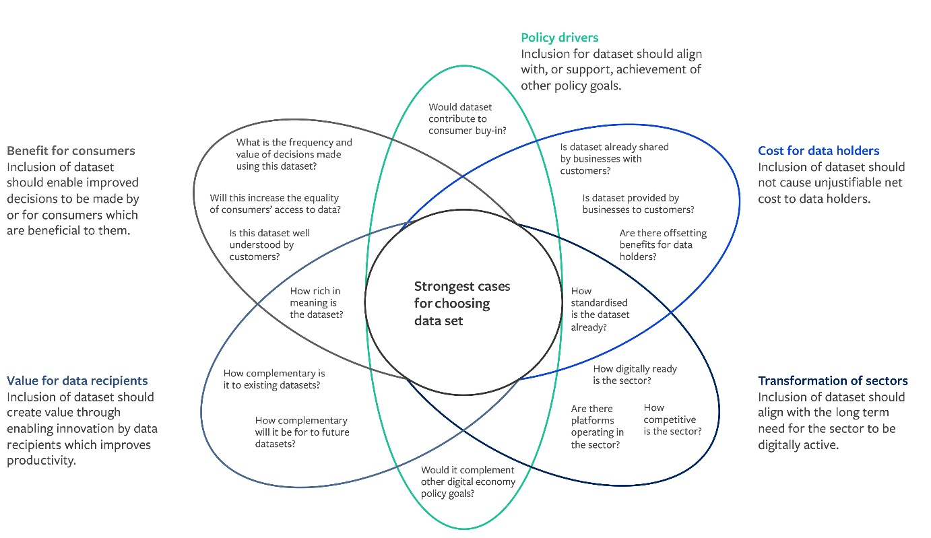

Building on the success of Open Banking to expand to Open Finance
The Strategic Assessment tested the key factors noted above across a range of potential sectors and datasets identified by stakeholders and through previous commissions of inquiry, including transport, retail, loyalty schemes, agriculture, education, health and digital platforms. Extension of the CDR to Open Finance emerged as a clear priority. Open Finance will include the concurrent assessment and designation of datasets across the non-bank lending, merchant acquiring, superannuation and general insurance sectors. By prioritising a smaller mix of targeted datasets across these sectors, the CDR will unlock a broader range of higher-value use cases, compared to expanding one sector at a time.
‘… prioritised designated data holders … will clearly enable better consumer outcomes, more competition, more choice, huge savings, smoother experiences, and new data-driven smarter propositions. These are at the essence of application of the Consumer Data Right.’ Adatree
For example, combining a few key datasets in superannuation and general insurance would support applications that provide consumers with a richer picture of their current and expected financial circumstances and will support improved financial planning, and key life decisions such as asset purchases, preparing for retirement or change in employment circumstances while balancing implementation considerations.
Stakeholders highlighted the benefits of a phased approach to superannuation and general insurance by focussing on dataset(s) that support important use-cases like whole-of-life financial management, recognising that some sectors, such as general insurance, will take longer to assess and implement. Feedback suggested an initial focus on consumer-specific account information, such as account balances, for superannuation rather than product data, and product and/or attribute data for sub-categories of general insurance. Feedback also recommended exploring relevant government data holdings as potential sources of superannuation and general insurance related data.
‘… we see the larger insurance categories as the top-priority sectors for introducing the CDR. For both home insurance and car insurance, we see markets where comparing the best available deals is currently extremely difficult and time-consuming for consumers. … It is [also] clear that superannuation is a sector where moving consumers to higher-performing funds will lead to hugely significant consumer benefit in the long term.’ Finder
Open Finance provides a strong foundation to introduce payment and action initiation reforms and has the potential to complement existing reforms in the Your Super Your Future package, as well as in the implementation of any Government Response to the Payments System review.
The exception for a phased approach to Open Finance is the extension of CDR to non-bank lending and merchant acquiring service providers. Implementation of CDR across non-bank lending and merchant acquiring service providers was viewed as a logical extension of Open Banking, with many of the datasets likely to be highly complementary to banking datasets and existing rules and standards likely to be highly extensible. Non-banking lending products are also increasingly an important source of credit, particularly in the COVID-constrained business environment, supporting a more comprehensive roll-out to the non-bank lending sector.
‘There is a high degree of consumer benefit to be gained should product and consumer data sharing be enabled in these sectors. These sectors are suggested based on the current barriers to switching, the potential consumer benefits, the applicability across a consumer’s lifecycle, and the potential to increase transparency across industries.’ iSelect, on general insurance and non-bank lending
The Reserve Bank of Australia’s Review of Retail Payments Regulation also highlighted how the CDR could improve transparency of pricing and competition, which will be explored through the Open Finance assessment process.

Access to consumer data held by Government will open up further benefits in an expanded CDR
Consultation with industry and across state and Commonwealth government agencies highlighted the benefits of designating customer-specific data held by government, either to complement private sector data or to support particular use cases (for example, verifying customers or qualification credentials). It is already possible for data held by government agencies to be included in a CDR designation instrument, with data from the Australian Energy Regulator and Victorian Energy Compare having been designated in the energy sector.
Prioritising the inclusion of customer data held by governments recognises that most consumer milestone events or decisions (for example, buying a house, getting married, having a child, starting or winding up a business, or retiring) will involve a mixture of data held by private business and government agencies about an individual or business.
Consultations also highlighted that expansion to government datasets and the inclusion of government agencies as both data holders and accredited data recipients has the potential to improve private sector goods and services, support improved Government service delivery, and support Australians and Australian businesses across all facets of their lives and operations. Expanding the CDR to customer-specific complementary data held by government could also significantly enhance user experience and the utility of the CDR.

Conclusions and next steps
The Strategic Assessment has truly demonstrated the benefit of undertaking a regular economy-wide scan to calibrate CDR expansion and provide the flexibility to respond to a rapidly changing digital economy and the evolving needs and expectations of consumers. The process benefited from significant levels of industry and expert engagement across the entire CDR ecosystem.
The approach of undertaking a high-level strategic assessment complements the more detailed process of formally assessing and designating data and data holders as set out in the Competition and Consumer Act 2010.
The expansion to Open Finance leverages momentum that has been building for the CDR by targeting high-value datasets that will support more rapid uptake and broad-based innovation. It will enable the CDR to deliver significant, tangible benefits for consumers by supporting frictionless switching and driving productivity gains by reducing administrative burden on SMEs. Further targeted consultation will be undertaken to support the assessment and designation of priority datasets in Open Finance, including datasets from across non-bank lending, merchant acquirers, superannuation and general insurance sectors, with a view to completing the first phase of assessments and designations of Open Finance in 2022.
The assessment process will also explore the inclusion of relevant government Open Finance data.

