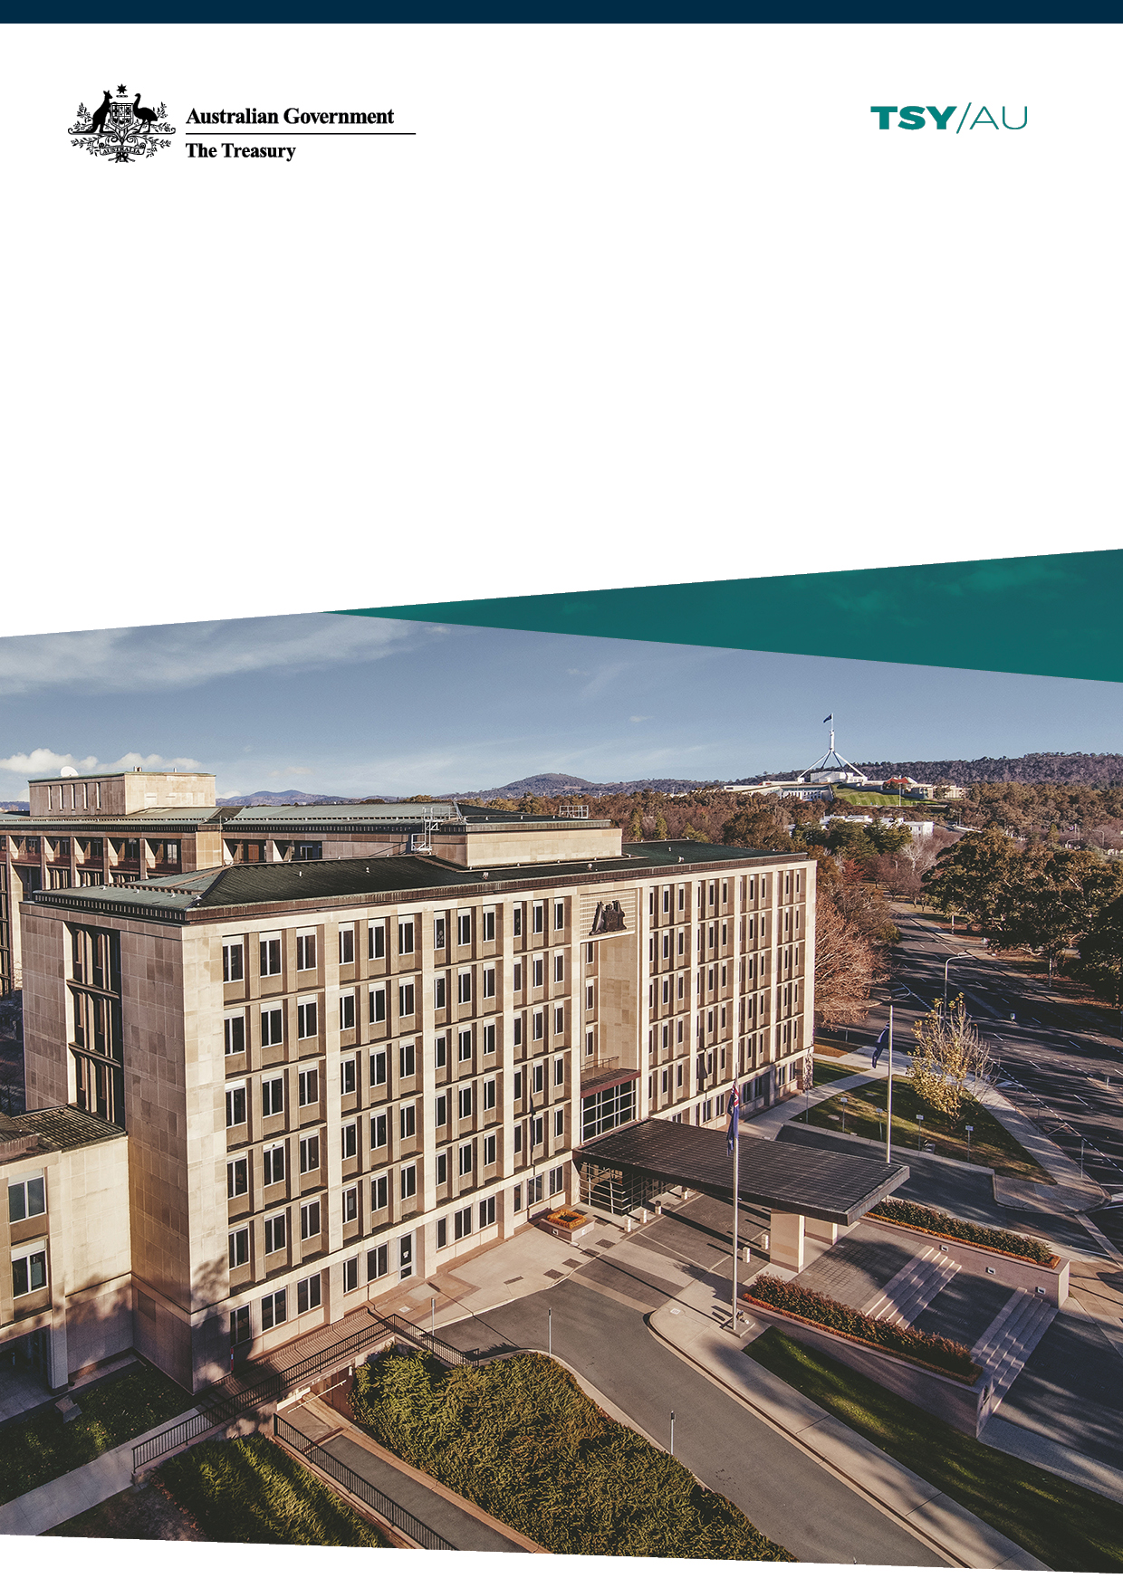

Australian Government   
Pay On-Time Survey 2020–21

Performance Report

December 2021

© Commonwealth of Australia 2021

ISBN 978-1-925832-41-9

This publication is available for your use under a [Creative Commons Attribution 3.0 Australia](http://creativecommons.org/licenses/by/3.0/au/deed.en) licence, with the exception of the Commonwealth Coat of Arms, the Treasury logo, photographs, images, signatures and where otherwise stated. The full licence terms are available from <http://creativecommons.org/licenses/by/3.0/au/legalcode>.

Creative Commons attribution licence 3.0 icon. 

Use of Treasury material under a [Creative Commons Attribution 3.0 Australia](http://creativecommons.org/licenses/by/3.0/au/deed.en) licence requires you to attribute the work (but not in any way that suggests that the Treasury endorses you or your use of the work).

*Treasury material used ‘as supplied’.*

Provided you have not modified or transformed Treasury material in any way including, for example, by changing the Treasury text; calculating percentage changes; graphing or charting data; or deriving new statistics from published Treasury statistics — then Treasury prefers the following attribution:

*Source: The Australian Government the Treasury*.

**Derivative** **material**

If you have modified or transformed Treasury material, or derived new material from those of the Treasury in any way, then Treasury prefers the following attribution:

*Based on The Australian Government the Treasury data*.

**Use of the Coat of Arms**

The terms under which the Coat of Arms can be used are set out on the Department of the Prime Minister and Cabinet website (see [www.pmc.gov.au/government/commonwealth-coat-arm](http://www.pmc.gov.au/government/commonwealth-coat-arm)s).

**Other uses**

Enquiries regarding this licence and any other use of this document are welcome at:

Manager  
Media and Speeches Unit  
The Treasury  
Langton Crescent   
Parkes ACT 2600  
Email: [media@treasury.gov.au](mailto:media@treasury.gov.au)

## **Contents**

Overview 1

Survey of Australian Government agencies 2

Results 2

Agencies are paying faster 2

Payment times by value and number 3

Interest payments 4

E-Invoicing 4

Table of Agency Results 6

# Overview

This report contains the results of the Australian Government Pay On‑Time Survey for the 2020–21 financial year. The survey has been conducted annually since 2002, and collects information from Government agencies about their performance against the Department of Finance [RMG-417 Supplier Pay On-Time or Pay Interest Policy](https://www.finance.gov.au/publications/resource-management-guides-rmgs/supplier-pay-time-or-pay-interest-policy-rmg-417)(the Pay On‑Time Policy).

The Pay On-Time Policy requires non-corporate Commonwealth entities (NCEs), referred to as Government agencies in this report, to make all payments under contracts valued up to $1 million (GST inclusive) within 20 calendar days. Where payment is not made in full within 20 calendar days, agencies are required to pay interest to the supplier on the outstanding amount where the amount of interest accrued is more than $100 (GST inclusive). Interest is payable at the general interest charge rate available on the ATO’s website calculated for each calendar day from the day after the payment was due up to and including the day the payment was made. In addition, since 1 January 2020, NCEs must offer five‑day payment terms where both parties have Pan‑European Public Procurement On‑Line (PEPPOL) compliant e‑Invoicing capability.

The 2020–21 survey results show there has been improvement in the proportion of payments for low value (up to $1 million) contracts paid within 20 calendar days compared to the previous year (see Chart 1).

Chart 1: Payments made in 20 calendar days

Chart 1 shows the percentage of invoices (for contracts up to $1 million) that were paid within 20 days for the 2019–20 and 2020–21 financial years. Agencies paid 93.2% of invoices for contracts up to   
$1 million in 2020–21 as compared to 90.6% in 2019–20. This is a 2.6 percentage point improvement in overall payment timeliness.

# Survey of Australian Government agencies

The 2020–21 Pay On‑Time Survey captured data on Government agencies’ performance against the Pay On-Time Policy for the 2020–21 financial year, including:

* The total number and value of invoices for contracts up to $1 million (GST inclusive)
* The total number and value of invoices for contracts up to $1 million (GST inclusive) that were paid within 20 days
* e-Invoicing capability
* The total number and value of e-Invoices for contracts up to $1 million (GST inclusive)
* The total number and value of e-Invoices for contracts up to $1 million (GST inclusive) that were paid within 5 days
* The total value of interest paid on late invoices and e-Invoices
* Reasons for any late payments.

# Results

## Agencies are paying faster

All 91 Government agencies in scope of the Pay On‑Time Survey provided data on their payment times of invoices subject to the Pay On‑Time Policy. In the past year, both the total number (Table 1) and total value (Table 2) of eligible invoices has fallen, a reflection of the year‑to‑year fluctuation in Government procurement. There have been improvements in the number and value of invoices paid after 20 days.

Table : 2019–20 and 2020–21 comparison by number of invoices of contracts valued up to $1 million (GST inclusive)

|  |  |  |
| --- | --- | --- |
|  | Number 2019–20 | Number 2020–21 |
| Paid within 20 days | 934,982 (90.6%) | 869,774 (93.2%) |
| Paid after 20 days | 96,926 (9.4%) | 63,407 (6.8%) |
| Total invoices | 1,031,908 | 933,181 |

Table 2: 2019–20 and 2020–21 comparison by value of invoices of contracts valued up to $1 million (GST inclusive)

|  |  |  |
| --- | --- | --- |
|  | Value 2019–20 | Value 2020–21 |
| Paid within 20 days | $7.99bn (85.1%) | $7.04bn (86.1%) |
| Paid after 20 days | $1.40bn (14.9%) | $1.14bn (13.9%) |
| Total invoices | $9.38bn | $8.18bn |

## Payment times by value and number

Overall, a higher proportion of eligible invoices — by both **value** and **number** — have been paid within 20 calendar days in the 2020–21 financial year, as compared to the 2019–20 financial year.

Chart 2: Percentage paid on time by value and number

Chart 2 shows the percentage of late invoices (by value and number) compared to on-time invoices for the past two financial years. The 2020–21 financial year saw increases in the percentage of invoices paid on time, with a 2.6 percentage point increase by number (from 90.6% to 93.2%) and 1 percentage point increase by value (from 85.1% to 86.1%).

## Interest payments

Under the Pay On‑Time Policy, interest is payable by a Government agency on late payments to invoices for contracts up to $1 million where the amount of interest accrued is greater than $100.

Chart 3: Interest paid

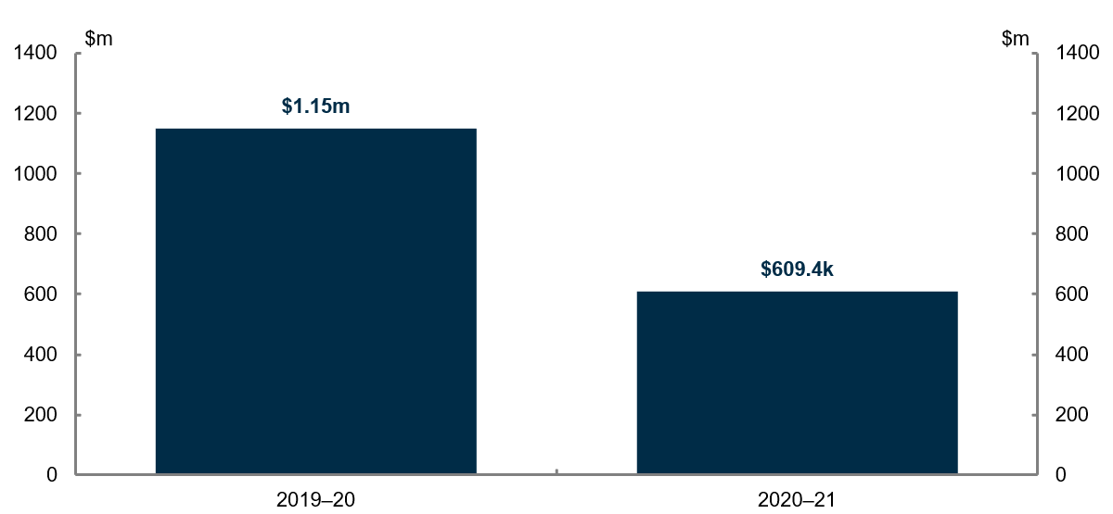

Chart 3 illustrates that the amount of interest paid in the 2020–21 financial year ($609,404) was approximately half (52%) that of the previous year ($1,150,164). This decrease is in part due to the Government’s improved payment times. However, it is also reflective of total expenditure on eligible invoices being lower in 2020–21, such that there were fewer invoices to potentially pay interest on.

## E-Invoicing

The number of e‑Invoicing enabled agencies increased from 4 in 2019–20 to 29 in 2020–21, but only 10 agencies recorded e‑Invoices that were in scope of the policy. At this stage only a small number and value of invoices are e‑Invoices (see Table 3). However, from 1 July 2022 all Commonwealth Government agencies are expected to be e‑Invoice enabled. As such, it is anticipated all e‑Invoicing values will increase over the coming two years.

Table 3: 2020–21 number and value of e-Invoices of contracts valued up to   
$1 million (GST inclusive)

|  |  |  |
| --- | --- | --- |
|  | Number 2020–21 | Value 2020–21 |
| Paid within 5 days | 57 | $575,467 |
| Paid late (after 5 days) | 35 | $446,381 |
| Total e-Invoices | 92 | $1,021,848 |

***Note:*** *this is the first time the survey has recorded and reported on e-Invoice numbers, value, and payment times.*

Chart 4: e‑Invoice payment times by number and value

Chart 4 shows the proportion of late e‑Invoices by number (38.0%) and value (43.7%). The percentages of e‑Invoices paid late are relatively high compared to the percentages of regular invoices paid late (6.8% by number, 13.9% by value). Payments made after 5 days on e‑Invoices resulted in a total of $213 paid in interest.

Agencies in the survey indicated that the adoption of e‑Invoicing required significant changes to payment systems which created difficulties in meeting the 5‑day requirement. Consequently, it is anticipated that the proportion of e‑Invoices paid late will decrease significantly in future years as agencies and their systems grow accustomed to e‑Invoicing.

## Table of Agency Results

Table 4 below shows the percentage of invoices (by number) paid within 20 days for regular invoices and within 5 days for e‑Invoices for all Government agencies that responded to the survey.

Overall, in 2020–21, 62 of the 91 responding agencies paid more than 90 per cent of invoices within 20 days. Compared to 2019–20, this result indicates that 14 additional agencies are now paying 90 per cent of their invoices on time.

Table 4: Percentage of invoices paid on time by number for each Government agency surveyed

|  |  |  |
| --- | --- | --- |
| Agency | 2020–21  Percentage of invoices paid  within 20 days by number | 2020–21 Percentage of  e-Invoices paid within 5 days by number |
| AAT | 74.3 | N/A |
| Aged Care Quality & Safety Commission | 100 | N/A |
| ARPANSA | 95.1 | N/A |
| Asbestos Safety & Eradication Agency | 100 | N/A |
| ASIC | 99.1 | 100 |
| Attorney-General's Department | 95.9 | N/A |
| AUSTRAC | 92.4 | N/A |
| Austrade | 85.8 | N/A |
| Australian Accounting Standards Board and Auditing and Assurance Standards Board | 93.5 | N/A |
| Australian Building and Construction Commission | 80.4 | N/A |
| Australian Bureau of Statistics | 96.6 | 100 |
| Australian Centre for International Agricultural Research | 95.7 | N/A |
| Australian Communications and Media Authority | 97.8 | N/A |
| Australian Competition and Consumer Commission | 90.6 | N/A |
| Australian Criminal Intelligence Commission | 93.3 | N/A |
| Australian Commission for Law Enforcement Integrity | 93.9 | N/A |
| Australian Electoral Commission | 84.6 | N/A |
| Australian Federal Police | 95.3 | N/A |
| Australian Financial Security Authority | 97.6 | N/A |
| Australian Fisheries Management Authority | 89.3 | N/A |
| Australian Institute of Criminology | 86.1 | N/A |
| Australian Institute of Family Studies | 86.4 | N/A |
| Australian National Audit Office | 78.6 | N/A |
| Australian Office of Financial Management | 88.4 | N/A |
| Australian Prudential Regulation Authority (APRA) | 100 | N/A |
| Australian Public Service Commission | 93.9 | N/A |
| Australian Research Council | 88.0 | N/A |
| Australian Security Intelligence Organisation | 80.2 | N/A |
| Australian Signals Directorate | 89.8 | N/A |
| Australian Skills Quality Authority | 95.5 | N/A |
| Australian Taxation Office | 91.9 | 72.2 |
| Australian Transport Safety Bureau | 66.4 | N/A |
| Bureau of Meteorology | 49.6 | N/A |
| Cancer Australia | 92.7 | N/A |
| Clean Energy Regulator | 95.4 | N/A |
| Climate Change Authority | 75.0 | N/A |
| Commonwealth Director of Public Prosecutions | 91.8 | N/A |
| Commonwealth Grants Commission | 100 | N/A |
| Department of Agriculture, Water, and the Environment | 93.4 | N/A |
| Department of Defence | 96.3 | N/A |
| Department of Education, Skills and Employment | 87.6 | 71.4 |
| Department of Finance | 86.5 | 52.9 |
| Department of Foreign Affairs & Trade | 93.0 | N/A |
| Department of Health | 69.9 | N/A |
| Department of Home Affairs | 95.7 | N/A |
| Department of Industry, Science, Energy and Resources | 99.1 | 100 |
| Department of Infrastructure, Transport, Regional Development and Communications | 90.9 | N/A |
| Department of Parliamentary Services | 85.4 | N/A |
| Department of Social Services | 98.0 | N/A |
| Department of the House of Representatives | 93.8 | N/A |
| Department of the Prime Minister and Cabinet | 100 | 100 |
| Department of the Senate | 91.1 | N/A |
| Department of the Treasury | 93.0 | 52.8 |
| Department of Veterans’ Affairs | 96.7 | N/A |
| Digital Transformation Agency | 87.8 | N/A |
| Fair Work Commission | 96.7 | N/A |
| Fair Work Ombudsman and Registered Organisations Commission Entity | 99.3 | N/A |
| Federal Court of Australia | 84.9 | N/A |
| Future Fund Management Agency | 76.9 | N/A |
| Geoscience Australia | 84.8 | N/A |
| Great Barrier Reef Marine Park Authority | 96.3 | N/A |
| Independent Parliamentary Expenses Authority | 93.9 | N/A |
| Inspector-General of Taxation and Taxation Ombudsman | 93.1 | N/A |
| IP Australia | 99.7 | N/A |
| National Archives of Australia | 95.1 | 100 |
| National Blood Authority | 89.0 | N/A |
| National Capital Authority | 94.4 | N/A |
| National Competition Council | 87.0 | N/A |
| National Faster Rail Agency | 99.0 | N/A |
| National Health and Medical Research Council | 94.3 | N/A |
| National Health Funding Body | 48.4 | N/A |
| National Mental Health Commission | 67.0 | N/A |
| National Recovery and Resilience Agency | 100.0 | N/A |
| NDIS Commission | 98.2 | N/A |
| North Queensland Water Infrastructure Authority | 100.0 | N/A |
| Office of National Intelligence | 95.3 | N/A |
| Office of Parliamentary Counsel | 98.7 | N/A |
| Office of the Australian Information Commissioner | 74.4 | N/A |
| Office of the Commonwealth Ombudsman | 99.6 | N/A |
| Office of the Inspector General of Intelligence and Security | 98.3 | N/A |
| Office of the Official Secretary to the Governor-General | 100.0 | N/A |
| Organ and Tissue Authority | 93.7 | N/A |
| Parliamentary Budget Officer | 97.3 | N/A |
| Productivity Commission | 97.9 | N/A |
| Professional Services Review | 96.5 | N/A |
| Royal Australian Mint | 100.0 | N/A |
| Safe Work Australia | 96.7 | N/A |
| Services Australia | 86.1 | 0 |
| Sport Integrity Australia | 72.1 | N/A |
| Tertiary Education Quality and Standards Agency | 97.2 | N/A |
| Workplace Gender Equality Agency | 98.6 | N/A |
| Average where applicable | 93.2 | 62 |