the lifetime fiscal impact of the Australian permanent migration program
Peter Varela, Nicholas Husek, Thom Williams, Richard Maher & Darren Kennedy

Treasury Paper

2021
Date created: December 2021

© Commonwealth of Australia 2021
ISBN 978-1-925832-39-6
This publication is available for your use under a Creative Commons BY Attribution 3.0 Australia licence, with the exception of the Commonwealth Coat of Arms, the Treasury logo, photographs, images, signatures and where otherwise stated. The full licence terms are available from http://creativecommons.org/licenses/by/3.0/au/legalcode.
Use of Treasury material under a Creative Commons BY Attribution 3.0 Australia licence requires you to attribute the work (but not in any way that suggests that the Treasury endorses you or your use of the work).
Treasury material used 'as supplied'
Provided you have not modified or transformed Treasury material in any way including, for example, by changing the Treasury text; calculating percentage changes; graphing or charting data; or deriving new statistics from published Treasury statistics — then Treasury prefers the following attribution:
Source: The Australian Government the Treasury
Derivative material
If you have modified or transformed Treasury material, or derived new material from those of the Treasury in any way, then Treasury prefers the following attribution:
Based on The Australian Government the Treasury data
Use of the Coat of Arms
The terms under which the Coat of Arms can be used are set out on the Department of the Prime Minister and Cabinet website (see www.pmc.gov.au/government/commonwealth-coat-arms).
Other uses
Enquiries regarding this licence and any other use of this document are welcome at:
Manager
Media Unit
The Treasury
Langton Crescent
Parkes ACT 2600
Email: medialiaison@treasury.gov.au
Use of administrative migration data in this paper
Results in this paper are based, in part, on migration data supplied by Home Affairs to the ABS under the Australian Border Force Act 2015, which requires that such data is only used for the purposes of the Census and Statistics Act 1905 or performance of functions of the ABS as set out in section 6 of the Australian Bureau of Statistics Act 1975. Any discussion of data limitations or weaknesses is in the context of using the data for statistical purposes, and not related to the ability of the data to support Home Affairs’ core operational requirements.
Legislative requirements ensure privacy and secrecy of these data are followed. For access to MADIP data under Section 16A of the ABS Act 1975 or enabled by section 15 of the Census and Statistics (Information Release and Access) Determination 2018, source data are de-identified and so data about specific individuals has not been viewed in conducting this analysis. In accordance with the Census and Statistics Act 1905, results have been treated where necessary to ensure that they are not likely to enable identification of a particular person or organisation.

Executive Summary
The Fiscal Impact of New Australians model (FIONA) has been developed by The Treasury to estimate the fiscal impact of permanent migrants over their remaining lifetimes in Australia. This estimate captures tax revenues and government expenses incurred by Commonwealth, State and Territory Governments that are directly attributable to migrants. FIONA adopts a lifetime perspective because migration typically results in a period of net fiscal benefit (while migrants are of working age) followed by a period of net fiscal cost (after migrants retire). Therefore, a lifetime perspective is required to fairly reflect the overall fiscal impact of permanent migrants. The model also estimates the lifetime value of taxes paid and the costs of services received by the general Australian population to enable comparison to the permanent migrant cohort.
The fiscal outcome of migration is an important consideration when assessing the operation of the migration program. Where migrants pay more in taxes than they receive in government services, it benefits the incumbent Australian population. However, it is only one, partial metric. Australia’s migration program exists for a variety of reasons and results in many benefits and costs that go beyond fiscal outcomes. Accordingly, the results from this paper should not be used in isolation to evaluate the migration program without consideration of these broader social, economic, and environmental outcomes.
FIONA builds upon previous Australian research, including by the Productivity Commission and Deloitte Access Economics. While following a similar conceptual framework to these studies, FIONA incorporates a variety of additional datasets that were not available when these earlier works were produced. In particular, FIONA incorporates information from the Multi-Agency Data Integration Project (MADIP) that links visa application data with a variety of administrative datasets. These new datasets facilitate a more accurate estimate of the direct fiscal impact of migrants and allow FIONA results to be disaggregated into more visa categories than was previously possible.
FIONA is based on a demographic projection of the 2018–19 permanent migration cohort which includes mortality, emigration away from Australia and net interstate migration. The model then uses a variety of approaches to identify taxes individuals pay, and the cost of services that they use. Where possible, administrative data are used that directly links the tax or government service to particular migrants. In other cases, FIONA models the fiscal impact of migrants using tax rates and expenses observed in survey data. The additional infrastructure costs incurred as the population increases are also included in FIONA results, which is an extension from previous estimates of lifetime fiscal impact.
The main drivers of the lifetime fiscal impact of the permanent migration cohort are the age profile and labour market outcomes of migrants. Permanent visas are usually granted to people between the ages of 25 and 35 who spend a high proportion of their life in the labour force before reaching retirement age relative to the Australian population. Permanent migrants also have, on average, stronger labour market outcomes compared to the Australian population. FIONA also captures differences across groups relating to receipts of transfer payments, visa application charges, settlement services, emigration rates and the use of health and aged care services. However, demography and labour market outcomes play a much larger role in explaining differences in FIONA estimates between migrant groups than these other factors.
While it is important to use a lifetime perspective to fairly capture the fiscal impact of migration, such an approach unavoidably introduces empirical uncertainty. For instance, estimates in FIONA are built on assumptions about how the Australian economy, tax system, and system of government services will evolve over the coming century. Such things are inherently difficult to predict. The best approach to managing this empirical uncertainty is to compare estimates of fiscal impact between groups of migrants, or between migrants and the Australian population overall.
For instance, across the three main elements of the Australian permanent migration program FIONA finds that:
- Migrants from the Skill stream (61 per cent of the 2018–19 permanent migrant cohort) have a more positive lifetime fiscal impact, on average, than migrants from the other streams. Within the Skill stream, employer sponsored visa holders are estimated to have the most positive lifetime fiscal impact.
- Migrants from the Family stream have, on average, a slightly lower lifetime fiscal impact than the Australian population. Within the family migrant stream, partner visa holders (22 per cent of the 2018–19 permanent migrant cohort) have a lifetime fiscal impact that is broadly comparable to the Australian population while parent visa holders (4 per cent of the 2018–19 permanent migrant cohort) have a lower fiscal impact.
- Humanitarian visa holders (10 per cent of the 2018–19 permanent migrant cohort) have the lowest fiscal impact over their lifetimes, reflecting the significant disadvantages faced by this group.
Chart 1: Estimated lifetime fiscal impact of the 2018–19 permanent migrant population
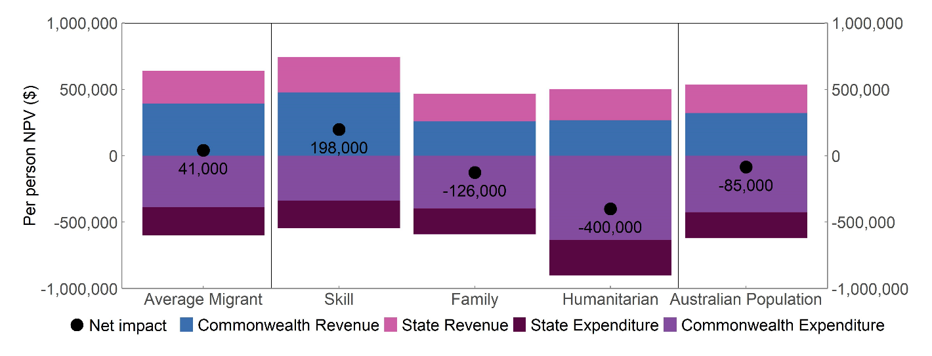Note: Estimates include both primary and secondary applicants.
FIONA shows that the 2018–19 permanent migrant cohort is fiscally positive at both the Commonwealth, and State and Territory levels. Chart 1 shows that the estimated fiscal impact of the 2018–19 permanent migrant cohort is $127,000 per person more positive than that of the 2018–19 population overall. This difference is relatively robust to modelling assumptions used in FIONA and provides strong evidence that the permanent migration program generates significant fiscal benefits, in aggregate, to Australia.
Contents

Executive Summary iii
1. Introduction 1
1.1. Fiscal impact is only one aspect of the permanent migration program 2
1.2. FIONA results complement shorter–term fiscal estimates 3
1.3. FIONA results are designed to compare between visa streams 3
1.4. FIONA only considers permanent migrants 4
2. Modelling the lifetime fiscal impact of migration 5
2.1. Demographic projection 5
2.2. Estimating revenues and expenses 6
2.3. Aggregating FIONA estimates to a net present value 7
3. Estimates of lifetime fiscal impact 7
3.1. Skill stream results 7
3.2. Family stream results 8
3.3. Humanitarian program fiscal outcomes 9
3.4. Fiscal impact of the 2018–19 permanent migrant cohort overall 9
3.5. FIONA outcomes by level of government 10
4. Major drivers of FIONA results 11
4.1. Migrants are younger on average than the Australian population 11
4.2. Skilled migrants have strong labour market outcomes 13
4.3. The interaction between age and income in FIONA 14
4.4. Quantifying the major drivers of FIONA results 15
4.5. Comparing Commonwealth and State level results 16
5. Robustness of key results to modelling assumptions 17
5.1. Impact of changing the discount rate 18
5.2. Including all Commonwealth and State revenue and expenses 18
5.3. Higher Health and Aged Care costs in the very long–run 20
5.4. Effects of COVID–19 20
6. Future directions 21
7. Appendix A: detailed FIONA methodologies 23
7.1. Demography 23
7.2. Approach to estimating revenues and expenses 26
7.3. Revenue and expense calculations 27
8. Appendix B: Fiscal impact of temporary migrants 38

Introduction
The Australian permanent migration program comprises the Skill, Family and Humanitarian programs which each have different application requirements and purposes.
- The Skill stream is intended to contribute to economic development and meet labour market needs within the broader context of meeting the national interest.
- The Family stream provides for migration of immediate family members of Australian citizens, permanent residents, or eligible New Zealand Citizens. This stream has requirements for both health and character, but no skills test or English language requirements.
- The Humanitarian program provides protection and resettlement to refugees and others in humanitarian need from all parts of the world. This stream includes an offshore component that offers resettlement in Australia to refugees and humanitarian entrants from overseas, and an onshore component that offers protection to those who lodge an asylum claim after arrival in Australia.
Within each stream, there exist various visa categories, which in turn comprise visa subclasses (a full mapping of visa subclass to categories used in this paper can be found in Appendix A). In addition, migrants who are granted a primary visa can bring their immediate family members on secondary visas, who are counted within the visa cap for that program. Some visa recipients do not ultimately arrive in Australia. The composition of the 2018–19 permanent migration program, along with the share of primary/secondary visa holders and the estimated proportion of migrants that arrive in Australia is shown in Table 1.
Table 1: Overview of the 2018–19 permanent migrant cohort
Visa category | 2018–19 Visa grants | Proportion who arrive (%) | 2018–19 Arrivals | Share primary visa holders (%)
Skill | 109,688 | 93 | 101,695 | 46
Employer Sponsored | 41,995 | 97 | 40,609 | 48
Independent | 34,240 | 92 | 35,135 | 50
State/Territory/Regional nominated | 25,991 | 91 | 23,678 | 44
Business Innovation and Investment Program | 7,262 | 77 | 5,715 | 28
Distinguished Talent | 200 | 79 | 157 | 43
Family | 50,472 | 95 | 47,716 | 85
Partner | 39,902 | 95 | 37,947 | 87
Parent | 6,798 | 92 | 6,254 | 64
Other Family | 3,772 | 93 | 3,515 | 95
Humanitarian | 18,131 | 99 | 17,968 | 31
Other | 115 | 95 | 109 | 55
Total | 178,406 | 94 | 167,487 | 56
The data for visa grants and share of primary visa holders was provided by the Department of Home Affairs. The proportion of migrants that ever arrive is estimated as those granted a visa in 2006–07, and then observed to permanently settle in Australia at any stage before 2016–17 (using the definition of settlement from the ABS net overseas migration statistics). Later cohorts of BIIP migrants are observed to have a higher arrival rate than the 2006-07 cohort, but continue to arrive at a slightly lower rate relative to other permanent migrant cohorts. All per capita estimates of fiscal impact presented in this paper are based on total arrivals, rather than total visa grants. The share of primary visa holders is calculated as the number of primary visa arrivals divided by total arrivals in each row.
Estimates in this paper are based on the 2018–19 permanent migrant cohort and are calibrated using economic and fiscal data from 2018–19 and earlier years. This has two important implications:
- The paper does not capture the economic impact of COVID-19 on the Australian economy, or the changes that have been made to the permanent migration program since 2018–19 including changes made in response to border closures. This means that estimates in this paper represent the fiscal impact of migration in more ‘typical’ economic circumstances.
- The estimates of lifetime fiscal impact presented in this paper are based on the experiences of previous migrant cohorts and may not capture emerging trends related to migrants’ experience in Australia.

Fiscal impact is only one aspect of the permanent migration program
The long-term fiscal impact of migration is an important consideration when assessing the permanent migration program. For instance, the long-term fiscal impact of the migration program will impact budget planning decisions such as those discussed in the 2021 Intergenerational Report. All other things equal, a permanent migration program with a positive fiscal impact allows taxes to be lowered, government debt to be reduced or spending to be increased across the population.
However, there are many other important outcomes of the migration program that are not captured within the FIONA framework, such as:
- The value placed on family reunion or on the resettlement of humanitarian migrants.
- Any broader economic impacts of migration including improvements to productivity through information sharing, changes to Australian wages and employment levels or the Australian distribution of income.
- The provision of non-market services by migrants, such as family caring responsibilities.
- The impact of migration on congestion in Australian cities and delays in the planning and construction of infrastructure (noting that FIONA does account for additional infrastructure spending due to migration).
- The reciprocal behaviour of other countries responding to Australian migration settings.
- The environmental impact of a larger Australian population.
- The impact that Australian migration policy has on outbound migration.
A longer discussion of this broader policy framework, along with some guidance for how economic models can be interpreted within that framework, can be found in Productivity Commission (2016) and Grattan Institute (2021).

FIONA results complement shorter-term fiscal estimates
FIONA estimates the fiscal impact of permanent migrants until they die or emigrate from Australia. This creates a lifetime profile of government revenues and expenses (net impact is shown as a solid black line in Chart 2).
Chart 2: Lifetime profile of revenues and expenses for the 2018-19 permanent migrant cohort
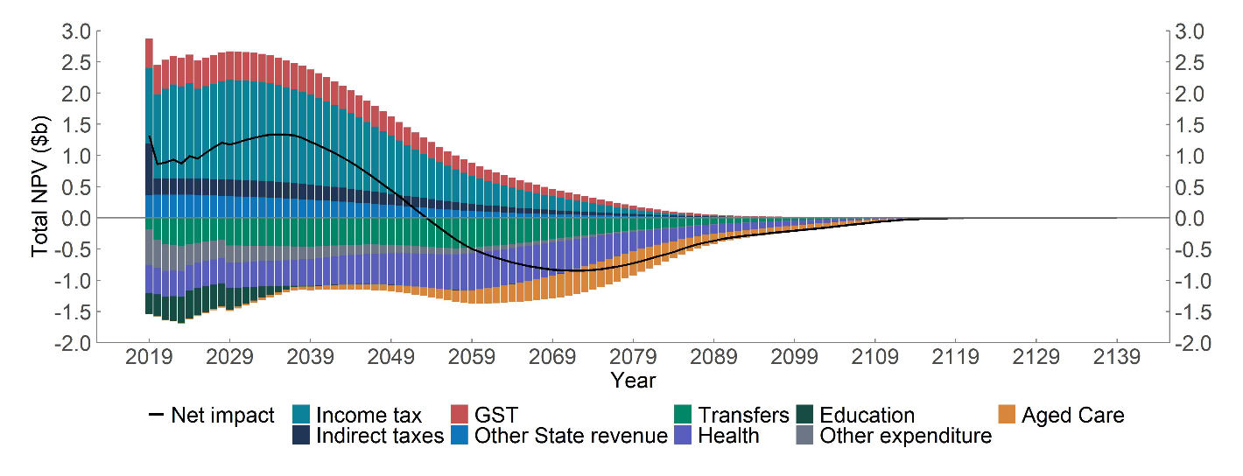
Note: the higher estimate of indirect taxes in year one occurs due to Visa Application Charges.

This long-term perspective provides important insights into migration planning especially given that shorter-term fiscal estimates present an incomplete view of the overall fiscal impact of migration.
However, implementing this long-term framework does require some simplifications to be made. For instance, FIONA uses a simplified version of the personal income tax system in order to project personal income taxes over the long term. FIONA is also designed to capture the average fiscal impact within each visa category but is not designed to consider changes to migration policy that occurs within visa programs (such as changes to the Skilled Occupation List).

FIONA results are designed to compare between visa streams
FIONA is a closed cohort model of the 2018–19 permanent migrant intake. Revenues and expenses attributable to this group are projected out for 120 years, until 2139. While this long-term perspective is necessary to capture the lifetime impacts of permanent migrants, such an approach inevitably introduces a healthy dose of empirical uncertainty. For instance, FIONA incorporates projections of how the Australian economy, tax system, and system of government services will evolve over the coming century, based on the Intergenerational Report projections, each of which are inherently difficult to predict.
As well as being clear eyed about this uncertainty, it guides us towards our emphasis on the differences in FIONA estimates between different groups of migrants, or between groups of migrants and the general Australian population. These differences are much more stable than absolute estimates generated by FIONA as many key model assumptions impact different migrant groups in similar ways (for instance, a lower assumed growth rate for health care costs would improve the estimated fiscal impact for all groups).
This effect is shown in Table 2, which is based on sensitivity tests of major modelling assumptions conducted in Section 5 of this paper. For all of the scenarios examined, the 2018–19 migrant cohort is found to be around $120,000 per person more fiscally positive over their remaining life in Australia than the population overall.
Table 2: FIONA estimates for all permanent migrants and the Australian population
 | 2018–19 permanent migrants | 2018–19 Australian population | Difference
Central FIONA estimate | 41,000 | –85,000 | 127,000
Lower discount rate of 4% | –45,000 | –167,000 | 122,000
Higher discount rate of 6% | 82,000 | –42,000 | 124,000
Including all revenue and expenses | 11,000 | –112,000 | 123,000
Higher health and aged care | –59,000 | –172,000 | 112,000
Incorporating impacts of COVID | 30,000 | –90,000 | 120,000
The central FIONA estimate is calculated using a nominal discount rate of 5%. Differences not exact due to rounding.

In addition, comparing the difference between FIONA estimates for two different migrants provides an estimate of the lifetime fiscal impact of changing the composition of the permanent migration program (for example within a given annual cap of permanent migrants, what the lifetime fiscal impact would be of increasing the skilled share).
In Table 2, the estimates shown for the 2018–19 Australian population are created solely to assist in interpreting results relating to migrants. They are not intended to represent an estimate of Australian fiscal sustainability, a topic which is discussed in detail in the Intergenerational Report. While a negative FIONA estimate for the Australian population is broadly consistent with the long-run fiscal projections contained in the IGR, several design features of FIONA (such as that FIONA is a closed-cohort model; does not include all Commonwealth revenues and expenses; but does include State level impacts) mean that a direct comparison with results from the IGR is not possible.

FIONA only considers permanent migrants
FIONA is designed to estimate the lifetime fiscal impact of the Australian permanent migration program. Temporary migrants are not directly in scope. However, the permanent and temporary migration programs are closely linked. For instance, the temporary migration program represents an important pathway towards permanent migration. The majority of permanent migrants have previously spent time in Australia on a temporary visa. In addition, many permanent migrants spend time in Australia on a bridging visa (part of the temporary migration program) while awaiting the outcome of a permanent visa application.
To complement FIONA estimates, Appendix B provides estimates of the fiscal impact of some parts of the Australian temporary migration program.

Modelling the lifetime fiscal impact of migration
This section of the paper provides a brief overview of the modelling approach used in FIONA, with a more detailed description provided in Appendix A of this report. FIONA calculations follow three broad steps, which are shown in Chart 3.
Chart 3: Overview of the FIONA modelling process

Demographic projection
The first stage of FIONA is to create a demographic projection of the 2018–19 migrant (and Australian) population over the remainder of their lifetimes in Australia. This calculation considers the share of visa recipients that ultimately arrive in Australia, mortality, emigration away from Australia and net interstate migration. FIONA is a closed cohort model, which means that it does not include any second-generation migrants.

Estimating revenues and expenses
FIONA models the additional revenues and expenses that can reasonably be attributed to the migrant cohort. Generally, this is based on the economic incidence of these revenues and expenses. For example, even though businesses are legally liable for payroll taxes, these amounts are attributed to their employees. The revenues and expenses modelled in FIONA are presented in Table 3. Revenues and expenses that are not modelled in FIONA include company tax, the sale of goods and services, Defence and costs related to the justice system. This is discussed further in section 5.2 of this paper.
Table 3. Revenues and expenses modelled in FIONA
 | Commonwealth | State and Territory
Revenue | Excise (fuel, alcohol, tobacco) | GST
Revenue | Personal Income Tax | Land Tax
Revenue | Visa Application Charge (VAC) | Stamp duty
Revenue |  | Motor Vehicle taxes
Revenue |  | Payroll tax
Expenses | Aged Care | Education
Expenses | Education | Health
Expenses | Health | Infrastructure
Expenses | Infrastructure
Expenses | Transfers (including Age Pension and childcare subsidies)
Expenses | Settlement services
The approach used to estimate each revenue and expense category varies based on the available data sources. Many FIONA calculations (personal income tax, transfer payments, VAC, settlement services, payroll tax and health) draw on administrative data that can be directly linked to individual migrants (in a deidentified way). In other cases, modules use income differences between visa groups as a predictor of revenues and expenses (indirect taxes, land tax and stamp duty). The remaining calculations are purely demographic, and only capture differences between migrants based on age and gender profiles (education, infrastructure, and aged care).
FIONA also requires assumptions about how some revenues and expenses are allocated within a household. For instance, payments relating to parenthood (including Family Tax Benefits, Childcare Subsidies and Parenting Payments) are attributed to the parent that receives the payment (rather than the child). In addition, GST and excises are allocated within the household in proportion to the income earned by the members of the household.
FIONA also requires an assumption about how each revenue and expense is likely to grow into the future. The growth rate chosen in each case is informed by the relevant legislation, as well as the macroeconomic framework and specific assumptions used in other Treasury models and publications, such as the Intergenerational Report. As is the case with other long-term Treasury projections, FIONA estimates generally assume that current policies are maintained into the future.
A detailed description of the methods used to model revenues and expenses in FIONA is provided in Appendix A.

Aggregating FIONA estimates to a net present value
The final step in FIONA is to convert all revenues and expenses into a single net present value for each cohort (in 2018–19 dollars). This is done by applying a nominal discount rate of 5 per cent per year.

Estimates of lifetime fiscal impact
This section of the paper presents FIONA results by visa category and applicant type to allow for detailed comparisons between these groups. As discussed elsewhere in this paper, the main purpose of FIONA is to compare the relative estimate of fiscal impact between different types of permanent migrants. FIONA estimates presented in this paper are averages across groups of migrants. Actual outcomes will vary between individuals within each visa group. This section concludes with aggregate estimates of the fiscal impact of the 2018–19 migrant cohort.

Skill stream results
The Skill stream is intended to contribute to economic development and meet the labour market needs of the Australian economy. Within this stream, there are different visa categories which target different types of migrants. For instance:
- Employer Sponsored migrants must have the necessary skills for the job and be nominated by an Australian employer.
- Skilled Independent migrants, generally, must meet points-test requirements, have an occupation on the skilled occupation list and be invited by the Australian Government to apply.
- State/Territory Sponsored migrants must meet certain requirements relating to business or investment and be sponsored by an Australian State or Territory Government.
- Distinguished Talent migrants must be exceptionally talented in specific fields (such as professional sportspeople and musicians) and be nominated by an applicable person/organisation.
- Business Innovation and Investment Program (BIIP) migrants must meet certain requirements relating to investment or entrepreneurial activities and in some instances must also be nominated by the Australian Government or an Australian State or Territory Government.
Most groups of primary skilled migrants have a large positive fiscal impact (Chart 4). Employer sponsored migrants are found to have the largest positive impact, while Skilled Independent, State and Territory Nominated and Distinguished Talent visa holders are also found to generate a large positive lifetime fiscal impact.
Primary BIIP visa holders are found to have a negative lifetime fiscal impact relative to the population overall. This result is driven by the relatively low level of personal income tax observed to be paid by this group, along with an older age profile than other skilled migrants. However, it is important to note that FIONA does not attempt to capture any information spillovers, investment effects or indirect employment effects of migration, and that these are key policy objectives of the BIIP migration stream.
Chart 4: Lifetime fiscal impact per person, by visa subclass for Skill stream
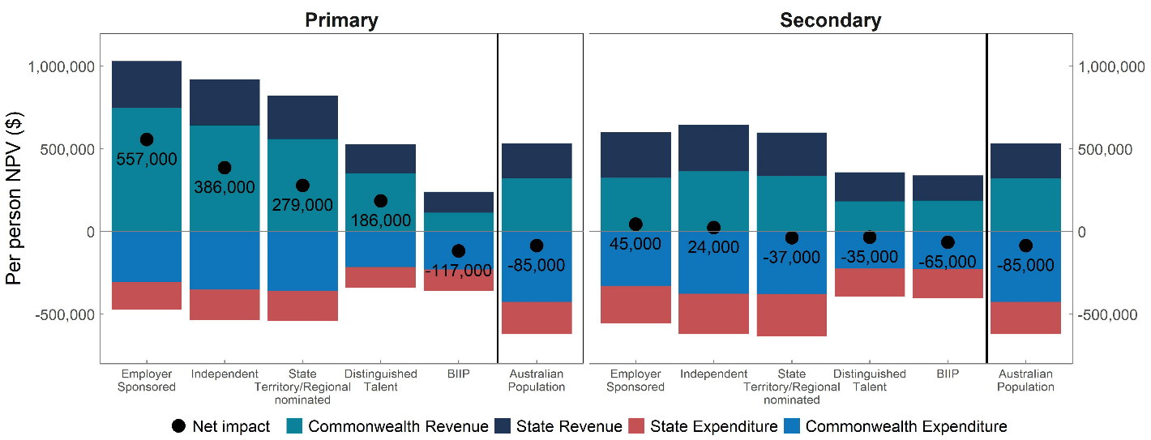
Note: The Australian population is not split into primary and secondary applicants.

Secondary skilled migrants are the immediate family members of primary skilled migrants. All secondary Skill visa categories have a fiscal impact which is slightly higher than the average of the Australian population. Skilled secondary migrants are younger on average than the Australian population, but have tended to have lower labour force participation, in part because they are more likely than the population as a whole to provide unpaid childcare. The combined fiscal impact of primary and secondary skilled migrants is more positive than other migrant streams, and more positive than the Australian population (as was seen in Chart 1).

Family stream results
The Family visa stream exists to reunite families — mostly granting visas to the partners and parents of Australian citizens and permanent residents — rather than for economic reasons. Chart 5 shows the lifetime fiscal impact of those granted a family visa in 2018–19. Note that the secondary Partner group are mainly accompanying children of a primary Partner grant, while secondary Parents are mainly accompanying spouses of the primary Parent. Other Family are mainly Child Visas.
Chart 5: Lifetime fiscal impact per person by visa subclass for Family stream
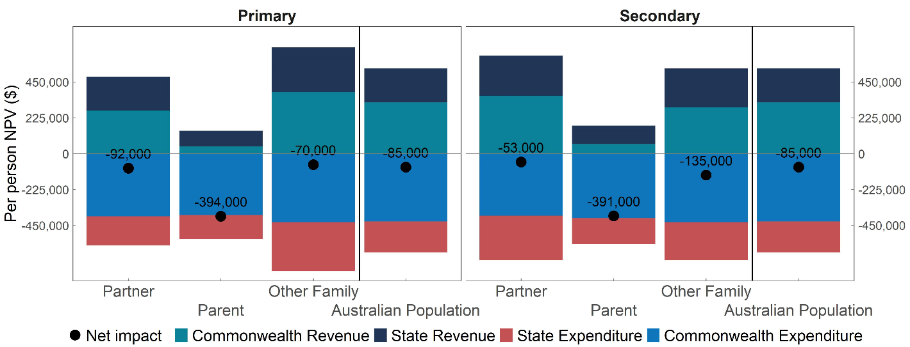
Note: The Australian population is not split into primary and secondary applicants.

The average estimated fiscal impact of partner visa holders (–$92,000 for primary Partner and –$53,000 for secondary Partner) is broadly similar to the Australian population overall (–$85,000). Most secondary Partner applicants are children, and consequently have higher revenue and expenses (especially education) costs over their remaining lifetime.
Parent visa holders have more negative fiscal outcomes on average (–$394,000 for primary Parents and –$391,000 for secondary Parents) than the population overall. This result is driven by their relatively short remaining working lives once they come to Australia, with the average age at grant being 61 years. Visa Application Charges paid by parent visa holders are small compared to the health and aged care services and transfer payments they receive from government.

Humanitarian program fiscal outcomes
Australia’s Humanitarian migration program provides protection and resettlement to refugees and others in humanitarian need from all parts of the world. Humanitarian migrants often arrive in Australia having experienced extended periods of trauma, and with complex health and well-being issues, disrupted education and less developed English language skills. These factors can limit their initial labour market prospects, and result in a greater reliance on income support, settlement services and health care than the Australian population overall.
FIONA estimates that the average Humanitarian migrant has a negative fiscal impact of $400,000 per person. More than 90 per cent of the negative fiscal impact of the Humanitarian migration stream falls on the Commonwealth Government, reflecting the Commonwealth’s responsibility for income support payments and settlement services.

Fiscal impact of the 2018–19 permanent migrant cohort overall
The preceding pages described how when compared to the Australian population overall:
- Skill stream migrants are more fiscally positive over their remaining lifetimes;
- Family stream migrants are broadly fiscally neutral; and
- Humanitarian program migrants are fiscally negative.
Looking at the 2018–19 permanent migrant cohort as a whole, FIONA finds that this cohort is more fiscally positive than the Australian population overall, by around $127,000 per person on average (as shown in Chart 1 and Table 2). Similarly, the average fiscal impact of migrants is $139,000 more positive than the fiscal impact of a newborn from the Australian population (–$98,000).
In relative terms, FIONA estimates that the 2018–19 permanent migrant cohort makes a positive aggregate lifetime fiscal contribution that is in the order of $20 billion higher than a similar sized cohort drawn from the Australian population. As discussed later in this paper, this substantially reflects the younger age profile of the migrant cohort (commonly referred to as a ‘demographic dividend’).
In absolute terms, FIONA estimates that the 2018–19 permanent migrant cohort make a lifetime fiscal impact of $7 billion. However, as discussed earlier, this estimate is sensitive to assumptions (refer to Table 2). The absolute estimate is sensitive to both the discount rate and the assumed rate of growth in health and aged care costs in particular over the next 120 years. This reflects significant net fiscal benefits during migrants’ working lives being significantly offset by net fiscal costs following retirement from the workforce.

FIONA outcomes by level of government
While the results in this paper are generally discussed in terms of the aggregated results across Commonwealth and State budgets, the key results presented in this paper follow a similar pattern across both Commonwealth and State Governments. For example, the 2018–19 permanent migrant cohort overall has a period of fiscal positivity in the coming decades, followed by a period of fiscal negativity as the migrant population retires.
Chart 6: Fiscal impact of the 2018–19 permanent migrant cohort by year and level of government
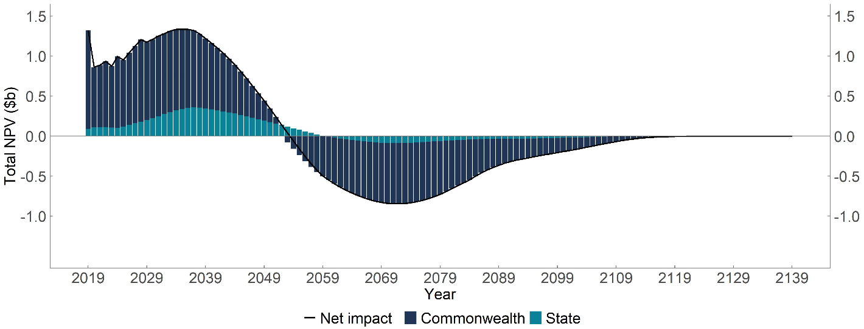
Note: The higher estimate in year one occurs due to Visa Application Charges.

The key relativities between visa streams are also seen at both the Commonwealth and State government levels (see Table 4). So is the finding that the 2018–19 cohort is, on average, more fiscally positive than the Australian population overall.
Table 4: Estimated lifetime fiscal impacts of migrants by visa stream and level of government
 | State NPV per person ($) | Commonwealth NPV per person ($) | Combined NPV per person ($)
Skill | 60,000 | 138,000 | 198,000
Family | 10,000 | –137,000 | –126,000
Humanitarian | –33,000 | –367,000 | –400,000
Average of migrant cohort | 36,000 | 6,000 | 41,000
Australian population | 19,000 | –104,000 | –85,000
Components may not sum to totals due to rounding.
FIONA is unable to accurately estimate the fiscal impact of migrants on individual States and Territories. This is because of Australia’s system of horizontal fiscal equalisation, which looks at the fiscal capacity of each State and distributes GST according to their capacity to raise revenue and deliver equivalent services. To the extent that this system captures the economic impact of migrants, then the net fiscal impact of migration (after equalisation through changes to GST distributions) would broadly be expected to be equal across states on a per capita basis. However, determining the extent of horizontal equalisation achieved in practice is beyond the scope of this paper. Further examination of these issues is a potential area for future research discussed in Section 6.

Major drivers of FIONA results
The major factors driving FIONA results are variations in age distributions and labour market experiences of different migrant groups. Other factors captured by FIONA — such as Visa Application Charges, the costs of migrant settlement services and the propensity of different groups to use services like health and aged care also help to explain the overall outcomes, but to a lesser extent.

Migrants are younger on average than the Australian population
The extent to which people in Australia pay taxes and use Government services varies over the lifecycle and can be broken down into three distinct stages. When individuals are young, they typically receive more from the government than they contribute in taxes, as they attend school and receive other government services while paying little if any tax. Then, as people enter prime working age, taxes paid typically exceed government expenses. As people retire, they tend to again receive more each year in government services, like health care, the Age Pension and aged care, than they pay in taxes. The lifetime profile of revenues and expenses modelled in FIONA for an Australian born in 2018–19 is shown in Chart 7.
Chart 7: Lifetime interaction with the Australian tax and transfer system
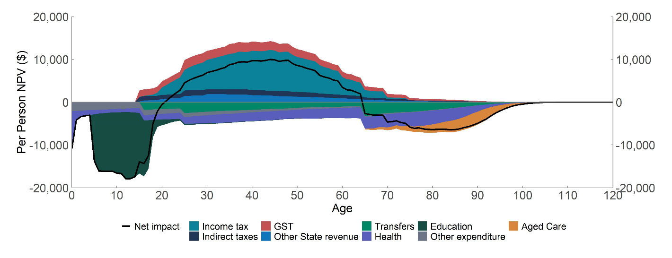
This chart shows the discounted revenues and expenses modelled in FIONA of an Australian born in 2018–19 (including the impacts of growth rates, discount rates, mortality rates and emigration).
This lifecycle pattern of how people contribute to government revenue, and benefit from government services, means that the age at which migrants come to Australia is the single most important driver of their estimated fiscal impact over their lifetime. The 2018–19 permanent migrant cohort are younger on average, and more likely to be of working age than the Australian population overall (Chart 8, Chart 9, and Table 5).
Chart 8: Age distribution of the 2018–19 permanent migrant cohort in Australia compared to the Australian residential population
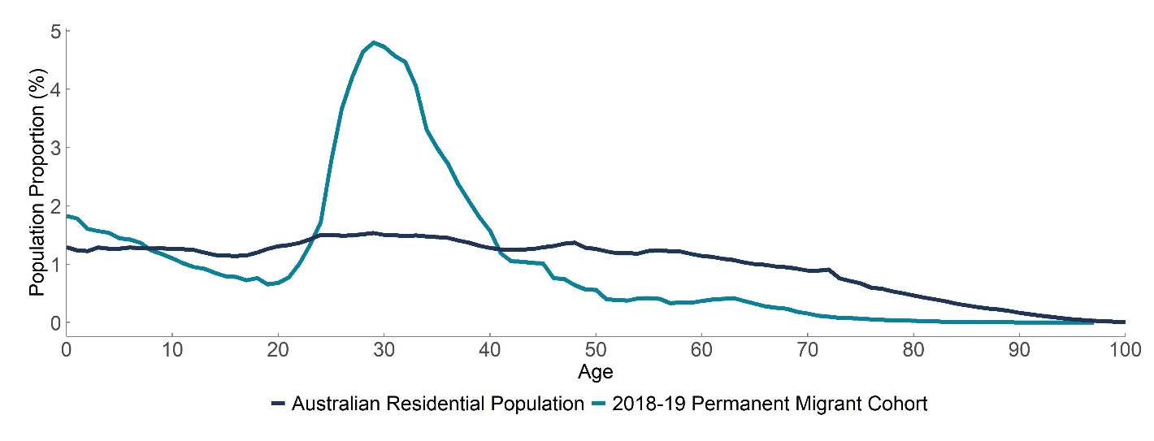
Note: Share of population is shown in one-year age bins.
Chart 9: Age distribution of the 2018–19 permanent migrant cohort
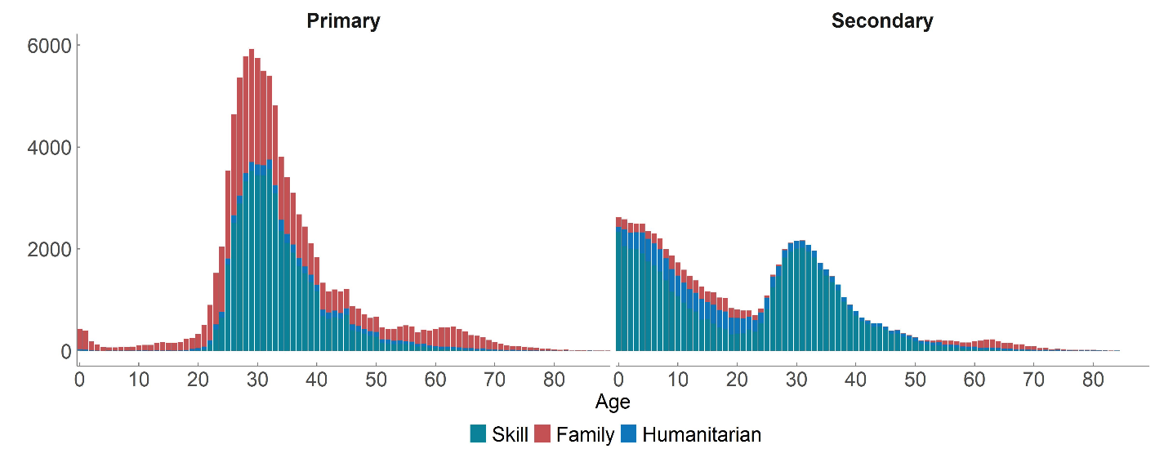
Table 5: Age distribution of 2018–19 migrant cohorts and overall Australian population
Visa category | Proportion of age |  |  | Average age
Visa category | < 18 years | 18 to 64 years | 65+ years | Average age
Skill | 24% | 76% | 0% | 27
Family | 15% | 79% | 6% | 33
Humanitarian | 40% | 56% | 4% | 26
Total 2018–19 migrant cohort | 23% | 75% | 2% | 29
Australian population | 23% | 61% | 16% | 38
The importance of age at arrival on FIONA results is demonstrated in Chart 10, which shows the lifetime fiscal impact (as a net present value) for migrants arriving at different ages. For all migrant streams, lifetime fiscal impact is highest when a migrant arrives early in their working life. This pattern is similar for the Commonwealth and States, although there is a larger difference for the Commonwealth.
Chart 10: Average lifetime fiscal impact by visa stream, age at arrival and level of government
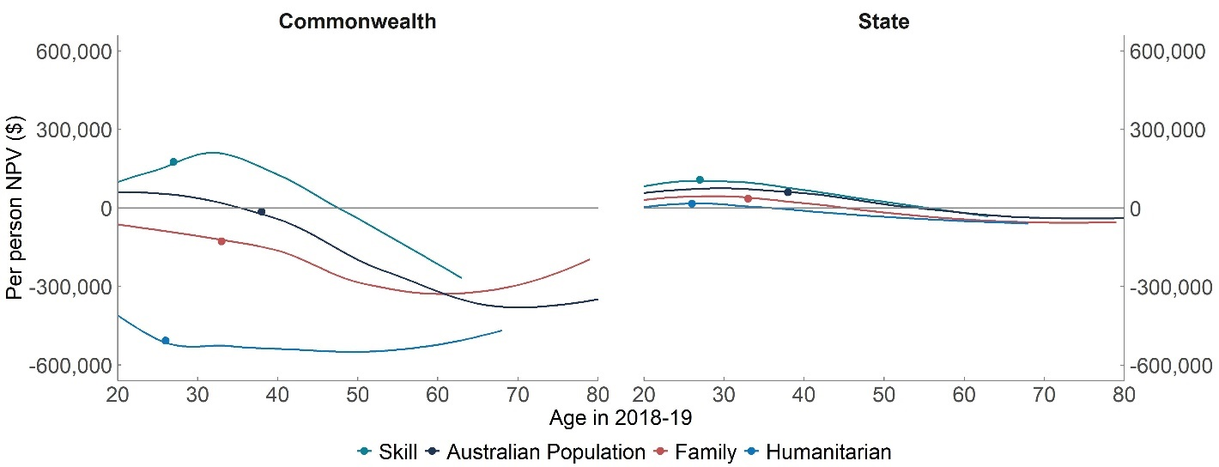Note: Each dot on the chart represents the average age of permanent visa grant.

Skilled migrants have strong labour market outcomes
Along with age at arrival, the other major determinant of lifetime fiscal impact estimated in FIONA is the projected amount of personal income tax paid, which in turn is driven by expected labour market outcomes for different groups of migrants. FIONA models:
- The likelihood of being employed each year (based on participation and employment rates).
- The distribution of labour income, conditional on being employed.
Skilled primary migrants are more likely to be employed, and to have a higher paying job, than the population overall. This is consistent with the intent of the Skill stream, which is designed to attract migrants who make a significant contribution to Australian economy, and fill positions where no Australian workers are available. In contrast, migrants arriving on Family, Humanitarian and Skill secondary visas, are less likely to be employed or to earn as much as the average Australian.
Chart 11 shows the relative likelihood of employment for migrant groups compared to Australians of the same age. A value of zero in the chart below would mean that migrants have the same likelihood of employment as Australians of the same age, while a value of 10 per cent would mean that migrants are 10 per cent more likely to be employed compared to the Australian average at the same age. This chart also shows that there is a ‘settling’ period in which some migrants have a lower level of labour market participation in the years immediately following migration.
Chart 11: Migrant employment differences from Australian population after arrival in Australia
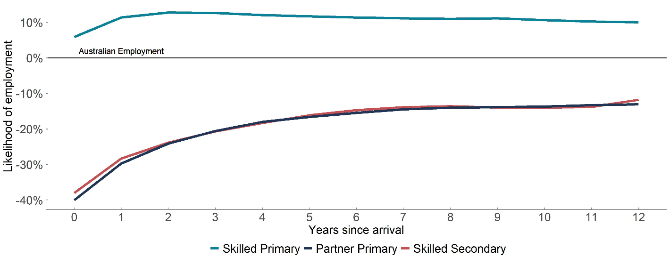Probability of employment is calculated as (total employed/total population) within 5-year age bins for migrant groups and the Australian population in the Australian Census and Migrants Integrated Dataset (ACMID). The figures presented are the weighted average ratio of the employment rate to the Australian population within these five age groups. These values are aggregated values of the ERadj factor in the personal income tax formula on page 28 of this paper. The chart is only based on those aged 15–75, which are primarily comprised of skilled migrants and primary partner migrants (see Chart 9).
Skilled primary migrants tend to earn more on average than other groups. Table 6 shows the proportion of skilled (primary and secondary) and primary Partner visa holders in each age-adjusted income quintile observed in de-identified personal income tax returns. For instance, primary skilled migrants are more likely to be in the top income quintile (compared to people of similar age), while Partner visa holders and skilled secondary visa holders are less likely.
Table 6: Age-adjusted income distribution of migrants, by visa group
Visa stream | Quintile 1 (Lowest) | Quintile 2 | Quintile 3 | Quintile 4 | Quintile 5 (Highest)
Skilled Primary | 12% | 14% | 19% | 23% | 33%
Skilled Secondary | 31% | 28% | 20% | 13% | 9%
Partner Primary | 29% | 28% | 20% | 14% | 10%
Australian Population | 20% | 20% | 20% | 20% | 20%
The probability of being in each income quintile is calculated within 5-year age bins based on administrative personal tax data. Tax returns are for the 2016–17 year and are based on migrants granted a permanent visa in 2013–14. The quintile calculation excludes those with zero or negative income.

The interaction between age and income in FIONA
Within the FIONA model, it is possible to compare the interaction between age and income in determining lifetime fiscal impact. For instance, Chart 12 shows the combination of age and income at arrival that would result in an estimated fiscal impact of $415,000 for a primary skilled migrant with no secondary applicants (the average fiscal impact estimated in FIONA for primary skilled applicants). This calculation captures the expected income growth of a migrant as they age — both because of productivity increases across the Australian economy and because individuals gain skills and experience over time.
In this illustrative example, a skilled migrant arriving at age 45 and initially earning:
- $160,000 a year is projected in FIONA to have the same fiscal impact as the average primary skilled migrant over their lifetime in Australia.
- more than $160,000 a year is projected to be more fiscally positive than the average primary skilled migrant over their lifetime in Australia.
- less than $160,000 a year is projected to be less fiscally positive than the average primary skilled migrant over their lifetime in Australia.
In contrast, with more taxpaying years ahead of them and more time to increase their income over time, the corresponding starting income for a 30-year-old to achieve the average lifetime fiscal impact for skilled migrants is around $100,000.
Chart 12: Illustrative FIONA estimates of the starting wage required to achieve the average lifetime fiscal impact of a primary skilled migrant
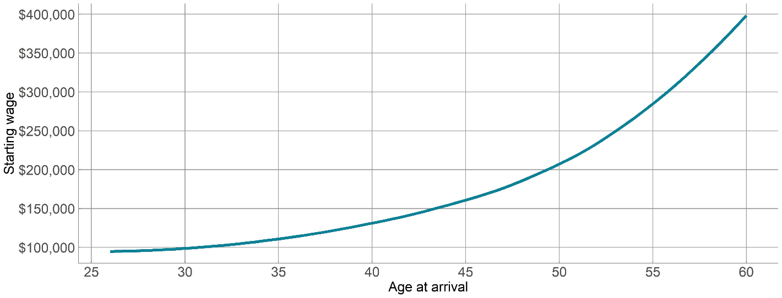This calculation uses the distribution of employment and participation rates from skilled primary migrants. This does not capture the fiscal impact of secondary migrants, nor does it capture any link between different levels of income and revenues and expenses outside of the personal income tax. This calculation could be repeated for secondary migrants and for migrants from different programs. Such a calculation would result in a different set of age and income combinations that yield that average fiscal impact. However, the general trade-off between age and income would be similar in each of these calculations.

Quantifying the major drivers of FIONA results
This section of the paper decomposes differences in estimated fiscal impact into major factors that are captured by FIONA. This calculation confirms that age profile and labour market performance are the most important drivers, while other factors captured in FIONA play a smaller role.
This decomposition is based on a series of calculations in which FIONA is re-estimated while setting migrant characteristics to be equal to the Australian population. In turn, this calculation isolates the impact of migrant age structure, income distribution, employment and participation rates, receipt of transfer payments, emigration, healthcare expenses (conditional on age) and Visa Application Charges.
The results from this series of calculations are shown in Table 7. For instance, if all skilled migrants were modelled as having the same age distribution as the Australian population, it would reduce the estimate in FIONA by $167,000 per person.
Table 7: Summary of the major drivers of FIONA results, $NPV per person (2018–19)
 | Skill | Family | Humanitarian
Difference between migrants and the Australian population | 283,000 | -41,000 | –315,000
Impact of different factors
Same age profile | –167,000 | –48,000 | –49,000
Same income distribution | –45,000 | +85,000 | +76,000
Same workforce participation | –15,000 | +35,000 | +49,000
Same transfers | –25,000 | –16,000 | +79,000
Same emigration | –11,000 | +3,000 | +67,000
Same health costs | –8,000 | –7,000 | +16,000
No Visa Application Charges | –3,000 | –5,000 | 0

Comparing Commonwealth and State level results
In Section 3 of this paper, it was shown that the major qualitative findings reported in this paper hold at both the Commonwealth and State levels. However, there are important differences between the ways that migrants interact with each level of Government. For instance, while government revenue and expenses at both the Commonwealth and State Governments display a clear profile across the lifecycle, State Governments spend more on younger Australians than they do on older Australians. This pattern, which can be seen in Chart 13, means that the demographic profile of migrants presented above in Chart 8 is particularly beneficial to State Governments.
Another key difference is that revenues and expenses are more progressive, in aggregate, at the Commonwealth level compared to the State level. This means that the Commonwealth tends to benefit more from skilled migrants and bear most of the costs from Humanitarian and Parent migrants (even after accounting for the relative size of Commonwealth and state budgets).
Chart 13: Lifetime interaction with the Commonwealth and State tax and transfer systems
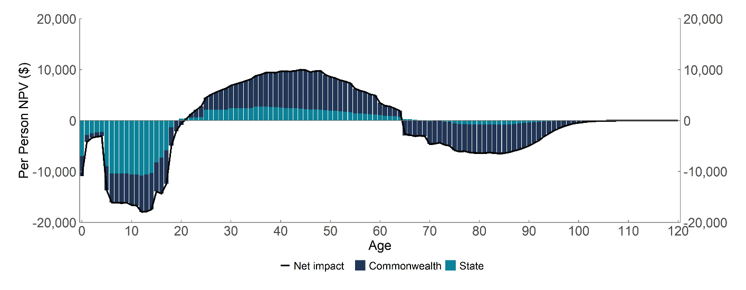This chart is defined in the same manner as Chart 7 but shows the net impact on the Commonwealth and State budgets modelled in FIONA.

Robustness of key results to modelling assumptions
In order to project the fiscal impact of migrants over the next 120 years, FIONA incorporates several important structural assumptions about how the economy will evolve in the future, the way revenues and expenses are allocated to individuals, and the discount rate used to convert results into net present values. While care has been taken to base these assumptions on the best available estimates and modern modelling practices, there is inherently a great deal of uncertainty around these assumptions.
To test the sensitivity of the key FIONA results to changes in these assumptions, we have conducted several alternative modelling scenarios, which include exploring the effect of:
- Changing the discount rate (5 per cent in baseline estimates) to 4 per cent or to 6 per cent.
- Allocating all Commonwealth and State government revenue and expenses not captured in FIONA to individuals on a pro rata basis.
- Increasing the long-term health and aged care spending growth rates.
- Applying economic parameters that capture the impacts of COVID-19 on the Australian economy.
A summary of the results from these sensitivity tests is shown in Chart 14. This shows that the relative ordering of the different migrant streams is robust to these modelling assumptions. However, the absolute estimate of the fiscal impact of the migration program (estimated to be $41,000 per migrant in the baseline scenario) is relatively sensitive to modelling assumptions.
Chart 14: Results from FIONA sensitivity tests
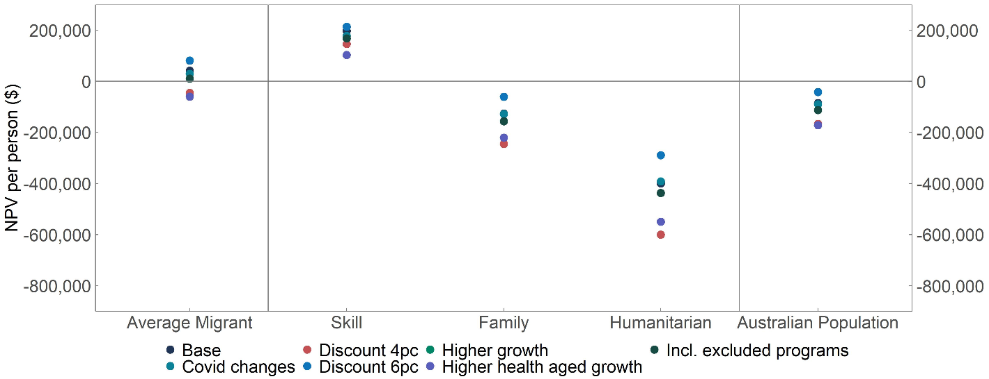

Impact of changing the discount rate
FIONA uses a discount rate of 5 per cent when calculating net present values. As with all lifetime models, the choice of discount rate has a substantial impact on FIONA estimates. The permanent migrant cohort has a positive fiscal impact in the coming decades, followed by a period of fiscal cost as the population retires. This means that the higher the discount rate used, the larger the relative importance of the early years in the model where there is a positive fiscal impact. Conversely, a lower discount rate will make the final years of the model relatively more important.
Chart 15: FIONA estimates with different discount rates
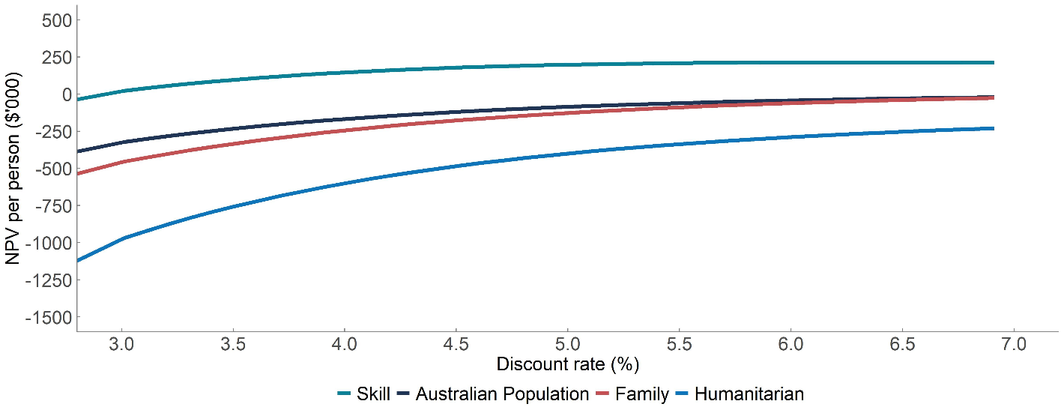

Including all Commonwealth and State revenue and expenses
As discussed in the methodology section of this paper, FIONA captures those government revenues and expenses that can be attributed to individuals. This includes most, but not all of Commonwealth and State budgets. Table 8 shows the 2018–19 Commonwealth and aggregated States budgets in comparison to FIONA estimates, and displays the major ‘missing’ categories of revenues and expenses.
Table 8: Comparison of FIONA and Commonwealth and State Budget totals
 | Commonwealth Expenses ($b) | Commonwealth Revenue ($b) | State Expenses ($b) | State Revenue ($b)
Budget Total | 424 | 427 | 218 | 198
FIONA Estimate | 235 | 244.8 | 121.5 | 117.6
Total Missing | 189.4 | 182.1 | 96.2 | 80.7
FIONA Coverage | 55.4% | 57.3% | 55.8% | 59.3%
Largest excluded items | Defence (30.8) | Company tax (99.8) | Justice (22.1) | Sales of goods and services (26.5)
Largest excluded items | General public services (26.2) | Non-taxation revenue (37.3) | Transfer payments (19.5) | Mining Royalties (15.5)
Largest excluded items | Public Debt interest (17.1) | Personal income tax not captured by FIONA (24.1) | Services to Communities (8.8) | Dividend income (11.0)
Figures are based on the Fiscal balance, which includes net investment. Commonwealth totals from the Final Budget Outcome for 2018–19, while State and Territory totals are based on the adjusted State Totals from the Commonwealth Grants Commission. Commonwealth payments to States ($61.8 billion in 2018–19) are excluded from State revenues and expenses in order to avoid double counting these values.
This sensitivity test investigates the potential impact of excluding these categories of revenue and expense by apportioning this value equally per capita across all individuals in FIONA. In effect, this adds an additional net cost of $7.3 billion to the Commonwealth budget and a net cost of $15.5 billion to the State budget in 2018–19. These ‘missing’ revenues and expenses were then projected into future years in line with projected wage growth. This calculation is similar to the Productivity Commission’s approach for whole of government modelling.
The results presented in Table 8 imply that including these revenues and expenses would slightly reduce the estimated fiscal impact of the 2018–19 migrant cohort (because slightly more expenses than revenues are ‘missing’ from FIONA), but would impact on all visa groups and the general population in a similar way, and therefore not change the relative ordering between groups.
In interpreting the results from this sensitivity test, it is important to note that this is a relatively simple approach to including the full Government budget. These components of revenue and expenses are excluded from FIONA for a variety of reasons and would be expected to be impacted by migration in different ways that are not captured by this approach. For instance:
- Corporate income tax and other taxes levied on businesses (such as motor vehicle taxes and stamp duty paid by business) are expected to grow broadly in line with nominal GDP. To the extent that this is true, migrants with higher incomes (such as skilled migrants) may generate a larger amount of corporate income tax than the typical migrant.
- Interest payments and mining royalties are largely detached from population size and would be expected to decrease, in per capita terms, as the population grows.
- In aggregate, other excluded revenues and expenses may be expected to be influenced by age, and therefore follow a lifecycle pattern (similar to the pattern in Chart 7). This is not captured by a simple per capita approach.

Higher Health and Aged Care costs in the very long run
FIONA models the growth in health and aged care costs using an approach consistent with the 2021 Intergenerational Report. This approach identifies that health care prices have increased at a faster rate than other prices in recent decades (even after accounting for demographic changes) and incorporates this trend into the projection of health care costs.
However, it is unclear whether this trend will persist in the very long run. Therefore, the FIONA baseline incorporates this higher growth rate until 2060, and then reverts to a growth rate of 4.025 per cent in line with projected long-term growth in Average Weekly Earnings (AWE) for the remainder of the projection period.
In this sensitivity test the higher growth rate is continued until the end of the modelling period (that is, we maintain the annual growth rate at 5.5 per cent over the period 2060–2140, rather than dropping down to 4.025 per cent). As shown in Chart 14 above, this assumption has a relatively large impact on the estimate of net fiscal impact in FIONA. More generally, this sensitivity test shows that the estimates of fiscal impact in FIONA are sensitive to ageing-related expenses in the long term.

Effects of COVID-19
The fiscal estimates presented in this paper are consistent with the economic parameters and projected growth rates that underpin the 2019–20 Mid-Year Economic and Fiscal Outlook (MYEFO). This means that they do not capture the impacts of COVID-19 on the Australian economy. This decision was made primarily on the basis that the pre-COVID economic conditions would better represent the economic experience of future migrants, and that a ‘normal’ economic baseline would be a more appropriate basis of analysis.
This sensitivity test examines how much this decision influences the FIONA results by replacing key economic parameters with equivalent estimates from the 2020–21 MYEFO, including CPI, AWE, participation rates and employment rates.

The results, which are presented in Chart 14, show that the net impact of this sensitivity test is relatively small, with skilled migrants becoming less positive, but humanitarian migrants becoming less negative. The intuition behind this result is that COVID will:
- Reduce revenue in the short term, but this is a relatively small proportion of the FIONA projection period.
- Reduce prices in the economy over the long term, which will reduce both revenue and expenses (with lower tax revenue offset by lower expenses).
This sensitivity test does not capture JobKeeper or other temporary spending programs. It also does not capture the change in the composition of the permanent migration program that occurred as the result of border closures during this period.

Future directions
FIONA represents an advancement in our understanding of the lifetime fiscal impact of Australia’s permanent migration program. Treasury welcomes feedback on the model design or on any of the results presented.
Treasury is particularly interested in any insights from readers on the more challenging issues we have encountered in developing FIONA. Some of these issues are outlined below.
- FIONA currently treats all migrants separately as individuals, rather than estimating the overall fiscal impact of family units who migrate together. While this simplifying approach will not affect the aggregate results, it will affect the estimates of fiscal impact within categories (such as the interpretation of lifetime fiscal impact by age at arrival). Extending FIONA’s results to family units would produce a more complete picture of the migration program.
- FIONA currently has a relatively simple treatment of gender. While mortality rates and health care costs are explicitly modelled by gender, most calculations in FIONA only capture these impacts implicitly. For instance, Chart 11 shows that partner visa holders have a lower level of employment than the Australian population but does not separately identify the extent to which this occurs because there are more women than men in this stream (who have a lower average level of employment than men). Further research that carefully identifies the economic outcomes of migrants by gender may provide context for interpreting trends in gender equity more broadly.
- FIONA does not explicitly model all elements of Commonwealth and State budgets. While in most cases we expect this would not materially affect the results, our treatment of business taxes is one possible exception. Credible analysis of how migration affects corporate income taxes and other taxes paid by businesses (such as stamp duty on commercial properties and motor vehicle taxes on commercial vehicles) would help more fully evaluate the fiscal impact of migrants, in particular those arriving under the Business Innovation and Investment Program.
- The State-level results reported in this paper are collective totals across all eight of the States and Territories. We have not estimated separate results for each State. This is primarily because at the State level of disaggregation, the results are highly sensitive to how Australia’s system of horizontal fiscal equalisation is modelled. This is beyond the scope of this exercise.
- FIONA currently uses a basic treatment of how migrants interact with Australia’s retirement income system. For instance, it is assumed that the likelihood of receiving transfer payments converges towards the average rate in the Australian population over a period of twenty years. One consequence is that most migrant groups are modelled as receiving similar amounts of Age Pension — whereas a more nuanced approach that fully incorporated asset accumulation across lifetimes and the Age Pension income and assets tests would likely produce larger differences between high- and low-income migrant cohorts. Such an approach would also allow for FIONA to capture superannuation taxes.

Appendix A: detailed FIONA methodologies
This Appendix provides additional technical detail to support the description of the modelling approach in section 2 of this report.

Demography

Migrant Population
The FIONA demographic calculation begins with administrative data from the Department of Home Affairs regarding the population of those granted a permanent visa in 2018–19. These data include information on visa subclass, applicant type (primary or secondary), gender and age. This is combined with information on migrants’ State of residence observed in MADIP.
This paper groups visas into ‘categories’ based on the visa classifications in Table A1.
Table A1: Visa classifications used in this paper
Visa Stream | Visa category | Subclasses included
Skilled | Distinguished Talent | 124, 858
Skilled | Skilled–Employer Sponsored | 186, 187, 856
Skilled | Skilled–Independent | 189, 175, 885
Skilled | Skilled–State/Territory/Regional nominated | 190, 487, 489, 496, 886, 887
Skilled | BIIP–Business Innovation and Investment Program | 188, 891, 132, 163, 164, 888, 890, 892, 893
Family | Other Family | 101, 102, 114, 115, 116, 117, 445, 802, 835, 836, 837, 838
Family | Partner | 100, 300, 309, 801, 820
Family | Parent | 103, 143, 173, 804, 864, 884
Humanitarian | Humanitarian | 200, 201, 202, 203, 204, 866
Other | Other | 151, 808, 834
Child visa holders are included in the Other Family visa category. FIONA includes ‘two-stage’ visas (such as the 801/820 Partner visa), which provide a permanent residence pathway for visa holders from a provisional or ‘first stage’ visa to a permanent or ‘second stage’ visa. To avoid double counting, the visa holder is counted to the Migration Program at grant of the provisional or ‘first stage’ visa only. This is consistent with the approach taken in annual Migration Program Report released by the Department of Home Affairs.

Migrant arrival rate
Some proportion of those granted a permanent visa never arrive in Australia. Using historical visa data from MADIP it is estimated that 6 per cent of all applicants granted a visa never arrive in Australia, with variation across visa categories. Humanitarian (99 per cent arrival) and Employer Sponsored visa holders (97 per cent arrival) are the most likely to permanently settle in Australia, and Business Innovation and Investment Program (BIIP) visa holders the least likely to permanently settle in Australia (77 per cent arrival).
Conditional on arriving in Australia, FIONA assumes that all migrants arrive on the same day (1 July 2018). In practice, there is significant variation in the time to arrival between migrants, with some arriving several years after being granted a permanent visa, and others arriving several years before on a temporary visa (Chart A1).
Chart A1: Estimated proportion of those granted a permanent visa holder in Australia in the years before and after being granted a visa
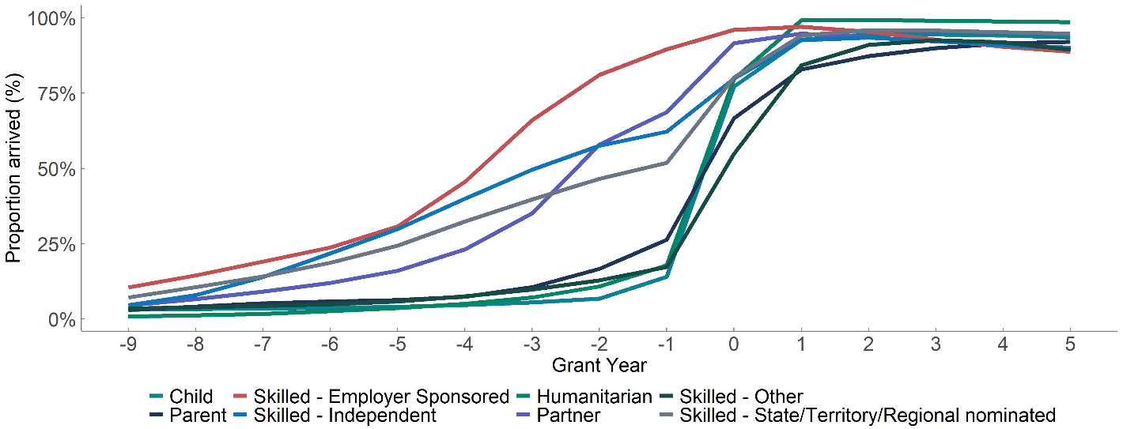
Skilled – Other includes both BIIP and Distinguished talent visa holders. This calculation is based on an average of permanent migrant cohorts from 2010-11 to 2016-17.

Australian population
The Australian population in FIONA uses the ABS definition of the Estimated Residential Population (ERP) on 30 June 2018. This population implicitly includes both permanent and temporary migrants as ERP includes all individuals that expect to be in Australia for at least 12 out of the next 16 months.
The share of each migrant stream and the Australian population in each Australian State and Territory is shown in Chart A2.
Chart A2: Estimated proportion of each visa stream and the Australian population, by State

Mortality and emigration
In each year there is some chance that migrants may exit the FIONA model, either due to death or permanent emigration. FIONA uses life tables provided by the Australian Government Actuary, which include mortality rates that vary based on age and gender. Migrants in all visa streams are assumed to have the same mortality rates as the Australian population and are calculated on a ‘period’ basis, meaning that the calculation does not attempt to adjust for any future improvements in mortality rates.
The emigration rate for different migrant groups was estimated using administrative visa data (accessed through MADIP) and is based on the average rate of emigration observed after migrants had been in Australia for five years (within the initial five years, there is significant movement while migrants settle). The emigration rates used in FIONA are provided in Table A2.
Table A2: Estimated emigration rates by Visa category
Stream | Visa category | Annual emigration rate (%)
Skilled | Employer-sponsored | 1.0
Skilled | Independent | 0.7
Skilled | State/Territory/Regionally nominated | 0.7
Skilled | BIIP and Distinguished Talent | 2.0
Family | Partner | 0.7
Family | Parent | 0.2
Family | Other Family | 0.5
Family | Other | 0.4
Other | Child | 0.4
Humanitarian | Humanitarian | 0.1
Australian Population | Australian Population | 0.6

Net Internal Migration
FIONA models net internal migration in a two-part process. Departure and arrival probabilities are calculated for a given migrant cohort (grouped by age, visa stream and State of arrival/departure) for each State. These probabilities are then applied to the migrant cohort projected to be in each State at the end of each year to determine the net movement and the population of that State for the next year.
Departure and arrival probabilities are calculated as follows:
- Departures are the average proportion of each State’s population that leave in a given year.
- Arrivals are the average proportion of all individuals that moved in a given year that arrive in each State.
These probabilities are estimated for the main visa streams and by age group and shown below in Table A3. These arrivals and departure probabilities are then assumed to converge towards the Australian population over a period of 15 years.
Migrant groups are found to have different patterns of net internal migration compared to the Australian population. For instance, migrants are more likely to move between States, and, when they move, they are more likely to move to Victoria, Western Australia, and the ACT.
Table A3: Estimated net internal migration by State and Visa Stream
 | Skilled | Family | Humanitarian | Australian Population
ACT | 0.50% | 1.03% | 0.94% | 0.04%
NSW | –0.13% | –0.29% | –0.35% | –0.15%
NT | –2.04% | –1.12% | –3.26% | –0.66%
QLD | 0.41% | 0.31% | –0.30% | 0.19%
SA | –1.59% | –0.59% | –1.55% | –0.28%
TAS | –1.77% | –0.26% | –7.77% | –0.11%
VIC | 0.15% | 0.24% | 1.09% | 0.16%
WA | 0.41% | 0.31% | 0.57% | –0.01%

Approach to estimating revenues and expenses
Each estimate of revenue and expenses is based on the following broad approach:
- The FIONA population is divided into groups based on age, gender, visa stream, State, and years since arrival in Australia (depending on data availability).
- Within each group, FIONA estimates the proportion of the population who either contribute to government revenue or receive direct benefit from a service.
- Within each group, FIONA calculates an average revenue/expense for the eligible population.
- The average revenue/expense is grown into future years.
- The average revenue/expense, program eligibility and total population are multiplied together to create the total cost for the migrant cohort.
Table A4 below summarises which variables each module varies by (step 1), the growth rate used for each module (step 4) and the main data sources.
Table A4: Overview of key model assumptions and data sources in revenue and expense calculations
Program | Module varies by | Growth rate | Primary data sources
Personal Income Tax | Visa category, age, years since arrival | Average Weekly Earnings (applied to pre-tax earnings) | Personal income tax returns Employment and participation rates based on ACMID.
GST and Excise (Fuel, Alcohol and Tobacco) | Age, visa category (as proxy for income) | Average Weekly Earnings | Household Expenditure Survey
Visa Application Charge (VAC) | Visa subclass, years since arrival | No growth applied as costs paid in first year of model | Administrative data from Home Affairs
Settlement services | Visa subclass, years since arrival | Wage Price Index | Administrative data from Home Affairs
Infrastructure (Commonwealth and State) | State, migrant stream (based on share in cities) | Consumer Price Index | Various State data aggregated by CGC
Health  (Commonwealth and State) | State, Age, gender, State, visa stream | IGR growth assumptions. Post 2060 grown by AWOTE | MADIP
Education  (Commonwealth and State) | Age, gender, State | Legislated growth rates, then a weighted average of CPI, WPI and WCI. | Administrative data from Department of Education, Census data
Aged care | Age, gender | IGR growth assumptions. Post 2060 grown by AWOTE | Australian Institute of Health and Welfare
Transfer payments | Age, visa category, years since arrival | Provided by the Department of Social Services | Administrative data from the Department of Social Services
Land tax | Age, State | Consumer Price Index | Administrative data from ATO
Stamp duty | Age, gender, State, visa category (as proxy for income) | ABS Established House Price Index (6416.0) | HILDA
Payroll tax | Visa category, age, years since arrival | Average Weekly Earnings | Personal income tax returns, Government Finance Statistics
Motor vehicle taxes | Age, State, visa category (as proxy for income) | Consumer Price Index | ACMID, Government Finance Statistics
MADIP refers to the Multi-Agency Data Integration Project. ACMID refers to the Australian Census and Migrants Integrated Dataset (ABS Cat No. 3417.0.55.001). HILDA refers to The Household, Income and Labour Dynamics in Australia Survey.

Many FIONA calculations (personal income tax, transfer payments, VAC, settlement services, payroll tax and health) draw on administrative data that can be directly linked to migrants (in a deidentified way). Some other calculations use income differences between visa groups as a predictor of revenues and expenses (indirect taxes, land tax and stamp duty). The remaining calculations are purely demographic, and only capture differences between migrants based on age and gender profiles (education, infrastructure, and aged care).
Several FIONA modules incorporate the number of years since a migrant is granted a permanent visa. This is an important factor in some FIONA modules as it can capture a transitional phase as migrants settle into life in Australia, as well as legislated restrictions on receipt of transfers and services. However, this estimate relies on information from different migrant cohorts (for instance, capturing a 20-year trend must use information from migrants who arrived in Australia more than 20 years ago) which may not be representative of the current cohort of migrants. In addition, such historical data are not always available.
In situations in which a long-term trend is difficult to estimate directly, FIONA assumes that some migrant outcomes converge towards the average outcomes of the general Australian population. For instance:
- The lifetime labour market interaction and receipt of transfer payments of all migrants granted a visa before the age of 15 is assumed to be the same as the Australian population.
- For all other migrants, the average receipt of government transfer payments converges towards the Australian population over a period of twenty years.

Revenue and expense calculations

Personal income tax
FIONA estimates personal income tax paid on earned income, which includes income from salary, wages, and business income, but excludes personal income tax paid on interest, shares, trusts, and investment properties. FIONA does not capture taxes on superannuation contributions and earnings. The personal income tax calculation is done in two steps. The first step projects the likelihood that an individual has positive income, while the second step calculates the expected amount of income tax paid (including the Medicare levy) by those with positive income.
The likelihood of paying personal income tax is based on Treasury macroeconomic projections of labour force participation and employment rates (which vary by age and gender). This is then adjusted up or down based on the relative likelihood of employment observed by different visa groups using ACMID data (aggregated versions of this factor are presented in Chart 11 of this report). This factor captures differences in employment rates between visa groups, as well as the period taken by previous migrant cohorts to settle into the Australian labour market.
The calculation of income tax paid by migrants is based on ATO administrative data that links personal income taxes and visa data. This is used to estimate the share of each migrant group within each income quintile, after controlling for differences in the age profile of migrants (aggregated versions of this income distribution is presented in Table 6 of this report). Total income tax paid is then calculated based on the average income level within each income quintile using a ‘tax calculator’. To calculate income tax in future years, income is grown in line with average weekly earnings, with the tax calculator unchanged until 2030.
$${PIT}_{Year, age, cat, app, ysa} ={ER}_{age}{ . ERadj }_{Ysa, cat, app}.\sum_{Q=1}^{5}{T(E\left(Y_{Q, Yr}\right){).P(Q)}_{cat, app }}$$
Where PIT is personal income tax, ER is the gross employment rate for the Australian population, ERadj is the relative rate of migrant employment, Cat is visa category, App refers to primary or secondary applicant, ysa refers to years since arrival, Q refers to the five personal income quintiles, Y is taxable income, T is the tax function described above, yr is year and P(Q) is the probability of a migrant being in each income quintile.
The personal income tax calculation in FIONA:
- Captures around 90 per cent of all personal income tax in 2018–19.
- Captures bracket creep within the personal income tax system until 2030 in a manner consistent with Treasury medium-term modelling (including the IGR).
Chart A3: 2018–19 estimated average personal income tax modelled in FIONA, by age, applicant type and visa stream
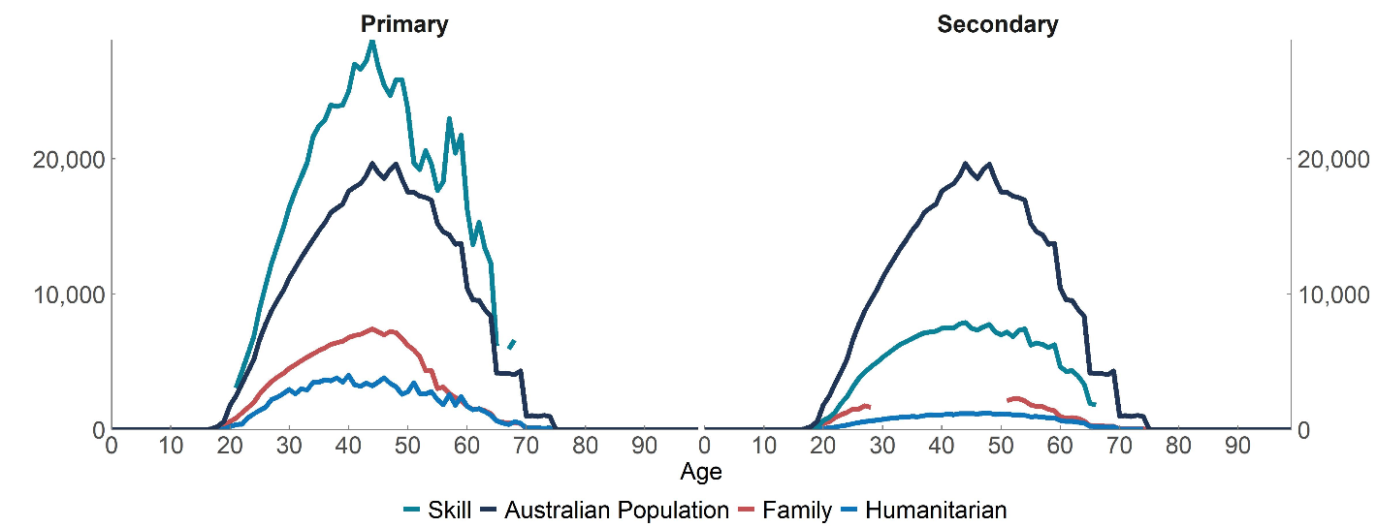In charts A3-A15, data points are only shown when the population size is greater than 10.

Indirect taxes (including GST)
FIONA includes the following indirect taxes:
- GST
- Fuel taxes (petrol, diesel, and other fuel products)
- Tobacco taxes
- Alcohol taxes (excise on beer, spirits, other alcoholic beverages, and Wine Equalisation Tax)
In each case, indirect tax revenue is modelled by grouping migrants into five-year age groups and disposable income quintiles, and then mapping these groups to estimates of the average level of consumption taxes paid by these age/income groups from the Fiscal Incidence Study in the Household Expenditure Survey. Consumption taxes are allocated to individuals based on their share of household income (for instance, an individual with 60 per cent of household income is allocated 60 per cent of that household’s consumption taxes). This estimate is then benchmarked to the National Accounts to account for underreporting of certain consumption items in the HES.
Chart A4: 2018–19 estimated average indirect taxes modelled in FIONA by age, applicant type and visa stream
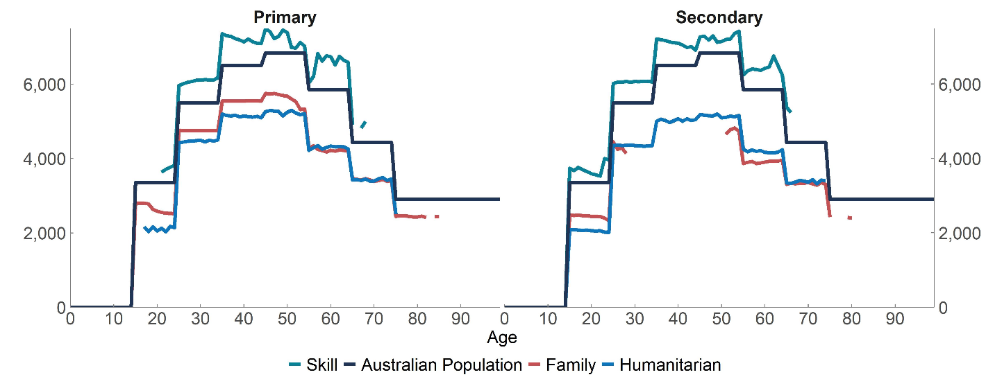

Visa Application Charges
Visa Application Charges (VAC) are paid by migrants when submitting their visa application, with some migrants being required to pay a second VAC when the visa is granted. The Department of Home Affairs provided data on the most common VACs paid for each visa subclass by applicant type and age, along with take-up rates for the payment of second VACs. All VACs are assumed to be received in the first year of the model. VAC revenue received by migrants that do not arrive in Australia is not allocated to any migrant in FIONA. FIONA does not include revenue from the Skilling Australia Fund Levy.
Chart A5: 2018–19 estimated average Visa Application Charges modelled in FIONA by age, applicant type and visa stream
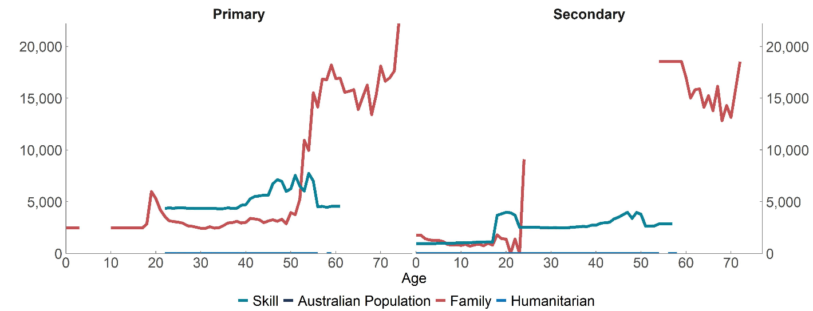

Payroll tax
Payroll tax is levied by States on wages and related benefits paid by employers. In FIONA it is modelled using migrant wages and salaries data from the personal income tax module. We attribute payroll tax to employed individuals using employment and participation rate data and apply the effective payroll tax rate paid by businesses in each State. Data on the Compensation of Employees by State is used to capture the proportion of wages subject to payroll tax in each jurisdiction. This approach implicitly assumes migrants work at businesses subject to payroll tax in the same proportion as the Australian population. Wage differences between migrants are reflected in the personal income tax data.
Chart A6: 2018–19 estimated average payroll tax modelled in FIONA by age, applicant type and visa stream
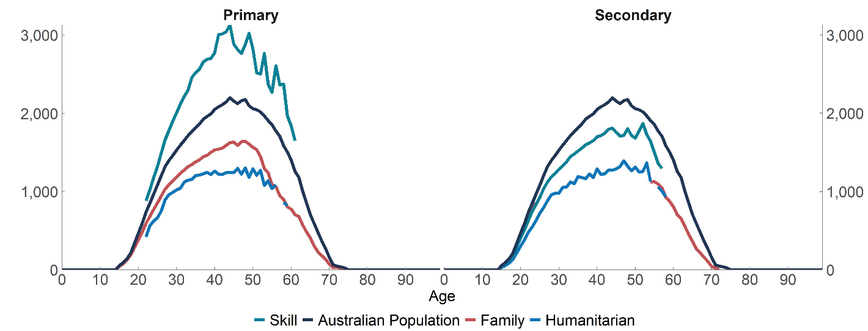Land tax
FIONA uses administrative data on the total amount of land tax paid by individuals (excluding corporations and trusts) in 2017–18 (grown using total growth in land tax paid from 2017–18 to 2018–19) which is grouped by age and visa data to estimate the average amount of land tax paid by age and visa category.
Chart A7: 2018–19 estimated average land tax modelled in FIONA by age, applicant type and visa stream
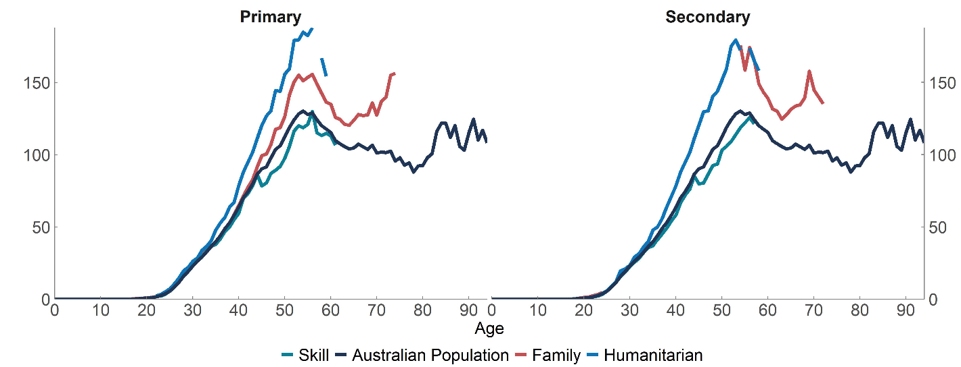
Note: Land tax calculations are based only on the age and State of migrants, leading to the counter-intuitive result that humanitarian migrants (who are more likely to live in NSW and Victoria) pay more land tax than other migrants.

Stamp duty
The likelihood of purchasing a property by people of different ages and incomes, as well as the average property price, was estimated using regression analysis on the HILDA dataset. This analysis incorporates the age and income profile of housing purchase decisions but does not specifically incorporate information on migrants. That is, migrants are assumed to buy a house with the same likelihood as other Australians of the same age and income. FIONA estimates are benchmarked to equal 80 per cent of total stamp duty revenue in each State (with the remaining 20 per cent paid by businesses and therefore out of scope for FIONA).
Chart A8: 2018–19 estimated average stamp duty modelled in FIONA by age, applicant type and visa stream
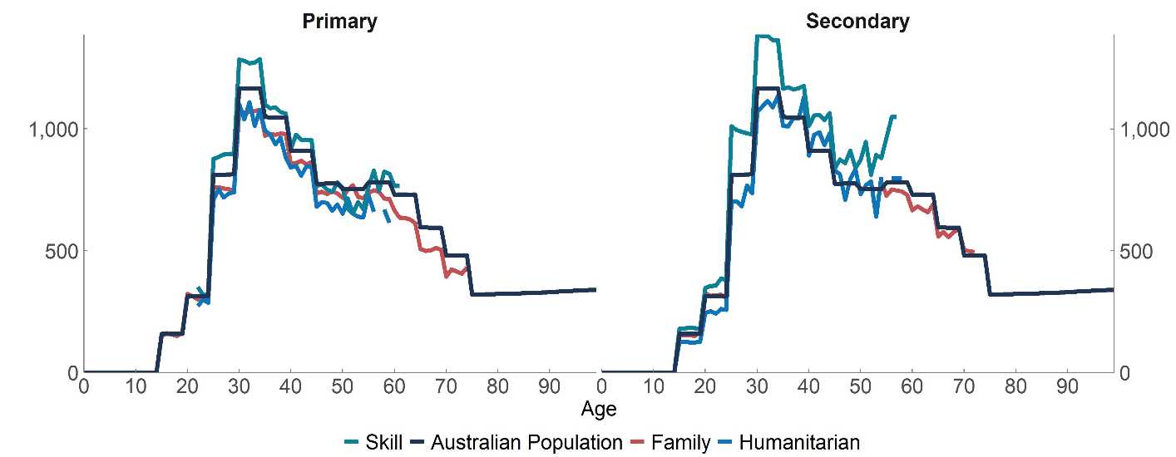
Motor vehicle taxes
Motor vehicle taxes modelled in FIONA include stamp duty on vehicle registration and other vehicle registration fees and taxes (categories 511 and 514 in Government Finance Statistics). These taxes are assumed to be proportional to levels of car ownership (in other words, FIONA does not capture any differences in car prices or try to identify the timing of car sales to model stamp duty). Average rates of car ownership are estimated by age, migrant stream and State using ACMID. The average tax rate per car in each State is found by dividing total tax revenue (from Government Finance Statistics) with the total number of cars identified in the Motor Vehicle Census. This approach captures around 75 per cent of all motor vehicle ownership, with the remaining motor vehicle taxes paid by businesses and therefore out of scope for FIONA.
Chart A9: 2018–19 estimated average motor vehicle taxes modelled in FIONA by age, applicant type and visa stream
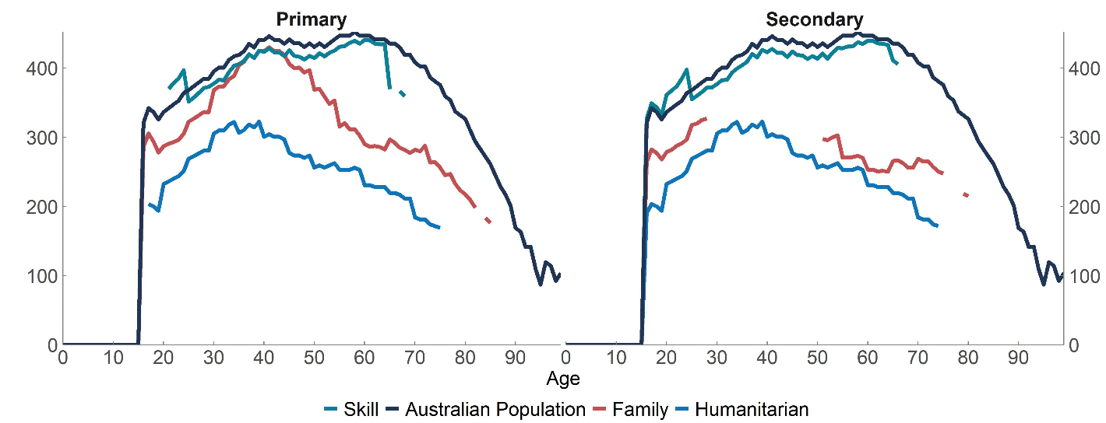Aged care
The Australian Institute of Health and Welfare publishes data with total costs and numbers of individuals involved in residential care, home care, home support, transition care and short-term restorative care. This information is used to calculate the take-up rate of these services by age and gender. It is also assumed that the cost per year for aged care services varies across service stream, but not by other characteristics including visa category.
Chart A10: 2018–19 estimated average aged care costs modelled in FIONA by age, applicant type and visa stream
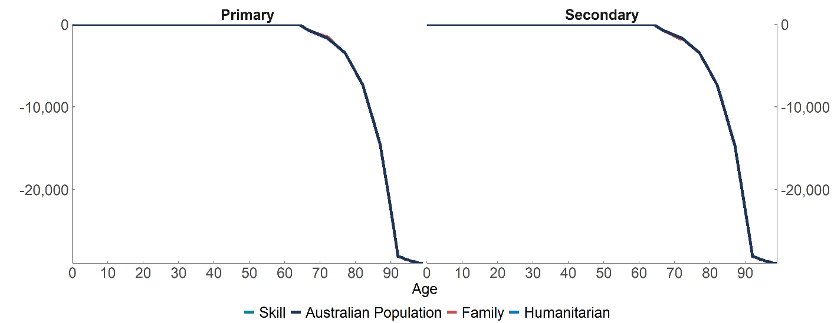
Health
In FIONA, health costs include spending on hospitals (both Commonwealth and States), Medicare Benefits Schedule (MBS), Pharmaceutical Benefits Scheme (PBS) and private health insurance. The Department of Health provided total Commonwealth hospital costs by age and gender for 2018–19 which were used to calculate average costs (assuming all individuals receive health costs), and these cost relativities were used for both Commonwealth and State spending on Health. Commonwealth Grants Commission data were used to benchmark State spending for hospitals.
Medicare data in MADIP were used to compare MBS and PBS utilisation across migrant streams. This analysis shows evidence of a ‘healthy migrant effect’ in which migrants from the Family and Skill streams use less healthcare than Australians on average (conditional on age and gender), while Humanitarian migrants have higher health care costs. This analysis is used to adjust MBS and PBS health costs in FIONA. No adjustments were made to other health care expenses.
Chart A11: 2018–19 estimated average health costs modelled in FIONA by age, applicant type and visa stream
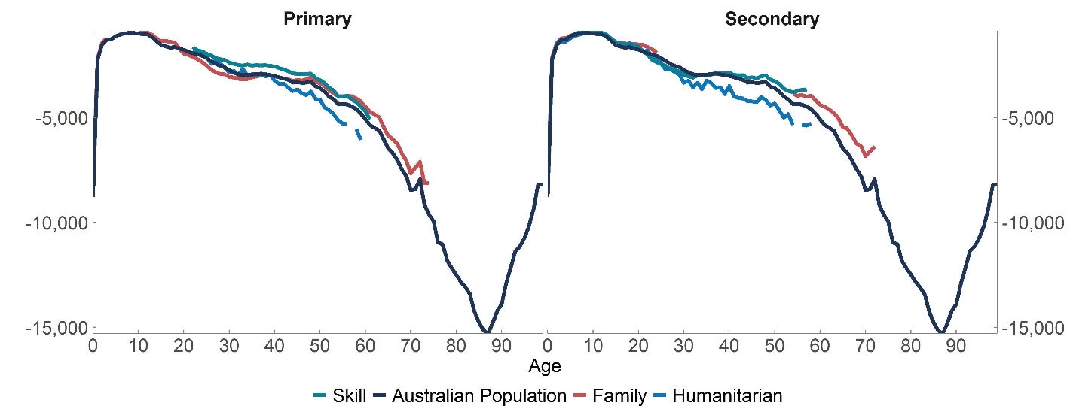Infrastructure
Infrastructure costs in FIONA are adapted from the approach used by the Commonwealth Grants Commission (CGC) and draws heavily on the data sources used by the CGC. As a model of fiscal costs, FIONA captures infrastructure that is funded through taxation (road, transport and hospital and school infrastructure) but excludes infrastructure funded through user-charging (such as electricity networks and airports). The key assumption used to model infrastructure costs is that total infrastructure requirements will grow in line with the Australian population.
FIONA converts infrastructure costs into an annualised value with four components:
- The replacement value of the existing capital stock ($489 per person, on average, in 2018–19)
- Operating expenses ($913 per person, on average, in 2018–19)
- Capital expenses related to depreciation ($625 per person, on average, in 2018–19)
- Capital expenses related to capital deepening ($296 per person, on average, in 2018–19)
Conceptually, the replacement value relates to the cost of ‘scaling-up’ the infrastructure network in response to population growth, while the operating expenses and depreciation expenses are the annual costs of keeping the infrastructure network at that level. Finally, costs related to capital deepening are based on recent trends in the growth of the (per capita) infrastructure stock.
FIONA adjusts for differences in infrastructure costs between States and between cities and regional areas. This results in higher infrastructure costs for migrants relative to the Australian population due to the higher likelihood that migrants live in Australia’s largest capital cities. All operating expenses are assumed to be paid by the States, with capital expenses apportioned between Commonwealth and State government based on the observed share in 2018–19. In addition to capital deepening described above, infrastructure costs are assumed to grow in line with CPI.
This approach results in an annualised infrastructure cost of between $2,000–$2,500 per person in 2018-19, and a lifetime cost (in net present value terms) that varies between $40,000 –$70,000 across migrant categories. This difference is driven by differences in future life expectancy and State of residence.
Chart A12: 2018–19 estimated average infrastructure costs in FIONA by age, applicant type and visa stream
Education
The Commonwealth and State and Territory Governments jointly fund education. The States have primary responsibility for schools and the Commonwealth has primary responsibility for higher education (including universities and vocational education and training) and childcare. ABS data (Cat. No. 4221.0) are used to calculate the proportion of individuals at different school types by State of residence, age, and gender. The Department of Education, Skills and Employment provided unit costs for different types of education which were used to calculate average costs.
Chart A13: 2018–19 estimated average education costs modelled in FIONA by age, applicant type and visa stream
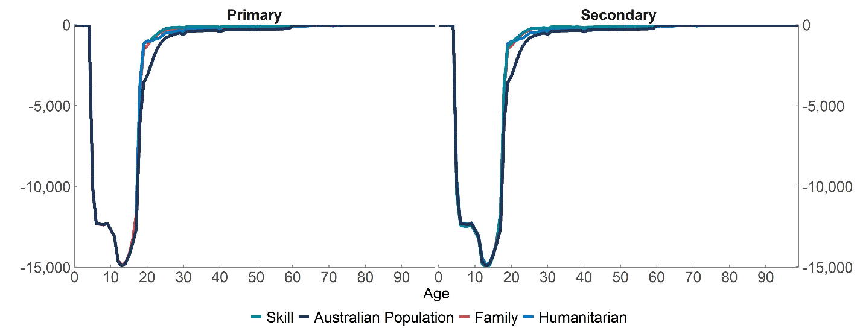
Transfer payments
The Department of Social Services provided administrative data on the receipt of transfer payments by visa category, applicant type and age. These costs were then grown forward based on legislated growth rates (for instance, working age income support payments grow in line with CPI, while the Disability Support Payment (DSP) grows in line with average earnings). FIONA captures the different waiting periods that must be observed by new migrants before receiving many transfer payments. In addition, the take-up rate of transfer payments converges linearly in the model towards that of the Australian population over a period of 20 years.
The transfer payments included in this calculation are, DSP, Age Pension, Carer Payments, Child Care payments (for parents), Special Benefit, Student payments, Non - Income Support (Carer), Non - Income Support (Other), Family Tax Benefit, Parenting payments, Working Age payments, New Parents income support and Income Support Dependent.
Chart A14: 2018–19 estimated average cost of transfer payments modelled in FIONA by age, applicant type and visa stream
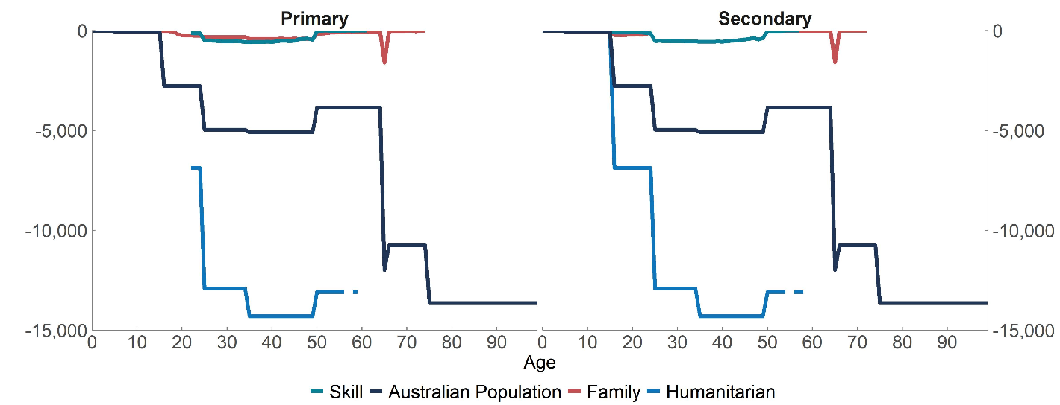Transfer payments in 2018–19 are low for Skill and Family Stream migrants due to the waiting periods that apply to most, but not all, transfer payments.

Settlement services
Migrants arriving in Australia can receive support under several programs including Settlement Engagement and Transition Support (SETS), Humanitarian Settlement Program (HSP) and the Adult Migration English Program (AMEP). The first two of these programs are primarily focused on providing services for the Humanitarian migrant stream. AMEP is mostly used by family stream migrants, followed by humanitarian and skilled stream migrants. The Department of Home Affairs provided administrative data to estimate the average cost for each migrant and the number of migrants involved within each program. Eligibility factors were also applied to reflect the length of time a migrant could benefit from these assistance programs.
Chart A15: 2018–19 Estimated average settlement services costs modelled in FIONA, by age, applicant type and visa stream
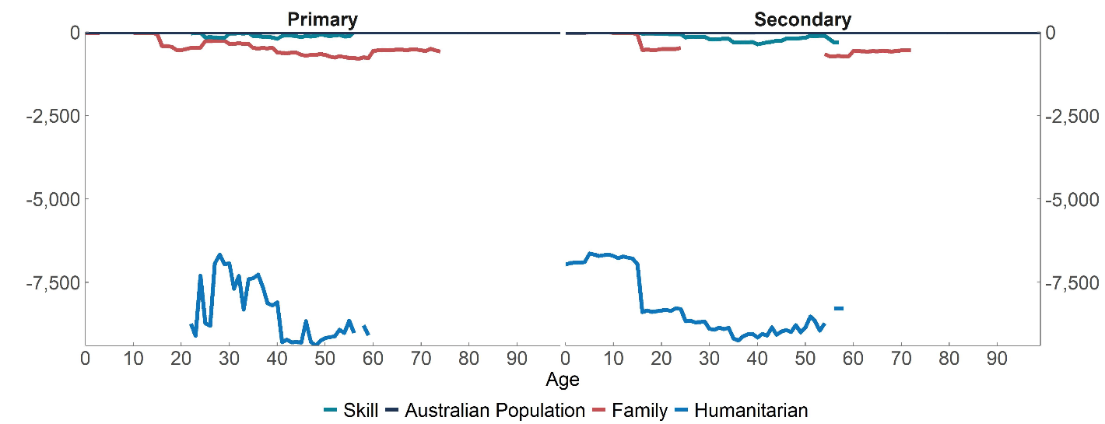

Appendix B: Fiscal impact of temporary migrants
The Australian migration program is composed of a permanent migration program that allows migrants to reside in Australia indefinitely, and a temporary migration program that allows migrants to temporarily enter Australia for a specific purpose, such as tourism, study, or work.
FIONA is designed to estimate the fiscal impact of permanent migrants. This reflects that permanent migrants create a long-term profile of revenues and expenses (as shown in Chart 2) and therefore are best examined using a lifetime perspective, while the fiscal impact of temporary migrants can be well represented using a shorter-term framework.
However, this focus on permanent migration does miss some important interactions between the permanent and temporary programs. For instance, Australian migrants often enter the country on a temporary visa before transitioning to permanent residency (Table B1). This means that estimates of fiscal impact calculated using FIONA will miss revenues and expenses incurred before receiving a permanent visa.
Table B1: First Australian visa of Skill and Family stream permanent migrants
 | Skill Stream | Family Stream
Student | 34% | 21%
Temporary skill | 24% | 2%
Offshore applicant | 24% | 52%
Working holiday maker | 9% | 15%
New Zealand | 6% | 1%
Temporary other | 2% | 9%
Post study work rights | 1% | 0%

This Appendix provides estimates of the fiscal impacts of temporary migrants to allow FIONA results to be interpreted within the context of this broader migration program. These calculations cover Temporary Skill Shortage visas (TSS), Working Holiday Maker (WHM), Student and Temporary Graduate visas and are designed to be as consistent as possible with FIONA calculations in the remainder of this report.
The key details of this calculation are:
- Personal income tax paid by temporary migrants is based on observed taxes paid by temporary migrants (and therefore captures different personal income tax treatment of those temporary migrants who are not Australian residents for tax purposes).
- Indirect taxes such as GST and commodity taxes, as well as infrastructure and Visa Application Charges follow the same approach as used in FIONA.
- Other revenues and expenses were excluded on the basis that temporary migrants are not eligible for many government services and are unlikely to engage in other forms of taxable activity (such as purchasing a house).
The results of this calculation are presented in Table B2. This shows that of the visa categories analysed, TSS visa holders have the most positive fiscal impact. This result is driven by the high level of personal income tax paid by this group. Other temporary visas analysed in Table B2 were all found to have a small positive fiscal impact.
Table B2: 2018-19 estimated average fiscal impacts for temporary migrants
Visa stream | 2018–19 Visas | Length of stay (years) | Visa Application Charges ($) | Personal Income Tax ($) | Indirect taxes ($) | Infrastructure ($) | Total NPV ($)
Graduate | 65,370 | 1.62 | 955 | 7,120 | 3,738 | -4,006 | 7,806
Student | 393,973 | 2.03 | 575 | 1,831 | 2,664 | -4,853 | 217
TSS | 77,258 | 2.43 | 1,265 | 36,592 | 6,606 | -5,863 | 38,601
WHM | 196,223 | 1.34 | 440 | 2,710 | 2,164 | -3,176 | 2,137
Table B2 reports the average fiscal impacts across primary and secondary applicants. The share of primary applicants across these visas in 2018–19 was Graduate (75 per cent), Student (87 per cent), TSS (51 per cent) and Working Holiday Makers (100 per cent). Visa totals include onshore visa grants and offshore visa grants that arrived in Australia in 2018-19. Length of stay is calculated as the time between a visa being granted and the visa holder transitioning to another visa stream or leaving the country.
In interpreting Table B2 it should be noted that migrants who transition through the temporary program into the permanent program are observed to have a different age and income distribution to the other migrants in the permanent stream. Therefore, these estimates should not be directly added to FIONA estimates in this paper. Nevertheless, the positive values in Table B2 suggest that FIONA estimates in this paper would be slightly increased if the period on temporary visas is included.

Estimates in Table B2 also exclude education fees paid by international students. (Such fees are not taxation revenue and therefore not captured in this fiscal estimate.) International students pay, on average, around $32,000 per year in student fees. As some proportion of international student fees are used to subsidise research in Australian universities, this represents an economic benefit of student visa holders in addition to the fiscal benefits in Table B2.

Tax Analysis Division, The Treasury, Langton Crescent, Parkes ACT 2600, Australia. Correspondence: Peter Varela, peter.varela@treasury.gov.au. The development of the FIONA model reflects the efforts of a large number of Treasury staff. In addition to the authors of this report, this includes Gillian Beer, Rita Scholl, Angie McCosker, Michelle Fairbairn, Mark Bott, Nisha Dutta, Martin Stevenson, Hannah Denson, Richard Yan, Sean Parry, Simon Lang, David Li, Cindy Tao, Pippa Kuhnel, Costa Georgeson, Iyanoosh Reporter, Andrew Hartley, Scott Wu, Owen Hutchison, Elliot Lavers, Martin O’Connor and Luke McKenzie. The authors of this paper would also like to acknowledge valuable comments on draft papers from Robert Breunig, Gabriela D’Souza, the Department of Home Affairs, Commonwealth Grants Commission, Productivity Commission and Grattan Institute.
The views expressed in this paper are those of the authors and do not necessarily reflect those of The Treasury or the Australian Government.
Throughout the paper, reference to State/s refers to both State and Territory governments.
The general Australian population is based on the Australian Estimated Resident Population as defined by the Australian Bureau of Statistics publication ‘National, state and territory population’. While this population includes some permanent and temporary migrants, per capita results would be very similar if these groups were removed.
Productivity Commission (2016), Migrant Intake into Australia, Inquiry Report No. 77, Technical Supplements D1 and D2.
Deloitte Access Economics (2016), 2015 Migrants Fiscal Impact Model, prepared for the Department of Immigration and Border Protection (Unpublished).
Throughout this paper, MADIP refers to: Australian Bureau of Statistics (2019), MADIP Basic Longitudinal Extract, 2011-2016 (2011-2016 Cohorts), Detailed Microdata, DataLab.
The Migration Act 1958 (s. 4) specifies the national interest as the overarching object of immigration policy.
For instance, the Global Talent Visa Program was launched in November 2019 and by 2020-21 had a planned visa allocation of 15,000 places (19 per cent of skilled visa holders).
The sensitivity of FIONA results to the economic conditions generated by COVID-19 are discussed in Section 5.
Research, both on Australian and international labour markets, suggests that the aggregate impact of migration on labour markets is likely to be small and may be either positive or negative. See for instance Breunig, R., Deutscher, N. and To, H. (2017). ‘The Relationship between Immigration to Australia and the Labour Market Outcomes of Australian‐Born Workers’ Economic Record.
FIONA implicitly assumes that Australia’s incoming migration program is independent of outgoing migration, which may not always be true. For instance, international social security arrangements are provided on a mutual basis between countries.
For instance, Australians may choose to move overseas to live with a partner in another country rather than applying for an Australian partner visa.
Productivity Commission 2016; ‘Migrant Intake into Australia’, Report No.77, Canberra,
Coates, B., Sherrell, H., and Mackey, W. (2021). Rethinking permanent skilled migration after the pandemic. Grattan Institute.
For instance, Visa Application Charges paid by parent visa holders provide a significant up-front cost which may make them look fiscally positive in the short term. However, the VAC does not offset all of the remaining lifetime fiscal impacts incurred by this cohort.
These scenarios all relate to factors that impact both migrants and the general population in a similar manner. The stability observed in Table 2 does not extend to the assumptions relating to migrant specific behaviour used in FIONA (such as, for instance, the rate that migrants use health or aged care).
Deutscher (2020, What drives second generation success? The roles of education, culture and context, Economic Inquiry, Volume 58, No. 4) finds that there is significant (but not full) regression to the mean amongst incomes of second-generation migrants (along with striking examples of second-generation success). This suggests that capturing the effects of both first- and second-generation migrants in FIONA would increase the positive fiscal impact of skilled migrants and increase the negative impact of low-skilled migrants, but that this effect would be modest. Second generation migrants also have higher incomes on average than Australians from similar backgrounds.
Several FIONA revenue and expense calculations use a simplified approach to economic incidence due to data availability. For instance, empirical studies suggest that the economic incidence of stamp duty is split between house buyers and house sellers, while FIONA assumes that all stamp duty is borne by house buyers.
In combination with migrant-specific employment rates and health care utilisation, this assumption allows FIONA to capture the fiscal impact associated with births to new migrants.
Within each revenue and expense calculation, all subgroups are grown at the same rate.
In addition, Humanitarian migrants are not subject to the waiting periods that other migrants must observe before receiving transfer payments.
Based on the proportion of migrants in each income quintile within a 5-year age range.
Note that values in Table 7 can’t be added together due to interactions between these factors. For instance, the combined impact of demography and income won’t be equal to the sum of these factors evaluated individually.
This is calculated by equalising the income distribution shown in Table 6.
This is calculated by setting the employment factor shown in Chart 11 to a value of 1.
This is calculated by removing the healthcare adjustment factor described in Appendix A.
The Treasury. 2018-19 Final budget outcome, https://archive.budget.gov.au/2018-19/index.htm, Table 2
Commonwealth Grants Commission, 2019 update, https://www.cgc.gov.au/inquiries/2019-update
This is equivalent to assuming that the Australian population in FIONA in 2018-19 has the same net fiscal deficit as reported in the 2018-19 Final budget outcome and CGC data.
This equates to a per person cost of $292 dollars at the Commonwealth level and $620 at State level.
Productivity Commission 2016; ‘Migrant Intake into Australia’, Report No.77, Canberra Supplement D, Figure D.8.
In addition, different data sources used in FIONA are released at different intervals, meaning that some would capture the effects of COVID while others wouldn’t. Therefore, updating FIONA to fully capture the impacts of COVID-19 would present significant technical challenges.
Note that this sensitivity test is not able to capture JobKeeper or other temporary spending programs.
Based on the share of newly arrived migrants in each State between 2011-12 and 2015-16, by age group and visa stream.
Arrival rates by visa category are presented in Table 1 of this paper.
The FIONA model uses estimates of revenue and expense defined in a way that is consistent with period life expectancy. For instance, FIONA health care costs are implicitly based on ‘period’ morbidity rates. Therefore, the incorporation of cohort mortality rates into FIONA would also need to account for associated changes in unit costs.
Where available, information on visa grouping is used as this is the key variable of interest for FIONA. After this, co-variates are prioritised with strong connection to the revenue or expense.
Different growth rates are applied to schools, university, and VET.
For instance, employment and participation rates for some visa types are significantly lower in the years immediately after migration before steadily increasing and then stabilising after 3 to 5 years.
Specifically, this calculation takes the share of people in each income quintile within a 5-year age range. Then, takes a weighted average across the population based on the share of migrants in each age group. This income distribution is maintained through all years of the model.
This tax calculator is based on the personal income tax system in 2018-19 (including planned changes under the Government’s personal tax plan). It is simplified in the sense that it includes the main tax rates and thresholds from the personal income tax system but does not include all of the details of the system, such as rebates and tax offsets.
After 2030, the thresholds in the personal income tax calculator are allowed to rise in line with projected growth in average weekly earnings. This avoids the unrealistic scenario where average tax rates increase indefinitely.
In FIONA, GST revenue refers to the amount collected by the Commonwealth on behalf of the States. The value of ‘top-up’ payments made by the Commonwealth to certain States is not captured.
Disposable income is income net of personal income tax and transfer payments. Note that this is a different definition of income to that used in the personal income tax module.
As is in the personal income tax calculation, this income distribution is adjusted for age profile, and then assumed to be stable for the remainder of an individual’s lifetime.
The Fiscal Incidence Study is described in the Australian Bureau of Statistics Household Expenditure Survey and Survey of Income and Housing User Guide, 2015-16.
Adjustment is based on Household Expenditure Survey and Survey of Income and Housing, User Guide, ABS Cat. No. 6503.0.
The likelihood of purchasing a property is estimated using a probit regression on 18 pooled waves of the HILDA survey. Explanatory variables include 5-year age bins, income quintiles (as defined in the FIONA personal income tax calculation), State, sex, and year. Housing purchase price predictions use a linear model with the same explanatory variables. Housing purchase events are imputed in HILDA based on movement of address and home ownership (for owner occupied properties) and changes in properties owned (for investment properties).
Existing evidence of home ownership amongst migrants is mostly focused on the stock of housing rather than the turn-over, while analysis of housing purchases using HILDA produced estimates that were highly sensitive to model specification.
Australian Bureau of Statistics 2020, Government Finance Statistics.
To the extent that skilled migrants are more likely to purchase expensive cars, or to buy cars more frequently than other migrants, this assumption will underestimate the difference in motor vehicle taxes paid across visa streams. However, the relatively small scale of motor vehicle taxes compared to other revenue heads means that this assumption will have a small impact on overall FIONA results.
Australian Bureau Statistics 2020, Motor Vehicle Census.
Australian Institute of Health and Welfare (2019), Aged care data snapshot - 2019.
While there is some evidence that migrants use less aged care services than non-migrants (for instance, AIHW 2007, Older Australia at a glance) these differences are less pronounced at older ages where the majority of aged care costs are observed. In addition, it is unclear whether current migrants in aged care (who arrived in Australia many decades ago) are representative of migrants arriving in 2018-19.
The specific definition of infrastructure used in FIONA is the same as that used by the CGC.
Infrastructure is assumed to exhibit constant returns to scale, which means that if the Australian population increased by 10 per cent, then Australia would need an infrastructure stock that was 10 per cent larger.
Estimates are based on data sources used by the Commonwealth Grants Commission.
The replacement value of the existing asset base is reported by State Governments, which is converted to an annualised value using a rate of return equal to the FIONA discount rate.
FIONA assumes that the rate of capital deepening observed in 2018-19 continues into future years.
As FIONA is based on policy in place in 2018-19, it does not incorporate recent changes to the Newly Arrived Resident’s Waiting Period.
Unit costs are not converged.
A full list of waiting periods for recent migrants is available on the Department of Social Services website - Waiting period for welfare payments for new migrants.
Other temporary visas (including Visitors, Special category, Bridging visas and New Zealand migrants) were excluded from the analysis because they do not have a strong relationship to the permanent migration program, or they only make up a small proportion of temporary visa grants.
Note that this approach differs from the personal income tax calculation in FIONA, which is based on income quintiles.
The Australian Taxation Office website provides Foreign Resident tax rates.
For instance, permanent migrants that transition through the TSS program are observed to earn more than other permanent migrants in the same permanent visa categories.
Calculation is based on the exports of education services in Australian Bureau of Statistics, International Trade: Supplementary Information, Calendar Year, 2017 and international student numbers from the Department of Education, Skills and Employment Selected Higher Education Statistics – 2019 Student Data.

