Modernising Registry Fees
  - Exploring opportunities to improve fee structures for the Australian Business Registry Services
December 2021

© Commonwealth of Australia 2021
This publication is available for your use under a Creative Commons Attribution 3.0 Australia licence, with the exception of the Commonwealth Coat of Arms, the Treasury logo, photographs, images, signatures and where otherwise stated. The full licence terms are available from http://creativecommons.org/licenses/by/3.0/au/legalcode.
Use of Treasury material under a Creative Commons Attribution 3.0 Australia licence requires you to attribute the work (but not in any way that suggests that the Treasury endorses you or your use of the work).
Treasury material used ‘as supplied’.
Provided you have not modified or transformed Treasury material in any way including, for example, by changing the Treasury text; calculating percentage changes; graphing or charting data; or deriving new statistics from published Treasury statistics — then Treasury prefers the following attribution:
Source: The Australian Government the Treasury.
Derivative material
If you have modified or transformed Treasury material, or derived new material from those of the Treasury in any way, then Treasury prefers the following attribution:
Based on The Australian Government the Treasury data.
Use of the Coat of Arms
The terms under which the Coat of Arms can be used are set out on the Department of the Prime Minister and Cabinet website (see www.pmc.gov.au/government/commonwealth-coat-arms).
Other uses
Enquiries regarding this licence and any other use of this document are welcome at:
Manager
Media and Speeches Unit
The Treasury
Langton Crescent
Parkes ACT 2600
Email: media@treasury.gov.au

Contents
Contents iii
Consultation Process 1
Request for feedback and comments 1
Publication of submissions and confidentiality 1
Further consultation process 1
Review of Registry Fees 2
Scope 4
Objectives of this consultation 4
Potential fee reforms 4
Search fees 5
Infrastructure fees 6
Late fees 6
Lifecycle fees 8
Consultation question summary 9
Appendices 10
Appendix A – Current registry revenue 10
Appendix B – Current fee schedule 10
Appendix C – Timeline of public consultation on fees 14
Appendix D – Historical basis for registry fees 14

Consultation Process

Request for feedback and comments
Interested parties are invited to respond to the consultation questions listed on page 9 and to comment on the issues raised in this paper by 28 January 2022.
While submissions may be lodged electronically or by post, electronic lodgement is preferred. For accessibility reasons, please submit responses sent via email in a Word or RTF format. An additional PDF version may also be submitted.

Publication of submissions and confidentiality
All information (including name and address details) contained in formal submissions may be made available to the public on the Australian Treasury website, unless you indicate that you would like all or part of your submission to remain confidential. Automatically generated confidentiality statements in emails do not suffice for this purpose. Respondents who would like part of their submission to remain confidential should provide this information marked as such in a separate attachment.
Legal requirements, such as those imposed by the Freedom of Information Act 1982, may affect the confidentiality of your submission.

Further consultation process
The Treasury will also consult broadly with industry representatives and other interested parties on the topics discussed in this consultation paper. This may involve conducting targeted consultation with these stakeholders on specific issues where more information and views are required.

Closing date for submissions: 28 January 2022
Email | regmod@treasury.gov.au
Mail | Data Economy Unit  Consumer Data Right Division  The Treasury  Langton Crescent  PARKES ACT 2600
Enquiries | Enquiries can be initially directed to regmod@treasury.gov.au  Media enquiries should be directed to medialiaison@treasury.gov.au or +61 2 6263  2300
The positions outlined in this paper have not received Government approval and are not yet law. As a consequence, this paper is merely a guide as to how the registry fees regime might operate.

Review of Registry Fees

Box 1: Overview
- The Government is committed to reducing compliance costs and making interactions with government simpler and quicker by modernising Australia’s business registers.
- Fees are a necessary part of the business registry system and are collected from companies and other entities.
- Treasury has been consulting broadly on business registers since 2017 and released a discussion paper focused on registry fees in 2018.
- Given changes to the broader business environment and the continued design and implementation of the Modernising Business Registers program, this paper is seeking views on the role and design of aspects of the registry fee regime.

Business registers are a critical component of Australia’s economic infrastructure and are accessed by a range of users to source data about companies and their operators. Business and industry participants rely on the registers when making decisions about counterparties (e.g. a bank as part of the decision to grant a loan). Government also uses the information held on registers for policy-making and regulatory activities. In order to maintain the currency and integrity of the registry system, the Government charges a range of fees for access to and interactions with the registers. Certain registry fees also recognise the benefits of maintaining a separate legal entity, including limited liability, and discourage frivolous applications, such as ‘hoarding’ of business names.
The Government started consultation on registry fees in 2018 to seek opinions on the role and form of registry fees in the new registry system being developed through the Modernising Business Registers (MBR) Program.
Broadly, existing registry fees are split into four categories outlined in Box 2 below.

Box 2: Types of Current Registry Fees
Registration, review, and renewal fees
Includes fees for company registrations, business name registrations and renewals, annual returns for foreign companies, and annual reviews.
Late fees
Charged when documents are not lodged, or fees are not paid, within the prescribed timeframe.
Search fees
Most searches conducted on ASIC’s registers are free, with fees charged on certain search products. Retail and wholesale users are both currently charged search fees.
Lifecycle fees
Encompasses fees incurred through the operation of a company.

As part of the 2020 Budget Digital Business Plan, the Government announced the full implementation of the MBR program. The MBR program will improve registry efficiency by modernising and uniting the Australian Securities and Investment Commission’s (ASIC) 31 business registers and the Australian Business Register (ABR) on to a new system at the Australian Taxation Office (ATO). Users will interact with the new Australian Business Registry Services (ABRS) to manage their registrations and registry obligations in one place. The changes to registry services being delivered through the ABRS go beyond a technology upgrade – they will make it easier for businesses to fulfil their regulatory responsibilities and streamline their interactions with government.
Figure 1: The Modernised Registry System at a Glance
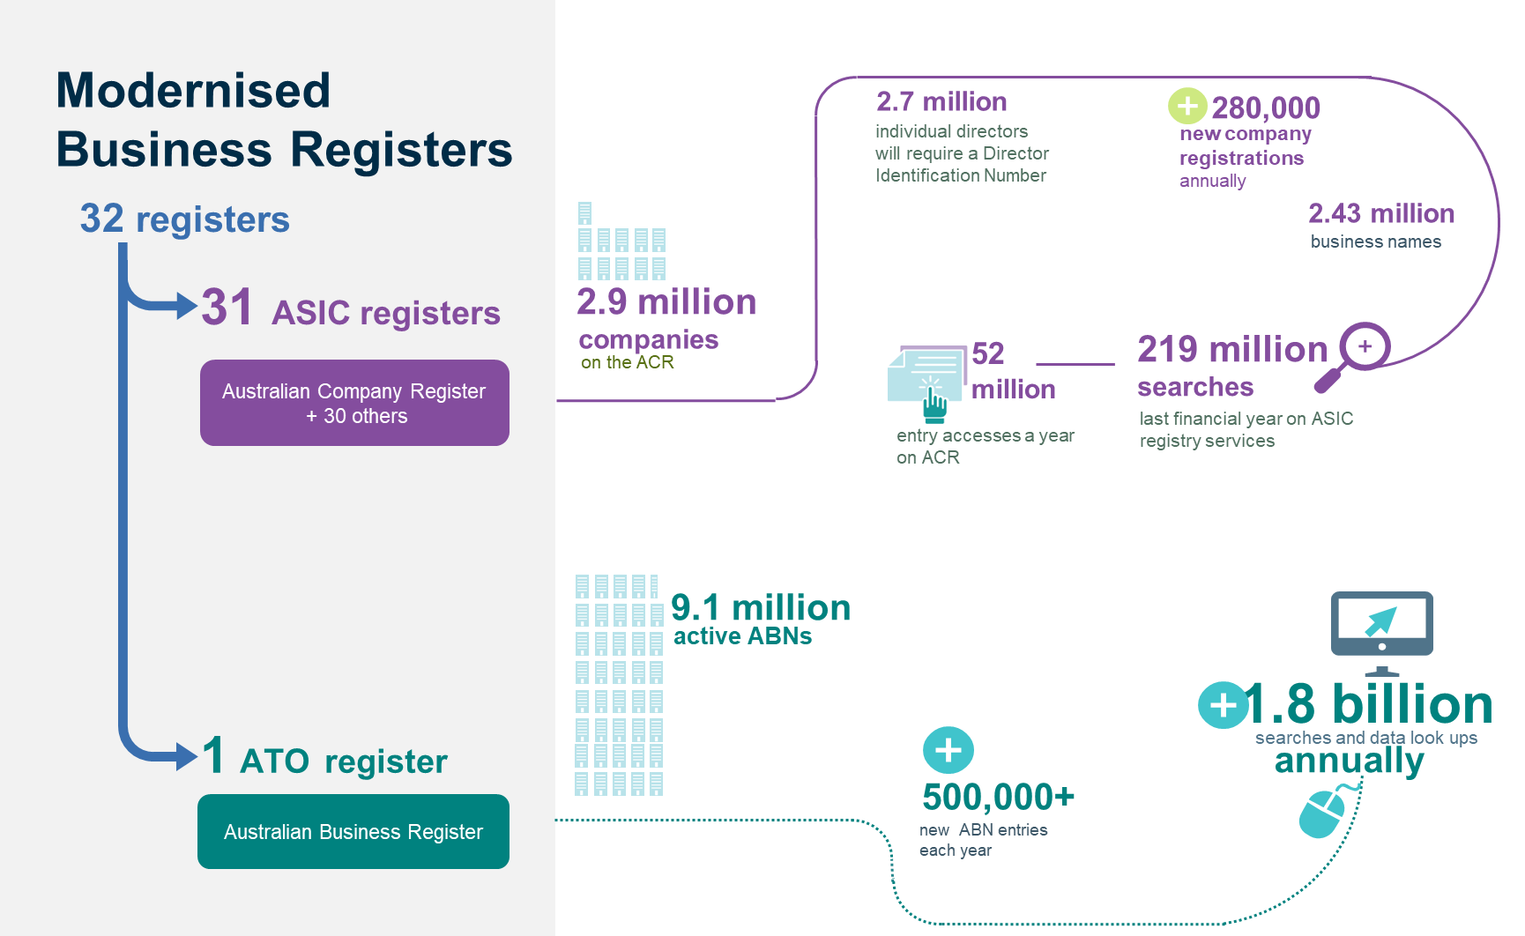
Figures courtesy of ASIC and ABRS
Since the last consultation on fees in 2018 there has been significant progress in the design and implementation of the ABRS. This has included the introduction of director ID into public beta in November 2021. Directors will be allocated a unique identifier that they will keep forever even if they cease to be a director, change their name, or move interstate or overseas. A director’s identity is verified during application, which improves data integrity and helps regulators to detect and deal with illegal phoenix activities.
The next stage of the MBR Program will be focused on the migration of registry information relating to companies. The new companies register will introduce a new range of services that will modernise the interactions between Government, businesses, and the public.
Figure 2: MBR Program Milestones
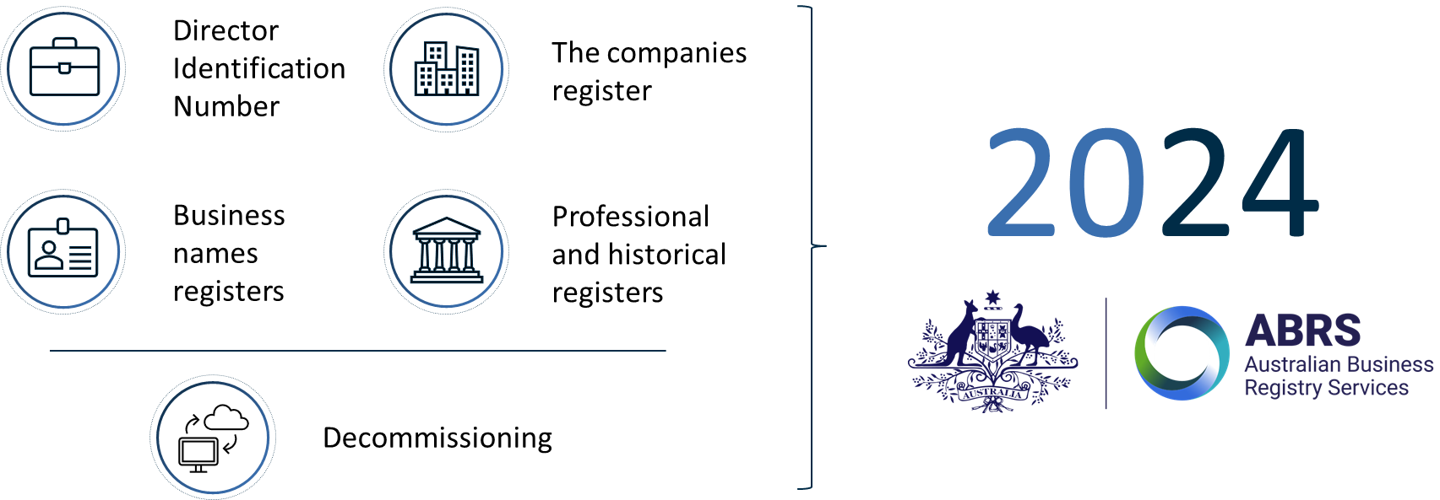

Scope
The scope for this consultation is the fees currently associated with ASIC’s business registers. Other ASIC regulatory fees and charges, including those under Industry Funding Model, are not being considered through this process. Possible fees for director ID, an ABN or for sub-funds attached to a Corporate Collective Investment Vehicle are also out of scope of this paper.
This consultation is focused on reform options at the category level (registration, review, and renewal fees, search fees, late fees, and lifecycle fees) rather than each individual prescribed fee within the regulations.
In addition, the introduction of an infrastructure fee for some wholesale users or use-cases continues to be under consideration following initial consultation in 2018.

Objectives of this consultation
Given changes to the broader business environment and the continued maturation of the MBR program, the Government is seeking further views on the role and design of aspects of the registry fee regime.
The principles of making fees simpler, easier to understand and more equitable, which were largely supported in the 2018 consultation, still form the framework for considering the design of registry fee structures. This consultation is to seek feedback on proposed reforms to registry fees and how fee settings can be best tailored to:
- reduce the cost of accessing registry information for many individuals and businesses
- reduce complexity and make it easier for businesses to interact with registry services by removing sources of frustration
- improve the integrity and currency of registry information
- promote access to data for innovative uses.
Any reforms raised as part of this consultation will continue to be considered alongside complimentary policy settings, including the Government’s broader deregulation agenda, the Australian Government’s Charging Framework (the Charging Framework) and Public Data Policy.

Potential fee reforms
In line with the modernisation of the business registers and their underlying systems, the Government is seeking to ensure that the associated fee structures support the benefits already delivered through the MBR Program.
The Government has been giving ongoing consideration to the design of registry fees. Your views, taking into account changes to the broader business environment and the addition of lifecycle fees to the scope of the review, will be considered alongside those provided in response to the 2018 discussion paper. This will inform the development and implementation of registry fees for the ABRS.
Reform options have been developed for search fees, infrastructure fees, late fees, and lifecycle fees. No reforms are proposed for registration, review, and renewal fees, as prior consultation indicated that stakeholders broadly recognised the structure and role played by these fees.

Search fees
The Government is committed to increasing the value of government-held data through broader accessibility and availability to the public. The searchable data held on the ABRS will be a key economic resource. Registry data is accessed by a range of users, including businesses and the public, professional and financial services, and all levels of government. While the overwhelming majority of searches conducted on ASIC’s registers are free, ASIC is required to charge search fees for some products (e.g. $9 for a current company extract or current business name extract) .
Stakeholder feedback from the 2018 consultation was supportive of further reductions to or a removal of fees on digital retail searches and highlighted the value of registry data to both businesses and the overall economy. In July 2019, the Government acted to:
- exempt journalists from paying certain registry search fees
- reduce the fee to access company roles and relationship extracts from $40 to $19.
The MBR program will deliver an improved search experience with two channels designed to better support users engaging with the registers.

Box 3: Searching Registry Information on the ABRS
When the existing registers transition to the new digital system, there will be two channels for searches:
- A retail channel where anyone can make individual searches for registry information (e.g. a business owner may conduct a search for the company extract of a potential counterparty).
- A wholesale channel where authenticated users can use the registry Application Program Interfaces (APIs) to make bulk requests to the data platform.

The current search fee structure does not differentiate between retail and wholesale searches and was developed for a registry system where most services were paper and counter based. Fees were set to approximate the cost incurred by the Government to retrieve the documents and provide them to the applicant. When the registers are transitioned to the ABRS, the cost to deliver digital searches is expected to fall substantially.
The Government is considering removing or further reducing fees for digital searches conducted through the retail channel. This would significantly improve access to registry data across the economy noting there would continue to be a limited set of data which cannot be provided through automated data processes. However, some stakeholders have expressed that further reductions to or removal of search fees may make personally identifiable data more readily available.
Consultation questions: Search fees
- Are you supportive of a further reduction to or removal of digital retail search fees?
  - Do you have any concerns about retaining fees on a limited range of searches?

Infrastructure fees
The MBR program will deliver a range of enhancements for wholesale users, improving the integrity of registry data and the way in which it is consumed. It will provide for direct connection through APIs and a test environment to enable engagement with the system to test concepts. This will allow wholesale users to perform bulk requests for public, commercial and, in some instances, personal purposes.

Box 4: Wholesale Users and Search Fees
- Some government agencies, academics and journalists receive concessional charges and exemptions for some searches.
- Large commercial users are charged as per the search fee schedule, which does not differentiate between bulk requests and one-off transactions.
- Small commercial or personal users (e.g. lawyers) may access information directly through the retail channel or employ the services of an information broker.

As indicated above, the current search fee structure does not differentiate between retail and wholesale users with previous consultation feedback acknowledging that this model is not fit-for-purpose. The previous consultation contemplated the imposition of a fee on API users recognising that there are additional benefits that are available to wholesale users that utilise this channel.
The government is considering the introduction of an infrastructure fee, consistent with the Charging Framework, which could be designed for wholesale users to better reflect both their use cases and business models.

Consultation question: Infrastructure fee users and use-cases
- Which types of users (or use-cases) should be charged an infrastructure fee? Are there any users (or use-cases) that should be exempt?

The government is also considering the components that may make up an infrastructure fee including the imposition of an onboarding or subscription fee and/or a usage charge.
Consultation question: Infrastructure fee components
- If a connection fee is introduced, which is preferable: a larger one-off onboarding fee, or a smaller ongoing subscription fee?
- If a usage charge is introduced how should it be set? For example, per company, attribute, unit of measurement (e.g. by API call)?

Late fees
The data held on the registers is relied upon by a range of users to make important economic decisions, including the provisioning of loans and verification of counterparties. The data is also relied upon by ASIC and other government bodies to make important regulatory decisions. It is therefore critical that the information held on the registers is current and accurate. The ABRS will deliver improvements to notifications, and invoicing and payment mechanisms, that are expected to reduce the number of late fees incurred. However, late fees will continue to play an important role in encouraging timely payment, and review and lodgement of documents and information.
The complexity of the current late fee regime is a persistent source of confusion and complaints related to the registers. For example, the late provision of information outlined in Scenario 1 can incur both a late review fee and a late lodgement fee for the same piece of information.

Scenario 1: Application of Multiple Fees for the Late Provision of Information
- Company’s annual review date occurs on 1 February 2021.
- A new agent is appointed for Company on 1 July 2021.
- New agent undertakes a data download and discovers old agent failed to update ASIC as register reflects old officeholders.
- New agent notifies ASIC of new officeholder, with effective date of change, 1 June 2019.
- Company incurs late fees:
  - $344 late lodgement fee
  - $688 late review fee (for both 2020 and 2021)

Under the current fee regime late payment fees are also charged where payments are made after the due date.
FIGURE 3: Current Application of Late Fees
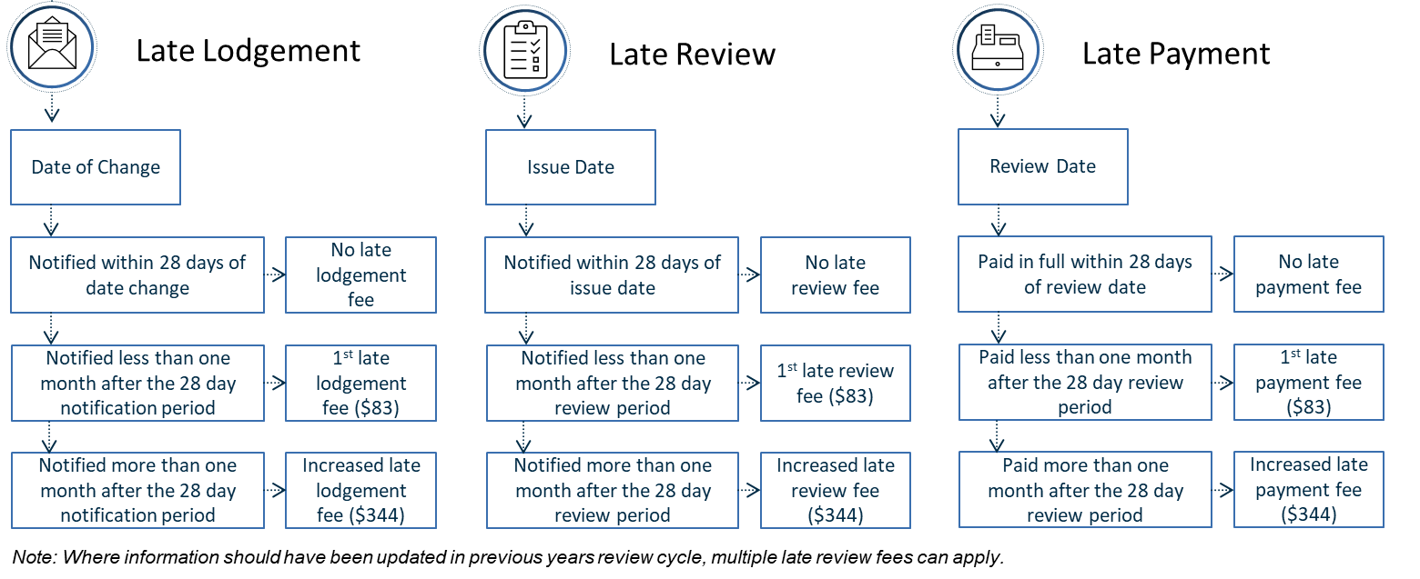
In 2018, stakeholders were asked to consider options for simplifying the late fee regime, including replacing the late payment fee with an interest charge on invoices payable. Responses from stakeholders highlighted that the use of a General Interest Charge would add further complexity to a late fee regime that was already poorly understood. Reflecting this feedback, the government is considering options to simplify the late fee regime by establishing a single type of fee for each of:
- late payment
- late provision of information.

Consultation questions: Late fees
- Would you support a late fee regime with a single fee for late provision of information and a single fee for late payment?
- If so, how should these fees be designed to ensure the information held on the registers is current and accurate?

Lifecycle fees
Under the current fee regime there are a number of other prescribed fees (lifecycle fees) that are incurred through the operation of a company (excluding registration, review, and renewal fees). These lifecycle fees include, as examples, notification of resolution (i.e. change of company name), de-registration of a company and the re-registration of a company.
The scope of this consultation has been expanded to account for these fees, providing an opportunity to consider:
- the removal of fees that are inefficient or encourage the wrong behaviour. For example, the fee charged for the voluntary de-registration of a company could be seen to disincentivise those who would otherwise like to wind down their business from doing so in a timely manner.
- retaining those that maintain the integrity of the register, incentivise engagement with the ABRS or reflect the cost of administering the service. For example, fees to reserve a company name and application for ministerial consent for names.

Consultation question: Inefficient or counterproductive lifecycle fees
- Are there any lifecycle fees that you believe are inefficient or counterproductive and should be specifically removed? Are there any that should be retained?

Currently, there are more than 10 distinct lifecycle fees. Through this consultation, rationalising the fee amounts charged into a smaller number of tiers is also being considered. For example, there may be a number of services that are charged at a low (e.g. $50), medium (e.g. $100) and higher cost tier (e.g. $1500).

Consultation question: Inefficient or counterproductive lifecycle fees
- Are you supportive of a rationalisation of lifecycle fees into tiered cost levels? If this change were adopted how many tiers should there be?

Consultation question summary
Table 1: Summary of Fees and Consultation Questions
Fee | Context | Questions
Search fees | Most searches conducted on ASIC’s registers are free, with fees charged on certain search products. Both retail and wholesale users are both currently charged search fees. | 1. Are you supportive of a further reduction or removal of digital retail search fees?  1.1. Do you have any concerns about retaining fees on a limited range of searches?
Infrastructure fees | An infrastructure fee on APIs would fairly charge users for a publicly funded specialised service which they use to generate private profit. | 2. Which types of users (or use-cases) should be charged an infrastructure fee? Are there any users (or use-cases) that should be exempt?  3. If a connection fee is to be introduced, which is preferable: a larger one-off onboarding fee, or a smaller ongoing subscription fee?  4. If a usage charge is to be introduced how should it be set (e.g. per company, attribute, unit of measurement (e.g. by API call))?
Late fees | ASIC charges late fees when documents are not lodged, or fees are not paid, within the prescribed timeframe. | 5. Would you support a simplified late fee regime, comprised of a fee for late provision of information and a fee for late payment?  6. If so, how should this be designed to ensure the information held on the registers is current and accurate?
Lifecycle fees | Lifecycle fees encompass fees incurred through the operation of a company (excluding review fees). | 7. Are there any lifecycle fees that you believe are inefficient or counterproductive and should be specifically removed? Are there any that should be retained?  8. Are you supportive of a rationalisation of lifecycle fees into tiered cost levels? If this change were adopted how many tiers should there be?
Registration, review, and renewal fees | Fees are charged for company registrations, business name registrations and renewals, annual returns for foreign companies, and annual reviews. | No proposed reforms.

Appendices

Appendix A – Current registry revenue
In 2020-21, the total value of registry fees administered was $1.08 billion, an 8.2 per cent increase from the previous year. The growth in fees was largely driven by a high number of new company registrations and a continued increase in the total population of companies.
Figure 4: ASIC Registry Fees, 2020-21
Source: ASIC

Appendix B – Current fee schedule
Table 2: Summary of Fees (Excluding Search Fees)
Name | Description | Current amount
Registration, review, and renewal fees
Registration | Initial fee to apply to register a company | Has share capital: $512  Does not have share capital: $422  Foreign company: $512
Annual review | Annual fee paid to maintain the registration of a company | Proprietary company: $276 (includes the $4 IFM fee)  Special purpose company (proprietary): $56  Special purpose company (public): $52  Public company: $1281  Registered scheme or notified foreign passport fund: $1281  A small transferring financial institution: $256
Annual return | Fee charged on the lodgement of an annual return of a foreign company | $1274
Business name registration and renewal | Fee to register or renew the registration of a business name | For one year: $37  For three years: $88
Lodge a copy of annual financial report by disclosing entity (that is not a company or registered scheme) or foreign company | Fee charged on the annual lodgement of a copy of financial statements and reports | $1274
Late fees
Late payment | Fee charged if the annual review fee is not paid on time | If payment is received within 1 month after due date: $83  If payment is received more than 1 month after due date: $344
Late review | Fee charged if changes to the annual statement are not made on time | If document is received within 1 month after the prescribed time: $83  If document is received more than 1 month after the prescribed time: $344
Late lodgement | Fee charged if a document is not lodged on time | If document is received within 1 month after the prescribed time: $83  If document is received more than 1 month after the prescribed time: $344
Lifecycle fees
Notification of resolution | Fees charged on notification of a resolution that has been passed or agreed to | Change of company name: $422  Change of company type or status: $83  Some notifications do not incur a fee
Application for voluntary deregistration of a company | Fee charged on an application to voluntarily deregister a company | $42
Application for ASIC reinstatement | Fee to reinstate a deregistered company. Note that annual review fees that would have been payable if the company had remained registered and any outstanding debt (written off or otherwise) must also be paid | $42
Application for reservation of a name/extension on reservation | Fee charged on an application to reserve, or extend the reservation of, a company name | $52
Application to change the review date | Fee charged on an application for a review date that is different to the anniversary of the registration date for a company or registered scheme. | Fewer than 10 companies, registered schemes, notified foreign passport funds and other entities specified in the regulations: $42 each  At least 10: $416
Application to change a company name to omit the word 'limited' | Fee charged on an application by an existing limited public company to change its name to omit the word 'Limited' from the end of its name | $422
Apply to Minister for consent to use a company name | Fee charged to apply for ministerial consent to register a company name containing a restricted term | $1274
Application for change of State or Territory of registration of a company | Fee charged on an application for a company to change its state or territory of registration | $512
Change of name for company under external administration | Fee charged on an application by an external administrator to change a company name | $42
Application to use an alternative address | Fee charged on an application by an individual to show an alternate address in the register in lieu of a residential address | $42
Application for transfer of registration of a company to registration under a law of the Commonwealth, or a State or Territory | Fee charged on an application by a company to transfer its registration under the law of the Commonwealth, or of a state or territory | $42
Fees not provided by other items in the schedule | Fees other than specified within the regulations. | $42

Table 3: Summary of Search Fees
PRODUCT | CURRENT |  | CURRENT AND HISTORICAL
 | Online | Paper | Online | Paper
Company and Organisation Searches
Company extract | $9 | $12 | $17 | $20
Roles and relationship extract | $19 | $22 | - | -
Certificate of registration of company | $19 | $22 | - | -
Australian registered body extract | $9 | $12 | $17 | $20
Foreign company extract | $9 | $12 | $17 | $20
Managed investment scheme extract | $9 | $12 | $17 | $20
Business Name Searches
Business name extract | $9 | $12 | $17 | $20
Business name holder extract | - | $22 | - | $43
Document Searches
Documents (less than 10 pages) | $17 | $20 | - | -
Documents (10 pages or more) | $42 | $45 | - | -
Certification of document | $19 | $19 | - | -
Person searches (paper only)
Personal name extract | - | $22 | - | $22
Preliminary search report | - | $12 | - | -
Banned and Disqualified Registers
Disqualified person extract | - | $12 | - | -
Banned securities representative extract | - | $15 | - | -
Banned futures representative extract | - | $15 | - | -

Appendix C – Timeline of public consultation on fees
Registry fees have been raised through three separate public consultation processes related to the modernisation of the business registers.
July 2018 – Consultation on the MBR Program included a question on how to fund registry systems in the future. An infrastructure fee on the use of wholesale channels was proposed as a mechanism for sustainable funding of the system.
November 2018 – In the July consultation, stakeholders expressed a desire for a broader review of registry fees in the context of a modernised registry system (the registry fee review). The November 2018 consultation paper sought feedback on how to make fees simpler, easier to understand and more equitable. Fees within scope were annual review fees, registration application fees, late fees, business name registration and renewal fees, search fees, and a proposed infrastructure fee. The responses to this paper remain under consideration in the context of the ongoing review.
January 2019 – As part of a broader consultation process, stakeholder feedback was sought on regulations that exempted journalists from paying certain registry search fees and reduced the fee associated with company roles and relationship extracts. These changes were made, effective from 1 July 2019.

Appendix D – Historical basis for registry fees
The Commonwealth Government assumed sole responsibility for corporate regulation in 1990, ending a co-operative scheme between the states and territories. ASIC began operation in 1991 as the Australian Securities Commission (ASC). ASIC’s fee structure was set with the aim of covering both the costs of regulating Australian companies and, for a time, transfer payments negotiated with states and territories as compensation for their loss of regulation revenue. By 1999-00, ASIC’s fee revenue was covering its operating costs and had returned its budget to a stable position.
The Treasurer announced the Corporate Law Economic Reform Program (CLERP) in 1997 as part of the Government’s objective of cutting costs for business and developing a pro-enterprise system of corporate law. The 7th stage of the program, CLERP 7, was focused on simplifying compliance and lodgements for business. An ‘overhaul’ of Corporations Law fees was proposed in CLERP 7, including simplifying the schedule of fees payable, introducing an annual review fee in place of the annual return fee, and introducing indexation of fees based on the Consumer Price Index (CPI). The key principles underlying the fee reforms were cost recovery, equity, and simplicity. Further, CLERP 7 asserted that the revenue generated from the basic level of corporation fees should approximate the total costs associated with corporate regulation. This was to recognise that regulation provides general benefits to all companies and as such its costs should be borne by all companies rather than through public funding by taxpayers. The reforms were introduced from 2003 and a formula to determine fee indexation was added in 2010.
There have been several major changes to the corporate regulation landscape since 2003. In 2012, ASIC’s Register of Company Charges was transferred to the Personal Property Securities Register at the Australian Financial Security Authority (AFSA). Further, business name registrations were shifted to ASIC from the states and territories. As a result, ASIC’s responsibilities have changed significantly, whilst simultaneously its regulated population has grown larger and more complex. An Industry Funding Model (IFM) for ASIC was introduced in 2017 that enables ASIC to recover regulatory costs, separate to registry fees, from the entities that cause the need for regulatory effort by ASIC. These changes to the Corporations Law landscape have not been accompanied by any major changes to the structure or level of registry fees, with the only notable registry amendment being to reduce the cost of some search fees and allow free access to some registry data for journalists in 2019.

https://treasury.gov.au/consultation/c2018-t341195
https://www.finance.gov.au/government/managing-commonwealth-resources/managing-money-property/managing-money/australian-government-charging-framework
https://www.pmc.gov.au/public-data
A full schedule of search fees is available at Appendix B.
Searches of some registry information may require some retail users to authenticate.
For example, certified documents, data which is stored in paper-based methods, and custom (non-standard) data requests.
Some information that is made available to the public will be governed through the Registrar’s disclosure framework instruments. These will be consulted on separately by the ABRS (ATO).
Access to the ABRS test environment and APIs may require users to meet certain standards and be authenticated.
A full list of lifecycle fees is available at Appendix B.
https://treasury.gov.au/consultation/c2018-t310411
https://treasury.gov.au/consultation/c2018-t341195
https://treasury.gov.au/consultation/c2018-t354963

