

**Franchise Disclosure Register**  
 **Guide and Exposure Draft of Regulations**September 2021

© Commonwealth of Australia 2021

This publication is available for your use under a [Creative Commons Attribution 3.0 Australia](http://creativecommons.org/licenses/by/3.0/au/deed.en) licence, with the exception of the Commonwealth Coat of Arms, the Treasury logo, photographs, images, signatures and where otherwise stated. The full licence terms are available from <http://creativecommons.org/licenses/by/3.0/au/legalcode>.

Creative Commons attribution licence 3.0 icon. 

Use of Treasury material under a [Creative Commons Attribution 3.0 Australia](http://creativecommons.org/licenses/by/3.0/au/deed.en) licence requires you to attribute the work (but not in any way that suggests that the Treasury endorses you or your use of the work).

*Treasury material used ‘as supplied’.*

Provided you have not modified or transformed Treasury material in any way including, for example, by changing the Treasury text; calculating percentage changes; graphing or charting data; or deriving new statistics from published Treasury statistics — then Treasury prefers the following attribution:

*Source: The Australian Government the Treasury*.

**Derivative** **material**

If you have modified or transformed Treasury material, or derived new material from those of the Treasury in any way, then Treasury prefers the following attribution:

*Based on The Australian Government the Treasury data*.

**Use of the Coat of Arms**

The terms under which the Coat of Arms can be used are set out on the Department of the Prime Minister and Cabinet website (see [www.pmc.gov.au/government/commonwealth-coat-arm](http://www.pmc.gov.au/government/commonwealth-coat-arm)s).

**Other uses**

Enquiries regarding this licence and any other use of this document are welcome at:

Manager  
Media and Speeches Unit  
The Treasury  
Langton Crescent   
Parkes ACT 2600  
Email: [media@treasury.gov.au](mailto:media@treasury.gov.au)

**CONTENTS**

Consultation Process 4

Request for feedback and comments 4

What is the Franchise Disclosure Register? 5

What information will appear on the Register? 7

Current Disclosure Document 7

Information to enhance franchisor profiles and search functionality 8

Transitional arrangements 10

Franchisors updating annually and operating on the Australian financial year 10

Other possible scenarios 10

How will the Register’s online portal operate? 12

Questions 15

# Consultation Process

## Request for feedback and comments

Interested parties are invited to comment on the issues raised in this paper and on the provisions of the Exposure Draft.

While submissions may be lodged electronically or by post, electronic lodgement is preferred.

All information (including name and address details) contained in formal submissions will be made available to the public on the Australian Treasury website, unless you indicate that you would like all or part of your submission to remain in confidence. Automatically generated confidentiality statements in emails do not suffice for this purpose. Respondents who would like part of their submission to remain in confidence should provide this information marked as such in a separate attachment.

Legal requirements, such as those imposed by the *Freedom of Information Act 1982*, may affect confidentiality of your submission.

View Treasury’s [Submission Guidelines](https://treasury.gov.au/submission-guidelines) for further information.

Closing date for submissions: 29 October 2021

|  |  |
| --- | --- |
| Email | [franchisedisclosureregister@treasury.gov.au](mailto:franchisedisclosureregister@treasury.gov.au) |
| Mail | Small and Family Business Division  The Treasury  Langton Crescent  PARKES ACT 2600 |
| Enquiries | Enquiries can be directed to franchisedisclosureregister@treasury.gov.au |

# What is the Franchise Disclosure Register?

The Franchise Disclosure Register will increase transparency in the franchising sector, and assist prospective franchisees to make an informed decision before entering a franchise agreement.

Information on the Register will be made available through an online, electronic Portal (see proposed clause 53 of the amending regulations Exposure Draft). The Portal will be accessible via [www.business.gov.au](http://www.business.gov.au).

Business.gov.au is a whole-of-government website for the Australian business community. It is a simple and convenient single-entry point for information, services and support to help businesses succeed in Australia.

Key features of the Portal for franchisor users include:

* Enabling franchisors to meet obligations to upload and publish information to the Register by creating and maintaining a profile for their franchise system and publishing Disclosure Documents
* Authentication and authorisation through MyGovID – more information about MyGovID is available at [www.mygovid.gov.au](http://www.mygovid.gov.au)
* Authorised individuals will be able to manage registration obligations via the Portal on behalf of franchisors where an individual’s MyGovID has been linked to an ABN

Key features of the Portal for franchisee users include:

* Publicly accessible
* The Portal will require all users to confirm that they accept the terms of use and that the information on the Portal is not endorsed or checked by Government
* Once acceptance is confirmed, the user will be able to review and compare information published by franchisors
* Provide search functionality for information on the Register

These features will motivate high quality of disclosure practices, improving the comparability and symmetry of franchising information, and enhancing the franchising industry’s reputation through open publication of information while delivering on the Government’s commitments in the context of the 2021-22 Budget to implement a Register.

Importantly, the Register will not be any form of endorsement of franchisors. The limits placed on the Secretary’s powers in the Exposure Draft reflect that the Secretary has an administrative role only in maintaining the Register. The Secretary does not have a role in monitoring information contained in the Register and information uploaded to the Register will not be checked, vetted or assessed for quality or completeness. When a franchisor uploads information to the Register, it will automatically be published on the Portal.

The Register will also operate in addition to existing disclosure requirements and practices under the Franchising Code. Franchisees will still be required to be provided with complete disclosure documents by the franchisor.

The Register will be hosted and administered by Treasury. Enforcement of the new obligations in the Franchising Code will be as per existing enforcement of the Franchising Code, which is undertaken by the Australian Competition and Consumer Commission (ACCC) in accordance with the [ACCC's Compliance and Enforcement policy](https://www.accc.gov.au/about-us/australian-competition-consumer-commission/compliance-enforcement-policy-priorities#_blank). To deter non‑compliance, pecuniary penalties will be available for breaches of key obligations relating to the Register.

The below illustration gives a high-level overview of the expected functionality of the Registry. See ‘How will the Register’s online portal operate?’ for further detail.

# What information will appear on the Register?

There will be new requirements for franchisors to upload and publish profile information and Disclosure Documents on the Register through an online portal.

The majority of profile information proposed for inclusion on the Register is within the existing scope of disclosure, however there will be some limited new information requirements. There will also be information which franchisors are required or allowed to redact from Disclosure Documents.

Included information:

* Current Disclosure Document, however franchisors to exclude:
  + Personal information (as defined by the *Privacy Act 1988*)
  + Information about individual franchisees or franchise sites
  + Sensitive quantitative information about franchisor rebates
* Information to enhance franchisor profiles and search functionality, including:
  + Simplified information within the existing scope of disclosure
  + New information – industry classification codes
  + Other information volunteered by franchisors

## Current Disclosure Document

The portal will contain Disclosure Documents uploaded and published by franchisors operating under the Franchising Code.

Disclosure Documents will be uploaded to the portal annually. Under the current Franchising Code, franchisors who are not expanding their franchise network do not have to update their Disclosure Documents unless requested by a franchisee (see existing clauses 8(7) and 8(8)). This is reflected in the proposed public disclosure obligations, however franchisors will be required to confirm that no update is required (see clause 53G).

This will ensure that franchisors who are not required to update their Disclosure Document retain a presence on the Register.

To ensure the Disclosure Document remains an accurate reflection on critical issues, any updates to ‘materially relevant facts’ will also need to be published to the Register (53F).

Recognising that Disclosure Documents may contain information that is inappropriate for publication on the portal, the following exceptions will apply:

* Personal informationRecognising that Disclosure Documents might contain personal information, franchisors will be required to redact personal information, within the meaning of the *Privacy Act 1988* (Cth) (see proposed clause 53D(4)(a)(i)).
* Site-specific information in the Disclosure DocumentInformation in the Disclosure Document which is prepared for a particular franchisee, rather than being relevant to the system, must be redacted (see proposed clause 53D(4)(a)(ii)). This reflects that only one Disclosure Document needs to be uploaded per franchisor; there will not be a requirement to provide a copy per franchisee.
* Commercially sensitive information about rebates  
  Recognising that quantitative supplier rebate information may be commercially sensitive, redactions will be permitted for this information (see proposed clause 53D(4)(b)).
* Historical information  
  The portal will not contain copies of historical Disclosure Documents. Franchisors will be able to delete their online profile if they wind up their business or cease to be a franchisor. Unless a franchisor updates their Disclosure Document or notifies that they are not required to update their Disclosure Document, Disclosure Documents will be removed from the Register after 18 months from the end of the financial year to which they relate (see proposed clause 53F). However, franchisors’ accounts (for example the name of the franchisor) will remain on the portal unless a franchisor logs in and deletes the account. An account without a published Disclosure Document will act as a ‘red flag’ to franchisee‑users of the portal as it may indicate a franchisor is not meeting their regulatory requirements.

While franchisors must redact some information from their published Disclosure Documents on the Register, full and complete Disclosure Documents must still be provided to prospective franchisees in accordance with the Code. Franchisees will be entitled to receive complete Disclosure Documents when negotiating or dealing with a franchisor to buy into a franchise system.

## Information to enhance franchisor profiles and search functionality

The Exposure Draft allows any information within the existing scope of disclosure to be separately provided to the Register (see proposed clause 53D(5)). This provision has been included to enhance franchisor profiles on the Register and search functionality, separate to the Disclosure Documents.

For example, the portal will show, as part of the franchisor’s profile, the name and location of the franchise system and the number of franchisees within the system.

The Register may also contain information beyond the existing scope of disclosure, per any explicit requirements in the Franchising Code (see proposed clause 53D(2)). In the Exposure Draft, the only new information is the industry the franchise operates in. It is proposed this will be according to the well‑established Australia and New Zealand Industry Standard Industrial Classification (ANZSIC) system.

The inclusion of this information on the portal is expected to enhance users’ ability to locate information and Disclosure Documents relevant to their sector of interest. It will allow a breakdown of franchisors by industry or sector to be generated using the Register. More information on ANZSIC is available on the Australian Bureau of Statistics website: [www.abs.gov.au](http://www.abs.gov.au).

The Register may also include other information, not explicitly identified in the regulations. However, this information will not be mandatory for franchisors to provide. This type of information will allow flexibility for the portal to adapt to the changing needs of industry and users without the need for amendments to the Franchising Code where that can be avoided, or there is no need for a formal regulatory requirement.

For example, franchisors may be able to include on the portal a brief description of their business, and information about how prospective franchisees can contact their organisation to discuss franchising opportunities.

# Transitional arrangements

To support the sector’s transition to the Register, transitional provisions have been developed reflecting an initial obligation to register and create a franchise profile, followed by annual requirements for a franchisor to update their profile and published documentation via the portal, as shown below:

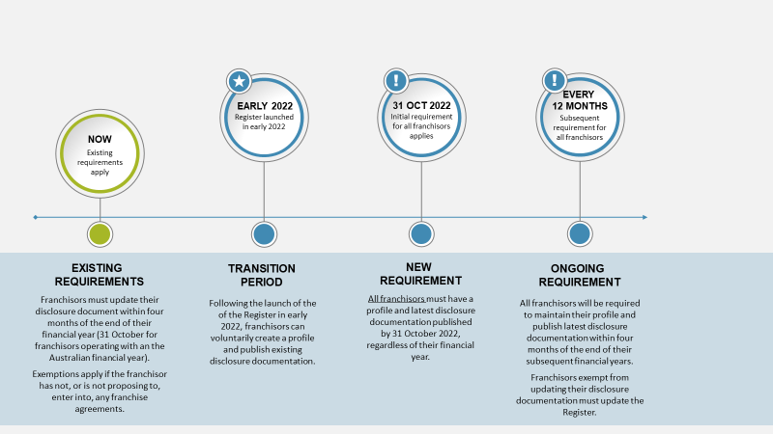

## Franchisors updating annually and operating on the Australian financial year

It is anticipated that the portal will be live from early 2022 to allow franchisors to voluntarily participate during the transitional period.

The new obligations under the Franchising Code will formally commence on 1 July 2022 and all franchisors will be required to meet their obligations by publishing information on the portal by 31 October 2022. This timing aligns with the existing update cycle for franchisors operating on the Australian financial year.

There will then be a requirement to update information published on the Register in line with existing update requirements to Disclosure Documents under the Franchising Code. For franchisors operating on the Australian financial year, this will mean publishing updated information and Disclosure Documents between 1 July and 31 October each year.

## Other possible scenarios

For franchise systems that operate on non-Australian financial year, this may mean that, during the transitional period, some franchisors need to publish Disclosure Documents on the Portal twice within 12 months. For example, a franchisor operating on a January – December financial year would be required to upload their Disclosure Document for the 2021 financial year by 31 October 2022 under proposed clause 53D, and then provide an updated Disclosure Document by 30 April 2023 (four months after the end of the financial year that they operate under) under proposed clause 53E.

Some franchise systems may not update their Disclosure Document because existing clause 8(7) of the Franchising Code applies. In this situation, the franchisor will have a choice about how to comply and can either elect to update their Disclosure Document, or publish the Disclosure Document relating to a previous financial year. In subsequent years, the franchisor can continue to certify that the Disclosure Document is not required to be updated if clause 8(7) continues to apply.

# How will the Register’s online portal operate?

The below illustrations provide an overview of the proposed functionality of the Register’s online portal for franchisors (or their nominated agents) and prospective franchisee (or public) users. Depending on the user, a different pathway is taken through the portal. These illustrations are indicative only and subject change following feedback from this paper, further design work and user testing.

### Franchisors and their nominated agents

A franchisor user will be required to log in using their MyGovID and create a public profile for the franchise. Users will be required to upload and publish the franchisor’s disclosure document as per the proposed amendments to the Franchising Code. Users could also upload and publish other documents that may be of interest to prospective franchisees (e.g. annual reports). This could also be done on behalf of a franchisor by their nominated, authorised agent.

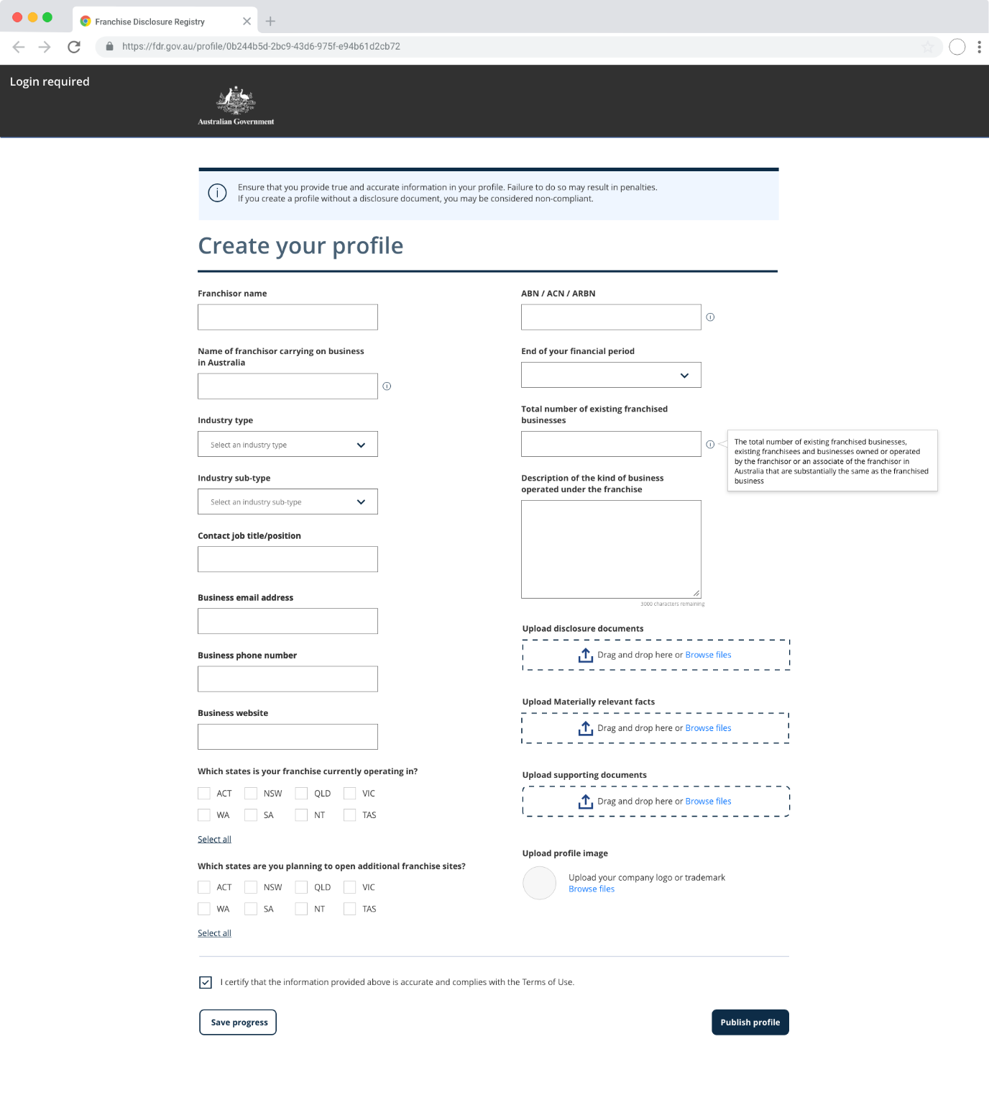

A user can then manage one or many franchise profiles and associated documents for each franchise via a ‘dashboard’.

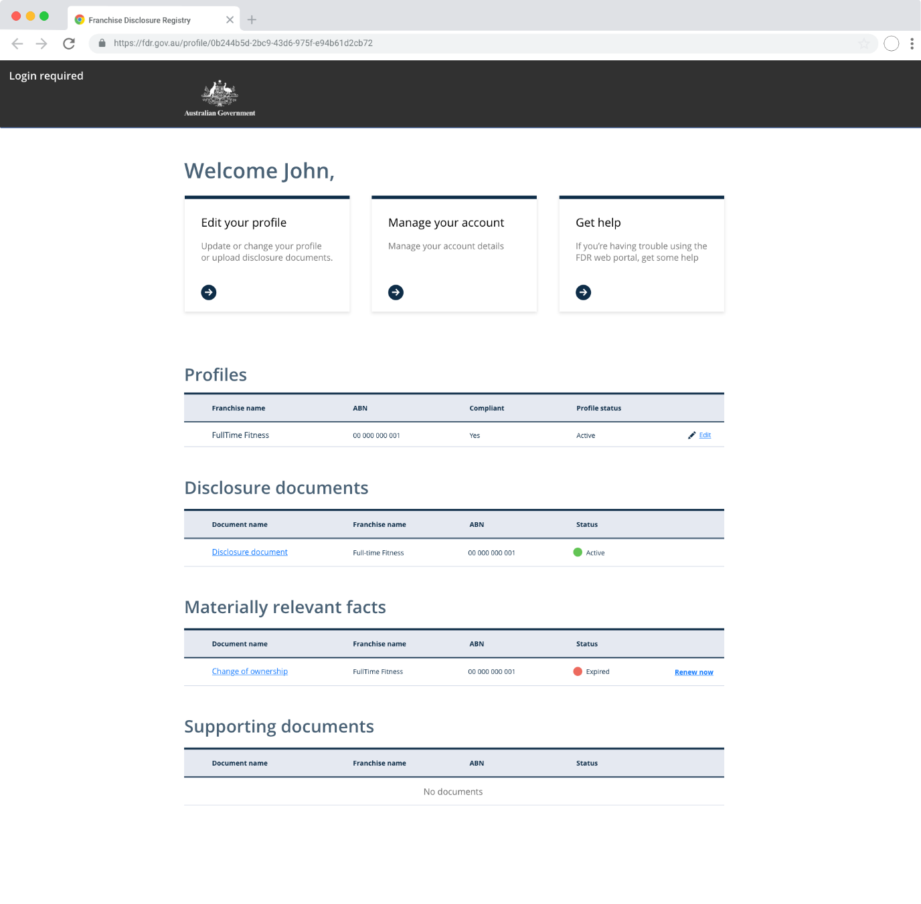

### Prospective franchisees and public users

Prospective franchisees and other public users will not be required to create a profile. Users could search for franchises with existing published profiles on the portal. The search criteria would be based on information in the franchisor profiles.

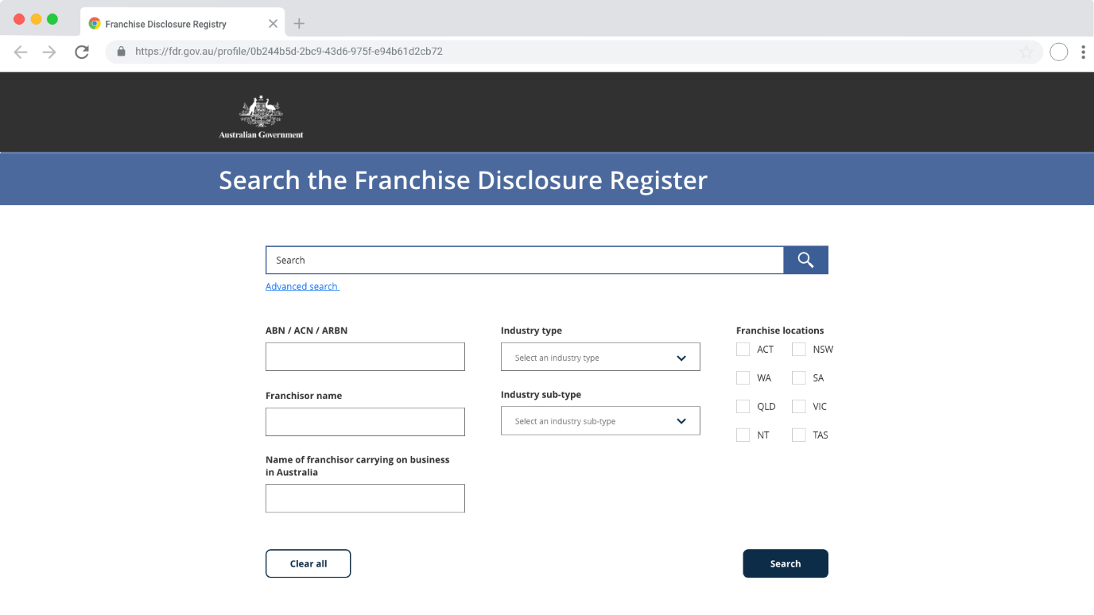

Results of franchises matching the search criteria would then be displayed.

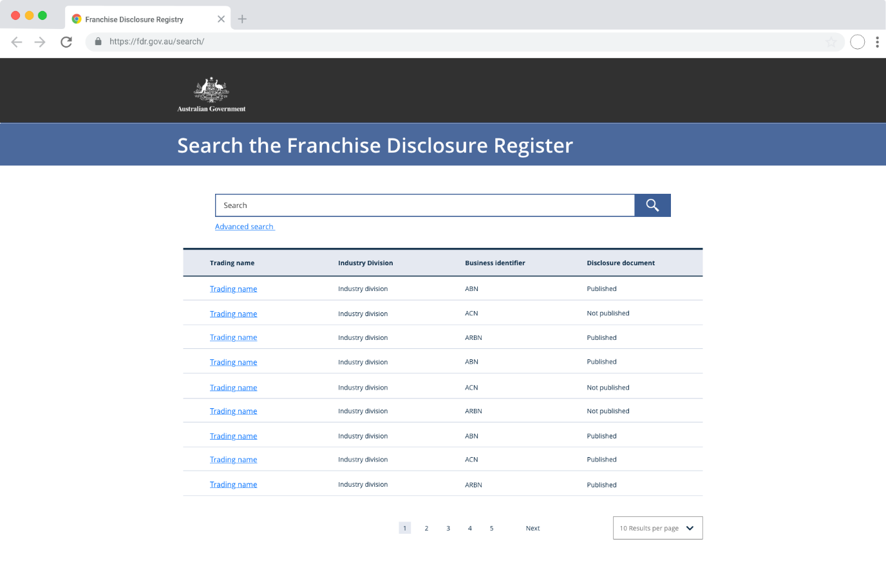

The profile and published documentation of a selected franchisor could then be explored.

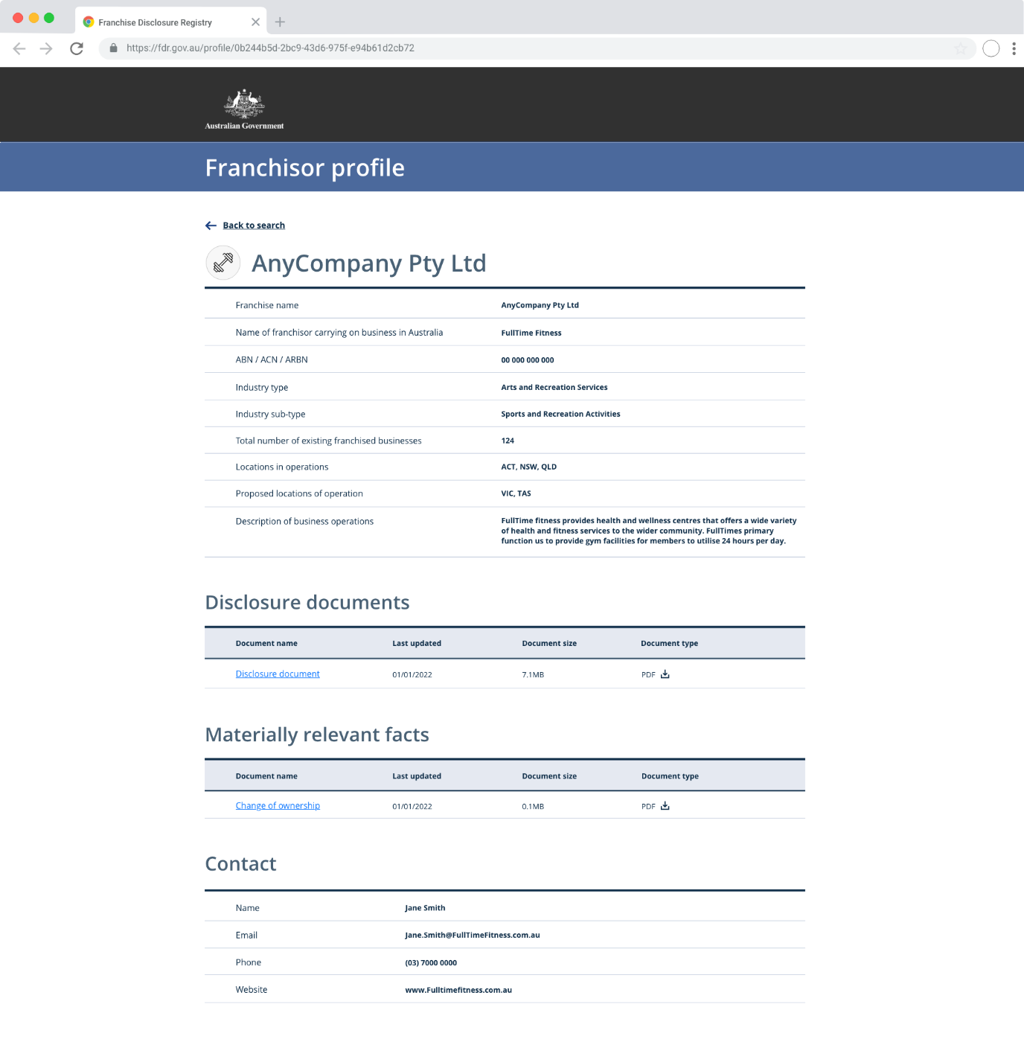

# Questions

**Draft regulations**

1. Are the amendments in the Exposure Draft likely to produce any unintended consequences?
2. Are there any consequential amendments to the Franchising Code which may be required which aren’t reflected in the Exposure Draft?

**Information on the Register**

1. Is the information to be included on the Register appropriate?
2. Are there other types of information, not within the existing scope of disclosure, that are important for prospective franchisees to compare?
3. Is the information to be redacted from franchisors’ Disclosure Documents appropriate?

**Transitional arrangements**

1. Are the transitional arrangements appropriate?

**Online portal**

1. Is the proposed portal functionality fit-for-purpose?
2. Do you have any other suggestions on how to ensure franchisees and users of the portal understand that information on the Franchise Disclosure Register is not endorsed or checked by Government?