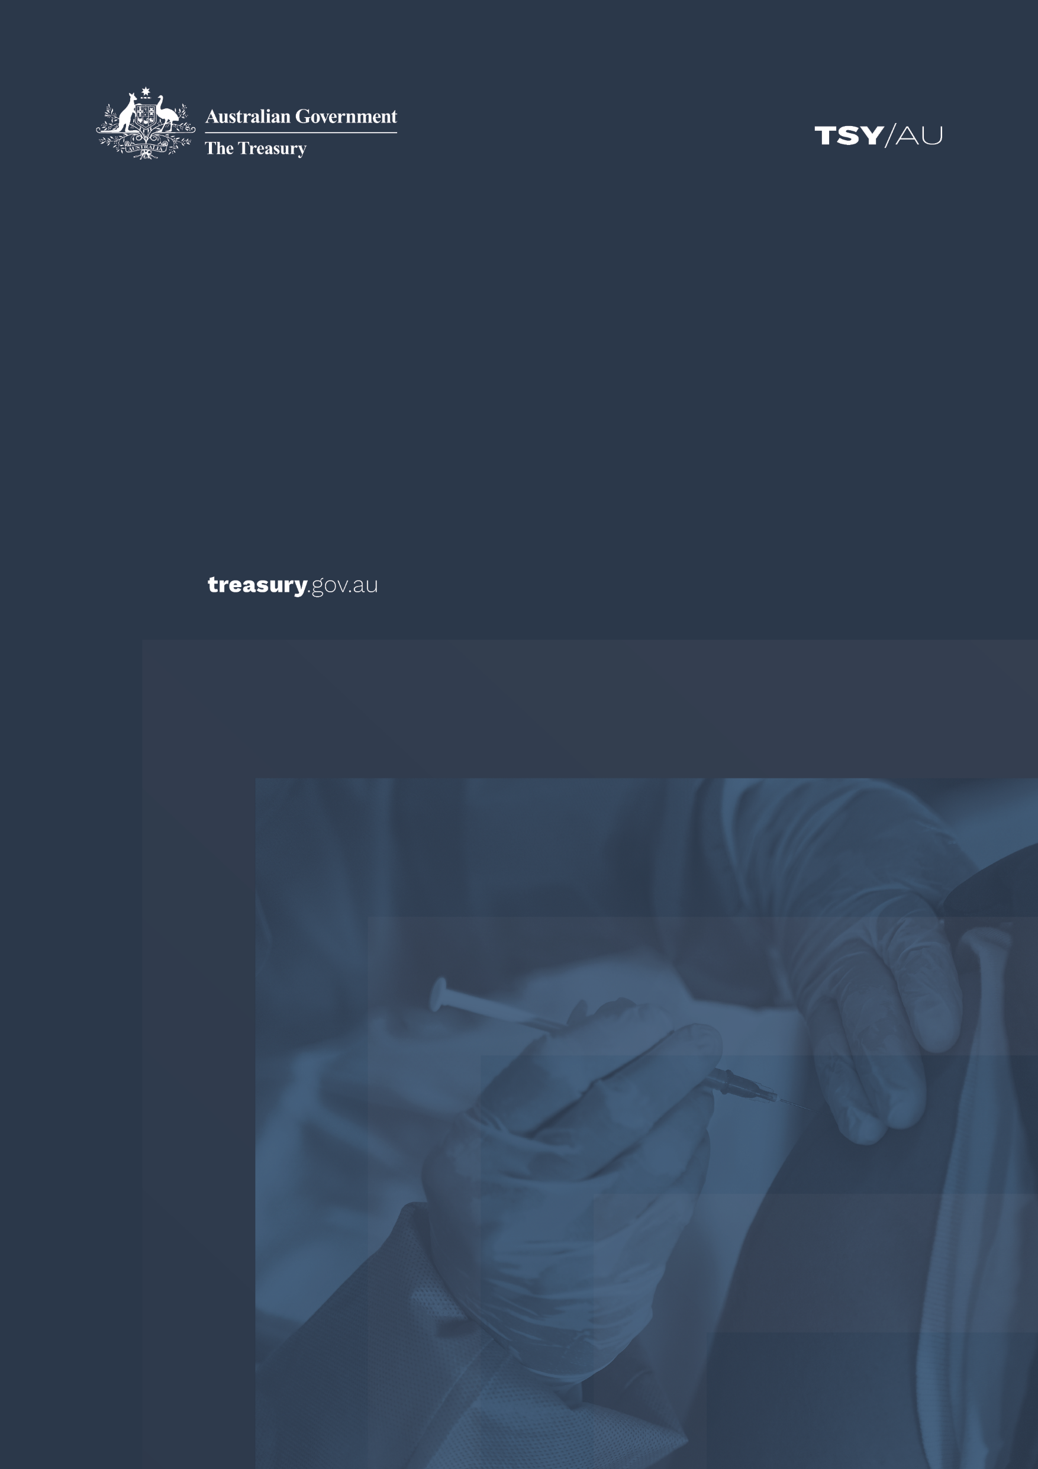

National Plan to Transition to Australia’s National COVID‑19 Response

Economic Impact Analysis

© Commonwealth of Australia 2021

ISBN: 978‑1‑925832‑39‑6

This publication is available for your use under a [Creative Commons Attribution 3.0 Australia](http://creativecommons.org/licenses/by/3.0/au/deed.en) licence, with the exception of the Commonwealth Coat of Arms, the Treasury logo, photographs, images, signatures and where otherwise stated. The full licence terms are available from <http://creativecommons.org/licenses/by/3.0/au/legalcode>.

Creative Commons attribution licence 3.0 icon. 

Use of Treasury material under a [Creative Commons Attribution 3.0 Australia](http://creativecommons.org/licenses/by/3.0/au/deed.en) licence requires you to attribute the work (but not in any way that suggests that the Treasury endorses you or your use of the work).

*Treasury material used ‘as supplied’.*

Provided you have not modified or transformed Treasury material in any way including, for example, by changing the Treasury text; calculating percentage changes; graphing or charting data; or deriving new statistics from published Treasury statistics – then Treasury prefers the following attribution:

*Source: The Australian Government the Treasury*.

**Derivative** **material**

If you have modified or transformed Treasury material, or derived new material from those of the Treasury in any way, then Treasury prefers the following attribution:

*Based on The Australian Government the Treasury data*.

**Use of the Coat of Arms**

The terms under which the Coat of Arms can be used are set out on the Department of the Prime Minister and Cabinet website (see [www.pmc.gov.au/government/commonwealth‑coat‑arm](http://www.pmc.gov.au/government/commonwealth-coat-arm)s).

**Other uses**

Enquiries regarding this licence and any other use of this document are welcome at:

Manager  
Media and Speeches Unit  
The Treasury  
Langton Crescent   
Parkes ACT 2600  
Email: [media@treasury.gov.au](mailto:media@treasury.gov.au)

# Contents

Contents ii

Executive Summary 1

Context 2

Vaccination and PHSM Scenarios 3

Direct Economic Costs of Public Health and Social Measures 3

Economic Costs Under a Strategy to Minimise Cases 5

Economic Costs Under a Managed Transmission Strategy 9

Conclusion 11

# Executive Summary

The Doherty Institute prepared a report for the 30 July 2021 National Cabinet meeting assessing the impact of different levels of community vaccination on the transmission potential of the Delta variant of COVID‑19. It also considered the impact of applying different ‘bundles’ of Public Health and Social Measures (PHSM), including lockdowns.

In this paper, Treasury estimates the direct economic costs of the COVID‑19 management strategies modelled by the Doherty Institute. The Doherty Institute’s estimates of the length of time PHSMs are required under different virus management strategies have been combined with estimates of the direct economic costs of the four levels of PHSM, and an assumed frequency and pattern of outbreaks under the Delta variant.

The key findings of this analysis are as follows:

* Continuing to minimise the number of COVID‑19 cases, by taking early and strong action in response to outbreaks of the Delta variant, is consistently more cost effective than allowing higher levels of community transmission, which ultimately requires longer and more costly lockdowns.
* As vaccination rates rise, significantly less lockdowns and other restrictions will be required to continue to minimise cases of COVID‑19, reducing the economic cost of managing the virus.
  + Moderate or strict lockdowns are still expected to be necessary to continue minimising outbreaks until Australia reaches 70 per cent vaccination rates for Australian adults (16+). As a result, the costs of managing COVID‑19 will remain high.
    - At 50 per cent vaccination rates, and based on the assumptions outlined in this paper, the direct economic cost of minimising cases is estimated to be around $570m per week. At 60 per cent, the estimated cost remains high, but falls to around $430m per week.
  + Once 70 per cent of Australian adults (16+) are vaccinated, and assuming the spread of COVID‑19 is minimised, it is expected that outbreaks can be contained using only low level restrictions, with lockdowns unlikely to be necessary. This will significantly reduce the expected economic cost of COVID‑19 management to around $200m per week.
  + At 80 per cent vaccination rates, these direct economic costs are expected to fall further still, to around $140m per week, and costs are lower under all scenarios.
* Treasury has not modelled the economic costs of a severe and widespread outbreak that breaches Australia’s health system capacity. It is expected that such a situation would carry very significant economic costs. International experience indicates that it would lead to significant behavioural changes regardless of the level of official restrictions, and longer outbreaks.

# Context

The Doherty Institute paper presents a range of scenarios around the likely transmission of the Delta variant through the Australian community at different national vaccination rates under both a suppression strategy (referred to throughout this paper as a case minimisation strategy) and a managed transmission strategy.

Under the case minimisation strategy, the Doherty Institute assume community transmission is limited and case numbers remain low, allowing for optimal performance of Track, Trace, Isolate and Quarantine (TTIQ) capacity. Under the managed transmission strategy, the Doherty Institute assumes ongoing community transmission, resulting in only partially effective TTIQ capacity.

The Doherty Institute identifies a range of additional health interventions, presented as low, medium and high PHSM ‘bundles’, necessary to further restrict the spread of the virus under different scenarios in order to either minimise cases of the virus or keep cases within health sector capacity.

Treasury has estimated the direct economic costs of the different approaches identified by the Doherty Institute. Estimated costs include the direct impacts of activity restrictions and lockdowns used to manage the virus and contain outbreaks. The expected costs of activity restrictions and lockdowns are calculated as the expected average weekly cost of applying the relevant bundle of PHSM’s multiplied by the expected time and coverage of the measures as estimated by the Doherty Institute. This analysis is all based on the ‘All adults (16+)’ vaccination strategy as outlined by the Doherty Institute.

The impact figures reported do not include a range of impacts including indirect confidence effects of improving certainty and reopening; dynamic effects (such as labour market scarring); social costs; the economic costs of illness and death; and fiscal costs.

The analysis does not cover a case where COVID‑19 is allowed to move through the community to the point where national health system capacity is breached. However, a severe and widespread outbreak of this kind, with large numbers of death and hospitalisations such as has been seen in other countries, could be expected to lead to significant behavioural changes that significantly constrain economic activity, regardless of the level of official restrictions.

Analysis of differential policies across US states found that 90 per cent of the reduction in foot traffic was due to behavioural change rather than restrictions. Similarly, comparison of consumer spending trends in Denmark, which imposed heavy restrictions, and Sweden, which did not, indicates that 87 per cent of the reduction in consumer spending was behavioural.[1]

An unmitigated health crisis would also harm the economy more broadly by severely affecting consumer and business confidence. It is expected that the economic and health related costs of such a scenario would exceed the costs of the most severe lockdown scenarios modelled.

# Vaccination and PHSM Scenarios

The Doherty Institute presents results on the combined effects of vaccination and PHSM scenarios on COVID‑19 transmission potential under a strategy to minimise cases and under a strategy of managed transmission. These results show that as vaccination rates rise, less stringent lockdowns and other restrictions are required to manage COVID‑19.

Table 1: The Doherty Institute scenarios that Treasury has analysed

|  |  |  |
| --- | --- | --- |
| Vaccination rate | Minimised cases | Managed transmission |
| 50% | Can only be minimised using **strict lockdowns** | Can only be managed within health system capacity using **strict lockdowns** |
| 60% | Can only be minimised using **strict or moderate lockdowns** | Can only be managed within health system capacity using **strict lockdowns** |
| 70% | Can be minimised using **low level restrictions** | Can only be managed within health system capacity using **strict or moderate lockdowns** |
| 80% | Can be minimised using occasional **low level restrictions** | Can be managed within health system capacity using occasional **low level restrictions** |

Notes: Ongoing baseline restrictions are required at all vaccination rates for both approaches.   
The minimised cases scenario assumes TTIQ is optimally effective, whereas the managed transmission scenario assumed case numbers increase to a level where TTIQ can only be partially effective. The vaccination rate is for population aged 16+.

## Direct Economic Costs of Public Health and Social Measures

The Doherty Institute identified four bundles of PHSM’s that could be used in managing the virus: baseline, low, medium and high. Each bundle relates to a set of health measures applied at a specific time and place in Australia’s pandemic experience.

* **High:** Equivalent to Stage Four lockdowns in place in Victoria in August 2020.
* **Medium:** Equivalent to the Stage Three lockdown in place nationally in May 2020.[2]
* **Low:** Equivalent to restrictions in place in New South Wales in August 2020.
* **Baseline:** Similar to the eased restrictions in place in New South Wales in March 2021.

A description of the specific measures included in each bundle is outlined in Table 2 below.

Table 2: Public Health and Social Measures (PHSM) bundles

|  | Strict lockdowns  *(High PHSM)* | Moderate lockdowns  *(Medium PHSM)* | Low level restrictions  *(Low PHSM)* | Baseline restrictions  *(Baseline PHSM)* |
| --- | --- | --- | --- | --- |
| Stay at home orders | 1. Stay‑at‑home except essential purposes | 1. Stay‑at‑home except for work, study and essential purposes | 1. No stay‑at‑home orders | 1. No stay‑at‑home orders |
| Density restrictions | 1. 4 sqm rule | 1. 2 sqm rule | 1. 2 sqm rule | 1. 2 sqm rule |
| Retail trade | 1. Non‑essential retailers and venues closed to public 2. Take away and home delivery only | 1. Increased retail activity, subject to density restrictions 2. Seated dining for small groups at cafes/restaurants | 1. Social distancing rules apply 2. Larger groups allowed | 1. Social distancing rules apply |
| Work | 1. Only workplaces categorised as permitted work allowed to operate on‑site and subject to restrictions | 1. Work from home if possible, capacity limits and restrictions on office space apply | 1. Return to work, but social distancing and capacity restrictions on office space apply | 1. 1.5 sqm rule |
| Schools and childcare | 1. Closed – remote learning only | 1. Closed or graduated return | 1. Open | 1. Open |
| Capacity restrictions | 1. No gatherings – Non‑essential venues etc closed | 1. Indoor venues closed 2. Capacity limits restricted to small groups outdoors | 1. Recreational activities allowed and venues open but social distancing and capacity limits apply | 1. Large sporting venues to operate at 70% capacity |
| Travel restrictions | 1. Essential movements only within 5 or 10 km radius 2. No intra‑ or inter‑state travel | 1. Non‑essential travel limited – no intra or inter‑state travel | 1. No travel restrictions 2. Interstate travel allowed | 1. No travel restrictions 2. Interstate travel allowed |
| Other | 1. Curfew 2. No household visitors and 2‑person limit on exercise | 1. 5 visitors to household and limited outdoor gatherings e.g., 10 people | 1. Requirements for record‑keeping, COVID‑safe plans |  |

Applying each bundle of measures generates a direct economic cost, by disrupting or limiting regular economic activity. These costs rise as the severity of the measures increase.

Treasury has estimated the direct economic cost by analysing the impact on hours worked across the economy during comparable lockdown periods in 2020, relative to pre‑COVID levels in February 2020 – that is, a reference period of no restrictions. The associated fall in economic activity is estimated by industry, as measured by Gross Value Added (GVA).

These industry‑based estimates are then combined to estimate the effect of different bundles of measures on economic activity at the state and national level.

Table 3: Direct National Economic Costs for PHSM Bundles, $ billion per week

|  |  |  |  |  |
| --- | --- | --- | --- | --- |
|  | Strict  ($b per week) | Moderate  ($b per week) | Low  ($b per week) | Baseline  ($b per  week) |
| Cost of restrictions applied nation‑wide | 3.2 | 2.35 | 0.65 | 0.1 |

Note: Treasury analysis of cost of restrictions on a national basis.

These direct measures of economic costs do not explicitly attempt to capture flow‑on indirect economic effects, such as on consumer or business confidence or supply chain disruptions of specific measures. The analysis also does not capture distributional impacts that may vary depending on the region in lockdown or the economic costs associated with health and social outcomes, such as the direct cost of hospitalisations and deaths.

The estimated costs per week also do not make allowance for possible compounding or ‘scarring’ impacts if restrictions such as lockdowns are repeated or sustained over longer durations. However, to date, evidence of this form of scarring has been limited, with economic activity generally rebounding quickly once restrictions are removed.[3] Many businesses have also made changes to adapt their operations to better manage the impacts of restrictions. Likewise, consumers have also made changes to their behaviour and spending patterns to manage the impact of restrictions such as shifting to online shopping.

Significant fiscal support has been provided by State and Commonwealth Governments to businesses and individuals during this pandemic to help to offset the cost of public health measures such as lockdowns and reduce the risk of compounding or scarring effects. For the purposes of this analysis, it is assumed that fiscal support continues to be provided as restrictions are applied.

The direct costs to Government of providing this support are not included in the economic impact estimates presented in Table 3 and are difficult to estimate. There are a range of factors to consider, including: the industry composition and labour market conditions present in the region under lockdown; the duration and severity of restrictions; the application of restrictions across sectors; and eligibility requirements for payments (such as length of time restrictions must be in place). However, were fiscal costs included, it would increase the estimated costs associated with strict and moderate lockdowns, further reinforcing the key conclusions of this analysis.

## Economic Costs Under a Strategy to Minimise Cases

Australia currently manages COVID‑19 by seeking to suppress the virus and minimise case numbers. Intermittent local outbreaks are responded to with strict lockdowns that eliminate community transmission, and case numbers are consistently kept low enough for TTIQ protocols to be optimally effective.

The Doherty Institute provides guidance on how long restrictions need to be applied to bring these outbreaks under control, using each bundle of PHSMs and for each level of vaccination. However, to assess the direct costs of maintaining this minimisation strategy, it is also necessary to make an assumption about the frequency of outbreaks in the community.

In consultation with the Australian Government Department of Health and the Doherty Institute and drawing on recent experience with the Delta variant, Treasury assumes that there will be, on average, five separate outbreaks in the community every quarter, each affecting one large metropolitan area, or around 20 per cent of the national economy.

It is further assumed that below vaccination rates of 60 per cent, these five outbreaks will each require strict lockdowns (High PHSM) to be applied for, on average, two weeks to bring community transmission back to zero (a cumulative total of 10 weeks per quarter). In practice, some outbreaks may only require short, sharp lockdowns, while in other cases, a longer lockdown may be necessary[4].

The costs of restrictions will also vary depending on the metropolitan areas affected. For modelling purposes, we construct a representative metropolitan region, equal to around 20 per cent of the national economy. The relevant restrictions are applied to this representative region to estimate the cost of an outbreak under the minimisation scenario.

Importantly, this does not represent a forecast of what will occur over coming months across the Australian community. There are extremely high levels of uncertainty around this assumption and the actual number and form of outbreaks could differ substantially.

## Economic Costs Assuming Ongoing Baseline Restrictions

Using the outbreak assumptions outlined above and the Doherty Institute’s estimates of how the total amount of time required in lockdown to minimise cases in an outbreak is expected to decrease as vaccination rates increase, Treasury (in consultation with the Department of Health and the Doherty Institute) has estimated the number of days restrictions are expected to be required per quarter to minimise cases, if baseline restrictions are constantly applied.

At 50 per cent vaccination rates, minimisation of cases can only be achieved by applying strict lockdowns. At vaccination rates of 60 per cent or above, different approaches can be applied. For example, at 60 per cent vaccination rates, cases can be minimised by either applying moderate lockdowns for 78 days per quarter or by applying strict lockdowns for 48 days per quarter. At 70 per cent vaccination rates, cases can be minimised by either applying strict or moderate lockdowns, or without lockdowns but with low level restrictions, for 82 days per quarter.

Table 4: Days per quarter for alternative restriction options under a strategy to minimise cases, with ongoing baseline restrictions

|  |  |  |  |
| --- | --- | --- | --- |
| Vaccination rate | Periodic low level restrictions only*  Days per quarter | Periodic moderate lockdowns only  Days per quarter | Periodic strict lockdowns only  Days per quarter |
| *50%* | N/A | N/A | 70 |
| *60%* | N/A | 78 | 48 |
| *70%* | 82 | 47 | 29 |
| *80% +* | 18 | 11 | 7 |

*Under low level restrictions, there are only restrictions on activity (i.e.no lockdowns).

N/A indicates that it is not possible to manage COVID‑19 within Australia’s health system capacity using a given level of restrictions at a certain vaccination rate, given assumptions regarding the frequency of outbreaks that is likely.

Table 5 shows the estimated direct costs of minimising cases via each level of restrictions. These costs are estimated by applying the weekly costs of these restrictions to the estimated number of days they will be required and the representative metropolitan region.

At vaccination rates of 50 per cent and 60 per cent, the lowest cost strategy is to utilise strict lockdowns in addition to ongoing baseline restrictions. At vaccination rates of 50 per cent, this strategy is estimated to have an economic impact of around $570m per week, decreasing to $430m at vaccination rates of 60 per cent.

At vaccination rates of 70 per cent, the lowest cost strategy is to use low level restrictions to minimise cases, without more costly lockdowns. This results in the estimated costs of managing the virus falling significantly to around $200 million per week.

If this strategy is continued at vaccination rates of above 80 per cent, it is estimated to have an even lower economic impact of $140m per week.

Table 5. Direct economic costs of required restrictions and lockdowns under a strategy to minimise cases, with ongoing baseline restrictions

|  |  |  |  |
| --- | --- | --- | --- |
| Vaccination rate | Periodic low level restrictions only  ($m per week) | Periodic moderate lockdowns only  ($m per week) | Periodic strict lockdowns only  ($m per week) |
| *50%* | N/A | N/A | 570 |
| *60%* | N/A | 490 | 430 |
| *70%* | 200 | 350 | 310 |
| *80% +* | 140 | 180 | 170 |

Notes:(1)N/A indicates that it is not possible to manage COVID‑19 within Australia’s health system capacity using a given level of restrictions at a certain vaccination rate, given assumptions regarding the frequency of outbreaks that are likely under this strategy. (2) Total costs include the estimated direct economic costs of lockdowns, baseline activity restrictions and international border restrictions. (3) Costs assume five outbreaks per quarter, lasting a total of 10 weeks at vaccination rates <60%, and contained to a metropolitan area (that is, around 20 per cent of Australia). (4) Highlighted cells represent most cost‑effective bundle, while maintaining health restrictions.

## Economic Costs Assuming Ongoing Low Level Restrictions

The Doherty Institute also presents a range of scenarios that involve applying low level restrictions (low PHSM) at all times, rather than just baseline restrictions. By applying a higher level of ongoing restrictions across the whole country, the need for strict and moderate lockdowns is reduced at each vaccination rate, but there are higher ongoing economic costs.

Table 6 presents the number of days per quarter that different restrictions are expected to be required under this approach. At 50 per cent vaccination rates, minimisation of cases can only be achieved by applying strict lockdowns. At vaccination rates of 60 per cent or above, different approaches can be applied. For example, at 60 per cent vaccination rates, cases can be minimised by either applying moderate lockdowns for 31 days per quarter or by applying strict lockdowns for 13 days per quarter.

Table 6: Days per quarter for alternative restriction options under a strategy to minimise cases, with ongoing low level restrictions

|  |  |  |  |
| --- | --- | --- | --- |
| Vaccination rate | Ongoing low level restrictions only  Days per quarter | Periodic moderate lockdowns only  Days per quarter | Periodic strict lockdowns only  Days per quarter |
| *50%* | N/A | N/A | 70 |
| *60%* | N/A | 31 | 13 |
| *70%* | No lockdowns required, ongoing low level restrictions only  91* | | |
| *80% +* |

* Under light restrictions, there are only restrictions on activity (i.e. no lockdowns).

Notes: (1) N/A indicates that it is not possible to manage COVID‑19 within Australia’s health system capacity using a given level of restrictions at a certain vaccination rate, given assumptions regarding the frequency of outbreaks. (2) Assumes five outbreaks per quarter, lasting a total of 10 weeks at vaccination rates <60%, and contained to a metropolitan area (that is, around 20 per cent of Australia).

Continuous application of low level restrictions is expected to reduce reliance on lockdowns. However, it is estimated that this approach carries a higher overall direct economic cost than approaches that involve only ongoing baseline restrictions. This is because ongoing low level restrictions (primarily density and capacity constraints on workplaces and large events) still impose significant constraints, particularly on hospitality, arts and recreation and workplace environments.

At vaccination rates of 50 per cent and 60 per cent, periodic lockdowns are still required to minimise cases, in addition to ongoing low level restrictions. At 50 per cent, the estimated direct economic cost of minimising cases is around $1 billion per week, almost double the cost of managing the virus through a combination of baseline and strict measures.

At 60 per cent, the expected economic cost falls to around $730 million per week, but remains substantially higher than the cost under baseline and strict measures of around $430 million.

Once vaccination rates reach 70 per cent, Doherty Institute modelling indicates cases can be minimised by applying low level restrictions at all times, at a cost of around $660 million per week.

Table 7. Direct economic costs of required restrictions and lockdowns, under a strategy to minimise cases, with ongoing low level restrictions

|  |  |  |  |
| --- | --- | --- | --- |
| Vaccination rate | Ongoing low level restrictions only  ($m per week) | Periodic moderate lockdowns only  ($m per week) | Periodic strict lockdowns only  ($m per week) |
| *50%* | N/A | N/A | 1,060 |
| *60%* | N/A | 780 | 730 |
| *70%* | No lockdowns required, ongoing low level restrictions only  660* | | |
| *80% +* |

*Cost of ongoing low level restrictions nation‑wide, with no additional restrictions or lockdowns in place

Notes*:* (1)N/A indicates that it is not possible to manage COVID‑19 within Australia’s health system capacity using a given level of restrictions at a certain vaccination rate, given assumptions regarding the frequency of outbreaks that are likely under this strategy. (2) Total costs include the estimated direct economic costs of lockdowns, baseline activity restrictions and international border restrictions. (3) Costs assume five outbreaks per quarter, lasting a total of 10 weeks at vaccination rates <60%, and contained to a metropolitan area (that is, around 20 per cent of Australia). (4) Highlighted cells represent most cost‑effective bundle, while maintaining health restrictions.

## Economic Costs Under a Managed Transmission Strategy

As noted, the Doherty Institute has also modelled a scenario where ongoing case numbers are higher, and restrictions are used to manage widespread community transmission within the capacity of the health system. TTIQ protocols are only expected to be partially effective in this scenario, as widespread community transmission will rapidly exhaust manual tracing efforts.

Estimating the costs of restrictions is simpler under this scenario than under a strategy to minimise cases, because COVID‑19 is assumed to be circulating in the community at all times. Therefore, it is not necessary to make assumptions about the number of outbreaks per quarter. Instead the focus is on the percentage of time different restrictions are required, on average across the country, in order to keep transmission at a rate that keeps cases below health system capacity limits.

The Doherty Institute has estimated the percentage of time restrictions would need to be in place to hold transmission potential around one, on average, in this context.[5] For example, when 80 per cent of adults are vaccinated, the Doherty Institute estimates that it will be possible to manage outbreaks with low level restrictions in place 89 per cent of the time. Alternatively, strict lockdowns could be imposed 31 per cent of the time.

As vaccination rates increase the total number of days required in lockdown to keep transmission potential around one decreases. However, unlike under a strategy to minimise cases, the Doherty Institute indicates that while vaccination rates remain below 80 per cent, it is not possible to manage higher levels of virus transmission in the community without some use of moderate or strict lockdowns. For example, at 80 per cent vaccination rates, cases can be managed by either applying moderate lockdowns for 47 days per quarter or by applying strict lockdowns for 29 days per quarter or no lockdowns but with low levels restrictions for 81 days per quarter.

Table 8: Days per quarter for alternative restriction options under a strategy of managing transmission, with ongoing baseline restrictions

|  |  |  |  |
| --- | --- | --- | --- |
| Vaccination rate | Periodic low level restrictions only*  Days per quarter | Periodic moderate lockdowns only  Days per quarter | Periodic strict lockdowns only  Days per quarter |
| *50%* | N/A | N/A | 77 |
| *60%* | N/A | N/A | 60 |
| *70%* | N/A | 74 | 45 |
| *80% +* | 81 | 47 | 29 |

* Under low level restrictions, there are only restrictions on activity (i.e. no lockdowns).

Notes: (1) N/A indicates that it is not possible to manage COVID‑19 within Australia’s health system capacity using a given level of restrictions at a certain vaccination rate.

Applying the estimated weekly costs of each level of restrictions to these estimates of the duration of time restrictions need to be in place to manage transmission, this strategy is estimated to have direct costs of $2.7 billion per week while vaccination remains at 50 percent and baseline restrictions are in place. This is almost five times the cost of managing COVID‑19 under a strategy to minimise cases at the same vaccination rates. By acting later and allowing the virus to spread more widely through the community, longer, broader and more severe lockdowns are ultimately required to remain within health system capacity limits, carrying a larger economic cost.

At vaccination rates of 60 per cent, the strategy of managing community transmission continues to require more extensive high‑level lockdowns, with estimated economic costs of around $2.1 billion per week. At vaccination rates of 70 per cent, these costs are around $1.6 billion per week.

At vaccination rates of 80 per cent, it is expected that outbreaks could be managed using only low level restrictions under a managed transmission strategy, however they would need to be applied across the whole country at a cost of around $590 million per week.

Consistent with the outcomes under a strategy to minimise cases, the most cost‑effective approach to managing community transmission is to maintain ongoing baseline restrictions and respond to outbreaks rapidly with strict lockdowns until low level restrictions alone are sufficient to manage the virus (in this case above 80 per cent).

Table 9. Direct economic costs of required restrictions and lockdowns to stay within health system capacity, under a strategy of managing transmission, with ongoing baseline restrictions

|  |  |  |  |
| --- | --- | --- | --- |
| Vaccination rate | Periodic low level restrictions only  ($m per week) | Periodic moderate lockdowns only  ($m per week) | Periodic strict lockdowns only  ($m per week) |
| *50%* | N/A | N/A | 2,690 |
| *60%* | N/A | N/A | 2,120 |
| *70%* | N/A | 1,930 | 1,640 |
| *80% +* | 590 | 1,260 | 1,070 |

Notes: (1) N/A indicates that it is not possible to manage COVID‑19 within Australia’s health system capacity using a given level of restrictions at a certain vaccination rate. (2) Total costs include the estimated direct economic costs of lockdowns and activity restrictions.

# Conclusion

Figure 1 (below) shows the comparative direct economic costs of managing COVID‑19 under the different scenarios outlined above at different vaccination levels.

Figure 1 demonstrates the following key conclusions:

* It is significantly more cost effective to manage COVID‑19 Delta variant by maintaining a strategy to minimise cases and optimal TTIQ, rather than allowing higher levels of community transmission to take hold.
* Applying strict localised lockdowns, for shorter durations, is more cost effective than applying more moderate lockdowns for longer periods.
* The direct economic costs of managing the virus decline sharply as the vaccine is rolled out, regardless of the strategy adopted.
* Under a strategy to minimise cases, once vaccination rates reach 70 per cent, lockdowns are unlikely to be required, significantly reducing the economic cost of managing COVID‑19.

Figure 1: Cost of managing COVID‑19 within health system capacity per week, $ millions  
Least costly combination of PHSM measures within each strategy

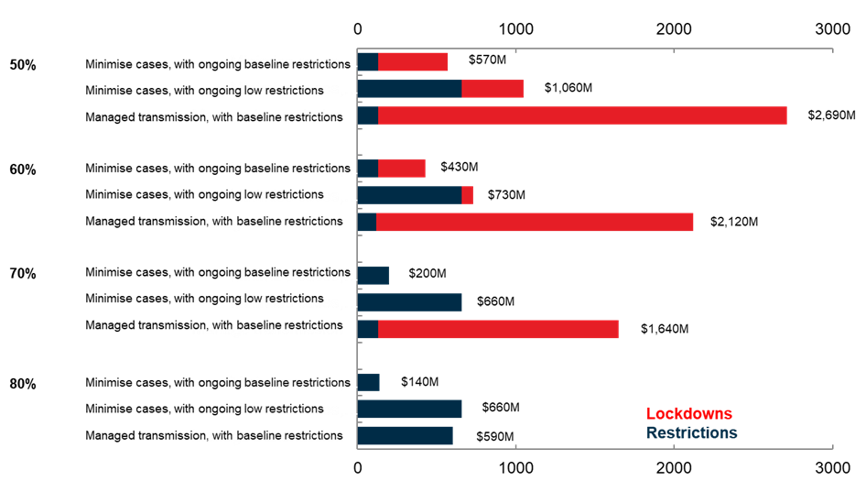

1. Goolsbee and Syverson (2020), “Fear, Lockdown, and Diversion: Comparing Drivers of Pandemic Economic Decline 2020”; Sheridan, Lau Andersen, Toft Hansen, and Johannesen (2020), “Social distancing laws cause only small losses of economic activity during the COVID‑19 pandemic in Scandinavia”.
2. Doherty Institute use NSW in early July 2021 as their reference period for Medium PHSM. The restrictions across these two time periods are broadly comparable.
3. Andrews, Hambur and Bahar (2021), “The COVID‑19 Shock and Productivity‑Enhancing Reallocation in Australia: Real‑time evidence from Single Touch Payroll”
4. These assumptions are defined over a quarterly period. Based on the current vaccine rollout schedule, progress through these phases would be significantly more rapid. For example, on the current schedule, vaccination rates would move from 60 per cent to 70 per cent in 2 weeks.
5. See Table S4.2 in the Doherty Institute report.