AUSTRALIAN SMALL BUSINESS AND FAMILY ENTERPRISE OMBUDSMAN

(ASBFEO)

INDEPENDENT REVIEW

JUNE 2021

Carmel McGregor PSM, Independent Reviewer

CONTENTS

Glossary 5
i. Acknowledgements 6
ii. Foreword 7
Executive Summary 8
Chapter 1: Findings and Themes 10
Role and Strategy 10
Influence and Relationships 11
Data, Analysis, and Information Sharing 11
Administrative and Internal Capability 11
Chapter 2: Recommendations 13
Chapter 3: Review Overview 16
Consultation Methodology 17
Chapter 4: Overview of the Australian Small Business and Family Enterprise Ombudsman 19
Overview of ASBFEO 19
Assistance Function 19
Advocacy Function 21
Social and Mainstream Media Presence 23
Forums and Committees 23
Performance and Accountability 24
Timeline – Key Events 25
Timeline – Key Publications 27
Figure 2: Timeline showing key Reviews and Inquiries Conducted by ASBFEO 27
Chapter 5: Providing Assistance to Small Businesses and Family Enterprises 29
The Assistance Provided to Small Businesses 30
ASBFEO’s Assistance Function 30
The types of assistance requested of ASBFEO and assistance provided 31
Was the assistance provided convenient and effective? 33
The Question of Further Powers 36
Recommendations 38
Chapter 6: Response to the 2017 Independent Review 39
The 2017 Review Recommendations 40
Recommendations 46
Chapter 7: Advocacy and Assistance: The Relationship Between ASBFEO’s Functions 48
The interaction between ASBFEO’s functions 49
The Name of ASBFEO 49
The Relationship Between ASBFEO’s Advocacy and Assistance Functions 51
The Effectiveness of ASBFEO’s Functions 52
ASBFEOs Approach to Advocacy: Effectiveness and Impact on Stakeholders 54
ASBFEO’s Assistance to Small Businesses: Effectiveness and Impact 55
Opportunities to Improve Advocacy Effectiveness 56
Recommendations 60
Chapter 8: Administrative and Legislative Arrangements 61
Current Administrative and Legislative Arrangements 61
ASBFEO’s operating and funding model 61
Comparison with Similar Agencies 62
Recommendations for Administrative or Legislative Changes to Support Delivery of ASBFEO’s Functions 62
Chapter 9: Challenges and Next Steps 64
Appendices 65
Appendix “A”- Terms of Reference 65
Appendix “B” – Stakeholder Consultation List 66
Appendix “C” - Small Business Survey Results 67
Appendix “D”- Inquiries and Submissions 68
Inquiries 68
Reviews 68
Research 68
Appendix “E”- Quarterly and Annual Report Analysis 69
Disclaimer 69
Appendix “F” – Productivity Commission Consultations 70
Appendix “G” – Details of ASBFEO’s Assistance Function 71
Appendix “H” – Correlation Coefficient Explained 74
Appendix “I” – Recommendation Desktop Review 75
Inquiries 75
Reviews 77
Attachments 79
Attachment I: Australian Small Business and Family Enterprise Ombudsman Review Discussion Paper 79
Review of the Australian Small Business and Family Enterprise Ombudsman: discussion paper 79
March 2021 79
Background 79
Assistance function 79
Advocacy function 80
Terms of reference 81

Glossary
Term | Definition
ABA | Australian Banking Association
ABS | Australian Bureau of Statistics
ACCC | Australian Competition and Consumer Commission
The Act, ASBFEO Act | Australian Small Business and Family Enterprise Ombudsman Act 2015 (Cth)
ADR | Alternative Dispute Resolution
AFCA | Australian Financial Complaints Authority
ANZSIC | Australian and New Zealand Standard Industrial Classification
ANZOA | Australian and New Zealand Ombudsman Association
ASBFEO, The Ombudsman | Australian Small Business and Family Enterprise Ombudsman
ASIC | Australian Securities and Investments Commission
ASL | Average Staffing Level
ATO | Australian Taxation Office
AAT | Administrative Appeals Tribunal
B2B | Business-to-Business
B2G | Business-to-Government
COSBOA | Council of Small Business Australia
DISER | Department of Industry, Science, Energy, and Resources (“Industry”)
FRAG | Federal Regulatory Agencies’ Group
FWO | Fair Work Ombudsman
PAYG | Pay as You Go
The Review | The 2021 Review of the Australian Small Business and Family Enterprise Ombudsman (this Report)
The Review Period | July 2017 – May 2021
R&D | Research and Development
SME | Small and Medium-Sized Enterprise
SBC | Small Business Commissioner

Acknowledgements

I wish to acknowledge and thank all who participated in this Review. For the giving of their time - generously and positively. This includes:
- ASBFEO, including the former Ombudsman, current Ombudsman and staff;
- The industry and government organisations with varying levels of interactions and professional relationships with ASBFEO; and
- The Australian small businesses and family enterprise community who provided their honest feedback and highly valued submissions.
All those who engaged with the Review shared a great passion and deep-seated awareness of the success of small businesses and family enterprises across Australia, ensuring they are provided with the support most needed during the most critical of times. Thank you to all of you.
Finally, a note of appreciation to Amanda North, Ivan Lusica, and Brendon Brown of Deloitte, for their steadfast support and sound analysis in the conduct of this Review and production of the final report.
- Carmel McGregor PSM, Lead Reviewer

Foreword

The Australian Small Business and Family Enterprise Ombudsman (ASBFEO) commenced operations in March 2016, operating under the Australian Small Business and Family Enterprise Act 2015 (Cth) (the Act).
Since its inception, ASBFEO has been positioned within several Federal portfolios and has reported to various small business ministers within government. Recent machinery of government changes has seen it return to The Department of the Treasury (Treasury) and respondent to the Hon. Stuart Robert MP, Minister for Employment, Workforce, Skills, Small and Family Business.
Section 95 of the Act requires that the operation of ASBFEO is reviewed every four years; with the exception of the first review which was conducted in March 2017 (the 2017 Review), after one year of operation.
ASBFEO has made an impressive start during its inaugural phase of operation and has largely acquitted the recommendations of the 2017 review. After creating its presence during this time, ASBFEO has played an important role through the challenges posed by natural disasters in 2020 and the global COVID-19 pandemic, both of which impacted small businesses and family enterprises significantly.
This review contends that the next phase for ASBFEO is one of consolidation and maturation of efforts and approach. However, there is an opportunity to adjust and enhance how it operates with a multitude of parties and to focus on the issues which will have the greatest impact.
Through the consultation phase which involved meetings, submissions and surveys, a number of themes have emerged which are discussed further in the report and informed the recommendations. These themes go to:
- Role and strategy
- Influence and relationships
- Data, analysis and information sharing
- Administrative and internal capability
There was strong support from all who participated in this review that ASBFEO provided an important role and much goodwill for it to succeed. The analysis and recommendations from this review, therefore, provide a platform for ASBFEO to seize the challenges of the future.

Executive Summary

Review background
The 2021 Review of the Australian Small Business and Family Enterprise Ombudsman (ASBFEO) was undertaken in response to a statutory requirement that its assistance function be reviewed every four years. The Terms of Reference for the Review covers the nature, convenience, and effectiveness of ASBFEO’s assistance function, ASBFEO’s response to the 2017 Review, the relationship between ASBFEO’s functions, and administrative and legislative arrangements. The Review was conducted between March and June 2021.

Consultation themes
Consultations highlighted several themes bearing on ASBFEO’s functions and relationships. ASBFEO has established impactful advocacy and assistance roles in relation to the Australian small business sector and family enterprises. In order to capitalise on this role in the future, ASBFEO has the opportunity to work with stakeholders in defining a set of strategic priorities for advocacy and assistance activities that will deliver outcomes most needed to the Australian small business sector.
Stakeholders emphatically commended ASBFEO on its ability to recognise issues affecting the small business sector and to prosecute those issues by raising awareness and advocating for policy positions. Many organisations noted, however, that the application of independence in providing a voice for small businesses should be finely tuned in order to cement a seat at the table of influence with policy makers and regulators. There is an opportunity for ASBFEO to consolidate its advocacy role by engaging in a more timely manner with key stakeholders and subject matter experts.
Building a compelling policy agenda for the small business sector requires a strong empirical foundation. Stakeholders have invited ASBFEO to better leverage evidentiary resources both from within the industry and from jurisdictional agencies with small business-related responsibilities. There are opportunities to better utilise data from jurisdictional small business functions – potentially through data-sharing protocols - to facilitate the identification of systemic issues and better track outcomes across the small business assistance ecosystem.
Questions regarding ASBFEO’s name and the characteristics of impartiality and independence were consistently, and often passionately, presented by Review participants. The Review considers the title of Ombudsman has created a misalignment of expectations regarding ASBFEO’s functions, including perceptions that ASBFEO is failing to acquit impartiality responsibilities. The Review notes that impartiality is not essential for the performance of ASBFEO’s assistance function, and that ASBFEO has manifestly acted with independence. Clarification of ASBFEO’s role is essential for reducing confusion and promoting collaboration towards outcomes for the small business sector.

Recommendations
The Review proposes five recommendations to build upon ASBFEO’s dynamic first five years and position it for continued influence and impact, as follows:
- Treasury and ASBFEO should review evidence of gaps in the assistance and dispute resolution ecosystem for Australian small businesses, then implement targeted approaches to resolve these gaps and improve assistance outcomes.

- ASBFEO should leverage its experience and relationships to prosecute a strategic agenda designed to focus resources for deep impact on high-priority small business sector issues.

- ASBFEO should build its capacity and capability for sustained advocacy impact by strengthening its collaboration with stakeholders and sharpening its ability to characterise the small business sector.

- ASBFEO should be renamed to promote role clarity.

- Treasury and ASBFEO should act to ensure administrative, funding and staffing arrangements remain supportive of ASBFEO’s mandate.

Detail for each recommendation is developed in Chapter 2: Recommendations and in the body of the report.

Challenges and next steps
Input to the Review provided strong support for ASBFEO’s continued role supporting the Australian small business sector and there is considerable goodwill for further collaboration. This report articulates the importance of focus on the following areas as platforms by which to plan and judge success for the future:
- Role and strategy
- Influence and relationships
- Data, analysis and insights
- Administrative and internal capability.

Chapter 1: Findings and Themes
The Review engaged stakeholders with varied interests in ASBFEO’s role and performance, including small businesses, industry associations and peak bodies, policy agencies, regulators, Ombudsmen, jurisdictional small business commissioners and agencies with small business-related functions. These engagements led to rich and diverse input, indicative of ASBFEO’s clear impact in the initial phase of its operations.
This chapter outlines the key themes that emerged during the consultation process. These themes are apparent throughout the report and the Review Team’s consideration of each has informed the direction and design of the report’s recommendations.

Role and Strategy
ASBFEO has carved out a highly meaningful role as an advocate and point of assistance for small businesses in Australia. Stakeholders have pointed to ASBFEO’s vital role in identifying issues that systemically affect the small business sector, and their capacity to speak unequivocally for small businesses.
ASBFEO has been highly active in its advocacy role, which has become almost synonymous with the office of the Ombudsman. Ms Kate Carnell AO “had a media following to rival that of many politicians” and successfully raised the profile of small business issues in the community and across government.
ASBFEO’s assistance work has benefited small businesses. The Ombudsman and its staff have attracted praise for their positive cross-jurisdictional engagement and commitment to helping small businesses resolve issues.
ASBFEO’s role exists within an ecosystem of regulatory, policy and small business-focused agencies as well as industry associations and peak bodies active in the small business sector. While ASBFEO’s active and positive stance is regarded highly, their endeavours have also highlighted potential systemic gaps that require further investigation. Most notably:
- Small businesses face a “costs order gorilla” when dealing with larger parties in disputes. ASBFEO does not have the powers to compel parties into mediation and in some cases, this means small businesses have no further avenues for resolving disputes due to the resource impacts entailed in legal actions.
- ASBFEO’s increased profile has resulted both in greater demand for assistance and in the identification of further ways the office could support small businesses and family enterprises.

Given increasing profile and demand, setting clear priorities for action is essential to achieving depth of impact over the coming years. It was not entirely clear to the Review how ASBFEO establishes the priorities it currently pursues and how they are weighed up against others. There is an opportunity for ASBFEO to articulate a clear agenda for its work and to help coordinate a strategic approach with other small business-related agencies. These considerations are explored within the report.

Influence and Relationships
As described above, ASBFEO operates in a stakeholder-rich environment. Over the Review Period, the Ombudsman has established a notable presence within this environment and sought strongly to advocate for small businesses on a range of policy issues through the office’s independent role. Key areas of contribution include access to finance, access to justice and support through the COVID-19 pandemic.
Stakeholders provided their perspectives on ASBFEO’s activities and presence. Small businesses and small business commissioners have greatly appreciated ASBFEO’s advocacy work. Peak bodies and industry associations particularly commended this work but noted a need for communication and consultation maturity to support good policy development. Policy agencies and regulators indicated earlier and more structured engagement and collaboration with subject matter experts could yield stronger policy outcomes and foster relationships.
The report explores themes around ASBFEO’s relationships and possible pathways for achieving increased advocacy efficacy.

Data, Analysis, and Information Sharing
Stakeholders have increasingly noted the value of ASBFEO’s insights into the small business sector, regarding both the advocacy and assistance functions. Data, analysis, and information sharing were some of the most commonly cited areas of opportunity in relation to ASBFEOs operations.
Stakeholders have noted the opportunity for ASBFEO to improve the empirical bases for its policy positions. At the same time policy stakeholders, both in the private and public sector, have expressed an increasing appetite for ASBFEO to boost policy value in characterising the small business sector through collation and use of data and improved methods for approaching and analysing the sector. Some stakeholders have indicated ASBFEO could play a data clearing house role across agencies and jurisdictions, better utilising empirical evidence from states and territories (for example from extensive small business surveys) to capture and communicate policy issues.
Data sharing could also support ASBFEO’s assistance role within the context of the Australian small business assistance ecosystem. Currently, warm assistance handovers occur between jurisdictions, but outcomes are not tracked. Data sharing protocols between jurisdictions and agencies may provide valuable insight into assistance outcomes and gaps for the sector.

Administrative and Internal Capability
The Ombudsman is an independent, statutory appointment, and the Ombudsman’s office is staffed through its parent agency. Stakeholders have affirmed the need for independence and highly value the exercise of this role in articulating challenges facing small business.
Several stakeholders raised the question of whether the title “Ombudsman” is appropriate given ASBFEO does not act impartially; rather the office is clear in its support for small business stakeholders. The report considers this question in detail. At a high level, impartiality is not required for the exercise of the assistance function in its current form, while the Ombudsman’s independence is critical to its success as an advocate. Should, however, ASBFEO attain stronger dispute resolution powers in the future, impartiality would be essential to the proper exercise of those powers and alternative administrative arrangements would be required.
Stakeholders have highlighted the desirability of increased policy development maturity for ASBFEO, and a concomitant need for increased visibility of small business issues for both regulators and policy makers. As such, several stakeholders indicated the desirability of a secondments program crossing both junior and more senior roles.

Chapter 2: Recommendations
ASBFEO has established itself as a champion for small business interests. The Review’s recommendations are designed to capitalise on the momentum and position ASBFEO for sustained advocacy cut-through and assistance impact.

Recommendation 1: Integrate Assistance for small businesses within an ecosystem
Treasury and ASBFEO should review evidence of gaps in the assistance and dispute resolution ecosystem for Australian small businesses, then implement targeted approaches to resolve these gaps and improve assistance outcomes.
- Treasury should consider the nature and impact of unresolved disputes on the small business sector, the factors driving lack of resolution and the relevant areas of legislation. Treasury should then ascertain whether there is a need for further dispute resolution avenues for small businesses and, if so, what role ASBFEO should play.

- ASBFEO should consider gaps in the Australian small business assistance ecosystem and work with jurisdictions, Ombudsmen, and other assistance functions to remediate them by:
  - Providing clear and consistent assistance pathways for small businesses across jurisdictions, including well-defined assistance entry points, handover processes and outcomes tracking (in keeping with privacy laws and other legislation).
  - Sharing data and insights to monitor outcomes across the small business assistance ecosystem and provide evidence of systemic issues affecting Australian small businesses.

- ASBFEO should develop and maintain a forecast for the demand of its assistance function in line with strategic intent, noting the impact of profile-raising activities on demand for assistance services.

Recommendation 2: Use Experience and Relationships to Drive a Strategic Agenda
ASBFEO should leverage its experience and relationships to prosecute a strategic agenda designed to focus resources for deep impact on high-priority small business sector issues. This includes:
- Articulating an annual charter or agreed strategic agenda to focus application of ASBFEO’s resources towards achieving impact in particular areas. This charter should include:
  - A policy input agenda
  - A data and research sharing program to support formalising approaches to characterising thematic and emerging issues for the small business sector.
  - Initiatives to promote effective assistance handovers within the Australian small business assistance ecosystem.
The charter should articulate key priorities but also provide bandwidth for responding to emerging issues.

- Coordinating a strategic agenda of policy issues and assistance initiatives across State / Territory agencies with small business functions (including small business commissioners) to formalise and build on current collaborations.

- Strengthen relationships with Tasmania, ACT and Northern Territory to finalise actions from the 2017 Review.

Recommendation 3: Build Advocacy impact
ASBFEO should build its capacity and capability for sustained advocacy impact by strengthening its collaboration with stakeholders and sharpening its ability to characterise the small business sector.
- ASBFEO should evolve the application of its independence function with policy and regulatory stakeholders, but equally, these bodies have an opportunity to welcome the insights and connections ASBFEO provides into the small business sector. To achieve policy cut through, ASBFEO should:
  - Build on its more recent endeavours to engage early and often with policy, regulatory, industry stakeholders and SMEs when conducting enquiries
  - With assistance from the Treasury, replicate engagement models that have proven effective, such as co-chairing the Small Business Stewardship Group with the ATO and convening the Federal Regulatory Agencies Group (FRAG).

- ASBFEO should provide insights as to the organising concepts for the small business sector by:
  - Providing clarity on the composition of the small business sector and characterising its nature with improved qualitative and quantitative models
  - Build on existing relationships with small business sector stakeholders to create pathways for enquiry into small business policy or regulatory questions and for elevating emerging concerns
  - Articulation of persistent and emerging issues impacting the small business sector, such as access to finance, the cost of these issues to the sector and economy more broadly, and the impacts of government policy interventions
  - Considering the strategic value of offering a data clearing house facility providing access to small business sector insights from a range of sources to support small business policy development

Recommendation 4: A Name that Aligns to function
ASBFEO should be renamed to promote role clarity.
- ASBFEO should be renamed to the Australian Small Business Commissioner or the Australian Small Business Advocate to:
  - Reduce confusion over the nature of ASBFEO’s assistance role, and
  - Support the value of ASBFEO’s advocacy work.

Recommendation 5: Align Administrative arrangements to Purpose
Treasury and ASBFEO should act to ensure administrative, funding, and staffing arrangements remain supportive of ASBFEO’s mandate.
- Treasury should retain the independence of the Ombudsman through the statutory appointment arrangement.

- ASBFEO should ensure its budget is used to manage demands in line with a strategic agenda.

- Treasury should implement a funding model for ASBFEO that is responsive to increasing demand and provides funding to support the delivery of any Ministerial inquiry requests.

- ASBFEO should design and implement a secondments program with key policy and regulatory agencies to bolster:
  - Issues awareness across these agencies, and
  - Policy development maturity within ASBFEO.

Chapter 3: Review Overview
This section provides an explanation of the conduct of the review, including the purpose of and background for the Review; the Terms of Reference; the review objective and questions the review examined; and the methodology used to address the review objectives and questions.
ASBFEO was established in 2016 to serve as a bridge between government and small businesses and family enterprises, making it easier for them to acquire help and support. Under Section 13 of the Australian Small Business and Family Enterprise Act 2015 (Cth) (‘ASBFEO Act’), ASBFEO must:
- Advocate for small business and family enterprises in relation to relevant legislation, policies, and practices (the advocacy function);
- Give assistance in relation to relevant actions if requested to do so (the assistance function); and
- Perform any other function conferred on the Ombudsman by any Act or legislative instrument.

Under Section 95 of the Act the Minister for Small Business is required to initiate independent reviews of ASBFEO’s assistance function at specific intervals.

In 2017, the first independent review of ASBFEO was conducted by Ms Su McCluskey (the 2017 review, the McCluskey review). This review determined how effectively and efficiently ASBFEO has undertaken its functions since its establishment in March 2016 and how these functions can be improved. ASBFEO is required to be independently reviewed no later than every four years
thereafter.

This report is the primary output of the second independent review of ASBFEO’s functions under the Act (the Review), led by Ms Carmel McGregor PSM and supported by a secretariat from Deloitte Touche Tohmatsu (Deloitte). The Review was initiated in March 2021 and completed in June 2021 under the Terms of Reference (ToR) that follow.

This review will examine:
- the kinds of assistance requested during the Review Period and whether the assistance provided was convenient and effective for the operators of small businesses and family enterprises;
- how ASBFEO has responded to the recommendations of the 2017 review;
- the interaction and effectiveness of ASBFEO’s functions, including any new roles acquired since the previous review;
- whether there are any legislative and administrative improvements that could better support ASBFEO in the delivery of its functions; and
The full ToR document for the Review is enclosed as Appendix “A”, and the Review Discussion Paper is located at Attachment A, below. As with the 2017 review, the ToR extend beyond the legislated requirement for review of the assistance function, including both review of ASBFEO’s advocacy function and consideration of its more recently acquired functions.

Consultation Methodology
Similarly, to the first review, stakeholder consultations were held with Commonwealth and State/Territory agencies whose functions impact small businesses and family enterprises, as well as with State Small Business Commissioners, peak bodies, industry associations and small businesses. To maintain privacy, stakeholder contributions are referenced in general terms throughout the report. Appendix “B” includes a full list of these stakeholders. The review also considered data and documentation provided by ASBFEO and the Department of Industry, Science, Energy and Resources (DISER).

The Review developed a structured framework for conducting consultation in response to the Terms of Reference. Over a period of six (6) weeks, stakeholders were invited to contribute to the Review via four (4) channels as shown in the table below:
Consultation Channel | Stakeholders | Method of Contact | Number of Respondents
In-person or online interview | - Commonwealth agencies (including regulators) with functions that impact small businesses and family enterprises  - State government agencies with responsibility for small business  - State small business commissioners  - Commonwealth and State Ombudsmen  - National and state-based industry associations  - Peak bodies | Email and phone contact utilising:  - A contact list provided by DISER  - Additional stakeholders identified during the course of the Review | 30
Written response to the Review Discussion Paper on the Consultation Hub | All stakeholders | Link to DISER Consultation Hub published:  - In a press release from The Hon Stuart Robert MP, Minister for Employment, Workforce, Skills, Small and Family Business  - On ASBFEO home page, social media channels and newsletter  - On DISER social media channels | 20
Response to the Small Business Survey | Small businesses | - | 48
Written submissions received via emails | - Commonwealth agencies (including regulators) with functions that impact small businesses and family enterprises  - State government agencies with responsibility for small business  - State small business commissioners  - Commonwealth and State Ombudsmen  - National and state-based industry associations & peak bodies | Emails received in response to the Discussion Paper or consultation invitations | 15

Consultation questions were tailored by stakeholder type and designed overall to capture a well-rounded body of evidence to assist the Review to answer each of the Terms of Reference. Participants through all consultation channels were also offered the opportunity to present their views on ASBFEO more generally.

Chapter 4: Overview of the Australian Small Business and Family Enterprise Ombudsman

This chapter describes the Australian Small Business and Family Enterprise Ombudsman in terms of their legislative mandate, their functions, and their key stakeholders, providing a contextual foundation for the remainder of the report.

Overview of ASBFEO
ASBFEO was established in 2016, with Ms Kate Carnell AO being the inaugural Ombudsman, to provide assistance to and advocacy for small businesses and family enterprises of less than 100 employees and/or annual turnover under $5 million. ASBFEO’s current Ombudsman, The Hon. Bruce Billson, commenced his tenure in March 2021.

As of June 2021, ASBFEO resides within the Treasury portfolio, having previously been part of the Industry, Science, Energy and Resources (February 2020 to June 2021), the Employment, Skills, Small and Family Business portfolio (August 2018 to January 2020), and the Treasury portfolio (March 2016 to August 2018). Key administration changes over the Review period are summarised in the timeline on Pages 25 and 27, below.

ASBFEO undertakes two key functions - assistance and advocacy - with the aim of supporting and providing a voice for the small business and family enterprise sector.
Assistance Function
Under Pt. 2, Div. 1, Sec 13 of the Australian Small Business and Family Enterprise Ombudsman Act 2015 (Cth) (‘the ASBFEO Act’), the assistance function is defined as “to give assistance in relation to relevant actions if requested to do so. ” This function enables the Ombudsman to receive and respond to requests for assistance in relation to small business and family enterprise matters that fall within the Commonwealth’s constitutional powers.
ASBFEO’s assistance function is accessible by all small and family businesses involved in a dispute with another business, or Commonwealth agency. ASBFEO can be contacted through an online complaint submission form, general enquiry form, or via telephone - offering initial assistance at no cost to the lodging organisation or individual.
If the issue falls within the scope of the Ombudsman’s operations, the Ombudsman makes initial inquiries into the complaint. If the complaint is not resolved, the Ombudsman has the power to recommend Alternative Dispute Resolution (ADR) by an independent mediator chosen by the parties. The Ombudsman does not formally adjudicate disputes. However, the Ombudsman has powers to release statements with names of parties that do not participate in the ADR process. ADR costs are shared between parties and are typically a more cost-effective way to resolve disputes (compared to formal methods of dispute resolution such as legal proceedings).
The Ombudsman works closely with a range of Commonwealth, State, and Territory agencies on a diverse range of requests for assistance. This includes providing warm handovers – directing the complaint to the correct jurisdiction - where ASBFEO is not best placed (whether jurisdictionally or procedurally) to assist.
ASBFEO’s assistance function received a total of 24,496 inquires during the Review Period.

Recently added Assistance functions
Since the 2017 Review, new functions have been added to ASBFEO’s set of responsibilities:
- December 2018 - ASBFEO began administering mediation adviser and dispute resolution adviser services under the franchising, horticulture, and oil codes of conduct. The dairy code was also added to this list in January 2020.
- March 2019 - ASBFEO commenced a Small Business Tax Concierge Service to support and assist small businesses in their disputes with the Australian Taxation Office (ATO). This assists small businesses to decide whether to lodge an application to the Administrative Appeals Tribunal (AAT) along with subsidised legal advice. ASBFEO reports that since commencement in March 2019, it has received 763 contacts relating to this service.
- March 2019 – the Act was amended to give the Ombudsman the power to give direct assistance to small business in obtaining a ‘no adverse costs’ order in proceedings to recover the amount of any loss or damage as a result of contraventions of the Competition and Consumer Act 2010. This power came into effect on 1 July 2019.
- November 2019 – commenced providing assistance to small business engaging with the ATO’s Compensation for Detriment and Defective Administration Scheme.

In addition to the above, ASBFEO also provides ongoing support through the following services:
- ASBFEO Small Business Hub;
- My Business Health portal
- MindHive collaboration platform;
- Website articles, blog posts, newsletter emails; and
- Social media engagement.

Assistance Function Stakeholders
Stakeholders of ASBFEO’s assistance function are described in the table below.
Stakeholder Group | Interest
Small Businesses | - Receiving assistance, especially concerning disputes
Minister for Small Business | - Assistance outcomes provided to small businesses  - Identification of systemic issues facing small businesses
Jurisdictional Small Business Commissioners and State and Territory agencies with small business-related functions | - Clear assistance entry points and pathways for small businesses, especially those facing cross-jurisdictional disputes  - Seamless handover protocols for referred disputes  - Information sharing to identify systemic issues
Other Ombudsman or Dispute Resolution Services | - Seamless handover protocols for referred disputes  - Information sharing to identify systemic issues
Policy Agencies | - Intelligence & information regarding systemic issues
Regulators
Advocacy Groups and related functions (including ASBFEO’s advocacy function)

Further details regarding ASBFEO’s Assistance Function are found in Appendix “G”. The Review considers the effectiveness and convenience of ASBFEO’s assistance function in Chapter 5: Providing Assistance to Small Businesses and Family Enterprises.

Advocacy Function
Under the Act, the advocacy function of the Ombudsman is to “advocate for small businesses and family enterprises in relation to relevant legislation, policies, and practices”.
The Ombudsman’s advocacy function involves research and inquiries into legislation, policies and practices affecting small businesses and family enterprises. Inquiries can be referred by the Minister or initiated by the Ombudsman. The Ombudsman has information-gathering powers in relation to all inquiries. The Ombudsman also contributes to inquiries by other agencies and the development of national strategies on matters affecting small businesses and family enterprises.
ASBFEO’s advocacy function is intended to:
- Promote good business practice
- Conduct inquiries and research into the small business industry
- Work with other arms of government to contribute to further inquiries and research, and
- To amplify the voices of small businesses for consideration in policy design and decision making.
This is achieved through constant community consultation with small businesses to understand the issues that they are facing.
The Act bestows powers upon ASBFEO to conduct “research and inquiries on Ombudsman’s own initiative”. Over the Review Period, ASBFEO has self-initiated multiple inquiries into contemporary issues facing small businesses, with the existence of these issues informed by a range of channels, such as through its assistance function, from State SBCs, and general research into present-day matters of interest in the media, purely by the Ombudsman’s own volition. Some key enquiries referred to by stakeholders during the consultation process are noted below:
- Insurance Inquiry
- Access to Justice Inquiry
- Insolvency Practice Inquiry
- Affordable Capital for Small and Medium Enterprise (SME) Growth Inquiry
- Payment Times and Practices Inquiry
- The Review of the R&D Tax Incentive
- The Review of Payment Times and Practices

Two inquiries were conducted at the request of the Minister:
- Impact of the Road Safety Remuneration Tribunal Payments Order
- Small Business Loans Inquiry

See Appendix “D” for a complete list of the enquiries, reviews and research reports completed by ASBFEO as of the date of this Review.
A total of 172 recommendations have been made by ASBFEO, 50 of which have been reported to the Review as “implemented” and 21 as “mostly implemented” (See subheading “Uptake of Recommendations” in Chapter 7 for the Review’s further analysis on this topic).

Advocacy Function Stakeholders
Stakeholders of ASBFEO’s advocacy function are described in the table below.
Stakeholder group | Interest
Small businesses | - Effective advocacy to inform policy that supports small business
Minister for Small Business | - Identification of systemic issues facing small businesses within the broader policy context
Jurisdictional Small Business Commissioners and State and Territory agencies with small business-related functions | - Clear and aligned advocacy that elevates small businesses challenges within the broader policy context  - “A voice in Canberra” for small business issues
Policy agencies | - Clear articulation of the challenges faced by small business to inform policy positions
Regulators | - Intelligence regarding systemic issues affecting the small business sector
Peak bodies and industry associations

Social and Mainstream Media Presence
ASBFEO has implemented a strong mainstream media and social media strategy to assist in the achievement of their advocacy goals and assistance function awareness.
ASBFEO maintains a website (www.asbfeo.gov.au) that is regularly updated with advice for small businesses, including quarterly reports that the Ombudsman makes to the Minister. As of the end of Q1 2021, this website had been visited 673,789 times in total.
ASBFEO has published over 440 media releases on their website and its social media presence, at the end of Q1 2021, was at:
- 2,002 Twitter Followers
- 5,459 Facebook Followers
- 2,959 LinkedIn Followers
- 253 Instagram Followers
- 416 YouTube Subscribers
- 3,069 Newsletter Subscribers

Forums and Committees
The Ombudsman participates in or chairs seven (7) cross-agency forums and committees whose terms of reference have a policy, regulatory, advocacy or assistance bearing on Australian small businesses. These bodies are:
- Small Business Stewardship Group, co-chaired with the ATO
- Business Register Strategic Advisory Board (BRSAC)
- Collaborative Partnership on Mature Age Employment
- Small Business Advisory Group (SBAG)
- COSBOA Member and Stakeholder Roundtable
- Supply Chain Roundtable
- Small Business Reference Group.

Performance and Accountability
This section outlines the primary performance and accountability mechanisms built into the Act.

Statutory Reviews
Reviews of ASBFEO’s assistance function are required under the Act, as follows:
- After the first year of operation (the 2017 Review); and
- Every four years thereafter.

Quarterly Reports
Under Section 40 of the Act, the Ombudsman must report quarterly to the Minister. These reports are to contain any current research conducted and inquiries made during the quarter and any changes to the relevant legislation and policies, that the Ombudsman reasonably believes would benefit small or family businesses.
ASBFEO has consistently produced quarterly reports that meet these requirements. All the reports additionally contain data for the period pertaining to social media presence, current or potential research to inquiries or reviews, and assistance function data collection. An overview of these activities is provided within this report.
[This space intentionally left blank]

Timeline – Key Events
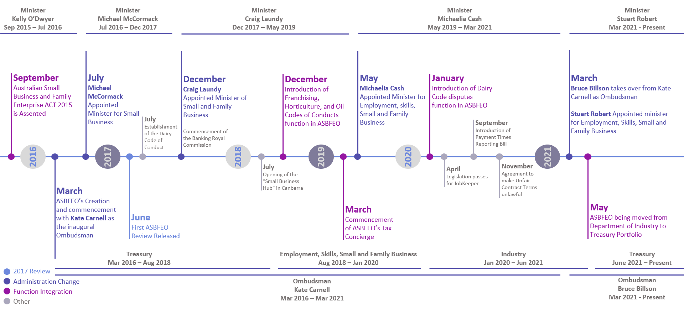
Figure 1: Timeline Showing Ministerial, Portfolio and Ombudsman Changes; Function Integrations and the 2017 Review

The above timeline of ASBFEO since its inception in 2016 highlights the key dates of Small Business Minister changes, Ombudsman changes, function integrations, and the release of the first ASBFEO review in 2017.
ASBFEO has fallen within the remit of five (5) different Small Business Ministers (and their respective portfolios) since its inception and has recently undergone its first Ombudsman change. In March 2021, the Hon Bruce Billson took over the role from Ms Kate Carnell AO, who had been the inaugural Ombudsman since ASBFEO’s inception.
The above timeline also shows the introduction of some key ASBFEO dispute functions including the Franchising, Horticulture, and Oil Codes of Conducts as well as, the Dairy Code. Assistance in relation to these functions accounted for 7% of the Ombudsman’s Assistance function according to their Q4 2020 Summary.
Grey milestones on the timeline chart above depict other events within Australia that pertain to and/or affected ASBFEO in some way, either through the broader economy or through related industries.
[This space intentionally left blank]

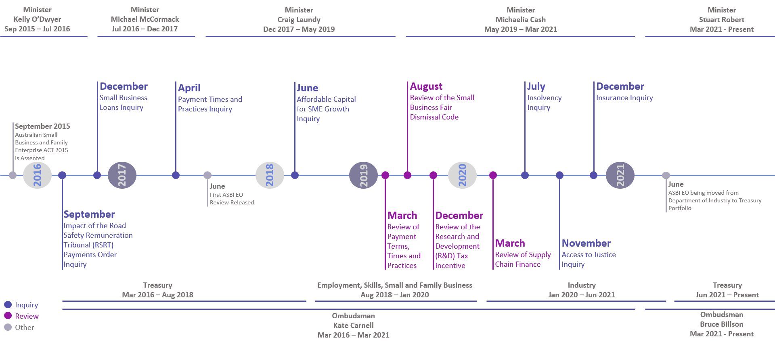
Timeline – Key Publications

Figure 2: Timeline showing key Reviews and Inquiries Conducted by ASBFEO

The timeline above provides an overview of the reviews and inquiries conducted by ASBFEO. These publications are key outputs of ASBFEO’s advocacy function, which enable them to identify and raise awareness on important issues affecting small businesses and family enterprises.
These publications identify the impacts and causes of systemic issues. They suggest solutions and remediation tasks that can be undertaken by the industry or government bodies to potentially resolve these issues, mitigating impacts across the small business sector.
[This space intentionally left blank]

Chapter 5: Providing Assistance to Small Businesses and Family Enterprises

Context
The small business sector contributes significantly to the Australian economy, operating in a highly competitive climate facing numerous challenges due to geography, population, supply and logistics, and negotiation with more strongly resourced parties. ASBFEO’s assistance function, established under the Act, responds to requests for assistance from a small business or family enterprise without duplicating the functions of other Commonwealth, State and Territory agencies. The legislation provides that ASBFEO may work cooperatively with other government agencies if it is more convenient and effective to do so and allows ASBFEO to assist small business owners access alternative dispute resolution processes.

Review topics
This chapter considers how ASBFEO has discharged their assistance function over the Review Period, including an analysis of the kinds of assistance requested during the Review Period and whether the assistance provided was convenient and effective (ToR 1). The Review has considered factors affecting the uptake of ASBFEO’s assistance function.

Findings summary
- ASBFEO received 24,496 requests for assistance in the Review Period
- The most common types of assistance requested of ASBFEO are:
  - Disagreements regarding payment times from large businesses to smaller businesses
  - Unfair contract terms set between entities
  - Issues pertaining to Industry code of conduct surrounding Franchisees, Dairy, Horticulture, and Oil.
- Over 85% of small businesses providing input to the Review indicated they were either somewhat satisfied or very satisfied with ASBFEO’s assistance
- Peak bodies, industry associations, Small Business Commissioners, Ombudsmen, and assistance functions expressed positive regard for ASBFEO’s responsiveness in providing assistance to small businesses
- Several smaller state and territory agencies with small business functions were not aware of ASBFEO or its role. These agencies expressed willingness to collaborate with ASBFEO in the future
- There are some gaps in the Australian small business assistance ecosystem, including a need for a more cohesive transfer of assistance cases between agencies, clearer assistance pathways across jurisdictions and responsibilities, and tracking of case outcomes across the system. Strides made during the COVID-19 pandemic response may now serve as a foundation for improved harmonisation across the system
- ASBFEO’s effectiveness in providing assistance is constrained primarily by the challenge of achieving visibility to small business stakeholders (a perennial problem for government agencies)
- Stakeholders have indicated there may be a gap in the system in relation to the determination of disputes involving small businesses.

Recommendations overview
- Treasury should consider the nature and impact of unresolved disputes on the small business sector, the factors driving lack of resolution and the relevant areas of legislation. Treasury should then consider whether there is a need for further dispute resolution avenues for small businesses. ASBFEO should consider gaps in the Australian small business assistance ecosystem and work with jurisdictions and other Ombudsman functions to remediate gaps and provide clear pathways for small businesses.

- ASBFEO should develop and maintain a forecast for the demand of its assistance function to support agreed policy objectives and align its profile-raising activities to support the achievement of policy intent.

The Assistance Provided to Small Businesses

ASBFEO’s Assistance Function
This section provides a brief overview of ASBFEO’s assistance function, its role, processes, and relationships with other government agencies that provide assistance to Australian small businesses.
Chapter 4: Overview of the Australian Small Business and Family Enterprise Ombudsman provides an introduction to ASBFEO’s assistance function. To recap: under Section 13 of the Act, the assistance function of the Ombudsman is “to give assistance in relation to relevant actions if requested to do so”. This is detailed further under Section 15 of the Act - “Respond under Division 2 of Part 4 to requests for assistance in relation to relevant actions, including by referring requests to another agency of the Commonwealth, a State or a Territory to give assistance”.
Common disputes that ASBFEO assist with include:
- Disagreements regarding payment times from large businesses to smaller businesses
- Unfair contract terms set between entities
- Issues pertaining to Industry code of conduct surrounding Franchisees, Dairy, Horticulture, and Oil.
The Ombudsman is also able to provide assistance in relation to court cases that may involve cost orders, by advising on the preparation of a case for a no adverse costs order under ss82(4) of the Competition and Consumer Act 2010 (Cth), should one be made in subsequent legal proceedings.
ASBFEO’s ADR function is a “No Adverse Costs Order” jurisdiction, where the individual lodging the complaint will not be liable for any financial loss or damage as a result of the ADR proceedings.

The types of assistance requested of ASBFEO and assistance provided

Types of assistance provided by ASBFEO
There are five broad categories of assistance that ASBFEO provides and accepts requests for assistance on. These include Disputes (Business to Business and Business to Government), General Small Business Assistance, Enquiries about ASBFEO, Industry Codes (e.g. Dairy, Horticulture, and Oil Codes of Conduct), and ATO/AAT/Tax Concierge Service inquiries. The breakdown of assistance enquiries (based on the quarterly reports between Q3 2019 - Q4 2020) is shown in the table and chart below:

Enquiries Type | Number of Disputes  (Q3 2019 – Q4 2020)
Industry Codes of Conduct | 969
Tax Concierge | 386
General Small Business Assistance | 5,307
Disputes (B2B, B2G etc.) | 4,864
Enquiry about ASBFEO | 71
TOTAL | 11,597

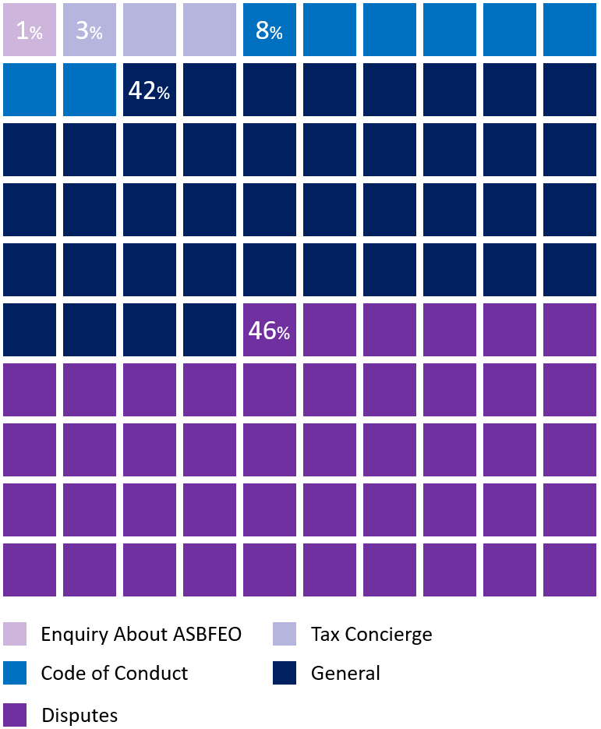
Figure 3: Requests for Assistance by case type as per asbfeo’s quarterly reports (collated by The Review)
Case studies of assistance provided by ASBFEO include:
- Contract cancelled without a cancellation fee (Contract Dispute)
- Sole Trader received outstanding payment (Payment Dispute)
- Reinstating Franchise (Franchising Dispute)
- Shopping centre agrees to pay fit-out cost (Retail Lease Dispute)
- Refund for damaged goods (Payments Dispute)

Whilst most case studies can be matched with the above categories, ASBFEO is able to take on other assistance cases if the assistance requested is in relation to relevant actions as outlined in the Act.

Case resolution pathways
Requests for assistance can follow six resolution pathways (methods of which a request for assistance has been resolved). The table below shows the number of times each of these pathways a matter has followed over the Review Period.,

Resolution | 2017-2018 | 2018-2019 | 2019-2020 | Total by Type | % by Type
Referred to appropriate agency | 814 | 2,413 | 763 | 3,990 | 25.3%
Referred to state Small Business Commissioners | 772 | 501 | 602 | 1,875 | 11.9%
Resolved by ASBFEO direct action | 103 | 126 | 203 | 432 | 2.7%
Resolved by ASBFEO with provision of information or referral to professional advice | 1,208 | 2,101 | 4,216 | 7,525 | 47.8%
Case in progress with ASBFEO | 62 | 1,376 | 191 | 1,629 | 10.3%
Referred to alternative dispute resolution | 34 | 85 | 189 | 308 | 2.0%
TOTAL | 2,993 | 6,602 | 6,164 | 15,759 | 100.0%

Requests for assistance are obtained via an online assistance form featured on ASBFEO’s website or via ASBFEO’s information line phone number. The Review did not consider or collate information on the distribution of cases by the method of contact over the whole Review Period, as this data is featured in various quarterly reports provide.

Drivers for changes to dispute resolution caseload
The total number of dispute assistance requests received by ASBFEO during the Review Period was 15,759 according to the sum of total disputes recorded in the annual reports published from 2017 to 2020. Disputes increased, on average (and excluding the first year), by 25.2% year on year. This increase in demand may be partially attributed to ASBFEO’s increased community awareness over the years, which will be further discussed below.
There is a strong positive relationship between social media followers and total disputes handled by ASBFEO (covering The Review Period, the correlation coefficient was 0.93 ). This may infer the success of ASBFEO’s marketing campaigns as the increase in all social media followers is correlated with an increased demand for assistance services. This topic is discussed in further detail in the Demand for Assistance Over the Review Period section.
From Q3 2019 - Q4 2020, the introduction of new industry codes under ASBFEO’s remit has accounted for 969 or 8.4% of total dispute assistance requests during this same period.
The newly formed AAT Tax Concierge has added 386 or 3.3% of total dispute assistance requests during this same period, and the adoption of the industry code assistance functions made a notable addition to the output of ASBFEO’s assistance function - particularly given the tax requirements surrounding the introduction of the JobKeeper benefits at the start of 2020.

Was the assistance provided convenient and effective?
The Review Team was asked to consider whether the assistance provided was convenient and effective for operators of small businesses and family enterprises. This section outlines Review findings based on consultation outcomes, small business survey results and analysis of ASBFEO’s assistance function reporting.

Assistance processes
ASBFEO has a clearly defined, five-step internal process for handling assistance requests and aims to have disputes resolved before the complainant is required to go to court to settle the issue. Processes and practices for dispute resolution have been captured over time and codified into support resources for staff, for example, ASBFEO’s Decision Matrix for Alternative Dispute Resolution.
Warm handover processes are in place with State-based Small Business Commissioners and other agencies providing small business assistance, however, improvements could be made to provide a more coherent ecosystem of small business support across jurisdictions. This topic is addressed below in the section titled Relationships with Other Agencies Offering Assistance to Small Businesses.

The Convenience and Effectiveness of ASBFEO’s Assistance Services
Stakeholders of all types were overwhelmingly positive in their assessment of ASBFEO’s assistance activities. Over 85% of survey responses saying they were either Somewhat Satisfied or Very Satisfied (as rounded and highlighted in purple below). 91% of respondents indicated they found the assistance/information they were looking for. These figures are shown in the charts below.

Small Business Survey Results Conducted by The Review Between March-May 2021
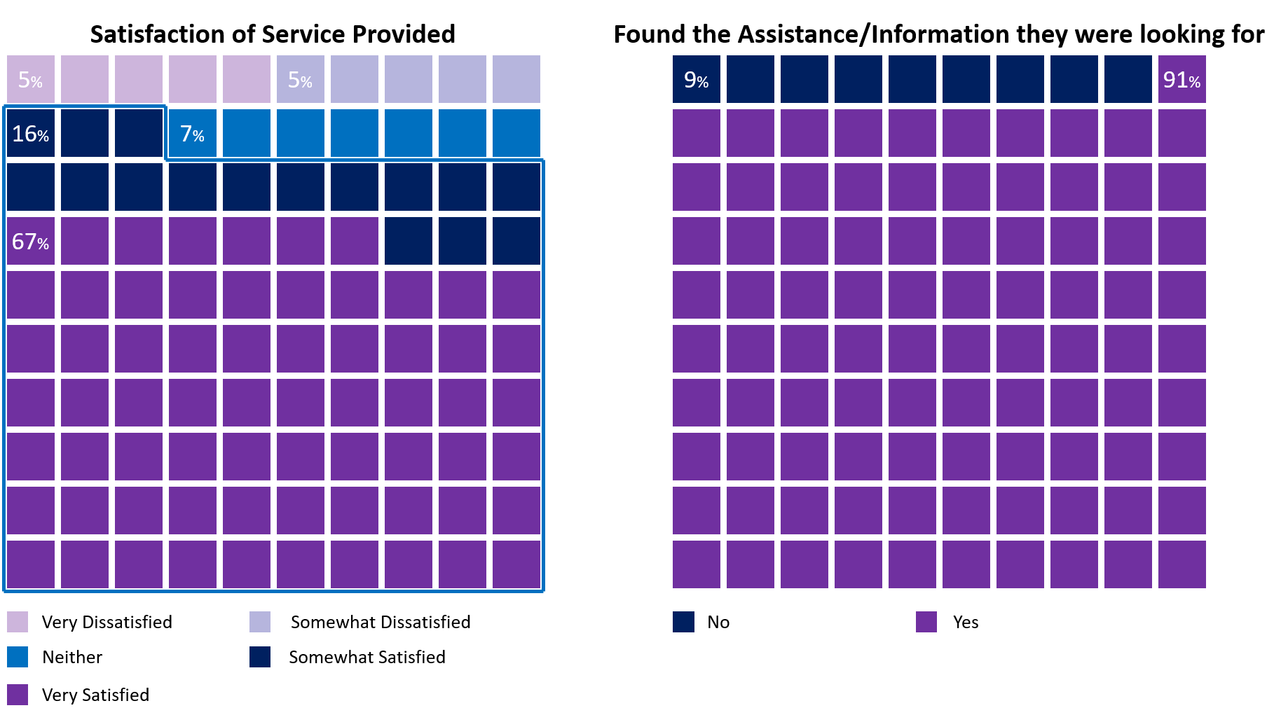
From the survey, 39 (81.3%) rated their likeliness to approach ASBFEO again 8, 9, or 10 (these individuals would be considered “promoters”).
“ASBFEO was quick to help” – Industry Body
Peak bodies, industry associations, and state-level Small Business Commissioners commented favourably on ASBFEO’s readiness to assist small business. ASBFEO was praised for its record of responding expeditiously, and for providing support to small businesses facing dire situations.
Beyond technical assistance services, ASBFEO was commended for listening to small businesses and providing support. It is important to note that small businesses often reach out to ASBFEO as a “last point-of-call” when “all other avenues are exhausted”, and when small business owners are approaching a point of desperation. A future consideration is whether specific and ongoing training may be required to support ASBFEO’s assistance staff as they handle these charged situations.

Reaching small businesses: a challenge to effectiveness
Consulted stakeholders across varying groups have indicated that reaching small business stakeholders is difficult. ASBFEO has maintained a strong media and social media presence and has tailored outreach approaches to different industries within the small business sector. The former Ombudsman, Ms Kate Carnell AO, shared that ASBFEO actively tailored its approaches to target particular subsets of small businesses, for example, ASBFEO uses Facebook to communicate with truck drivers as this was found to be their favoured platform.

Design Constraints to effectiveness
Despite the value ASBFEO’s assistance function has delivered to stakeholders, there are constraints to the effectiveness ASBFEO is legislatively positioned to achieve. ASBFEO can encourage parties to attend mediation, for example, but does not have powers to compel participation. As a result, several stakeholders, including respondents to the Small Business Survey, described ASBFEO as a “toothless tiger”. This issue is explored further below (see section below: The Question of Arbitration”).

Relationships with other agencies offering assistance to small businesses
ASBFEO’s legislated role is to assist small businesses without duplicating functions. This requires ASBFEO to implement handover processes with other agencies that assist small businesses. ASBFEO has implemented warm handover processes with State-based Small Business Commissioners, however, some gaps remain in the system.
Smaller State and Territory agencies (such as those based in the ACT, Northern Territory and Tasmania) had little awareness of ASBFEO; the ACT Chief Minister, Treasury and Economic Development Directorate, for example, engaged with the Review to find out more about ASBFEO and gain an understanding of how they might collaborate with ASBFEO to better reach small businesses in the ACT.
Some Small Business Commissioners, the Australian Financial Complaints Authority (AFCA), the Fair Work Ombudsman (FWO) and some industry bodies indicated that while handover processes are in place, there is a lack of outcomes tracking across the ecosystem. This has led to adverse effects including:
- some small business assistance cases dropping out of the system
- small businesses “shopping around” for the best assistance deal, resulting in duplication of effort across the system
- loss of clarity regarding gaps in the provision of assistance outcomes to small businesses, which also results in lost opportunities to identify potential systemic issues that might require the development of policy positions.

These agencies further indicated that small businesses may be confused as to assistance system entry points across jurisdictions. Amongst the many comments were calls for increased clarity, consistency, and coherent approaches across jurisdictions to support small businesses efficiently and effectively find help.
Many improvements were made in this regard during the COVID-19 pandemic response, for example - ASBFEO’s initiatives to consolidate information regarding Federal Government support measures for small businesses. The opportunity now exists for ASBFEO to also synthesise information on State-based initiatives to:
- promote small business awareness of assistance across levels of Government
- identify gaps in the Australian small business assistance ecosystem

The Federal, State and Commonwealth Ombudsmen consulted during the Review indicated very little interaction with ASBFEO during the role. They noted rather strongly, however, that ASBFEO does not fulfil a conventional Ombudsman role. The title of Ombudsman is reflected upon in Chapter 7: Advocacy and Assistance: The Relationship Between ASBFEO’s Functions.

Demand for Assistance over the Review period
The demand for ASBFEO’s assistance function has increased partially in response to additional functions, and partially as a result of the Ombudsman’s growing community visibility. Industry Codes and AAT Small Business Tax Concierge requests for assistance account for 13.6% (Code: 969, AAT Tax Con: 386) of requests since their introduction in quarter 3 2019 to quarter 4 2020. ASBFEO’s social media presence increased, on average, by 24% year on year since inception to the end of 2020.
ASBFEO conducted active traditional and social media campaigns over the Review period. ASBFEO’s social media presence has increased, on average, 24% every quarter. With total followers/subscribers on social media totalling 29,020 as of the end of 2020.
There is a very strong, positive correlation mean of 0.9384 between ASBFEO’s number of followers on various platforms, website visits, events attended, and media releases and their number of disputes lodged each quarter (since inception). There was a slightly stronger correlation mean of 0.9411 between social media followers, website visits, events attended, and media releases and disputes lodged in the following quarter (since inception).
The hypothesis behind this calculation is that there is a period of time (three months based on the data recorded) between a small or family business owner finding (following) ASBFEO on social media and them needing to contact them for any issue that has arisen. These calculations show that there is value in increasing ASBFEO’s awareness so they can help a larger number of small and family business owners in disputes that may have already arisen or may, in the future, arise.
The Review notes that the number of ASBFEO’s social media followers is moderate. As previously noted, a majority of ASBFEO’s social media activity is on Facebook (5,459 Facebook followers), with a smaller presence on Instagram (253 followers).
There is evidence that ASBFEO’s increasing profile has generated both small business demand for assistance services and the identification of further opportunities for ASBFEO to expand its assistance role. Noting the likely increase in future demand as ASBFEO becomes more broadly known, the Review considers that funding arrangements should be flexible enough to respond to the additional workload. This issue is explored further in Chapter 8: Administrative and Legislative Arrangements.

The Question of Further Powers
Over the course of the review, small business sector stakeholders - including ASBFEO - indicated there is a possible gap in the Australian small business assistance ecosystem regarding dispute resolution. ASBFEO has a role promoting mediation of disputes small businesses are involved in, and other bodies have dispute resolution powers. Stakeholders have indicated there are many instances where the existing mechanisms are insufficient to deliver fair outcomes for small businesses.
Mediation, arbitration, and court challenges remain costly (whether financially or in lost hours) and risky avenues for small businesses, particularly for those in disputes with large, well-resourced organisations.
ASBFEO does not have the authority to compel disputing parties to undergo mediation, listen to the other party, change their position to settle the issue, or act in a timely way. In addition, ASBFEO does not have the authority to make binding decisions on disputes and is often labelled a “toothless tiger” for this reason. Stakeholders have indicated small business are vulnerable when larger parties aren’t interested in bringing a dispute to resolution. This potentially leaves a gap in the assistance ecosystem for small businesses involved in disputes.
ASBFEO, small businesses, some industry associations, and other small business sector stakeholders have called for ASBFEO to be given further powers to address this gap. They argue that strengthening ASBFEO's powers regarding dispute outcomes may help to resolve the power imbalance in small/large business disputes outside of court proceedings.
While beyond the scope of this report to consider whether or not ASBFEO should be given further powers, the Review notes this question will persist for small business stakeholders and should be formally and fully addressed. The Review recommends a broader approach be taken to this question – covering a full review of gaps in the small business assistance ecosystem and consideration of how best to remediate those gaps.
The Review makes the important note that should ASBFEO be granted further powers, there is a requirement for the execution of that role to be impartial – which would require cultural or structural changes to the organisation.
Questions regarding the interaction between independence and impartiality is addressed in Chapter 7: Advocacy and Assistance: The Relationship Between ASBFEO’s Functions.
“If you go down the wrong path, ASBFEO could be an organisation which can keep businesses to account and show them the right path by having the power to prompt behavioural change …. if you cross the line.”

Recommendations

Recommendation 1: Integrated Assistance for small businesses
Treasury and ASBFEO should review evidence of gaps in the assistance and dispute resolution ecosystem for Australian small businesses, then implement targeted approaches to resolve these gaps and improve assistance outcomes.
- Treasury should consider the nature and impact of unresolved disputes on the small business sector, the factors driving lack of resolution and the relevant areas of legislation. Treasury should then ascertain whether there is a need for further dispute resolution avenues for small businesses and, if so, what role ASBFEO should play.

- ASBFEO should consider gaps in the Australian small business assistance ecosystem and work with jurisdictions, Ombudsmen, and other assistance functions to remediate them by:
- Providing clear and consistent assistance pathways for small businesses across jurisdictions, including well-defined assistance entry points, handover processes and outcomes tracking (in keeping with privacy laws and other legislation).
- Sharing data and insights to monitor outcomes across the small business assistance ecosystem and provide evidence of systemic issues affecting Australian small businesses.

- ASBFEO should develop and maintain a forecast for demand of its assistance function in line with strategic intent, noting the impact of profile-raising activities on demand for assistance services.

Chapter 6: Response to the 2017 Independent Review

Context
This chapter outlines how ASBFEO has responded to the recommendations of the 2017 independent review (ToR 2).

Review topics
This chapter considers each of the 2017 Review recommendations and uses evidence from consultations and document review to identify the degree to which each of the recommendations has been acquitted.

Findings summary
ASBFEO has made positive strides towards implementing the recommendations from the 2017 Review. It is important to note that ASBFEO continues to face many of the same challenges that presented in 2017 and that many of the recommendations made then continue to hold relevance. While more can always be done, ASBFEO is now positioned with a strong understanding of the small business sector and should make targeted choices about its strategies and activities to have the greatest impact.

Recommendations overview
ASBFEO should leverage its experience and relationships to prosecute a strategic agenda designed to focus its resources for deep impact on high-priority small business sector issues.
- Articulation of an annual charter or agreed strategic agenda to focus the application of ASBFEO’s resources towards achieving impact in particular areas, including
  - A policy agenda
  - A data and research sharing program to support formalising approaches to characterising thematic and emerging issues for the small business sector.
  - Initiatives to promote effective assistance handovers within the Australian small business assistance ecosystem.

- Coordinating a strategic agenda across State / Territory agencies with small business functions (including small business commissioners) to formalise build on current collaborations

- Strengthen relationships with Tasmania, ACT and Northern Territory to finalise actions from the 2017 Review.

The 2017 Review Recommendations
The Review has assessed ASBFEO’s conduct over the past four years against each of the 2017 review recommendations (listed below).

2017 Recommendation 1: Any expansion in ASBFEO’s assistance function should be carefully considered in light of its important advocacy role and occur only in response to a clearly identified gap.
ASBFEO's remit has expanded with new functions over the last two years.
In December 2018, ASBFEO began administering mediation adviser and dispute resolution adviser services under the codes of ethics for franchising, horticulture, and oil. This list has since been updated to include the dairy code.
In March 2019, ASBFEO launched a Small Business Tax Concierge Service to help small companies resolve issues with the ATO. From inception to the end of the 2020 financial year ASBFEO has been contacted directly relating to this topic 386 times. This provides small enterprises with assistance in deciding whether to file an application with the AAT, as well as subsidised legal advice. ASBFEO has assisted 71 small business owners with their ATO conflicts by informing them about the current AAT process and providing guidance on costs and deadlines.
In the same month of March 2019, the Act was modified to allow the Ombudsman the authority to directly aid small businesses in securing a no adverse costs order in action to reclaim the value of any harm or injury caused by violations of the Competition and Consumer Act 2010. This authority went into effect on 1 July 2019.
The latest addition to ASBFEO’s responsibilities was in November 2019, where it commenced assisting small businesses that are part of the ATO's Compensation for Detriment and Defective Administration Scheme.
Supporting Data
Data from ASBFEOs quarterly and yearly reports (below) show sufficient engagement from small businesses with regards to the above new functions. The Review has been informed that ASBFEO’s uptake of the new functions has arisen as a result of the ASBFEOs involvement with industry bodies administering these codes and not at their specific request.
Feedback from Stakeholders
Input from small business owners contributing to the Review through the survey and the Consultation Hub indicated a strong level of satisfaction with ASBFEO’s services. Regarding the new assistance functions, 91% of respondents who contacted ASBFEO advised their query was resolved and just over 85% of those state they were “Satisfied to Very Satisfied” (on a scale of 1-5, with 1 being extremely dissatisfied and 5 being very satisfied).
The Review has received feedback that ASBFEO should undertake more roles in the assistance function around topics such as:
- Anti-competitive practices between large corporations and small business; and
- Other codes relevant to the small business sector.

Summary
Feedback on ASBFEO’s new functions has been largely positive. Small businesses have indicated a high level of satisfaction and several stakeholders called for expansion of ASBFEO’s assistance role. There has been no evidence presented that the new functions are superfluous to gaps in the assistance environment for small businesses.
ASBFEO should continue to investigate instances where a clear gap exists in areas where small businesses require support, utilising the assistance function to inform the advocacy function to provide options to Government for remediating gaps.

2017 Recommendation 2: ASBFEO should continue its efforts to raise its profile among small businesses and family enterprises, with a focus on clarifying its role in relation to family enterprises.
Since the 2017 Review, ASBFEO has continued to raise its profile amongst small businesses and family enterprises through print and digital media.
ASBFEO has taken steps to build its profile amongst family enterprises, including:
- Partnering with Family Business Australia to publish an “Introductory Guide to Family Business Succession Planning”, accompanied by a video featuring the current and former ASBFEO, as well as the CEO of Family Business Australia.
- Participating in community days such as the “Family Business Day” in 2019 and 2020.
- ASBFEO has utilised multi-channel marketing campaigns across digital, social, and traditional media with the intent of raising its profile to a wider audience, including family businesses.

Stakeholders commented that family enterprises may continue to be a coverage area of contention. Reasons for this include:
- a lack of agreed definition of family businesses - some of these organisations may not understand the definition or consider themselves as a family enterprise
- Many family enterprises are large businesses and considered in the private wealth category, rather than as small businesses
- Challenges faced by family enterprises may have distinctions from those faced by small businesses.

As such, a question arises as to the relative importance of focusing on ASBFEO raising its profile amongst family enterprises. There is an opportunity for ASBFEO to consider and clarify the role it should play servicing this sector of the business community based on the challenges they face.

2017 Recommendation 3: ASBFEO should establish one or more forums through which to directly engage with small businesses, family enterprises and their representatives on an ongoing basis.
Following the 2017 review, ASBFEO has established the following forums to directly engage with small businesses, family enterprises and their representatives on an ongoing basis:
- Policy forum – comprising of 21 industry associations and peak bodies representing small businesses to provide direct input into the advocacy function of ASBFEO
- Small Business Hub – A community co-working space that provides free desk space on a casual basis to small businesses or their representative organisations while in Canberra
- National Strategy Group - Includes members representing all small business commissioners and representatives from Queensland and NT government.
- MindHive – An online platform to engage with Australia’s small businesses, family enterprises and other key stakeholders
- Social Media Platforms – Facebook, Twitter, Instagram, YouTube, and LinkedIn
- Interstate Community Visits by the Ombudsman

The Review considers these initiatives to have been meaningful and provided impact in deepening engagement with small businesses.

2017 Recommendation 4: ASBFEO should bolster its input into policy and legislation that affects small businesses and family enterprises, including through training, secondments, consultation, and evaluation.
ASBFEO’s advocacy function has been prolific in exploring policy issues affecting small businesses. The office has consistently sought to make a policy impact and has consistently championed policy positions designed to benefit the sector.

Cross agency collaboration
ASBFEO’s reports it has increased focus on engaging early in the processes with other Departments, to ensure enough time is provided for those Departments to provide considered feedback to proposals. ASBFEO has improved the level of departmental engagement and opportunity for input into policies and programs. ASBFEO has expressed their commitment to continue exploring avenues for inter-agency collaboration to enable regular and ongoing engagement with ASBFEO’s office.

Internal capability
ASBFEO’s office has also reported increased focus on training, with the delivery of in-house and external training and development opportunities. These opportunities include regular whole-of-office policy roundtables to engage the wider ASBFEO team on developing solutions to issues affecting the sector, webinars, and bringing in external trainer-experts in identified development areas.

Opportunities
Chapter 7: Advocacy and Assistance: The Relationship Between ASBFEO’s Functions explores stakeholder feedback and Review observations regarding ASBFEO’s policy influencing maturity. The Review recognises ASBFEO’s endeavours to build its policy influence and notes some practical steps it can take, with the support of the Treasury, to continue this journey for a sustainable future.

2017 Recommendation 5: ASBFEO should work with other agencies to determine how they can share data and research about small businesses and family enterprises.
There has been progress since the 2017 review in the way in which data is shared between ASBFEO and the State’s SBCs and other government agencies. ASBFEO reports its “Small Business Counts” report has been developed in response to this recommendation and is based on anonymised data from the ATO, the ABS and the private sector.

ASBFEO works with the ABS on the publication of research and reports about the small business sector and any future opportunities to collaborate. ASBFEO publishes this data and is able to provide additional insights to other government agencies when requested.

The Review understands the ABS is currently updating its data collection, release, and analysis tools, and ASBFEO is working closely with the ABS to ensure that data relating to small and family businesses is enhanced. There is scope for specialised research to provide a deeper empirical source of sector insights. ASBFEO advised the Review of their perspective that “data collection and analysis are impeded by data coding practices (for example, the use of Australia and New Zealand Standard Industrial Codes), which are outdated and not fit for purpose.”

Stakeholders placed a high value on ASBFEO’s growing role in providing small business sector insights. There is some appetite for a more formalised approach to this role as a valuable tool in the policy production process for both government agencies and the private sector. There is a potential opportunity for ASBFEO to act as a “clearing house” in future for reliable, authoritative, and timely data and insights about the sector (including their data regarding assistance requested and provided). This role should be considered when assessing ASBFEO’s strategic priorities, and if proceeded with, adequately resourced.

The Review considers ASBFEO could better leverage the data resources of small business sector stakeholders – both government agencies and private sector bodies – by engaging earlier in research or policy development work. Stakeholders to the Review offered the opportunity to engage in open and collegiate dialogue and to share data and insights to inform policy development. Empirical data from both primary and secondary sources (other than that gained from its assistance function) and understanding of “real world” impacts of recommendations may bolster the efficacy of ASBFEO’s advocacy work.

The Review considers that more data sharing between government agencies, as well as a broader set of industry groups and bodies, is required to inform ASBFEOs recommendations in the future.

2017 Recommendation 6: ASBFEO should work with other agencies to access data that would enable it to assess how effectively it transfers requests for assistance to them, most likely focusing on the proportion of requests they resolve themselves and the proportion they refer on to a third agency.
The Act expressly provides for referral of Assistance requests to other relevant agencies where they exist, avoiding duplication and forum shopping. The procedure to transfer a request for assistance to another agency is to ﬁrst speak to that agency, to ensure a warm referral of the matter, to ensure that business owners do not need to provide an additional set of information to the new, agency reviewing the same. ASBFEO reports they routinely receive warm referrals from other dispute resolution agencies.

ASBFEO has also established a group similar to the National Strategy Group, between Assistance staff in each of the Commissioner's offices. The Ombudsman chairs a Federal Regulatory Agencies Group (FRAG), which allows for further sharing of intelligence and provides greater opportunities
for warm referrals of matters through this forum.

ASBFEO reports that tracking the successful resolution or “on-referral” rates for matters transferred to other agencies has been difficult due to there being no system available to “tag” matters as they progress through different agencies. Some agencies also require small businesses to lodge directly via forms, including the Victorian Small Business Commissioner and AFCA, making them more difficult to track.

The Review notes that there are no clear protocols for referrals between State SBCs and ASBFEO, the feedback received from various stakeholders confirms this position. To date, it is understood that the responsibility currently sits with the originating entity to track which matters were referred to ASBFEO. Establishing data sharing protocols for case referral tracking may promote effectiveness and discourage small business from “forum shopping” across jurisdictions.

2017 Recommendation 7: ASBFEO should work with states that do not have small business commissioners to establish clear protocols for its referrals.

ASBFEO has increased their efforts to work closely with State Small Business Commissioners and similar counterparts in Queensland and Tasmania. This has included undertaking many joint assistance matters with the then Queensland Small Business Champion (now Commissioner), Ms Maree Adshead. ASBFEO reports they have an established protocol to refer matters to Ms Adshead as appropriate. ASBFEO provided support for the establishment of the office of the Small Business Commissioner, providing data on assistance requests to the Queensland Government for this purpose.

In Tasmania, ASBFEO has advised that they have worked closely with the Tasmanian Small Business Advocate for the limited number of matters received. It is important to note that interstate matters are, as a general rule, referred to ASBFEO for a resolution.

The Ombudsman acts as the designated dispute resolution agency for the Australian Capital Territory, Northern Territory, and other territories.

Notwithstanding the above, the consultation with these states and territories has revealed a gap in ASBFEOs coverage of the Northern Territory, Tasmania, and the Australian Capital Territory. Leaders of small business policy and service delivery in these jurisdictions noted limited interactions with and awareness of ASBFEO’s role. The ACT Government engaged with the Review Team as an opportunity to learn more about ASBFEO’s outreach to small businesses and offer the opportunity for collaboration in the future. Representatives within these jurisdictions expressed their small business sectors have unique challenges and connection to the national small business agenda would be beneficial.

The Review is of the opinion that more communication and further outreach to the small business functions within each of the jurisdictions without Small Business Commissioners would be beneficial for all interested stakeholders.

2017 Recommendation 8: The attendees of some meetings of ASBFEO and the state small business commissioners should be expanded to facilitate a broader discussion of common issues and areas of potential duplication.
Following the 2017 review, ASBFEO and their office have established regular, joint Small Business Commissioner and FRAG meetings to ensure better collaboration when agencies operate in or visit a particular state.

From the consultation, the Review was advised that a large proportion of issues that are seen by one State SBC are commonly found by other SBCs and ASBFEO. Since ASBFEO’s inception, they have been described as the “glue to collaboration”, bringing the SBCs together, as secretariat and informal chair to the forums.

One aspect for suggested improvement of the forums is the format, where a strategic “what’s next?” mindset can be adopted after the sharing of ideas and issues. In addition to status updates, a future-focused and action-oriented approach to meetings can also be considered where solutions to issues can be ideated and agreed upon to drive change.

Recommendations
While ASBFEO responded positively to the recommendations of the 2017 Review, a number of themes persist. There is continued high demand for ASBFEO to expand its activities and impact.
There is a continued need for advocacy that leads to policy input, legislative change and outcomes to support small businesses. A key pillar for ASBFEO’s next phase is the consolidation and maturation of the approach towards the goal of enduring policy impact.
ASBFEO’s advocacy and assistance activities have made an impact, and that impact continues to generate demand for data-driven approaches to strengthen each of the functions. Stakeholders continue to request data and research sharing, and formalised approaches to qualifying and quantifying thematic and emerging issues for the small business sector.
The opportunity exists for ASBFEO to respond to the continued strong demand for small business sector insights in both public and private sector, moving beyond anecdotal evidence to a rich database of small business sector information.
There is an opportunity to build on the foundation of collaborative efforts across jurisdictions during the response to the COVID-19 pandemic in 2020. Stakeholders have indicated a continuing need for improving the effectiveness of assistance entry points and transfer within the Australian small business assistance ecosystem. In particular, there is a need for consideration regarding the totality of assistance provided to small business through ASBFEO, the Commonwealth Ombudsman, SBCs, AFCA, FWO and other functions.
Stakeholders continue to highlight the potential benefits of sharing data across the system of small business assistance in Australia. ASBFEO has opportunities to promote data sharing across this system, noting privacy limitations and challenges. A future opportunity may be an investigation into the value of tracking outcomes between agencies based on whether it would help:
- Surface systemic issues
- Materially improve small business outcomes
- Characterise the small business sector.

While demand remains strong for ASBFEO to generate advocacy and assistance impact for the small business sector, the Review recommends ASBFEO adopt a strategic stance to conducting its activities. ASBFEO does not have unbounded resources or time; it should consolidate a core agenda to prosecute, developed in collaboration with key stakeholders. Similarly, ASBFEO should coordinate a strategic agenda with other agencies holding small business-related functions.

Recommendation 2: Use experience and Relationships to drive a strategic agenda
ASBFEO should leverage its experience and relationships to prosecute a strategic agenda designed to focus its resources for deep impact on high-priority small business sector issues by:
- Articulating an annual charter or agreed strategic agenda to focus the application of ASBFEO’s resources towards achieving impact in particular areas, including
  - A policy agenda
  - A data and research sharing program to support formalising approaches to characterising thematic and emerging issues for the small business sector.
  - Initiatives to promote effective assistance handovers within the Australian small business assistance ecosystem.
The strategic agenda would help identify key priorities but also give the headroom where required, in order to respond to emerging issues.

- Coordinating a strategic agenda across State / Territory agencies with small business functions (including small business commissioners) to formalise build on current collaborations

- Strengthen relationships with Tasmania, ACT and Northern Territory to finalise actions from the 2017 Review.

Chapter 7: Advocacy and Assistance: The Relationship Between ASBFEO’s Functions

Context
ASBFEO provides assistance to and advocacy for small businesses and family enterprises. Under the legislation, ASBFEO is required to:
- Advocate for small businesses and family enterprises in relation to relevant legislation, policies and practices (the advocacy function)
- Give assistance in relation to relevant actions if requested to do so (the assistance function), and
- Perform any other function conferred on the Ombudsman by any Act or legislative instrument.

Review topics
This chapter considers the interaction between and effectiveness of ASBFEO’s functions, including roles acquired since the previous review (ToR 3). Commentary is provided on the characteristics of independence and impartiality in the discharge of ASBFEO’s functions, on the relationship between ASBFEO’s assistance and advocacy functions, and on the benefits and risks of the two functions informing each other.

Findings summary
- The independence of ASBFEO is highly valued in relation to its advocacy function
- ASBFEO’s application of independence in the exercise of its advocacy function has challenged Federal policy and regulatory agencies and some elements of the business community
- Impartiality is considered essential for the role of an Ombudsman. ASBFEO has acted as a strong advocate for small business, rather than impartially.
- A broad range of stakeholders have questioned whether the title of Ombudsman is fitting given ASBFEO’s functions and activities
- The Review considers the use of the name Ombudsman generates expectations of impartiality that go beyond the requirements of such to deliver effective assistance to small businesses. This has created a tension that may be alleviated with a name change
- Earlier and more collaborative engagement of policy, regulatory, industry and expert stakeholders in the advocacy process is likely to yield improved support for ASBFEO’s policy positions
- Stakeholders have raised the need for greater nuance to ASBFEO’s policy positions, offering a view of small business and big business as inter-related parts of a whole, with impacts to one area having flow-on effects to the other.

Recommendations overview
- ASBFEO should build its capacity and capability for sustained advocacy impact by strengthening its collaboration with stakeholders and sharpening its ability to characterise the small business sector
- ASBFEO should be renamed to promote role clarity.
“Advocacy is about outcomes. Pragmatism is required, but [one] that doesn't diminish the issue. Take a longer-term view to improve influence and avoid unintended outcomes….”

The interaction between ASBFEO’s functions
This section considers whether there is sufficient separation between the operation of the advocacy and assistance functions within ASBFEO. In particular, the Review considers the name of the office, the important characteristics of independence and impartiality, and the impact of ASBFEO’s advocacy role.

The Name of ASBFEO
The Review notes that the question of ASBFEO’s name, specifically the use of the term “Ombudsman”, generates significant interest, both within the small business and the Ombudsmen communities. As such, the name of the office warrants serious consideration.
ASBFEO’s role is defined as “support[ing] small business and family enterprises to enable them to grow and thrive” and its functions are to “assist and to advocate for small businesses and family enterprises”. Stakeholders strongly expressed the view these roles are inconsistent with the functions generally bestowed on Ombudsman institutions. The Australian and New Zealand Ombudsman Association (ANZOA) states that the name of Ombudsman signifies “an independent office, which primarily has a complaint handling and investigation function”. ANZOA lays out six essential criteria for describing a body as an "Ombudsman”, covering:
- Legally defined jurisdiction
- Powers of investigation, obtaining information, and discretion in dispute resolution processes
- Accessibility of the office to the public
- Commitment to procedural fairness
- Accountability mechanisms

The Review considers that using the term Ombudsman to describe an advocacy organisation such as ASBFEO can be misleading. The use of the name has likely caused confusion for people accessing the services of ASBFEO or other Ombudsman bodies. Stakeholder input has provided evidence that the name of “Ombudsman” creates expectations of impartiality which ASBFEO has not acquitted. The following section investigates the question of impartiality and whether ASBFEO requires a greater degree of impartiality in its operations.

Independence and Impartiality
The Review was asked to consider whether the further separation of ASBFEO’s functions is required to support the acquittal of expectations. ASBFEO’s structure is distinct from other Ombudsman functions, as discussed above and the implications of this distinction are explored in this section.
When interpreting this question and assessing ASBFEO, the Review acknowledged the plain-English definition of the following terms:
- “Independence” - “freedom to make laws or decisions without being governed or controlled by another country, organisation…”
- “Impartial” - “Not supporting any of the sides involved in an argument”
The independence of ASBFEO is highly valued in relation to the advocacy function. Stakeholders including small business commissioners, peak bodies, industry associations, policy agencies and regulators, informed the Review team that ASBFEO is effectively operating independently of the government of the day.
Most participants to the Review regarded ASBFEO as performing adequately in identifying the key issues that impact the small business sector and considered this work “vital” to elevating supportive policy positions. Many noted that an “unambiguous voice” for small business is essential for influencing systems to produce fair outcomes for small businesses given the “headwinds” they can encounter in dealing with larger business players.
“ASBFEO is an unambiguous voice for small business…”

Independence, a powerful tool, can lead to isolation if deployed fiercely or utilised in an unreceptive environment. ASBFEO faces a challenge in continuing to positively engage the small business sector while tempering advocacy approaches to safeguard trust with government agencies and Ministers – the decision-making audiences of ASBFEO’s advocacy work. Trust is a critical ingredient to building sustainable policy influence, and trust requires engagement from all relevant parties.
To achieve greater and sustained policy influence, ASBFEO should act on the opportunity for practical action in creating:
- Organising concepts by which to frame policy issues for the sector.
- Channels of approach to the sector to obtain relevant data that can be utilised by agencies to inform policy development.
- Relational depth with policy and regulatory agencies.

An example of such actions that have proven beneficial is the collaboration between ASBFEO and the ATO. Investment in the relationship saw ASBFEO accept the ATO’s invitation to co-chair the Small Business Stewardship Group, resulting in deeper insight, collaboration, and engagement for both parties, with material benefits. The Review highlights this as a model of mutual efforts that improve efficacy and outcomes for the small business sector.
Impartiality is considered essential for the role of an Ombudsman. Stakeholders have indicated ASBFEO is not viewed as impartial, as their focus has been on:
- Using their independence for effect to support their advocacy as much as possible – a role that is significantly appreciated amongst stakeholders, despite the challenge it has presented to policy and regulatory agencies
- Bold and unwavering support for small businesses.

The Review considers it a challenge for ASBFEO to abide by traditional constructs of impartiality if being also an “advocate”. Notwithstanding this, there is no evidence to suggest that ASBFEO has failed to be impartial in its Alternative Dispute Resolution (ADR) or mediation functions.
The Review argues impartiality is not necessary for the current exercise of ASBFEO’s assistance function. Further, given a name change, stakeholder expectations of the need for impartiality will resolve, freeing ASBFEO to provide advocacy and support to small businesses without undue expectations.
As a final note, ASBFEO and other stakeholders have highlighted the need for arbitration to support fair outcomes for small businesses in disputes with larger entities. While beyond the scope of this report to consider whether ASBFEO should acquire powers to bind parties to resolution outcomes, the Review notes that impartiality is essential for the application of such powers. The question of arbitration was discussed more fully in Chapter 5: Providing assistance to small businesses and family enterprises.

The Relationship Between ASBFEO’s Advocacy and Assistance Functions
Both assistance and advocacy functions should be evidence-driven to promote trust with stakeholders and to generate appropriate outputs. Stakeholders have consistently highlighted the benefits of ASBFEO’s advocacy function being informed by the assistance function. The two functions can and do operate synergistically, for example: in the instance, a systemic issue affecting multiple small businesses across geographies or states is identified through the Assistance function, the data can be used to further inform the output of the Advocacy function.
The Review notes some stakeholders indicated that more formal pathways for sharing information between these functions would be beneficial for both ASBFEO and across the Australian small business assistance ecosystem. These pathways may include:
- More structured and detailed information gathering processes for assistance cases
- Data sharing protocols across small business assistance agencies
- Data analysis capabilities to draw out systemic themes.

The Effectiveness of ASBFEO’s Functions
This section describes the effectiveness of ASBFEO’s function in terms of effort expended and outcomes achieved.
ASBFEO’s reputation has become almost synonymous with its advocacy role. Government and industry stakeholders are very aware of ASBFEO’s advocacy impact and congratulate ASBFEO on identifying the key issues impacting the sector. This work has been valuable in highlighting the need for policy that supports small businesses.
ASBFEO has been highly active in performing its advocacy duties, producing notable volumes of inquiries, reviews, and media releases (print and digital) as its primary approaches to advocacy. There is widespread acknowledgement that this work - has been undertaken with the greatest intent to make a positive impact on small businesses. ASBFEO has acted as a resounding voice for small businesses and their interest.
“If ASBFEO ends up becoming a cheer squad for the Government or is silent on issues, it may seem there’s no independence.”

Advocacy effectiveness can be measured by:
- the increased acknowledgement of the small business agenda
- through inquiries and reviews conducted by ASBFEO, as well as submissions to other government enquiries, such as Productivity Commission projects
- The reflection of the advocated positions in government policy.

The following sections explore these considerations.

Uptake of ASBFEO Recommendations
A practical outcome of good advocacy is the uptake of recommendations and the implementation of advocated positions in government policy. In this section, the Review considers how often and to what degree ASBFEO’s recommendations have been implemented.
ASBFEO maintains detailed records of recommendations included in their various enquiries, research papers and reviews. In assessing uptake of ASBFEO’s recommendations, the Review has considered documentation provided by ASBFEO and conducted desktop research to supplement these records.
ASBFEO self-assessed the impact of the recommendations on a 5-tier “Outcome Status” scale (with an outlier category for “no information”). The scale ranges from “Not Implemented” at the lower end of the scale, a signal of support mid-scale, and “Implemented” as the top outcome.
ASBFEO reports 21% of their recommendations as “Implemented” and 12% as “Mostly Implemented”. The following chart shows the implementation status of ASBFEO’s recommendations across each type of paper over the Review Period.
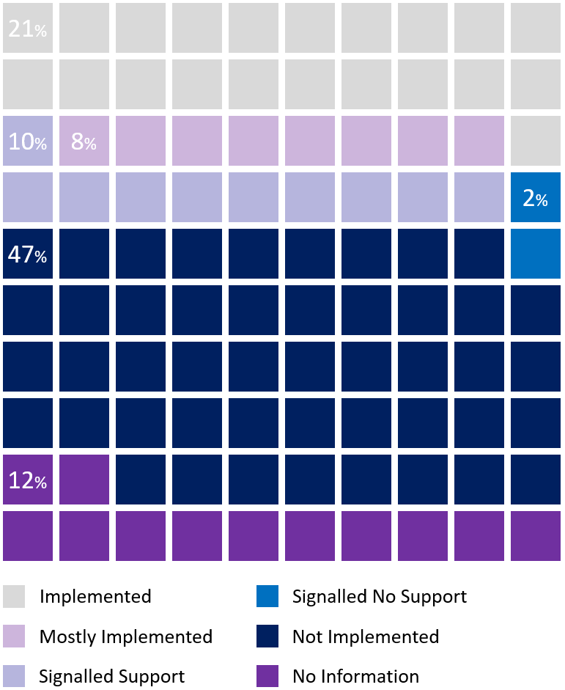
Completed Review Recommendation Implementation Status
Figure 4: Implementation Status of ASBFEO's recommendations
Additional detail is provided in Appendix “D”.
The Review undertook an analysis of the implementation status of recommendations recorded as being implemented or partially implemented, using evidence provided by ASBFEO and independent research. In nine cases, the Review found insufficient evidence to warrant the ascribed recommendation status. Details are provided in Appendix “I”.
To promote best practice, we challenge ASBFEO to continue refining and developing its self-assessment methodology (with well-defined criteria for each “Outcome Status” the continued use of empirical evidence) to support its benchmarking initiatives and re-affirm the effectiveness of its advocacy function internally and externally (should the question be asked in the future).
Based on ASBFEO’s reported recommendation implementation rate, extensive consultation, and the Review’s analysis, ASBFEO’s advocacy function has been effective in acquitting its legislative and stakeholder expectations.

ASBFEOs Approach to Advocacy: Effectiveness and Impact on Stakeholders

Advocacy role challenges federal agencies
ASBFEO has acted independently in its advocacy role, and the Review has noted the challenge this has at times posed to Federal Government agencies in particular.
Various stakeholders at the State and Federal level noted instances where ASBFEO’s comments, reviews and actions caused surprise, being released to the media and other public forums without pre-briefing. This has caused tension because agencies were not afforded the opportunity to brief their respective Ministers. These stakeholders further highlighted the desirability of earlier engagement in ASBFEO’s advocacy processes to support both effective policy development and fostering of trust in furthering small business sector interests.
“ASBFEO is a lobbying group with a government badge”
One notion shared by a government entity was the request to acknowledge the constraints of government (whether be it practically, legally or within a specific time frame), as well as what can and cannot be achieved.
On the other hand, the role of an “Ombudsman” implies keeping government agencies in line, and this further contributes to the need for ASBFEO to clarify its role with other agencies within the small business governance and support ecosystem –to avoid any misunderstandings and ensure alignment of priorities in the future.

Small business and large business as parts of a whole: Is a “combative” approach against “big business” warranted?
The Review acknowledges that the Australian economy relies on the growth of small businesses as well as the success of “big business”, with the role of ASBFEO seen as both necessary from industry organisations and professional bodies with members of various sizes and turnover.
Stakeholders have raised the need for greater consideration of the relationships between small and large businesses and the complex dynamics between the two. Impacts to small business flow on to large businesses and vice versa, where a well-informed appreciation of the intricacies and mechanisms involved are important for effective policy development. Stakeholders have suggested engagement with industry bodies will provide access to local and international subject matter expertise and deep experience of both issues and context – important inputs to the analysis of highly complex and sensitive systems.

Advocacy Quality
Reviews and inquiries into the issues affecting small businesses should start without any preconceived notions or outcome in mind (and with impartiality and independence as a base), with the findings based on empirical evidence from consultations and investigations as input. Policy makers and industry advocates commented that ASBFEO’s advocacy work could be better informed through engagement with subject matter experts and those with an understanding of the nuance of issues. This prevalent opinion is important for ASBFEO to acknowledge. By doing so, there is an opportunity to gain greater influence on the government’s agenda and policy making, and in turn to improve prospects for small businesses and family enterprises around Australia.
Fearless and frank viewpoints combined with evidence-based arguments can bolster the validity of the issues raised and elevate the discussion with State and Commonwealth Governments as well as and any interested stakeholders and industry bodies.

The effectiveness of the relationship between ASBFEO’s functions
The Review found that small business commissioners, industry bodies and some regulators were generally enthusiastic about the advocacy and assistance function working cohesively to:
- generate learnings
- promote the effectiveness of assistance design
- identify systemic issues
- provide a foundation for advocacy work.

These organisations noted examples and expressed the view that benefits would be lost if these functions were separated.
With agencies and other entities with a broader scope than just small business alone who are not as closely connected, they are typically unsure of the effectiveness of the assistance function due to low visibility.
Some policy makers and regulators, however, noted difficulties, regarding ASBFEO as primarily an advocacy body. These concerns are addressed in the Independence and Impartiality section above.
As already noted, the Review considers the advocacy and assistance functions should continue to operate cohesively. This relationship is proving effective; however, questions of the role and name clarification must be addressed to appropriately position ASBFEO for continued impact.

ASBFEO’s Assistance to Small Businesses: Effectiveness and Impact
“ASBFEO punches above its weight – they are on the front-foot and prompt to respond [to issues raised by small businesses]…”
The effectiveness of the Assistance Function is covered in Chapter 5: Providing Assistance to Small Business and Family Enterprises above.
In summary, the review is of the view that ASBFEO has impactfully and effectively provided assistance to small businesses throughout the Review period. This is evidenced in the quarterly and annual reports published by ASBFEO, the feedback received from Small Business advocates, organisations, and interest groups in various states and territories, as well as in addition to interview and survey of small businesses by the review.

Opportunities to Improve Advocacy Effectiveness
This section considers specific opportunities for ASBFEO to improve the effectiveness of its advocacy function and assistance functions.

Earlier Engagement of Key Stakeholders to advocacy work
One key theme identified from a broad group of stakeholders was the timing of stakeholder engagement with regards to inquiries, consultations, reviews, and/or recommendations.
“[It is important to] engage with experts to inform policy…”
Some stakeholders expressed their dissatisfaction in the way ASBFEO approached its advocacy work, commenting on being surprised by findings and policy positions announced in the media ahead of opportunities to contribute, comment, or brief key stakeholders. Several commented that ASBFEO could improve their impact by developing a more collaborative, data-driven, strategic approach to communication with stakeholders.

Improvements to quality of policy recommendations
Another common theme identified was the development of sophistication around the identification of issues, where a number of stakeholders held the view that inquiries and media releases were based on anecdotal evidence or the experiences of “one or two small businesses”.
Prior to prosecuting an issue, it is suggested that the ASBFEO provide details as to the investigations conducted into a particular issue, to avoid the allegations of hearsay. The 2017 recommendations touched upon the sharing of data with other agencies and this should provide a framework for substantiating the complex issues and experiences of small businesses.
“We’re not worried about ASBFEO raising issues - this is a good thing. The problem is continuously taking one small business’s experience and extrapolating it into whole industry problem and a media campaign.”
Ideally, inquiries and reviews are to be well-informed and socialised with key stakeholder interest groups to promote data accuracy and stakeholder buy-in. This includes collecting, collating, and utilising empirical data from both primary and secondary sources to form a view.
ASBFEO may find communicating well-informed views to stakeholders (with supporting evidence) will allow for a feedback loop that considers all impacts (such as practical considerations to implementation i.e. “how it works in the real world”).
Stakeholders considered this would improve the strength of ASBFEO’s arguments, boost uptake of recommendations and result in more sustainable outcomes.

Development and Implementation of a Strategic Agenda
As noted in Chapter 6, ASBFEO could improve the quality and impact of its advocacy work by allocating resources in support of the strategic agenda for focus areas. This will improve efficiency and effectiveness by:
- Reducing the likelihood of re-prosecution of issues
- Ensuring ASBFEOs time and resources are focused and scope and outcomes are well-defined
- Affording stakeholders adequate notice to react and respond to enquiries and reviews in a timely way

The strategic agenda should act as a guide but not remove ASBFEOs ability to identify systemic issues and prosecute the same by following a proactive, bottom-up approach to system issue identification.

Improved alignment with other small business and Ombudsman functions
Chapter 5 discusses the opportunity for ASBFEO to play a defining role in the orchestration of small business assistance and related Ombudsman services across Australia. By facilitating alignment, clear pathways, and consistent information, ASBFEO can help improve the following:
- The outreach of agencies at Federal and State / Territory levels to small businesses
- The efficiency and effectiveness of the system overall in providing assistance to the sector, including reduced duplication.

Acting as a “friend of the court”
There may be an opportunity for ASBFEO to fulfil an amicus curiae (friend of the court) role by providing incisive commentary and small business context in court or arbitration settings. This is an opportunity to provide assistance informed by the deep small business expertise of ASBFEO’s advocacy function and could deepen the value ASBFEO offers to the small business sector.

Building trust with government agencies through clear role definition
With many government agencies and industry bodies involved with the Small Business ecosystem within Australia, there is potential for confusion amongst both the public and government bodies as to the role ASBFEO plays.
Some agencies noted they had no background on the role of ASBFEO and where it sat within the whole ecosystem and across jurisdictions, especially those states with Small Business Commissioners.
Building trust between ASBFEO and other agencies is essential, where driving the right level of engagement can be challenging. One way this could be achieved is through clear guidance on ASBFEO's role.
In this regard, there is an opportunity for ASBFEO to raise its profile and clarify its role with the stakeholders consulted as part of this Review would be a practical starting point for ASBFEO.

Consistency in quarterly/annual reporting FORMAT and DATA SETS to enable BETTER benchmarking
ASBFEO's Quarterly Reports provide an excellent opportunity to gain a big picture view of how the Ombudsman is assisting small and family companies. ASBFEO is able to emphasise significant subjects of discourse, express their past, present, and future inquires and reviews, demonstrate their current media mentions and advertising tactics, and illustrate their statistical successes of communication with the larger community through this media release.
The statistics that are consistently tracked and mentioned in these reports include (but are not limited to):
- The number of people/entities who have contacted the ombudsman and the cause for their inquiry
- The state from which persons contact ASBFEO
- How ASBFEO assisted with the issue presented to them.

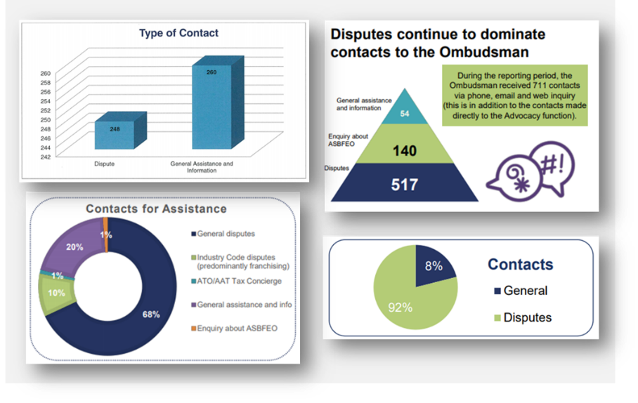
Figure 5: Examples of Diverse Graphs and Imagery Used in Quarterly ASBFEO Reports
Whilst the underlying information is undoubtedly useful - and for the most part – consistent in terms of data set/source from the beginning of 2016 to the present, it was observed that the data is presented in various formats from quarter to quarter. This makes straightforward comparisons somewhat challenging and potentially time-consuming for the typical reader and reviewer alike.
This also draws attention to the manner in which the information is presented, for example, some figures expressly indicate the raw numbers of the contact method, whilst others outline the proportion of a total (as seen in the images above). This results in inconsistencies across quarters, as percentages representing parts of a total were observed to result in missing data (where percentage totals occasionally failed to add up to a whole).
Finally, circling back to the use of percentages to display data points, there are discrepancies that arise with its use when displaying data such as the location of contacts from around Australia (example below).
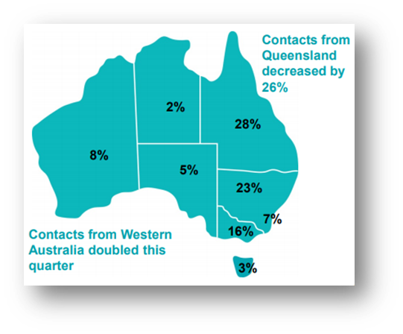
Figure 6: Example of a figure from ASBFEO Quarterly Reports with incomplete data
As stated, these numbers add up to 92 per cent, with the remaining 8 per cent left out of the report. This may be due to human error while displaying the information visually, however, 13 of the 20 reports (Q1 2016 – Q4 2020) contain the same type of inaccuracies (to varying degrees ranging from 1 to 8 per cent), with no explanation of what the unaccounted percentages correspond to.
This unaccounted-for sum is labelled as "Other" in some early 2016 reports, again, with no explanation as to what this category includes. The same “missing percentage data” error may also be observed in various data fields such as dispute types (i.e. “Business to Business” or “Business to Government”) throughout a majority of the 20 quarterly reports reviewed.

Importance of Ministerial support
ASBFEO must receive adequate levels of ministerial support and “time on the floor”, as advised by various stakeholders. This speaks to the effectiveness of ASBFEO’s advocacy function, where key issues affecting small businesses are “shouted from the tree-tops” and socialised at the highest level of government.
Irrespective of the portfolio and governing minister, having the voices and interests of small business and family enterprises front of mind - especially during the COVID recovery period – will play a crucial part in the maturity of ASBFEOs role in a multi-agency ecosystem.

Opportunities for Small busiNesses to enter the digital age
Australian businesses have the opportunity to market and sell their products and services to customers all over the world through digital channels. Small businesses, however, may not have the knowledge, resources, or initial appetite to invest in digitisation or even “getting online”. Some stakeholders considered there may be a role for ASBFEO in assisting small businesses embrace the efficiencies and reach of digital platforms.
The Review regards this potential activity as one opportunity amongst many others. Any investment of ASBFEO resources on digital initiatives for small businesses should be weighed against other strategic initiatives, with consideration to other government initiatives already assisting small businesses with digital endeavours.

Recommendations

Recommendation 3: Build Advocacy impact
ASBFEO should build its capacity and capability for sustained advocacy impact by strengthening its collaboration with stakeholders and sharpening its ability to characterise the small business sector.
- ASBFEO should evolve the application of its independence function with policy and regulatory stakeholders, but equally, these bodies have an opportunity to welcome the insights and connections ASBFEO provides into the small business sector. To achieve policy cut through, ASBFEO should:
- Build on its more recent endeavours to engage early and often with policy, regulatory, industry stakeholders and SMEs when conducting enquiries
- With assistance from the Treasury, replicate engagement models that have proven effective, such as co-chairing the Small Business Stewardship Group with the ATO and convening the Federal Regulatory Agencies Group (FRAG).

- ASBFEO should provide insights as to the organising concepts for the small business sector by:
- Providing clarity on the composition of the small business sector and characterising its nature with improved qualitative and quantitative models
- Build on existing relationships with small business sector stakeholders to create pathways for enquiry into small business policy or regulatory questions and for elevating emerging concerns
- Articulation of persistent and emerging issues impacting the small business sector, such as access to finance, the cost of these issues to the sector and economy more broadly, and the impacts of government policy interventions
- Considering the strategic value of offering a data clearing house facility providing access to small business sector insights from a range of sources to support small business policy development.

Recommendation 4: A name that aligns to function
ASBFEO should be renamed to promote role clarity.
- ASBFEO should be renamed to the Australian Small Business Commissioner or the Australian Small Business Advocate to:
  - Reduce confusion over the nature of ASBFEO’s assistance role
  - Support the value of ASBFEO’s advocacy work

Chapter 8: Administrative and Legislative Arrangements

Context
The Australian Small Business and Family Ombudsman – formerly Ms Kate Carnell AO, and currently The Hon Bruce Billson – is a statutory appointment and the office is independent. The Ombudsman’s staff are employed by the Department.

Review topics
This chapter assesses whether there are any legislative and administrative improvements that could better support ASBFEO in the delivery of its functions (ToR 4). This includes a view of:
- Funding model
- Staffing model
- Administrative or legislative changes required to support ASBFEO in the delivery of its functions

Findings summary
- The independence of the Ombudsman is highly appreciated amongst stakeholders
- The benefits of the current model include: ASBFEO not having to manage its own corporate services; flexibility of secondment arrangements to improve policy awareness and promote policy development maturity
- Staff capability requirements include both small business sector experience and policy development expertise
- ASBFEO has held back the budget in case the Minister asks for an enquiry. This practice leaves ASBFEO exposed to budget cuts.

Recommendations overview
Administrative and legislative arrangements should promote the raison d’etre of ASBFEO. To this end, the Review recommends:
- The Ombudsman should continue as a statutory officer to support the independence of the role
- ASBFEO should ensure its budget is used to manage demands in line with strategic agenda.
- Treasury should implement a funding model for ASBFEO that is responsive to increasing demand and provides funding to support delivery of any Ministerial inquiry requests.
- ASBFEO should design a secondments program with key policy and regulatory agencies

Current Administrative and Legislative Arrangements

ASBFEO’s operating and funding model
The Australian Small Business and Family Ombudsman – formerly Ms Kate Carnell AO, and currently The Hon Bruce Billson – is a statutory appointment, supporting the office’s independence. The Ombudsman’s staff are employed by the Department and staffing levels are constrained under an ASL cap. The real test of the current operating and funding model is if ASBFEO continues growing in response to their increased profile: into the future, ASBFEO’s funding model should be flexible to the demand for its services.
While the current funding and staffing model leaves ASBFEO at the behest of its parent agency, a memorandum of understanding can be established regarding efficiency dividends.
The pros and cons of any operating model go back to the agency’s raison d’etre. Given the recent change of Ombudsman, Minister and parent department, there is an opportunity to revisit the purpose and intended impact of the office and revise administrative and legislative arrangements to support these strategic parameters.
The benefits of ASBFEO’s current model include:
- External management of its own corporate services (such as HR, Finance, etc);
- The flexibility of secondment arrangements to improve policy awareness and promote policy development maturity; and
- DISER protected ASBFEO from efficiency dividends.

Comparison with Similar Agencies
As ASBFEO’s operating model is not wholly unique, the organisation may consider reviewing aspects of other similar agencies and government bodies as a benchmark measure for operational effectiveness and efficiency.
Some organisations such as the US Small Business Administration (https://www.sba.gov/) and AFCA were mentioned by various stakeholders as organisations which ASBFEO can examine to adopt practices in the way advocacy and assistance are conducted.

Recommendations for Administrative or Legislative Changes to Support Delivery of ASBFEO’s Functions
The Review considers some administrative arrangements for ASBFEO are currently appropriate, while some could be improved to support the acquittal of ASBFEO’s mandate into the future. The Review also notes that there is an opportunity to revisit ASBFEO’s mandate given recent machinery of government changes. As such, the following recommendations have regard for ASBFEO’s operating environment and are designed to support the purpose and functions of ASBFEO into the future.

Recommendation 5: Align Administrative arrangements to Purpose
Treasury and ASBFEO should act to ensure administrative, funding, and staffing arrangements remain supportive of ASBFEO’s mandate.
- Treasury should retain the independence of the Ombudsman through the statutory appointment arrangement.

- ASBFEO should ensure its budget is used to manage demands in line with strategic agenda.

- Treasury should implement a funding model for ASBFEO that is responsive to increasing demand and provides funding to support the delivery of any Ministerial inquiry requests.

- ASBFEO should design and implement a secondments program with key policy and regulatory agencies to bolster:
- Issues awareness across these agencies, and
- Policy development maturity within ASBFEO.

Chapter 9: Challenges and Next Steps
ASBFEO has established a strong value proposition for its assistance and advocacy roles within the Australian small business ecosystem. The Review has proposed a number of recommendations to build upon ASBFEO’s dynamic first five years and position it for continued influence and impact. The recommendations are intended to support stronger and more enduring policy influence for ASBFEO’s advocacy function and to build on ASBFEO’s assistance track record with clearer assistance pathways for small businesses within the cross-jurisdictional assistance ecosystem.
Feedback throughout the review was consistent and supportive of the role of ASBFEO. There is considerable goodwill in working together to support small business. However, the clarity we have sought to provide through a focus on the key themes below, are the platforms by which to plan and judge success for the future.
- Role and strategy
- Influence and relationships
- Data, analysis, and insights
- Administrative and internal capability

The first five years of ASBFEO have been formative and critical. Great achievements have been made – ASBFEO’s challenge for the future is to build on this success, consolidate and strengthen their place in the ecosystem and leverage the invaluable data and expertise of others in the system.

Appendices

Appendix “A”- Terms of Reference
Terms of Reference for the Review of the Australian Small Business and Family Enterprise Ombudsman
The Australian Small Business and Family Enterprise Ombudsman Act 2015 (the Act) requires a review of the operation of the Australian Small Business and Family Enterprise Ombudsman (ASBFEO) every four years.

Since its establishment in 2016, ASBFEO has developed and enhanced its assistance and advocacy functions and acquired several new services. The first review of ASBFEO was completed in June 2017.

This review will examine:
- the kinds of assistance requested during the Review Period and whether the assistance provided was convenient and effective for the operators of small businesses and family enterprises;
- how ASBFEO has responded to the recommendations of the 2017 review;
- the interaction and effectiveness of ASBFEO’s functions, including any new roles acquired since the previous review;
- whether there are any legislative and administrative improvements that could better support ASBFEO in the delivery of its functions; and

The review will include a public consultation period of a minimum of four weeks. The review and written report must be provided to the Minister for Employment, Skills, Small and Family Business no later than 19 June 2021.

Appendix “B” – Stakeholder Consultation List

Stakeholder Organisation
Accord Australasia Limited
ACT Chief Minister, Treasury and Economic Development Directorate
Attorney-General's Department
Australasian Convenience and Petroleum Marketers Association
Australian Automotive Dealer Association
Australian Banking Association
Australian Chamber of Commerce and Industry (ACCI)
Australian Charities and Not-for-profits Commission
Australian Competition and Consumer Commission (ACCC)
Australian Financial Complaints Authority (AFCA)
Australian Institute of Credit Management
Australian Prudential Regulation Authority (APRA)
Australian Securities and Investment Commission (ASIC)
Australian Small Business and Family Enterprise Ombudsman (ASBFEO)
Australian Taxation Office (ATO)
Business Council of Australia
Business Tasmania
Commonwealth Ombudsman
Council of Small Business Organisations Australia (COSBOA)
CPA Australia
Department of Industry, Science, Energy and Resources
Fair Work Ombudsman (FWO)
Franchise Council of Australia
Independent Contractors Australia
Institute of Public Accountants
Law Council of Australia
Master Grocers Australia (MGA)
Kate Carnell AO
National Farmers' Federation
NSW Ombudsman
NSW Small Business Commissioner
NT Department of Industry, Tourism and Trade
Office of Best Practice Regulation
Ombudsman Tasmania
Ombudsman WA
Productivity Commission
Queensland Department of Employment, Small Business and Training
Queensland Ombudsman
Queensland Small Business Commissioner
Regional Development Australia
Small Business Commissioner - WA
The Treasury
Various Small Businesses & Family Enterprises (through the Small Business Survey and Interviews)
Victorian Ombudsman
Victorian Small Business Commission

Appendix “C” - Small Business Survey Results
The following tables provide extracts of key small business survey results.
Satisfaction of Service
Very Dissatisfied | Somewhat Dissatisfied | Neither Satisfied nor Unsatisfied | Somewhat Satisfied | Very Satisfied | Total
2 | 3 | 2 | 8 | 33 | 48
4.17% | 6.25% | 4.17% | 16.67% | 68.75% | 100%

Likelihood of Approaching ASBFEO Again (Scale of 0 – 10)
0 | 1 | 2 | 3 | 4 | 5 | 6 | 7 | 8 | 9 | 10 | Total
1 | 1 | 0 | 0 | 2 | 0 | 2 | 3 | 1 | 7 | 31 | 48
2.08% | 2.08% | 0.00% | 0.00% | 4.17% | 0.00% | 4.17% | 6.25% | 2.08% | 14.58% | 64.58% | 100%

Appendix “D”- Inquiries and Submissions

Inquiries
Date | Type | Parent Report | Number of Recommendations | Minister Requested
9/12/2020 | Inquiry | Insurance | 15 | Self-initiated
30/11/2020 | Inquiry | Access to Justice | 6 | Self-initiated
1/07/2020 | Inquiry | Insolvency Practices Inquiry | 10 | Self-initiated
29/06/2018 | Inquiry | Affordable Capital for SME Growth Inquiry | 8 | Self-initiated
1/03/2017 | Inquiry | Payment Times and Practices Inquiry | 10 | Self-initiated
12/12/2016 | Inquiry | Small Business Loans Inquiry | 15 | the Hon Michael McCormack MP
14/09/2016 | Inquiry | Impact of the Road Safety Remuneration Tribunal Payments Order | 14 | the Hon Michael McCormack MP

Reviews
Date | Type | Parent Report | Number of Recommendations
2020 | Reviews | Personal Property Securities Register | -
1/03/2020 | Reviews | Review of Supply Chain Financing | 7
12/12/2019 | Reviews | Review of the R&D Tax Incentive | 4
6/08/2019 | Reviews | Review of the Small Business Fair Dismissal Code | 15
1/03/2019 | Reviews | Review of Payment Times and Practices | 7

Research
Date | Type | Parent Report | Number of Recommendations
2021 | Research | Procurement report | -
3/03/2021 | Research | A Tax System that works for small business | 25
24/04/2019 | Research | Australian Taxation Office and small business | 10
1/11/2018 | Research | Cascading deemed statutory trusts in the construction sector | 3
1/04/2018 | Research | Workplace Relations – Simplification for small business | 23
28/02/2018 | Research | Fintech lending | -
1/11/2017 | Research | Barriers to investment study | -

Appendix “E”- Quarterly and Annual Report Analysis
ASBFEO Resolution Pathways (Extracted from Annual Reports)
 | 16-17 | 17-18 | 18-19 | 19-20 | TOTAL
Referred to Appropriate Agency | 634 | 814 | 2413 | 763 | 4624 (26.8%)
Referred to State SB Comm | 303 | 772 | 501 | 602 | 2178 (12.6%)
Resolved by ASBFEO Direct Action | 267 | 103 | 126 | 203 | 699 (4.1%)
ASBFEO Provided Information or Referred to Professional Service | 199 | 1208 | 2101 | 4216 | 7724 (44.8%)
Case in Progress with ASBFEO | 78 | 62 | 1376 | 191 | 1707 (9.9%)
Referred to ADR | 17 | 34 | 85 | 189 | 325 (1.9%)
TOTAL | 1498 (8.7%) | 2993 (17.3%) | 6602 (38.3%) | 6164 (35.7%) | 17257 (100%)

Disclaimer
While every effort has been made to ensure the accuracy and completeness of this report, no guarantee is given, nor responsibility taken by the Independent Reviewer for errors or omissions.

The Independent Reviewer does not accept responsibility in respect of any information given in relation to or as a consequent of anything contained herein. As such, no warranty is given in relation to the accuracy, reliability, or appropriateness of any information.

Appendix “F” – Productivity Commission Consultations
Instances where ASBFEO provided submissions in response to consultations from the Productivity Commission.

Inquiry | Submission(s) | Cited?
Right to repair (2021) | Sub. 59 | Draft Due Q1/Q2 2021
Resources sector regulation (2020) | Sub. 23 | Cited twice
Mental health (2020) | Sub. 375 | Not cited
National transport regulation reform (2020) | Sub. 29 | Not cited
Competition in the Australian Financial System (2018) | Sub. 30 | Cited once
Telecommunications Universal Service Obligation (2017) | Sub. 39, Sub. DR110 | Cited twice
Consumer Law Enforcement and Administration (2017) | Sub. 21 | Cited twice
Intellectual Property Arrangements (2016) | Sub. DR403 | Cited 5 times

Appendix “G” – Details of ASBFEO’s Assistance Function
Under Part 2, Division 1, Section 13 of the Australian Small Business and Family Enterprise Ombudsman Act 2015, the Assistance function of the Ombudsman is to give assistance in relation to relevant actions if requested to do so.
ASBFEO’s assistance function is available to all small and family businesses to provide assistance in the way of dispute resolution services that are typically cheaper than other means of mitigation, like a court dispute, for both parties. ASBFEO can be contacted through an online complaint submission, general enquiry form, or via telephone. The Ombudsman’s assistance function allows the Ombudsman to receive and respond to requests for assistance in relation to small business and family enterprise matters that fall within the Commonwealth’s constitutional powers.
If the issue falls within the scope of the Ombudsman’s operations, the Ombudsman makes initial inquiries into the complaint. If the complaint is not resolved, the Ombudsman has the power to recommend Alternative Dispute Resolution (ADR) by an independent mediator chosen by the parties. The Ombudsman does not formally adjudicate disputes. However, the Ombudsman has powers to release statements with names of parties that do not participate in the ADR process.
The Ombudsman works closely with a range of Commonwealth, State and Territory agencies on a variety of requests for assistance.
The Ombudsman is required to respond to requests for assistance in relation to relevant actions, including those referred by another agency of the Commonwealth, a State or a Territory or by working co-operatively with said agencies. If a request for assistance related to a dispute, the Ombudsman can make recommendations about how the dispute may be managed or if an alternative dispute resolution process would be a more appropriate option.
The Ombudsman is also able to assist in the preparation of a case for a no adverse cost orders under ss82(4) of the Competition and Consumer Act 2010 (Cth). This function is particularly important for small businesses that may be caught in a legal dispute with larger businesses or governments entities.
ASBFEO can assist small businesses with issues pertaining to dispute resolution between two or more businesses and disputes between businesses and governments. Though there is no structured process for resolving disputes as each case may be drastically different, some of the processes that are possible include:
- Setting informal structured payment plans for owed money from business to business.
- Contacting the businesses that are owing money and further requesting they repay money due to a business that has contacted the Ombudsman
- Requesting for waived outstanding invoices
- Requesting for a refund for damaged goods
- Requesting for information to be updated for small business with a third party

Whilst ASBFEO does not have the powers to force third parties to co-operate with small businesses that have contacted the Ombudsman for assistance, the Ombudsman will attempt to contact the business or government department that is causing the issue for the complainant and request for remediation in coming to a resolution to solve the dispute, by way of Alternative Dispute Resolution (ADR).

Recently added functions
Since the first ASBFEO Review, some new functions were added to ASBFEO’s responsibilities:
- December 2018 - ASBFEO began administering mediation adviser and dispute resolution adviser services under the franchising, horticulture, and oil codes of conduct. The dairy code was also added to this list in January 2020.
- March 2019 - ASBFEO commenced a Small Business Tax Concierge Service to support and assist small businesses in their disputes with the Australian Taxation Office (ATO). This assists small businesses to decide whether to lodge an application to the Administrative Appeals Tribunal (AAT) along with subsidised legal advice. ASBFEO reports that since commencement, it has received 386 contacts relating to this service.
- March 2019 – the Act was amended to give the Ombudsman the power to give direct assistance to small business in obtaining a ‘no adverse costs’ order in proceedings to recover the amount of any loss or damage as a result of contraventions of the Competition and Consumer Act 2010. This power came into effect on 1 July 2019.
- November 2019 – commenced providing assistance to small business engaging with the ATO’s Compensation for Detriment and Defective Administration Scheme.

Further into the assistance function, ASBFEO also offers ongoing help through their Tax Concierge Service, Small Business Hub, My Business Health Portal, MindHive platform, Website tips, email newsletter, and social media posts.
The Tax Concierge Service, which commenced in March 2019, aims to help small and family businesses decide if an application to the AAT for review of an ATO decision, that has been made, is a situation appropriate resolution process. Since its introduction, ASBFEO has had 386 contacts relating to this function.
The Small Business Hub in Canberra CBD, which opened in July 2018, is a hot desk/room styled office for all small businesses to use on a booking basis, to conduct business meetings, conferences, or work requiring a private desk. It is also a hub for any interactions between small businesses and government departments.
The “My Business Health” portal is central, online, hub to quickly and easily obtain specific help with any small or family business matters, how to come to a resolution without professional advice, and where who you can contact, in each state, for further advice and help if needed.
The MindHive platform is what ASBFEO uses to gain further insight into issues and problems that are currently encroaching on the small and family business industry. Business owners are invited to sign up to the platform in order to give their option on various challenges and issues put forward by the Ombudsman. ASBFEO are then able to gain valuable industry insight in the most pressing issues affecting small businesses directly from those being affected.

Appendix “H” – Correlation Coefficient Explained

A Correlation Coefficient is the representation of a relationship between two data sets. In this report, these data sets are Social Media Followings and Assistance Disputes lodged. A Correlation coefficient is a numerical number ranging from -1 to +1.

A result of -1 would mean the two variables are perfectly negatively correlated. Further meaning that for every unit increase of X, Y decreases by 1 unit and vice versa. A result of 0 would mean the two variables share no relationship and, finally, a result of +1 would mean a perfectly positive relationship further meaning that for every unit increase of X, Y also increases by 1 unit.
The result in this report of 0.93 (over the Review Period) may indicate that there was a strong, positive relationship between social media followers and the number of assistance disputes lodged with ASBFEO. This figure should be interpreted on its face value, as it does not consider any other assumptions, internal/external organisational factors, or other variables that may potentially impact the values used in this calculation.

Appendix “I” – Recommendation Desktop Review
Inquiries
Impact of the Road Safety Remuneration Tribunal Payments Order - 1
Recommendation 10: Apprenticeship/traineeship scheme for the trucking industry
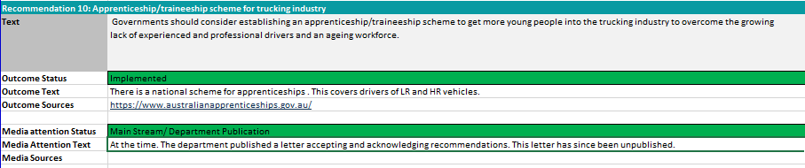
Review’s Comments:
- The link provided does not help find any specific apprenticeships for the trucking industry – it could be that this link is outdated and/or no apprenticeships available at the time of the review.
- There are, and already was, existing apprenticeships available, proposed and targeted towards younger audiences prior to the inquiry ( https://www.abc.net.au/news/2016-06-15/proposed-truck-driving-apprenticeship-to-attract-younger-people/7513278).

Recommendation 14: Industry Associations to proactively engage with drivers and small businesses
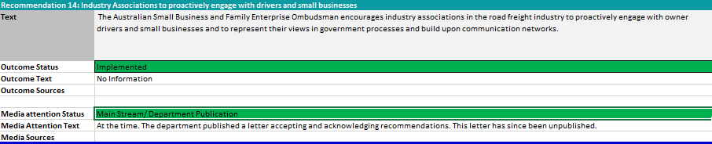
Review’s Comments:
- No reasonable means to determine at face value if this has been implemented or not – with outcome text as “no information”
- Ongoing or further inquiry may assist in determining the outcome of this with the evidence of this follow-up attached.

Payment Times and Practices Inquiry - 3
Recommendation 4: Publication of Australian Government payment times and policies.
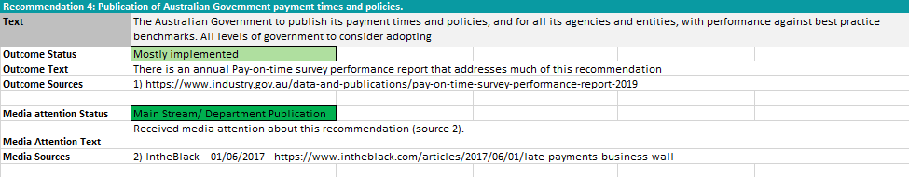
Review’s Comments:
- The survey referred to which categorically considers this as “mostly Implemented” has been conducted annually since 2002.
- It is difficult to infer that the publication of data was a result of ASBFEO’s recommendations.

Affordable Capital for SME Growth Inquiry - 4
Recommendation 2: Government Guarantee Scheme
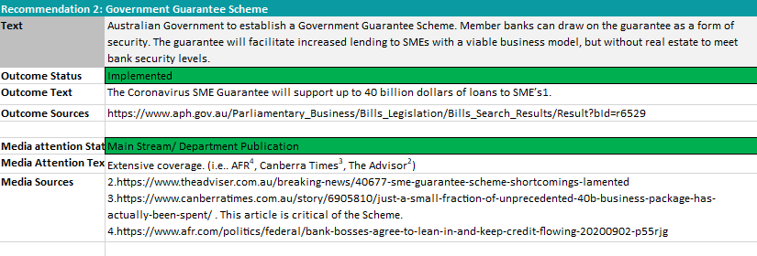
Review’s Comments:
- Implemented as a result of the impacts of COVID-19. Although the inquiry may have been a factor in the implementation, it cannot be reasonably inferred that this scheme was instituted solely due to the ASBFEO’s inquiry (no mention of ASBFEO in the bill or resources).

Recommendation 8: SME guide to financial products
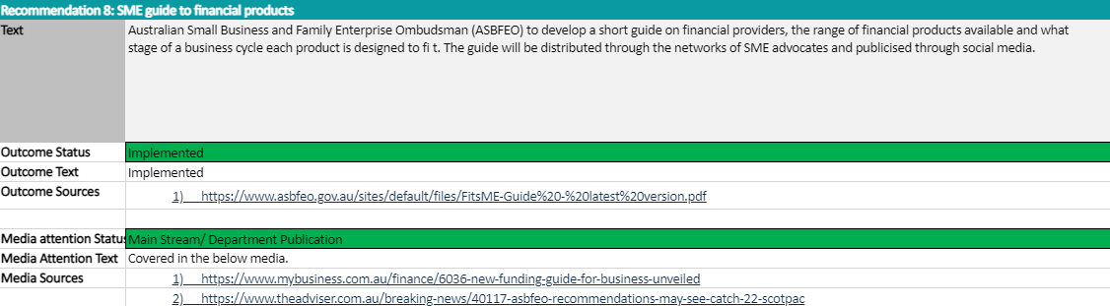
Review’s Comments:
- This recommendation is by ASBFEO and directed to ASBFEO for action.
- ASBFEO should err on the side of caution when utilising the same to indicate or measure the effectiveness of an inquiry that they had conducted.

Insolvency Practices Inquiry - 5
Recommendation 6:
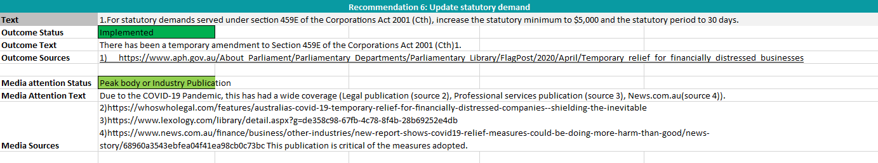
Review’s Comments:
- Implemented as a result of the economic impacts of COVID-19 as a temporary solution. No permanent/ongoing solution.
- Although the inquiry may have been a factor in the implementation, it cannot be reasonably inferred that this scheme was instituted solely due to the ASBFEO’s inquiry (no mention of ASBFEO in the bill or resources).

Reviews
Review of Payment Times and Practices – 2
Recommendation 5: Impact of Supply Chain Financing Options
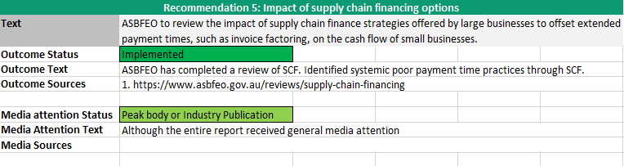
Review’s Comments:
- Recommendation from ASBFEO to ASBFEO – concerns as mentioned above.

Review of Supply Chain Financing – 4
Recommendation 4: SCF as a real choice
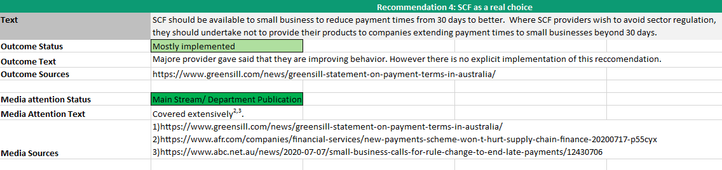
Review’s Comments:

- The outcome text states, “No explicit implementation of this recommendation”. This possibly signifies a lack of evidence to consider this recommendation as “Mostly Implemented”.
Recommendation 6: Further review from competition perspective
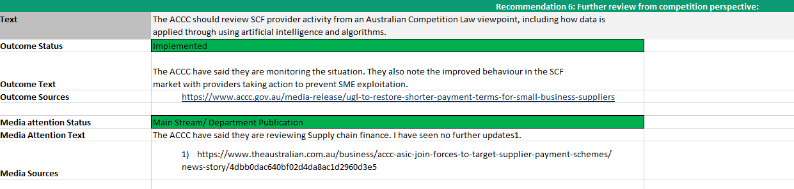
Review’s Comments:
- The Outcome Text of “ACCC monitoring the situation” may not be enough evidence to consider this has been successfully implemented. Potentially, “Mostly implemented” may be the more appropriate designation, however, the Review considers the actions performed by the ACCC more akin to the status of “Signalled Support”.

Attachments

Attachment I: Australian Small Business and Family Enterprise Ombudsman Review Discussion Paper

Review of the Australian Small Business and Family Enterprise Ombudsman: discussion paper

March 2021

This discussion paper provides information about the review of the Australian Small Business and
Family Enterprise Ombudsman (ASBFEO).

The law [Australian Small Business and Family Enterprise Act 2015 (Cth)] requires that the operation of the Australian Small Business and Family Enterprise Ombudsman’s (ASBFEO) office is reviewed every four years. The next review is due for completion by June 2021 and will take place between March 2021 and June 2021. Once completed, the findings of the review will be presented to the Australian Government.

The review will be conducted by Ms Carmel McGregor PSM, supported by Deloitte. This discussion
paper aims to provide information about the review process and the functions of the ASBFEO. It also
poses a range of questions for consideration for small businesses, government agencies and other
relevant stakeholders to assist with written submissions and consultation discussions.
ASBFEO was also reviewed previously, one year after it commenced in 2016. The report and other
information from the first review in 2017 can be found on the treasury website.

Background

The ASBFEO commenced operation in March 2016 and is now part of the Industry, Science, Energy
and Resources portfolio in the Australian Government.

The ASBFEO was set up to provide small businesses and family enterprises with a way to provide
their views on policy and programs to government, and to make it easier for them to access
assistance. The law states that ASBFEO’s functions are to:
- advocate for small businesses and family enterprises in relation to relevant legislation,
- policies and practices (the advocacy function);
- give assistance in relation relevant actions if requested to do so (the assistance function);
and
- perform any other function conferred on the Ombudsman by any Act or legislative
- instrument.

Assistance function
The ASBFEO responds to requests for assistance from small businesses and family enterprises that
have a dispute with other businesses or Commonwealth Government agencies.
Assistance with disputes can take the form of providing information on how to fix the issue,
facilitating discussions between the parties and if required, providing access to another dispute
resolution service or agency that can assist. The ASBFEO provides tips, guides and case studies to
assist small businesses and family enterprises looking for help with a dispute.

The ASBFEO also assists small business with information, resolution options and access to mediation
and/or arbitration services in relation to disputes that are covered by a mandatory code, for
example:
- The Dairy Code of Conduct which covers trading arrangements between parties to a milk
- supply agreement within the dairy industry.
- The Horticulture Code of Conduct which aims to improve trading arrangements between
- growers and traders in the horticulture sector.
- The Oil Code of Conduct which regulates the conduct of wholesalers and fuel resellers.
- The Franchising Code of Conduct which regulates the conduct of participants in franchising.

The ASBFEO offers a Small Business Concierge Service that helps small businesses apply to
the Administrative Appeals Tribunal (AAT) for a review of an Australian Taxation Office decision. The
Concierge Service guides and supports the small business through the process. This includes
information on the AAT procedures for reviewing a decision; access to legal advice and fee
reductions; and ongoing support. Additionally, the ASBFEO provides a small business compensation
assistance service to help small businesses navigate the compensation for detriment caused by
defective administration (CDDA) scheme as it relates the Australian Tax Office.

There are a number of other assistance services provided by the ASBFEO, including web-based
advice and information about running a small business and a business hub. There has also been a
recent strong focus on assisting businesses to manage the impact of COVID-19 and natural disasters
such as the 2019-20 summer bushfires.

Advocacy function
Another function of the ASBFEO is to advocate on behalf of small businesses and family enterprises.
This can take the form of providing advice to government on policy proposals, conducting inquiries
or providing advice to other inquiries.
Recently the ASBFEO completed an inquiry examining Access to Justice for small business and family
enterprises. The inquiry examined disputes that arise, what small businesses do when faced with a
dispute and the factors that influenced their decisions about what action to take in a dispute. The
final report made recommendations to improve access to justice for small business owners.
The ASBFEO has also completed a number of other inquiries on diverse topics:
- Insurance Inquiry
- Insolvency Practices – the final report was released on 21 July 2020
- Affordable Capital for Small to Medium Enterprise Growth
- Payment Times and Practices
- Small Business Loans
- Impact of the Road Safety Remuneration Tribunal Payments Order

Terms of reference
The Australian Small Business and Family Enterprise Ombudsman Act 2015 (the Act) requires a
review of the operation of the Australian Small Business and Family Enterprise Ombudsman
(ASBFEO) every four years.

Since its establishment in 2016, ASBFEO has developed and enhanced its assistance and advocacy
functions and acquired several new services. The first review of ASBFEO was completed in June
2017.

This review will examine:
1. the kinds of assistance requested during the Review Period and whether the assistance
provided was convenient and effective for the operators of small businesses and family
enterprises;
2. how ASBFEO has responded to the recommendations of the 2017 review;
3. the interaction and effectiveness of ASBFEO’s functions, including any new roles acquired
since the previous review; and
4. whether there are any legislative and administrative improvements that could better
support ASBFEO in the delivery of its functions.

The review will include a public consultation period of a minimum of four weeks. The review and
written report must be provided to the Minister for Employment, Skills, Small and Family Business
no later than 19 June 2021.

Consultation questions
The following questions are provided as a guide for submissions or discussion with the Reviewer.
However, they are not intended to be exclusive and stakeholders are welcome to raise any relevant
issues that relate to the operation of the ASBFEO.
Proposed questions:
- What kind of assistance has the ASBFEO provided your business during the Review Period
(2017-2021)?
- Did the assistance provided resolve the issue or dispute? What more could be done to help
businesses resolve disputes?
- How has the advocacy work performed by the ASBFEO benefited small and family
businesses? Are there any improvements that could be made to the advocacy work?
- How does the ASBFEO work with other key stakeholders such as government agencies, small
business commissioners and services such as legal or community services?
- Are the current legislative and administrative arrangements that support the ASBFEO fit for purpose or can they be improved?
- Other issues and suggested improvements?

Consultation process
Written submissions are invited by the head reviewer, with a closing date of 30 April 2021.
Key stakeholders will be invited to participate in consultation discussions with the head reviewer.
Other parties can indicate interest in participating in discussions by emailing SmallBusinessOmbudsmanReview@industry.gov.au. Due to the current travel restrictions in some
parts of Australia, it is likely that consultation discussions will be held via video or teleconference.

Australian Small Business and Family Enterprise Ombudsman Act 2015 (Cth) (‘ASBFEO Act’) s 15.
Ibid s 71.
Ibid s 68.
ASBFEO, Quarterly Report (Q1 2021).
Ibid s 13
Ibid s 14.
Ibid Pt. 3 Div. 2 s 36
ASBFEO, Quarterly Reports (Q1 2016 – Q4 2020).
Ibid s95.
ASBFEO, Quarterly Report, Q4 2020.
Total of “Contacts Received” as per ASBFEO Quarterly Reports Q3 2017 – Q1 2021.
ASBFEO Act s15(a)
Ibid s15(c)
Ibid s91A
Data on enquiry types is taken from ASBFEO Quarterly Reports Q3 2019 – Q4 2020. ATO/Tax Concierge/AAT and Industry Codes of Conducts categories were reported on from Q3 2019 – Q4 2020, as such we have selected this period for data uniformity purposes. The Q1 2021 Report has been excluded from this table as the enquiry type breakdown had changed from this point onwards.
ASBFEO Website, Case Studies, <https://www.asbfeo.gov.au/assistance/case-studies>
ASBFEO Act s15
ASBFEO, Annual Reports, 2017– 2020
Q3 - Q4 of 2020 and Q1 of 2021 are excluded. If these periods were included, data would be assumed as ASBFEO’s reporting quarterly data for this period is percentage based and not absolute data.
ASBFEO, Quarterly Reports, Q3 2017 – Q1 2021
Appendix “H” - Correlation Coefficient Explained
ASBFEO, Quarterly Reports, Q3 2019 – Q4 2020
11,597 total according to the Quarterly Reports of this period
ASBFEO, Quarterly Reports, Q1 2016 – Q4 2020
Appendix C, Small Business Survey Results
Excluding first quarter report (incomplete quarter) and first whole quarter to exclude outlier of 1116% increase from 93 followers to 1131 followers across all platforms).
ASBFEO, Quarterly Reports, Q1 2016 – Q4 2020
ASBFEO, Quarterly Reports, Q1 2016 – Q4 2020
ASBEFEO Act s 13.
Australian and New Zealand Ombudsman Association, “Essential criteria for calling a body an Ombudsman” <http://www.anzoa.com.au/assets/anzoa-policy-statement_ombudsman_essential-criteria.pdf>
Cambridge University Press, Definition of independence from the Cambridge Business English Dictionary
Cambridge University Press, Definition of impartial from the Cambridge Advanced Learner's Dictionary & Thesaurus
See Chapter 7 above on data surrounding advocacy activities
See Appendix “E”
See Appendix “F”
See Appendix “D”
ASBFEO Act s 13
Ibid s 15.
Ibid 71.
ASBFEO.gov.au, Case Studies, < https://www.asbfeo.gov.au/assistance/case-studies>
ASBFEO, Quarterly Reports, Q3 2019 – Q4 2020
Deloitte was engaged to provide secretariat support to Ms McGregor in the conduct of the Review.

