
Small Business
Digital Taskforce

Report to Government
  - March 2018



Chair’s Foreword
Australia’s 2.1 million small businesses power the Australian economy. The best opportunities to grow the economy and create jobs come from developing the capability and productivity of small businesses. In the 21st century, an increasingly important capability is for small businesses to adopt and successfully implement digital technologies.
This Taskforce was established to look at ways to accelerate the rate of small business digital adoption by raising awareness of the opportunities that ‘going digital’ presents. We have been asked to provide recommendations to government on the best methods to make this happen.
The Taskforce believes that the current ecosystem for providing small businesses with information and advice is disjointed and in need of repair.
Small businesses:
- tend to be suspicious of tech companies’ pitch to buy their products;
- tend not to go to government for digital advice, and governments’ efforts to engage small businesses online have been mixed;
- trust peak industry associations, but these bodies have not been able to provide best practice digital advice or effective digital awareness campaigns for their members; and
- trust their accountants’ advice on digital issues, but the profession lacks a central, authoritative reference point to source this advice.
The Taskforce recommends the establishment of a new independent body to serve as a central point for information and advice on digital options for Australian small businesses and their advisers.
The Taskforce’s vision is that this independent body will provide small businesses, industry associations, the accountancy profession, and others, with tailored, up-to-date, and easily accessible information and advice on digital best practice. At its centre, the new body will maintain a curated online platform which will be recognised internationally as the ‘gold standard’ for digital small business advice.

Significantly, the proposed new body will:
- partner with industry associations and Small Business Commissioners to facilitate a flow of information relating to small businesses’ digital needs and best practice digital advice; and be the main vehicle through which the federal government promotes awareness of the benefits of digital adoption for small businesses.
This report makes a number of recommendations to promote digital awareness, based on the insights of businesses themselves in a user-centred design process. These include video and audio case studies promoting digital success stories, an online ‘digital health check’ tool, supporting industry associations with ‘digital best practice guides’, a local ‘digital champions’ programme providing trusted sources of local advice and digital roadshows targeting regional areas. The recommendations are all designed to reach out to small businesses and their advisers and sell some key messages:
- ‘going digital’ will save a small business time, allowing more time to spend on the business or with family;
- ‘going digital’ will provide a small business with the flexibility and mobility to work ‘anywhere, anytime’;
- ‘going digital’ can increase a small business’ revenue by reaching new customers and markets; and
- ‘going digital’ will protect a small business’ investment.
Ideally, the Taskforce believes that these recommendations should be pursued by the new body. But the federal and state governments should not wait: the time to raise awareness is now.
The Taskforce is excited by the opportunity to create an integrated and curated framework for small business digital information and advice. A highly regarded independent body that effectively coordinates and markets digital information and advice will establish Australia as a world leader. This will be a significant achievement.
I would like to thank all Taskforce members for their commitment to realising our important agenda. I also extend my sincere thanks to the small business people who have given generously of their time to contribute to the Taskforce.
Yours sincerely
Mark Bouris AM
Chair, Small Business Digital Taskforce

Taskforce Membership


Mark Bouris AM
Executive Chairman, Yellow Brick Road
“I am very passionate about working in collaboration with small business and finding ways to support the millions of small businesses who are the heart of the economy.”

Hon Craig Laundy MP
Minister for Small and Family Business, the Workplace and Deregulation
“Embracing digital technology enables productivity, profitability and time saving aspects that small and family businesses can really benefit from now and into the future.”

Spiro Pappas
Executive General Manager
Global Institutional Banking, National Australia Bank
“The small business challenges are significant and we need to tackle these challenges in order to create jobs of the future”


Pip Marlow
CEO Customer Marketplace,
Suncorp Group Ltd
“Small businesses are the engine room of the Australian economy and the more they thrive, the more the country thrives.”

Gerd Schenkel
Managing Director of BGA Digital
“It’s important for the country that we remain competitive and innovative and small business adopting digital technology is critical for that.”

Hon David Coleman MP
Assistant Minister for Finance
“It’s really important strategically for Australia that we continue to embrace digital technology as so much of our economic growth relies on it.”

Su McCluskey
Proprietor, Cluskers Stud
Chairperson of Energy Renaissance,
Director of Australian Unity and Director of the Foundation for Young Australians
“By helping small business to embrace digital technology and grow, you are helping the economy to grow.”

Purpose and Terms of Reference

Purpose of the Taskforce
Improving digital engagement could significantly improve small business productivity in Australia, and help create an economy that is strong, dynamic and digitally sophisticated.
The purpose of the Taskforce is to accelerate the rate of small business digital adoption by increasing awareness of key digital economy opportunities, drawing on advice from business, and building on and informing existing government initiatives.

Process
The Taskforce will report its findings to the Treasurer and the Minister for Industry, Innovation and Science by 29 March 2018.

Terms of Reference
The Taskforce will examine and identify the opportunities to small businesses from engaging and increasing their participation with the digital economy. The Taskforce will provide examples of small businesses that are taking advantage of digital technologies and demonstrate the benefits that these businesses have achieved. These examples should consider how digital technologies are improving:
  - relationships with customers;
  - management and performance of businesses;
  - interactions with government at the Commonwealth, State and local levels; and
  - the productivity and innovation within businesses.
The Taskforce should also identify the key risks to small businesses of not engaging in the digital economy.
The Taskforce should identify regulatory or other impediments (such as cultural/behavioural barriers) to small businesses adopting new digital technologies to support their business and improve their productivity. It will also make recommendations on the most effective way to provide information to small business on the benefits of the digital economy.
The Taskforce will consult with relevant Government departments such as the Department of Industry, Innovation and Science on how its work can inform the development of the Government’s national Digital Economy Strategy and complement the work being done on the National Business Simplification Initiative. In doing so, the Taskforce should consider the findings from existing research that has been undertaken on business digitisation, such as the Department of Industry, Innovation and Science’s research on small and medium enterprise digital capability, and work by the Australian Taxation Office (ATO) regarding Single Touch Payroll.

Table of Contents

Executive Summary 6
Recommendations 8
State of Play 10
What are the challenges for small business in ‘going digital’? 16
What are the benefits for small business in ‘going digital’? 19
Case studies 25
What are the risks in not ‘going digital’? 36
Attitudinal drivers for small business ‘going digital’ 37
Structural drivers for small business ‘going digital’ 38
What are governments doing? 39
The role of service providers 43
Appendices 45
Appendices 2 47

Executive Summary
Digital technology offers small businesses in all sectors of the Australian economy both commercial opportunities and greater work-life balance. A small business can use a point of sale system, an accounting software package, a customer relationship management system, and a variety of phone apps, to grow their revenue and increase their return on investment. ‘Going digital’ can enable a business owner to work ‘anywhere and anytime’, to spend more time with family, and to protect the value of the business. And yet many Australian small businesses are delaying, ignoring, or simply are unaware of digital opportunities, and failing to realise the economic and lifestyle advantages that digital tools clearly offer. Why is this the case? How can the rate of digital adoption be increased?
This Taskforce was established to increase awareness among Australian small businesses of the value in using digital technology. The Taskforce approached this task from two complementary perspectives:
- a ‘user-centred’ approach focusing on the mindset and views of small business owners who have struggled, and who have succeeded, in ‘going digital’; and
- a system-level approach, highlighting the shortcomings of the current ecosystem that coordinates the digital advice that small businesses receive.

A small business perspective
Initially, the Taskforce wanted to understand the factors that might inhibit a small business from adopting digital technology. It drew from recent government funded user-centred research, which shows that many small businesses don’t see how digital technology would benefit their business; they fear the impact of digital on their tried and tested analog processes; they lack the time to look into digital options, but when they do inquire they become overwhelmed with information (p. 23).
There are also ‘structural’ challenges including poor (or no) internet connectivity (especially in rural and regional Australia), concerns with cyber security, and a customer base that demands ‘old methods’ (p. 24).
Significantly, the challenges of ‘going digital’ will vary from business to business depending, among other factors, on the age of the business and its owner.
In light of these challenges, the Taskforce wanted to understand the business mindset and the circumstances in which a small business successfully adopts digital technology. This report presents case studies of 11 Australian small businesses of different sizes, and in different sectors and stages of development. The case studies show that many decisions are based on the need to fix a problem, a fear of ‘being left behind’, customers’ expectations, and the need to maintain the value of the business when it is time to exit. Often, it is an accountant or another ‘trusted adviser’ that gives a small business owner the advice on what technology to use, where to purchase it, and how to use it.
The role of ‘trusted advisers’ is crucial. User-centred research shows that small businesses trust the information and advice they receive from their accountants and industry associations; they tend to trust local sources of advice; they want advisers to show them how to use and implement digital products; and they are receptive to success stories of businesses like them.
The Taskforce believes that the best way to accelerate the rate of small business digital use is to equip the trusted adviser with the right tools, information and skills so they can expertly help the small businesses they engage with. But to do this, change is needed.

Connecting the ecosystem
This report argues that the ecosystem that provides small businesses and their advisers with digital information and advice has become disjointed. Multiple federal and state government agencies have programmes and policies to promote digital awareness, without much coordination of their efforts. Further, it is difficult to navigate the many private sector products and services offered by Australian and international companies. There is not a lot by way of independent, timely comparison of these products and services. The digital information and advice that industry associations provide to their members is piecemeal.

Headline recommendation
The Taskforce recommends establishing a non-governmental organisation (NGO) that can distil and disseminate information and promote small businesses’ awareness of digital issues.
The Taskforce recommends that the Federal Government first conduct a scoping exercise to assess the most appropriate legal vehicle to establish the NGO, the resourcing requirements, digital platform development and best practice models.
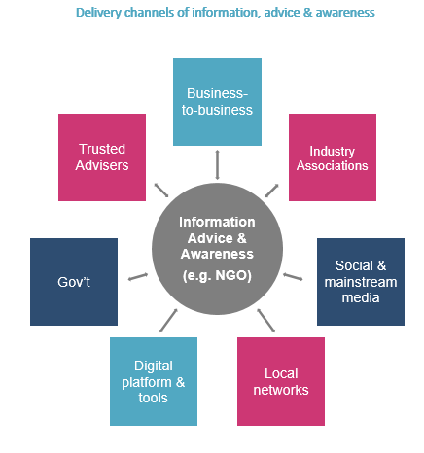
This proposed body will:
- consolidate, disseminate, and simplify the information and advice on digital options provided by government and the private sector;
- establish a two-way flow of information between the NGO and industry associations and Small Business Commissioners;
- have a multi-channel approach, recognising the diversity of small businesses’ digital needs depending on the sector in which the business operates, the mindset of the owner, and the business’ stage of development;
- be the main vehicle through which the federal government will promote awareness of the benefits of digital adoption for small businesses;
- establish and enhance business-to-business information sharing and best practice;
- develop and deliver business benchmarking tools to enable businesses and advisers to assess the ‘digital health’ of a business; and
- promote, coordinate and amplify awareness campaigns on digital issues of concern to small business, including cyber security.
The Taskforce believes that through the proposed NGO, Australia has an opportunity to lead the world in promoting digital awareness in the small business community. The proposal is bold, original, and necessary. It will strengthen existing channels by developing a partnership between the NGO and industry associations. Australian small businesses will be the main benefactors, able to confidently capitalise on the many opportunities that the digital economy will present.

Recommendations
1. Establishment of a non-governmental organisation (NGO). The Taskforce recommends the establishment of an NGO to serve as the central, national point for information and advice on digital opportunities for Australian small businesses and their advisers. To establish the NGO as a reliable and trusted source of advice, it is important that proper consideration be given to the remit, legal form, funding and administrative support needed to run the body. The Taskforce therefore recommends that the Federal Government first conduct a scoping exercise to assess:
- the resources necessary to develop a digital platform to support the functions of the NGO. This assessment would observe the Government’s Digital Service Standard process;
- appropriate national and international best practice examples of NGOs designed to support the capability of small and medium businesses, including funding models; and
- options on the appropriate legal vehicle and governance structure in which to establish and create this NGO.
The Taskforce recommends that the Federal Government establish a Working Group to oversee the scoping exercise. The terms of reference for the Working Group should be set by the Minister for Small and Family Business. The Working Group should have the funding necessary to engage private sector expertise.

Awareness and Engagement
The following recommendations can be assessed and taken forward by government separately from the development of an NGO. The NGO may deliver some of these initiatives in the future.
- Develop/support an annual event for small business, which highlights and explores emerging digital technology developments and related issues impacting small business. Attendees would including vendors, industry associations, government, university students and small businesses. The event would include a marketplace to enable vendors and suppliers to showcase new digital applications and services as well as potentially the new Small Business Awards announcements (below).

- Explore the development of a new Small Business Awards programme. This would be sponsored by industry and complement existing business awards such as Telstra Business Awards and the Australian Information Industry Association (AIIA) Awards but would highlight the ‘unsung’ small business owners who are loved by their customers. It would also showcase small businesses that are using digital technology to enhance their customer experience. The Awards would form part of the annual event.

- Develop and aggregate video and audio case studies and success stories of small businesses that have gone digital. Use existing and new distribution platforms such as business.gov.au, Facebook, YouTube, the ATO, State/Territory sites as well as traditional media to test the impact. Explore with Data61 how to aggregate case studies across public and private sectors to take advantage of the many case studies that already exist.
- As part of the development of case studies, work with digital platform and peer-to-peer service providers (e.g. eBay, Amazon, Uber, Freelancer etc.) to identify small businesses utilising platforms and peer-to-peer services to grow and scale their businesses.

- University student – Business connections.
Explore how businesses can be made more aware and utilise university students studying IT, marketing, business and related fields for short term and project work to help raise the digital capability of businesses and make university students more job-ready. The Ribit platform, developed by CSIRO/Data61, is a service to leverage.

Supporting Trusted Advisers
- Develop an awareness and communications campaign and tools targeting the trusted advisers and intermediaries of small businesses such accountants, industry associations, banks and even spouses/partners of business owners.
- In support of the trusted adviser, develop a small business digital health check tool to enable small businesses and their advisers to assess the level of digital maturity of the businesses. Use benchmark data across government and private sector to indicate to the businesses where they rank amongst their peers (by industry, size, location etc.) Provide them with links to resources, advice and local events to enable them to raise their digital sophistication. Leverage existing examples including Queensland’s Digital Health Check and New Zealand’s Digital Journey.
- Raise the digital capability of industry associations. Work with a selection of willing and engaged industry associations to develop specific digital playbooks or digital best practice guides for their specific business sector. For example, “the top 5 digital tools for tradies”. This would enable the industry association to provide specific and consistent support for their membership. Initially pilot industries where the data indicates their level of digital uptake is low (e.g. construction or agriculture). A government grant programme may be the appropriate funding vehicle.

Supporting Local and Regional Networks
- Explore scaling the Queensland Local Digital Champions Programme nationally. Local digital champions will volunteer/be nominated by local communities as a touchpoint for information and advice on helping local businesses more effectively use digital technologies. They will also be able to direct businesses to trusted information sources and professional business advisory services.
- Digital Advice Roadshows for regional communities. Explore existing roadshow models (ATO, Google, AusPost, NBN) to develop a public-private partnership model to create ‘pop-ups’, travelling ‘fix-it squads’ and digital business experts to travel where businesses are. It will be a demand-driven model where communities (with the help of local digital champions) will aggregate demand and interest before the roadshow comes to the community. This way roadshows can be scheduled and prioritised base on greatest community need/engagement.

State of Play

Small business – no ‘one-size fits all’
The Australian small business sector is very diverse, covering a multitude of industries and business activity.
Approximately 70 per cent of businesses are family owned and operated; one-third are owned by migrants; one-third are owned by women; one-third are located in regional areas. Nearly
60 per cent of small businesses are sole traders or independent contractors with no employees. Only seven per cent of small businesses are turning over $2 million or more per year.
Even within these segments, the attitudes and motivations of business owners varies significantly. Many business owners are less interested in growing their business as they are in the lifestyle factors they perceive in working for themselves.
In 2016 - 17 there were approximately 328,000 businesses entering the market and 261,000 exiting. The different stages of a business - from starting to exiting – can also strongly influence the motivations for adopting digital technologies.
The diversity in small business activity, attitudes, business stages and motivations means that the trigger points and motivations for adopting digital technologies varies greatly within the sector. There is no ‘one size fits all’.

What do we mean by ‘digital’?
We define digital technology as the outward or customer facing technology (such as websites, social media and e-commerce applications) as well as the inward facing business process technology (such as cloud software, customer relationship management and supply chain management).
The term ‘digital maturity’ encompasses the extent to which a business uses digital technology to improve its performance and competitive advantage.
A digitally mature business is one that uses digital technologies to drive productivity and customer value. Those at the frontier are constantly exploring and experimenting with new technologies to drive value. There is no stasis point of digital maturity. In fact it is just the opposite.
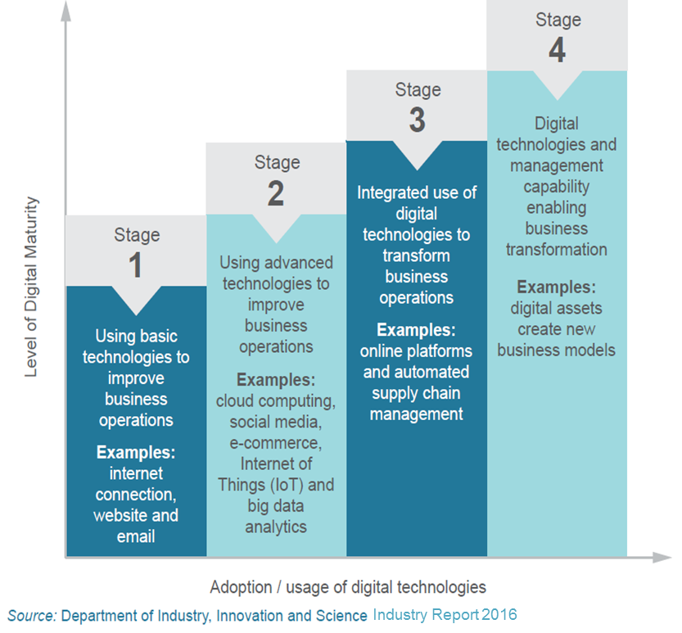
The stages to digital maturity for a business are not always linear and depending on its size, business life-cycle, and industry-type, a business will have different drivers and opportunities for adopting digital technologies.

Ingredients to thrive
The use of digital technologies alone will not unlock the potential of a business to thrive in the digital economy. Some businesses actually have little potential as their business model is untested or they are not motivated to grow and transform. Those businesses that were thriving in the digital economy have five inter-related ingredients:
- Business acumen – a tested business model, a good understanding of their customer and where they fit in the value chain, strong leadership and a vision for the future.
- Cash flow – enough financial resources to invest in technology and be flexible as circumstances change.
- Motivation to grow and transform – a willingness to experiment and internally disrupt their processes and business model to drive growth and transformation.
- Access to trusted advice and information – access to trusted advisers, support networks and information to allow confident decision making.
- Effective use of digital technologies - means using it to improve business processes, drive productivity and enhance customer offerings.
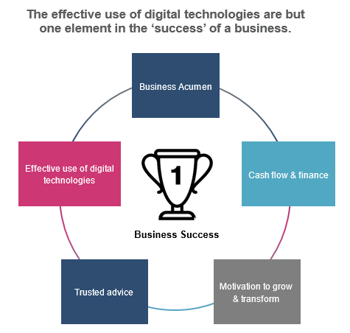

“I do stress to my clients that digital technology is just a tool. It can make processes more efficient but it is not a silver bullet to all businesses issues.” Business owner/adviser

Australian Small Business Segments

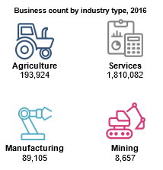

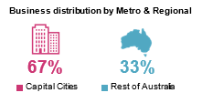
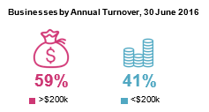
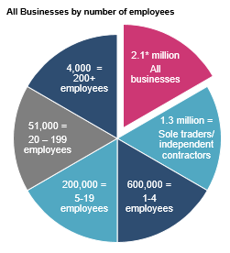
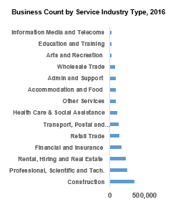
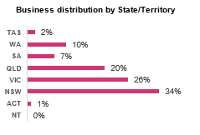
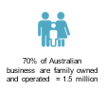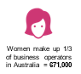

Of the 2.1* million businesses in Australia nearly 60% are sole traders or independent contractors. Backed by Australian Bureau of Statistics (ABS), there is a strong correlation between the size and its ability to effectively use digital technologies. Many small and micro businesses are neither ready, willing nor able to fully embrace digital technologies

Small Business Personas
In a complementary project conducted by the Department of Industry, Innovation and Science exploring what is holding back small businesses from adopting digital technologies, a number of small business personas were identified. A persona is a representation of a group of users with similar characteristics and experiences. Personas can help better target solutions by better understanding the business needs and motivations of the ‘user’. For example, there are some personas (‘Desperately Seeking’; or ‘Business Transformer’) that may be less attracted to online portals and seeking information online than they are with face to face support. The Taskforce took account of the diversity of small business persona types in developing its recommendations. More information on these personas is at the Appendix.

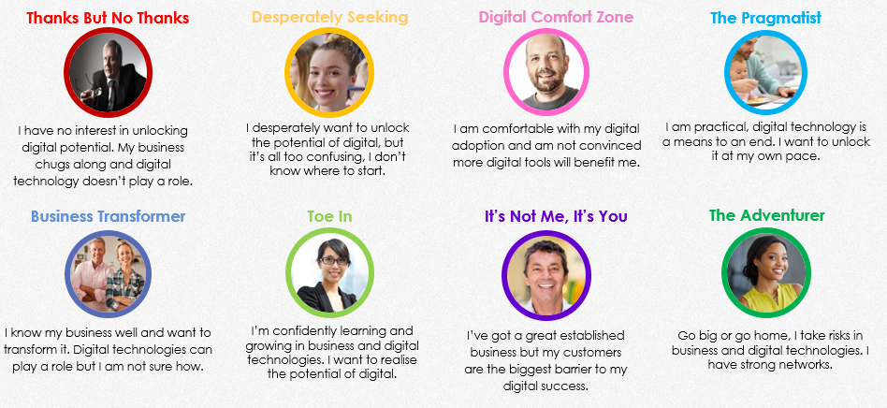State of Play - Australian Business use of Digital Technologies
Data from the Australian Bureau of Statistics (ABS) shows on the one hand Australian citizens are voracious users of digital technologies and services, but on the other there isn’t the same level of usage or adoption among small businesses. This is an opportunity missed by many small businesses and this was highlighted recently by Telstra’s Small Business Intelligence 2018 report. It clearly showed that customer expectations of small business is that that they are findable online, they have a web presence and customers can transact online with them.
The ABS data shows that while over 50% of all Australian businesses now have a web presence, fewer small business are utilising these ‘outward facing’ technologies than they are using the business process software such as accounting and invoicing software services.
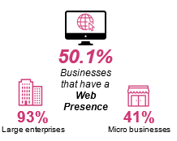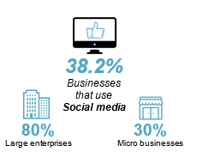
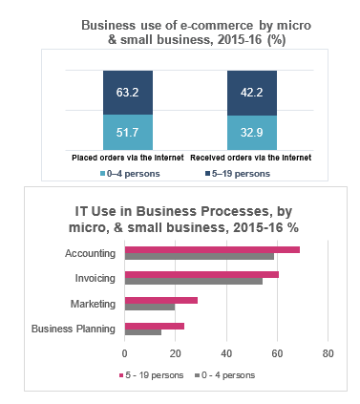
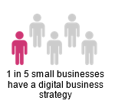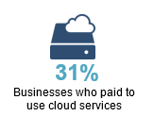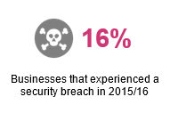

What are the challenges for small business in ‘going digital’?

The challenges
The Taskforce recognises that there are numerous challenges to small business in adopting digital technologies – the most common one cited being a lack of time. But when this issue is unpacked, the related issues include: too much information; a lack of trusted information; uncertain return on investment (RoI); and perceptions that the time and cost of implementing a new system are prohibitive.
These challenges can also be exacerbated by attitudinal fear and resistance and a lack of trusted advice available to small business owners.
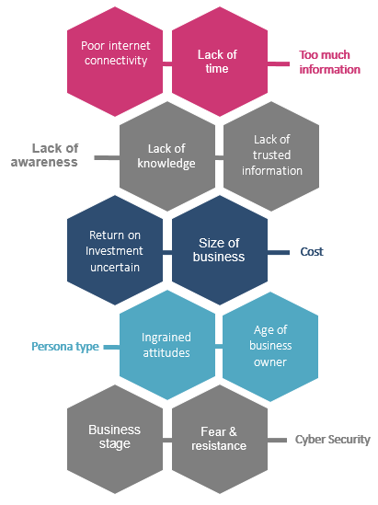

What are the challenges in ‘going digital’?

Not enough time
In stakeholder interviews, this was a recurring theme: “We are just too busy running our business to think about changing our systems.” Small business owners can perceive that the time involved in researching and trialing new technology outweighs the benefits.

Where to first?
Lack of time, however, is part of a broader problem. Time-poor small business people do not know where to start looking. Fundamentally, there is a lack of awareness when it comes to digital adoption - small businesses ‘don’t know what they don’t know’. Small business owners don’t know what technologies are available, let alone how what is available could benefit their business. This lack of awareness was a key theme in stakeholder discussions.

Ingrained attitudes
The Taskforce recognises that there is, and will always be, a cohort within the small business community that will not adopt digital technologies, even if there are opportunities presented. Typically, these businesses are well-established with a stable customer base that is familiar and comfortable with their analog approach. The commercial need for change is not apparent. The general attitude of these businesses is: ‘this is the way we have always done things, it’s worked, so why change? Indeed, Deloitte has found that small and medium sized businesses that have been in operation longer ‘tend to have lower levels of digital engagement’ (2017, p.15).

Too much information
Small business owners who do begin looking into digital options can quickly become overwhelmed by the amount of information they’re confronted with. It is often difficult to know what information to trust, and what information to ignore. ‘Information overload’ was another theme identified in stakeholder discussions. The Taskforce’s recommendations reflect the importance of small business owners having reliable, trustworthy channels to access tailored information.

Fear of the unknown
A closely related challenge for a small business in adopting new technology is overcoming fear of the unknown. A concern for many small business owners is not knowing what impact a new technology will have on existing business processes. Will there be difficulties implementing the technology? Will there be troubleshooting support? How will the technology impact staffing levels and reporting and compliance processes? Will the technology deliver a return on investment? Concern about these issues can deter a small business from ‘going digital’.

Internet connectivity
The issue of connectivity is fundamental to the goal of small businesses ‘going digital’. Without a fast, reliable and affordable internet connection, a small business will struggle to find and retain customers, and operate efficiently.
Notwithstanding the achievements of the national broadband network (nbn), many small businesses in Australia have difficulty with this access. In a 2017 Xero survey of more than 1000 Australian small businesses, 70 per cent of those surveyed said poor connectivity was hindering their efficiency and productivity.
The challenge of connectivity is greater in regional areas. The lack of reliable internet connection was the major theme during the Taskforce’s discussions with Toowoomba-based businesses. Many of these businesses noted the commercial limitations of the current level of connectivity.

Cyber Security
In the context of increasing the rate of small business digital adoption, the issue of cyber security is a two-edged sword. On the one hand, small business owners’ perception that their data can be hacked and stolen is clearly a deterrent to digital adoption. A survey by the NSW Small Business Commissioner in 2017 found that 42% of survey respondents indicated they limited their digital presence to reduce the risk of cyber threats. There is clearly a sentiment within some Australian small businesses that their existing analog processes are a safer way of keeping data safe. On the other hand, the same perceptions can drive the uptake of most advanced digital technologies. Cyber security concerns have motivated many Australian small businesses to move from desktop-based to cloud-based computing systems, reflecting the many practical and security benefits of using the cloud.

What are the challenges in ‘going digital’? – What we heard
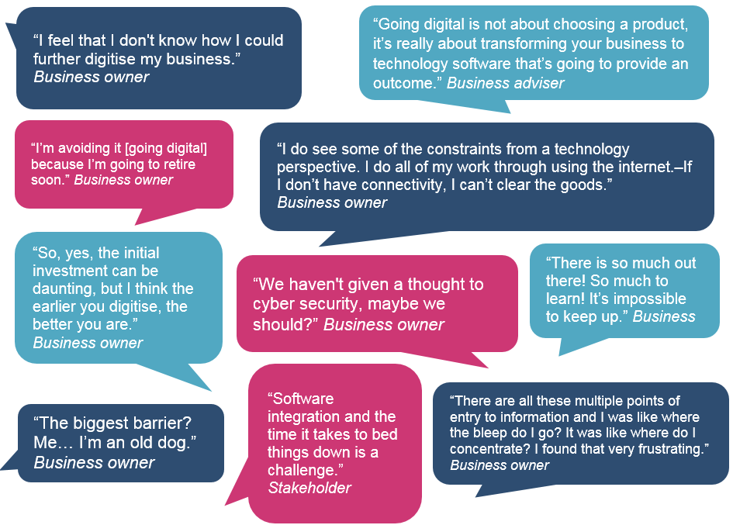

What are the benefits for small business in ‘going digital’?
Digital technologies offer opportunities for small businesses to work smarter and more efficiently, increasing cash flow and saving time on administrative tasks.
Having a web presence and selling online enables small businesses to access new customers and markets, which can increase revenue, profit and enhance the ability to trade internationally. Today’s customers are online and, increasingly, expect the businesses they interact with to be online as well. Digital technologies, including social media, can enable better customer service and responsiveness to changing consumer demands.
Digital technologies also offer greater mobility and flexibility for people starting and running a business. This creates additional opportunities for people in regional areas and people juggling family, study and career commitments.
Deloitte Access Economics found that small to medium- businesses with advanced levels of digital engagement are:
- 50 per cent more likely to be growing revenue and
- 60 per cent more likely to have more revenue per employee, than businesses with basic levels of digital engagement.
Further, productivity enhancements associated with adopting digital technologies contributed over $104 billion to Australia’s GDP over the decade to 2014.

The benefits
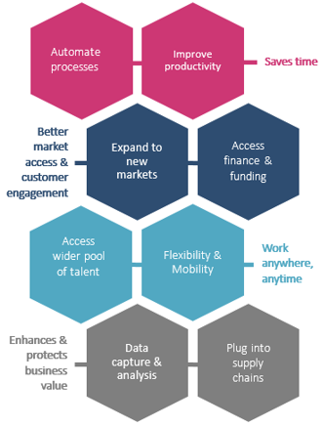

Saves time
- Small businesses are time poor. Many business owners are struggling with the administrative tasks that come with running a business.
- Using paper and ink or even excel spreadsheets to do accounts, invoicing, payroll and other operating processes is simply slower and less accurate than using integrated digital tools.
- Automated and digitised processes can free up more time for things like business planning and spending time with family and friends.

“Having things automated and not having to do things manually has just opened up time for us to look at developments for the business … like new products and growing the business.”
Trish Chapallaz, Solar4RVs
“Having things automated and not having to do things manually has just opened up time for us to look at developments for the business … like new products and growing the business.”
Trish Chapallaz, Solar4RVs
“Feedback from our customers about our software and the solution is, “why haven’t they done this sooner? It’s so easy to use.. “The technology itself makes their business easier to run and more productive.”
Glenn Skerman, AgData

Stats
1/3rd of their time – the amount of time the average Australian small business spends dealing with admin tasks
$56 billion – amount of money wasted per annum by Aus. & NZ businesses on unnecessary, time consuming admin tasks
81 – the number of working days per year the average small business spends on admin tasks

Greater market access & customer engagement
- Businesses need to go where their customers and suppliers are - that is increasingly online and on a mobile. Customers expect to be able to find, interact and transact with businesses online.
- Having a web presence and selling online enables small businesses to access new customers and markets, which can increase revenue, profit and enhance the ability to trade internationally.
- Being online also opens up opportunities to access a wider pool of talent, find different forms of finance and to plug into supply chains.

“The benefits I’ve seen through using digital tools like Facebook and LinkedIn is that they have helped us reach people beyond my network. It just opens networks and markets up for us.”
Melissa Anderson, AIL
“We have an ecommerce website and social media, which is a really important avenue for us to be able to connect with our customers and to be able to provide that personal interaction.”
Trish Chapallaz, Solar4Rvs
“… the biggest risk for businesses that choose to not embrace digital technology is that they are missing out on those market opportunities. Businesses can get efficiency and productivity gains by just looking at digital solutions internally. But equally there are a lot of external opportunities that they really need to be embracing and digital tools can help them do that.”
Will Laird, RSM

Stats
21.7 million – internet users in Australia (June 2017) and 3.9 billion worldwide
15 million – Facebook users in Australia (June 2017)
88 per cent – of Australians have a smartphone
$41.3 billion – online shopping spend by Australians in 2016. 35 per cent of ecommerce transactions completed on a mobile device

Work anywhere, anytime
- Free and low cost digital tools and apps combined with increasingly sophisticated mobile devices are enabling business owners and their staff to work anywhere, anytime.
- Physical real estate and IT hardware is expensive to buy and maintain. Working from home or on the move, and utilising cloud services adds flexibility to scale up or scale down depending on circumstances.
- When data is stored in the cloud, work can be done at anytime from anywhere with an internet connection.
- Digital tools allow remote teams to collaborate effectively.

“Digital technology has enabled me to work anywhere at anytime. I just pack up my car and I’m good to go. I’ve got my invoicing, credit card reader, newsletter signup sheet, I can take photos of my receipts. I’ve got everything on my phone and iPad and can work anywhere, any time. “
Marty Blair, M.ARTY Hairdesign
“Digital technology lets us contact our accountant at any time and talk to them about live numbers that are true to the day. We can account for our tradesmen no matter where they are and ensure they are arriving at jobs on time as promised.”
Tom Martin, Water Tight Canberra

Stats
1 in 3 – the number of Australians working part-time 2016
55 per cent – the percentage of Australians who would take a 20 per cent pay cut if they could work from home

Enhances & protects business value
- Digitising and automating the operations and procedures of a business will demonstrate to an investor or potential buyer that:
    - the business has value beyond the individuals running it;
    - it has the ability to scale;
    - the business data can be transparent and accessible.
- Having a professional web presence and social media following adds value to a business brand and creates goodwill, which can also be attractive to an investor or buyer.

“We’re constantly looking to grow our business. The technology that’s out there underpins our value and growth. Without that technology I don’t see how we could continue to grow.”
Glenn Skerman, AgData
“When we are doing due diligence for a client who may be looking to buy or sell a business we look at the digital platforms they are using. We want to know that those systems can continue when the business owner is gone and the business and employees are able to continue to deliver the services to the customer.”
Business adviser
“A business that is modern, has all the policies and procedures documented, and has great software platforms and IP policies will always be more valuable than a business that has manual documentation and relies on one person.”
Brad Bulow, Sammut Bulow

Stats
60,000 – the approximate number of Australian businesses for sale in 2017
420,000 – the approximate number of businesses owned by Baby Boomers (aged between 53-71) that may be looking to sell and retire over the next 10 years.

Case studies
The following case studies are examples of small businesses in Australia from a diverse cross section of industries, sizes and locations - who have adopted digital technology and are realising the benefits.
Eleven business owners were interviewed on camera about their business and digital journey, their challenges and hopes for the future, and any advice they might have for other small businesses about adopting digital technology.
The interviews can be found online at: Industry.gov.au/smalldigbiz-case-studies

Case Study: Morty hairdesign


Martina Blair
M.ARTY
Hairdesign
Sydney, NSW

To see more of their story, go to
Industry.gov.au/smalldigbiz-case-studies



‘‘If you want to be self-employed, digital is the way to go - digital technology has enabled me to work anywhere at anytime. I just pack up my car and I’m good to go.”
Marty started her business in 2011, following the birth of her child and wanted to return to hairdressing on own her terms and run a business that suited her family needs. Mobile hairdressing was the solution.
Marty’s customers range in age from 30-60 years old and are based across the north shore of Sydney.
‘I’ve found with digital tools you have to go in with an open mind and experiment and then find out what is best for you, your business and your customers. I’ve now created a mobile hairdressing business that has grown so I’m able to work 5 days.’
‘I find it important to connect with other businesses and networking groups to see what apps, digital platforms and services are working for them.’

Case Study: Water Tight Canberra


Tom Martin
Water Tight Canberra
Canberra, ACT

To see more of their story, go to
Industry.gov.au/smalldigbiz-case-studies



“I love digital technology. It’s given me my Saturdays and my afternoons back to spend with family and helped me build the successful business that I have now.”
Tom started Water Tight Plumbing eight years ago after finishing his studies and apprenticeship. He identified a niche in the strata maintenance market which has grown to be a large part of Tom’s plumbing business.
Tom’s customers are strata managers and individuals across the ACT.
‘The one thing I’ve learnt through every software that we’ve implemented, is that any cost you may have for it, saves you significant money in the long run in terms of administration cost and ease of doing business.’
‘In ten years’ time we will hopefully have doubled in size and using digital technology will mean we won’t be doing anymore administration as it will be built in.’
‘The advice I’d have for young plumbers would be to adapt to new technologies and to learn all the intricate features of the technology.’

Case Study: Sammut Bulow


Brad Bulow
Sammut Bulow
Ipswich, Queensland

To see more of their story, go to
Industry.gov.au/smalldigbiz-case-studies


“Our key message is that going digital is not about choosing a product, it’s really about transforming your business to technology software that’s going to provide an outcome.”
Brad and his partners, established Sammut Bulow, 15 years ago, with the aim of building lasting relationships with clients by understanding their needs and designing exceptional services to suit.
Sammut Bulow serves business clients in south-east Queensland.
‘The biggest accomplishments are when you can help a client go from a stressed life, a chaotic life, behind on lodgements, behind where they want to be financially, to a business where they can make decisions with confidence.’
‘Once you work out the benefits, they know it is a change they have to make and they end up loving the product as well because they’ve got more time to work on their business.’
‘It’s important to have a digital philosophy, especially for your business.’

Case Study: AgData Australia


Glenn Skerman
AgData Australia
Toowoomba, Queensland

To see more of their story, go to
Industry.gov.au/smalldigbiz-case-studies



“Thinking about the technologies we use, there’s probably two underlying reasons for the choice that we’ve made. One is improving customer experience. The other is the efficiency and productivity gains to be had within the business.”
AgData was started in 1984 by Glenn’s father who was an early pioneer in creating computer based systems to replace paper.
The business is based in Toowoomba with about 10,000 clients around Australia.
‘The benefits that we’ve seen from some of these newer technologies that we have implemented, comes from our customers. The feedback is typically “why haven’t they done this sooner? It’s so easy to use”.’
‘We’re constantly looking to grow our business. The technology that’s out there underpins that growth. Without that technology I don’t see how we could continue to grow the business.’
‘Why didn’t we do it sooner? The benefits to be had by using some of these technologies, you’d be mad not to take them up.’

Case Study: Pool Pro


Sean Ralph,
Pool Pro
Loganholme, Queensland

To see more of their story, go to
Industry.gov.au/smalldigbiz-case-studies



“Without digital technology, we wouldn’t have grown like we did, and like we are growing. It’s saved us a lot of time, a lot of money, expertise.”
Pool Pro was started in 1993 by Sean’s mother to try and help ‘mum and dad’ companies get better prices than mass merchants offered.
Pool Pro’s customers are privately owned pool shops in Australia with links also to the Pacific Islands, New Zealand and Asia.
‘Without digital technology, we wouldn’t have grown like we did, and like we are growing. It’s saved us a lot of time, a lot of money, expertise.’
‘The only way we’ll stay competitive on the world stage is more technology and smarter ways to operate, manufacture and get our products to market.’
‘You’ve got to open up your horizon/thinking a bit to what is out there, how it can benefit your business.’

Case Study: Australia International Logistics

Melissa Anderson,
Australia International Logistics
Toowoomba, Queensland

To see more of their story, go to
Industry.gov.au/smalldigbiz-case-studies



“When thinking about value add for my customer base, which is where I see growth, I include digital opportunities.”
Australia International Logistics is a family owned company with over 30 years’ experience in all facets of the importer-exporter industry.
Its customers are domestic and international importers and exporters in the Toowoomba and surrounding regions. They tackle logistics across air, sea, road or rail.
Melissa aims to take the complexity out of the import/ export process and through continuous improvements to understand a client’s business needs through a long term partnership.
‘In my business, I will always look for ways to find out what the next area of digital technology that is going to come in. Especially in our industry, we need to value add. It’s the value add services and how you can streamline it to your client that takes precedent.’
‘If there is anything that I could give another small business in regards to advice or just a few pointers, a few tips; I would definitely say don’t be fearful of it.’

Case Study: Bush Agribusiness


Ian McLean
Bush Agribusiness
Toowoomba, Queensland

To see more of their story, go to
Industry.gov.au/smalldigbiz-case-studies



“We are now getting so much data that we outgrew spreadsheets and doing manual processes so we needed an ability to store and interrogate our data accurately with confidence. We can now get much more out of our data.”
Bush Agribusiness brings together Ian’s diverse skill set of an upbringing in the pastoral sector and management accounting training.
The customer base is a mixture of large and small extensive pastoralists across Australia.
‘One thing we do is individual and group benchmarking of businesses. We’ve had to create a new database so we can bring disparate data sets together and deliver better advice to clients.’
‘We will continue to develop our specialised database. I am passionate about extracting more effective information about a business from existing systems.’
‘I do stress to my clients that digital technology is just a tool. It can make processes more efficient but it is not a silver bullet to all businesses issues.’

Case Study: Solar 4 RVs


Trish Chapallaz
Solar 4 RVs
Melbourne, Victoria

To see more of their story, go to
Industry.gov.au/smalldigbiz-case-studies


“Our key driver is to maintain sector leadership by being at the forefront of digital and solar technology.”
Solar 4 RVs began in 2013 after Trish and her husband Phil purchased a recreational vehicle (RV) for their retirement and could find no mobile solar applications and services suitable for their RV. They saw a gap in the market and started their business from there.
The customer base is largely online, distributing all over Australia, New Zealand and some Pacific Islands.
‘I think that having things automated and not having to do things manually has just opened up time for us to look at developments for the business and rather than focusing on the manual task, we are able to allocate time to other things; to new products, to thinking about other things and growing the business.’
‘Don’t give up, don’t give up. It’s so worth it in the end.’

Case Study: RSM Australia


Will Laird
RSM Australia
Toowoomba, Queensland

To see more of their story, go to
Industry.gov.au/smalldigbiz-case-studies



“Our key message is that going digital is not about choosing a product, it’s really about transforming your business.”
Will Laird joined RSM in 2015 when his business was integrated into the Toowoomba branch of RSM global accounting firm.
Clients are businesses of all scales, Australia-wide.
‘When a business can see the benefits of going digital like going home early to spend some time with the kids or increased profits and meet customer demands, then they really get on board.’
‘Going digital always has three components to it: the business efficiencies and productivity gains; the market access and the customer experience.’
‘The best place to start with any digital strategy is look at the end game – where do you want to get to? They also need to know about data sharing and data security because the key message there is that data is valuable so don’t give your data away.’

Case Study: Bohmer’s Tree Care

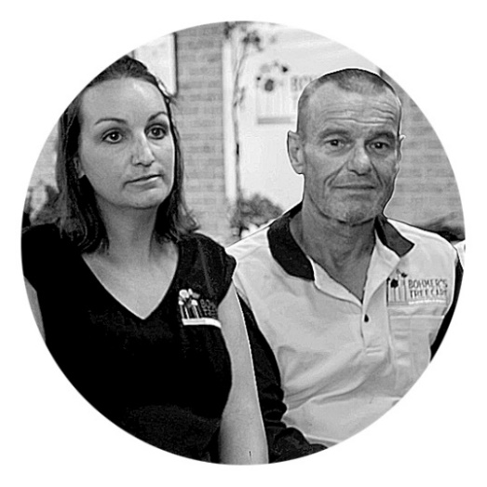Natasha & Clive Woodnutt
Bohmer’s Tree Care
Wollongong, NSW

To see more of their story, go to
Industry.gov.au/smalldigbiz-case-studies



“Digital technology is really working for us as a business because we have more time as a family.”
Bohmer’s Tree Care is an award-winning, locally owned family business with over 30 years arboriculture experience. The business is client focused with an environmentally friendly approach to its arborist services.
Bohmer’s customers include local councils, schools and the department of housing as well as private clients across Sydney, Wollongong and the Southern Highlands.
‘Digital technology makes it seamless from the field staff, to the administration staff to the customer.’
‘We’re saving an hour and a half each day by doing risk assessment digitally. You can make a lot of money in an hour and a half!’
‘We started using drones for marketing purposes and realised they could be used for tree assessments as well.’
‘My advice to others when looking to adopt digital technology - go for it, do it, don’t hesitate.’

Case Study: Tractorless Vineyard

Jeff Aston
Tractorless Vineyard
Southern Highlands, NSW

To see more of their story, go to
Industry.gov.au/smalldigbiz-case-studies



“We’re looking in the next few years to take our business overseas and digital technology – like Vintrace – will help us to do this and do it well.”
Tractorless Vineyards started as a contract winemaking service and has grown to include its own label and range of wine, beer and cider products. Jeff’s winemaking philosophy is to create a sustainable and diverse food and wine experience from locally sourced, foraged, grown and produced foods.
Jeff’s customers are mainly local growers (using a cooperative model) and sells his own products through the vineyard’s cellar door.
‘Going digital, I can’t speak enough about it – these days, I think you’re silly not to.’
‘Today people that come in to me and aren’t digital, it almost annoys me. We’re in the 21st century, it makes everyone’s life so much easier.’
‘There is nothing negative, yes there are challenges but there are more challenges in not going digital, particular as we go forward.’

What are the risks in not ‘going digital’?

The risks of not ‘going digital’: compare the pair

Example 1
Take 2 small businesses: A and B. The businesses compete as independent women’s clothing retailers. Both businesses started around 5 years ago, as shopfronts in the same regional town. They both employ 10 staff, they both source and manufacture their garments locally, and both have similar annual turnover. Both small businesses aspire to increase production and revenue. Neither business has much by way of digital capability.
Recognising the possibilities of digital technology, business A sets out on a digital strategy. It goes online to seek out high quality, cheap fabric suppliers overseas. It signs a contract with a Chinese company and uses the company’s website to order regular fabric shipments. Business A recognises the need to upgrade its production facilities, replacing manual sewing machines with the latest computerised technology. Per hour of labour, more garments are made. And the garments are now sold not just to locals, but via its website to customers in every Australian capital city. Advertising via social media is reaching new customers every day. Business A also realises that its back end processes are outdated. It adopts a software accounting package and develops tailored software to assist with inventory management. Instead of paperwork, all payroll and superannuation compliance is now done digitally though ATO apps. The new back-end processes have saved a significant amount of time and stress. Although some staff were moved out of production, they have found new skills and new jobs in managing website orders, packaging, and social media responses.
Business B, meanwhile, does not ‘go digital’. It has the same local supplier, a dwindling customer base, falling market share, falling profits, a time consuming and frustrating back end process, inefficient manufacturing processes, and an asset that is declining in value.
At face value, this example shows that the risk in not going digital is that a business’ market share and revenue may fall while their digitised competitors gain efficiencies and new customers.
However, the real ‘risk’ is also the opportunity cost, or the value of the digital benefits foregone. The full cost to business B from its ‘business as usual’ strategy is not only its weakened financial position but also all the foregone opportunities that business A is now enjoying: new customers, more revenue, more profits, greater market share, simpler processes, and a business that’s worth far more than it was previously.
Example 2
Plumber A and Plumber B both have young families, both work 60 hour weeks, and both want more leisure time. Neither plumber is particularly interested in growing their business or employing staff, and neither has much by way of digital technology at the front or the back-end of their business. However, both are frustrated by the amount of paperwork involved in running their business. Both plumbers send out paper invoices and their spouses handle the receipts and paperwork at tax time.
Plumber A decides to ‘go digital’. He talks to his accountant, who guides him through the process of how to use a simple tap and go point of sale system. He gets rid of all his paper invoicing and sends soft copy invoices from his iPad. For customers who are happy to pay instantly, he carries a mobile payment device where customers can tap and pay at the end of the job. He now takes photos of receipts and doesn’t have to carry them around. The accountant also helps his spouse with a basic accounting software package to monitor cash flow and bills due.
Plumber A and his spouse are happy: there’s no paperwork, no chasing invoices, no losing receipts, and tracking cash flow is easy. They spend a lot more time with their kids.
Plumber B, meanwhile, continues to struggle with the paperwork. He and his wife are frustrated. They want to spend more time with their kids on holiday but they’re snowed under by the paperwork.

Attitudinal drivers for small business ‘going digital’
In developing its recommendations, the Taskforce spoke to several small business people about why they had adopted digital technology. There were four main reasons.

Fear of ‘being left behind’
Many small businesses adopt technology out of concern that they are being left behind by their competitors. This fear is likely to be pronounced in competitive, process-based industries where technology can deliver substantial cost savings.
A plumber who has always provided his customers with paper invoices notices that his competitors are all using the Square point of sale system. He hears that their customers love it and his competitors don’t have the hassle that he does at tax time.
A pool products wholesaler faces strong competition from large foreign importers with state-of-the-art automated manufacturing processes. This drives his decision to introduce automated processes in his business (see p38).

Solving a problem
- A significant driver in a small business’ decision to adopt digital technology is the need to solve a problem. For example:
- a small regional logistics firm recognises that in order to grow revenue, it needs to find new customers. It uses Facebook and LinkedIn to identify export markets
(see p39);
- a mobile hairdresser, sick of taking a cash float to jobs, adopts a digital payment method on her phone. She no longer needs to carry, count, reconcile or deposit cash (see p34);
- an arborist is concerned at the time
and risk involved in scaling trees. He introduces drones which send data about the job to his iPhone and to the customer (see p43);
- a wine maker, overwhelmed by paper-based accounts to keep track of his stock, adopts cloud-based industry specific software for wine inventory management (see p44).

Trusted source of advice
A key theme of the Taskforce’s investigation is that small businesses act when they receive advice from a trusted source. A small business owner will generally be more likely to adopt technology if it is advised to do so from a trusted source (such as an accountant or a bank manager).

Needing to sell
Another factor that may drive a small business to adopt digital technology is the need to sell the business and attract a good price. Without a modern, digitally-connected ‘front’ and ‘back-end’ to the business, selling may be more difficult.
Over the past decade, the number of businesses listed for sale in Australia has increased by 800 per cent (VMB-RMIT Index of Business Value Multiples, April 2017). There is evidence that many small businesses struggle to sell. Further, the value of many small- and medium-sized businesses has been falling. Analog businesses, which have not sought to develop efficient processes and expand their customer base, are likely to be valued less than their tech-savvy competitors.
In coming years, there will be many baby-boomer owned small businesses placed on the market. The prospective buyers will be from tech-savvy younger generations. While some buyers will see an opportunity to buy and revamp an analog business, many prospective buyers will be put off by the work that would need to be done to modernise the business and build the customer base.

Structural drivers for small business ‘going digital’
The work of the Taskforce has focused largely on the attitudinal drivers for small business owners to adopt digital technologies.
The Taskforce is also aware that there are various structural influences that can drive a business to adopt technologies. It draws attention to the following influences:
- Supply chain expectations. In certain sectors, retailers and wholesalers demand from their suppliers that transactions and the sending of information be done electronically. The Taskforce heard from the National Farmers’ Federation that its members are often required to adopt digital technologies that are compatible with their buyers’ systems. The large grocery retailers, Coles and Woolworths, currently direct their suppliers to engage through a portal which the retailers use to communicate information about what they want. The portal can also be used by suppliers to assess and improve their performance;
- Government engagement. The federal and state governments are progressively engaging with the small business community digitally. Government systems now enable small businesses to complete their tax and super obligations online.
        - In 2015, the ATO introduced SuperStream which enables employers to pay their super contributions electronically, with the data then transmitted electronically to the super fund in a standard format.
        - On 1 July 2019, the government will extend Single Touch Payroll (STP) to small businesses (0-19 employees). Under STP, when employers complete their payroll, the tax and super information for each employee will be electronically sent to the ATO. Employers may need to update their payroll system to one that is STP enabled and suits their business needs.
      - consumer expectations in industries that are client-facing where customers demand digital engagement. Consumers’ expectations about how they find businesses and how they pay for their services have changed. From predominantly cash-based transactions in the 1990s, customers now routinely expect electronic point of sale systems. There is a growing expectation that customers can find, compare and buy from businesses online. Consumer expectations are a powerful and ongoing driver for small businesses to adopt digital technologies;

      - accepted industry ways of doing business. Many industries develop a ‘digital standard’: a set of basic technologies employed by the vast majority of businesses. This ‘standard’, though not formally established, can be a powerful influencer. For example, the vast majority of cafes now have ‘tap and go’ point of sale systems. Very few had this technology 20 years ago. When establishing a café, owners will recognise that they need to match the ‘industry standard’ for technology. Similarly, advisers will give advice to small business owners based on the accepted way of doing business. Should a small business seek advice on how to manage its bookkeeping, it is likely they will be recommended an accounting software package; and
      - demographics. The Taskforce heard from some industry bodies that the growing number of millennial small business owners is leading to greater uptake of, and experimentation with, new technologies. The National Farmers Federation, for instance, commented that the transition of family farms to a younger generation was promoting greater digital uptake.

What are governments doing?
The Taskforce recognises that there is a great deal of activity at both state and federal levels designed to support small businesses.
At the federal level there is ongoing work to consolidate and streamline business registries and licensing information across local, state and federal jurisdictions to make it easier for business. There is ongoing work to establish digital identity and e-invoicing standards. The ATO is digitising and streamlining its tax and super compliance requirements. There are information portals at federal and state levels providing guidance to business on how to start, run and exit a business and there is a plethora of information on grants and assistance small businesses may be eligible for.
The information portal – business.gov.au (and associated social media and call-centre channels) has been designed to be a ‘one stop shop’ for all of the government information, assistance, forms and services businesses need. The ATO also has a strong outreach program but user research indicates most businesses are still largely unaware that government provides information and advice to business.
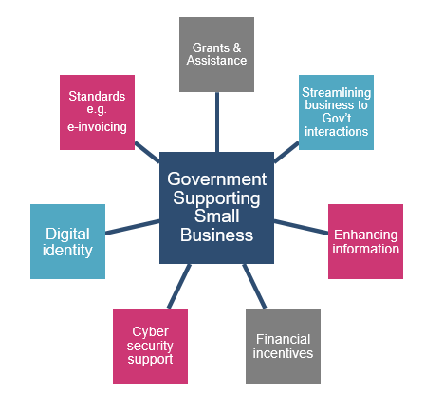

What is the Federal Government doing?

NBSI
The National Business Simplification Initiative (NBSI) focusses on two key areas: better regulation—to reduce the complexity of regulation for businesses by streamlining regulatory and compliance requirements; better business services—to address business demands for simplified digital transactions and tailored information and advice. There is an ongoing work program supporting NBSI designed to help streamline the interactions businesses have with government.

ASBAS
The Australian Small Business Advisory Services Programme (ASBAS) is designed to give small businesses greater opportunity to access advice that is essential to building and sustaining a business. The ASBAS Programme aims to improve the capacity of established, not-for-profit small business advisory service providers to deliver low cost small business advisory and information services. Eligible providers include organisations such as business enterprise centres, chambers of commerce and industry associations. Since March 2015, ASBAS projects have delivered over 73,000 services to small businesses and small business intenders.
The current ASBAS Digital Solutions Funding Round (2018-2021) will provide up to $18.2 million to fund service providers to deliver low cost, high quality digital advisory services to small businesses. The services will include online selling, social media and digital marketing, using small business software and online security.

Entrepreneurs’ Programme
The Entrepreneurs’ Programme is an Australian Government initiative to improve business competitiveness. Using Advisers and Facilitators drawn from industry, the primary focus is on providing access to the best advice and networks to improve competitiveness and productivity to eligible small and medium businesses.

business.gov.au
Business.gov.au is an online government resource for the Australian business community. Business.gov.au offers access to all government information, assistance, forms and services. The website is a whole-of-government service providing information on planning, starting and growing a business.

Single Touch Payroll
Single Touch Payroll is a reporting change for employers. It means employers will report payments such as salaries and wages, pay as you go (PAYG) withholding and super information to the ATO directly from a payroll solution at the same time they pay their employees. STP will provide greater visibility to a small business of their liabilities payable to employees and the ATO. The ATO is currently working with the software industry to support and encourage them to develop low cost/no cost options for small business employers.

The Digital Economy Strategy
On 19 September 2017, the Australian Government announced it will develop a national Digital Economy Strategy. The Strategy will set out a roadmap for government, the private sector and the community to work together to ensure all Australians can take full advantage of the digital economy.
The Government will launch the Strategy in the first half of 2018, following an open conversation with governments, businesses and the community. The Government already supports action on a diverse range of digital economy initiatives across multiple agencies. A key purpose of the Strategy will be to draw together, complement and build on these existing initiatives. The launch of the Strategy in 2018 will set the scene for continuing discussion and debate with the Australian public on Australia’s digital future.

Cyber Security
The importance of cyber security is increasing as people and systems become more interconnected and the amount and value of information held online has increased. At the same time efforts to steal and exploit that information have increased, harming the economy, privacy and safety, and potentially leading to further security risks.
The Taskforce recognizes the work government is currently doing to increase awareness of cyber security and ensure government systems that businesses access are safe and secure. This includes the Cyber Security Strategy and investment of over $230 million to deliver initiatives than enhance Australia’s cyber security.
The Cyber Security Small Business Programme is an integrated element of the Cyber Security Strategy to improve cyber security for Australia’s small businesses. The programme provides grants of up to $2,100 to co-fund small businesses to have their cyber security tested by approved service providers.
The Australian Signals Directorate (ASD) and the Stay Smart Online website provide practical guidance for business wishing to avoid and respond to a security breach. Advice from ASD indicates that if a business implements
four steps to mitigate cyber incidents it will keep them safe with a 90% confidence level.
Service providers now appreciate more than ever the importance of cyber security for their small business customers. Increasingly, they are updating their software to incorporate higher levels of security such as two-factor authentication as any security breach at the customer end reflects poorly on the service provider’s product.
To protect businesses against future threats, it is important that the government continues to raise awareness about cyber security and provide potential breach prevention methods.
Like digital adoption more generally, cyber security awareness will require an ongoing effort by governments, service providers, industry associations and trusted advisers.
The NSW Small Business Commissioner partnered with other States to conduct a survey and publish the Cyber Aware National Report in November 2017. In 2017, the Australian Small Business and Family Enterprise Ombudsman published a cyber security best practice guide for small business.

$20,000 Instant asset write-off
The Taskforce recognises that financial incentives and tax breaks can be a significant motivator for business to change their behaviour. Evidence indicates that the $20,000 instant asset write-off has been very effective for many small and medium business in upgrading their equipment and capital assets including ICT equipment and customised software. While this initiative is due to cease in July 2018, the Taskforce would encourage the Government to assess its impact particularly in businesses that used the write-off for ICT equipment and related assets.

The Black Economy Taskforce
The Black Economy Taskforce was established to develop a forward-looking whole-of-government policy response to combat the black economy in Australia. The black economy refers to people who operate entirely outside the tax and regulatory system, or who are known to the authorities but do not correctly report their tax obligations. The Government is considering the recommendations of the Black Economy Taskforce.

IT Procurement Taskforce
The Government has established the Digital Transformation Agency with responsibility for ICT policy and procurement policy, oversight and delivery, bringing together all the levers available to drive better ICT and digital outcomes. The ICT procurement taskforce was established in October 2016, as part of the Australian Government’s Policy for Better and More Accessible Digital Services 2016 election commitment. As part of the election commitment, the Taskforce was required to:
- identify opportunities to make it easier for start-ups and small and medium businesses to compete for government ICT contracts.
The Government is in the process of implementing most of the recommendations from the ICT Procurement Taskforce.

States & Territories
The states and territories have a variety of initiatives and policies that foster an environment that encourages small businesses to adopt digital technologies. New South Wales and Queensland provide the most support for small businesses to do this. Of interest to the Taskforce are:
Queensland
Small Business Digital Grants Program: matched funding program from $1,000 to $10,000 to small businesses to purchase software or equipment to enhance the digital capabilities of their business.
Advance Queensland Community Digital Champions: digital advocates from industry, community and all demographic groups to give back to their communities and teach others how to benefit from the digital age.
Digital Scorecard: The Digital Scorecard is designed to help businesses identify ways to improve their digital capability and become more competitive in today’s global digital economy.
New South Wales
Business Connect: aims to support small businesses to start-up, create jobs through growth, help established small to medium enterprises (SMEs) become sustainable and increase business confidence across NSW. Supporting digital readiness and regional business development.
Tasmania
Digital Ready / For Business
The Digital Ready for Business portal has tools and resources for businesses to take advantage of the digital economy. One feature of interest is the Digital Coaches programme which enables a business to access a free 2-hour coaching session with a digital expert.

The role of service providers
Clearly, the tech companies that develop and sell digital products and services have a strong vested interest in promoting rapid digital uptake among small businesses. The range and capability of these digital products has developed rapidly over the past decade. Cloud accounting, for example, has become increasingly popular since 2008 with the introduction of Xero in the Australian market. Xero, MYOB, Reckon and Quickbooks all now offer a cloud based accounting package for small business.
As noted earlier, small businesses can be wary of the tech providers and whether their pitch is genuine and their products are necessary and suitable. The providers do face an ongoing challenge of communicating the benefits of their products to small businesses. To this end, however, tech providers have been promoting and marketing their products and services to small businesses through three avenues.
1. The role of accountants is changing from a tax and compliance expert to the broader role of a ‘trusted adviser’. Accountants not only use suppliers’ products to provide their small business clients with more detailed and timely information and business analytics. They also recommend various digital products to their clients. The Taskforce notes that Xero, MYOB and Reckon are explicitly promoting their vision of accountants as trusted business advisers through the use of their platforms.
2. Some industry associations have worked with tech suppliers to inform their members of the products and services on offer. The Taskforce supports strengthening these links.
3. The federal government is also engaging with service providers to improve its interactions with the small business community. The ATO, notably, regularly engages with tech suppliers to ensure that providers are developing products that enable small business to meet their compliance obligations digitally.

Service provider meeting
The Taskforce met with key digital service providers and vendors to discuss the work of the Taskforce, and have a collaborative discussion on what would make a difference in helping small businesses go digital. Suppliers included banks, telco’s, digital software providers and niche small business providers. 
The key messages shared by suppliers were as follows:
- Suppliers were very willing to work together to help accelerate the adoption of digital tech among small business, but this would require coordination.
  - Accountants and bookkeepers remain the “trusted advisers” for small business. They raise awareness of options by indirectly marketing the products offered by service providers and are seen as a trusted source of impartial advice.
  - Government should work together across all levels to oversee a common standard of information sharing. This means access to Government data for small business in an open framework that all suppliers are able to use.
  - Accounting providers need to have interoperable systems that allow businesses to change, providing greater flexibility and choice, instead of locking a business in to one provider. This also includes standards such as e-invoicing.
  - Cyber security threats are prevalent but customers are not aware and not equipped to understand and deal with these threats. Providers are having to introduce two-factor authentication, and other security measures because a lack of cyber security capability of among small business has thrown the onus onto the service provider.
  - Face-to-face engagement is still important to small businesses. When small businesses utilise digital tools, they still would like face to face or one-on-one support for training or tech help.
  - Suppliers indicated that customers would respond favourably and utilise a rebate to use digital technology, if it was offered.

Appendices

Personas
A persona is a representation of a group of users with similar characteristics and experiences. Personas can help better target solutions by better understanding the business needs and motivations of the ‘user’.
Each of the personas below is mapped according to their level of digital savviness and willingness to adopt digital technologies into their business. The size of the persona icon pictured to the right is a rough approximation of the number of Australian small businesses aligned with this persona. 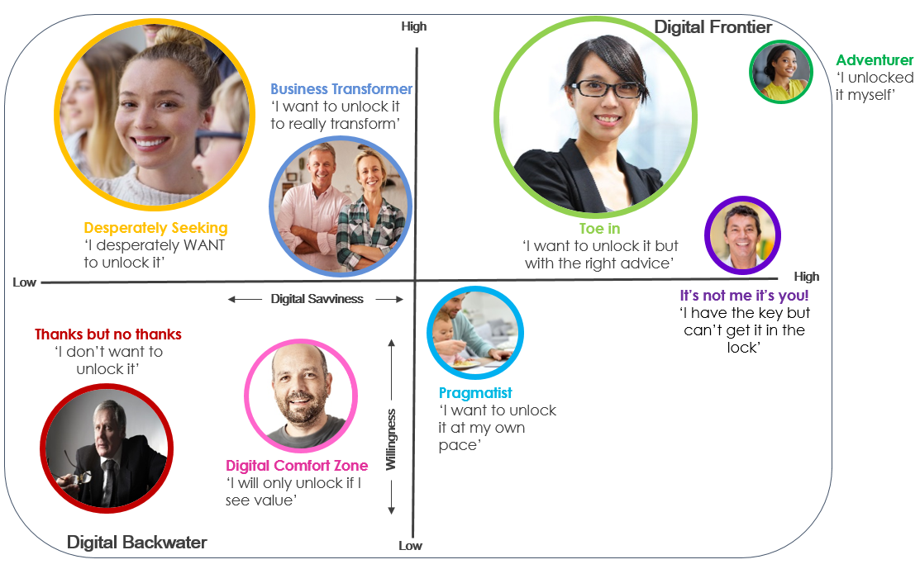 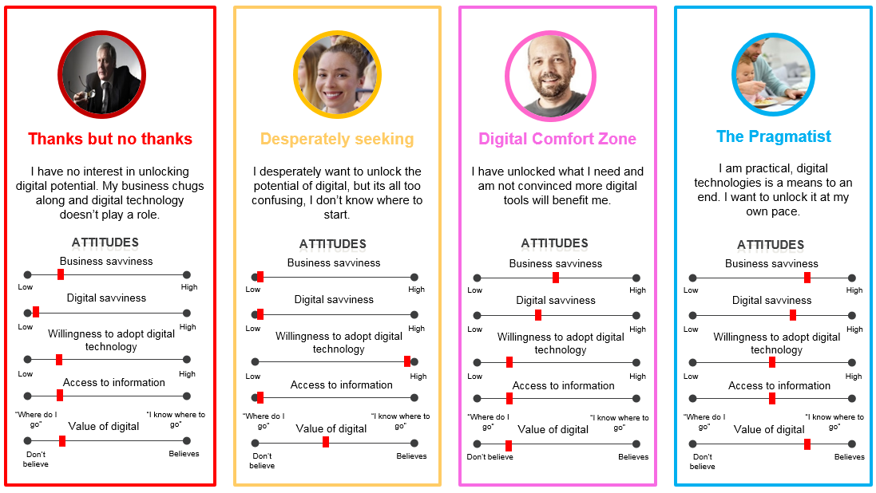
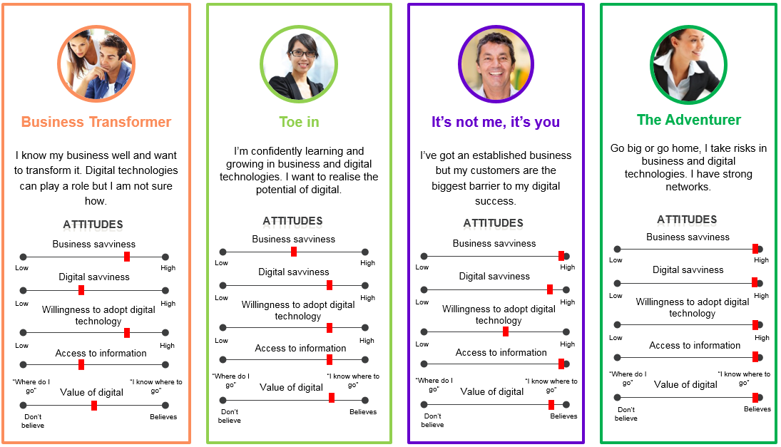

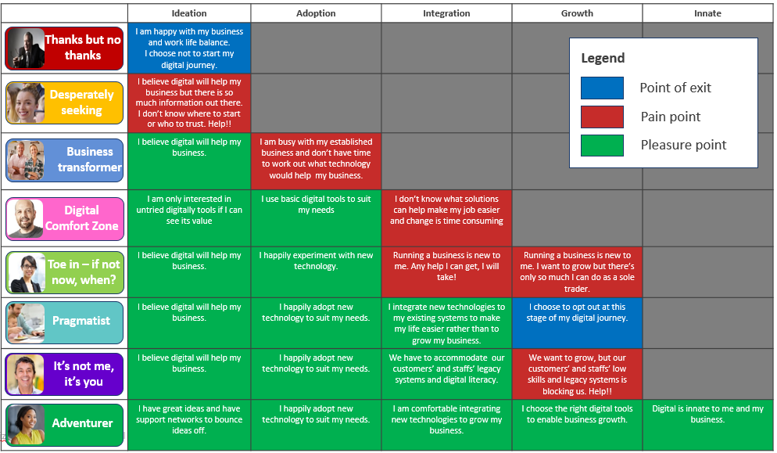

Appendices 2

Taskforce Activities & Engagement
Between November 2017 and March 2018 the Taskforce directly and indirectly engaged with hundreds of small businesses through workshops, one-on-one interviews, social media engagement and it drew on the user-centered research and surveys from government agencies and private sector service providers. The Taskforce also met with federal and state government agencies responsible for small business, over a dozen industry associations as well as state small business commissioners and many of the leading technology service providers in the country.

Small Business Actor Map
This Actor Map represents the variety of individuals and organisations that provide information and advice and have some influence on small businesses. There is an opportunity to leverage the people and organisations that have influence over the decisions that small businesses make about going digital.
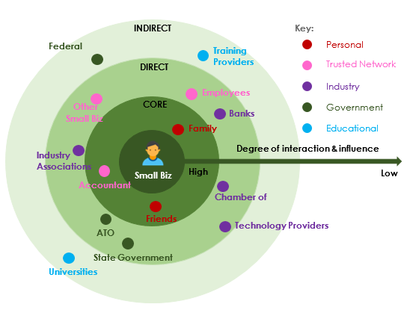

Workshops & Events
The Taskforce had the benefit of attending various events as part of the work of the Department of Industry’s (BizLab) Small Business Digital Capability Project. This included group testing workshops with small business owners in:
        - Brisbane (21 November 2017);
        - Canberra (22 November 2017);
        - Sydney (27 November 2017);
        - Melbourne (18 December 2017); and
        - Toowoomba (1 February 2018).
The Taskforce held four stakeholder events aimed specifically at addressing the terms of reference:
        - a meeting with government agencies on 8 February at Parliament House in Canberra where current government initiatives relevant to small business digitisation were discussed;
        - a meeting with leading tech suppliers on 5 March in Sydney where the Taskforce discussed current trends and future initiatives to market digital products and services to small businesses;
        - a meeting on 26 March with the ATO’s Stewardship Group, consisting of government agencies, industry bodies and small businesses; and
        - a meeting on 26 March with the Australian Small Business and Family Enterprise Ombudsman and State Small Business Commissioners.

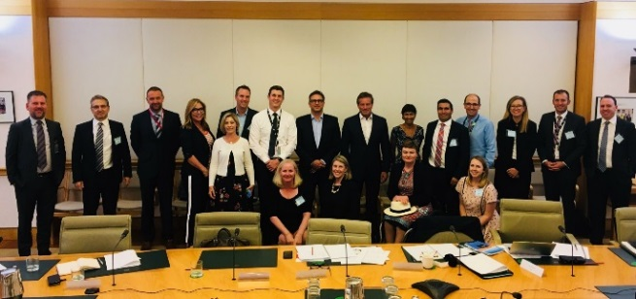
The Taskforce secretariat held one-on-one discussions with the following stakeholders:
- Burnett Inland Economic Development Organisation (BIEDO);
- Chartered Accountants ANZ;
- Council of Small Business of Australia (COSBOA);
- Master Builders Association;
- Master Plumbers ACT;
- Restaurant and Catering Australia;
- National Farmers’ Federation;
- The Small Business and Family Enterprise Ombudsman;
- Deloitte;
- Google;
- MYOB;
- Reckon;
- Square;
- Telstra; and
- Xero.
A number of themes emerged during the Taskforce secretariat’s consultations:
- Older business owners are generally less likely to be using digital technology. This reflects their lack of awareness of digital options and potential benefits.
- Lack of connectivity is a pain point, particularly in regional areas. The National Farmers Federation (NFF) noted that access, speed and cost of service were all significant issues for rural and regional businesses.
- Businesses that have a high level of customer interaction are generally quicker adopters of technology. Point-of-sale systems, cashless payment acceptance and digital accounting software have significantly higher uptake among restaurants, cafes and retail stores.
- Many sole traders and micro businesses have a spouse that looks after ‘back-of-house’ operations. There is clearly an opportunity for tech providers to market their products and services to the spouses of small business owners.
- Industry bodies that demonstrate higher levels of training, support and awareness of digital technologies have significantly greater digital adoption among their member base. There is a strong correlation between the level of training provided by industry bodies to members and their willingness to adopt technology.

Deloitte: Connected Small Business, 2017 https://www2.deloitte.com/au/en/pages/economics/articles/connected-small-businesses-google.html
Deloitte: Connected Small Business, 2017 Deloitte Connected Small Business Report

