

Payment Times Reporting Framework (Stage 2)

Consultation Paper

November 2019

ISBN

978-1-76051-865-3

1. Creative Commons

With the exception of the Commonwealth Coat of Arms, the Department’s logo, any material protected by a trade mark and where otherwise noted all material presented in this document is provided under a [Creative Commons Attribution 3.0 Australia](http://creativecommons.org/licenses/by/3.0/au/) licence.

The details of the relevant licence conditions are available on the Creative Commons website (accessible using the links provided) as is the full legal code for the [CC BY 3.0 AU licence](http://creativecommons.org/licenses/by/3.0/au/legalcode).

The document must be attributed as the Payment Times Reporting Framework (Stage 2) Consultation Paper.

Contents

Executive Summary 4

1. Introduction 5

1.1 Importance of payment times to small business 5

1.2 Progress to date 5

2. Outcomes of Stage 1 PTRF consultations 6

2.1 Objectives of the Framework 6

2.2 Framework elements 6

3. Issues for Stage 2 PTRF consultations 7

3.1 Which reporting areas should be in the PTRF? 7

3.2 Should the PTRF identify small business suppliers? 8

3.3 How should we address the issue of identifying small businesses? 9

3.4 Who will report? Groups versus entities 13

3.5 How should we capture supply chain finance? 15

4. Implementation 16

4.1 What IT solution should be adopted for reporting? 16

4.2 How should the reporting periods be defined? 16

4.3 What types of expenditure should be covered by the framework? 17

4.4 How should the number of days for payment be calculated? 18

4.5 What approach to compliance should be adopted? 18

# Executive Summary

The Australian Government announced on 21 November 2018 that it would introduce a Payment Times Reporting Framework (PTRF) which would require large businesses and Commonwealth Government agencies with over $100 million in annual turnover to report on their small business payment times and practices.

The Australian Government is committed to encouraging fairer and faster payment times and terms for small business. By providing access to large business payment performance, small business will be able to make informed decisions about their potential customers. Greater transparency will also create impetus for cultural change to improve payment practices.

The Department of Employment, Skills, Small and Family Business undertook a first round of consultations in the first half of 2019 to seek views on the development of the PTRF. The consultations considered:

* who should be obligated to report;
* the principles governing the information which should be reported;
* how this information should be reported (including reporting timeframes); and
* how the PTRF should be administered.

A number of complex issues which were important to stakeholders were raised during these consultations. We are seeking stakeholder views on the approach to these elements of the PTRF. These include:

* the information which should be provided by the PTRF to inform small businesses about the payment practices of their potential customers while minimising the regulatory burden on large businesses;
* whether small businesses should be identified in the PTRF;
* an approach to identifying small business suppliers for the PTRF which avoids negative impacts on these firms without creating an unnecessary reporting burden for large businesses;
* whether related large business entities report individually, as a group or in a joint statement;
* how the PTRF should treat supply chain financing; and
* approaches to implementation, including IT and compliance.

The Department is interested in stakeholder views on these issues as well as any other areas which would inform the design of the PTRF. Responses to any or all of the issues raised in the discussion paper can be made by submitting a written submission to [PaymentTimes@employment.gov.au](mailto:PaymentTimes@employment.gov.au) by 2 December 2019. Submissions will not be published; however a summary table (potentially including anonymous quotes) may be published.

Our Privacy Policy tells you what information we will collect about you and what we will do with that information. The information you provide will only be used for the purpose above by the Department and AlphaBeta, the Department’s consultant engaged to assist in the developing the PTRF. You can contact the Department at [privacy@employment.gov.au](mailto:privacy@employment.gov.au) if you have any questions.

# Introduction

## 1.1 Importance of payment times to small business

A recent report on late payments[1] from large business by the business software firm, Xero, highlights the importance of addressing the issue of late and long payments from large business to small businesses. Looking at over 10 million invoices from more than 83,000 small and medium businesses, the analysis found the estimated value of late payments to these businesses was $115 billion over the 2017-18 financial year. If these payments were made on time it would be the equivalent of transferring $7 billion in working capital from large to small and medium businesses.

This has significant impacts as small and medium businesses that are paid slower than average grow revenue about a third slower than those paid faster than average. It also has a domino effect across the economy as small and medium businesses paid faster than average pay their own suppliers eight days sooner.

## 1.2 Progress to date

The Prime Minister announced in November 2018 that the Government would develop a reporting framework requiring large businesses with over $100 million annual turnover to publish information on how they pay small business. Following this announcement, the Department of Employment, Skills, Small and Family Business (the Department) undertook consultations to seek views on the development of the framework in the first half of 2019.

This involved engagement with over 70 small and large businesses, industry associations and professional bodies in roundtables via four channels:

* **industry and Government expert working groups** which included business associations such as the Council of Small Business Organisations Australia, the Pharmacy Guild, the Business Council of Australia, the Australian Chamber of Commerce and Industry, and key government agencies such as the Australian Small Business and Family Enterprise Ombudsman, Australian Securities and Investments Commission, and the Australian Taxation Office;
* **workshops and a small business online forum** including four stakeholder workshops in Sydney, Melbourne, Perth and Canberra;
* **online discussion paper and submissions** (a previous copy of the discussion paper is available at [www.employment.gov.au/PaymentTimes](http://www.employment.gov.au/PaymentTimes)); and
* **one on one meetings with stakeholders** which included multiple meetings with industry, state, federal and overseas governments.

# Outcomes of Stage 1 PTRF consultations

## 2.1 Objectives of the Framework

The reporting framework has three objectives:

* improve the collection of information about the payment practices of large businesses and government agencies towards small business;
* make information about payment practices visible and easily accessible to small businesses and other interested stakeholders; and
* minimise the compliance and administrative burden associated with the reporting framework for small and large businesses and government agencies.

## 2.2 Framework elements

The first stage of the consultation agreed four key elements of the PTRF model:

**Who will report**

* Australian and foreign large businesses and corporate government entities with annual turnover of over $100 million

**What they will report**

* Reporting will be limited to the minimum number of areas that provide the most insight on the payment terms large business offer to small business and their payment performance
* Reporting will only be on correct, non-disputed invoices

**How they will report**

* Large businesses will report via a central portal. The information reported will be published on a public register
* Large businesses will be required to submit two reports each year for six month reporting periods. Reports will be due within three months of the these reporting periods ending

**How the scheme will be administered**:

* The framework will have four core powers and functions that are common to reporting frameworks to ensure it is effective, namely:
* compelling information
* publishing information
* monitoring compliance
* imposing penalties for non-compliance.

# Issues for Stage 2 PTRF consultations

A number of complex issues which were important to stakeholders were raised during the first stage of consultations. We are seeking stakeholder views on the design of these elements of the PTRF. We invite your responses to the questions at the end of each section.

## 3.1 Which reporting areas should be in the PTRF?

The choice of reporting areas is key to achieving the transparency objective of the PTRF. It will be important to collect sufficient information to inform small businesses about the payment terms and practices of their potential customers, while avoiding unnecessary regulatory imposts on large businesses.

During the first phase of consultation, stakeholders considered potential reporting areas on payment performance (e.g. the percentage of invoices paid within specified time brackets and the percentage of invoices paid late) and payment terms. Stakeholders also emphasised the importance of being able to compare reporting entities to common standards and performance benchmarks, e.g. percentage of invoices paid within a given number of days, rather than simply reporting average days to pay per entity. Finally, stakeholders agreed it was important to limit reporting to critical information to minimise the reporting burden on large businesses.

The proposed reporting areas set out in Figure 1 below reflect this stakeholder feedback.

###### Figure 1: Reporting areas for the PTRF

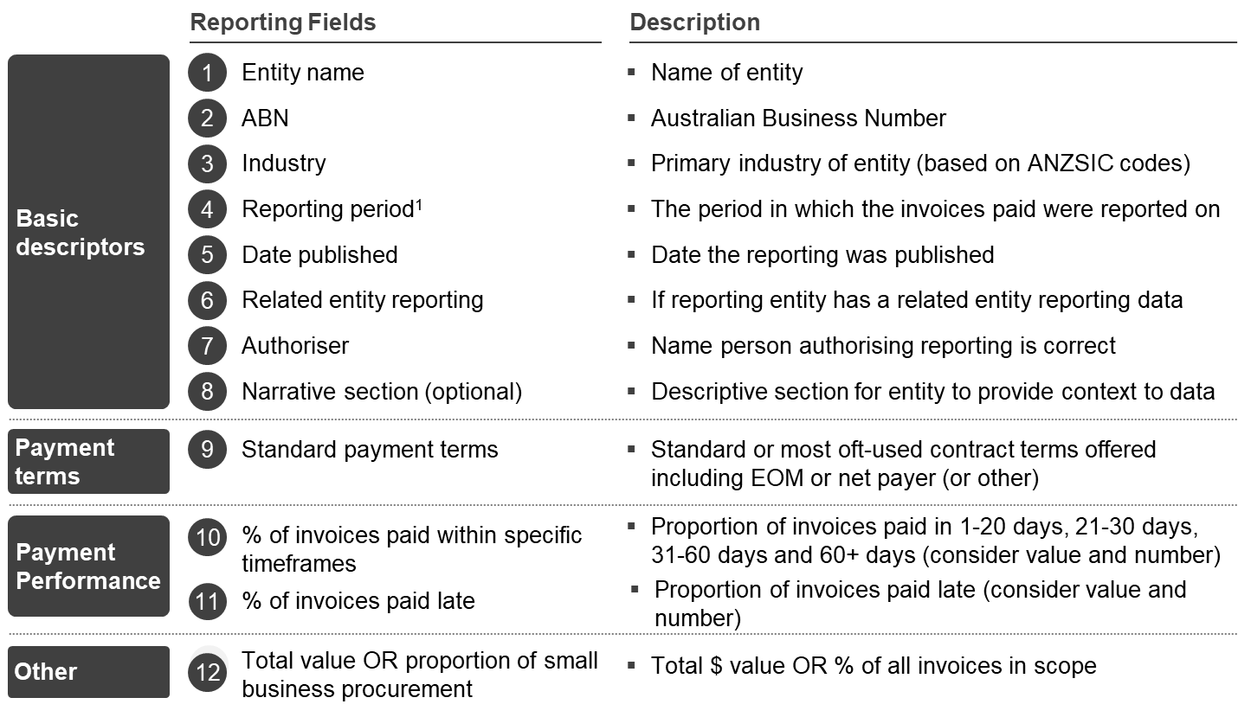

We are seeking feedback from stakeholders on the choice of reporting areas. We are also seeking feedback on the ease of reporting against the proposed areas, and whether including additional questions under some areas would make reporting more insightful. For example, businesses may have a range of payment terms for different suppliers, such as a supermarket which sources products from a range of industries that has specific payment terms for each industry.

The United Kingdom’s payment times reporting scheme requests a range of information on large business payment terms to provide a clearer picture for small business suppliers. Case study 1 sets out the payment terms related questions from this reporting scheme. We are interested in feedback on whether a similar approach should be adopted in Australia.

***Case Study 1: Examples of questions regarding payment terms in the United Kingdom’s payment times reporting scheme***

What is the shortest standard payment period?

What is the longest standard payment period?

Were there any changes to the standard payment terms in the reporting period?

What is the maximum contractual payment length agreed during the reporting period?

*Questions*

1. Are these the correct reporting areas for the PTRF to provide transparency of practices while minimising the reporting burden?
2. Should large businesses report on their small business invoices as a total dollar value or as a proportion of their total procurement?
3. What information should be included on payment terms in the PTRF? For example, could we consider an approach similar to the UK model?

## 3.2 Should the PTRF identify small business suppliers?

A key question for the design of the PTRF is whether a separate mechanism that identifies small business either publicly or to their suppliers should be developed as part of the framework.

Given there is currently no public small business identifier, stakeholders expressed concerns the PTRF could impose a significant regulatory burden on small businesses if they were forced to verify their status for multiple suppliers. Similarly, the process could be costly for large businesses as they could be required to contact each of their suppliers to confirm whether they were a small business.

Concerns were also expressed that a separate mechanism which identified small businesses could have adverse impacts. These could include encouraging discrimination in procurement if customers perceive small businesses present a business risk because they have less capacity to scale or meet variable customer demand.

The Department is therefore seeking stakeholder feedback on the positive and negative impacts of a mechanism for small business identification, and small businesses’ views on whether they wish to be publicly identified for the purposes of the PTRF.

*Question*

1. What are the positive and negative effects of identifying small businesses? If there are negative effects, how could they be mitigated?

## 3.3 How should we address the issue of identifying small businesses?

During the first phase of consultations stakeholders had a variety of views on the best way to identify small businesses for reporting purposes. Given that feedback, the Department has since explored different ways to identify small businesses.

The aim of these options is to find an approach that seeks to minimise the burden on small and large businesses, while not disadvantaging small business suppliers. For example, two of the options would not publicly identify small businesses, addressing concerns about potential discrimination. The other two options would require public identification and could be implemented if these concerns are found not to have a material basis.

The four options currently under consideration for the PTRF are:

* requiring large businesses to identify their small business suppliers;
* creating a public small business look-up tool;
* using an expenditure threshold; and
* using a confidential small business reporting tool.

**Large businesses identify their small business suppliers**

Under this option each large business required to report under the PTRF would be responsible for identifying and verifying its small business suppliers. The PTRF would provide a standard definition of a small business so there is consistency in how small businesses were defined. This is the approach currently used by signatories to the Business Council of Australia’s Australian Supplier Payment Code.

##### Advantages

* It provides flexibility for large businesses to adopt the process for identifying small business suppliers which suits them, while ensuring a standard definition is used. For example, a large business could engage a private sector data provider to undertake this task.

##### Disadvantages

* It could create a significant regulatory burden for small businesses who may be required to verify their identity to multiple suppliers.
* It could impose a significant cost on large businesses as identifying and flagging small business suppliers in their system could be a manual and, time-consuming process.
* It may increase regulatory risk for large businesses who may not be able to guarantee they are reporting on all their small business suppliers.

**Creating a small business look-up tool**

Under this option, a third party supplier would develop a look-up tool to help automate small business identification that all large businesses required to report could use. It could be supported by the government or the private sector, or through a combination of government seed funding and an ongoing fee for service model.

The recent review of the Business Council of Australia’s Australian Supplier Payment Code called for the creation of a small business register to assist with supplier identification.

There are a number of issues to consider if a look-up tool was to be developed.

*Positive or negative screen of small businesses*

* a look-up service listing small businesses - large businesses would enter information about their suppliers (such as ABNs or company names) which would then be automatically checked against a register to see if any entries had a *positive match to being a small business*.
* a look-up service based on a ‘negative screen’ of small businesses – large businesses would enter identifying information about their suppliers which would then be automatically checked against a register to see if any entries had *a negative match to being a large or medium business.*

*Extent of information provided on small businesses*

* The information provided on small businesses could be limited to a simple yes/no answer on whether the business met the PTRF small business definition.

*Extent of access to the information*

* Access to the look-up tool could be limited to large businesses required to report under the PTRF or could it opened up more broadly. Consideration would need to be given to the multiple definitions of small business currently in use as well as consideration of unintended uses of this information.

##### Advantages

* It would significantly lower the regulatory burden associated with the PTRF for large businesses and their small business suppliers.
* It would make it easier for small businesses to prove qualification for preferential payment terms, such as the 30 day payment terms for small businesses offered by signatories to the Australian Supplier Payment Code.

##### Disadvantages

* Private sector data may not be sufficiently accurate to meet the requirements of a regulatory framework.
* There is likely to be a significant cost to establish and maintain this system.
* It may have adverse consequences for the majority of small businesses that are not suppliers to large businesses.

**Using an expenditure threshold**

Under this option, large businesses would report on invoices from suppliers where their total annual spend was below a certain threshold. For example, this could require a large business to report all invoices for a supplier from which they procure less than $1 million of goods and services annually. In this way the expenditure threshold acts as a proxy for whether a supplier is a small business, without having to go through a verification process.

##### Advantages

* It imposes a low regulatory burden on large and small businesses as there are no verification costs associated with small business identification.
* It aligns with the Business Council of Australia’s Australian Supplier Payment Code where an expenditure threshold (together with a turnover definition) is one of the options for identifying small businesses.
* It is similar to the Australian Government’s Pay on Time policy which uses contracts with government worth less than $1 million as a proxy for small business.
* It does not publicly identify small businesses thus removing concerns about unintended consequences on their ability to bid for larger contracts or negotiate favourable terms with large businesses.

##### Disadvantages

* It is only a proxy for small businesses and could include invoices from medium and other large businesses if a large business procures less than $1 million of goods and services annually from these suppliers. This may reduce the incentive for large businesses to offer preferential payment terms to their small business suppliers, undermining the policy objective of the PTRF.
* It may not pick up small businesses who have contracts larger than $1 million with large businesses.

**Using a confidential small business reporting tool**

Under this option large businesses would either:

* provide an aggregated summary of their payment times for invoices from each of their suppliers (including the ABN for each supplier); or
* provide disaggregated payment times data for all their invoices (including the ABN details of the supplier for each invoice).

The Department or third party provider would then confidentially identify small business suppliers, but would not provide large businesses with information on which suppliers are small businesses or not.

Aggregated information would then be published on the central portal for the PTRF to provide one entry on small business payment performance for each large business. In this way, individual small business suppliers or the payment times for each small business invoice would not be identified publicly or to the large business.

##### Advantages

* It reduces the regulatory burden on large and small businesses as there are no verification costs with small business identification.
* It does not identify small businesses either to the public or their suppliers thus removing concerns about unintended consequences on their ability to bid for larger contracts or negotiate favourable terms with large businesses.
* Using government data provides the most accurate assessment of small business payment performance.

##### Disadvantages

* Large and small businesses may have concerns about providing supplier information to government or a third party.
* It would be difficult for large businesses to assess the accuracy of the information reported about their company on the PTRF.
* As large businesses would not be able to identify their small business suppliers, they could not use the information to offer them improved payment terms, undermining the policy objective of the PTRF.
* It could involve significant costs for government or business.

*Questions*

1. Which approach/es do you favour for small business identification, and why?

a) large businesses identifying their small business suppliers

b) developing a public small business register

c) using an expenditure threshold

d) confidentially identifying small business suppliers using government or third party data

1. If we were to use an expenditure threshold would a $1 million annual spend with a supplier be a reasonable value for the expenditure threshold?

## 3.4 Who will report? Groups versus entities

A key question for the PTRF is to determine how related entities should report. Organisations that meet the reporting threshold may have different structures, with both parent and subsidiary businesses. For groups with more than one business, we need to decide if they report individually, as a group, or in a joint statement. Figure 2 provides an overview of the different types of structures that would fall within the scope of the PTRF.

###### Figure 2: Determining how related entities should report

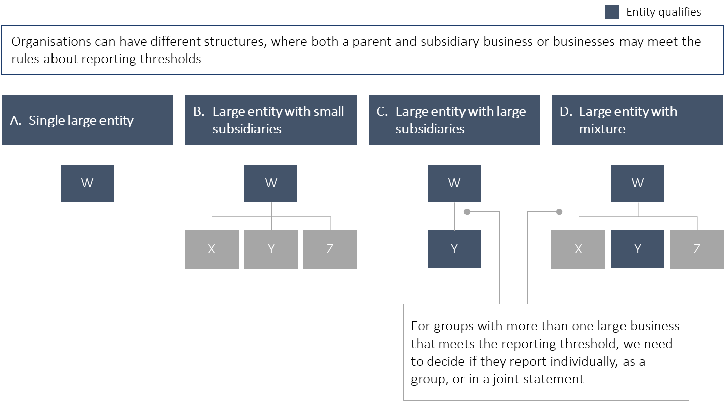

It will be important to find an approach that provides comparable and easily accessible information on the payment performance of large businesses so the policy intent of the framework is met. This will need to be balanced with minimising the regulatory burden placed on large businesses, and ensuring reporting is practical and transparent. For example, some companies have complex joint venture and subsidiary structures which make tracing control and relationships complicated.

**Group reporting**

One approach could be to use group level reporting which is employed by the Modern Slavery Reporting framework. This involves the controlling qualifying entity reporting for both itself and all other related entities. The threshold for reporting would be an annual turnover of over $100 million for the group as a whole.

##### Advantages

* Aligns with other reporting obligations such as the Modern Slavery scheme.
* May reduce the regulatory burden as large businesses will not have to report by disaggregating their financial reports at entity level.

##### Disadvantages

* The name of the group may not be recognised by small business suppliers who deal with different entities and could therefore impact the transparency objective of the PTRF (this could be partially overcome by the group listing the related entities it was reporting on).
* Where large businesses do not already report at a group level, it may be difficult for them to aggregate data across the group.
* May lack sufficient detail to provide a comprehensive picture of payment times in different industries and states and territories.

**Entity Reporting**

Alternatively an entity level approach could be employed in which each qualifying entity reporting only for itself. The threshold for reporting at an entity level would be an annual turnover of over $100 million.

##### Advantages

* Provides a clearer and more accessible picture of payment times practices and supports the transparency objective of the PTRF.

##### Disadvantages

* Where large businesses do not already report at an entity level, it may be difficult for them to disaggregate data at the entity level.
* May lead to omissions if it is not accompanied by group reporting and not all the entities in the group are at the PTRF reporting threshold.

**Reporting at either level**

Under this option, companies could decide whether they report at group or entity level (or the framework could set out rules mandating which level companies reported at). In this scenario each entity could report separately. Eligibility to report would be based on group turnover above $100 million. Large businesses could choose whether to report as a group, or to divide their reporting by entity if that is more practical.

##### Advantages

* Allows large businesses flexibility to report in a way which is consistent with their business processes.
* May significantly reduce the regulatory burden on large businesses as they could use the approach they already use for taxation.

##### Disadvantages

* May lead to lack of comparability of data between different large businesses and impact the transparency objective of the PTRF.

*Questions*

1. What are the advantages and disadvantages of reporting at a group or entity level?
2. What are the advantages and disadvantages of providing large businesses with a choice?

## 3.5 How should we capture supply chain finance?

A number of large businesses are providing the option for suppliers to use supply chain finance if they want to be paid earlier than the standard terms offered by the business. This practice may involve payment of invoices by a third party finance company at a discount to their original value.

Issues have arisen when companies have significantly extended their payment terms and then advised their suppliers to access supply chain finance to obtain early payment.

It may be useful for the PTRF to provide transparency on the use of supply chain finance by large business and ensure that it is not used to provide a more favourable picture of their payment performance. Section 4.4 provides additional information about how payment times might be calculated where there are supply chain arrangements.

*Question*

1. What types of information should be collected by the PTRF on supply chain finance?

# Implementation

The Department is seeking stakeholder views on implementation arrangements for the PTRF including the following issues:

* IT requirements (including secure login and arrangements for submitting data);
* reporting periods;
* the types of expenditure covered by the framework;
* reporting processes including approaches to calculating payment times;
* approach to publication of results on the central portal (providing options to search individual submissions or look at industry comparisons); and
* compliance and auditing processes.

*Questions*

1. Are there other issues the Department will need to consider in the implementation phase of the PTRF?
2. Should the PTRF central publication portal include information on trends over time or provide information to allow comparisons by industry and location?

## 4.1 What IT solution should be adopted for reporting?

The Department is currently exploring two solutions for uploading data to the PTRF central portal:

* manual upload of data to a web portal using a CSV format (excel spreadsheet); and/or
* an automated approach for uploading data using a system to system interface (this option would only be used if a large amount of data was required to be uploaded as might be the case with the confidential small business identification option described above).

Large businesses would log-in using a whole of government identification solution.

*Questions*

1. What timeframes would be required for your business to implement a CSV format based or automated reporting system?
2. Are there other issues the Department needs to be aware of in developing the reporting IT interface for the PTRF?

## 4.2 How should the reporting periods be defined?

During the first phase of consultations stakeholders generally agreed reporting should be every six months to provide better currency of data for small business users of the PTRF. This reporting frequency would also allow businesses to reflect on their payment performance and more quickly make improvements where necessary.

Given some of the business reporting under the PTRF will have different financial years, we are seeking stakeholder views on whether the six monthly reporting periods should follow these financial years or whether they should be based on a calendar year. In the latter case reporting period one would start in January and finish at the end of June and reporting period two would start in July and finish at the end of December. Businesses would be required to report within three months of the end of the reporting period.

*Question*

1. Should the PTRF allow companies to use their financial year as a basis for reporting or should it be based on a calendar year?

## 4.3 What types of expenditure should be covered by the framework?

Defining the scope of expenditure covered by the PTRF will be critical to ensure reporting is robust and comparable between companies. Some of the issues being considered are outlined below.

*Types of payment* - should different types of payment be included/excluded such as credit cards which can have a large number of low value transactions.

*Types of payees -* should certain types of payees be excluded such as international suppliers or businesses in the same group.

*Types of purchases* – should all goods and services be covered, including intangible property such as IP.

*Size of payments* – should transactions below a certain amount be excluded to avoid covering large numbers of low value payments for items like travel accommodation.

*Questions*

1. What are your views on the above categories of expenditure?

## 4.4 How should the number of days for payment be calculated?

Calculating when the ‘clock starts ticking’ on payment times is one of the important issues which needs to be considered in the implementation of the PTRF. There are two main options which could be considered, each of which has its strengths and weaknesses.

In the UK scheme, Day 1 is the day after the date on which the large business receives the invoice. The question then becomes received by who in the organisation - is it one of the business areas or the central finance unit. If the organisation chooses to start the clock when the invoice arrives in the finance unit, this may not capture the delay as it is passed between different areas of the organisation.

The second option is for Day 1 to be the date on the invoice. This option is clearer and would be common across all organisations. However, there may be delays in the transmission of the invoice from the small to the large invoice, reducing the timeframe for it to be paid and meet the large businesses’ standard payment terms.

As identified above, this start date would only apply to correct and non-disputed invoices where goods have been received.

Another issue is introduced by the use of supply chain finance. To avoid this technique being used to artificially reduce payment times, the end date for the payment period could be calculated on the date which the finance provider receives the payment from the large business. Alternatively, the payment period could be the standard payment term offered by the large business to the small business.

*Questions*

1. What are your views on the two options to determine the start of the payment period? Are there others?
2. How do you think we should measure payment dates when supply chain finance is used to avoid this practice being used to provide an artificial picture of payment times performance?

## 4.5 What approach to compliance should be adopted?

Compliance and enforcement mechanisms will be essential to the successful operation of the PTRF. The experience of the United Kingdom’s payment times reporting scheme shows measures are necessary to ensure companies report their payment terms and practices, as are mechanisms to check the accuracy of reported data.

**Mechanisms to ensure information is reported**

To ensure data is reported accurately and on time, a number of compliance approaches are being considered, including:

* civil penalties—fines could be imposed on large businesses. It is envisaged these fines would be flagged on the central PTRF portal;
* court injunctions—a court order could be issued directing a large business to report its payment times information. It is envisaged these court orders would be flagged on the central PTRF portal; and
* criminal sanctions—large businesses could be subject to a criminal offence which would be punishable on conviction by a fine. This approach is used in the UK scheme.

Provisions would be included in the PTRF legislation allowing companies to apply for an extension of time or to resubmit reports where there are extenuating circumstances.

**Mechanisms to ensure accurate information is reported**

A number of mechanisms are being considered by the Department to ensure the accuracy of information reported for the PTRF. These could include requests for information or random audits by external auditors.

If the information was found to be inaccurate civil penalties could apply which would be flagged on the central PTRF portal. If it was demonstrated false information was deliberately or recklessly provided, a criminal sanction could be applied. The latter approach is used in other reporting schemes.

The full suite of compliance measures will be included in the exposure draft of the legislation.

1. Xero Small Business Insights, Paying the price: the economic impacts of big businesses paying Australian small businesses late