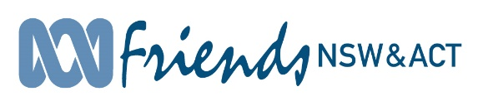
Northern Suburbs of Sydney Branch (NSoS)
C/- 18 Mt Ida Street, Gordon NSW 2072
Telephone 0428 860 623
E-mail: northernsydney@abcfriends.org.au

29 January, 2021

The Hon Michael Sukkar MP
Assistant Treasurer
Minister for Housing & Minister for Homelessness, Social & Community Housing

Dear Assistant Treasurer
Pre 2021-22 Budget Submission

Thank you for the opportunity to make a Pre-Budget Submission for the 2021-22 Budget.

The Northern Suburbs of Sydney (NSoS) branch of ABC Friends recommends that Australian government commits 0.5% of federal government expenditure to funding the ABC and that they establish longer-term frameworks for this funding in order to de-couple ABC funding from the electoral cycle.

NSoS calls on the Federal Government during its pre-budget deliberations to ensure:
- reversal of the $84 million cuts in July 2020
- an end to the ABC’s budget indexation freeze
- reinstatement of the over 1,250 job positions lost at the ABC
- restoration of the $783 million cuts to ABC funding since 2014
- increase in the ABC’s budget to 0.5% - the level it was in the mid-1990s (now around 0.2% of all Commonwealth government spending)
- well-funded ten year funding for the ABC

We would be delighted to visit Canberra to celebrate the Government’s action in restoring a strong and well-funded ABC.

Yours sincerely
Janine Kitson

Janine Kitson
Convenor
Northern Suburbs of Sydney

