# **Mansfield Autism Statewide Services**

# **Pre Budget Submission**

## **Key Recommendation**

### Provide public infrastructure funding for the expansion of the Mansfield Autism Statewide Services model, as per ‘Operation Gamechanger’, to provide increased capacity and services for families living with autism and training opportunities for teachers and allied health professionals, in the context of a world’s best practice Therapeutic Care Farm.

### Increase the availability and quality of planned respite and crisis care for families living with autism, to help prevent carer fatigue that can lead to family breakdown and relinquishment.

### Provide experience based Autism Spectrum Disorder (ASD) training for relevant undergraduate degrees and certificates and professional development opportunities for teachers and allied health professionals.

Table of Contents

**Key Recommendation** 1

**Who we are** 2

**Bursting at the seams** 3

**Planned Respite & Early Intervention** 4

**Operation Gamechanger**  6

**Cost benefit analysis** 7

**Funding the balance** 8

**For more information** 9

#### January, 2021

## **Who we are**

### Mansfield Autism Statewide Services (MASS) is a not-for-profit organisation, that has supported Victorian families living with autism for over 50 years, and we are ‘bursting at the seams’.

### Current services include

### respite, crisis and full-time care

### family camps

### day school

### term therapeutic residence school

### in-home practitioners

### entry to school and work transition programs

### professional development for teachers, allied health industry placements

### We are unique in that we provide a ‘wraparound’ service aiming to keep families together. Our programs are based on the key principles of exercise, healthy eating and active engagement. Our strategies reduce anxiety; enabling brains to learn and increasing positive behaviours.

### Demand for placements far outstrips our physical capacity to supply. Families with fully funded NDIS programs are unable to secure a placement as we are full. Our masterplan for our recently purchased 100 acres in Mansfield, Victoria, will future proof us. Our programs are operationally and financially viable, but we require capital expenditure assistance to realise our vision.

### Our model of service provision is unique in Australia: it works and it transforms lives.

Mansfield Autism Statewide Services Pre Budget Submission January 2021

## **Bursting at the seams**

### Mansfield Autism Statewide Services (MASS) offers a unique wrap around service that is not replicated anywhere else in Australia. Founded over 50 years ago by pioneer Dr Joan Curtis, MASS has evolved its not for profit, independent, integrated service provision to meet and anticipate need and demand. The case studies and the demand for service based on reputation, speak for themselves.

### **What’s different?**

### MASS provides a range of integrated ‘wrap around’ services that work with the whole of family and not just the child. The provision of the specialist school alongside the residential program and supported in home by the travelling practitioners are key to the amazing and evidenced success that MASS has demonstrated in its life changing work. All of the programs are underpinned by the core principles of importance of family, engagement, exercise and healthy and wellbeing.

### The term therapeutic placement program runs for 9 weeks and the student lives with us while learning new skills. Our Autism Practitioners follow up work in the family home for multiple days to support the integration and maintenance of the new skills, involving family and other local support workers and teachers. The family camps provide respite and education and include mentoring for the siblings and support for the parents, all in the context of a fun, family holiday. The transition programs work with students not quite ready for school and those exiting but needing more help for independent or semi-independent living. Our day school is available for local and regional students and we have families queuing to move to Mansfield but we’re full, so that doesn’t guarantee them a spot. We provide outreach programs, respite care, crisis care, and we are home to students in permanent full time care. Our requests for service are far in excess of our ability to provide services, given the limitations of our infrastructure.

### The recent purchase of 40 hectares 4 km from Mansfield, is the first step toward our vision of new and expanded services, in the context of a Therapeutic Care Farm. The value of farm settings and nature have been shown to reduce anxieties, enabling better learning and reducing the incidence of heightened behaviours. The layout of the masterplan has all benefited from MASS’ decades of experience and this translates into the building designs with safety, resilience and low sensory environments being key.

### The Victorian State Inquiry into Autism, after hearing submissions and considering all the evidence provided, recommended “The Victorian Government fund the expansion of the Mansfield Autism Statewide Services model, including the travelling teacher program, across regional Victoria.” We have also put a submission to the current Federal Inquiry into Autism and have invited a site visit and hearing.

### We are financially and operationally sound but unable to self fund the capital works. We are actively seeking government and philanthropic support to fund ‘Operation Gamechanger’ with the infrastructure builds grouped into Project Residence, Project Education, Project Retreat and Project Recreation.

Mansfield Autism Statewide Services Pre Budget Submission January 2021

## **Planned Respite & Early Intervention**

### Typically, MASS sees families at the end of their tethers; emotionally drained and exhausted. For many families, the journey through diagnosis and securing a funded plan takes time and money and may end with the absolute frustration of not being able to find a provider. Autism is overly represented in NDIS plans and reports indicate some 30-40% of allocated funds are unspent. MASS is often in the heartbreaking position of advising parents that we are at capacity, with all of our programs being full for the next 12 months. Funding in the NDIS plans only lasts for one year, with no guarantee it will be renewed if unspent. We feel the pressure to find spots because we know the earlier we can work with a child and a family the better for all. A consequence of not intervening early and not having access to planned respite, means some families find themselves in the crisis stage and this can and does result in relinquishment.

### **Failing to provide services**

### The cost of failing to provide services has negative impacts on personal, family, community and economic fronts. According to the Australian Institute Health & Welfare Child Protection Australia 2018-19, children may be placed in out-of-home care when parents are incapable of providing adequate care, when alternative accommodation is needed during times of conflict, or when parents/carers need respite. Sometimes young people with autism, without sufficient support, find themselves in the youth justice system. While MASS has experience of working successfully with young people with autism in the out of home and youth justice scenarios, it is far preferable to prevent such circumstances from arising.

### According to the Commission for Children and Young People, Systemic inquiry into the lived experience of children and young people in the Victorian out-of-home care system, November 2019:

### there are more children and young people ‘with complex health and behavioural and developmental needs entering care’ who spend longer in out-of-home care as a consequence of late intervention by child and family services and

### Government expenditure on out-of-home care services has consistently exceeded spending on family support services intended to prevent children and young people from going into care.

### The Productivity Commission 2019 found that the annual dollar figure for a young person in residential care is $666,100 per child. Based on the cost to state government of the children MASS has in permanent care, who have significant health, behavioural and developmental needs, the cost is far higher and in excess of $1m per child per annum.

### The Victorian Inquiry into services for people with autism spectrum disorder, heard from parents about how desperate they can become without sufficient support and that relinquishment then becomes an option. The Commission heard from submitters that it was the term residential placement complemented by the in home practitioner support from Mansfield that had helped to turn things around for a number of families.

Mansfield Autism Statewide Services Pre Budget Submission January 2021

### **The need for respite is screaming**

### After the trauma of her young autistic son going missing, while on a family bushwalk at Mt Disappointment, Ms Penny Callaghan took the opportunity to highlight what all parents in her circumstance understand: “knowing you have planned respite can help keep you going.”

### In a confluence of opportunity, MASS was able to provide respite care after the traumatic event, for both of Ms Callaghan’s sons in school holidays, when she was unable to access any locally. The placement, hours from her family home, highlighted the lack of skilled provider respite capacity in the system.

### Every month, MASS has many new requests for service from families with funding for respite. Across the state, and including MASS, many respite beds are taken up by children in out of home crisis and permanent care in what has become a negatively perpetuating cycle.

### As reported in The Age July 11, 2020.

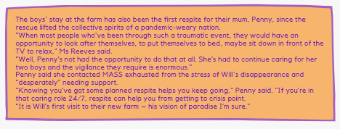

Mansfield Autism Statewide Services Pre Budget Submission January 2021

## **Operation Gamechanger** – Development of a bespoke, world’s best practice centre of excellence for children with autism, in the context of a Therapeutic Care Farm in regional Victoria

Project Education – new term & day school facilities with unique professional development design features such as one way windows for non invasive peer observation

Project Residence accommodation for term placement, respite, acute and permanent care

Project Retreat 12x family cabins all self-contained, with a mix of all access and ambulant, with conference and training centre for activities, presentations and dining with commercial kitchen. Available for external bookings. Ideal for accessible tourism and groups market.

Project Recreation equine facilitated learning arena, swimming pool, hard court play area, walking paths, sensory gardens, revegetation & seed propagation centre

### **Shovel ready**

### Masterplan completed. Planning approved. Detail design in progress. EY Financial Plan & Employment Assessment. Cost Benefit Analysis. Infrastructure funding applications in progress.

### **Delivering** **jobs**

### **Pre Operation Gamechanger Post Operation Gamechanger**

### 126 staff (EFT 83) 250+ staff EFT 165 + indirect 47 jobs

### 220 clients 480 clients (in 5 years)

### ~$6.7m gross revenue 2018 $17.22m (in 10 years)

### ~860 respite nights 4000+ new respite nights

### 5 Cert & Grad training placements ~170 Cert & Grad training placements

### *IRR 15% over 10 years NPV $0.92m based on discount rate 10%*

### *169.5% increase in revenue FTE 115.7% more than base year*

### *$54m output construction phase $26m output pa operational*

### *BCR 1.6 $127m societal & economic benefit over 10 years life of project (conservative)*

### **Multiple Portfolio Outcomes**

### Regional Development + Education + Health + Disability + Family +

### Youth + Housing + Justice + Accessible Tourism + Training

Mansfield Autism Statewide Services Pre Budget Submission January 2021

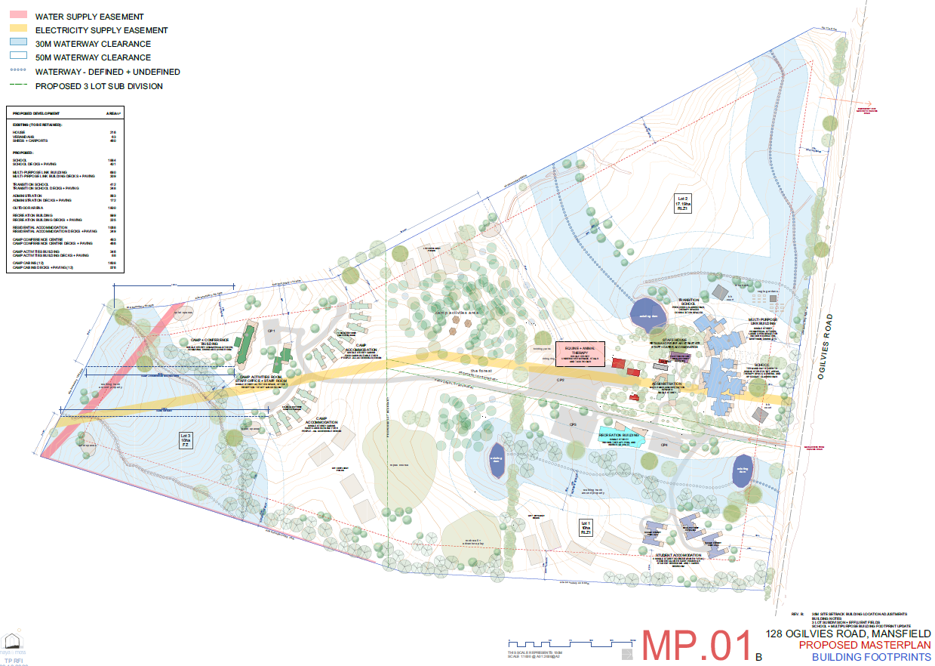

**Cost benefit analysis**

A strong business case and impressive positive investment return rate of 1.61, with a socioeconomic benefit of $127m over a ten year life of project, has been calculated on Mansfield Autism’s farm development dubbed ‘Operation Gamechanger’.

The analysis focused on four of the services to be offered at the farm including day school, therapeutic term and residential placement, full time care and family camps. Only four of many benefits were targeted for analysis, being the opportunities for a reduction in mental health spending for families, reduction in the loss of income for families, reduction in the incidence and subsequent state cost of relinquished children and the increase in spending due to the job generation associated with the expansion.

The report highlighted the lack of evidenced work in this space. The sector would do well to invest in economic analysis of intervention and support services efficacy.

## Project Retreat Conference

## 

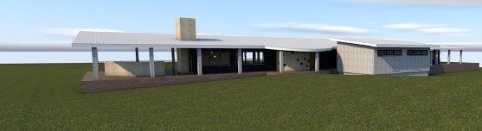

## Project Retreat Cabin

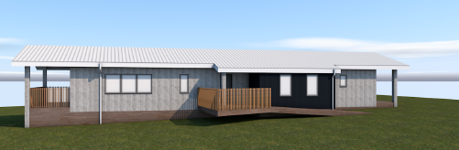

## Project Residence – Block cluster

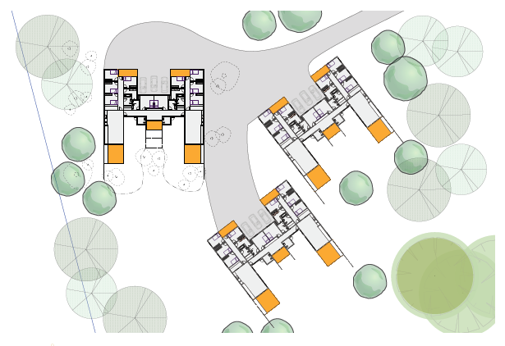

## Project Education

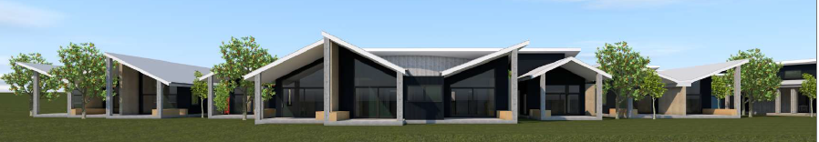

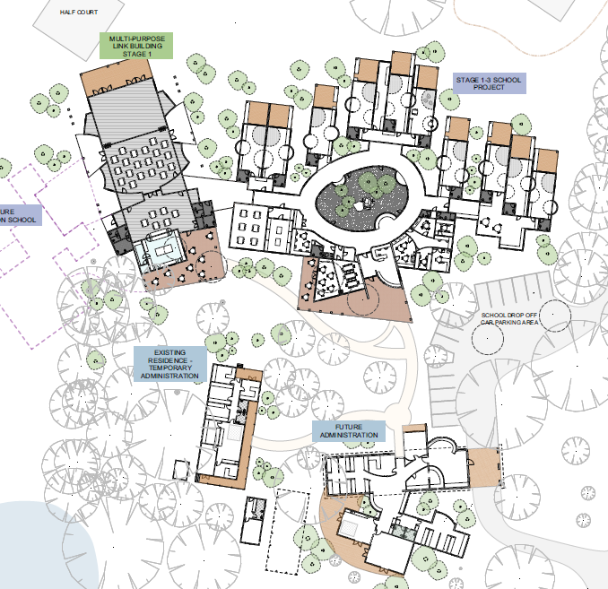

## **Funding the balance**

### Mansfield Autism Statewide Services (MASS) is financially sound and operationally viable. MASS has invested in the property purchase at over $2m and the loan has been paid down considerably. MASS has progressed detailed design and property improvements and has approval for significant additional borrowings in excess of $5m to co-contribute to project stages.

### The job generation, economic stimulus and social benefit of the project warrants public money investment, as demonstrated in the cost benefit analysis.

### MASS requires government investment to augment its own significant multi-million dollar investment (including of donations), to realise the vision of Operation Gamechanger. The estimated cost of all projects is $36m excluding land purchase. MASS will co-contribute and is seeking to raise funds via the philanthropic sector.

### OPTION A – Federal funding multi portfolio with Special Project status $30m

### OPTION B – Federal funding of balance of project elements

### once applications in competitive funding rounds status is confirmed

### **Status of existing and intended applications**

### Victorian Building Stimulus Project Residence Under assessment

### Local Economic Recovery BRV Project Retreat Stage 1 Under assessment

### Block Grant Authority Project Education Stage 1 Pending

### Building Better Regions Rd 5 Project Retreat/Recreation Pending

### **Estimated Project Costs**

### Project Retreat Conference, Training & Activities Centre $11m Cabins

### Project Education Classrooms, Specialist Therapy Space $14.6m Multipurpose Activities & Vocational Hall, Amenities

### Transition school, Admin building

### Project Residence Client and student residences for placement, $6m crisis, respite and permanent care

### Project Recreation Pool, equine arena, hardcourt, splash park, $2.5m

### External works & services ICT, wastewater, power, roads, carparks, $2m

Mansfield Autism Statewide Services Pre Budget Submission January 2021

## **For more information**

### MASS welcomes the opportunity to provide more information as required to support its pre budget submission.

### MASS extends an invitation to visit our farm and existing facilities in Mansfield, Victoria and witness first hand our ‘wrap around’ model of service provision and our expansion plans for the future.

### Thank you for the opportunity.

### **Contact**

### Simone Reeves

### Director

### Mansfield Autism Statewide Services

simoner@autismmansfield.org.au

