

**Pre-Budget Submission**

**2021-22**





**EXECUTIVE SUMMARY**

Gascoyne Gateway Pty Ltd (GGL) welcomes the opportunity to contribute to the 2021-22 budget process. GGL is an Australian veteran owned, privately funded and operated initiative delivering a single jetty deep-water Port. The multi-user Port and logistics facility will support the Morrison Government’s commitment to enhancing Australia’s sovereign capability, self-sufficiency and resilience by re-establishing supply chains and securing critical fuel imports Australia’s economy needs as we emerge from the COVID pandemic.

This submission will demonstrate how the Project supports Australia’s national interest, benefits the economy, wider community and creates opportunities for the Australian Defence Force (ADF) and Australian Border Force (ABF). This Project provides a unique opportunity for the Nation where a privately funded infrastructure provides a significant strategic Defence enabler for Australia and her allies. Moreover, the Project will be the first ‘green port’ in Australia to be designed, built and operated as ‘carbon neutral’, utilising planned renewable energy sources.

The Project is located at the Mowbowra Creek Industrial Area approximately 10km south of Exmouth in WA’s Gascoyne region. GGL have been working with the local Shire Council and Traditional Owners since the Initiatives inception in 2019 and have now commenced community consultation. On 3 July 2020, the WA Premier, the Hon Mark McGowan MLA, advised GGL that their project had been formally recognised by the WA State Government as a ‘Project of State Significance’. In January 2023 a final investment decision will be made with construction planned to commence later that year. The Port is intended to be operational by early 2025 with the lifetime of the Jetty lasting 50-100 years.

Aware of this, GGL make the following recommendations for the Government’s consideration for inclusion in the 2021-22 budget:

|  |  |  |
| --- | --- | --- |
| No | GGL RECOMMENDATION | COST TO GOVERNMENT (AUD including GST) |
|  | That the Australian Government considers investing in the Gascoyne Gateway Initiative via the Northern Australia Infrastructure Facility (NAIF) | TBC $200-$300 million AUD debt facility from existing NAIF funds |
|  | That the Australian Government recognise the initiative as an Infrastructure project of National Significance | $0 - NIL |
|  | That the Australian Defence Force (ADF) recognise the National Strategic Importance of the initiative | $0 - NIL |
|  | That the Australian Government recognise that GGL’s initiative will bolster Australia’s domestic fuel security and ease pressures on the nation’s refineries | $ TBC Subject to Fuel Security Grants being sought |
|  | That the Australian Government recognise that GGL’s initiative will support the National Hydrogen Roadmap and will support an economically sustainable industry | $0 – NIL |

**TABLE OF CONTENTS**

**Executive Summary1**

**Background3**

Who are we?3

Trade and Infrastructure Project of State and National Significance4

Australia’s First Green Port4

Indigenous Engagement5

Project Timeline5

**Recommendation One** 8

**Recommendation Two**  11

Regional Jobs for the Exmouth Community12

Regional Economic Boost12

Revenue Streams13

**Recommendation Three**  13

Australian Defence Force and Border Force Opportunities13

**Recommendation Four**  15

Morrison Government’s Fuel Storage Initiatives 15

Oil and Gas Opportunities 16

**Recommendation Five**  16

**Letters of Support and Intent** 17

**Further Information** 22

**Who We Are** 23

**BACKGROUND**

**Who are we?**

Gascoyne Gateway Limited Pty Ltd (GGL) is an Australian veteran owned, privately funded and operated initiative that will support the Morrison Government’s commitment to enhancing Australia’s sovereign capability, self-sufficiency and resilience by re-establishing supply chains and securing critical fuel imports Australia’s economy needs as we emerge from the COVID pandemic.

GGL’s single jetty deep-water Port will deliver a multiuser Port and logistics facility that will provide a regional economic boost and create and protect jobs in Exmouth. The Project, located at the Mowbowra Creek Industrial Area approximately 10km south of Exmouth in WA’s Gascoyne region, is intended to be Australia’s first “Green” multiuser Port and logistics facility, addressing a number of long-standing issues and concerns with respect to the defence and border force maritime, tourism and fuel logistics and storage industries in WA.

We have been working with the Shire of Exmouth and Traditional Owners since the project’s inception and have now commenced GGL’s community engagement in earnest, inviting key stakeholders to participate in four community reference groups (more information can be found at [www.gascoynegateway.com.au](http://www.gascoynegateway.com.au)).

This project will benefit Australia is a number of ways, simply put, the project:

1. Is of State and National Significance
2. Provides Australian Defence Force (ADF) and Australian Border Force (ABF) Opportunities
3. Will be Australia’s first Green Port
4. Provides Multiple Revenue Streams
5. Provides Oil and Gas Opportunities
6. Has an Indigenous Engagement Strategy
7. Provides a Regional Economic boost, and
8. Creates Jobs for the Local Community.

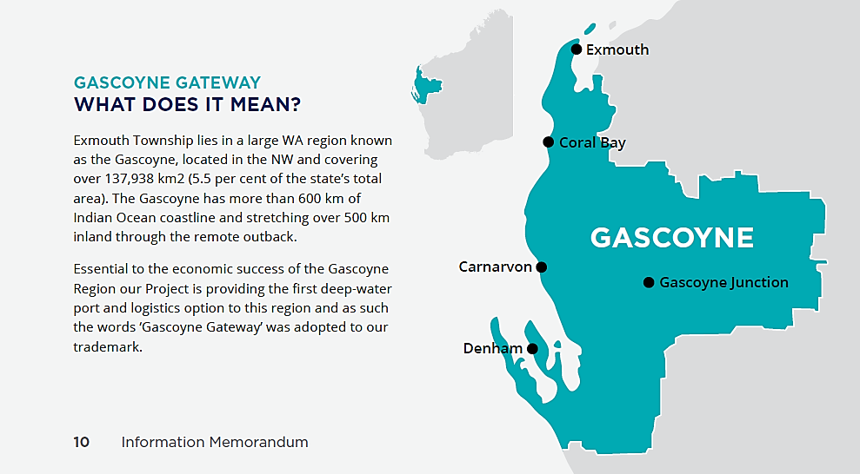

**Trade and Infrastructure Project of State and National Significance**

On 3 July 2020, the WA Premier, the Hon Mark McGowan MLA, advised GGL that the project had been formally recognised by the WA State Government as a ‘Project of State Significance’. With that status, the project has been granted Lead Agency Status under the WA Department of Jobs, Tourism, Science and Innovation (JTSI). JTSI is now providing GGL with high-level advisory and support services to facilitate State Government approvals and development phases of the project.

Australia’s First “Green Port”

GGL is committed to ensuring the protection of the delicate regional coastline and pristine surrounding environment. The Project will be the first ‘Green Port’ in Australia to be designed, built and operated as ‘carbon neutral’, utilising planned renewable energy sources. GGL’s vision is to become environmentally ‘re-generational’ in mitigating present environmental risk and improving present environmental settings. Importantly, the planned site of the facility sits *well outside* theNingaloo World Heritage Park, within Coastal Waters and is adjacent to the current Exmouth Industrial Area and Land Fill site.

GGL is committed to delivering the most environmentally sustainable Port in the world. This will be achieved through:

* Independent potable water production made through renewables.  Also reducing draw on aquifers by augmenting town supply
* Regulation of shipping movements, speeds & anchoring to avoid mega-fauna interaction
* Response capability for marine emergency/spill
* Limestone Reef being investigated to reduce impact of tourism on and support research
* Dredging impact reduced by minimising requirement through design, use of ‘plume curtains’, and spoil piped ashore for use as part of the construction
* Replacement of 5% of long-haul trucks for Pilbara – reduction in 120,000 tonnes Co2 p.a.
* PIANC Working with Nature principles – endangered species protection
* Potentially risk removal to World Heritage Marine Park by relocation of fuel facility from Point Murat (Navy Pier)
* Electric/hydrogen vehicles/plant to operate the facility
* Use of ‘green’ and sustainable building materials
* Production of Green Hydrogen for transition from fossil fuels and potential export

**Indigenous Engagement**

Engagement with the Traditional Owners has been critical to GGL from the beginning and as such we have pursued early engagement with the Nganhurra Thanardi Garrbu Aboriginal Corporation (NTGAC). GGL will also undertake a Heritage Survey and agreement – understanding the Heritage site at Mowbowra Creek.

Furthermore, the Project will deliver multi-generational outcomes through the development of an Indigenous Land Use Agreement (ILUA) with the Traditional Owners and a Reconciliation Action Plan has been developed, including:

* Direct Employment
* Indirect Employment
* Shire Initiatives (community, health, well-being)
* VET Skills, Education, Business Coaching
* Small Business Opportunities

**PROJECT TIMELINE**

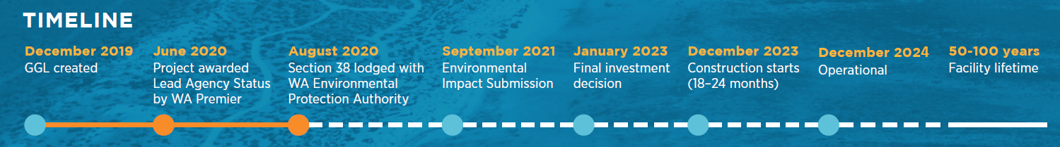

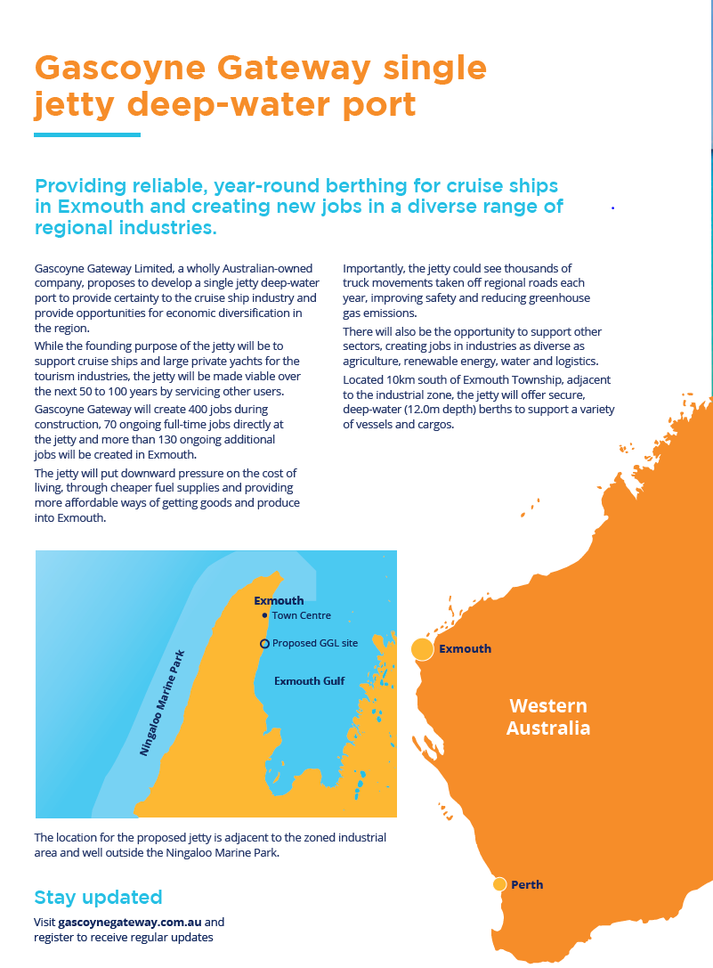

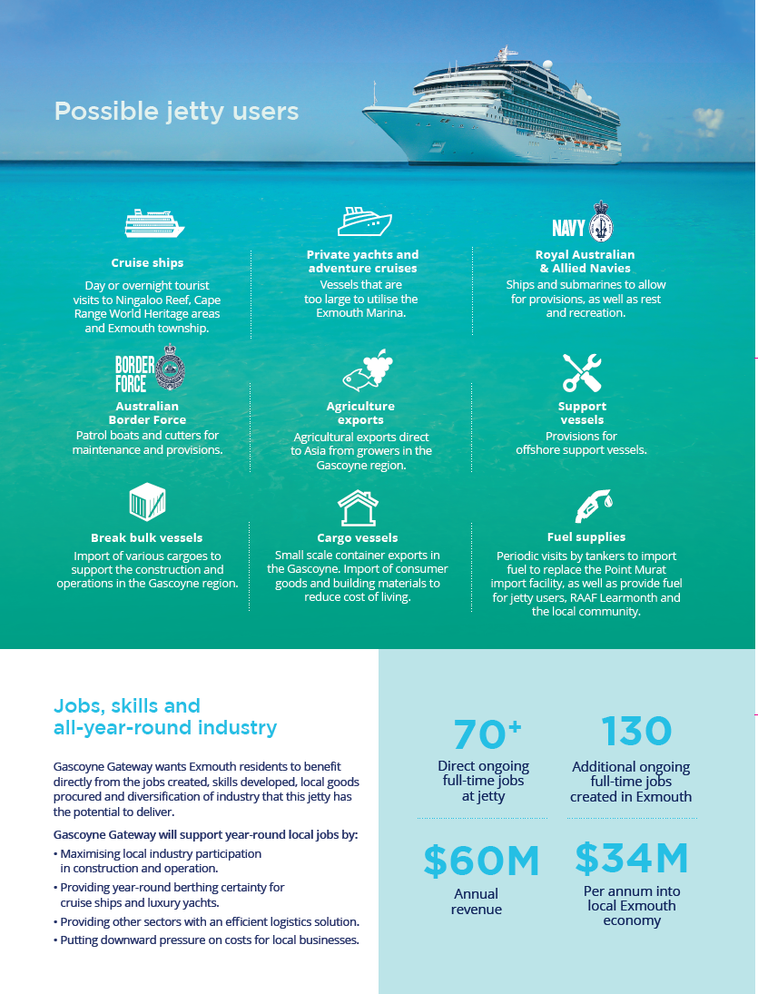

**GGL RECOMMENDATIONS**

|  |  |  |
| --- | --- | --- |
| No | GGL RECOMMENDATION ONE | COST TO GOVERNMENT (AUD including GST) |
|  | That the Australian Government considers investing in the Gascoyne Gateway Initiative via the Northern Australia Infrastructure Facility (NAIF) | TBC - $200-$300 million AUD from existing NAIF funds |

|  |  |  |
| --- | --- | --- |
| No | NAIF CRITERIA | GGL INITIATIVE |
|  | **Involve the construction of north Australia economic infrastructure** | **Trade and Infrastructure Project of WA State and National Significance**   * On 3 July 2020, the WA Premier, the Hon Mark McGowan MLA, advised GGL that GGL’s project had been formally recognised by the WA State Government as a ‘Project of State Significance’ * With that status, the project has been granted Lead Agency Status under the WA Department of Jobs, Tourism, Science and Innovation (JTSI).   JTSI is now providing GGL with high-level advisory and support services to facilitate State Government approvals and development phases of the project * The project will offer secure, deep water (12.0m depth) multiple berths to support a variety of vessels and cargos * The shore side support will include fuelling, lay-down areas, warehousing, bonded goods stores, stores, and operational support, and maintenance * The project will maximise local industry participation in construction and operation and will provide year-round berthing certainty for cruise ships and luxury yachts; and * It will furthermore provide other sectors with an efficient logistics solution. |
|  | **Located in Northern Australia** | * The Project, located at Mowbowra Creek approximately 10 km south of Exmouth in WA’s Gascoyne region, and * It is intended to be Australia’s first “Green” multiuser Port and logistics facility, addressing a number of long standing issues and concerns with respect to the defence and border force maritime, tourism and fuel logistics and storage industries in WA. |
|  | **Require a loan to able to be repaid or refinanced** | It is estimated the Project will generate $60 million in annual revenue, derived from 13 different revenue streams:   1. Royal Australian Navy sustainment 2. Australian Border Force sustainment 3. Coalition Allies sustainment 4. Cruise Liners 5. Super Yachts 6. Adventure Tourism 7. break bulk freight imports 8. Platform support vessels 9. Containers 10. Fuel Tankers and Imports 11. Oil and Gas Support 12. Green Hydrogen Storage and Export 13. Sovereign Fuel Storage Reserves |
|  | **Public Benefit** | **Regional Economic Boost**   * GGL engaged ACIL Allen Consulting (‘ACIL Allen’) to conduct a preliminary economic benefits assessment of GGL’s Project, and * ACIL Allen estimates that the Project will contribute close to $1.0 billion to the Gross Regional Product (GRP) of the Gascoyne region over a 25-year period, with $706.2 million directly contributed. * **In annual average terms, the Project is projected to contribute $34.1 million to the Gascoyne economy every year.**     **Regional Jobs for the Exmouth Community**  The Project will provide a sustainable business model through the diversification of other essential business through the facility and will generate:   * 400 direct jobs in construction * 70 direct full-time jobs directly at the jetty * 130+ additional full-time jobs in Exmouth * Up to 600 jobs across the Gascoyne indirectly   **World’s First Carbon Neutral Maritime Port**   * GGL is committed to delivering Carbon Neutral regeneration ‘Green’ Facility. * GGL’s vision to be ‘the most environmentally sustainable Port in the World’ * This will be achieved through: * Independent potable water production made through renewables.  Also reducing draw on aquifers by augmenting town supply * Regulation of shipping movements, speeds & anchoring to avoid mega-fauna interaction * Response capability for marine emergency/spill * Limestone Reef being investigated to reduce impact of tourism on and support research * Dredging impact reduced by minimising requirement through design, use of ‘plume curtains’, and spoil piped ashore for use as part of the construction * Replacement of 5% of long-haul trucks for Pilbara – reduction in over 120,000 tonnes Co2 p.a. * PIANC Working with Nature principles – endangered species protection * Potentially risk removal to World Heritage Marine Park by relocation of fuel facility from Point Murat (Navy Pier) * Electric vehicles/plant to operate the facility * Use of ‘green’ and sustainable building materials * Production of Green Hydrogen for transition from fossil fuels and potential export     **Sovereign ADF and ABF Capability and Fuel Storage Reserve**   * The project will boost and complement Defence (Navy) sovereign capabilities:  Commercial berths and water depths that will cater for every RAN and ABF vessel including OPVs, LHDs and submarines. There will also be fuel tanks, warehousing, cargo and laydown areas and administration buildings * The project will also provide safe, secure and flexible refuelling and replenishment for the ABF, RAN and allied warships. There are no channels, tidal ranges are less than 2.0 metres and there is unrestricted access * One of the key features of GGL’s project is the intention to develop a minimum 30-million litre state-of-the-art fuel storage facility that will see 100 million litres of usage per annum to provide strategic holdings to meet and sustain the ADF and ABF supply chain and supplement durability commercial distribution in the Gascoyne/West Pilbara. * The project also intends to bolster Australia-US strategic alliances and GGL will ensure we work closely with the Australian Government and the United States Government to strengthen defence cooperation, including on force posture. |
|  | **Indigenous Engagement Strategy** | * GGL has pursued early engagement with NTGAC * GGL will undertake a Heritage Survey and agreement – understanding the Heritage site at Qualing Pool.  Little disturbance (e.g. no mining) * The Project will deliver multi-generational outcomes through the development of an Indigenous Land Use Agreement (ILUA) with the Traditional Owners; and * A Reconciliation Action Plan has been developed, including:  1. Direct Employment 2. Indirect Employment 3. Shire Initiatives (community, health, well-being) 4. VET Skills, Education, Business Coaching 5. Small Business Opportunities |

|  |  |  |
| --- | --- | --- |
| No | GGL RECOMMENDATION TWO | COST TO GOVERNMENT (AUD including GST) |
|  | That the Australian Government recognise the initiative as an Infrastructure project of National Significance | $0 - NIL |

There are two nationally significant problems being experienced in the north west of WA:

1. Supply chain inefficiencies in the delivery of freight into the North West of WA; and
2. Inadequate marine infrastructure between Fremantle and Darwin to reliably berth deep draught vessels in all weather, handle container freight, support cruise ships or support RAN and ABF vessels.

Opportunities demonstrated in Exmouth are:

1. to capitalise on the demand for a direct shipping service in North West of WA;
2. to build a multi-use port facility;
3. to become Australia’s first carbon neutral maritime port; and
4. strategic fuel security of marine diesel, transport diesel and aviation fuel.

Supply chain inefficiencies caused by container deliveries via truck from Fremantle into the Pilbara region is currently costing businesses and consumers $1.7 billion more than container delivery via Exmouth into the Pilbara region. Freight costs into the Pilbara region from Fremantle were $3.4b per year in 2020. There is an opportunity to reduce freight costs by 50% by importing through a port in Exmouth (Attachment 8). Current prices of importing through Fremantle are $1.9b more than if the cargo was imported through Exmouth. This meets the current Infrastructure Priority List assessment guide of a threshold value of $30 million per annum (nominal, undiscounted) in measuring net material benefit, taking the potential unquantified quality of life considerations into account.

There is a compelling case for the construction and operation of a deep water single jetty supporting Exmouth, Western Australia. This Facility would provide essential capability for a variety of seaborne operations including tourism (cruise ships, super yachts, adventure tourism), container and break bulk freight imports, oil and gas support, fuel imports, Royal Australian Navy and Australian Border Force sustainment.

There is no single use purpose that could financially support the build and operation of a Marine Facility of this nature therefore, the Multi-use model provides an ongoing financial viability for the next 50-100 years while also being of a suitable business model to attract Private investment.

Working with local industry and State Government Stakeholders, Gascoyne Gateway Limited was formed to plan, invest, then Build, Own, Operate this community, Regional, and State economic enabler.

The overarching policy settings to optimise the timings and end state remain inconsistent. With the connection between Infrastructure Australia; Northern Australia Infrastructure Facility; and,

Defence infrastructure plans unclear, higher level connecting policy is required to ensure multi-departmental streamlining and efficiencies.

**Regional Jobs for the Exmouth Community**

The Project aligns naturally with the States’ declared ‘Our Priorities’ with ‘Regional Prosperity’ and ‘a Strong Economy’ being identified and highly sought. With an anticipated long term revenue base of $40-60m p.a. while providing 70-80 full time jobs, the Project will support the Exmouth Shire and Gascoyne Development Commissions’ desire to see Exmouth flourish.

The Port will provide a sustainable business model through the diversification of other essential business through the facility and will generate:

* 400 direct jobs in construction
* 70 direct full-time jobs directly at the jetty
* 130+ additional full-time jobs in Exmouth
* Up to 600 jobs across the Gascoyne indirectly

**Regional Economic Boost**

GGL engaged ACIL Allen Consulting (‘ACIL Allen’) to conduct a preliminary economic benefits assessment of GGL’s Project. ACIL Allen estimates that the Project will contribute close to $1.0 billion to the Gross Regional Product (GRP) of the Gascoyne region over a 25-year period, with $706.2 million directly contributed. In annual average terms, the Project is projected to contribute $34.1 million to the Gascoyne economy every year.

Sensitive to the delicate Australian coastline, Gascoyne Gateway is planned to be the first ‘Green Port’ in Australia designed, built and operated as a ‘carbon neutral’ endeavour utilising planned renewable energy sources as part of the design.

This Port addresses the problems associated with supply chain inefficiencies and inadequate marine infrastructure in the Gascoyne region whilst capitalising on the opportunities for direct shipping of freight into the region.

The current Port Hedland port capacity Priority Initiative identifies opportunities to increase exports and make better use of port infrastructure to enable cargo to be delivered to Port Hedland instead of being trucked from Fremantle. Container handling facilities at Exmouth are a more cost effective and amenable to shipping practices. Diverting container ships to Port Hedland costs 30% more in time and money than diverting to Exmouth which only increases the costs for a container ship delivering to Fremantle by <4%. The nature of container trade is that they rely on booking slots, they do not wait at anchor for an opportunity to unload, this is not practical in a port like Port Hedland. Dampier and Port Hedland are bulk export specialist ports, Exmouth is designed to be set up for bespoke low volume minerals shipped via container not loaded by bulk handing conveyors.

Support for addressing the problems and opportunities presented here has been provided in correspondence from Professor Peter Newman and by the Premier of WA the Hon Mark McGowan by recognising the need to allocate lead agency status for this project to the WA Department of Jobs, Tourism, Science and Innovation (JSTI).

**Revenue Streams**

It is estimated the Project will generate $60 million in annual revenue, derived from 13 different revenue streams:

1. Royal Australian Navy sustainment
2. Australian Border Force sustainment
3. Coalition Allies sustainment
4. Cruise Liners
5. Super Yachts
6. Adventure Tourism
7. Break Bulk Freight Imports
8. Platform Support Vessels
9. Containers
10. Fuel Tankers and Imports
11. Oil and Gas Support
12. Green Hydrogen Storage and Export
13. Sovereign Fuel Storage Reserves

|  |  |  |
| --- | --- | --- |
| No | GGL RECOMMENDATION THREE | COST TO GOVERNMENT (AUD including GST) |
|  | That the Australian Defence Force (ADF) recognise the National Strategic Importance of the Initiative | $0 - NIL |

**Australian Defence Force and Border Force Opportunities**

GGL have established an ongoing dialogue with the Minister for Defence, the Minister for Defence Industry, as well as the Department of Defence and the Australian Border Force (ABF). GGL is committed to ensuring that the Port can support the interoperable sovereign capability of the ADF and the ABF.

The Port will have commercial berths and water depths that will cater for every vessel in the Royal Australian Navy (RAN) and ABF including Offshore Patrol Vessels, LHDs and submarines. There will also be fuel tanks, warehousing, cargo and laydown areas and administration buildings.

Unlike other options between HMAS Stirling and Darwin, this unique, purpose-built capability will provide safe, secure and flexible refuelling and replenishment for the ABF, RAN and allied warships including options to the emerging USN 1st Fleet that is appearing likely to be stationed in the Indo Pacific.

Exmouth is 40 percent closer to Christmas and Cocos-Keeling Islands, offering to halve the operating and maintenance costs of RAN and ABF vessels when operating from Exmouth. The shared Exmouth airport and RAAF Learmonth is 25km from the facility and is serviced daily by two 100 seat jets from Perth. GGL furthermore plans to directly import and operate a fuel installation of up to 250 million litres of marine diesel, aviation fuels and other transport fuels, bolstering the facility’s interoperability.

The project will maximise local industry participation in construction and operation and will provide year-round berthing certainty for cruise ships and luxury yachts.

The Port furthermore aligns with *2020 Defence Strategic Update* in that we provide a 100% Australian sovereign capability that will support the ADF’s requirement to:

* prioritise GGL’s immediate region for the ADF’s geographical focus the area ranging from the north-eastern Indian Ocean through maritime and mainland South East Asia to Papua New Guinea and the South West Pacific;
* grow the ADF’s self-reliance for delivering deterrent effects;
* expand Defence’s capability to respond to grey-zone activities; and,
* enhance the lethality of the ADF for high-intensity operations.

GGL is committed to providing our nation and the ADF and ABF with a state-of-the-art sovereign fuel facility to provide aviation and diesel fuel for both the ADF and ABF’s use and commercial distribution in the Gascoyne/West Pilbara. GGL can ensure quality and quantity of aviation and diesel fuel is available for ADF, ABF and Australia’s Coalition Allies to meet current strategic, emerging threats and any high-intensity crisis.

GGL understand that the ADF is currently undertaking the *Defence Fuel Transformation Program* (DFTP) to improve Defence Fuel Supply Chain nationally and that as part of the DFTP, the ADF has gone out to tender for a Fuel Services Contract (FSC). While the FSC will address fuel management and supply, we understand it does not address the storage and strategic reserves that may be necessary to respond to a high-intensity crisis. GGL’s initiative will help address these storage and strategic fuel challenges.

On 16 December 2020, GGL met with the Secretary of Defence, Mr Greg Moriarty, the Deputy Secretary Estate and Infrastructure Group, Mr Steve Grzeskowiak and Head of Navy Capability, Rear Admiral Peter Quinn.

GGL also had the opportunity to meet with the US Naval Attaché, Captain Matthew Ort on 15 December 2020 (which followed on from GGL’s meeting with the US Consul General David J Gainer in Perth on 20 August 2020). Both the Consul General and Captain Ort understood the strategic importance of the Port and recognised how Gascoyne Gateway could significantly support the enhanced maritime cooperation between the US and Australia in the region and have asked us to continue to keep them abreast of the project’s progress.

|  |  |  |
| --- | --- | --- |
| No | GGL RECOMMENDATION FOUR | COST TO GOVERNMENT (AUD including GST) |
|  | That the Australian Government recognise that GGL’s initiative will bolster Australia’s domestic fuel security and ease pressures on the nation’s refineries | $ TBC TBC |

**Morrison Government’s Fuel Storage Initiatives**

Supporting the Morrison Government’s comprehensive Fuel Security Packages that were announced in the 2020-21 Federal Budget, GGL’s Port will include a 25+ million litre fuel storage facility that will see over a 100 million litres of throughput per annum. This will provide a state-of-the-art sovereign fuel facility to provide aviation and diesel fuel for both the ADF and ABF’s operational and contingency use. It will also provide commercial distribution in the Gascoyne/West Pilbara region. Altogether, this initiative seeks to strengthen Australia’s fuel security while also supporting the economy and local investment and jobs in the Gascoyne region.

Australia’s fuel supplies have remained robust for decades now through both major market and supply disruptions, truly an accomplishment to be proud of. However, as refineries close due to competitive pressure, Australia is increasingly reliant on imported fuel. GGL understand that most aviation fuel supplies are sourced through BP Kwinana and road freighted (1300km) to Exmouth. This may suggest that there may not be enough fuel tanker trucks to sustain contingency or surge aviation operations, as we understand was the case during the MH-370 search when intensive search operations exerted considerable pressure on WA aviation fuel stocks.

Each year approximately thirteen (13) million litres of diesel fuel is imported to be stored at the Naval Communication Station Harold E. Holt (HEH), located 25 kilometres north of Exmouth. It is transferred via civilian tankers using the Navy Pier at Point Murat (within the Ningaloo World Heritage Marine Park). The Navy Pier is generally utilised by fuel tanker vessels approximately once each year to facilitate this transfer and the HEH tanks are replenished before cyclone season to ensure that sufficient stocks are maintained, to reduce operational risk. GGL understands that this risk has been previously realised when cyclones have damaged the storage facility and thus isolated the facility from resupply.

As Australia enters a more unpredictable environment both strategically and economically, the Government must be prepared for any significant event that can disrupt our supply chains. GGL proposes to provide a sovereign capability for the HEH fuel import arrangement on behalf of the ADF and ABF with the following key objectives:

1. Provide the ADF and ABF with a state-of-the-art sovereign fuel facility to provide aviation and diesel fuel for both the ADF and ABF’s use and commercial distribution in the Gascoyne/West Pilbara. GGL will ensure that the sovereign fuel supply at their Port will ‘turned over’ approximately once per quarter assuring year-round, high-quality fuel availability;
2. Provide a minimum 30-million litre storage facility that will see 100 million litres of usage per annum. Currently, this does not include any contingency or strategic reserve for ADF;
3. Remove ongoing risk to the Commonwealth for an accidental fuel spill inside the Ningaloo marine park and instead, see the operation conducted more frequently and remotely from the marine park;
4. To offset the approximate $2.5m p/a maintenance costs of HEH (including a daily 20-26,000 litres of diesel to power its VLF transmitters), GGL propose that the current independent tankage could be reduced, and all fuels sourced via a daily 20k road tanker (identical to those that provide fuel supplies to service stations);
5. Potentially offer replenishment of fuel an ammunition and Rest & Recreation options for Allied navies; and,
6. To provide aviation fuel capacity to support P8A Poseidon sorties and also allow the MQ-4 Triton remotely piloted aircraft to deploy from the RAAF Base Learmonth, in order to support Indian Ocean maritime patrol.

Oil and Gas Opportunities

Vessels from the Oil and Gas sector are regular users of Exmouth Gulf. Ships providing equipment and materials for use in exploration and construction off the North West coast often utilise the sheltered waters of the Gulf to undertake ship to ship transfer and personnel exchange ashore. The expansion of the Carnarvon Basin and Enfield Gas reserves will support use of the Gascoyne Gateway through a distance advantage over other locations and the provision of additional depth will support the deeper draught vessels in this industry.

Over and above the priority to take fuel and supplies close to the area of operations, is the capability to undertake logistics management of import/export commodities at a Port site with warehousing and bonded cargo capacity. Commonly, oil and gas operationally consumable goods are imported as freight cargo, and most often transported in uniform container form. Presently, oil and gas companies rely on such goods being transported by priority road freight, before being shipped by Offshore Supply Vessel to the Field for use.

|  |  |  |
| --- | --- | --- |
| No | GGL RECOMMENDATION FIVE | COST TO GOVERNMENT (AUD including GST) |
|  | That the Australian Government recognise that GGL’s initiative will support the National Hydrogen Roadmap and will support an economically sustainable industry | $0 – NIL |

As Australia transitions to a low-emissions energy future, there is vast potential for a Hydrogen Industry to emerge supporting sustainable energy storage, national technological advantages, and export opportunities. This is highlighted by the National Hydrogen Roadmap, which provides a blueprint for the development of the hydrogen industry in Australia.

As the roadmap states, one of most significant barriers to the Hydrogen market activation is a lack of infrastructure compared to other energy carriers. GGL’s initiative would assist in this area by producing Green Hydrogen aiding in the transition from fossil fuels.

As stated by the roadmap, potential export opportunities that GGL’s initiative would produce would likely increase the competitiveness of hydrogen against other technologies. The roadmap states that exporting hydrogen could be a key opportunity with demand from China, Japan, South Korea and Singapore reaching the order of 3.8 million tonnes in 2030. GGL’s ability to produce and store green hydrogen, alongside its geographical location would position Australia in a prime position to capture this potential market.

While global market trends are seeing a push for low carbon economies, potentially placing some energies at risk such as thermal coal, the global market for Hydrogen is set to increase reaching USD 155 billion by 2022. Green hydrogen has many applications such as electricity, heat, transport, ammonia, chemicals, glass manufacturing, food, synthetic fuels and metals processing. This provides an economically sustainable industry which GGL can support Australia by both producing and storing green hydrogen helping secure Australia’s economy for years to come.

LETTERS OF SUPPORT AND INTENT

GGL is pleased to advise they have received a number of letters of support and commercial intent from the following stakeholders:

1. Hon Mark McGowan MLA, Premier of Western Australia – Letter of Support
2. Letter of Intent from Boskalis Offshore Energy
3. Letter of Intent from Phoenix International Underwater Solutions Worldwide

**Letter of Support from Western Australia Premier, the Hon Mark McGowan MLA**

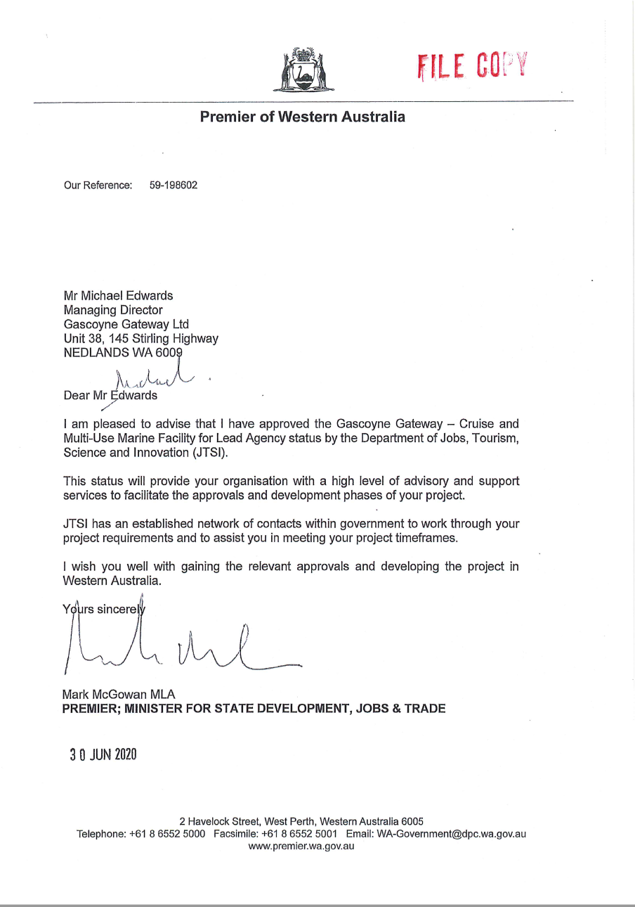

**Letter of Intent from Boskalis Offshore Energy**

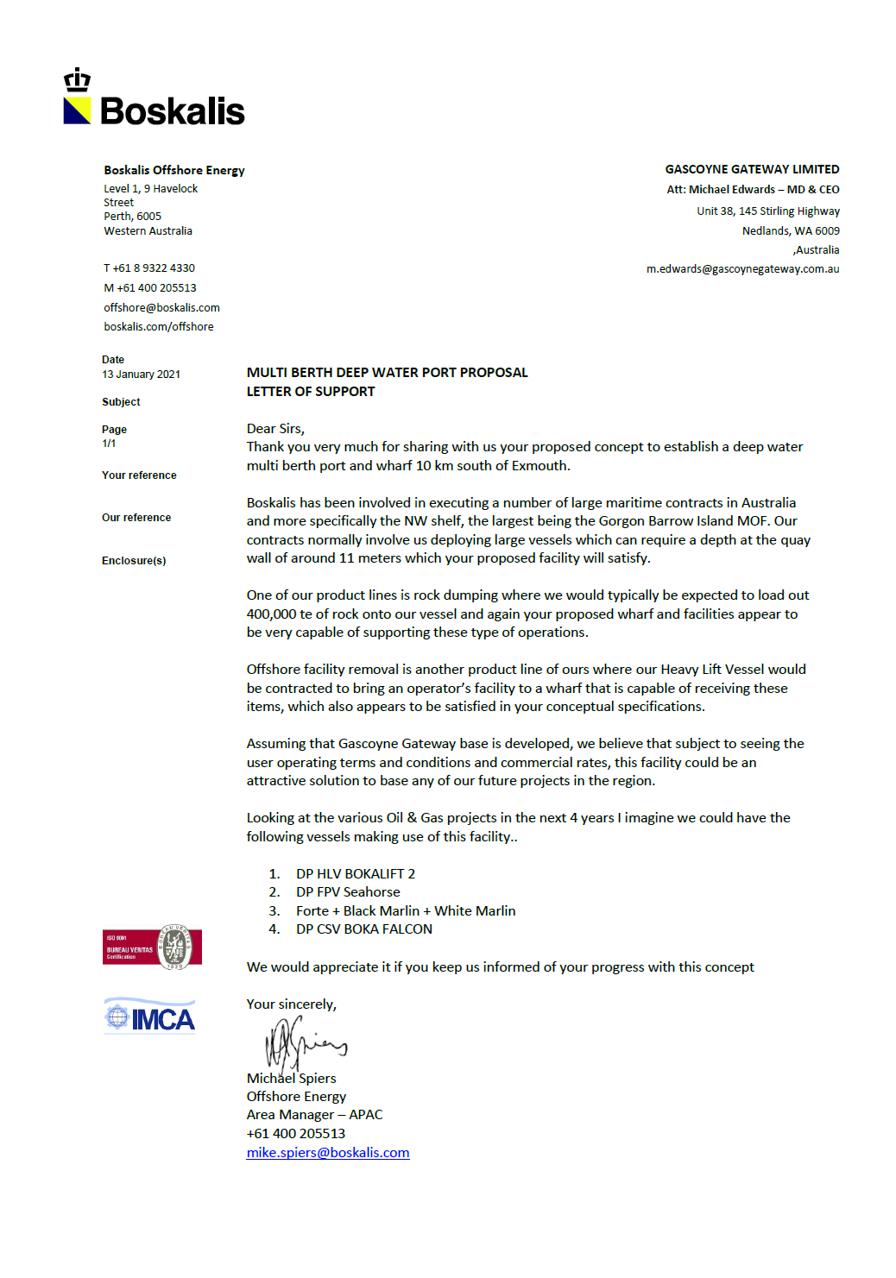

**Letter of Intent from Phoenix International Underwater Solutions Worldwide**

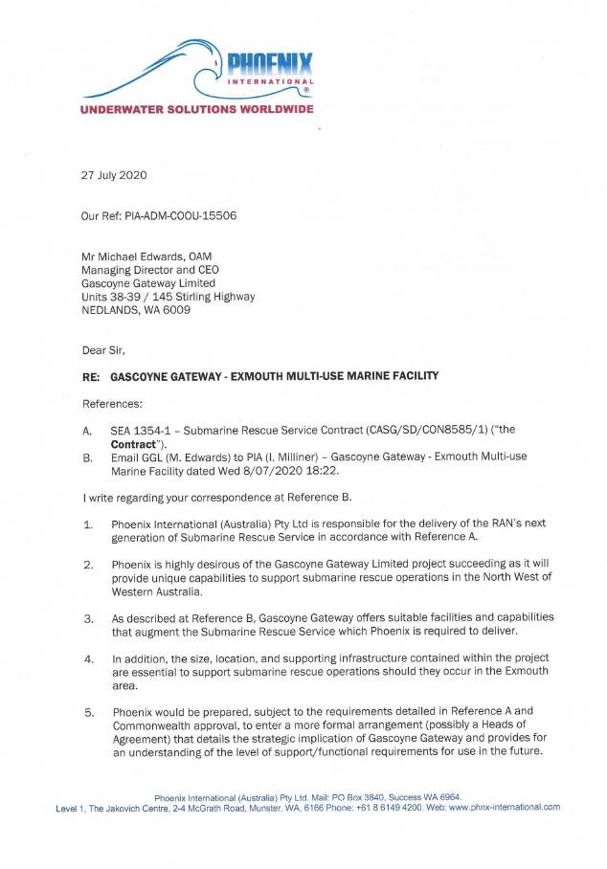

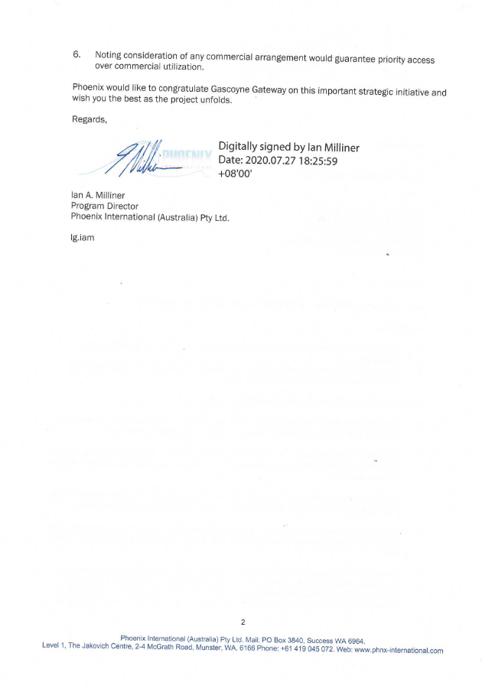

**for further information**

For more information regarding the Gascoyne Gateway Ltd:

**E:** [info@gascoynegateway.com.au](mailto:info@gascoynegateway.com.au)

**W:** [www.gascoynegateway.com.au](http://www.gascoynegateway.com.au)

**P:** Gascoyne Gateway Ltd**,** Unit 38/145 Stirling Highway**,** NEDLANDS WA 6009

**ABN:** 72 638 151 747

**ACN**: 638 151 747

**Who We Are**

**Michael D Edwards OAM – Co-Founder and Managing Director**

Michael is experienced in world-wide operations whilst leading and managing teams of 15-350 personnel, delivering a range of experiences and breadth of knowledge that have the capacity to strengthen any commercial project or operation.

He is a professional mariner with over forty years’ experience in both Naval (formal Clearance Diver) and Commercial operations, where driving innovation and efficiency were paramount to successful business outcomes.

In the last 15 years, his provision of technological and process innovation has delivered outstanding results in efficiency and commercial advantage to significant resources and Government clients in Western Australia.

Michael has stepped away from his executive director role within Oropesa Port Management Pty Ltd, where he is also a major shareholder so that he can concentrate on his role at GGL. Michael is a Founding Director of Gascoyne Gateway Limited and a major shareholder.

**Daniel Jackson – Chief Operating Officer**

Before embarking on the Gascoyne Gateway journey, Daniel built an impressive career in Defence and the Private Sector, including more than 14 years of highly accomplished and commended service as a Clearance Diver and Electronics Engineering Technician, specialising in sensors and detection systems within the Royal Australian Navy.

Upon transition from the Navy and a distinguished tenure embedded with Australian Special Forces, Daniel has spent the last 10 years in senior management and executive roles, designing, and deploying operational strategies to deter threats, mitigate risk, respond to change and build business resilience.

Daniel is a member of the Edith Cowan University Quality, Audit and Risk Committee and has a board experience leading and delivering projects through cross-function teams within mineral exploration, mining, construction, heavy industry, training and technology. Daniel’s creative and entrepreneurial passion, evident in his depth of business acumen and experience in governance and compliance, has led to co-founding and growing a number of start-up companies.

**Denise Goldsworthy – Independent Non-Executive Chair**

Denise is a metallurgist, commencing her career with BHP Steel, then various roles across the mining industry and innovation sectors and eventually becoming Managing Director of Dampier Salt (Rio Tinto Limited) where she is credited with both expanding and invigorating this division’s returns across the three mines, processing facilities and three port-based supply chains.

Denise is an experienced non-executive director and experienced chair. Since leaving executive management roles Denise has devoted herself to lending her expertise, experience and energy to many company and charitable boards she helps steward.

She is Chair of the Navy Clearance Divers Trust which helps support service personal in their transition to civilian life, to recover and live with injury as well as providing support to Clearance Diver’s families.

Denise is well known as master of constructive questioning that has delivered a track record of driving rapid, yet sustainable step change in business performance, ranging from cash/earnings and safety, to productivity and product quality through a complementary combination of cultural, systems and technology changes. Externally recognised as a high-quality director utilising expertise in business engagement and system design to achieve reliable outcomes.

Denise has been an advisory mentor to the Founding Directors of Gascoyne Gateway Limited for many years, became a director within a month of incorporation and is a shareholder of the Company who provided early and essential working capital.

**Adam Mc Phail – Co-Founder and Non-Executive Director**

Adam has had a professional maritime career spanning thirty five years across defence (former Clearance Diver, leadership and command roles) and commercial industries, delivering a broad perspective and significant depth to the variety of influences challenging the business of maritime operations in the modern economy.

Adam has spent the last 15 years as a commercial Marine Pilot, Marine Surveyor, and Port Operations Contractor, providing services to industry as the lead consultant on green field port design and existing port operational efficiency, management and review.

He focuses on the engagement of leading-edge technology to maximize the safety and efficiency of today’s port functions and has frequently been used as a subject matter expert for government submissions, reports and analysis.

Adam continues to deliver advantage to various projects in coastal development and port operations via his executive director role within Oropesa Port Management Pty Ltd where he is also a major shareholder. Adam is a Founding Director of Gascoyne Gateway Limited and a major shareholder.

**Alistair MacKinley – Independent Non-Executive Director**

Alistair was a lawyer running his own large successful legal practice for 30 years specialising in corporate commercial and transactional advice.

He has been director of a number of listed and unlisted public companies including start-ups as well as not for profits.

In recent years he has acquired and operated a number of successful commercial businesses.

Alistair has also been a legal advisor and mentor to the Founding Directors of Gascoyne Gateway Limited and became a director during the incorporation period. He is also a shareholder of the Company who provided early and essential working capital.

**Tony Brun – Independent Non-Executive Director**

Tony is currently the Head of Planning across Melbourne Airport.

Previously he was the Chief Strategy Officer at Perth Airports and Chief Executive Officer at the City of Greater Geraldton.

He has served on various Boards including South West Catchments Council as Chairman, and also the RAAF Association of WA as a non-executive director. He is also a Fellow of the Australian Institute of Company Directors.

He continues to serve as an Adjunct Professor – Sustainability at Curtin University.