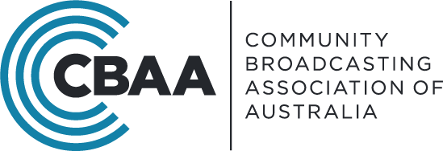
19 March 2021

Thresholds Working Group
C/- Not-for-profit Unit
Individuals and Indirect Tax Division
The Treasury
Langton Crescent
PARKES ACT 2600

Financial reporting thresholds for ACNC-registered charities
Dear Ms Allitt,
We write regarding the proposal to raise the reporting thresholds for charities registered with the Australian Charities and Not-for-profits Commission (the ACNC).
The Community Radio Broadcasting Association (the CBAA) appreciates the opportunity to comment on this proposal. The CBAA is the peak body for community radio broadcasters across Australia.
The CBAA supports the changes in financial reporting thresholds as proposed. As approximately 50% of our sector operate as charities, this proposal will benefit at least half of our sector. The median income of our community radio broadcasting member stations is $75,000; and more than ¾ of our sector produce annual revenues less than the proposed small revenue threshold.
The CBAA notes that, if effected, this proposal will provide significant benefit to all charities in our sector. Our small charities will be able to redirect an estimated $2,500 extra funds and extra time back to their charitable purpose: providing independent community radio for diverse local communities across Australia. Our medium and large charities will also see significant reductions in administrative burdens.
The proposal strikes the right balance in promoting accountability and transparency. We also believe the timing of this proposal is right; amid a time of plummeting donations, constrained access to volunteers, and at a time when our community’s desire for localised, independent radio is stronger than ever.
The CBAA is appreciative of the ongoing work being conducted by the ACNC to promote harmonised financial reporting thresholds across jurisdictions and reduce regulatory red tape. In making the proposed changes it is essential that changes are also made where necessary at a state level to ensure the alignment of reporting requirements across State and Federal regimes.
We continue to be available to the ACNC for conversations about the benefits of your good work in this area, for our sector.
If you would like to discuss this further, please do not hesitate to contact Holly Friedlander Liddicoat, CBAA’s Head of Advocacy and Communications at holly.friedlander@cbaa.org.au or via 02 9310 2999.
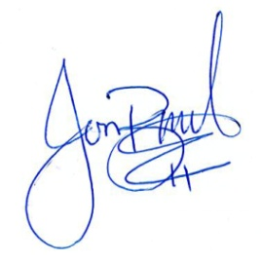
Best regards,

Jon Bisset
Chief Executive Officer

