30 October 2020

Subject: Submission for consultation on making permanent reforms in respect of virtual meetings and electronic document execution
By way of background, Resolution Capital Limited (Resolution Capital) is a Sydney based investment manager that specialises in publicly listed real estate securities. Currently we manage over A$10bn on behalf of a range of clients both domestically and internationally.

We wish to provide the following response to the request for submissions with respect to draft legislation that makes permanent changes to the Corporations Act 2001 in relation to virtual meetings and electronic document execution (Corporations Amendment - Virtual Meetings and Electronic Communications - Bill 2020).

For reasons we will briefly outline, the proposal to give Australian public companies the ability to move to a virtual only meeting format is not in the best interests of shareholders.

Resolution Capital is an active manager and is committed to promoting good corporate governance and protecting our clients’ best interests. Engagement and keeping the Board and management teams accountable are important components to achieve this. Formal shareholder meetings have proven to be a critical part of this process.

We are concerned that giving companies the option to move to virtual only shareholder meetings compromises transparency and effectiveness of engagement with public company Boards and management teams.

In our opinion, giving shareholders the ability to publicly ask challenging questions and highlighting contentious issues is more effective in a physical context than in a virtual setting. One key concern we have with virtual only meetings is that it potentially becomes harder to get through to ask questions and to follow-up without being cut off unbeknownst to other shareholders. We also believe it is more meaningful of being able to look someone in the eye. Hence, there is a risk that the public display of corporate governance and accountability will be reduced in a virtual only setting thereby leading to a lowering of standards.

We do understand that sometimes it is not practical for a shareholder to be present. Hence, we believe a hybrid option, which serves both physical and online audiences, provides the best of both worlds: improved engagement without the risk of less accountability.

In summary, we recommend that the draft legislation to permanently allow virtual-only meetings should be rejected.

Regards,

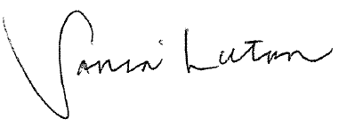

Sonia Luton
Managing Director

