Manager
Market Conduct Division
The Treasury
Langton Crescent
PARKES ACT 2600

30 October 2020

Via: businesscomms@treasury.gov.au

Dear Manager

Submission on proposed legislative changes to Corporations law: Corporations Amendment (Virtual Meetings and Electronic Communications) Bill 2020
IOOF welcomes the opportunity to provide feedback on the proposed bill to make permanent reforms in respect of virtual meetings and electronic document execution.
IOOF supports moves to facilitate electronic communications and virtual meetings. The current situation with COVID-19 has drawn attention to the capacity for Australian business to successfully operate in a virtual environment, and communicate and hold meetings electronically with staff, clients and shareholders. We believe we are especially qualified to comment as the IOOF Group head office is in Melbourne and we have successfully operated on a virtual basis throughout the extended lockdown period.
The key issue that arises is that the reforms have been restricted to Corporations law, and do not extend to comparable situations governed by superannuation law. Superannuation funds are governed by both corporations and superannuation law, and there should be consistency between the requirements under both statutes. This is particularly the case where proposed legislation would improve super member outcomes and reduce costs for super funds.
Binding death benefit nominations
Under Superannuation Industry (Supervision) Regulations 1994 6.17A, a member can make a death benefit nomination that is binding to the trustee, but only if the notice is signed by the member, in the presence of two witnesses. In a COVID-19 environment, we have found many members are unable or unwilling to expose themselves to the risk of having their nomination witnessed. Further, many States have introduced relief from, or alternatives to, witnessing requirements for deeds executed under State law.
We urge the Government to consider implementing alternative witnessing arrangements for binding nominations so members can have certainty as to the treatment of their superannuation benefit during this pandemic.
Notices for Annual General Meetings (AGMs) and Annual Member Meetings (AMMs)
The draft legislation proposes to make permanent the temporary measures to facilitate virtual meetings introduced during the COVID-19 lockdown, including AGMs with shareholders. The draft bill also facilitates electronic notices in relation to meetings. Providers can give notice of a meeting by:
“sending to the electronic address provided by the member or another electronic address that the sender believes on reasonable grounds to be the person’s electronic address. Alternatively, the sender could provide the person with details sufficient to allow them to view or download the document (either electronically or via traditional means).”
Under the proposed bill the member does not need to consent to electronic communications – as is required by the Electronic Transactions Act.
Recent changes to the SIS Act introduced a requirement for RSE licensees to hold an annual meeting of members for each RSE. Subsection 29P(3)(a)(ii) provides that the meeting may be conducted electronically (including virtually). However under ss 29P(2) and (3) there is no provision for notices to be provided electronically.
It is our view that proposed legislation should be expanded to facilitate electronic provision of notices for annual member meetings for RSEs. Increasingly RSEs holds electronic addresses for members provided directly by the member or via updated account information from the ATO’s Provision of Details Service for inactive/uncontactable accounts.
We also believe that, consistent with the draft explanatory memoranda, superannuation trustees should be able to provide details of where to access the notice for the member annual meeting on the fund website. As most super funds provide members with online access to their super account information, personal notices could be accessed through a link via the fund website. Super trustees can also provide directions to the fund website in annual member communications, periodic statements and trustee reports as required under sections 1017D and 1017DA of the Corporations Act 2001.
Meeting the legislative requirements for communicating to members is increasingly cumbersome and costly. Over the past two years members have received a stream of communications from trustees about legislative changes - Protecting Your Super, Putting Members Interests First, fee changes etc - in addition to regular communications. Future proposed changes to ongoing advice fees and the YourSuper initiative announced in the 2020 Federal budget reinforce that members are likely to receive an increased level of communications from super funds going forward.
Requiring superannuation funds to provide this information to members via physical post increases fund expenses at a time when trustees are under added pressure to reduce costs to members where possible. Further, in the 21st century it is a reasonable expectation from members that their superannuation funds should be able to communicate through electronic means.
Our view is that, where possible, legislators should act to facilitate electronic options for communications for members, including utilising existing facilities such as websites and online member accounts. Our members expect no less from us.

Yours sincerely

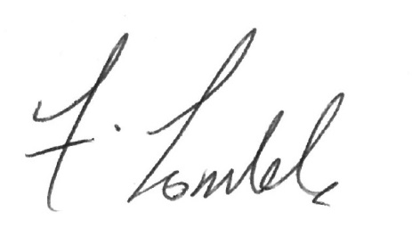
Frank Lombardo
Chief Operating Officer

