

Your Future, Your Super package

# Submission

23 December 2020

David Bell

|  |
| --- |
| David Bell is Executive Director of The Conexus Institute, a not-for-profit research institution focused on improving retirement outcomes for Australian consumers.  This submission represents work of The Conexus Institute. It references collaborative work undertaken by a working group (“Working Group”) involving Conexus Institute and five leading industry consultants. Unless clearly attributed to the Working Group view, all opinions and analyses provided in this submission should only be attributed to The Conexus Institute. |

## Table of Contents

1. Summary 3

2. YFYS Performance Test 3

2.1. Summary of Working Group Paper 3

2.2. Additional research 8

2.3. Summary 19

3. Concerns around marketing spend 20

4. Summary 21

## Summary

In this submission we undertake further exploration of the Your Future, Your Super (YFYS) performance test and detail our concerns around the possibility of a “marketing free-for-all” which could flow from account stapling.

The concerns raised by The Conexus Institute as part of the Working Group’s analysis of the YFYS performance test remain in place. In this submission the Conexus Institute has broadened its analysis to re-consider effectiveness under modified versions of the YFYS performance (such as introducing some unlisted benchmarks). We believe the performance test will remain ineffective unless more significant changes are made. Indeed, in some areas the test is overstating industry performance. The Productivity Commission used an implementation test to estimate underperformers across the population of funds and recommended the same test be applied to test funds individually. Unfortunately, our additional analysis considers the first use of the test far more appropriate than the second.

We maintain our view that the test will distort portfolio decision-making – we provide additional analysis and case studies to illustrate this. As it stands the communication challenge remains significant – we see no easy solution to this problem unless the test changes.

What can be done? In the absence of incorporating qualitative oversight, including a second somewhat orthogonal quantitative test could provide sizable marginal benefit to the test effectiveness and reduce undesirable outcomes. Dispute of results would be lower and the message to consumers would be clearer.

Finally, our analysis of the draft legislation (“Single Default Account” and “Best Financial Interest Duty”) raises concerns of a “marketing free-for-all”. We explain the rationale for how this may occur and how funds can justify increasing their marketing spend. Given marketing is a zero-sum activity we believe further measures will be required to protect the default savings of consumers from marketing expenses.

We are available to assist policymakers on any aspect of this submission or research undertaken by the Working Group.

## YFYS Performance Test

### Summary of Working Group Paper

In response to the release of the YFYS reforms announced in the Budget, a working group was formed to analyse and assess the YFYS performance test. A Detailed Paper and a Summary Paper have been made publicly available, along with statistical models. The Detailed Paper is available [here](https://theconexusinstitute.org.au/wp-content/uploads/2020/11/YFYS-Detailed-Paper-20201127.pdf).

The critique looked at a range of areas, some of which are de-emphasised in this submission. For instance, the Working Group consider that product design can have a huge impact on member outcomes, but that it may be more appropriately assessed through another policy instrument such as APRA’s Outcomes Assessment.

When we focus purely on assessing investment performance, Diagram 1 provides a good summary of the investment management process. The red box identifies the only output captured in the YFYS performance test.

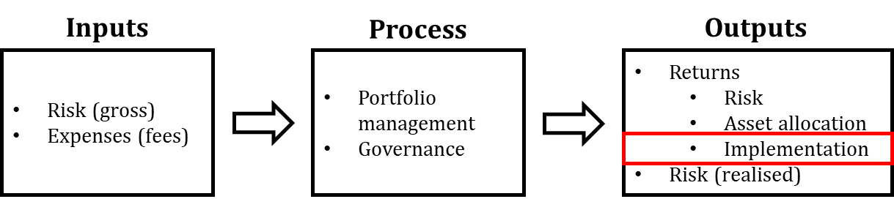

Diagram 1: Process representation of investment management. The red box reflects the focus of the YFYS performance test. Note that chosen inputs (risk and expenses) account for the assessed opportunity set (expected returns, forecast volatility, correlations etc.), fund membership characteristics (demographic profile), and fund-level constraints such as liquidity.

The Working Group explored the statistical effectiveness of the YFYS performance test. Reflected in Diagram 2, we identified three challenges which resulted in the Working Group’s view that the test would have weak effectiveness over time, summarised in Table 1.

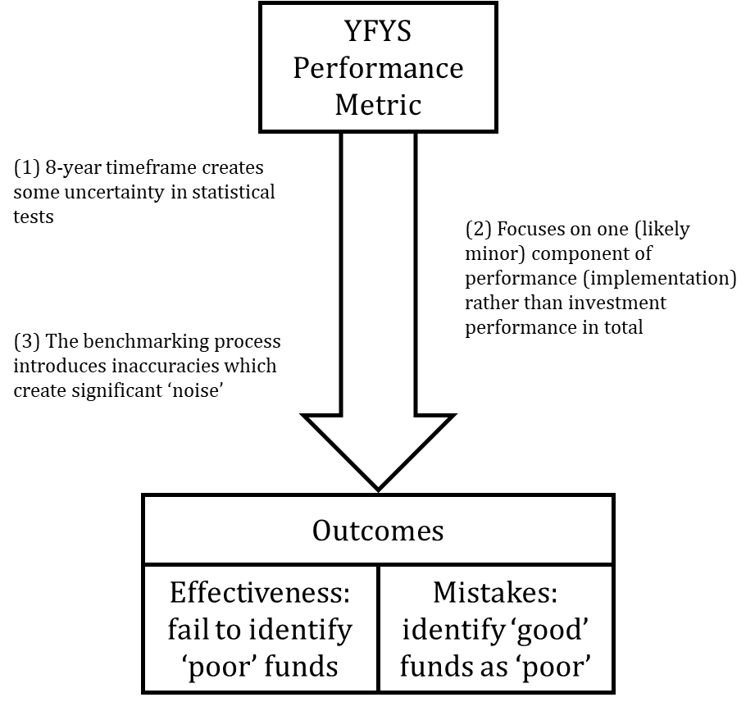

Diagram 2: Detailing concerns around the effectiveness of the YFYS performance metric.

|  |  |
| --- | --- |
| **Test** | **Likelihood** |
| Effectiveness: likelihood of failing to identify a ‘poor’ fund as ‘poor’ | 42% - 65% |
| Mistakes: likelihood of identifying a ‘good’ fund as ‘poor’ | 35% |

Table 1: Assessed statistical effectiveness of the YFYS performance metric. For more details see the Detailed Paper.

In Diagram 2 benchmark noise is created by benchmarking sectors against indices which do not track their short-term performance. There are many sectors impacted, most notably private equity, unlisted property, unlisted infrastructure, all forms of credit, inflation-linked bonds, and the entire universe of alternative assets.

The Working Group developed a statistical test (the models for which are available) to assess the overall effectiveness of the YFYS performance metric. The results are summarised in Table 2. Overall, the effectiveness of the YFYS performance test was assessed to be very weak (in the context that a coin-toss would result in 50% outcome for effectiveness and mistakes).

|  |  |
| --- | --- |
| **Test** | **Likelihood** |
| Effectiveness: likelihood of failing to identify a ‘poor’ fund as ‘poor’ | 42% - 65% |
| Mistakes: likelihood of identifying a ‘good’ fund as ‘poor’ | 35% |

Table 2: Assessed statistical effectiveness of the YFYS performance metric. For more details see the Detailed Paper.

The Working Group then assessed the potential for undesirable outcomes. The Working Group raised strong concerns around undesirable outcomes relating to distorting the portfolio management process, consumer outcomes, and industry structure. These are summarised in Table 3.

|  |  |  |
| --- | --- | --- |
| **Concern 1: How funds will invest** | **Concern 2: Direct impact on consumers** | **Concern 3: Impact on industry structure** |
| * Distortion to portfolio management behaviour. Focus on reducing tracking error to performance benchmark and through-time performance management will make trustees more short-term focused and make a range of ‘noisy’ investment strategies less attractive. We expect this to increase portfolio turnover costs and reduce portfolio quality. * Dangerous incentive for funds which are well behind on the performance test to ‘swing for home runs’ and take high tracking error relative to benchmark. * Actively managing the performance test by taking advantage of benchmark shortcomings. * Poor alignment with portfolio management approaches such as total portfolio approach (TPA). * Deterrent to strategies which reduce risk and provide diversification. * Management of ESG risk creates more benchmark “tracking error”. * Potential for reduced investment in Australian unlisted assets. * Features of the YFYS performance test do not match up well with future portfolio management challenges. | * Given the low effectiveness of the test super funds may ‘contest’ the result with their members, creating confusion. * The YFYS performance test result may create confusion for consumers when placed alongside total performance on the YFYS Comparison Tool. * Potential for a large cohort of funds to fail the YFYS test concurrently (due to benchmarking noise), reducing system confidence. * Does not remove consumers from investment products with assessed high administration fees. * Penalises the heavily disengaged who may remain in a fund which becomes more impaired. | * A deterrent to consolidation as funds will be hesitant to merge with other funds which may dilute their portfolio quality, impair their inflow profile, or distract management focus. * Potential ‘zombie’ funds which are impaired, making them an unattractive merger partner. |

Table 3: Summary of undesirable outcomes likely to result from the YFYS performance test. For more details see the Detailed Paper.

The final part of the Working Group’s initial work was to consider possible solutions. The Working Group found this difficult because it depends on what constraints are assumed. One example of a design constraint is whether a qualitative overlay is a possibility. The Working Group considered this an area for further work as more insight around constraints came to hand.

### Additional research

Following the release of initial resources, the Working Group continues with the ongoing mandate of providing research-based insights to support the development of a more effective performance test.

Other information has come to hand:

* The release of draft legislation by Treasury
* [Research by the Thinking Ahead Institute on the YFYS reforms](https://www.thinkingaheadinstitute.org/research-papers/australia-proposed-your-future-your-super-reforms/) which we consider insightful and high quality

We (Conexus Institute) are of the view that Government is intent on implementing the YFYS reforms and our focus is on improving the announced forms rather than challenging the need for them. This should not be interpreted as an endorsement of the reforms – improving consumer outcomes in a complex system is a difficult challenge and we are not confident that these reforms will achieve their intention of better consumer outcomes.

#### Working Group principles

For the purposes of framing an effective performance test with limited undesirable outcomes the Working Group agreed on some principles. These may be valuable for Treasury:

1. Developing an effective performance test is a great opportunity to improve superannuation outcomes for consumers.
2. It is important to minimise any undesirable outcomes created by introducing a performance test.
3. The ramifications of failing any performance test need to be proportional to its reliability.
4. Qualitative assessment by an entity such as APRA would acknowledge changes made through time by super funds to address past performance issues.
5. A well-designed collection of multiple metrics is likely to be more reliable and effective than a single metric.
6. If the intention is for a consumer outcome test, then it makes sense to include administration fees.

#### Additional combinations of implementation and SAA performance

During consultation with Treasury, it was requested that we consider further combinations of implementation and SAA performance to expand the understanding of the effectiveness of the YFYS performance test. Extended analysis is provided below in Diagram 3 and Diagram 4. Both tables ignore the impact of benchmark noise (benchmark noise move all probabilities towards 50%).

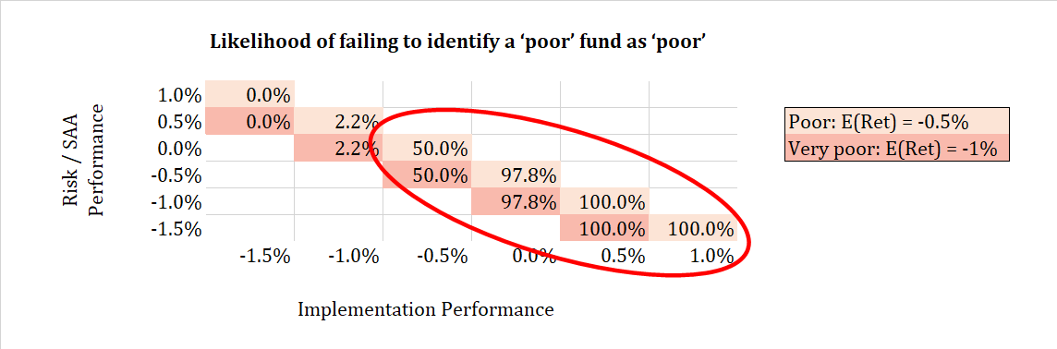

Diagram 3: Further analysis on likelihood of failing to identify a ‘poor’ fund as ‘poor’. Analysis applies the same assumptions as Table 3 of the Detailed Paper (included as Appendix).

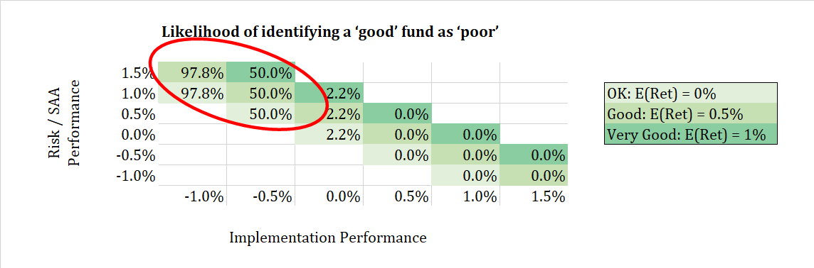

Diagram 4: Further analysis on likelihood of identifying a ‘good’ fund as ‘poor’. Analysis applies the same assumptions as Table 3 of the Detailed Paper (included as Appendix).

In Diagram 3 and Diagram 4 we consider different combinations of performance sources which add up to the same net outcome (as per colour-coding). The circled regions highlight situations where the YFYS performance test will be ineffective when viewed through the lens of consumer outcomes.

We make two observations. First, there are a large range of situations where the performance test will prove ineffective. Second, the ignorance of the YFYS performance test to risk / SAA performance is demonstrated by how the numbers are identical down each column.

#### Distortion in detail – the ‘drift’ and the ‘noise’

During discussions with Treasury, we were requested to provide some further detail on how the YFYS performance test will distort portfolio management decisions. We begin by explaining the concepts of drift and noise in a benchmark-focused world, and then provide some examples of how being cognisant of the YFYS performance test does not always align with the concept of maximising returns-for-risk. Finally, we list a range of sub-sectors which are exposed to drift and/or noise.

Whenever investing relative to a benchmark, two concepts are important:

1. The drift: or the expected return of the investment opportunity relative to the benchmark
2. The noise: the volatility of the performance of the investment opportunity relative to the benchmark, sometimes known as tracking error

Both concepts are important to benchmarked portfolio managers. If a manager has positive (negative) drift they expect to outperform (underperform) over time. Noise represents variability: for an asset with positive drift, the greater the noise the more likely that the fund will underperform at a particular point in time (as noise becomes extremely large the likelihood approaches 50%).

For a benchmark-focused manager it is rational to search for assets with high positive drift and low noise. Through a consumer outcome lens this is reasonable behaviour if the benchmarking process aligns with the objectives of member best outcomes, which we define as maximising return for an appropriate level of risk. Unfortunately, the alignment is not strong, as detailed in Table 4.

|  |  |  |
| --- | --- | --- |
|  | **Member outcome (return for risk)** | **YFYS benchmark-focused** |
| **Return** | Every decision will be about maximising return for risk | Asset class decisions motivated by drift versus benchmark |
| **Risk** | Variability in outcomes | Noise – variability in returns relative to benchmark |
| **Diversification** | Accounted for in decision-making | Irrelevant |

Table 4: Assessed primary alignment between member outcomes focus and YFYS benchmark focus.

We see little primary alignment between the two approaches to managing assets. Clearly there is greater alignment if we accounted for secondary motivations.

To explore further we provide a basic framework (Diagram 5) for assessing issues which face portfolio managers who focus on member outcomes (return for risk). Table 5 then provides some case studies to feed through this framework. This provides the ability to, first, better understand and, second, consider the degree to which the YFYS performance test may distort investment decision-making.

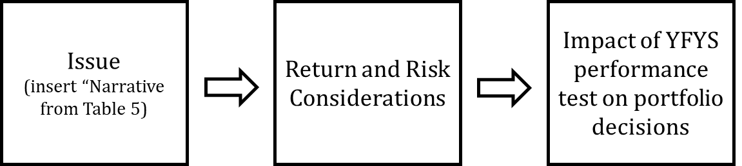

Diagram 5: Basic framework for assessing issues faced by member outcomes-focused portfolio managers through the alternative lens of the YFYS performance test.

|  |  |  |  |  |
| --- | --- | --- | --- | --- |
| **Sector** | **Narrative** | **Return** | **Risk / diversification** | **Impact on decision-making** |
| Equities – low volatility | Concerned about stock concentration within traditional index and consider a low volatility approach a better risk-adjusted way to achieve equity exposure | Likely lower (though some debate) than traditional equities | * Reduced risk * Noise relative to benchmark | Less likely to use in a YFYS performance test environment |
| Credit – high yield | High yield credit provides access to a different risk premium | Expected to be higher than traditional composite bonds | * Higher risk than other fixed income sectors * Noise relative to benchmark * Brings some portfolio diversification | Overly attractive to use in a YFYS performance test environment over the long-term |
| Fixed interest – inflation -linked bonds | Inflation-linked bonds are useful for managing risk to the purchasing power of member’s retirement savings | Uncertain | * Useful for managing member’s liability risk * Noise relative to benchmark | Less likely to use in a YFYS performance test environment |
| Fixed interest – short duration | Concerned about the amount of debt issuance, higher duration, and low yields, one may consider low duration bonds | Uncertain | * Reduced volatility * Noise relative to benchmark | Less likely to use in a YFYS performance test environment |

Table 5: Case studies of contemporary challenges faced by portfolio managers.

In summary, we demonstrate that any investment decision involving a sector which does not align closely to one of the defined performance benchmarks is now impacted by more than what is in member best interests.

A final comment on ESG strategies: these strategies fit the same themes outlined in Table 4 and Table 5. They involve a risk-based (and potentially a return-based) decision to allocate way from index weights. This means they will generate noise relative to their benchmark and this noise is undesirable in a YFYS performance test environment. Under a YFYS performance test the rational response of a portfolio manager would be to limit the use of strategies which reduce ESG risk.

#### Reflections on Productivity Commission: can the same performance test be applied at a population-level and at an individual fund-level?

The YFYS performance test has its origins in the work of the Productivity Commission’s (PC) review into superannuation. The approach can be summarised as using fund-specific asset allocation benchmarks along with predominantly passive benchmarks. It was applied by the PC to assess system-level investment performance (e.g. X number of funds are underperforming). There was also a recommendation by the PC that it should form the basis of a performance test to be applied to each fund individually.

In Table 6 we assess the ability of the performance test to perform both roles.

|  |  |  |  |
| --- | --- | --- | --- |
| **Application of performance test** | **Noise and bias** | **Sources of inaccuracy and bias** | **Comment on accuracy** |
| 1. Population test | * Accuracy of findings will be reasonable at a population level (e.g. X number of funds are underperforming) if each benchmark does not introduce bias. The impact of noise introduced by benchmark shortcomings will be diluted in a population test (i.e. X remains a reasonable expectation of the number of funds which are underperforming). * Bias (e.g. the test result is understated or overstated) is introduced whenever a benchmark shortcoming introduces a non-zero expected impact. | Sources of noise:   * Listed benchmarks for unlisted sectors * Allocation within a sector (more or less aggressive than the benchmark) – all sectors, particularly alternatives   Bias:   * Ignoring withholding tax impact * Ignoring credit   (Both discussed in next section) | In our opinion:   * The performance test likely understates the degree of industry underperformance for this type (implementation) of performance. * The distribution of outcomes is likely overstated. |
| 1. Individual fund test | * Accuracy of findings could be unreasonable in the presence of significant benchmark noise. * Bias (e.g. the test result is understated or overstated) is introduced whenever a benchmark shortcoming introduces a non-zero expected impact. | Sources of noise:   * Listed benchmarks for unlisted sectors * Allocation within a sector (more or less aggressive than the benchmark) – all sectors, particularly alternatives   Bias:   * Ignoring withholding tax impact * Ignoring credit * Allocation within a sector (more or less aggressive than the benchmark) – all sectors, particularly alternatives | In our opinion:   * The performance test likely understates the degree of industry underperformance for this type (implementation style) of test. * The test will have significant accuracy issues (as identified in Working Group paper). |

Table 6: Assessment of an implementation-style performance test applied as a population test and as an individual fund test.

Based on Table 6 we make the following comments:

* While we have strong reservations around solely focusing on measuring performance implementation, the population-level test applied in the PC is most likely to be broadly accurate, and we estimate that, if anything, it may understate the prevalence of underperforming funds.
* However, the noise and bias mean the test is ill-equipped to be applied as an individual fund performance test. There is likely to be significant inaccuracy in the assessment of individual funds.

#### Opportunity for a stronger, more accurate performance test

In proposed form the YFYS performance test does not test implementation performance as tightly as it could – this is to the detriment to the intended purpose of the test. We identify two specific areas where effectiveness could be improved, detailed in Table 7.

|  |  |  |
| --- | --- | --- |
| **Opportunity to improve effectiveness** | **Explanation** | **Impact** |
| 1. Use withholding tax-adjusted indices | Indices are often calculated on a worst-case withholding tax outcome basis. As a result, their performance is understated compared to what a super fund would achieve and fund relative performance overstated (read [here](https://www.firstlinks.com.au/global-index-flaw-flow-on-consequences) for further background).  APRA (Member Outcomes) is aware of this issue and how to address it. | Performance understatement applies predominantly to equity-based indices. The understatement is generally larger for market sectors with higher dividend yields.  The longer-term understatement for global equities has been around 35bp pa.  The understatement benefits would apply broadly similarly to all funds as all use global equities. |
| 1. Credit | Under the proposed YFYS performance test all credit strategies are included in the “fixed interest” category and benchmarked against a composite fixed income index.  Generally accepted logic is that credit would be expected to outperform equivalent duration fixed income over the long-term as it earns a higher yield to compensate for credit risk.  Examples of categories of credit which earn high credit spreads include high yield, leveraged loans and emerging markets debt.  Funds which allocated to credit in the past receive a performance uplift which is unrelated to implementation performance. | We use high yield as an example.  Over the last 17yrs high yield outperformed the composite benchmark by about 3.2% pa. A fund allocating 10% to high yield credit strategies would have received a YFYS performance test benefit of 32bp pa. This performance uplift is independent of actual implementation performance.  The “credit free ride” benefits apply differently across the industry as the level of credit exposure varies across funds. |

Table 7: Details of two areas where the performance test could be made stronger and a more accurate representation of implementation performance.

We believe that, through the lens of measuring implementation performance, both enhancements are essential to ensuring accurate outcomes when identifying poor performers. Such changes should go together with any changes to improve benchmark selection in the areas of unlisted assets.

#### Benchmarks – choice and limitations

There appears some possibility that the range of benchmarks will be expanded to improve the benchmarking process. We think there are groups better placed than us to provide insight on appropriate benchmarks. Unfortunately, adding a few more benchmarks will give ‘lip service’ to the bigger issues at play, notably:

* A benchmark fails to account for the varying risk / return opportunities within each asset class that a fund may choose to use to produce returns and manage risk on a member’s behalf.
* To capture all this nuance requires many sub-sector benchmarks, perhaps 50.
* Addressing unlisted assets should be accompanied by addressing credit and withholding tax otherwise the test is positively biased to funds.
* We expect many of the undesirable outcomes to still occur.

The analysis in Table 8 summarises the possible outcomes.

|  |  |  |  |  |  |  |
| --- | --- | --- | --- | --- | --- | --- |
|  | **Current YFYS** | | **Less Benchmark Noise** | | **No Benchmark Noise** | |
|  | **Total Performance** | **Implementation Performance** | **Total Performance** | **Implementation Performance** | **Total Performance** | **Implementation Performance** |
| **Risk of mistakenly identifying a ‘good’ fund as ‘poor’** | 35% | 35% | 15% | 15% | 2% | 2% |
| **Risk of failing to identify a ‘poor’ fund as ‘poor’** | 42% - 65% | 42% | 31% - 84% | 31% | 16% - 98% | 16% |

Table 8: Assessed YFYS performance test effectiveness for different degrees of benchmark noise. We assume 3.6% ann. vol. for “Current YFYS” (as per Detailed Paper), and a reduction by 2/3rds for the “Less Benchmark Noise” scenario.

If policymakers chose to ignore the impact of risk and asset allocation decisions and focus solely on implementation performance, then removing a large portion of benchmarking noise can improve test effectiveness. Unfortunately, the analysis in Table 8 ignores the biases identified in the previous section, namely credit and withholding tax. In Table 9 we factor in a 40bp[1] bias (understatement of benchmark performance) and repeat the analysis undertaken in Table 8.

|  |  |  |  |  |  |  |
| --- | --- | --- | --- | --- | --- | --- |
|  | **Current YFYS** | | **Less Benchmark Noise** | | **No Benchmark Noise** | |
|  | **Total Performance** | **Implementation Performance** | **Total Performance** | **Implementation Performance** | **Total Performance** | **Implementation Performance** |
| **Risk of mistakenly identifying a ‘good’ fund as ‘poor’** | 24% | 24% | 3% | 3% | 0% | 0% |
| **Risk of failing to identify a ‘poor’ fund as ‘poor’** | 55% - 76% | 55% | 62% - 97% | 62% | 73% - 100% | 73% |

Table 9: Assessed YFYS performance test effectiveness for different degrees of benchmark noise (assumptions as per Table 8), including the 40bp bias.

The ‘free ride’ provided by credit and withholding tax reduces the likelihood of identifying poor performers. Funds which did not have a sizable exposure to credit missed this free ride creating an unfair assessment environment.

#### Consumer decision-making

We are concerned around how consumers will make an informed decision surrounding a fund identified as underperforming. Table 10 sets out a simple example.

|  |  |  |
| --- | --- | --- |
| **Performance component** | **Fund A** | **Fund B** |
| Implementation (YFYS Performance Test) | -0.5% pa | 0% pa |
| SAA | +0.5% pa | -0.5% pa |
| Risk-based performance | 7.0% pa | 7.0% pa |
| Total performance | 7.0% pa | 6.5% pa |

Table 10: Simple case study to highlight difficulties of communicating to consumers a failed performance test.

We consider the likelihood of the scenario identified in Table 10 to be almost certain. We note in Table 10 that Fund A and Fund B have a similar level of overall risk exposure and, all else equal, would be expected to generate similar performance. Consider a member of Fund A who receives a letter notifying them that their fund failed the YFYS performance test and referring them to a government-provided comparison website. How will the following scenarios be addressed:

* They would see that Fund A outperformed some other funds (e.g. Fund B) which did not fail the test
* How will they obtain information which helps them to understand why Fund A outperformed Fund B yet Fund A was identified as an underperformer?
* If consumers search for more information on the YFYS performance test and discover a range of critiques (and few endorsements), will the Government provide information to help address these critiques?

#### Possibility of a simple secondary test

As identified in the Working Group’s Detailed Paper, as a performance test the primary shortcomings of the YFYS performance test are summarised as follows:

* The test fails to acknowledge the performance of strategic asset allocation decisions (detailed in Diagram 1)
* Benchmarking challenges: benchmark shortcomings mean that the test fails to recognise risk-reduction strategies within a sector and encourages risk-taking within sectors (introducing some unlisted asset indices is only a partial fix)
* Fails to acknowledge diversification benefits (the difference between gross and net risk)

These shortcomings result in a performance test which will have weak effectiveness and distort the decision-making process away from best member outcomes.

In the absence of a qualitative assessment (Principle 4), a second quantitative metric could improve the reliability of the test and reduce the distortion to portfolio management decisions. A metric of this nature should look to complement the existing YFYS performance metric, by:

* Acknowledging all components of investment performance
* Be removed from the benchmarking challenges which generate bias and noise
* Acknowledge diversification benefits (i.e. acknowledge net risk rather than gross risk)

The working metric introduced in the Working Group’s Detailed Paper addresses all these issues. It runs orthogonal to the YFYS performance metric in many ways (for instance it requires no exposure information). It is not perfect, but it would provide a useful complement to the YFYS performance metric, and address many of the concerns raised. Our expectations are that a large proportion of, but not all, funds which fail the YFYS performance test would also fail the secondary test. Further details are found in the Appendix of the Detailed Paper.

### Summary – YFYS performance test remains will be ineffective and generate undesirable outcomes

We have further explored the YFYS performance test. Our concerns around the effectiveness of the test and generation of undesirable outcomes remain. We have provided further case studies to explain how distortion will take place. We explored the challenges of applying a benchmark-based implementation test at a population level (as per the Productivity Commission) and an individual fund level. We consider the test to be more robust at a population-level and flawed at an individual fund level.

Interestingly we identify some areas where the test is overstating industry performance and we identify areas for improvement. And in response to the potential for a few unlisted asset indices to be incorporated we re-estimate the effectiveness of the YFYS performance test for different levels of benchmark noise, finding that the test would continue to face effectiveness issues and generate undesirable outcomes.

The communication challenge facing policymakers is significant. Simply put failing a test which only focuses on one component of performance is going to be very difficult to communicate effectively.

Finally, we consider the hypothetical scenario of an additional quantitative test and believe that this could be achieved in a relatively simple manner. It could offset the noted shortcomings of an implementation test and make test results more acceptable.

## Concerns around marketing spend

Beyond the performance test the YFYS reforms contained measures to reduce the creation of multiple accounts and to increase trustee accountability around best financial outcomes for members. The recent release of draft legislation (“Single Default Account” and “Best Financial Interest Duty”) enables further reflection. We have strong concerns that industry will significantly increase marketing spend to the detriment of consumers. One trusted adviser described this as creating the potential for a “marketing free-for-all”.

We explain how this scenario could eventuate:

1. The intention of account stapling is to reduce flows into non-first employer funds, particularly as a second account
2. In response to loss of fund inflow, adversely affected super funds are likely to market more both to consumers and employers
3. Since marketing is a zero-sum activity (a member rolls out of one super fund into another), even first employer funds may increase marketing to defend their membership

Will Best Financial Interest Duty restrict the proliferation of marketing? Unlikely – Example 1.3 in the Explanatory Materials details an example where marketing can be justified because it resulted in new members and operational cost efficiencies. Only a modest extension to this example is required to justify marketing by all funds, based on a more nuanced interpretation of marketing success, namely the recognition that marketing prevents membership departures. We provide a mock example below.

|  |
| --- |
| Example 1 Blue Super Funded decided to fund a television marketing campaign to promote their fund, spending $5 million of members’ money. Due to the marketing activities of other funds Blue Superannuation Fund believes they would lose 5,000 members if they undertook no marketing. Blue Superannuation Fund believes that marketing spend will lead to the fund retaining its membership. This will allow the trustee to maintain operational costs and preserve the investment strategy including the allocation to illiquid assets. |

We make some additional comments to complement Example 1:

1. If total industry marketing spend increased then Blue Super Fund should update their expectation of membership loss (it would likely be greater than 5,000 members).
2. As industry marketing spend increases, it could be argued that the effectiveness of a $5 million spend will fall, assuming that the percentage of ‘engageable’ consumers is limited. In an environment of heightened industry spend on marketing, Blue Super may have to spend more than $5 million to retain its membership.
3. The negative impact of losing members is arguably greater than the impact of attaining more members. Operationally, a fund in outflow faces difficult decisions relating to service offering and staff. From an investment perspective a fund in outflow faces reduced ability to invest safely into illiquid assets. Further, capital for every new investment opportunity must be raised from the sale of an existing position, increasing transaction costs.

We believe that (3) presents an argument just as strong as Example 1.3 in the Explanatory Materials. When (1) and (2) are considered in conjunction with Example 1 above, accounting for the zero-sum nature of marketing in a closed system, our concerns around a “marketing free-for-all” become obvious. These concerns represent a problem similar to [Tournament theory](https://en.wikipedia.org/wiki/Tournament_theory).

## Summary

In this submission we undertake further exploration of the YFYS performance test and detail our concerns around the scenario of a “marketing free-for-all” which could flow from account stapling.

The concerns raised by The Conexus Institute as part of the Working Group’s analysis of the YFYS performance test remain in place. In this submission the Conexus Institute has broadened its analysis to re-consider effectiveness under modified versions of the YFYS performance (such as introducing some unlisted benchmarks). We believe the performance test will remain ineffective unless more significant changes are made. Indeed, in some areas the test is overstating industry performance. The Productivity Commission used an implementation test to estimate underperformers across the population of funds and recommended the same test be applied to test funds individually. Unfortunately, our additional analysis considers the first use of the test far more appropriate than the second.

We maintain our view that the test will distort portfolio decision-making – we provide additional analysis and case studies to illustrate this. As it stands the communication challenge remains significant – we see no easy solution to this problem unless the test changes.

What can be done? In the absence of incorporating qualitative oversight, including a second somewhat orthogonal quantitative test could provide sizable marginal benefit to the test effectiveness and reduce undesirable outcomes. Dispute of results would be lower and the message to consumers would be clearer.

Finally, our analysis of the draft legislation (“Single Default Account” and “Best Financial Interest Duty”) raises concerns of a “marketing free-for-all”. We explain the rationale for how this may occur and how funds can justify increasing their marketing spend. Given marketing is a zero-sum activity we believe further measures will be required to protect the default savings of consumers from marketing expenses.

We are available to assist policymakers on any aspect of this submission or research undertaken by the Working Group.

1. Calculated as 30% exposure to international shares at a 30bp performance understatement and a10% exposure to high yield participating in a 3% performance drift.