Review of the operation of the *National Housing Finance and Investment Corporation Act 2018*

**Issues Paper**

December 2020

© Commonwealth of Australia 2020

This publication is available for your use under a [Creative Commons Attribution 3.0 Australia](http://creativecommons.org/licenses/by/3.0/au/deed.en) licence, with the exception of the Commonwealth Coat of Arms, the Treasury logo, photographs, images, signatures and where otherwise stated. The full licence terms are available from <http://creativecommons.org/licenses/by/3.0/au/legalcode>.

Creative Commons attribution licence 3.0 icon. 

Use of Treasury material under a [Creative Commons Attribution 3.0 Australia](http://creativecommons.org/licenses/by/3.0/au/deed.en) licence requires you to attribute the work (but not in any way that suggests that the Treasury endorses you or your use of the work).

*Treasury material used ‘as supplied’.*

Provided you have not modified or transformed Treasury material in any way including, for example, by changing the Treasury text; calculating percentage changes; graphing or charting data; or deriving new statistics from published Treasury statistics — then Treasury prefers the following attribution:

*Source: The Australian Government the Treasury*.

**Derivative** **material**

If you have modified or transformed Treasury material, or derived new material from those of the Treasury in any way, then Treasury prefers the following attribution:

*Based on The Australian Government the Treasury data*.

**Use of the Coat of Arms**

The terms under which the Coat of Arms can be used are set out on the Department of the Prime Minister and Cabinet website (see https://www.pmc.gov.au/government/commonwealth-coat-arms).

**Other uses**

Enquiries regarding this licence and any other use of this document are welcome at:

Manager  
Media and Speeches Unit  
The Treasury  
Langton Crescent   
Parkes ACT 2600  
Email: [media@treasury.gov.au](mailto:media@treasury.gov.au)

# Contents

Contents iii

Consultation Process 1

Request for feedback and comments 1

Purpose 2

Background 2

Terms of reference 3

The housing market in Australia 4

Why NHFIC was created 5

NHFIC’s key functions 5

Key consultation points for the Review 6

Impact of NHFIC on the Community Housing Provider Sector 6

The role of NHFIC in housing supply 7

The role of NHFIC in increasing home ownership 8

The role of NHFIC research 8

The operation and governance of NHFIC 8

Other issues 9

# Consultation Process

## Request for feedback and comments

Interested parties are invited to comment on the issues raised in this paper by Wednesday 6 January 2021. Submissions may be lodged electronically or by post.

While submissions may be lodged electronically or by post, electronic lodgement is preferred. For accessibility reasons, please submit responses sent via email in a Word or RTF format. An additional PDF version may also be submitted.

All information (including name and address details) contained in submissions will be made available to the public on the Treasury website unless you indicate that you would like all or part of your submission to remain in confidence. Automatically generated confidentiality statements in emails do not suffice for this purpose. Respondents who would like part of their submission to remain in confidence should provide this information marked as such in a separate attachment.

Legal requirements, such as those imposed by the Freedom of Information Act 1982, may affect the confidentiality of your submission.

View our [submission guidelines](https://treasury.gov.au/submission-guidelines) for further information.

Further consultation process during the Review

The Review of the operation of the *National Housing Finance and Investment Corporation Act 2018* will consult broadly in developing the report and recommendations. This may involve conducting targeted consultation with interested parties on specific issues where the Review requires more information or to solicit further views.

Closing date for submissions: 6 January 2021

|  |  |
| --- | --- |
| Email | NHFICSecretariat@treasury.gov.au |
| Mail | Manager  NHFIC Act Review Secretariat  The Treasury  Langton Crescent  PARKES ACT 2600 |
| Enquiries | Enquiries can be directed to Will Devlin |
| Phone | 02 6263 2763 |

**Unless you indicate that you would like all or part of your submission to remain in confidence, it will also be available to the public on the Commonwealth Treasury website.**

## Purpose

This Issues Paper provides the context and background for the Review of the operation of the *National Housing Finance and Investment Corporation Act 2018* (the Review), including the policy developments that led to the establishment of the National Housing Finance and Investment Corporation (NHFIC). Treasury invites interested parties to make submissions on the key areas of interest for the Review.

Submissions to the Issues Paper, together with other consultation conducted during the course of the Review, will be used to inform the preparation of a Final Report to Government. The Final Report will make recommendations as to whether any changes to the operation of the *National Housing Finance and Investment Corporation Act 2018* (the NHFIC Act) should be considered.

## Background

As part of the *Reducing Pressure on Housing Affordability* plan announced in the 2017–18 Budget, the Government announced the establishment of NHFIC, a new corporate Commonwealth entity dedicated to improving housing outcomes for Australians.

NHFIC was established by the NHFIC Act and commenced operation on 1 July 2018. The objective of the NHFIC Act is to establish NHFIC to improve housing outcomes for Australians by:

1. strengthening efforts to increase the supply of housing;
2. encouraging investment in housing (particularly in the social or affordable housing sector);
3. providing finance, grants or investments that complement, leverage or support Commonwealth, state or territory activities relating to housing;
4. contributing to the development of the scale, efficiency and effectiveness of the community housing sector in Australia; and
5. assisting earlier access to the housing market by first home buyers.

Section 57 of the NHFIC Act requires the Minister to cause a review of the operation of the Act, to be undertaken as soon as possible after 30 June 2020. Additionally, section 57A requires the Minister to cause a review of NHFIC’s activities assisting additional first home buyers to commence by 2021. This Review will gather information to fulfil the requirements of both sections 57 and 57A.

On 19 November 2020, the Minister for Housing and Assistant Treasurer, the Hon Michael Sukkar MP, appointed Mr Chris Leptos AM to lead the Review, supported by a secretariat in Treasury.

NHFIC is required to perform its functions in accordance with the NHFIC Act and directions given by the Minister through the *National Housing Finance and Investment Corporation Investment Mandate Direction 2018* (Investment Mandate). The Investment Mandate sets out the Government’s expectations about the performance of NHFIC’s functions including matters such as the strategies and policies that the Board must observe, decision-making criteria, and risk and return on investments.

## Terms of reference

The Review will consider the following:

1. **The impact of the National Housing Finance and Investment Corporation (NHFIC) on the Community Housing Provider (CHP) Sector**

The review will assess the impact of NHFIC’s programs on the CHP sector, including by examining the impact of NHFIC on:

* the CHP sector’s access to finance – including whether NHFIC has generated a more efficient source of funds, reduced refinancing risks, and reduced borrowing costs;
* the scale and prominence of CHP sector delivery of sub-market rental housing – including through partnerships with the private sector and institutional investors;
* improving the attractiveness of affordable housing as an asset class for private investment; and
* the financial capacity of the CHP sector through the provision of professional advisory services (via the Capacity Building Program) – including in relation to NHFIC applications, business planning, property development, risk management and financing.

1. **The Role of NHFIC in Housing Supply**

The review will consider the role of NHFIC in increasing housing supply, including:

* the appropriateness of NHFIC’s financing, including NHFIC’s ability to complement, leverage or support Commonwealth, state or territory activities relating to housing that otherwise would not have occurred;
* NHFIC’s role in facilitating additional investment in housing, including social and affordable housing;
* whether the scope of the definition of eligible project proponents and eligible projects for NHFIC financing outlined under the Investment Mandate is effective; and
* the suitability of the government guarantee for NHFIC’s liabilities, including its bond issuances.

1. **The Role of NHFIC in Increasing Homeownership**

The review will consider the effectiveness of the First Home Loan Deposit Scheme in facilitating earlier access to the housing market for first home buyers.

1. **The Role of NHFIC Research**

The review will consider the effectiveness of NHFIC in undertaking research into housing affordability.

1. **The Governance and Operation of NHFIC**

The review will assess NHFIC’s financial and corporate governance arrangements as detailed in the Act including by considering:

* the feasibility of NHFIC (or its parts) self-funding its operational costs;
* Section 49 of the NHFIC Act which provides for the payment of annual dividends to the Commonwealth;
* Section 48 of the NHFIC Act which provides for the maintenance of adequate capital and reserves; and
* the effectiveness of current governance and reporting arrangements, including the role of the NHFIC Board and CEO, in enabling NHFIC to execute its functions pursuant to section 8 of the NHFIC Act.

1. **Other**

The review will consider other matters relevant to the operation of the NHFIC Act, as appropriate.

## The housing market in Australia

There are four main types of housing in Australia (see Figure 1):

* **owner-occupied properties** (either with or without a mortgage);
* **private rentals** (including those that are assisted by government support programs, such as Commonwealth Rent Assistance);
* **social housing** (comprising both community housing and public housing, where rents are subsidised and are set as either a percentage of tenant income or relative to an average market rent benchmark); and
* **crisis housing** (provided by homelessness service providers to a broad range of household types as a last resort measure).

A term that is commonly used in public discourse is “affordable housing”. While it is somewhat imprecisely defined, the Review regards affordable housing as housing that is accessible to households on low to moderate incomes without placing them in undue financial stress. Broadly this encompasses subsidised rental housing – which includes social housing and that part of the private rental market that is supported by government assistance payments – and assisted home ownership (see Figure 1).

#### Figure 1: Defining ‘affordable housing’ and interactions across the housing sector

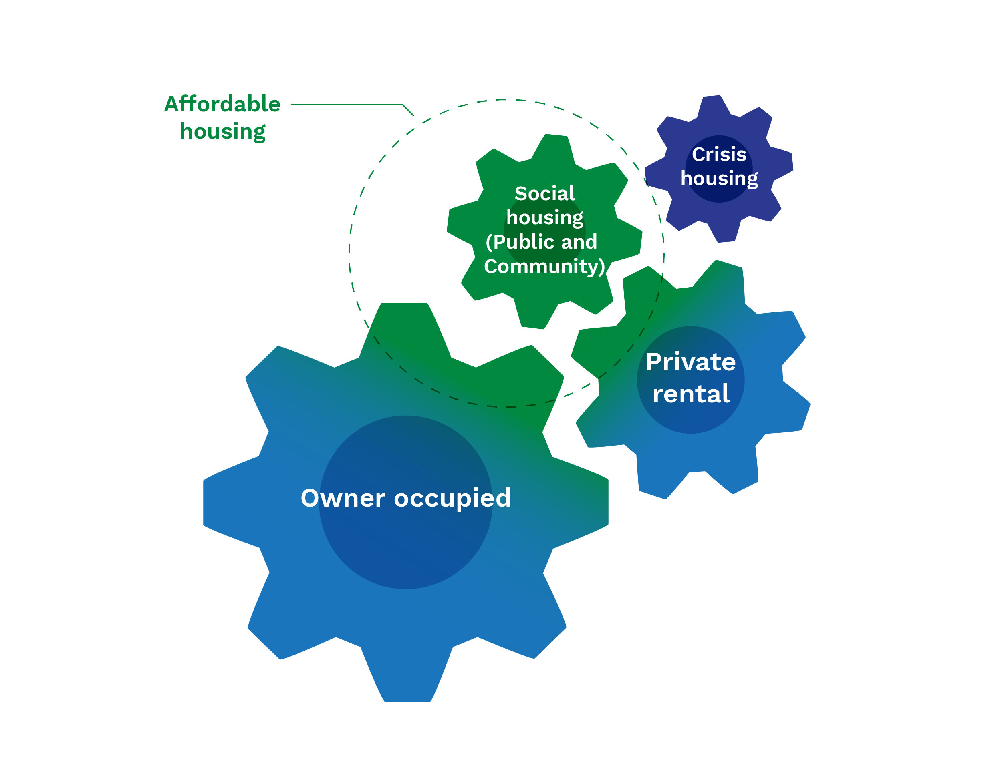

*Note: diagram for illustrative purposes only and does not accurately reflect the proportional size of each housing type*.

## Why NHFIC was created

In 2015 the Council on Federal Financial Relations requested further work be undertaken on housing affordability with a focus on solutions to improve the supply and provision of social housing.

In 2016, the Affordable Housing Working Group (‘the Working Group’), comprised of Commonwealth and state and territory government officials, was established to investigate innovative solutions to improve the availability of affordable rental housing. The Working Group’s 2016 report, “Innovative Financing Models to Improve the Supply of Affordable Housing”, recognised that access to private and institutional investment at scale for the purposes of affordable housing was one of the major challenges in the Australian housing system.

The Working Group report also identified an “affordable housing bond aggregator” as a viable model that would:

* facilitate access to cheaper and longer-term finance for community and affordable housing providers, enabling providers to refinance their existing borrowings and finance new developments;
* create a market for private investment in affordable housing that both normalises and expands flows of capital into the sector; and
* address the barriers of return and liquidity by providing an instrument that is understood by sophisticated investors as a fixed income investment with the ability to be traded in a secondary market.

In the 2017-18 Budget, the Government announced the establishment of NHFIC for the purposes of operating both an Affordable Housing Bond Aggregator (the bond aggregator) and a National Housing Infrastructure Facility (NAIF – a facility to provide financial assistance for infrastructure that supports new housing, particularly affordable housing). The administration of these two functions by one entity was designed to ensure policy alignment and create administrative efficiencies.

## NHFIC’s key functions

NHFIC seeks to achieve its statutory objectives by administering the Affordable Housing Bond Aggregator (the bond aggregator), the National Housing Infrastructure Facility (NHIF), and by undertaking capacity building activities for registered community housing providers (CHPs).

In October 2019, NHFIC’s activities were expanded when the NHFIC Act was amended to establish the First Home Loan Deposit Scheme and a new research function to examine housing supply, demand and affordability in Australia (see Figure 2).

#### Figure 2: The functions of NHFIC

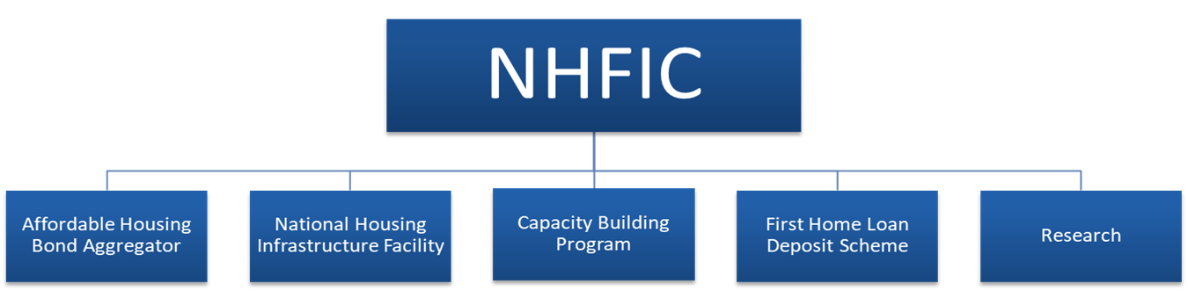

## Key consultation points for the Review

The Review invites interested parties to make submissions on any or all issues raised by this Issues Paper or the Terms of Reference. The following sections set out the key areas of interest for the Review in the preparation of its final report.

### Impact of NHFIC on the Community Housing Provider Sector

##### NHFIC’s Affordable Housing Bond Aggregator

One of the key challenges facing the CHP sector is the ability to access cheap, long-term financing. The bond aggregator aims to provide eligible CHPs with lower cost and longer-term financing than would otherwise be available to them (from, for instance, commercial lenders). It makes loans to eligible CHPs and finances those loans via the issuance of bonds to institutional investors. Because the loan requirements of any single CHP is not likely to be of sufficient size to issue bonds in their own right, the bond aggregator seeks to build scale efficiencies in the sector by aggregating CHPs’ collective borrowing needs and issuing bonds on their behalf.

It is anticipated that the loans under the bond aggregator provided to date will collectively save CHPs around $200 million in interest payments over the term of the loans. NHFIC’s [Social Bond reports](https://www.nhfic.gov.au/what-we-do/investor-relations/social-bonds/) detail the loans to CHPs that have been financed from NHFIC’s bond issuances to date and the uses of these funds.

The operations of the bond aggregator are supported by a $1 billion Special Account. This allows NHFIC to draw down on a line of credit, providing a warehouse facility to advance loans to CHPs before a sufficient volume of loans has been made to enable a bond issuance. When NHFIC repays an amount it has borrowed, the amount is credited to the Special Account and is available to be redrawn.

Consistent with the terms of reference, the Review invites interested parties to comment on the effectiveness of the Bond Aggregator, giving consideration to the impact of NHFIC on:

* the CHP sector’s access to finance – including whether NHFIC has generated a more efficient source of funds, reduced refinancing risks, and reduced borrowing costs; and
* the scale and prominence of CHP sector delivery of sub-market rental housing – including through partnerships with the private sector and institutional investors.

##### NHFIC’s Capacity Building Program Grants

NHFIC’s Capacity Building Program Grants enable eligible CHPs to access tailored assistance from a panel of approved professional advisory service providers to help with applications for funding from either the bond aggregator or the NHIF. Grants of up to $20,000 are available under the program, which is administered by the Community Housing Industry Association on NHFIC’s behalf.

The program seeks to develop the financial and management capability of registered CHPs. A cap of $1.5 million applies to the amount that NHFIC can spend on capacity building activities.

Consistent with the terms of reference, the Review invites interested parties to comment on the effectiveness of the Capacity Building Program Grants. The Review will examine the impact of NHFIC on:

* the financial capacity of the CHP sector through the provision of professional advisory services (via the Capacity Building Program) – including in relation to NHFIC applications, business planning, property development, risk management and financing.

### The role of NHFIC in housing supply

##### NHFIC’s National Housing Infrastructure Facility

The NHIF is a $1 billion facility that provides finance for eligible infrastructure projects to unlock the supply of new housing, particularly affordable housing. The purpose of the NHIF is to overcome impediments to the provision of housing that are due to the lack of necessary infrastructure. It does this by providing finance for eligible infrastructure projects that would not otherwise have proceeded, or that would only have proceeded at a much later date.

The NHIF offers both concessional loans and grant funding for new or upgraded infrastructure needed for new housing, such as roads, water, sewerage, electrical, communications, and remediation.

Consistent with the terms of reference, the Review invites submissions to comment on the effectiveness of the NHIF, considering:

* whether it is providing a useful complement to other Commonwealth, State or Territory activities to boost housing supply; and
* whether the scope of the definition of eligible project proponents and eligible projects for NHFIC financing outlined under the Investment Mandate is effective.

##### Increasing private investment in housing

The Government’s intention is for the bond aggregator and the NHIF to operate in conjunction with and complement commercial lenders and State and Territory government initiatives. The stated policy intent is that NHFIC financing is additional to that which is otherwise available, rather than replacing finance available from other sources.

Since its establishment, NHFIC has raised nearly $1.2 billion across three social bonds, making it the biggest issuer of social bonds in Australia. Each of NHFIC’s three bond issuances to date have been around 3-4 times oversubscribed.

The stated policy intent is that NHFIC improve the attractiveness of affordable housing as an asset class for private investment.

Consistent with the terms of reference, the Review invites submissions regarding the effectiveness of NHFIC in attracting private investment in housing. In particular, the Review will consider:

* the impact of NHFIC on improving the attractiveness of affordable housing as an asset class for private investment; and
* NHFIC’s role in facilitating additional investment in housing, including social and affordable housing.

##### The Government’s guarantee of NHFIC’s liabilities

Under Section 51 of the NHFIC Act, the Commonwealth guarantees NHFIC’s liabilities under any contract entered into before 1 July 2023 (or later day determined by the Minister by legislative instrument). The Investment Mandate imposes a $3 billion cap on the sum of NHFIC’s guaranteed liabilities and amount drawn from its line of credit facility. The Liability Cap includes amounts issued through NHFIC bonds.

The intent of the legislated Commonwealth guarantee of NHFIC’s liabilities is to support market confidence and strengthen NHFIC’s ability to improve housing outcomes.

The guarantee also recognises that the ability of CHPs to use their assets as security for loans is often complicated by state and territory interests in the underlying assets. A guarantee was intended to mitigate much of this uncertainty for investors, lowering borrowing costs for NHFIC that can then be passed through to eligible CHPs.

Consistent with the terms of reference, the Review invites submissions to comment on the suitability of the liability guarantee and the associated Liability Cap, considering its resulting impact on the CHP sector, Commonwealth’s finances and the functioning of private capital markets.

### The role of NHFIC in increasing home ownership

NHFIC administers the Government’s First Home Loan Deposit Scheme (the Scheme) which was established following the 2019 amendment to the NHFIC Act. The Scheme enables eligible first home buyers to build or purchase a new home with a deposit of as little as 5 per cent. NHFIC does this by guaranteeing up to 15 per cent of the value of a dwelling that is financed by an eligible home loan, thus allowing first home buyers to enter the housing market earlier than may otherwise be the case, and without needing to incur the cost of lenders mortgage insurance (LMI). First home buyers must apply through one of 27 participating lenders across Australia, which includes both major and minor lenders. The Scheme is limited to 10,000 guarantees per financial year.

NHFIC issued the first 10,000 guarantees on 1 January 2020 and all places were allocated by 30 June 2020. The second tranche of 10,000 guarantees was released on 1 July 2020.

In the 2020-21 Budget, the Government announced that it would make available an additional 10,000 guarantees for the 2020-21 financial year for eligible first home buyers building or purchasing *new* homes. These additional guarantees are also subject to higher dwelling price caps.

Under section 57A of the NHFIC Act, a review of NHFIC’s assistance to first home buyers is required to commence within 15 months from the date when the first guarantee was issued under the Scheme.

Consistent with the terms of reference, the Review invites submissions to comment on:

* the effectiveness of the Scheme in facilitating earlier access to the market for first home buyers.

### The role of NHFIC research

NHFIC’s research function was established as part of the 2019 amendment to the Act that established the First Home Loan Deposit Scheme. Under the Act, NHFIC is required to undertake research into housing affordability in Australia. This function is explained in the Investment Mandate, which states that NHFIC’s research function will support the monitoring of housing demand, supply and affordability in Australia by highlighting current and potential future gaps between housing supply and demand, while also complementing existing housing-related research. NHFIC may also undertake research on its own initiative and undertake specific research requested by the Minister, as per the Investment Mandate.

Consistent with the terms of reference, the Review invites submissions to comment on the effectiveness of NHFIC’s research function in advancing our national understanding of housing affordability in Australia.

### The operation and governance of NHFIC

The NHFIC Act established NHFIC as a corporate Commonwealth entity, governed by an independent Board. The Government sets its expectations about the performance of NHFIC’s functions through the Investment Mandate (a non-disallowable legislative instrument) issued by the Minister.

##### NHFIC’s operational funding

The NHFIC Act and Investment Mandate require the NHFIC Board to target an average return on its loans to registered CHPs that allows it to cover the operating costs of the bond aggregator and to maintain adequate capital and reserves. The NHFIC Act also allows for the payment of annual dividends by NHFIC to the Commonwealth.

The Review will consider the effectiveness of NHFIC in meeting these requirements.

##### Governance

The Review will consider the effectiveness of NHFIC’s governance and reporting arrangements, including the role of the NHFIC Board and CEO.

The Review notes that the Australian National Audit Office is currently conducting an audit of the administration of NHFIC and is due to table its report in January 2021. The findings of this audit will be considered as part of the Review.

### Other issues

The Review welcomes views on any other matters relevant to the operation of the NHFIC Act.