Your Future, Your Super
Reforms to make your super work harder for you
October 2020

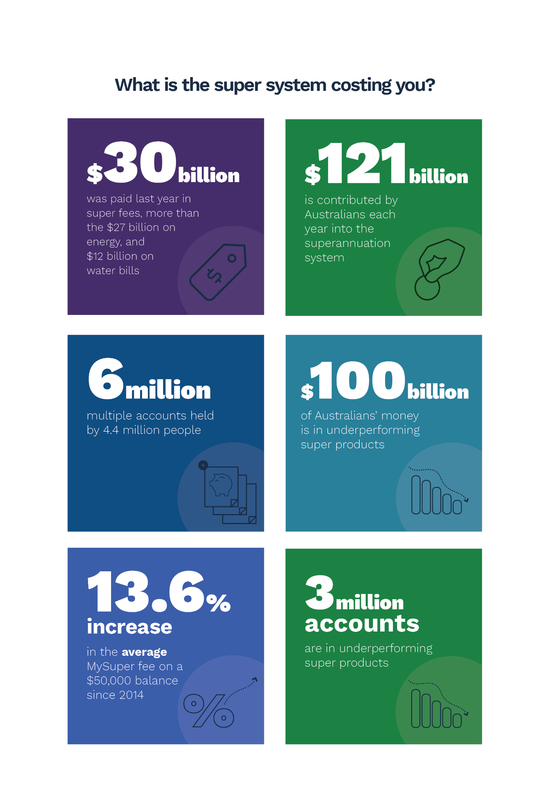
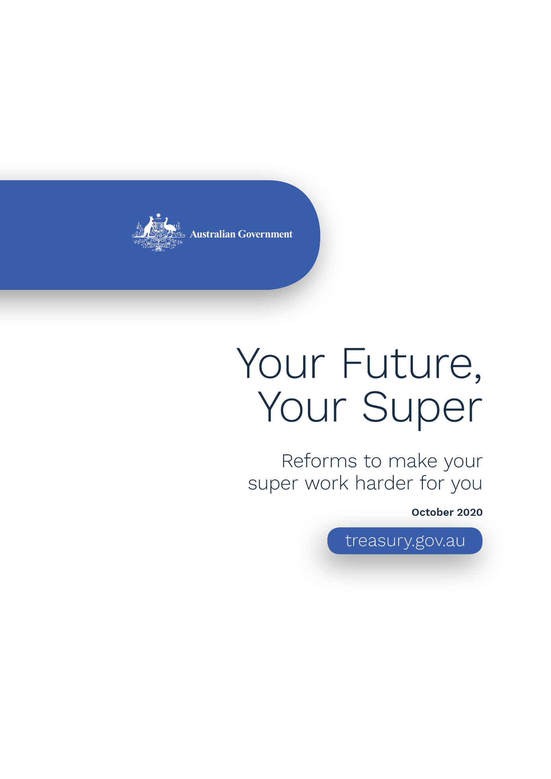
What is the super system costing you?
Your Future, Your Super
© Commonwealth of Australia 2020
ISBN 978-1-925832-18-1
This publication is available for your use under a Creative Commons Attribution 3.0 Australia licence, with the exception of the Commonwealth Coat of Arms, the Treasury logo, photographs, images, signatures and where otherwise stated. The full licence terms are available from http://creativecommons.org/licenses/by/3.0/au/legalcode.
Use of Treasury material under a Creative Commons Attribution 3.0 Australia licence requires you to attribute the work (but not in any way that suggests that the Treasury endorses you or your use of the work).
Treasury material used ‘as supplied’.
Provided you have not modified or transformed Treasury material in any way including, for example, by changing the Treasury text; calculating percentage changes; graphing or charting data; or deriving new statistics from published Treasury statistics — then Treasury prefers the following attribution:
Source: The Commonwealth of Australia
Derivative material
If you have modified or transformed Treasury material, or derived new material from those of the Treasury in any way, then Treasury prefers the following attribution:
Based on Commonwealth of Australia data
Use of the Coat of Arms
The terms under which the Coat of Arms can be used are set out on the Department of the Prime Minister and Cabinet website (see www.pmc.gov.au/government/commonwealth-coat-arms).
Other uses
Enquiries regarding this licence and any other use of this document are welcome at:
Manager
Media and Speeches Unit
The Treasury
Langton Crescent
Parkes ACT 2600
Email: media@treasury.gov.au
Internet
A copy of this document is available on the central Budget website at: www.budget.gov.au.

Contents
Minister’s foreword 1
Executive summary 3
Introduction 5
Fixing the superannuation system 7
Your super follows you 12
Empowering members 13
Holding funds to account for underperformance 14
Increasing transparency and accountability 16
Measuring the benefits of Your Future, Your Super 18
Next steps – roadmap for reform 24
Appendix 1 25
Appendix 2 26

Minister’s foreword
The superannuation system manages almost $3 trillion in retirement savings on behalf of 16 million Australians. There are enough savings in the superannuation system to buy every company listed on the Australian Securities Exchange – one and a half times. Due to the compulsory nature of the system, it is expected to reach $5 trillion by 2034.
While the superannuation system has grown significantly, it needs to adapt to better meet the needs of Australians. The current system is letting too many Australians down.
Australians are paying $30 billion per year in superannuation fees. This is more than the $27 billion Australian households pay on their energy bills or the $12 billion they spend on water bills. By 2034, it is estimated that Australians could be paying $45 billion in superannuation fees.
At the same time, Australians hold around 3 million accounts in underperforming funds managing over $100 billion in retirement savings. A member in the worst-performing MySuper product could be up to $98,000 worse off in retirement.
The current system has also resulted in 6 million unintended multiple accounts which are unnecessarily draining members’ superannuation savings.
Every dollar that an Australian pays in higher fees is a dollar that they will not benefit from in their retirement.
The Morrison Government’s goal is for the superannuation system to maximise the retirement savings of all Australians. We want your money to work harder for you, so that the money you contribute today is invested in your best financial interests, allowing you to enjoy a higher standard of living in retirement.
We also want to help you make more informed decisions about who manages your superannuation. The superannuation system is complex and members do not have access to a single, trusted and reliable source of information to help them make a better choice.
Greater member engagement is critical to the success of the superannuation system. It drives greater competition which delivers lower fees and better returns for members.
The Morrison Government’s Your Future, Your Super package will implement a number of key recommendations from the Productivity Commission review into superannuation and the Royal Commission into Misconduct in the Banking, Superannuation and Financial Services Industry.
Your Future, Your Super makes the superannuation system better for members in four key ways:
- Your superannuation follows you, prevent the creation of unintended multiple superannuation accounts.
- Empowering members, by making it easier for you to choose a well-performing product that meets your needs.
- Holding funds to account for underperformance, protecting you from poor outcomes and encouraging funds to lower costs and fees to boost Australians’ retirement incomes.
- Increasing transparency and accountability for how superannuation funds use members’ savings.
Together, these changes will save Australians $17.9 billion over 10 years.
The Your Future, Your Super package is the Morrison Government’s next step in modernising and improving the superannuation system to ensure it is working harder for you.
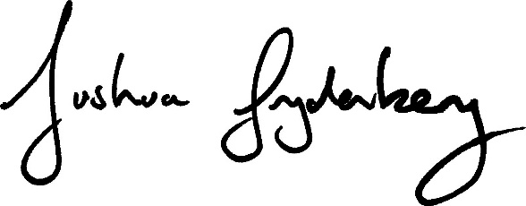

Executive summary
- Australia’s $3 trillion superannuation system is the fourth largest in the world and is responsible for managing the retirement savings of 16 million Australians.
- Superannuation will help many Australians to enjoy a higher standard of living in retirement. But structural flaws within the system mean many Australians will be let down.
- Since 2013, the Coalition Government has undertaken a number of reviews to ensure the financial system, including the superannuation system, is working for members. These reviews have found:
  - The creation of unintended multiple accounts as people change jobs and do not make a decision can have a significant impact on their retirement savings and the efficiency of the superannuation system, to the detriment of all members.
  - Australians are paying too much for their superannuation. Longstanding default arrangements have led to inadequate competition between funds and at the same time too few members actively choose their own fund. System complexity and the lack of simple and clear information is holding back more members from finding the best product for them. As a result, most members end up in the default fund selected by their employer. This means funds have little incentive to genuinely compete on the fees they charge.
  - The inefficient design of default arrangements means members can fall victim to the ‘unlucky lottery’ in which they may be placed into underperforming products. This could result in a member being significantly worse off at retirement compared with being in a higher performing fund.
  - Funds lack accountability to their members for their conduct and the outcomes they deliver and there is inadequate transparency on how funds are spending members’ money.
- The Productivity Commission estimated in 2018 that fixing these flaws would benefit members by $3.8 billion each year. Were these flaws to continue, Treasury estimates it would cost members $5 million a day.
- Fixing these flaws represents the next step in the Government’s plan to make sure that your super is working harder for you.
- Since 2018, the Government has successfully legislated to:
  - Protect the retirement savings of millions of Australians from the negative effects of unintended multiple accounts, including duplicate fees and insurance, through the introduction of reforms to clean up the stock of inactive low-balance accounts. Since 1 November 2019, $2.9 billion of inactive savings has been proactively consolidated into the active accounts of 1.4 million people. This is estimated to have saved Australians around $700 million so far in unnecessary fees or insurance premiums.
  - Prevent the unnecessary erosion of balances by requiring that insurance is offered only on an opt-in basis for those aged under 25 years, so that young people do not pay for insurance they do not need.
  - Cap fees on low balance accounts and ban exit fees.
  - Remove restrictions from members being able to choose their superannuation fund. These changes have allowed about 800,000 Australians to choose where their retirement savings are invested, rather than being forced into a fund because they work in a particular industry.
- The Your Future, Your Super package has four key elements:
- Your superannuation follows you
  - Your retirement savings should not be eaten away by duplicate fees and insurance premiums on multiple unintended accounts.
  - The Government will make sure that a new superannuation account is not automatically created every time you start a new job. Instead, your super will follow you, so that your new employer will pay your superannuation contributions into your existing account.
  - Stopping the creation of millions of unintended multiple accounts will boost balances in super by about $2.8 billion by avoiding duplicate fees and lost returns over the next decade.
- Empowering members
  - You should be given simple and clear information from a reliable source to help you choose a high-performing and/or low-cost superannuation product that meets your needs.
  - The Government will make it easy for you to choose who manages your superannuation through a new, interactive, online YourSuper comparison tool.
  - The YourSuper comparison tool will make the performance of MySuper products clear, requiring funds to compete for your savings.
- Holding funds to account for underperformance
  - Under our compulsory superannuation system, you should know whether your fund is underperforming and underperforming funds should be called out.
  - The Government will better protect you from poor superannuation outcomes by requiring superannuation products to meet an annual performance test.
  - If your fund fails the test it will be required to tell you and refer you to the new YourSuper comparison tool that can help you select a better performing fund if you choose to do so. Persistently underperforming products will be prevented from taking on new members.
  - The test will ensure funds are focused on improving the investment returns they are delivering and lowering the fees they are charging their members.
- Increasing transparency and accountability
  - For most Australians superannuation will be their largest asset in retirement (besides their family home). Superannuation funds should be held to the highest standards of accountability and transparency in how they spend your retirement savings.
  - The Government will increase trustee accountability by strengthening their obligations to ensure superannuation fund actions are only undertaken in your financial interests. The Government will also ensure that your superannuation fund is more transparent in providing information about its operations ahead of its Annual Members’ Meeting.

Measure | Benefits to members  over 10 years
Your superannuation follows you | $2.8 billion
Empowering members | $3.3 billion
Holding funds to account for underperformance | $10.7 billion
Increasing transparency and accountability | $1.1 billion
Total | $17.9 billion
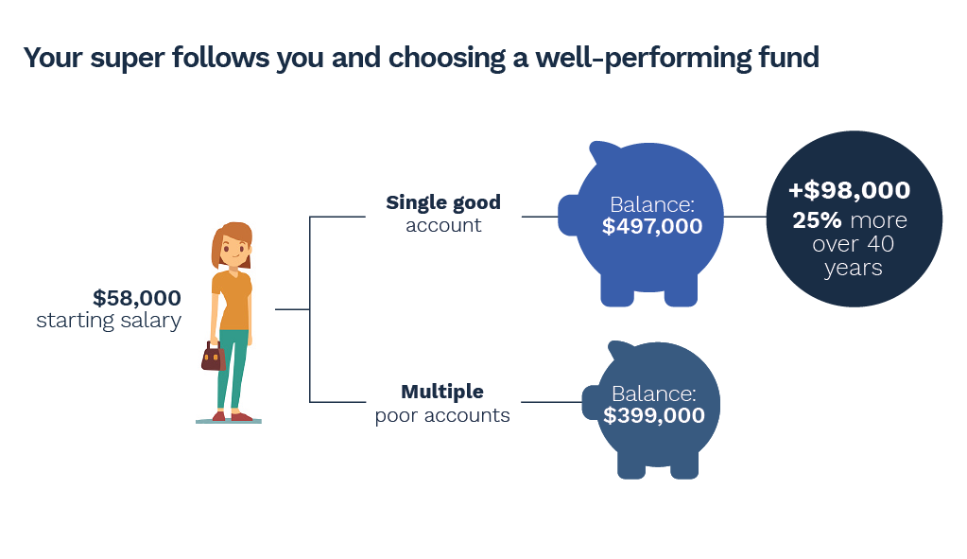

Introduction

Australia’s superannuation system
Australia’s superannuation system exists to maximise the retirement savings of Australians. The system is responsible for the retirement savings of 16 million Australians, representing about $3 trillion. This is 50 per cent larger than the value of all the companies listed on the Australian Securities Exchange (ASX) and up from $148 billion in 1992.
The industry charges substantial fees for its services. Right now, Australian households pay $30 billion per year in superannuation fees (excluding insurance premiums). This is more than the $27 billion Australian households pay on their energy bills or the $12 billion they spend on water bills.
As the system grows, the amount Australians pay in fees will continue to rise. The total assets in the superannuation system are projected to reach $5 trillion by 2034. Under the current system, the amount of fees that will be paid by members in 2034 would reach $45 billion.
Importantly, Australians are required to contribute 9.5 per cent of their salary towards their retirement.
Every year, through a combination of compulsory and voluntary contributions, about $121 billion in superannuation contributions is paid into the system; approximately $1 billion is contributed by 470,000 new members who enter the superannuation system each year and do not choose a fund.
Superannuation savings are overseen by three regulators:
- Australian Prudential Regulation Authority (APRA) — to ensure superannuation savings are effectively managed to provide a benefit in retirement.
- Australian Securities and Investments Commission (ASIC) — to ensure superannuation funds operate efficiently, honestly and fairly.
- Australian Taxation Office (ATO) — to enforce superannuation funds’ reporting and administrative obligations and regulate self-managed superannuation funds.

Prior reviews of the system
Since 2013, the Coalition Government has commissioned a number of reviews to ensure the financial system, including the superannuation system, is working for Australians.
The 2014 Financial System Inquiry (FSI) found the superannuation industry was charging high fees and needed to improve its efficiency, competitiveness and governance arrangements.
In response, the Government tasked the Productivity Commission to undertake a detailed investigation. Its three-year, comprehensive review was released in 2019.
The Productivity Commission found that the superannuation system was working well for some members, but that outcomes for other members were poor. Structural flaws in the system were resulting in lower retirement balances for millions of members. These flaws included a system that led people to open multiple accounts they did not need, resulting in unnecessary fees. It also identified funds that persistently delivered poor returns for members. The Productivity Commission found the system offers an ‘unlucky lottery’ because of the variation in fees and performance between funds and the arbitrary nature of the default system.
The Royal Commission into Misconduct in the Banking, Superannuation and Financial Services Industry (Financial Services Royal Commission) identified similar concerns. It recommended that an employee’s superannuation account should be stapled to the member, so that a new account is not automatically created every time someone starts a new job. It also recommended a number of changes to further strengthen protection for members and improve regulatory oversight. These recommendations have been accepted by the Government and are being implemented.
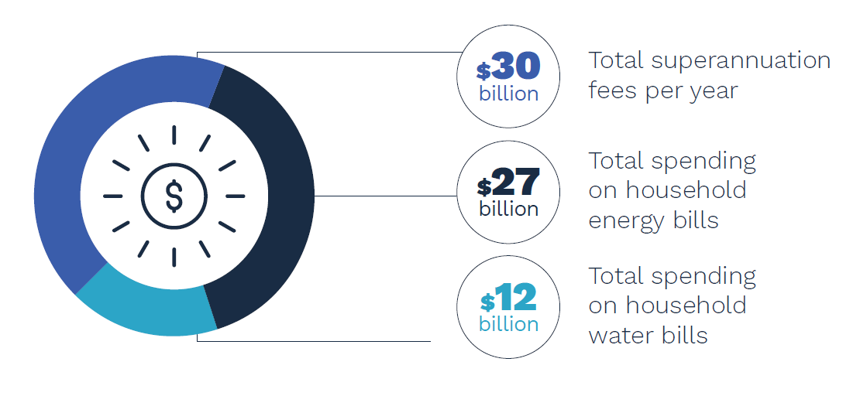

Fixing the superannuation system

Structural flaws that need to be fixed
- Funds with underperforming products are not held to account
The investment returns of superannuation products have a large bearing on retirement balances. Small differences in fees and returns translate into large differences in retirement outcomes – for better or worse – because they accumulate and compound over time.
Treasury analysis of APRA data shows that many superannuation funds are consistently poor performers. This includes 21 out of 77 MySuper products that underperformed a performance benchmark developed by the Productivity Commission by more than 0.5 percentage points over the period of 2014 to 2019. Those products:
- Held over $100 billion in assets across 3 million accounts.
- Received over 330,000 new member accounts and over $10 billion in contributions in 2018-19 alone.
- Charged members $1.2 billion in fees annually.
Across the entire industry, the cost of underperformance is at least $10.7 billion over 10 years. The worst performing fund was 1.4 percentage points below its benchmark.
In the worst performing MySuper product, this leaves the average member up to $98,000 worse off at retirement.
The Government expects the superannuation system to deliver a lot more for Australians.

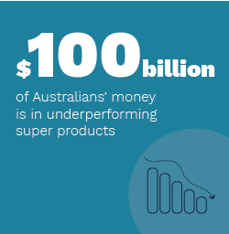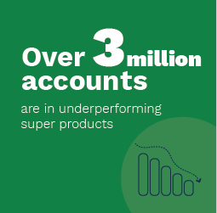

- A lack of competition, disengaged members and embedded inefficiency means Australians pay higher fees
Many Australians are disengaged from the superannuation system. The Productivity Commission found that “many Australians find superannuation complex and are disengaged from decisions about their retirement savings.”
Design elements of the superannuation system, including that contributions are compulsory and that the majority of members end up in a fund that they have not chosen, perpetuates this disengagement.
As stated by the FSI, there needs to be strong member engagement to drive competition. Without strong competition, all members end up paying more in fees and accumulating less retirement savings.
Further, as the FSI identified, the complexity of the system is also a key driver of disengagement. There is a wide variety of products and information and no tools available to help members easily compare funds.
The Productivity Commission found that two-thirds of members do not actively select a superannuation product when starting a new job. Without the confidence and support to engage from the outset, many members remain disengaged as they age. Many people do not make active decisions about their superannuation until they are close to retirement. Even when people do engage, switching funds is relatively uncommon. Not only does this lack of engagement drive poor outcomes for the individual, it also compromises the effectiveness of the system.
This lack of member engagement also undermines the benefits of competition. Without strong competition, all members end up paying more in fees and accumulating less retirement savings.
The Productivity Commission found that fees in Australia are high by international standards, in part reflecting the absence of member-driven competition: “notwithstanding large differences in pension systems across countries, especially in asset allocation and administration, the costs incurred by Australian superannuation funds are some of the highest in the OECD.” Other analysis has previously suggested that “Australians are paying up to three times more than they should for superannuation.”
Additionally, as the Productivity Commission concluded, the benefits of scale are not being fully realised or passed on to members in the form of lower fees.
Since MySuper became operational in 2014, the average annual fee of MySuper products for a $50,000 balance has increased. This represents a total fee increase of 13.6 per cent since June 2014. Over the same period MySuper products have increased in scale from $362 billion in June 2014 to $731 billion by June 2020.
This suggests many members are paying more for their superannuation products than they need to. Even a small difference in the level of fees and returns in a year can substantially reduce a member’s retirement balance.

Chart 1: The average fees for MySuper products have increased
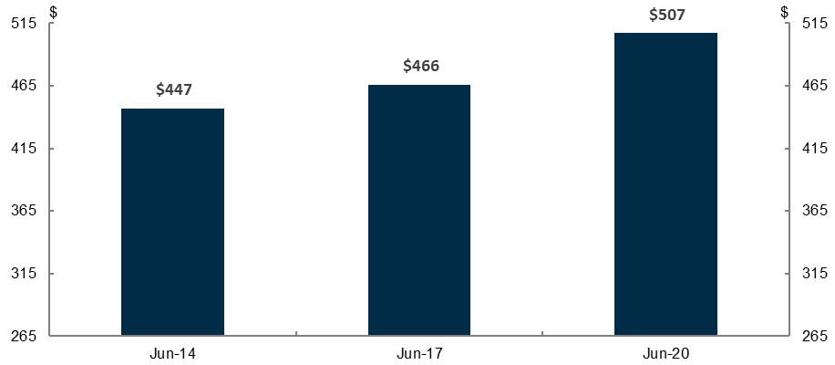
Note: Fees are dollar-weighted and for a $50,000 balance. The dollar weighted-average annual fee of a MySuper product on a $50,000 balance was 0.89 percentage points in June 2014, 0.93 percentage points in June 2017, and 1.01 percentage pointsin June 2020. The minimum fee was $265 on a $50,000 balance in June 2014. Source: APRA Quarterly MySuper statistics June 2020 and APRA Quarterly MySuper statistics back series.

Chart 2: Fees and investment returns vary widely across MySuper products
Fees | Investment returns
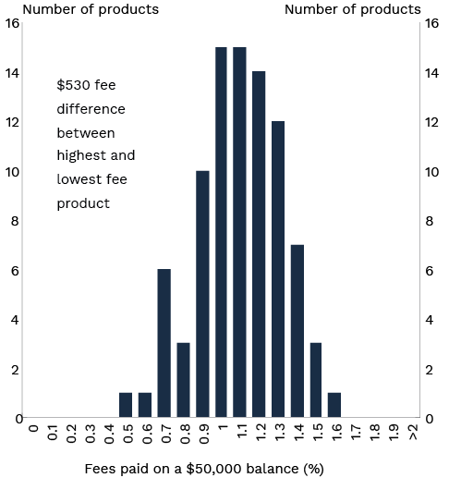 | 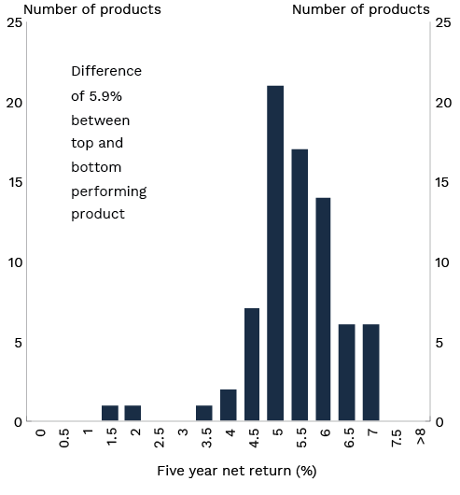
Note: Five year net return to 30 June 2020 and for a $50,000 balance. Fees as at 29 May 2020. Life cycle products are asset-weighted. The five year net return is only available for 76 of the 88 MySuper products.
Source: APRA Quarterly MySuper statistics June 2020 and APRA MySuper Heatmap June 2020.
- Unintended multiple accounts
Unintended multiple accounts are created when you change jobs and do not nominate a superannuation fund. Under our compulsory superannuation system, your employer is obligated to nominate a superannuation fund on your behalf. Each employer is required to have a ‘default’ fund that they pay your compulsory contributions into, if you do not choose your own fund. If you change jobs multiple times over your working life and do not nominate a superannuation fund, you could end up with multiple superannuation accounts with different funds, all charging separate fees and insurance premiums.
As stated by the Productivity Commission, “these unintended multiple accounts erode members’ balances via multiple sets of fees and insurance premiums, and often end up as lost, and then unclaimed, accounts.”
The latest data from the ATO shows there are around 6 million multiple accounts held by 4.4 million people. Over one third of multiple accounts are held by people aged 35 or younger. These multiple accounts charge $450 million in fees a year.
As a result of the Government’s legislated Protecting Your Super reforms, inactive low balance accounts are now automatically consolidated into a member’s active account by the ATO. While these reforms address the existing number of multiple accounts, they will not prevent the creation of new unintended multiple accounts.
Further reform is needed. Every year about 1.6 million people change jobs and 470,000 people enter the workforce for the first time. Most people are defaulted into a new account, giving rise to about 850,000 duplicate accounts every year. Added labour market turnover as the economy recovers from the impact of COVID-19 creates even more urgency to protect members from being defaulted into a duplicate account they do not need.
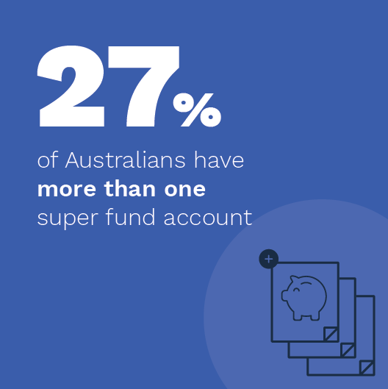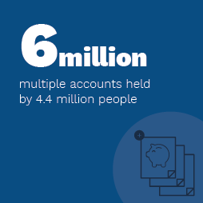
- Some superannuation trustees are not acting in the best interests of their members
While members are saving for their retirement, superannuation trustees have one job: to maximise their members’ retirement savings. This obligation is all the more important given the compulsory nature of our system.
The current law attempts to make this obligation clear by requiring trustees to act in their members’ best interests.
However, the Productivity Commission found that “funds clearly do not always act in their members’ best interests.” As a result, the Productivity Commission recommended that the Australian Government should pursue “…a clearer articulation of what it means for a trustee to act in members’ best interests.”
As noted at the hearings of the Financial Services Royal Commission:
“Trustees are surrounded by temptation — to preference the interests of their sponsoring organisations, to act in the interests of other parts of their corporate group, to choose profit over the interests of members, to establish structures that consign to others the responsibility for the fund and thereby relieve the trustee of visibility of anything that might be troubling.”
Another problem identified by the Productivity Commission with the superannuation system was “…it is opaque, with members finding it difficult to understand how their super fund stacks up against others.” This opaqueness and lack of transparency means members are effectively unable to hold their fund to account for the returns they deliver and the expenditure they undertake.
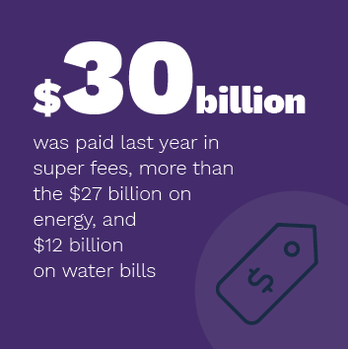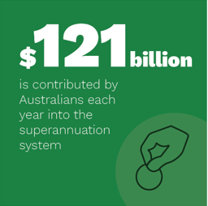

Your Future, Your Super
The Government’s Your Future, Your Super package is the next step in the Government’s plan to make sure the superannuation system delivers for members:
- Your super follows you, prevent the creation of unintended multiple superannuation accounts.
- Empowering members by making it easier for you to choose a well-performing product that meets your needs.
- Holding funds to account for underperformance, better protecting you from poor superannuation outcomes.
- Increasing transparency and accountability for how superannuation funds use your savings.
Your Future, Your Super will deliver substantial savings for members
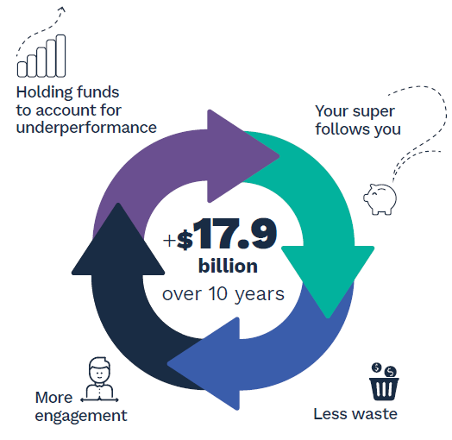

Your super follows you

The objective
To stop the creation of unwanted multiple accounts that reduce retirement savings of members.
Your super follows you
The Government will ensure that when you move jobs your account will be ‘stapled’ automatically to you, to protect your retirement savings being drained by the costs of unintended multiple accounts.
In the Financial Services Royal Commission’s Final Report Commissioner Hayne stated, “… default superannuation accounts should only be created for new workers, or workers who do not already have a superannuation account. And that default account should then be carried over, or ‘stapled’, to members as they move jobs. The proliferation of unnecessary default accounts is not in the interests of members.”
The Government believes Australians who already have a superannuation account should only have another account if they decide to open one. The Government will ensure that a superannuation member’s account will be ‘stapled' to them as they change jobs. At the time of starting a new job, unless a member decides otherwise, their employer will pay superannuation contributions into their existing fund.
The introduction of stapled accounts will implement Recommendation 3.5 of the Financial Services Royal Commission and Recommendation 1 of the Productivity Commission Superannuation Inquiry.
This reform will ensure that members are no longer accumulating multiple superannuation accounts every time they change jobs. This will result in higher retirement savings for millions of Australians as they will no longer be paying multiple sets of fees and insurance premiums.

How it will work
The first phase of the reforms will commence on 1 July 2021. Employers will no longer automatically create a new superannuation account in their chosen default fund for new employees when they do not decide on a superannuation fund. Instead, employers will obtain information about the employee’s existing superannuation fund from the ATO, if it is not provided by the employee.
The employer will do this by logging on to ATO online services and entering the employee’s details. Once an account has been selected, the employer will pay superannuation contributions into the employee’s account.
The second phase of the reforms will see the ATO provide a new service for employers. As of 1 July 2022, the ATO will enable digital software providers to give employers the option to automate the communications between the employer’s payroll system and the ATO system. Once this new service is adopted, it will remove the need for the employer to manually enter into their payroll system their employees’ superannuation fund details, reducing business administration costs.
Under both phases, if an employee does not have an existing superannuation account (e.g. is new to the workforce) and does not make a decision regarding a fund, the employer will pay the employee’s superannuation into their nominated default superannuation fund.

Empowering members

The objective
- To empower members to make their own decision about who manages their retirement savings with simple, clear and trusted information.
- To encourage more competition in the system to lower fees and increase returns for members.
Empowering members
The Government will develop a new interactive online ‘YourSuper’ comparison tool which will allow you to make better decisions about which MySuper fund manages your savings.
When superannuation products are easy to compare, people are more likely to become engaged with superannuation and choose the product that is right for them. That is why, by 1 July 2021, the Government will deliver an interactive YourSuper comparison tool which will be administered by the ATO.
For the first time, members will be able to compare the performance and fees of all MySuper products in a single place, based on independent and reliable information, with underperforming products clearly marked.

How it will work
The YourSuper comparison tool will, by 1 July 2021:
- Display a quarterly updated table of MySuper products ranked by fees and investment returns, with products that have not met the new higher performance standard clearly highlighted as underperforming.
- Link you to the fund’s website when you select a product from the table of MySuper products.
- Show your current superannuation accounts and allow you to select one of your existing superannuation accounts.
- Prompt you to consider consolidating accounts if you have more than one fund.
The YourSuper comparison tool will be based on information that superannuation funds report to APRA and will be developed in consultation with the Treasury. The information about product performance will be updated quarterly to ensure people are making decisions using up-to-date information.
By facilitating greater and well-informed member engagement, the website will allow members to avoid poor performing and high-fee products. Employees who are starting a new job will be able to use the YourSuper comparison tool to locate a MySuper account.

Benefits of the YourSuper comparison tool
The YourSuper comparison tool will mean members can simply and safely pick a well-performing MySuper product. Selecting a high-performing product compared with a poor-performing product can significantly boost retirement incomes.

Holding funds to account for underperformance

The objective
- To protect Australians’ retirement savings from underperforming superannuation products to maximise their savings for retirement.
- To ensure funds are maximising net (after fees) investment returns.
- To hold funds accountable for the outcomes they deliver to members.
- To make members aware when their superannuation product is underperforming.
Holding funds to account for underperformance
The Government will ensure members' retirement savings are protected from underperforming funds by subjecting MySuper products and other trustee-directed superannuation products to an annual objective performance test based on net investment returns, with clear consequences for failing the test.
Australians will be better protected from underperforming funds. Superannuation products will be subject to a clear and objective annual performance test; members will be informed if they are in an underperforming product and provided with the tools to switch; and funds will face consequences for underperformance.
The Productivity Commission emphasised that measures to deal with underperforming products are necessary, and MySuper products should be a priority given the size and level of disengagement in the default segment.
As of 1 July 2021, MySuper products will be subject to an annual performance test. The first test for MySuper products will see funds that are underperforming need to inform their members of their underperformance by 1 October 2021. When funds inform their members about their underperformance they will also be required to provide them with information about the YourSuper comparison tool.
Underperforming funds will also be listed as underperforming on the YourSuper comparison tool until their performance improves.
Funds that continue to underperform and fail two consecutive annual underperformance tests, will not be permitted to accept new members. These funds will not be able to re-open to new members until their performance improves.
As of 1 July 2022, annual performance tests will be extended to ‘trustee-directed products’ (TDPs) outside of MySuper.
TDPs are accumulation superannuation products:
- which are regulated by APRA;
- where the trustee has control over the design and implementation of the investment strategy; and
- where the investment strategy covers more than one asset class.
These products are most comparable to MySuper products; the performance test is easily adaptable to these products; and APRA is already collecting data on them.
The annual benchmarking of TDPs will begin on 1 July 2022 and TDPs will be subject to the same consequences as MySuper products for underperformance.
The annual performance test will initially apply to accumulation products and cover net (after fees) investment returns – the most important factor in determining retirement balances. Applying the test to both MySuper products and TDPs will cover the majority of assets in accumulation products within the APRA-regulated fund sector.
Over time, other investment options which are made available by the trustee will also be subject to annual performance tests.
Case study 1: Your Future, Your Super will ensure superannuation funds are held to account for their performance
Backhill Superfund offers a MySuper product and several non-MySuper options for its members including Growth, Conservative, Cash, Property and Infrastructure. It also offers an Australian equities direct investment option for members who want to manage their own portfolio of Australian shares.
The new performance test will cover Backhill MySuper (from 1 July 2021), as well as Growth and Conservative options (from 1 July 2022).
From 1 July 2021, APRA commences its first performance test and finds that Backhill MySuper has underperformed. APRA informs Backhill Superfund of the assessment in September and Backhill Superfund has to notify its MySuper members by 1 October 2021. Backhill Superfund is also required to inform its MySuper members where they can locate the YourSuper comparison tool. From 1 July 2022, APRA completes the second performance test of Backhill MySuper and finds that the product has failed to improve its performance. APRA informs Backhill Superfund of this and Backhill MySuper stops receiving new members from 1 October 2022.
From 1 July 2022, APRA also completes the assessment of the Growth and Conservative options and finds that both have underperformed. Backhill Superfund has until 1 October 2022 to notify its members in those options of this outcome and subsequently incorporates this assessment in its annual member outcomes assessment.

The performance test will be based on the methodology adopted by the Productivity Commission and further refined by APRA in its ‘Heatmap’ analysis (see Appendix 2). This test will:
- allow the performance of products to be compared easily as the benchmark is tailored to each product’s asset allocation;
- be customised to individual products and continue to provide funds with flexibility in constructing their investment portfolio;
- assess actual performance, net of fees and taxes; and
- be calculated over an eight-year time period that allows funds to target long-term returns and not blame ‘one bad year’ for underperformance.
These changes will see $10.7 billion in higher returns for members over 10 years as members leave underperforming products, some underperforming products improve their performance and others merge with higher performing funds.

How it will work
Each year APRA will construct an individual benchmark for every MySuper product and TDPs based on an individual product’s portfolio asset allocation, taking into account fees, tax and other relevant assumptions. Each product will then be compared annually against their benchmark.
Products that underperform their net investment return benchmark by 0.5 percentage points per year over an eight-year period will be classified as underperforming. For MySuper products that were in place from 1 July 2014, their first performance test will be based on seven years of performance data. On an ongoing basis the test will apply over an eight-year period.
To ensure funds are all held to the same standard, the test will be set in regulations by the Government and administered by APRA. APRA will publish the results of the test.
The new performance framework will now be the primary method for measuring underperformance in the superannuation sector and the APRA Heatmaps and the annual member outcomes self-assessment under existing law will be amended accordingly.
The implementation of this reform will give effect to recommendation 4 of the Productivity Commission Superannuation Inquiry.

Consequences
All products that fail the test will be required to notify members in writing. As part of this notification members will be informed that the YourSuper comparison tool is available for them to compare their product against other MySuper products and help them switch to a better performing product. Underperforming products will be identified on the YourSuper comparison tool.
Products that fail the test two years in a row will not be permitted to accept new members until their net investment performance improves. This will stem the flow of contributions into underperforming products and better protect members from poor outcomes. Products will be allowed to receive new members again if their performance improves.
As part of APRA’s supervision, trustees of funds that are underperforming and closed to new members will need to justify how they are meeting their obligations to existing members if they do not merge or improve their performance.

Increasing transparency and accountability

The objective
To ensure trustees only use members’ money to maximise members’ retirement savings.
Increasing trustee accountability
The Government will legislate to compel superannuation trustees to act in the best financial interests of their members.
This measure will remove ambiguity on how superannuation trustees should be spending members’ money. As the Productivity Commission identified, unfortunately the culture of some superannuation funds has drifted away from the sole responsibility that they have as custodians of members’ money. Consistent with the recommendation of the Productivity Commission to clarify what it means for a trustee to act in members’ best interests, the Government will put beyond doubt that trustees must act in the best financial interests of members. It will also give effect to the statement in the Explanatory Memorandum to the Superannuation Legislation Amendment (MySuper Core Provisions) Act 2012 that “RSE [Registrable Superannuation Entity] licensees will have a heightened obligation to act in the best financial interests of members that accept the default option.”
In addition to strengthening the duty owed by trustees, the onus on demonstrating compliance with the new duty will be reversed so that trustees must establish that there was a reasonable basis to support their actions being consistent with members’ best financial interests.
To ensure that the best financial interests duty is complied with by superannuation funds these changes will be accompanied by anti-avoidance measures, to ensure payments from the superannuation fund to a third party (including an interposed or a related entity) do not undermine the intent of the changes.
No materiality threshold will apply to the new duty.
The implementation of this reform will give effect to recommendation 22 of the Productivity Commission Superannuation Inquiry.
Consequences
The penalty provisions introduced by the Government under the Treasury Laws Amendment (Improving Accountability and Member Outcomes in Superannuation Measures No. 1) Act 2019 will apply for breaches of the new duty for both the trustee and individual directors.

Case study 2: Your Future, Your Super will ensure superannuation funds are more accountable for how they spend your money
Backhill Superannuation Fund decided to fund a television marketing campaign to promote their fund, spending $5 million of members’ money. Backhill Superannuation Fund argues that spending the money will lead to an increase in the number of members by 5,000. As a result of the increase in members, the trustee believes that this will allow them to reduce their fees by 0.01 percentage points by spreading the fixed costs of the fund across more members. However, following the campaign no decline in fees results.
APRA undertakes an audit of Backhill Superannuation Fund. It asks for information to justify why the marketing campaign was in the best financial interests of its members. The trustee produces detailed analysis that shows previous campaigns delivered the increase in members. The trustee is also able to produce evidence of unforeseeable events that undermined the effectiveness of the campaign. APRA is satisfied that at the time of making the decision to proceed with the marketing campaign the fund had acted reasonably in forming the view that the expenditure was in the best financial interests of its members.

Providing further transparency on how trustees are spending your money
The Government will require your superannuation fund to provide you with better information regarding how they manage and spend your money in advance of the Annual Members’ Meeting.
Member engagement will be improved if members receive simpler and clearer information about how funds manage and spend members’ money. This information will allow them to assess the decisions the trustee has made on their behalf.

How it will work
As part of the Treasury Laws Amendment (Improving Accountability and Member Outcomes in Superannuation Measures No. 1) Act 2019, superannuation funds are now required to hold Annual Members’ Meetings once a year. These meetings allow the trustee to explain how the fund has performed in the last financial year and answer any questions that members have. The Annual Members’ Meetings can be held digitally, which will allow more members to participate.
The Government will implement regulations that will require the notice of meetings to members to include the following:
- The annual report of the fund.
- The annual outcomes assessment funds are required to undertake.
- A copy of the most recent periodic statement for the member.
- A summary of each significant event or material change notice that superannuation funds were required to send under the Corporations Act 2001 in the last financial year.
- Remuneration of key executives, in line with ASX-listed companies along with any related entity of the fund.
- Marketing expenditures relating to promoting the fund, either directly or indirectly.
- Political donations, either directly or indirectly.
- Sponsorships relating to promoting the fund, either directly or indirectly.
- Payments to industry bodies or trade associations, either directly or indirectly.
- Related party transactions (including payments to non-investment entities).
Guidance will be provided to assist funds in presenting the information in a way that allows members to understand the information and ensure there is consistency across the industry.

Measuring the benefits of Your Future, Your Super
Your Future, Your Super will encourage competition between funds, remove unnecessary waste built into the system, and improve standards so funds focus on delivering better fund performance and minimise unnecessary expenditure. By giving Australians clear information on investment performance outcomes and making it easier to compare products, members will be empowered to make better choices about who they trust to invest their retirement savings.
Through these changes, better performing superannuation products will grow and gain members. Underperforming products will be made more accountable to their existing members and will not be able to receive new members if they continue to underperform.
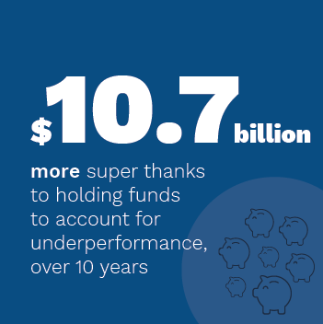
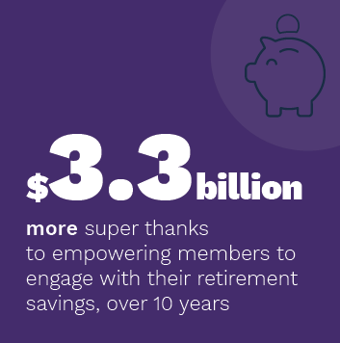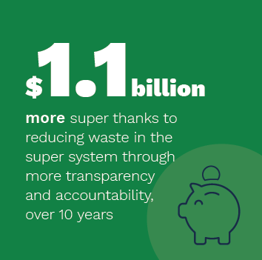

The aggregate improvement in superannuation balances from the Your Future, Your Super package of reforms is estimated to be $17.9 billion over 10 years. On an annual basis the reforms would be expected to benefit members by around $1.8 billion a year. Not progressing the reforms could cost Australian households around $5 million per day.
Each component of the Government’s policy package contributes to these benefits for Australians:
- By improving underperformance, superannuation balances will be $10.7 billion better off over 10 years.
- More members making informed decisions about their superannuation and increased engagement via the YourSuper comparison tool will provide an additional benefit of $3.3 billion over 10 years.
- Superannuation that follows you, by removing the problem of multiple unintended accounts, will lead to an aggregate increase of superannuation savings of $2.8 billion over 10 years.
- Less waste of members’ money through greater transparency and accountability also has the potential to boost members’ savings by around $1.1 billion over 10 years.
These estimates have been developed by Treasury in consultation with the Australian Government Actuary, including by updating relevant Productivity Commission analysis.

Impacts on members
Your Future, Your Super will make it easier for members to choose a well-performing product and actively engage with their superannuation. Australians will no longer have unintended superannuation accounts that result in multiple fees and unnecessary duplicate insurance premiums that reduce their retirement savings.
The reforms will hold superannuation funds to a higher standard in how they spend members’ money. Australians will be told when their product is underperforming and prevented from joining persistently underperforming products. The focus on benchmarked investment performance will also foster competition, encouraging funds to reduce fees and costs, and boost members’ retirement savings. Young Australians entering the workforce could be up to $98,000 better off at retirement because of these reforms. Australians approaching retirement will also benefit from these reforms. A typical 50 year old who uses the YourSuper comparison tool to choose a top performing fund after being notified of underperformance could have around $60,000 more superannuation at retirement.
Ultimately, Your Future, Your Super will mean that your super will work harder for you, helping you save more for your retirement.

Case study 3: Your Future, Your Super will help young Australians choose the superannuation fund that is right for them, and avoid unnecessary fees
Jill enters the workforce as a full-time legal secretary. As Jill hasn’t had a job before, she doesn’t have a superannuation fund. Jill is asked by her employer to fill in a ‘choice of superannuation fund’ form.
Jill investigates what funds are available but finds it difficult to compare different superannuation funds and is unsure of how to find a good fund. As a result, Jill signs the paperwork her employer provides and is defaulted into the employer-nominated fund.
Jill changes jobs twice early in her career. Each time, she does not nominate a fund and is defaulted into a new superannuation fund by her employer.
As a result, Jill has three separate superannuation accounts. Over time, the superannuation held in Jill’s first two inactive accounts has been subject to additional insurance, administration and investment fees.
At retirement, Jill has had her hard earned retirement savings eaten away by poor performing funds and multiple sets of insurance premiums and fees.
Under the reforms introduced in this package, Jill will be better off.
When Jill enters the workforce, she is presented with easy to understand information about MySuper product fees and performance through the YourSuper comparison tool. It helps Jill to compare fund performance and choose a top-performing superannuation product which meets her needs.
When starting a new job, Jill will no longer have to nominate her existing fund and provide its details to avoid being defaulted into a new, duplicate fund. Instead, Jill’s first superannuation account will stay with her throughout her career until she chooses to change funds. When starting a new job, Jill will be encouraged to again access the YourSuper tool and confirm she wishes to maintain her existing superannuation account. If she does not, her employer will get her superannuation details from the ATO. This prevents Jill holding unintended duplicate superannuation accounts and incurring unnecessary fees and insurance premiums. As a result of these reforms Jill will be $98,000 better off when she reaches retirement age.
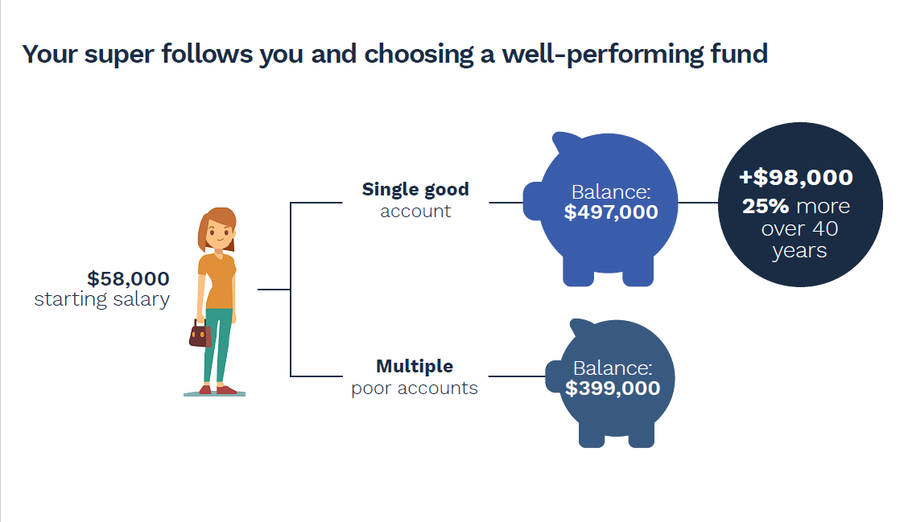

Case study 4: Your Future, Your Super will help Australians into well-performing funds
Sam enters the workforce as a truck driver and takes the superannuation product his employer defaulted him into. When he changes jobs, he maintains his existing superannuation account to avoid having duplicate accounts and being charged a second set of fees. However, his superannuation product performs poorly in terms of net investment returns. Sam notices his account balance growing over time due to regular contributions and is unaware that his product is underperforming. Upon reaching retirement, Sam’s balance is far lower than what it should have been due to decades of underperformance.
Under the reforms introduced in this package, Sam will be better off.
Sam may still be defaulted into an employer-nominated superannuation fund when he first enters the workforce if he doesn’t make a different choice. However, if his product underperforms then Sam will be notified and encouraged to consider using the YourSuper comparison tool to make a different choice of fund. If Sam used the YourSuper tool to switch his superannuation to a top-performing fund when notified, he could have had an extra $87,000 in superannuation available when he retires.
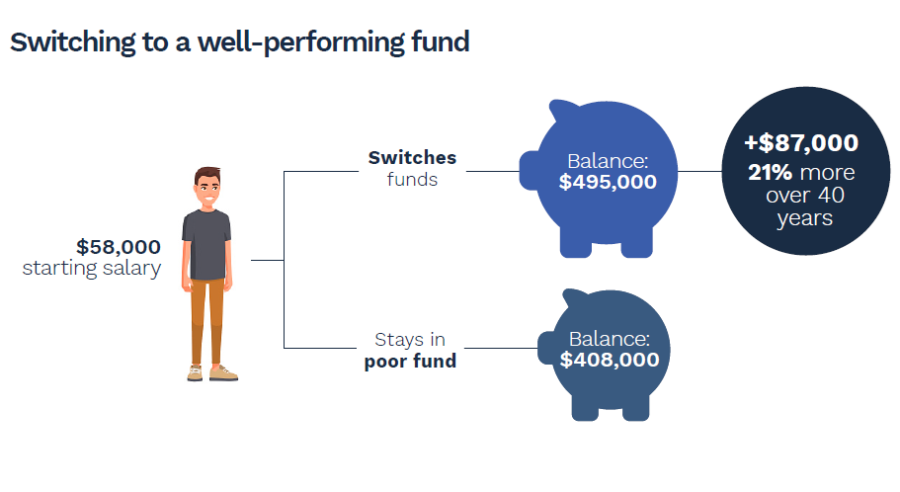

Case study 5: Your Future, Your Super will help Australians approaching retirement
Maureen is a 50 year old real estate agent, and hasn’t engaged with her superannuation in a while. While she knows the importance of her superannuation and makes regular contributions, she doesn’t have a clear idea of how her fund is performing or how to choose a high performing fund. Unfortunately, the superannuation fund she is with is underperforming just as she’s starting to prepare to retire. And as Maureen is close to retirement, the returns she earns now make a big difference to her final superannuation balance. When she retires, Maureen’s balance is far lower than what it should have been because her savings didn’t grow as much in those final years she was working.
Under the reforms introduced in this package, Maureen will be better off.
Maureen can now use the YourSuper comparison tool to check if her superannuation fund is performing well. This tool is also a trusted and easy way for Maureen to compare across MySuper funds, and find one that best suits her needs if she decides to switch. If her product underperforms, Maureen will be notified and encouraged to consider using the YourSuper comparison tool to make a different choice of fund. By using the YourSuper tool to switch her superannuation to a top-performing fund when notified, Maureen’s retirement savings could have been boosted by $60,000.
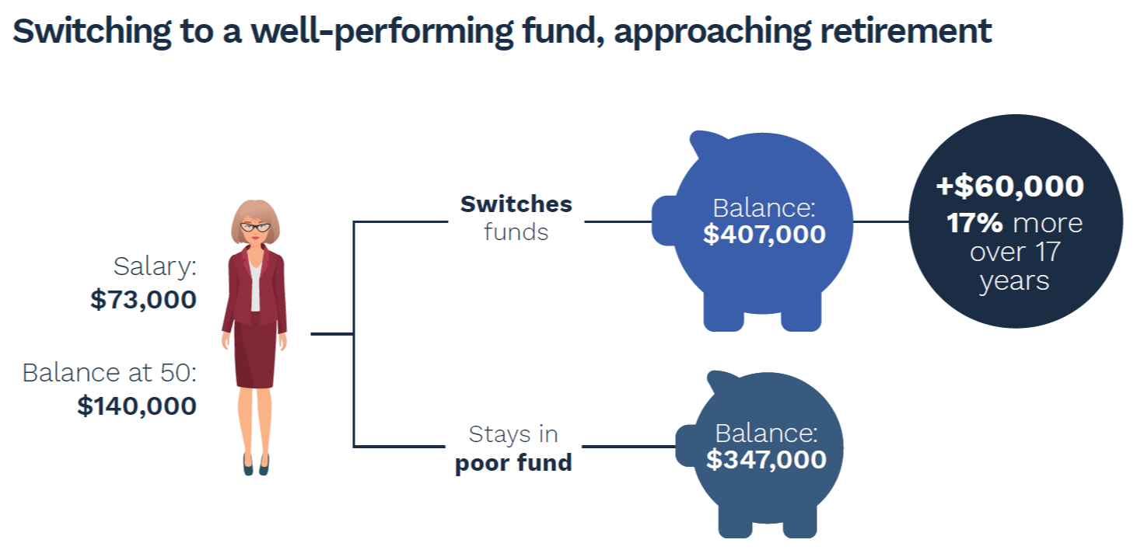

Next steps – roadmap for reform
All measures will commence by 1 July 2021.
Policy | Commencement date | Implementation
Your super follows you | 1 July 2021 | No unintended multiple accounts will be created after 1 July 2021.
Empowering members | 1 July 2021 | The YourSuper comparison tool will be available to all Australians by no later than 1 July 2021.
Holding funds to account for underperformance | 1 July 2021 | APRA will complete the first benchmarking tests for MySuper products in September 2021, with trustees of underperforming products to notify members by 1 October 2021.
 | 1 July 2022 | APRA will complete the first benchmarking tests for trustee-directed products in September 2022, with trustees of underperforming products to notify members by 1 October 2022.
Increasing transparency and accountability
Best financial interests duty | 1 July 2021 | Obligations will apply to trustee decisions taken on or after 1 July 2021.
Annual Members’ Meetings | 1 July 2021 | Trustees will be required to send information for Annual Members’ Meetings from 1 July 2021.

Appendix 1
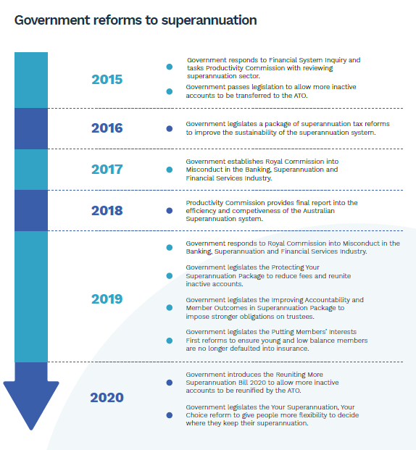

Appendix 2

Underperformance benchmarking methodology
The regulations will stipulate the benchmarking test as consistent with the current Heatmap methodology employed by APRA. Net investment returns are calculated as:
$${\left\{\prod_{t=1 }^{n}{\left(1+NIR_{t}\right)}\right\}}^{\frac{1}{n}}-1$$
And strategic asset allocation benchmark portfolio returns are calculated as:
$${\left\{\prod_{t=1}^{n}{\left(1+\sum_{a=1}^{A}{\left(SAA_{a,t-1}*R_{a,t}\right)}\right)}\right\}}^{\frac{1}{n}}-1$$
Where:
- n = number of periods
- t = period t
- NIR_{t} = net investment return in period t
- $a$ = asset class $a$
- A = the number of asset classes in the benchmark
- SAA_{a,t}$-$1 = the allocation to asset class $a$ in period t$-$1
- $R_{a,t}$ = $\left(Index_{a,t}-Fee_{a}\right)*\left(1-ETR_{a}\right)$
  - $Index_{a,t}$ = the return for the index chosen to reflect asset class $a$ in period t
  - $Fee_{a}$ = the fee assumed for asset class $a$
  - $ETR_{a}$ = the assumed effective tax rate for asset class $a$
The indexes used, fee and tax rate assumptions used in the Heatmap for each asset class are as follows:
Asset class | Index | Fee | Tax
Australian Equity | S&P/ASX 300 | 0.05% | 0.00%
International Equity (hedged) | MSCI All Country World Ex-Australia Equities Index with Special Tax (100% hedged to AUD) | 0.11% | 14.00%
International Equity (unhedged) | MSCI All Country World Ex-Australia Equities Index with Special Tax (unhedged in AUD) | 0.09% | 14.00%
Australian Property | S&P/ASX 300 A-REIT Index | 0.12% | 14.00%
International Property | FTSE EPRA/NAREIT developed ex Australia rental hedged to AUD | 0.22% | 14.00%
Australian Infrastructure | FTSE Developed Core Infrastructure Index hedged to AUD | 0.26% | 14.00%
International Infrastructure | FTSE Developed Core Infrastructure Index hedged to AUD | 0.26% | 14.00%
Australian Fixed Interest | Bloomberg Ausbond Composite 0+ Index | 0.10% | 15.00%
International Fixed Interest | Bloomberg Barclays Global Aggregate Index (hedged in AUD) | 0.10% | 15.00%
Australian Cash | Bloomberg Ausbond Bank Bill Index | 0.04% | 15.00%
International Cash | Bloomberg Ausbond Bank Bill Index | 0.04% | 15.00%
Other (assets categorised as Other / Commodities) | 25% International Equity (hedged), 25% International Equity (unhedged), 50% International Fixed Interest | As per the underlying asset classes
Source: APRA MySuper Product Heatmap information paper.
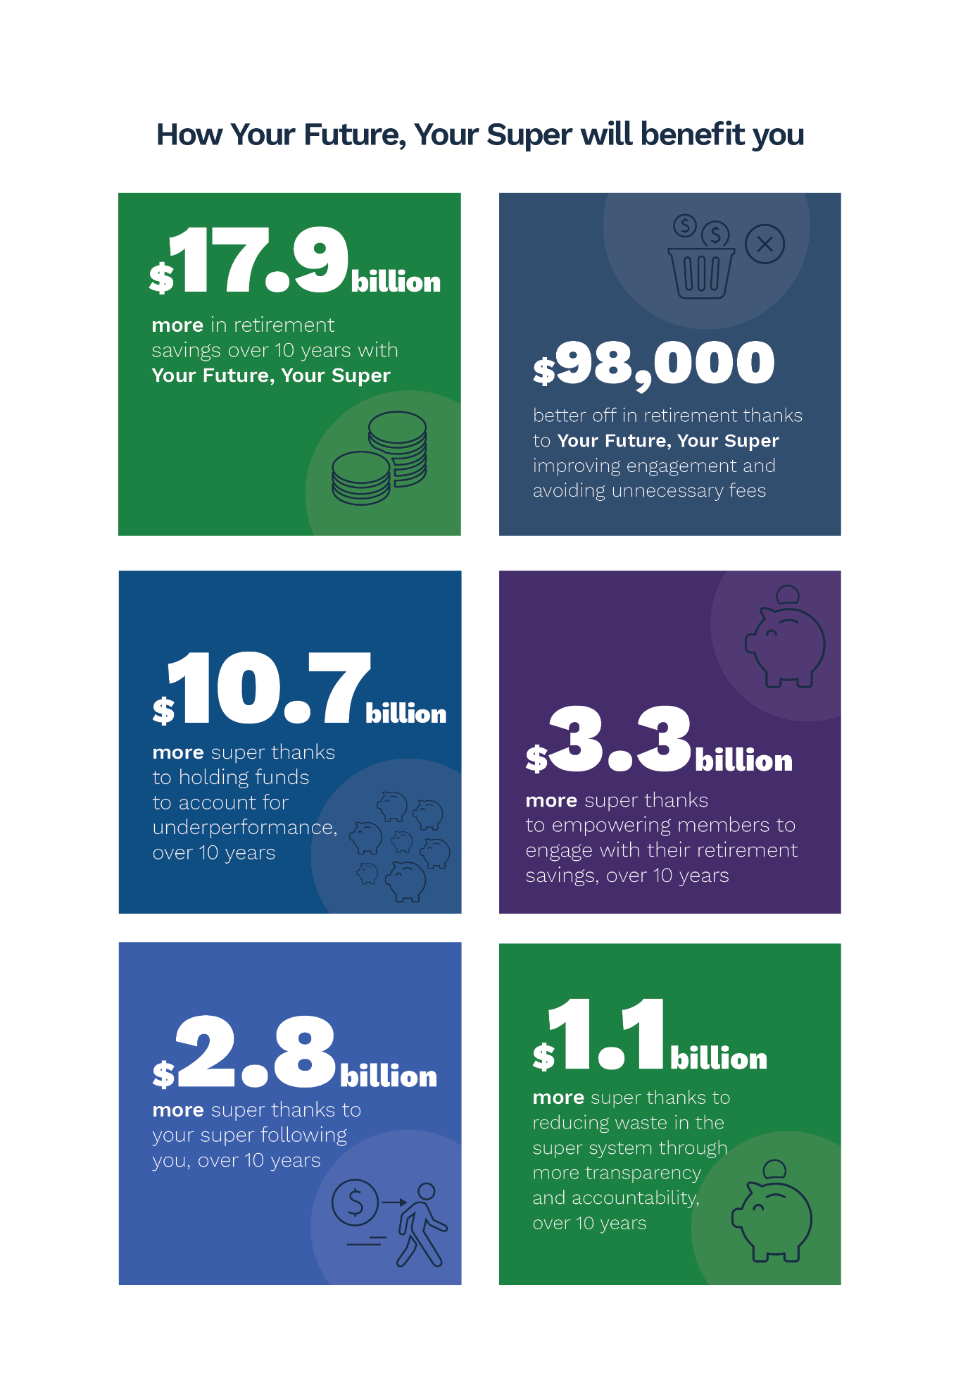
How your future your super will benefit you

ASX (Australian Securities Exchange), Corporate Overview, ASX website, 2020; Parliament of Australia, Chronology of superannuation and retirement income in Australia, Australian Parliament House website <https://www.aph.gov.au/About_Parliament/Parliamentary_Departments/Parliamentary_Library/pubs/BN/0910/ChronSuperannuation>, 2010.
Productivity Commission, Superannuation: Assessing Efficiency and Competitiveness, Inquiry Report, published online, 2018; Rainmaker Information, Superannuation, published online, 2020.
Treasury analysis.
Rice Warner, Superannuation Market Projections Report, 2019.
Rice Warner, Superannuation Market Projections Report, 2019.
APRA (Australian Prudential Regulation Authority), Quarterly superannuation performance statistics highlights, June 2020, published online, released 25 August 2020; Productivity Commission, Superannuation: Assessing Efficiency and Competitiveness, Inquiry Report, published online, 2018, p 554.
Australian Government, Financial System Inquiry Final Report, published online, November 2014.
Productivity Commission, Superannuation: Assessing Efficiency and Competitiveness, Inquiry Report, published online, 2018.
Productivity Commission, Superannuation: Assessing Efficiency and Competitiveness, Inquiry Report, published online, 2018, pp 23, 30, 247.
Commonwealth of Australia, Royal Commission into Misconduct in the Banking, Superannuation and Financial Services Industry, 2019, pp 250-251, 253.
Commonwealth of Australia, Royal Commission into Misconduct in the Banking, Superannuation and Financial Services Industry, 2019, pp 28-30.
Australian Government, The Government response to the Royal Commission into Misconduct in the Banking, Superannuation and Financial Services Industry, published online, February 2019.
Productivity Commission, Superannuation: Assessing Efficiency and Competitiveness, Inquiry Report, published online, 2018, p 245.
Productivity Commission, Superannuation: Assessing Efficiency and Competitiveness, Inquiry Report, published online, 2018, p 248.
Australian Government, Financial System Inquiry Final Report, published online, November 2014, p 105.
Australian Government, Financial System Inquiry Final Report, published online, November 2014, p 103.
Productivity Commission, Superannuation: Assessing Efficiency and Competitiveness, Inquiry Report, published online, 2018, p 337.
Productivity Commission, Superannuation: Assessing Efficiency and Competitiveness, Inquiry Report, published online, 2018, pp 245, 251-3.
Productivity Commission, Superannuation: Assessing Efficiency and Competitiveness, Inquiry Report, published online, 2018, p 157.
Grattan Institute (Jim Minifie), Super Sting: how to stop Australians paying too much for superannuation, published online, 2014 <https://grattan.edu.au/report/super-sting-how-to-stop-australians-paying-too-much-for-superannuation/>.
Productivity Commission, Superannuation: Assessing Efficiency and Competitiveness, Inquiry Report, published online, 2018.
Productivity Commission, Superannuation: Assessing Efficiency and Competitiveness, Inquiry Report, published online, 2018, p295.
The latest data are sourced from real time event reporting (Member Account Transaction Service/ Member Account Attribute Service, except for self-managed superannuation funds) during 2018-19 to 2020-21 for open accumulation phase accounts (including with zero balance), as at the end of August 2020. The data has been sourced from a range of time because of differences in the frequency in which funds report to the ATO.
Productivity Commission, Superannuation: Assessing Efficiency and Competitiveness, Inquiry Report, published online, 2018, p 554.
Treasury analysis.
Superannuation Industry (Supervision) Act 1993, section 52.
Productivity Commission, Superannuation: Assessing Efficiency and Competitiveness, Inquiry Report, published online, 2018, p 455, see also p 610.
Productivity Commission, Superannuation: Assessing Efficiency and Competitiveness, Inquiry Report, published online, 2018, p 611.
Michael Hodge QC, Senior Counsel assisting the Royal Commission, Transcript of Proceedings, Round 5, 6 August 2018, Royal Commission into Misconduct in the Banking, Superannuation and Financial Services Industry.
Productivity Commission, Superannuation: Assessing Efficiency and Competitiveness, Inquiry Report, published online, 2018, p 576.
Commonwealth of Australia, Royal Commission into Misconduct in the Banking, Superannuation and Financial Services Industry, 219, pp 250-251.
Productivity Commission, Superannuation: Assessing Efficiency and Competitiveness, Inquiry Report, published online, 2018, pp 6-14.
Productivity Commission, Superannuation: Assessing Efficiency and Competitiveness, Inquiry Report, published online, 2018, p 43.

