Playgroup
Australia

2020 Pre-budget Submission

Playgroup Australia would welcome further opportunity to consult
or expand on the proposals raised in this submission.

Fiona May
CEO
ceo@playgroupaustralia.com.au
02 6103 0173

Contents

Executive Summary 4
Introduction 6
1. What is playgroup? 6
2. Why is playgroup important? 6
3. How we contribute 7
Budget Proposals 8
1. Ageless Play 8
2. Maintain and grow community playgroups 12
3. Sustain the PlayConnect program 17
4. PlayConnect Expansion 21
Appendix 1: Budget Data 24
1. Ageless Play: 24
2. Community Playgroup continuation: 24
3. Sustain the PlayConnect Program 25
4. PlayConnect expansion. 25
References 27

Executive Summary
Playgroup Australia and the State and Territory Playgroup Organisations support over 8000 playgroups for families and children from birth to five years old.
We estimate 170,000 families participate in the playgroups. This makes it one of Australia’s largest social movements. The playgroup movement has been providing and supporting playgroups
for more than 45 years through volunteerism and outreach work.
Playgroups build stronger communities, stronger families and give children their first education experiences outside home. Playgroups help connect children and parents to the communities around them. They give parents who are isolated or feel out of their depth a chance to meet others
and be supported by their peers, and to connect with community services. Feedback from
families, and evaluations by researchers, have confirmed the benefits of playgroups.
Playgroups range from universally accessible community playgroups, which are run entirely
by volunteer parents and make up the majority of our playgroups, to targeted playgroups supported by professional staff that assist children with developmental difficulties, or children from disadvantaged backgrounds, and their parents.
Playgroup Australia manages funding from the Australian Government through the Department of Social Services (DSS), to a total of $6.9M per annum. This includes $5.6M for community playgroups and $1.3M for PlayConnect supported playgroups. Funding for both programs is scheduled to terminate in June 2020.
In this submission, Playgroup Australia details four specific funding proposals for government.
All are family-focused supports, using proven existing delivery models, that stand to contribute strongly to multiple government objectives for very small outlays.

The four proposals are to:
- Develop Ageless Play, a playgroup model hosted by aged care services, with set-up
and ongoing support from Playgroup organisations, where local parents with young
children attend a weekly playgroup session with older people. $1.1m over 4 years.
- Sustain community playgroups, regular gatherings of parents and caregivers with their children aged birth to five, currently occurring in almost 80 percent of Australian
postcodes. $27.0m over 4 years.
- Sustain PlayConnect, an evidence-based early intervention program for families with
children who exhibit Autism Spectrum Disorder (ASD) or ASD-like characteristics.
$6.8m over 4 years.
- Extend the PlayConnect model to reach more families who benefit from early
intervention play and peer support.
  - establish PlayConnect playgroups in new locations where there is known demand, including rural and remote locations. $6.7m over 4 years
  - extending the disability play model to new children and parents. $6.7m over 4 years
  - pilot a program called PlayAdvantage for children from disadvantaged
backgrounds. $0.6m over 2 years.

A 2019 Independent Cost Benefit analysis of
Community Playgroups found:
Every dollar invested in Community
Playgroups delivers $3.60 in benefits.

This is an excellent result.

Introduction

What is playgroup?
Playgroup has been a fundamental building block
of Australian society for generations and is
accessible to everyone.
It brings together children and their parents and caregivers to play, share, connect and grow. It enables local connections between families that support child development, parent-to-parent support, volunteerism, and community cohesion and development. Playgroups help develop strong, resilient children and communities, and build capacity in parents to support child and
family wellbeing in the vital early years.
Playgroup organisations currently support over 300,000 playgroup activities each year, reaching almost 80% of Australian postcodes. The Longitudinal Study of Australian Children (LSAC) estimates that 40% of Australian children aged under five attend a playgroup at some stage prior to starting school. Our role is to help ensure playgroups are available to every family, and that children from vulnerable backgrounds or with disabilities are able and encouraged to participate.

Why is playgroup important?
Playgroup participation has been shown to:
- increase children’s readiness for school (Gregory et al 2016);
- improve parental outcomes, including for disadvantaged families
(Hancock et al 2015);
- improve community capacity-building and increase levels of
community trust (McShane et al 2016); and
- improve performance of children on all Australian Early Development
Census (AEDC) measurements including physical, social, emotional, language communication and cognitive development (Gregory et al 2016).

How we contribute
Playgroups contribute to outcomes established by a wide range of Government policies and strategies including the National Framework for Protecting Australia’s Children; a range of health strategies (including mental and physical health for both adults and children); early education outcomes; and family and community wellbeing. Playgroups also provide a stepping-stone for parents to undertake other volunteering and community activities, all of which create social capital.
Playgroups represent very high value-for-money in child development and community capacity-building. Bringing children from vulnerable families into a supportive community early in their lives, builds their resilience and preparedness for school and social interaction.
The pyramid below maps the types of playgroups to the needs of children and families. The universal model of community playgroups, which is often a child’s first learning experience outside the home, sits at the bottom of the pyramid.
The more intensively supported playgroups feature engagement by professionals and serve an early intervention purpose. For children with complex needs or those from vulnerable backgrounds, specialist practitioners are involved. These specialists provide important support and capacity-building for parents, caregivers and the broader community.
Playgroups represent very high value-for-money in child development and community capacity-building. Bringing children from vulnerable families into a supportive community early in their lives, builds both family and child resilience, preparedness for school and social capital.

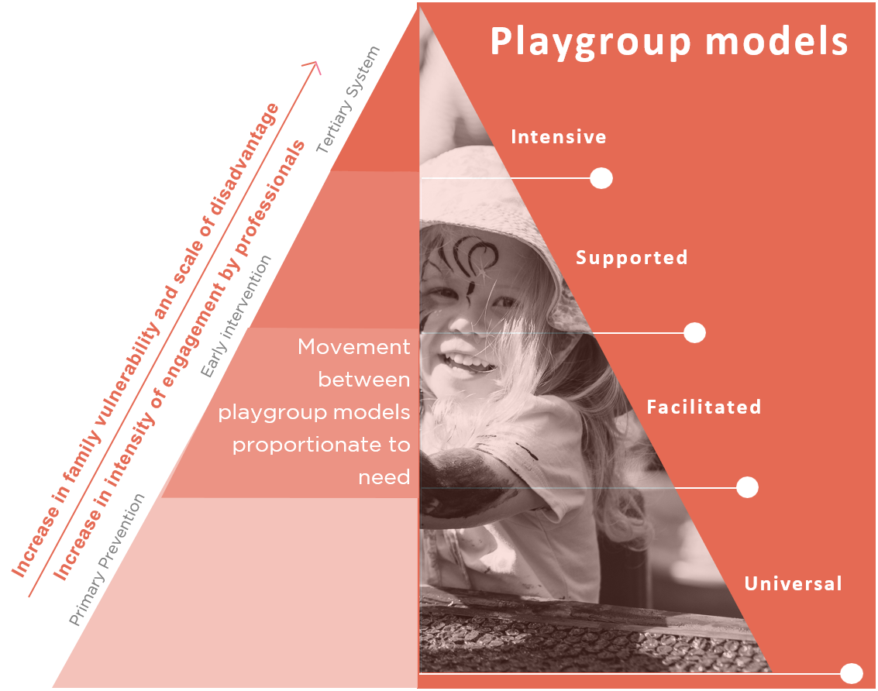

Budget Proposals
Playgroup Australia has four specific proposals for government, across different levels of the playgroup model, reflecting different community needs and government policy goals. All are family-focused supports that stand to contribute strongly to multiple government objectives for small outlays.

Ageless Play
Ageless Play is a playgroup model hosted in aged care settings, with set-up and ongoing support from Playgroup organisations, where local parents and caregivers with young children attend a weekly playgroup session with older people. The playgroups operate as a traditional parent-led community playgroup or facilitated playgroup with the aged care provider utilising their existing staff resources and with assistance from Playgroup Organisations, to support residents, older persons and families.

Current situation
The concept of Ageless Play playgroups captured the public’s imagination after the airing of the award-winning Old People’s Homes for Four-Year-Olds program on the ABC in August-September 2019. Within the community playgroups program, playgroup organisations had already supported the development of 40 Ageless Play playgroups, which increased to 60 following the documentary.
There is strong unmet demand for Ageless Play. Within weeks following the airing of the television program, the list of families and individuals seeking to be involved in the program had grown to over 5,000. Currently, we cannot adequately respond to that demand.
As of December 2019, there are already 431 aged care facilities, ranging across single-service operations to providers with nationwide operations, who are interested in introducing the program, across metropolitan, regional and remote locations.
Playgroup Organisations do not have the capacity to grow this program within existing resources, even with some aged care providers making contributions to start-up costs. Other aged care providers, particularly outside metropolitan areas, are reporting no capacity to contribute financially to the establishment of these playgroups, though they are ready to provide in-kind resources and their staff, once trained, would facilitate the groups at aged care services’ expense.

Proposal
We recommend that the government fund a dedicated Ageless Play program, allowing playgroup organisations to work with aged care providers and communities to bring the total number of groups supported to 420. $1.1m over four years.
All that this requires is a budget to support scaling up. We therefore propose a four-year
program, progressively scaling up from the current 60 groups to approximately 420 groups
by the fourth year.
If Ageless Play could be established in just the aged care services that have expressed interest to date, then, together with the 60 now operating, we would reach 18% of residential aged care services across the country. At this scale, Ageless Play has the potential to represent a systemic shift in inter-generational relationships, and in the quality of life in residential care services.
These services are ready to contribute through staff time and by providing the space and facilities. Playgroup Australia’s members just need start-up funding for connecting families with facilities, and initial aged care staff training and mentoring, along with periodic support, ensuring the aged care staff are also skilled to meet the needs of children and families participating.
The process of setting up a new intergenerational playgroup involves initial support to establish the playgroup and then, through skilled capacity-building, handing over the day-to-day running of the playgroup to the facility and the participants. Subsequently, participants require only a guiding hand in times of transition or challenge, such as re-training of staff when there is turnover at the aged care service.
This model enables each playgroup to be supported for an initial government investment of around $2,500 per year. The symbiotic relationships involved in intergenerational playgroups ensure there is a strong and continuing incentive for all participants to work to ensure continuity.
Fully establishing the Ageless Play program is easy:
- The service delivery model is already established and accepted.
- It uses the existing skills base and structure of playgroup organisations’
and aged care workforces.
- It leverages willing assistance from the aged care sector.
- It has strong community support.
- It requires only startup funding, as recurring cost will be met from aged care
provider co-contributions.
Benefits of Ageless Play
Playgroups in aged care facilities offer their residents a form of personal and community engagement. At the same time, they offer intergenerational support and engagement for children and parents in the community.
There is a growing population living in aged care facilities without regular engagement with family or friends. Consequently, more older Australians are experiencing loneliness, helplessness and boredom in their later life which contribute to poor mental and physical health and low quality of life. Similarly, caregivers and their children may be unable to access other playgroups in their area, and this would give them an alternative opportunity as well as connect them to a wider network, potentially replacing extended family supports which are not locally available.
For older persons, Ageless Play addresses concerns raised in the Royal Commission into Aged Care, relating to loneliness, and lack of stimulation and purpose. For the young, Ageless Play exposes them to interaction with other adults, and the opportunity to learn from those with significant life experience. Older Australians in aged care homes may be an additional or substitute ‘grandparent’ figure in a child’s life, strengthening and connecting families and communities. For parents and the community, Ageless Play breaks down barriers, offers the chance to share wisdom about parenting from an experienced older generation, and represents excellent value for money in child development. Ageless Play also contributes to addressing ageism in our community through the relationships which form for very young children and their parents with older Australians.

Maintain and grow community playgroups
Community playgroups are regular gatherings of parents and caregivers with their children aged birth to five. Led by parents/caregivers, they are flexible and responsive to the needs of participants.
These playgroups provide opportunities for:
- children to learn and develop through play activities and social interaction with their parents/caregivers and other children and adults.
- parents to establish social and support networks to encourage and assist them in their valuable parenting role.
- community development through enhanced social capital and the potential for networking between families, local businesses and services.
- families to have a soft entry to other relevant programs and services in their local community.
Current research estimates over a third of Australian children are accessing playgroups before they reach pre-school age and that this increases their school readiness.

Current situation
Community playgroup funding relies on a unique volunteer model, supported nationally by Playgroup Australia and delivered by the State and Territory Playgroup Organisations, to maximise outcomes from the government’s investment.
Commonwealth funding will currently terminate on 30 June 2020, and existing funding levels are placing a strain on the program and its capacity to reach communities. Without this program funding, over 7,000 existing community playgroups would be unable to access support, insurance and resources from the playgroup organisations, and new families would not be supported to join. This would put playgroup sustainability at risk, leaving current and future families without an important source of community connection, and children without important opportunities to learn.
Since 2012, the program funding has received only CPI increases. However, sustaining community playgroups is becoming more expensive and providing quality support to all the volunteers who lead these groups presents new challenges. The costs of insurance, venues and resources for playgroups have risen. Further, social and economic changes are placing pressure on the time resources of families. We are aware of the changing needs of children and families and will consider how the program needs to evolve in response.

Proposal
We recommend that the current grant-based contract for community playgroups be extended, allowing playgroup organisations to continue to support community playgroups.

$27.0m over four years

Through a four-year extension of the current grant structure, playgroup organisations can continue to deliver and evolve their extensive support for volunteers and families. Playgroup organisations continue to work together to establish cost efficiencies however families are finding it increasingly difficult to find the time and skills to volunteer to organise the logistics, venues and planning for playgroups. Facilitated playgroups overcome this deficiency.
We propose to re-balance the playgroup support delivery model to better reflect the needs of working families and vulnerable communities. In doing this, it will contribute to multiple government priorities and continue to reach the most vulnerable communities.

“There is no replacement for connecting face-to- face, allowing children to develop social skills and interactions in a supportive environment. Friendships begin through cups of tea and sharing picnics whilst children explore and discover themselves, each
other and the world around them.”
Playgroup parent, Victoria

Benefits of Community Playgroups
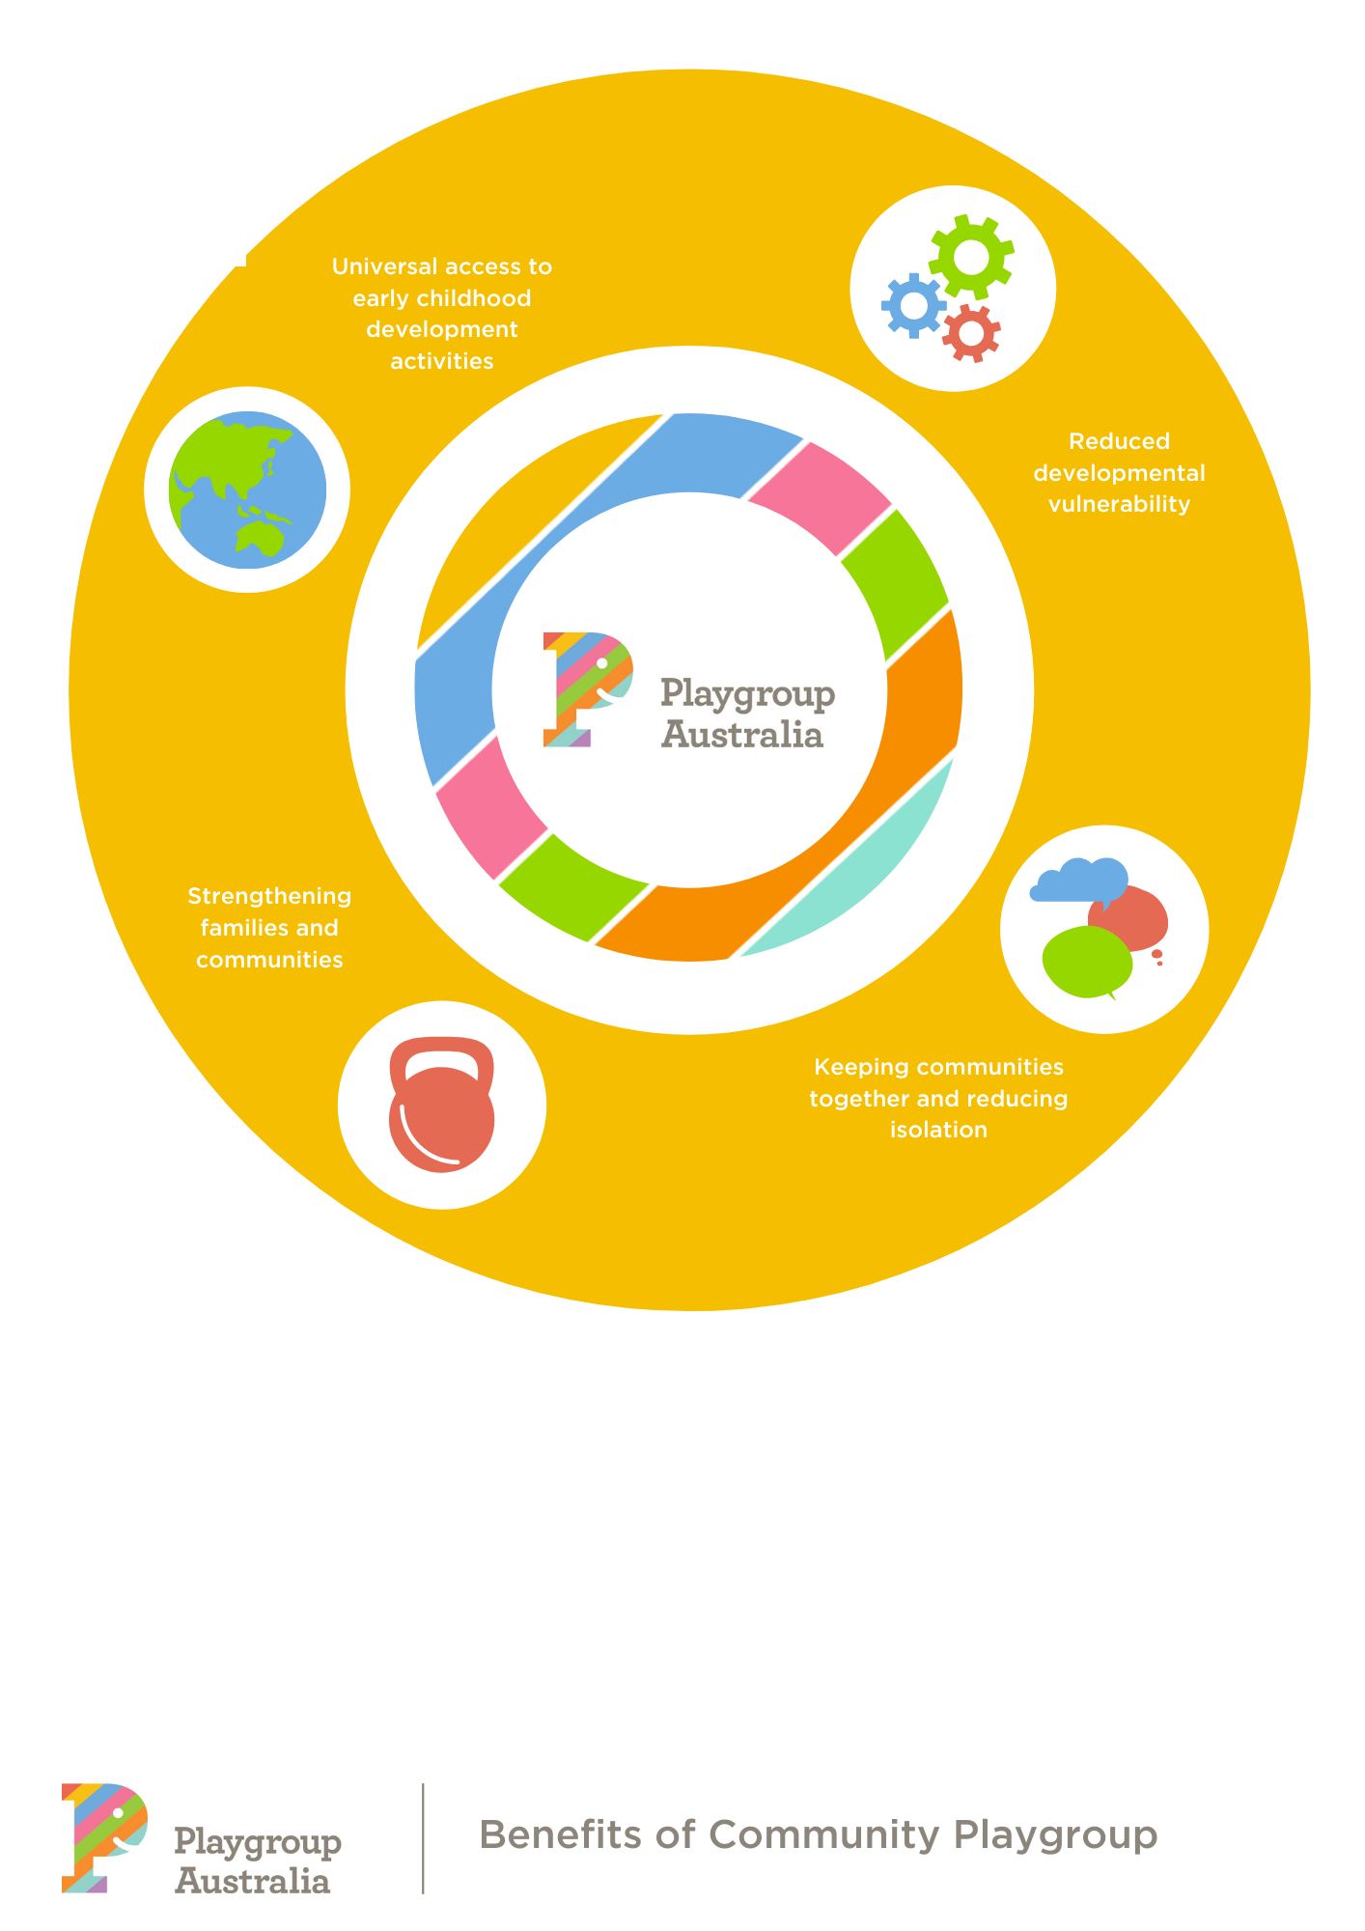
Benefits of Community Playgroups
Community playgroups have many positive
outcomes for children, parents and caregivers, and the wider community. By harnessing the power of local communities, playgroups multiply the power
of the government’s investment and achieve
positive results for local communities.
In the short term, children benefit by increased participation in play and social interaction. Parents benefit by increasing their skills, knowledge and confidence to provide developmentally appropriate play activities. Parents also gain knowledge of community support services and build informal support networks at a time when families are most vulnerable. Studies have shown that community capacity-building and higher levels of community trust are developed through engagement with playgroups.
Medium term outcomes of community playgroups include an improved home learning environment, increased support for parents in their parenting role, increased parent wellbeing
and capacity, and more participation in community activities. There is improved child learning and development through play and social interaction. AEDC data indicates that children who do not attend playgroups prior to school are 1.75 times more likely to be developmentally vulnerable on one or more domains of development at school entry than children who attend playgroups, after adjusting for differences in demographic characteristics and socio-economic status.
In the long term there is enhanced child learning and development leading to greater opportunities for them as adults. There is enhanced parent and family wellbeing and increased social capital (e.g. community connectedness and links to other families with children), which,
in turn, means improved education outcomes leading to increased social and economic opportunities.
Research by Professor James Heckman of Oxford University confirms that to achieve the highest long-term benefits, early intervention must commence very early in a child’s life — starting at 3-4 years of age with preschool is too late. Community playgroup investment is a low-cost universal prevention and early intervention strategy that provides outcomes for children, parents and the community.
The 2019 Cost Benefit Analysis of Community Playgroup placed a value on the costs of community playgroup (including venues, volunteer time, resources and support) of $223.2 million and valued the benefits of community playgroup (including play, volunteer employment, children’s future employment and freeing up resources in health, education, justice and child protection) at $807.3 million. This represents a very strong return of $3.60 for every dollar invested. When the value of benefits are compared with only the current government investment of $5.6m pa the return is significantly greater.
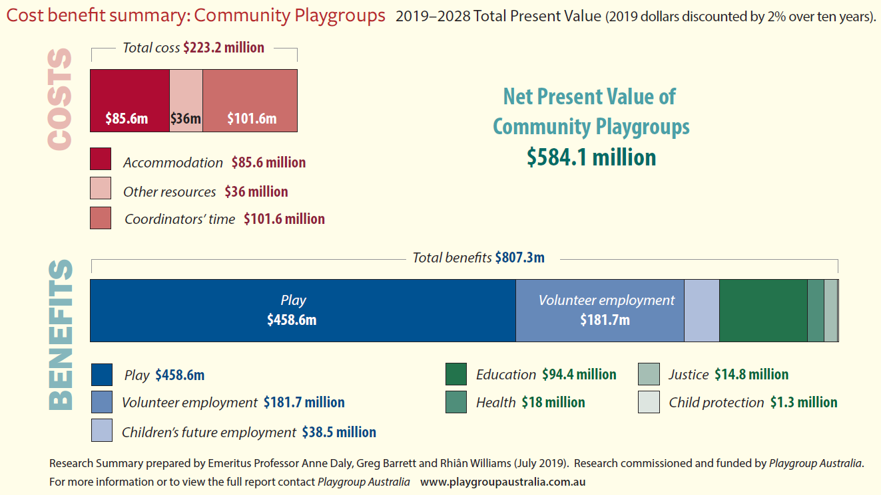

Playgroup is good
for the economy and good for children

Sustain the PlayConnect program
PlayConnect playgroups cater to families with children that exhibit Autism Spectrum Disorder (ASD) or ASD-like characteristics such as developmental delays or other behaviour that may be of concern.
The program is an evidence-based early intervention program, coordinated nationally by Playgroup Australia and delivered by the State and Territory Playgroup Organisations.

Current situation
PlayConnect has been funded since 2008. In 2019, Commonwealth funding of $1.30 million (ex GST) has enabled the national delivery by our State and Territory Organisations of 42 PlayConnect playgroups across 39 sites nationwide to a total of 538 children. Groups are being delivered in all states and territories, with 20 metropolitan and 22 regional groups meeting on a weekly basis. Over a quarter of families supported are from culturally or linguistically diverse and Aboriginal and Torres Strait Islander backgrounds.
The number of families being supported is almost triple the contractual obligations of the program and demonstrates both value for money and the importance of the program to participants.
Like funding for community playgroups, funding for the specialised PlayConnect playgroups terminates in June 2020.
With the rollout of the NDIS, the program had been marked for transition to the NDIS in 2019 and extended to mid-2020, with the intent of determining the most appropriate ongoing funding source. Uncertainty for the network of PlayConnect participating families and facilitators affects planning and the ability to focus on achieving developmental and support outcomes for young children with ASD and their parents.
“PlayConnect has been a life saver for our son, his siblings and myself at the most difficult, frightening and challenging time of our lives. The support, assistance and care from all staff and other parents has guided us through a daunting time to happy outcomes and a brighter future.
Our son and his siblings are in a safe space where they have become more connected and happier as well as developing new skills, making connections and developing their interests. PlayConnect has provided my family with a community of support,
a wealth of knowledge, and a place to call home.”
Bronwyn Jeffrey, PlayConnect mum

Proposal
Playgroup Australia recommends that the Government continue funding for this program which plays a critical role in bridging a service gap.
$6.8m over four years.
PlayConnect primarily serves those not yet in a position to apply for NDIS and is therefore not suitable to be rolled into the broader NDIS scheme. Rather, PlayConnect complements other services by providing a soft entry point for families before diagnosis or assessment, and potential NDIS entry, including Early Childhood Early Intervention (ECEI) partners.
The discontinuation of PlayConnect funding would considerably reduce accessible family support and early intervention for very young children with ASD and ASD-like characteristics.
In addition to impacting negatively on current users of the system, Playgroup Australia has identified strong and increasing demand for these specialised playgroups. As a supported playgroup initiative (rather than run entirely by volunteers), PlayConnect requires a greater government commitment than community playgroups. However, as an early intervention initiative, PlayConnect is successful and remains highly cost-effective.
PlayConnect is one of several programs that had been established through the Helping Children with Autism and Better Start programs that are not suitable to be transitioned to the NDIS. Other affected programs include Early Days parent workshops and Raising Children Network. Each of these programs fill a critical function of providing support and information to families while they are on the pathway to diagnosis and prior to NDIS journey or to accessing other supports. Their funding should be renewed.

Benefits of PlayConnect

The PlayConnect program is a vital service for children exhibiting ASD or ASD-like characteristics, who often miss out on mainstream opportunities for engagement. Importantly, the benefits of PlayConnect are much more far-reaching. In addition to targeted outcomes for children, the program:
- Fosters social support networks between families;
- Builds connections between parents and relevant service pathways;
- Acts as a ‘soft-entry’ point to the disability service sector;
- Allows families to explore the needs of their child and appropriate interventions;
- Builds capacity of parents;
- Supports whole family units;
- Increases community connections;
- Increases community understanding and awareness of ASD; and
- Supports families that are not eligible for the NDIS.
PlayConnect also bridges a service gap, because, unlike the NDIS and therapy supports, children do not need a formal diagnosis to participate. PlayConnect requires no formal referral, includes siblings, and is free for participants.
The program can include extended family members and is flexible in its delivery.
Feedback from parents confirms the program’s benefits. An independent review conducted in 2015 found most parents were either satisfied or very satisfied with the quality of the program, and over 85% would recommend it to others with young children with ASD.

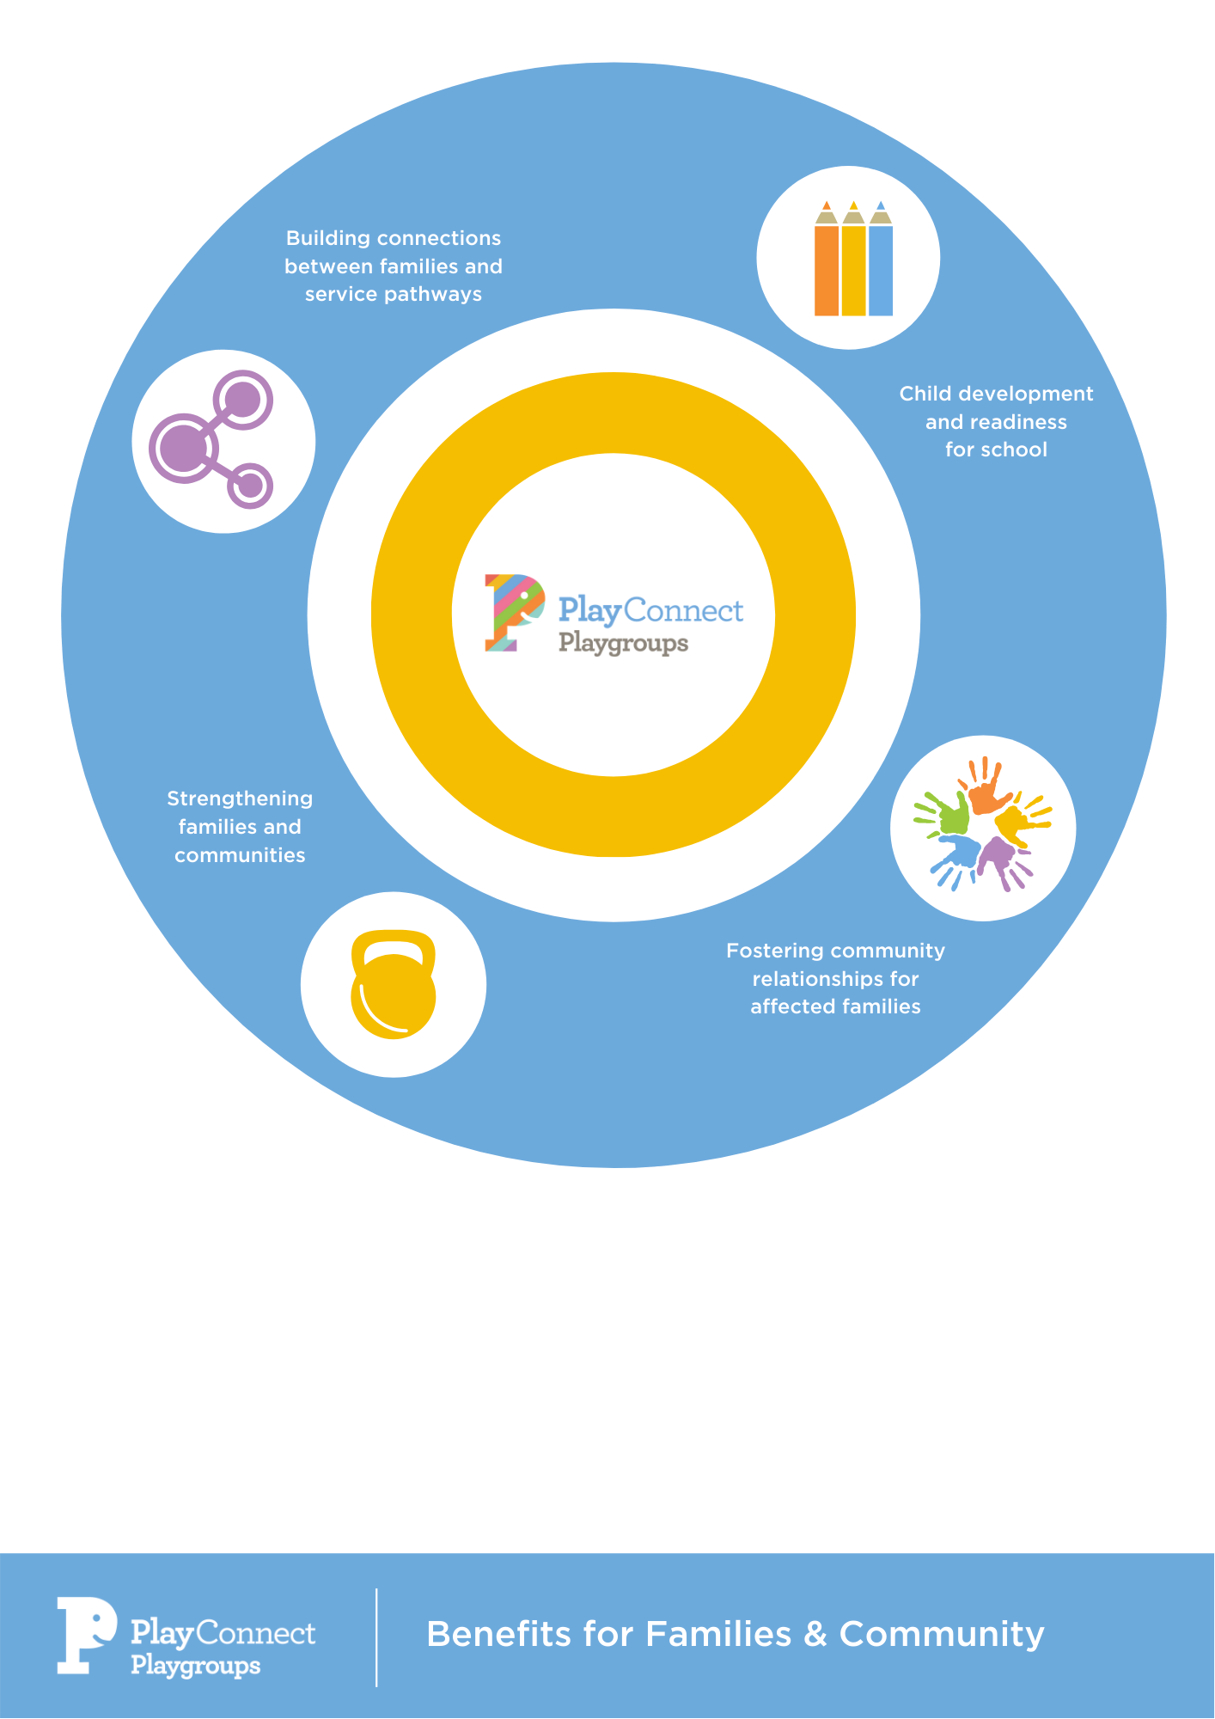

PlayConnect Expansion
Playgroup Australia proposes extending the PlayConnect program in three ways:
- Bringing PlayConnect to new sites with the capacity to deliver services to families
with children that exhibit ASD or ASD-like characteristics.
- Implementing a new stream of PlayConnect for families with children with other disabilities or developmental delay.
- Piloting a new stream called PlayAdvantage, targeted toward
socio-economically vulnerable families.
With these extensions to the PlayConnect program, the benefits experienced by the children
and families in the existing 42 groups across Australia can be brought to others who we know
can benefit from early intervention play programs.

PlayConnect in new locations
Playgroup Australia recommends that PlayConnect be extended to deliver additional playgroups for families with children with ASD or ASD-like characteristics, in locations where demand and capacity to deliver have been identified.
$6.7m over four years.
Playgroup Australia has undertaken research around the demand for, and capacity to deliver, PlayConnect playgroups, including the:
- local level of disability, specifically the prevalence of ASD;
- availability of local services and service partners
- experience of, and community discussions with, playgroup staff while in the field;
- staffing capacity; and
- location of existing sites.

Our research has identified a total of 55 additional sites, more than half in regional locations, where there is both demand and capacity.
Our recommendation is for a four-year program to deliver into all of these regions, so that by 2023-24 there will be 97 PlayConnect groups running across all jurisdictions, from cities to remote locations.
While Playgroup Australia has identified available and appropriate locations, we would confirm locations and sequencing of the rollout in partnership with the Department of Social Services (DSS) and work closely with DSS to ensure evaluation of the sites each year, taking into account demographic shifts that may affect both demand and capacity, particularly in remote and very remote areas.

Extension of the disability model

Playgroup Australia recommends that a new stream of PlayConnect be implemented, for families with children with other disabilities or developmental delay.
$6.7m over four years.
Playgroup Australia has researched the demand for the PlayConnect type of supported playgroup among sectors of the community where mainstream community playgroups may not be appropriate or accessible, and where parents may require extra assistance. Specifically, Playgroup Australia is looking to extend the model to cater for families with children who experience other disabilities.
Children with intellectual impairment, sensory or other disabilities, like children with ASD, may have little opportunity to play and interact with peers in a mainstream setting. Their parents are also facing challenges in accessing information and support, whether from government, community or other parents. A supported playgroup would provide a potential ‘step-up’ pathway to build readiness to engage in mainstream settings. Parents and children would benefit from ready access to trained and responsive staff, who can support the capacity of parents and children to interact and learn through play during their children’s early years.
There is significant community benefit in parents being more confident and having greater skills as this can pave the way to transition children with disabilities into mainstream services. Families typically engage in playgroups prior to accessing formal disability services including the NDIS. In addition, playgroup participation is not an eligible funded activity under NDIS early intervention plans for young children. The parent skill building and peer to peer support outcomes of PlayConnect are also not typically funded in early intervention NDIS plans.
Given appropriate funding, Playgroup Australia proposes to adapt and deliver a PlayConnect-type supported playgroup to families with children with other disabilities, building the program over four years to reach an additional 550 families in key identified locations, to complement the existing PlayConnect locations.

PlayAdvantage pilot program
Playgroup Australia recommends that government support a pilot of a new stream of supported playgroup, called PlayAdvantage, targeted toward socio-economically vulnerable families.

$0.6m over two years.
Both research and the experience of playgroup organisations shows that children and their parents from disadvantaged or vulnerable backgrounds benefit from access to supported playgroups. Socio-economic disadvantage is often a barrier to accessing services, as well as knowledge and parenting skills. There is no economic barrier to entry with supported playgroups – they are free to attend.
Socio-economic disadvantage in many cases might be a result of, and be exacerbated by,
locational disadvantage, and among Aboriginal and Torres Strait communities. Supported playgroups are often a feature of locational responses such as under the Communities for Children program, however, more could be done.
As an example, Playgroup South Australia recently ran a pop-up playgroup event in a Communities for Children region which attracted ten families experiencing disadvantage who had previously been unknown to the local service system. Playgroups, run by the playgroup organisations, rather than the service system, are non-stigmatising and act as a safe opportunity to connect with the community and build trust. They are also and a soft entry to other services.
Playgroup Australia proposes to run a 2-year pilot program of weekly supported playgroups, called PlayAdvantage, aimed specifically at children and families/caregivers from disadvantaged backgrounds. These groups would commence in locations where targeted supported playgroups are not already being delivered and would include a focus on connecting families to other services and playgroups as appropriate. We strongly believe that, given appropriate support and guidance, children and parents would reap significant benefits. These playgroups will provide a non-stigmatising, welcoming early intervention option to families who do not currently need tertiary system supports. The proposal includes a budget for evaluation, which would be planned from the start, to ensure an accurate understanding of the costs and benefits of the new service.

Appendix 1:
Budget Data

Ageless Play: Breakdown of budget proposal

Budget year | Number of new groups |  | Cost, including CPI increase ($000)
Year 1 | 80 |  | $ 212
Year 2 | 100 |  | $ 272
Year 3 | 120 |  | $ 327
Year 4 | 120 |  | $ 335
 | 420 |  | $ 1,146
Figures based on existing initial year support and establishment costs. These amounts build the ERO decision into the base amounts. On-going support for established playgroups will be funded from other sources including co-contribution from aged care facilities.

Community Playgroup continuation:
Breakdown of budget proposal
Budget year |  |  | Cost, including CPI increase ($000)
Year 1 |  |  | $ 6,499
Year 2 |  |  | $ 6,662
Year 3 |  |  | $ 6,829
Year 4 |  |  | $ 6,999
 |  |  | $ 26,990
These amounts build the ERO decision into the base amounts after 2021.

Sustain the PlayConnect Program.
Breakdown of budget proposal

Budget year | Number of groups operating |  | Cost, including CPI increase ($000)
Year 1 | 42 |  | $ 1,657
Year 2 | 42 |  | $ 1,690
Year 3 | 42 |  | $ 1,724
Year 4 | 42 |  | $ 1,759
 | 42 |  | $ 6,830
These amounts build the ERO decision into the base amounts after 2021.

PlayConnect expansion.
Breakdown of budget proposal

PlayConnect – scaled growth
Budget year | Number of groups operating |  | Cost, including CPI increase ($000)
Year 1 | 11 |  | $ 664
Year 2 | 27 |  | $ 1,471
Year 3 | 43 |  | $ 2,098
Year 4 | 55 |  | $ 2,513
 | 55 |  | $ 6,746
This budget proposal has a higher average price per group than the current program. This reflects the costs of establishing groups in regional and remote locations. Currently, it costs approximately $34,000 to operate a metropolitan group, but this rises to $62,000 for remote groups, almost entirely due to increased staff travel time. Future years could have reduced costs as regional and remote staff would be employed and trained to further increase community capacity.

PlayConnect – all disability

Budget year | Number of groups operating |  | Cost, including CPI increase ($000)
Year 1 | 11 |  | $ 664
Year 2 | 27 |  | $ 1,471
Year 3 | 43 |  | $ 2,098
Year 4 | 55 |  | $ 2,513
 | 55 |  | $ 6,746

PlayAdvantage – pilot

Budget year | Number of groups operating |  | Cost, including CPI increase ($000)
Year 1 | 10 |  | $ 313
Year 2 | 10 |  | $ 321
 | 10 |  | $ 634

References
ABC series, ‘Old People’s Homes for Four-Year-Olds’, 2019. Available on iview.
Commerford, J & Robinson, E (2016). Supported playgroups for parents and children: The evidence for their benefits. CFCA Paper no.40.
Daly, A, Barret, G & Williams, R (July 2019). 2019 Cost Benefit Analysis of Community Playgroup.
Garcia, JL, Heckman, JJ, Leaf, DE, Prados, MJ (2019). Quantifying the life-cycle benefits of a prototypical early childhood program. National Bureau of Economic Research Paper No. 23479.
Gregory, T, Sincovich, A, Harman-Smith, Y & Brinkman, S (2017). The reach of Playgroups across Australia and their benefits for children’s development: A comparison of 2012 and 2015 AEDC data. Telethon Kids Institute, South Australia.
Heckman, JJ (2018). Return on Investment in Birth-to-Three Early Childhood Development Programs. Heckman. The Economics of Human Potential.
Hancock, K.J, Mitrou, F, Povey, J, Campbell, A & Zubrick, SR (2016). Three-Generation Education Patterns among Grandparents, Parents and Grandchildren: Evidence of Grandparent Effects from Australia. LCC Working Paper 2016, 08.
Hancock, K, Cunningham, N, Lawrence, D, Zarb, D, & Zubrick, R (2015). Playgroup participation and social support outcomes for mothers of young children: A longitudinal cohort study. PLoS ONE, 10(7).
Hancock, K, Lawrence, D, Mitrou, F, Zarb, D, Berthelsen, D, Nicholson, JM, & Zubrick, SR (2012). The association between playgroup participation, learning competence and social-emotional wellbeing for children aged 4-5 years in Australia. Australasian Journal of Early Childhood, 37(2), pp. 72-81.
McShane, I, Cook, K, Sinclair, S, Keam, G & Fry, J (2016). Relationships Matter: The Social and Economic Benefits of Community Playgroups. A research report prepared for Playgroup Australia. Melbourne RMIT University.
Playgroup Australia, Annual Report 2018-19.
Strong Foundations Collaboration (2019). The first thousand days: A case for investment. PwC, ARACY, Bupa, MCRI.

For more information contact Playgroup Australia
playgroupaustralia.com.au

