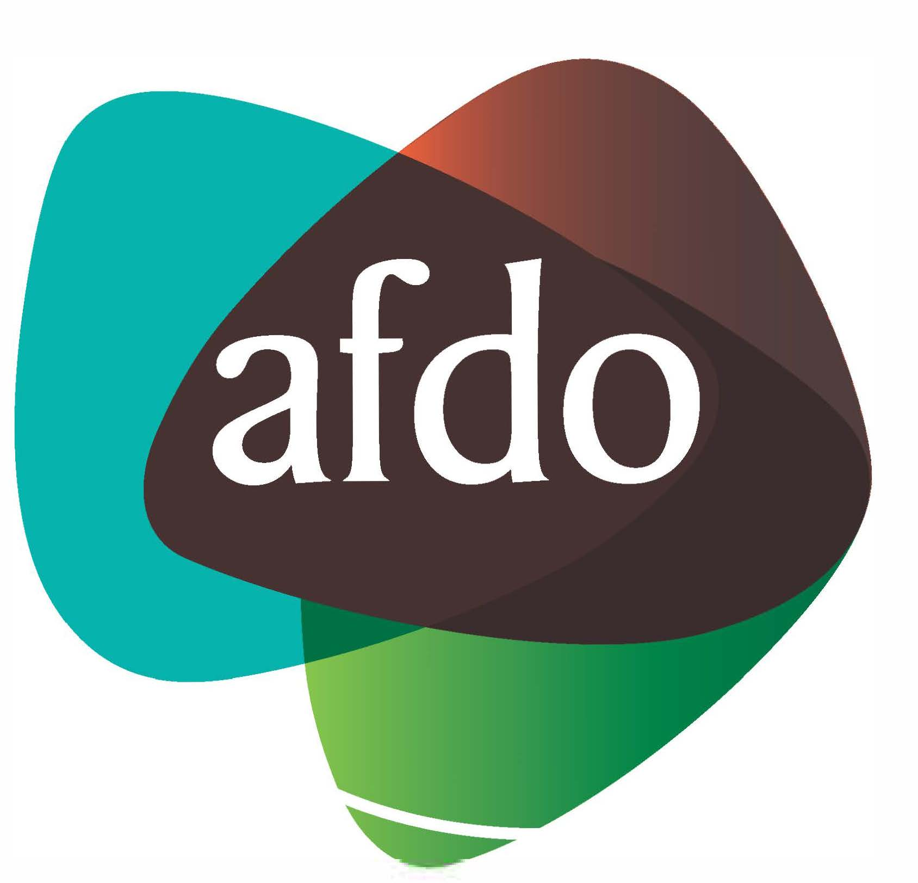

Australian Federation of Disability Organisations

Pre Federal Budget Submission
2020 - 2021

31st January 2020

Table of Contents
Table of Contents 2
About AFDO 3
General principles underpinning submission 4
1. National Disability Strategy and progressive achievement of measurable outcomes at a federal level as well as ensuring this applies to all levels of government. 5
Recommendation & cost 6
2. Continued access to services and relevant supports provided at a Federal and State/Territory level through COAG and other agreements or arrangements for people with disability not participating in the NDIS. 7
Recommendation & cost 8
3. Equitable Funding of National Disability Representative Organisations (Systemic Advocacy) 9
Recommendation and cost 10
4. Funding individual disability advocacy organisations 11
Recommendation and cost 12

About AFDO
Since 2003, the Australian Federation of Disability Organisations (AFDO), a Disabled Peoples Organisation (DPO) and recognised Disability Representative Organisation (DRO), has been the recognised national peak organisation in the disability sector, along with its disability specific members, representing people with disability and their families. AFDO’s mission is to champion the rights of people with disability in Australia and support them to participate fully in Australian life.

As one of the three founding members of the National Disability and Carer Alliance, AFDO played a key role in the campaign for the introduction of the National Disability Insurance Scheme (NDIS) through its “Every Australian Counts” campaign. As the NDIS has moved through the trial phase and begun the transition to full scheme, AFDO and its members have continued to work constructively with the National Disability Insurance Agency (NDIA) as well as Commonwealth, State and Territory governments to provide critical feedback and address implementation issues as they arise.

Our member organisations represent disability specific communities nationally with a total reach of over 2,800,000 Australians.

AFDO continues to provide a strong, trusted, independent voice for the disability sector on national policy, inquiries, submissions, systemic advocacy and advisory on government initiatives with the Federal and State/Territory governments.

AFDO’s members include:

Blind Citizens Australia
Brain Injury Australia
Deaf Australia
Deafblind Australia
Autism Aspergers Advocacy Australia
Down Syndrome Australia
Physical Disability Australia
Disability Advocacy Network Australia
Disability Justice Advocacy
People with Disability WA
Disability Resources Centre
Inclusion Australia (NCID)
People with Disabilities ACT
Women with Disabilities Victoria
Enhanced Lifestyles
Deafness Forum of Australia
Women with Disabilities ACT
National Mental Health Consumer &
Carer Forum (NMHCCF)

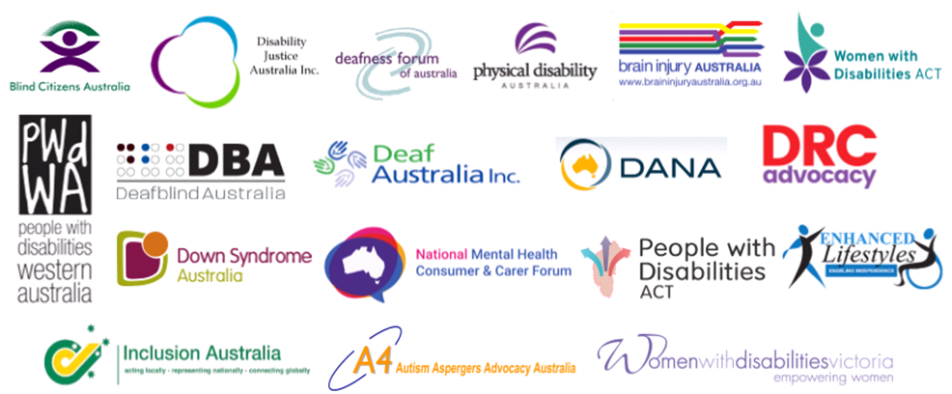

General principles underpinning submission

Government funding should adhere to the principles of the UNCRPD. As such, it should:

- Identify appropriate areas for ‘mainstreaming’ disability issues within broader government programs;

- Where appropriate develop specialized programs for people with disability which focus on increasing community participation and social inclusion (for example, strengthening specialist open employment services for people with disability);

- Work in collaborative partnership with people with disability and their representative organisations

This submission takes it as a given that the government will work to appropriately implement recommendations upheld through disability related inquiries, such as those on hearing health, access to electronic media, migration laws and disability. It is particularly important that the introduction of any recommended programs is undertaken in consultation with people with disability and their representative disabled person’s organisations.

AFDO expects people with disability and their organisations to be consulted during the roll out process of the National Disability Strategy and any reform of the National Disability Agreements, a lack of Key Performance Indicators and a short term implementation plan make budget submission requests difficult.

AFDO and its national members have been funded through the Department of Social Services, to undertake systemic advocacy, information and feedback for the Disability Royal Commission over three years for the period 2019/2020 – 2020/2021 and 2021/2022.

National Disability Strategy and progressive achievement of measurable outcomes at a federal level as well as ensuring this applies to all levels of government.
The National Disability Strategy was agreed to by the federal and state/territory governments in 2008. The Strategy is a well-developed document with key strategies to deliver on Australia’s commitment under the UNCRPD under six main areas;

Inclusive and accessible communities—the physical environment including public transport; parks, buildings and housing; digital information and communications technologies; civic life including social, sporting, recreational and cultural life.

Rights protection, justice and legislation—statutory protections such as anti-discrimination measures, complaints mechanisms, advocacy, the electoral and justice systems.

Economic security—jobs, business opportunities, financial independence, adequate income support for those not able to work, and housing.

Personal and community support—inclusion and participation in the community, person-centred care and support provided by specialist disability services and mainstream services; informal care and support.

Learning and skills—early childhood education and care, schools, further education, vocational education; transitions from education to employment; life-long learning.

Health and wellbeing—health services, health promotion and the interaction between health and disability systems; wellbeing and enjoyment of life.

Whilst, the document’s aims and strategies are supported there has been little financial or relevant other commitment at any level of government and it lacks agreed outcome measures to ensure that the objectives are progressively reached.

The main deliverable under the strategy over recent time has been the implementation and roll out of the NDIS, which is an important achievement, but is only an element or part of one of the six strategic areas.

The United Nations Convention on the Rights of Persons with Disabilities (UNCRPD) of which Australia ratified and is a signatory, as well as a signatory to the Optional Protocol. Once a country ratifies this means that the country is legally bound to implement the core 33 articles and must report on their progress in writing to the United Nations on a periodic basis.

Australia has also ratified and signed to the UN Sustainability Goals. These 17 Goals are intrinsically linked with the UNCRPD and requirements for the rights of people with disability. These two international requirements mean that Australia must deliver measureable outcomes in meeting its obligations under both.

Recommendation & cost

- Funding for Evaluation and Benchmarking of current National Disability Strategy for 2020 – 2030

- Funding for the development of appropriate targets, outcomes and measurement tools for the National Disability Strategy

- Funding for appropriate consultation and co-design as part of any development of the National Disability Strategy.

Year | Activity | Amount
2020 – 2021 | Evaluation and Benchmarking - NDS  $430,000 | $430,000
2020 – 2022 | 6 Projects proposed on each of the Strategic Goals, Targets, Outcomes and Measurements established  @ $450,000 per project  Focus of each on multi jurisdictions being Federal/State/Territory & Local Governments and how they are aligning reporting with goals, targets, etc. | $2.70 million
 | Total over 2 financial years | $3.13 million

Continued access to services and relevant supports provided at a Federal and State/Territory level through COAG and other agreements or arrangements for people with disability not participating in the NDIS.

One in five Australians are people with a disability, that’s over 5 Million of our current population. You are also more likely to acquire a disability as you age, we are living longer, and the projected age of Australians as a proportion of the population is rapidly rising with this to significantly increase over the next five to ten years.

The NDIS is welcomed and fully supported by AFDO however, the scheme will only cover 460,000 Australians with disability at full roll-out. That leaves over four and half million Australians living with disability who are not part of the scheme.

AFDO is concerned that some levels of government are failing in their obligations and duty to these Australians by reducing or removing services and supports that were previously in place, or that may be required following the implementation of the NDIS.

Mainstream service systems such as hospitals, the courts, the child protection system and schools also have agreed responsibility to meet the needs of people with disability using those services. People with disability are being caught between the reduction or removal of some services and the limited availability of disability support from mainstream services.

The Disability Support Pension is another example of where there is concern that Government is failing in its obligations; in this case to social protection and economic participation. The Australian Federation of Disability Organisations (AFDO) is concerned that changes to the Disability Support Pension and wider social security system in recent decades have led to the exclusion of many persons with disabilities from access to essential social security.

Another key concern is for those people with disability who are not part of the NDIS and are over sixty five years of age and in the aged care system.

These Australians also require a commitment to continued access to services and supports to ensure they remain well and in their homes for as long as possible or that aged care providers are required to meet these requirements.

The Federal Government and all levels of government have a responsibility to ensure that those Australians who are not part of the NDIS as outlined above, continue to have access to essential services and relevant supports.

AFDO calls for this commitment from the federal level and this is also a key component outlined in COAG or any other agreements or arrangements with other levels of government.

Recommendation & cost
- Federal Government to negotiate for people with disability who are not part of the NDIS of all ages including those within the aged care system for continued access to services and relevant supports provided at a Federal and State/Territory level through COAG and other agreements or arrangements.

Year | Activity | Amount
2020 – 2021 | Negotiation at Federal level and included in agreement(s) with all States/Territories to ensure services and supports outside of those for NDIS participants are continued to be provided to PwD as per any other Australian | $750,000
2022 – onwards | Ongoing service and supports for PwD outside of NDIS participants provided by all States/Territories as per any Australian | Federal cost not known  State/Territory Costs subject to negotiation

Equitable Funding of National Disability Representative Organisations (Systemic Advocacy)

We require a commitment to increased, ongoing, adequate and equitable funding to Disability Representative Organisations (DROs) that undertake systemic advocacy, including specialist people with disability organisations that know and are experts of their communities

Disability is diverse, meaning that there is a significant difference between the needs of people and that organisations that connect to their own communities and provide information and peer support are essential as we move to full roll-out of the NDIS, the priority of a renewed National Disability Strategy 2020 – 2030, and build the capacity of communities to become more welcoming and accessible.

Funding of DRO’s has been reduced and in the case of the AFDO led Consortium (11 national members) bid resulted in a totally inadequate funding amount being awarded by the Department of Social Services of just over $27K per annum for each organisation to undertake this work per annum! The Deapartment could have awarded a Consortium $1.5 million in its own right? Other DRO’s receive $300K each per annum in their own right? This is totally inequitable and unacceptable.

We require equitable funding to be provided to all DRO’s as we all have exactly the same Funding Agreement, contract and conditions, no difference in requirements should mean no difference in $ funded.

We were informed, by the Minister for Families & Social Services, in late Decemebr 2019, that the current DRO funding Agreement will be extended for a further year at the same rates, whilst the Department of Social Services undertakes a review of the program. This will be the second review within the last four years!

We outlined that this is not acceptable to AFDO and our 10 natioanl member organisations and we will be commencing a national funding equity campaign involving our reach with over 2.8 million Australians including peoepl with disability if our budget request is not adopted.

AFDO has 10 national members funded as recognised DRO’s as evidenced on the DSS website, one of these is Disability Advocacy Network Australia (DANA) which is taken out of this funding stream, as it is more appropriate to fund DANA from the National Disability Advocacy Program (NDAP), than through the DRO funding. DANA is included under the recommendation for individual advocacy funding organisations.

Recommendation and cost

  - Fund AFDO as a Disability Representative Organisation (DRO) from $27K+ per annum (current AFDO Consortium split), to $300,000 per annum in its own right, in line with the current funding to other funded DRO’s, representing no additional budget cost. Current funding of DRO’s including AFDO totals $2.1million per annum, there would be no change to the current budget amount.

  - Provide new funding to the AFDO National member organisations (x9) that are all currently recognised as DRO’s by the Federal Government (but only receive $27K each per annum, from AFDO led Consortium), increased to $220,000 per organisation per annum = $1.98 million per annum additional funding required.

  - Revise the amount of funds and the term of the current Disability Representative Organisation’s Funding Agreement to make this for a further 4 year term.

  - Allow for an indexation review and adjustment on funded amounts every two years to ensure funding reflects increases in CPI or other costs to maintain organisations sustainability.

Year | Activity | Amount
2020 – 2021 | DRO Additional Funding  (9 DRO recognised AFDO National Organisations) | $1.98 million
2021 – 2024 | DRO Additional Funding over 3 years | $5.94 million
2022 – 2023 | Indexation review and adjustment on total DRO funding $4.08 million  projection of 3% | $144K
 | Total additional DRO Funding  over 4 financial years | $8.064 million

Funding individual disability advocacy organisations

As with previously mentioned, systemic advocacy organisations (DRO’s), individual disability sdvocacy organisations are equally as vital to protecting and advancing the rights and interests of Australians with disabilities and contributing to the ongoing quality assurance and improvement of service systems.

The Productivity Commission recognised the critical role of independent advocacy to the NDIS. Advocates will play a crucial role in not only protecting the rights of individuals but in contributing to systemic improvement of the NDIS.

In addition, independent advocacy remains instrumental in addressing the inequities and injustices experienced by people with disabilities in other service systems and domains, for instance education, health, justice and housing, and thereby optimising the intended ripple effects of the NDIS in the lives of people with disabilities.

Disability Advocacy Network Australia (DANA) is a national peak body, a key AFDO member and represents the voice of individual advocacy agencies operated through the National Disability Advocacy Program (NDAP) across Australia.

DANA strongly argues that advocacy should be funded proportionally to disability service delivery expenditure and through a model that values independence and accessibility. To reap the benefits of a strong and healthy advocacy sector, the sector should be represented, supported and strengthened nationally.

The Commonwealth’s contribution to disability advocacy via the NDAP is falling in percentage terms relative to its contribution to service delivery, and in recent years also in real terms due to indexation failing to even meet the costs of maintaining operations at existing levels.

The Productivity Commission has identified that funding for advocacy, information and print disability organisations has previously represented roughly 1.3% of direct service delivery costs across all Commonwealth and State disability services (Productivity Commission (2009) Report on Government Services 2009 Canberra, Table 14A.5 and 14A.6. During the period examined by the Productivity Commission, the percentage accounted for by advocacy, information and print disability ranged from 1.26% through to 1.35%). As a minimum benchmark, funding must be returned to this level. Beyond that a methodical review of actual need and demand should be undertaken to establish the basis for a new funding model for disability advocacy across the Commonwealth, States and Territories.

The independence of advocacy from service provision is crucial to avoid conflicts of interest. Only truly independent advocates can safeguard and promote the rights and interests of vulnerable people and adequate funding for independent advocacy organisations, such as provided through NDAP and state and territory advocacy programs, is essential to ensuring independent advocacy is accessible for the most vulnerable people with disability.

Coordinating the focus across the disability advocacy sector is the work of the sector’s national peak body, Disability Advocacy Network Australia (DANA). Largely unfunded DANA has been supported since 2014 via AFDO and its membership. As the national advocacy peak DANA should be appropriately funded via NDAP along with all of its advocacy members. AFDO strongly supports this funding necessity and approach.

DANA undertakes; facilitating sector collaboration, coordinating information collection, providing systemic issues and policy advice on a national basis based with member input and reporting as well as implementing a comprehensive sector development program.

Recommendation and cost
- Increase NDAP funding to cater for the support of the national advocacy peak DANA

- Increase funding for disability advocacy to 1.3% of service delivery expenditure

- Undertake a review of need and demand for disability advocacy and establish a new funding model for advocacy

- Retain independence in advocacy funding

Year | Activity | Amount
2020 - 2021 | Additional funding of NDAP for DANA operation | $300,000 pa
2020 - 2021 | Adjust funding for disability advocacy, NDAP,  match 1.3% of the service delivery expenditure  (SDE) | NDAP funding adjust to 1.3% of service delivery expenditure
2021 - 2024 | NDAP additional funding for DANA national peak over 3 financial years  NDAP funding adjustment; min 1.3% of the service delivery expenditure | DANA = $900,000  NDAP funding = 1.3% of SDE
 | Total additional Funding  over 4 financial years | $1.2 million DANA  1.3% of SDE

