Financial Sector Reform (Hayne Royal Commission Response—Stronger Regulators (2020 Measures)) Bill 2020: FSRC rec 7.2 (ASIC Directions)

EXPOSURE DRAFT EXPLANATORY MATERIALS

Table of contents

Glossary 1

Chapter 1 ASIC Directions 3

Glossary
The following abbreviations and acronyms are used throughout this explanatory memorandum.
Abbreviation | Definition
Financial Services Royal Commission | Royal Commission into Misconduct in the Banking, Superannuation and Financial Services Industry
ASIC | Australian Securities and Investments Commission
APRA | Australian Prudential Regulation Authority
APRA Act | Australian Prudential Regulation Authority Act 1998
ASIC Act | Australian Securities and Investments Commission Act 2001
Credit Act | National Consumer Credit Protection Act 2009
Corporations Act | Corporations Act 2001
Bill | Financial Sector Reform (Hayne Royal Commission Response—Stronger Regulators (2020 Measures)) Bill 2020: FSRC rec 7.2 (ASIC directions)
AFS licence | Australian financial services licence
Credit licence | Australian credit licence
The Taskforce | The ASIC Enforcement Review Taskforce

- ASIC Directions

Outline of chapter
  - Schedule 1 to the Bill implements part of the Government’s response to recommendation 7.2 of the Financial Services Royal Commission, by providing ASIC with powers to give directions to AFS licensees and credit licensees in order to prevent or address suspected breaches of financial services law or credit legislation.

Context of amendments

Government’s response to the Financial Services Royal Commission recommendations
  - On 4 February 2019, the Government released its response to the Financial Services Royal Commission – Restoring trust in Australia’s financial system.
  - Schedule 1 to the Bill gives effect to the Government’s commitment to implement the recommendations from Chapter 8 of the Taskforce review, made in response to recommendation 7.2 of the Financial Services Royal Commission.

ASIC Enforcement Review Taskforce Report
  - The ASIC Enforcement Review Taskforce was established in response to a recommendation of the Financial System Inquiry.
  - The Taskforce reviewed the enforcement regime of ASIC to assess the suitability of the existing regulatory tools available to it in order to perform its functions adequately. A final report was delivered in December 2017 and made 50 recommendations.
  - Chapter 8 of the final report made five recommendations, concluding that the Government should provide ASIC with a power to direct AFSL and Credit licensees in order to address or prevent risks to consumers.

Summary of new law
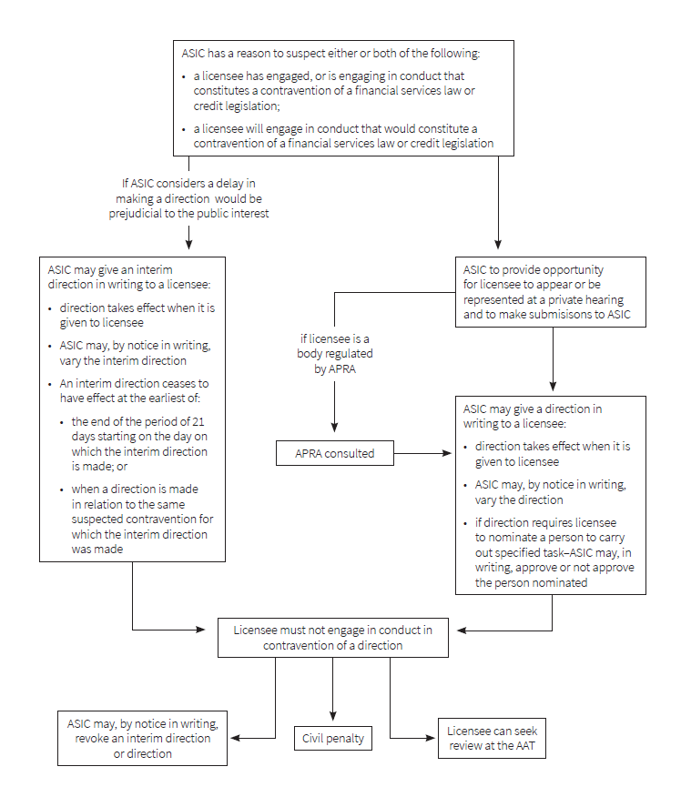
    - Summary of ASIC directions procedure

Detailed explanation of new law

When can ASIC give a direction
  - ASIC can give a direction to an AFS licensees if ASIC has a reason to suspect that a licensee has, is or will engage in conduct that contravenes the financial services law. [Schedule 1, item 1, subsection 918(1) of the Corporations Act]
  - The term ‘financial services law’ is defined in section 761A of the Corporations Act.
  - ASIC can give a direction to credit licensees if ASIC has a reason to suspect that a licensee has, is or will engage in conduct that contravenes the credit legislation. [Schedule 1, item 2, subsection 78B(1) of the Credit Act]
  - The term ‘credit legislation’ is defined in section 5 of the Credit Act.
  - The directions are designed to be quick and efficient responses to the conduct of AFS licensees and credit licensees, aimed at early regulatory intervention in order to better protect consumers.
  - For this reason, the threshold for triggering a direction is that ASIC must have a ‘reason to suspect’ that a licensee has, is or will engage in contravening conduct. [Schedule 1, items 1 and 2, subsection 918(1) of the Corporations Act and subsection 78B(1) of the Credit Act]
  - The requirement for a regulator to have a ‘reason to suspect’ is a lower threshold than a ‘reason to believe’. This is an objective test based on the facts and circumstances of each case.
  - The Bill allows a direction to be given in relation to one or more suspected contraventions. However, if a single entity is suspected of contravening both the financial services law and the credit legislation in a single course of conduct, a direction will need to be made under both the Corporations Act and the Credit Act. [Schedule 1, items 1 and 2, subsection 918(2) of the Corporations Act and subsection 78B(2) of the Credit Act]

ASIC may give interim directions
  - ASIC may give an interim direction to a licensee if ASIC considers that a delay in giving a direction would be prejudicial to the public interest. [Schedule 1, items 1 and 2, section 918F of the Corporations Act and section 78H of the Credit Act]
  - As there is a public interest in ASIC issuing a direction without delay, the procedural requirements for an interim direction are less rigorous than for a direction otherwise (see paragraphs 1.31 to 1.40). Because of this, an interim direction will expire at the end of a 21 day period from the day on which it is given, or if a direction in relation to the same suspected contravention is given to the licensee. [Schedule 1, items 1 and 2, section 918H of the Corporations Act and section 78K of the Credit Act]
  - If a licensee contravenes an interim direction before it ceases to have effect, that licensee’s liability to a civil penalty is not discharged solely because the interim direction is no longer in force.

What directions can ASIC give
  - The Bill provides a non-exhaustive list of directions that ASIC may give to AFS licensees or credit licensees. As the list of directions is non-exhaustive, ASIC are not limited by the list as to the substance of the directions they give. The list is however indicative of the kinds of directions that could be used by ASIC under the new law. [Schedule 1, items 1 and 2, subsection 918(5) of the Corporations Act and subsection 78B(5) of the Credit Act]
  - The Bill provides that the list of directions can be extended by regulations. Any types or kinds of directions that are being regularly made by ASIC, but that are not listed in the Bill, are expected to be prescribed in the regulations to provide transparency to licensees. Any regulations made are subject to disallowance and parliamentary scrutiny. [Schedule 1, items 1 and 2, paragraph 918(5)(h) of the Corporations Act and paragraph 78B(5)(h) of the Credit Act]
  - A direction must be given to a licensee in writing, and must be directed toward either addressing or preventing the suspected contravention that triggered the direction or preventing a similar or related contravention. [Schedule 1, items 1 and 2, subsection 918(3) of the Corporations Act and subsection 78B(3) of the Credit Act]

TY Pty. Ltd. Licensee identifies that a particular authorised representative has provided advice to clients that it is not in their best interest. This comes to ASIC’s attention as a result of TY Pty. Ltd. Licensee lodging a breach report about the conduct. As a result of the information in the breach report, ASIC has reason to suspect that TY Pty. Ltd. Licensee has breached the financial services law. In response to this, ASIC could direct TY Pty. Ltd. Licensee to:
- undertake a review of the records of that particular authorised representative to determine the extent of the misconduct;
- report to ASIC on the outcomes of the review; and
- not accept any new clients from that particular authorised representative until it has reported back to ASIC on the outcomes of the review.
  - In this example, a direction to not accept new clients is aimed at preventing contraventions occurring, whilst a review of advice given by the authorised representative is aimed at addressing a suspected contravention.
  - ASIC can direct a licensee to address a suspected contravention by way of implementing a scheme to compensate persons who have suffered loss or damage due to that suspected contravention. Compensation may involve both financial and non-financial redress. [Schedule 1, items 1 and 2, subsections 918(5) and (6) of the Corporations Act and subsections 78B(5) and (6) of the Credit Act]
  - The Bill sets out a number of matters which ASIC has discretion to include in a direction about a compensation scheme. A direction about a compensation scheme may be at any level of specificity. ASIC may specify all elements of the scheme in detail if necessary, or alternatively specify only some elements of the scheme, with the licensee to implement the remaining parts as they see fit. [Schedule 1, items 1 and 2, subsection 918(6) of the Corporations Act and subsection 78B(6) of the Credit Act]
  - The directions power allows ASIC to direct a licensee to set up a compensation program, but it does not allow ASIC to direct a licensee to compensate a client or class/group of clients – only a court would be able to order that payment(s) be made and the amount of any such payment. The directions power enables ASIC to ensure that any remediation program established by a licensee provides a suitable process for addressing the impact of a breach on clients including, for example notifying clients about the program, identifying potential claimants, processes for assessing claims and rights to appeal decisions made where appropriate.
  - ASIC can also give directions that are ancillary steps required to address or prevent a suspected contravention. For example, ASIC may direct a licensee to conduct a review of its records or systems prior to putting a compliance process in place. [Schedule 1, items 1 and 2, paragraph 918(5)(g) of the Corporations Act and paragraph 78B(5)(g) of the Credit Act]
  - ASIC may also give a direction to a licensee which requires that licensee to nominate a person who will carry out a task that has been specified in the same direction. ASIC is empowered to approve or not approve the person who the licensee nominates. [Schedule 1, items 1 and 2, section 918E of the Corporations Act and section 78H of the Credit Act]
  - ASIC may limit a direction so that an AFS licensee or credit licensee need only in engage in certain conduct during a period of time specified in the direction or until a specified time. A direction may alternatively specify a time by which compliance with a direction must be completed. [Schedule 1, items 1 and 2, subsection 918(4) of the Corporations Act and subsection 78B(4) of the Credit Act]
  - Where a time is specified in a direction, a licensee must comply with a direction within that time limitation, however described.
  - A direction does not need to have a time limit or time period specified. ASIC may instead direct that the obligation to engage in specified conduct remain in place until a condition specified in the direction is met. For example, ASIC may direct that a licensee must not accept new clients until such time as it has engaged suitably qualified accounting staff. [Schedule 1, items 1 and 2, paragraph 918(4)(c) of the Corporations Act and paragraph 78B(4)(c) of the Credit Act]
  - ASIC may also include a matter, detail or instruction contained in any instrument (legislative or not) or other writing, by referring to or identifying this in a direction. [Schedule 1, items 1 and 2, subsection 918(7) of the Corporations Act and subsection 78B(7) of the Credit Act]
  - The Bill clarifies that a written direction given by ASIC is not a legislative instrument. This clarification is merely declaratory of the law as such a direction would not be legislative instrument within the meaning of section 8 of the Legislation Act 2003. [Schedule 1, items 1 and 2, subsections 918(8) and 918F(7) of the Corporations Act and subsections 78H(8) and 78H(7) of the Credit Act]

Procedure when giving a direction
  - Before giving a direction, other than an interim direction, ASIC must give the licensee an opportunity to appear, or be represented, at a hearing. ASIC must also give the licensee an opportunity to make submissions to ASIC in relation to the matter to which the direction relates. The submissions need not be made at a hearing. [Schedule 1, items 1 and 2, subsection 918C(1) of the Corporations Act and subsection 78E(1) of the Credit Act]
  - If ASIC gives a licensee a reasonable opportunity to appear or be represented at a hearing, but the licensee does not to take up that opportunity, ASIC does not need to hold a hearing.
  - If ASIC intends to make a direction to a licensee who is a body that is regulated by APRA, ASIC must consult APRA before that direction is given to a licensee. However, a failure to consult with APRA will not invalidate any direction given. [Schedule 1, items 1 and 2, subsections 918C(2) to (3) of the Corporations Act and subsections 78E(2) to (3) of the Credit Act]
  - After giving a direction to a licensee, ASIC must publish a copy of that direction on their website as soon as practicable. ASIC does not need to publish a copy of an interim direction on their website. [Schedule 1, items 1 and 2, section 918A of the Corporations Act and section 78C of the Credit Act]
  - A direction and an interim direction to a licensee takes effect when it is given to the licensee, and compliance is required from that time. The timing of the publication of a copy of the direction on the ASIC website does not affect the timing of the requirement to comply with a direction. [Schedule 1, items 1 and 2, sections 918B and 918G of the Corporations Act and sections 78D and 78J of the Credit Act]

ASIC may vary or revoke a direction
  - ASIC can vary a direction or an interim direction that it has given to an AFS licensee or credit licensee if ASIC considers that this is necessary and appropriate. However, before doing so, ASIC must give the licensee an opportunity to appear or be represented at a hearing. ASIC must also give the licensee an opportunity to make submissions to ASIC in relation to the matter to which the variation relates. ASIC does not need to give a licensee these opportunities if they are varying an interim direction. [Schedule 1, items 1 and 2, subsections 918D(1) to (2) and section 918J of the Corporations Act and subsections 78F(1) to (2) and section 78L of the Credit Act]
  - If ASIC gives a licensee a reasonable opportunity to appear or be represented at a hearing, but the licensee does not to take up that opportunity, ASIC does not need to hold a hearing.
  - ASIC can repeal a direction that it has given to an AFS licensee or credit licensee if ASIC considers that the direction is no longer necessary or appropriate. [Schedule 1, items 1 and 2, subsection 918D(3) and section 918J of the Corporations Act and subsection 78F(3) and section 78L of the Credit Act]
  - A variation or revocation of a direction must be given to a licensee in writing. The variation or revocation of the direction takes effect when it is given to the licensee. [Schedule 1, items 1 and 2, subsections 918D(1), (3) and (5) and section 918J of the Corporations Act and subsections 78F(1), (3) and (5) and section 78L of the Credit Act]
  - After varying or revoking a direction, ASIC must publish a copy of that variation or revocation on their website as soon as practicable. ASIC does not need to publish a copy of a variation or revocation of an interim direction on their website. [Schedule 1, items 1 and 2, subsection 918D(4) of the Corporations Act and subsection 78F(4) of the Credit Act]

ASIC may delegate the power to give directions
  - ASIC can delegate, in writing, a power to give directions in accordance with section 102 of the ASIC Act. The delegation provisions allow ASIC to delegate the directions power to members and staff members of ASIC (amongst other people).

A decision by ASIC can be reviewed
  - A decision by ASIC or a delegate to give a direction, interim direction or an approval of a person nominated by a licensee to do a specified task, is subject to the usual safeguards. This includes administrative review (see Part 9.4A of the Corporations Act and sections 327 and 328 of the Credit Act), judicial review and consideration in appropriate circumstances by the Commonwealth Ombudsman.

Compliance with a direction
  - An AFS licensee or credit licensee must comply with a direction given by ASIC. Failure to comply with a direction is a contravention of the legislation and is a civil penalty. [Schedule 1, items 1 and 2, section 918K of the Corporations Act and section 78M of the Credit Act]
  - Section 1317QA of the Corporations Act and section 175A of the Credit Act deal generally with civil penalty contraventions that continue beyond the time that compliance is required.
  - It is a general obligation of AFS licensees to comply with financial services laws. Failure to do so can result in suspension or cancelation of an AFS licence.
  - Failure to comply with a direction may also result in liability to a banning order or court order (including injunctions) and trigger obligations to report breaches under the Corporations Act.
  - It is a general conduct obligation of credit licensees to comply with the credit legislation. Failure to do so can result in suspension or cancelation of a credit licence. Failure to comply with a direction may also give rise to liability to a banning order under the Credit Act.
  - Paragraph 912A(1)(b) of the Corporations Act requires an AFS licence to comply with the conditions on their licence. However, a licensee will not fail to comply with the conditions of their licence if the licensee has engaged in conduct that was necessary to comply with a direction given by ASIC. [Schedule 1, items 1 and 2, section 918L of the Corporations Act]
  - Paragraph 47(1)(c) of the Credit Act requires a credit licensee to comply with the conditions on their licence. However, a licensee will not fail to comply with the conditions of their licence if the licensee has engaged in conduct that was necessary to comply with a direction given by ASIC. [Schedule 1, items 1 and 2, section 78N of the Credit Act]

Other matters
  - A guide to the new law has been provided in the amendments to the Credit Act. The guide is included to assist readers understand the substantive provisions of the new law. This guide is not intended to be comprehensive and readers should rely on the substantive provisions of the Bill. [Schedule 1, item 2, section 78A of the Credit Act]

Consequential amendments
  - The Bill makes consequential amendments to the Corporations Act in order to specify that a contravention of a direction or interim direction is a civil penalty provision. [Schedule 1, item 3]

Application and transitional provisions
  - The Bill contains a number of transitional and application provisions which amend the Corporations Act and the National Consumer Credit Protection (Transitional and Consequential Provisions) Act 2009. The transitional and application provisions ensure that directions and interim directions can be given to licensees in circumstances where the relevant conditions for making a direction or interim direction were met before, on or after the commencement day. [Schedule 1, items 4 and 5]

