Job-to-job transitions and the wages of Australian workers

Nathan Deutscher[[1]](#footnote-2)

Treasury Working Paper[[2]](#footnote-3)

2019‑07

Date created: November 2019

© Commonwealth of Australia 2019

This publication is available for your use under a [Creative Commons BY Attribution 3.0 Australia](http://creativecommons.org/licenses/by/3.0/au/deed.en) licence, with the exception of the Commonwealth Coat of Arms, the Treasury logo, photographs, images, signatures and where otherwise stated. The full licence terms are available from <http://creativecommons.org/licenses/by/3.0/au/legalcode>.

CC by_grey

Use of Treasury material under a [Creative Commons BY Attribution 3.0 Australia](http://creativecommons.org/licenses/by/3.0/au/deed.en) licence requires you to attribute the work (but not in any way that suggests that the Treasury endorses you or your use of the work).

*Treasury material used 'as supplied'*

Provided you have not modified or transformed Treasury material in any way including, for example, by changing the Treasury text; calculating percentage changes; graphing or charting data; or deriving new statistics from published Treasury statistics — then Treasury prefers the following attribution:

*Source: The Australian Government the Treasury*

Derivative material

If you have modified or transformed Treasury material, or derived new material from those of the Treasury in any way, then Treasury prefers the following attribution:

*Based on The Australian Government the Treasury data*

**Use of the Coat of Arms**

The terms under which the Coat of Arms can be used are set out on the Department of the Prime Minister and Cabinet website (see [www.pmc.gov.au/government/commonwealth-coat-arms](http://www.pmc.gov.au/government/commonwealth-coat-arms)).

**Other uses**

Enquiries regarding this licence and any other use of this document are welcome at:

Manager

Media Unit

The Treasury

Langton Crescent   
Parkes ACT 2600

Email: [medialiaison@treasury.gov.au](mailto:medialiaison@treasury.gov.au)

Job-to-job transitions and the wages of Australian workers

Nathan Deutscher

2019-07

November 2019

# Abstract

Leading models of on-the-job search suggest that competition among firms for employed workers – reflected in higher job-to-job transition rates – is an important driver of real wages. Intuitively, workers are better placed to move or bargain for increases in wages, hours or promotions when they have more outside options, namely other employers who want to hire them. I test the predictions from this model in the Australian data. Higher job-to-job transition rates in Australian local labour markets are associated with higher wages growth, including for those who stay in their jobs. A 1 percentage point increase in the rate at which workers switch jobs is associated with a ½ percentage point increase in growth in average wages. This association holds after controlling for a range of cyclical influences, including the rate at which the unemployed find work, suggesting the relationship between job-to-job transition rates and wages growth runs deeper than both simply being higher in cyclically stronger labour markets. Further work on what drives variation in job-to-job transitions rates could help in better understanding the underlying drivers of this relationship.

JEL Classification Numbers: E24, J62, J64

Keywords: Wages, job mobility, job search

Nathan Deutscher

Macroeconomic Modelling and Policy Division

Macroeconomic Group

The Treasury

Langton Crescent

Parkes ACT 2600

## Introduction

Past Australian research suggests that, outside downturns in the labour market, those switching jobs typically experience higher wages growth (Treasury 2017) – but can a more fluid labour market benefit wages in aggregate and for those who stay in their jobs? I present suggestive evidence that it can. Higher job‑to‑job transition rates in Australian local labour markets are associated with higher wages growth, including for those who stay in their jobs. This finding is consistent with models of job search which predict higher wages growth when workers have more outside options.

The role of labour market fluidity in wages growth has generated substantial interest from leading policy institutions in many advanced economies.[[3]](#footnote-4) This reflects both sluggish nominal wage growth in the face of relatively tight labour markets, and longer-run evidence of declines in market dynamism. While standard macroeconomic factors can nonetheless explain much of the weakness in wages growth across advanced economies (Arsov and Evans 2018), there is potential for changes in the job ladder – including relatively low rates of job switching – to weigh on wages (Haldane 2019).

Job switching is one means (though not the only) by which workers find a job that better suits their skills and preferences. Individuals may switch jobs for many reasons – for example, they may seek more satisfying or secure employment, better pay and conditions, or different hours.[[4]](#footnote-5) These transitions may reflect both the ‘pull’ of a new job and a ‘push’ away from an individual’s current job and are an important feature of labour market flows more generally, including transitions involving spells in unemployment and out of the labour force. In this paper I focus on job switching that simply involves a change in employer, without delving into whether this involves a change in role or location.

In the academic literature, it has long been noted that job switching can play an important role in *individual* wages growth. In an early contribution to the literature, Topel and Ward (1992) found job‑to‑job transitions accounted for a third of the wages growth experienced in the first decade of the careers of young men in the United States. In Australia, job switching also appears to be an important source of wage growth for some individuals: as noted earlier, those who switch jobs in a given year typically experience higher wage growth than those who stay (Treasury 2017; Ellis 2019).

Attention has recently turned to how job switching is associated with *aggregate* outcomes, looking beyond the individuals who switch. In models of on-the-job search, there is a strong connection between the rate at which employed workers receive outside offers – reflected in the pace of job switching – and average real wage growth (Burdett and Mortensen 1998; Moscarini and Postel-Vinay 2016a,b). Part of this is a simple composition effect – more job switching means more job switchers, who typically move for higher wages. But part of this is also a strategic response by employers – when workers have more outside options, employers will need to issue more attractive offers to retain them.

The theoretical prediction of a close connection between job-to-job transition rates and real wages growth is born out in the empirical literature to date, which has primarily focused on the United States. Faberman and Justiniano (2015) show a strong relationship between job switching rates and nominal wage growth, at the national level and over the business cycle. A number of other studies have exploited more finely‑grained variation. For example, Karahan et al (2017) show a strong relationship between job switching rates and wages within states, while the same relationship is evident within labour markets defined by age, gender, race and education (Moscarini and Postel-Vinay 2017). In the New Zealand setting, Ball et al 2019 similarly find a strong relationship between regional job switching rates and wages (though not for those staying in their jobs).

This paper contributes to the literature by showing a strong association between job-to-job transition rates and real wages growth in the Australian setting. A 1 percentage point increase in the rate at which workers switch jobs is associated with a ½ percentage point increase in growth in average wages. These associations persist after accounting for national- and state-level business cycles, suggesting the relationship between job-to-job transition rates and wages growth runs deeper than both simply being higher in stronger labour markets. Rather, it is consistent with the presence of more outside options facilitating wages growth through an increase in opportunities for those who move and the bargaining power of those who stay. What drives variation in job-to-job transitions and outside options remains an open question – for example, changing patterns of competition for labour among incumbent firms and firm entry could both play a role.

A structural association between job switching and wages is consistent with an emerging literature relating economic dynamism to aggregate outcomes more broadly. Davis and Haltiwanger (2014) document substantial declines in labour market fluidity in the United States, with large falls in job and worker reallocation rates across states, industries and demographic groups. The authors point to a body of evidence that less fluid markets lead to lower productivity, real wages and employment. Declines in job switching have also been noted in Australia (Lowe 2017), while there is also evidence of a decline in the rate at which labour is reallocated from less to more productive firms (Andrews and Hansell 2019).

Finally, these findings are relevant given the low wage growth observed in Australia in recent years (Treasury 2017; Lowe 2018). The outlook for wages is of central importance to the living standards of Australian workers, macroeconomic policy and to Australia’s fiscal standing (taxes on personal income, predominantly wages, account for around half Australian Government tax revenue).

As emphasised in Quinn (2019), much of the weakness in nominal wage growth reflects standard macroeconomic factors – lower inflation and inflation expectations, slower productivity growth, high rates of participation and spare capacity in the labour market, and the unwinding of the commodity price boom. Even so, wage growth in Australia (and other advanced economies) has been somewhat lower than would have been predicted based on past relationships with these key determinants (Treasury 2017; Bishop and Cassidy 2017; Arsov and Evans 2018). This has led traditional Phillips curve models to overestimate annual wage growth by on average ½ of a percentage point in recent years (Cassidy 2019; Quinn 2019).

A range of explanations have been put forward for the modest, yet meaningful, unexplained weakness in wages growth. One possibility is a modest and potentially transitory decline in the pass through from productivity to wages (Andrews et al 2019). A complementary or alternate explanation is that a less fluid labour market, which has been reflected in a decline in job switching rates, has reduced upward pressure on wages (Lowe 2017). Despite interest in this potential channel, the association between job switching and aggregate wage growth has been impossible to assess in earlier Australian work – this paper fills that gap. The strong association between job-to-job transitions and the earnings of Australian workers is consistent with a less fluid labour market weighing on wages growth in recent years.

In the following section I briefly discuss models of job search and their implications for wages, before moving on to describe the data (Section 3) and empirical framework (Section 4). In Section 5 I present the results exploring the association between job-to-job transitions and wages growth for a variety of model specifications and subpopulations. In Section 6 I conclude by discussing the implications of the findings and avenues for future research.

## Models of job search and wages

The market for jobs is not like the market for simple commodities, where identical goods are traded at a single unit price. Instead, jobs differ substantially in the bundles of skills they require and benefits they confer. Economic theory has developed a wide variety of models in which individuals and firms search for a good `match’ before employment begins.[[5]](#footnote-6) These search models provide a number of predictions about the drivers of real wage growth that can be tested against the data.

In early models of job search, only the unemployed searched for jobs. Once employed, workers stayed in their jobs, unless those jobs were destroyed. In some models workers could voluntarily leave a job, but they would have to enter unemployment before they could begin searching for a new one (Mortensen and Pissarides 1994). These models successfully replicated many real world features of the economy. Yet for some purposes it is necessary to recognise the importance of on-the-job search – it is not only the unemployed who search for new job opportunities. Indeed, in recent years, job-to-job transitions have accounted for around 40 per cent of new hires.[[6]](#footnote-7)

Burdett and Mortensen (1998) introduced a model of the labour market that allows for on-the-job search. Moscarini and Postel-Vinay (2016a,b) explore this model further, showing it leads to differing predictions about the drivers of real wage growth. In earlier models it is the rate of transitions from unemployment to employment that drives real wages growth; with on-the-job search it is the rate of transitions from one job to the next that should dominate. Intuitively, an individual’s wage in a job is a function of both their productivity in that job, and their outside options – either their ability to leave for unemployment and then find a better job from there, or their ability to find it directly. This paper largely follows Karahan et al (2017) in testing the relative predictive power of proxies for these two transition rates for real wages.[[7]](#footnote-8)

## Data

I use a longitudinal matched employer-employee dataset constructed from the universe of employer payment summaries from 2004-05 to 2015-16 (for corporate entities).[[8]](#footnote-9) The employer payment summaries include identifiers for the employee, employer and the amounts paid over the financial year. A distinct employer-employee relationship consists of at least one payment summary with nonzero payments linking an employer to a given individual. Employers that have different identifiers but sit under the same head company in 2018 are considered the same employer. This avoids classifying an individual as having multiple jobs when they are paid by multiple entities in the same consolidated group.

Individual locations are based on the employee residential postcode provided on the payment summaries.[[9]](#footnote-10) These postcodes are then mapped up to Statistical Area 4 – the largest regions below state level in the Australian Statistical Geography Standard (Australian Bureau of Statistics 2016). These regions have populations of between 100,000 to 500,000 people and are intended to reflect local labour markets.[[10]](#footnote-11)

Finally, individual wages are taken as the sum of gross payments across all jobs. This includes all salary, wages, bonuses and commissions paid to the individual by the employer, regardless of whether or not they file a tax return. Wages are in nominal terms, and will capture not just hourly wage rates but also hours worked. Individual gender and year of birth is taken from the Australian Taxation Office Longitudinal Information Files; this draws on client records and hence is also not reliant on individuals filing a tax return in a given year.

### Identifying employment transitions

The data does not identify the start or end dates of employment relationships within financial years. Despite this limitation, reasonable proxies for a variety of employment transitions can be formed. Figure 1 provides an illustration of the proxies discussed in more detail below.

I define an individual as making a job-to-job (EE) transition in year t when they have:

1. at least one employer carrying over from year t-1 into year t;
2. at least one employer carrying over from year t into year t+1; and
3. no employer that spans years t-1, t and t+1.

Intuitively, these individuals had stable but different employers at the beginning and end of the year. These transitions could also involve a change in hours or role, and may include an unobserved spell out of the labour market (reflecting a drawback of the annual data used here). These transitions will not capture transitions within an employer. To turn this into a job-to-job transition rate I consider all those with stable employment at the beginning and end of the year (conditions (1) and (2) hold), and take the proportion for whom the employers are different (condition (3) holds). I also restrict to this sample (those with stable employment) when measuring wages in a local labour market. This definition of job switching will capture those who switch to self-employment in a corporate entity, but will abstract from moves from, to or between other entities. It will potentially capture some changes that arise from mergers, acquisitions or other re-organisations. While the ability to refine this measure is limited by the data, both the level and time trend in job-to-job transitions appears similar to that observed in the Household Income and Labour Dynamics in Australia (HILDA) survey (see below).

I define an individual as making an unemployment-to-employment (UE) transition in year t when they have:

1. at least one employer in year t-1;
2. no employer carrying over from year t-1 into year t; and
3. at least one employer in year t.

Figure 1: Identification of employment transitions

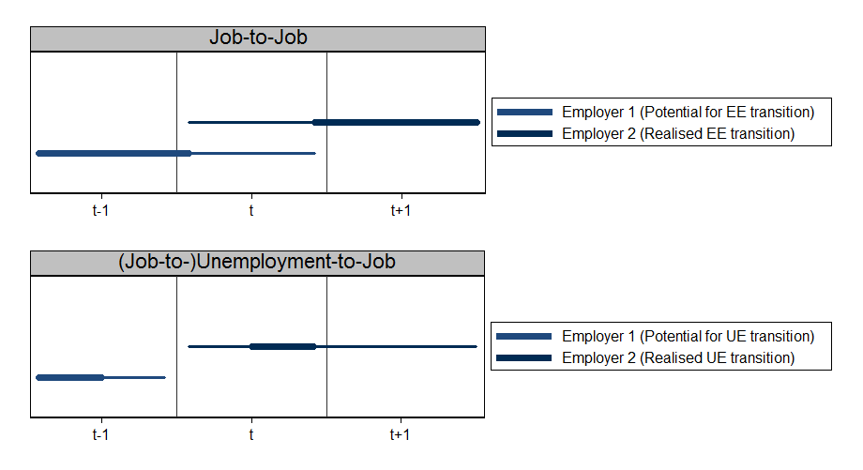Note: Illustration of the definitions of job-to-job transitions and unemployment-to-job transitions. The bold lines illustrate the required conditions – whether a job must be held in a given year or given adjacent years. The thin lines are one possible realisation of these conditions (for example, that the job-to-job transition occurs with no unemployment spell and that the unemployment-to-job transition results in a lasting employment relationship).   
Source: Treasury illustration.

Intuitively, these individuals enter the year having left their earlier employer, but subsequently get a job. Again, to turn this into a transition rate I consider all for whom conditions (1) and (2) hold and take the proportion for whom condition (3) also holds. This definition excludes transitions out of long-term unemployment by requiring the individual to have had an employer at some point in year t-1. This restriction is useful as it allows all those out of employment to be mapped to a local labour market on the basis of the residential postcode for the individual reported on their past payment summary.

### Job switching – how often, who, when and where?

I now present a brief overview of job switching patterns in Australia. Table 1 presents key summary statistics for those in stable employment – those with employers crossing both the beginning and end of the year. It presents statistics for this sample as a whole (Panel A) and split into those staying with an employer (Panel B) versus those not (Panel C). While not the norm, job switching is hardly rare. Around 13 per cent of those in stable employment switch jobs in any given year – 10 million out of the 72 million observations (Table 1). There are also clear patterns in how the likelihood of job switching varies over the lifecycle, business cycle and across Australia.

Job switching appears to be an important element of the job ladder – the process by which individuals beginning their careers grow and learn about their skills, and move up into positions that reward them. Figure 2 shows the sharp decline in job switching rates over the lifecycle, from over 20 per cent in the late teens and early 20s to under 5 per cent from the late 60s. At all ages, those switching jobs enjoy higher median wages growth than those staying in their current job. These patterns are also apparent in the aggregate summary statistics in Table 1; those switching jobs are typically younger, with lower wages but higher wages growth.

Table 1: Summary statistics

|  |  |  |  |  |  |
| --- | --- | --- | --- | --- | --- |
|  | Mean | p10 | p50 | p90 | N |
| *Panel A: With stable employment* | |  |  |  |  |
| Wages | 56,603 | 13,251 | 47,550 | 103,031 | 71,966,100 |
| Wages growth |  |  | 6.3 |  | 71,966,100 |
| Age | 40.2 | 22.2 | 40.0 | 58.2 | 71,857,000 |
| Proportion female | 0.49 |  |  |  | 71,857,000 |
|  |  |  |  |  |  |
| *Panel B: Job-stayers* |  |  |  |  |  |
| Wages | 57,884 | 13,798 | 48,998 | 104,203 | 62,445,400 |
| Wages growth |  |  | 5.8 |  | 62,445,400 |
| Age | 41.1 | 23.1 | 41.1 | 59.0 | 62,347,100 |
| Proportion female | 0.49 |  |  |  | 62,347,100 |
|  |  |  |  |  |  |
| *Panel C: Job-switchers* |  |  |  |  |  |
| Wages | 48,202 | 11,336 | 39,377 | 93,886 | 9,520,700 |
| Wages growth |  |  | 15.5 |  | 9,520,700 |
| Age | 34.1 | 19.9 | 31.5 | 52.4 | 9,509,800 |
| Proportion female | 0.48 |  |  |  | 9,509,800 |
|  |  |  |  |  |  |

Note: Shows summary statistics for key outcome and demographic variables for the three analysis samples. Wages and wages growth are in nominal terms.   
Source: Treasury calculations using de-identified Pay-As-You-Go annual payment summaries, 2004-05 to 2015-16, and the Australian Taxation Office Longitudinal Information Files.

Figure 2: Job switching rates by age and gender, and associated wage growth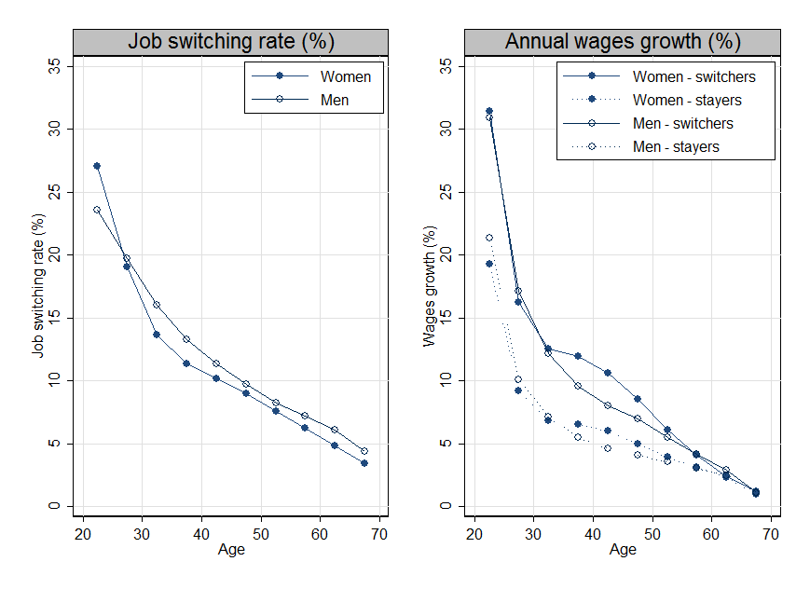

Notes: Left panel shows the job switching rate for individuals of the given gender and in the given five-year age group. Right panel shows the median annual wages growth for individuals of the given gender and in the given five-year age group by whether the individual is a job switcher or stayer.  
Source: Treasury calculations using de-identified Pay-As-You-Go annual payment summaries, 2004-05 to 2015-16, and the Australian Taxation Office Longitudinal Information Files.

There are clear cyclical influences on job switching rates. Figure 3 shows how job-to-job transition rates have varied over time, both nationally and within local labour markets. Both the level and general time trend in the national job-to are similar to those observed in past Treasury work using the HILDA survey (Treasury 2017). There is a pro-cyclicality to the job-to-job transition rate, with it rising in years of strong economic growth in the 2000s, falling with the Global Financial Crisis, and recovering somewhat thereafter. A similar pattern is also apparent in earnings growth.

There is also notable variation in job switching rates between local labour markets evident in Figure 3. In Figure B1 (see Appendix) I explore these differences in a little more detail. Queensland and Western Australia have had persistently higher job switching rates than New South Wales and Victoria; these four states also appear to have experienced different cyclical fluctuations in switching rates. In contrast there is little difference between switching rates in capital city versus regional labour markets.

Figure 3: National and regional job-to-job transition rates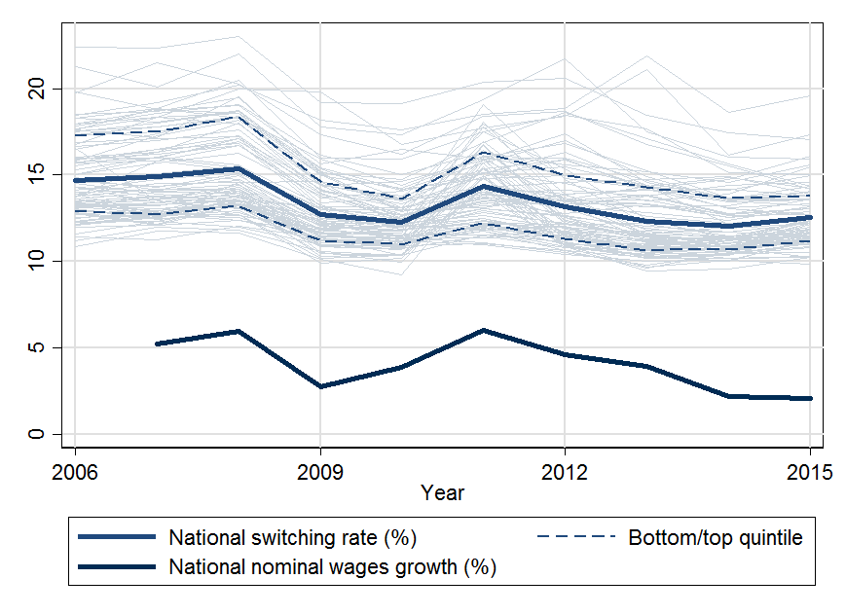

Note: Shows the national job switching rate (bold black line) and SA4 job switching rates (light blue lines), as well as the bottom and top quintile of SA4 job switching rates. National nominal annual wages growth for the stable employment sample is also shown. Note this includes growth from both wage rate increases in the same role, changes in hours and changes in role and so is not directly comparable to the Wage Price Index, for example.   
Source: Treasury calculations using de-identified Pay-As-You-Go annual payment summaries, 2004-05 to 2015-16.

## Empirical framework

As is apparent in Figure 3, job-to-job transition rates and wages growth tend to follow the economic cycle. I turn to regression analysis and experiment with a range of controls in order to look beyond this cyclical association. The empirical framework is not intended to establish a definitive causal effect – it is not clear that movements in the job-to-job transition rate *cause* movements in wages growth. Doing this would require an exogenous source of variation in job switching rates that seems likely to prove elusive. Rather, I explore whether the association between the two remains after controlling for a host more obvious confounders, such as national and regional cyclical factors, as would be expected if the link reflected a deeper link, such as that arising in models of job search. In particular, I test the relative predictive power of employment and unemployment transitions on wages growth through regressions of the form:

$∆log{W_{jt}}=α_{j}+α_{t}+{β X}_{jt}+ {γ EE}_{jt}+δ {UE}_{jt} +ε_{jt}$. (1)

The dependent variable, $∆log{W_{jt}}$, is the change in the natural logarithm of average wages in SA4 $j$ and financial year $t$. The key independent variables are the job-to-job (${EE}_{jt}$) and unemployment-to-job (${UE}_{jt}$) transition rates as defined above.

This approach is broadly in line with that taken by Karahan et al (2017) where the relative predictive power of employment transitions on wages across US states is examined through similar regressions. While the US data has the advantage of being quarterly rather than annual, I use more localised labour markets (Australian SA4).

I focus on wages growth, rather than levels, following the approach taken by Moscarini and Postel‑Vinay (2017). The rationale is that the determinants of wages growth are likely more forward‑looking and hence better able to respond to employment transition rates than wage levels, which may be sticky due to past commitments. However, I replicate the regressions with the level of log wages as the dependent variable to ensure this choice does not drive the conclusions. Across all regressions, I weight by the number of individuals underlying the regional wages aggregate.

I consider a diverse set of control variables. This includes financial year fixed effects $α_{t}$ to control for national-level business cycle effects and regional fixed effects $α_{j}$ to control for persistent tendencies towards higher or lower wage growth in given regions. Note also that while the dependent variable is in nominal terms, the inclusion of year fixed effects will sweep out changes in the national price level, meaning the coefficients of interest can in this sense be interpreted as an effect on real wages growth. Finally, in $X_{jt}$ I include controls that are allowed to vary both across time and regions. I allow for linear trends within regions and/or state interacted with year to control for more localised time trends. I also include the regional unemployment rate, average duration of unemployment and proportion employed in each industry according to the Australian Bureau of Statistics (ABS 2018b; ABS 2018c), as well as the average age and proportion female in the population underlying the outcome measures for the region.

## Results

The results from the regressions are in Table 2. Panel A shows a strong and relatively robust association between the job-to-job transition rate in a local labour market and wages growth. A 1 percentage point increase in the rate at which the employed switch jobs is associated with a 0.4-0.5 percentage point increase in wages growth. The same increase in the rate at which the unemployed find jobs is associated with a 0.1 percentage point increase in wages growth.[[11]](#footnote-12) These coefficients remain of similar size and highly statistically significant as controls are added. This includes allowing linear trends within local labour markets (2) or state-year fixed effects (3) to account for potentially different experiences of business cycles within states, or both (4). Finally in column (5) I include the full set of control variables covering local business cycles, industry composition and demographics.

The association between job-to-job transitions and wages growth in on-the-job search models arises from two channels. First, a composition effect – more transitions imply higher wages growth given workers who switch typically experience higher wages growth when they do (Figure 2). Second, a strategic effect, whereby employers offer higher wages in order to retain staff in the face of more intense competition for employed workers. To examine this further I split the full sample into those who switch versus those who stay with their employer to abstract from compositional effects.

The association between the job-to-job transition rate and wages growth is even stronger when we focus on the outcomes of the job-switchers themselves (Panel B). A 1 percentage point increase in the rate at which the employed switch jobs is associated with around a 1-2 percentage point increase in wages growth. This is consistent with employers needing to offer higher wages growth in more fluid labour markets, but causation could also run the other way. For example, it may be that local labour markets with higher wages growth on switching, due to the nature of employment creation, induce more job switching.

The strongest evidence for a causal link between the job-to-job transition rate and wages growth is the strong and robust association for those staying in their jobs (Panel C). Even for those staying in their jobs, higher switching rates are associated with strong wages growth. This is consistent with workers being better placed to bargain for increases in wages, hours or promotions when they have more outside options, namely other employers who want to hire them.

Table 2 – Power of employment transitions in predicting wages growth

|  |  |  |  |  |  |
| --- | --- | --- | --- | --- | --- |
|  | (1) | (2) | (3) | (4) | (5) |
| *Panel A: All wage earners* |  |  |  |  |  |
| EE (job-to-job) rate | 0.45\*\*\* | 0.40\*\*\* | 0.51\*\*\* | 0.55\*\*\* | 0.55\*\*\* |
|  | (0.05) | (0.05) | (0.07) | (0.08) | (0.09) |
| UE (unemployment-to-job rate) | 0.15\*\*\* | 0.12\*\*\* | 0.08\*\*\* | 0.10\*\*\* | 0.10\*\*\* |
|  | (0.02) | (0.03) | (0.03) | (0.03) | (0.03) |
| *Panel B: Job-switchers* |  |  |  |  |  |
| EE (job-to-job) rate | 1.78\*\*\* | 1.86\*\*\* | 1.64\*\*\* | 1.96\*\*\* | 1.52\*\*\* |
|  | (0.13) | (0.15) | (0.19) | (0.21) | (0.23) |
| UE (unemployment-to-job rate) | -0.13\* | -0.22\*\*\* | -0.05 | -0.15\* | -0.02 |
|  | (0.07) | (0.08) | (0.07) | (0.09) | (0.09) |
| *Panel C: Job-stayers* |  |  |  |  |  |
| EE (job-to-job) rate | 0.40\*\*\* | 0.35\*\*\* | 0.45\*\*\* | 0.47\*\*\* | 0.32\*\*\* |
|  | (0.05) | (0.06) | (0.08) | (0.09) | (0.10) |
| UE (unemployment-to-job rate) | 0.17\*\*\* | 0.16\*\*\* | 0.11\*\*\* | 0.13\*\*\* | 0.11\*\*\* |
|  | (0.02) | (0.03) | (0.03) | (0.04) | (0.04) |
|  |  |  |  |  |  |
| Specification details |  |  |  |  |  |
| Year fixed effect | X | X | X | X | X |
| SA4 fixed effect | X | X | X | X | X |
| SA4 trend |  | X |  | X | X |
| State X Year fixed effect |  |  | X | X | X |
| SA4 time varying controls |  |  |  |  | X |

Note: Presents estimates from equation (1): namely a weighted least squares regression of the change in the natural logarithm of average wages in an SA4 in a given year on the job-to-job and unemployment-to-job transition rates, and a set of control variables. The control variables are as detailed above, noting that the SA4 time‑varying controls include the unemployment rate, average number of weeks searching for a job, share of workers in each of 19 one-digit industry classifications based on the Australian Bureau of Statistics Labour Force Survey data, and the average age and proportion of females in the relevant sample (ABS 2018b; ABS 2018c). Standard errors in parentheses. Significance levels are indicated as follows: \* 10 per cent; \*\* 5 per cent; \*\*\* 1 per cent.  
Source: Treasury calculations using de-identified Pay-As-You-Go annual payment summaries, 2004-05 to 2015-16, and the Australian Taxation Office Longitudinal Information Files.

These results are economically meaningful, both in the context of aggregate wages growth and the implied effects for individual workers. As a simple illustration of this, Figure 4 shows what the coefficients on the job switching rate imply for the additional wages growth received by a worker at the mean level of wages for the relevant group. I show the predicted effect of a 2 percentage point increase in the job switching rate – this is roughly the decline in the job switching rate observed over the period examined (from 2006 to 2015). This magnitude is also about twice the standard deviation in the job switching rate after controlling for SA4 and financial year fixed effects, and is thus on par with the larger variations observed in the data after accounting for persistent regional effects and the national business cycle.

Finally, it is interesting to note that while the rate at which the unemployed find work is associated with higher wages growth, this is entirely driven by those staying in their jobs. In Karahan et al (2017) they find no such association, but note that it is puzzling as theory readily accommodates a role for both the unemployment-to-job and job-to-job transition rates. For example, losing workers is a credible threat whenever they might easily find a new job, whether immediately (through job switching) or after a short stint of unemployment. Thus employers may also need to lift wages to keep workers when unemployment-to-job transition rates are higher.

Figure 4: Predicted effect of a 2 percentage point increase in job-switching rate in a local labour market: additional annual wages growth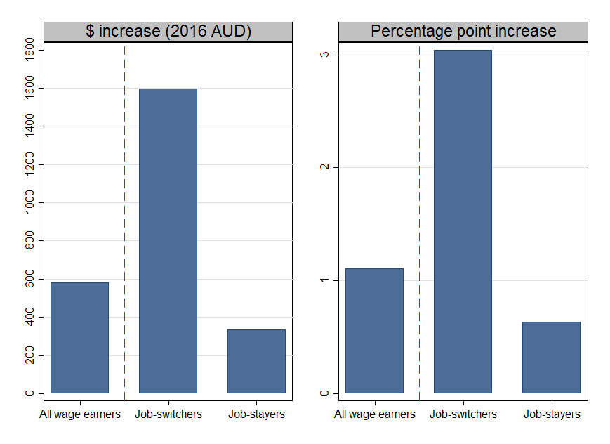

Note: Shows, for illustrative purposes only, the predicted effect of a 2 percentage point increase in the job‑switching rate in a local labour market on wages growth – either in percentage point terms or in dollar terms (with the latter based on an individual at the mean level of wages for the estimation sample in 2015-16). This is based on coefficient estimates reported in column (5) of Table 2.   
Source: Treasury calculations using de-identified Pay-As-You-Go annual payment summaries, 2004-05 to 2015-16.

In Appendix Table A1, I replicate the results in Table 2 with the level rather than change in log wages as the dependent variable. This is more akin to the exercise conducted in Karahan et al (2017). The results in Appendix Table A1 provide some comfort that the choice of dependent variable has not driven the results. While the point estimates are more variable across the specifications, the general pattern of results persists – we typically see a strong association between job-to-job transition rates and wages that is strongest for switchers but still present for stayers.

Finally, I explore the stability of the results when splitting the sample into different time periods or geographic regions. If the results were driven by a particular set of years or regions than that would cast doubt on the claim that they reflect an underlying microeconomic mechanism. In Appendix Table A2, I replicate the results in Table 2, Panel C splitting the sample in two: either into capital cities and other regions; or into those years strictly prior to 2010-11 or after and including it.[[12]](#footnote-13) Across all regressions a positive association remains, though it varies in size and significance. If anything the association between job switching rates and wages growth for those staying in their jobs is larger in the capital cities and in earlier years. The former result could have easily gone either way. On the one hand, job switching may be a better proxy for underlying competitive pressures in urban labour markets rather than in regions where it may also capture an element of seasonal agricultural work, structural adjustments or similar. On the other hand, there could have been an attenuation in the relationship, reflecting spill overs between local labour markets within capital cities.[[13]](#footnote-14) In Appendix C I explore these boundaries between labour markets further.

### Individual level regressions

The results above are based on average wages in Australian labour markets (SA4) over a twelve year window. This is an intuitive and computationally simple set of regressions – do more fluid labour markets see higher wages growth? This section explores the individual level data, allowing for a richer look at the experiences of individuals in labour markets of varying fluidity.

I make a number of sample restrictions to avoid individuals with particularly high or low earnings growth – potentially reflecting participation decisions – driving the results. For example, transitions from study or to retirement might involve job-to-job transitions from or to lower-paid part time work. In particular, I restrict attention to working age individuals, that is, those aged 25-64 years and exclude those with very low or high annual earnings (under $10,000 or over $1m). To aid computation, I further restrict attention to a random 10 per cent sample.

To begin, Figure 5 represents the relationship between the change in the natural logarithm of wages and the job‑to-job transition rate in the raw data for the 5 million individuals in the sample who stayed with their employer. To control for demographic, cyclical and persistent regional differences both variables are residualised by regressing them on: sex; a quadratic in age; the unemployment‑to‑employment transition rate; and year and SA4 fixed effects. The sample is then split into 20 quantiles according to the residual job-to-job transition rate and the mean residual change in log wages is shown. A clear relationship is apparent – individuals in more fluid labour markets experience higher wages growth. As before, a 1 percentage point increase in the rate at which workers switch jobs is associated with a roughly ½ percentage point increase in growth in average wages

In Table 3 I move beyond this graphical exploration, largely replicating the regressions from Table 2, but this time with the unit of observation as the individual rather than an entire labour market. I run regressions of the form:

$∆log{W_{ijt}}=α_{i}+α_{j}+α_{t}+{β X}_{ijt}+ {γ EE}_{jt}+δ {UE}_{jt} +ε_{ijt}$ (2)

This is identical to equation (1) except the dependent variable, $∆log{W_{ijt}}$, is now the change in the natural logarithm of wages for individual $i$ in SA4 $j$ and financial year $t$. The key independent variables are the job-to-job (${EE}_{jt}$) and unemployment-to-job (${UE}_{jt}$) transition rates as defined above. As these are only defined at an SA4 level, I cluster standard errors at this level. I once again include financial year fixed effects $α_{t}$ to control for national-level business cycle effects and regional fixed effects $α_{j}$ to control for persistent tendencies towards higher or lower wage growth in given regions. I now also include individual fixed effects $α_{i}$ to control for the fact that some individuals may have higher average wage growth than others, and may also be more likely to be found in or move to more or less fluid labour markets.[[14]](#footnote-15) Finally, in $X_{jt}$ I include a variety of controls that are allowed to vary across individuals, time and regions. This includes sex and a quadratic in age, but also the set of controls for time-varying region characteristics explored earlier.

Once again, a higher job switching rate is associated with higher wages growth. In the final specification in column (6), a 1 percentage point higher switching rate is associated with a 0.3 percentage point increase in wages growth for all wage earners, a 1 percentage point increase for those switching jobs and a 0.2 percentage point increase for those staying in the same job.[[15]](#footnote-16) This provides comfort that the results are not driven by inadequate controls for differences in the workers found in local labour markets over time, such as their age, sex and any fixed differences in skills.

Figure 5 – Average annual wage growth is higher in more fluid labour markets 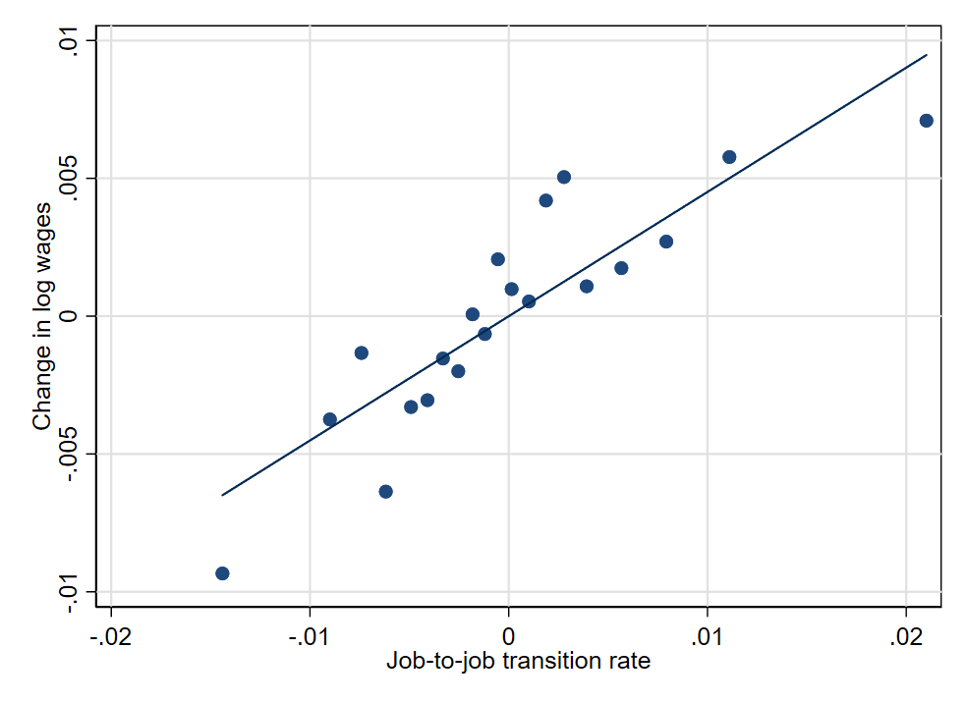

Note: Presents the mean change in log wages for individuals in each of the 20 quantiles of the distribution of job-to-job transition rates. Both the change in log wages and job-to-job transition rates are first residualised by regressing them on: sex; a quadratic in age; the unemployment-to-employment transition rate; and year and SA4 fixed effects.   
Source: Treasury calculations using de-identified Pay-As-You-Go annual payment summaries, 2004-05 to 2015-16, and the Australian Taxation Office Longitudinal Information Files.

Table 3 – Power of employment transitions in predicting wages growth (individuals)

Note: Presents estimates from equation 2): namely an ordinary least squares regression of the change in the natural logarithm of individual wages on the job-to-job and unemployment-to-job transition rates and a set of control variables. The control variables are as detailed above, noting that the SA4 time‑varying controls include the unemployment rate, average number of weeks searching for a job, share of workers in each of 19 one-digit industry classifications based on the Australian Bureau of Statistics Labour Force Survey data (ABS 2018b; ABS 2018c). All specifications control for individual sex and a quadratic in age. Standard errors in parentheses, clustered at SA4 level. Significance levels are indicated as follows: \* 10 per cent; \*\* 5 per cent; \*\*\* 1 per cent.   
Source: Treasury calculations using de-identified Pay-As-You-Go annual payment summaries, 2004-05 to 2015-16, and the Australian Taxation Office Longitudinal Information Files.

|  |  |  |  |  |  |  |
| --- | --- | --- | --- | --- | --- | --- |
|  | (1) | (2) | (3) | (4) | (5) | (6) |
| *Panel A: All wage earners* |  |  |  |  |  |  |
| EE (job-to-job) rate | 0.49\*\*\* | 0.41\*\*\* | 0.34\*\*\* | 0.29\*\* | 0.34\*\*\* | 0.32\*\*\* |
|  | (0.05) | (0.07) | (0.05) | (0.12) | (0.11) | (0.12) |
| UE (unemployment-to-job rate) | 0.18\*\*\* | 0.18\*\*\* | 0.12\*\*\* | 0.14\*\*\* | 0.12\*\*\* | 0.13\*\*\* |
|  | (0.03) | (0.04) | (0.03) | (0.03) | (0.03) | (0.03) |
| *Panel B: Job-switchers* |  |  |  |  |  |  |
| EE (job-to-job) rate | 0.03 | 0.32 | 0.23 | 1.04\* | 1.14\* | 0.98\* |
|  | (0.15) | (0.33) | (0.34) | (0.53) | (0.58) | (0.58) |
| UE (unemployment-to-job rate) | 0.41\*\*\* | 0.28\*\* | 0.20 | 0.16 | 0.07 | 0.16 |
|  | (0.08) | (0.13) | (0.14) | (0.15) | (0.17) | (0.18) |
| *Panel C: Job-stayers* |  |  |  |  |  |  |
| EE (job-to-job) rate | 0.45\*\*\* | 0.37\*\*\* | 0.31\*\*\* | 0.20\* | 0.24\*\*\* | 0.22\*\* |
|  | (0.04) | (0.06) | (0.04) | (0.11) | (0.09) | (0.10) |
| UE (unemployment-to-job rate) | 0.15\*\*\* | 0.15\*\*\* | 0.10\*\*\* | 0.12\*\*\* | 0.11\*\*\* | 0.12\*\*\* |
|  | (0.02) | (0.03) | (0.03) | (0.03) | (0.03) | (0.03) |
|  |  |  |  |  |  |  |
| Specification details |  |  |  |  |  |  |
| Year fixed effect | X | X | X | X | X | X |
| SA4 fixed effect | X | X | X | X | X | X |
| Individual fixed effect |  | X | X | X | X | X |
| SA4 trend |  |  | X |  | X | X |
| State X Year fixed effect |  |  |  | X | X | X |
| SA4 time varying controls |  |  |  |  |  | X |

A final exercise that is possible with the individual level data is to run a quantile regression, examining the effect of higher job switching rates at various points of the wage growth distribution, after conditioning on the control variables. I focus on job‑stayers and use the simplest specification (in column (1)) for ease of computation. The resulting coefficients are in Table 4. An association between job switching rates and wages growth is present across the quantiles of the conditional distribution of wage growth, but is strongest in the tails. This suggests more fluid labour markets have less surprisingly large wage falls and more surprisingly large wage rises. Large wage changes in the same job are generally rare (Bishop and Cassidy 2017); but the measures of wages growth used in this work will also capture role changes (demotions or promotions) and changes in hours. These results provide suggestive evidence that these are further means by which employers respond to competitive pressures in the labour market as evidenced by job-to-job transitions.[[16]](#footnote-17)

Table 4 – Power of employment transitions in predicting wages growth (individuals)

Note: Presents estimates from a quantile regression of the change in the natural logarithm of individual wages on the job-to-job and unemployment to job transition rates and a set of control variables. The control variables include year and SA4 fixed effects, and individual sex and a quadratic in age. Standard errors in parentheses. Significance levels are indicated as follows: \* 10 per cent; \*\* 5 per cent; \*\*\* 1 per cent.   
Source: Treasury calculations using de-identified Pay-As-You-Go annual payment summaries, 2004-05 to 2015-16, and the Australian Taxation Office Longitudinal Information Files.

|  |  |  |  |  |  |
| --- | --- | --- | --- | --- | --- |
|  |  | Quantile | | |  |
|  | 10th | 25th | 50th | 75th | 90th |
|  |  |  |  |  |  |
| EE (job-to-job) rate | 0.40\*\*\* | 0.22\*\*\* | 0.22\*\*\* | 0.42\*\*\* | 0.69\*\*\* |
|  | (0.03) | (0.01) | (0.01) | (0.02) | (0.07) |
| UE (unemployment-to-job rate) | 0.11\*\*\* | 0.07\*\*\* | 0.06\*\*\* | 0.11\*\*\* | 0.27\*\*\* |
|  | (0.01) | (0.00) | (0.00) | (0.01) | (0.03) |
|  |  |  |  |  |  |

## Conclusion

Competition among firms for employed workers has the potential to exert meaningful pressure on wages – an intuitive idea that is illustrated in leading models of on-the-job search and increasingly borne out in empirical studies. In this paper I find evidence for this in the Australian setting. I show that higher job-to-job switching rates in Australian local labour markets are associated with higher wages growth. A 1 percentage point increase in the rate at which workers switch jobs is associated with a ½ percentage point increase in growth in average wages. This association remains under a variety of specifications. It is not just those who switch jobs who benefit from a more fluid labour market, as those who stay in their jobs also experience higher wages growth. This is consistent with the idea that workers with more outside options – other employers who want to hire them – are better placed to negotiate increases in wages, hours or promotions.

This paper does not explore what drives variation in job-switching rates over time or between regions. While the decisions of individual workers may play a role, these switching rates will also reflect a wide range of external factors over which workers have no control. Workers may switch jobs less often if there are fewer employers (for example, due to rising concentration or declining firm entry), if moving or commuting is difficult, or if contractual or regulatory barriers get in the way. Structural changes in the nature of work may make skills less immediately transferrable between firms or industries, while the rise of dual income couples and population ageing may also lead to a less mobile workforce. This paper suggests such factors could have flow on consequences to wages. Further work on labour market fluidity, its causes and consequences, would be well worthwhile. This could include distinguishing between job changes that include changes of location, industry or occupation, and also those that are related to key transitions from study to work or work to retirement. Heterogeneity in the associations could be explored further (in datasets with richer demographic information), as could the role of young firms as a potential driver of job switching.

References

Andrews, D. and Hansell, D. 2019. *Productivity-enhancing labour reallocation in Australia*, Treasury Working Paper 2019-06.

Andrews, D., Deutscher, N., Hambur, J. and Hansell, D. 2019. *Wage growth in Australia: lessons from longitudinal microdata*. Treasury Working Paper 2019-04.

Arsov, I. and Evans, R., 2018. Wage growth in advanced economies. *Reserve Bank of Australia Bulletin*, pp.132-52.

Australian Bureau of Statistics (ABS) 2018a. Participation, Job Search and Mobility, Australia, February 2018, Cat. No. 6226.0, Australian Bureau of Statistics, Canberra.

Australian Bureau of Statistics (ABS) 2018b. Labour Force, Australia, Detailed –Electronic Delivery, August 2018, Cat. No. 6291.0.55.001, Australian Bureau of Statistics, Canberra.

Australian Bureau of Statistics (ABS) 2018c. Labour Force, Australia, Detailed, Quarterly, August 2018, Cat. No. 6291.0.55.003, Australian Bureau of Statistics, Canberra.

Ball, C., Groshenny, N., Karagedikli, O., Ozbilgin, M., and Robinson, F., 2019, *Low wage growth and job-to-job transitions: Evidence from administrative data in New Zealand*, University of Adelaide, School of Economics Working Paper, forthcoming.

Bishop, J., Gustafsson, L. and Plumb, M., 2016. Jobs or hours? Cyclical labour market adjustment in Australia. *Reserve Bank of Australia Research Discussion Paper*, (2016-06), Reserve Bank of Australia.

Bishop, J. and Cassidy, N., 2017. Insights into low wage growth in Australia. *RBA Bulletin, March*, pp.13‑20.

Burdett, K. and Mortensen, D.T., 1998. Wage differentials, employer size, and unemployment. *International Economic Review*, pp.257-73.

Cassidy, N. 2019. ‘Low Wages Growth: An Introduction’ in *RBA 2019 Annual Conference: Low Wage Growth*, Reserve Bank of Australia, Sydney.

Cooper, J. and Corcoran, J. 2018, Journey to Work in Australia. *Census of Population and Housing: Commuting to Work - More Stories from the Census, 2016*. Cat. No. 2071.0.55.001, Australian Bureau of Statistics, Canberra.

Davis, S. J. and Haltiwanger, J., 2014. Labor market fluidity and economic performance. NBER Working Paper No. 20479, National Bureau of Economic Research.

Ellis, Luci 2019. What’s up (and down) with households? *Address to Housing Industry Association March Industry Outlook Breakfast*, Sydney, 26 March 2019.

Faberman, R.J. and Justiniano, A., 2015. Job switching and wage growth. *Chicago Fed Letter*.

Freestone, O., 2018. The Drivers of Life‐Cycle Wage Inequality in Australia. *Economic Record*, *94*(307), pp.424-44.

Gong, X. and Breunig, R., 2014. Channels of labour supply responses of lone parents to changed work incentives. *Oxford Economic Papers*, *66*(4), pp.916-39.

Haldane, A. 2019. Climbing the jobs ladder. *Speech at Glanford Park Stadium*. Scunthorpe, 23 July 2019.

Karagedikli, Ö. 2018. Job-to-job flows and inflation: Evidence from administrative data. *Reserve Bank of New Zealand Analytical Note* 2018-09.

Karahan, F., Michaels, R., Pugsley, B., Şahin, A. and Schuh, R., 2017. Do Job-to-Job Transitions Drive Wage Fluctuations over the Business Cycle? *American Economic Review*, *107*(5), pp.353-57.

Lowe, P. 2017. The labour market and monetary policy. *Address to the Anika Foundation Luncheon*, Sydney, 26 July 2017.

Lowe, P. 2018. Productivity, wages and prosperity. *Address to the Australian Industry Group*, Melbourne, 13 June 2018.

Mortensen, D. T. and Pissarides, C. A., 1994. Job creation and job destruction in the theory of unemployment. *The Review of Economic Studies*, *61*(3), pp.397-415.

Moscarini, G. and Postel-Vinay, F., 2016a. Wage posting and business cycles: A quantitative exploration. *Review of Economic Dynamics*, *19*, pp.135-60.

Moscarini, G. and Postel-Vinay, F., 2016b. Wage posting and business cycles. *American Economic Review*, *106*(5), pp.208-13.

Moscarini, G. and Postel-Vinay, F., 2017. The Relative Power of Employment-to-Employment Reallocation and Unemployment Exits in Predicting Wage Growth. *American Economic Review*, *107*(5), pp.364-68.

Quinn, M. 2019. What’s driving low wages growth in Australia? *Speech to the Australian Conference of Economists*, Melbourne, 16 July 2019.

The Treasury, 2017. Analysis of wage growth. Australian Government, Canberra.

Topel, R.H. and Ward, M.P., 1992. Job mobility and the careers of young men. *The Quarterly Journal of Economics*, *107*(2), pp.439-79.

Appendix A: Additional Tables

Table A1 – Power of employment transitions in predicting wages

|  |  |  |  |  |  |
| --- | --- | --- | --- | --- | --- |
|  | (1) | (2) | (3) | (4) | (5) |
| *Panel A: All wage earners* |  |  |  |  |  |
| EE (job-to-job) rate | -0.06 | 0.29\*\*\* | 1.02\*\*\* | 0.67\*\*\* | 0.54\*\*\* |
|  | (0.10) | (0.05) | (0.10) | (0.06) | (0.06) |
| UE (unemployment-to-job rate) | -0.32\*\*\* | 0.06\*\* | -0.13\*\*\* | 0.02 | 0.01 |
|  | (0.04) | (0.02) | (0.03) | (0.02) | (0.02) |
| *Panel B: Job-switchers* |  |  |  |  |  |
| EE (job-to-job) rate | 1.32\*\*\* | 1.98\*\*\* | 2.34\*\*\* | 2.24\*\*\* | 1.79\*\*\* |
|  | (0.15) | (0.10) | (0.16) | (0.14) | (0.14) |
| UE (unemployment-to-job rate) | -0.54\*\*\* | 0.01 | -0.13\*\* | -0.10\* | -0.03 |
|  | (0.07) | (0.05) | (0.06) | (0.05) | (0.05) |
| *Panel C: Job-stayers* |  |  |  |  |  |
| EE (job-to-job) rate | -0.10 | 0.20\*\*\* | 0.98\*\*\* | 0.59\*\*\* | 0.44\*\*\* |
|  | (0.10) | (0.05) | (0.10) | (0.07) | (0.07) |
| UE (unemployment-to-job rate) | -0.29\*\*\* | 0.06\*\*\* | -0.12\*\*\* | 0.04 | 0.01 |
|  | (0.04) | (0.02) | (0.04) | (0.03) | (0.03) |
|  |  |  |  |  |  |
| Specification details |  |  |  |  |  |
| Year fixed effect | X | X | X | X | X |
| SA4 fixed effect | X | X | X | X | X |
| SA4 trend |  | X |  | X | X |
| State X Year fixed effect |  |  | X | X | X |
| SA4 time varying controls |  |  |  |  | X |

Note: Presents estimates from equation (1), but in level terms: namely a weighted least squares regression of the natural logarithm of average wages in an SA4 in a given year on the job-to-job and unemployment to job transition rates and a set of control variables. The control variables are as detailed above, noting that the SA4 time‑varying controls include the unemployment rate, average number of weeks searching for a job, share of workers in each of 19 one-digit industry classifications based on the Australian Bureau of Statistics Labour Force Survey data and the average age and proportion female of the relevant sample (ABS 2018b; ABS 2018c). Standard errors in parentheses. Significance levels are indicated as follows: \* 10 per cent; \*\* 5 per cent; \*\*\* 1 per cent.   
Source: Treasury calculations using de-identified Pay-As-You-Go annual payment summaries, 2004-05 to 2015-16, and the Australian Taxation Office Longitudinal Information Files.

Table A2 – Power of employment transitions in predicting wages growth

|  |  |  |  |  |  |
| --- | --- | --- | --- | --- | --- |
|  | (1) | (2) | (3) | (4) | (5) |
| *Panel A: Non-capital cities* |  |  |  |  |  |
| EE (job-to-job) rate | 0.23\*\*\* | 0.17\*\*\* | 0.37\*\*\* | 0.31\*\*\* | 0.16 |
|  | (0.06) | (0.06) | (0.11) | (0.12) | (0.12) |
| UE (unemployment-to-job rate) | 0.14\*\*\* | 0.12\*\*\* | 0.12\*\*\* | 0.12\*\*\* | 0.06 |
|  | (0.03) | (0.03) | (0.04) | (0.04) | (0.04) |
| *Panel B: Capital cities* |  |  |  |  |  |
| EE (job-to-job) rate | 0.53\*\*\* | 0.49\*\*\* | 0.31\* | 0.52\*\*\* | 0.68\*\*\* |
|  | (0.08) | (0.09) | (0.17) | (0.20) | (0.21) |
| UE (unemployment-to-job rate) | 0.18\*\*\* | 0.16\*\*\* | 0.01 | 0.06 | 0.07 |
|  | (0.04) | (0.04) | (0.05) | (0.06) | (0.06) |
|  |  |  |  |  |  |
| *Panel C: Post 2010-11 (inclusive)* |  |  |  |  |  |
| EE (job-to-job) rate | 0.31\*\*\* | 0.42\*\*\* | 0.29\*\*\* | 0.20 | 0.22 |
|  | (0.06) | (0.08) | (0.10) | (0.16) | (0.18) |
| UE (unemployment-to-job rate) | 0.23\*\*\* | 0.17\*\*\* | 0.22\*\*\* | 0.24\*\*\* | 0.19\*\*\* |
|  | (0.03) | (0.04) | (0.04) | (0.05) | (0.06) |
| *Panel D: Pre 2010-11* |  |  |  |  |  |
| EE (job-to-job) rate | 0.63\*\*\* | 0.47\*\* | 0.99\*\*\* | 0.80\*\*\* | 0.29 |
|  | (0.14) | (0.23) | (0.18) | (0.29) | (0.29) |
| UE (unemployment-to-job rate) | 0.04 | 0.10 | -0.06 | -0.03 | 0.03 |
|  | (0.05) | (0.06) | (0.06) | (0.08) | (0.07) |
|  |  |  |  |  |  |
| Specification details |  |  |  |  |  |
| Year fixed effect | X | X | X | X | X |
| SA4 fixed effect | X | X | X | X | X |
| SA4 trend |  | X |  | X | X |
| State X Year fixed effect |  |  | X | X | X |
| SA4 time varying controls |  |  |  |  | X |

Note: Presents estimates from equation (1): namely a weighted least squares regression of the natural logarithm of average wages in an SA4 in a given year on the job-to-job and unemployment to job transition rates and a set of control variables. The control variables are as detailed above, noting that the SA4 time‑varying controls include the unemployment rate, average number of weeks searching for a job, share of workers in each of 19 one-digit industry classifications based on the Australian Bureau of Statistics Labour Force Survey data and the average age and proportion female of the relevant sample (ABS 2018b; ABS 2018c). Standard errors in parentheses. Significance levels are indicated as follows: \* 10 per cent; \*\* 5 per cent; \*\*\* 1 per cent.   
Source: Treasury calculations using de-identified Pay-As-You-Go annual payment summaries, 2004-05 to 2015-16, and the Australian Taxation Office Longitudinal Information Files.

Appendix B: Additional Figures

Figure B1: Job switching rates by states and capital city status

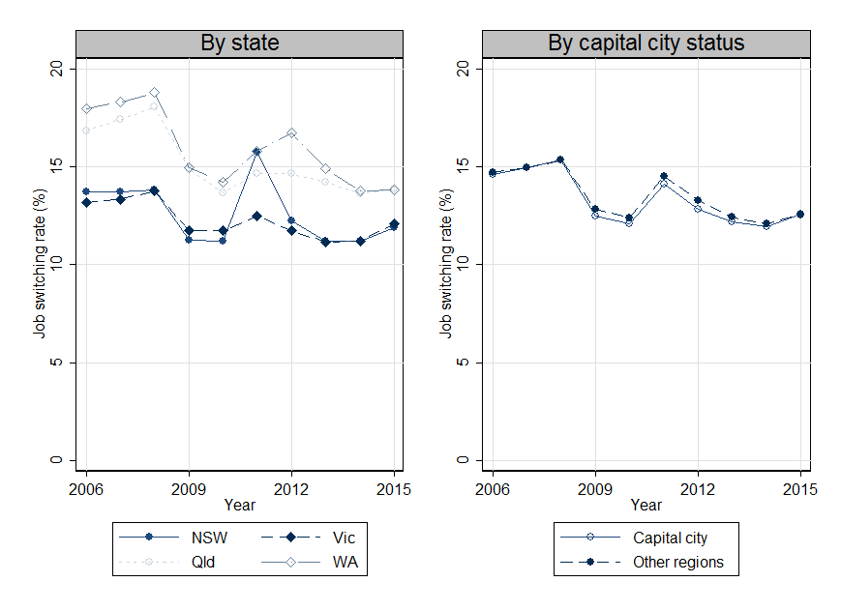Note: Shows the job switching rate by states and capital city status.   
Source: Treasury calculations using de-identified Pay-As-You-Go annual payment summaries, 2004-05 to 2015-16.

Appendix C: Demarcation of local labour markets

In this Appendix I conduct a series of tests exploring the boundaries of when and where job switching rates are most strongly associated with wages – to what extent do job switching rates from neighbouring years or locations matter? This may lend further weight to the idea that the aggregate association between job switching and wages growth reflects an underlying causal mechanism – rather than persistent or slowly evolving differences in local labour markets. I focus on the association between job switching rates and the wages growth of those remaining in their jobs.

In the first instance, I repeat the earlier regression with the full set of controls (Table 2, Panel C, column (5)), but use the job switching from t years ahead, with t={-2,-1,0,2,1}. The resulting coefficients on the job switching rates are in the left panel of Figure 5. The association between the job switching rate and wages growth in a given year is driven by the job switching rate in the year in question – higher job switching rates from neighbouring years are not associated with higher wages growth. This makes it clear the association between job switching and wages growth is not driven by persistent or slowly evolving differences across local labour markets.

Figure C1: Demarcation of local labour markets

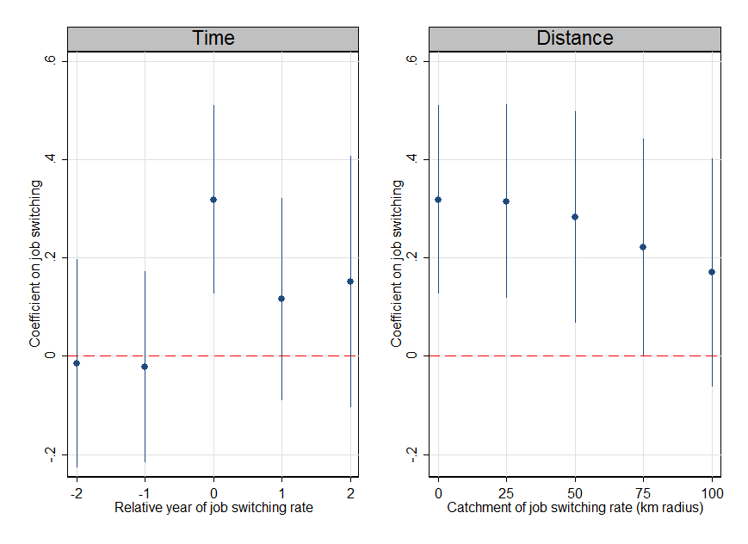Note: Presents estimated coefficients on job switching (and 95 per cent confidence intervals) from equation (1): a weighted least squares regression of the change in the natural logarithm of average wages in an SA4 in a given year on the job-to-job and unemployment-to-job transition rates and a set of control variables – with varying definitions of the job-to-job transition rate. The job-to-job transition rate is measured in either a neighbouring year (left panel) or over a larger catchment area (right panel). The control variables include: SA4 fixed effects and trends; state interacted with year fixed effects; and SA4 time‑varying controls including the unemployment rate, average number of weeks searching for a job, share of workers in each of 19 one-digit industry classifications based on the Australian Bureau of Statistics Labour Force Survey data and the average age and proportion female of the relevant sample (ABS 2018b; ABS 2018c).   
Source: Treasury calculations using de-identified Pay-As-You-Go annual payment summaries, 2004-05 to 2015-16, and the Australian Taxation Office Longitudinal Information Files.

I now conduct a similar exercise, but instead draw in job-switching rates from increasingly large geographic areas. I calculate the job-switching rate across all SA4 within 0, 25, 50, 75 or 100km an SA4 (based on SA4 centroids) and look at the association between this job switching rate and wages growth. The association initially holds steady, and then gradually weakens (right panel of Figure C1). This is perhaps not surprising – given the large numbers of people who commute across SA4 (Cooper and Corcoran 2018), these slightly larger geographic regions may still provide an accurate measure of the outside offers that matter for wage bargaining.

1. Macroeconomic Group, The Treasury, Langton Crescent, Parkes ACT 2600, Australia. Correspondence: Nathan Deutscher, [nathan.deutscher@treasury.gov.au](mailto:nathan.deutscher@treasury.gov.au). I thank Dan Andrews, Robert Breunig, Jonathan Hambur, Meghan Quinn, Luke Willard, Thomas Williamson and seminar participants at the Treasury and Reserve Bank of Australia for helpful suggestions. [↑](#footnote-ref-2)
2. The views expressed in this paper are those of the author and do not necessarily reflect those of The Australian Treasury or the Australian Government. [↑](#footnote-ref-3)
3. See the recent speech by Andrew Haldane (Chief Economist at the Bank of England) (Haldane 2019) ‘Climbing the Jobs Ladder’. The link between job-to-job transition rates and wages has also featured in the speeches and research of central banks in the United States (Faberman and Justiniano 2015; Karahan et al 2017), New Zealand (Karagedikli 2018) and Australia (Lowe 2017). [↑](#footnote-ref-4)
4. For example, Gong and Breunig (2014) found lone parents increased their hours of work via job changes in response to welfare reforms. [↑](#footnote-ref-5)
5. This work was recognised with the award of the 2010 Nobel Prize in Economics to Peter Diamond, Dale Mortensen and Christopher Pissarides. [↑](#footnote-ref-6)
6. Based on the proportion of employed civilians over 15 years of age with their current employer/business for fewer than 12 months who had changed employer/business in the last 12 months (Australian Bureau of Statistics 2018). [↑](#footnote-ref-7)
7. These models remain a simplification that abstracts from other long-run changes that may weigh on wages through workers’ productivity and bargaining power. These include trends in globalisation, technology, and unionisation and industrial relations. Each of these topics, while outside the scope of the paper, has received substantial attention in the literature. [↑](#footnote-ref-8)
8. Future versions of the matched employer-employee dataset will include payment summaries from trusts and partnerships. This version nonetheless captures the bulk of employment relationships. [↑](#footnote-ref-9)
9. Where an individual has multiple employers providing postcodes, I preference the location from the employer paying the largest salary in the event that the postcodes do not match. [↑](#footnote-ref-10)
10. Major cities include several SA4, including 14 in Sydney and 9 in Melbourne. Smaller capital and regional cities are single SA4, including Ballarat, Bendigo, Canberra, Darwin, Hobart, Newcastle, Toowoomba, Townsville and Wollongong. [↑](#footnote-ref-11)
11. There is slightly more variation in the unemployment-to-employment transition rate than the job-to-job transition rate – the former has a standard deviation of 4.2 percentage points compared to the latter’s 2.5 percentage points. Even accounting for this the association between the job-to-job transition rate and wages is generally stronger than that between the unemployment-to-employment transition rate and wages. [↑](#footnote-ref-12)
12. An alternative geographic split is to compare the ‘mining states’ of Western Australia and Queensland to the rest of the nation. Once again, positive associations between the job-to-job transition rate and wages growth is observed in both samples. [↑](#footnote-ref-13)
13. For example, workers may lean against the wage-depressing influence of low job switching rates by searching for job offers in nearby labour markets; firms may similarly seek workers from outside. [↑](#footnote-ref-14)
14. Freestone (2018) finds no evidence of systematic heterogeneity in wage growth, instead preferring a model with highly persistent wage shocks. A useful avenue for future work – ideally with data spanning a longer time periods – would be to examine the role of job-to-job transitions in a more comprehensive model of individual wage growth. [↑](#footnote-ref-15)
15. Note that even if we replicated the SA4-level regressions precisely at the individual-level, rather than adding some more detailed controls, we would not expect to return exactly the same results. This is because the dependent variable for the SA4‑level regressions – the change in log of average wages is not the same as the average of the change in log wages at the individual level. [↑](#footnote-ref-16)
16. Indeed, changes in hours worked have become an increasingly important way in which the Australian labour market responds to cyclical fluctuations: Bishop et al (2016) find the share of adjustment due to changes in hours worked has increased threefold since the late 1990s. [↑](#footnote-ref-17)