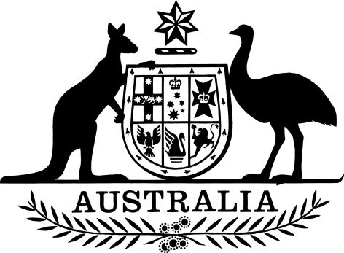
EXPOSURE DRAFT

Superannuation (Self Managed Superannuation Funds) Taxation Regulations 2018
I, General the Honourable Sir Peter Cosgrove AK MC (Ret’d), Governor-General of the Commonwealth of Australia, acting with the advice of the Federal Executive Council, make the following regulations.
Dated 2018
Peter Cosgrove
Governor-General
By His Excellency’s Command
Kelly O’Dwyer [DRAFT ONLY—NOT FOR SIGNATURE]
Minister for Revenue and Financial Services

Contents
1 Name 1
2 Commencement 1
3 Authority 1
4 Schedules 1
5 Definitions 1
6 When levy due for payment 2
Schedule 1—Repeals 3
Superannuation (Self Managed Superannuation Funds) Taxation Regulations 1999 3

1 Name
This instrument is the Superannuation (Self Managed Superannuation Funds) Taxation Regulations 2018.

2 Commencement
(1) Each provision of this instrument specified in column 1 of the table commences, or is taken to have commenced, in accordance with column 2 of the table. Any other statement in column 2 has effect according to its terms.

Commencement information
Column 1 | Column 2 | Column 3
Provisions | Commencement | Date/Details
1. The whole of this instrument | 1 July 2018. | 1 July 2018
Note: This table relates only to the provisions of this instrument as originally made. It will not be amended to deal with any later amendments of this instrument.
(2) Any information in column 3 of the table is not part of this instrument. Information may be inserted in this column, or information in it may be edited, in any published version of this instrument.

3 Authority
This instrument is made under the Superannuation (Self Managed Superannuation Funds) Taxation Act 1987.

4 Schedules
Each instrument that is specified in a Schedule to this instrument is amended or repealed as set out in the applicable items in the Schedule concerned, and any other item in a Schedule to this instrument has effect according to its terms.

5 Definitions
In this instrument:
Act means the Superannuation (Self Managed Superannuation Funds) Taxation Act 1987.
return lodgement day, for a superannuation entity for a year of income, means the last day a return for the entity can be given under section 35D of the Superannuation Industry (Supervision) Act 1993 for the year of income.

6 When levy due for payment
(1) This section is made for the purposes of subsection 15DB(1) of the Act for the levy payable for:
(a) the 2018-19 year of income or a later year of income; and
(b) a superannuation entity.
(2) The levy for the year of income is due and payable on the return lodgement day for the superannuation entity for the preceding year of income.
(3) However, if the year of income is the one in which the election was made:
(a) under subsection 19(4) of the Superannuation Industry (Supervision) Act 1993; and
(b) for that Act to apply in relation to the superannuation entity (as a fund);
the levy for the year of income is due and payable on the return lodgement day for the superannuation entity for that year of income.

Schedule 1—Repeals

Superannuation (Self Managed Superannuation Funds) Taxation Regulations 1999
1 The whole of the instrument
Repeal the instrument.

