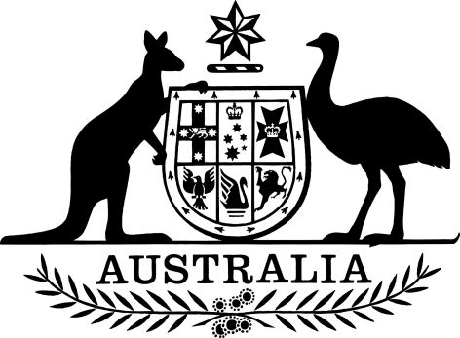
EXPOSURE DRAFT

Small Superannuation Accounts Regulations 2018
I, General the Honourable Sir Peter Cosgrove AK MC (Ret’d), Governor-General of the Commonwealth of Australia, acting with the advice of the Federal Executive Council, make the following regulations.
Dated 2018
Peter Cosgrove
Governor-General
By His Excellency’s Command
Kelly O’Dwyer [DRAFT ONLY—NOT FOR SIGNATURE]
Minister for Revenue and Financial Services

Contents
1 Name 1
2 Commencement 1
3 Authority 1
4 Schedules 1
5 Definitions 1
6 Balance of accounts—non-member spouse 2
Schedule 1—Repeals 3
Small Superannuation Accounts Regulations 2002 3

1 Name
This instrument is the Small Superannuation Accounts Regulations 2018.

2 Commencement
(1) Each provision of this instrument specified in column 1 of the table commences, or is taken to have commenced, in accordance with column 2 of the table. Any other statement in column 2 has effect according to its terms.

Commencement information
Column 1 | Column 2 | Column 3
Provisions | Commencement | Date/Details
1. The whole of this instrument | The day after this instrument is registered.
Note: This table relates only to the provisions of this instrument as originally made. It will not be amended to deal with any later amendments of this instrument.
(2) Any information in column 3 of the table is not part of this instrument. Information may be inserted in this column, or information in it may be edited, in any published version of this instrument.

3 Authority
This instrument is made under the Small Superannuation Accounts Act 1995.

4 Schedules
Each instrument that is specified in a Schedule to this instrument is amended or repealed as set out in the applicable items in the Schedule concerned, and any other item in a Schedule to this instrument has effect according to its terms.

5 Definitions
In this instrument:
Act means the Small Superannuation Accounts Act 1995.
member spouse has the same meaning as in section 15 of the Act.
non-member spouse has the same meaning as in section 15 of the Act.
payment split has the same meaning as in section 15 of the Act.
splitting agreement means:
(a) a flag lifting agreement (within the meaning of Part VIIIB of the Family Law Act 1975) that provides for a payment split; or
(b) a superannuation agreement (within the meaning of Part VIIIB of the Family Law Act 1975).
splitting order has the same meaning as in Part VIIIB of the Family Law Act 1975.

6 Balance of accounts—non-member spouse
(1) This section is made for the purposes of subsection 15(4) of the Act and applies to an account opened in the name of a non-member spouse on or after the commencement of this instrument.
(2) The balance of the account is the lesser of:
(a) the amount of the non-member spouse’s interest specified in a splitting agreement or splitting order served on the Commissioner of Taxation; and
(b) the balance of the member spouse’s account immediately before the payment split.

Schedule 1—Repeals

Small Superannuation Accounts Regulations 2002
1 The whole of the instrument
Repeal the instrument.

