The Resources Boom and Economic Policy
in the Longer Run
Draft 17 September 2012

Peter Sheehan
Research Director
Centre for Strategic Economic Studies
Victoria University, Melbourne
peter.sheehan@vu.edu.au

Bob Gregory
Professorial Fellow
Centre for Strategic Economic Studies
Victoria University, Melbourne
and Professor Emeritus
Australian National University
bob.gregory@anu.edu.au

Prepared for the Conference
STRUCTURAL CHANGE AND THE RISE OF ASIA

Jointly hosted by
International Monetary Fund,Treasury
and the Reserve Bank of Australia Conference

Canberra, Australia
19 September 2012

Abstract

A major economic impact on Australia of the rise of Asia has been through the resources sector. Australia is experiencing the biggest and most sustained resources boom in its history, and over the past decade has sustained economic growth well in advance of its developed country comparators. The mining boom is yet to run its full course but, at this stage, the lift in Australian income levels, compared to Australian OECD Europe and US relativities of a decade ago is probably of the order of 25 per cent.
We think of this extraordinary mining boom as moving through three stages: the increase in the terms of trade, an induced mining investment response and finally a significant increase in mining exports. This paper explores the implications and policy issues arising as the mining boom passes through these three phases. The emphasis is firmly placed on the medium term and the analysis is stripped back to what we regard as the essential elements of economic outcomes and needed policy responses as the mining boom runs its course.
We put forward four propositions about the economic impact of moving through these stages.
First, the direct impact of the large increase of the terms of trade, considered in isolation (the trading gain), has been has been massive, and of the order of 10-12% as a ratio of GDP since 2002. The trading gain income effects of the terms of trade increases are not included in real GDP but they do impact on real GDP. The general flow-on effects of the terms into real GDP have been very positive and this net direct impact contributes an additional large stimulatory effect. These flow-on effects, measured by changes in real GDP, have lifted Australian incomes by a further 10-12 per cent relative to our European and North American comparator nations. Over the next five years, however, we conjecture that the terms of trade will fall substantially and this fall will be a substantial deflationary force acting on the Australian economy to remove some of the trading gains and slowing the rate of growth of real GDP.
Second, in the near future this deflationary shock from the decline in the terms of trade will be offset to some extent by the large increase in mining investment that has begun and will continue, although scaled back relative to previous projections. While the investment boom lasts it will be a positive force for economic growth. But this source of stimulus should peak in two years or so.
Third, the increase in mining export volumes, in response to the large price increases over the last decade, have been very modest to date but this situation is about to change as mining exports begin to increase rapidly in response to increased supply capacity. We expect exports to increase substantially even though export prices are likely to fall. Increased mineral exports will be a positive force increasing income with the potential to offset some of the deflationary impacts of falling terms of trade and falling mineral investment.
Fourth, when we put together our best conjectures as the future evolution of the terms of trade, mining investment and mineral exports and attempt to balance the changing pattern of positive and negative influences on growth outcomes the calculations invariably suggest that the total mining boom experience will become a net deflationary force operating on the Australian economy within a few years. We conjecture that the negative impact on economic growth begins in about eighteen months or so and will become increasingly evident quite quickly. There seems to us to be little doubt as to the direction of change – mining will move from a stimulatory force of a contractionary one - although it is not at all certain how strong the negative forces will be. If there is a major economic downturn two or three years hence the central challenge facing macroeconomic policy over the medium term is how to address this deflationary shock. What should be done to retain as much as possible of the past income benefits of the resources boom?
Our first policy point, in addressing these deflationary forces, is that the limits of monetary policy in this environment must be recognised. If interest rates over the next year or so are significantly reduced the limits of conventional monetary policy could be quickly reached, as has been the case in our comparator countries of Europe and North America. Expansionary monetary policy, to full offset a major deflationary impact as the mining stimulus to growth is withdrawn, is not a feasible outcome. In the longer term exchange rate devaluations, which could be substantial relative to current exchange rate levels, will help but we do not see large and quick responses of a sufficient magnitude within the economy over the period needed.
Our second policy point, in response to a deflationary shock, is that the Government should follow a more expansionary fiscal policy, with an acknowledgement of continuing deficits and increasing debt levels. But, in spite of Australia’s strong fiscal position, the extent of this response is likely to be limited by the low level of government revenue as a share of GDP, by slow growth in tax receipts from resource projects and by political concern about deficits and debt. Given these real and political constraints on monetary and fiscal policy how might we proceed?
Our third policy point addresses this question. We do not see any real alternative to increased government involvement in providing increased expenditure stimulus. We have a particular program of reform in mind to achieve this. We suggest that a new Federal-State infrastructure investment vehicle be developed, which made use of rising revenue to the States from mining royalties (including to the non-resource states through the GST redistributive mechanisms) to meet the funding costs of such investment. An important part of the development of this institutional structure will be to use the Australian Government’s strong credit rating position to facilitate low cost financing by the States. We suggest that this development also be used to reform the tax revenue base and suggest that consideration be given to increases in the GST rate. This would be a win-win situation, providing benefits for both levels of government and the Australian economy. This plan goes to the very nature of Australian federalism and it is important that the policy discussion begin as soon as possible. The economics might be straightforward but the politics may be difficult.

The Resources Boom and Economic Policy in the Long Run
Peter Sheehan and Bob Gregory
- Introduction

The rise of Asia is of such historical significance that it is driving, and will continue to drive, fundamental structural change in all countries. This structural change will be brought about through many channels, including changes in relative costs and prices for the output of different industries and changes in demand patterns. While Australia has for some decades felt this impact across many industries – such as manufacturing, tourism and education – the dominant impact so far this century has been through changes in the price of resources rather than increased export volumes or investment. Looking forward this situation will change as increasing mining investment and export volumes begin to exert an increasing influence.

Resources booms are a recurrent feature of Australian life. As is widely recognised this boom is of a scale, duration and significance not seen before in our history, at least since the gold rush of the 1850s. The resources boom, from its beginnings in early 2003, has had a powerful positive impact on Australia’s economic growth and on the incomes of most Australians.
One indication of this powerful influence is given in Chart 1 which shows real GDP for Australia, and for the major developed regions of the world, as an index based on the December quarter of 2002 equal to 100. Historically, Australian GDP has grown broadly in line with that in the USA, but in the nine years between the December quarters of 2002 and 2011, real GDP in the USA grew by 15.9% while that in Australia rose by 29.6%, and the GDP differences are even bigger for the other countries and regions shown. At the end of the period there is a RGDP gap of 10 per cent, relative to 2003.
Chart 1 also includes an additional indication of this powerful influence, the effect of the terms of trade. The resources boom has been accompanied by a substantial increase in the terms of trade, providing a free income gift to Australians. To measure these gains statisticianscalculate real gross domestic income (RGDI), that is, real GDP plus the trading gain arising from the increase in the terms of trade. For the other countries the relationship between real GDP and real GDI has not significantly changed so there is no need to add an adjustment to real GDP. Accounting for the terms of trade lifts Australian RGDI by about 12 per cent so that the difference between real GDI in Australia and real GDP in the USA for example, relative to a 2002 base, is about 27%. Again the difference is larger for the other countries and regions.
This is an extraordinary and unprecedented change in income relativities between Australia and the usual comparator nations and the question naturally arises as to whether this unprecedented change can be maintained. It seems clear that a decade ago no economist would seriously have entertained that, within the following decade, Australia could lift its national income by 27 per cent relative to Europe and the US. Even if such a gap were conceded for the sake of argument, few would have believed that such a gap could be maintained. It is difficult to overstate the scale of this income gain and the extent to which it is an outlier in the available historical record. But it is also a gain that can be readily reversed.Many factors contribute to this extraordinary outcome, including the impact of the global financial crisis in Europe and the US, but from an Australian perspective there is little doubt that the most important factor has been the resources boom.
Thus, as a result of a combination of good fortune and good management, the rise of Asia has to date brought Australia greatly increased real GDP and real gross domestic income, through the resources boom. This has made it easier for policymakers to manage disturbances through this period, such as the global financial crisis. But it is in the nature of booms that they don’t go on for ever, and often lead to busts. Even though the current boom arises from a long run historical change it will come to an end, and indeed the signs of transition are already evident. Commodity prices have peaked, and some have fallen significantly. The future peak of the investment boom is clearly visible, with a strong pipeline of big projects still underway but few new ones being committed. But the export phase of the boom has barely begun, and the volume of Australia’s resource exports will increase for a decade from 2010-11, probably more than doubling in that time. Thus we are beginning to see the transition of the resources boom from the terms of trade, through the investment phase and then on to the export phase.
Chart 1. GDP trends since 2002 in selected developed countries
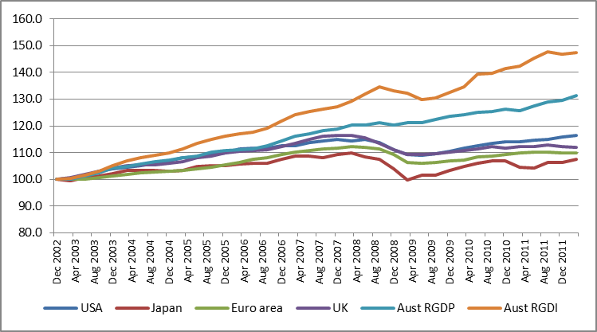
Notes: Data are expressed as indices based to 2000 = 100 in order to aid comparability.
Source: ABS Cat. no. 5206.0, Table 2; and Reserve Bank of Australia Statistical Bulletin.
This paper addresses some of the issues that Australia faces if and when this transition in the resources boom gathers pace, by considering three questions. First, how should we think about the impact of such as complex phenomena on the economy, and how will that impact changes over time? Second, what are the main challenges that the changing face of the resources boom sets for Australian policy makers? Third, what are the options for responding to some of those central challenges?

We focus on the longer term, and not on the complex issues about how the changing resources boom interacts with many other factors to shape the economy in the short-run. Our intention is not to forecast the future path of the resources boom but to explore the issues that arise if, as many believe likely, both the terms of trade and the level of resources investment fall significantly over the next few years.

- Understanding the Impact of the Resources Boom: Four Main Impacts

In addressing the impact of the resources boom, we consider in this section its direct impact through three main channels – the rise in the terms of trade, the increase in mining investment and the growth in resource exports – without considering the various second round effects that ensue in response to these impacts. These include multiplier effects from different categories of income and expenditure and changes in the exchange rate. Some of these are considered in Section 3.

The terms of trade
It has been well known among Australian policy analysts, at least since the Korean War boom, that large increases in the terms of trade can generate large real income gains. What is less well known is how to measure the real income changes and how they relate to changes in real income from other sources. Indeed, these are not straightforward tasks and there is no universal agreement (see Silver and Mahdavy 1989; UN 1968; Macdonald 2010) on measuring real income gains and on how real income gains from the terms of trade relate to other changes in income.

The key analytical issue arises as follows. Most macro growth analysis relies on real gross domestic product (RGDP) as a measure of real income. But RGDP is not a complete measure of real income gains when there are large increases in the terms of trade. RGDP attempts to measure volume increases in goods and services and, by construction, does not attempt to measure any real income changes that arise directly from the price of imports and exports. Hence, the usefulness of RGDP as a measure of income and living standards during a mineral boom will depend on whether additional income is being generated by an increase in export volumes, measured by RGDP, or an increase in export prices, not measured by RGDP. To measure RGDP national account statisticians deflate each component of current price GDP by its own price deflator to calculate the underlying volume. When the higher export value, generated by an export price increase, is deflated by the higher export price, this will indicate correctly that the export volume and RGDP have not changed. But an export price increase, ceteris paribus, has increased real income. A country must be better off when overseas sales increase substantially because of an increase in export prices.

A deflator is needed to enable the income from the export price increase to be included in a measure of national income.It is has been argued that a domestic expenditure deflator should be used deflate export and import prices to calculate the real gain (often called the trading gain), but the standard practice, also followed by the Australian Bureau of Statistics (ABS), is to use the import deflator to deflate both imports and exports. This practice focuses attention on the terms of trade.

The rise in Australia’s terms of trade since 2003 has been well documented, and is summarised in Chart 2. After a long period of stability, the terms of trade more than doubled between 2002 and 2011. At the peak in the third quarter of 2011, the terms of trade were 110% higher than the average for the decade to 2002. As is evident from Chart 2, most of those gains had occurred by the middle of 2008, although there was another surge after the global financial crisis.
Chart 2. The terms of trade and the trade weighted exchange rate, actual 1998-2012 and indicative 2012-2017
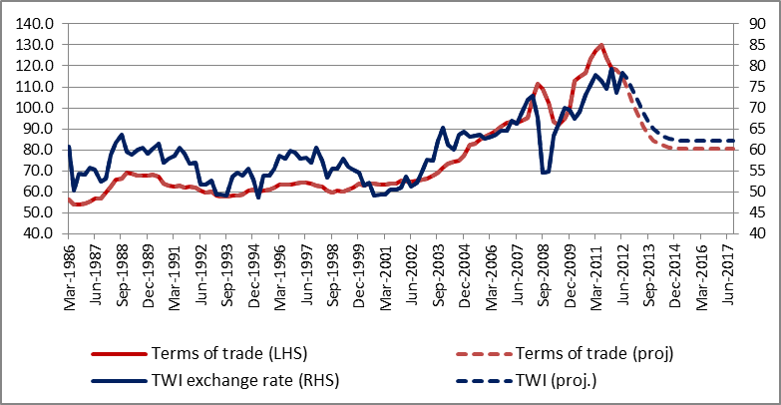
Actual and estimated
Indicative
Sources: For exchange rate, Reserve Bank of Australia Statistical Bulletin; for terms of trade, ABS Cat. no. 5206.0, Table 1.

The increase in real income arising from the higher terms of trade is truly real income, and can be spent on goods and services, either locally produced or imported, can be saved or can be repatriated offshore. If export prices remain high in subsequent periods, relative to import prices, the higher level of income will continue to accrue in those periods, and will only decline if the terms of trade fall. Other things being equal the size of the income gain from an improvement in the terms of trade will be larger the larger the share of exports in GDP. It also follows that the larger the real GDP share of exports the larger the fall in income produced by a decline in the terms of trade.
Chart 2 also brings out the extent of the rise in the trade-weighted $A exchange rate that accompanied the boost in the terms of trade. A close relationship between the terms of trade and exchange rate movements has been observed in Australia for quite some time and this association plays an important role in the adjustment process that flows from a terms of trade improvement.
If the exchange rate rises for a fixed level of foreign currency export and import prices, both export and import prices fall in local currency. This has no impact on the terms of trade gain, but shifts part of the benefit of that gain from exporters to importers. If import prices fall the real value of the income of those using imported goods will rise, to the extent of their use of imports and the degree of price reduction for those particular imports. Over the last decade, the fall in the price of imports induced by the exchange rate appreciation has probably accounted for as much as one half of the increases in real wages. This income increase is a reallocation of the income gains from the terms of trade, via a reallocation from exporters to importers. The exchange rate adjustment does not reduce the total income gain unless it produces a change in export and import prices in foreign currency.
The trading gains to Australia have been estimated by the ABS and the official calculations are included in Chart 3. Australia’s terms of trade reached their peak in the current boom in the September quarter of 2011, and some export prices have fallen significantly since then. It seems highly likely that, as global supply of many products grows rapidly, the terms of trade will fall further over the next few years, even assuming continued strong growth in Asia. But the extent and timing of that fall remain unpredictable.
To help to crystallise the potential policy implications of recent trends, we make some ‘indicative’ assumptions about key variables and estimate the major impacts out to the end of 2017 on this basis (see Chart 2). We assume that the terms of trade fall over the three year period from the June quarter of 2012 to a level 30% above their average in the decade prior to the resources boom, and are stable thereafter. This fall substantially reduces the income gains from the mining boom.
Chart 3. Trading gain since 2002 as a share of GDP, 2002-2017
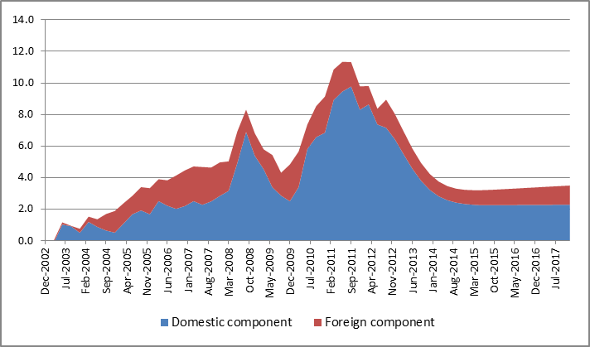
Actual and estimated
Indicative
Source: ABS Cat. no. 5206.0, Table 1; and estimates of the authors.
The estimated trading gain, relative to 2002, falls from about a peak of about 11% of GDP reached in 2011 to about 3.5% of GDP in 2015 and thereafter. It is noticeable from Chart 3 that the trading gain, as a share of GDP, remains significant out to 2017 on these assumptions, and indeed rises a little in the latter years even though the terms of trade are fixed. This reflects the fact that trading gains are calculated from the terms of trade change and the level of real exports. The calculations underlying Chart 3 assume that exports increase faster than GDP and the terms of trade remain higher than in 2002, so that the rapid growth in export volumes leads to a higher trading gain.
There is a complication that we have included in the calculations underlying Chart 3 and highlighted its assumed effect in red. Mining companies are largely foreign so that a significant proportion of the trading gains or losses should accrue to foreigners. The ABS has adjusted the national accounts for their best estimate of foreign ownership of Australian resources. A comparison of real GDI and real gross national income (RGNI) will enable us to estimate the division of the trading gains between Australians and foreigners on a net basis. RGNI is equal to RGDI less net property income payable to foreigners, that is property income payable to foreigners less property income receivable by Australians from aboard. This reminds us that Australians benefit from higher commodities prices through their ownership of resources activities overseas as well as in Australia. Over the past four years the ABS has estimated that Australians have received about 80% of the trading gains, but the distribution is affected by the exchange rate. We have assumed that along with the terms of trade decline the exchange rate devalues substantially. A lower exchange rate does not affect the size of the trading gains but it does affect its distribution between exporters and those who consume imports. In response to the 30 per cent devaluation assumed the proportion of the trading gain that accrues to foreigners gradually rises to 35% by the end of the period shown.
To conclude, we emphasize that economic growth and the economic cycle depend on changes in trading gains. Hence, although Australian income levels at 2017 are higher than at 2003, because the terms of trade are higher, from 2011 onwards the influence of the terms of trade changes are towards reducing income level relative to the 2011 peak.
The resources investment path, local content and construction jobs
Looking forward, the increase in mining investment will become an increasing feature of the mining boom. As with the terms of trade, the rise in resource investment as a share of GDP in this boom will be without precedent in the historical record. The dominant products have been coal, iron ore and LNG. LNG projects have become increasingly important as the boom has matured.
The ABS provide data on mining investment but data on future investment is severely limited. To gain some understanding of the likely further path of resources investment we have undertaken an analysis of about 200 major resource projects, data on which is provided in the April 2012 Mining Industry Major Projects listing published by the Bureau of Resources and Energy Economics (BREE). We also include information that has become available since the April 2012 listing was published.
In the BREE listing, uncompleted projects are classified as advanced (either under construction or committed) or less advanced projects (which are undergoing feasibility studies or awaiting final approvals). The main focus of our analysis is to understand better the time path of capital spending and employment related to these projects. There is, as yet, no evidence of major projects that were classified as advanced in the April 2012 listing being cancelled, although it has become clear that many of the less advanced projects (eg the Olympic Dam project, the Pluto LNG expansion and the second round expansion of the WAIO iron ore port facilities) will not proceed.
The BREE source provides data on the total capital expenditure on the project, the planned start date for operations and, for many projects, the level of construction and operational employment but needs to be supplemented to construct a time path of investment. On the basis of company and other information we have assigned to each project a duration of construction and a spending profile, and have also used that to estimate the time path of construction employment. These and other characteristics of project differ substantially by project type. The results of this exercise are summarised in Table 1 and in Chart 2.
Table 1. Estimated capital expenditure and other variables for 198 major resource projects, 2010-11 to 2016-17
 | 2010-11 | 2011-12 | 2012-13 | 2013-14 | 2014-15 | 2015-16 | 2016-17
Capital expenditure | ($ billion)
Black coal - mining and infrastructure | 5.0 | 8.1 | 12.2 | 15.3 | 13.3 | 7.5 | 2.5
Iron ore - mining and infrastructure | 6.4 | 12.3 | 18.5 | 21.2 | 18.1 | 10.8 | 3.6
Coal seam gas | 3.0 | 8.8 | 14.1 | 17.0 | 14.4 | 9.3 | 4.5
Offshore LNG projects | 7.8 | 17.2 | 25.7 | 28.3 | 24.7 | 15.3 | 6.4
All other projects | 9.4 | 10.0 | 7.4 | 3.9 | 1.8 | 0.6 | 0.0
Total | 31.7 | 56.4 | 78.0 | 85.6 | 72.3 | 43.6 | 17.1
Construction employment | (‘000s)
Black coal - mining and infrastructure | 5.8 | 9.3 | 13.5 | 17.4 | 16.6 | 10.6 | 3.7
Iron ore - mining and infrastructure | 6.9 | 13.5 | 21.0 | 22.8 | 17.6 | 10.1 | 3.5
Coal seam gas | 2.9 | 9.4 | 16.1 | 19.4 | 16.8 | 10.7 | 4.4
Offshore LNG projects | 3.7 | 7.9 | 11.5 | 12.6 | 11.8 | 8.7 | 4.3
All other projects | 12.1 | 13.3 | 10.8 | 7.3 | 4.7 | 1.6 | 0.0
Total | 31.3 | 53.4 | 72.9 | 79.6 | 67.5 | 41.6 | 15.9
Other estimates
Local content of capex ($b) | 21.3 | 35.6 | 46.9 | 49.5 | 40.1 | 23.1 | 8.5
Operations employment (‘000s) | 2.9 | 7.3 | 14.3 | 22.6 | 32.2 | 39.8 | 43.5
Total employment (‘000s) | 34.3 | 60.7 | 87.2 | 102.2 | 99.7 | 81.4 | 59.5
Source: Estimates of the authors based on BREE (2012) and other sources.

Estimated capital expenditure on these projects amounted to about $32 billion in 2010-11, rising to $56 billion in 2011-12 and $78 billion in 2012-13. The estimates suggest that spending will peak in 2013-14, at about 6% of GDP for these projects alone. But, as the projects are completed, capital spending is estimated to fall by 80% to about $17 billion by 2016-17. Construction employment on these projects, as inferred from the project totals specified by the companies, is expected to peak at about 80,000 in 2013-14 but to fall sharply after 2014-15.

Little systematic information is available about the local content of this mining investment, although the ratio of capital expenditure to construction employment is one indirect indicator. It is clear that local content varies with project type, and that the level of local content is likely to fall as the exchange rate rises. On the basis of liaison work at the Reserve Bank of Australia, Connolly and Orsmond (2011) concluded that about half of the cost of mining investment in recent years has been spent in Australia, with higher figures for iron ore and coal and lower figures for LNG. We have constructed local content estimates by using local content share assumptions for different project types, with the shares declining over time as project planning is affected by the high value of the $A.
Chart 4. Estimated capital expenditure, by local and import content, and employment, by construction and operations, for major resource projects, 2010-11 to 2016-17
Panel A: Capital expenditure ($ billion) Panel B: Employment (‘000 persons)
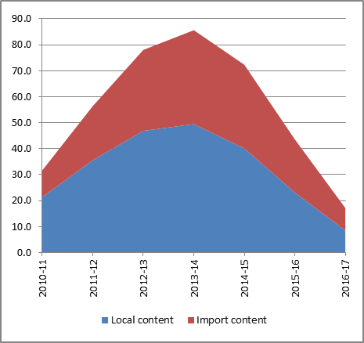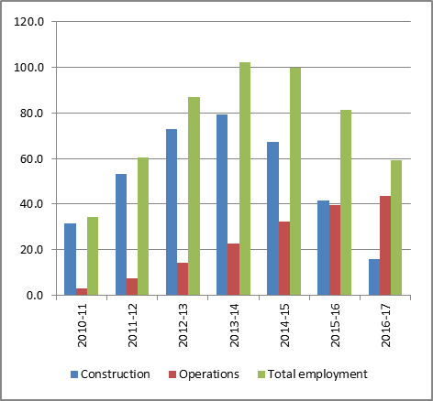
Source: Estimates of the authors based on BREE listing and other information.
It is evident that these mining projects have a relative high import leakage in the investment stage and are highly productive when in operation, employing relatively few people. According to the company figures, supplemented by our own estimates when company data are not available, operational employment on these 198 projects with a capital expenditure of about $400 billion, will generate ongoing operations employment of about 44,000 persons or about 0.4% of total Australian employment. The nine LNG plants are a particular example of this: with capital expenditure of $198.8 billion and the capacity to quadruple Australia’s current exports of LNG, the anticipated increase in operational employment is 5,200.

This characteristic of rising and then falling capital expenditure will be common to all analyses of a fixed set of projects, for the construction period inevitably comes to an end. But two points are relevant here. First these projects are at the heart of the investment boom, and as noted will contribute of the order of 6% of GDP in 2013-14. Secondly, while other projects are possible, there is major source of new projects available to replace these projects when they are completed, especially in a world in which the terms of trade fall significantly. On the basis of these estimates and parallel assumptions about the other components of mining GFCF, we have prepared the overall estimates of the increase in GFCF in mining relative to a 2002 base, and of the domestic content of that investment, summarised in Chart 5.

Chart 5. Increase in mining investment since 2002 as a share of GDP
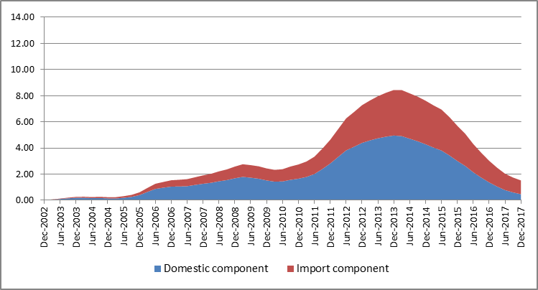
Actual and estimated
Indicative
Source: ABS Cat. no. 5248.0, Table 58; and estimates of the authors.

It should be noted that, as these are changes relative to a 2002 base, they imply that the mining investment to GDP ratio, so defined, will peak at over 10% of GDP but will in due course fall rapidly. These estimates also imply that, even as late as 2016-17, the total level of mining GFCF will be over 3% of GDP, a high figure by historical standards.
The production and export phase
This massive investment in resource projects is above all export oriented, and we estimate that Australian resource exports will at least double, in volume terms, in the decade from 2010-11. Beyond investment, several characteristics of the production phase of resources in Australia are relevant to understanding the policy issues. While projects will inevitably differ by product type, these projects will have low employment in the production phase, as noted above, with limited other domestic linkages in terms of purchases. As important form of domestic linkage will be through royalties and taxes paid, but in terms of Australian Government tax receipts the lags to full production, the presence of deductible state royalties and high depreciation allowances and the low domestic multipliers will all reduce the direct flow of tax revenues to the Australian Government in the medium term. But the underlying tax base is being increased strongly as these projects get underway.
Australia’s mining industry has a high degree of foreign ownership, consistent with Australia’s extensive integration into the global economy. Connolly and Orsmond (2011) estimated that the industry was about 80% foreign-owned, and many large new projects are 100% foreign owned. The only relevance of this fact here is that it means that much of the income earned will the distributed overseas, again reducing the domestic impact.
Our indicative estimates of the domestic impact of the expansion of resource exports are based on the following assumptions:

- that the volume of resource exports doubles between the June quarter of 2012 and the final quarter of 2017;
- that the domestic impact of the production stage of the new projects coming on stream is significantly lower than of existing mining activity, because of more capital intensive technologies and higher levels of foreign ownership; and
- these features are particularly marked for the LNG projects, and especially the offshore ones, which are coming on stream later in the period.

An extreme example of these trends is the Shell Prelude project, which is a $15 billion wholly foreign-owned LNG situated in waters offshore in Western Australia. Shell is constructing in Korea a massive platform which will be towed to the offshore site, and from which all drilling, liquefaction and shipping activities will take place, with none of the gas being piped to the Australian mainland. The domestic impact is likely to be minimal, other than through the tax paid.

Chart 6. Increase in resource exports since 2002, as a share of GDP
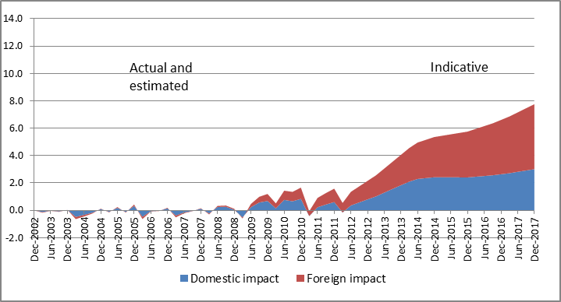
Source: ABSCat. no. 5302.0, Table 101.
The resulting estimates of the increase in resource exports as a share of GDP, relative to a 2002 base, are shown in Chart 6, together with the estimates of the domestic impact. On these figures the increase in resource exports amounts to nearly 8% of GDP by the end of 2017, but of this the domestic impact is only about 3% of GDP. As previously stated, the specific numbers are intended as indicative only, although the broad trends seem indisputable.
Summary of impact
Charts3, 5 and 6 above have summarised our estimates of the net domestic impact, as a proportion of GDP, of the rise in the terms trade, the increase in mining investment and the developing increase in resource exports, with indicative figures out to 2017. There are some differences between these items – the terms of trade effect is the net increase in real domestic income, while the investment impact is on domestic demand and the export effect is a mixture of the two. Nevertheless, for illustrative purposes we add them up in Chart 7, to get a simple measure of the net direct impact of the resources boom.
These figures suggest that this impact, measured relative to a December quarter 2002 base, amounted to about 12% of GDP in 2011 and 2012 but will fall steadily to about 6% of GDP by 2016-17. They illustrate the massive net impact direct of the resources boom on the economy from these three factors (leaving aside the many other consequent changes, such as the multiplier effects of investment spending and the rise in the exchange rate). But they also suggest that this impact will fall by perhaps half over the next five years. By 2017 the net impact of the boom remains at about 5%, reflecting the rise in resource exports, the assumption that the terms of trade remain above their 2002 level and investment in resources remaining well above the long term trend.
Chart 7. Net direct impact since 2002, as a share of GDP
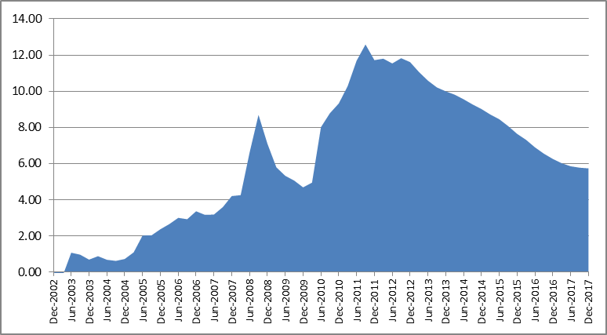
Actual and estimated
Indicative
Source: National sources and estimates of the authors, as noted in Charts 3, 5 and 6.
We stress again the range of assumptions required to generate the historical figures underlying Chart 7, and the indicative nature of the estimates out to 2017. No one can know the future, and in particular we are not attempting to address any of the complex issues about how these factors inter-relate with others, both at home and abroad, to shape the short-term future of the economy. Nevertheless, there are six key facts that underlie these indicative numbers:
- that resource prices, and hence the terms of trade, have peaked and are likely to fall significantly at some time over the next few years;
- that much of the benefits of the terms of trade accrues to Australians, both through their share of higher export revenue and through lower import prices flowing through the higher value of the $A;
- that resources investment is approaching its peak and in due course will fall quite sharply, as there are relatively few large new projects in the pipeline and likely to proceed;
- that resources investment has a relatively high import content, and that this is rising because of the high $A and of the shift to large LNG projects with major components fabricated offshore;
- that exports of resource products will rise rapidly over the decade from 2010-11, probably more than doubling in real terms over that period; and
- that these increased exports have a low employment and more generally low linkages into the domestic economy.
In our judgement each of these facts are well documented, although putting hard numbers on them is quite a different matter. But they do imply that the net direct impact of the resources boom is likely to decline quite sharply as the terms of trade fall and as resources investment passes its peak and begins to fall, and that the magnitude of that reduction will be large.
- Endogenous Responses to the Net Direct Impact of the Resources Boom

So far we have been discussing the net direct impact of the resources boom. But such an impact will inevitable put in train a wide range of endogenous responses, which are at least worthy of another paper. Here we just mentioned what we take to be the two main such responses: the immediate spill-overs of mining activities to related industries, including supplier industries, and the rise in the $A, with consequent effects of imports and on trade exposed industries.

Considerable work has been done, both in the Australian Treasury and in the Reserve Bank, to study the broader effects of mining investment. For example, Gruen (2011) defines mining and mining related industries, which together cover those parts of the domestic manufacturing, construction and services industries that contribute directly to mining investment and production, and uses the input-output tables and other information to allocate value added across detailed industries to these components. He finds that the mining and mining-related industries together account for about 20% of the economy, by comparison with 7-8% for mining as defined by the ABS. Value added in this more broadly defined sector has been growing very rapidly, with the mining-related component expected to growth by over 20% per annum in the three years 2010-11 to 2012-13. In this way the impact of the rise in mining investment has been amplified on the way up, but also will be amplified on downside as this investment falls.

The other factor is the rise in the exchange rate (see Chart 2), and the consequent effects of imports and on trade exposed industries. Indeed, Chart 8 shows that the diversion of gross national expenditure to imports over the past decade has been without precedent in the recent historical record. Between 2001-02 and 2011-12 the share of net imports to GNE rose from –7.8% to 3.9%, a change of 11.7% of GNE. This reflected several factors, including the changing global competitive position associated with the rise of Asia, the capital investment boom and the rising $A exchange rate. But even if all imports of capital goods are removed from net imports, the rise in the net imports/GNE ratio over the decade is still about 9% points. This diversion of demand into imports has been a powerful offset to the expansionary forces discussed above.

Chart 8. Net imports as a share of GNE, based on moving annual totals, in real terms
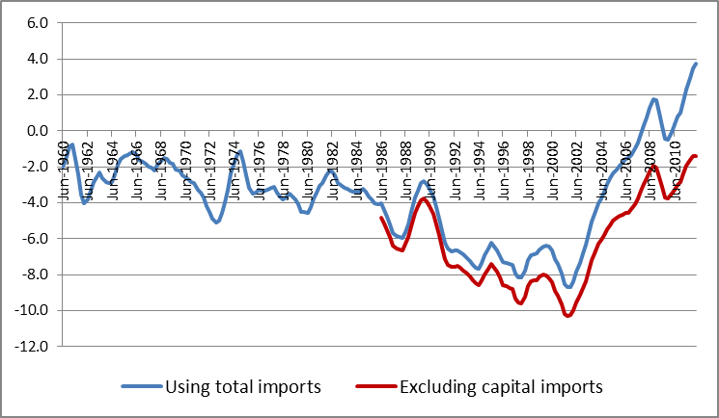
Sources: ABS Cat.No. 5206.0.Table 2; and estimates of the authors.

About the response of endogenous factors going forward we make just two comments. The first is that, just as the broader linkages of mining investment amplified the impact of the rise in that investment on the economy, so they will also amplify the effect as mining investment falls. The second is that, while the assumed fall in the exchange rate will reduce the competitive pressure on the non-mining import competing sector, we would expect that impact to be limited by lags and hysteresis effects. That is, businesses will take some time to assure themselves that any reduction in the $A is permanent and to revise their business strategies accordingly, and some of the changes made as a result of the high $A (such as closure of manufacturing plants) will not be reversed.
In our view the net effect of the discussion to date is that in the coming years Australia faces a major deflationary demand shock as the resources boom unwinds. While precise estimates are not possible, this shock will be considerably less (in reverse) to the stimulus provided by the resources boom over 2003-12 but may take place over a shorter time frame. The timing of this shock is difficult to predict, because it is the net effect of several major factors, each of which are influenced by developments both abroad and at home. But the key facts – that the terms of trade and investment aspects of the resources boom will unwind and that the unwinding will have a major impact on income and growth in Australia unless there is an effective policy response – seem inevitable.
- Policy Issues over the Medium Term
In this section of the paper we take up some of the issues involved in finding an effective policy response. While the reality of a downside shock seems inevitable, there seems to be some time to come before the full effect is felt. This means that there is time for a proper national debate to develop a coherent set of policy responses, rather than a series of short-run responses to a sudden threat.
The key policy issues
Many commentators have focused on labour market reform and improvements in productivity. There are, in our view, good reasons why these are not key issues. Falling productivity in mining and the electricity, gas and water industries have made a significant contribution to the observed productivity slowdown, and there are special factors for each of these. Aggregate productivity grew strongly through 2011-12, and should accelerate as mining output builds up. The fact that we have been through the biggest resources boom in our history without any relevant inflation is a great tribute to our labour market and wage setting institutions. Labour market reform and productivity enhancing reforms are worthwhile but they are unlikely to contribute substantially to a more effective management of the economic downturn that we are discussing and it would be disappointing if these issues diverted attention from our main argument. The key challenge, in our view, is to manage the implications of the unwinding of the resources boom for domestic demand and employment.
The limits of monetary policy
The experience of Japan for nearly two decades, and of the USA and Europe more recently, has focused attention on the relative roles of monetary and fiscal policy, and indeed on the limits of the both. These limits are very clear today, where both the USA and Europe are in the zero interest rate trap, and hence at the limits of conventional monetary policy, and also have to deal with very large budget deficits and debt loads, and hence are at the limits of conventional fiscal policy.
Until recently, theory and practice around the world has given primacy to monetary policy in responding to macroeconomic shocks. But, with many economies in the zero interest rate trap, the limits of monetary policy are now being realised. Monetary policy cannot be expected to play the central role in addressing the long term demand shocks that we believe that Australia will face. Indeed, heavy reliance on monetary policies in the short run may prejudice effective policy later. In particular, the current de facto policy settings – that monetary policy will support the economy in the short-run while fiscal policy is restrictive at both federal and state levels – contain serious risks for the longer term. Australia’s ability to respond effectively to the medium term demand shock will be compromised if the resources of conventional monetary policy are exhausted in the early stage of the response.
The challenges facing an expansionary fiscal policy
By international standards the budget and debt position of the Australian Government is very strong, and the resources boom should strengthen that position in the long term, as the effective doubling of mining activity ultimately generates stronger revenue streams. In this sense it might seem that Australia has a good deal of fiscal space to address the issue at hand, either in the general sense of having substantial room for fiscal manoeuvre in responding to shocks or in the more technical sense used in the literature of the gap between the actual or projected level of debt and the level at which debt becomes unsustainable (Ostry et al. 2010). This is indeed what the current estimates do show (Ostry et al. 2010; Ghosh et al. 2011). But over the policy horizon we are considering fiscal policy faces three serious constraints, which may limit its ability to respond fully to the demand shock.
- Low revenue levels.
As discussed in the 2012-13 Budget Papers, current levels of Federal revenue as a share of GDP are very low by historical standards. In 2010-11 the ratio of revenue to GDP was lower than had been at any time in the past 35 years, and below even the low point reached in the trough of the early 1990s recession (1992-93). There are essentially two reasons why this has occurred. One is a range of factors emerging after the GFC and discussed in the Budget Papers (see below). The second is the severe misreading of fiscal policy during the first stage of the resources boom, when large scale tax cuts were provided in successive budgets even though the economy was strong. In the five Budgets from 2003-04 to 2007-08 (inclusive) tax revenue foregone amounted to $60 billion, or 5.1% of GDP in 2007-08.

- Poor medium term outlook for revenue.
In Statement 3 of Budget Paper No 1 for 2012-13, Treasury says that:
The downward revisions since MYEFO principally reflect sluggish asset prices, consumer caution, weak profitability outside the resources and resources-related sectors, and high levels of investment-related tax deductions within the mining sector.(pp. 3-6)

These factors, and especially those connected with the resources boom, seem likely to persist for some time as the resources boom unwinds. Both profits and wage incomes in the non-resource sector will remain subdued through much of the next phase as will taxable profits of resource companies from existing projects.
- Prime focus on deficit elimination and debt reduction in the political debate.
In the expansionary phase of the resource boom it was appropriate to focus on deficit elimination and debt reduction, and indeed the available room for policy in the third stage would be greater if there had been more focus on these issues during the expansionary stage. But, reinforced by the fiscal disarray evident in many other developed countries, the commitments of that time have become enshrined in the policies of both major parties. This is likely to be an obstacle to rational discussion of the role of fiscal policy in meeting the challenge ahead.
In response to the emerging deflationary shock, the Government should, and in practice will be forced to, follow a more expansionary fiscal policy, with continuing deficits and increasing debt. But the extent of this response will be limited by the factors noted above. It will also be limited by uncertainty about the long run revenue receipts from resources projects, and this matter needs to be the subject of serious investigation, so that fiscal policy can be placed on a firmer footing.
From resources Investment to infrastructure investment
It is common ground in Australia that the country has a major infrastructure deficit, with a long term backlog of necessary investment estimated in several quarters to be equivalent to 40-50% of annual GDP. There are several reasons for this situation, one of which has been the emphasis placed by governments over the past two decades on deficit and debt reduction. Another has been the impact of the resources boom on the economy, and especially on the engineering and construction sector, which has limited the scope for initiating further big infrastructure projects. At the same time, sustained economic and population growth around the country has contributed to additional infrastructure requirements.
Australia’s system of fiscal federalism has also contributed to this infrastructure problem. Most of the infrastructure areas in question are the responsibility of the states rather than of the national government. But the states have limited revenue powers, and hence limited capacity for further borrowings while still retaining AAA or near-AAA credit ratings, given that the ratings agencies use the ratio of tax supported debt to consolidated operating revenue as a key ratings criterion. With low debt and a relatively strong revenue base, the Australian Government has substantial borrowing capacity and indeed the yield on Australian Government 10 year bonds has fallen to nearly 3% per annum.
But the states as a whole do have a source of additional revenue over the next decade or so, namely through the growth in resource royalties that will accrue both from higher prices and from increased capacity as the vast array of new projects currently being built come on stream. Mining-related revenues for the states as a whole totalled $4.8 billion in 2007-08 but were estimated by the GST Distribution Review have more than doubled to $11.1 billion by 2011-12 and to rise to $13.8 billion by 2014-15. With most of the massive expansion in Australia’s LNG capacity to come on stream after 2014-15 total mining revenue could approach $20 billion by 2020. Clearly the path of future prices for key commodities will be an important determinant of royalty levels, even as volumes rise.
In the first instance these revenues accrue to the states in which the projects are based (Western Australia, Queensland and to a lesser extent New South Wales). The practice of fiscal capacity equalisation means that these additional revenues are effectively additional resources for the states as a whole, after a lag. The states with the first round of additional revenues get a lower share of the GST pool and the other states get an increased share, to offset their lack of revenue raising capacity in this regard.
Another important institutional development in respect of infrastructure in Australia in recent years has been the establishment of Infrastructure Australia (IA) in April 2008. IA is an expert advisory body providing advice to the Council of Australian Governments on a wide range of infrastructure issues, and assembling and analysing a database of high projects ready to proceed or in the assessment pipeline. While IA has contributed significantly to a more professional approach to infrastructure planning and assessment, and some initial priority projects have been funded by governments, more substantive progress has foundered to date on the funding issues.
In considering infrastructure issues it is important to distinguish between the funding and financing of infrastructure investment. The states have the prime responsibility for funding infrastructure but have highly constrained operating budgets, few revenue powers and, for political reasons, limited appetite for much higher user charges. In terms of low cost financing through government borrowing, the states have limited capacity for additional borrowing and the level of government with such capacity and the lowest borrowing cost (the Australian Government) does not have the prime responsibility for funding infrastructure. While there are many higher cost private sector financing options available, these all ultimately require the relevant State Government to have the capacity to fund the project.
One way to cut through these problems might be use some part of the rising mining royalty revenue of the states to fund infrastructure investments, while using the Australian Government’s strong borrowing capability to underpin the financing task. One way in this might be done is as follows:
- Set up a new joint Commonwealth-State body, say Infrastructure Financing Australia (IFA);
- Allow IFA to borrow for infrastructure projects with a high social rate of return , backed by an Australian Government guarantee; and
- Having regard to the increased revenues that all states are getting, in one way or another, from the combination of mining royalties and GST, draw off part of the GST revenue to meet the funding debt costs, including some guarantee fee, of infrastructure borrowings by IFA.
The effect of this approach would be to allow a significant number of high quality infrastructure projects to proceed quickly. The funding cost would be met by the states in proportion to the scale of projects financed, while they would receive benefits in line with the high social rate of return. One effect of this would be to introduce some element of equalisation of infrastructure funding capacity into Australia’s system of fiscal federalism.
- Conclusions
In summary, our conclusions are as noted below.
Impact of the resources boom over the past decade. The resources boom has been the dominant influence on the Australia economy for nearly a decade now, with a major expansionary impact. This has arisen from the increase in the terms of trade and from the local content of resources investment, net of the lagged effect of the higher $A on trade-exposed non-resource industries. Of these the rise in the terms of trade has been the most important.
Deflationary shock as the resources boom unwinds. As the resources boom unwinds over the next few years, Australia will experience a large deflationary impact, primarily driven by the fall in the terms of trade and in resource investment. The production and export of resource commodities will rise sharply as projects are completed, but this will generate little employment and limited domestic income to offset the terms of trade decline and the falls in mining investment. Whether the exchange rate remains high or falls sharply over this time period will mainly affect the form rather than the scale of this deflationary shock: a high $A will preserve real income gains through lower import prices for those who consume imports but at the cost of continued pressure on trade exposed industries, while the effects will be reversed if the $A falls sharply.
Key policy challenge is how to respond to this deflationary shock. Many have argued that the productivity growth or labour market reform are central issues to be addressed as the resources boom passes. Productivity growth in the long run is particularly important but in our view the key challenge over the next few years lies in addressing the change in the impact of the resources boom from expansionary to deflationary.
The limits of monetary policy. Until recently, theory and practice around the world has given primacy to monetary policy in responding to macroeconomic shocks. But, with many economies in the zero interest rate trap, the limits of monetary policy are now being realised. Monetary policy cannot be expected to play the central role in addressing the long term demand shocks that Australia now faces. Indeed, heavy reliance on monetary policies in the short run may prejudice effective policy later. In particular, the current de facto policy settings –that monetary policy will support the economy in the short-run while fiscal policy is restrictive at both federal and state levels – contain serious risks for the longer term.
A more expansionary fiscal policy will be needed, but fiscal policy also has limits. Australia has a strong fiscal and public debt position, and is recognised as having extensive ‘fiscal space’ to address shocks such as those discussed here. But three factors qualify that assessment. First, government revenue as a share of GDP is currently at a historically low level, as a result of revenue of about 5% of GDP foregone in tax cuts in the first stage of the resources boom and of special factors since the GFC. Secondly, revenue is likely to grow only slowly over the medium term, because of slow growth in the non-resource sector and in tax payments from resource companies. Thirdly, the focus of the political debate remains firmly on deficit elimination and debt reduction, still reflecting earlier stages of the resources boom.
In response to the emerging deflationary shock, the Government should, and will, follow a more expansionary fiscal policy, with continuing deficits and increasing debt. But the extent of this response will be limited by the factors noted above. It will also be limited by uncertainty about the long run revenue receipts from resources projects, and this matter needs to be the subject of serious investigation.
From resource investment to infrastructure investment – a central response. It is widely agreed that Australia has a massive infrastructure backlog, amounting on some estimates to 40-50% of GDP. A central task for policy, as the resources boom goes from the investment to the production phase, is to find ways to stimulate large scale infrastructure investment. This replacement of resources investment by infrastructure investment should be at the heart of the response to the deflationary shock.
New cooperative approaches to major infrastructure investment are possible. Achieving large scale infrastructure investment will involve finding innovative ways of both funding (that is paying for) and financing (that is raising debt or equity capital for) infrastructure. Most infrastructure is the responsibility of State Governments, which have very little capacity to raise extra debt or, at the moment, to fund major infrastructure investment. The Commonwealth has a very strong position in debt markets, but has limited inclination to fund infrastructure in the States’ areas of responsibility.
As a result of the resources boom the States are gaining increased revenue through mining royalties, which could reach $14 billion by 2014-15 and perhaps $20 billion by 2020. These flow initially to the resource States but then are substantially redistributed to other States through the fiscal equalisation system. If the federal and state governments were to set up a joint infrastructure funding body that could borrow with an Australian Government guarantee, a component of the GST pool could be directed to the funding body each year to meet financing costs. This in effect would be a use of higher resource revenue (for the resource states) or of the benefit non-resource States get from resource revenue. For the Commonwealth it would have no impact on the budget deficit but would increase the level of debt guaranteed. We also suggest that this innovation be used to reform the tax revenue base and suggest that consideration be given to increases in the GST rate. This is probably required, not only in response to the past evolution of taxing arrangements over the mining boom period but also in anticipation of the changing demographics of the Australian work force.Our proposed institutional changes to infrastructure development in Australia would be a win-win situation, providing benefits for both levels of government and the Australian economy.
References
Bureau of Resources and Energy Economics (BREE) 2012, Mining Industry Major Projects April 2012, Canberra, May.
Connolly, E. and Orsmond, D. 2011, The Mining Industry: From Bust to Boom, RBA Research Discussion Paper RDP2011-08, Reserve Bank of Australia, Sydney, at http://www.rba.gov.au/publications/rdp/2011/2011-08.html
Ghosh, A.R., Kim, J.I., Mendoza, E.G.,Ostry, J. and Qureshi, M.S. 2011, ‘Fiscal Fatigue, Fiscal Space and Debt Sustainability in Advanced Economies’, NBER Working Paper No. w16782, National Bureau of Economic Research, Cambridge, Mass.
Gregory, R.G. 2011, 'Then and Now: Reflections on Two Australian Mining Booms', CSES Working Paper No. 50, October, Centre for Strategic Economic Studies, Victoria University, Melbourne.
Gruen, D. 2011, ‘The Macroeconomic and Structural Implications of a Once-in-a-Lifetime Boom in the Terms of Trade’, address to the Australian Business Economists, Sydney, 24 November.
Macdonald, R. 2010, ‘Real gross domestic income relative prices and economic performance across the OECD’, Review of Income and Wealth, vol. 5, no. 3, pp. 449-650.
Ostry,J., Ghosh, A.R., Kim, J.I. and Qureshi, M.S. 2010, ‘Fiscal Space’, IMF Position Note SPN/10/11, International Monetary Fund, Washington DC, at www.imf.org/external/pubs/ft/spn/2010/spn1011.pdf
Silver and Mahdavy 1989Silver, M. and Mahdavy, K. 1989, ‘The measurement of a nation’s terms of trade effect and real national accounting framework’, Journal of the Royal Statistical Society, vol. 152, no. 1, pp. 87-107.
UN 1968United Nations (UN) 1968, System of National Accounts: Studies in Methods (ST/STAT/SER.F/2/Rev.3.Sales No. E.69.XVII.3), United Nations Statistical Commission, New York.

Over the period of interest, the estimated Australian trading gains do not differ significantly when calculated with either of the two main deflators. Further discussion of these and related issues can be found in Gregory (2011).
There are currently nine large LNG plants under construction, with a total capital cost of just on $200 billion, and with total production capacity of 64 Mt in their initial stages. By comparison Australia’s exports of LNG in 2010-11 were about 20 Mt.
There are two main ABS sources of data on mining investment, that on overall gross fixed capital formation in mining (GFCE)(ABS Cat.No. 5204.0) and that on new capital expenditure by private businesses (NCE)(Cat.No. 5625.0). The former is more inclusive – including for example spending on exploration and on R&D – while the latter is available on a quarterly basis and is more often cited. For the latest year for which data are available (2010-11) mining GFCE reached 4.8% of GDP, three times its 2002-03 level of 1.6%, and by comparison with 3.2% on the NCE measure. As investment rose sharply, the NCE measure jumped to 6.3% of GDP by the June quarter of 2012, and the ABS investment intentions survey (and other sources) confirms that a further substantial increase is underway in 2012-13.
We have also made judgements about two major projects about which there remains uncertainty, the Roy Hill iron ore project and the Browse LNG project. We have assumed that, given the quality of the iron ore deposit, the Roy Hill project will proceed but will be delayed for some time. On the Browse project we have assumed that it will not proceed in our timeframe, given the uncertainty about the location of the liquefaction plant and about the choice between available options.
This estimate is based on Treasury estimates of tax receivable at unchanged tax rates compared to revenue actually received. It is not yet known whether or not the unchanged tax rate figures are adjusted for forecasting errors – Treasury substantial underestimated the growth of revenue over this period (by about three percentage points per year). If they are not adjusted this estimate is an underestimate, because the revenue at unchanged tax rates would have been higher if the correct forecasting model was used.

