Discussion Paper
For consideration and feedback

Early thinking: Operational governance for
trans-Tasman e-Invoicing

October 2018

Purpose
This paper provides information about the trans-Tasman electronic invoicing (e-Invoicing) collaboration and seeks feedback from a few key stakeholders on early thinking about operational governance options for trans-Tasman e-Invoicing arrangements. The feedback we receive will inform the further development of options and related advice to Australian and New Zealand (A-NZ) governments.

Introduction and invitation to comment
As outlined in the background section of this paper, the A-NZ governments have committed to progressing a standardised, trans-Tasman e-Invoicing framework. The A-NZ officials’ joint working group will shortly need to develop advice for responsible A-NZ Ministers on longer-term management and delivery arrangements (operational governance) for the ongoing collaboration.

We invite you to review our initial thinking, as outlined in this document, and make submissions in relation to the questions posed in this document. Please also provide any other comments or suggestions you might like to make.

Please email your feedback by Friday 16 November 2018 to:

Australia: BRRSecretariat@ato.gov.au
New Zealand: e-Invoicing@nzbn.govt.nz

If you would like to discuss any of the information in this paper before you send your reply, please call:

Australia: Mark Stockwell – phone +61-7-3149-5022 or mobile +61-4-2200 9518
New Zealand: Henry Dowler – mobile +64-27-344-6691

This Trans-Tasman collaboration is in its early stages. The operational governance issues and options in this paper will be considered by A-NZ Ministers following completion of this public consultation phase. The content of this paper is not Australian or New Zealand government policy.

Thank you very much.

Mark Stockwell Joanne Hogan
e-Invoicing Project Manager Director, New Zealand Business Number
Australian Taxation Office Ministry of Business, Innovation & Employment
Australia New Zealand

Background
Each year, A-NZ businesses process around 1.3 billion invoices. Paper and email based invoicing is manually intensive and prone to human error resulting in increased processing costs and payment times for businesses. e-Invoicing is the direct, electronic exchange of invoices between suppliers’ and buyers’ systems. e-Invoicing is a clear opportunity to streamline business-to-business transactions, improving efficiency and reducing error handling, saving businesses time and money. Research estimates that e-Invoicing could result in benefits to the Australian and New Zealand economies potentially in excess of $30 billion over ten years.

The Single Economic Market Agenda and government commitments
The A-NZ economic and trading relationship is recognised as one of the closest, broadest and mutually compatible in the world. The A-NZ governments have committed to a process called the Single Economic Market agenda (SEM), designed to create a seamless trans-Tasman business environment. The SEM builds on the A-NZ Closer Economic Relations (CER) agreement.

The SEM has already brought significant economic benefits to both countries by lowering business costs and increasing the ease with which both businesses and people can operate across the Tasman. This includes improving the business environment through regulatory coordination and helping businesses to take advantage of openness in trans-Tasman markets, for example through the A-NZ Leadership Forum (the Forum).

The Forum is a business-led initiative designed to further develop both the A-NZ bilateral relationship, and to provide a vehicle for direct business input into the trans-Tasman economic integration agenda. The Forum brings together Ministers and leaders of business, government and academia to create an independent public platform for discussing the A-NZ relationship.

On 2 March 2018, at the annual A-NZ Leaders’ meeting in Sydney, the A-NZ Prime Ministers made a joint statement reaffirming the commitment to broadening and deepening the economic relationship between the two nations to achieve Trans-Tasman economic integration, as part of SEM. This statement included a commitment to jointly pursue “common approaches to e-Invoicing”.

In Budget 2018, the New Zealand government committed operating funding to support the e-invoicing collaboration. On 31 May 2018, the Australian Government confirmed that work to progressively adopt e-Invoicing (eInvoicing) will begin across all levels of government.

The e-Invoicing interoperability framework
You may already be aware of the Australian Digital Business Council (DBC) and the e-Invoicing interoperability framework developed by the DBC. If not, Appendix One to this paper provides an overview of that framework.

The DBC is an industry driven initiative of peak Australian industry bodies, technology providers and has also involved government agencies. The Australian Government (Australian Taxation Office - ATO) has provided secretariat support. The DBC and ATO collaborated on the creation of the framework by setting up working groups comprising of a broad range of industry stakeholders.

Establishing a trans-Tasman e-Invoicing approach
The A-NZ governments have established a joint officials’ working group to support industry to standardise eInvoicing processes in Australia and New Zealand, and take advantage of opportunities arising from the digital economy.

The working group includes members from the ATO, the Department of Industry, Innovation and Science, the Department of Jobs and Small Business, the Digital Transformation Agency, the Australian Treasury; and the New Zealand Ministry of Business Innovation and Employment and Office of the Government Chief Digital Officer. Representatives from Australian state and territory governments (New South Wales and South Australia) are also participating.

In August 2018, A-NZ officials advised their respective Ministers that, in the context of SEM, a common trans-Tasman approach to e-Invoicing is the best way forward. Ministers have agreed and confirmed the following five design principles for the common approach.
- Interoperable single digital economic market – including systems, technology, semantic models, alignment of international standards to ensure ease of trade across jurisdictions;
- Digital inclusion – to enable easy access to all businesses and digital service providers and aligned to the Digital Service Standard for both Australia and New Zealand;
- Open and responsive to change and innovation – ability to respond to changes in a dynamic environment whilst enabling innovation in broader contexts such as procure-to-pay and eDelivery/digital message exchange;
- System integrity – trusted and secure; and
- Government commitment – commitment by multiple layers of governments to deliver an integrated solution across multiple jurisdictions.

The introduction of this common e-Invoicing approach will make it faster and easier for businesses on both sides of the Tasman to interact and transact with each other, and with government. This means that, in future, we will see A-NZ businesses being digitally enabled and directly transacting with one another in an efficient, automated and standardised way. This will improve productivity, reduce instances of fraud, improve data quality, and enrich interactions between businesses when dealing with each other, and with government.

Governance of the trans-Tasman approach
Formalising the international arrangement

Although the trans-Tasman design principles have already been approved by A-NZ Ministers, the A-NZ governments are considering some form of arrangement which covers joint ‘strategic’ governance arrangements at the international level and other matters such as:
- A-NZs’ shared objectives for e-Invoicing;
- the scope of the collaboration (i.e. what is in and what is out of scope);
- the general spirit and intent of the parties entering into the arrangement and any guiding principles for working together;
- any specific commitments being made as part of the collaboration; and
- responsibilities and key accountabilities, including trans-Tasman monitoring and reporting requirements.

Longer-term operational governance in the A-NZ context

The A-NZ level arrangement will not address longer-term management and delivery arrangements (operational governance) for trans-Tasman e-Invoicing. Therefore, this engagement with key A-NZ stakeholders is a critically important step for the working group as we develop advice for Ministers, in the context of SEM, on operational governance options for trans-Tasman e-Invoicing.

The intention is to establish an independent, fair and equitable governance structure for trans-Tasman e-Invoicing. The graphic below provides an illustration of how the operational governance body may function in the broader context and its relationship with the A-NZ ‘strategic’ governance arrangements.

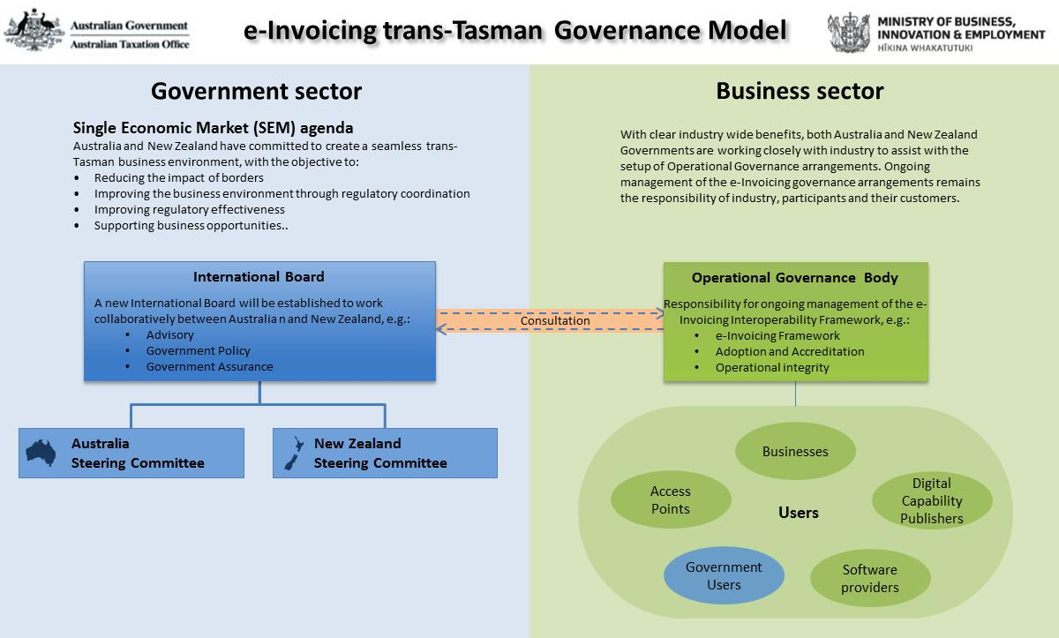

Research has not revealed any similar trans-Tasman or international e-invoicing governance arrangements involving both the public and private sectors that could be used as illustrative examples within, and provide guidance for this consultation.

Key considerations for operational governance

Introduction
The A-NZ governments want to work collectively with industry on both sides of the Tasman to determine and establish longer-term operational governance arrangements for a common trans-Tasman approach to e-Invoicing.

In doing this, it will be necessary to consider issues and options around matters such as:
- the advantages and disadvantages of different types of legal personalities;
- stakeholder and participant interests, roles, responsibilities and decision rights;
- accountabilities, risks and liabilities;
- operational continuity, reliability and sustainability; and
- cost-effectiveness and funding.

Beyond the shared SEM objectives of lowering business costs and increasing the ease with which businesses (including government agencies) can operate within each country and across the Tasman, the governments’ primary interests are around its role in ensuring:
- adequate attention to policy issues such as privacy, intellectual property, security, crimes of deceit, anti-money laundering, and digital identity;
- an appropriate service quality (i.e. as an important piece of economic infrastructure and because government will also be a large user of the service)
- ensuring the operational governance body is self-sustaining; and
- broader regulatory compliance (e.g. with relevant laws).

Operational governance is required for the ongoing management of the e-Invoicing Interoperability Framework, to drive adoption, and is essential to provide assurance to maintain confidence and the trust of users, participants, and their customers in its operations.

The overall operational governance of the broader e-Invoicing ecosystem includes the management of the e-Invoicing Interoperability Framework and the Digital Capability Locator (DCL) service. To participate in e-Invoicing, participants (Access Points and Digital Capability Publishers) would need to have robust relationships with clients and comply with the requirements of the operational governance body, which would cover the following:

- e-Invoicing Interoperability Framework
- Information Technology security controls
- Operational arrangements (set out in additional memorandums/deeds)

The operational governance body will need to establish processes to manage the e-Invoicing Interoperability Framework and associated security and operational arrangements. These arrangements do not preclude software developers or digital service providers operating under existing infrastructure or setting up new islands of trade or direct connections.

Digital Capability Locator (DCL) service

The DCL service is being established by the ATO to support the adoption of e-Invoicing across A-NZ. The DCL is as a centralised lookup facility of “digital addresses” facilitating the delivery of e-Invoices to businesses.

To be given access to the DCL, a digital service provider will need to:
- Meet the ATO Digital Service Provider Operational Framework requirements, and
- Agree to additional terms and conditions specific to the DCL.

The nature of the governance arrangements across the e-Invoicing ecosystem will require collaboration between the operational governance body and the ATO to ensure broader security aspects and risks of the trans-Tasman e-Invoicing framework are appropriately managed.

Legal considerations
Initial policy and legal analyses in A-NZ have concluded that, while further more detailed consideration will be required as collaborative works progress, there are no significant policy or legal barriers to implementation of e-Invoicing in A-NZ.

Question 1
What do you consider to be significant policy or legal barriers to the implementation of e-Invoicing in Australia and/or New Zealand (including NIL confirmation)?

Legal personality, continuity and limited liability

We recognise that operational governance of trans-Tasman e-Invoicing will likely involve a group of stakeholders across government, industry and business. We think that, regardless of who finally participates in the governance arrangement, it should be undertaken by an incorporated entity.

This is because an incorporated entity has its own legal identity separate from its members/shareholders, will operate in accordance with clear ‘rules’ and A-NZ laws treat an incorporated entity as if it were a separate ‘person’ in its own right, so that it can, for example:

- enter into contracts in its own name
- buy, sell, own, lease and rent property
- execute legal documents (such as deeds and leases) in its own name, using its ‘common seal’ (official stamp)
- borrow money and give the lender securities over property owned by the group
- sue and be sued in the courts in its own name.

An incorporated entity also has ‘perpetual succession’, which means it continues to exist as a separate legal entity regardless of changes in its membership/shareholders. This helps to give the collective members/shareholders a stronger reputation (permanence and credibility), for example when it comes to contracting.

Incorporation also helps to limit liability for members/shareholders. When an incorporated entity takes on any debts or other legal responsibilities, it can usually only be sued in its own name, and its members/shareholders aren’t usually personally responsible. Directors’ and officers’ liability insurance would also likely be available to an incorporated entity at a reasonable cost.

By comparison, the relationship between members of unincorporated groups may be less certain over time and they do not have to have rules. Unincorporated groups are not separate legal entities. They do not have a continuing existence independent of their members, and they have no legal standing to own property or borrow money in their own name.

Potentially, the members of an unincorporated group’s management committee (or equivalent), and possibly all members of the group, are personally responsible (liable) for any obligations the group takes on, and for any judgment made against the group by the courts.

Question 2
What do you think would be the best legal structure for the operational governance body? Please explain your answer.

Government and industry participation in operational governance
The A-NZ governments will provide guidance and support to industry in the initial establishment phase (perhaps up to 12-months). We need to be confident that:
- the operational governance arrangements will enable SEM objectives, regulatory compliance, and high quality of service;
- appropriate and continuous risk avoidance and management will occur, including management of reputational risk for government in the event of a security breach at any point in the e-Invoicing model;
- that the operational governance body is self-sustaining; and
- appropriate monitoring and accountability arrangements are in place.

Beyond establishment of the digital capability locator (DCL), our governments’ primary interests can largely be met through regulatory oversight, guidance, monitoring and reporting and, if necessary, enforcement of relevant laws. As noted above, those primary interests relate to matters like privacy, intellectual property, security, crimes of deceit, anti-money laundering, digital identity and compliance with relevant laws.

We also believe an incorporated body with a board structure with an independent chair and officers will alleviate concerns of different parties having undue influence over commercial matters and directions.

Government agencies have substantial businesses transactions in their own right. Both the Australian and New Zealand governments announced in May that government agencies will progressively adopt e-Invoicing. As such, government agencies will be able to monitor, contribute to and influence ongoing operational decision-making as users of the service (i.e. collectively, individually and in association with industry users). In this way, our governments will work alongside industry stakeholders to ensure that e-Invoicing remains continuously fit-for-purpose.

As e-Invoicing is an industry-led initiative for primarily business-to-business transactions, it would not be appropriate for our governments to unnecessarily expose themselves (i.e. taxpayers) to e-Invoicing operational costs and risks. Those costs and risks are best managed through normal corporate/industry business practices and law, such as ‘quality of service’ agreements and terms and conditions. We think this industry-led approach would produce the best overall governance arrangement in terms of industry driven continuous improvement and innovation such as a full procure to pay model, roles, responsibilities, decision rights, costs, and risks.

In practical terms, this would produce an industry-led operational governance arrangement that would include the following functions and roles:
- ownership of the trans-Tasman framework and any associated Intellectual Property (IP);
- oversight of the accreditation model;
- change management for network impacts;
- meeting all relevant regulatory compliance obligations;
- financial management including oversight of a self-funding model and charging structure, which may include licensing charges to providers and/or transactional costs for use.
- stipulating the level of insurance requirement;
- identification of agreed process for dispute resolution;
- defining the level of contract disclosure between parties;
- defining and governing behaviour between service providers operating under the framework
- establishing and maintaining service level agreements, the security framework and ongoing compliance with all relevant requirements (e.g. MoU).

Question 3
a) Beyond the initial establishment phase, who do you think should lead the operational governance of trans-Tasman e-Invoicing; and what functions and roles should the operational governance arrangement include? Please explain your answer.
b) Do you see sufficient incentive in our proposal for you to consider participating in the operational governance body?

Operational sustainability

Our governments’ support and guidance to industry in the initial establishment phase, and ongoing encouragement of government agencies as users of the framework, should help to drive wider adoption and ensure longer-term operational sustainability. We expect that government agencies, like all other businesses, would pay a fair price for the e-Invoicing services they use.

To ensure cost-effectiveness, an industry-led, self-funding (not-for-profit) operational governance arrangement is appropriate. We expect this would likely involve:
- A not-for-profit operational body with trans-Tasman industry and government user representatives;
- a small, efficient core management team (accountable to the operational body) to drive the overall work programme;
- the use of action teams and working groups to complete specific tasks and projects; and
- providing a single interface for trans-Tasman e-Invoicing with industry on both sides of the Tasman.

Self-funding could take the form of transactional fees, licensing fees or other user charges to offset the entity’s costs. Other international invoicing models have a variety of these models and varying scale of operations. We do not have access to details of these operations at this point nor do we believe there is only one solution for the funding.

Question 4
- How do you think the long-term sustainability of the operational governance of trans-Tasman e-Invoicing, with appropriate cost allocations, can best be assured; and what funding models do you suggest? Please explain your answer.

Our initial conclusion about a preferred option
In summary, our initial conclusion is that the preferred option for operational governance of trans-Tasman e-Invoicing, after an initial establishment phase, is an industry-led, self-funding (not-for-profit), incorporated entity with a Board of Directors consisting of industry stakeholder representatives appointed by A-NZ industry groups and governments.

Other options that were considered in the course of this early-thinking process were:
- an unincorporated, industry-led entity;
- an unincorporated entity with industry and government ‘membership’; and
- an incorporated entity with industry and government membership/shareholdings.

The information in this paper, explains that the two unincorporated options were not preferred for reasons such as:
- the lack of a clear legal ‘personality’;
- uncertainty about longer-term relationships between members;
- unlimited liability for individuals and organisations participating as members of unincorporated groups; and
- associated difficulties with managing accountabilities and longer-term sustainability.

Question 5
Do you have any additional comments or information to assist us with reviewing and further developing our early thinking and conclusions about a preferred option for operational governance of trans-Tasman e-Invoicing? If so, please provide your comments here and/or direct us to the additional information you would like us to consider.

Next steps
Subject to the agreement of Ministers, we expect that next steps will be along the following lines. Timings may change, but, all going smoothly; we consider a ten week process for the following steps is realistic and reasonable:
- Closing date for submissions (16 November)
- Consideration of submissions (November)
- Ministers to consider and announce joint A-NZ agreement on the way forward (to be confirmed subject to this consultation process feedback)

Appendix One: The Australian Digital Business Council Interoperability Framework

The following information is extracted from the Australian Digital Business Council publication ‘eInvoicing Interoperability Framework’ (July 2016, Version 1.0). For more detail, click on the following link: http://digitalbusinesscouncil.com.au/interoperability-framework/

The Framework aims is to provide certainty on how a prescribed set of established open standards can be used to extend eInvoicing to all Australian businesses, minimise the cost of implementation for software providers and enhance business interactions (especially for micro to small businesses) by making invoicing an automatic digital interaction.

What is it?
The Council’s Interoperability Framework is based on the concept of standardising interconnections around what is called a ‘four corner model’. Similar models have emerged from the financial sector (for inter-bank interoperability), telecommunications sector (for global roaming) and are already being used in many countries for eInvoicing. In Australia, the superannuation sector (via Superstream) also uses a standardised form of the ‘four corner model’.

Under this logical model, businesses can send messages:
- directly to each other by implementing their own Access Points (without intermediaries);
- via a mutual 3rd party Access Point (3-corners); or
- via two independent external service providers (4-corners).

As the digital economy grows, the trend is toward the increased use of 4-corner models. However, as with rail networks, telephony systems and other communication technologies, unless standards are introduced, complex and expensive interconnections are required to connect all existing participants. The DBC Framework has proposed standards for the creation of an ‘open’ 4-corner model.

A key requirement for the eInvoicing Interoperability Framework is that a Buyer’s or Supplier’s digital address and digital capabilities may change over time. The associated challenge with using an ‘open’ 4-corner model is finding out what businesses are reachable and what their digital capabilities are. The Framework resolves this by establishing a business discovery service. The idea of using the 4-corner model with business discovery is a well-established and an internationally accepted solution, and an extension to the existing Superstream model.

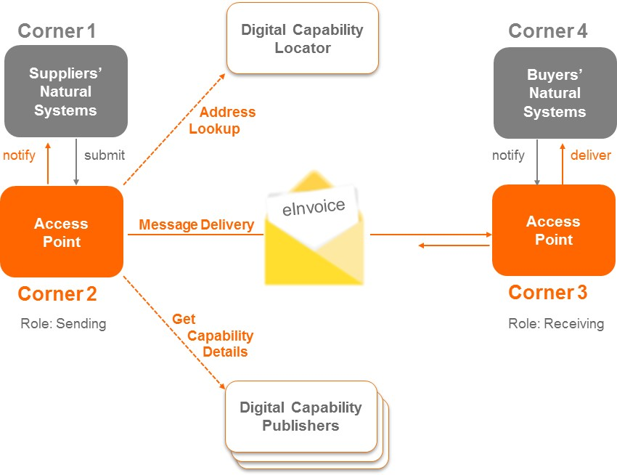
Figure 1: The Four Corner model with Business Discovery applied to eInvoicing

The actors involved in eInvoicing are:

- Buyers: The Buyer is the legal person or organisation who purchases goods or services;
- Suppliers: The Supplier is the legal person or organisation who provides a good or service;
- Access Point: A service (in-house or outsourced) that sends and receives e-Invoices and passes them on to the respective participants;
- Digital Capability Locator: A service for looking up the location of the Digital Capability Publisher for a Buyer or Supplier; and
- Digital Capability Publishers: Providers of a service for Buyers and Suppliers to store details of their capabilities, and includes what scenarios they can process, the data formats they support and the delivery address for their e-Invoices.

e-Invoicing using the Framework means that the business applications of the Suppliers and Buyers (corners one and four) do not exchange invoices directly with each other but via Access Points (corners two and three). Any organisation (such as a Buyer or Supplier) has the choice of using a third party service provider to provide an Access Point or to implement their own.

Finally, the meaning of the information in e-Invoices needs to be understood by all Buyers and Suppliers regardless of the natural business systems they use, so an agreed set of information elements in a standardised data format is required for exchanges between Access Points.

How does it work?
Interoperability means working together – a collaboration of systems, services and people with common understanding. An interoperability framework can be defined as the overarching set of policies, standards and guidelines that describes how organisations have agreed, or should agree, to do business with each other1.

There are four components to the Framework:

- Legislation and policy: Reducing legal or policy reasons why paper is preferred to digital. This includes recommending refinements to legislation and policy, if any, to remove impediments or barriers to adoption;
- Organisational interoperability: Describing business process scenarios and standardising how businesses discover each other’s digital capabilities for these scenarios;
- Semantic interoperability: Standardising the data exchanged so the information is commonly understood by the parties involved; and
- Technical interoperability: Technical standards and protocols to ensure information is exchanged securely and reliably between parties (directly or via service providers).

