Commonwealth Bank of Australia
ABN 48 123 123 124

Review into Open Banking
Commonwealth Bank of Australia Submission to Treasury’s Review

22 September 2017

Contents
Executive summary 1
Proposals 1
Figure 1 The benefits of Open Banking 2
Section I 3
Figure 2 The model proposed by the ABA 4
Figure 3 Uplifting standards across the banking industry 6
Section II 6
A. Consumer education must be a key focus 7
B. Digital identity is an early area of opportunity 7
C. Shared data-types should offer tangible consumer value 8
Section III 9
Figure 4 UK direct implementation costs 9
Closing remarks 10

Commonwealth Bank of Australia
ABN 48 123 123 124
Review into Open Banking
Commonwealth Bank of Australia Submission to Treasury’s Review
Executive summary
The Commonwealth Bank supports Open Banking
The Commonwealth Bank welcomes the Treasurer’s initiative to introduce an Open Banking regime in Australia and is pleased to submit this paper in response to the Treasurer’s Open Banking Review Issues Paper.
The Commonwealth Bank is fully aligned with the Government’s stated intention to introduce an Open Banking framework to “allow greater choice for customers, in this case by giving them easier access to, and more control over, data relating to their finances and transactions held by their banks”.
The Commonwealth Bank has listened to the Government and worked across industry and other stakeholders to frame a world-leading model for Open Banking. The proposals contained in this submission will support the Government to deliver on its promise to implement sustainable Open Banking reforms that benefit the entire Australian economy.
The Commonwealth Bank is firmly of the view that the model for the banking sector could then provide a blueprint for open data reform across other industries. The Commonwealth Bank believes that a successful model needs to:
- be grounded in consumer choice, placing banking customers in control of access to data;
- not diminish the level of protection that customers currently receive, particularly in light of ever increasing fraud and cyber threats; and
- encourage market efficiency, using a transparent streamlined accreditation framework to ensure that all participants (both contributors of data as well as recipients) maintain suitable standards.
Executed well, the Open Banking model will drive sustainable competition, innovation and productivity benefits without compromising integrity and trust.
Proposals
Recommendations to enable the effective implementation of Open Banking
This submission sets out three proposals that the Commonwealth Bank believes will enable an effective implementation of Open Banking reforms.
Proposal 1 – Adopt the industry model described by the ABA
The Commonwealth Bank has had the opportunity to consider, and through our membership contribute to, the submission produced by the Australian Bankers’ Association (ABA). The Commonwealth Bank is supportive of the operating model and ‘safe data sharing’ framework described by the ABA. Section I of this submission outlines the Commonwealth Bank’s thoughts regarding the benefits of the model outlined in the ABA’s submission.
Proposal 2 – Encourage the banking industry to take proactive steps to implement Open Banking
The banking industry should take steps to proactively commence the implementation process. The Commonwealth Bank is already making investments to ensure it is well-placed to support the Government’s objectives. Section II of this submission outlines immediate and ongoing investments that the Commonwealth Bank is making in relation to:
- making banking product and service reference data more easily accessible to the market;
- increasing consumer education and literacy, including educating customers around insecure data sharing practices and establishing robust support mechanisms; and
- investing in digital identity solutions.
Proposal 3 – Ensure the implementation process is executed efficiently
The experience from the UK’s implementation of Open Banking suggests the cost to the Government and industry will be significant. Section III of this submission outlines some of that research together with suggestions regarding ways to manage the implementation process efficiently.

Figure 1
The benefits of Open Banking

The Open Banking model puts consumers in direct control of access to data through trusted relationships. It upholds protection and cyber security standards, and features a streamlined accreditation utility. The benefits of this model will extend to consumers, new entrants, the Government and current participants:

Consumers will enjoy greater access to data encouraging increased engagement, product comparison and increased competition.
Consumers will be able to assess the trustworthiness of organisations before sharing their data.
New market entrants will be able to leverage the distribution reach of the established participants.
New market entrants will have clarity of what standard they need to reach to participate in the Open Banking model.
Established participants will be able to offer new competitive services and innovative partnerships, enabled by greater access to data across the industry.
Government can use the Open Banking model as a template for other industries.
Government can use the Accreditation Utility to define and continually uplift cyber standards and other consumer protections.

Section I
The Commonwealth Bank supports the model described by the ABA
The Australian Bankers’ Association submission outlines a proposal for implementing Open Banking that comprises (i) an operating model, overseen by the Government, that is based on participants (both organisations transferring data as well as data recipients) being accredited so that consumers have confidence that their data will be handled according to the highest standards and (ii) a consumer oriented mechanism for data sharing that is triggered by clear informed choice, which puts consumers in control.
The Commonwealth Bank has had the opportunity to consider the ABA’s submission in advance and, through our membership, contribute to its development. The Commonwealth Bank supports the model and notes that it offers specific advantages.
Firstly, the ABA’s data sharing framework is centred on informed consumer consent. There are specific points in the proposed data sharing process where the user is prompted to nominate:
- the accredited participant to receive data;
- the type of data to be shared, including date range and level of detail;
- the permitted use case for the data;
- whether the user agrees to receive marketing; and
- whether or not the user wishes to revoke consent.
Ensuring consumers consider and consent to each of these items will place them firmly in control of access to data. This approach takes the industry forward by removing the need for insecure practices such as unauthorised password sharing and screen-scraping which has been referred to by UK Open Banking as “a model that is both brittle and insecure”.
Secondly, the banking sector operating model proposed by the ABA offers strong consumer assurance by being accreditation based. This provides an opportunity for the Government to work with the banking industry to frame standards that will uplift performance and security across industry. The Commonwealth Bank believes key criteria for accreditation should include:
- a level of maturity of an organisation’s systems and processes;
- assurances that data shared is kept securely and remains onshore;
- due diligence regarding the financial stability and probity of data recipient entities, ensuring that all accredited participants in the model meet customer requirements and expectations;
- assessments that the necessary legal and regulatory standards and approvals are secured and then maintained on an ongoing basis; and
- ensuring accredited participants that have custody of consumer data maintain levels of insurance commensurate with the data held.

Figure 2
The model proposed by the ABA

The Open Banking model proposed by the ABA is designed to place consumers in better control of their financial data, protecting them from data misuse and cybersecurity risks.

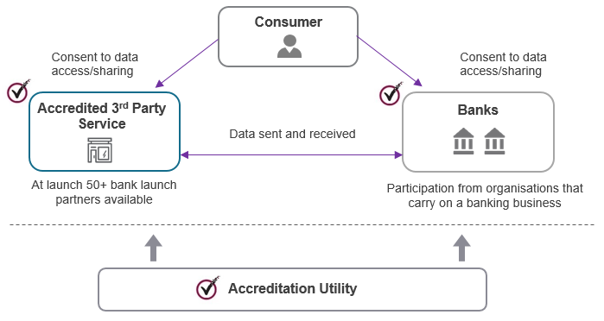

Under this model:
- Consumers will provide informed consent via clear and efficient mechanisms before transferring any of their financial data to recipients. Data should only be transferred where there is an appropriate use case to support access.
- Banks and licensed third party participants will meet accreditation standards determined by economy-wide government regulation as well as industry specific safeguards.
- An Accreditation Utility will publish standards, provide once-off accreditation to participants, set accreditation fees and charges, conduct assessments for regular re-accreditation and monitor compliance. The Utility will also remove accreditation on expiry or breach, and be supported by an economy of certifiers, auditors and specialists.
- Government will provide oversight, by establishing an industry-wide data sharing regulatory framework that subjects data users to minimum data security, privacy and consumer protection standards. A key initiative will be the introduction of legislation to establish a Comprehensive Consumer Right to data.

A key benefit of a model that is consumer oriented and accreditation based is that it confirms security as a priority. The fact that the data sharing model described by the ABA relies on consumer initiated data transfers rather than APIs means that, in the event of a security breach, perpetrators will be unable to unilaterally extract large volumes of consumer data. This is important in the face of increasing threats from criminal organisations and rogue states.
Furthermore, the de-centralised nature of the model minimises the risk of wholesale data compromise. The recently publicised data leak suffered by Equifax in the United States highlights the vulnerabilities associated with a centralised data repository. The proposed model would also be consistently applied to any overseas based technology companies seeking to access customer data.
Finally, the ABA model also offers strong productivity benefits for smaller players, such as Fintechs. Instead of organisations having to approach each bank individually, accreditation will entitle an organisation to apply for the opportunity to receive data once consumer approval has been secured. The Commonwealth Bank already partners with a number of start-ups and Fintechs. An accessible Open Banking model will foster further innovation by increasing the level of interaction amongst market participants. Furthermore, the ABA’s proposal presumes that Open Banking participants are prepared to reciprocate by also allowing consumers to direct the transfer of their data to other third parties. This principle of reciprocity is key to creating a ‘network effect’ to quickly advance Open Banking implementation.
Continuously improving Open Banking
Whilst the model proposed by the ABA provides a sound basis from which Open Banking can potentially be implemented, the Commonwealth Bank notes that the model can be further refined and improved over time. To ensure that efforts expended on banking can be replicated across sectors, the Commonwealth Bank believes that the following common principles should be adhered to.
- Open Banking reforms should result in consumers being better off. This means creating solutions that allow consumers to receive the productivity benefits associated with greater access to data, without increasing their exposure to data misuse and mishandling. To achieve this, reforms must be designed with a view to placing consumers in control over access to data.
- There should be clear incentives for existing market players as well as new entrants to participate. The Commonwealth Bank is of the view that a constructive model that provides natural incentives for take-up should be based on principles of reciprocity. Participants seeking access to consumer data should be prepared to (i) meet high levels of operational integrity and (ii) be prepared to share data when requested by consumers.
- Models need to be interoperable across industries. This means ensuring that data sharing is approached with the same values and principles regardless of sector.
The Commonwealth Bank’s research suggests that other adjacent industries such as Superannuation and Energy are also exploring a trust-based accreditation approach. This submission recommends refining a workable framework for banking as an initial step so that Open Banking can be implemented without delay. As a further phase of activity, the Government and the banking industry should work together to investigate opportunities for cross-sector standards and assurances.
The Commonwealth Bank takes this opportunity to note the efforts of the ABA to work across its member base to develop a proposal that banks are in a position to adopt. The Commonwealth Bank believes the ABA model is directionally sound and recommends that the Government consider it as a practical implementation of Open Banking.

Figure 3
Uplifting standards across the banking industry

Regulated financial institutions must comply with a range of mandatory standards that set firm levels of compliance for data handling and processes. For instance, APRA prudential standard CPS 231 and Practice Guides CPG 234 and 235 address risks associated with handling data and dealing with third parties.

Those standards set out APRA’s expectations for regulated financial institutions to consider and address risks such as:

- fraud due to theft of data;
- business disruption due to data corruption or unavailability;
- delivery failure due to inaccurate data;
- breach of regulatory obligations resulting from unauthorised disclosure; and
- controls to ensure adequate data quality and data security, particularly in arrangements involving third parties.

Once customer financial data leaves the custody of a regulated financial institution and is transferred to an unregulated entity, important controls such as the above may no longer apply. It is important that this potential exposure is covered by applying the right safeguards to all Open Banking participants. This can be achieved through a well-designed accreditation model.

Section II
Proactive measures that industry can take
The Commonwealth Bank recognises the potential productivity gains of increasing consumers’ ability to access and control access to their data. The Commonwealth Bank welcomes the Government’s initiative to unlock benefits to consumers and the economy.
Framing the appropriate regulatory model should not be rushed. The Commonwealth Bank expects that the implementation of a regulatory framework for Open Banking will require substantial legislative changes. Assuming the Productivity Commission’s recommendations are endorsed, the Government would look to enact a new Data Sharing and Release Act. Following that, a range of existing laws and regulations will also need review and amendment.
Inevitably, legislative change will take time. In order to ensure consumers have better access and control over their financial data as soon as possible, the Commonwealth Bank is prepared to immediately take steps to introduce the data sharing model proposed by the ABA. This will enable the Government to start delivering on the promise of open data benefits in the coming 12 months whilst work continues to draft suitable new legislation.
This section of the submission sets out further areas of opportunity where the Commonwealth Bank is committed to moving quickly to deliver outcomes that will support Open Banking in Australia. The Commonwealth Bank recommends that the Government and industry consider these initiatives as areas for early action. Importantly, certain regulatory waivers or interim measures from the Government may be required in order to support industry action.

A. Consumer education must be a key focus
The importance of consumer education and support has been repeatedly emphasised by experts reflecting on the experiences of the UK government in establishing its Open Banking regime.
Research in the UK shows that 90% of adults have never heard of Open Banking. Furthermore, 26% of the UK savings market and 20% of the mortgage market claim to have some awareness of Open Banking, but generally do not know or understand the details of Open Banking or what it could mean for them. In fact, 67% of respondents expressed a concern that under the Open Banking model proposed by the UK government their data would fall into the wrong hands.
This lack of understanding and confidence has undermined the UK government’s efforts to introduce an effective data sharing framework. The Commonwealth Bank’s view is that the Government and the banking industry should work together, learning from the UK, and educate consumers on the proposed benefits of Open Banking and also how to engage in a way that does not reduce their confidence in the security of the system.
Accordingly, the Commonwealth Bank is already taking proactive steps to lift the levels of understanding amongst its customers around safe data sharing practices, drawing heavily on existing government standards as well as lessons from industry best practice.
In addition to education around security practices, the Commonwealth Bank already invests heavily in a comprehensive customer support capability aimed at providing assistance for its customers. Support takes the form of tools and resources to help customers avoid potentially unsafe data sharing activities, such as disclosing their log-ins and password credentials to third parties, as well as providing frontline support in the event of concerns around data misuse.
This submission strongly recommends that resources be focussed on a comprehensive education programme across the banking sector aimed at ensuring consumers have resources and support in relation to Open Banking.

B. Digital identity is an early area of opportunity
One potential productivity gain from open data reforms may be the delivery of solutions that allow consumers to verify their identity digitally. The banking sector, together with government agencies, are highly-trusted repositories for identity verification.
The Commonwealth Bank has started trialling innovations that allow consumers to verify certain identity fields with other participants in the digital economy. Whilst these initiatives are still in their infancy, early experiences suggest that there is a demand for identity verification services. Digital identity offerings could incorporate a range of features such as Know Your Customer (KYC) checks for verification of individual identity data fields. A key challenge to overcome will be the regulatory requirements associated with complex data fields. For instance, KYC data consists of highly sensitive data, and any intention to share it will need to take in to account data privacy and security regulations, and the security capabilities of the end receiver of the data.
Work has also commenced to assess the suitability of data sharing technology alternatives in the digital identity space. For instance, the Commonwealth Bank is participating in Government-initiated data sharing systems, such as with the Australian Taxation Office in relation to superannuation data that leverages verification mechanisms through standard identifiers, such as a Tax File Number. The Commonwealth Bank will continue to engage in constructive dialogue with the Government around potential benefits offered by digital identity innovation.

C. Shared data-types should offer tangible consumer value
Phase 1 of the UK government’s implementation of Open Banking included increasing access to service and product and reference data such as published interest rates and product terms. There are productivity benefits with making this information available in a standardised, easily accessible form. New market entrants are able to create business models leveraging this data, enabling consumers to compare product offerings with increased accuracy and reliance.
The Commonwealth Bank recommends that the initial phase of Open Banking in Australia also include this initiative. The Commonwealth Bank has already commenced work to identify the data fields that, when exposed, will provide the market with greater access to valuable service and product data.
Whilst a Comprehensive Consumer Right could effectively apply to an undefined range of data, a phased implementation approach is recommended, considering the practical challenges associated with sharing certain data-types as well as the specific legal and consumer consent requirements that need to be addressed. Accordingly, the Commonwealth Bank suggests that transaction account information is considered as a data set to be shared in Phase 1. Transaction accounts represent a product type where the consent issues associated with sharing data, as well as the complexities in banking regulations are solvable within a reasonable timeframe. Highly sensitive data types or information associated with complex financial products will naturally carry complications that must be worked through.
The Commonwealth Bank also recognises the Government’s intention to support small businesses. The Commonwealth Bank has already invested heavily in capabilities to enable sharing of data with accounting software integrators in order to provide small business customers with financial tools and resources. Specifically, the Commonwealth Bank is already working with large established providers such as MYOB and Xero, as well as other smaller software competitors. The Commonwealth Bank believes that there are added complexities with sharing small business transaction account data. This is largely due to the broad range of legal structures that small businesses use (eg sole traders, partnerships, trust arrangements and incorporated entities). However, if the Government is committed to including small business transaction account information in the early phases of Open Banking, the Commonwealth Bank will direct resources to work with regulators and industry to support that outcome.
Section III
The true costs and benefits to the economy of implementing Open Banking
The Treasury’s Issues Paper specifically seeks input regarding the cost of implementing Open Banking in Australia. The Commonwealth Bank notes that the cost of implementing Open Banking can vary significantly, and that careful planning will allow the Government and industry to jointly achieve the outlined objectives while minimising associated costs. The Commonwealth Bank supports the Government’s intentions of embedding learnings from implementation of the Open Banking standard in the UK, and outlines key areas for consideration below.
Analysis of the government-led implementation of Open Banking in the UK suggests upfront implementation cost for participants can be substantial. Research indicates that in the UK, the average direct cost of implementing Open Banking and associated payments reforms run to between GBP 150-200 million per institution, and costs have run as high as GBP 300 million for particular banks (see breakdown in Figure 4). It is noted that these figures do not include ongoing costs such as operating expenses as well as the indirect financial burden of change impacts and the cost of servicing and supporting consumers. Allowing for indirect costs, financial impact may run as high as GBP 500 million for some participants.
These high figures are understandable given the technical complexity of the UK model. The Commonwealth Bank’s own inquiries suggest that the standard API solution has required more than 36,000 lines of specifications to be developed for industry consumption.

Figure 4
UK direct implementation costs
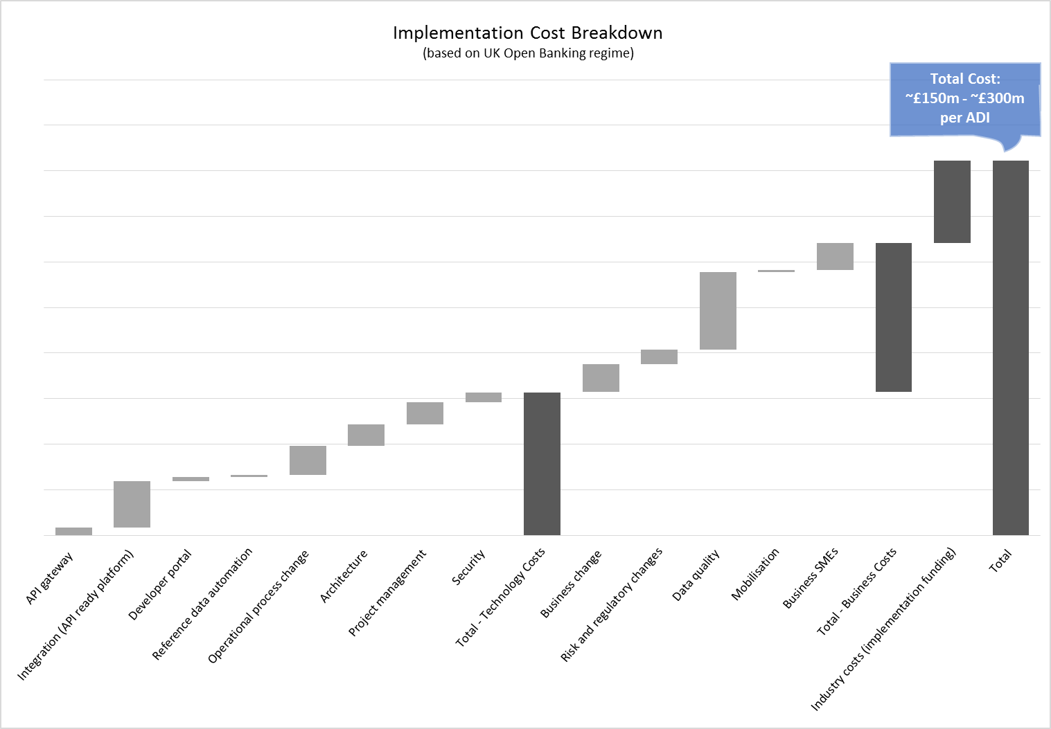

In addition, the Commonwealth Bank’s inquiries suggest that market participants have increased headcount significantly, in some cases by more than 150 full time resources, in order to meet the demands of an Open Banking regime. The cost to government is also material – the published annual operating budget of the UK government’s Implementation Entity has been set at GBP 70 million. These costs comprise of three categories:
- technology costs, including system build and integration;
- business costs, including change management, risk and regulation; and
- industry costs, including administration of the Implementation Entity and the development and maintenance of standards.
Implementing change to support Open Banking reforms is not only a technology project but also requires large investments to change business processes, and contribution to an industry-wide process for setting and monitoring standards. In some cases UK participants have identified business implementation costs of a similar scale to, if not in excess of, technology costs. In particular, significant resourcing has been allocated to manage business change and for data quality assurance.
The wide variance in costs to market participants is also noteworthy. The advice received by the Commonwealth Bank suggests that the cost range is primarily due to differences in the maturity and complexity of existing systems.
The variable and potentially high costs of implementing Open Banking should not be a deterrent to the pursuit of good policy. However, practical design choices can be made to moderate the execution risk and potential financial burden on the industry.
The Commonwealth Bank recommends that the Government consider a technology neutral approach to regulating Open Banking. This allows industry to find the most suitable technology to execute on the Government’s direction. As an example, the ABA has recommended focussing on the customer experience and that outcome could be effectively enabled by existing data-sharing technologies such as a secure data extract.
The other clear benefit of a technology neutral approach is that it enables the Government’s open data reforms to evolve with technological developments and leaves the banking industry free to identify technology solutions that can operate across sectors, thereby fulfilling the overall goal of a true open data economy.
Closing remarks
Open Banking – delivering benefits for all parts of the Australian economy
Since the announcement of the Productivity Commission Inquiry into Data Availability and Use, the Commonwealth Bank has been actively engaging with policy-makers at all levels as well as industry bodies in relation to the Government’s proposed reforms. Throughout that process, the Commonwealth Bank has gained a greater understanding of the Government’s proposed aims and the Commonwealth Bank is fully aligned with the goal of delivering Open Banking reforms that benefit consumers across the economy.
Through this submission, the Commonwealth Bank has provided analysis and solutions to ensure that the Government is able to frame a balanced and sustainable operating model for Open Banking. If implemented properly, with collaboration between the Government and the private sector, the banking sector has the opportunity to offer a precedent for open data reform across the economy.
For more than a century, the Commonwealth Bank has operated as a bank for all Australians. The Commonwealth Bank is committed to securing and enhancing the financial wellbeing of all parts of the Australian economy. That firm commitment to financial inclusion is one important way in which the Commonwealth Bank contributes to a fair and prosperous Australian economy. The Commonwealth Bank pursues this vision by providing tangible resources for all Australians. As a signatory to the Code of Banking Practice, the Commonwealth Bank has re-affirmed its service commitment to Australians with diverse needs and customers in remote Indigenous communities.
This focus on financial inclusion and support is central to the way that the Commonwealth Bank operates. The Commonwealth Bank strongly believes that Open Banking should likewise be implemented in a way that delivers benefits to Australia and all consumers.
The initiatives outlined in this submission have been framed with a view to supporting the Government’s policy goals and also delivering on the Commonwealth Bank’s commitment to its customers.
The Commonwealth Bank is pleased to recommend this submission for the Government’s consideration.

Australian Bankers’ Association, “Review into Open Banking in Australia”, September 2017.
For more than 10 years Commonwealth Bank customers have had the ability to extract their transaction data into CSV files. This functionality is free of charge and enables customers to access their data securely. The framework contemplated by the ABA would provide customers with an additional means of access and transferring data.
UK Open Banking OIDC Security Profile, available online at: https://www.openbanking.org.uk/read-write-apis/security-profile/id1-0-1/
On 7 September 2017, Equifax disclosed that the company had suffered a data breach, impacting 143 million customers. The compromised data was of a highly sensitive nature, including names and social security numbers. See The Australian Financial Review, “Equifax data breach proves big wake-up call”, 20 September 2017, page 25.
The superannuation industry’s Superannuation Transaction Network (STN) is an example of an accreditation-based regime to support data sharing. Compliance with the STN is monitored by a self-funded independent body established in 2016 known as the Gateway Network Governance Body, which is endorsed and monitored closely by the Australian Taxation Office.
Initially, it is assumed that affected regulations would include: (i) the Privacy Act and subordinate legislation, (ii) banking regulations such as the National Consumer Credit Protection Act and ePayments Code, and (iii) umbrella legislation such as the ASIC Act, Corporations Act and the Australian Consumer Law. The eventual list of affected laws will depend on the form of any new data access laws.
ABA Open Data Symposium, April 2017. Addresses by David Beardmore, Open Banking Institute and Mike Booth, Director Ernst & Young discussed the need to educate customers on how their data may be used and its privacy implications, and ensuring that an appropriate and well-understood customer consent regime is introduced as a key step for establishing Open Data reforms.
Equifax/YouGov, “Use of Personal Data”, October 2016, available online at: http://www.equifax.com/assets/unitedkingdom/yougov_survey_use_of_personal_data.pdf
In recent years, the Commonwealth Bank Group has invested over $100 million per annum on its cyber defences, with the ultimate purpose of maintaining and enhancing the trust that Commonwealth Bank’s customers have in its business and minimising fraud loss for customers. Opening remarks of ABA Open Data Symposium, April 2017.
Whilst specific input has been sought from consumer groups and advocacy bodies for implementation of the Open Banking standard in the UK, a consumer communications and outreach program is still under development to improve overall awareness of the benefits of Open Banking. However, existing, related initiatives include Nesta’s Open Up Challenge to advocate crowd-sourced development of beneficial use cases for Small Businesses, and Bacs Payment Schemes Limited’s obligation to increase customer awareness and confidence in Current Account Switching Service (CASS). See Retail banking market investigation – Final report, August 2016, pages xl, xlv.
Retail banking market investigation – Final report, August 2016, page 442.
Competition and Markets Authority reference during the UK Treasury Select Committee hearing, 1 November 2016. https://www.parliament.uk/business/committees/committees-a-z/commons-select/treasury-committee/inquiries1/parliament-2015/retail-banking-market-review-16-17/
For example, 97% of all branches are wheelchair accessible and 100% of Commonwealth Bank ATMs are audio enabled. The Commonwealth Bank also offers specialist banking services customised for Aboriginal and Torres Strait Islander customers in remote Australia via the Indigenous Customer Assistance Line (ICAL).
Code of Banking Practice, 2013, available online at: https://www.commbank.com.au/content/dam/commbank/about-us/download-printed-forms/CodeofBankingPractice_ADB2555_0604.pdf

