PO Box 2041
Blackburn South Vic 3130
AUSTRALIA

Ph: 03 9877 0369
tioz@transparency.org.au
www.transparency.org.au

10 February 2017

Tax and Corporate Whistleblower Protection Project
C/- Ms Jodi Keall Senior Adviser Financial System Division
100 Market Street
Sydney NSW 2000

Dear Ms Keal

Review of tax and corporate whistleblower protections in Australia
Transparency International Australia welcomes the opportunity to make a submission to the Consultation. We strongly support the need for comprehensive reform in this area, and welcome this Review and the Government’s commitment to act on the results of this Consultation informed by the recommendations of the parallel Inquiry by the Parliamentary Joint Committee on Corporations and Financial Services through legislative reform by June 2018.
We note the very wide scope of the Consultation paper and the Inquiry’s terms of reference. For this reason, Transparency International Australia has updated its public position on what it considers to be the key issues of principle which need to drive the recommended reforms. Please find that position attached, which we trust will assist your consideration of the outcomes of the Consultation and the recommendations of the Committee in respect of many of its key terms of reference.
We would be happy to expand on any of the proposals if so desired, as we offered to do for the Committee. We apologise timing and resource constraints prevented attendance at public consultations.
We also make the following observations:
- While much of the focus of the parallel processes is on private and not-for-profit sector employees and workers, we note that the Committee has also been tasked to inquire into the improvement of protections in the public sector.
In this respect, we note the recommendations of the 2016 Moss Review of the Public Interest Disclosure Act 2013 (Cth), and endorse those recommendations, with the caveat that in our view they do not go far enough in grappling all reform priorities – as reflected in the attached position paper.
- The Australian Government has committed (for example, in its Open Government Partnership national action plan of December 2016) to an objective of ‘harmonising’ private sector whistleblower protections with those contained in the Public Interest Disclosure Act 2013 (Cth). We note that given the extent of the recommendations for improvement of that Act, and the likely need for greater flexibility in the implementation of protections across the private and not-for-profit sectors, that this objective is unlikely to be very useful. While key aspects of whistleblower protection can and should be common, TI Australia considers that as a general principle, a one-size-fits-all approach designed to work for the public sector – even once brought up to a higher standard – should not necessarily be imposed on other sectors. Again, we are happy to elaborate.
- TI Australia was a partner organisation to the Australian Research Council Linkage Project Whistling While They Work, and is a supporter organisation to Whistling While They Work 2, both led by Griffith University (whose Professor A J Brown is one of our directors). We note that this research is ongoing and hope that the Committee and Government will be able to adapt their timetables on these issues to take full account of its findings, so that the solutions adopted are evidence-based to the maximum extent possible.
We would be very happy to elaborate or to address specific issues of concern to the Committee, in more detail, in a supplementary submission or conversation if that would be useful.
Yours sincerely
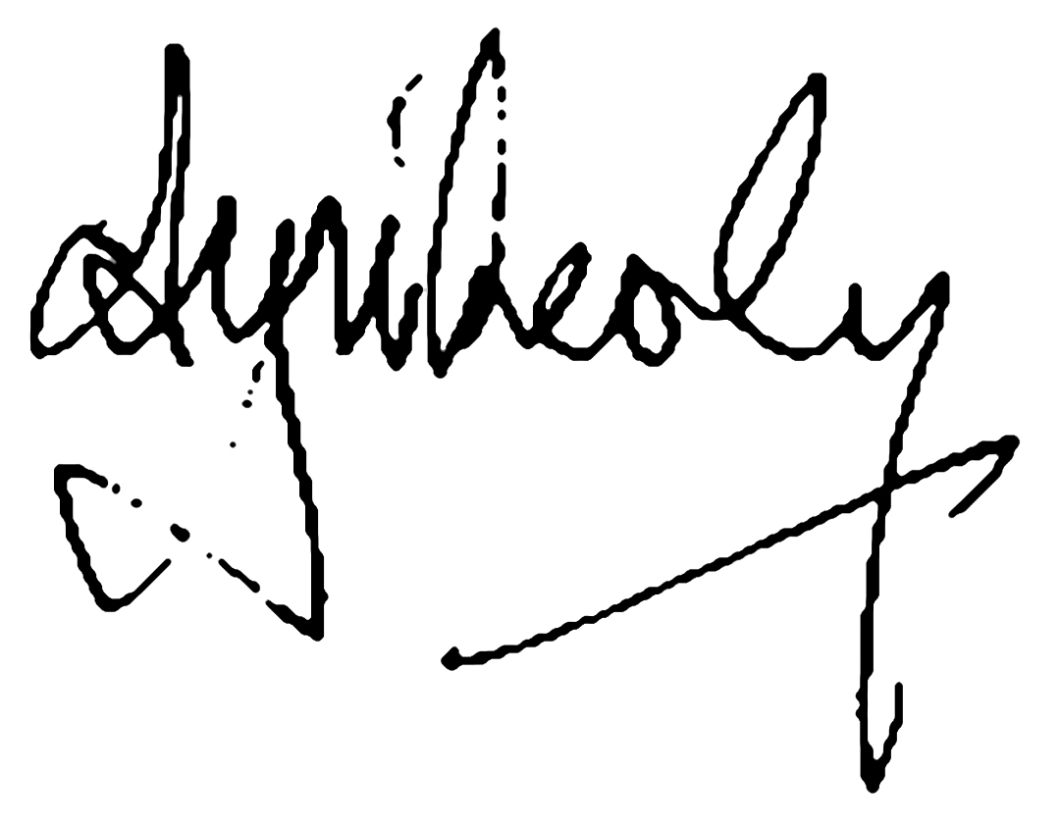

The Hon Anthony Whealy QC
Chairman
Transparency International Australia

WhistleblowING
purpose

To ensure public interest whistleblowing is facilitated, protected and acted on in Australia – as a key plank of corruption detection and resilience for organisations and employees alike, across the public, business and civil society sectors.
the problem

Whistleblowers (organisational insiders who disclose wrongdoing in or by their organisation, to trigger action) play a key role in exposing otherwise unknown acts of corruption. Frequently, it becomes clear that organisations, law enforcers and other regulators could have acted earlier to prevent or deal with corruption or wrongdoing – if only people with relevant knowledge had spoken up, to the right people or in the right way, or had been listened to when they first raised concerns.
While Australia has been at the forefront of recognising the role of whistleblowing in its public integrity systems, there remain major problems:
- Nationally, legal protections for business and civil society whistleblowers are largely missing, and include out-of-date thresholds and barriers
- At federal and state level, key government whistleblower protection legislation remains incomplete or out-of-date
- Existing legislation is not proving effective in delivering support, protection and remedies for employees in the face of risks of detriment for making a public interest disclosure
- Best practice organisational approaches to facilitating and protecting whistleblowing do not have clear enough statutory support and oversight; and
- There is a lack of independent advice and legal support services for employees who are considering blowing, or who do blow, the whistle on wrongdoing.
history and previous recommendations

Article 33 of the UN Convention Against Corruption (2004) emphasises measures to protect any person ‘against any unjustified treatment’ for reporting facts relevant to corruption. In practice, as TI’s experience shows, such facts often come from organisational insiders: whistleblowers.
Since 2010, in their Anti-Corruption Action Plans, G20 leaders have also committed to effective public and private sector whistleblowing regimes. In 2011, OECD guidance for G20 leaders confirmed that protections need to be available in response to all major types of public interest concerns, integrity violations and breakdowns. A comprehensive approach to whistleblower protection is also advocated in TI’s International Principles for Whistleblower Legislation (2013).
In some respects, Australia’s record in recognising whistleblowing is advanced. Beginning with Queensland, state parliaments began legislating for public sector whistleblower protection in

1991. In 2013, following a major parliamentary inquiry, federal public sector legislation was also passed with strong support from all political parties: the Public Interest Disclosure Act (Cth).
However, the first review of the Act in 2016 confirms this legislation needs to be streamlined and overhauled to address basic questions on coverage and delivery of remedies. For example, federal protection does not apply to disclosures about corruption or wrongdoing by Ministers, their staff, other politicians, or judges; and protections are weaker for national security employees.
At state level, legal upgrades took place in Queensland, NSW and the ACT in 2010-2012, but some protections remain inconsistent and out-of-date. For example, Victoria, Tasmania, the Northern Territory and South Australia have no rules for when a disclosure may be made to the media.
The single largest gap is lack of comprehensive whistleblower protection in Australia’s business and civil society sectors. Its importance for corruption detection is clear: whistleblowers have been instrumental in triggering and aiding Australia’s first prosecutions for foreign bribery (against Securency Ltd and Note Printing Australia) since 2010. The OECD’s recent review of Australia’s foreign bribery laws and enforcement reinforces the need to close this gap.
In 2014, the Senate Economics Committee recommended a comprehensive overhaul of the limited existing whistleblowing provisions of the Corporations Act 2001 (Part 9.4AAA). Now, TI Australia welcomes the work of the Joint Parliamentary Committee on Corporations and Financial Services to advance this overhaul, supported by Commonwealth Treasury. This follows an important agreement between independent Senators and the Government, initial landmark reforms to Fair Work (Registered Organisations) legislation, and the Australian Government’s commitment to new legislation in 2018, in its first Open Government Partnership action plan.
Transparency International Australia is also a formal supporter of Whistling While They Work 2 / Integrity@WERQ, the Griffith University-led Australia and New Zealand research project. As the first research to examine organisational responses to whistleblowing across all sectors, its preliminary report has already identified across-the-board challenges. Notwithstanding that 96% of the 702 organisations surveyed in 2016 reported that they provided at least some form of support to staff who raise wrongdoing concerns:
- Less than half (46%) reported that they provide whistleblowers with access to a management-designated support person inside the organisation (53% of public agencies, 39% of private business and 32% of not-for-profits);
- Only two thirds (67%) provide management intervention in workplace problems, if required (falling to only 60% of not-for-profits and 51% of private business); and
- Less than a fifth (16%) reported having mechanisms for ensuring adequate compensation or restitution if a whistleblower experiences reprisals, conflicts, stress or other detrimental impacts for reporting (17% of public agencies, 17% of business and 13% of not-for-profits).

tI australia’s position
- The Australian Parliament should promptly fill the gap in private sector whistleblower protection by passing comprehensive legislation covering all corporations and employers (including not-for-profits), to achieve a national scheme which is:
  - Consistent across all major wrongdoing types, industries and sectors,
  - Integrated and efficient (unlike, e.g. the USA protections are piecemeal and vary across more than 47 different federal regulatory laws),
  - Contained in new, overarching legislation, with consequential amendments to national employment law (Fair Work Act) and specific regulators’ mandates.
- Out-of-date thresholds and barriers to reporting should be removed from all Australian whistleblower protection laws, such as:
  - limits on the ability of some workers (e.g. contractors, volunteers) to claim protection;
  - requirements for ‘good faith’ (as opposed to honest belief on reasonable grounds);
  - requirements for whistleblowers to always first identify themselves.

- All Australian whistleblower protection laws should extend to whistleblowers who reasonably make their concerns public -- for example because there is no safe mechanism for internal or regulatory reporting, their employer fails to respond reasonably to their disclosure, or other reasonable circumstances -- including availability of a statutory public interest defence to civil or criminal proceedings in those situations.
- Deliberate reprisals against public interest whistleblowers should be criminal – but civil remedies should be made available, via low-cost avenues, wherever a whistleblower suffers personally or in employment as a result of inadequate support and protection from their employer or relevant regulators – including any failure to have or follow minimum procedures, or where any person ‘failed to fulfil a duty to prevent, refrain from, or take reasonable steps to ensure other persons under the person’s control prevented or refrained from’ detrimental conduct (Fair Work Registered Organisations Act, s.337BB).
- Australia should seriously consider the benefits of qui tam provisions which incentivise corporate employees to disclose fraud and wrongdoing by providing rewards of up to 25 per cent of recovered damages, or penalties, such as under the US federal False Claims Act – while recognising that since much whistleblowing does not concern fraud or lead to financial penalties, comprehensive compensation provisions (above) are still needed to ensure fair outcomes in most cases.
- Governments and business should support development and implementation of best practice whistleblowing management systems in organisations, including:
  - Development of the new Australian Standard on Whistleblower Protection;
  - Statutory requirements for minimum whistleblowing procedures consistent with the Standard, and based on research such as Whistling While They Work 2;
  - Effective oversight and independent monitoring and compliance, and
- Independent advice, support and legal services should be expanded as part of improved oversight and compliance under new laws, to assist organisations and employees in detecting and dealing with wrongdoing, help organisations with best practice whistleblowing procedures, and ensure access to remedies and justice for public interest whistleblowers.

1 See M Gorbanova, Speak Up: Empowering citizens against corruption, Transparency International, April 2015 http://www.transparency.org/whatwedo/publication/speak_up_empowering_citizens_against_corruption
2 OECD Compendium of Best Practices and Guiding Principles (2011) http://www.oecd.org/g20/topics/anti-corruption/48972967.pdf.
3 http://www.transparency.org/whatwedo/pub/international_principles_for_whistleblower_legislation.
4 House of Representatives Standing Committee on Legal and Constitutional Affairs, Whistleblower Protection: A comprehensive scheme for the Commonwealth public sector (2009).
5 Moss Review: https://www.dpmc.gov.au/government/legislation-review/statutory-review-public-interest-disclosure-act-2013.
6 See A J Brown (2013), ‘Towards 'ideal' whistleblowing legislation? Some lessons from recent Australian experience’, E-Journal of International and Comparative Labour Studies, 2(3): 153–182.
7 See Wolfe, S., Worth, M., Dreyfus, S & Brown, A.J. (2014), Whistleblower Protection Laws in G20 Countries: Priorities for Action, Blueprint for Free Speech, Griffith University, University of Melbourne, Transparency International Australia <https://blueprintforfreespeech.net> September 2014.
8 Senate Economics Committee (2014). The Performance of the Australian Securities & Investments Commission: Report of the Senate Economics Committee Inquiry. Canberra: Parliament House (June 2014).
9 http://www.aph.gov.au/Parliamentary_Business/Committees/Joint/Corporations_and_Financial_Services/ WhistleblowerProtections
10 http://www.treasury.gov.au/ConsultationsandReviews/Consultations/2016/Review-of-whistleblower-protections
11 Commonwealth Parliamentary Debates (Hansard), Senate, 21 November 2016, p.105.
12 http://www.whistlingwhiletheywork.edu.au/wp-content/uploads/2016/11/Whistleblowing-Processes-Procedures-Snapshot-Prelim-Results-Griffith-University-8-Nov-2016-FINAL2.pdf.
13 http://ogpau.pmc.gov.au/sites/default/files/posts/2017/01/australias-first-open-government-national-action-plan-final.pdf (7 December 2016).
14 Devine, T. and T. Massarani, 2011, The Corporate Whistleblower’s Survival Guide, San Francisco: Berrett-Koehler, p.151.

