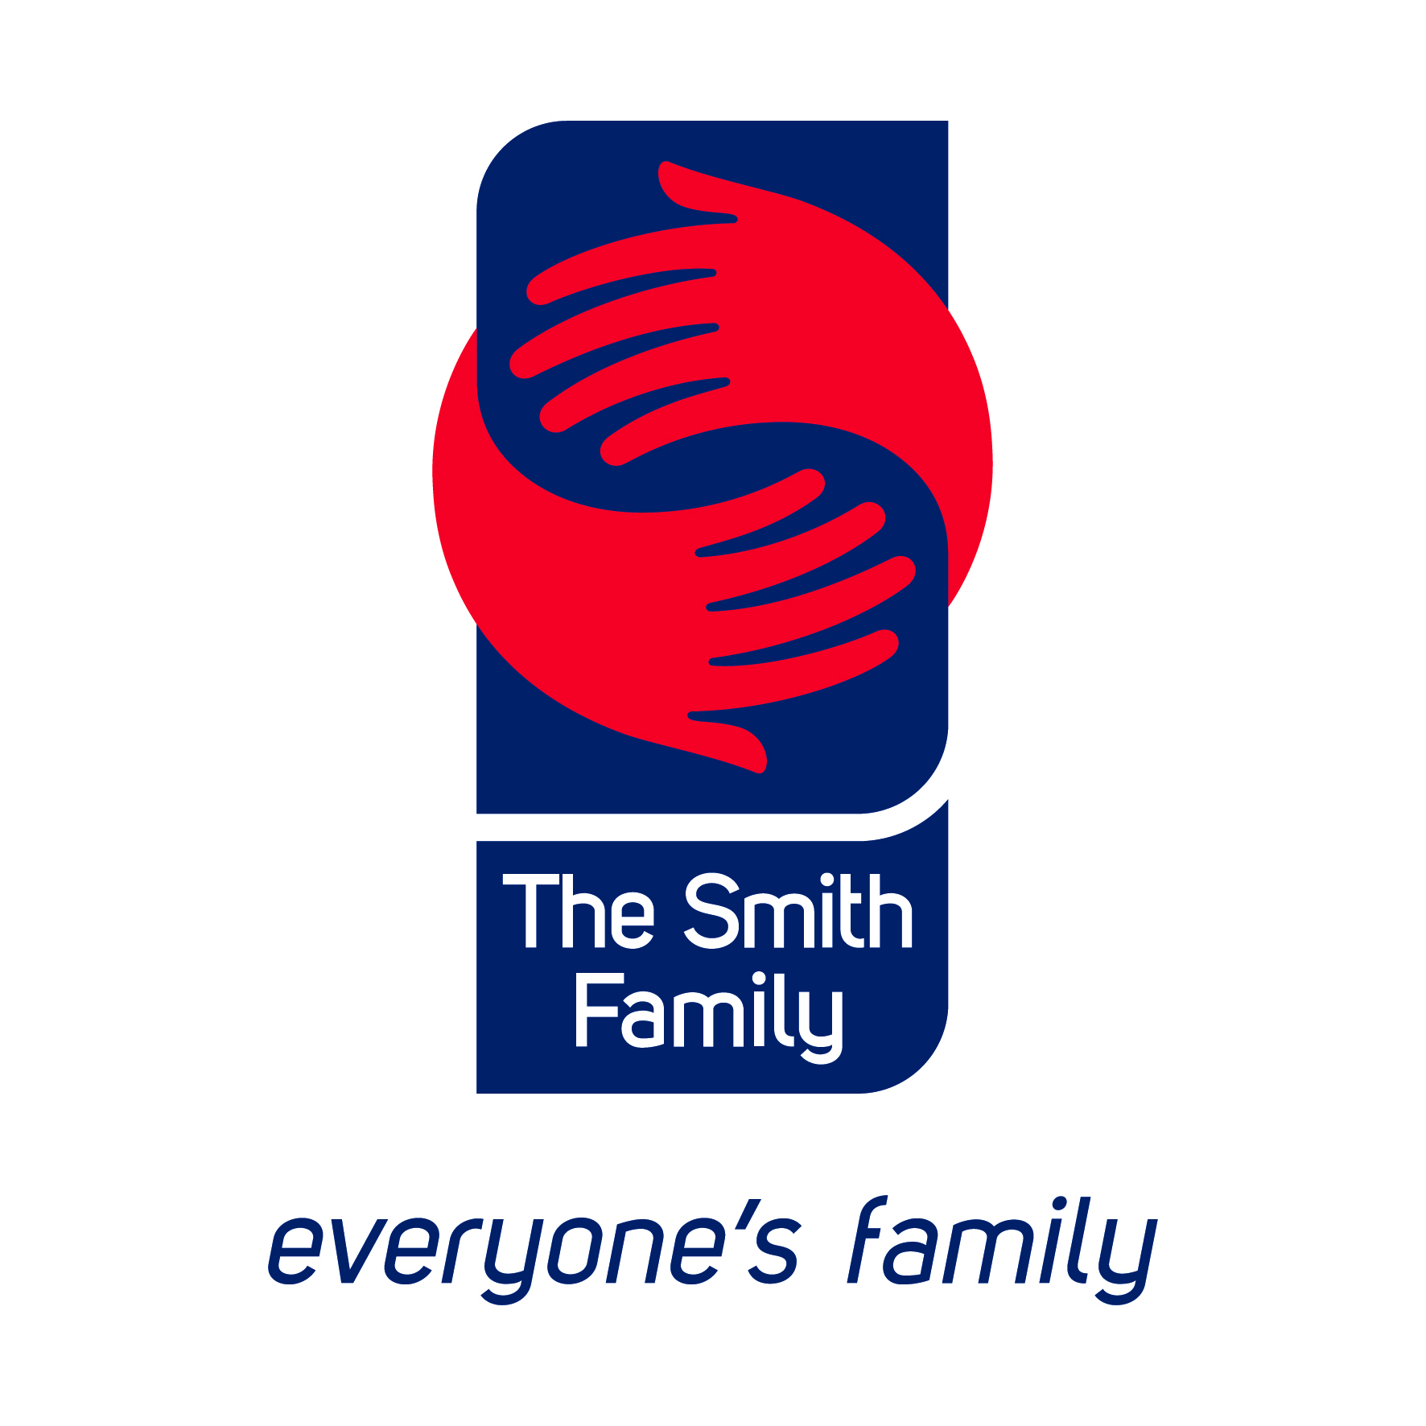

The Smith Family’s submission on the
Exposure Draft: Australian Charities and Not-for-Profits Commission Bill 2012

January 2012

Contact person:
Anne Hampshire
Head, Research and Advocacy
Level 9, 117 Clarence St
Sydney NSW 2000
Ph: 02 9085 7249
Email: anne.hampshire@thesmithfamily.com.au

Background on The Smith Family
The Smith Family is a national, independent children’s charity committed to increasing the educational participation and achievement of Australian children and young people in need. Our vision is a better future for young Australians in need. Our belief is every child deserves a chance and our mission is to create opportunities for young Australians in need, by providing long-term support for their participation in education.

The Smith Family provides holistic and long-term support from pre-school, through primary and secondary school and on to tertiary studies. In 2010-11, The Smith Family supported over 44,000 children, young people and parents/carers through its suite of Learning for life programs, including around 33,000 young people on an educational scholarship, approximately 4,500 of whom were of Aboriginal or Torres Strait Islander background. A further 73,000 children, young people and parents/carers participated in programs facilitated by The Smith Family, such as the Commonwealth Government’s Communities for Children initiative.

The Smith Family has a strong focus on sustainability and draws its income from a range of sources. In 2010-11, its annual income was just over $68.5 million. Just under a quarter of this was sourced from Government funding, over 60% from fundraising (donations and corporate support) and bequests, around 8% from the VIEW (Voice, Interests and Education of Women) Clubs of Australia and just over 3% from The Smith Family’s commercial enterprise.

The Smith Family was established in 1922 and is a company limited by guarantee. It has Public Benevolent Institution and Deductible Gift Recipient status and is an Income Tax Exempt Charity.

Reform in the not-for-profit sector
The Smith Family welcomes the opportunity to provide some brief comments on the exposure draft of the Australian Charities and Not-For-Profits Commission Bill 2012. The Smith Family is cognisant that the draft Bill is part of a large suite of not-for-profit reforms and will also be making a submission to the related Review of governance arrangements Consultation Paper. The sector has historically enjoyed strong public confidence as evidenced in part by their significant community fundraising and volunteer base. One of the reasons that governments, of all political persuasions, have increasingly contracted out to the not-for-profit sector a diverse range of services previously provided by government, is in part the public confidence and trust in which the sector is held. Central to the large scale platform of reforms that is currently occurring, has been an affirmation from government of the critical role the charitable and not-for-profit sector plays in the economic and social wellbeing of individual Australians and the nation as a whole (see for example the A definition of charity Consultation Paper, 2011).

The Smith Family notes that the past decade has seen a significant number of reviews and inquiries regarding the charities and not-for-profit sector, and this has involved substantial input and effort from a diverse range of stakeholders. The Smith Family believes it is now appropriate that action be taken that builds on some of this work and welcomes the establishment of the Australian Charities and Not-for-Profits Commission (ACNC). The legislation which supports its establishment, the ACNC’s early areas of focus and the approach it takes, will be key in ensuring both the short and long term achievements of the Commission and the continued support of key stakeholders.

Principles underpinning the reform
The Smith Family believes that fundamental to reforms in the NFP sector should be the complementary principles of:

- Transparency and public accountability;
- Certainty, consistency and workable compliance regimes; and
- Maximising the contribution of the charities and not-for-profit sector to the Australian community.

The Object of the Act
Division 2 of the draft Exposure Bill defines the Object of the Act as “to promote public trust and confidence in not-for-profit entities that provide public benefits” (Section 2-5 (1)). Section 2-5 (page 4) goes on to note that to further this object, the Act aims to: promote good governance, accountability and transparency in not-for-profit entities; minimise regulatory duplication; and establish a process for registering and regulating such entities (Section 2-5 (2)).

The Smith Family suggests that some thought be given to refining the Object of the Act. While the current wording of the Act’s Object reflects, in part, the three principles identified above, in particular in relation to transparency and accountability and consistent compliance regimes for the sector, it tends to under-emphasise the third principle and the clear message from government (and the wider community) of the value of the sector. It could perhaps be read as implying that there is a lack of public trust and confidence in not-for-profits and this is at odds with the Government’s statements regarding the sector and the evidence of strong public confidence in the sector.

The Smith Family notes that the Community Council for Australia (CCA’s) submission has drawn attention to the fact that the England and Wales Charities Commission has a wider range of primary objectives than what is currently articulated in the Australian draft legislation. The former includes increasing public confidence, promoting legal compliance and effective use of resources (in line with Australia’s current draft) but also includes encouraging charitable giving and voluntary participation, sustainability of organisations, as well as innovation. It is The Smith Family’s view that the Objects of the Australian legislation should reflect the three principles it has identified above and would argue that as the legislation currently stands it does not adequately reflect the third principle namely, of maximising the contribution of the charities and not-for-profit sector to the Australian community.

In refining the Object, consideration might also be given to refining the Background in Section 3-5 (page 7) to reflect the nature of the role the not-for-profit sector plays in Australia. This section could draw on for example, the National Compact which has been developed between the Federal government and the not-for-profit sector. As the Background section is currently worded, the sector’s role is described as “unique” (with no detail about the nature of that uniqueness or any details of the sector’s role and contribution). This “uniqueness” is then used as the basis or rationale for NFPs needing to be “accountable to donors, governments and to the public more generally”. As indicated in the three principles identified above The Smith Family is fully supportive of transparency and public accountability but suggests that articulating the contribution and role of the sector in Australia, rather than just its “uniqueness” would be helpful. In this way the legislation itself can play an educative role.

Key features of the ACNC and Commissioner
The Smith Family strongly endorses that key features of the ACNC and the Commissioner should include their independence and the capacity of the Commission to function as a one-stop shop and hence reduce red tape. This independence should be enshrined in legislation. Central to this independence and ensuring public confidence in the ACNC itself are:

- An Annual Report made directly by the Commissioner to Parliament (this requirement may require some refining of how Section 165-5 of the Exposure Draft is currently drafted).
- Open recruitment processes for the appointment of the Commissioner and the Advisory Board (Section 170).
The Smith Family welcomes the establishment of an Advisory Board to support the work of the ACNC. An open recruitment process for both is important for ensuring public and sector confidence. Further, strong operating practices are important for ensuring the effectiveness of the Board. This should include the Board being able to proactively raise issues and provide advice to the Commissioner rather than just providing advice ‘at the request of the Commissioner’ as currently proposed in Clause 170-15 of the draft legislation.
- Clarity regarding the relationship between the ACNC and other key agencies, including but not limited to, the Australian Taxation Office (ATO).
The nature of the relationship between the ACNC and other agencies such as the ATO should be clear from the legislation. Clarity is required not least about staffing arrangements for the ACNC. The Commissioner must have full authority to recruit and employ staff of their choosing and not be reliant on the Commissioner of Taxation for staff as Section 163-5 currently suggests. Clarity about the relationship the ACNC has with other organisations is also important if it is able to act as a ‘one-stop-shop’ for the sector and reduce red tape as envisaged. The draft legislation is currently unclear (or silent) on how the ACNC will interact with other regulators and government agencies, outside of broad information sharing powers. The separate discussion paper regarding governance in the sector raises a number of issues which could potentially increase red tape. These will be covered in The Smith Family’s separate submission on that paper.

Resourcing of the ACNC
While matters of resourcing cannot be covered within legislation, a key contributor to the success of the ACNC will be striking the appropriate balance between its role, available resources, and shorter and longer term priorities. Careful planning regarding priorities and implementation will be required in order that progress can be made on achieving the overall aims of the reforms and that this is done in a way that is manageable for all stakeholders. Ensuring an appropriate level of resourcing is allocated for the initial and ongoing ‘education’ role of the ACNC will be critical.

References
Treasury (2011) Definition of a charity: consultation paper, Australian Government, Canberra

