4 August 2017

Manager
Accumulation and Savings Unit
Retirement Income Policy Division
The Treasury
Langton Crescent
PARKES ACT 2600

Email: superannuation@treasury.gov.au

Dear Madam/Sir,

SMSF ASSOCIATION SUBMISSION ON HOUSING-RELATED SUPERANNUATION MEASURES
The SMSF Association (SMSFA) welcomes the opportunity to make a submission regarding the Government’s draft legislation concerning the First Home Super Saver Scheme (FHSSS) allowing individuals to save for their first home inside superannuation and the downsizing measure allowing individuals aged 65 years or over to make contributions from the proceeds of selling their main residences to their superannuation account.
The SMSFA intends to limit its submission to the policy’s impact on superannuation and retirement rather than its effectiveness as housing affordability measures.
Contributing the proceeds of downsizing to superannuation
Broadly the SMSFA welcomes the opportunity to allow couples over the age of 65 to contribute money and increase their superannuation when in normal cases they would be excluded from doing so. We are supportive that the policy allows individuals to make a significant top-up contribution to their super funds, allowing them to fund a secure and dignified retirement. Whilst the SMSFA has concerns that the measures may not significantly trigger an encouragement in downsizing to achieve the Governments housing affordability intention, the measures do provide this ability when it is appropriate to do so.
The SMSFA is supportive of the framework that entails the downsizing measures and its similarity to other contribution types such as the capital gains tax (CGT) small business retirement exemption and the small business 15 year exemption. These are appropriate contribution frameworks that have existed and performed successfully in the current superannuation industry and should work in the same fashion as downsizing contributions.

The major concern the SMSFA has is the fact that the family home is exempt from the assets test for the age pension, whilst superannuation is not. This may potentially force older Australians into a scenario where they, as a whole, are worse off after undertaking this downsizing initiative. We understand this policy direction but careful financial advice will be essential in the utilisation of this measure and may significantly cut down its use. Therefore this extremely important factor should be highlighted further and should be included as a separate question and answer in the Government fact sheet related to downsizing.
Additionally, the SMSFA believes that the 90 day time limit on a downsizing contribution will limit the ability for individuals to get quality financial advice. Individuals should therefore be given a minimum of 12 months in order to determine the best form of action to take with their proceeds, especially given the sensitivity to the assets test. It also allows individuals the time needed to find a new suitable living arrangement and manage their financial affairs effectively. It would then still be up to the individual to prove to the fund that they satisfy the conditions to make these contributions within the timeframe.

First Home Super Saver Scheme (FHSSS)
The SMSFA is supportive of the overarching policy behind the FHSSS due to its intent to not dip into existing superannuation savings and its ability to engage younger people with their superannuation. Further helping young individuals save for a house will help individuals in their desire for a secure and dignified retirement by virtue of less rent and owning a family home.
However, as the scheme does not force an individual to pre-determine that a voluntary contribution will be for a home, we have the following concerns regarding the draft legislations potential misuse:
- Individuals eroding their existing superannuation balance.
- Tax treatment of funds withdrawn and not utilised for the purchase of a first home.
The SMSFA has concerns about the lack of safeguards surrounding the situation where actual superannuation earnings are less than the shortfall interest charge rate. In these circumstances, the release of deemed earnings may erode an individual’s retirement savings, which does not align with the policy rationale of the measure. To avoid this detrimental effect, we recommend that the Minister be given powers to make regulations to adjust the earnings rate to a lower rate where prevailing economic conditions are driving lower investment returns. This would be similar to powers the Minister has in regards to minimum pension payments for superannuation income streams.
We also have concerns that contributions made during 2017-18 will be taken to made on 1 July 2017. This can result in approximately a maximum of $610 in associated earnings being released from the superannuation system which was not earnt via the voluntary contribution. This would in effect be dipping into an individual’s already existing superannuation and this should not form part of the framework of the FHSSS, especially when first home buyers would typically already have smaller superannuation balances. We do understand that this approach provides an increase in efficiency for the ATO but this should not be at the expense of existing superannuation balances.
Government should consider the approach which applies from 1 July 2018 where individuals that are requesting an FHSSS determination will have earnings calculated on the first day of the month in which each contribution is made.
The consultation draft also provides that if an individual does not happen to buy or construct a home in the relevant time period they must either recontribute the release amount into superannuation or pay a tax equal to 20 per cent of the assessable amount released from superannuation. We are concerned by these provisions as they undermine the integrity of the superannuation preservation rules and may allow manipulation of the FHSSS to reduce tax on income earned.
Under the current draft provisions, the money can be released from super and used for any other purpose. Taxpayers should not be able manipulate the provisions to make low tax voluntary contributions to superannuation and then withdraw them for other purposes where the intention of the FHSSS is to fund home purchases. For example a taxpayer could manipulate the provisions in the following manner:
- A taxpayer is earning $200,000, paying tax at the top marginal rate of 47% including Medicare Levy.
- They contribute $6000 as a tax deductible voluntary contribution to superannuation which is effectively tax-free in their hands and then taxed at 15% in the fund.
- They then withdraw the amount (and deemed earnings) and pay 17% tax (MTR-30% offset) on the FHSSS determination, decide not to use it to purchase a home and pay a further 20% tax on the FHSSS determination in 12 months.
- In total they have paid an effective tax rate of approximately 47% on the $6,000. This is the same as if the amount was not contributed to superannuation, but in effect, the taxpayer has garnered an accelerated and safe earnings rate with no adverse tax consequences and without ever intending to purchase a first home.
This result can make the FHSSS undermine the importance of contributions, undermining the integrity of superannuation which has strict preservation rules linked to its concessional tax treatment of contributions and earnings.
In order to ensure the integrity of the FHSSS and superannuation more broadly the amounts withdrawn and not used to fund a house purchase or construction should be either:
- recontributed to superannuation as a non-concessional contribution, or
- taxed at a taxpayer’s marginal tax rate less a 15% tax offset on the concessional contribution aspect of the amount withdrawn to reflect the tax paid on the contribution to the superannuation fund and with no offset for non-concessional contributions.

  - This is more aligned with illegal early release of superannuation which is taxed at marginal tax rates
  - Non-concessional contributions should form part of this calculation as a disincentive due to the FHSSS ordering rules

The temptation to spend the money elsewhere should be prevented as much as reasonably possible and the proposed taxation rates will help further discourage individuals from withdrawing money and not using it to purchase a house. Alternatively non-concessional contribution taxation and the 20% FHSSS tax could be reviewed.
Furthermore, it is essential before being given a FHSSS determination that the ATO should be able to readily and easily confirm that the individual should has never held an interest in a CGT asset that is taxable Australian real property. We believe the ATO has this capability through its data matching capabilities.

ABOUT THE SMSF ASSOCIATION
The SMSF Association is the peak professional body representing SMSF sector which is comprised of over 1.1 million SMSF members who have $674 billion of funds under management and a diverse range of financial professionals servicing SMSFs. The SMSF Association continues to build integrity through professional and education standards for advisors and education standards for trustees. The SMSF Association consists of professional members, principally accountants, auditors, lawyers, financial planners and other professionals such as tax professionals and actuaries. Additionally, the SMSF Association represents SMSF trustee members and provides them access to independent education materials to assist them in the running of their SMSF.

If you have any questions about our submission please do not hesitate in contacting us.

Yours sincerely,
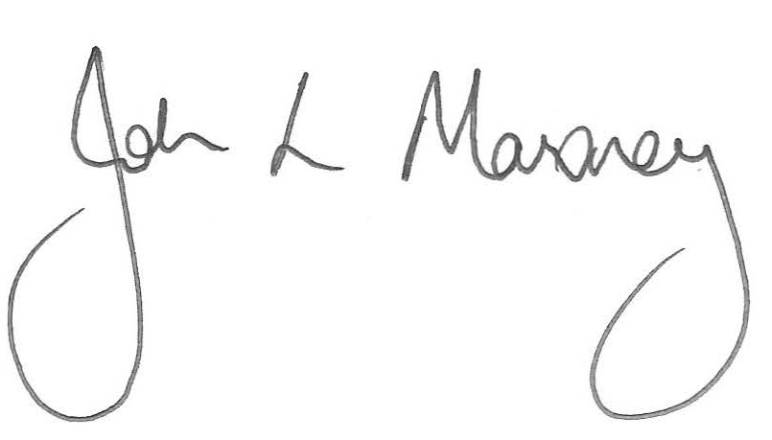

John Maroney
Chief Executive Officer
SMSF Association

