RESPONSE National Housing Finance and Investment Corporation E.

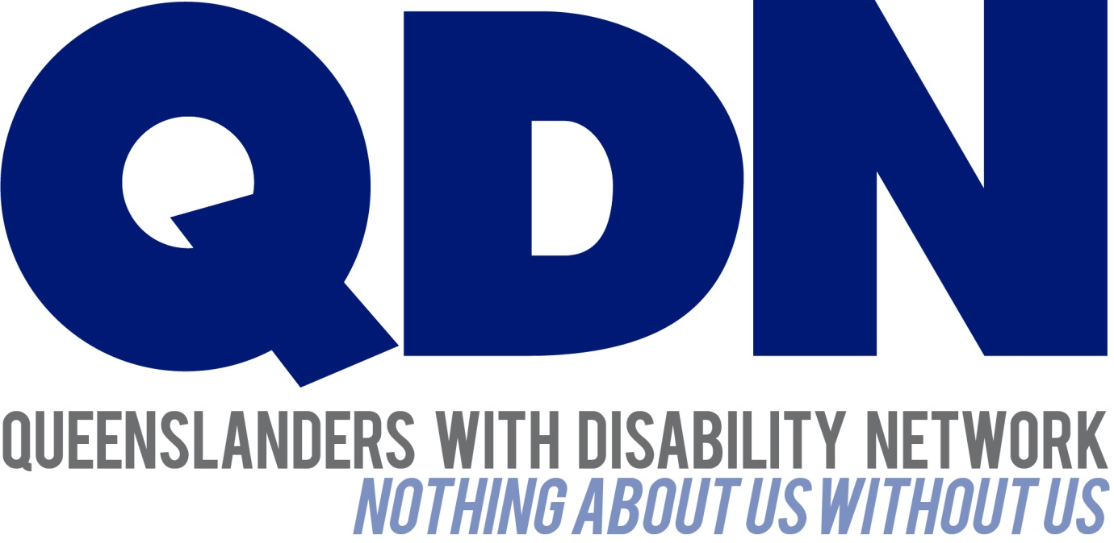

Contents
1
About Queenslanders with Disability Network (QDN) 3
Value Statement on People with Disability 3
QDN Guiding Housing Principles 4
Rights 4
Choice 4
Inclusion 4
Control 4
Response 5
Conclusion……………………………………………………………………………………………………………………………5

About Queenslanders with Disability Network (QDN)
QDN is an organisation of, for, and with people with disability and the organisation’s motto is “nothing about us without us.” QDN operates a state-wide network of members who provide information, feedback and views from a consumer perspective to inform systemic policy feedback to Government and peak bodies. QDN also provides information and referral support to people with disability.
QDN has over 700 members across Queensland. All of QDN’s voting members are people with disability.

Value Statement on People with Disability
QDN’s work in providing feedback and input into systemic policy issues is based upon the organisation’s core values and the place of people with disability in an inclusive, Australian society.
QDN believes that:
- All people with disability have a right to a place in the community and have contributions to make to community. This is as empowered, free citizens who are as valued, present, participating and welcomed as members of any dynamic and diverse society.
- The place of people with disability in the community is not just about people with disability having a house in the community. Core to this is that they are welcomed in the community as ordinary citizens where they are genuinely given opportunities to contribute and actively participate. People with disability need to be in communities where their individuality, their talents, and their lived experiences of disability are recognised and acknowledged.
- Culturally and historically, people with disability are not afforded the same value, opportunities or access to community life.
- Any inclusion in community for people with disability is conditional and vulnerable to withdrawal.
- Many people with disability in Queensland are excluded from the most basic experiences of ordinary lives.
- Current exclusionary practices are unacceptable and must be challenged.
- These issues affect not only people with disability but the whole community.
- The responsibility is shared. It lies within government (federal, state and local) and the community at large, to ensure that people with disability have a place and are resourced to belong in community.

QDN Guiding Housing Principles

Rights
People with disability have the same rights to housing assistance as other people and should be supported to exercise those rights. This means:

Housing is designed to enable family and friends with disability to visit.

Choice
People with disability choose where, how and with whom they live. This means: People can afford to live in housing suitable to their needs.
People are able to make informed decisions about their housing choices.

Inclusion
Housing enhances the independence and social and economic participation of people in family and community life. This means:

Housing is non-congregate and encourage a mix of occupants with and without disability in housing developments.

Housing is located within communities close to amenities and services.

Housing is designed to meet the principles of universal housing design as developed in the Livable Housing Design Guidelines and incorporates assistive technology as needed.

Queenslanders are educated and aware of benefits of universal housing design and the need to include people with disability in local communities.

Control
The provision and management of housing is separate from the provision and management of paid support. This means:

Housing is primarily a person’s home, not someone else’s workplace.

A person can change their housing without affecting their support arrangements.

QDN Response
Queenslanders with Disability Network (QDN) supports the National Housing Finance and Investment Corporation Bill 2018 to establish the National Housing Finance and Investment Corporation. We believe the establishment of this Corporation will assist in providing affordable housing investment infrastructure.
We are keen to ensure that the needs of people with disability are well considered. Given the current context including the recent introduction of the NDIS and, the increased demand by people with disability in mainstream housing, we would encourage the skills base of the of the Board include someone with a lived experience of disability and/or a and strong understanding of disability and housing.
We are also particularly pleased to note that the liabilities of the NHFIC will be guaranteed by the Commonwealth.

Conclusion
QDN welcomes the opportunity to provide further comment on this matter.

